English Year 7 Summer 2 Blended Learning Booklet
Wild Boy
Name:
Form:
English Teacher:
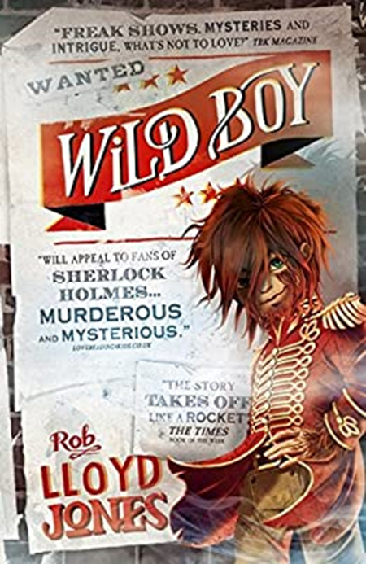

Page | Lesson Number | Title
2 | N/A | Y7 Overview
3 | N/A | Zoom In: Unit 2 Wild Boy
4 | N/A | Knowledge Organiser
5 | 1 | The Opening of the Novel
6 | 2 | Context of Wild Boy
8 | 3 | Freak Shows
11 | 4 | The World Through Wild Boy’s Eyes
15 | 5 | Introductions to Characters
17 | 6 | ‘There’s Been A Murder’
19 | 7 | Wild Boy and Clarissa
21 | 8 | Life in the Sewers
23 | 9 | Building Suspense
26 | 10 | Newspaper Article
28 | 11 | Wild Boy Accused
29 | 12 | Horror Writing
31 | 13 | The Machine What Changes You
34 | 14 | Back to the Fairground
37 | 15 | Who is the Killer?
39 | 16 | Clarissa Everett
41 | 17 | Friendship in Wild Boy
42 | 18 | Friendship in Wild Boy 2
44 | 19 | Book Review
47 | 20 | SAL

Instructions
For each lesson:
- Write the title and L/I
- Read the stated chapters
- Answer the connect questions
- Complete the DART, DIP and other activities
- Answer the Key Questions

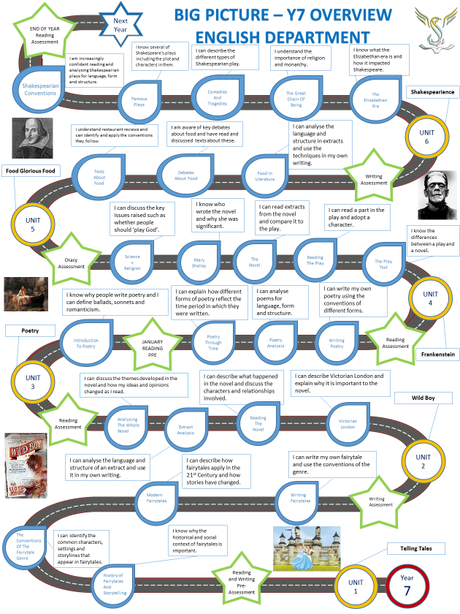

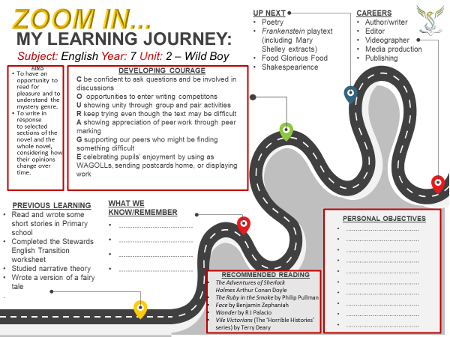
Plot Summary  Orphaned ‘Wild Boy’ lives in a workhouse in Victorian London. Abused and treated as a ‘freak’ because of his hairy appearance, he is recruited to join a travelling freak show. With living conditions no better, Wild Boy uses his astounding powers of observation to escape from his cruel master and joins forces with his former enemy – an acrobat from the circus, Clarissa. Together they set out to solve the mysterious murder of a circus performer, but in doing so risk their own lives and their fragile friendship. |  |  | 6. Sentence Starters:  The writer presents…  (Evidence/quotation)…  This suggests to the reader…  The writer is revealing that…  In particular his use of (method/technique) implies…
- Characters  Wild Boy: a boy completely covered in hair, with a special gift for observation  Clarissa Everett: Circus acrobat, petty thief and Wild Boy’s friend  Finch: Freak show owner and showman  Sir Oswald Farley: legless assistant to Finch; Wild Boy’s friend  The Professor: circus performer and murder victim  Mary Everett: Circus owner and Clarissa’s mother  Dr Griffin: Murder victim  Marcus Finch: the man with the golden eye  The Hooded man: mysterious suspect  The Gentlemen: group of men who work for the government | - Conventions of Mystery Genre  - Crime  - Detective/police – or a character who solves the crime  - Suspects  - Victim  - Clues  - Motives  - Red-herrings  - Tension  - Foreshadowing  - Resolution  - CHALLENGE: Can you think of at least three examples from the novel? | - Conventions of Horror Genre  - Common fears e.g. nightmares, darkness, monsters  - Gruesome details used to frighten e.g. blood  - Supernatural features  - Gothic features e.g. castles, dungeons, hidden rooms  - Setting can be somewhere with a dark history e.g. hospitals, abandoned places  - Hero protagonist  - Victim  - Evil/villain as antagonist  - CHALLENGE: Can you think of at least three examples from the novel? | 7. Subject Terminology  Genre: A category of literature  Convention: A way in which something is usually done  Imagery: Descriptive or figurative language, often appeals to senses  Verb: word indicating an action or state of being  Adjective: a word that describes a noun  Personification: Giving an animal or object qualities or abilities that only a human can have  Onomatopoeia: A word that mimics the sound of the object or action it refers to when it is spoken.  Tone: The general mood or attitude of a piece of writing  - CHALLENGE: Find examples in the novel for each key word
- Conventions of a newspaper article
- Headline and Strapline
- Introduction to create interest – (include who, what, where, when, how and why?)
- 3-4 developing paragraphs
- Short but effective conclusion
- Lively style
- Reported speech
- Past tense
- FAT HORSE techniques

Lesson 1: The Opening of the Novel
LI: To understand the purpose of a prologue
Reading: The Prologue (pages 7-15)
Connect
- When is the prologue set (you will find this on page 7)?
- Who was Queen at this time?
- What do you know about this time period?

Activate
The extract from the prologue describes the London setting at the beginning of the novel. Read the extract and answer the following questions (DART)
Prologue
That night, the night the showman came, the moon was the colour of mud.
Above the houses the sky turned from black to ding brown as a thick fog crept over the city. The monstrous mud-brown cloud rose from the river. It slithered over rooftops, curled around gas lamps and smothered their lights to ghostly orange globes. It crawled along the riverbank, swallowing the warehouses, workhouses and tumbledown tarry-black houses that leaned over the dark water. Doors were bolted. Shutters slammed. Even the rats in the alley froze in fright as the cloud came rolling in. The fog swallowed everything – but not the showman.
His gloved fist banged on the workhouse door.
No reply.
He banged again.
- What colour was the moon?
- What colour was the sky?

- What was bolted? What was slammed?
- What ‘froze in fright’?
- What are we told about the showman?

- What is the embedded clause in the first sentence?
- Where is alliteration used?

- Where is personification used?
Demonstrate
How does the writer create the mood in the prologue? Use your DART answers and the sentence starters below to help you (DIP).
- The writer creates an ominous mood in the prologue by describing the setting.
- For example…
- This shows…

- The writer develops this mood by describing…
- For example…
- This shows…

- Moreover, the description of the fog using personification is very dramatic.
- For example…
- This suggests…

Consolidate

What is the purpose of the prologue? What does it suggest about what is going to happen? How does it make you feel? What questions do you have about the novel?
Key Questions

What is a prologue?

What is the purpose of a prologue?

What mood is created by the writer?

What is pathetic fallacy?

How is it used in the prologue?

Why would a writer choose to do this?

Lesson 2: Context of Wild Boy
LI: To understand and imagine the context and setting of the novel
Connect
- Choose three words you associate with ‘wild’.
- Choose three words you associate with ‘boy’.
- Using these words what do you think the novel Wild Boy will be about?
Reading: Chapters 1 and 2 (pages 21-37)
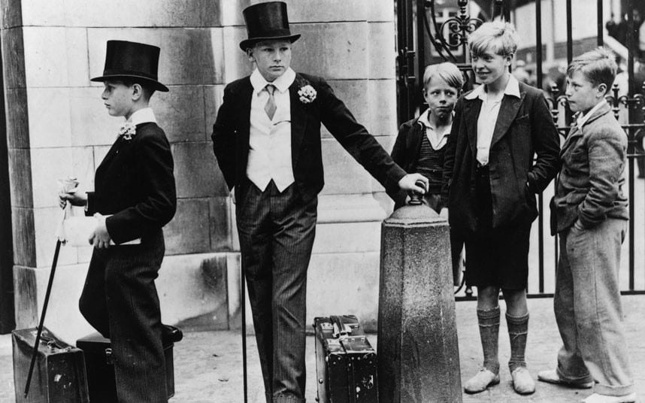
Activate
Look at the pictures of Victorian life. Write five words for each image describing what you see.
1. _______
2. _______
3. _______
4. _______
5. _______

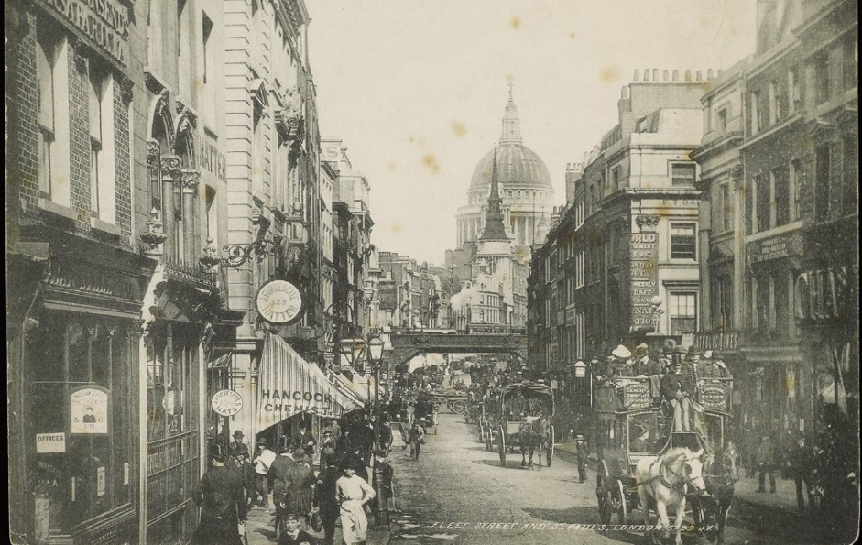

1. _______
2. _______
3. _______
4. _______
5. _______

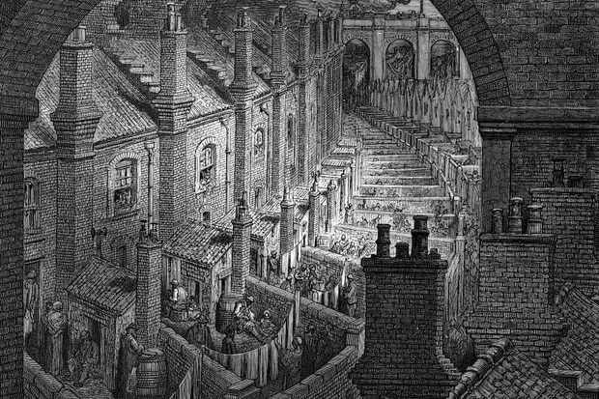
1. _______
2. _______
3. _______
4. _______
5. _______

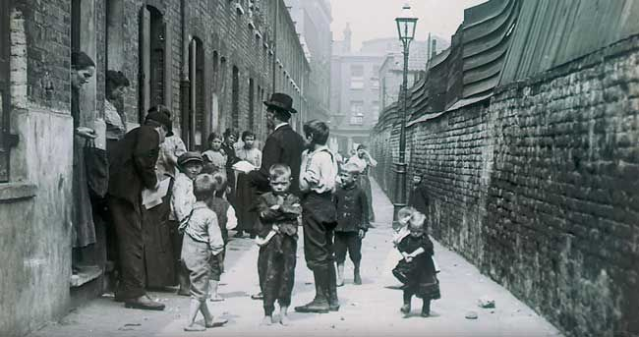
1. _______
2. _______
3. _______
4. _______
5. _______

Read the information about the Victoria era and answer the questions that follow (DART).
Victorian Times
The Victorian era refers to the period Queen Victoria was Queen (1837-1901). The Victorian era was a time of great change in Britain; the industrial revolution (which has taken place just prior to the Victorian times) was a time when the manufacturing of goods moved from small shops and homes to large factories. This shift brought about changes in culture as people moved from rural areas to big cities in order to work. Lots of inventions emerged during this time including railways, steam power, electricity, and the telephone. Conditions in the cities were often unpleasant and wages for some workers were low. There was no government support for people having a hard time and many were forced to live in workhouses; a highly undesirable place where the very poor were offered somewhere to live and work if their situation was desperate. Inequalities were very common and while wealthy children received the best education children from poor families had to work. Alongside changes in industry and manufacturing social changes were also occurring. Fairs were very popular with a variety of entertainment activities including rides, amusements, games, and sideshows. Freak shows were very popular at fairs and were sideshows featuring people and animals that had not developed normally. Despite these changes, punishments for crime remained harsh and murder, for example, was punishable by death.
- How long was the Victorian era?
- Write down three things that were invented during the Victoria era. What came just before the Victoria era which started this?
- What adjective is used to describe conditions in the cities?
- Where were many poor people forced to live?
- What are inequalities? What examples is given in the text?
Demonstrate
What have you learnt about Victorian London? What elements have appeared in the novel so far? (DIP)
Consolidate
What is Wild Boy about? Why will context be important?
Key Questions
- What does context mean?
- Why is it important?
- What was the industrial revolution?
- What did impact did it have on life in London?
- What does inequality mean?
- What inequalities existed within Victorian London?

Lesson 3: Freak Shows
LI: To evaluate a freak show poster from Victorian times
Reading: Chapters 3 and 4 (pages 38-53)
Connect
- What is a freak show?
- Why is Wild Boy the star of his own freak show?
- How is he treated by other people?

Activate
Read the information about freak shows and answer the questions that follow.
Freak Shows
The exhibition of freaks was an essential component of travelling fairs in Europe and America throughout the Victorian period. The freak could not be seen before a show and therefore needed the showman to market their particular attractions to the curious public. An essential part of the telling of the tale consisted of wonderfully and medically impossible reason to explain to the audience the history of the person they were going to see. The most popular attractions were oddities with extraordinary talents, who could do supposedly normal things despite their disabilities. The fairground created a world of extremes, where largeness in size, hairiness in body and the more miniature or large the stature was celebrated and sought after. This reversal of the norms in fashion and bodily perfection is never more exemplified than in the case of 'Mary Ann Bevan - the Ugliest Woman in the World, who was a star for many years at Pickard’s Grand Panopticon in Glasgow. Other nineteenth century exhibits included Patrick O’Brien the Irish Giant, a regular act at St Bartholomew's Fair and Sam Taylor the Ilkeston Giant. Examples of physical extremities included The Fat Boy of Peckham and Sacco-Homann the famous fasting man and such was the popularity of fat women shows that five alone could be found at Hull Fair, the largest travelling fair in the United Kingdom in the 1890s.
- Which word shows successful fairgrounds had to have freak shows?
- What were the most popular attractions?
- What examples of a ‘world of extremes’ are described?
- Why was Mary Ann Bevan a ‘freak’?

- What linked Patrick O’Brien and Sam Taylor?
- Why were freaks so important to the fairground owners?
- How would the star of a freak show have felt about this?

Look at the posters and consider the following questions:
- Why are each of these people ‘freaks’?
- How do the posters try to create interest and intrigue?
- Do you feel sympathy for any of these people?
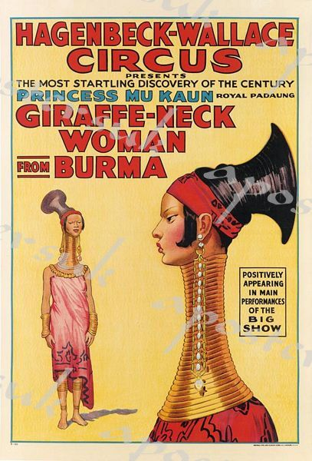
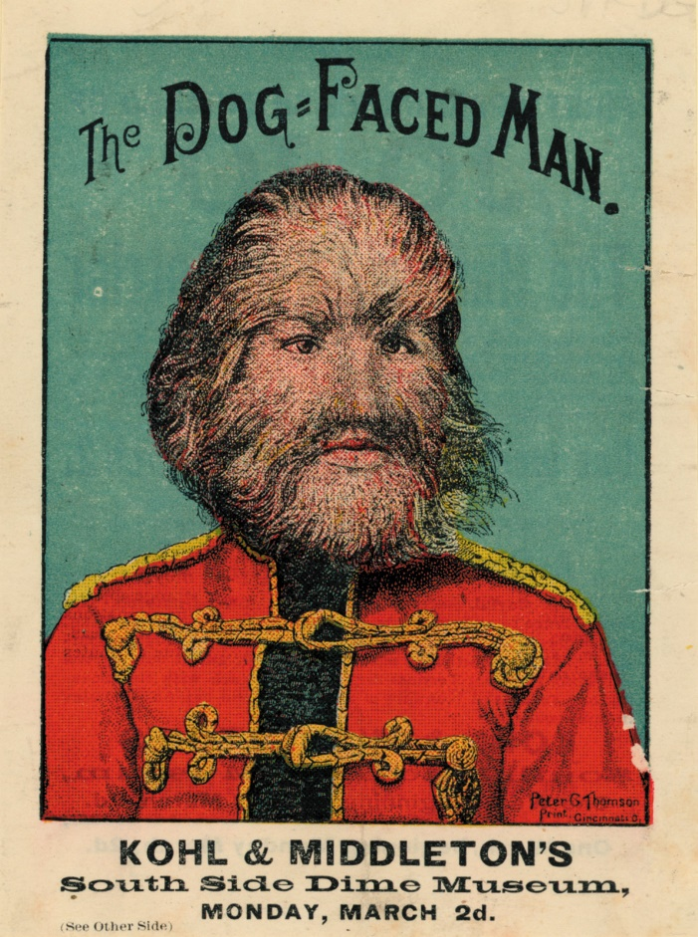

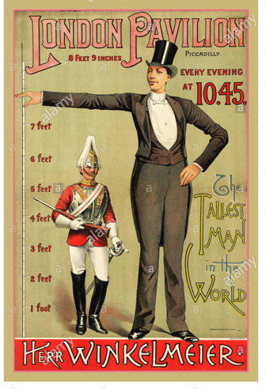

DIP

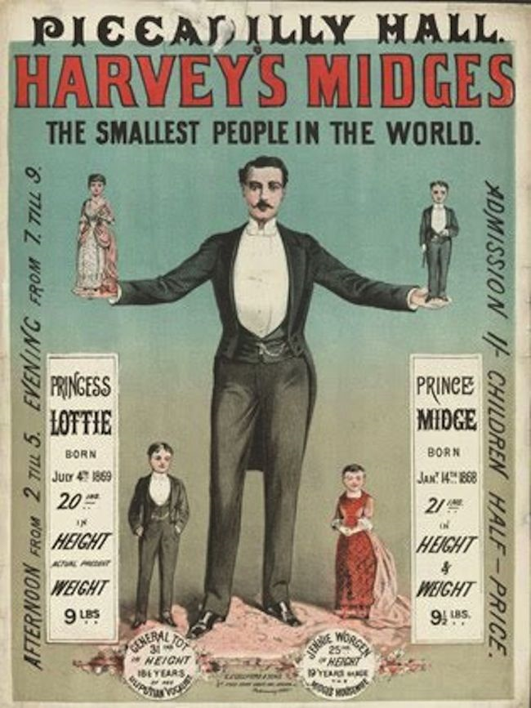
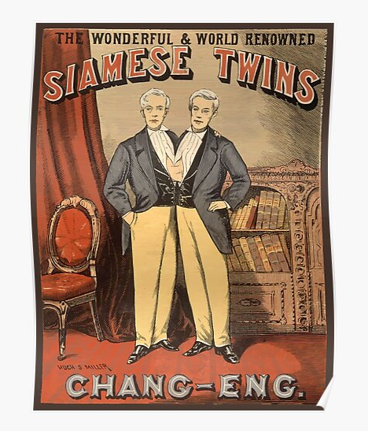
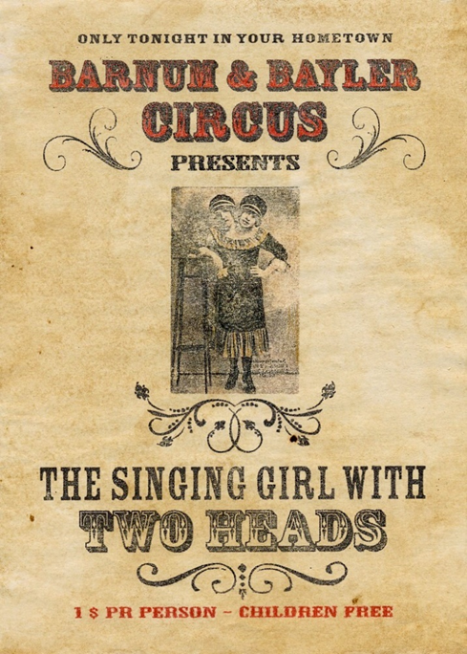

Demonstrate

Design your own freak show poster. What is special about your freak? How are you going to create interest in your freak? Why might someone be sympathetic towards your freak?
Write a short commentary about your freak show that either tries to create a sense of interest and intrigue or tries to create sympathy for your freak (DIP).

Consolidate

Which freak show would you most like to see? Why?

Key Questions
- What is a freak show?
- What is the purpose of a freak show poster?
- What techniques do the posters use to sell the shows?
- How would you attract people to go and see a freak show?
- Do people feel sympathy for freaks?
- How would you feel if you were a freak?

Lesson 4: The World Through Wild Boy’s Eyes

LI: To create character studies through notes from reading
Connect
- What did Wild Boy do at the end of chapter 4?
- How did the thief react?
- What other ‘good deeds’ has Wild Boy tried to do?
Reading: Chapters 5 and 6 (pages 54-69)
Read the information about full stops and commas. Re-write the extract to include them where they are missing.
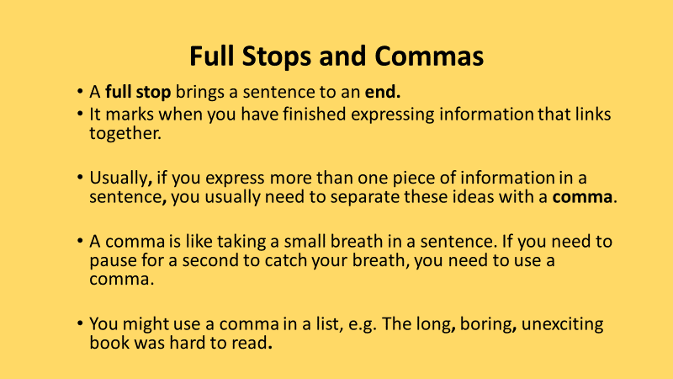
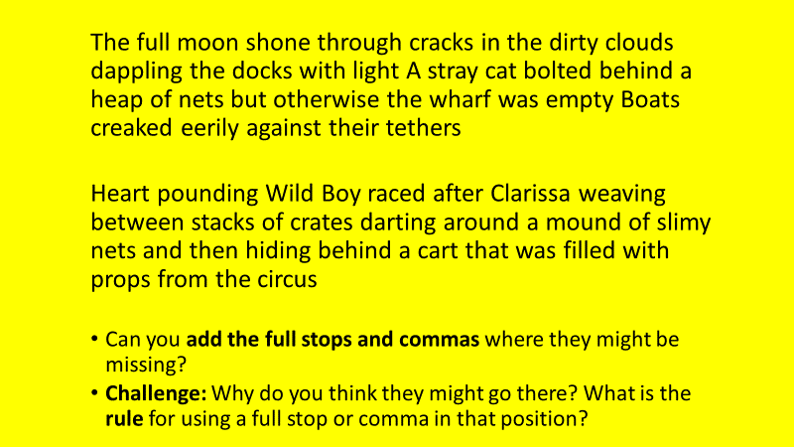
Activate
In the extract from chapter 3 Wild Boy is talking to Sir Oswald. Read the extract and answer the questions that follow (DART).
‘Watching the fight, eh?’ Sir Oswald said. He peered through the crack in the wood. ‘The Colossus versus the Skeleton? Not much of a contest there. Used to box a little myself you know, back when I had pins. Mind you, never against a brute the size of the Colossus’
‘The living Skeleton will win,’ Wild Boy said.
‘Poppycock!’ The man is so thin I can count his ribs through his vest.’
‘He was in the army.’
‘I have never heard him say that’.
Wild Boy doubted that anyone had. Few of the freaks spoke about their past. Some found it too depressing to speak of happier times. Others, like him, simple had no happier times to speak of.
Sir Oswald leaned closer to the crack, studying the Skeleton curiously. ‘Master Wild, how could you possibly know that he was in the army?’
‘See the white bits in his eyes?’ Wild Boy said.
‘Barely!’
‘They got black specks in them. They’re powder burns from musket fire. You see the same on soldiers about the fair.’
‘Perhaps you do, Master Wild…’
‘And look how he folded his coat, and that old tattoo on his arm. Army bloke, no doubt about it. Watch this now…’
Outside, the Living Skeleton swung a fist. The Human Colossus fell to the mud with a splash and a mighty thump.
‘Outstanding!’ Sir Oswald said. ‘Master Wild, you do have an extraordinary skill.’
‘Ain’t no skill,’ Wild Boy said. ‘It’s just looking’.
‘Poppycock’.
Wild Boy shrugged. It was just what came from years of being locked up with nothing to do but watch the world and dream that he was someone else. It wasn’t just his eyes that were sharp either. Confined to that room, he’s learned to separate individual sounds from the roar of the city – the barks of different dogs, or the rattle of particular carriages. He could distinguish between hundreds of smells and taught himself to read just from posters and placard he’d seen through the window. He didn’t see any of it as being particularly skilful. It was just what came from being a freak.
‘Right’, Sir Oswald sad, ‘I shall test you’. He moved across the van and looked through another crack. ‘How about that lady there? What can you tell me about here?’
Wild Boy didn’t like talking about the way he saw things. He knew that it was something different about him, and he hated being different. But he couldn’t help himself. It was too much fun. He joined Sir Oswald and peered eagerly out onto the path.
‘Which lady?’ he asked.
‘The one in the green bonnet.’
‘She’s a seamstress in a factory.’
‘Now how could you know that?’
‘She has blisters on the insiders of her fingers, probably from the needles. And her old bonnet’s fixed up with different coloured threads, see? Most likely, scraps from her factory, otherwise why not buy the right colour?’
‘Incredible! And how about that man in the smock?’
‘He’s a boxer. Lost his last fight for money.’
‘Scoundrel!’
‘He needed it for his new baby, a boy’.
‘Ah well, that’s fair game. And that woman there?’
‘She’s a flower seller.’
‘Now how could you possibly know that?’
‘Cos she’s selling flowers’.
They slid back from the wall, both laughing. Wild Boy felt a warm glow inside. He realised that he was proud to have impressed Sir Oswald.

Lines 1-26
- Why do none of the freaks speak about their past? (lines 9-11)
- How does Wild Boy know the living Skeleton was in the army? (lines 14-17)
- Why is you in italics? (line 18)
- What two words does Sir Oswald use to describe Wild Boy’s skill? (line 23)
- How does Wild Boy respond to this? (line 25)
- Look at question 1 – why does Wild Boy not like talking about his past?
- Look at question 4 – why is this particularly significant for Wild Boy?
- Look at question 5 – why does he respond like this?

Lines 27-58
- How did Wild Boy learn his skill? (lines 27-28)
- Which other two senses are particularly ‘sharp’? How do we know? (lines 30-32)
- How does Wild Boy know the lady in the green bonnet is a seamstress? (lines 46-48)
- Why did the boxer deliberately lose his last fight? (lines 50-52)
- How does Wild Boy feel about impressing Sir Oswald?
- How does Wild Boy feel about the way he sees things? (lines 38-41)
- Identify an example of sight, sound, feel/touch, and smell in the extract
- What might Wild Boy be able to taste?

Demonstrate
Imagine you are Wild Boy. Look at the image – what can you see? What could you hear? What could you smell? What could you touch? What could you taste?
What do you know about the people you can see? What could you see that nobody else could see?
Write a first person description of the fairground and the circus (from Wild Boy’s perspective) (DIP).
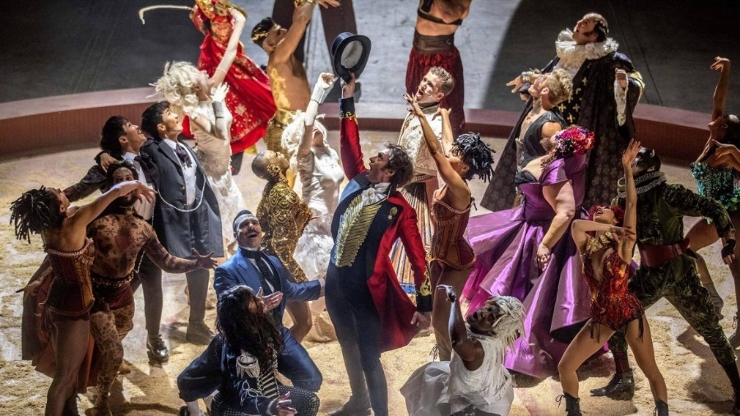
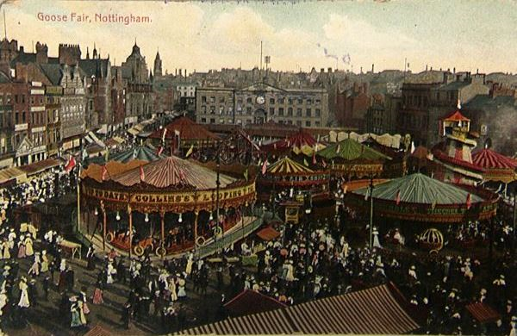

Consider:
- The five senses
- How you feel
- Small details
- The quality of the descriptive vocabulary (nouns and adjectives) you are using

Consolidate

What have you done well? What could you improve? Highlight examples of sensory description and examples of knowing things that nobody else knows.

Key Questions

What special skill does Wild Boy have?

Why does he not believe it to be special?

How do your experiences impact your behaviour?

What is the first person?

What is meant by sensory description?

Which senses are easiest to describe?

Lesson 5: Introductions to Characters

LI: To make deductions and draw inferences about characters and their behaviour
Reading: Chapters 7 and 8 (pages 70-85)
Connect
- Why are friends important?
- What does it mean to feel lonely?
- What does segregation mean?
Activate
In the extract from chapter 1 Wild Boy is spotted by a young girl who is visiting the fairground. Read the extract and answer the questions that follow (DART).

Just then, the girl looked up and saw him.
Wild Boy flinched back, ready to dive through the hatch in the van roof if the girl screamed. But the girl didn’t scream. Instead, a smile rose across her spotty cheeks.
The hairs tingled all over Wild Boy’s body. Was she smiling at him? He shifted up and, very slowly, raised a hand in reply. But now the girl’s mouth curled in to a malicious grin. She pointed at him and shrieked to her friends, ‘Look! Monster! Monster! I seen a hairy monster!’
Wild Boy dropped to the roof, cursing himself. Of course she wasn’t smiling at him.
- Which word shows Wild Boy thought the girl was going to scream?
- Which word shows Wild Boy was excited when he thought the girl was looking at him?
- Which word shows the girl’s true feelings towards Wild Boy?
- ‘Of course she wasn’t smiling at him’ – why is Wild Boy annoyed at himself?
- What does this show about he is used to being treated?

Demonstrate

How do the other characters treat Wild Boy? Match the following characters to the quotations above: Finch (the showman), Bledlow (the master), Sir Oswald, the children in the workhouse, Clarissa
How do the other characters treat Wild Boy (DIP)?
Use the quotations you have identified for each character to help you. Include paragraphs for at least two characters in your answer.
E.g. Finch is nasty and horrible towards Wild Boy. For example, he describes the moment he found him by saying ‘Ugly little baby too. Thought he was a drowned rat’. The fact Finch describes Wild Boy as ugly and a rat shows the negative attitude he has towards him, highlighting a reason why the workhouse was not a good place for Wild Boy to be.
Consolidate
Why do characters treat Wild Boy in this way? Why do different characters treat him differently?
Key Questions
- Why are friends important?
- How is Wild Boy used to being treated?
- How does the writer use language to show this?
- Why do people treat him like this?
- How does this impact what he expects of others?
- Why does Sir Oswald treat Wild Boy differently?

Lesson 6: ‘There’s Been A Murder’
LI: To identify suspense building techniques in dialogue
Reading: Chapters 9 (pages 86-96)
Connect
- Who has been murdered?
- How does Wild Boy know?
- What happened when he tried to tell other people?

Activate

Having read chapter 9:
- What evidence is Mary Everett using against Wild Boy?
- Why else are they accusing Wild Boy?
- What is Showman’s Law?
- Who comes to Wild Boy’s rescue?
- What does Wild Boy notice about him?

Suspense – excited or anxious uncertainty about what may happen

Demonstrate
In the extract from chapter 9 Mary Everett is interrogating Wild Boy. Read the extract and complete the task that follows (DART):
‘What’s happening?’ Wild Boy demanded. ‘Let me out!’
A smudge of charcoal ran like a black tear down the ringmaster’s powdered cheek. ‘Thought you’d feel at home with the animals, freak.’
She swept her torch through the dark. Its arc of flame lit a row of cages raised on wooden carts around the side of the big top. These were the homes of the circus’s wild beasts – a family of cowering chimpanzees a pair of grinning hyenas and a Bengal tiger curled against the bars, its amber eyes glinting in the torchlight.
Around Wild Boy’s cage, more and more torches crackled to life. A dozen circus porters stepped from the dark. He could smell the booze on their breath and see it in their bleary eyes.
He shuffled forward and clutched the bars. ‘Listen to me,’ he said. ‘There’s been a murder… Professor Wollstonecraft –’
‘He admits it!’ said one of the porters.
‘No, it weren’t me!’
‘Then who was it?’ Mary Everett said.
‘I…I never saw his face. He wore a mask’.
A ripple of laughter spread through the porters. The hyenas joined in, drool trickling from their shiny fangs.
‘Enough!’ said Mary Everett, and everyone shut up – even the hyenas. ‘You were seen running from the Professor’s van,’ she said. ‘But so was someone else. Who’s your partner?’
‘I ain’t not go no partner, I swear. It was the hooded man. Listen to me, he walks funny and he –’
The ringmaster jabbed her torch at the bars, causing a burst of sparks. Wild Boy cried out and tumbled back as the fire singed the hair on his hands and face.
Mary Everett used her torch to light a cigar. She took a long drag and blew smoke through the bars. ‘No, you listen to me, freak. You were seen running from the Professor’s van. And you got blood on your hands.’

DIP
How is suspense built through the dialogue at the start of chapter 9?
Use the examples you highlighted in your answer.
Below there is a WAGOLL to help you.
WAGOLL
Lloyd Jones builds suspense through the aggressive and nasty way in which Mary Everett interacts with Wild Boy. For example, ‘No, you listen to me, freak’. The fact Mary Everett does not listen to Wild Boy and is clearly in control of the situation suggests she is not going to give him a chance to give his version of events. This builds suspense as she is judging him on the basis that he is a ‘freak’ and it seems likely to the reader Wild Boy is going to be punished regardless of whether he is guilty or not.

Consolidate
Why is dialogue an effective way to build suspense? What do you think will happen to Wild Boy?
Key Questions

What is dialogue?

What does suspense mean?

Why is Wild Boy being accused of the murder?

What does Wild Boy about Mary Everett and the Golden Eyed Man?

Why is he able to do this?

How could this help him?

Lesson 7: Wild Boy and Clarissa
LI: To make deductions and draw inferences about characters and their behaviour
Reading: Chapters 10 and 11 (pages 97-113)
Connect
1. What are your first impressions of Clarissa?
2. How does she meet Wild Boy?
3. What does she say to him?

In the extract from chapter 5 Wild Boy and Clarissa are having an argument. Read the extract and answer the questions that follow (DART).
Page 59-60
Clarissa slammed a hand against the stable wall. ‘Why didn’t you tell me he had a knife? He was crazy, a lunatic! And what was he saying?’
‘Something about a machine,’ Wild Boy wheezed. ‘What did he have under his cloak?’
‘Nothing! Just this.’
She thrust a scrap of paper at his face.
It looked like a letter. Wild Boy reached out to take it, but she snatched it back.
‘It’s your fault,’ she said. ‘I ain’t got nothing now!’
She glanced towards the circus tent and Wild Boy saw a fear in her eyes that he recognised. Clarissa, too, was scared to go back’.
‘Well’, he said, ‘maybe we can find another…’
‘Shut up, freak! I should never have listened to you.’ She shoved him in the chest and ran off towards the circus. ‘You owe me double now’.
Wild Boy didn’t bother yelling a reply. He had bigger problems than Clarissa Everett. Like her, he’d got nothing. And so he had to return to Finch. By now the showman would have passed out from drinking. But come the morning…
- Identify three things that show Clarissa is angry.
- What does ‘Wild Boy saw a fear in her eyes that he recognised’ suggest about how Wild Boy feels about Clarissa?
- Why did Wild Boy have ‘bigger problems than Clarissa Everett’?
- Has Clarissa and Wild Boy’s relationship changed since they first met?
- How/why?

DIP
Think about the end of Chapter 10
Use the questions and sentence starters below to answer the following:
What kind of relationship does Wild Boy have with Clarissa? (DIP)
Wild Boy and Clarissa have a difficult/challenging/improving/developing relationship. At the start…
(Are things starting to change?) Things are starting to change because…
(Do you think they need each other?) It could be argued they need each other because…
(Do you think they can be friends?) They may end up friends/they won’t be friends because…
In some ways their situation is similar because…
Consolidate
Why is the relationship between Wild Boy and Clarissa significant? What is your attitude towards Clarissa?
Key Questions
- How did Clarissa and Wild Boy treat each other at the start of the novel?
- Why did they treat each other this way?
- What does this tell us about first impressions?
- Why does their relationship start to improve?
- What are loyalty and trust?
- How do they develop in a relationship?

Lesson 8: Life in the Sewers
LI: To analyse the impact of language and structural devices
Reading: Chapters 12 (pages 117-121)
Connect
How many of the following can you define?
Verb, adverb, noun, adjective, simile, alliteration, short sentence/paragraph, list
Read the information about dynamic and stative verbs and complete the task below.
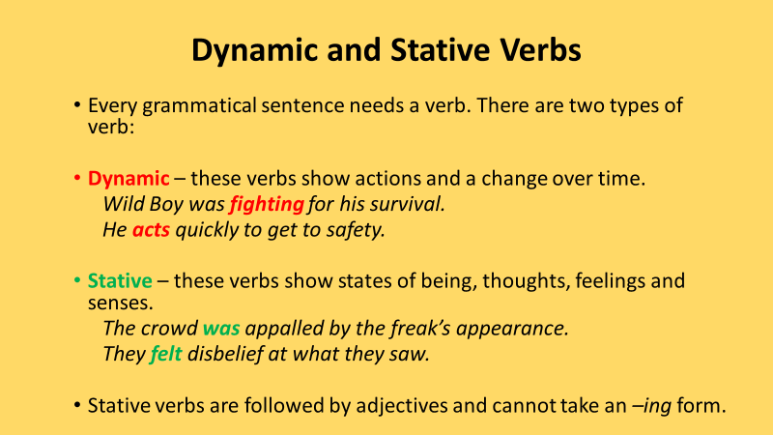
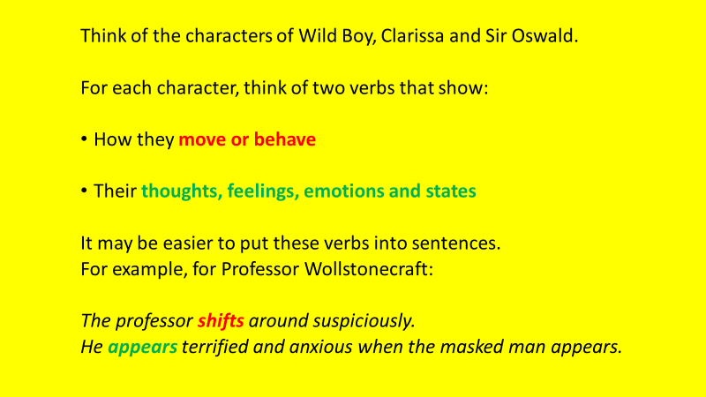
Activate
In the extract from chapter 12 Wild Boy has woken up in the sewers. Read the extract, write down five adjectives to describe the sewer, and complete the activities that follow (DART).
A trickle of slime stole down a wall, glistening in a slant of moonlight that fell between the nodding shed-like houses. It slipped between the cobbles, gathering as it went the particle of waste spattered across the street – gobbets of phlegm, flecks of vomit, the reeking overspill from domestic cesspits.
The filth of the street percolated down. It nudged at the ceiling of an ancient sewer, crept through a crack in the crumbling mortar. It hung from the bricks in a single fat drop. Then it fell and landed – pat! – on the head of a small boy covered in hair.
Wild Boy opened his eyes.
Everything was black. Not a crack of light anywhere. He was lying on his back on what felt like wet cloth. He heard dripping water, although his mouth was dry and taste like mould. He extended a foot cautiously into the darkness, felt cold slime on broken brick. He tried to stay calm, but panic overwhelmed him.
‘I didn’t do it’, he gasped. ‘It wasn’t me’.
He scrunched his eyes shut and prayed that when he opened them he’d be back at the fair and everything would be normal.
Demonstrate
Write a description of what it would be like to wake up in the sewers. Use ideas from the extract and sensory description.
Opening sentence: I slowly opened my eyes. I didn’t know where I was (DIP).
Consolidate
Self-assessment: highlight examples of sensory description and other literary techniques you have used in your writing.
Key Questions
- What is an adjective?
- What is an adverb?
- Why did Wild Boy go into the sewers?
- What does this show us about his situation?
- What is sensory description?
- Why is it useful?

Lesson 9: Building Suspense
LI: To identify suspense-building techniques in the dialogue
Reading: Chapters 13 (pages 122-127)
Connect
- What is tension?
- How is it built in Wild Boy?
- What is the tensest moment in the novel so far?

Activate

Suspense – excited or anxious uncertainty about what may happen.
How do Wild Boy and Clarissa interact during chapter 13? What is the role of Sir Oswald in the most suspenseful moment?

Read the information about colons and complete the tasks that follow.

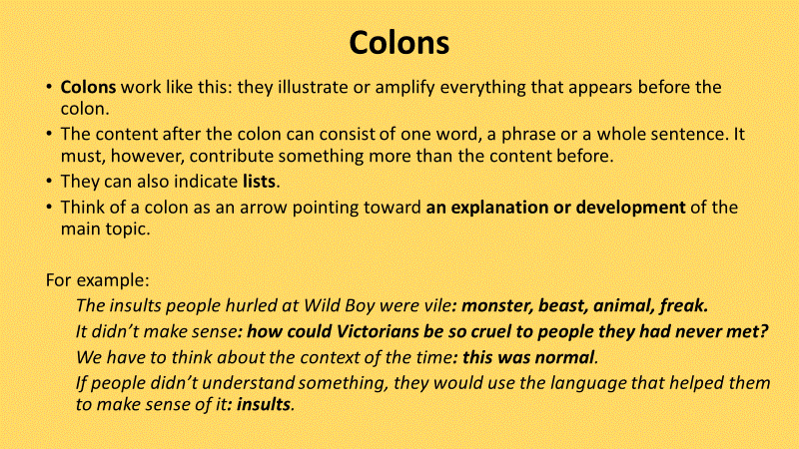

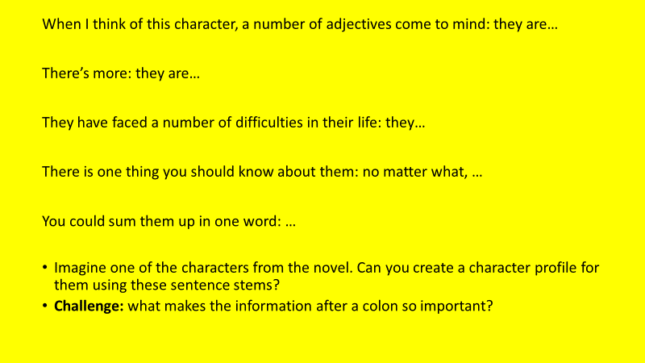

Demonstrate

In the extract from chapter 13 Wild Boy and Clarissa are having an argument. Read the extract and answer the questions that follow (DART).

Clarissa: ‘This is your fault! I should be in the circus tonight but instead I’m wanted for murder’
WB: ‘Circus? It’s them that’s after you! If your bloomin’ mother hadn’t –’
Clarissa: ‘Shut your head about her! She didn’t understand!’
WB: ‘Some misunderstanding! She set dogs on us!’
Clarissa: ‘And I wish they’d caught you!’
WB: ‘Tell her, if she touches me again she’ll be eating sewage’
Clarissa: ‘I bumped in to Sir Oswald after we split up. It was his idea to find you though. I’d have left you here to drown’.
Clarissa: ‘I wish I’d never let you free!’
WB: ‘Why did you then? I didn’t need your help!’
Clarissa: ‘I wish I’d never!’
WB: ‘You never shoulda! You look out for yourself and that’s all!’
- What insults are made?

- What threats are made?
- How do they use Sir Oswald in their interactions?
- Why are there so many exclamation marks?
- Why are there so many short sentences?
- Look at page 126 – which line suggests Wild Boy is not showing his true feelings in this argument?

Use the WAGOLL and the sentence starters below to help you answer the following question:
How is suspense used during chapter 13?
WAGOLL
Suspense is built through the interaction between Wild Boy and Clarissa when they are reunited in the sewers. Wild Boy and Clarissa insult and threaten each other. For example, ‘shut your head’. This shows Clarissa doesn’t want Wild Boy to speak about her mother. Wild Boy says, ‘if she touches me again she will eat sewage’.
Both characters use Sir Oswald to help get their point across. For example…
There are lots of exclamation marks and short sentences. For example…
However, it is possible they are not showing their true feelings in this argument. For example…
Key Questions

What is dialogue?

What does it show about characters in a novel?

Why are Wild Boy and Clarissa arguing?

How does this reflect their relationship?

What role does Sir Oswald play in their interaction?

Why are his motivations for doing this?

Lesson 10: Newspaper Article
LI: To understand and apply the conventions of a newspaper article
Reading: Chapters 14 and 15 (pages 128-142)
Connect
- Who has been the victim of a crime?
- Who is suspected of the crime?
- What is a motive?
- What does tension mean?
- How does Wild Boy identify clues about who committed the murders?

Read the information about speech and complete the activities below.
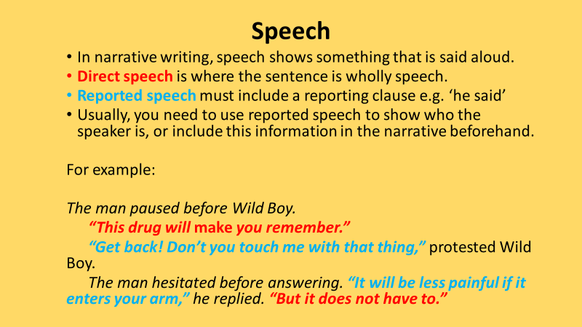
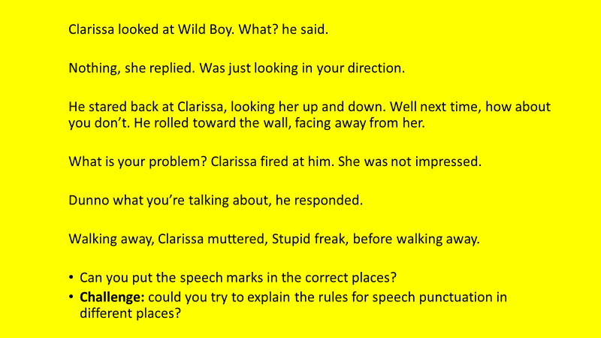

Demonstrate
Read the newspaper article about the murder of Professor Wollstonecraft (DART), briefly summarise each paragraph (what is the purpose of it?) and write down as many details that are reported as you can.
Professor Wollstonecraft Murdered!
In a dramatic series of events last night, a circus performer was brutally murdered at the Greenwich Fair.
Professor Wollstonecraft was alone in his caravan when sometime around 9.30pm several people heard screams that suggested an attack had been carried out and a murder had been committed.
Circus performers rushed to the caravan to find Professor Wollstonecraft had been brutally stabbed. The words Wild Boy were scratched into the mud beside the body, making it clear who committed this horrific act.
Wild Boy was captured shortly after by Mary Everett but he managed to escape. The city has been through into a state of panic the like of which has never been witnessed.
Speaking to the newspaper, Mary Everett said, ‘Wild Boy is definitely guilty. He was covered in the Professor’s blood and he is a monster.’
Detectives continue to look for Wild Boy and there is a reward for anybody who can provide information about him that leads to him being captured and punished for what he has done wrong.
Demonstrate
Write an article about the murder of Doctor Griffin (DIP).
Use the scaffold provided by the Professor Wollstonecraft article to help you (and magpie as much of it as you like!)
Consolidate
Self-assessment. Have you followed the structure of a newspaper article? Have you included all the important details?
Key Questions
- Who is suspected of murdering Professor Wollstonecraft?
- Why is this the case?
- How would Wild Boy feel about the second murder?
- What is included in a good newspaper article?
- What details are important to explaining the second murder?
- What is mysterious about what happened?

Lesson 11: Wild Boy Accused
LI: To know the conventions of the mystery genre
Reading: Chapters 16 and 17 (pages 143-158)
Connect
- Why do people think Wild Boy killed Professor Wollstonecraft and Doctor Griffin? (Name as many reasons as you can)
- How might Wild Boy try to defend himself?
- Who might be able to help Wild Boy in this situation?

In the extract from chapter 6 Wild Boy is using his ‘skill’ to watch the fairground. Read the extract below and answer the questions that follow (DART).
He slid to the edge of the roof, his sharp eyes raking the crowds. From here he could see all the way to the circus tent at the end of the path, a swirl of colour against the soot-black sky. There were hundreds of people down there. He saw a beggar with a sign saying SHIPWRECKED SAILOR (whom he could tell had never been to sea). He saw four women playing cards (three of whom he knew were cheating). He saw a woman faking a fit outside a gin tent, a man with a hook for a hand, a girl stealing gingerbread…

- Identify two things (not people) that Wild Boy can see from the caravan roof.
- Identify five people Wild Boy can see from the caravan roof.
- How might this skill help Wild Boy in his current predicament?

Activate
Brainstorm a summary of what has happened in the novel so far. What is the most important thing that has happened? What was the most dramatic or tensest moment?
Research and write down the definitions of the mystery genre conventions on the following page:

Demonstrate
What conventions of the mystery genre have appeared in the novel so far? What is the strangest thing that has happened in the novel so far?
How does Wild Boy follow the conventions of the mystery genre? (DIP)
Consolidate
Why will it be hard for Wild Boy to overcome the problems he is facing? What do you think will happen next in the novel (based on the conventions of the mystery genre)?
Key Questions

What is a genre?

What is a convention?

Why do writers follow conventions?

What is the key event from the novel so far?

How does Wild Boy follow the conventions of the mystery genre?

What does it suggest might happen next?

Lesson 12: Horror Writing
LI: To identify, evaluate and apply features of horror writing
Reading: Chapters 18 - 20 (pages 159-176)
Connect
- How many features of horror writing can you identify?
- How is Wild Boy an example of horror writing?

Activate
In the extract from chapter 17 Wild Boy is looking round Doctor Griffin’s house looking for clues. Read the extract and answer the questions that follow (DART):
Wild Boy had no idea what he’d expected to find on the first floor of Doctor Griffin’s house, but he hadn’t expected this.
He raised his candle, scattering glittery light around thousands of glass jars crammed onto shelves and into cabinets up and down the long room. Each jar was filled with golden fluid and suspended in the fluid was part of a human corpse. Grisly objects loomed from the dark – a severed hand, an amputated foot, the honeycomb lining of a human stomach.
‘Looks like a museum,’ he said, gazing along the rows of pickled organs and limbs.
Clarissa peered anxiously over his shoulder. ‘It’s horrid,’ she said.
Wild Boy nodded, pretending to agree. In fact, he was fascinated. He wished he had time to look around the Doctor’s museum properly and examine each object in every jar. But he could hear the police officers’ voices through a window at one end of the long room, and he knew they could come into this house at any time. He had to focus, find more clues. He was certain the killer had come down here. He’d followed the blood trail from upstairs, and there were more marks on these floorboards.
He moved slowly through the room, crouching with his candle to study the drops of dry blood. What he saw didn’t make a lot of sense – the trail led one way and then the other, as if the killer had walked back and forth between the cabinets and the shelves. Then it returned to the door and vanished.
- What was in the jars?
- What ‘grisly’ objects were in the room?
- How does Clarissa describe the room?
- Did Wild Boy agree?
- Why was he certain the killer had been there?
- What didn’t make sense?
- What features of horror writing are present in the extract?
- What features of horror writing are present in the rest of Wild Boy?

Demonstrate
Identify five conventions of the horror genre you could use in your own writing. How are you going to use each feature? Can you magpie from the extract?
Write an introduction to a horror story (focus on describing the setting and introducing a character) (DIP).

Consolidate
Which features of the horror genre have you used? How could your work be improved?
Key Questions
- What type of characters feature in horror writing?
- What is the setting like in horror writing?
- What events happen in horror writing?
- How does the extract show features of horror writing?
- How does the rest of the novel demonstrate features of horror writing?
- Which features of horror writing would you reproduce in your own writing?

Lesson 13: The Machine What Changes You
LI: To closely analyse an extract
Reading: Chapters 21 and 22 (pages 177-194)
Connect
- Who saved Wild Boy and Clarissa at the end of chapter 20?
- What memories does Wild Boy have of the workhouse?
- How will these memories make him feel?

Read the information about analytical verbs and complete the task below. Try to use these verbs in your analytical writing later in the lesson.
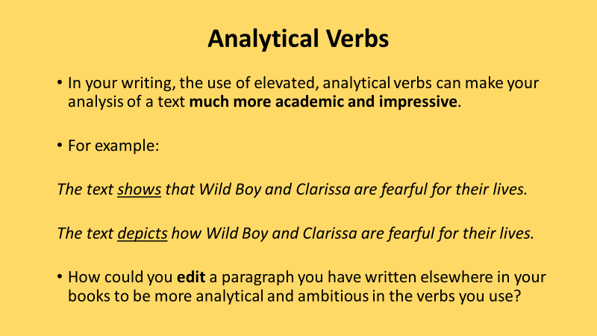
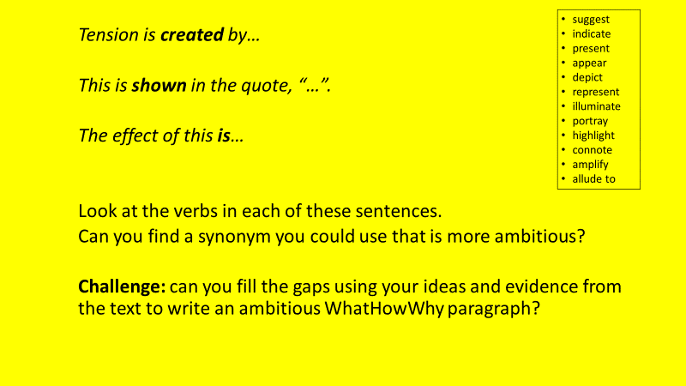
Activate
In the extract from chapter 21 Wild Boy is talking to Sir Oswald. Read the extract and answer the questions that follow (DART).
Sir Oswald thought about this for a moment. ‘I am hardly an expert on such matters, Master Wild. But I once spoke with Professor Wollstonecraft about electricity. He told me that it was an extraordinary power, capable of incredible things. So, yes, perhaps it is possible. But I know this: you must keep going. Find this machine and perhaps you will find the killer. Do not give up now, Master Wild. If you do, then they have won. Mr Finch, Master Bledlow, and all those boys who persecuted you here…they will all have won.’
He shoved his hat back on his head. ‘Now, speaking of Mr Finch, I must return to the warehouse.’
Finch. Wild Boy had almost forgotten about him. It seemed strange that only a few days ago his biggest worry had been a beating from the showman. He felt sorry for Sir Oswald – without a show Finch would probably be drunk all day.
‘I will return in an hour with food and clean clothes,’ Sir Oswald said. ‘Promise me you will not go anywhere until I return?’
Wild Boy managed another slight smile. ‘Where else am I gonna go?’
The grin returned to Sir Oswald’s wrinkled face.
‘That’s the spirit! Miss Everett has lit a fire downstairs, so I suggest you make yourself at home. Quite industrious, that young lady. I knew the two of you would make a fine team. Keep looking, Master Wild. It is not over yet.’
Sir Oswald raised his hat in salute, and left.
Wild Boy turned back to the window. He knew Sir Oswald was right. He had learned his skill here – if it was a skill. Perhaps he could save himself, and Clarissa. But what then? He’d still be a freak. Nothing would have changed. Unless…
Unless it was true.
‘The machine what changes you,’ he whispered.

- Who had Wild Boy almost forgotten about?
- Why was this strange?
- Why did Wild Boy feel sorry for Sir Oswald?
- What word does Sir Oswald use to describe Clarissa?
- Why did Wild Boy still want to change?
- Why does Wild Boy trust Sir Oswald?
- Why do Wild Boy and Clarissa ‘make a good team’?

Demonstrate

Write down the four underlined quotations. What are the two key words in each quotation? What do they show about Wild Boy’s situation? What do they suggest he will do? How will the reader feel towards Wild Boy?

How does Lloyd Jones use language and structure to convey Wild Boy’s thoughts, feelings, and emotions in the extract? (DIP) Use the WAGOLL below to help you.

WAGOLL

Lloyd Jones uses a triadic structure to list the people from Wild Boy’s past who treated him badly and made life difficult for him. Lloyd Jones writes, ‘Mr Finch, Master Bledlow, and all those boys who persecuted you here…They will all have won’. This reminds Wild Boy of the tough times he had growing up and how much his life has improved, making him determined not to suffer in that way again. The reader will feel sympathy for Wild Boy and hope he is able to improve his life in the future.

Consolidate
What advice has Sir Oswald given Wild Boy? Why does he give this advice? What do you think Wild Boy will do?
Key Questions

What are language and structure?

What does Wild Boy remember from his childhood?

Why was he picked on?

Which characters have supported him during the novel?

What motivates Wild Boy?

In what ways is he conflicted?

Lesson 14: Back to the Fairground
LI: To identify sensory-related words and use in writing a description
Reading: Chapters 23 and 24 (pages 195-210)
Connect

When was the last time Wild Boy and Clarissa were at the fairground? Who will they see there? How will they feel about this?

Read the information about sensory verbs and complete the activities that follow.

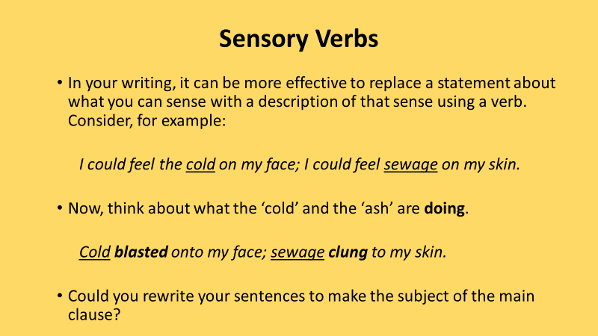
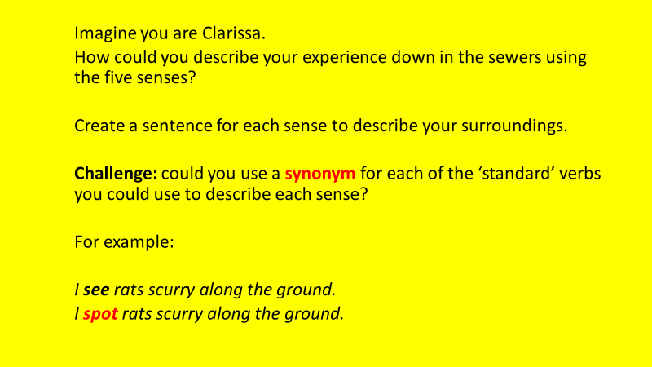
Activate
In the extract from chapter 23 Wild Boy has returned to the fairground. Read the extract and answer the questions that follow (DART).
Wild Boy leaned around the side of the cart, checking that they hadn’t been seen. From here he could see straight into the iron-roofed warehouse where the travelling fair had camped. Everyone was there – the showmen, the circus crew, the performers, and stall holders – all making last-minute preparations before riding to Bartholomew Fair in the heart of London.
And there, among the vans, was his old freak show. Sir Oswald was still fixing up the caravan, hanging on to the side with one arm as he connected a new pipe to those that already snaked around the wooden walls.
Augustus Finch leaned against the van. The scars were shiny across the Showman’s face, and his badger-streak hair hung wild about his eyes. He still struggled to stand on his wounded foot, which pleased Wild Boy to see.
‘Serves the old goat right,’ he muttered.
He realised that he wasn’t scared of Finch anymore. So much had happened since he’d fled that caravan. He had bigger fears to face now.
Clarissa came up beside him. She was looking into the warehouse too, and she had seen her mother.
Mary Everett looked even more frightening than Finch, with fresh white make-up smeared across her face and staining her greasy hair. The powder crumbled from her cheeks as she leaned on her crutch and roared orders at a couple of porters fixing a wagon wheel.
- Where was the travelling fair heading to next?
- What was Finch doing?
- Why was Wild Boy pleased?
- What did he realise?
- Who did Clarissa notice?
- How would Wild Boy and Clarissa feel about returning to the fair?
- Why might Wild Boy be concerned about Clarissa?

Demonstrate
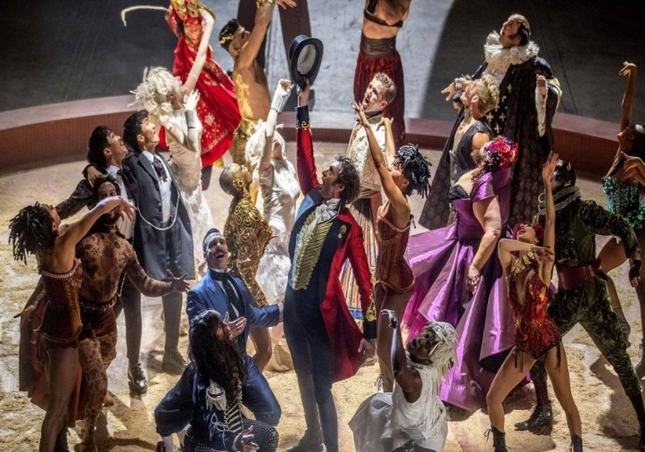
Imagine you are Wild Boy…

Write a first person description of the how it would feel to return to the fairground (from Wild Boy’s perspective) (DIP).
- How do you feel about returning to the fairground?
- Why are you there?
- How have things changed since you were last there?
- How do you think Clarissa feels about returning to the fair?
- How has your relationship with Clarissa changed since you were last there?

Consider:
- The five senses
- How you feel
- Small details
- The quality of the descriptive vocabulary (nouns and adjectives) you are using

Consolidate
What have you focused on today? How has it improved your writing?

Key Questions
- When were Wild Boy and Clarissa last at the fairground?
- What was the purpose of their return?
- Why might they not want to go back?
- How will they deal with seeing Finch and Mary Everett?
- What has changed since they were last there?
- What does this say about friendship?

Lesson 15: Who is the Killer?
LI: To use inferences and deductions to make predictions
Reading: Chapters 25 and 26 (pages 211-224)
Connect
Where have Wild Boy and Clarissa been to investigate the case? Why are they investigating the case? What clues have they found so far?
To deduce – arrive at (a fact or conclusion) by reasoning, drawing a logical conclusion
Bobbies – policemen (after Sir Robert Peel who created London’s first organised police force in 1829)

Activate

In the extract from chapter 9 Wild Boy and Clarissa are trying to find clues to help solve the case. Read the extract and answer the questions that follow (DART).

She looked at him curiously, and immediately he felt bad. He didn’t know why he’d lied to her. He still thought that what the killer had said sounded ridiculous. But if it was true…
The truth was, he didn’t want Clarissa knowing how interested he was becoming in the machine. They were meant to be finding the killer, after all.
‘So what should we add?’ Clarissa asked.
Wild Boy thought for a moment, replaying the scene from the Doctor’s house over in his mind and picking out the important details. ‘Well, the killer can jump. The drop from the window was high. Most people would break their legs.’
‘I jumped it easily.’
‘But you’re an acrobat.’
Clarissa added the fact to her list. ‘And he can disappear’, she said.
‘Eh?’
‘In the alley.’
‘He didn’t disappear. He just made it look that way.’
‘You mean a trick?’
‘What was the in the alley?’ Wild Boy asked.
‘Boxes. The walls. Oh, and some rats. Maybe he turned into a rat.’ Clarissa examined the list, as if all the answers they needed were there. ‘The killer is the man with the golden eyeball,’ she decided. ‘He’s the only one in the Doctor’s painting that ain’t dead, and he had the same ring as him and the Professor. There’s that hair an’ all and the cane marks by the Doctor’s body.’
‘I only said they looked like cane marks.’
‘What else could they be? Hobnail boots maybe?’
‘Maybe,’ Wild Boy agreed. He felt more alert every second they spoke about the investigation. It was as if the misery of the workhouse, that heavy black shroud, had lifted away. His thoughts became clear and focused.
There was one big clue that they’d not yet considered. ‘Here, give us the Doctor’s notebook,’ he said.
- Why did Wild Boy ‘feel bad’?
- How does he know the killer can jump?
- What was in the alley?
- Who does Clarissa think is the killer?
- What clue had they not considered yet?
- How has Wild Boy and Clarissa’s relationship changed from the start of the novel?
- Does Wild Boy agree with who Clarissa thinks the killer is?

Demonstrate

Clues so far
- Killer walk funny
- Killer knew the Professor
- Marks in mud by Professor’s body – from a cane?
- Marks on killer’s hood – lives in a place with a low ceiling
- Hair by doctor’s body – silver or white?

Write a case report using the clues (DIP). Consider:
- What crimes have been committed?
- What do Wild Boy and Clarissa know?
- What do they need to find out?
- Are any of the clues particularly useful/useless?
Consolidate
What is the most important clue they have at the moment? What information would help them crack the case?

Key Questions
- How has Wild Boy and Clarissa’s relationship changed?
- What was law and order like in London at this time?
- Why was it hard to prove who committed crimes?
- Why was Wild Boy an easy target?
- What clues have Wild Boy and Clarissa found?
- What do they still need to find out?

Lesson 16: Clarissa Everett
LI: To identify how the writer makes readers feel sympathy for a character
Reading: Chapters 27 and 28 (pages 225-237)
Connect
Sympathy – feeling sorry for someone and their situation
- Who is the most influential person in your life?
- How have they influenced you?
- Who has had the biggest impact on Wild Boy?

DART
The extract from chapter 7 is discussing Clarissa’s family history. Read the extract and answer the questions that follow (DART).
It was dangerous just being here. Whenever the fair travelled, freaks and their showmen always camped apart from the circus crew. It had been that way ever since the circus’s star acrobat ran off with a heavily tattooed performer called the Painted Lady. That acrobat was Clarissa’s father, leaving Mary Everett a bitter, broken women. One night she walked drunk on the tightrope, fell, and broke her leg. She never performed again. Instead she became the ringmaster. And she had developed a hatred of freaks that bordered on obsession.
Before her husband ran off, Mary Everett had apparently been a beautiful woman. Wild Boy couldn’t imagine it now. She had the same fiery red hair as Clarissa, except it was greasy and straggly, hanging like wet straw beneath the brim of her battered top hat. Whether she also had Clarissa’s pale skin or freckles was impossible to say, for her face was covered with a thick layer of white make-up that fairground rumours said she hadn’t rubbed off since the day her husband had disappeared.
The crowd settled down as, high above, Clarissa strode along a tightrope. Sequins glimmered on her costume as she jumped into a somersault and landed again on the wire with barely a wobble.
For a moment Wild Boy forgot all about the letter as he watched in amazement. Clarissa wasn’t just good – she was astounding. All of the anger had vanished from her face, and her eyes sparkled with delight. Wild Boy wondered if this was her escape. Did she feel the same way doing this as he did spying on crowds?
- What did Clarissa’s father do?
- Why did Mary Everett stop performing?
- What simile is used to describe Mary Everett’s hair?
- What adjective describes Clarissa’s performance?
- What question does Wild Boy ask himself when he sees Clarissa perform?
- What impact might Mary’s experiences have had on Clarissa?
- How did performing help Clarissa to ‘escape’?

Demonstrate
How do the following quotes create sympathy for Clarissa?

How has Lloyd-Jones presented the character of Clarissa during the novel so far? (DIP)
Use the quotations and the sentence starters to help you.
- When Wild Boy and Clarissa first met they did not like each other.
- Gradually Wild Boy and Clarissa have developed a friendship and started to help each other.
- For example…
- Lloyd Jones has started to create sympathy for Clarissa. The reader is sympathetic towards Clarissa because…
- Her life has been difficult because…
- This allows the reader to relate to Clarissa and feel sympathy for her because…
Consolidate
What is your view of Clarissa? Has it changed?
Key Questions

What does influential mean?

How can people influence you?

What has influenced Wild Boy and Clarissa?

How have their experiences been similar?

How does this explain their characters?

Which is more important – the way you are born or the life you live?

Lesson 17: Friendship in Wild Boy
LI: To use a planning tool to help me plan an essay
Reading: Chapters 29 - 31 (pages 238-255)
Connect
- What makes a good friend?
- Why is friendship important?

Activate
In the extract from chapter 31 Clarissa has been abducted by the hooded man. Read the extract and answer the questions that follow (DART).

The hooded man was escaping over the rubble. The killer moved awkwardly, with those heavy, limping strides. Clarissa hung over his shoulder; her fiery hair draped down the back of his cloak.
‘Clarissa!’ Wild Boy cried.
He raced after them, leaping piles of broken stone. Around the courtyard, the sparks had set fire to the stables. Over the roar of the flames, Wild Boy heard gunshots coming from the Tower’s dock.
‘Stop him!’ someone shouted. ‘Don’t let him get away!’
But they were too late. As Wild Boy ran closer, a belch of steam rose into the rain, and a steamboat clugged out onto the Thames. The hooded man stood at the controls. Behind him, Clarissa lay on the desk. She looked up, dazed and bleary-eyed, blood dribbling from the wound on her head. For a second, she and Wild Boy locked eyes. And then she was gone as the boat disappeared into the drizzle.
Another block fell from the Tower and smashed into a pile of crates beside the dock. But Wild Boy just stood still, staring at the river. There was an empty feeling of dread in his belly, like hunger gnawing at his guts.
- What adverb describes the way the killer moves?
- What did Wild Boy hear?
- Why are there so many exclamation marks in the extract?
- What does it mean to ‘lock eyes’?
- Why did Wild Boy stand still?

- What does this extract show about how Wild Boy feels towards Clarissa?

Demonstrate
Complete the following table (DIP). Can you add quotations of your own?
Think about the relationship between Wild Boy and Clarissa.
How has Wild Boy and Clarissa’s relationship changed? How does Clarissa encourage Wild Boy? (DIP)
Consolidate
Which attributes of a good friend do Wild Boy and Clarissa demonstrate? Why is their friendship important?
Key Questions
- What is friendship?
- Why is it important?
- Why do Wild Boy and Clarissa become friends?
- How can a good friend help you?
- How do prior experiences impact your life?
- Can people change?

Lesson 18: Friendship in Wild Boy 2
LI: To write an essay about the novel
Reading: Chapters 32 - 34 (pages 259-278)
Connect
- Who is Wild Boy’s first friend in the novel?
- Who is his best friend now?
- Why are his friends important to him?

Activate
In the extract from chapter 32 Wild Boy is talking to Marcus. Read the extract and answer the questions that follow (DART).

Marcus came up beside Wild Boy. His golden eyeball glinted in the boat’s lantern. ‘This would be easier if you told me who we are after’, he said.
Who we are after. At least Wild Boy knew that now. But he couldn’t tell Marcus the killer’s identity. He didn’t know for sure if he could trust him. Was the Gentleman’s main concern saving Clarissa or finding the killer’s machine?
‘I’ve just realised that I never asked your name’, Marcus said.
‘It’s Wild Boy’.
‘No, I mean your real name’.
His real name. He remembered all the times he’d dreamed of being someone else. But not anymore. He knew now that he wasn’t just a freak. He was different, and for the first time he was glad to be.
‘My name’s Wild Boy’, he said firmly.
Marcus smiled. ‘Well then, Wild Boy, we have a killer to catch, a friend to save and your names to clear. Are you ready for it?’
He was ready, all right. In the hectic few minutes after the hooded man escaped, Wild Boy hadn’t only solved the mystery of the killer’s identity; he’d also devised a plan to save Clarissa. It was risky, dangerous. But his friend was relying on him.
- What does Wild Boy not know about Marcus’ motives?
- What is Wild Boy’s ‘real name’?
- What is Wild Boy’s top priority in this extract?
- Why is it significant that Wild Boy and Marcus both refer to Clarissa as Wild Boy’s friend?
- Why does Wild Boy no longer want to be someone else?
- Where else in the novel is the friendship between Wild Boy and Clarissa demonstrated?

Demonstrate
How does Lloyd Jones explore friendship in Wild Boy? (DIP)
Use the table from lesson 17 and the sentence starters below to help you. Can you add another row to your table based on what you have read in this lesson?
- Lloyd Jones explores the theme of friendship through the relationship between Wild Boy and Clarissa. Clarissa has encouraged Wild Boy to be himself and to celebrate the fact he is unique. For example (insert quotation from the extract). This shows Clarissa is a good friend because…
- Friendship is also demonstrated by Wild Boy’s determination to save Clarissa. For example…
- The friendship between Wild Boy and Clarissa has developed during the novel. When they first met…
Consolidate
How will Wild Boy feel about the truth about Sir Oswald? Did anyone suspect him?
Key Questions
- What is an essay?
- Why is it important to think about the whole novel?
- How is this demonstrated in Wild Boy?
- What was your first impression of Clarissa?
- How has this changed?
- What can we learn about friendship?

Lesson 19: Book Review
LI: To know and apply the conventions of a review
Reading: Chapters 35 - 37 (pages 279-301)

Connect
- What is the purpose of a book review?
- What did you enjoy about the novel?
- What did you not enjoy about the novel?

Activate
Read the review of the Tzar’s Curious Runaways and answer the following questions (DART)

- Does the reviewer like the book?
- How much of the plot do they discuss?
- What else do they include?
- Identify five words or phrases you could magpie for your own review.

Demonstrate
Write a review of Wild Boy (DIP).
Use your answers to the DART questions and the questions on the next page about your response to the end of the novel to help you.
Remember to give it a rating out of 10 – would you recommend it to someone else?

Key Questions
- What did you like/not like about the novel?
- What surprised you?
- Are there are any questions that are unanswered?
- Who was your favourite character?
- What was the most important thing that happened in the novel?
- Is there a moral to the story?

Reading
Reading to understand or interpret what a text is about.

Developing a personal response to a text.

Analysing the language and structure in a text and starting to recognise deliberate choices by the writer.

Making a judgement about or starting to evaluate the effectiveness of a text in relation to authorial intent.

Using subject specific terminology to identify literary devices or techniques that are used in a text.

Attainment Band | Wild Boy
Yellow Plus | - Your understanding of a text goes beyond what is literally on the page to fully consider the conventions of genre and the influence of context.  - Your responses to the text are detailed and supported with relevant and focussed (word-level) evidence.  - You give detailed explanation and analysis beginning to explore the deliberate impact of the writer’s choices on the reader.  - You make interesting and perceptive critical judgements directly supported by relevant and focussed (word-level) evidence.  - You explain the effect of a range of devices.
Yellow | - Your understanding of a text is more nuanced and includes a basic sense of genre and the context in which it was written.  - Your responses to the text are valid, sometimes original, and clearly supported and explained with relevant evidence from the text.  - Your explanation and analysis are well developed, referring to the impact or effect on the reader.  - You make increasingly critical judgements that are clearly supported and explained with relevant evidence from the text.  - You identify and label a range of devices.
Blue | - Your explanations of the text are simple, identifying explicit meaning.  - Your responses to the text are valid and supported by/based on relevant evidence from the text.  - Your answers include an attempt at explanation or basic analysis of your points, i.e. why a point is important or relevant in answering the question.  - You make basic judgements supported with some relevant evidence from the text.  - You identify and label simple language devices.
Green | - You can describe the text.  - Your responses to the text are simple but valid with some relevant reference to the text.  - There is little or no explanation or analysis in your answers.  - You make simple but unfocused judgements with no relevant supporting examples from the text.  - You identify simple language devices without using subject terminology.
White | - You can re-tell the text.  - Your responses are simple with little or no evidence from the text.  - There is no explanation of your responses.  - You make little or no judgement of the text.  - You do not identify any language devices.

