Religious Education Year 7 Blended Learning Booklet
Symbols
Name:
Form:
Aim to complete one lesson each week. Write out the title and LI and then complete the tasks.
All video links are online using the ClassCharts link.
The Knowledge Organiser on page three has all the key information and vocabulary to help you with this unit.
Upload all work onto Class Charts for feedback.
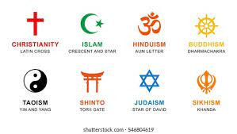
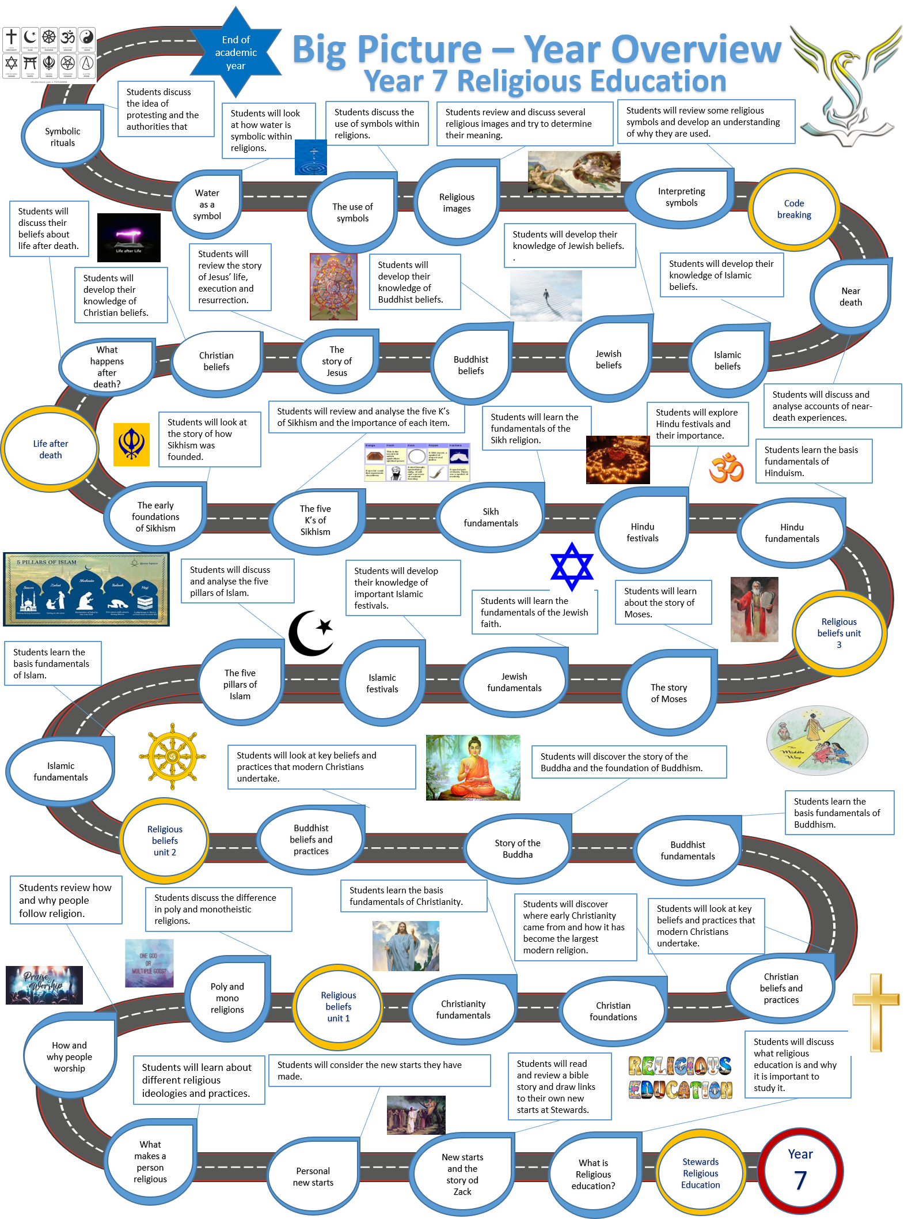

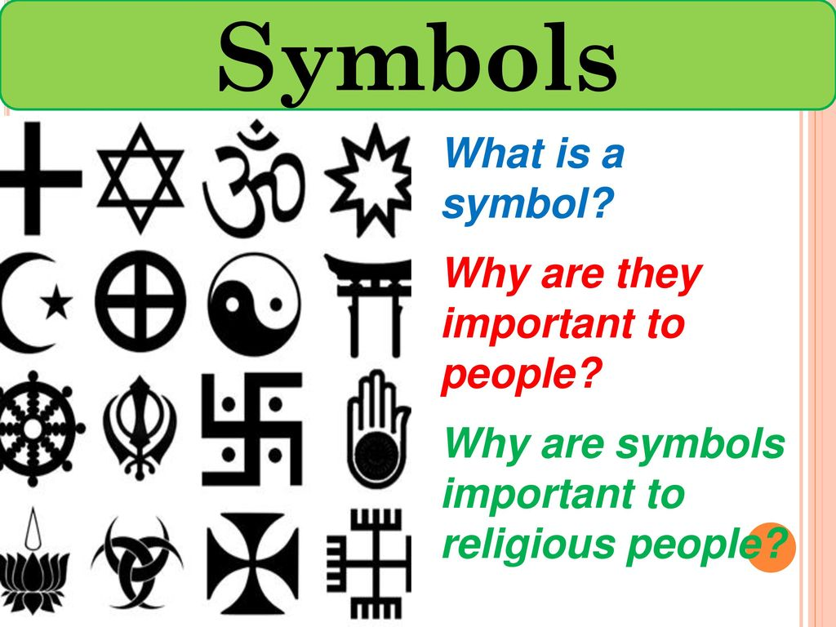

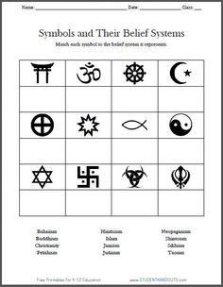

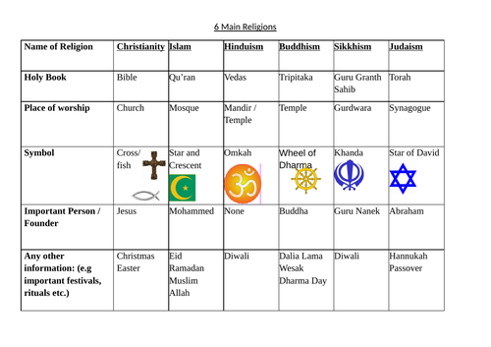

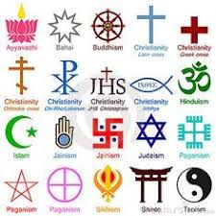
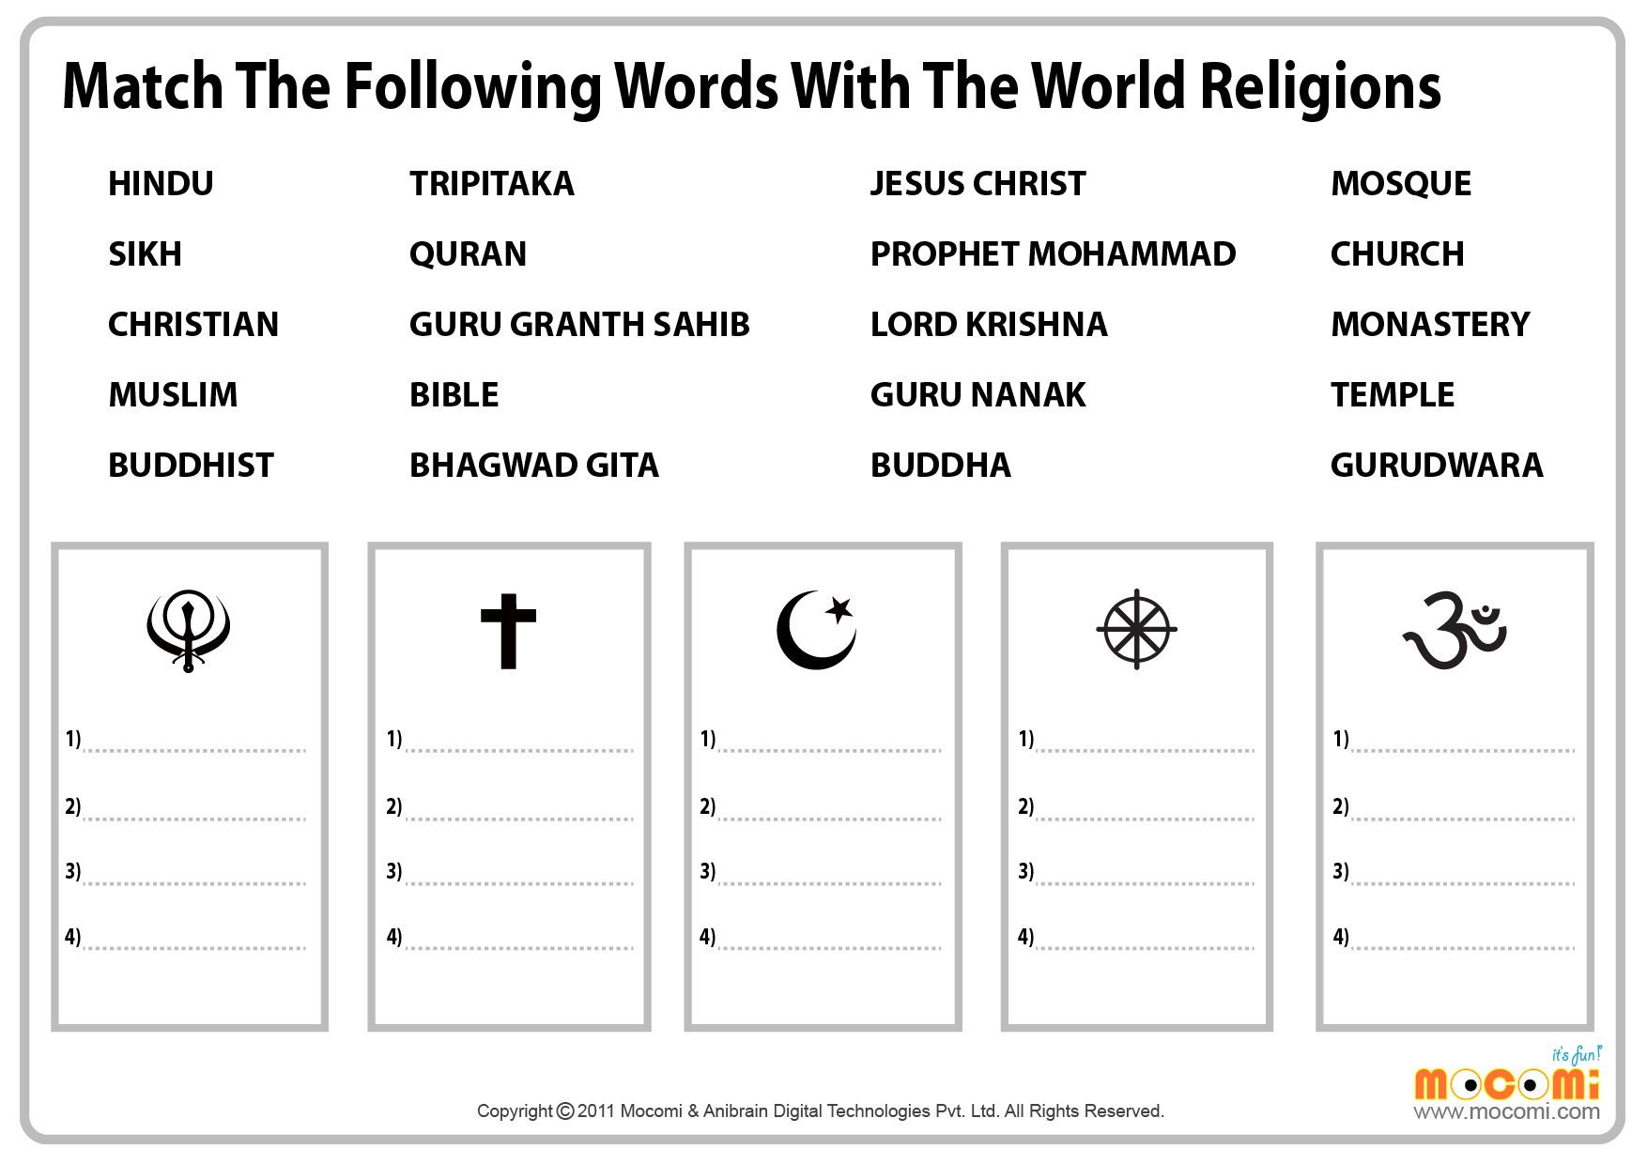

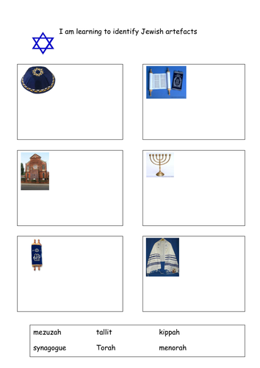
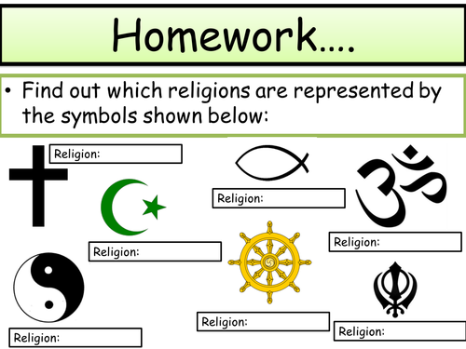

Lesson 1 Symbols within religion

Li: To consider how symbols are used within religious groups and their importance.

Do Now Task:
Can you think of any religious symbols? Create a list, mind map draw them out (not too large).

Task 1: What are symbol used for?

Are they still useful?

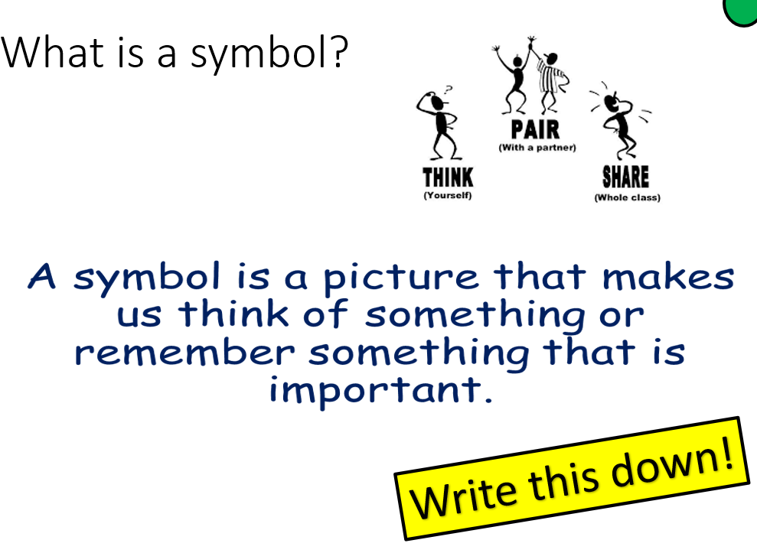

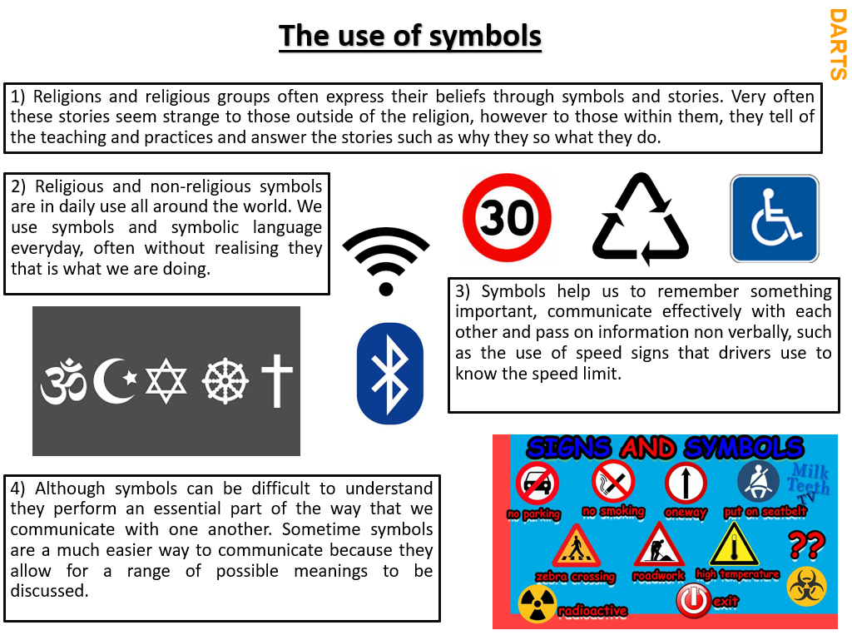

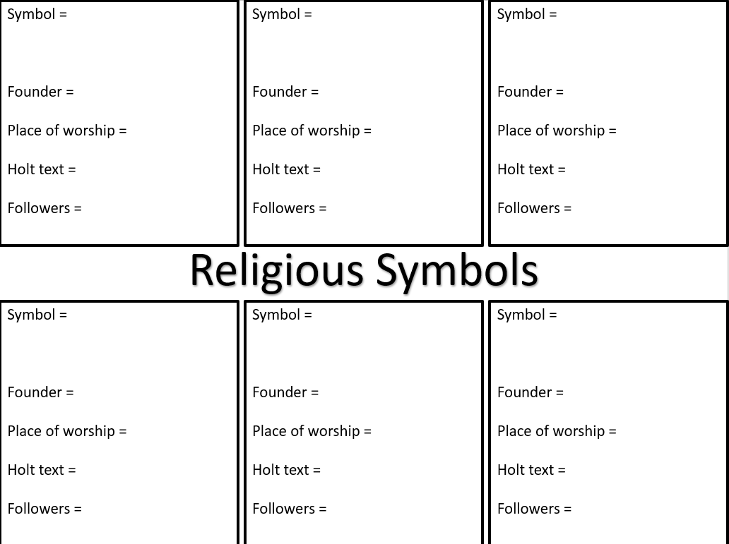

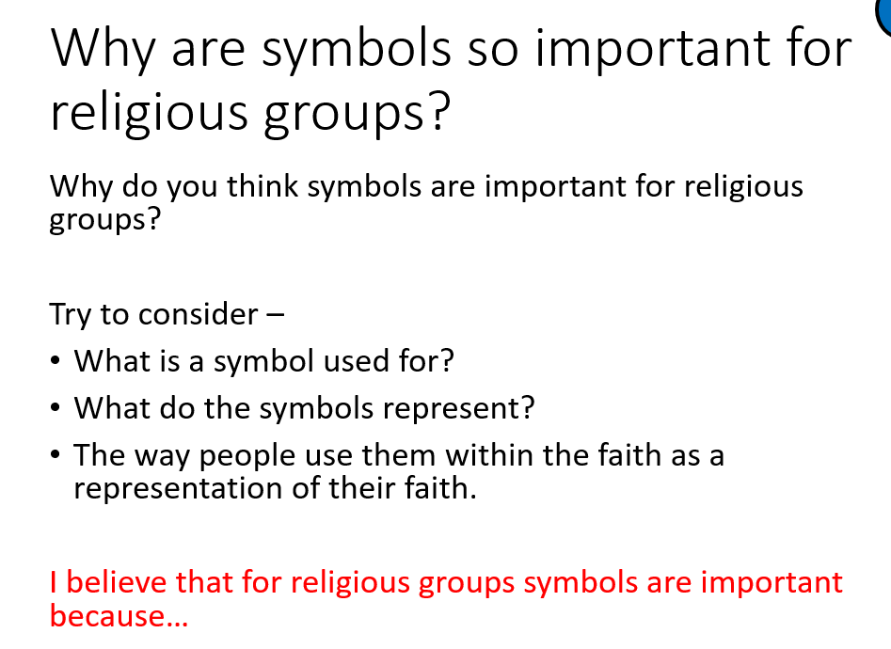

Task: Write a short sentence that summarises how we use symbols on a daily basis.

WAGOLL
Symbols help us to remember something important, communicate effectively with each other and pass on information non verbally, such as the use of speed signs that drivers use to know the speed limit.

Lesson two: Religious symbols
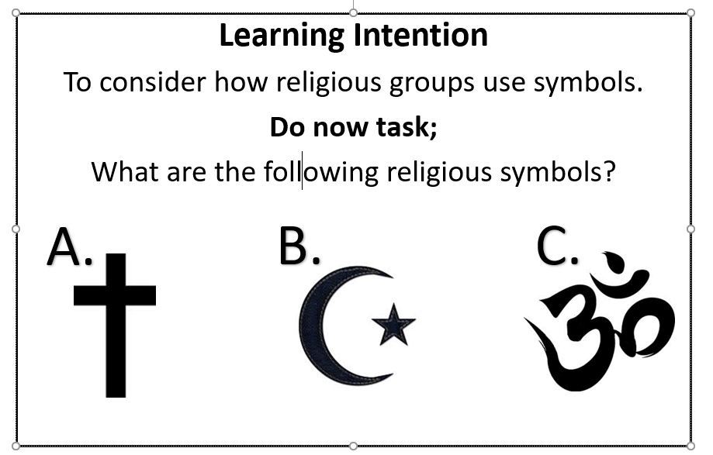

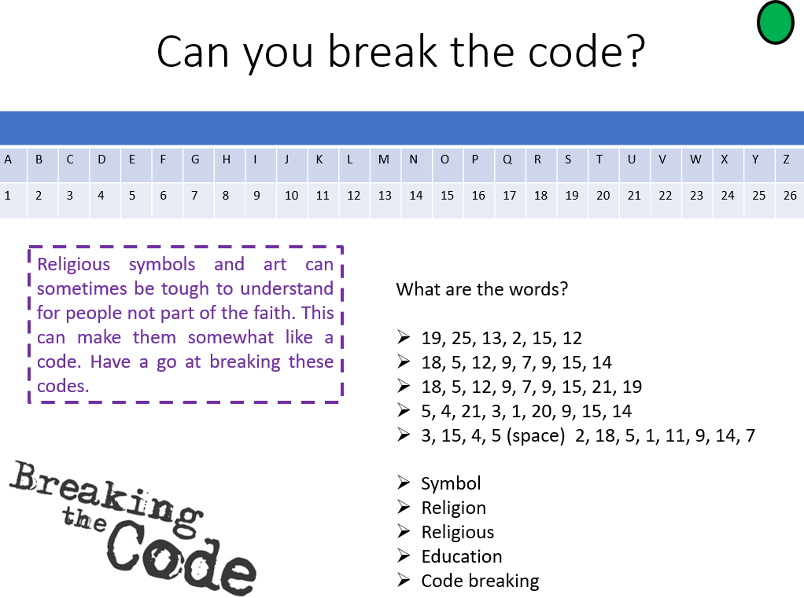

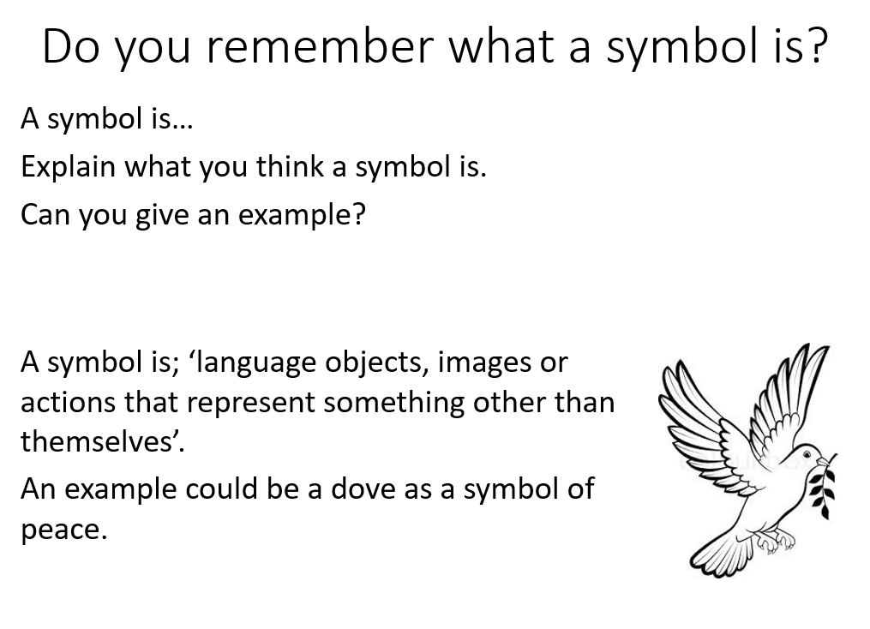

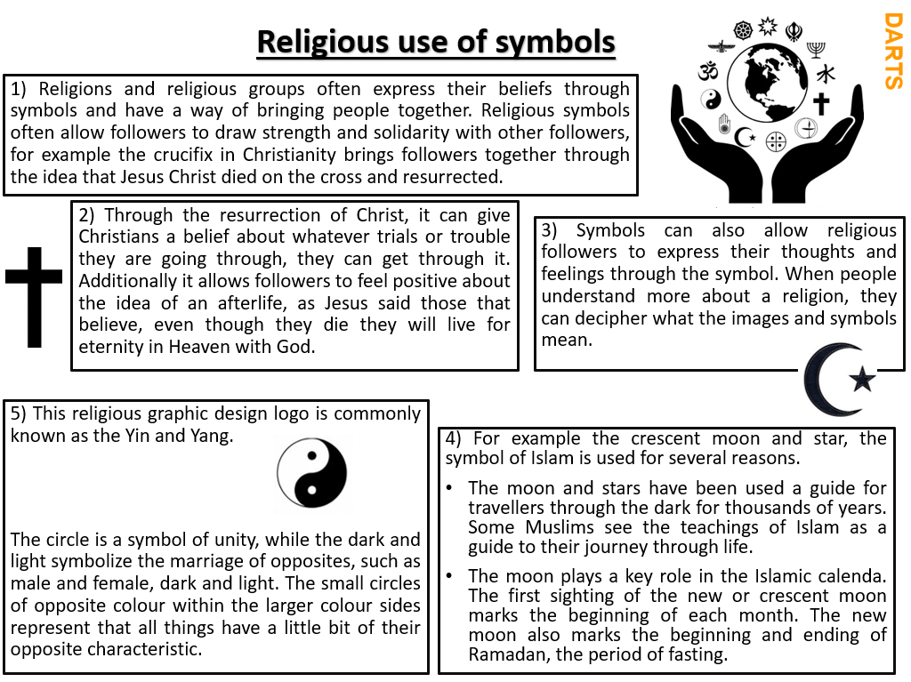

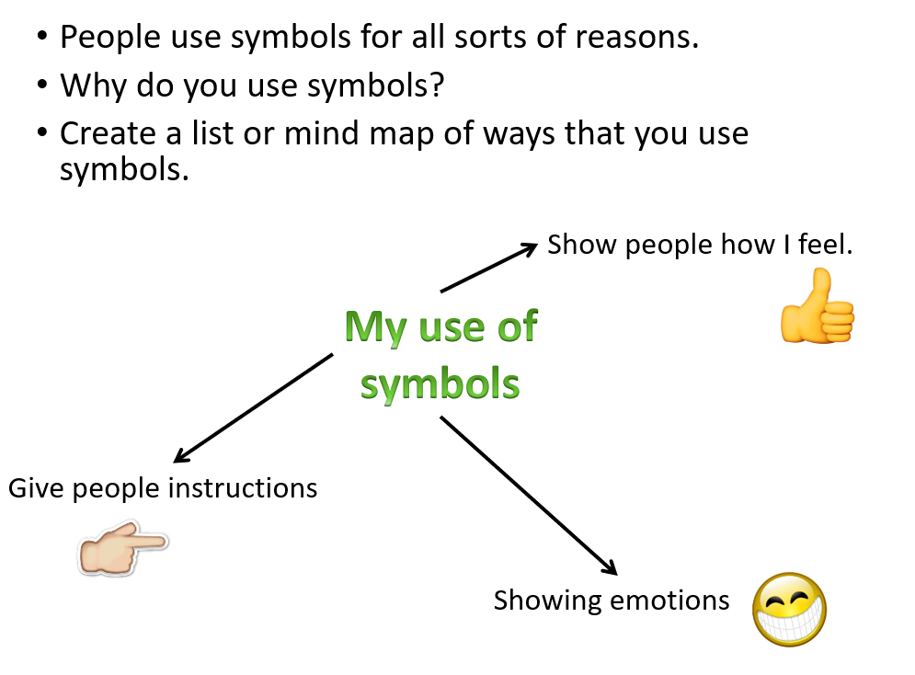

What do you think?

If you were to be summed up as a symbol, what do you think it might look like?

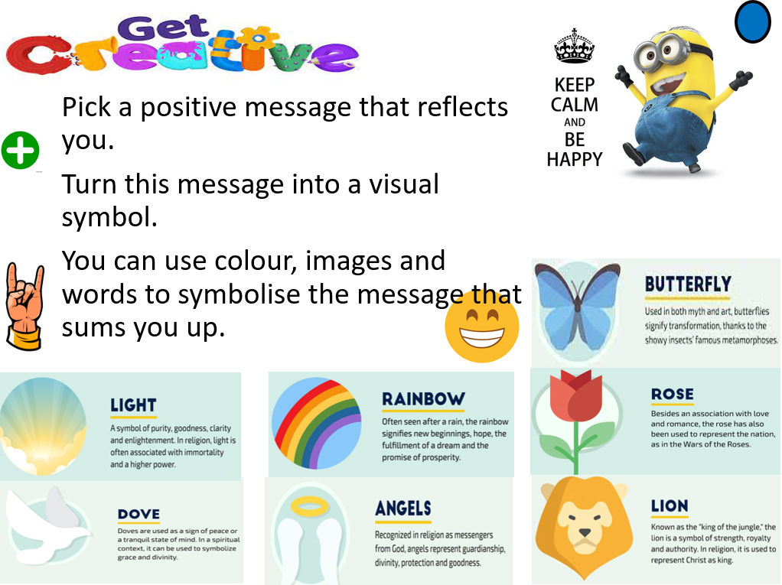

Written one sentence to summarise why symbols are important for religious followers.

WAGOLL
Religious symbols are impotent for religious followers as it can bringing people of the same faith together, both building a person’s faith and strengthening their bond within the faith.

Lesson 3: Religious Symbolism – water
Learning Intention
To consider why water is considered an important symbol for religious groups
Do now task;
Create an image for the following symbols.
(Draw each symbol in pencil / no words permitted / doesn’t have to be well drawn / Just draw the first thing that comes to mind)
Stop
Go
Turn left
No entry

Task: write down, What are the benefits of using symbols?
Are symbols still useful today? Explain and give an example.
How can symbols be useful within everyday use for us?

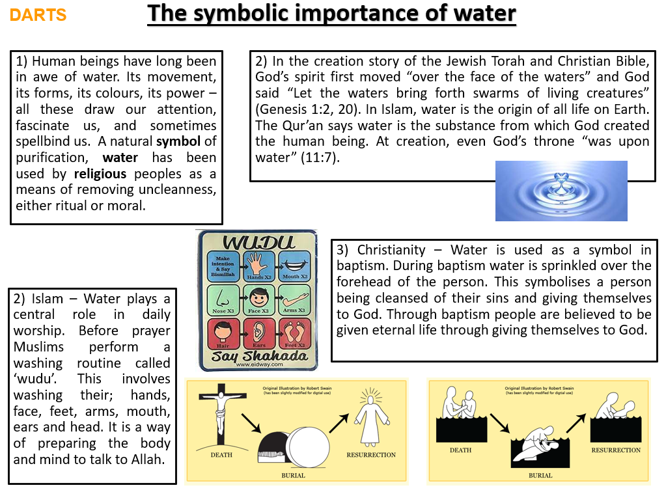

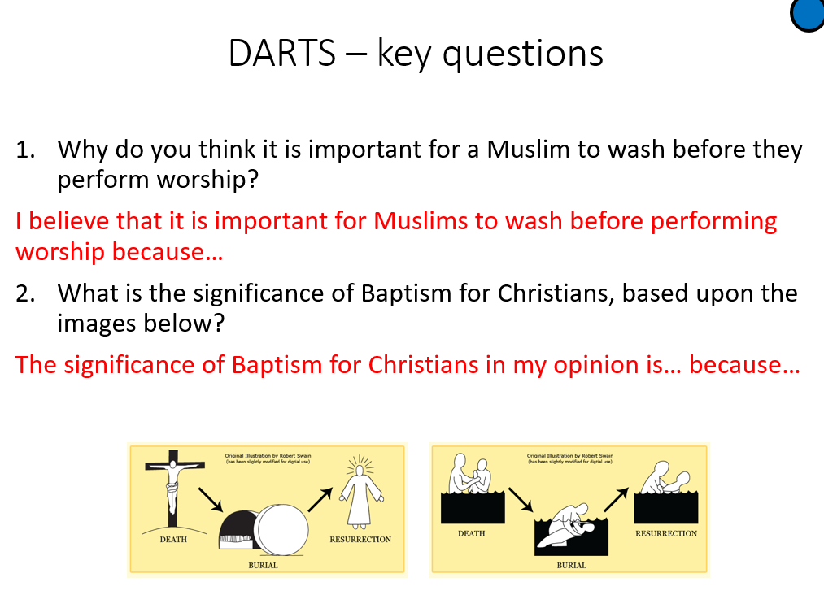

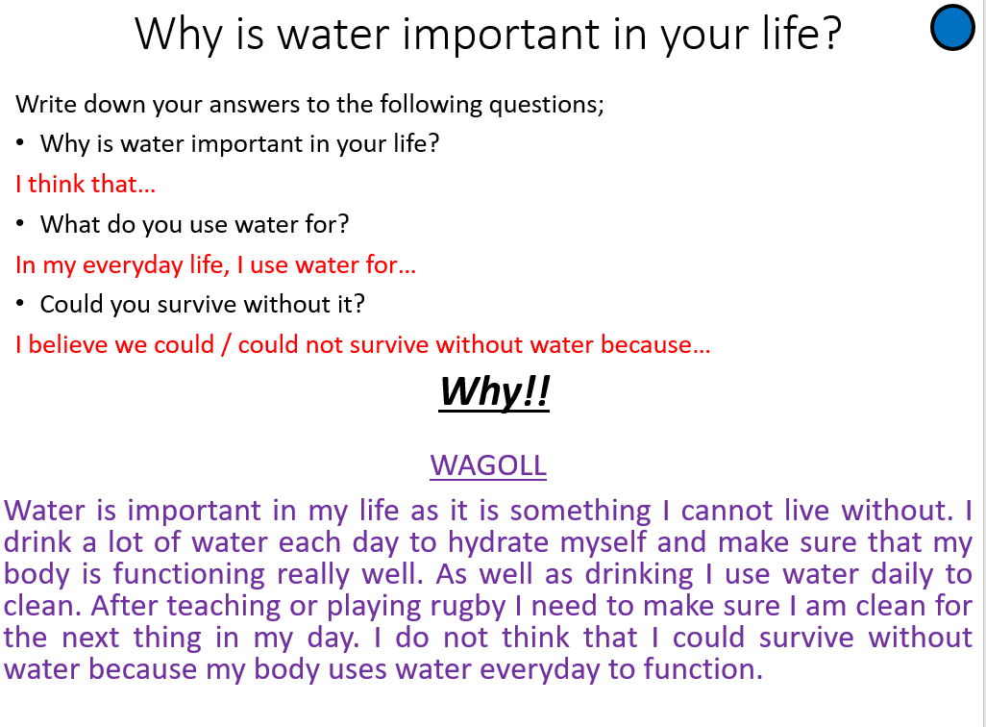

Lesson 4: Religious Images
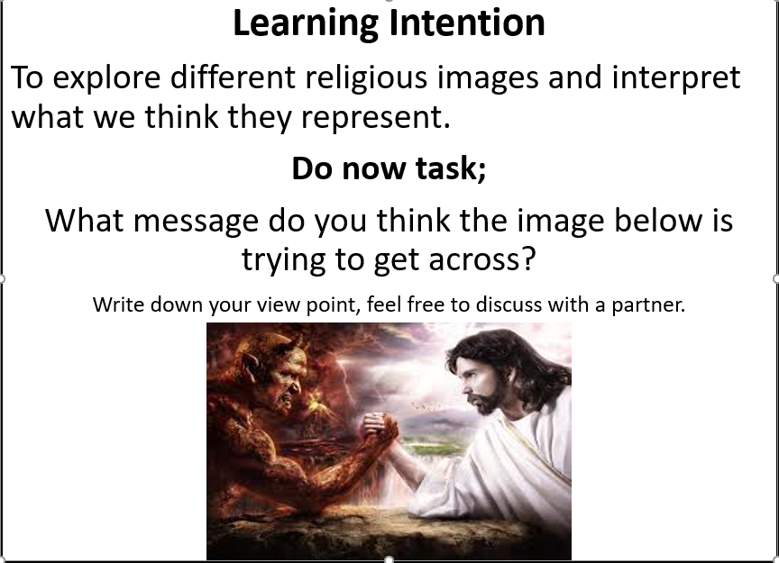

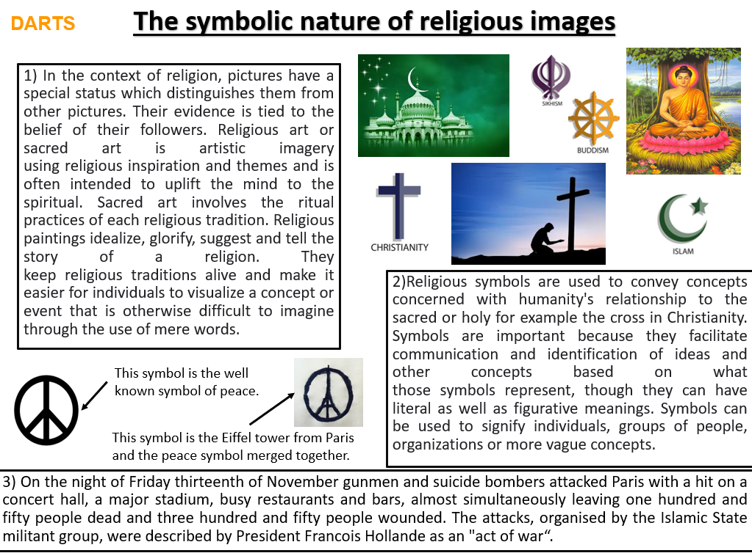
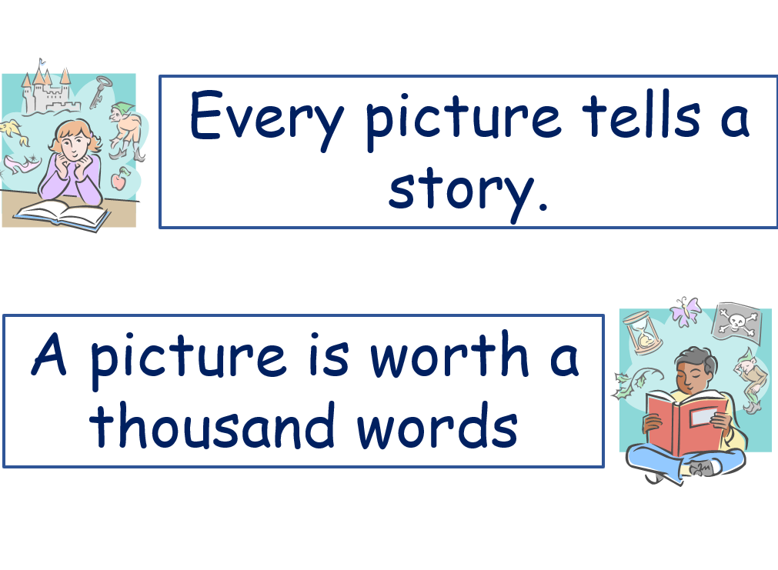
What does the above statement mean and do you believe this to be true?

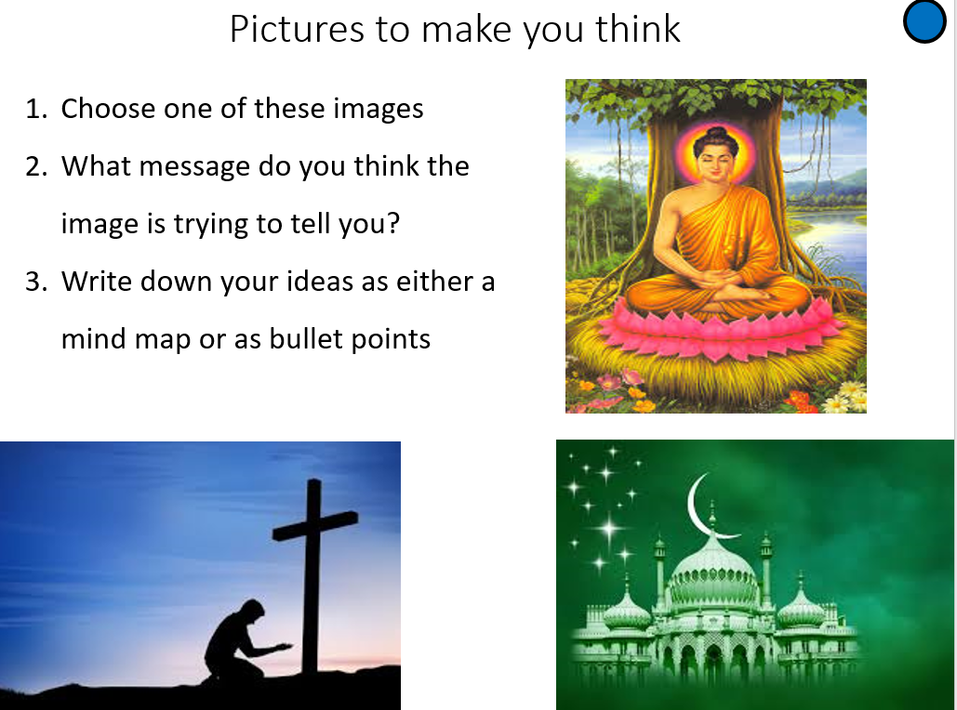
Lesson 5: Symbolic Rituals
Learning Intention
To explore different religious rituals.
Do now task;
Check out the challenge questions below and have a go at one of the questions based on last lesson.
Write down your view point, feel free to discuss with a partner.
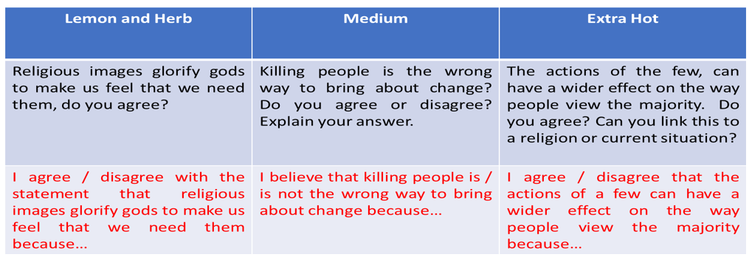

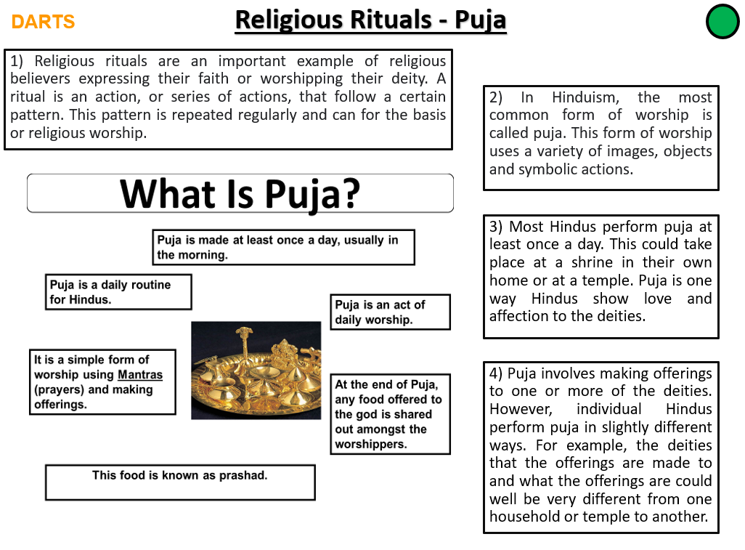

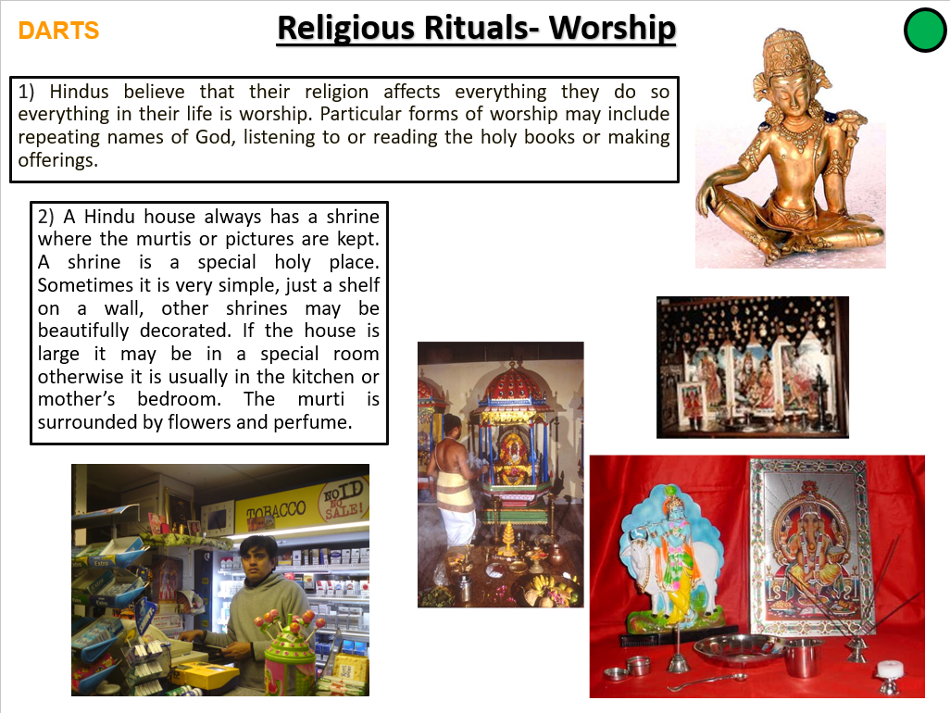

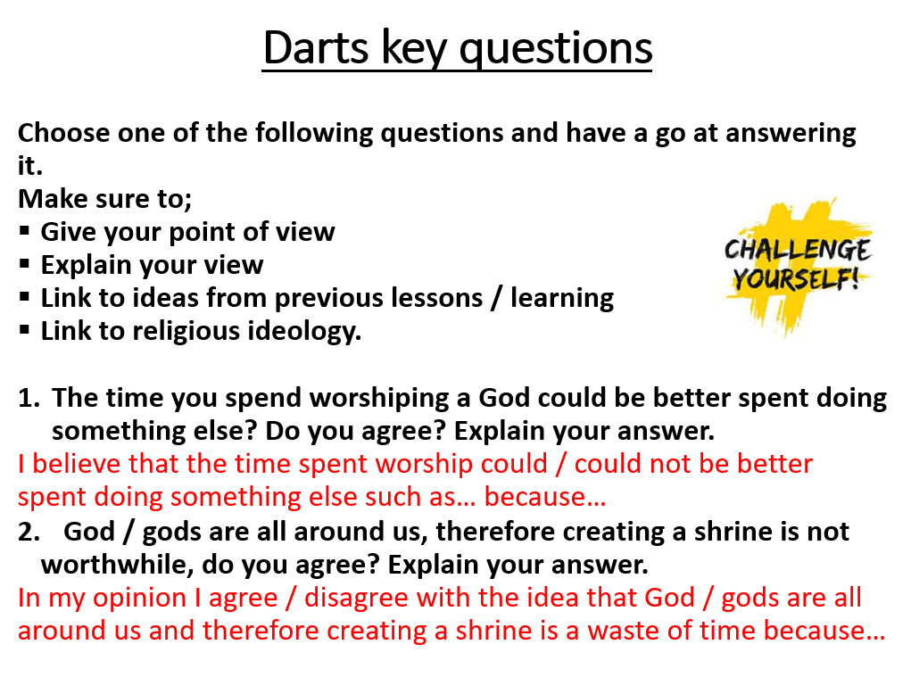

Lesson 6: Symbolic Actions
Learning Intention
To discover the ways symbolic actions are regularly used.
Do now task;
Read over your previous lessons in preparation for a short spelling test.

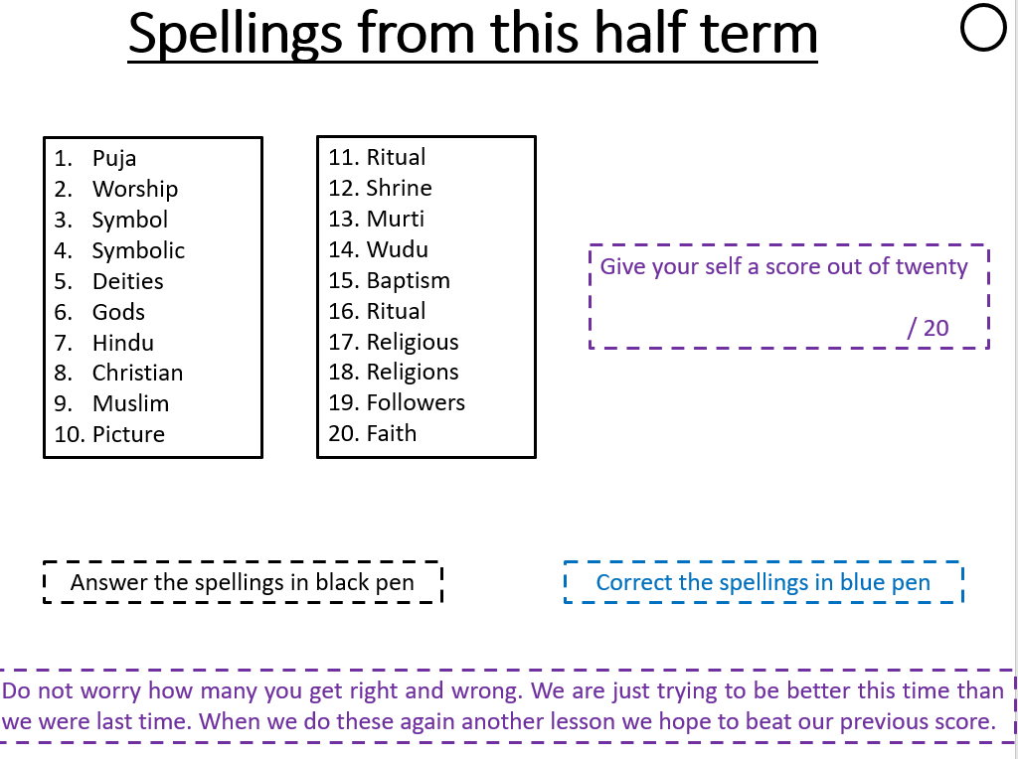

Learn the spellings.
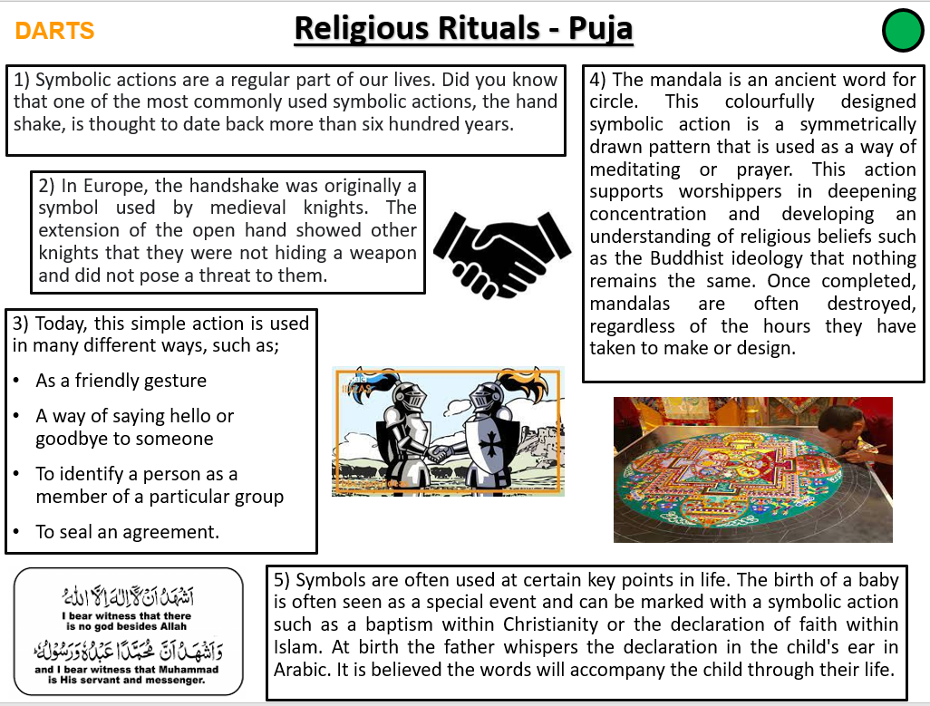

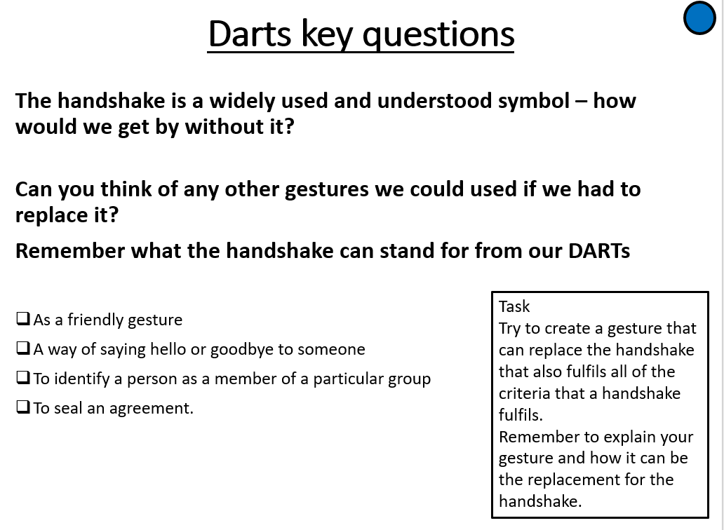

Colour the Mandala

Check your answers from lesson 1.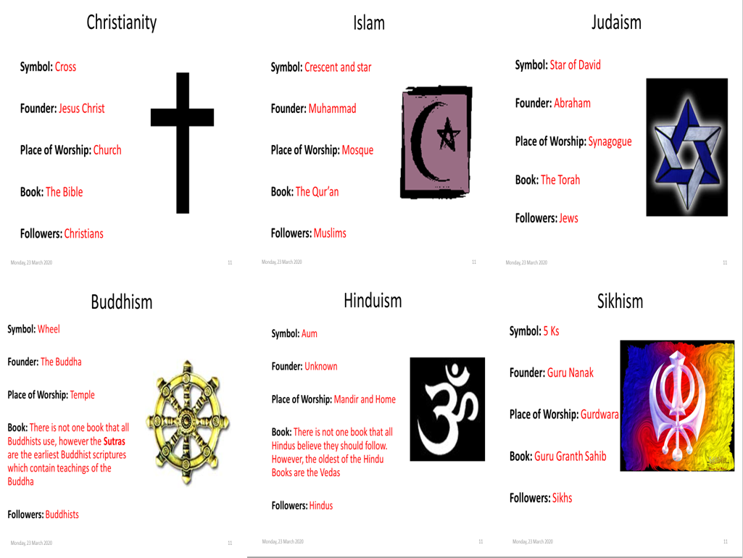

Lesson 4: check your answers
