ICT KS3 Year 8 Autumn 2 Blended Learning Booklet
Introduction to Programming - Python
Name:
Form:
Aim to complete one lesson each week. Write out the title and LI and then complete the tasks.
The Knowledge Organiser on page 3 has some key information and vocabulary to help you with this unit.
Upload all work onto ClassCharts for feedback.
IF you do not have access to Python, you can write your programs in pencil/ pen in the spaces provided in this book.
To complete this book fully, you will need to download Python 3 from the Internet.
You can download Python with this link: https://www.python.org/downloads/
You should be able to select “Downloads” and select “Python 3.8.5”

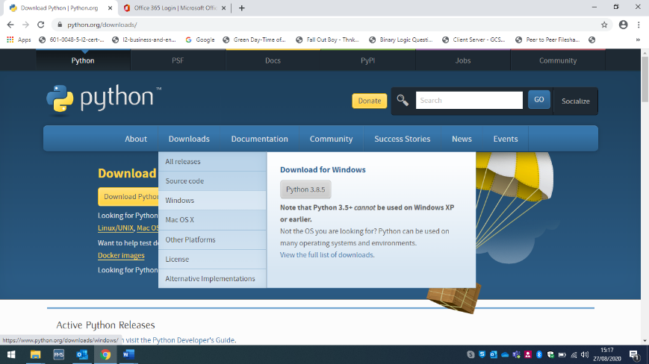

Contents
Page3: Big Picture - Year 8 Overview
Page 4: Zoom in - My Learning Journey
Page 5 and 6: Knowledge Organiser
Page 7 - 8: Lesson 1
Page 9 – 10: Lesson 2
Page 11: Lesson 3 and 4
Page 12: Lesson 5
Page 13: Lesson 6
Page 14: Assessment Ladder

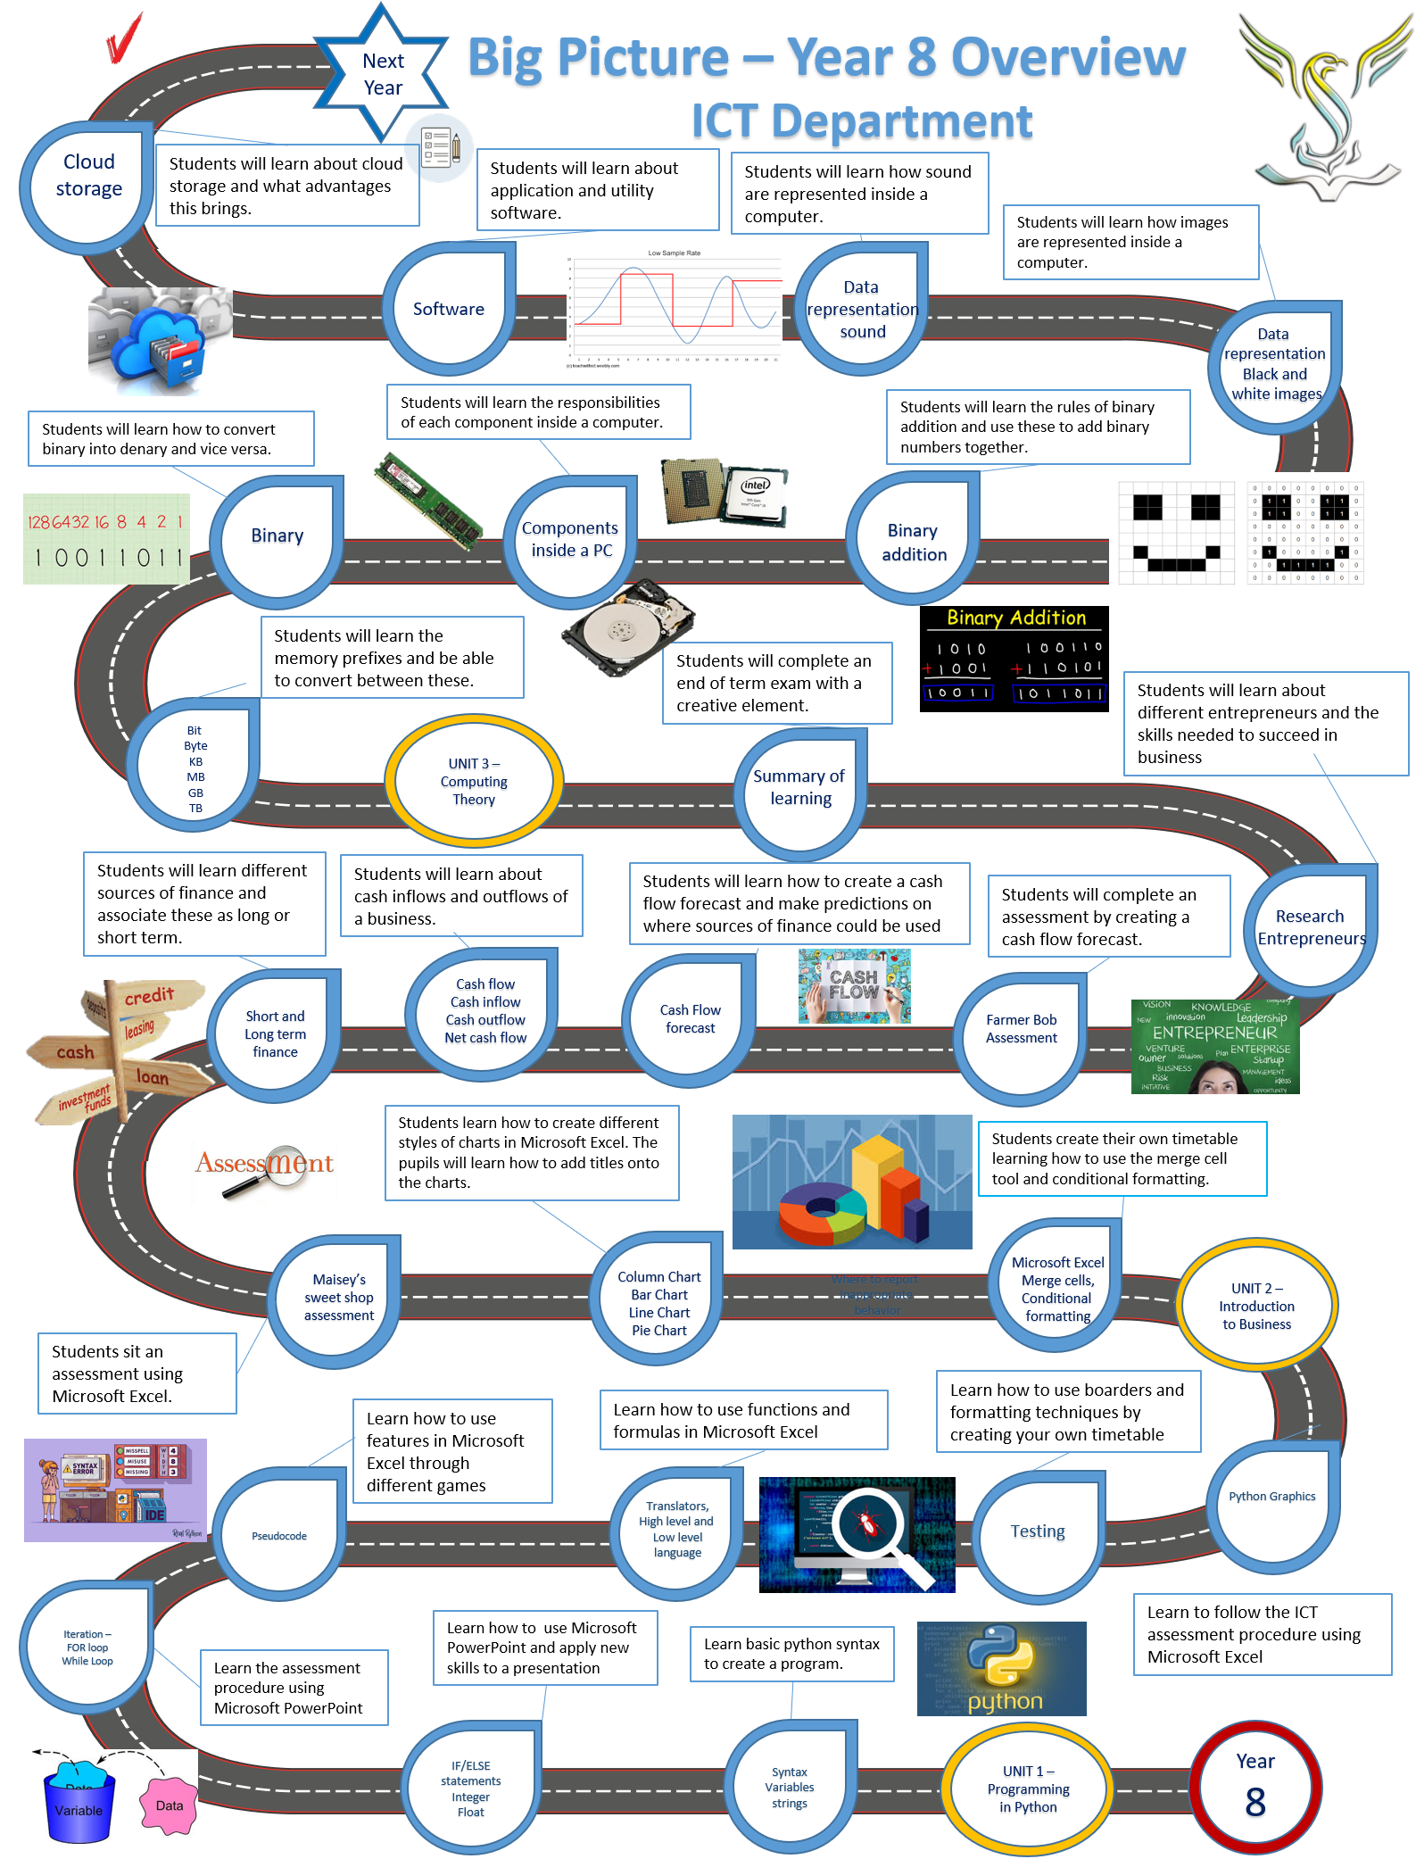

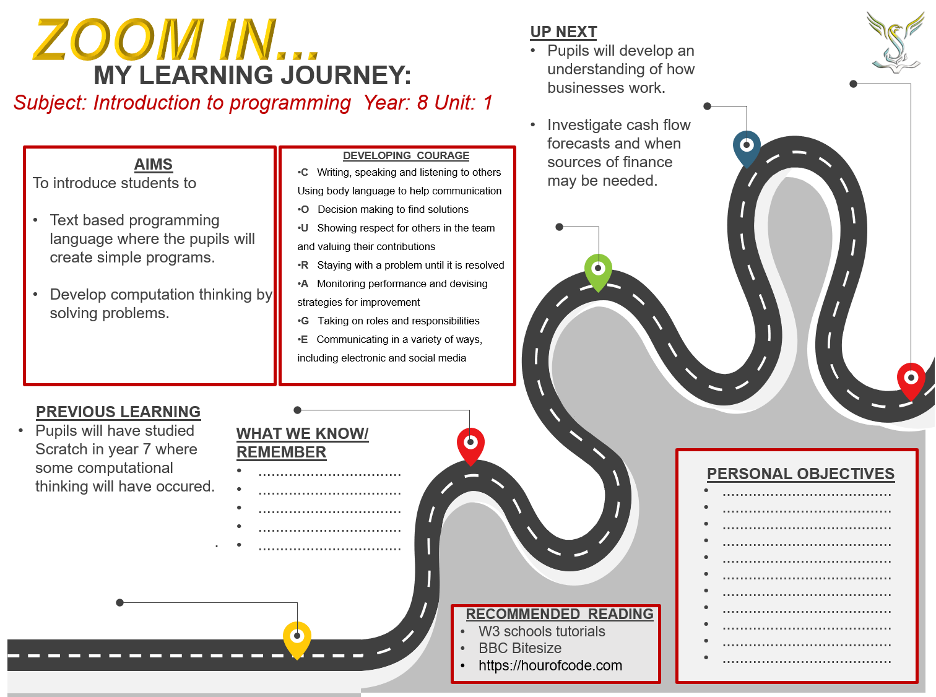
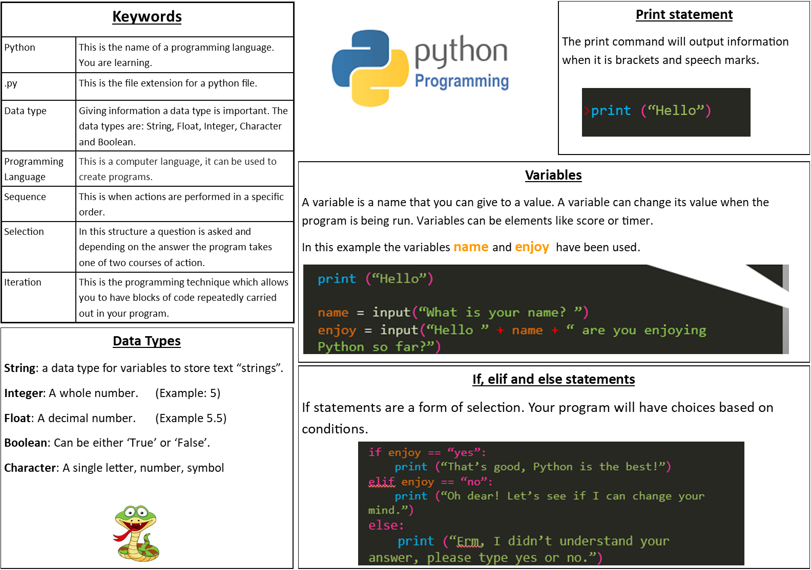

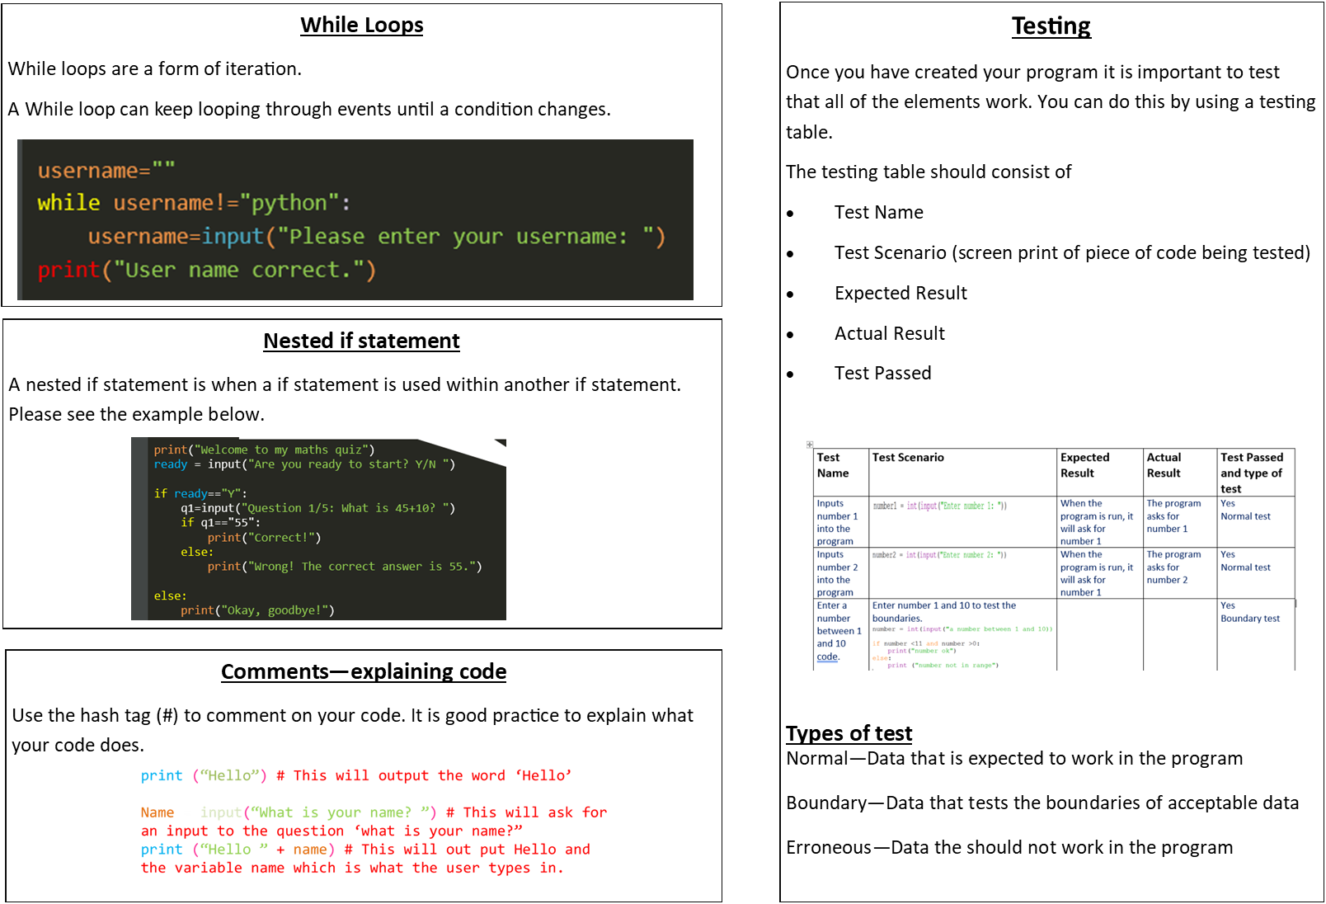

Lesson 1
- LI: to understand how to use basic Python syntax and variables

DART – Link the keyword with the meaning below.
Keywords
(Data Type, Sequence, Programming Language, Selection, Iteration, Python, .PY)

This is the name of a programming language you are learning. ___________________

This is the file extension for a python file. __________________

Giving information a data type is important. The data types are: String, Float, Integer, Character and Boolean. ________________________

This is a computer language; it can be used to create programs. ____________________

This is when actions are performed in a specific order. _______________________

In this structure a question is asked and depending on the answer the program takes one of two courses of action. _______________________

This is the programming technique which allows you to have blocks of code repeatedly carried out in your program. __________________________

Spot the syntax errors in the code above. Circle the 3 errors.
Can you also correct the errors…?
Task
Can you write a program in the box below that will accept the height and width of a room as inputs. The program should output the area of that room.

Lesson 2
LI: to understand how to use iteration when using Python
New Learning
7 Boolean is another Data Type – This can store one of two values:
  - True
  - False
We already know what integer, float and string means.

Research the Boolean expressions below to find out what they mean. Click on the link below
https://www.bbc.co.uk/bitesize/guides/zqp9kqt/revision/1

write down if the below expressions are True or False

Task - True or False?
x = 5 y = 10
x>y
x=y
y<=x
x!=Y
x<=y

New Learning
Use your knowledge organiser to define iteration.
Iteration:

Study the code above. Can you explain what you think the code does in the box below?

Lesson 3
Let’s start programming.
If you click on the link below you will be able to watch a video on the ‘first steps’ of programming.
https://classroom.thenational.academy/lessons/first-steps-6ctk4d
You will have gone through some of these things last term however it will be good to recap these skills.

Lesson 4
Click on the link below to start the lesson on ‘Crunching Numbers’.
https://classroom.thenational.academy/lessons/crunching-numbers-6gtked

Extra lessons (Optional)
If you want to take your programming skills further then please have a look at the other online lessons here.
https://classroom.thenational.academy/units/intro-to-python-programming-9c22

Lesson 5
LI: to understand how programming is used in the real world.

Write your program in the box

Lesson 6 Maths Quiz Assessment
LI: to understand how to create a program using all previous programming skills
Task
Your task is to create a maths quiz. The code below will get you started.
You can download python to complete this task. The instructions and link to download Python are on the front of this book.
Alternatively, you can use the website/ account you set up from the video in lesson 3.

Take a picture of your code and send it your teacher on class charts.

Attainment Band: | Introduction to programming -Python
 | Knowledge and Understanding | Skills
Yellow Plus | Understands how to use iteration in Python  Able to understand errors and debug code  The programs work correctly (Assessment extension) | Show independent skills and can include a while loop in a program  Can debug programs and make them work correctly  Create a testing table to record tests to ensure program works (Assessment extension)
Yellow | Understands the term Iteration  Understands the need to test programs using different inputs  Understands how variables change throughout the program  Understands the difference between a compiler and a translator | Can create a program using iteration with some help  Tests the possible inputs to ensure all sections of code work  Can explain how the variables work in a program  Identifies which translator Python uses and is able to explain why
Blue | Understands how IF statements are used in a program  Understand how variables are used in a program  Understands the importance of indents in code  Understands why you need a translator | Can create a program using IF ELIF and ELSE statements  Can create a programme using variables  Can use indents in programs correctly
Green | Understands how 3 different data types work  Understands the term sequence  Can create a simple program with some assistance | Can create a program using different data types (String, Integer, Float, Boolean)
White | Understands the term ‘Programming Language’  Understands the term algorithm | Can create a simple program using Python  Can copy code accurately and make a program run  Can run a program independently to ensure it works

