Geography Year 11
Blended Learning Booklet

Y11-3 Rivers

Name:
Form:

Aim to complete one lesson each week. Write down the title and LI for each lesson and then complete the tasks which are highlighted.
The Knowledge Organiser on page 3 has all the key information and vocabulary to help you with this unit.
Upload all work onto ClassCharts for feedback.

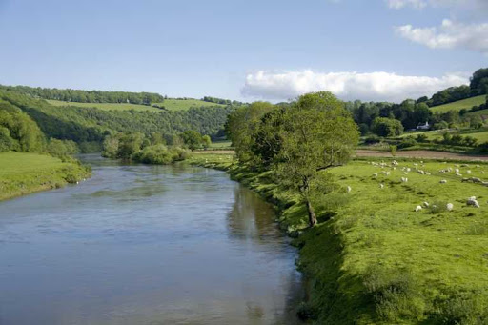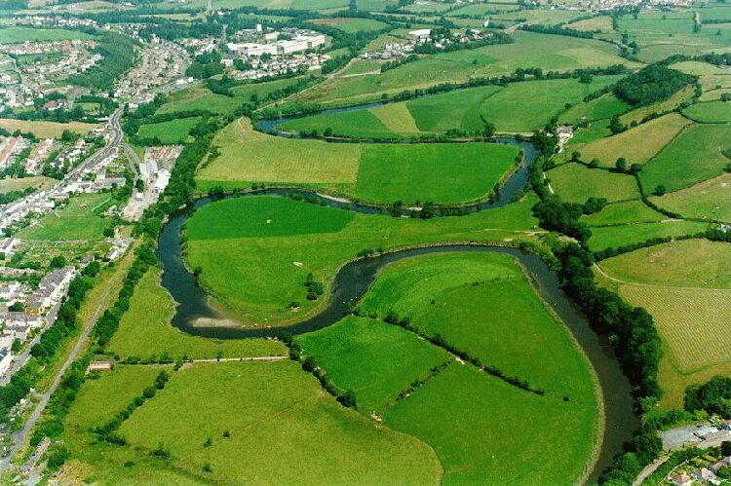

Contents
Page 3: Zoom in - My Learning Journey
Page 4: Lesson 1
Page 5: Lesson 2
Page 6: Lesson 3
Pages 7 & 8: Lesson 4
Page 9: Lesson 5
Page 10: Lesson 6
Pages 11 & 12: Lesson 7
Page 13: Lesson 8
Pages 14 & 15: Lesson 9

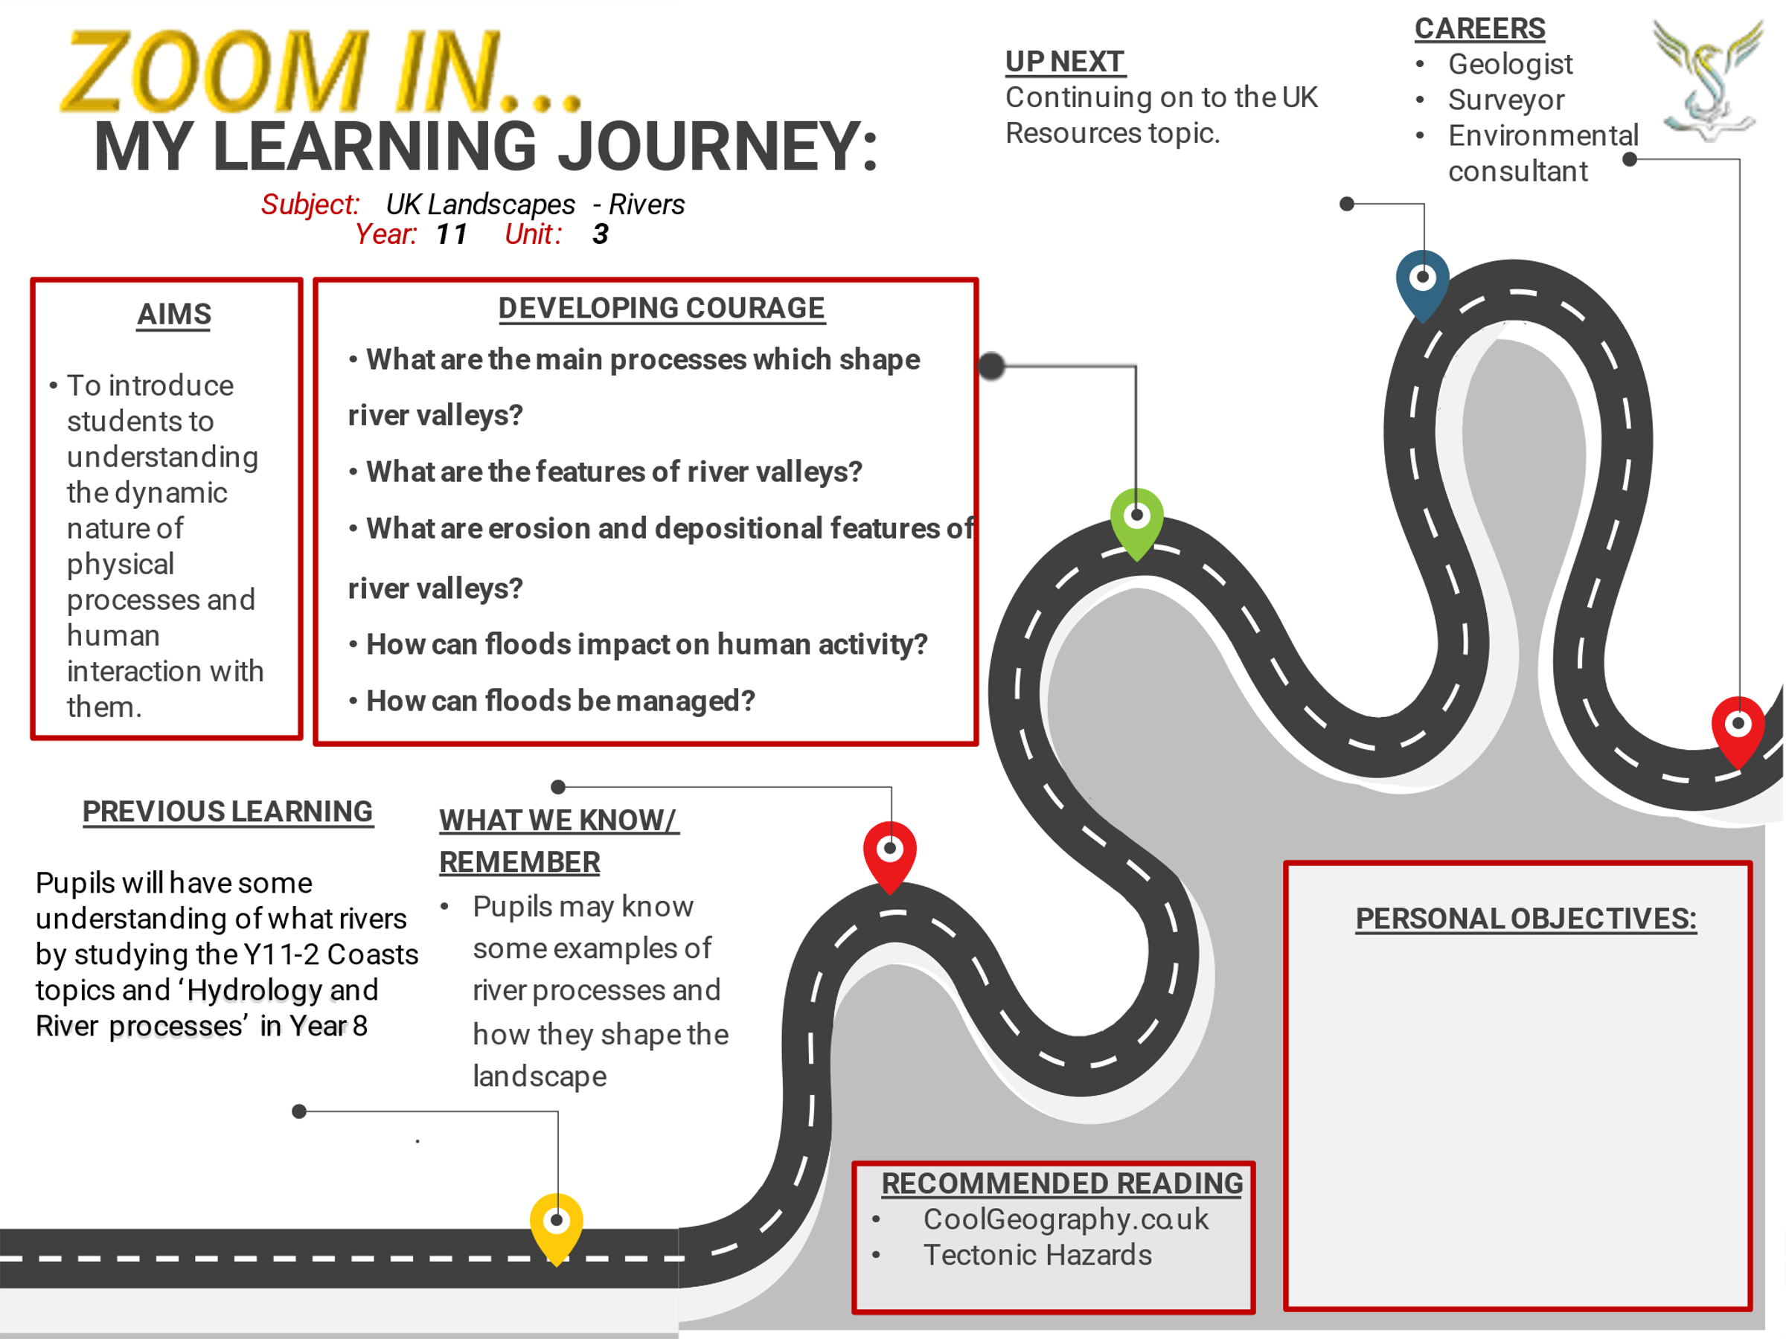

Lesson One: Shaping river valleys
LI: To define and describe the physical processes which shape river valleys – transportation, erosion and deposition

Types of erosion
Erosion is the process that wears away the river bed and banks. Erosion also breaks up the rocks that are carried by the river.
There are four types of erosion:
- Hydraulic action - This is the sheer power of the water as it smashes against the river banks. Air becomes trapped in the cracks of the river bank and bed and causes the rock to break apart.
- Abrasion - When pebbles grind along the river bank and bed in a sand-papering effect.
- Attrition - When rocks that the river is carrying knock against each other. They break apart to become smaller and more rounded.
- Solution - When the water dissolves certain types of rocks, e.g. limestone.

Methods of transportation
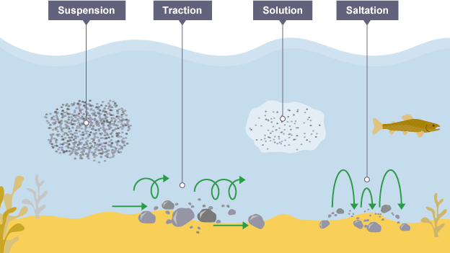

Deposition
When the river loses energy, it drops any of the material it has been carrying. This is known as deposition.
Factors leading to deposition:
- shallow water
- at the end of the river's journey, at the river's mouth
- when the volume of the water decreases

Tasks: Create your own revision cards or notes which describe and define the processes of erosion, transportation and under what conditions deposition occurs.

Watch the video on river processes: https://www.youtube.com/watch?v=E6sWiPAu708

Lesson Two: Upper course landforms
LI: LI: To explain the formation of distinctive river landforms created by erosion in the upper course
Read through the following landforms found in the upper course of a river:

The process of erosion can create different landforms. The erosional features are often found in the upper course of the river including waterfalls & gorges and interlocking spurs.

Waterfall and gorges
A waterfall is a sudden drop along the river course. It forms when there are horizontal bands of resistant rock (hard rock) positioned over exposed, less resistant rock (soft rock).
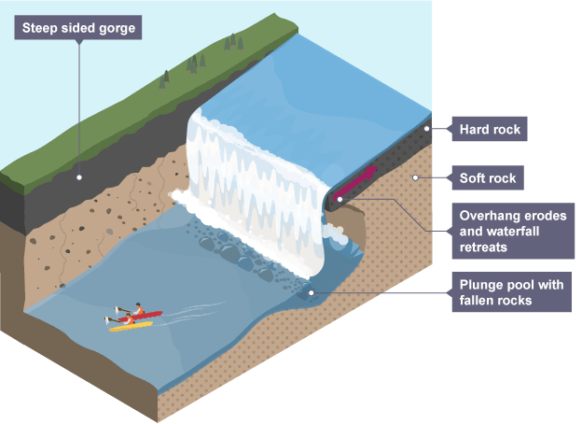
- The soft rock is eroded quicker than the hard rock and this creates a step.
- As erosion continues, the hard rock is undercut forming an overhang.
- Abrasion and hydraulic action erode to create a plunge pool.
- Over time this gets bigger, increasing the size of the overhang until the hard rock is no longer supported and it collapses.
- This process continues and the waterfall retreats upstream.
- A steep-sided valley is left where the waterfall once was. This is called a gorge.

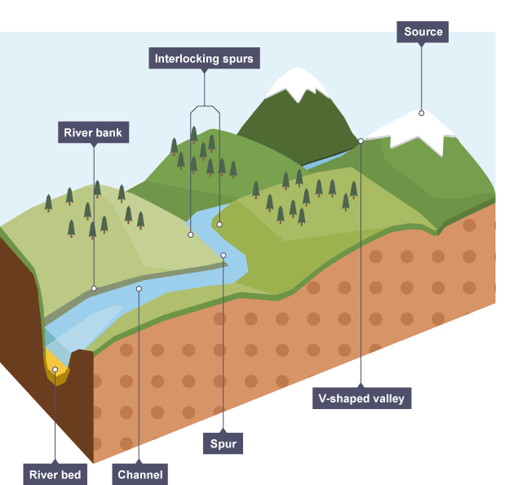

Interlocking spurs
In the upper course there is more vertical erosion.
The river cuts down into the valley. If there are areas of hard rock which are harder to erode, the river will bend around it.
This creates interlocking spurs of land which link together like the teeth of a zip.

Tasks: Create your own revision cards or notes which describe and define the processes of weathering and erosion

Watch the video on upper course river landforms: https://www.youtube.com/watch?v=XHeYoz1LUd0

Lesson Three: Landforms in the middle course
LI: To explain the formation of distinctive river landforms created by erosion – meanders and ox-bow lakes

TASK: Using the information below, describe how erosion and deposition create meanders:

Erosional and depositional landforms

Meanders
As the river makes its way to the middle course, it gains more water and therefore more energy. Lateral erosion starts to widen the river. When the river flows over flatter land they develop large bends called meanders.
- As a river goes around a bend, most of the water is pushed towards the outside. This causes increased speed and therefore increased erosion (through hydraulic action and abrasion).
- The lateral erosion on the outside bend causes undercutting of the bank to form a river cliff.
- Water on the inner bend is slower, causing the water to slow down and deposit the eroded material, creating a gentle slope of sand and shingle.
- The build-up of deposited sediment is known as a slip-off slope (or sometimes river beach).

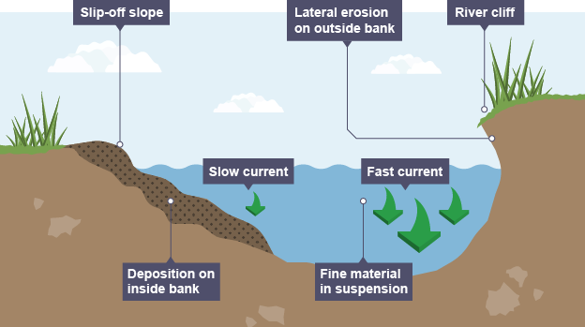

Oxbow lakes 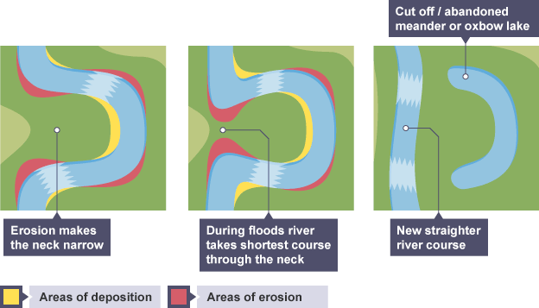
Due to erosion on the outside of a bend and deposition on the inside, the shape of a meander will change over a period of time.
Erosion narrows the neck of the land within the meander and as the process continues, the meanders move closer together.
When there is a very high discharge (usually during a flood), the river cuts across the neck, taking a new, straighter and shorter route.
Deposition will occur to cut off the original meander, leaving a horseshoe-shaped oxbow lake.

Tasks: Create your own revision cards or notes which explain how ox-bow lakes are formed.

Watch the video on middle course river landforms: https://www.youtube.com/watch?v=uyhV5d7VerI

Lesson Four: Landforms in the lower course
LI: To explain the formation of distinctive coastal landforms created by deposition – levees, floodplains and estuaries

Depositional landforms

Floodplains - A floodplain is an area of land which is covered in water when a river bursts its banks.
Floodplains form due to both erosion and deposition. Erosion removes any interlocking spurs, creating a wide, flat area on either side of the river. During a flood, material being carried by the river is deposited (as the river loses its speed and energy to transport material). Over time, the height of the floodplain increases as material is deposited on either side of the river.
Floodplains are often agricultural land, as the area is very fertile because it's made up of alluvium (deposited silt from a river flood). The floodplain is often a wide, flat area caused by meanders shifting along the valley.
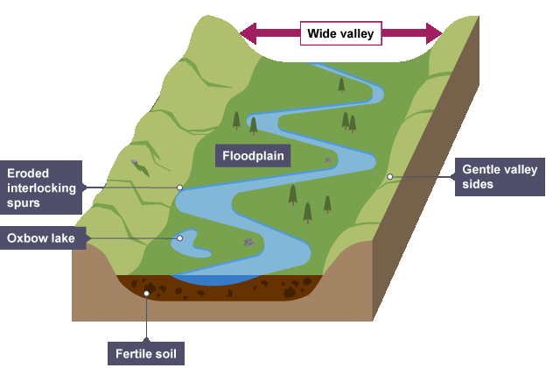

Task: Using the diagram and notes above, describe the formation of a floodplain
Task: What is alluvium? How might it benefit farmers?
Task: Describe how people could use the large, flat floodplain areas next to a river. What are the dangers of using a floodplain?
Task: Watch the video about floodplains: https://www.youtube.com/watch?v=e2CT7WkA7ik

Task: Using the diagrams and notes below, describe the formation of levees and how people use estuaries

Levees
- Levees occur in the lower course of a river when there is an increase in the volume of water flowing downstream and flooding occurs.
- Sediment that has been eroded further upstream is transported downstream.
- When the river floods, the sediment spreads out across the floodplain.
- When a flood occurs, the river loses energy. The largest material is deposited first on the sides of the river banks and smaller material further away.
- After many floods, the sediment builds up to increase the height of the river banks, meaning that the channel can carry more water (a greater discharge) and flooding is less likely to occur in the future.
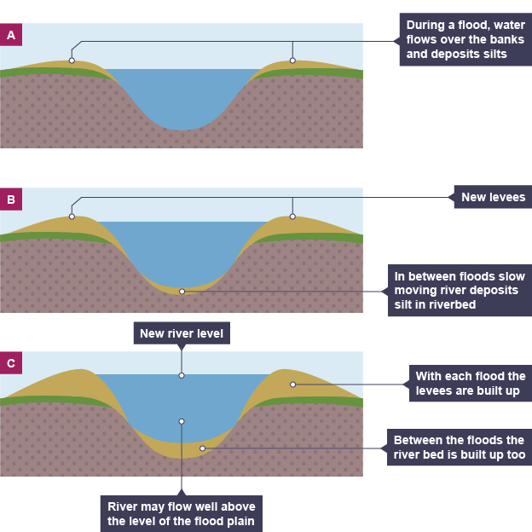

Estuaries
An estuary is where the river meets the sea. The river here is tidal and when the sea retreats the volume of the water in the estuary is less reduced. When there is less water, the river deposits silt to form mudflats which are an important habitat for wildlife. People have used estuaries for thousands of years as convenient places to build docks as they are easily connected to the sea. In recent years as excellent locations for heavy industries which need access to large quantities of water and accessibility to the sea, examples in the UK include the factories, petrochemical works and power stations located along the Thames Estuary.

Lesson Five: Causes of river flooding
- LI: To explain how human and physical factors increase the risk of flooding

Flood risk factors
Flooding occurs when a river bursts its banks and overflows onto the surrounding land. There are many factors which can cause a flood - often the natural landscape can influence flooding and human interactions can increase the risk.

Physical causes of flooding
- Prolonged rainfall - if it rains for a long time, the land around a river can become saturated (it's holding as much water or moisture as can be absorbed). If there is more rainfall it cannot be soaked up, so it runs along the surface - this is known as surface run-off.
- Heavy rainfall - if there is heavy rainfall there is less chance of it being soaked up by the soil (infiltration) so it runs off into the river. The faster the water reaches the river, the more likely it will flood.
- Relief - a steep valley is more likely to flood than a flatter valley because the rainfall will run off into the river more quickly.
- Geology - permeable rocks allow water to pass through pores and cracks, whereas impermeable rocks do not. If a valley is made up of impermeable rocks, there is a higher chance of flooding as there is an increase in surface run-off.
- Vegetation - trees and plants absorb water, this is known as interception. Lots of vegetation reduces flood risk. Sometimes people cut down trees (deforestation). This will increase the flood risk, as the water will not be intercepted and flow into the river.

Human causes of flooding
- Urban land use - when an area surrounding a river is built on, there is an increase in the amount of tarmac and concrete, which are impermeable surfaces. Drains and sewers take water directly to the river which increases flood risk.
- Deforestation - can cause flooding as trees are excellent at intercepting rainfall and storing water and when they are removed the precipitation (water) will reach the river channel more quickly.
- River management - Sometimes measures taken to manage the river can increase the amount of water in the river. Putting concrete into a river to speed up the movement of water in one part of the river can cause flooding further downstream
- Global warming - As sea levels rise, there will be an increase in the amount of water available for evaporation and precipitation in the water cycle. This means that more water could be falling onto drainage basins than usual.

Task: Explain how physical and human factors can increase the risk of flooding
Task: Watch the video about the causes of flooding: https://www.youtube.com/watch?v=U5ut_RR-P-A

Lesson six: Casestudy of a UK flood
LI: To examine a case study of river flooding in the UK
Read through the following information and answer the questions:

UK floods December 2016: Over 100 people evacuated as river bursts banks

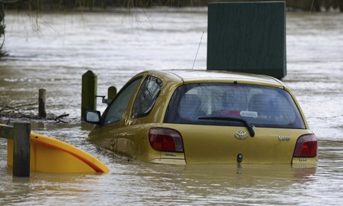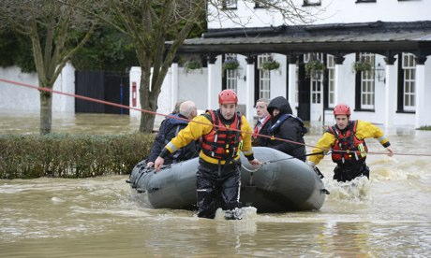
More than 100 people were evacuated from their homes in Dorset in the early hours of Christmas Day 2016 after the river Stour burst its banks and swept through parts of Christchurch. This followed several days of heavy rainfall across southern England.
Ninety residents at the Iford Bridge home park, which is near Bournemouth, were led out of their homes at 3am after the water levels rose to 1.2 metres (4ft) and floodwater started seeping into the homes. The rescued people were taken to a day centre in Bournemouth, and to a church, which was later cut off by the rising waters.
By 5.30am, the floodwater had reached the front gardens of some properties along Water Lane and Old Bridge Road in Christchurch and the council handed out dozens of sandbags. Gill Hayes, who lives on Old Bridge Road, said the water was just two metres (7ft) from her front door. "I was meant to be going to my son's for Christmas, but I can't get out of the house because the road is flooded," she said. "In any case I wouldn't want to leave my home in case the flooding gets worse."
Tony Allen, who lives on Water Lane, said: "The first thing we saw on Christmas morning was the fire brigade in a rubber boat coming up the lane. We have seen it flooded before but never this bad." Most of the evacuees were collected by friends and family; those remaining were put in bed and breakfast accommodation.
Twenty-seven guests and nine members of staff were evacuated from the four-star Burford Bridge hotel in Surrey after it was flooded by dirty, muddy water when the river Mole burst its banks. The huge surge of water began entering the hotel on Tuesday morning, forcing workers and patrons to seek refuge on the first floor. Firefighters used boats to rescue the trapped staff and guests after the rapidly rising floodwaters submerged the hotel's ground floor, cellars and car park. A hotel worker said Christmas had been cancelled, adding that the hotel, which is in the village of Mickleham, was closed until further notice.

Questions:

- When did the river Stour in Dorset burst its banks?
- How many people were evacuated from their homes?
- What caused the flooding in Dorset and southern England?
- What happened at Iford Bridge home park?
- How much did water levels rise?
- What happened to the 90 people who were evacuated?
- What happened in the town of Christchurch?

Lesson Seven: Protecting against flooding - hard engineering
LI: To explain how hard engineering strategies which can be used to protect against river flooding
Read through the following information about hard engineering:

Hard engineering strategies
Flooding can cause damage to homes, businesses, infrastructure and communications. Hard engineering involves building artificial structures which try to control rivers. They tend to be more expensive. Each hard engineering strategy has its advantages and disadvantages.

Dams and reservoirs
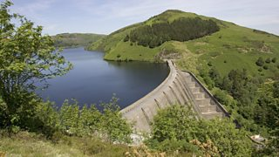
The dam traps water, which builds up behind it, forming a reservoir. Water can be released in a controlled way.

Advantages: Can be used to produce electricity by passing the water through a turbine within the dam and reservoirs can attract tourists.

Disadvantages: Dams can be very expensive. Dams trap sediment which means the reservoir can hold less water. Habitats can be destroyed when valleys are flooded. Settlements are lost leading to the displacement of people. In developing countries locals are not always consulted and have little say in where they are relocated.

River straightening and dredging

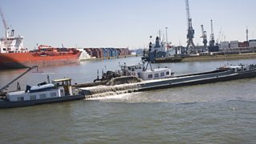
Straightening the river speeds up the water so high volumes of water can pass through an area quickly. Dredging makes the river deeper so it can hold more water.

Advantages: More water can be held in the channel. It can be used to reduce flood risk in built-up areas.

Disadvantages: Dredging needs to be done frequently and can be expensive. Speeding up the flow of water in a river increases flood risk downstream.

Embankments
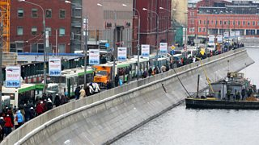
Raising the banks of a river means that it can hold more water.

Advantages: Expensive, but a with a one-off cost as the barriers should last for many years. Allows for flood water to be contained within the river.

Disadvantages: Looks unnatural. Water speeds up and can increase flood risk downstream.

Flood relief channels
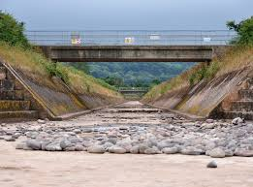
The floodwater flows into the relief channel and is taken either to an area where it can be absorbed or re-enters the river further down its course.

Advantages: Removes excess water from the river channel to reduce flooding.

Disadvantages: Expensive to build and if water levels continue to rise, the relief channel may also flood.

TASK: Which methods of hard engineering have been used in the image above? Are they effective?

TASK: What are the advantages and disadvantages of using hard engineering to protect against river flooding?

TASK: Watch the video about the 2020 UK winter floods https://www.youtube.com/watch?v=XPqlfLuioC8&t=13s

Lesson Eight: Protecting against flooding - soft engineering
LI: To explain how soft engineering strategies which can be used to protect against river flooding

Soft engineering strategies
Soft engineering does not involve building artificial structures, but takes a more sustainable and natural approach to managing the potential for river flooding. Each approach has its advantages and disadvantages.

Flood warnings and preparation
The environmental agency monitors rivers and issues warnings via newspapers, TV, radio and the internet when they are likely to flood so people can prepare.

Advantages
- People have time to protect their properties, e.g. with sandbags.
- Many possessions can be saved, resulting in fewer insurance claims.

Disadvantages
- Some people may not be able to access the warnings.
- Flash floods may happen too quickly for a warning to be effective.
- They do not stop land from flooding - they just warn people that a flood is likely.

Floodplain zoning
Allowing only certain land uses on the floodplain reduces the risk of flooding to houses and important buildings.
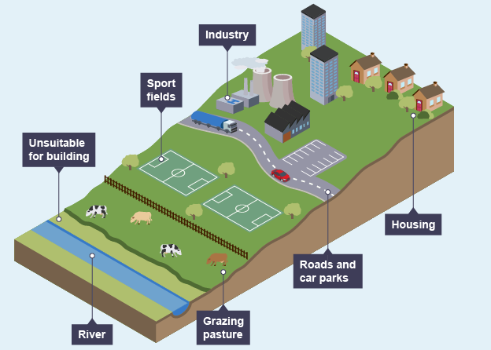

Advantages
- More expensive buildings and land uses are further away from the river, so have a reduced flood risk.
- Less damage is caused, leading to fewer insurance claims.

Disadvantages
- Not always possible to change existing land uses.
- Planners have to decide what type of flood to plan for.

TASK: What are the advantages and disadvantages of using hard engineering to protect against river flooding?
TASK: watch the video about flood management strategies https://www.youtube.com/watch?v=AX1i5uJ50qM

Lesson Nine: Casestudy of a UK flood management scheme
LI: To examine how management strategies have been used to protect a specific UK river from flooding

Flood management case study - Boscastle, Cornwall

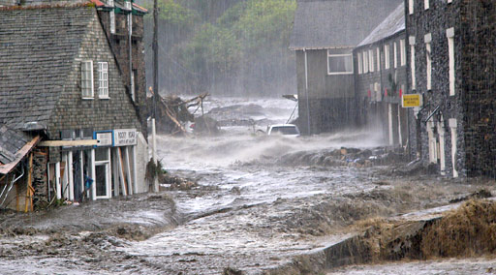

The Boscastle flood in August 2004
In August 2004, the village of Boscastle saw a month's worth of rain fall in just two hours. The drainage basin of Boscastle is steep and impermeable rock. Boscastle is also located on a confluence of three rivers. These factors led to a flash flood which caused over one thousand homes, cars and businesses to be swept away or damaged. Luckily, no people were killed and injuries were very minor.

The flood defence scheme
Special attention was paid to the car park. The cars swept away in the 2004 flood were to blame for blocking the bridge and causing the river to burst its banks. It has since been moved more than 30ft from the riverbank and raised by three feet. A guard of bollards was placed around the perimeter. Those working on the project prefer to call them 'car catchers’. A diversion channel has also been built so that during periods of high river discharge and when there is a risk of flooding, the diversion channel can be opened to divert water around the village and out to sea. This reduces the amount of water flowing through the main river channel.
The basic features of the scheme are shown on the diagram below:
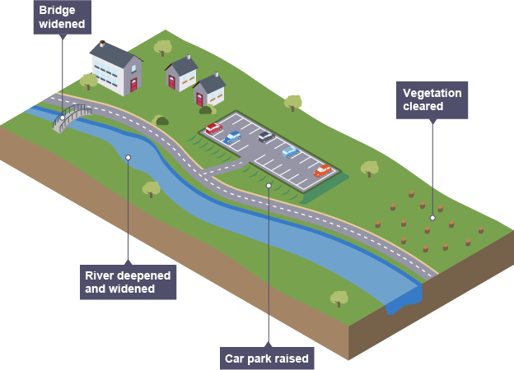

To prevent this type of flood happening again, the environmental agency invested £10 million into several flood defences, such as:
- Widening and deepening the river channel - this allowed the river to carry more water.
- Removing low bridges and replacing them with wider bridges - this meant large amounts of water could flow freely underneath the bridge and the bridge wouldn't act like a dam (in the 2004 flood, vegetation and debris became blocked, creating the effect of a dam).
- Raising the car park and using a permeable surface - this allowed cars to be much higher and so they were less likely to be swept away.
- Tree management - dead trees were removed to prevent them being swept away, causing blockages under bridges. Land owners were encouraged to maintain vegetation and plant new trees.
The river channel has been straightened and deepened to increase water flow:
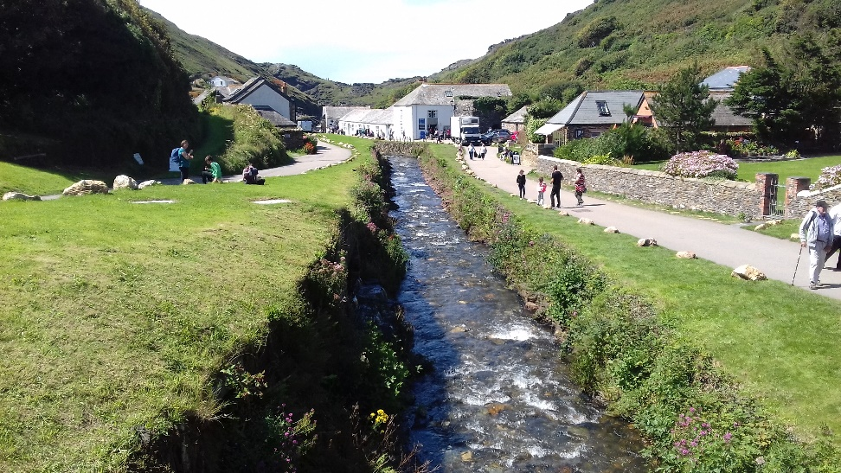

The main car park has been raised and moved away from the river:
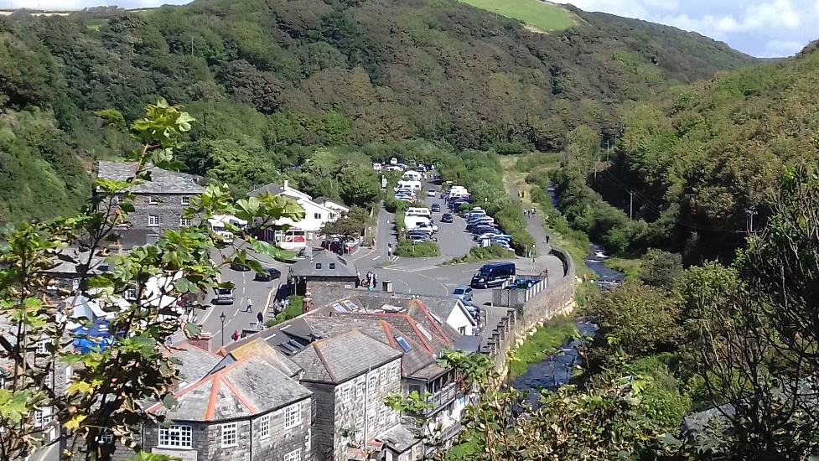
TASK: Watch the BBC news report on the Boscastle Floods https://www.youtube.com/watch?v=P2QW9rsp570
TASK: Explain how flood management strategies have been used in Boscastle to prevent flood damage.

