Year 8
Blended Learning Booklet Music
Autumn A
Band Musicianship: The Four Chord Trick
Go to: Oak National Academy. Go to: Lessons Go to: Subjects. Go to: Key Stage 3. Go to: Music Go to: Band Musicianship 1:The Four-Chord Trick

Name:________________________________ Class:________

Design an image to distinguish your booklet from others

Year 8 Blended Learning Unit 1 KO: Band Musicianship The Four Chord Trick
- Many songs are composed using 4 chords only
- This could be chords: C, F, G and A minor.
- They are chords I, IV, V and VI
- To create a chord on the keyboard: Play a note, Miss a note, Play a note Miss a note Play a note
- This type of chord is a triad
- Chords we are using: Keyboard and Guitar
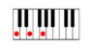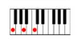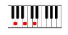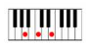
C Major F Major G Major A minor Song Structure
Intro, Chorus, Verse, Outro
Sometimes: Bridge, break
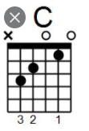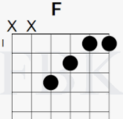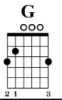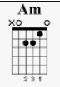
- Playing reggae chords off the beat gives the music more energy 8. Primary chords are I, IV and V (1, 4 and 5) that would be C, F and G in C major
- Sixth chord is a minor chord; darker or sadder than a major chord 10. The secondary chords: II III and VI Stretch: In G Major, Chords I, IV V and VI are: G C D Major and E minor A semitone is the smallest gap between two no=tes on the piano or guitar
Year 8: Blended Learning Unit 1 SAL: Band Musicianship The Four Chord Trick

Shotgun by George Ezra/ Other 4 Chord Songs

Colour | Knowledge | Skill
Gold | Can transpose the four chords to a different key | Is able to use the skank rhythm and play along comfortably/  Is able to play one of the strumming patterns
Yellow | Understands which chords make up I IV V & VI in C major | Can play the chords fluently for the songs
Blue | Understand how to build a triadic chord | Is able to play all four chords
Green | Understands that a chord is two or more notes | Is able to play 1 chord
White | Little knowledge of how to play a chord | Not yet able to play a chord

Comment: ________________________________________________________________

Assessed by:_____________________________________

Stretch: Could you play this in G? Chords would be: G C Am D

Year 8 Unit 1 Blended Learning: Band Musicianship: The Four Chord Trick
Go to: Oak National Academy. Go to: Lessons Go to: Subjects. Go to: Key Stage 3. Go to: Music Go to: Band Musicianship 1:The Four-Chord Trick
Lesson 1: Oak National Academy: LI: to understand the role of chords
CONNECT: Puzzle: Guitar Parts Words Search:
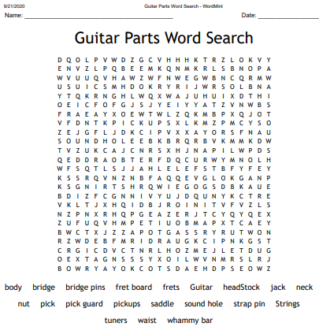
Warm ups on the video
ACTIVATE: Play the chords of C, G, F and A minor, as suggested on the slides. Use a keyboard, a virtual keyboard or guitar or ukulele if you have them.
DART:
ARTS & CULTURE

Have Scientists Found a Secret Chord for Happy Songs?
We can explain the meaning of lyrics by looking at their component words and grammatical structure. But how do we explain the meaning of music?
By Alan Marsden, The Conversation US on November 17, 2017

Redacted by Ms Reeves for simplicity

Everyone knows that a good tune needs not just to fit the rhythm of the words but to convey something appropriate to their meaning.
We can explain the meaning of lyrics by looking at their component words and grammatical structure. But how do we explain the meaning of music? What does the music of, say, Leonard Cohen’s Hallelujah convey? Some people think if we gather enough data to answer these questions then we might be able to program a machine to work out what our ears tell us with ease: that Jerusalem is rousing and Singin’ in the Rain is joyful.
New research published in the journal Royal Society Open Science attempts to tackle this issue by investigating the links between the emotions of lyrics and the musical elements they are set to. While the methods used are sophisticatedly statistical, the conclusions are extremely dry. The finding that a single chord type is most associated with positive lyrics is a huge simplification of the way that music works, highlighting the sheer scale of the challenge of creating a machine that could understand and compose music like a human can.
The authors downloaded the lyrics and chord sequences of nearly 90,000 popular songs from Ultimate Guitar, a longstanding community website where users upload their own transcriptions of music.
To match the lyrics of the songs to emotions, the researchers took data from labMT, a crowd-sourced website that rates the emotional valence of words (the degree to which they represent good or bad feelings). The details of when and where the songs originated from were taken from Gracenote, the same database as your music player probably uses to show artists’ information.

DEMONSTRATE:
Write out the rhythms:

Clap the rhythms:
Play along with the backing track
CONSOLIDATE:
Take the quiz to mark your progress: SCORE: /

Lesson 2: Oak National Academy: Band Musicianship: The Four Chord Trick
LI: to understand how chords help us to identify reggae
CONNECT: Puzzle: Finish last week’s guitar Word Search
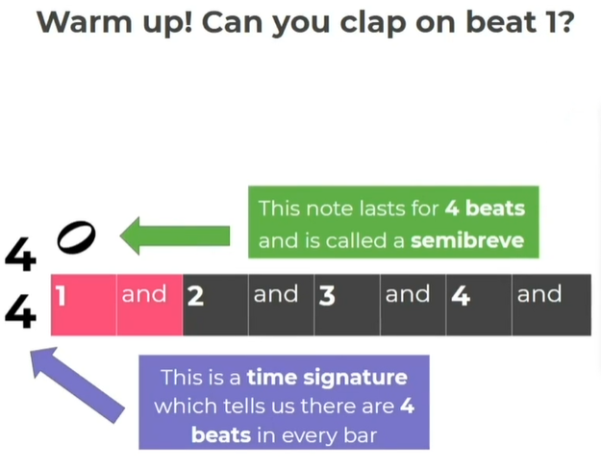
ACTIVATE: Rhythmic clapping warm ups on the video
On the beat/ off the beat clapping
Practice the Skank rhythm
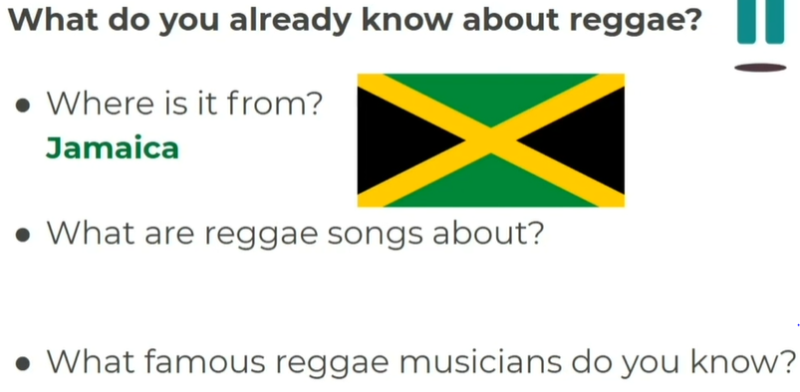
DART: (Same article as before, continued)
By correlating the attractiveness of words with the type of chord accompanying them, the authors confirmed that major chords were associated more with positive words than minor chords. Unexpectedly, they found that seventh chords—chords with four different notes rather than the usual three—had an even higher association with positive words, even in the case of minor seventh chords
Quantitative studies like this of music and emotion are becoming increasingly common and popular.

MORE THAN DECORATION
Seventh chords are not interchangeable with major and minor chords. They have a particular musical function and occur at different places in a phrase, just as adjectives have a different function from nouns. The authors claim their approach of using the words of vocal music as a key to its emotional content is novel, but this is not the case. One of the most influential books on music and emotion in its day, The Language of Music by Derek Cooke (1959), used exactly that approach. Alas for modern universities, where researchers’ universes seem to have been shrunken to their own particular disciplines.
We should beware the lazy assumption that words carry the true meaning of a song and music and the rest are just feelings, to be applied like cake decorations. Music has its own elements and structures, and speaks in many ways. The experience of music is so much more than just its sounds.

DEMONSTRATE: Play along to the more challenging backing track on your chosen instrument
CONSOLIDATE: Take the quiz about reggae chords and rhythms. SCORE: _____________

Lesson 3: Oak National Academy: Band Musicianship: The Four Chord Trick
LI: to understand which chords are useful and how
CONNECT:
Puzzle:
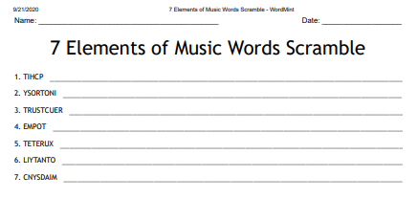
Take the reggae test again at the start of the lesson to refresh your memory
ACTIVATE: Clap the warmup syncopated rhythms
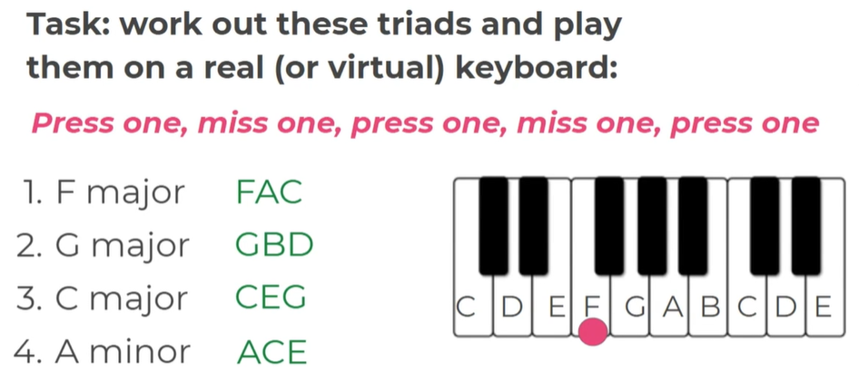
DART:
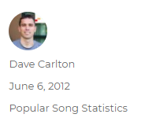

From: Have Scientists Found a Secret Chord for Happy Songs?
By Alan Marsden, The Conversation US on November 17, 2017 (continued)

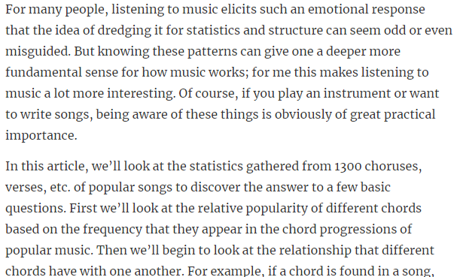
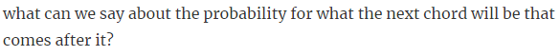

DEMONSTRATE: Play a melody and harmonise it
CONSOLIDATE: Take the syncopation quiz. SCORE: _________

Lesson 4: Oak National Academy: Band Musicianship: The Four Chord Trick
LI: to understand how secondary chords can be introduced in an accompaniment
CONNECT: Take the introductory quiz to recap last week’s lesson
ACTIVATE:
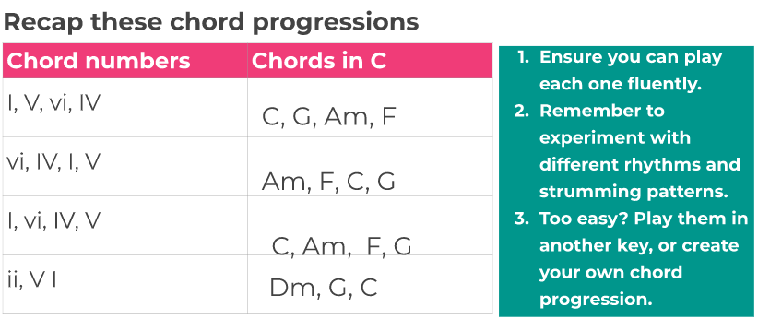
DART:

From: Have Scientists Found a Secret Chord for Happy Songs?
By Alan Marsden, The Conversation US on November 17, 2017 (Continued)
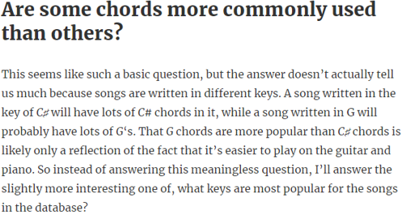
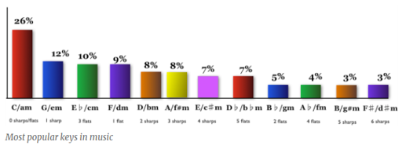
DEMONSTRATE: Practice the chord progressions and more syncopated rhythms
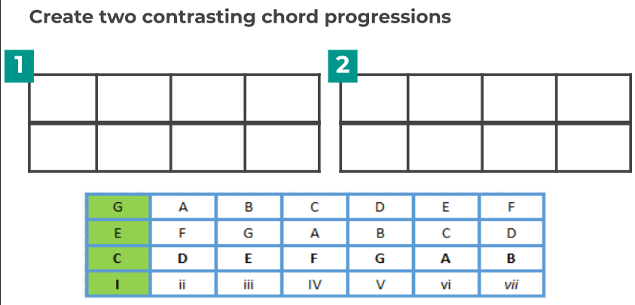

CONSOLIDATE: Take the final quiz. SCORE:_____

Lesson 5: Oak National Academy: Band Musicianship: The Four Chord Trick LI: to be able to play in a virtual band
CONNECT: Puzzle:
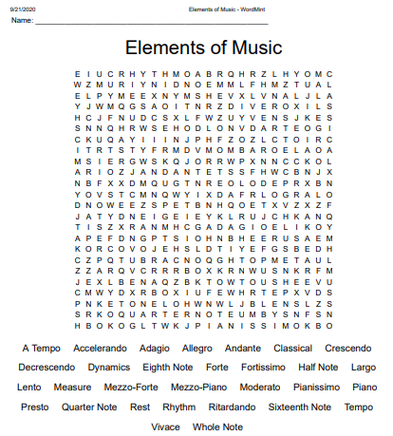
Use the quiz to recap what you have learnt and refresh your knowledge of chords, syncopation, and dotted crotchets
ACTIVATE: Clap back the rhythms
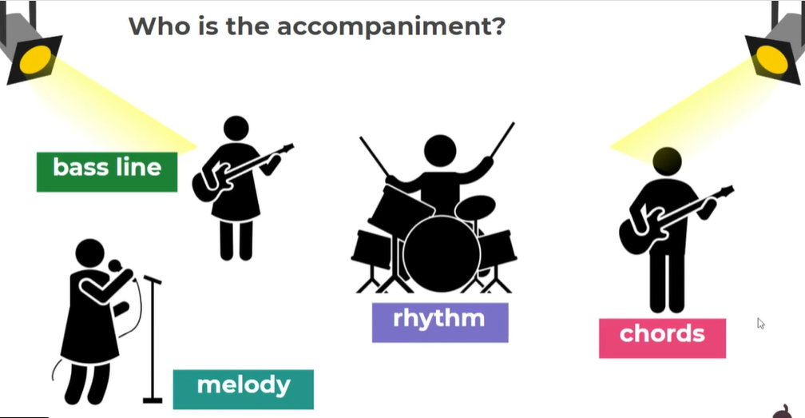
DART:

From: Have Scientists Found a Secret Chord for Happy Songs?
By Alan Marsden, The Conversation US on November 17, 2017 (Continued)
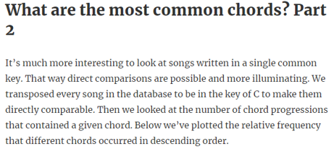
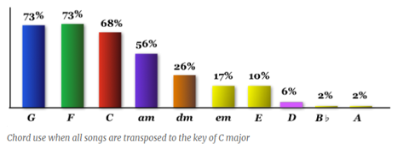
DEMONSTRATE: Create two contrasting chord progressions
Put them into Band Lab (Digital Audio Workstation) Make sure you have permission from your parents/carers to use this. Go to Band Lab Education
What do we know about band musicianship? Complete the boxes to show what you know
Roles in a band | Chords | Rhythm

Three primary chords in C major? | Three secondary chords in C Major?

Write down your chord progression:
Chord Progression 1
Chord Progression 2

Are you using a DAW? YES or NO
Which one? Band Lab Garage Band Other
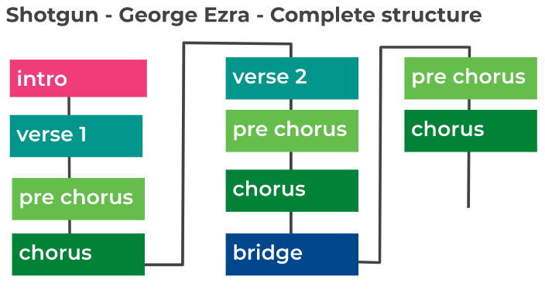
CONSOLIDATE:
Take the quiz to finish up today’s lesson Record your answers and your score here:

Lesson 6: Oak National Academy: Band Musicianship: The Four Chord Trick
LI: to understand how pop songs are constructed
CONNECT:
Continue to work on last week’s word search.
Take the refresher quiz at the start of the lesson SCORE:_____________
What is a semitone? _________ Draw a quaver rest__________
ACTIVATE: Try a gentle shoulder roll before clapping back
DART:From: Have Scientists Found a Secret Chord for Happy Songs?
By Alan Marsden, The Conversation US on November 17, 2017 (Continued)

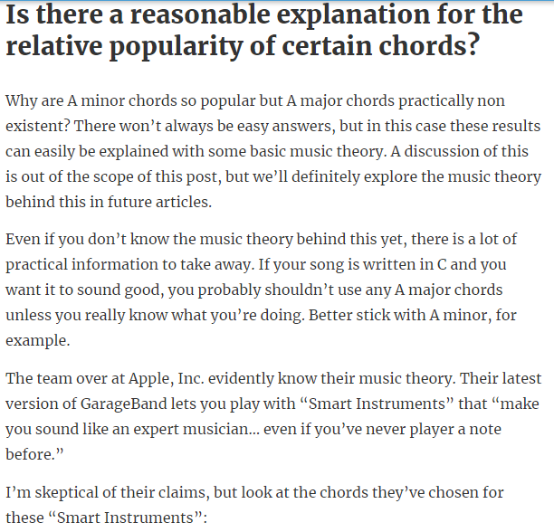

DEMONSTRATE:
Go over all the chords you know, either on your instrument or on the virtual piano.
Play through Shotgun by George Ezra again, going for fluent chord changes
CONSOLIDATE:
Share the structure of your song with a family member/someone who lives with you
Song structure: (Intro, Chorus, Verse, Bridge, Break, Verse, Outro
Order | Part
1
2

3

4

5

6

Lesson 7: Oak National Academy: Band Musicianship: The Four Chord Trick
LI: to be able to perform popular music drum patterns
CONNECT: Puzzle:
Finish Week the Word Search from Week 5
ACTIVATE: Clap the rhythm grid: 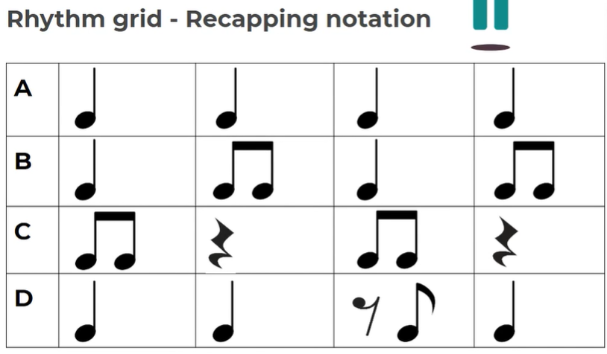
DART:From: Have Scientists Found a Secret Chord for Happy Songs?
By Alan Marsden, The Conversation US on November 17, 2017 Continued
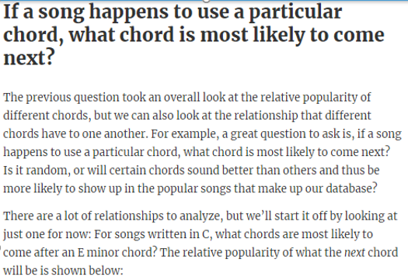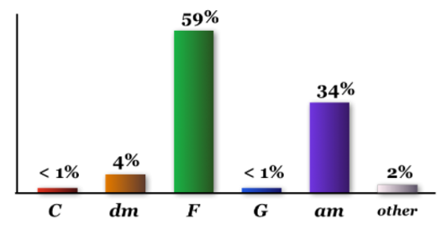

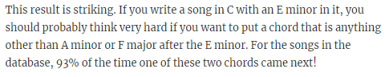
DEMONSTRATE: 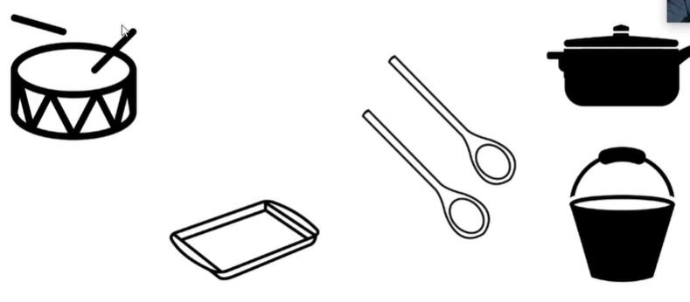 Try the rock beat below, using the simple equipment found in the kitchen
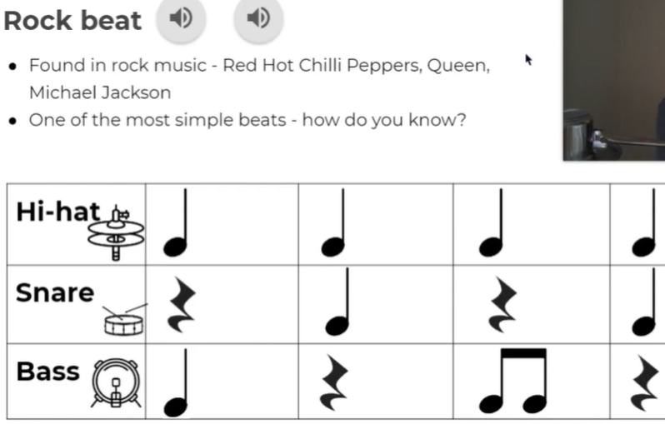
Try the other beats, too
CONSOLIDATE: Answer the following questions:
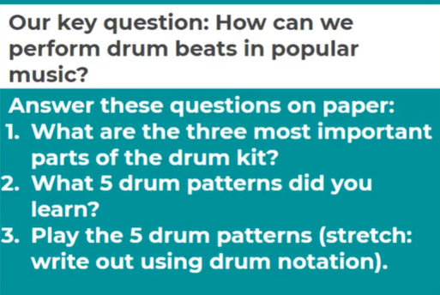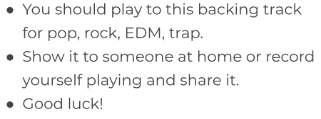

Share your drum beat:_____________________________________________

CONGRATULATIONS! You have finished Autumn 1 Music Booklet!

