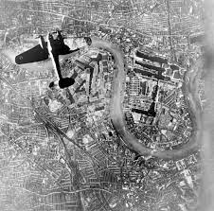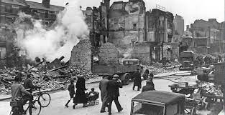**Year 10 History Blended Learning Booklet Summer 2 – The Blitz**

**Name:**

**History Teacher:**

**Contents**

**Year 10 Big Picture 3**

**Knowledge Organisers 4**

**Lesson 1 London – A target city 7**

**Lesson 2 The nature of the Blitz 10**

**Lesson 3 Impact on Civilian life 13**

**Lesson 4 London’s response to the Blitz 15**

**Lesson 5 Source skills 17**

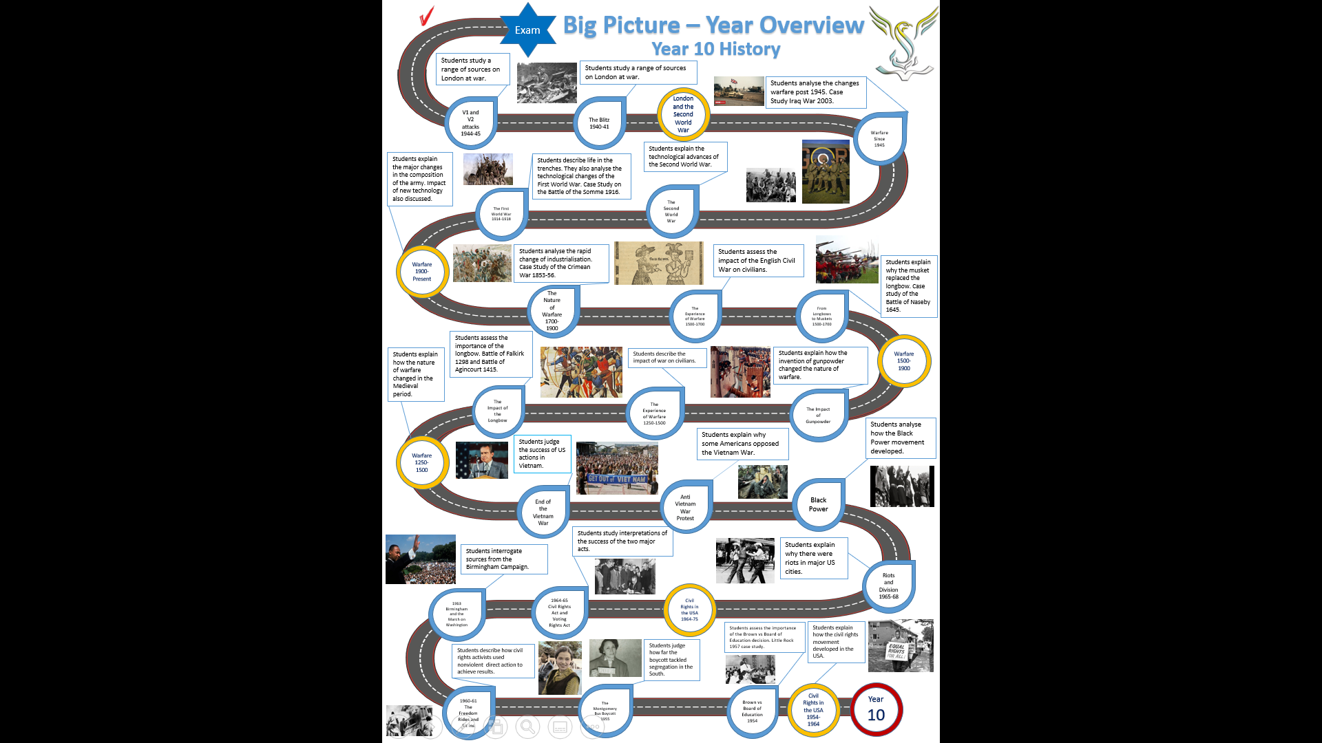

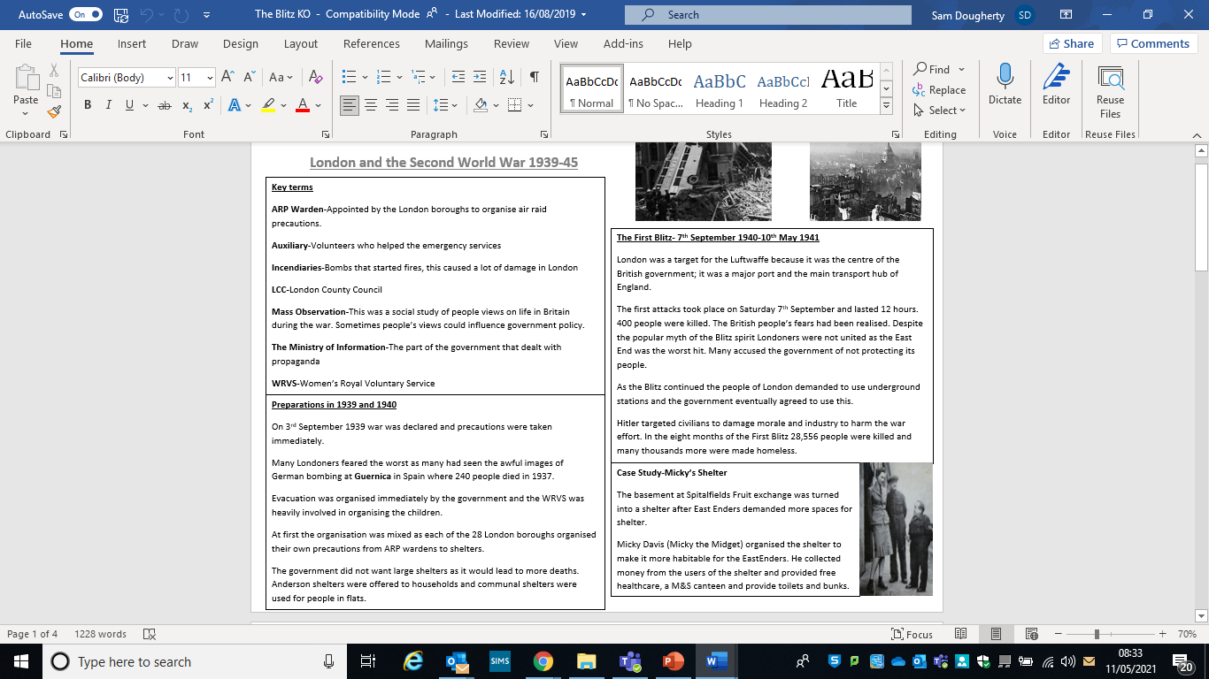

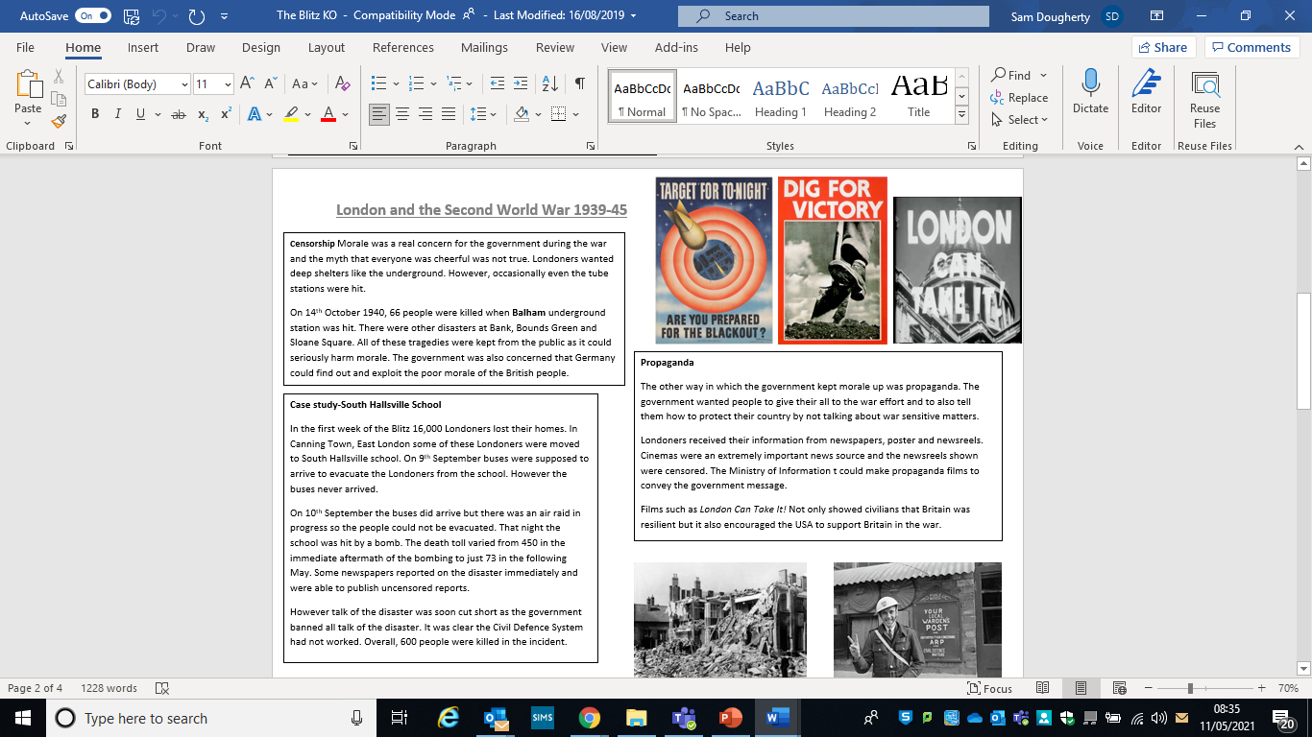

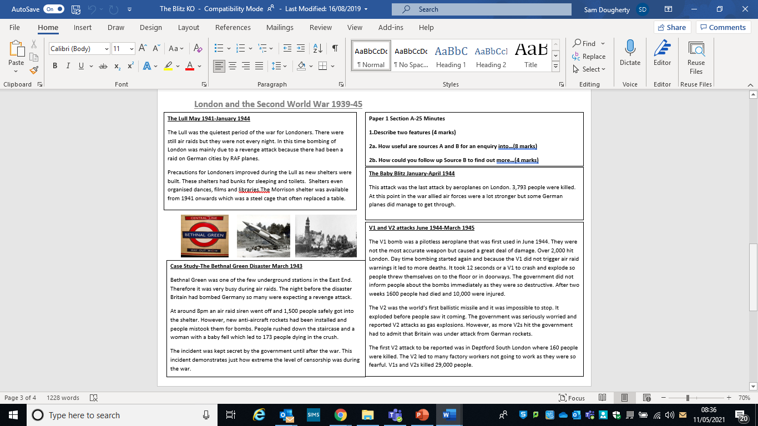

**Lesson 1 – London a target city**

**LI:** To understand why London was a target for German bombers.

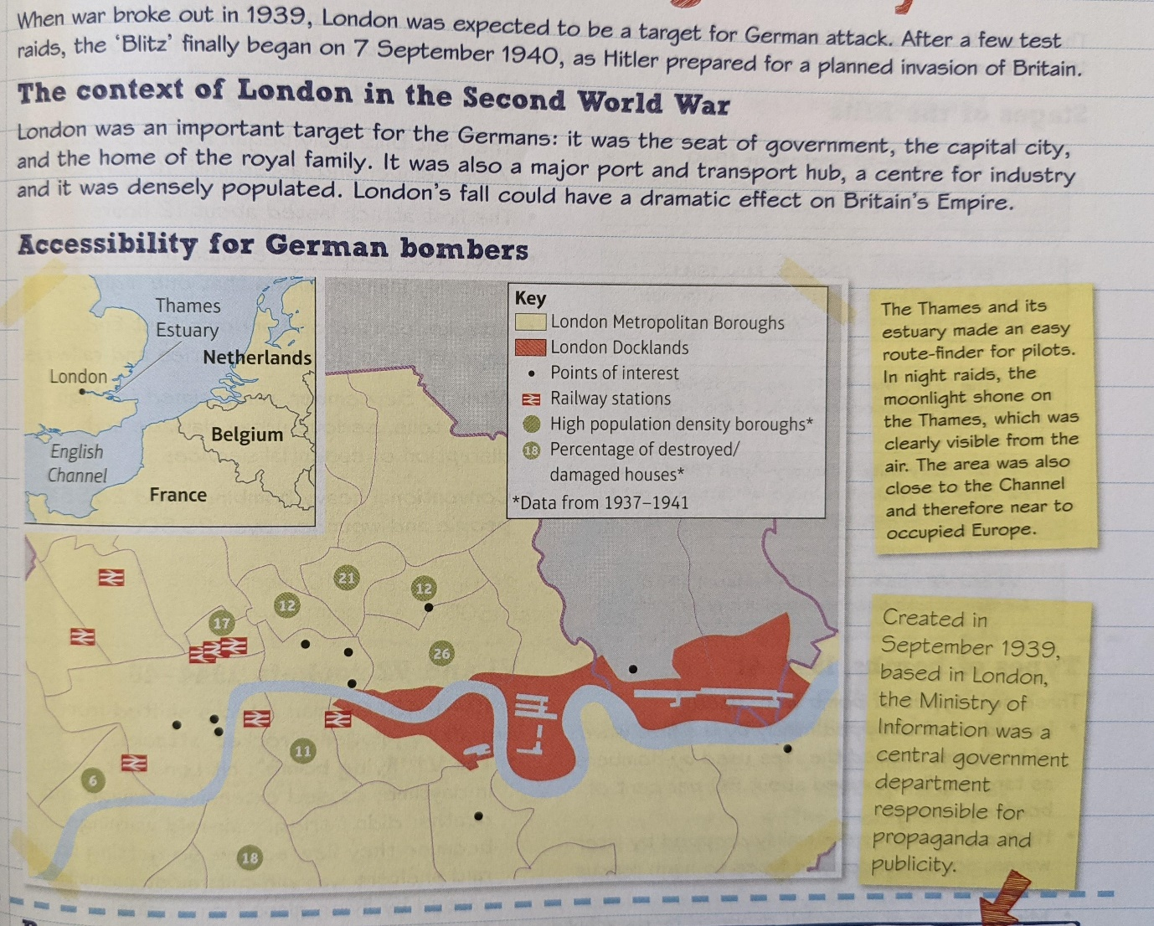

**List five reasons why London was such an important target for German bombing:**

**Preparations for war, 1939**

Planning was shared between the London County Council (LCC) and 28 borough councils.

* Gas masks had been issued to all Londoners following the 1938 Munich Crisis.
* The Air-Raid Precautions Act required local governments to set up air-raid precautions (ARP).
* The LCC organised Fire, Ambulance and Heavy Rescue Services and care of homeless.
* The boroughs set up local ARP wardens.
* In January 1939, there was a drive to recruit volunteers together called Civil Defence.
* London children were to be evacuated into the country by school from 1 September.
* The National Service brochure offered fees for rural families willing to take in evacuees.
* In a policy of dispersal, families were offered Anderson shelters or space in communal shelters if they did not have a garden.

**Propaganda and censorship**

London civil servants created propaganda and ensured censorship effectively controlled public information.

Propaganda was used to maintain morale and encourage people to support the war effort. Part of this aimed to influence attitudes about the Blitz.

The government helped to create the 'Blitz spirit', where a united British population, from worker to royalty, weathered the storm together and stood defiant. Photographs showed the royal family visiting bomb sites.

**Explain in two paragraphs how London prepared for war in 1939. In this answer below, you MUST clearly explain what an ARP Warden is. Use your Knowledge Organisers above or google it.**

**Lesson 2 – The Nature of the Blitz**

**L/I:** To understand how the Blitz changed over time.

The first Blitz targeted industry and transport: bombing was heaviest in the East End of London. After 19th September, all London became the target as the Germans aimed to destroy civilian morale.

**Black Saturday, 7 September 1940**

• The First Blitz truly began around 5 p.m. on 7 September and lasted until 10 May 1941.

• The first attack lasted about 12 hours.

• Over 400 people were killed and 1600 seriously injured during that one night.

• Attacks focused on London's East End especially the docks, industries, and railways.

• After 19 September, raids aimed for high death tolls, serious urban damage, and disruption of essential services.

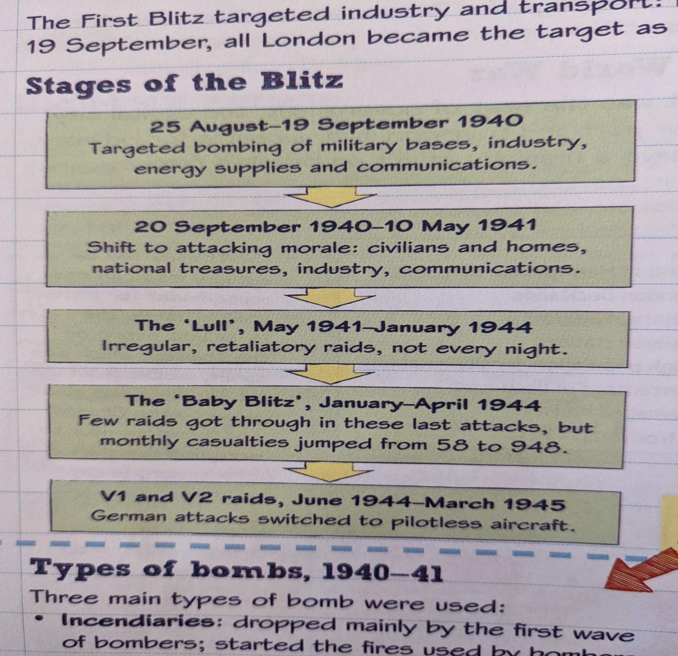• Conventional heavy bombing killed 28 556 people and wounded over 25 500 in total.

**Types of bombs, 1940-41**

**Three main types of bomb were used:**

**Incendiaries:** dropped mainly by the first wave of bombers; started the fires used by bombers as targets; fires caused about 90 per cent of bombing damage.

**High explosives:** were mainly dropped by later waves; some had delayed fuses to harm rescue workers.

**Mines:** the most powerful; dropped by parachute so attacks were silent and hard to detect.

**V1 and V2 rockets, 1944-45**

In 1944-45, German attacks shifted from aircraft to pilotless 'rocket' attacks.

**The V1 'flying bomb':** hit London targets in daytime; caused extensive damage and deaths; did not trigger air-raid warnings because they flew so low, so getting to air raid shelters was difficult; most casualties caused by flying glass from explosions.

**The V2 rocket:** the first ballistic missile (a rocket carrying a warhead); so fast that it exploded before people heard it coming; attacks continued until the launch sites were captured by the Allies in Europe.

**The V2 attack on Deptford, 1944**

On 25 November 1944, the first V2 attack to be widely reported hit New Cross, Deptford. Woolworths, a large store, was struck on a Saturday lunchtime when many were shopping. About 160 people were killed and 200 injured.

**The impact of the V1 and V2s**

• Civilian morale very low and factory workers were often absent from work.

• More evacuations began, and the Underground filled with civilians seeking shelter.

•The government's popularity fell as people felt unprotected.

• Over 30000 houses were destroyed and almost 29000 people were killed or injured.

**Explain in a how the Blitz on London changed throughout the war. Use the stages of the Blitz and the weapons information to help you.**

**Try and come up with three paragraphs, which explain how the Blitz changed over time.**

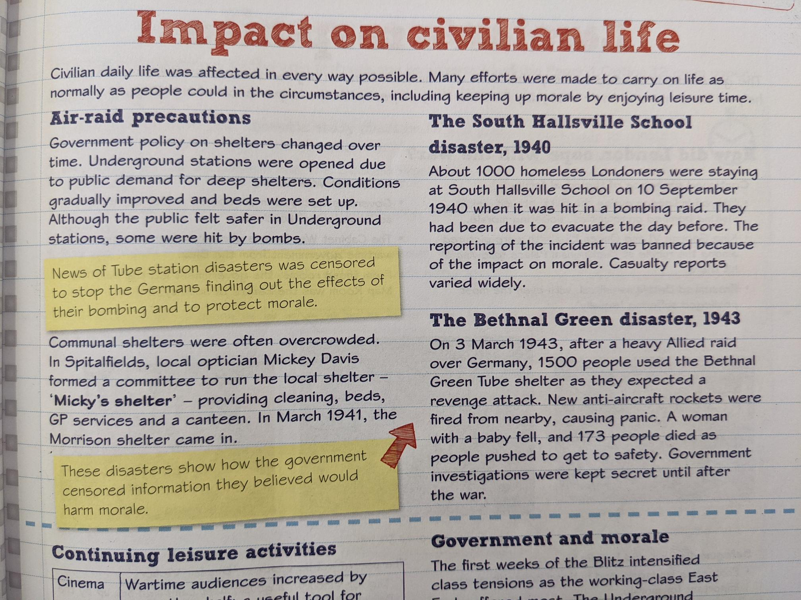**Lesson 3 - Impact on civilian life**

**L/I:** To understand the impact the Blitz had on civilian life.

**Explain the two disasters above in your own words and how they impacted civilian morale.**

**What did Mickey Davis do to make life more bearable for civilians in communal shelters?**

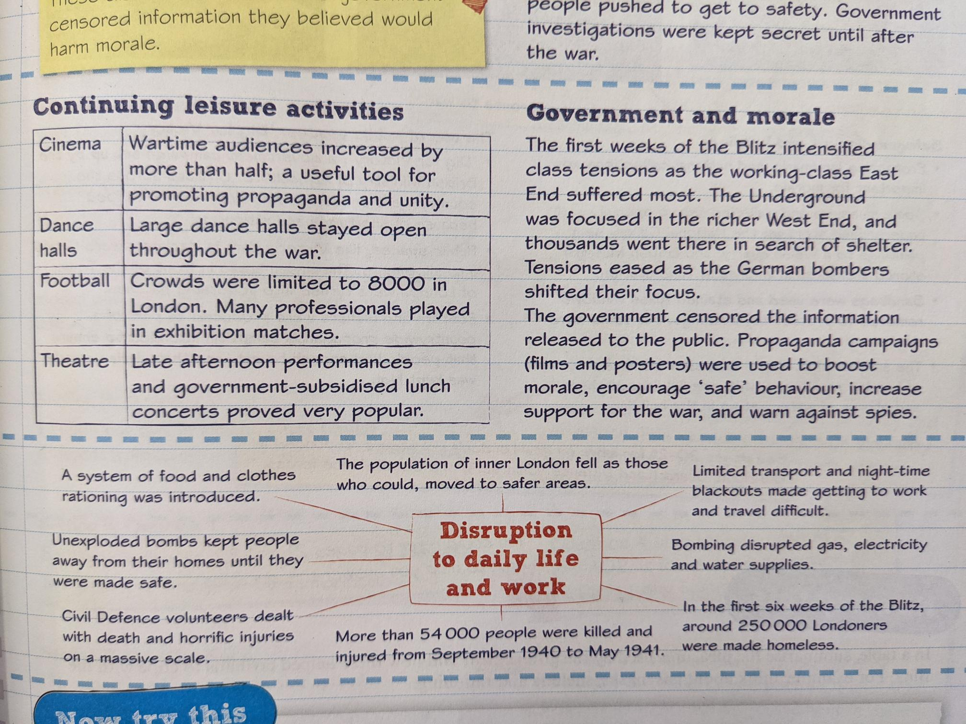

**Clearly explain three ways that civilian morale was kept high during the war.**

**Lesson 4 – London’s response**

**L/I:** To understand how the government kept morale high in London and introduced measures that protected Londoners.

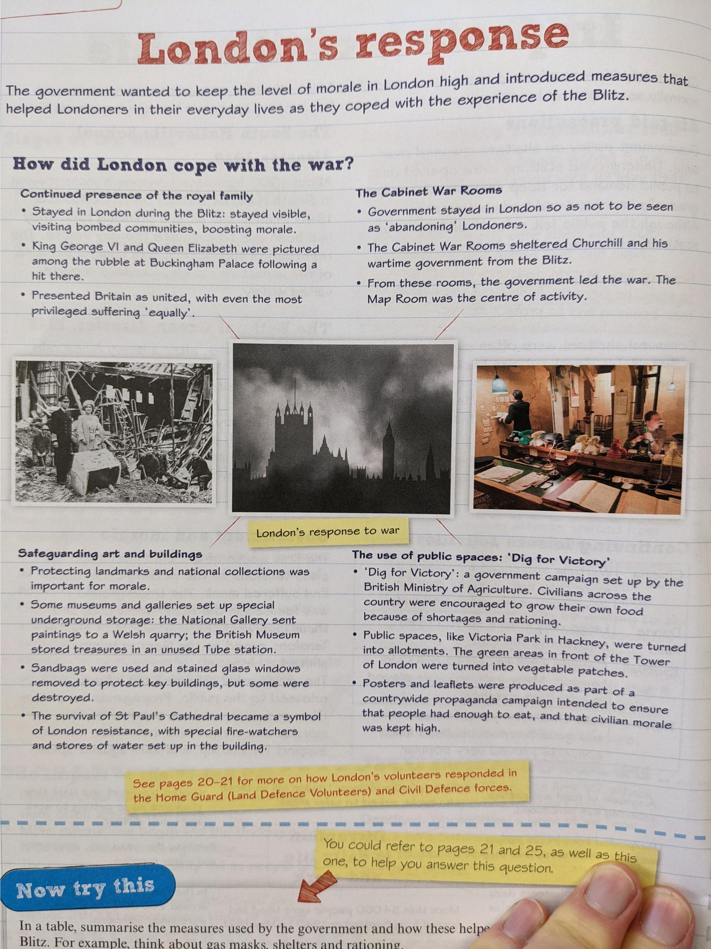**The government wanted to keep the level of morale in London high and introduced measures that helped Londoners in their everyday lives as they coped with the experience of the Blitz.**

**Use the above, and other parts of your booklet, to create a list of measures used by the government and how these helped civilians cope with the Blitz. For examples, think about gas masks, shelters, and rationing.**

|  |  |
| --- | --- |
| **Name of the measure** | **Explanation of how it helped civilians cope with the Blitz** |
|  |  |
|  |  |
|  |  |
|  |  |
|  |  |
|  |  |

**Lesson 5 – Source skills**

**L/I:** To understand how to use Sources properly in an exam.

**Question 1: describing features.**

Question 1 on your exam paper will ask you to ‘Describe two features of……’ There are four marks available for this question: two for each feature you describe.

**What does describe mean?**

Describe means to give an account of the main characteristics of something. You develop your description with relevant details, but you do not need to include reasons or justifications.

**Answer the following exam style questions:**

**Describe two features of the government’s attempt to maintain morale during the Second World War. (4 marks)**

**Here is an average example:**

**Feature 1**

The government-maintained morale by using propaganda to put across a positive message.

**Feature 2**

People could go out for entertainment.

**Answer the question above and Improve the example by giving more detail.**

**Feature 1**

**Feature 2**

**Read through the Source skills 1 and 2 informaiton below, to help you understand how to use Sources properly in an exam.**

