**Year 10 Blended Learning Booklet Spring 1**

**Warfare 1250-Present**

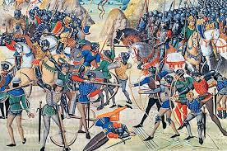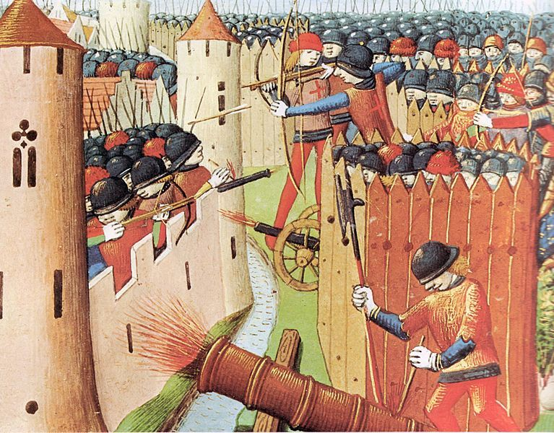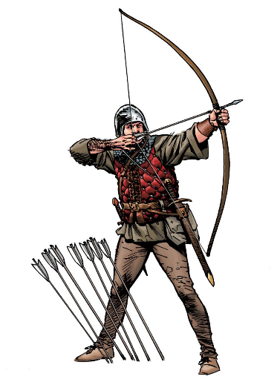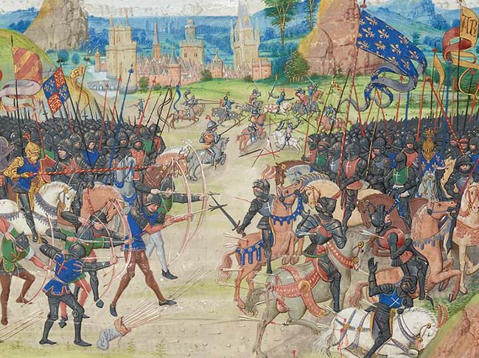

Name:

Tutor Group:

Teacher:

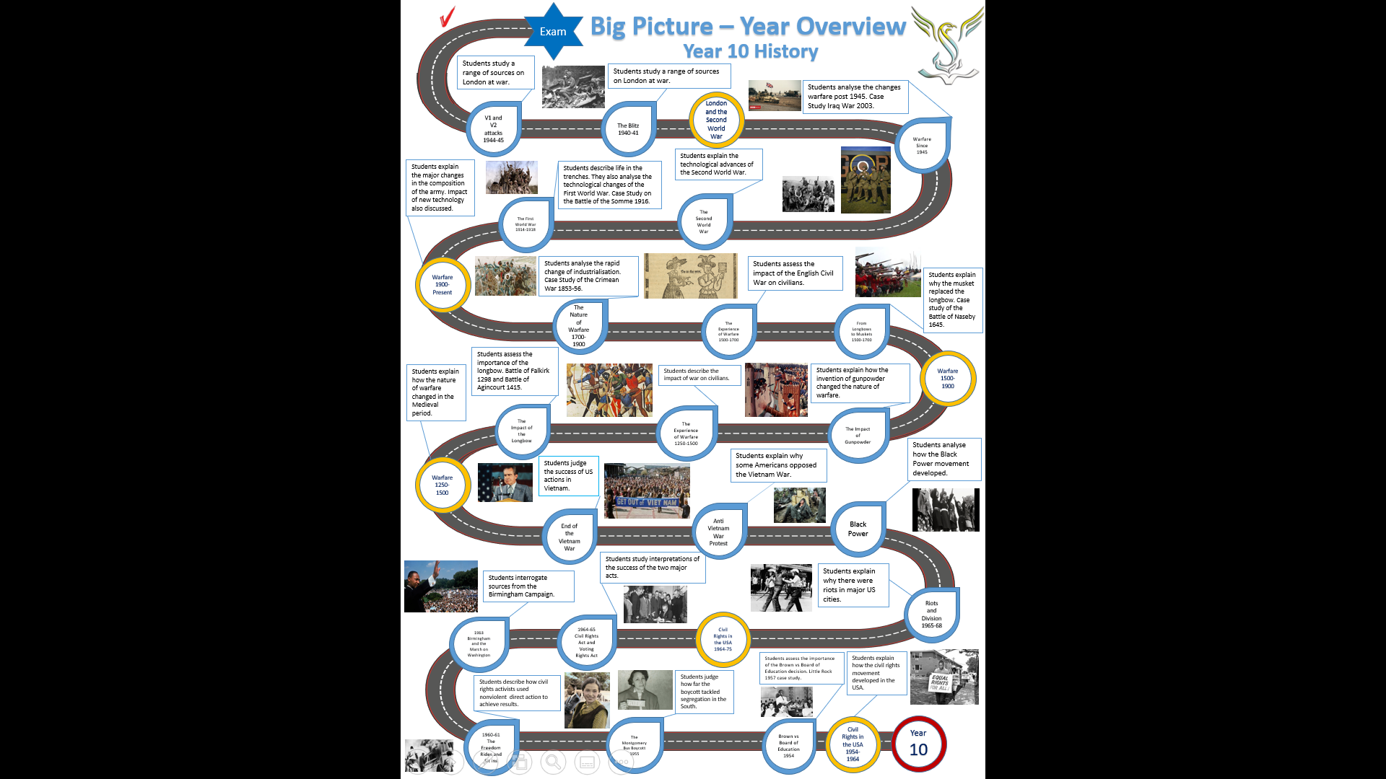

**Medieval Warfare**

LI: To compare Medieval Warfare to modern warfare.

**Lesson 1 Medieval Warfare 1250-1500**

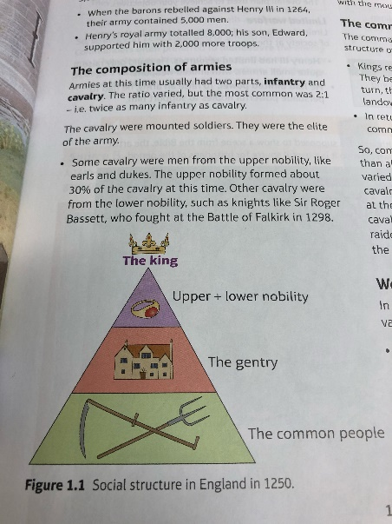**LI: To describe Medieval warfare**

From 1250-1500 England was frequently at war with France and fought for control of Scotland and Wales. Armies were very different to today. The average army was composed of 5,000-10,000 men. These were broken into two parts the cavalry (men or horseback) and the infantry (foot soldiers). Cavalry were made up of the nobility and knights whereas the infantry were composed of common men.

The cavalry were armed with lances or spears and swords. They had suits of armour to protect them.

The infantry had swords and daggers. The only had caps and leather jackets for protection.

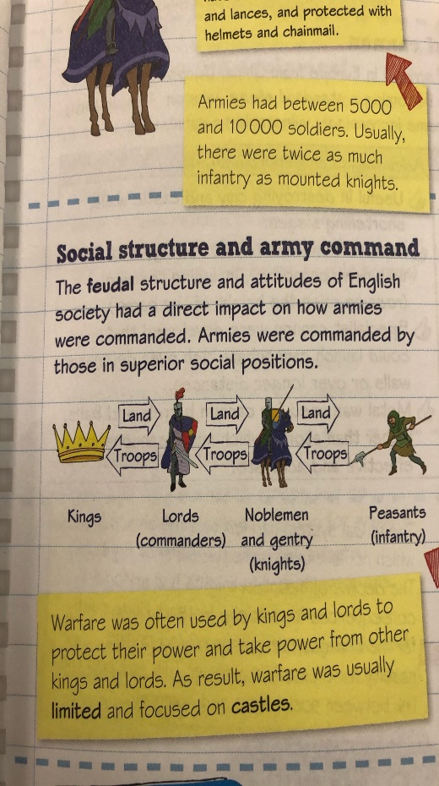The social structure of Medieval England was very rigid, the nobles commanded the army. Authority in the army was based on social status rather than skill. The Feudal System that the Normans brought to the country was still in use.

Peasants were attracted to the army sometimes because it might provide adventure or the opportunity to plunder. In 1285, **the Statute of Winchester** was issued which meant that once a year all men between 16 and 60 had to muster (gather) ready for 40 days service.

During the late 13th century and early 14th century recruitment started to change as men were recruited through **the assize of arms**. This new law meant landowners had to provide a number of fully equipped knights. The more land you had the more knights you had to provide. You could get around this law by paying the king **scutage tax.** This tax meant you could pay money instead and the king could hire a mercenary army who were professional soldiers.

The tactics of the time were divided into cavalry and infantry roles. The cavalry used the mounted charge. Charging at the enemy trying to reach their commander. The cavalry used a shield wall overlapping their shields. When in battle they also used melee which was hand to hand fighting with swords, pikes and daggers.

1. Describe the structure of a Medieval army

…………………………………………………………………………………………………………………………………………………………………………………………………………………………………………………………………………

1. What was the difference in equipment between the cavalry and infantry?

…………………………………………………………………………………………………………………………………………………………………………………………………………………………………………………………………………

1. How were men recruited for the army in 1250?

…………………………………………………………………………………………………………………………………………………………………………………………………………………………………………………………………………

1. How did recruitment change after 1285?

……………………………………………………………………………………………………………………………………………………………………………………………………………………………………………………………………………………………………………………………………………………………………………………………………………………………………………………………………………………………………………………………………………………

1. What was scutage tax?

………………………………………………………………………………………………………………………………………………………………………………………………………………………………………………………………………………………………………………………………………………………………………………………………………………

1. How far has warfare changed since the Medieval period?

……………………………………………………………………………………………………………………………………………………………………………………………………………………………………………………………………………………………………………………………………………………………………………………………………………………………………………………………………………………………………………………………………………………………………………………………………………………………………………………………………………………………………………………………………………………………………………………………………………………………………………………………………………………………………………………………………………………………………………………………………………………………………………………………………………………………………………………………………………………………………………………………………………………………………………………………………………………………………………………………………………………………………………………

**Lesson 2 The Battle of Falkirk 1298**

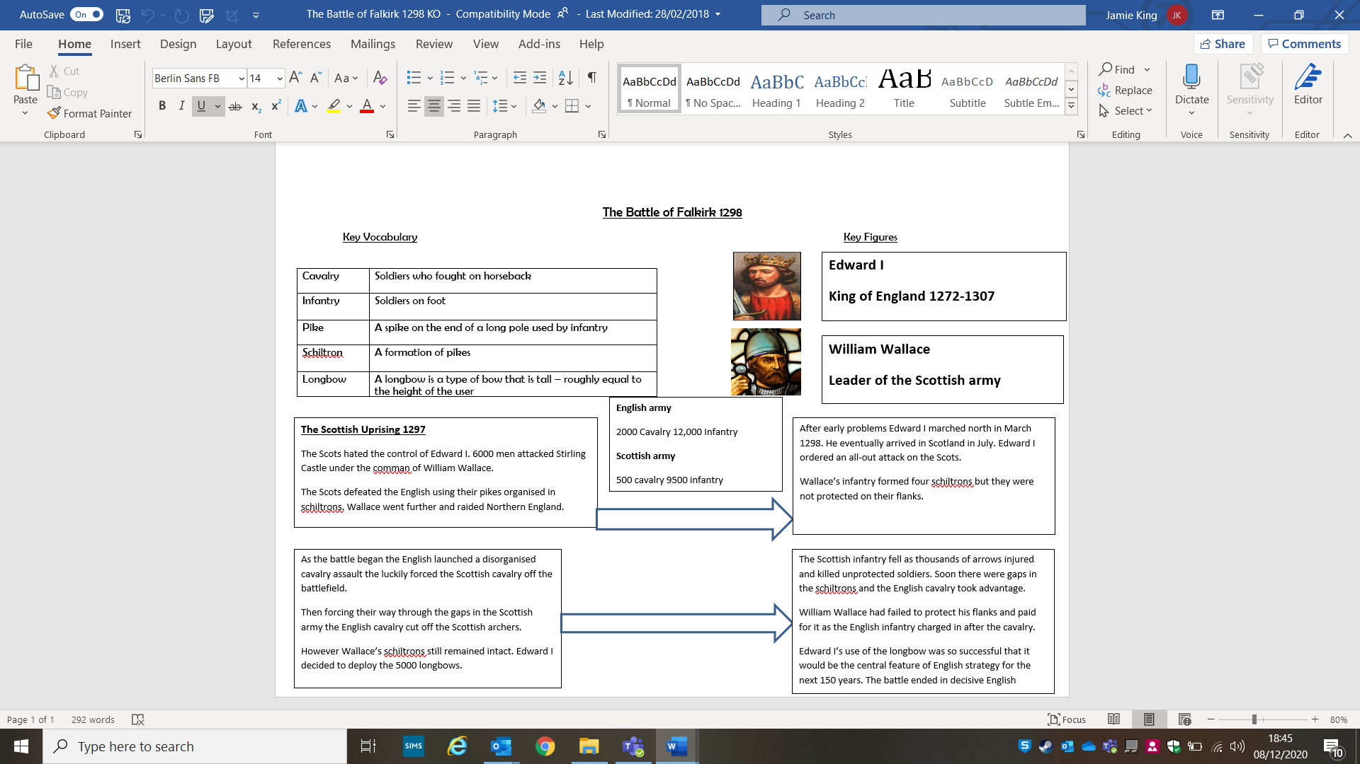**LI: To identify the strengths and weaknesses of the English and Scottish armies at the Battle of Falkirk 1298.**

**Tasks**

1. Watch this video on a schiltron formation to see how battle were fought in the 13th century: <https://vimeo.com/95958058>
2. Why could Edward I not allow William Wallace to travel further south?
3. What disadvantage did the Scots have at the start of the battle?
4. What difference did Edward’s longbows make to the battle?
5. What was the significance of the Battle of Falkirk for the use of the longbow in the Medieval period?

**Lesson 3 Gunpowder**

**LI: To explain how the use of gunpowder developed between 1300 and 1500.**

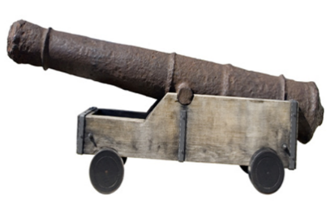Gunpowder had been around for hundreds of years before it was brought to Europe. The Chinese had invented it and it was an Englishman called Roger Bacon who brought it to these shores.

Cannon did not start to appear on English battlefields until the 1320s. The presence was not very significant as the earlies cannon had a wooden barrel, bound with metal bands and shot round balls of stone.

1327 Edward III used cannon against the Scots

1346 English used cannon in a siege at Calais but it had little impact

1415 Henry V used Cannon at a siege in Harfleur but they had little impact and Henry spent five weeks there before the battle of Agincourt.

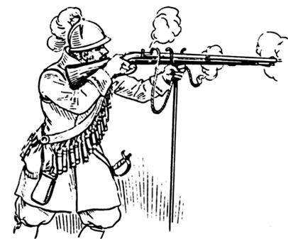The major problem with cannon is they were extremely heavy and only had a range of 100 yards from 1430 onwards there were significant improvements. Metal was used which saw a huge improvement in cannon balls as metal ones replaced stone. The length of the barrel was extended which led to greater accuracy and power. Trunnions were invented which were rods at each side of the cannon to higher of lower the frame of the cannon when aiming. Specialist cannon were invented like the mortars and howitzers to lob missiles over castle walls. Eventually by the end of the 16th century castles walls had to be made thicker as cannon improved. They were filled with earth to soften the impact of cannon balls.

Along with cannon, firearms improved and the first gunpowder weapons that could be carried by an individual were invented. The Arquebus was invented by the Venetians and was used by the 1490s. Despite these advances cannon were still unreliable; King James II of Scotland was killed by his own cannon when it exploded. They were slow to load and had inaccurate and therefore only useful in sieges.

1)Why was the use of cannon limited up to 1430?

……………………………………………………………………………………………………………………………………………………………………………………………………………………………………………………………………………………………………………………………………………………………………………………………………………………………………………..

2) Why did cannon improve from 1430 onwards?

……………………………………………………………………………………………………………………………………………………………………………………………………………………………………………………………………………………………………………………………………………………………………………………………………………………………………………………………………………………………………………………………………………………………………………………………..

3)What was the first firearm that could be used by an individual?

…………………………………………………………………………………………………………………………………………………………………………………………………………………………………………………………………………

4) Why do you think longbows were used for such a long time despite the invention of cannon and firearms?

………………………………………………………………………………………………………………………………………………………………………………………………………………………………………………………………………………………………………………………………………………………………………………………………………………………………………………………………………………………………………………………………………………………………………………………………………………………………………………………………………………………………………………………………………………………………………………………………………………………………………………………………………………………………

**Lesson Four-The Impact of Warfare**

**LI: To describe the different ways civilians were affected by warfare.**

From 1250 to 1500 civilians were affected by warfare in several ways. The first was **requisitioning** which meant food and supplies were taken from civilians and given to the army. Usually, these goods would be paid for by the king’s army but not always. This could leave civilians in poverty. **Purveyance** was a type of requisitioning which the king would give civilians a wooden token called a **‘tally’** which was like an IOU. The civilians were meant to receive a fair price for the good they handed over to the army, but this did not always happen. When food ran out then the armies had to forage for food in the countryside or simply steal it from farmers.

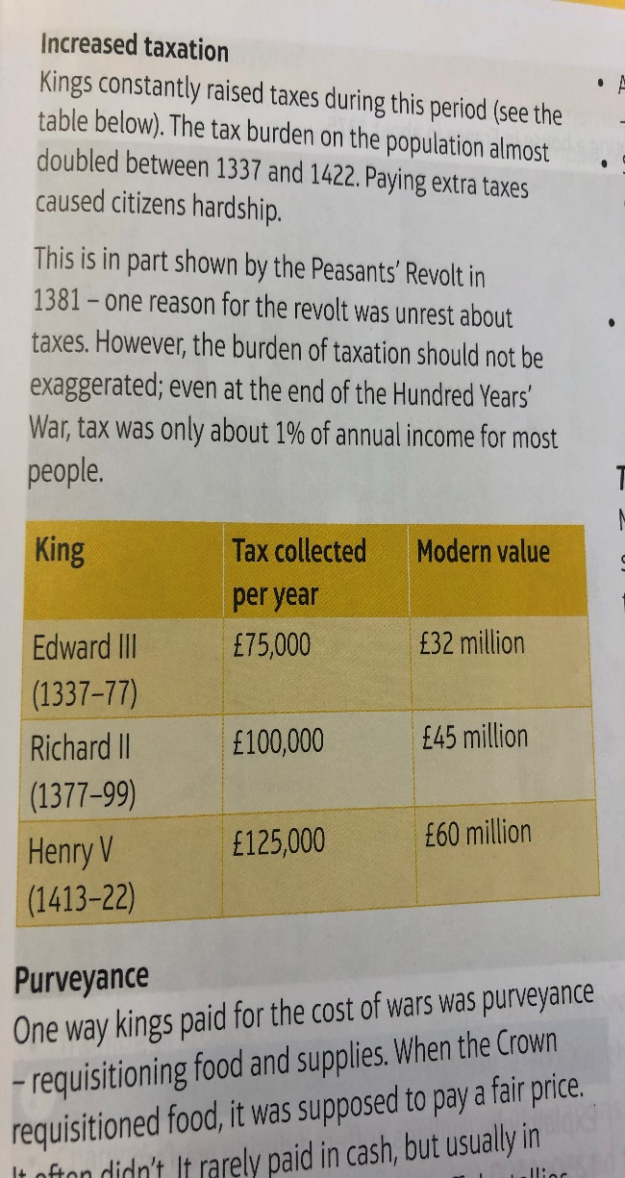Another way civilians were affected by warfare was being forced to fight. The Feudal system and the assize of arms would force many peasants to fight. There was the choice to pay scutage tax. Even when some men did join the army they deserted soon after. In 1300, 9000 men were mustered but just one moth later only 5000 remained. When England was at war tax rises were needed to pay for the army. You can see how the tax demanded by kings increased.

Warfare in this period was limited and sometimes it was easier to weaken the enemy by attacking their civilians rather than the army itself. Very often armies raided towns and villages which caused huge panic amongst civilians. In 1296, the Scots invaded Northern England where they killed old people, women, and children. Rather than sending an army the English paid them to go away. Armies often stole supplies as it would feed them and give their enemy fewer supplies.

Often an army might not attack a town but it would take civilians prisoner and hold them for ransom. The town would then have to pay to get them back. In 1380, 168 civilians were kidnapped in the French town of Bergerac and the town paid for their freedom.

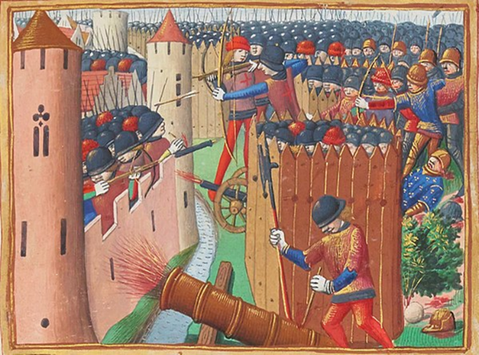Finally, sieges were a central part of Medieval warfare. The invading army would cut off food and water supplies to a town. Then they would attack the towns walls with siege weapons such as cannon. This led to huge suffering in the town. An example of this was the Siege of Rouen by the English under Henry V in 1418-19. He chose to starve the town until they surrendered.

**Exam Question**

Explain why civilians suffered in warfare ,1250-1500, 12 marks, 3 paragraphs

* Sieges and ransoms
* Purveyance

………………………………………………………………………………………………………………………………………………………………………………………………………………………………………………………………………………………………………………………………………………………………………………………………………………………………………………………………………………………………………………………………………………………………………………………………………………………………………………………………………………………………………………………………………………………………………………………………………………………………………………………………………………………………………………………………………………………………………………………………………………………………………………………………………………………………………………………………………………………………………………………………………………………………………………………………………………………………………………………………………………………………………………………………………………………………………………………………………………………………………………………………………………………………………………………………………………………………………………………………………………………………………………………………………………………………………………………………………………………………………………………………………………………………………………………………………………………………………………………………………………………………………………………………………………………………………………………………………………………………………………………………………………………………………………………………………………………………………………………………………………………………………………………………………………………………………………………………………………………………………………………………………………………………………………………………………………………………………………………………………………………………………………………………………………………………………………………………………………………………………………………………………………………………………………………………………………………………………………………………………………………………………………………………………………………………………………………………………………………………………………………………………………………………………………………………………………………………………………………………………………………………………………………………………………………………………………………………………………………………………………………………………………………………………………………………………………………………………………………………………………………………………………………………………………………………………………………………………………………………………………………………………………………………………………………………………………………………………………………………………………………………………………………………………………………………………………………………………………………………………………………………………………………………………………………………………………………………………………………………………………………………………………………………………………………………………………………………………………………………………………………………………………………………………………………………………………………………………………………………………………………………………………………………………………………………………………………………………………………………………………………………………………………………………………………………………………………………………………………………………………………………………………………………………………………………………………………………………………………………………………………………………………………………………………………………………………………………………………………………………………………………………………………………………………………………………………………………………………………………………………………………………………………………………………………………………………………………………………………………………………………………………………………………………………………………………………………………………………………………………………………………………………………………………………………………………………………………………………………………………………………………………………………………………………………………………………………………………………………………………………………………………………………………………………………………………………………………………………………………………………………………………………………………………………………………………………………………………………………………………………………………………………………………………………………………………………………………………………………………………………………………………………………………………………………………………………………………………………………………………………………………………………………………………………………………………………………………………………………………………………………………………………………………………………………………………………………………………………………………………………………………………………………………………………………………………………………………………………………………………………………………………………………………………………………………………………………………………………………………………………………………………………………………………………………………………………………………………………………………………………………………………………………………………………………………………………………………………………………………………………………………………………………………………………………………………………………………………………………………………………………………………………………………………………………………………………………………………………………………………………………………………………………………………………………………………………………………………………………………………………………………………………………………………………………………………………………………………………………………………………………………………………………………………………………………………………………………………………………………………………………………………………………………………………………………………………………………………………………………………………………………………………………………………………………………………………………………………………………………………………………………………………………………………………………………………………………………………………………………………………………………………………………………………………………………………………………………………………………………………………………………………………………………………………………………………………………………………………………………………………………………………………………………………………………………………………………………………………………………………………………………………………………………………………………………………………………………………………………………………………………………………………………………………………………………………………………………………………………………………………………………………………………………………………………………………………………………………………………………………………………………………………………………………………………………………………………………………………………………………………………………………………………………………………………………………………………………………………………………………………………………………………………………………………………………………………………………………………………………………………………………………………………………………………………………………………………………………………………………………………………………………………………………………………………………………………………………………………………………………………………………………………………………………………………………………………………………………………………………………………………………………………………………………………………………………………………………………………………………………………………………………………………………………………………………………………………………………………………………………………………………………………………………………………………………………………………………………………………………………………………………l

**Lesson Five-The Battle of Agincourt**

LI: To judge the importance of the longbow in the battle of Agincourt.

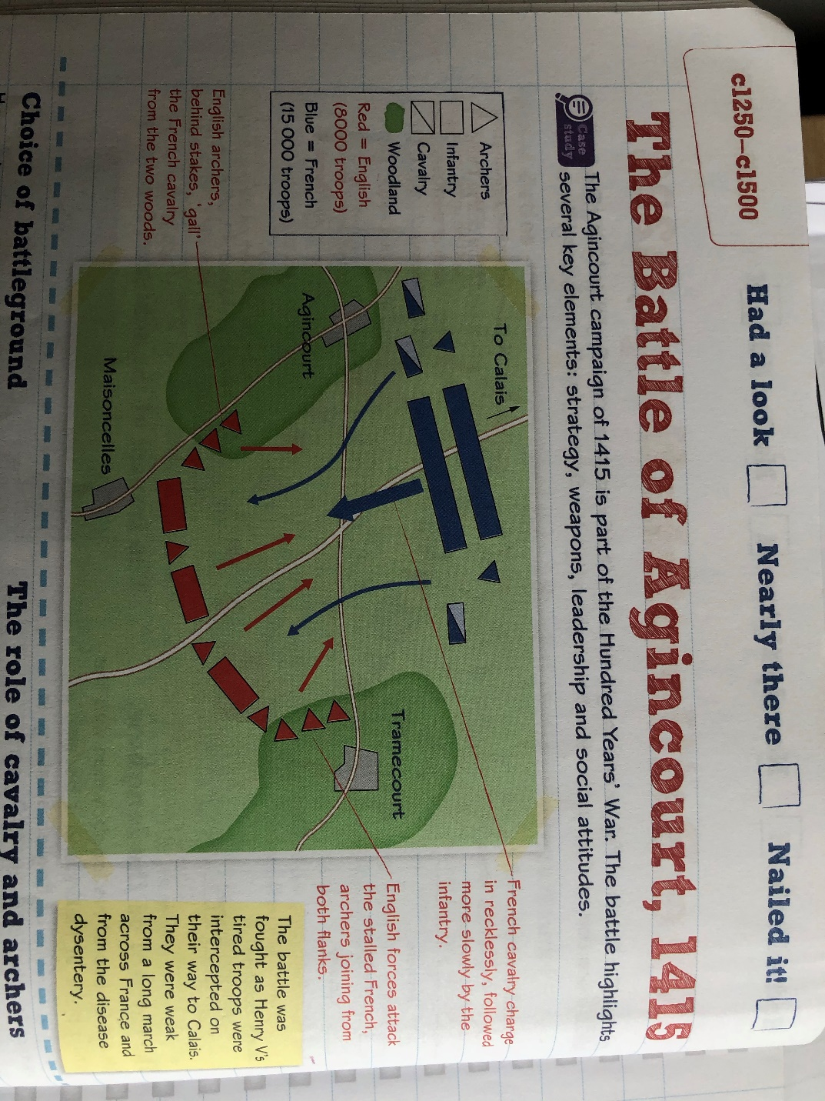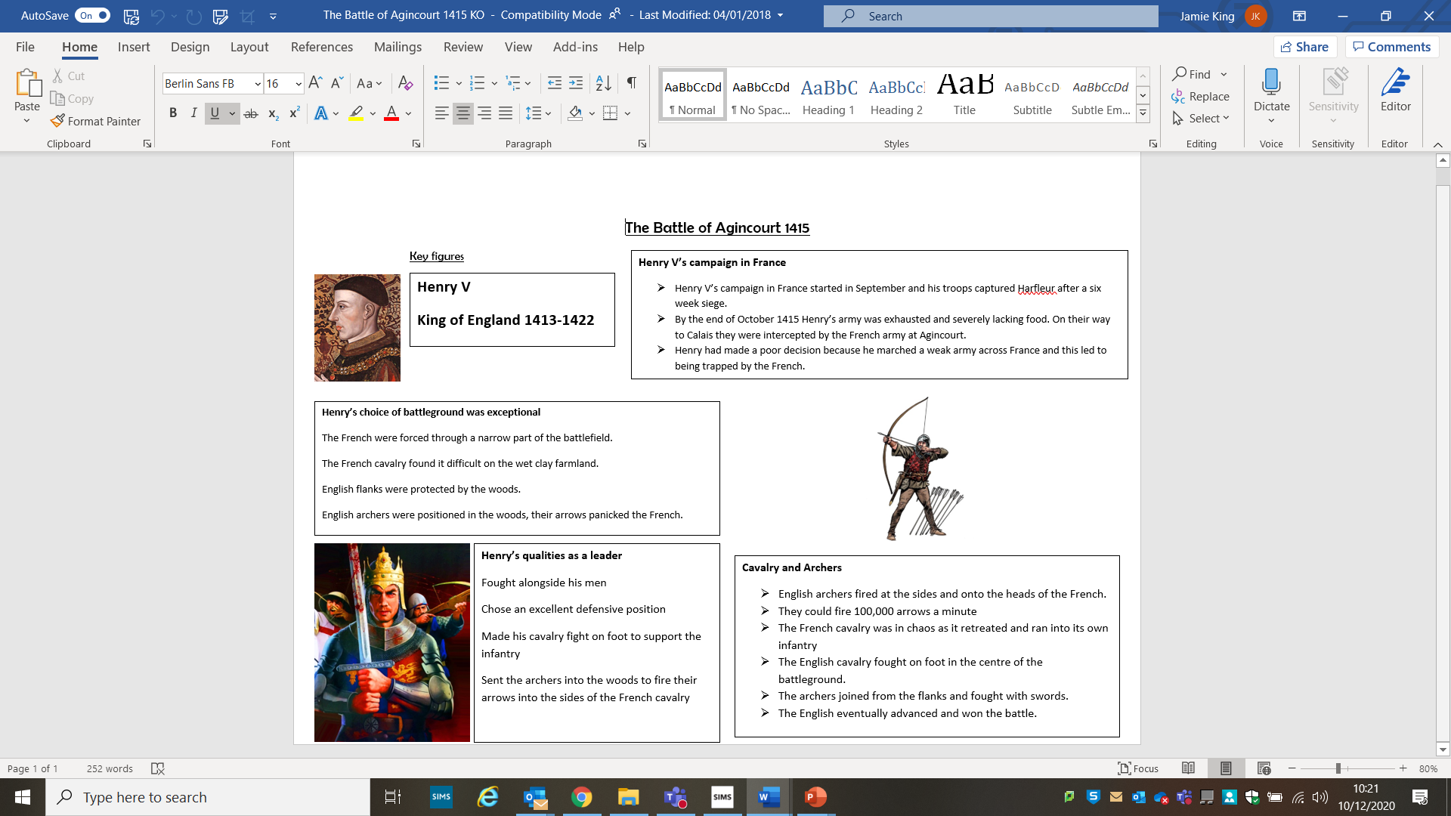

**Key Questions**

1. Why was Henry V’s choice of battlefield so important to his victory at Agincourt?
2. Watch this video from Kevin Hicks on the longbow. Describe the longbow and explain why it was such a powerful weapon in the 15th century. <https://www.youtube.com/watch?v=bGcm-J1ggfw>
3. Read about Henry V’s campaign in France. Why should he be considered a lucky king?
4. What exceptional qualities did Henry V have as a leader?
5. Why did the English win the Battle of Agincourt?

|  |  |
| --- | --- |
| Lesson | Tasks complete |
| Medieval Warfare |  |
| Falkirk 1298 |  |
| The Impact of Gunpowder |  |
| The Impact of Warfare on civilians |  |
| Agincourt 1415 |  |