Religious Education Year 9 Summer two Blended Learning Booklet

Poverty

Name:

Form:

*Aim to complete one lesson each week. Write out the title and LI and then complete the tasks.*

*All video links are online using the ClassCharts link.*

*The Knowledge Organiser has all the key information and vocabulary to help you with this unit.*

*Upload all work onto ClassCharts for feedback.*

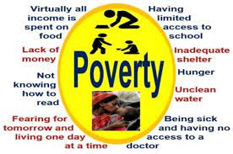

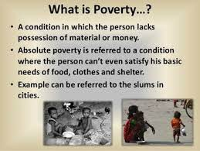

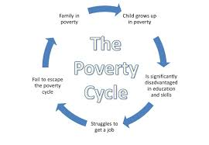

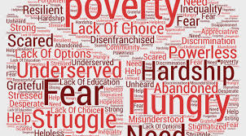

Lesson 1 What is Poverty?

**LI: To explore what poverty is and reasons why it exists.**

Do now task;

Write down what you think the world poverty means.

Please learn these spellings.

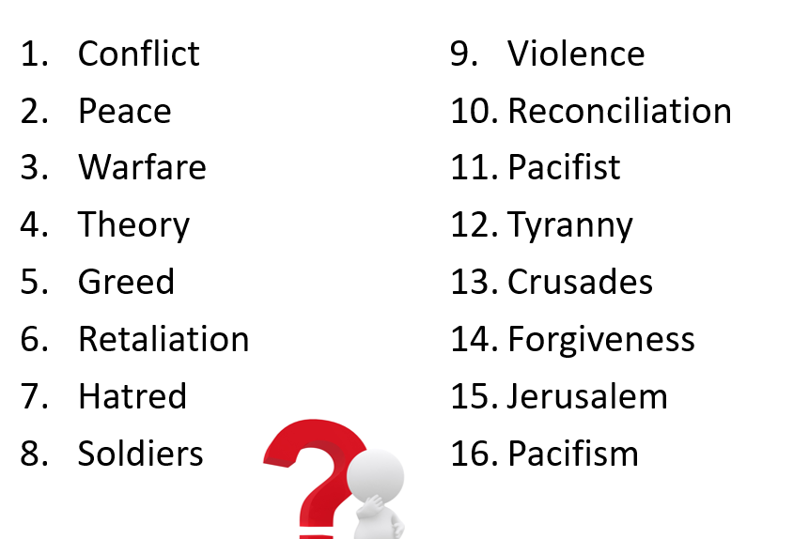

Task1: without looking at the definition try to explain What is poverty?

Write down how you would describe poverty and then write down the full description below.

**Poverty is a state or condition in which a person or community lacks the financial resources and essentials for a minimum standard of living. Poverty means that the income level from employment is so low that basic human needs can't be met.**



**Key questions – what do you think?**

**What do you think we can do to help reduce poverty?**

**Is there a way we can eradicate / get rid of poverty forever?**

**Can poverty every finish?**

**Lesson 2: Short term vs long term poverty aid.**

**Learning Intention**

**To discover the differences between short term and long term aid.**

**Do now task;**

**What can you remember from last lesson?**

**What is poverty and why does it occur?**

**Create a list or mind map of everything you remember.**

**What do you think short term aid is?**

**What do you think long term aid is?**

**Short term aid is help that is given to people immediately .**

**Long term aid is help given to the country to rebuild itself.**

**Lesson 3: Religious teachings about poverty**

**Learning Intention**

**To identify religious attitudes and teachings about poverty.**

**Do now task;**

**What does LEDC’s and MEDC’s stand for?**

**What do you think?**

**What do you think religious groups would say about poverty and people living in poverty?**

Key questions – what do you think?

What do you think the key learning is from both of this story from Judaism and Christianity?

Why do you think it is seen as important to support those in need?

Lesson 4: Exploitation of the poor.

Learning Intention

To consider how those with less are exploited for financial gain.

Do now task;

How do you think people exploit those that have less?

Task: How do you think people exploit those that have less?

Lesson 5: Religious views on wealth

Learning Intention

To consider the responsibility of the wealthy and how wealth should be used.

Do now task;

If you won the lottery, what would you do with the money?

Learn the following spellings for a test:

Lesson 6: Religious Studies Final Lesson Year 9

Learning Intention

To review the topics we have covered this academic year in the format of a group quiz.

Do now task;

Read over your book and review the notes you have made throughout the academic year.

