Geography Year 11
Blended Learning Booklet

Y11-2 Coasts

Name:
Form:

Aim to complete one lesson each week. Write down the title and LI for each lesson and then complete the tasks which are highlighted.
The Knowledge Organiser on page 3 has all the key information and vocabulary to help you with this unit.
Upload all work onto ClassCharts for feedback.

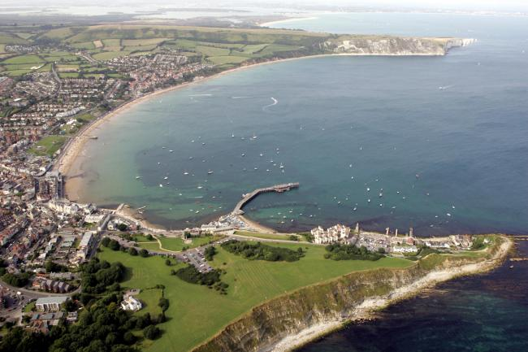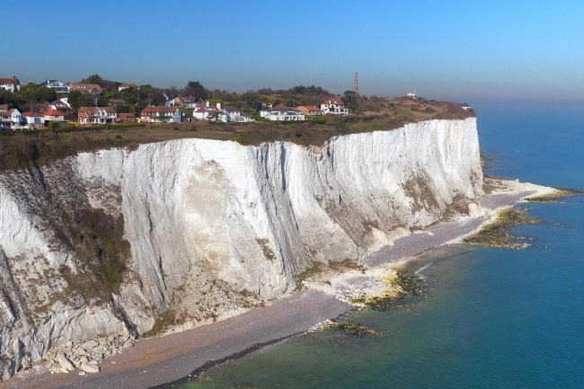

Contents
Page 2: Big Picture - Year 11 Overview
Page 3: Zoom in - My Learning Journey
Page 4: Lesson 1
Pages 5 & 6: Lesson 2
Pages 7 & 8: Lesson 3
Page 9: Lesson 4
Pages 10 & 11: Lesson 5
Page 12: Lesson 6
Page 13: Lesson 7
Page 14: Lesson 8
Page 15: Lesson 9

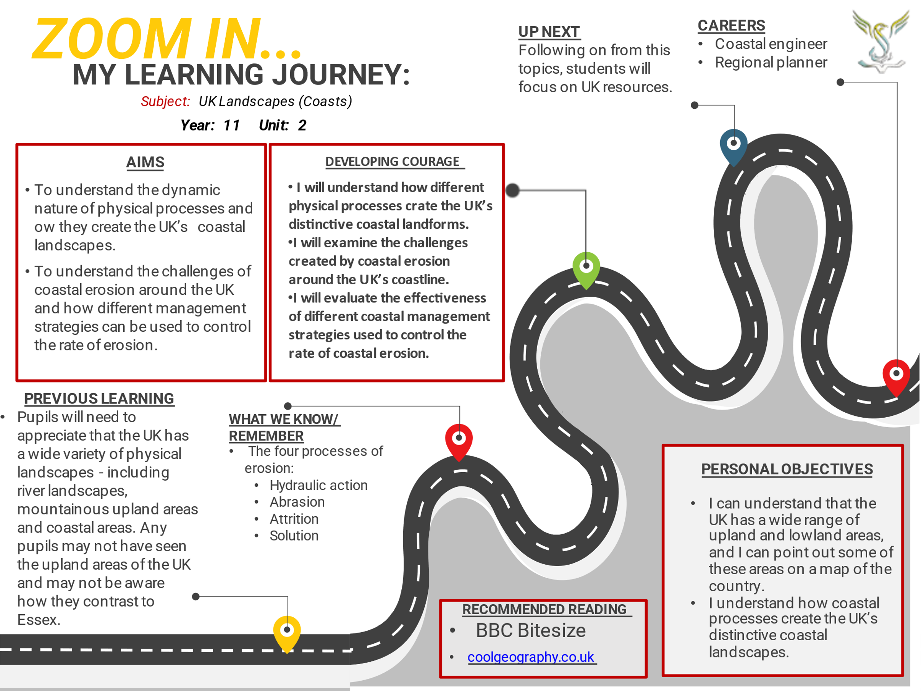

Lesson One: UK Landscapes
- LI: To identify that the UK has a range of diverse landscapes.

Lake District (Northern England):

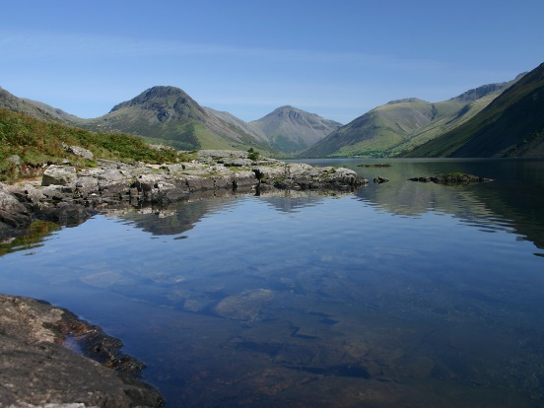
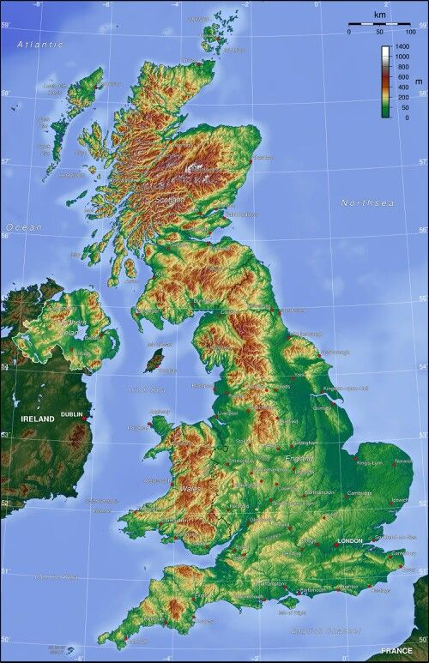
TASKS to complete:
- Describe each landscape – notables features, height and shape of the land.
- Draw a line from each photo and locate the landscape on the map above. Use online maps or an atlas to help you.
- Use the map to identify highland and mountain areas and areas which are low lands

Dorset Coast (Southern England):

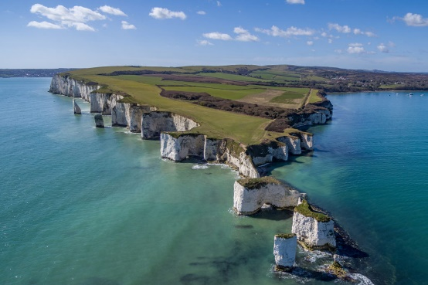

Scottish Highlands:

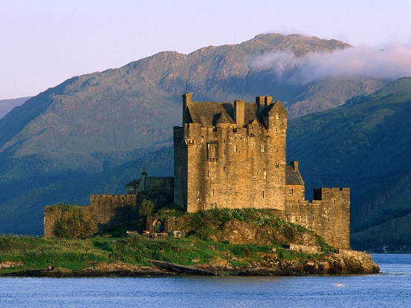

Essex countryside:

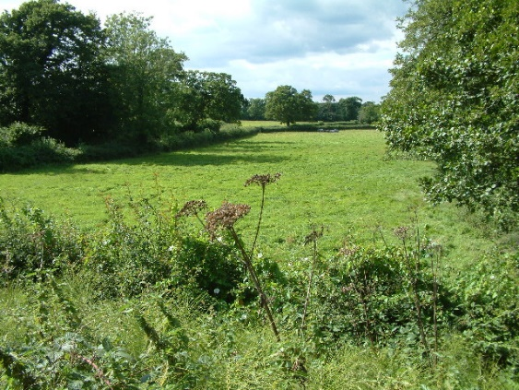

Watch the video on UK landscapes: https://www.youtube.com/watch?v=H8uy86v6Kaw

Lesson Two: Coastal processes
- LI: To define and describe the physical processes which shape coastlines – weathering, erosion and mass movement.

Read through the following coastal processes:

Types of weathering
Exposed rocks along the coastline can be broken down by the processes of weathering.

Freeze-thaw weathering
Freeze-thaw weathering occurs when rocks are porous (contain holes) or permeable (allow water to pass through).
- Water enters cracks in the rock.
- When temperatures drop, the water freezes and expands causing the crack to widen.
- The ice melts and water makes its way deeper into the cracks.
- The process repeats itself until the rock splits entirely.

Biological weathering
Plants and animals can also have an effect on rocks. Roots burrow down, weakening the structure of the rock until it breaks away.
- Plant roots can get into small cracks in the rock.
- As the roots grow, the cracks become larger.
- This causes small pieces of rock to break away.

Chemical weathering
Rainwater and seawater can be a weak acid. If a coastline is made up of rocks such as limestone or chalk, over time they can become dissolved by the acid in the water.

Methods of erosion
Erosion is the wearing away of rock along the coastline. Destructive waves are responsible for erosion on the coastline. There are four types of erosion:
- Hydraulic action - this is the sheer power of the waves as they smash against the cliff. Air becomes trapped in the cracks in the rock and causes the rock to break apart.
- Abrasion - this is when pebbles grind along a rock platform, much like sandpaper. Over time the rock becomes smooth.
- Attrition - this is when rocks that the sea is carrying knock against each other. They break apart to become smaller and more rounded.
- Solution - this is when sea water dissolves certain types of rocks. In the UK, chalk and limestone cliffs are prone to this type of erosion.

Tasks: Create you own revision cards or notes which describe and define the processes of weathering and erosion

Watch the video on the processes of weathering, erosion and deposition:

https://www.youtube.com/watch?v=ewj629B4Oe8

Task: Create your own revision notes for each of the processes of mass movement detailed above

Mass movements:

Rockfall: Bits of rock fall off the cliff face, usually due to freeze-thaw weathering.

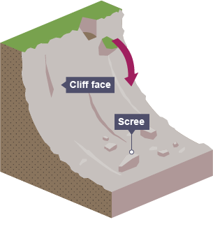

Landslide: Large blocks of rock slide downhill.
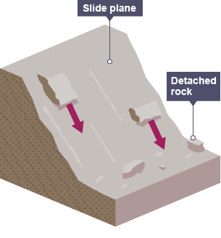

Rotational slip: Saturated soil slumps down a curved surface.

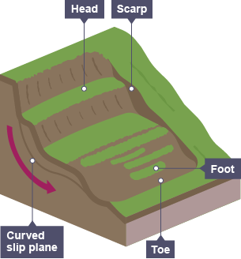

Lesson Three: Coastal processes
- LI: To define and describe the physical processes which shape coastlines – waves, transportation and deposition.

TASK: Using the information below, compare how constructive waves and destructive waves – what are their similarities and differences?

Wave types
There are two different types of wave - constructive and destructive. They can affect the coastline in different ways. When a wave reaches the shore, the water that rushes up the beach is known as the swash. The water that flows back towards the sea is known as the backwash. The energy of the swash and backwash determine the type of wave.
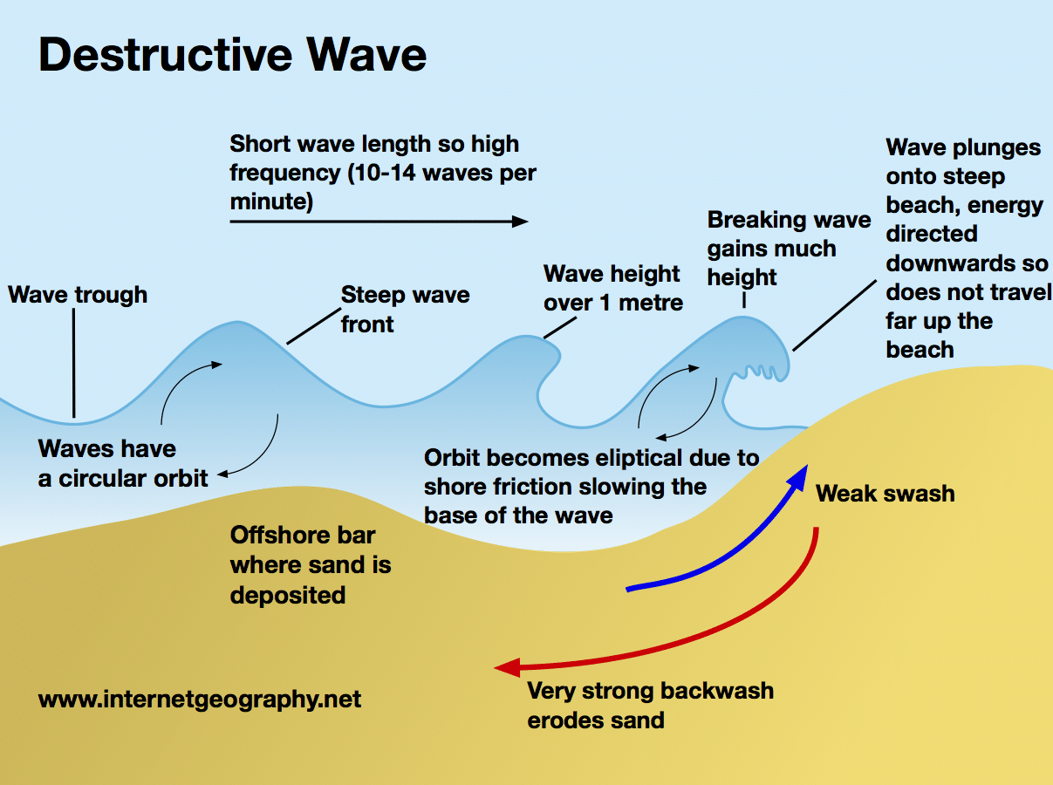

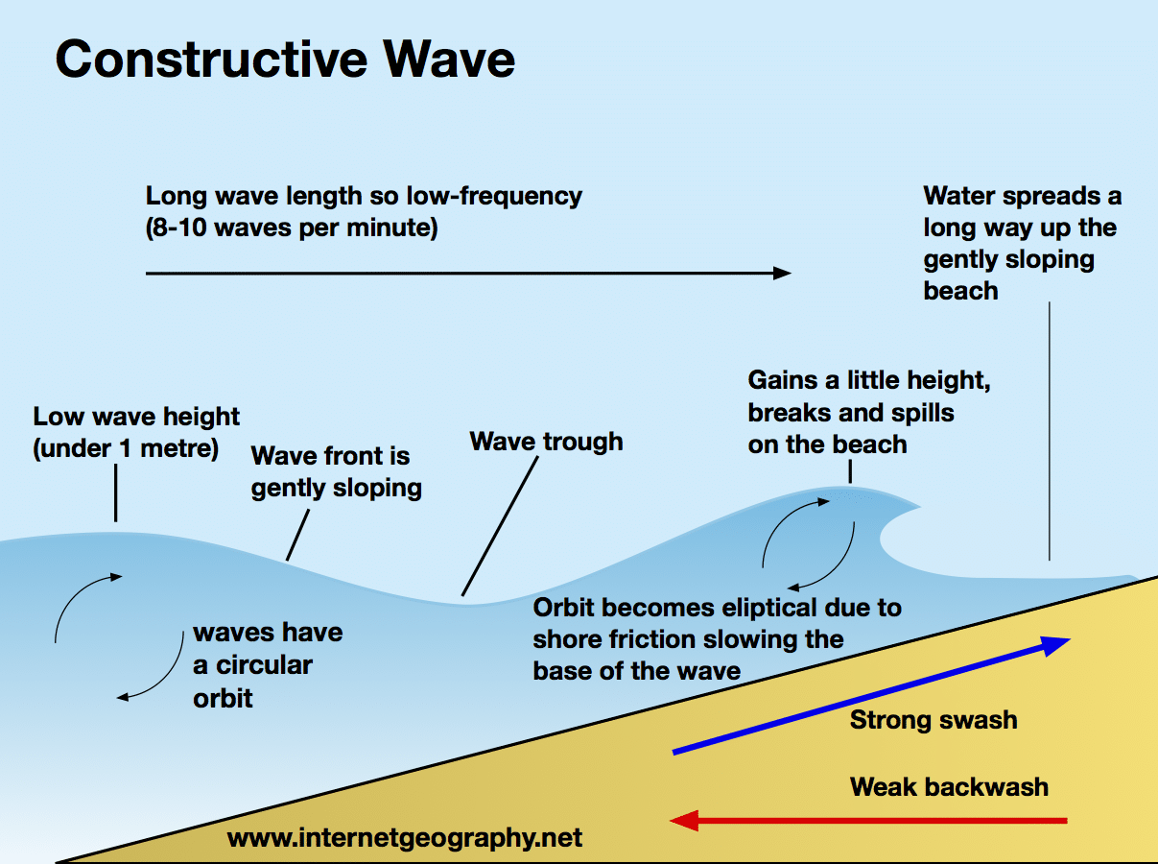

TASK – watch the video on waves: https://www.youtube.com/watch?v=YtEAXPlfUK8

TASK – watch the video on longshore drift: https://www.youtube.com/watch?v=3bENNfLUIdw

Processes of transportation
Beach material can be moved in four different ways. These are:
- Solution - when minerals in rocks like chalk and limestone are dissolved in sea water and then carried in solution. The load is not visible.
- Suspension - small particles such as silts and clays are suspended in the flow of the water.
- Saltation – where small pieces of shingle or large sand grains are bounced along the sea bed.
- Traction – where pebbles and larger material are rolled along the sea bed.

Longshore drift
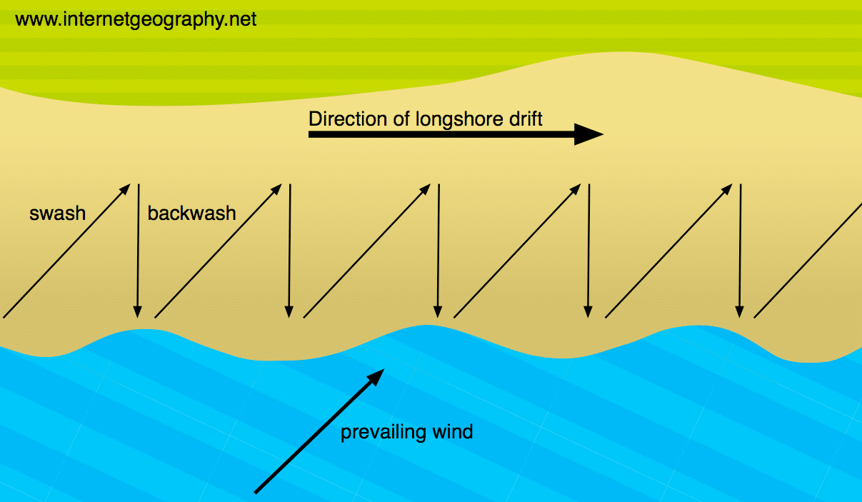
Sediment is carried by the waves along the coastline. The movement of the material is known as longshore drift. Waves approach the coast at an angle because of the direction of prevailing wind. The swash will carry the material towards the beach at an angle. The backwash then flows back to the sea, down the slope of the beach. The process repeats itself along the coast in the zigzag movement.

Deposition
When the sea loses energy, it drops the material it has been carrying. This is known as deposition. Deposition can occur on coastlines that have constructive waves.
Factors leading to deposition include:
- waves starting to slow down and lose energy
- shallow water
- sheltered areas, e.g. bays
- little or no wind

Tasks: Using the notes above, create your own revision cards/notes on the processes of transportation and deposition.

Lesson Four: Coastal landforms - erosion landforms
- LI: To explain the formation of distinctive coastal landforms created by erosion – headlands and bays.

Task - watch the video on the formation of headlands & bays: https://www.youtube.com/watch?v=F1PtFRs23EA

Headlands and bays
Cliffs along the coastline do not erode at the same pace. When a stretch of coastline is formed from different types of rock, headlands and bays can form.
Bands of soft rock such as clay and sand are weaker therefore, they can be eroded quickly. This process forms bays. A bay is an inlet of the sea where the land curves inwards, usually with a beach. Hard rock such as chalk is more resistant to the processes of erosion. When the softer rock is eroded inwards, the hard rock sticks out into the sea, forming a headland.
Erosional features such as wave-cut platforms and cliffs can be found on headlands, since they are more open to the waves. Bays are more sheltered with constructive waves which deposit sediment to form a beach.
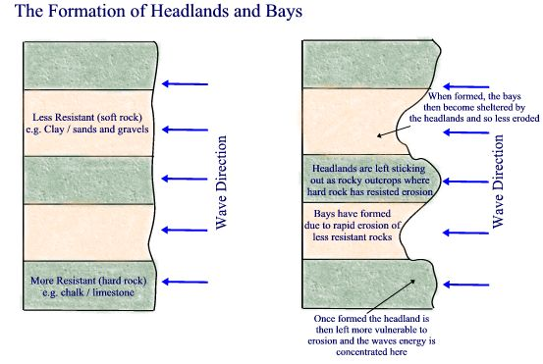

Task: Using the diagram and notes above, describe the formation of headlands and bays. Draw your own diagram to help you.

Lesson Five: Coastal landforms - erosion landforms
- LI: To explain the formation of distinctive coastal landforms – caves, arches & stacks and cliffs.

Watch the video on the formation of caves, arches and stacks: https://www.youtube.com/watch?v=00Khn0RSpYA

Caves, arches, stacks and stumps
Caves, arches, stacks and stumps are erosional features that are commonly found on a headland.
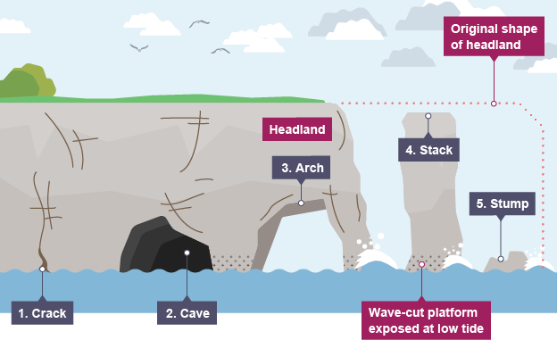
- Cracks are widened in the headland through the erosional processes of hydraulic action and abrasion.
- As the waves continue to grind away at the crack, it begins to open up to form a cave.
- The cave becomes larger and eventually breaks through the headland to form an arch.
- The base of the arch continually becomes wider through further erosion, until its roof becomes too heavy and collapses into the sea. This leaves a stack (an isolated column of rock).
- The stack is undercut at the base until it collapses to form a stump.
TASK: Describe the formation of caves, arches and stacks in your own words.

Cliffs and wave-cut platforms
Cliffs are shaped through erosion and weathering. Soft rock erodes quickly and forms gentle sloping cliffs, whereas hard rock is more resistant and forms steep cliffs. A wave-cut platform is a wide gently-sloping surface found at the foot of a cliff.
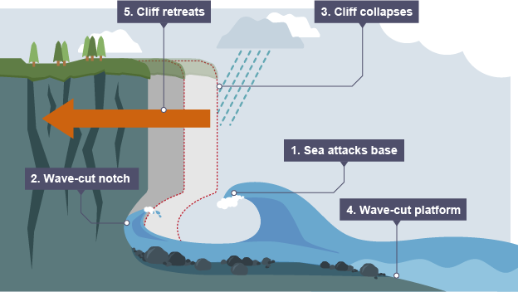
A wave-cut platform is formed when the following occurs:

- The sea attacks the base of the cliff between the high and low water mark.
- A wave-cut notch is formed by erosional processes such as abrasion and hydraulic action - this is a dent in the cliff usually at the level of high tide.
- As the notch increases in size, the cliff becomes unstable and collapses, leading to the retreat of the cliff face.
- The backwash carries away the eroded material, leaving a wave-cut platform.
- The process repeats. The cliff continues to retreat.

TASK: Describe the formation of cliffs and wave-cut platforms in your own words.

Lesson six: Coastal landforms - deposition landforms
- LI: To explain the formation of distinctive coastal landforms created by deposition – beaches, bars and sand dunes.

Read through the following information:

Spits
A spit is an extended stretch of sand or shingle jutting out into the sea from the land. Spits occur when there is a change in the shape of the landscape or there is a river mouth.
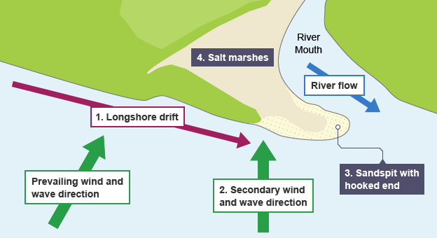
This is how spits are formed:
- Sediment is carried by longshore drift.
- When there is a change in the shape of the coastline, deposition occurs. A long thin ridge of material is deposited. This is the spit.
- A hooked end can form if there is a change in wind direction.
- Waves cannot get past a spit, therefore the water behind a spit is very sheltered. Silts are deposited here to form salt marshes or mud flats.

Beaches
Beaches are made up from eroded material that has been transported from elsewhere and then deposited by the sea. For this to occur, waves must have limited energy, so beaches often form in sheltered areas like bays. Constructive waves build up beaches as they have a strong swash and a weak backwash.
Sandy beaches are usually found in bays where the water is shallow and the waves have less energy. Pebble beaches often form where cliffs are being eroded, and where there are higher energy waves.
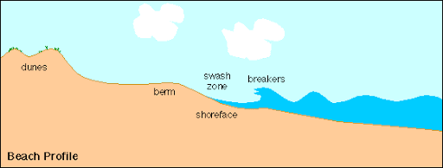
A cross-profile of a beach is called the beach profile. The beach profile has lots of ridges called berms. They show the lines of the high tide and the storm tides. A sandy beach typically has a gentle sloping profile, whereas a shingle beach can be much steeper. The size of the material is larger at the top of the beach, due to the high-energy storm waves carrying large sediment. The smallest material is found nearest the water as the waves break here and break down the rock through attrition.
TASK: Describe the formation of a spit.

TASK: Explain why beaches usually form in sheltered areas.

Lesson Seven: Protecting coastlines - hard engineering
- LI: To explain how hard engineering management strategies can be used to protect coastlines.

Read through the following information about hard engineering:

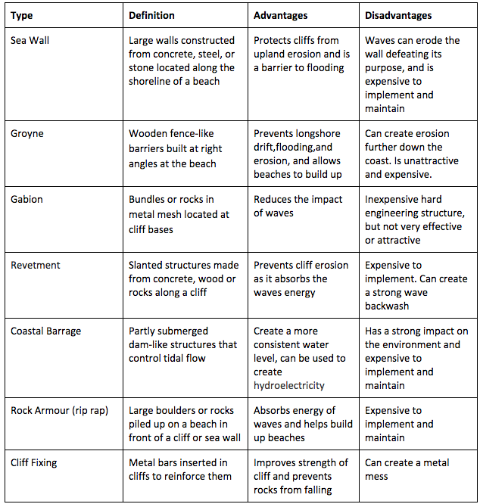

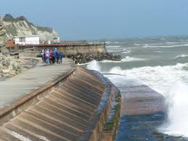

TASK: Which methods of hard engineering have been used in the image above? Are they effective?
TASK: What are the advantage and disadvantages of using hard engineering to protect coastlines?

Lesson Eight: Protecting coastlines - Soft engineering
- LI: To explain how soft engineering management strategies can be used to protect coastlines.

Read through the following information about hard engineering:

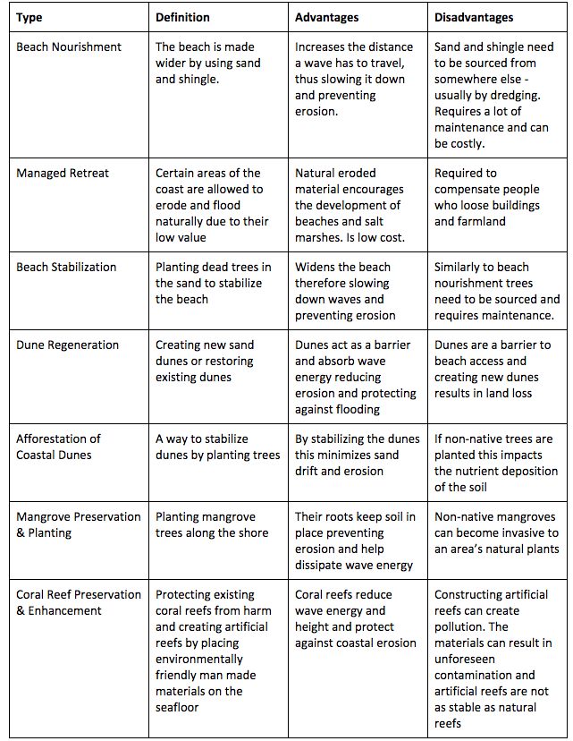

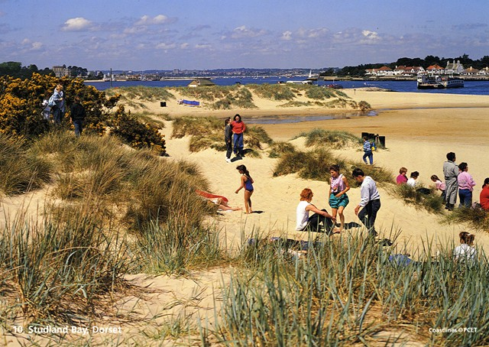
Studland Bay in Dorset

TASK: Which method of soft engineering has been used in the image above? Why is it highly effective?
TASK: What are the advantage and disadvantages of using soft engineering to protect coastlines?

Lesson Nine: Protecting coastlines – Holderness case study
- LI: To explain how management strategies have been used to protect a specific UK coastline.

Read through the following information about a coastal management case study:

The Holderness coastline – UK
The Holderness coastline in East Yorkshire is eroding very quickly. It is made from soft mud called Boulder Clay.
The coastline is retreating almost 2 metres every year – a European record! In the last 2000 years, the coast line has retreated by almost 2 miles.
The material from Holderness travels south towards the Essex coast and protects London from erosion.
There are many arguments for and against trying to save Holderness from erosion through building coastal defences along the coastline.
Arguments for saving Holderness:
- Local people want to save their own homes.
- Holderness is an area of good farmland and is useful for food production.
- People do not want to move to another area as they will lose their sense of community.
- Major North Sea gas terminals are located to the north of the village of Easington along the Holderness coast. This gas terminal supplies the UK with 25% of our gas for heating and cooking.

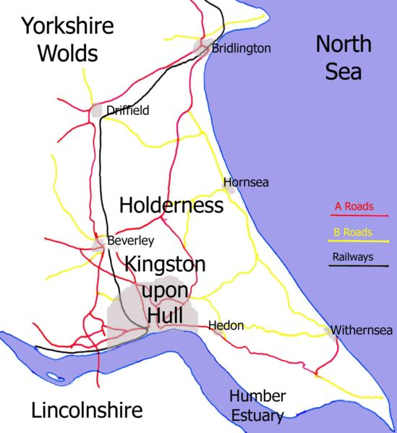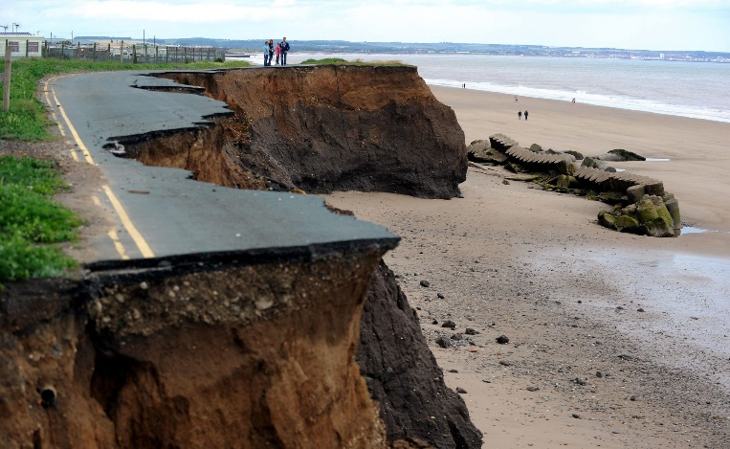
A map of the Holderness area and an example of coastal erosion along the Holderness coast
Arguments for NOT saving Holderness:
- Erosion is a natural process and the sand from Holderness helps protect more valuable places like London which has a population of nearly 9 million.
- Very few people live along this coastline (about 70,000).
- Building coastal defences will cost hundreds of millions of pounds – it could be spent elsewhere.
- Taxes would have to rise to pay for any coastal defences at Holderness. This would make people in other parts of the UK angry as they will see it as a waste of money.

QUESTIONS:
Q1) Describe the location of the Holderness coast.
Q2) How quickly is the Holderness coastline eroding?
Q3) What is the link between erosion at Holderness and London?
Q4) What are the arguments for protecting the Holderness coastline?
Q5) What are the argument for letting the Holderness coastline erode?
Q6) Do you think the Holderness coastline should be protected or should it be allowed to erode to help protect more important places like London?

