Religious Education Year 8 Summer Blended Learning Booklet
Religious leaders
Name:
Form:
Aim to complete one lesson each week. Write out the title and LI and then complete the tasks.
All video links are online using the ClassCharts link.
The Knowledge Organiser on pages 5 & 6 has all the key information and vocabulary to help you with this unit.
Upload all work onto ClassCharts for feedback.
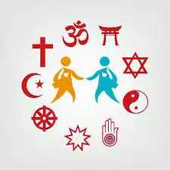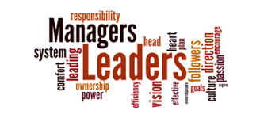
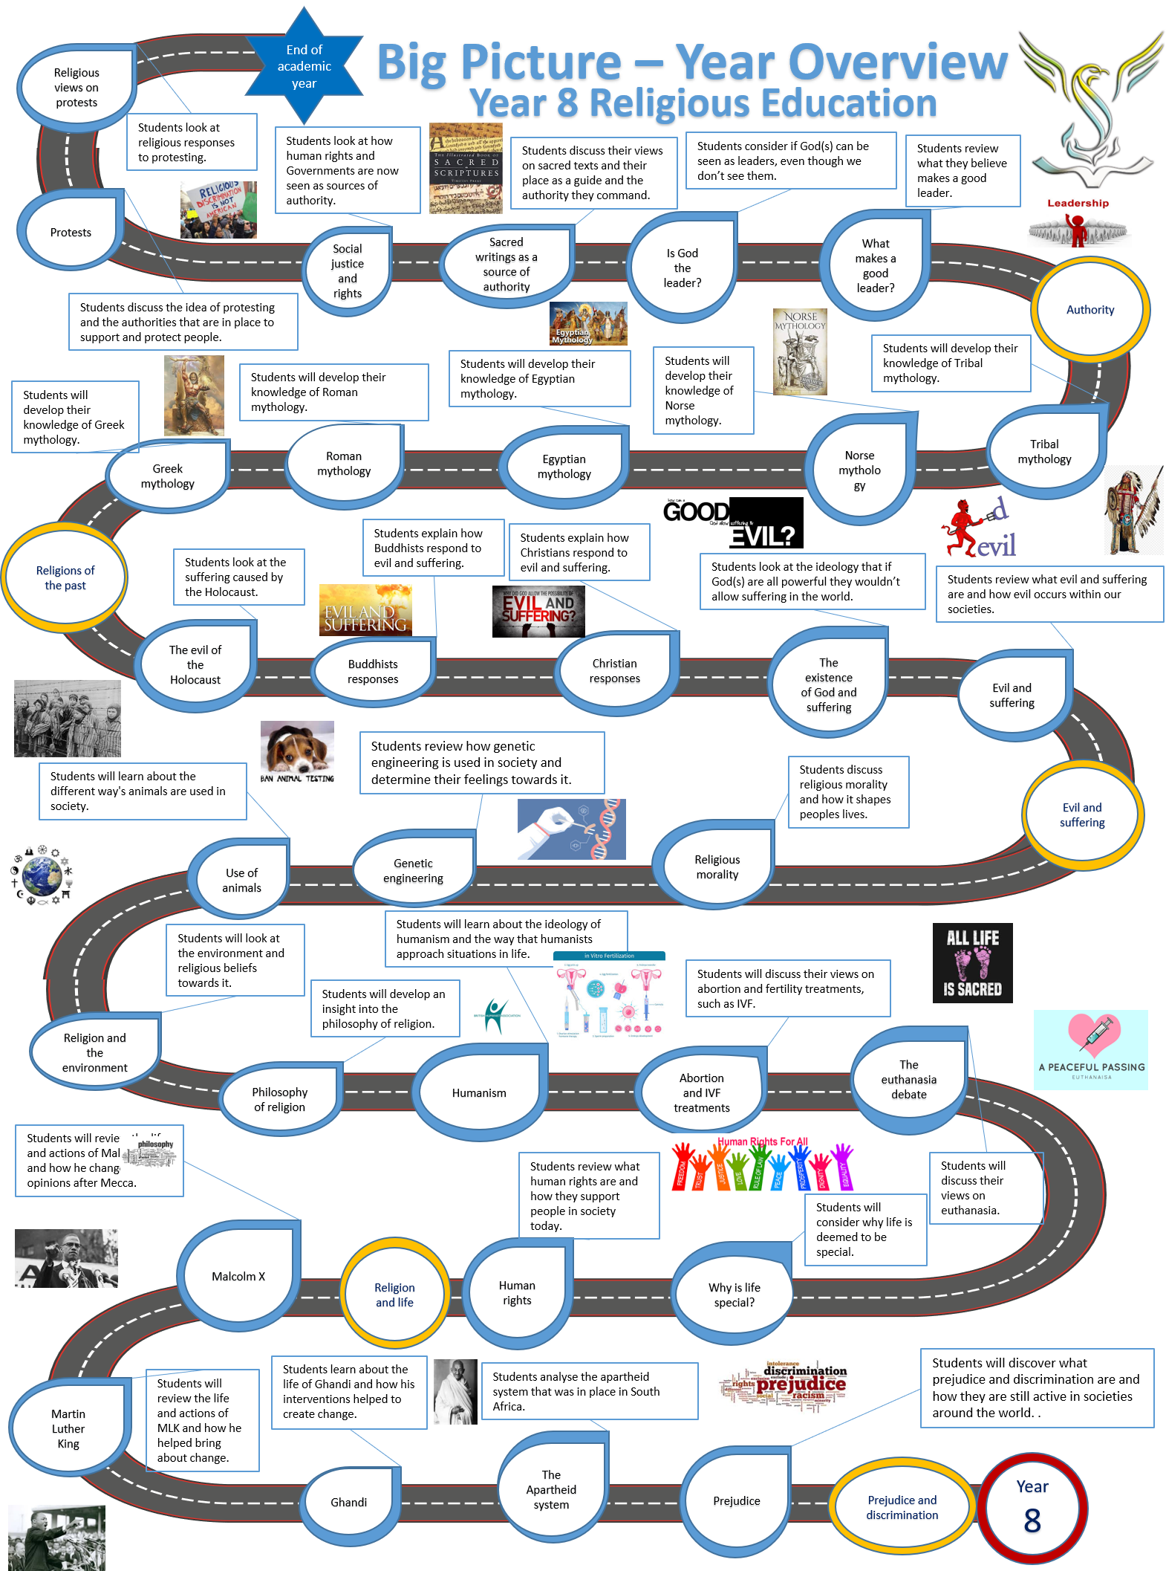

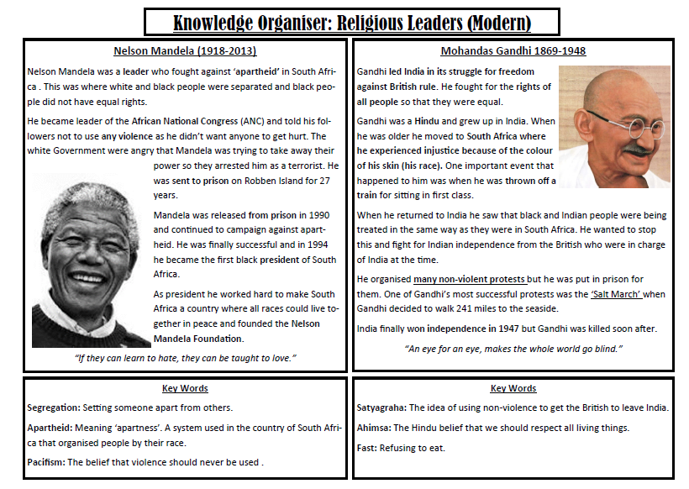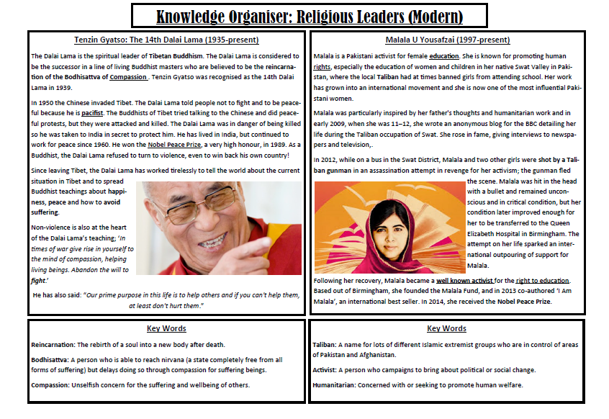
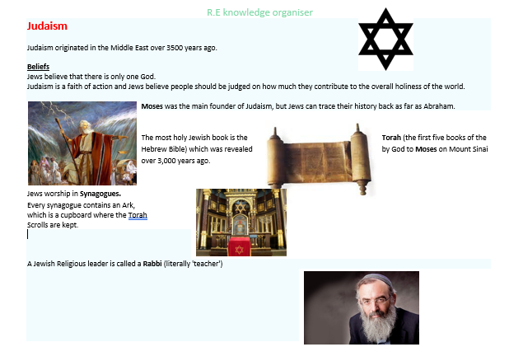
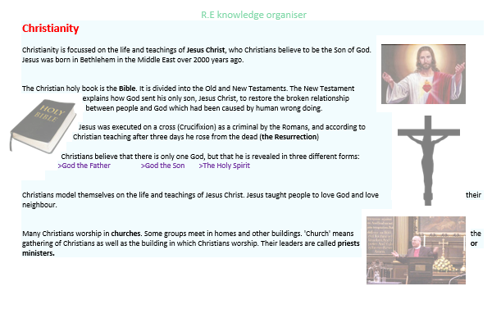

Lesson 1 What makes a good leader.
Learning Intention
To consider the characteristics that make a good leader.

Do now task.
Can you think of any characteristics that make a leader good? Create a list or mind map.

Learn the spelling list.
- Mythology
- Zeus
- Hades
- Titans
- Olympians
- Mount Olympus
- Underworld
- Sacrifices
- Egyptian
- Aboriginal
- Dreamtime
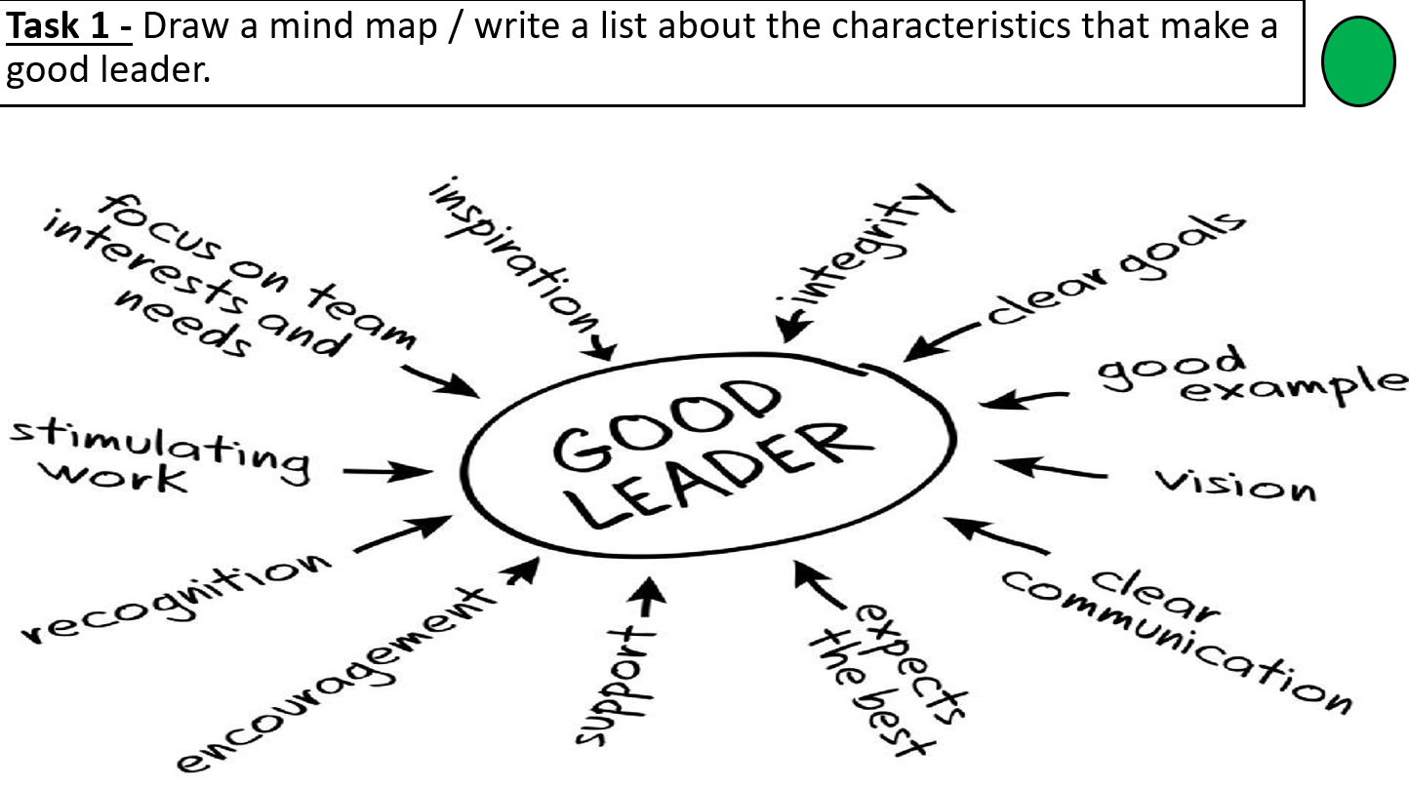

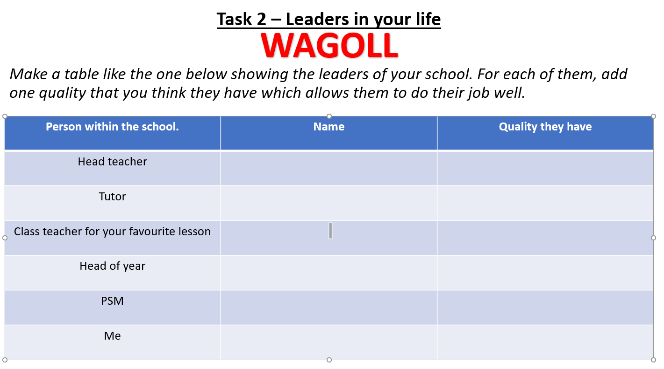

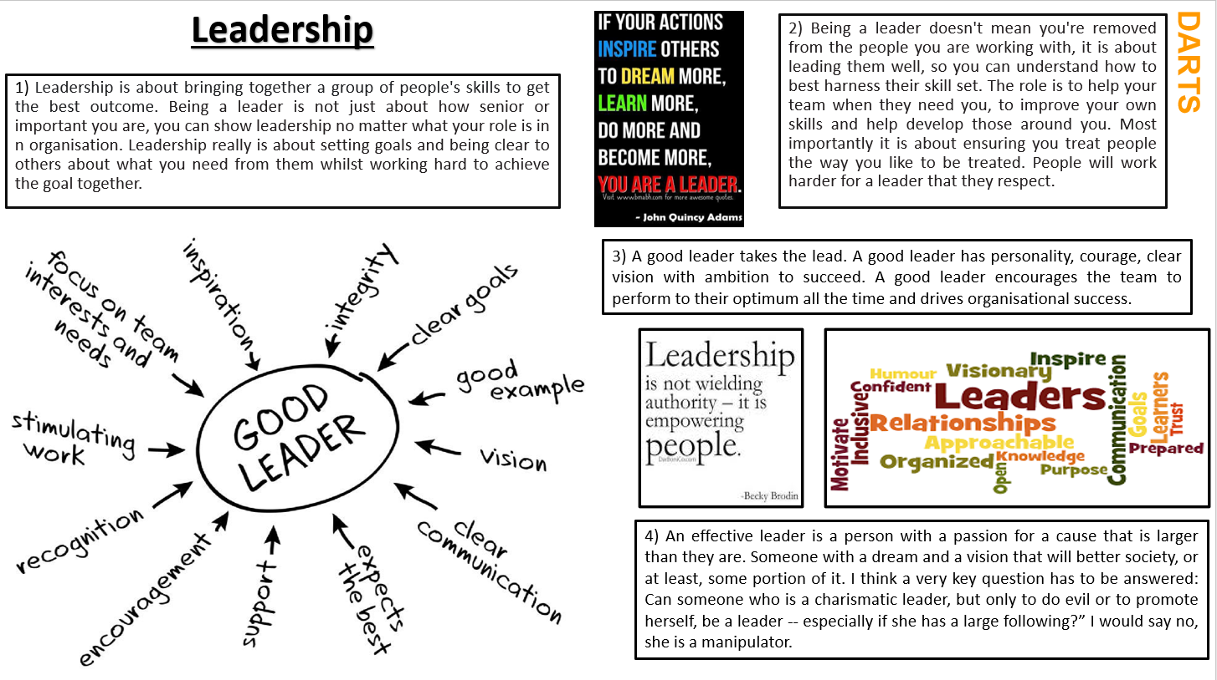

Task - DARTS key questions

What do you think is the most important quality of a leader in your life?
I think that the most important quality of a leader is… because…

Who do you consider to be a leader in your life?
In my life I believe that… is a leader because…

In your opinion, should a leader lead by example or lead by telling you what to do?
In my opinion, leader should lead by telling you what to do / by example, because…

Task: Explain briefly what a leader is.

WAGOLL
A leader is someone who leads by example and brings others with them on the journey to reach the teams / organisations goal.

Lesson 2: Religious leaders
Learning Intention
To reflect on whether religious leaders have authority from God.

Do now task;
Can you think of any religious leaders from any of the religions we have studied so far in years seven and eight?
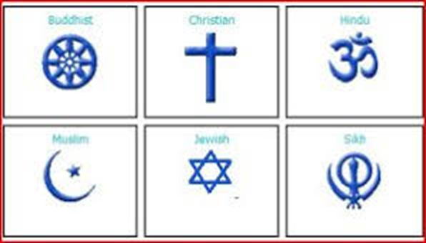
Task 1
Add in any you may have missed out (put them in using blue pen).

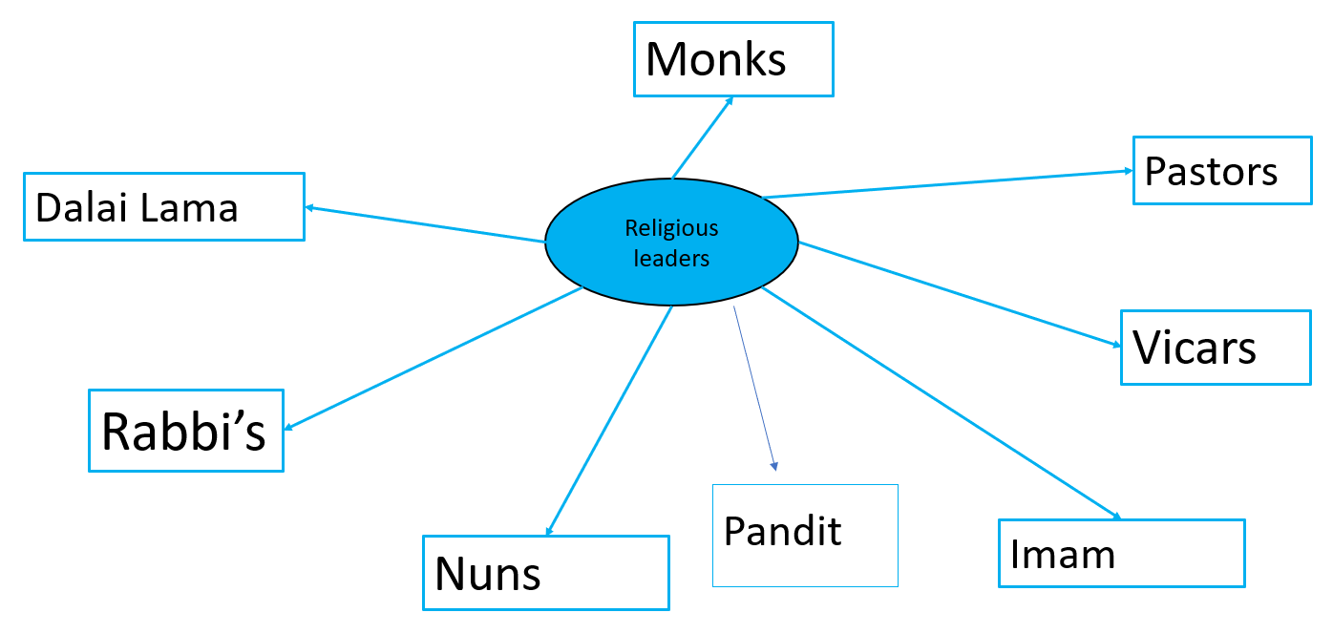

Task 2 –

What do religious leaders do?

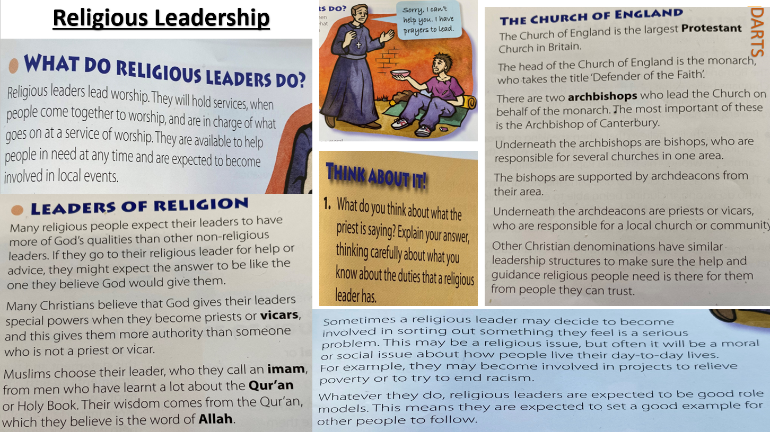

Task 3 - DARTS key questions

What do you think the most important role of a religious leader should be?
I think that the most important role of a religious leader is... Because…

Should a religious leader be serving God or their community more?
In my opinion a religious leader should focus on serving God / their community more because…

Task 4 – What would you do?

If you were a religious leader, what would be the thing you focused on more? Serving God, serving the community, learning more about your religion or something else? Explain your point of view giving details about why.

If I were a religious leader my main focus would be… because…

List three religious’ leaders.

1.
2.
3.

Lesson 3: Religious Texts
Learning Intention
To reflect on the idea of religious authority being shown through a sacred text.

Do now task.
Can you think of any holy books from different religious groups? Create a list or mind map.

Learn the spellings:

- Pope
- Imam
- Leadership
- Leader
- Communication
- Supportive
- Skills
- Personality
- Ambition
- Qualities
- Monks
- Pastors
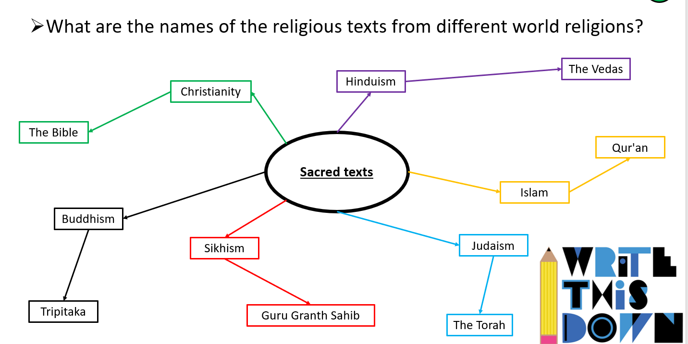
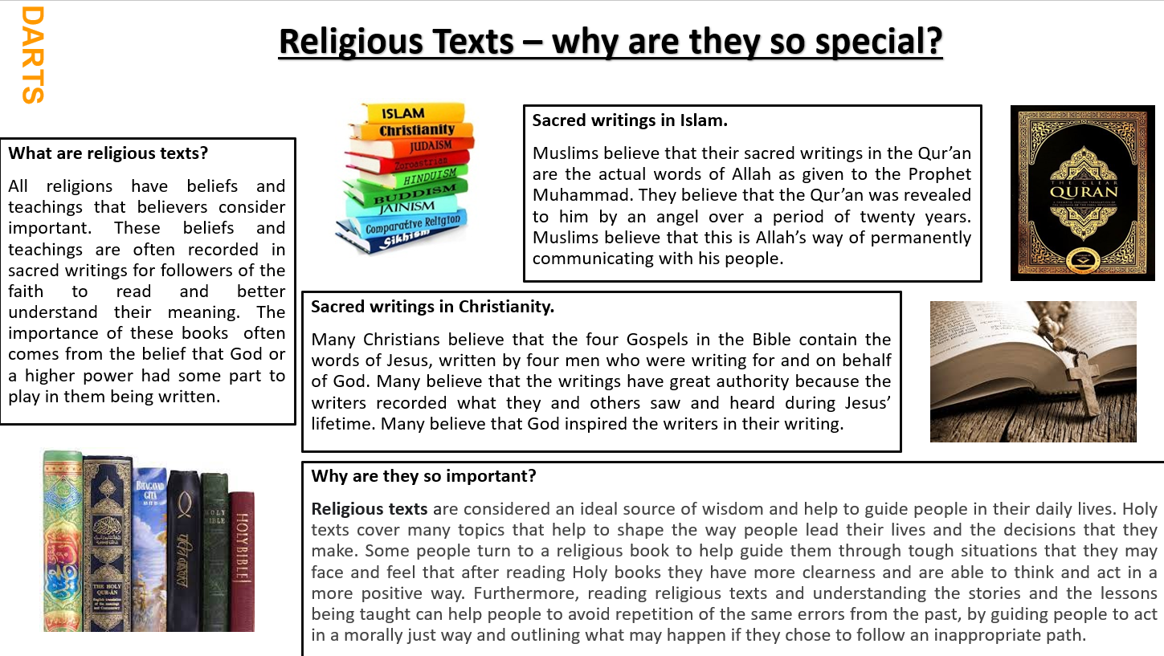

Why do you think religious texts have been given, by God throughout history? What is their purpose?

Do you think people should trust what their sacred books tell them?

Do you think these texts are still relevant today?

Task 4: DARTS questions

Why do you think religious texts have been given, by God throughout history? What is their purpose?
I believe / do not believe that religious texts have been given by God throughout history because…
Do you think people should trust what their sacred books tell them?
I think that people should / should not trust what their sacred book tells them because…
Do you think these sacred texts are still relevant today?
I believe that these sacred texts are still / not relevant today because…

Final task: Name three holy texts from the start of today’s lesson and which religion are they linked to.

Lesson 4: Sources of authority

Learning Intention
To consider what authority is and who has it in our lives.

Do now task.
Discuss with a partner, what do you think authority is?

What can we remember from last lesson?

Learn the spelling words:
- Leader
- Leadership
- Authority
- Responsible
- Bible
- Qur’an
- Pope
- Imam
- Vicar
- Guru
- Allah
- God
- Torah
- Guru Granth Sahib
- Morals
- Religion
- Religious
- Sacred
- Responsibility
- Worship
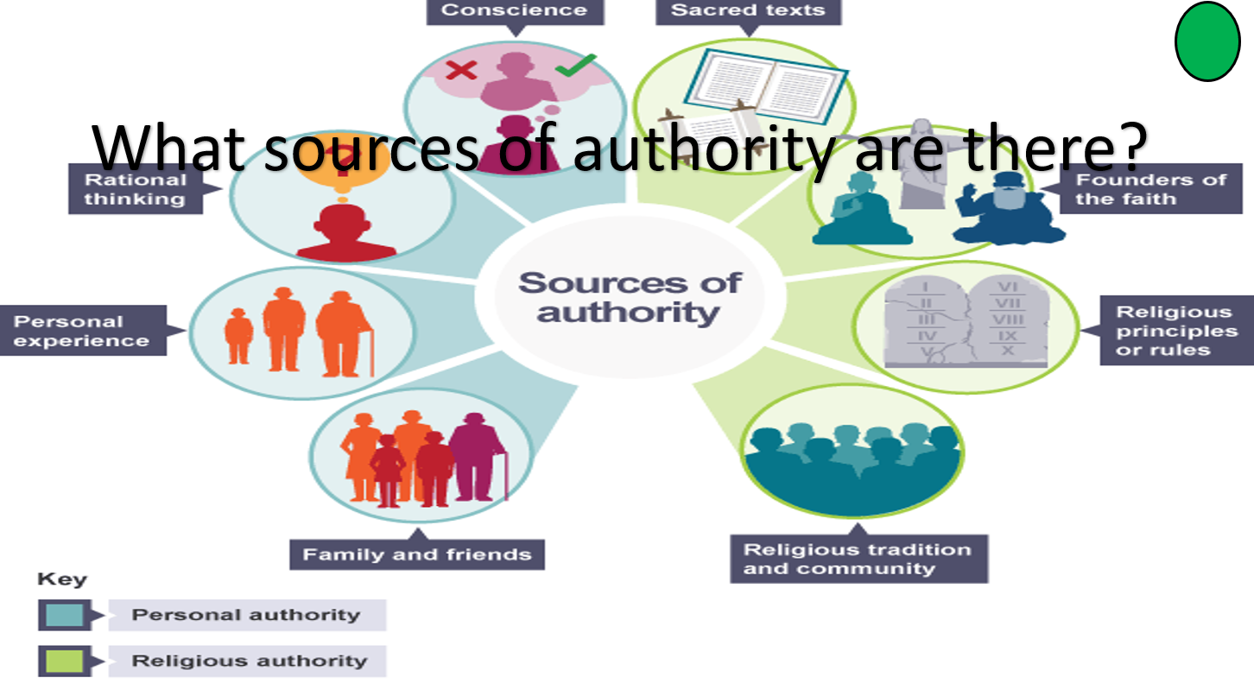

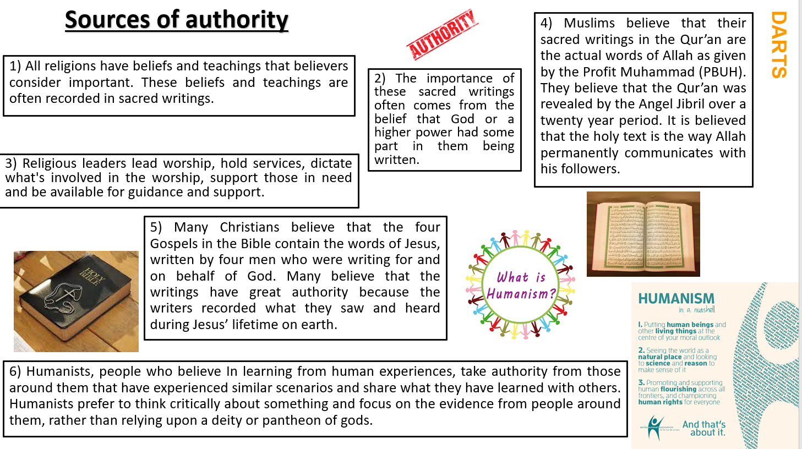

Task 4 - DARTS key questions

Why do you think that religious texts are considered to be an authority within each faith?

Which is more important do you think, religious leaders or religious texts? Explain your point of view.

Task 4 - DARTS key questions
Why do you think that religious texts are considered to be an authority within each faith?
In my opinion religious texts are considered to be a source of authority within religious groups because…
Which is more important do you think, religious leaders or religious texts? Explain your point of view.
I think that religious leaders / religious texts are the most important for religious followers because…

Give the definition for what a Humanist is.

Humanists are people who believe in learning from human experiences and take authority from those around them that have experienced similar scenarios and share what they have learned with others.

Lesson 5: Morals and Conscience

Learning Intention
To find out what conscience is and where it might come from.

Do now task;
Discuss with a partner, what do you think the conscience is?

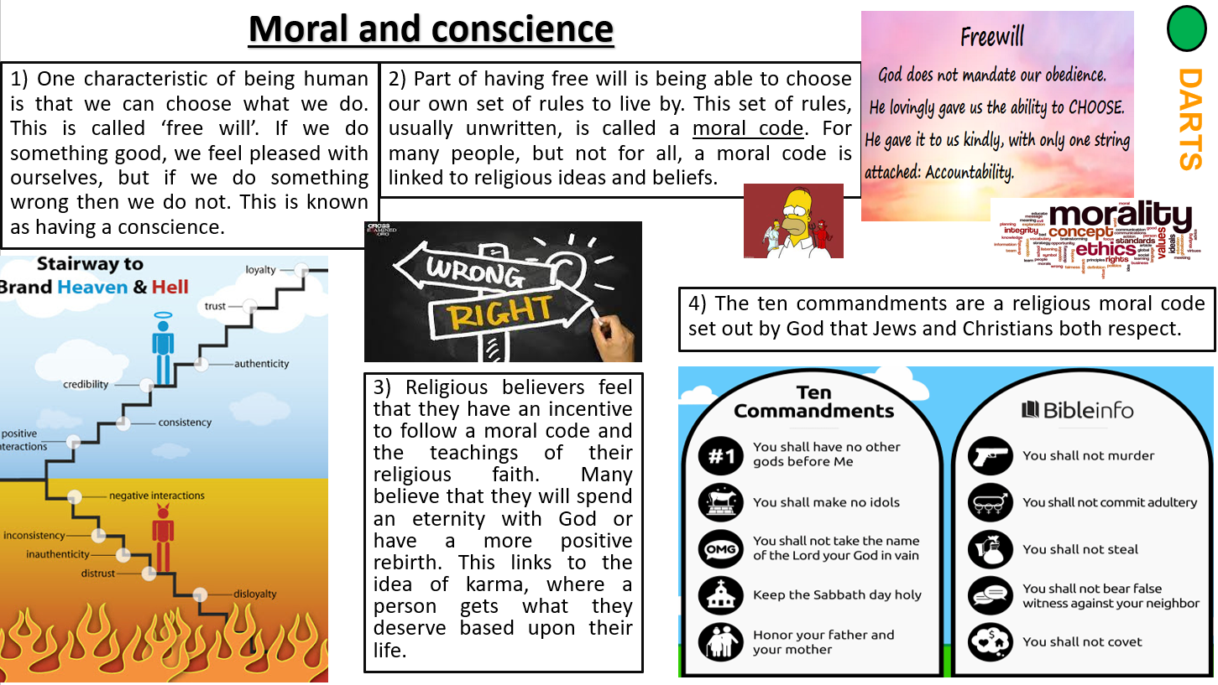

Task - Key questions

Does your own moral code allow you to do the following?
Tell lies all the time.
Tell lies in some circumstances.
Steal because you want something you cannot afford.
Disrespect your parents because they are getting on your nerves.
Take something, such as food, because you need to support your family.

How do your morals change in different situations?
What would you do?
The school is offering rewards for good behaviour, you need to have a certain number of positive points, you have five too few. The teacher leaves the room, and you can see the laptop is open on the class page and you could easily add the five points on, what do you do?
If you do not add the points on someone you think that does not deserve to go will go instead, what do you do?
If you do not add the points on you will be the only person in the class that does not go, what do you do?
If you put on the five points one child will miss out, do you add the points?
If you add the points your best friend does not get the reward, what do you do?
You find out that the reward is a trip to go ice skating, what do you do?
You find out the trip is to go to a theme park, free of charge, what do you do?
Your teacher offers to put on the five points, because they think you deserve to go, what do you do?

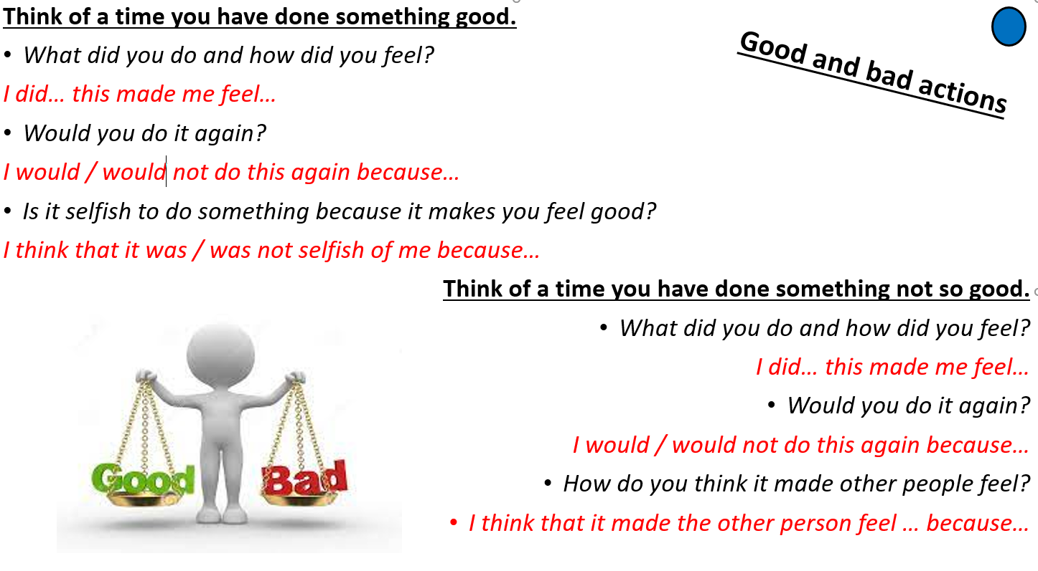

Why do you think it is important for religious believers, to make good moral decisions?

I think it is important for religious believers to make good moral decisions because…
Lesson 6:

