GCSE English Language & Literature Blended Learning Booklet:

Unit 2 – Transactional Writing & Literature Revision
Name:
Form:
Class Teacher:

AO5 and A06 Mark Scheme
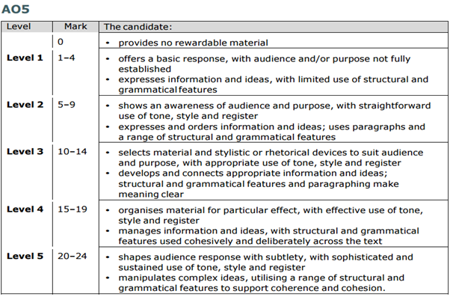
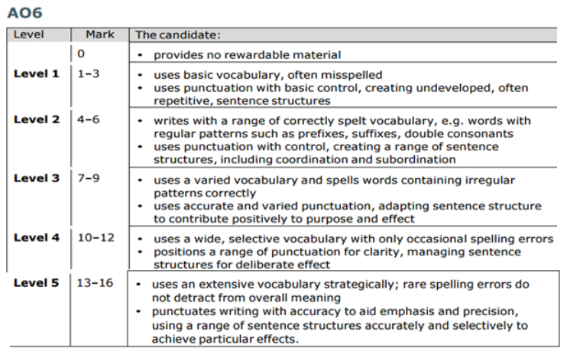

Marking criteria for the Speaking and Listening Endorsement (SLE)
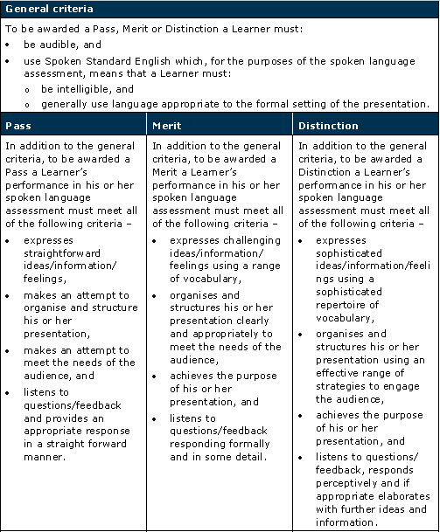
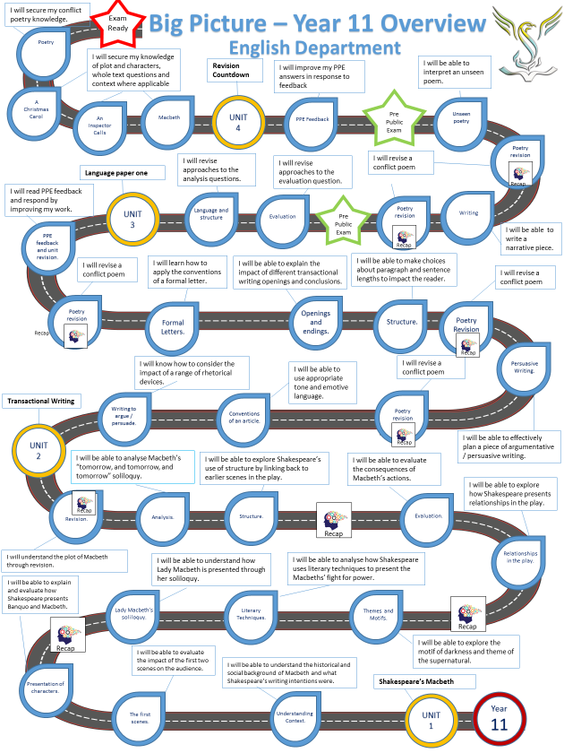
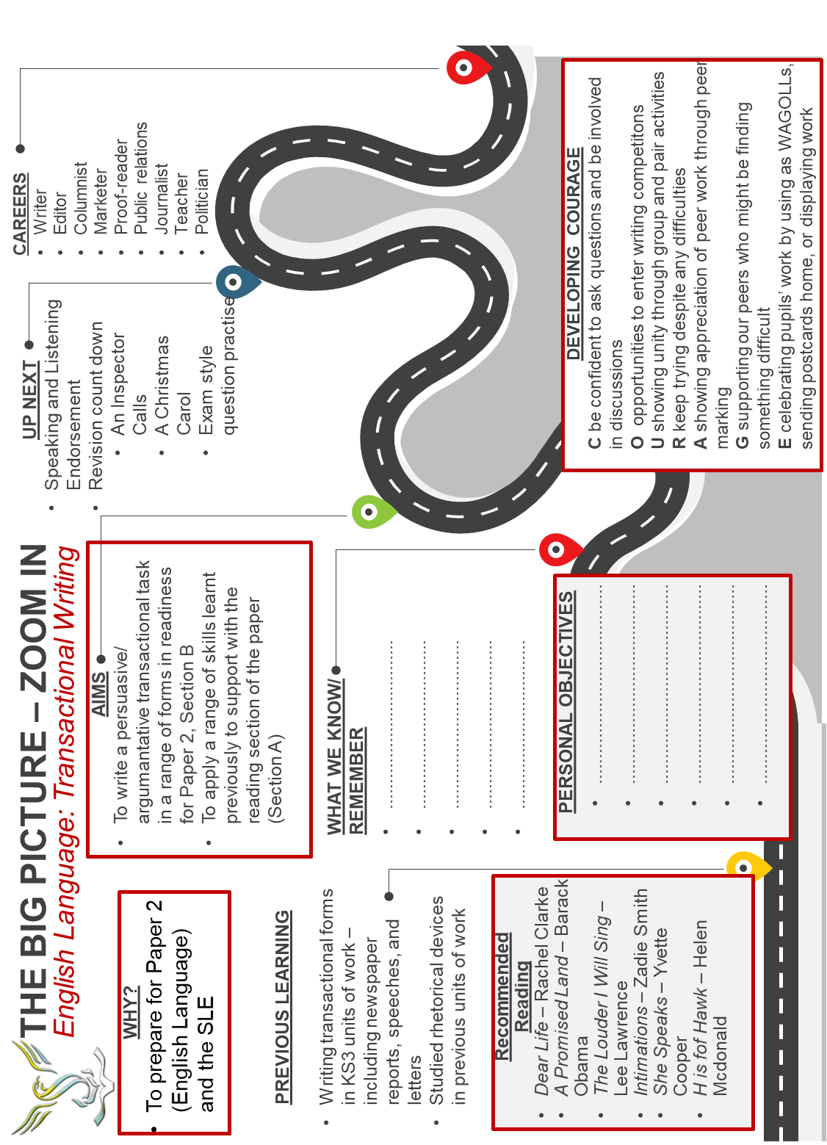
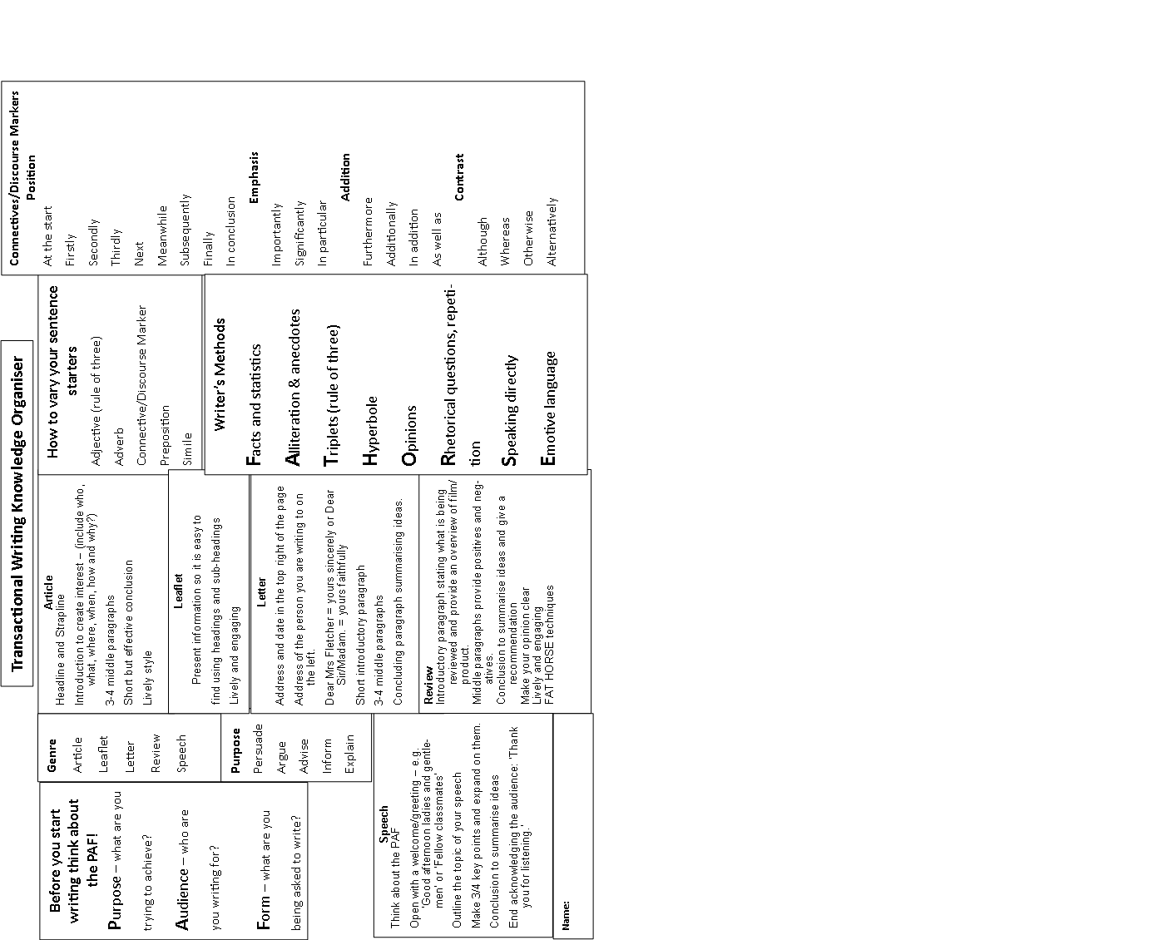

Lesson: | What you’ll be looking at: | Tick when complete
- Macbeth Revision | Plot of Macbeth
- Macbeth Revision | Characters, and themes in Macbeth
- What I know about writing to argue and / or persuade | Knowledge Organiser and reflection
- Consider the impact of a range of rhetorical devices. | Language paper 2 expectations  Persuasive article
- The conventions of an article | Examples of newspaper articles
- Identifying tone and using appropriate vocabulary | Knowledge Organiser quiz  Emotive language and appropriate synonyms
- Planning and writing a piece of argumentative / persuasive writing | Planning arguments  Writing an article in exam conditions
- Applying the conventions of a speech | “HeForShe” – Emma Watson.  Specific conventions for speeches  Incorporating devices and conventions used in “HeForShe” in your own writing.
- SLE 1. Overview of SLE | Expectations, mark schemes, exemplars (video)
- SLE 2. Creating presentation ideas and writing | Generating ideas. Writing speeches.
- SLE 3. Writing and improvement | Feedback and improvement.
- SLE 4. Writing completion | Finish the SLE and transfer onto revision cards / post-its
- Knowing and applying the conventions of a formal letter | Analysing the opening of a letter.  The conventions of a formal letter.  Writing a formal letter.
- Evaluation of effective conclusions in transactional writing | What makes an effective ending?  Assess sample transactional writing endings.
- Understanding how writers use sentence structure for effect | Identifying a range of sentences  Using sentences for effect
- Newspaper reportage | Analysing a newspaper article  The conventions of a newspaper article  Writing a newspaper article
- Restaurant review | Analysing a restaurant review  The conventions of a restaurant review  Writing a review
- AIC Revision | Plot, characters, and themes in An Inspector Calls
- ACC Revision | Plot, character, and themes in A Christmas Carol

Lesson 1: Macbeth Revision
LI: To consolidate my knowledge and understanding of the play Macbeth
Big Fat Plot Quiz
Question | Answer
- What weather accompanies the witches both times they appear? Why?

- What three prophecies do the witches make?

- What position does Duncan give to Macbeth and why?

- How do Banquo and Macbeth’s attitudes to the witches vary?

- What does Lady Macbeth call on to give her strength and what does she ask them to do?

- Lady Macbeth tells Macbeth to look like the ‘innocent ____________’ but be the ‘___________’ under it. What does this mean?

- What motivates Macbeth to kill Duncan?

- How does Lady Macbeth convince him?

- What does Macbeth see just before the murder? What could this symbolise?

- How are Lady Macbeth and Macbeth’s attitudes to the murder different after it has happened?

- Who finds the murdered king?

- Where do Malcolm and Donalbain go? Why?

- Who suspects Macbeth of acting ‘foully’?

- Who does Macbeth order to be killed next? Who is actually killed?

- Is Lady Macbeth involved in this murder? Why?

- Whose ghost appears at the banquet and what could this represent?

- Who is plotting in England to reclaim the throne?

- What three prophecies do the witches make next time Macbeth visits?

- What happens to Macduff’s ‘pretty chickens’?

- What happens to Lady Macbeth in the final act?

- How does Macbeth respond to the news?

- What do the English army use to disguise themselves?

- Who kills Macbeth? How is he able to?

- Add two plot questions of your own

25.

TIER 2 VOCABULARY: Look at the list of tier 2 vocabulary below. Define each term (use a dictionary or online resource to help you) and make a quick note of how they link to ‘Macbeth’. One has been done for you.

‘MACBETH’ – TIER 2 VOCABULARY LIST
Term | Definition | Link to ‘Macbeth’
hubris

hamartia

duplicitous

heinous

malevolent

mercurial | Subject to sudden or unpredictable changes of mood or mind. | Macbeth becomes increasingly mercurial as his guilt begins to overwhelm him. An example of this is when he sees Banquo’s ghost.
regicide

MISCONCEPTIONS: The following statements are incorrect. Explain why around the outside of the grid
Macbeth kills Banquo because he is concerned about his friends’ jealousy. | We see all of the prophecies come true in the play. | Lady Macbeth feigns madness to avoid suspicion.
Ambition is seen as irrelevant and unimportant. | Hope does not exist in the play. | Macbeth never acts of his own accord. Lady Macbeth and/or the witches are behind his every action.

GCSE Thinking Quilt: ‘Macbeth’
Ambition | Power | Appearance vs Reality | The Supernatural | Violence | Fate and Free Will
Shade in each of the themes. Then shade in each box (quotation/character) that links to that theme. Some could be more than one theme.

‘Is this a dagger which I see before me, the handle toward my hand?’ | ‘If you can look into the seeds of time and say which grain will grow and which will not, speak then to me…’ | ‘Come, you spirits that tend on mortal thoughts, unsex me here, and fill me from the crown to the toe top-full of direst cruelty’ | ‘I think our country sinks beneath the yoke; it weeps, it bleeds; and each new day a gash is added to her wounds’ | ‘I have no spur to prick the sides of my intent, but only vaulting ambition, which o’erleaps itself and falls on th’other’ | Macduff
Macbeth | ‘And oftentimes, to win us to our harm, the instruments of darkness tell us truths; win us in honest trifles, to betray’s in deepest consequence’ | ‘Out, out, brief candle’ | ‘All the perfumes of Arabia will not sweeten this little hand’ | ‘Look like the innocent flower, but be the serpent under’t’ | ‘Upon my head they placed a fruitless crown and put a barren sceptre in my grip, thence to be wrenched with an unlineal hand, no son of mine succeeding’
‘All hail, Macbeth, that shalt be king hereafter’ | ‘Here lay Duncan, his silver skin laced with his golden blood’ | Lady Macbeth | ‘Disdaining Fortune, with his brandished steel, which smoked with bloody execution’ | ‘This tyrant, whose sole name blisters our tongues, was once thought honest’ | ‘To be thus is nothing, but to be safely thus’
Banquo | ‘Fair is foul and foul is fair’ | ‘Stars, hide your fires; Let no light see my black and deep desires’ | ‘Never shake thy gory locks at me!’ | The Witches | King Duncan

Lesson 2: Macbeth Revision
LI: To consolidate my knowledge and understanding of the play Macbeth

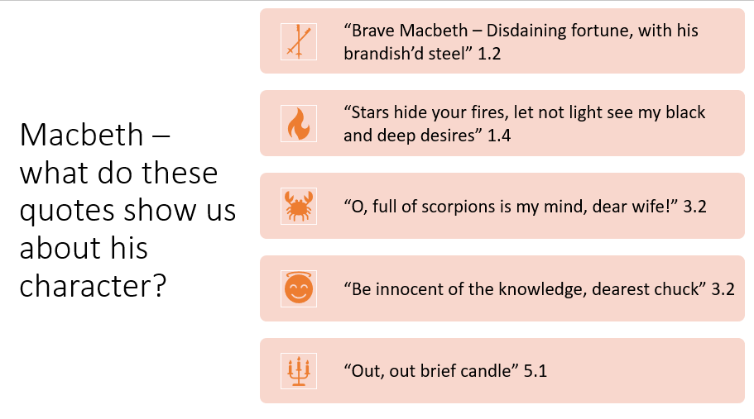
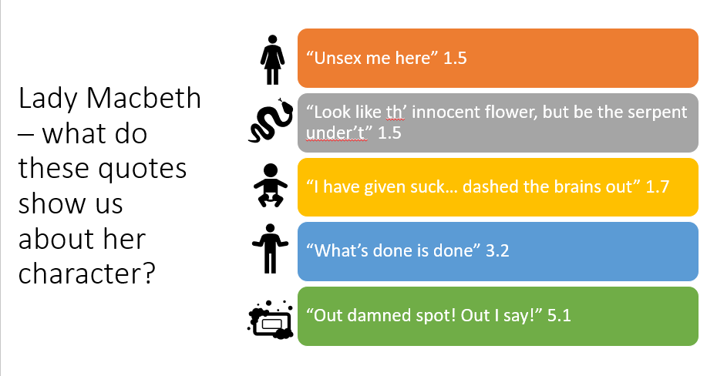

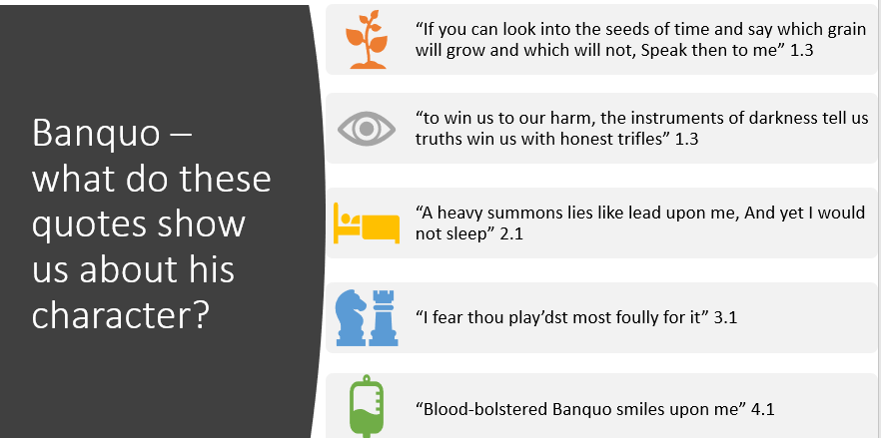

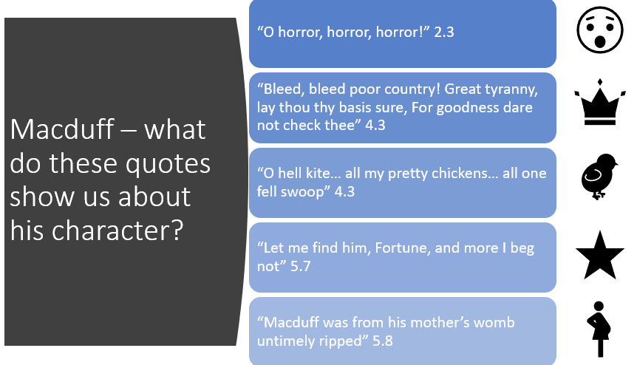

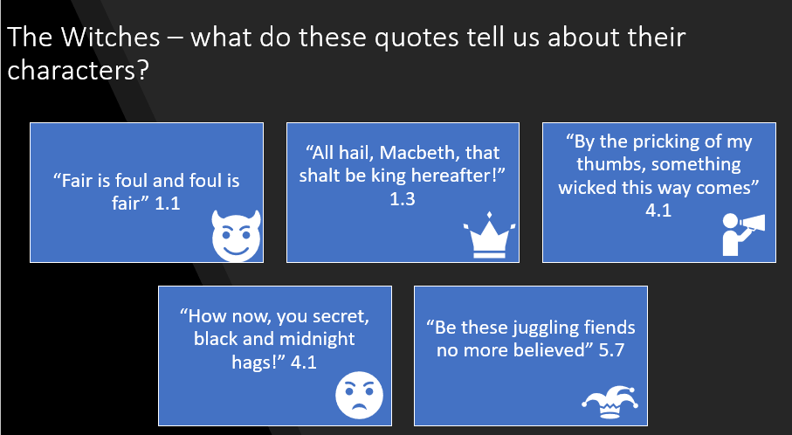

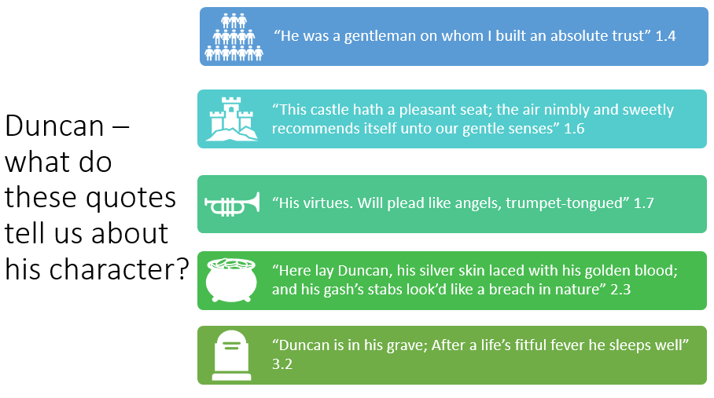

Lesson 3: Writing to argue / persuade
LI: To demonstrate what I know about writing to argue and persuade
- Read the mark scheme for AO5 and AO6 at the front of this booklet. Using a black pen, make your own individual annotations. Think about the following…what are you expected to do during this unit of study? How do you maximise your marks?
- Familiarise yourself with the knowledge organiser for this unit
DART: Annotate this exam-style question. What is the focus of the question? What is the purpose, audience, and form required when writing the answer?
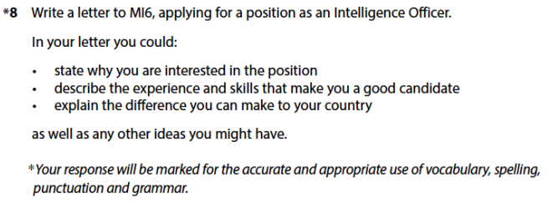Read the following example of a student writing to argue. Annotate this example with features of writing to argue. Use the Knowledge Organiser to help you to do this.
To whom it may concern,
My name is J**** A**** and I am very interested in applying for a position in your constabulary in the not too distant future. I am interested in becoming an operative in your business as I feel that I posses the skills of a high grade spy, this would make me the perfect candidate for this placement.
My skills set include being very focused on my job, dedecated to perfection and an incredibly hardworking attribute to anything I set my mind to. My experience in espionage may be limited but I feel my skills will allow you to see that I am a more than adequate to assign a job at your establishment without too much difficulty.
The main reason I think you should hire me is that I love my country and I want to make it a secure place to live, eat and generally live a life without the thought of war or violence at an International level. The difference I feel I can make to the level of security in this country is of a level I feel your constituency would be lacking without.
To reiterate, my skills collection my previous job background of the British army revisits and then going onto the armed division of the Kent police force shows I know what is expected, I know and understand the job role expected of me.
I am also very up to date on the latest communication technological discovery’s and how they can be used in you company. I hope you listen to my application as I feel inclined to say that my services towards your undercover operation would on assist you in your aims.
Yours Sincerely, J**** A****
DIP: Write a letter applying for the role of canine carer at Dog’s Trust
- What is the purpose of the letter?
- Who is the audience for the letter?
- Should it be written in a formal or informal register?
Try to use some of the techniques in the KO and the example letter above

Lesson 4: Writing to argue / persuade continued
LI: Consider the impact of a range of rhetorical questions
DART: Read this persuasive article and annotate for language devices (use the KO these if you need to).
The Argument Against Headphones
One in ﬁve teenagers in America can’t hear rustles or whispers, according to a study published in August in The Journal of the American Medical Association. These teenagers exhibit what’s known as slight hearing loss, which means they often can’t make out consonants like T’s or K’s, or the plinking of raindrops. The word “talk” can sound like “aw.” The number of teenagers with hearing loss — from slight to severe — has jumped 33 percent since 1994.
Given the current ubiquity of personal media players — the iPod appeared almost a decade ago — many researchers attribute this widespread hearing loss to exposure to sound played loudly and regularly through headphones. (Earbuds, in particular, don’t cancel as much noise from outside as do headphones that rest on or around the ear, so earbud users typically listen at higher volume to drown out interference.) Indeed, the August report reinforces the findings of a 2008 European study of people who habitually blast MP3 players, including iPods and smartphones. According to that report, headphone users who listen to music at high volumes for more than an hour a day risk permanent hearing loss after five years.
Maybe the danger of digital culture to young people is not that they have hummingbird attention spans but that they are going deaf.
The history of headphones has always been one of unexpected uses and equally unexpected consequences. Headphones were invented more than a century ago. According to some accounts, modern headphones were the brainchild of Nathaniel Baldwin, a tinkerer from Utah who grew frustrated when he couldn’t hear Mormon sermons over the noise of the crowds at the vast Salt Lake Tabernacle. Baldwin’s device, which was designed first as an amplifier, came to incorporate two sound receivers connected by an operator’s headband. Within each earphone was, according to legend, a mile of coiled copper wiring and a mica diaphragm to register the wire’s signals with vibrations. When the Navy put in an order for 100 such Baldy Phones in 1910, Baldwin abandoned his kitchen workbench, hastily opened a factory and built the prosperous Baldwin Radio Company. His innovations were the basis of “sound powered” telephones, or phones that required no electricity, which were used during World War II.
It’s not incidental that Baldwin imagined headphones first as a way to block out crowd noise and hear sermons. Workers and soldiers have long used them to mute the din of machinery or artillery while receiving one-way orders from someone with a microphone. From the beginning, it seems, headphones have been a technology of submission (to commands) and denial (of commotion).
When World War II ended, submission-and-denial was exactly what returning veterans craved when they found themselves surrounded by the clamor and demands of the open-plan family rooms of the postwar suburbs. By then, they knew what device provided it. In the ’50s, John C. Koss invented a set of stereo headphones designed explicitly for personal music consumption. In that decade, according to Keir Keightley, a professor of media studies at the University of Western Ontario, middle-class men began shutting out their families with giant headphones and hi-fi equipment. Further, they recalled the sonar systems they saw at war.
The Walkman appeared in 1979, the invention of Sony, and headphones became part of a walking outfit. Headphones and earbuds are now used with MP3 players, mobile phones, tablet computers and laptops.
Most discussions of the transformation of music by digital technology focus on the production end. But headphones transform sound for the consumer too. Headphones are packed with technology. When an audio current passes through the device’s voice coil, it creates an alternating magnetic field that moves a stiff, light diaphragm. This produces sound. If you think about all the recordings, production tricks, conversions and compressions required to turn human voices and acoustic instruments into MP3 signals, and then add the coil-magnet-diaphragm magic in our headphones, it’s amazing that the intensely engineered frankensounds that hit our eardrums when we listen to iPhones are still called music.
Whatever you call it, children are listening to something on all these headphones — though “listening” is too limited a concept for all that headphones allow them to do. Indeed, the device seems to solve a real problem by simultaneously letting them have private auditory experiences and keeping shared spaces quiet. But the downside is plain, too: it’s antisocial. As Llewellyn Hinkes Jones put it not long ago in The Atlantic: “The shared experience of listening with others is not unlike the cultural rituals of communal eating. Music may not have the primal necessity of food, but it is something people commonly ingest together.”
Headphones work best for people who need or want to hear one sound story and no other; who don’t want to have to choose which sounds to listen to and which to ignore; and who don’t want their sounds overheard. Under these circumstances, headphones are extremely useful — and necessary for sound professionals, like intelligence and radio workers — but it’s a strange fact of our times that this rarefied experience of sound has become so common and widespread. In the name of living a sensory life, it’s worth letting sounds exist in their audio habitat more often, even if that means contending with interruptions and background sound.
Make it a New Year’s resolution, then, to use headphones less. Allow kids and spouses periodically to play music, audiobooks, videos, movie, television and radio audibly. Listen to what they’re listening to, and make them listen to your stuff. Escapism is great, and submission and denial, too, have their places. But sound thrives amid other sounds. And protecting our kids’ hearing is not just as important as protecting their brains; it is protecting their brains.
Do now:Evaluate which device is most effective and why

DIP: Answer this exam-style question using these rhetorical devices :
Direct address, pattern of three, alliteration, hyperbole, list, repetition, rhetorical question, contrast

Pupils should be banned from using mobile phones in school
Write a persuasive article either agreeing or disagreeing with the
statement above.

Extension task:
Write a magazine article exploring the idea that technology is taking over teenagers’ lives. Focus on the use of appropriate rhetorical devices. Plan the devices first.

Lesson 5: Opinion Articles
LI: To know the conventions of an article (editorial)
DART: Read the following article and annotate it for conventions of a newspaper article.
Article
- Headline and strapline
- Introduction to create interest (include who, what, where, when, how, and why?)
- 3 – 4 middle paragraphs
- Short but effective conclusion
- Lively style
- FAT HORSE techniques

Strong, smart teen girls have had enough. No wonder men like Trump are rattled
Sasha Brown-Worsham
Greta Thunberg and her cohorts are ready to change the world – and that scares a certain kind of man
Tue 1 Oct 2019 14.09 BSTLast modified on Tue 1 Oct 2019 14.11 BST

‘Thunberg doesn’t need anyone to push her. She pushes herself. She’s well-informed, brilliant, and unafraid to take on all the leaders in the world.’ Photograph: Andrew Hofstetter/Reuters
The president of the United States openly mocked a teenage girl. After dismissing the 16-year-old climate activist Greta Thunberg in person and earning her ire, he tweeted to his 65 million followers: “She seems like a very happy young girl looking forward to a bright and wonderful future. So nice to see!”
Dismissive. Sarcastic. Mocking. Utterly typical. Is anyone surprised?
The Republican party has a teenage girl problem. And Thunberg knows what’s up. On Monday, she gave an impassioned and emotional speech at the climate summit in New York.
“You have stolen my dreams and my childhood with your empty words,” she said. “The eyes of all future generations are upon you. And if you choose to fail us, I say we will never forgive you. We will not let you get away with this. Right here, right now is where we draw the line.”
Trump took it personally – hence, his tweet. On Tuesday, Thunberg fought back, changing her Twitter bio to read “a very happy young girl looking forward to a bright and wonderful future”.
She’s fierce. And she’s not the only one.
Just last year, a 13-year old Canadian water activist named Autumn Peltier told the United Nations it was time to “warrior up” on World Water Day. “Our water deserves to be treated as human with human rights. We need to acknowledge our waters with personhood so we can protect our waters,” the Anishinaabe girl from Wikwemikoong First Nation told the diplomats gathered in New York City.
Greta Thunberg and Autumn Peltier will join the pantheon of teenage girls who changed everything. Girls like Anne Frank, a young teen when she wrote her diary. Or Joan of Arc, who led an army. Or Malala Yousafzai, who won the Nobel peace prize for her work securing education for girls in Pakistan and around the world at the age of 17.
It’s no wonder men like Donald Trump are shaking in their boots. Because hell hath no fury like a teenage girl who is awake and aware and done with your [lies]. The fears of men like Trump have made mocking teenage girls a favorite American pastime.
We mock their trends. In the 1980s, it was the Valley Girls. Their big hair. The way they spoke. The way they pegged their jeans and chewed their gum. The accessories they carried. Today, newspapers and parenting magazines are full of hand wringing over “VSCO girls”, the modern day Valley Girl, most of whom are in their early teens and some even younger. All the things they enjoy – Fjällräven backpacks, HydroFlasks, Birkenstocks, scrunchies. It’s all fodder for their elders’ mocking. We dismiss their water bottles, their fashion choices, the words they use. We mock their selfies (narcissists!), their clothing (cheap and too much skin!), their makeup (too much in general! Be natural!).
What would happen if teenage girls were actually allowed to feel good about themselves? What if we allowed them to have their interests with no shame? They might rise up and change everything. And that scares a certain kind of man.
The Fox commentator Michael Knowles called Thunberg a “mentally ill Swedish child who is being exploited by her parents and by the international left”.
Knowles issued an apology. But he wasn’t the only one. The conservative pundit Dinesh D’Souza compared Thunberg’s image to ones used in Nazi propaganda. He posted a photo on Twitter of Thunberg, with her long braids, next to an illustration of a young woman with a similar hairstyle standing in front of a swastika flag.
As the mother of a teenage girl myself, I know how hard they are to manipulate. They are strong and smart and know themselves in ways big and small. They can’t be forced by anyone – not teachers or parents – to say things they don’t mean at a school assembly, let alone on world stage. Thunberg doesn’t need anyone to push her. She pushes herself. She’s well-informed, brilliant, and unafraid to take on all the leaders in the world. Like so many other teenage girls. Like Anne Frank. Like Peltier. Like Joan of Arc.
Republicans are due a reckoning. Where do they really stand on 16-year-old girls? Are they children, manipulated by George Soros and their parents, when they are saying intelligent things? Or are they women? They certainly seem to be treated as “women” when it’s time to hang with the likes of the convicted sex offender Jeffrey Epstein or former Alabama chief justice Roy Moore, who was accused of sexual misconduct by numerous women and girls and still had many Republican supporters.
It’s no wonder so many Republicans are scared of teenage girls. If teenage girls can accomplish so much and live so powerfully even as they are mocked, condescended, demeaned and shamed, imagine what they could do if we just shut up and got the hell out of their way.
Answer these questions:
- What opinion is being expressed?
- What conventions are used and what is their effect?
- How does the writer use rhetorical devices to achieve this?
- What do you notice about the structure of the article?
Big question: what is the difference between the article above and a news reporting article (example below)? Give examples to back up your point.

Earthshot prize: Prince William launches £50m drive to repair planet

Five £1m prizes will be awarded each year for next 10 years to support environmental solutions
A photo of the Duke of Cambridge taken by the Duchess of Cambridge at the Chiatibo glacier in the Hindu Kush mountain range in Pakistan, released to mark the launch of the Earthshot prize. Photograph: Duchess of Cambridge/PA
Caroline Davies
Thu 8 Oct 2020 07.00 BST
The Duke of Cambridge has announced that £50m will be awarded over 10 years through his ambitious Earthshot prize, billed as “the most prestigious global environment prize in history”, which aims to find solutions to repair the planet by 2030.
Five £1m prizes will be awarded each year for the next 10 years, aiming to provide at least 50 solutions to some of the world’s environmental problems.
Inspired by John F Kennedy’s ambitious “moonshot” lunar programme, the prize is centred on five “Earthshots” – simple but ambitious goals for the planet. These are:
- Protect and restore nature.
- Clean our air.
- Revive our oceans.
- Build a waste-free world.
- Fix our climate.
Individuals, people-powered movements, businesses cities, and countries can be nominated for the prizes.
“The plan is to really galvanise and bring together the best minds, the best possible solutions, to fixing and tackling some of the world’s greatest environmental challenges. We’ve got to harness our ingenuity and our ability to invent,” William said.
“The next 10 years are a critical decade for change. Time is of the essence, which is why we believe this very ambitious global prize is the only way forward.”
William has spent two years setting up the prize through his Royal Foundation, taking advice from teams behind the Nobel prize and the Xprize. He believes it is unique, and he is bringing leading global figures and organisations onboard.
With the planet at a “tipping point”, he said, he felt the sense of urgency of the situation worsening each year, coinciding with a feeling of pessimism over humankind’s ability to solve complex challenges. This was causing many people to look the other way, he believed.
“The duke took this as an opportunity to ask what he could do to turn this equation around. He wanted to keep the sense of urgency but turn the pessimism into optimism in the belief it would lead to real action,” said Jason Knauf, the chief executive of the Royal Foundation. “It was this new equation – urgency plus optimism equals action – that led to the Earthshot prize.”
Knauf added: “Our power to innovate and cooperate 50 years ago put a man on the moon. And our power to innovate and cooperate can now save the planet for future generations.”
William is said to have been clear that the prize could not just be about him or his Royal Foundation, and that it was imperative it was led by a global team of experts. He said he had chosen the challenge after realising he had a leadership role to play and now was the time to play it.
Nominations for the first five £1m prizes will open on 1 November. More than 100 “nominators” have been selected from around the globe. The first five winners will be announced at a ceremony in London next year.
The prize is supported by a global alliance of partnerships, including WWF and Greenpeace, and there are plans for it to have its own foundation by next year. Backers include the Aga Khan Development Network, Bloomberg Philanthropies, DP World in partnership with Dubai Expo 2020, and the Jack Ma Foundation.
To mark the launch, William and Sir David Attenborough are interviewed on BBC Radio 4’s Today programme on Thursday. William said: “I felt very much that there’s a lot of people wanting to do many good things for the environment and what they need is a bit of a catalyst, a bit of hope, a bit of positivity that we can actually fix what’s being presented.
“And I think that urgency with optimism really creates action. And so The Earthshot prize is really about harnessing that optimism and that urgency to find solutions to some of the world’s greatest environmental problems.”
“We believe that this decade is one of the most crucial decades for the environment and by 2030 we really hope to have made huge strides in fixing some of the biggest problems the Earth faces.”
William told the Today programme: “The key thing about the Earthshot Prize is that positivity. It’s the idea we need to find solutions to be able to live our lives and enjoy our lives and not feel guilty and bad about some of the things we do. That ultimately has to change. Because I also worry from a mental health point of view, the anxiety and the worry that many of these younger generations are going to have, hearing about what we’re talking about. It’s going to weigh on them. And they don’t want to inherit a world that is going to be full of doom and gloom”
DIP: Exam Style Question: Write a newspaper article exploring the idea that young people should be able to express themselves.
Lesson 6: Opinion Articles continued
LI: To identify an appropriate tone and how this is created using vocabulary

Do now quiz:​
- Name 3 features of an article​
- What should the introduction include?​
- How many paragraphs should there be in the middle?​
- What kind of style should it be written in?​

DART: What makes this advert emotive?
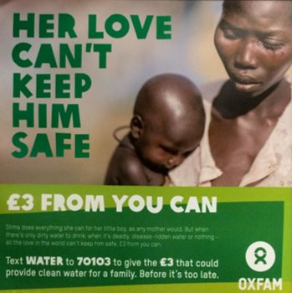
Stima does everything she can for her little boy, as any mother would. But when there’s only dirty water to drink, when it’s deadly, disease-ridden water or nothing – all the love in the world can’t keep him safe. £3 from you can.’​
Which one of these statements is emotive? (a or b?).
Highlight the words or phrases that make the statement emotive.
a) Another person in the bar was injured by the man's glass.​
b) An innocent bystander suffered facial injuries when the thug launched his glass across the bar.​
​
a) The government will slash interest rates.​
b) The government will reduce interest rates.​
​
a) For what seemed a lifetime, Mr Smith was subjected to a vicious, cowardly assault by the unemployed, steroid-pumped monster.​
b) Mr Smith was attacked by Mr Jones for two minutes.​

DIP: Rewrite these statements to make them emotive
1) A woman was attacked by an unknown male on Saturday night.​
​
2) Government figures showed over four million children in the UK were living in relative poverty in 2018.​
​
3) Mr Jones was found unconscious in his home at 10am Monday morning.​

Look over the article you wrote last lesson and…
- Identify five words which can be improved.​
- Use a thesaurus to find synonyms.​
- Rewrite/add a section to this task so that it includes emotive language​

Lesson 7: Planning a piece of writing
LI: to use a planning tool to help me plan an argumentative/persuasive piece of writing.
DART: Using the following answer to an exam question, create a plan using this tool:
Introduction
Points
Elaboration
Ending
Language
Link
Purpose
Audience
Form

Introduction

Point 1:

Elaboration 1:

Point 2:

Elaboration 2:

Point 3:

Elaboration 3:

Ending

Language and Links
Vocabulary: | Devices: | Connectives:

Use this answer to create your plan (reverse engineering):
Candidate B
These days you can track peoples movements across the country.
A network of CCTV cameras watch from above which phones can be tracked simply by being switched on. It sounds like a spy film but it’s reality. I’m asking has it gone too far?
These days CCTV isn’t just used for safety. If a company want to find out about another they can simply set up a camera and then watch.
The government is also tracking people. Sure, some of these people are dangerous or likly to commit crimes but does that give the government the right to track everyones journeys? Should ordinary innocent people be followed? I strongly dissagree with
the government trying to watch people leaving them no privacy.
Log onto twitter and they can see any of your messages, tweets or photos. Same with just about every social network account or email. If the government can see all this what would stop a corrupt person from leaking personal things about well known
people to the press. What’s the line that is drawn? What is private anymore?
If the government can hack accounts what would happen if their system was hacked? Admittedly there are some advantages. mainly the fact that crimes are easier to solve. This is because, especially in larger cities and towns, the cameras are on every
corner. While all this new found technology is great on the surface it is exploted. Supermarket scanners show what we, as a nation, are buying. The company then makes produce to match that. 20 years ago companys would go and survey shoppers to
find out what produce they would like but now it’s all done remotely. The main problem with these scanners is that while they keep people safe they also meant that it can feel like you’re always being watched. Also what happened to the hours of footage taken every day. Do they store it or destroy it? If it is stored the question of ‘is it sucure?’ comes into play. As people who will take the time to try and unravel computer sucurity just because they can. Also
does it cost to keep all that footage in storage? If so who’s paying for it? With the way things are these days it’s probably tax payer who pay to keep footage possibly that they didn’t know had been filmed, secret. If the footage is destroyed then we have the right to know how and whether it is totally impossible to recover it. Aside from the few advantages it all seems like a very bad idea to me and the fact there aren’t warnings makes it worse.
England has become a worldwide version of big brother.
DIP: Using the same planning tool, create a plan to answer this exam-style question:
Write an article for a newspaper, exploring the value of exams in school.
You could write about:
- The types of exams most students take, and how relevant they are
- The advantages and disadvantages of taking exams to test ability
- Alternative ways to test students at the end of their schooling e.g. coursework or practical tests as well as any other ideas you might have

Use the mark scheme (A05 and AO6) at the beginning of this document to ensure you maximise your marks for this question.

Lesson 8: The conventions of a speech
LI: To know and apply the conventions of a speech

DART: Read the following speech and annotate it for conventions of a speech (use your KO for guidance) and then answer this question: How are the conventions of a speech different to other forms studied so far?

Emma Watson: Gender equality is your issue too
Date: Saturday, September 20, 2014
Speech by UN Women Goodwill Ambassador Emma Watson at a special event for the HeForShe campaign, United Nations Headquarters, New York, 20 September 2014

Today we are launching a campaign called “HeForShe.”
I am reaching out to you because I need your help. We want to end gender inequality—and to do that we need everyone to be involved.
This is the first campaign of its kind at the UN: we want to try and galvanize as many men and boys as possible to be advocates for gender equality. And we don’t just want to talk about it, but make sure it is tangible.
I was appointed six months ago and the more I have spoken about feminism the more I have realized that fighting for women’s rights has too often become synonymous with man-hating. If there is one thing I know for certain, it is that this has to stop.
For the record, feminism by definition is: “The belief that men and women should have equal rights and opportunities. It is the theory of the political, economic and social equality of the sexes.”
I started questioning gender-based assumptions when at eight I was confused at being called “bossy,” because I wanted to direct the plays we would put on for our parents—but the boys were not.
When at 14 I started being sexualized by certain elements of the press.
When at 15 my girlfriends started dropping out of their sports teams because they didn’t want to appear “muscly.”
When at 18 my male friends were unable to express their feelings.
I decided I was a feminist and this seemed uncomplicated to me. But my recent research has shown me that feminism has become an unpopular word.
Apparently I am among the ranks of women whose expressions are seen as too strong, too aggressive, isolating, anti-men and, unattractive.
Why is the word such an uncomfortable one?
I am from Britain and think it is right that as a woman I am paid the same as my male counterparts. I think it is right that I should be able to make decisions about my own body. I think it is right that women be involved on my behalf in the policies and decision-making of my country. I think it is right that socially I am afforded the same respect as men. But sadly I can say that there is no one country in the world where all women can expect to receive these rights.
No country in the world can yet say they have achieved gender equality.
These rights I consider to be human rights but I am one of the lucky ones. My life is a sheer privilege because my parents didn’t love me less because I was born a daughter. My school did not limit me because I was a girl. My mentors didn’t assume I would go less far because I might give birth to a child one day. These influencers were the gender equality ambassadors that made me who I am today. They may not know it, but they are the inadvertent feminists who are changing the world today. And we need more of those.
And if you still hate the word—it is not the word that is important but the idea and the ambition behind it. Because not all women have been afforded the same rights that I have. In fact, statistically, very few have been.
In 1995, Hilary Clinton made a famous speech in Beijing about women’s rights. Sadly many of the things she wanted to change are still a reality today.
But what stood out for me the most was that only 30 per cent of her audience were male. How can we affect change in the world when only half of it is invited or feel welcome to participate in the conversation?
Men—I would like to take this opportunity to extend your formal invitation. Gender equality is your issue too.
Because to date, I’ve seen my father’s role as a parent being valued less by society despite my needing his presence as a child as much as my mother’s.
I’ve seen young men suffering from mental illness unable to ask for help for fear it would make them look less “macho”—in fact in the UK suicide is the biggest killer of men between 20-49 years of age; eclipsing road accidents, cancer and coronary heart disease. I’ve seen men made fragile and insecure by a distorted sense of what constitutes male success. Men don’t have the benefits of equality either.
We don’t often talk about men being imprisoned by gender stereotypes but I can see that that they are and that when they are free, things will change for women as a natural consequence.
If men don’t have to be aggressive in order to be accepted women won’t feel compelled to be submissive. If men don’t have to control, women won’t have to be controlled.
Both men and women should feel free to be sensitive. Both men and women should feel free to be strong… It is time that we all perceive gender on a spectrum not as two opposing sets of ideals.
If we stop defining each other by what we are not and start defining ourselves by what we are—we can all be freer and this is what HeForShe is about. It’s about freedom.
I want men to take up this mantle. So their daughters, sisters and mothers can be free from prejudice but also so that their sons have permission to be vulnerable and human too—reclaim those parts of themselves they abandoned and in doing so be a more true and complete version of themselves.
You might be thinking who is this Harry Potter girl? And what is she doing up on stage at the UN. It’s a good question and trust me, I have been asking myself the same thing. I don’t know if I am qualified to be here. All I know is that I care about this problem. And I want to make it better.
And having seen what I’ve seen—and given the chance—I feel it is my duty to say something. English Statesman Edmund Burke said: “All that is needed for the forces of evil to triumph is for enough good men and women to do nothing.”
In my nervousness for this speech and in my moments of doubt I’ve told myself firmly—if not me, who, if not now, when. If you have similar doubts when opportunities are presented to you I hope those words might be helpful.
Because the reality is that if we do nothing it will take 75 years, or for me to be nearly a hundred before women can expect to be paid the same as men for the same work. 15.5 million girls will be married in the next 16 years as children. And at current rates it won’t be until 2086 before all rural African girls will be able to receive a secondary education.
If you believe in equality, you might be one of those inadvertent feminists I spoke of earlier.
And for this I applaud you.
We are struggling for a uniting word but the good news is we have a uniting movement. It is called HeForShe. I am inviting you to step forward, to be seen to speak up, to be the "he" for "she". And to ask yourself if not me, who? If not now, when?
Thank you.
DIP: Write a speech encouraging pupils at your school to do more to protect the environment from climate change. (use the speech above as an example – steal techniques from this speech)

Lesson 9: Introducing the Speaking and Listening Endorsement (SLE)
LI: To understand what is required for the SLE

DART: Read through the marking criteria at the beginning of this document and highlight the elements that you need to focus on to achieve your grade target (you need to meet all the criteria to be able to attain the level (pass, merit, or distinction)).
Watch the following videos of SLEs. After each one, and using the marking criteria to guide you, give them a mark (pass, merit, distinction) and describe why you believe the candidate should be awarded the mark you gave them.
- Jabreel
- Charlotte
- Connor
Read through the examiner reports for each of the candidates (below) and then answer these questions:
- Do you agree with what the examiner is saying?
- Can you see how the candidate attained their mark?
- Write down the top three top tips that you can use in your own SLE.
A1: JIBREEL
Jibreel presents to a group of classmates and his teacher on the topic of free will.
Jibreel has chosen a complex topic and uses a sophisticated repertoire and range of vocabulary. He speaks with few notes and demonstrates extensive knowledge. The presentation has clear organization. His relaxed but enthusiastic approach to the topic and its importance clearly engages the audience.
He listens carefully to questions, responding confidently and appropriately. The teacher asks a challenging question which allows Jibreel to elaborate further on his ideas.
His spoken Standard English is assured and flexible. It should be noted that he uses quite a large number of fillers. Attitudes to such use vary from individual to individual, but it needs to be made clear here that fillers are common in speech and that use of them is not an issue within the framing of these criteria, and within the context of his presenting to colleagues.
Jibreel achieves a Distinction when looked at against the criteria. It is worth noting two points in particular which help him achieve this:
• he speaks on a complex topic which requires, by definition a sophisticated range of ideas
• he is helped by the teacher’s question which enables him to elaborate his ideas. Who asks the questions, and the level of challenge of the questions, needs to be considered by teachers and candidates when setting up the presentation

A3: CONNOR
Connor presents to a group of classmates on the life and death of Dr Crippen.
Connor speaks without notes at a relentless pace and with (presumably) extensive knowledge. It seems at times as though he may have learnt source material, which is not in itself an issue but which here can be seen to impact on the way he delivers his presentation.
The topic itself could be challenging, but the way he unrolls the narrative, with no real pause for reflection, means that his approach is better described as straightforward.
The presentation has some shape, albeit in a straight narrative time-line. He uses a suitable range of appropriate vocabulary. He confidently uses spoken Standard English.
Connor answers questions clearly and fully, with thought and consideration, but the pace of the delivery, and the uniform pitch suggests that he does not fully meet the needs of an audience .
In assessing Connor we see a student who fully achieves the criteria for Pass, and achieves sometimes within the Merit category. This means, though that under these criteria he is awarded Pass. Further development of his skills could focus on extending the range of his ideas, varying the speed and pitch of his delivery and ensuring that he receives questions which make him move beyond narrative detail.

A2: CHARLOTTE
Charlotte gives a conventional ‘speech’, standing up, arguing a cause and responding to questions.
Charlotte is relaxed and engages very well with her audience, right from the beginning. She has a calm authority about her, both when presenting and when answering questions. Through her use of rhetorical strategies she engages with the audience.
She highlights central and sophisticated concepts through reference to data, both researched and personal, and in the structure of her talk moves from abandoned High Streets to wider issues of mass food production. These are linked, although she could do more to highlight that link for her audience. She has a sophisticated repertoire of language and vocabulary. The use of rhetorical strategies, especially at the beginning and end, give her presentation an overall shape.
She responds thoughtfully and perceptively to audience questions and copes well with the adult’s challenging final question. This shows that she can engage with sophisticated ideas. At all times she demonstrates assured and flexible use of spoken Standard English.
It should be added here that Charlotte’s use of notes is perfectly acceptable. Because she is standing (without a lectern ) they are visible to us, but they allow her to remind herself of her structure and to ensure precise information is given.
Charlotte has strong presentation skills and a clear engagement with her audience even though she is presenting a formal speech. She is stronger in some areas of the Distinction criteria than others, but all of the criteria apply, so she is awarded Distinction.

Lesson 10: Creating SLE presentation ideas
LI: To identify and research possible topics for SLE production
DART: Spend some time researching what is happening in the world today. You could visit news websites such as the BBC or The Guardian. You could listen to a news broadcast on the radio or watch one on TV (Sky, BBC, ITC, Channel 4).
DIP: Write 3-4 paragraphs outlining the main events that are happening in the world today.
- Could one of these events be a topic for your presentation?
- Identify 2-3 ideas that you could possibly use as a topic.
Choose one idea and then research the topic online. Describe how you are going to approach the following in your SLE:
- How will you engage your audience and keep them engaged?
- How will you structure your ideas?
- Which language techniques will you use and what effect do you want to achieve?
- Which facts will you include?
- What key vocabulary will you use?
Complete planning grid on the following page and then submit this to your teacher.
Here are some ideas in case you’re stuck:
- Freewill
- Crime and punishment
- Gender stereotypes
- Sports
- Religion
- Technology
- Social Media
- Animal rights
- Celebrity Culture
- Hobbies you may have
- Heroes
- COVID / lockdown

SLE title_________________________________________________
 |  | Purpose/Reasons:
Argument/main idea:
Key points to include: | 1.  2.  3.  4.  5. | 1.  2.  3.  4.  5.
Techniques to use: | 1.  2.  3.  4.  5. | 1.  2.  3.  4.  5.

For each of your key points, explain the reason or purpose behind making these points.
Do the same for the techniques that you are going to use (FATHORSE).
Once the grid is complete, send it to your teacher for approval.
Lesson 11: Writing your SLE
LI: To write your SLE.
DART: Reread your annotated speech by Emma Watson - “Gender Equality is your issue too” from lesson 7.
- How could you incorporate some of the techniques she uses in your own speech?
DIP: Using the plan you produced last lesson, write out your speech in best, making sure you include FAT HORSE techniques.
Lesson 12: Completing your SLE
LI: To write your SLE.
DART: Reread the speech you wrote last lesson. Highlight where you have used FAT HORSE techniques.
DIP: Make any improvements to your speech. Practice delivering your speech to family members or even to yourself in the mirror. Time yourself.
Submit your speech to your teacher via Classcharts for feedback.

Lesson 13: Letters
LI: To know and apply the conventions of a formal letter
DART: Read the letter from Lennie James below. (Warning: Has expletives and disturbing images)
- Annotate the letter for conventions of a letter and rhetorical devices (FAT HORSE)
- How effective is this letter in its purpose?
To whom it may concern,
My name is Lennie James. I am a 42-year-old father of three. I grew up in south-west London. I was brought up by a single mother. I was orphaned at 10, lived in a kids' home until I was 15 and was then fostered. I tell you this not to claim any special knowledge of how you've grown, but to explain how I have, and from where I draw my understanding.
I want to talk to you about the knife you're carrying in your belt or pocket or shoe. The one you got from your mum's kitchen or ordered online or robbed out of the camping shop. The knife you tell yourself you carry for protection, because you never know who else has got one.
I want to talk to you about what that knife will do for you. If you carry it, the chances are you will be called on to use it. It is a deadly weapon, so if you use it, the chances are you will kill with it. So, after you’ve killed with it, after you’ve seen how little force it takes for sharpened steel to puncture flesh. After your mates have run away from the boy you’ve left bleeding. When you’re looking for somewhere to dash the blade, and lighter fluid to burn your clothes. When your blood is burning in your veins and your heart is beating out of your chest to where you want to puke or cry but can’t coz you’re toughing it out for your boyz. When you are bang smack in the middle of ‘did you see that?!’ and ‘Oh Jesus Christ!’ here’s who to blame…
Blame the boy you just left for dead. Blame him for not believing you when you told him you were a bigger man than him. Blame him for not backing down when you made your chest broad, bounced into him and told him about your knife and how you would use it. Blame him for calling you on and making you prove yourself. Tell yourself if he had just freed up his phone or not cut his eyes at you like he did, he wouldn’t be choking on his blood and crying for his mum.
Then blame your mum. When the police are banging down her door looking for you, or she hears the whispers behind the ‘wall of silence’, tell her it’s all her fault for being worthless. Cuss her out for having kids when she was nothing but a kid herself, or for picking some drug or some man over you again and again. Even if she only had you and devoted herself to you, even if she is a great mum, blame her anyway. Blame her for not being around more to make sure you took the chances she was out working her fingers to the bone to give you.
When you’re done with her, blame the man she picked to make you with. Blame him for being less than half the man he should have been. When he comes to bail you out and starts running you down for the terrible thing you’ve done, tell him straight: ‘I did what I did coz you didn’t do what you should have done.’ Even if he did right; respected your mother, worked to provide for his family financially and spiritually, taught you right from wrong and drummed it home every day… Even if he nurtured you as best he could, blame him for the generation of men he comes from.
Damn them for letting you believe that respect is to be found with a gun in your hand or knife in your pocket. Damn them and everyone who feeds the myth of these gangsters, villains, thieves, and hustlers. Anyone who makes them heroes while damning hard-working, educated, honest men as weak, sell-outs, or pussies.
When I was where you are now, generations of state agencies, social services, policymakers, and politicians had not abdicated all responsibility for me. We weren’t left to our own devices like you have been. Is it any wonder that you end up expressing yourself in such a violently pathetic way?
We should be ashamed. I am. You have shamed us into a desperate need to do something about ourselves. We have collectively failed you and we should take all the blame that is ours for that… but so should you.
I blame you. I blame you because as a generation you are selfish, self-centred and have little or no empathy for anyone but yourselves. You are politically stunted and socially irresponsible and... you scare us. What scares us most is that you would rather die than learn. Your only salvation may be that still most of you aren’t playing it out dirty. The vast majority of young men, even with all that is stacked against them, are finding their way around the crap. The boy you will kill, should you continue to carry that knife, almost certainly had the same collective failures testing him. He probably felt no less abandoned and no less scared. He also, almost certainly, wasn’t carrying a knife.
Your victim will be remembered long after you. Name me one of the boys who killed Stephen Lawrence. Once you’ve bloodied that knife you may as well be dead because you’ll be buried for 10 to 20 years. Banged up for that long, only a fool would look back and think it was worth it. You’ll be nothing more than a sad, unwanted, unnecessary statistic.
If you were mine, this is what I would tell you. I would make myself a big enough man to beg. I’d get down on bended knees if I had to. I would beg you to take that knife out of your pocket and leave it at home. I would tell you that I know you are scared and lost and that I know the risks involved in what I’m asking to do. I know that what we could step about, you have to walk through, and that there is always some fool who isn’t going to make it any other way but the wrong way. I’m just begging you not to be that fool.
Be a better man than that. Let the story they tell of you be that you exceeded expectations… that you didn’t drown. Don’t spend your days looking to be a ‘bad-man’ – try to be a good one. Our biggest failure is that our actions have left you not knowing how precious you are. We have left you unaware of your worth to us. You are precious to us. Give yourself the chance to grow enough to understand why.
Be safe.
Lennie James
DIP: Write an open letter to your local MP (Robert Halfon), expressing your views on the range of activities and facilities available for young people in your town.
- Highlight and label your use of high-impact devices inspired by the exemplar (Lennie James’ letter).

Lesson 14: Conclusions
LI: To evaluate effective conclusions in transactional writing.

DART: Read the example endings below. Assess each one for WWW and EBI in terms of their effectiveness.
Here is one reason for making an effective ending:
It leaves a lasting impression on the reader.
Add two more reasons for making an effective ending to a transactional writing piece.
Endings to various transactional writing tasks.
- I wouldn’t want the legacy I leave behind for my granddaughter to be a mobile phone, would you?
- How many vulnerable old people will be violently assaulted?
- Next time you’re doing the weekly shop, think about how you can avoid plastic packaging. At the very least, make sure you’ve at least packed your reusable bag.
- You’ll learn to love it. Trust me.
- And just as I said to begin with, it’s experiences not possessions that are important.
How has each one made a lasting impression on the reader?

DIP: Write a letter to a secondary school aged relative persuading them to try life without electronic communication devices for a week.
Ensure that you write an effective ending which leaves a lasting impression on the reader. Use one of the following devices:
- A vivid image
- A call to action
- A warning
- A happy note
- A thought-provoking question
- A link back to your introduction

Lesson 15: Sentence Structures
LI: To understand how writers use sentence structure for effect.

DART: Read the following letter from Serena Williams. Identify a range of sentence structure used for effect:
- A simple sentence
Look up these terms online or in a dictionary if you’re unsure about them.
- A complex sentence
- A compound sentence
- A declarative sentence
- An interrogative sentence
For each of these sentence types, describe what the effect on the reader is.
Extension question: what is the effect of positioning different types of sentence next to each other (juxtaposition)?
Serena Williams’ letter - Published in Porter Magazine’s Incredible Women of 2016
To all incredible women who strive for excellence,
When I was growing up, I had a dream. I’m sure you did, too. My dream wasn’t like that of an average kid, my dream was to be the best tennis player in the world. Not the best “female” tennis player in the world.
I was fortunate to have a family that supported my dream and encouraged me to follow it. I learned not to be afraid. I learned how important it is to fight for a dream and, most importantly, to dream big. My fight began when I was three and I haven’t taken a break since.
But as we know, too often women are not supported enough or are discouraged from choosing their path. I hope together we can change that. For me, it was a question of resilience. What others marked as flaws or disadvantages about myself – my race, my gender – I embraced as fuel for my success. I never let anything, or anyone define me or my potential. I controlled my future.
So, when the subject of equal pay comes up, it frustrates me because I know first-hand that I, like you, have done the same work and made the same sacrifices as our male counterparts. I would never want my daughter to be paid less than my son for the same work. Nor would you.
As we know, women have to break down many barriers on the road to success. One of those barriers is the way we are constantly reminded we are not men, as if it is a flaw. People call me one of the “world’s greatest female athletes”. Do they say LeBron is one of the world’s best male athletes? Is Tiger? Federer? Why not? They are certainly not female. We should never let this go unchallenged. We should always be judged by our achievements, not by our gender.
For everything I’ve achieved in my life, I am profoundly grateful to have experienced the highs and lows that come with success. It is my hope that my story, and yours, will inspire all young women out there to push for greatness and follow their dreams with steadfast resilience. We must continue to dream big, and in doing so, we empower the next generation of women to be just as bold in their pursuits.
DIP: Rewrite the following piece of transactional writing using different sentence types for effect. You will need to add your own words.
Professional footballers are probably the worst fakers. With just one tap from another player they fall over. Sometimes they dive to the ground. Occasionally they fly. They always start screaming. It shows they are seriously injured. The say it was a foul. They demand a free kick. It is ridiculous.

DIP: Your school’s website has recently published an article about role models for students. Write a letter to the editor of your school website exploring the idea that sportsmen and women are poor role models for young people. Plan your sentence structure. What effect do you want to achieve through these?

Lesson 16: Newspaper reportage
LI: To understand how journalists report news events and to write my own
DART: Read the following news reportage from The Guardian. Annotate it for particular techniques used by news reporters: e.g. the use of eye witnesses.
Key questions:
- What makes this report so engaging to the reader?
- What specific language does the reporter use?

Belarus police will fire on protesters if necessary, says deputy interior minister
Gennady Kazakevich accuses protesters of anarchy and threatens use of ‘lethal weapons’
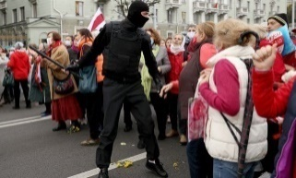

Masked Belarusian security officials confront older protesters during a rally to demand the resignation of Alexander Lukashenko. Photograph: AFP/Getty Images
Security forces in Belarus could fire on protesters if they deem it necessary, a minister has warned, as EU foreign ministers agreed to impose sanctions personally targeting President Alexander Lukashenko.
Gennady Kazakevich, the first deputy interior minister, said in a video statement: “We will not leave the streets, and law enforcement officers and internal troops if necessary will use riot control equipment and lethal weapons.”
The statement was the first time the authorities have explicitly threatened to use firearms against opposition demonstrators and would mark a major escalation in the two-month standoff between Lukashenko and protesters, who have staged peaceful rallies against his disputed re-election in August and against the abuse and torture of detainees.
The warning came after security forces cracked down harshly on anti-Lukashenko protests on Sunday, prompting EU foreign ministers to agree it was time to sanction Lukashenko himself.
Late on Monday, officers used tear gas and stun grenades against a group of older people holding a regular protest march, prompting outrage from the opposition.
The protests broke out when Lukashenko claimed victory in elections held on 9 August that are widely regarded as rigged. Popular opposition candidate Svetlana Tikhanovskaya, who claims to be the true winner, has been based in Lithuania since she was forced to flee after being threatened in a conversation with officials the night after the election.
In Belarus, police have so far acknowledged using water cannon, rubber bullets and stun grenades to disperse the protesters.
Kazakevich claimed that protests had become “extremely radical”, saying stones and bottles were thrown at police on Sunday by protesters armed with knives, who built barricades and set fire to tyres. “This has nothing in common with civil protest,” the deputy minister said, claiming that “groups of fighters, radicals, anarchists and football fans” were taking part.
Belarus was facing attempts to revive the “chaos of the 1990s” and foment the “colour revolutions” that have toppled pro-Kremlin leaders in other ex-Soviet states, he said.
His statement came as police have used some of the harshest tactics yet against protesters.
On Monday, men in balaclavas carrying batons confronted a crowd of mainly middle-aged and older women carrying placards with slogans such as “the grandmothers are with the people”, video footage by Tut.by independent news site showed.
Minsk police spokesman Roman Lashkevich told Russia’s RIA Novosti news agency: “We deployed stun grenades from an Osa flare gun and fired teargas when the citizens started to show aggression”.
“Today the regime crossed yet another line,” Tikhanovskaya said in a statement, pointing out that older Belarusians had once been seen as Lukashenko’s most loyal demographic.
The men in balaclavas were shown spraying teargas from inside their vehicles as protesters angry at the detention of demonstrators threw flowers at them and shouted “Fascists!” and “Cowards!”
Later, protesters in Minsk blocked roads and set tyres on fire, as military vehicles drove through the city centre, Tut.by reported.
During Sunday’s mass protests, police deployed water cannon and stun grenades in Minsk, detaining more than 700 people across the country, the interior ministry said.
The crackdown ended any expectations that a prison visit by Lukashenko to hold over four hours of talks with critics held in jail at the weekend marked any change in approach.
European foreign ministers on Monday agreed Lukashenko’s name should join a list of 40 of his officials already sanctioned by the EU with travel bans and asset freezes, diplomatic sources said.
The EU had held back from penalising Lukashenko himself, hoping to persuade him to engage in dialogue with opposition forces to resolve the crisis.
DIP: Watch this video of a man stopping a tank convey in Tiananmen Square, China in 1918 , then write a news report describing the events. Remember to use the techniques you have identified during the DART task. You will need to make up eye witness accounts.
Tiananmen Square protest

Lesson 17: Restaurant Reviews
LI: To understand how writers convey their opinions of restaurants
DART: Read the following restaurant review from The Guardian. Annotate it for techniques used by journalists:
- focuses on strengths and weaknesses
- uses evidence to support ideas
- draws a conclusion, saying whether something will be useful for, or interesting to, its audience
- gives personal opinion with confidence and authority

Key questions:
- What makes this report so engaging to the reader?
- What specific language does the reporter use?

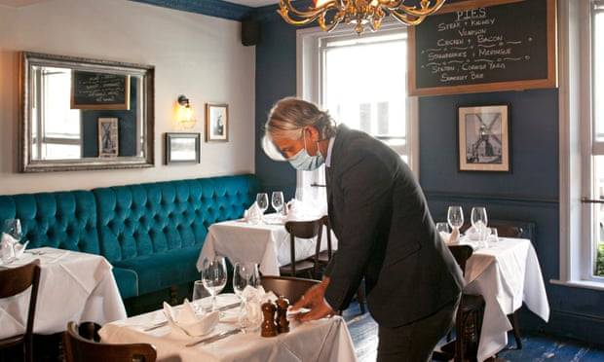
The Windmill, London: ‘You’ll be rewarded with terrific pie’ – restaurant review
With its golden-crusted pies, the Windmill pub in Mayfair has taken a turn for the better
Blowing in the wind: the Windmill’s dining room. Photograph: Sophia Evans/The Observer
Editor’s note: we have decided that, while restaurants remain open, we will continue to review them
The Windmill, 6-8 Mill Street, London, W1S 2AZ (020 7491 8050). Snacks and starters £2.25-£9, mains £12-£24 (all pies £14), desserts £6-£9.50, wines from £22.50
There are certain food items that make everything better. A well-made pie is one of them. The Windmill, a pub in London’s Mayfair, now serves very well-made pies. In the days following my dinner there, I kept thumbing open the photograph on my phone and gazing upon their steak and kidney pie, with its glazed suet pastry case, lightly crimped around the edges. It looked like a promise, fully kept.
There was a time, many centuries ago, when pastry was used only as a lid on stews, or as a case to protect cuts of meat from the flames in the hearth. It would be discarded or fed to the pigs or, if the big house was conscious of its obligations, given to the poor. By the late medieval era we were putting fats into pastry and making it distinctly edible. Follow that golden thread all the way through history to this brilliant piece of steak and kidney loveliness. Which I didn’t order. Think about that for a moment. Faced by an extensive pie menu – not just steak and kidney but venison and mushroom, chicken, bacon and leek and so on – I chose something else. I allowed my companion, who had just celebrated a significant birthday, to have the pie. I am a very kind man. Also, I felt I had a responsibility to try other things on the menu. But you know what I really wanted.
The Windmill, in a narrow lane just off Regent Street in London, is a 19th-century pub that has recently been colonised. It has been taken over by the team who run the Guinea Grill, four minutes’ walk away on Bruton Place. The Guinea is one of those London landmarks, a tight knot of rooms in which good steaks are eaten and big bottles of Bordeaux are drunk. It is famed for its mixed grill and, of course, its pies. I can’t pretend I like all the other clientele. It attracts a certain hooting, stomping, testicular crowd, many from the hedge-fund offices around here; the sort who encourage me to refine my plans for a policy of involuntary euthanasia to put us out of their misery when I become prime minister. But that’s not the Guinea’s fault.
In 2016, Young’s installed the revered publican Oisín Rogers at the Guinea. He’s a man with the cheery looks of a children’s television presenter and the unflinching, steely room command of Bet Lynch of the Rovers in her pomp. He spruced up the menu, introducing a magnificent cooked breakfast, and cheered up the service. Now he’s been given dominion over the Windmill, also a Young’s pub. Nathan Richardson, the Guinea’s head chef, has come over, along with a number of other staff. As a result, it feels like an outcrop of the mothership. Vladimir, the broad-chested sommelier from the Guinea, is working the tables the night we go, offering a lengthy wine list that frankly looks absurd for a humble London pub. It transpires that this is essentially the Guinea’s list. “If someone orders something from the list, I go round the corner and get it,” he says. Thus, if you want to drink a 2005 Château Latour at £2,450 with your steak and kidney pie, you may. If that’s not your thing, there are lots of other less worryingly priced bottles.
Downstairs is the pub bar with its own menu of devilled kidneys on toast, sausage rolls and fish fingers. There’s also that pie selection, which is more extensive than that at the Guinea and includes both a shepherd’s and a fish pie, and filo-wrapped option filled with pumpkin, chestnuts and mushroom. The upstairs dining room, with its green-blue walls and thick tablecloths, has a fancier menu, but you can order from both.
Up here it starts with snacks for between £2.25 and £4.50: bouncy roasted chicken hearts with a sticky glaze on wooden skewers; straws of still-warm baked pastry brushed with a meaty reduction with a hilariously rich bone marrow mayo to help them along; a bowl of white crab meat with diced egg and toasted brioche; squares of cured lamb topped with a silvery curl of vinegared anchovy. You could order all of these as a starter. Or you could pretend they’re a British equivalent to cicchetti and order them alongside the starters.
From the menu downstairs we have pert devilled kidneys served in a kicking sauce with a slow-release cayenne punch that soaks magnificently into the toast; from the menu upstairs comes a warm fillet of soused mackerel with a dollop of sour cream, and discs of crunchy carrot, all of it with a pickle that remains the right side of teeth-baring.
And then that pie, with a pastry shell that cracks to reveal that it has been properly filled with solid lumps of braised beef and kidney in a gravy as deep as any James Joyce novel. My companion kindly scoops a corner of it on to my plate and I sigh. At the Guinea these pies come with a frilly paper collar. Mind you, at the Guinea they cost £18 and here it’s £14. You choose. I have the beef fore rib, which arrives carnation-bloom pink and neatly sliced, with a brioche crumb and more of that bone marrow mayo. It’s a grand piece of meat treated with care. And, yes of course, we have vegetables. There are peas. With pieces of bacon. Some of you will now be ranting about meat consumption and an unbalanced diet. Maybe I shouldn’t tell you the chips are cooked in beef dripping. Mind you, they’re the one failure. Those chips needed a longer bath in the melted animal fats. Does it help if I tell you that, after this, I needed to go back to the gym? Repeatedly? No, thought not.
We finish with a sturdy treacle tart and some cracking meringues with blackberries. As in they cracked under the spoon to give way to the lusted-after chewiness beneath. We ate the night before the 10pm curfew was introduced and the sense of frustration among the staff was palpable. Young’s have launched an impressive app that enables you to book, order and pay without human interaction. Tables are spaced and the one-way system is in place. They’ve done everything they needed to do and like so many others have had to contend with the hollowing out of trade in the centre of town. If you feel comfortable with a night out, show the Windmill some love. You’ll be rewarded with terrific pie.
DIP: Write a review for a meal you have eaten recently. Think about using the techniques you have identified in the article. Feel free to magpie anything you think is particularly successful.

Lesson 18: AIC Revision
LI: To consolidate my knowledge and understanding of the play An Inspector Calls

Big Fat AIC Quiz
1. What colour is the lighting on stage prior to Inspector Goole’s arrival?

2. Mr Birling says: ‘A man has to make is own way, look after himself and his family.’
Is this a socialist or capitalist ideology? How do you know?

3. What is the name of the historical period used to describe society in which the events of AIC happen?

4. What is the intended dramatic effect of the lighting change which coincides with Inspector Goole’s arrival?

5. Is ignorant an appropriate word to describe Mr Birling? Why?

6. Recall three topics of after dinner conversation on which Mr Birling gives his personal opinions

7. What is the dramatic effect of Sheila’s sudden exit from the stage in Act One?

8. Mr Birling says: ‘If you don’t come down sharply on some of these people, they’d soon be asking for the earth.’ Explain who he is referring to in his use of the pronoun ‘they’ and what is conveys about his attitude to ‘them’

9. ‘If we were all responsible for everything that happened to everybody we’d had anything to do with, it would be very awkward, wouldn’t it?’ Who says this? To whom? What does it convey about the speaker’s attitude to responsibility?

10. What is ironic about the opinions Mr Birling expresses on the topics he discusses?

11. Mr Birling informs the Inspector: ‘I was Lord Mayor here two years ago when Royalty visited’. What year was he Lord Mayor? What is Mr Birling trying to do here? Why?

12. Which character is described in the stage directions as being another character’s ‘social superior’? What does this mean?

13. Is it Lord or Lady Croft who feels that Gerald ‘might have done better’ for himself socially than proposing to Sheila? What does this tell the audience about the time?

14. Is penitent an appropriate word to use to describe Sheila by the end of Act One? Why?

15. What is the intended dramatic effect of Gerald pouring himself a drink when Inspector Goole explains Eva Smith changed her name to Daisy Renton?

16. is deceitful an apt word to describe Gerald? Why?

17. Which character enters the dining room in Act Two ‘briskly, and self-confidently, quite out of key’ with the mood on stage?

18. Which character asks Gerald: ‘were you in love with her?’

19. What was the reason Gerald gave for ending the affair?

20. Which character might be best described as avaricious? Why?

21. What did Eva do at the charity committee which Mrs Birling describes as a ‘piece of gross impertinence’ and ‘quite deliberate’?

22. Is rueful an appropriate word to describe Mrs Birling? Why?

23. Talking about prostitutes in the Palace Bar, Gerald tells the Inspector: ‘I hate those hard-eyed, dough-faced women’. How does this comment make Gerald a hypocrite?

24. Is reckless an apt word to describe the way Eric admits he behaved in the past?

25. Is Eric humbled by his experience?

26. Which two characters might be described as obstinate? Why?

27. In which order are the characters interviewed in the play? Why do you think Priestley does this?

28. Is it appropriate to describe Inspector Goole as the antithesis of Arthur Birling? Why?

29. Write two of your own questions about the play:

30.

Lesson 19: ACC Revision
LI: To consolidate my knowledge and understanding of the novella A Christmas Carol

Big Fat ACC Quiz
1. Who wrote ‘A Christmas Carol’?

2. When was it published?

3. What era is it set in?
4. How many Staves are there in the novella? What is a Stave?

5. In the opening, Marley is described as being ‘Dead as a ….’ ? Why is this important? How long has Marley been dead for?

6. What is the name of Scrooge’s clerk? How is he treated?

7. What could the pathetic fallacy in “It was cold, bleak, biting weather” suggest to the reader about Scrooge?

8. How could Fred be considered the antithesis (opposite) of Scrooge? How is Fred related to Scrooge?

9. What is the significance of Christmas time? How is society supposed to act? To what extent do you think that Scrooge is justified in his feelings about Christmas? Think about how materialistic people are and whether the true meaning of Christmas has been lost

10. What does the rhetorical question “Are there no prisons?” reveal about how Scrooge thinks of the lower class? What are the connotations of the noun “prison”?

11. The Ghost of Christmas Past is described as “yet not so like a child as like an old man” – what could the conflicting appearances suggest?

12. How does Scrooge react to seeing his old school? What does this show about his character?

13. Scrooge states that Fezziwig had “the power to render us happy or unhappy”. What does this show about the power of a boss? How could this contrast Scrooge’s own actions in Stave One?

14. When Belle states that “​another​ ​idol​ ​has​ ​displaced​ ​me”, what does this mean? What has Scrooge prioritised instead of their relationship?

15. How does the Ghost of Christmas Present compare to the Ghost of Christmas Past? Which one do you think is more important for Scrooge?

16. Bob Cratchit describes Tiny Tim to be “as good as gold” – what does this literally mean? How could it also link to the family’s view on money?

17. “This boy is Ignorance. This girl is Want. Beware them both”. Why are Ignorance and Want both personified? How could they represent different parts of society?

18. How does Scrooge react to the final spirit? Why was he “bent down upon his knee”? How does this compare with his initial reaction to the spirits in the novella?

19. Why does the final Spirit not talk? What effect does this have on both Scrooge and the reader?

20. Why is Scrooge shown his future gravestone? What will happen to Scrooge if he does not change his ways?

21. What have the three visitors to the shop done? What is ironic about the way they treat Scrooge in death?

22. “The narrator’s is the most important voice in A Christmas Carol.” How far do you agree with this opinion?

23. What examples are there of Scrooge’s new generosity?

24. Write two of your own revision questions:

25.

