English Year 10 Autumn 1
Blended Learning Booklet:
An Inspector Calls

Name: ………………………………………………………..
Class teacher: …………………………………………….

- Aim to complete three lessons each week.
- Upload all work onto ClassCharts for feedback from your Class teacher.
- Answer all questions in full sentences, supported with quotations from the text where relevant.
- The SAL (GCSE mark scheme) is at the back of this booklet.



Lesson: | What you’ll be looking at: | Tick when completed:
- Prior Knowledge and Predictions | SAL and prior-knowledge questions
- Social and Historical Context | Key features of life in 1912 and 1945
- Dramatic Devices | Prologue
- Characters in the Opening of the play | Characters and first impressions
- Mr Birling and Dramatic Irony | Mr Birling’s monologue in Act One linking back to context
- Mr Birling in Act One | Mr Birling and how he is presented in Act One
- Sheila in Act One | Sheila and how she is presented in Act One
- Theme of Transformation | How Priestley presents the theme of transformation through the character of Sheila
- Gerald in Act Two | Gerald and how he is presented in Act Two
- Character Exam Practice | Write and evaluate an essay response about Gerald
- Mrs Birling in Act Two | Mrs Birling and how she is presented in Act Two
- Using Quotes | Embedding apt quotations into an exam answer
- Eric in Act Three | Eric and how he is presented in Act Three
- The Inspector | The Inspector’s final speech and how it demonstrates Priestley’s message
- The End | Respond and analyse the ending of the play
- Who is to blame? | Evaluate which character was most to blame
- Exemplar essay | Assess an essay using the SAL
- Form | The importance of the form of the play
- Bonus: Whole Play Consolidation | Quiz questions and watch the BBC adaptation of the play

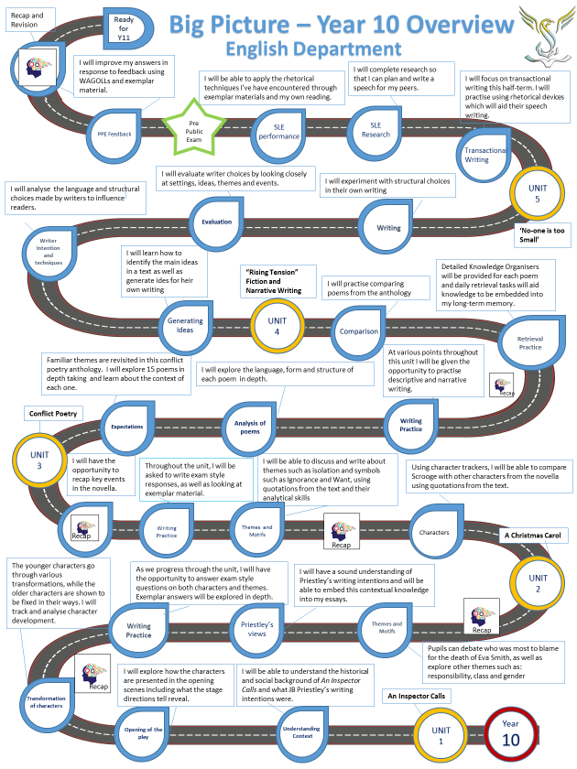

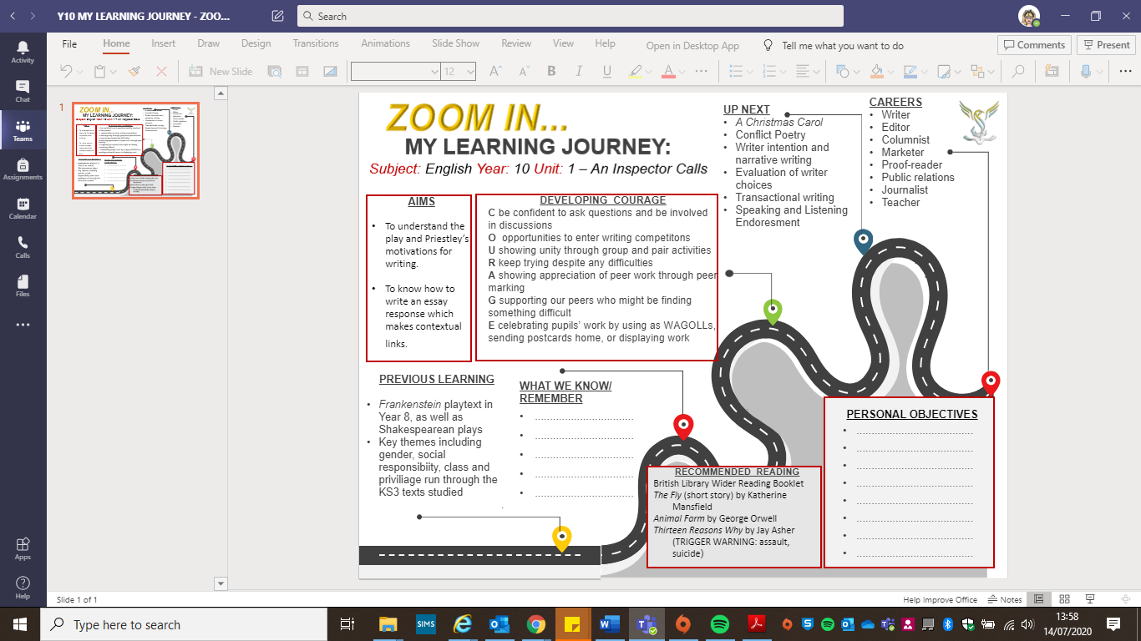
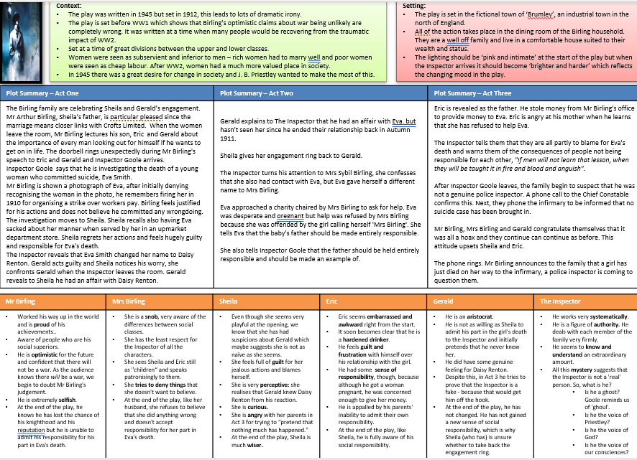
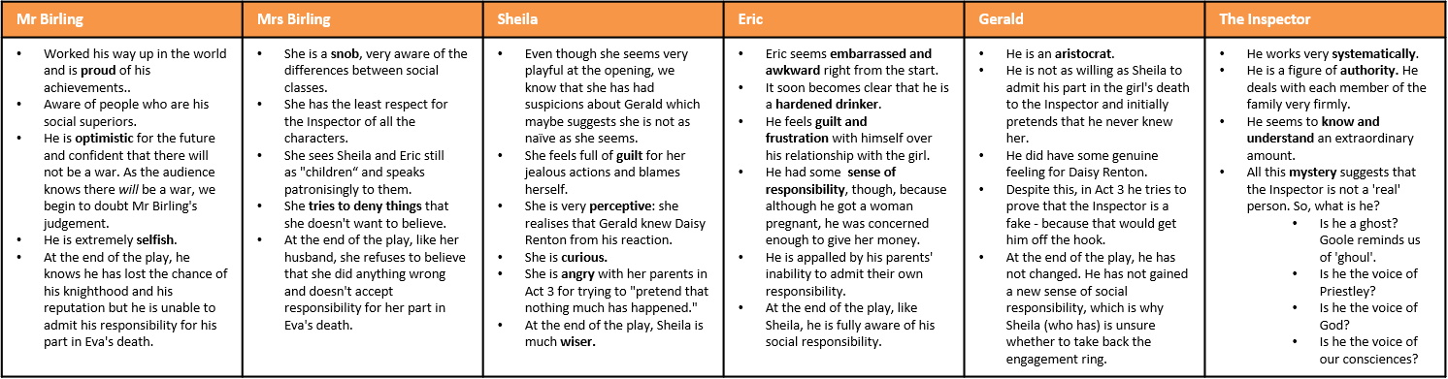
Setting:
- The play is set in the fictional town of ‘Brumley’, an industrial town in the north of England.
- All of the action takes place in the dining room of the Birling household. They are a well off family and live in a comfortable house suited to their wealth and status.
- The lighting should be ‘pink and intimate’ at the start of the play but when the Inspector arrives it should become ‘brighter and harder’ which reflects the changing mood in the play.

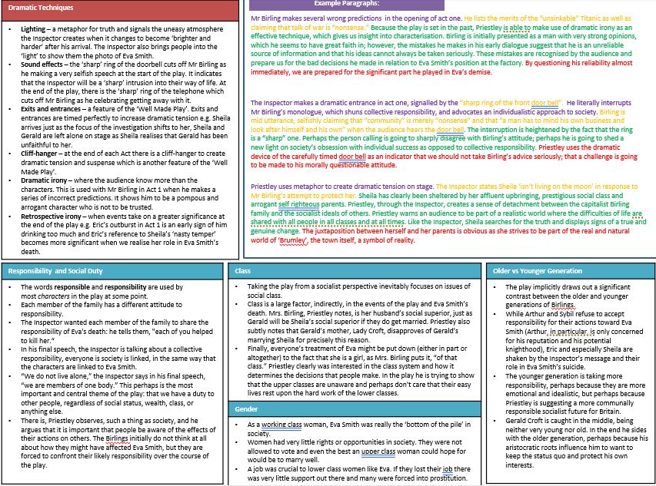
Lesson 1: An Inspector Calls
LI: to demonstrate existing knowledge and skills.
- What can you infer from the title of the play? Write a possible storyline.
- DART: read the SAL (at the back of this booklet) Use black pen to make your own individual annotations. What are you expected to do in this part of the Literature GCSE?
- Write your own opinion on the following statements:
  - The government should provide income support for people who don’t want to work.
  - It is not the government’s responsibility to keep people who are ill or unable to work.
  - Everyone should receive the same wages regardless of their job.
  - We should give at least a tenth of our salary/wages to those who have less than us.
- DIP: Write a paragraph explaining your predictions for the play based on what you have looked at in this lesson. Use suitable connectives in your writing and use a variety of punctuation to support meaning.

Lesson 2: Social and Historical Context
LI: to explore the historical/social context and Priestley’s motivations for writing the play
- Write your own opinion on the following statements:
  - We don’t live alone; we live in a community.
  - We are all responsible for each other.
  - Everyone has the right to be treated fairly and with respect whatever their class or social status.
  - We are all connected to one another and our actions affect other people’s lives.
  - Everyone should put themselves first and look after ‘number one’.
- KEY Q: What themes do you think the play will address?
- DART: Watch this GCSE Pod https://members.gcsepod.com/shared/podcasts/title/10265 and make notes on what you think are important to the context of the play.
- CHALLENGE: Listen to the two lectures on the Historical Context in Britain: https://www.massolit.io/courses/priestley-an-inspector-calls
- DIP: How was life in 1912 different to life in 1945? Use comparative connectives, facts from what you have read, and explain why people wanted change.

Lesson 3: The Prologue and Dramatic Devices
LI: to explore dramatic devices used in the prologue
- Write definitions for the following dramatic devices:
  - Lighting
  - Stage directions
  - Symbolism
  - Props
  - Casting
  - Costume
- DART: Read the prologue and find examples of the dramatic devices
- DIP: What do we learn about the Birling family from Priestley’s use of dramatic devices in the prologue? Why do you think Priestley has been so specific about the way the play is staged?

Lesson 4: Introduction to the Characters
LI: to analyse how the characters are presented in the opening of the play
- What do you know about each of the following characters?
  - Mr Birling
  - Mrs Birling
  - Sheila
  - Eric
  - Gerald
- DART: Read the opening of the play, from “Birling: Give us the port, Edna?...” to “Mrs Birling: I had better go into the drawing room and leave you men” (pages 2-5). Summarise what happens in this section.
- DIP: Choose one of the characters and explain your first impressions of him/her using evidence from the text.
- KEY Qs: What do we learn about them? How? What do they say? What do other characters say about them? How does this change your ideas about them? What are their relationships with other characters like? How can you tell?

Lesson 5: Mr Birling – Dramatic Irony
LI: to understand how dramatic irony is used to present the character of Mr Birling
- Which character(s) do you like and dislike so far? Explain your answer
- Write a definition for ‘dramatic irony’
- DART: Read Mr Birling’s speech, from “Birling: (rather heavily) I just want to say this…” to “Birling:…And we don’t guess – we’ve had experience – and we know” (pages 6-7). Find examples of dramatic irony in Birling’s monologue.
- KEY Qs: What historical events does Mr Birling refer to? What do we know as an audience about these events in reality? How does this make Mr Birling look to a 1945 audience? CHALLENGE: How does Priestley use language to help create this impression? Find specific words/phrases you could use as quotations that add to this impression of Birling
- DIP: Write an explanation of the effect of Priestley’s use of dramatic irony

Lesson 6: Mr Birling
LI: to analyse how Mr Birling is presented at the beginning of the play
- What do we know about Mr Birling? Focus on the facts (explicit)
- What impression does the audience get of Mr Birling? How? Why has Priestley included Mr Birling? What is his role/purpose in the play? (implicit)
- DART: Read pages 7-16 (up until Sheila’s entrance) What do we learn about Mr Birling here?
- KEY Qs: Who dominates the conversation? What does this tell us? What is the significance of the Inspector’s entrance? How does Birling react to the Inspector’s arrival? How is this different to Eric’s reaction? What is Birling’s relationship like with Eric? What is his relationship like with Gerald? How many times does he deny responsibility or involvement with Eva’s death?
- DIP: How does Mr Birling react to Eva’s death? What does this say about his character? CHALLENGE: How could you change the way Mr Birling is presented in this scene? What effect would this have on the audience?
- https://members.gcsepod.com/shared/podcasts/title/10265

Lesson 7: Sheila Birling
LI: to analyse how Sheila is presented during Act One
- What was life like for women in 1912? How did this change by 1945?
- What do we already know about Sheila?
- DART: Read from Sheila’s entrance “Sheila: (gaily) what’s all this about streets?” to “Oh – why had this had to happen?” (pages 16 – 25) What do we learn about Sheila from her reaction to hearing about Eva’s death?
- KEY Qs: What emotions does Sheila go through? What is your reaction to her behaviour? Do you think she was justified? Can you identify where she realised her part in the death of Eva Smith? Do you think class or hierarchy has anything to do with her behaviour? Is Sheila’s reaction more in line with the Inspector’s or Mr Birling’s? What could this suggest about her?
- DIP: How does Priestley show that Sheila has the potential to change/represent more socialist views? Write an analysis about how Sheila is presented in this scene
- https://members.gcsepod.com/shared/podcasts/title/10265
Lesson 8: Sheila’s Transformation
LI: to analyse how Priestley explores the theme of transformation through the character of Sheila
- How would you describe Sheila so far? Write your ideas down. The images below might help you




- DART: Read pages 25 – 33. How has Sheila transformed since we first met her at the beginning of the play? Why?
- KEY Qs: Have any characters shown a change/transformation so far in the play? Who? Why/why not? How have Sheila’s family relationships changed? How has the way she speaks changed?
- DIP: Write a detailed description of how you would play Sheila if you were acting as her in this scene. Explain your choices. You could describe:
  - Voice
  - Facial expressions
  - Body language/gestures
  - Proxemics to other characters

Lesson 9: Gerald Croft’s Interrogation
LI: to analyse how Gerald is presented during Act Two
- Explain how we know these things about Gerald using textual references (quotes):
  - Gerald is an eligible bachelor
  - Gerald has a rosy future ahead of him
  - It’s a future that looks a lot like Birling’s
  - He has had an affair with Daisy
- What do we already know about Gerald? How do you think he is going to react to Eva’s death?
- DART: Read from “Inspector: And anyhow, I knew already…” to Gerald’s exit. (Pages 34 – 40) How is Gerald to blame? Does he take responsibility? CHALLENGE: Why has Priestley included this complex character?
- DIP: Choose one of the statements below to write an explanation about, using relevant quotations form what you have read
  - Gerald clearly has no respect for women, or Eva. His response is clearly a pretence.
  - Gerald does take some responsibility. Sheila’s reaction to him makes us like him at the end.
  - Gerald actually helped Eva. It is clear he helped her, protected her, and cared for her.
- https://members.gcsepod.com/shared/podcasts/title/10265

Lesson 10: How to Approach Exam-style Essays
LI: to plan, answer and assess an exam question about character (Gerald)
- Answer the following questions in full sentences:
  - Is ‘aristocrat’ and appropriate adjective to describe Gerald? Why/why not?
  - How does Gerald initially react to hearing about Daisy’s death?
  - What quotation could you use to prove that Gerald feels he is innocent?
  - How could you interpret the following quotation from Gerald: “I didn’t feel about her as she felt about me.”
- KEY Q: Essay Question: “(with sharp sarcasm) You were the wonderful Fairy Prince. You must have adored it Gerald.” How is Gerald presented so far in the play?
- DART: Read the following two WAGOLLs. What makes them ‘good’? What is missing? (Look at the SAL at the back of this booklet)
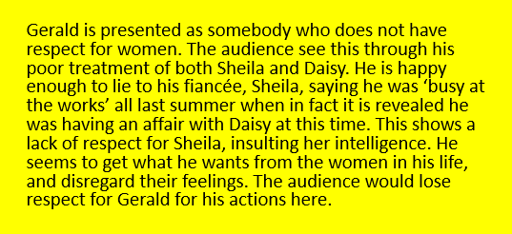
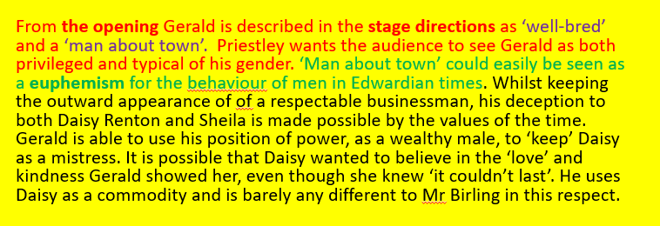

- DIP: Write the rest of the essay response independently. Use the WAGOLLs to help you if you get stuck

Lesson 11: Mrs Birling
LI: to analyse how Mrs Birling is presented in Act Two
- What do you already know about the character of Mrs Birling?
- What themes could she link to? Why?
- DART: Read pages 40 – 49. Write down any relevant quotations in relation to the following questions:
  - What is Mrs Birling’s reaction to hearing about Eva?
  - How does Mrs Birling refer to Eva?
  - What does she say about her responsibility?
  - How is dramatic irony used in the scene?
- DIP: How is Mrs Birling presented during her interrogation? Write an analytical response.
- https://members.gcsepod.com/shared/podcasts/title/10265

Lesson 12: Embedding Quotations
LI: to identify apt quotations and understand how to embed these in my comments
- Do you agree with the following statement made by a student:
“Mrs Birling’s arrogance makes her the character we dislike the most”
- Pick two of the following questions and explain why:
  - If Mrs Birling was a season, what would she be?
  - If Mrs Birling was a colour, what would she be?
  - If Mrs Birling was an animal, what would she be?
  - If Mrs Birling was a food, what would she be?
- DART: Read the following two paragraphs about Mrs Birling. Which paragraph do you think is more developed? How do you know? WWW? EBI?
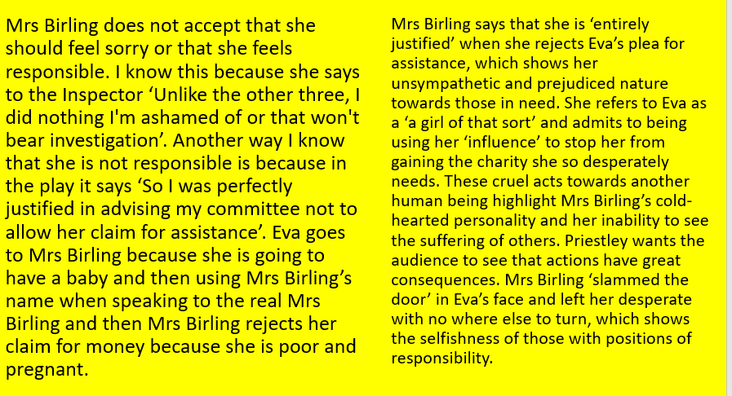

- DIP: Edit your paragraph from last lesson so that it now uses embedded quotations. Use blue pen to show your edit. Write two more paragraphs using embedded quotations.
- Answer the following questions in full sentences:
  - What is the name of Birling’s business?
  - What is the name of the Birling’s maid?
  - Why is Priestley writing this play? (in as few words as possible)
  - Who is Alderman Joe Meggarty?
  - Who is Charlie Brunswick?
  - What does Mrs Birling call the affair between Gerald and Daisy?
  - Why does Mr Birling defend Gerald’s actions? (try to think of at least two possible reasons)
  - Why did Sheila have Eva sacked?
  - What was the name of the shop Eva was sacked from?
  - Why aren’t Lord and Lady Croft at the engagement party? (try to think of an explicit and an implicit answer)

Lesson 13: Eric’s Interrogation
LI: to analyse how Eric is presented during Act Three
- Sum up Mrs Birling’s involvement in Eva’s death in one succinct sentence.
- What key quotations could you use to demonstrate that Mrs Birling is:
  - Obnoxious
  - Selfish
  - Entitled
- What do we begin to learn about Eric’s involvement towards the end of Mrs Birling’s interrogation?
- What do you think Eric is guilty of based on what you have already read?
- DART: Read from the start of Act Three to “Eric: You don’t understand anything. You never did. You never even tried – you – “(Page 55). What do we learn about Eric in this scene? How does he view his involvement? (Think about the theme of responsibility)
- DIP: Write a diary entry from the point of view of Eric about what has happened. You could write about:
Vocabulary
Traumatic Grief
Resentful Agitated
Dismayed Apprehensive
  - How/where you first met Eva and what you did
  - How you feel towards your mother
  - What you think about your mother/father’s views
  - Whether you regret any of your actions

- https://members.gcsepod.com/shared/podcasts/title/10265

Lesson 14: Inspector Goole
LI: to closely read and analyse the Inspector’s final speech
- What do we know about the Inspector so far?
- What do you think is the role of the Inspector?
- DART: Read from “Sheila: (frightened) Eric, don’t – don’t-…” to the Inspector’s exit. (Pages 55 – 57) What do we learn from the Inspector? Identify key quotations and make links to key themes (wealth, power, responsibility…)
- KEY Qs: Why do Mr and Mrs Birling not like the Inspector? How does the Inspector manipulate the family? What does the Inspector represent? What quotation would you choose to sum up the Inspector’s character and all he represents and why?
- DIP: Write your opinion on the role of the Inspector. Who is he? How could this be made into an exam style question?
- https://members.gcsepod.com/shared/podcasts/title/10265

Lesson 15: The End
LI: to analyse the ending of the play
- Choose one of the quotations about Eric below. Write an explanation of what it suggests about his character. You should try to embed the quotation to create a more fluent response.
  - ‘Why shouldn't they try for the highest possible wages, we try for the highest prices?’
  - ‘You could have kept her on instead of throwing her out’
Key Terminology:
Denouement: the ending point of a drama/story
Cyclical structure: Where the conditions at the end are someway the same as they are at the beginning.
  - Sheila - ‘You’re squiffy’
  - ‘Half shy, half assertive..’
- KEY Q: How accurate were you with your predictions with what happened in the play?
- Who do you think is going to learn their lesson? Who won’t? Why/why not?
- DART: Read from “He walks straight out” in the stage directions, to the end of the play (pages 56- 72).
- DIP: What effect does the ending have on you and why? Is this similar or different to the effect it would have had on an Edwardian audience? CHALLENGE: How could you edit the ending to change or strengthen Priestley’s message?

Lesson 16: Who is to blame?
LI: to evaluate which character was most to blame for their involvement in Eva’s death
- KEY Qs: Who do you think acted responsibly towards the end of the play? How does this link to Priestley’s message? How does this link to the historical/social context? Who was the most to blame? Why? How are family relationships affected by the events of the evening? Do you think Sheila will become engaged to Gerald again? Why? Is the ending a fit punishment for the Birlings? Why?
- DART: Read this section on BBS Bitesize and make your own notes https://www.bbc.co.uk/bitesize/guides/zxcqycw/revision/2
- DIP: Explore who you think is to blame in An Inspector Calls and who acted responsibly by the end of the play
- https://members.gcsepod.com/shared/podcasts/title/10265

Lesson 17: Using Exemplar Materials – Social Class
LI: to assess an exemplar essay using the SAL and use this to write my own response
- KEY Qs: What is social class? What is social mobility? How does marriage fit into the social class system? What effect does a capitalist system have on the social classes? Was the system broken? What reforms were needed? What is it like now?
- DART: Read the following essay response to the question: How is social class explored in An Inspector Calls? How could you improve this answer? What could you add?
Mr and Mrs Birling embody the arrogance of the upper class, when they dismiss Eva Smith as a troublemaker and liar. They call her ‘a girl of that class’ and that they were ‘entirely justified’ in their actions towards her. Mr Birling tries hard impress Sheila’s fiancé Gerald, in the hope that he reports back to his parents (who are a Lord and Lady) that the Birlings are a wealthy and respectable family. He brags about a potential knighthood and even buys the same port as Gerald’s father, ‘Finchley tells me this is the exact one your father has’.
Keeping up appearances is important to Mr Birling, as he has worked his way into upper class society, so rather than seem concerned for the girl who has just committed suicide he says, ‘ the press will have a field day…this will not look good for us’. This tells us that Birling is worried that the rose tinted world he has built is about to crash down around him. Appearances are everything to this man and a result of this, the audience in 1945 may have felt that their own attitudes were similar before both wars obliterated the entrenched class system. Priestley wants the audience to think back to the way people acted and uses the characters’ attitude towards social class to make them think about what future generations need to do in order to make the world a better place.
- DIP: Write at least a paragraph answering the exam question above. Use the exemplar essay to help if you get stuck. Highlight in yellow where you have:

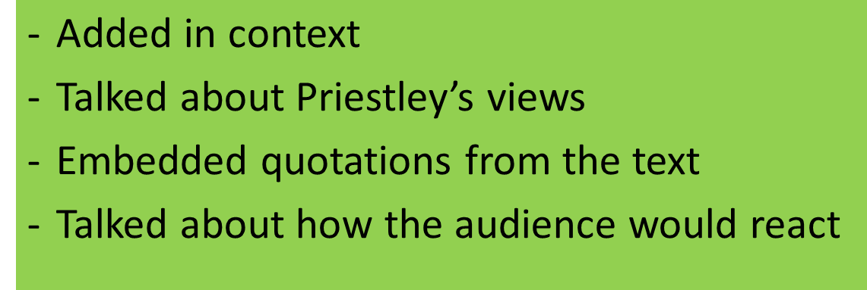

- https://members.gcsepod.com/shared/podcasts/title/10265

Lesson 18: The Form of the Play
LI: to understand and explain the form of the play
- What genre do you think the play is? Why?
- DART: Read your Knowledge Organiser. What does it say about the play’s form?
- KEY Qs: What is a ‘well-made’ play? What is a crime-thriller? What does ‘morality’ mean? What is a morality play? In what ways is this play a morality play? What morals do we learn? What moral crimes do characters commit? Is AIC a well-made play or a morality play? Why would Priestley make use of all these genres? How do they help him communicate his message?
- DIP: Create a revision tool for a key theme and character of the play (you can choose!)
- https://members.gcsepod.com/shared/podcasts/title/10265

Lesson 19: Retrieval and Consolidation of AIC
LI: to revise key moments of the play, as well as characterisation and context
- Quiz: Answer these questions in full sentences:
  - When is the play set?
  - When was the play written?
  - The play is about post-war Britain as well as which era? (Think about who was the reigning monarch)
  - Which character best represents the socialist viewpoint?
  - Which character best represents the capitalist viewpoint?
  - What is happening just as the Inspector enters the dining room?
  - Who threw Eva out of her job at the factory?
  - What reason did that character give for sacking her?
  - Who argued against Eva’s sacking (as well as the Inspector)?
  - Whose fault was it that Eva was sacked from Milwards and why did it happen?
  - How did Gerald meet Eva?
  - How did Mrs Birling meet Eva?
  - What reason did Mrs Birling give for refusing to help Eva?
  - Who was the father of Eva’s baby?
  - How did Eric get the money that he offered to Eva?
  - Who does the Inspector blame for Eva’s death?
- Watch the BBC adaptation of the play. What has been kept from the play? What is different? Why do you think the director made these changes? https://www.digitaltheatreplus.com/education/collections/bbc-studios/an-inspector-calls
- https://members.gcsepod.com/shared/podcasts/title/10265

 English Assessment Ladder Y10 Unit 1 Autumn 1
 | Literature Paper 1: An Inspector calls (AO1 and AO3 32 marks) (AO4 8 marks)
 | Knowledge and Understanding | Skills
Yellow Plus | AO1  High level of engagement with the text. Assured and confident personal response  AO3  Assured relationship between text and context | AO1  Assured personal response, showing a high level of engagement with the text  Developed critical style with maturity, perceptive understanding and interpretation  Integrated discerning references, with points made with assurance and full support from the text  AO3  Excellent understanding of context  Understanding of the relationship between text and context is integrated convincingly into the response
Yellow | AO1:  Thoroughly engaged response with a developed opinion  AO3:  Detailed understanding of text and context | AO1  Developed, personal way that thoroughly engages and fully relates to the text  Sustained critical style and there is well-developed interpretation  Well-chosen references to support a range of effective points  AO3  Sustained comment on relevant context  Detailed awareness of the relationship between text and context
Blue | AO1:  Demonstrates a relevant personal response  AO3:  Demonstrates understanding of text and context | AO1  Relevant personal response, soundly related to the text  Appropriate critical style, with comments showing a sound interpretation  Relevant and focused points that are supported from the text  AO3  Sound comment on relevant context  Sound relevant comment on the relationship between text and context
Green | AO1:  Largely descriptive response with some personal response  AO3:  Integrates some knowledge of the relationship between text and context | AO1  Respond in a narrative way with some personal response  Some evidence of a critical style with some reference to the text  Some valid points, even if they are inconsistent or lack focus at times  AO3  Some awareness of relevant context  Some comment on the relationship between text and context
White | AO1:  Simple understanding with little personal response  AO3:  Knows and understands the relationship between text and context | AO1  Simple comment about the text and/or task  Simple opinion and some relevant supporting reference  Simple idea about content and/or theme  AO3  Limited awareness of context  Limited comment on the relationship between text and context

AO4 Mark Scheme
Use for ALL Questions in Paper 1 – Section B (British Play OR British Novel)
Level | Mark | No rewardable material.
 | 0
Level 1 | 1-2 | threshold performance-in the context of the Level of Demand of  the question, Learners spell and punctuate with reasonable  accuracy, and use a reasonable range of vocabulary and sentence  structures; any errors do not hinder meaning in the response;
Level 2 | 3-5 | intermediate performance-in the context of the Level of Demand  of the question, Learners spell and punctuate with considerable  accuracy, and use a considerable range of vocabulary and sentence  structures to achieve general control of meaning;
Level 3 | 6-8 | high performance-in the context of the Level of Demand of the  question, Learners spell and punctuate with consistent accuracy,  and consistently use vocabulary and sentence structures to achieve  effective control of meaning.

Indicative content
Examiners are encouraged to reward any valid interpretations. Answers might, however, include some of the following:

AO1
• Response to the characters with possible treatment of who is more aware of idea of social responsibility
• Reactions to idea of the Inspector in terms of how he affects the characters as well as how he offers an opportunity to learn/change
• Different characters’ attitudes towards responsibility: Mrs Birling’s hypocrisy, Mr Birling’s treatment of his workers
• Differences between older and younger generations’ response to Inspector and Eva Smith
• The use of the Inspector as dramatic device to enable characters to learn about responsibility
• Any comments related to the presentation of character: Mr Birling’s attitude towards others, contrast between Mr Birling and Eric/Mrs Birling and Sheila
• Presentation of anger/bluster/defensiveness
• Use and effects of pauses and hesitancy to suggest discomfort

AO3
• Treatment of idea of responsibility as social issue
• Comments dealing with wider ideas of class consciousness
• Contrast between family’s light-hearted relief and final shock of telephone call – used as punishment for self-satisfaction
• Ideas about Eva Smith as metaphor

