Year 11
Unit 2.3– Health, Fitness and Well-being
Autumn 2 Blended Learning Booklet

Name:

Aim to complete two lessons each week.
All video links and content are also uploaded on ClassCharts
The knowledge organisers have all the key information and vocabulary to help with this unit.
Upload all work onto ClassCharts for feedback

Contents:
Page 3: Big Picture – Year overview
Page 4: Zoom in – My learning Journey
Page 5: Knowledge organiser – Health, Fitness and Wellbeing
Page 6: Knowledge organiser – Nutrition
Page 7: Lesson 1 – Introduction/ Health Fitness and Wellbeing
Page 8-11: Lesson 2 – Health (Physical, Emotional & Social) benefits
Page 12-17: Lesson 3 – Consequences of a sedentary lifestyle
Page 18-22: Lesson 4 – 6 Mark Exam Question
Page 22-28: Lesson 5&6 – Balanced diet
Page 29-30: Lesson 7 – Effects of diet and hydration
Page 31: Lesson 8 – Revision
Page 31: Lesson 9 – End of topic test
Page 31: Lesson 10 – Test review and feedback
Page 31: Lesson 11: Book review
Page 32&33 – Assessment ladder

Lesson 1: Health, Fitness and Well-being
LI: To understand what is meant by health, fitness and well-being
Seneca: Health and Lifestyle: Physical Health and Well-Being 5.1.1
GCSE Bitesize: https://www.bbc.co.uk/bitesize/guides/zpmq6fr/revision/1
Powerpoint: Uploaded on to ClassCharts

Introduction to topic: https://www.youtube.com/watch?v=En1RBBzQZoA
Q: What do the people in the clip have in common?

Dart: On Classcharts - Why do teenagers participate in sport?
Health is...
Fitness is...

Well-being is...
https://www.youtube.com/watch?v=wWGulLAa0O0
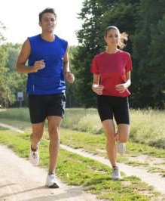
Health requires you to be well physically, mentally and socially where as fitness is only physical.
There is a link between health and fitness.
Exercising will increase your fitness and improve health, whilst you need to be healthy in order to be able to exercise and develop fitness.
The three categories of health:
Lesson 2:
LI: To understand the different health benefits of physical activity and consequences of a sedentary liefstyle
Seneca: Health and Lifestyle: Mental and Social 5.1.2
GCSE Bitesize: https://www.bbc.co.uk/bitesize/guides/zpmq6fr/revision/2
https://www.bbc.co.uk/bitesize/guides/zpmq6fr/revision/3
Powerpoint: Uploaded on to ClassCharts

Dart: On Classcharts – Physical activity and the immune system
The Physical Benefits of Exercise on Health
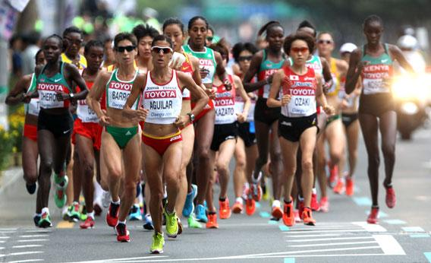

- How could exercising or taking part in sport benefit you emotionally?

The Emotional Benefits of Exercise on Health

The Social Benefits of Exercise on Health

The Benefits of Exercise - Case Study


Louise is considering joining a gym. She would be interested in using the fitness equipment, playing badminton at the recreational club and attending fitness classes such as zumba and yoga.

DIP: Read the scenario above. Using the scaffolded grid below, explain why Louise should join the gym, using the physical, emotional and social benefits that she could experience from taking part in these activities.

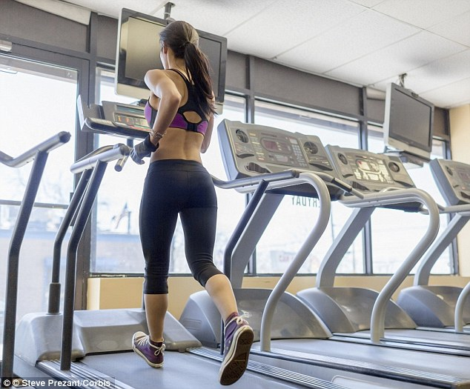
Physical Benefits:
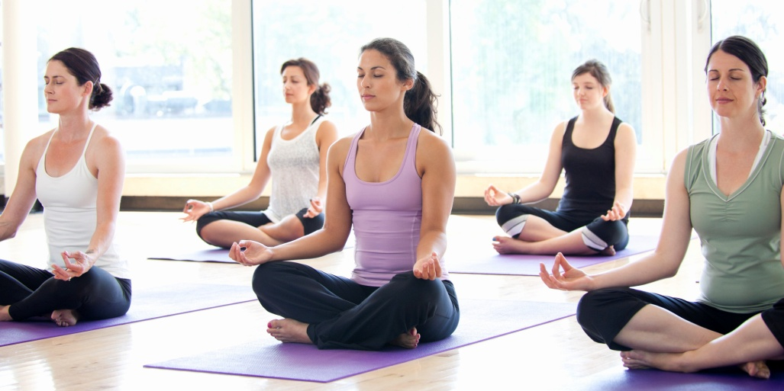
Emotional Benefits:
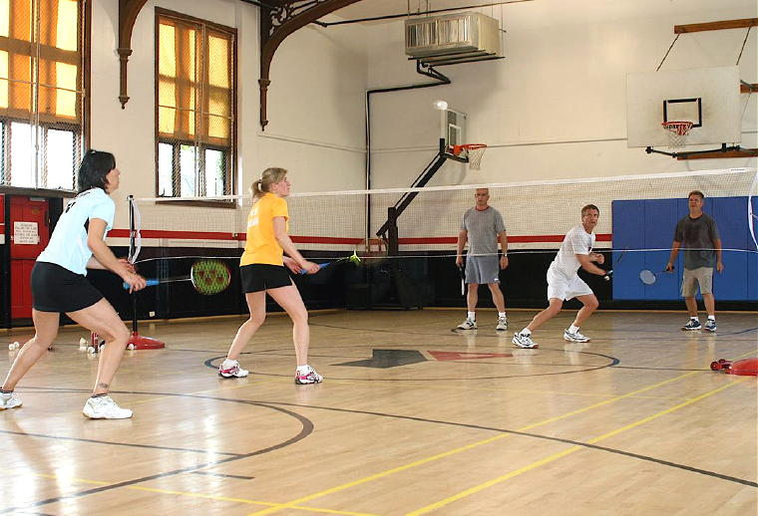
Social Benefits:

Lesson 3:
LI: To understand the different consequences of a sedentary lifestyle on a person’s health.
LI: To be able to apply the physical, emotional and social benefits to different age groups.
Seneca: Health and Lifestyle: Fitness 5.1.3
Health and Lifestyle: Sedentary lifestyles 5.1.4
GCSE Bitesize: https://www.bbc.co.uk/bitesize/guides/zpmq6fr/revision/2
https://www.bbc.co.uk/bitesize/guides/zpmq6fr/revision/3
Powerpoint: Uploaded on to ClassCharts

Dart: On Classcharts – A Sedentary lifestyle increase the risk of adolescent depression
A Sedentary Lifestyle
What is a sedentary lifestyle?

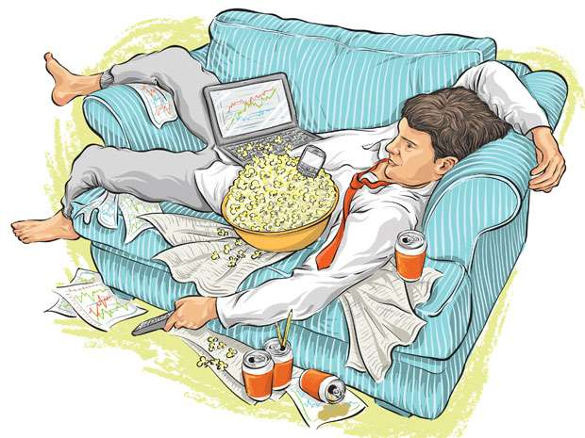
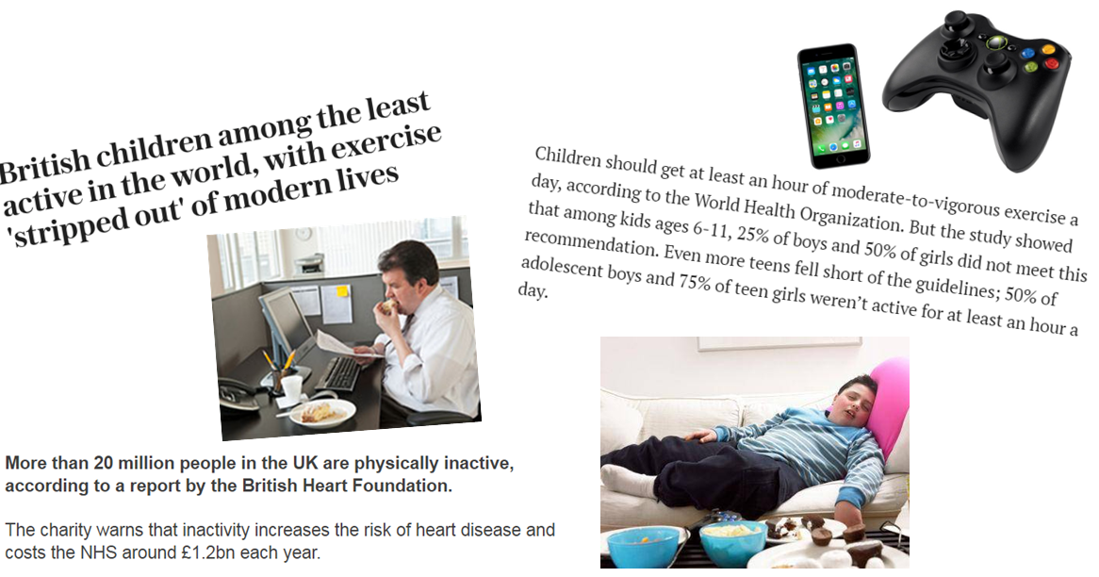

The Consequences of a Sedentary Lifestyle on Physical Health

The Consequences of a Sedentary Lifestyle on Emotional Health

The Consequences of a Sedentary Lifestyle on Social Health

The Consequences of a Sedentary Lifestyle - Case Study
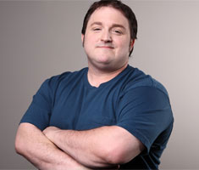
Phil lives a sedentary lifestyle. He works 9-5 in an office; he drives to and from work and chooses to relax by watching TV after work. He wants to know why he should find the time to become more active.

Task: Read the scenario above. Explain the impact of his sedentary lifestyle on his physical, mental and social health in an effort to convince him to take up some physical activity.
Extension: Link your descriptions to the potential benefits he could experience if he takes up exercise.

Physical Health Consequences:
Emotional Health Consequences:
Social Health Consequences:
Living an Active Lifestyle

Q: Is it easier for some of the groups below to live a healthier, more active lifestyle and not be sedentary than other groups? Why?

Q: Are some of the benefits of exercise more important for some groups than others? Would these affect someone's reasons for participating?



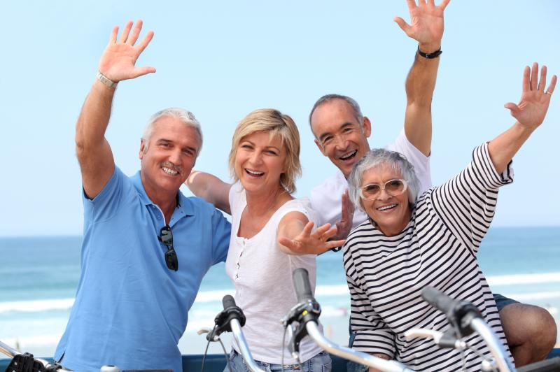

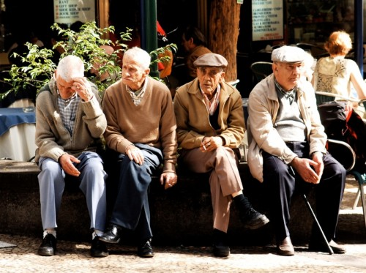



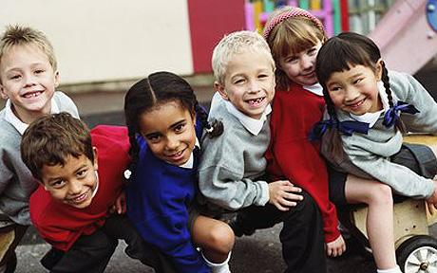

Lesson 4:
LI: To understand how to structure and answer a 6 mark question
LI: To be able to explain the physical, emotional and social benefits of living an active

The structure of your answer should be:
A short introduction that addresses the question and introduces your answer.
Two/Three paragraphs (depending on the question) – state your point showing your knowledge and understanding (AO1), provide a relevant sporting example (AO2) and evaluate how this can improve health (AO3)
A conclusion that summarises your answer and makes reference to the question again.

Q: Explain the physical, emotional and social benefits of living an active lifestyle (6).

What is the question asking?
What are the physical, social and emotional benefits of an active lifestyle? Give examples of each. What impact does this have on the individual?

Introduction
Answer the question briefly. Talk about what is classes as an active lifestyle.
Say briefly what you are going to say in the rest of your answer including the three examples of each of the physical, social and emotional.

________________________________________________________________________________________________________________________________________________________________________________________________________________________________________________________________________________________________________________________________________________________________________________________________________________________________________________________________________________________________________________________________________________________________________________________________________________________

Paragraph 1
Name one physical benefit of an active lifestyle. Describe what this characteristic means.
Give a sporting example that relates to this characteristic and link it to the description you have given.
Explain the implications (what would happen) to the individual when they may be sedentary

__________________________________________________________________________________________________________________________________________________________________________________________________________________________________________________________________________________________________________________________________________________________________________________________________________________________________________________________________________________________________________________________________________________________________________________________________________________________________________________________________________________________________________________________________________________________________________________________________________________________________________________________________________________________________________________________________________________________________________________________________________________________________________________________________________________________________________________________________________________________________________________________________________________________________________________________________________________________________________________________________________________________________________________________________________________________________________________________________________________________________________________________________________________________________________________________________________________________________________________________________________________________________________________

Paragraph 2
Name one social benefit of an active lifestyle. Describe what this characteristic means.
Give a sporting example that relates to this characteristic and link it to the description you have given.
Explain the implications (what would happen) to the individual when they may be sedentary

___________________________________________________________________________________________________________________________________________________________________________________________________________________________________________________________________________________________________________________________________________________________________________________________________________________________________________________________________________________________________________________________________________________________________________________________________________________________________________________________________________________________________________________________________________________________________________________________________________________________________________________________________________________________________________________________________________________________________________________________________________________________________________________________________________________________________________________________________________________________________________________________________________________________________________________________________________________________________________________________

Paragraph 3
Name one emotional benefit of an active lifestyle. Describe what this characteristic means.
Give a sporting example that relates to this characteristic and link it to the description you have given.
Explain the implications (what would happen) to the individual when they may be sedentary

_________________________________________________________________________________________________________________________________________________________________________________________________________________________________________________________________________________________________________________________________________________________________________________________________________________________________________________________________________________________________________________________________________________________________________________________________________________________________________________________________________________________________________________________________________________________________________________________________________________________________________________________________________________________________________________________________________________________________________________________________________________________________________________________________________________________________________________________________________________________________________________________________________________________________________________________________________________________________________________________________________________________________________________________________________________________________________________________________________________________________________________________________________________________________________________________________________________________________________________________________________________________________________________________________________________________________________________________________________________________________________________________________________________________________________________________________________________________________________________________________________________________________________________________________________________________________________
Conclusion
What are the physical, social and emotional benefits of an active lifestyle?
Why are they important?
What would happen if the sports person didn’t have the characteristics?
Look back at the question and summarise your answer.

_________________________________________________________________________________________________________________________________________________________________________________________________________________________________________________________________________________________________________________________________________________________________________________________________________________________________________________________________________________________________________________________________________________________________________________________________________________________________________________________________________________________________________________________________________________________________________________________________________________________________________________________

Feedback:

Lesson 5&6: Balanced Diet
LI: To know the definition of a balanced diet
LI: to know the components of a balanced diet: carbohydrates, proteins, fats, vitamins, minerals, fibre and water.
Seneca: Nutrition: 5.2.1
GCSE Bitesize: https://www.bbc.co.uk/bitesize/guides/zgvsbk7/revision/2
Powerpoint: Uploaded on to ClassCharts

Introduction to topic: https://www.youtube.com/watch?v=En1RBBzQZoA
Q: What do the people in the clip have in common?

Dart: On Classcharts - Why do teenagers participate in sport?
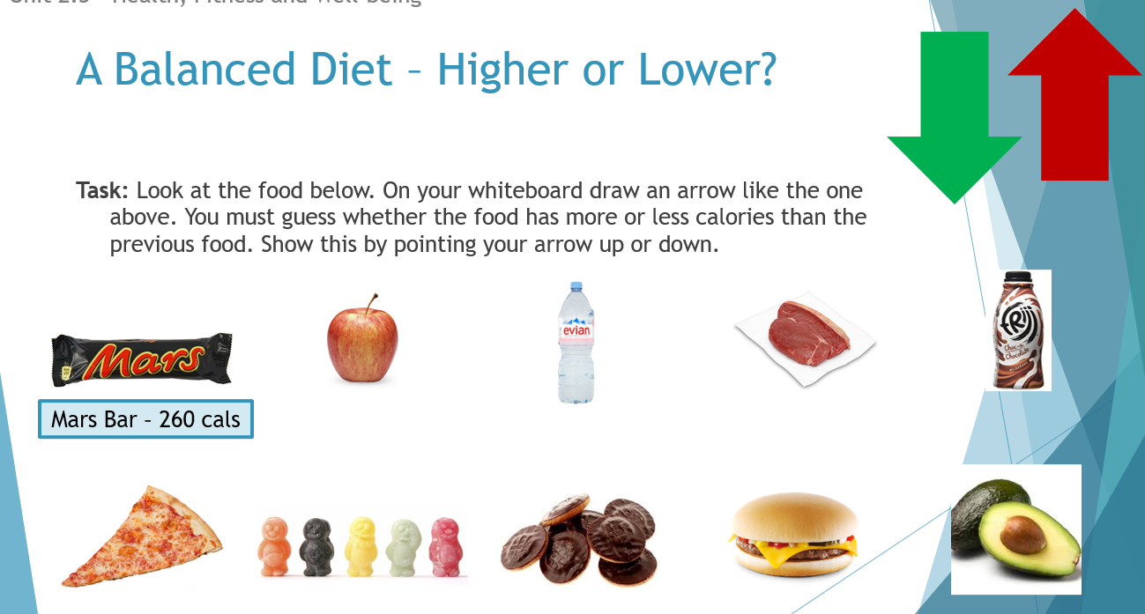

A Balanced Diet
A balanced diet is...

There are seven components of a balanced diet, these are:
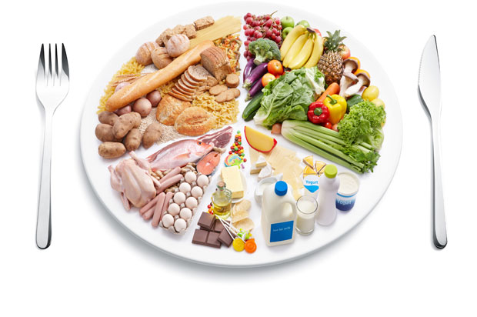
- V
- V
- V
- V
- V
- V
- V

Athletes require these components in different quantities depending on the requirements of their sport.
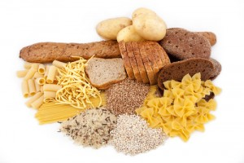
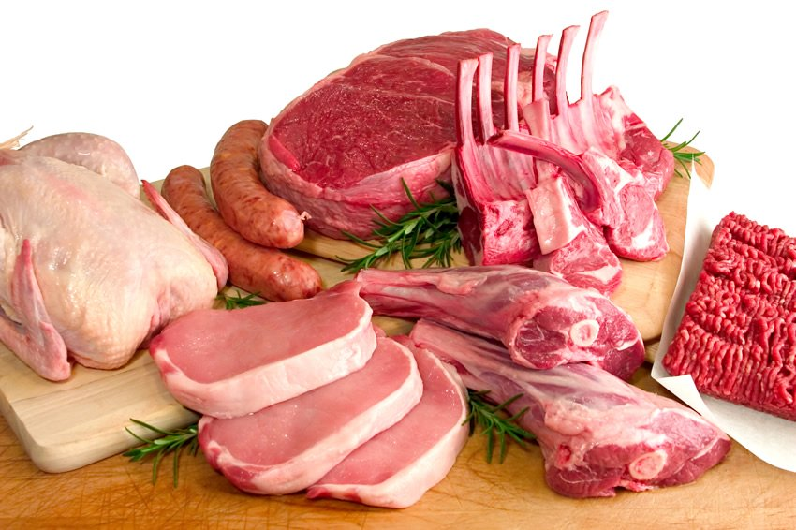

https://www.youtube.com/watch?v=KMGUmcveQeg

The Components of a Balanced Diet

Nutrient:

Description and Function:

Foods where it is found:

Video 1: | How would this nutrient affect the athlete’s performance?  https://www.youtube.com/watch?v=sj29fw25vvA
Video 2: | How would this nutrient affect the athlete’s performance?  https://www.youtube.com/watch?v=txwYwLKDNNU

Nutrient:

Description and Function:

Foods where it is found:

Video 1: | How would this nutrient affect the athlete’s performance?  https://www.youtube.com/watch?v=Smk7QF5K2l8
Video 2: | How would this nutrient affect the athlete’s performance?  https://www.youtube.com/watch?v=PEG0M8EkbUA

Nutrient:

Description and Function:

Foods where it is found:

Video 1: | How would this nutrient affect the athlete’s performance?  https://www.youtube.com/watch?v=UNq25Pt1W7c
Video 2: | How would this nutrient affect the athlete’s performance?  https://www.youtube.com/watch?v=iQY6EoYVRxs (from 12 mins)

Nutrient:

Description and Function:

Foods where it is found:

Video 1: | How would this nutrient affect the athlete’s performance?  https://www.youtube.com/watch?v=rlotBBSInYA
Video 2: | How would this nutrient affect the athlete’s performance?  https://www.youtube.com/watch?v=8RczLz_7yyI

Nutrient:

Description and Function:

Foods where it is found:

Video 1: | How would this nutrient affect the athlete’s performance?  https://www.youtube.com/watch?v=5dSHUzzX7jI
Video 2: | How would this nutrient affect the athlete’s performance?  https://www.youtube.com/watch?v=-kaaXz4IgrA

Nutrient:

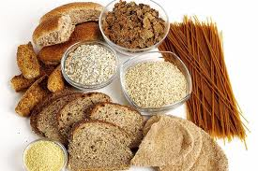
Description and Function:

Foods where it is found:

Sporting Example:

Nutrient:

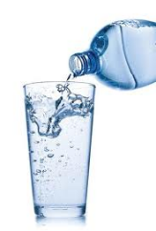
Description and Function:

Foods where it is found:

Sporting Example:

Lesson 7: Effects of diet and hydration
LI: To understand the effect of diet and hydration on energy use in physical activity
Seneca: Hydration: 5.2.2
GCSE Bitesize: https://www.bbc.co.uk/bitesize/guides/zgvsbk7/revision/1
https://www.bbc.co.uk/bitesize/guides/zgvsbk7/revision/3
Powerpoint: Uploaded on to ClassCharts

Introduction: https://www.youtube.com/watch?v=mve0mVu5y5A
Dehydration
Q:What are the risks of dehydration when taking part in sport?
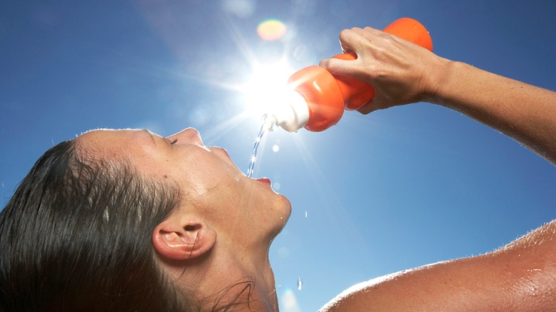

An Athletes Diet
Task: For each of the sports people below discuss which nutrients their diet will be made up of. Describe how these nutrients will help them to be successful in their sport.
- Extension: How would these athletes diets/calorie intake differ from an average persons? Why?

https://www.youtube.com/watch?v=QXRvXtcSu14
DIP: Watch the video which shows his daily calorie intake and discuss how he is able to eat like this but remain in shape?
https://www.youtube.com/watch?v=nYGDRVxM2pg
Calorie Intake and Energy Balance
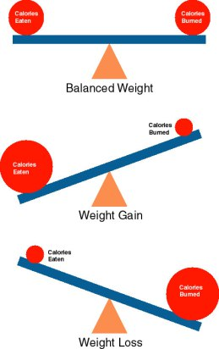

Lesson 8: Exam Revision
LI: To understand the different revision techniques.
LI: To identify the areas of weakness

Revision Task: Seneca 5.2.3 End of Topic Test – Repeat until you achieve 100%
Revision Task: 5.2.4 Exam style questions
Revision Task: GCSE Bitesize Health, Fitness and Well-being 3 sections tests
https://www.bbc.co.uk/bitesize/guides/zpmq6fr/test
https://www.bbc.co.uk/bitesize/guides/zxqd2p3/test
https://www.bbc.co.uk/bitesize/guides/zgvsbk7/test

Revision Task: GCSE Pod: Health, Fitness and Well being -1 sections assigned

Lesson 9: Topic Test
LI: To be able to complete the end of topic test to the best of my ability in exam conditions.

Topic Test will be uploaded on to Classcharts

Lesson 10: Feedback and analysis
LI: To understand personal areas of strength and weakness

Mark scheme and All feedback will be uploaded on to Classcharts

Lesson 11: Folder/Book Review

Theory Attainment Band : | Physical factors affecting performance: HEALTH FITNESS & WELL-BEING
Theory Attainment Band : | Skills | Knowledge and Understanding
9 | - Flawlessly factual and perceptive responses that relate accurately to the focus of the question  - Demonstrate excellent understanding, providing clear and detailed descriptions and explanations  - Communication in writing is highly effective using appropriate and coherent terminology  - Spelling, punctuation and grammar is precise | - Know what is meant by health, fitness and well-being  - Understand the different health benefits of physical activity and consequences of a sedentary lifestyle:  - Physical:  - Injury  - Coronary heart disease (CHD)  - Blood pressure  - Bone density  - Obesity  - Type 2 diabetes  - Posture  - Fitness  - Emotional:  - Self-esteem / confidence  - Stress management  - Image  - Social:  - Friendship  - Belonging to a group  - Loneliness  - Be able to apply the above to different age groups  - Be able to respond to data about health, fitness and well-being  - Know the definition of a balanced diet  - Know the components of a balanced diet:  - Carbohydrates  - Proteins  - Fats  - Minerals  - Vitamins  - Fibre  - Water and hydration  - Understand the effect of diet and hydration on energy use in physical activity.  - Be able to apply practical examples from physical activity and sport to diet and hydration.
8 | - Consistently factual and sustained responses that relate to the focus of the question  - Demonstrate excellent understanding, providing well-defined explanations and descriptions  - Communication in writing is highly effective using appropriate and coherent terminology  - Spelling, punctuation and grammar is precise
7 | - Offer factually and sustained responses that relate to the focus of the question  - Successfully and confidently address all aspects of the question  - Demonstrate high levels of understanding, providing clear and detailed descriptions and explanations  - Communication in writing is highly effective using appropriate and coherent terminology  - Spelling, punctuation and grammar is accurate
6 | - Confidently offer factually accurate and sustained responses that closely relate to the focus of the question  - Demonstrate excellent understanding and provide clear and detailed descriptions and explanations  - Writing shows strong evidence of communicating ideas with high efficiency and use of appropriate terminology  - On the whole, spelling, punctuation and grammar is accurate
5 | - Responses are consistently factually accurate that closely relate to the focus of the question  - Demonstrate good understanding and provide clear and detailed descriptions and explanations  - Writing shows evidence of communicating ideas with efficiency and use of appropriate terminology  - Spelling, punctuation and grammar is appropriate
4 | - Responses are often factually accurate and show some relation to the focus of the question  - Demonstrate sound understanding and provide adequate descriptions and explanations  - Writing shows evidence of communicating ideas with limited efficiency and use of appropriate terminology  - Spelling, punctuation and grammar is often adequate
3 | - Responses are often inaccurate and show little relation to the focus of the question  - Demonstrate basic understanding and provide limited descriptions and explanations  - Communication in writing is approaching an adequate level of coherence, using some appropriate terminology  - Spelling, punctuation and grammar is developing in consistency
2 | - Responses are vague and do not relate to the question  - Little demonstration of understanding and explanations are often incorrect  - Communication in writing is largely ineffective and lacking coherence  - Spelling, punctuation and grammar is inconsistent
1 | - Responses do not relate to the question  - No demonstration of understanding and explanations are incorrect  - Communication in writing is ineffective and disjointed  - Spelling, punctuation and grammar is weak

