Year 11 History Blended Learning Booklet
Henry VIII and His Ministers 1509-1540
Autumn 2

Aim to complete two lessons each week. Write out the title and LI and then complete the tasks.
All video links are online using the ClassCharts link.
Upload all work onto ClassCharts for feedback.

Name:
Form:


Dissolution of the Monasteries
Thomas Cromwell
Henry VIII
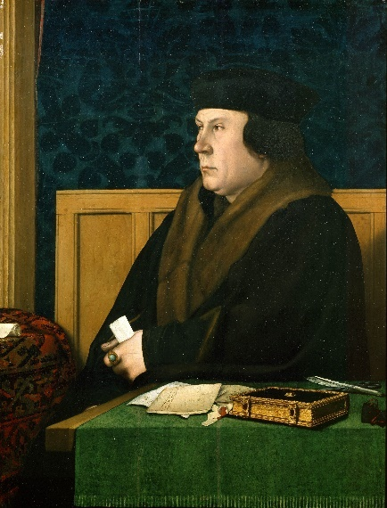
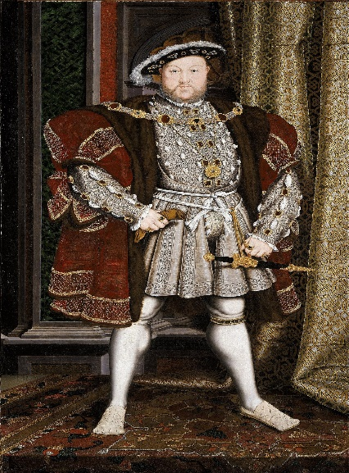

Contents
Big Picture 3
Zoom in 4
Knowledge Organiser 5
Lesson One-Rise of Thomas Cromwell 6-7
Lesson Two-Cromwell and the Annulment 8-9
Lesson Three-The Fall of Anne Boleyn 10-11
Lesson Four-Anne Boleyn’s execution and Jane Seymour 12-13
Lesson Five-Cromwell’s reforms 14-15
Lesson Six-The Fall of Cromwell 16

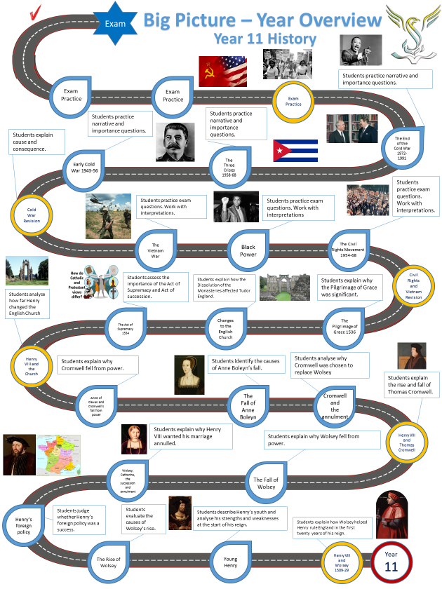

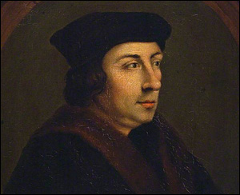
Thomas Cromwell Knowledge Organiser
Background
Thomas Cromwell was born in Putney in 1485. He was the son of Walter Cromwell a local blacksmith, cloth worker and ale house keeper. Just like Wolsey, Cromwell came from humble origins. Thomas Cromwell had a difficult relationship with his father and decided to leave England in his teenage years.


Europe
In 1503, Cromwell joined the French army and fought against the Spanish at the Battle of Garigliano. The French were defeated and Cromwell deserted the army leaving for the wealthy town of Florence.
While in Florence, Cromwell met a wealthy merchant banker called Francesco Frescobaldi. Cromwell rose up in the Frescobaldi household and he learnt a great deal about art, literature and music.
In 1515, Cromwell travelled to Antwerp in Belgium. The city was at the centre of the cloth trade and Cromwell learnt how to do business and make contacts.
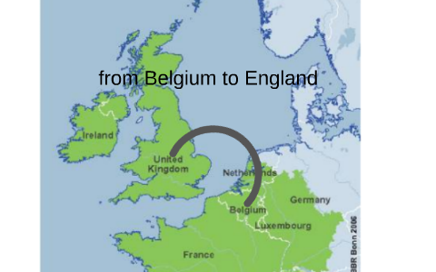
Return to England
Cromwell returned to England as an educated man with many contacts. He had learnt how to be an effective businessman and had learnt a great deal about the law. He married Elizabeth Wyckes who was from wealthy family and consequently Cromwell’s reputation grew further.
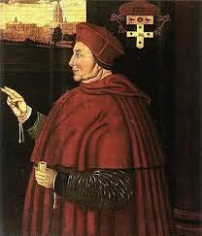
Cromwell’s service to Wolsey
Thomas Cromwell served Thomas Wolsey for over a decade. He became part of his council in 1519. Cromwell was a very helpful person to have around given his knowledge of the law and business. Wolsey and Cromwell were similar characters who had risen through the rigid Tudor social hierarchy. Cromwell often delivered Wolsey’s messages to Henry VIII. In 1523, Cromwell became a member of parliament.

Lesson One: The Rise of Thomas Cromwell
LI: To analyse why Cromwell was chosen to replace Wolsey.
Using your knowledge organiser complete the spider diagram on the rise of Cromwell. Include the skills that he possessed and the reasons that his reputation grew.

The rise of Thomas Cromwell

Personality
Cromwell’s personality was one of the main reasons that he rose through Tudor society. He was charming and witty. He knew how to win people over. He became a man who people could trust. He was one of Wolsey’s most trusted friends.
Defending Wolsey
Even when Wolsey fell from power he stuck by him. Cromwell expected that his career at court was now over. Attacks against Wolsey could include him too.
Cromwell used his position as an MP for Taunton to defend Wolsey which meant he gained an audience with the King. Henry was impressed by Cromwell’s loyalty.

GCSE POD VIDEO
https://members.gcsepod.com/shared/podcasts/title/12338/75895
Watch the video and answer the following questions:
- How did Wolsey’s life experience help him to rise through Tudor society?
- Why was Henry impressed by Cromwell’s defence of Wolsey?
- How was Cromwell rewarded by Henry?
- What had happened by 1532?
- Why was Henry’s work as an MP useful for getting Henry an annulment?
- Why was the Act in Restraint of Appeals important?
- What role did Thomas Cranmer (not Cromwell) play in the annulment?

Lesson Two: Cromwell and the Annulment
LI: To analyse the significance of the Act in Restraint of Appeals 1533.
Timeline of 1533
January-Anne Boleyn was pregnant. Henry need an annulment more than ever if the baby was to be a legitimate heir.
Henry and Anne Boleyn are married by Thomas Cranmer in a secret marriage ceremony.
Thomas Cranmer
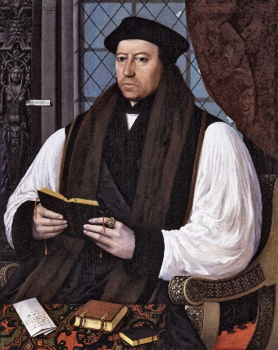
March-The Act in Restraint of Appeals
This was the basis of Henry’s annulment. England was an empire and therefore did not have to listen to the Pope.
23rd May-An annulment hearing was led by Archbishop Cranmer. Henry had finally got his annulment.
30th May-Huge coronation celebrations for Anne Boleyn as she is made queen.
September-Elizabeth Tudor was born. Henry was disappointed as he did not have the son he wanted.
Cromwell’s Plan
- Cromwell started working on the annulment case in 1531. He suggested that the power should be removed from the pope to make the decision.
- He suggested that parliament should be used to pass a law transferring power from the pope to Henry.
CROMWELL’S CHANGES WERE VERY SIGNIFICANT.
- Cromwell was saying that the pope should not rule over matters of religion in England. This had never happened before.
- Parliament was now being used to change the most important laws in the country and not just granting new taxes.

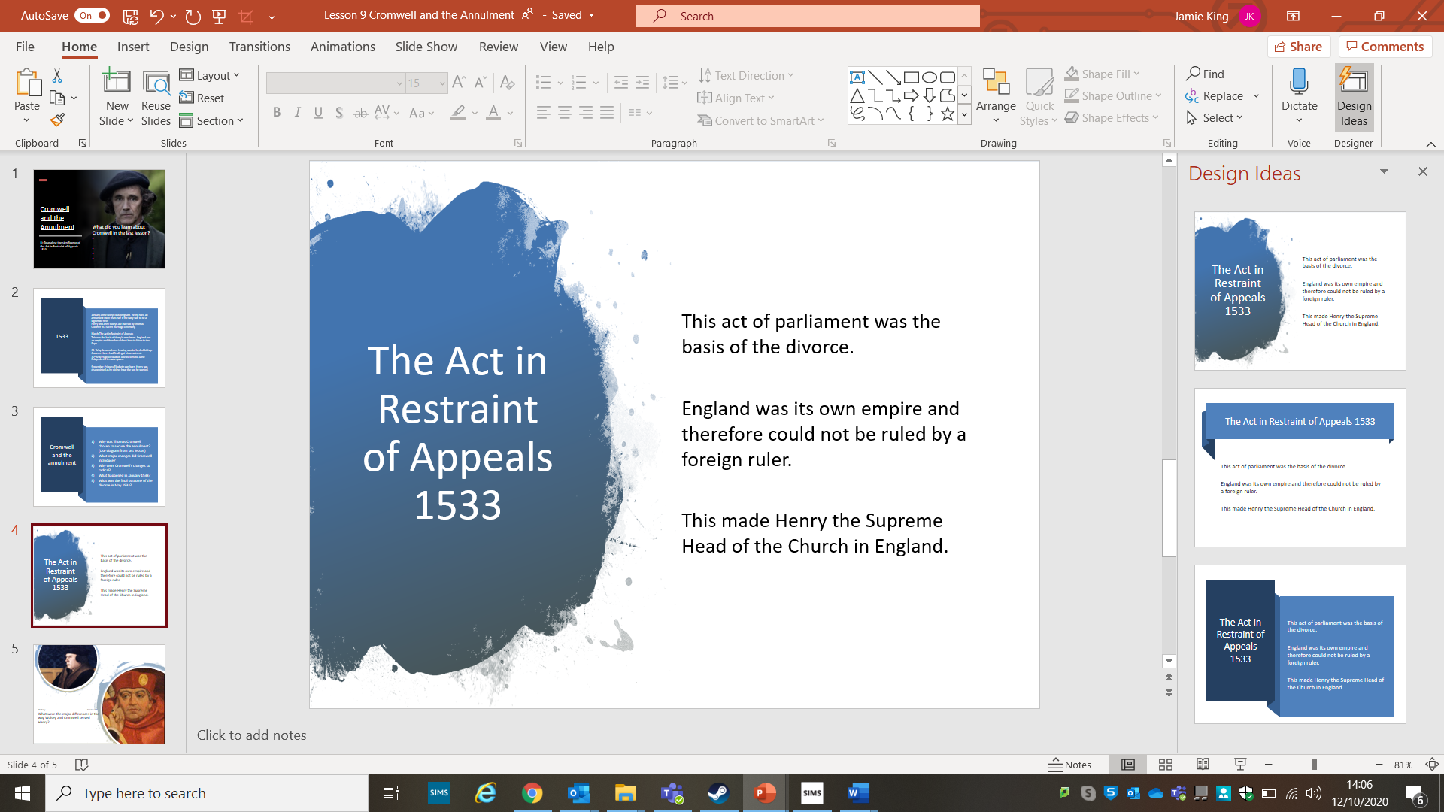
Key Questions
1.Why was Thomas Cromwell chosen to secure the annulment? (Use diagram from last lesson)
2.What major changes did Cromwell introduce?
3.Why were Cromwell’s changes so radical?
4. Which event of 1533 do you think was the most significant?

Lesson Three: The Fall of Anne Boleyn
LI: To identify the causes of Anne Boleyn’s fall.
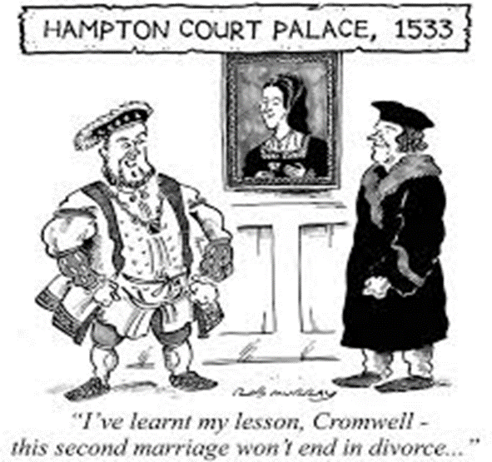
Fall of Anne Boleyn DART
Anne Boleyn and Henry married in January 1533 in a secret ceremony carried out by Thomas Cranmer. By May 1533, Henry ensured that Anne Boleyn’s coronation was extravagant. He wanted every to be in no doubt that Anne Boleyn was the Queen of England. Many saw still had a huge amount of respect for Catherine of Aragon. In September 1533, Anne gave birth to Elizabeth much to the disappointment of Henry who was desperate for a male heir.
Despite this disappointment Henry was optimistic that he and Anne would have more children. He had waited six years for an annulment from Catherine of Aragon and was now free to extend the Tudor dynasty with a male heir. However, Anne suffered miscarriages in 1534 and 1536. Henry was now in his mid-forties (the beginning of old age in Tudor England).
Henry was desperate for a male heir and the start of 1536 gave him a sharp reality check as he fell from a horse and almost died. Henry was now 45 and time was quickly running out for him to produce an heir. England was viewed as vulnerable and the pope issued a papal bull saying England would be given to anyone who could invade and take it.
Henry looked to end his marriage to Anne. He was now in love with Jane Seymour and had grown tired on Anne’s sharp mind and assertive attitude. He instructed Cromwell to form a case against her. A rumour reached Henry that Anne had been unfaithful. In April, Cromwell started an investigation. Mark Smeaton, a court musician was arrested and probably tortured. He confessed to having an affair with Anne Boleyn. Further arrests followed:
- Sir Francis Weston, 25, friend of Henry and member of the Privy Chamber
- Sir Henry Norris, 54, friend of Henry and Groom of the Stool
- Sir William Brereton, 48, member of the privy chamber
- Anne’s brother, George Boleyn, 32 a diplomat and member of the privy chamber
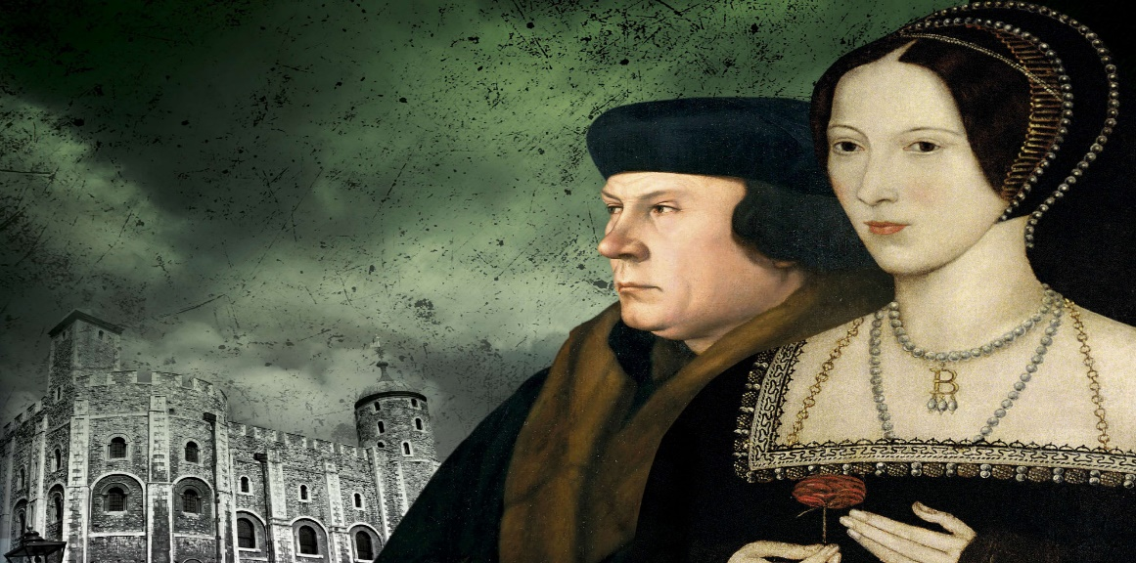

It is very unlikely that Anne was unfaithful to Henry, but the rumours spread throughout Henry’s court. Anne was seen as a flirt and many believed the rumours. Only Smeaton admitted his guilt the other four men denied the charge of adultery. Henry did not care if these rumours were true he now believed Anne Boleyn deserved to die.
Cromwell played a decisive role in Anne Boleyn’s fall. He firstly looked to see if Anne had been secret married to Henry Percy before her marriage to Henry VIII but he could find no evidence. He then interrogated Mark Smeaton and gathered evidence from gossip around court.
Cromwell and Anne were enemies due to Anne’s role in the fall of Wolsey. Cromwell was determined not to suffer the same fate as his master.
Key Questions
- Why did Anne Boleyn have an extravagant coronation?
- Why did the events of 1534-36 convince Henry that he needed to rid himself of Anne Boleyn?
- Why was it essential to Henry that he had a male heir on the throne when he died?
- How did Cromwell construct evidence against Anne?
- Why did many believe the rumours about Anne Boleyn?

Use the GCSE Pod for help.
https://members.gcsepod.com/shared/podcasts/title/12338/75896

Lesson Four: Anne’s Boleyn’s execution and Jane Seymour
LI: To analyse the importance of the Seymour family
What do you think was the main cause of Anne Boleyn’s fall?
……………………………………………………………………………………………………………………………………………………………………………………………………………………………………………………………………………………………………………………………………………………………………………………………………………………………………………………………………………………………………………………………………………………………………………………………………………………………………………………………………………………………………………………………………………………………………………………………………………………………………………………………………………………………………………………………………………

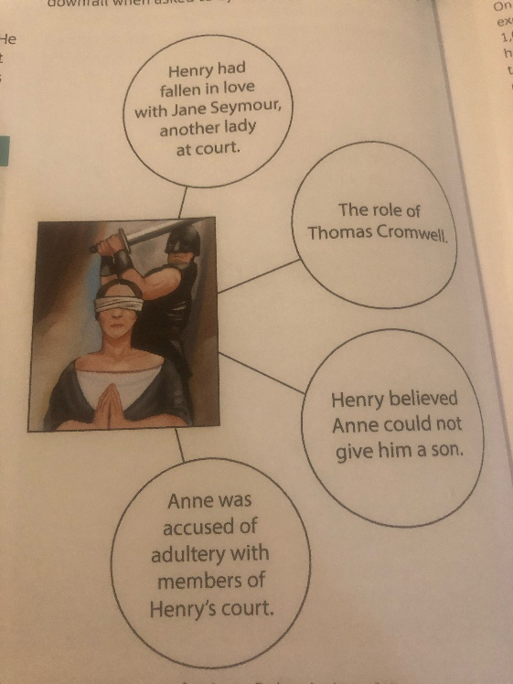
Anne’s execution
On 2nd May 1536, Anne Boleyn was arrested and sent to the Tower of London. On 15th May she was tried with her brother in front of 26 noblemen. The judge was her uncle the Duke of Norfolk. Anne still protested her innocence but was found guilty. On 17th May the marriage was annulled by Thomas Cranmer and as a consequence Princess Elizabeth lost her claim to the throne.
On 19th May, Anne was executed in front of around 1,000 people. In her final words she declared her love for Henry.

The Succession
Henry proposed to Jane Seymour the day after Anne Boleyn was executed. The wedding took place on May 30th. Henry was desperate for a male heir. The annulment of his marriages to Catherine of Aragon and Anne Boleyn had made both of his daughters illegitimate. Parliament passed a Succession Act that made Henry’s illegitimate son Henry Fitzroy the heir to the throne. However, this act was soon useless as Henry Fitzroy died.
Henry’s hopes now rested with Jane Seymour who was a loyal wife and whose motto was ‘bound to serve and obey’. She was not overly bright and did not want to challenge Henry like Anne Boleyn had done.
In October 1537, Jane Seymour gave birth to the future Edward VI. Henry finally had his male heir. The joy of the baby’s birth did not last long as Jane died ten days after the birth. Henry was devastated. He wore black for the next three months and did not marry for over two years.
The Seymours still remained important members of the court after Jane had died. The were a wealthy family who had ten children. The most successful of the children was Edward. He was made the Earl of Hertford three days after Edward the VI was born and remained a key adviser for Henry VIII.
Key Questions
1.What was the state of succession in May 1536?
2. Describe Jane Seymour.
3. Why did the joy of Edwards VI’s birth not last long?
Exam Question-12 Marks
Explain why Anne Boleyn fell from her position as Henry’s queen.
• The succession
• Jane Seymour

Lesson Five: Cromwell’s reforms
Cromwell’s reforms of government 1533-40
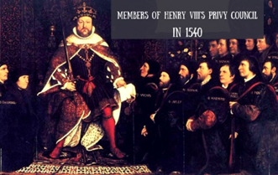
Thomas Cromwell made some extremely important changes to government in England and Wales. The first change he made was to the Royal Council as it had no rules over how meetings should be organised. It had 100 members but very few attended and decisions were not recorded. The Royal Council had also been dominated by Wolsey and Cromwell. Therefore, the Royal Council became the Privy Council. It was reduced from 100 members to 20. These 20 members were lawyers and administrators who could help Cromwell run the country for Henry.

Cromwell then focused on governing the North. The North of England had always governed themselves and almost saw themselves as independent. Cromwell soon put a stop to this as he abolished the Franchises and Liberties. This meant the North would be controlled from London much more. The Council of the North was given lots of power to maintain law and order.
In 1536, Cromwell introduced the Act of Union which officially made Wales part of England. English law replaced Welsh law. Wales was given representation in parliament and was divided into counties. These counties each had a Justice of the Peace who was like a policeman and a judge all in one.

Cromwell had to keep an eye on Henry’s income and expenditure. Henry’s chamber was in the Royal Household but it was very disorganised. Henry did not really take any interest in finances so it was left to Cromwell to re-organise. Firstly, he created the Court of Augmentations in 1536 which dealt with property and income gained from the dissolution of the monasteries. This was extremely important as Henry’s income rapidly increased as more monasteries were closed.

The second court that was created was the Court of First Fruits and Tenths 1540. This collected tax from the clergy who had previously paid their money to the pope in Rome.
Cromwell made massive changes to the running of government and created many systems that we still use today. He created modern bureaucracy where each department of government received money from a specific source. Each department was checked to ensure it was working properly. Each department had well trained professionals. All of this resulted in Henry not having to be as involved in the routine task of monitoring income and expenditure.

Key Questions
- Describe how Cromwell transformed the Royal Council
- How did Cromwell change how the North was governed?
- How did Cromwell change how Wales was governed?
- What was the purpose of the Court of Augmentations?
- What was the purpose of the Court of First Fruits and Tenths?
- Why were Cromwell’s changes significant?

Lesson Six: The Fall of Cromwell
Watch the following GCSE Pod video on the Fall of Cromwell:
https://members.gcsepod.com/shared/podcasts/title/12338/75898

- Why was Thomas Cromwell executed?
- What were the four main causes of his fall?
- Why did Cromwell arrange the wedding between Henry and Anne of Cleves?
- Why did Henry’s marriage to Anne of Cleves not succeed?
- What title was Cromwell rewarded in 1540?
- Why was Henry so unpredictable by 1540?
- What role did the Duke of Norfolk play in the fall of Cromwell?
- What role did the six articles play in Cromwell’s fall?

