
Stewards Academy

Geography Year 11
Blended Learning Booklet

Y11-1 Water Resources

Name:
Form:

Aim to complete one lesson each week. Write down the title and LI for each lesson and then complete the tasks which are highlighted.

Upload all work onto ClassCharts for feedback.

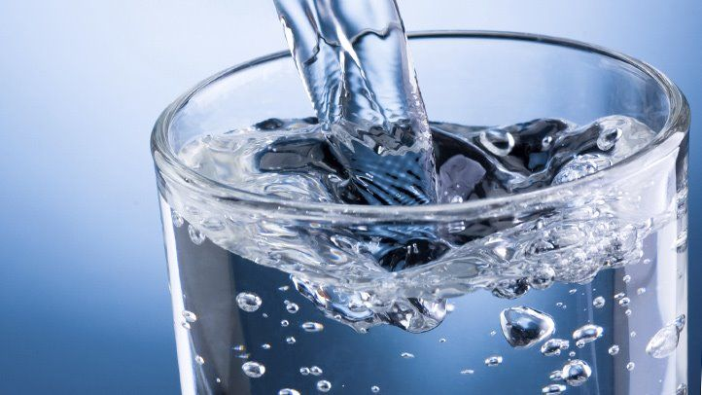

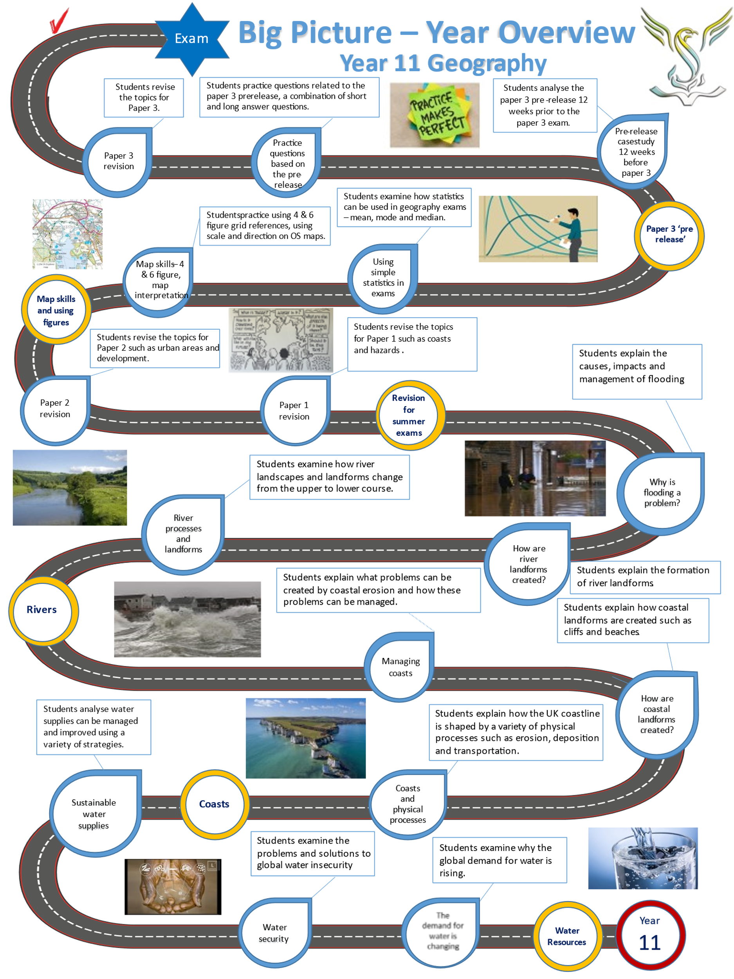

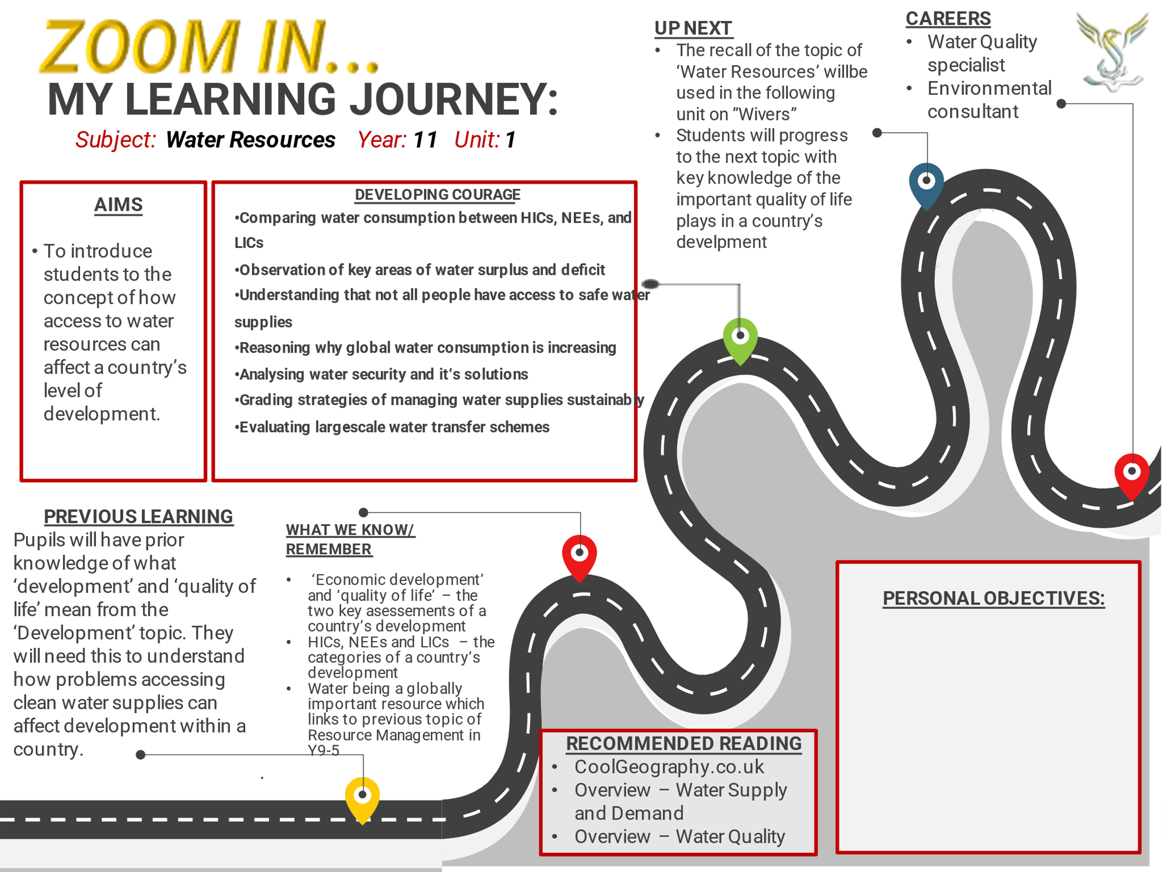

LESSON 1:
TITLE: What are the global patterns of water surplus and deficit?
LI: To understand the global patterns of water surplus and deficit.

Global distribution of water
Global water supplies are not evenly distributed. Some places have a water surplus, whereas others have a water deficit.

Global water supply
Different countries have different amounts of water. Generally speaking:
- Countries along the Equator have enough water. Warm, moist air rises here, which causes high levels of rainfall.
- Countries to the north of the Equator (at a latitude of approximately 30°) have physical water scarcity. This is when there isn’t enough rainfall. Cooler, dry air falls here and so it is very arid (dry).
- Countries to the south of the Equator (at a latitude of approximately 30°) experience some water scarcity. This is less severe than in the north because countries in the south tend to span greater latitudes, e.g. Australia has both desert and rainforest and so water can be transferred.
- Countries with the highest latitudes (those that are furthest away from the Equator) have enough rainfall to provide plenty of fresh water.
KEY WORDS:

- Water scarcity – Places which lack enough rainfall for local needs e.g. Sahara Desert.
- Economic water scarcity – Places or countries who cannot afford to clean their water.
- Water surplus - Places with more than enough water to meet their needs.
- Water vulnerability – Places like the UK which could run out of water.
The map below shows the global access to water resources
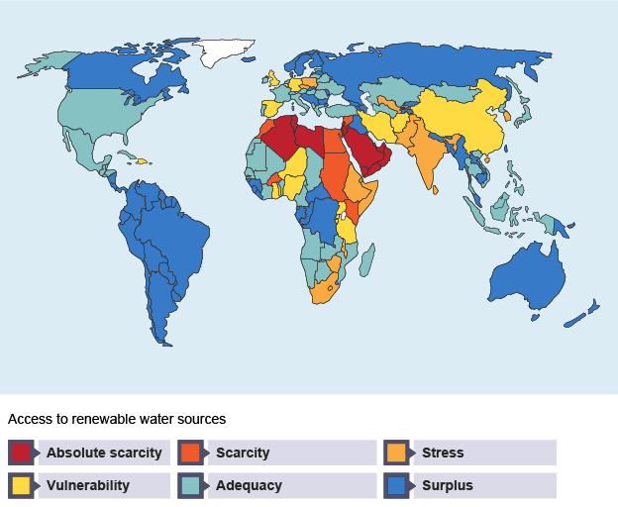

TASK 1 – questions on global water supplies

Q1) What does ‘water scarcity’ mean?

Q2) Describe how we use water in our homes e.g. cooking, heating…

Q3) Explain why countries near the Equator have plenty of water.

Q4) Why do we need to filter and clean our drinking water?

Q5) Which continent has the highest levels of water scarcity?

Q6) What does ‘economic water scarcity’ mean?

Problems with water supply: drought in California, USA
California is a coastal state in western USA. It has deserts to the east, but there is usually plenty of rainfall to provide water along the coast.
California has experienced drought since 2011. Irrigated crops use a lot of the freshwater supplies in the region. Rising temperatures, falling rainfall levels and a growing population are also contributing to the problem.
The drought has lowered groundwater levels. This can cause lots of problems, such as:
- Subsidence - this is a fall in the level of the land, which damages properties.
- Sea water intrusion - this is when sea water flows in to groundwater spaces known as aquifers. People cannot drink sea water as it is salty.
- Fires - vegetation becomes very dry and intense heat, such as lightning strikes, can set it alight easily.
- Ecosystem damage.
There are no official rules in California that stop property owners from pumping more water out of the ground. Groundwater limits are now being considered, but these couldn’t be enforced until 2020. Until then, people are being encouraged to use less water.
TASK 2 – question on California’s problems
- Using California as an example, explain the challenges (problems) created by drought.
………………………………………………………………………………………………………………………………………………………………………
………………………………………………………………………………………………………………………………………………………………………
………………………………………………………………………………………………………………………………………………………………………
………………………………………………………………………………………………………………………………………………………………………
………………………………………………………………………………………………………………………………………………………………………
………………………………………………………………………………………………………………………………………………………………………
………………………………………………………………………………………………………………………………………………………………………
………………………………………………………………………………………………………………………………………………………………………
LESSON 2:
TITLE: What factors influence global water security?
LI: To explain the human and physical factors which influence global water security.

What is water security?
Water resources are not shared equally around the world. Some countries have lots of water (WATER SECURITY), while others struggle to supply their people with enough water (WATER INSECURITY).
There are lots of human and physical factors which influence water security.

TASK 1: Sort the factors below into human and physical factors (use a highlighter)

HUMAN – factors created by people

PHYSICAL – factors created by the physical environment

People in some areas of India and Africa are too poor to buy clean water and can’t afford water treatment plants. | Natural hazards such as volcanoes can pollute fresh water supplies with ash, making it undrinkable. | Some countries cannot afford large scale water treatment works, sewage works or efficient water pipe networks.
Harsh desert climates like the Sahara (lack of rainfall and high temperatures) can make water supplies unreliable. | In Indian villages, richer villagers control the water supply and don’t allow poorer people to use their water. | In HIC’s like the UK, we are building too many homes in drier areas like Essex which do not receive enough rainfall to meet local needs.
Wars and conflict can destroy reservoirs where water is stored. Water supplies can be disrupted as a result. | LIC’s like Ethiopia and Somalia do not have the technology or money to dig deep wells to reach water supplies hidden deep underground. | Areas with permeable rocks such as chalk and limestone have very large volumes of water stored deep underground.
As countries become richer and more developed, the demand water increases as more people have flushing toilets and washing machines. | Areas with hot, dry climates like deserts naturally have low levels of rainfall and water. | Industrial areas like northern China use huge volumes of water to produce heavy goods like aluminium, iron and steel.
Countries with lots of technology can reduce their water use by using smart meters, but poorer countries cannot do this. | Rainfall levels can vary naturally and we never get an even amount of rainfall each year. | Humans are causing global warming and this is highly likely to change our rainfall patterns. Some places could have more rainfall and others far less.

TASK 2 - questions on water security
- Explain how ‘human factors’ can influence water security.
………………………………………………………………………………………………………………………………………………………………………
………………………………………………………………………………………………………………………………………………………………………
………………………………………………………………………………………………………………………………………………………………………
………………………………………………………………………………………………………………………………………………………………………
………………………………………………………………………………………………………………………………………………………………………
………………………………………………………………………………………………………………………………………………………………………
………………………………………………………………………………………………………………………………………………………………………
………………………………………………………………………………………………………………………………………………………………………
………………………………………………………………………………………………………………………………………………………………………

- Explain why Essex is facing water shortages.
………………………………………………………………………………………………………………………………………………………………………
………………………………………………………………………………………………………………………………………………………………………
………………………………………………………………………………………………………………………………………………………………………
………………………………………………………………………………………………………………………………………………………………………
………………………………………………………………………………………………………………………………………………………………………

TASK 3: Watch the following video on water security.

https://www.youtube.com/watch?v=qa7o_E5IsDk

You can make 10 notes of your own from the video:

1)

2)

3)

4)

5)

6)

7)

8)

9)

10)
LESSON 3:
TITLE: Why is the global water consumption increasing
LI: To explain the reasons for increasing global water consumption.

TASK 1 – DART and questions on why the demand for water is increasing

Why is the demand for water increasing?
Over the past 100 years, the World’s population has grown at a very rapid rate. It has grown by over 5 billion people since 1900 and all these people have demands on the World’s fresh water.
According to the United Nations (UN), each person needs at least 20 litres of clean water per day for their basic needs. Wealthier HICs like the USA use huge volumes of water per person per day, but many less developed LICs use far less water per day.
There are huge inequalities in water use between countries. Generally, the greater the wealth and standard of living in a country the higher the per person consumption of water.
Below is a list of countries and their daily water use per person:
USA (HIC) – 575 litres of water
UK (HIC) – 149 litres of water
Uganda (LIC) – 15 litres of water
Mozambique (LIC) – 4 litres of water

As countries become richer, their demand for water rapidly increases, here are some reasons why:
1. Rising Living Standards – people living in HICs like the USA have more money to spend on items that consume water such as dishwashers, washing machines, flushing toilets and showers. People also tend to eat more meat as living standards increase, which also needs more water in its production.
2. Industrial growth – this consumes water in many ways, so as countries develop their manufacturing industries consume more water. For instance, it takes 1,000 cubic meters of water to produce one metric tonne of steel.
3. Farming – this has changed with increasing economic development. Modern commercial agriculture uses huge amounts of water in irrigation systems. On the graph above you can see that this is the biggest user of water.
4. Energy uses – water is essential for producing HEP (Hydro Electric Power) and for steam needed to drive turbines in fossil fuel powered and nuclear-powered power stations.
5. Domestic uses - including drinking, cooking and washing also consume water.
6. Leisure uses – these include watering parks and golf courses, filling swimming pools and for things like water skiing.
Questions
- Describe how you use water each day.
………………………………………………………………………………………………………………………………………………………………………
………………………………………………………………………………………………………………………………………………………………………
………………………………………………………………………………………………………………………………………………………………………
………………………………………………………………………………………………………………………………………………………………………
………………………………………………………………………………………………………………………………………………………………………
- According to the United Nations, how much water should the average person need each day?
………………………………………………………………………………………………………………………………………………………………………
………………………………………………………………………………………………………………………………………………………………………
………………………………………………………………………………………………………………………………………………………………………
- Explain why people living in HICs like the USA consume more water compared to LICs like Mozambique. Use statistics in your answer.
………………………………………………………………………………………………………………………………………………………………………
………………………………………………………………………………………………………………………………………………………………………
………………………………………………………………………………………………………………………………………………………………………
- Explain why the global demand for water is increasing.
………………………………………………………………………………………………………………………………………………………………………
………………………………………………………………………………………………………………………………………………………………………
………………………………………………………………………………………………………………………………………………………………………
………………………………………………………………………………………………………………………………………………………………………
………………………………………………………………………………………………………………………………………………………………………
………………………………………………………………………………………………………………………………………………………………………
………………………………………………………………………………………………………………………………………………………………………
………………………………………………………………………………………………………………………………………………………………………

………………………………………………………………………………………………………………………………………………………………………

LESSON 4:
TITLE: What are the impacts of water insecurity?
LI: To examine the impacts of water insecurity.

TASK 1 - Watch the video on the impacts of water insecurity in Ethiopia:

https://www.youtube.com/watch?v=yPxMOzN0Uq4

TASK 2 - Watch the video on the impacts of water insecurity in Cape Town, South Africa:

https://www.youtube.com/watch?v=XxZAqswJfL4

TASK 3 – Read the DART and answer the questions:

Impacts of water insecurity

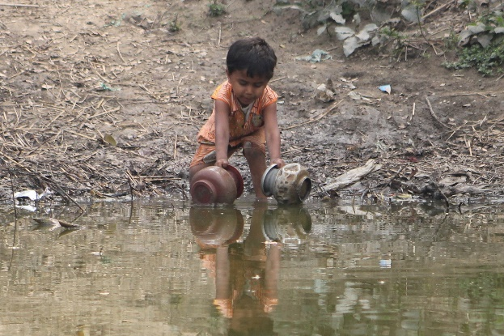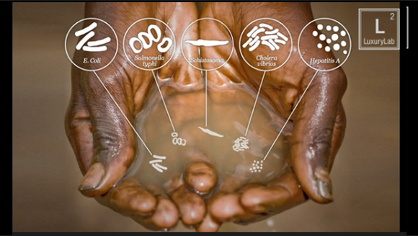

Around 3.5 million people die each year due to drinking dirty water
Water security is when people (the entire population of a country) has sustainable access to adequate quantities of acceptably clean water. People in developed HICs like the UK have water security. This means we can afford to purify or clean all our drinking water. The water supplied to your home, to businesses, hospital, schools and any other building must reach very high safety standards. In the UK, we flush our toilets and water our gardens with purified drinking water.
However, many LIC or developing countries do not have the infrastructure to provide clean water and supply it to their entire population, even though they may have lots of water. This means they suffer water insecurity. A good example of an LIC with this problem is Bangladesh. Bangladesh has some of the world’s largest rivers flowing through it, but many people cannot afford to purify or clean their drinking water.
Globally, around 780 million people do not have access to clean water and 3.5 million people die each year due to drinking dirty water. There are several impacts of water insecurity. Some of these impacts are linked in a ‘cycle of poverty’ which affects millions of people around the world.
- Disruption of education. Water insecurity means that many girls living in some rural areas of developing countries can spend hours walking to collect water rather than attending school.
- Waterborne diseases. Drinking or using dirty water puts people at risk of waterborne diseases and illnesses, such as diarrhoea, malaria and schistosomiasis. Schistosomiasis is a parasitic worm that enters the body through the skin encountering water that contains untreated sewage. It has been reported in 78 countries and 90% of people receiving treatment for it live in Africa.
- Food production. Water insecurity can lead to lower levels of food production. Irrigation can increase crop yields by as much as 400%. Places that do not have enough water to irrigate crops have less to eat.
- Industrial output. Industry needs water for all stages of production. Water is used as a raw material, a coolant, a method of transport, and in some cases a source of energy. Areas that experience water insecurity are unable to operate factories and make products.
- Conflicts. Water is a source of conflict in some parts of the world. Seizing dams is a powerful way of controlling water and electricity supplies.
TASK 4 - Questions
  - Why do HICs like the UK have good water security?

………………………………………………………………………………………………………………………………………………………………………
………………………………………………………………………………………………………………………………………………………………………
………………………………………………………………………………………………………………………………………………………………………
………………………………………………………………………………………………………………………………………………………………………
  - Explain why many people in Bangladesh suffer water insecurity, despite having lots of water available.
………………………………………………………………………………………………………………………………………………………………………
………………………………………………………………………………………………………………………………………………………………………
………………………………………………………………………………………………………………………………………………………………………
………………………………………………………………………………………………………………………………………………………………………
  - How many people experience water insecurity? How many people die due to water-bourne diseases?
………………………………………………………………………………………………………………………………………………………………………
………………………………………………………………………………………………………………………………………………………………………
………………………………………………………………………………………………………………………………………………………………………
………………………………………………………………………………………………………………………………………………………………………
  - Explain the impacts of water insecurity for people living in LICs like Bangladesh.
………………………………………………………………………………………………………………………………………………………………………
………………………………………………………………………………………………………………………………………………………………………
………………………………………………………………………………………………………………………………………………………………………
………………………………………………………………………………………………………………………………………………………………………
………………………………………………………………………………………………………………………………………………………………………
………………………………………………………………………………………………………………………………………………………………………
………………………………………………………………………………………………………………………………………………………………………
………………………………………………………………………………………………………………………………………………………………………
LESSON 5:
TITLE: Increasing the supply of water in the UK
LI: To examine large scale strategies to increase water supply in the UK

TASK 1 – Read the case study

Case study - Kielder reservoir water transfer scheme

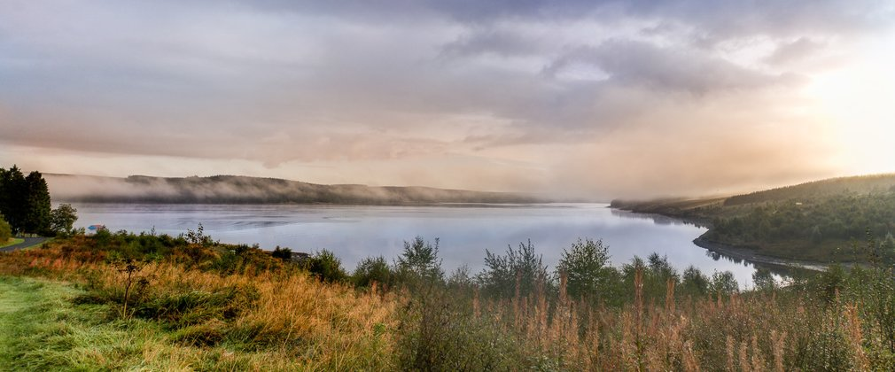

Kielder reservoir in Northumberland is an example of a water transfer scheme. It the largest artificial lake or reservoir in the UK. It was completed in 1982 after 5 years of construction and filling up with water. The reservoir is surrounded by the Kielder Forest and is an important habitat for many species of birds, mammals, reptiles, amphibians and insects

Location
Kielder reservoir is located in an area of high land called the Pennines mountains. It is located in the far north of England, close to the border with Scotland and 330 miles north of London. It receives more rain than areas to the east, which lie in the rain shadow of the Pennine mountains. Water that collects in Kielder reservoir is transported southwards and released into rivers that flow to the cities of Newcastle-upon-Tyne, Sunderland, Durham, Darlington and Middlesbrough.

Advantages
Kielder reservoir has brought many advantages:
- Electricity is generated through hydroelectric power (HEP) at the dam. This is a reliable and clean source of energy.
- The reservoir has reduced water insecurity in the north east. Rivers that flow into cities like Middlesbrough and Sunderland have much more water in them.
- A further extension could be built linking Kielder reservoir to supply London. This would mean new tunnels and pumping stations, but it would keep London supplied with water in the future.
- Tourism at Kielder has created new jobs and generated incomes. People visit the reservoir for water sports and for the beautiful scenery that has been created around the lake.

Disadvantages
Kielder reservoir has brought disadvantages:
- The breeding patterns of fish have been disrupted through the dam blocking the river. Also, fewer pebbles travel downstream, which impacts on habitats.
- Many families were moved from their homes in order to make way for the dam and reservoir.
- Farmland and many habitats were lost when the land behind the dam flooded.

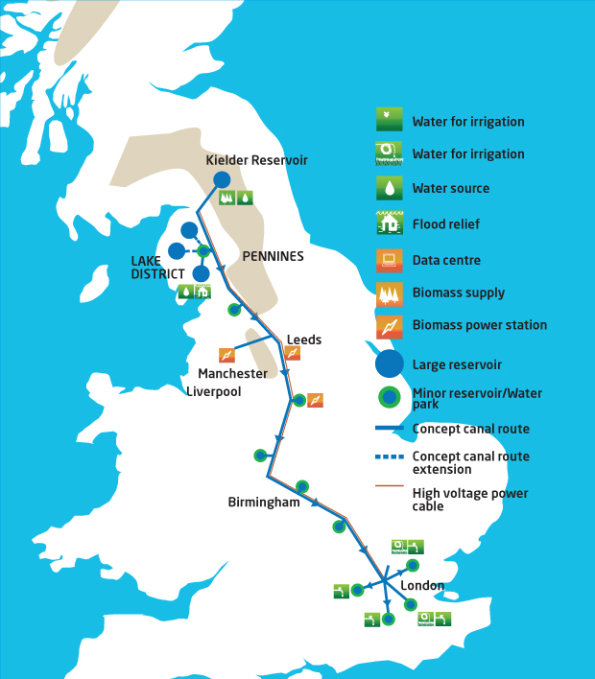

Map showing the route of the water transfer scheme from Kielder reservoir down to London - a distance of 330 miles!

TASK 2 – Complete the 9-mark question

Explain the advantages and disadvantages of a major water transfer scheme you have studied.
[9 marks & SPaG]

………………………………………………………………………………………………………………………………………………………………..……………………

……………………………………………………………………………………………………………………………………………………………………………………..

………………………………………………………………………………………………………………………………………………………………..……………………

……………………………………………………………………………………………………………………………………………………………………………………..

………………………………………………………………………………………………………………………………………………………………..……………………

……………………………………………………………………………………………………………………………………………………………………………………..

………………………………………………………………………………………………………………………………………………………………..……………………

……………………………………………………………………………………………………………………………………………………………………………………..

………………………………………………………………………………………………………………………………………………………………..……………………

……………………………………………………………………………………………………………………………………………………………………………………..

………………………………………………………………………………………………………………………………………………………………..……………………

……………………………………………………………………………………………………………………………………………………………………………………..

………………………………………………………………………………………………………………………………………………………………..……………………

……………………………………………………………………………………………………………………………………………………………………………………..

………………………………………………………………………………………………………………………………………………………………..……………………

……………………………………………………………………………………………………………………………………………………………………………………..

………………………………………………………………………………………………………………………………………………………………..……………………

……………………………………………………………………………………………………………………………………………………………………………………..

……………………..………….………………………………………………………………………………………………………………………………………………….. ………………………………..……………………………………………………………………………………………………………………………………………………………………………………..……………………………………………………………………………………………………………………………………………………………………………………………………………………………..……………………………………………………………………………………………….…………..

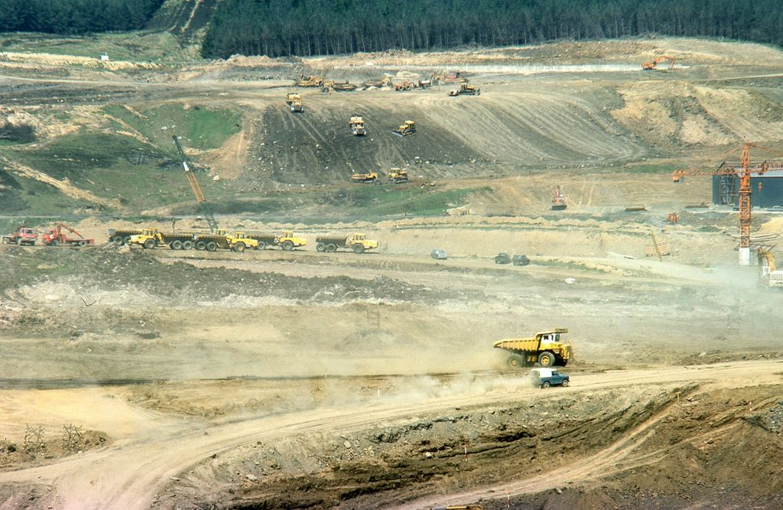
Kielder reservoir being constructed in the late 1970s

LESSON 6:
TITLE: Large-scale water transfer projects in a LIC/NEE
LI: To examine a large-scale water transfer scheme in a LIC or NEE

TASK 1 – Watch the video on the Lesotho highlands water transfer project: through the following casestudy
https://www.youtube.com/watch?v=sgLTSQQZokk

TASK 2 - Read through the following casestudy:

Casestudy of a water transfer project in a LIC - Lesotho highlands water project

Lesotho is a small, landlocked country which is surrounded by its huge neighbour, South Africa.

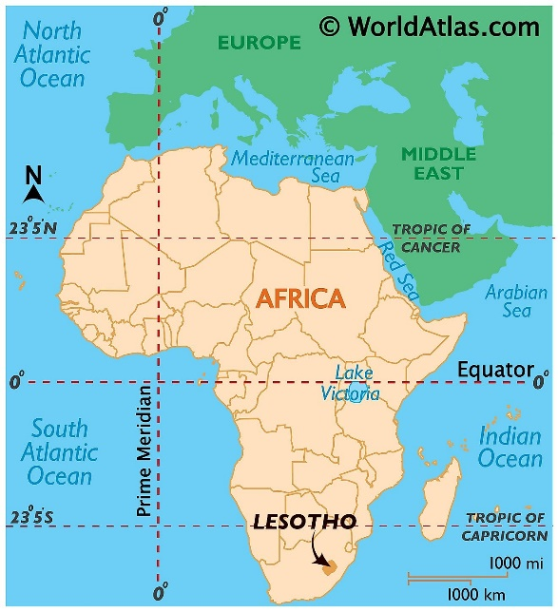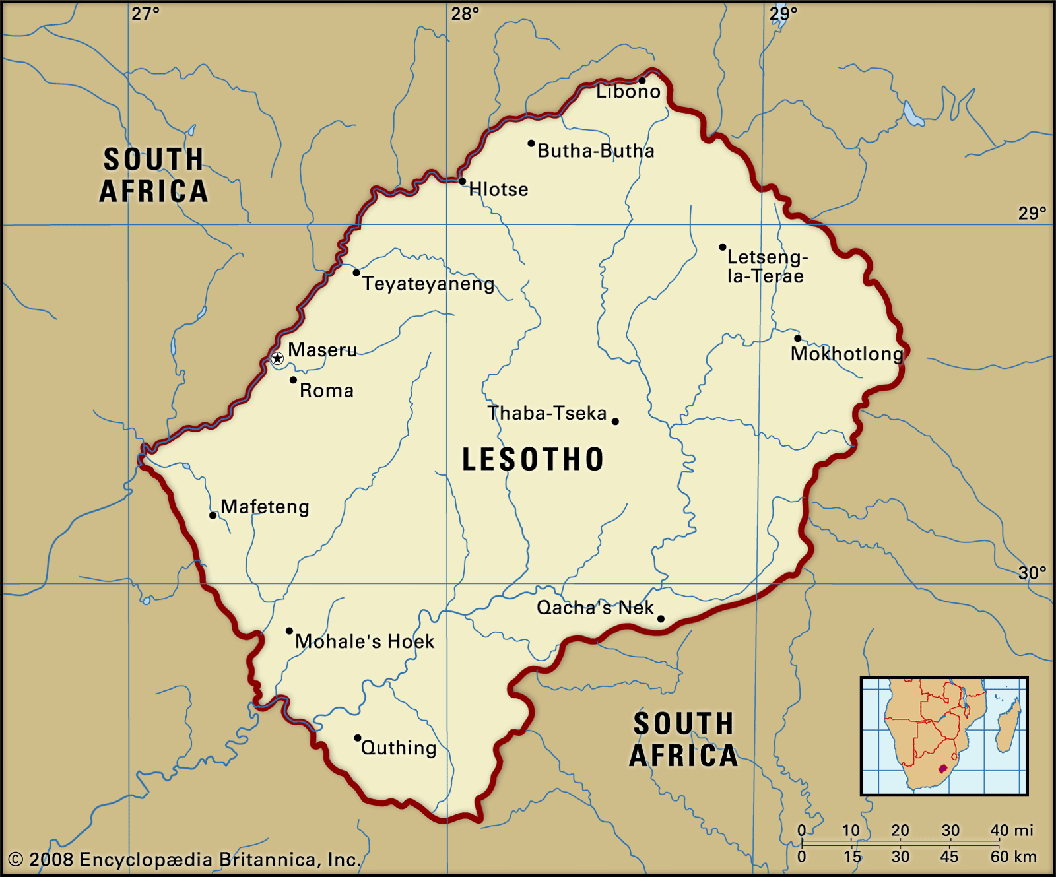

Lesotho is a country blessed with an abundance of water. Lesotho and neighbouring South Africa have an agreement which stipulates that Lesotho supplies South Africa with water in exchange for payments, which Lesotho must use to build dams that generate electricity.
The Lesotho Highlands Water Project (LHWP) is the largest infrastructure project under construction in southern Africa. The primary objectives of the project are to transfer water to Gauteng Province, an urbanizing region in the industrial heartland of South Africa, and to provide hydropower to Lesotho.
The dams are being built to supply water to the new villages and to benefit people in Lesotho and the Republic of South Africa. The water from the dams will mostly go to South Africa and will also generate hydroelectricity for people in Lesotho which should help it develop a better standard of living for its people.
Lesotho remains one of the most unequal countries in the world. A profile of Lesotho's poor shows that poverty levels are highest among people living in rural areas, female-headed households, people who are less educated, the unemployed and those with large families.
The Lesotho Highlands Water Project (LHWP) is the largest bi-national infrastructure project between Lesotho and South Africa. It involves the construction of an intricate network of tunnels and dams to divert water from the mountains of Lesotho to South Africa.

Benefits of LHWP
The scheme will help the country to develop and will provide 75% of Lesotho's income. The dams will provide HEP, providing cheaper electricity to Lesotho. There will be improved roads in the country because of construction work.
Disadvantages of LHWP
The dam does bring much-needed infrastructure, clean energy and jobs. But there are fears that without broad economic development, those benefits could disappear in the long run, sending a wave of people from rural Lesotho to South Africa. The dam could flood their fields, and they could lose their livelihoods.

TASK 3 – Create a fact file on the Lesotho Highlands Water Project
What to include:
- Details on the location of Lesotho, its rainfall and relationship with South Africa
- Describe Lesotho’s problems - rural poverty, lack of education and what else?
- Explain why the LHWP has been created – who benefits from the project?
- Explain the advantages and disadvantages of the LHWP.

LESSONS 7 & 8:
TITLE: Managing water supplies on a large and small scale
LI: To evaluate which large and small-scale strategies can be used to increase water supplies in LIC’s
TASK 1 – Read the DART on sand dams and answer the questions
Small scale water supplies - What is a sand dam?
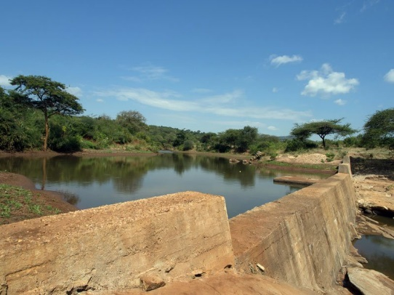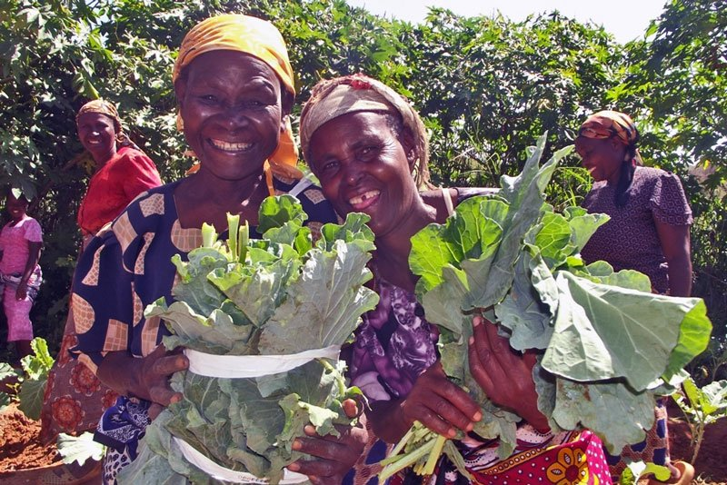

A sand dam is a reinforced rubble cement wall built across a river. They are often built in LICs such as Kenya and can be a highly effective way to store water. They are a simple, low cost, low maintenance technology that stores rainwater so people can have a reliable and safe source of water.
What is the impact of sand dams?
Sand dams provide the water for people to farm productively. A sand dam works by trapping sand behind it, which eventually deepens. After 5 years, the sand is deep enough to effectively store lots of water. The sand can also filter the water as it flows down through it.
Sand dams provide a year-round water source. This saves time and enables farmers to grow both more crops and a wider range of crops. Even during periods of rainfall shortage or drought, sand dams allow a constant supply of food.
Increased crop production improves nutrition and food security. Extra or surplus food can be sold at local markets; allowing families to earn extra money. When families can produce food and generate money, they are able to afford education for their children.
With easy access to water, children do not have to spend their time collecting water, are less likely to suffer acute health impacts of diarrhoea and water-borne disease and realize their potential for a future outside of poverty.
Sand dams can:
- Help farmers produce more crops and allow them to make money by selling crops they do not need.
- Help people cope with climate change by creating water security.
- Reduce conflict by increasing access to water for people.
- Help protect against drought and enabling vulnerable people to improve food production.
- Allow the installation of wells producing safe, clean drinking water.
Questions:
- Why are sand dams suitable for LIC countries like Kenya?
- How do sand dams work?
- Why do sand dams help farmers and their families?
- Explain the benefits of sand dams to people living in LICs like Kenya.
TASK 2: Watch the video on sand dams
https://www.youtube.com/watch?v=YjzcfPax4As

TASK 3: Read the DART and complete the question on large scale water supplies

Large scale water supplies – China’s water transfer project

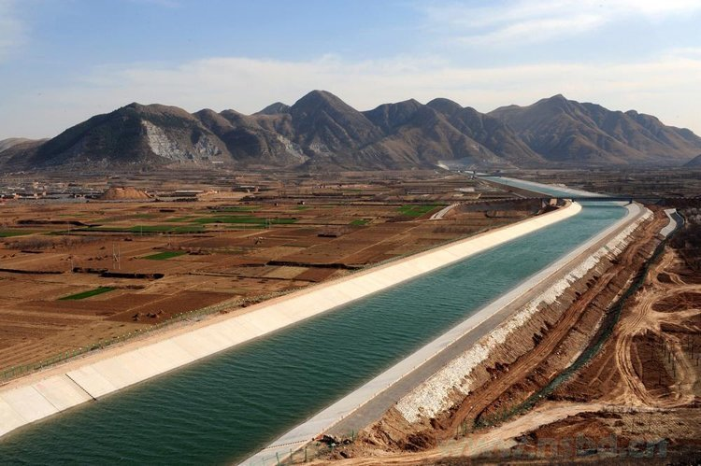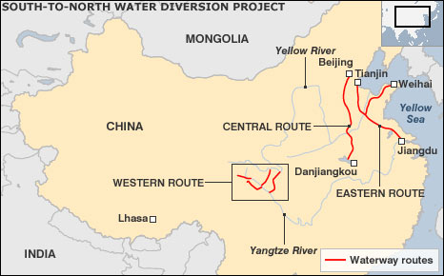

The South-North Water Transfer Project, China – on the left on of the channels built to transfer water and, on the right, a map of the project.

The South-North Water Transfer Project aims to transfer significant quantities of water from China's humid south to the arid north. The US$62 billion scheme, designed to move 12 trillion gallons of water over more than 1000 kilometres, was launched in 2002.
The aims of the project are to divert 44.8 billion cubic meters of water per year from the Yangtze River in southern China to the Yellow River Basin in arid northern China. 80% of these water resources are in the South of China. In 2016, 82% of China's total water supply was surface water, but only 18% was groundwater.
Disadvantages of water transfer schemes:
- The dams and aqueducts (bridges used to transport water) that are needed are expensive to build.
- Building dams can have a negative environmental impact, this includes large-scale flooding of natural habitats.
- Fish migration can be disrupted by dams.
- There might be political issues, e.g. people may not want water from their area transferred to another.
- There would be increased traffic and noise from the construction of dams to provide extra capacity.

Advantages of water transfer schemes:
- Areas affected by water scarcity will no longer face restrictions in water use during dry periods.
- Jobs will be created as part of the construction of dams, aqueducts and pipelines.
- Recreational opportunities as the result of the construction of dams and reservoirs.
- Reservoirs offer new habitats for plants and animals.

Question: “Large scale water transfer projects are an effective way of meeting the water needs for millions of people”. Do you agree with this statement?

…………………………………………………………………………………………………………………………………………………………………

…………………………………………………………………………………………………………………………………………………………………

…………………………………………………………………………………………………………………………………………………………………

…………………………………………………………………………………………………………………………………………………………………

…………………………………………………………………………………………………………………………………………………………………

…………………………………………………………………………………………………………………………………………………………………

…………………………………………………………………………………………………………………………………………………………………

…………………………………………………………………………………………………………………………………………………………………

…………………………………………………………………………………………………………………………………………………………………

…………………………………………………………………………………………………………………………………………………………………

…………………………………………………………………………………………………………………………………………………………………

…………………………………………………………………………………………………………………………………………………………………

