Year 11
Unit R054 – Sport and the Media
Spring 1 Blended Learning Booklet

Name:

Aim to complete two lessons each week.
All video links and content are also uploaded on ClassCharts
The knowledge organisers have all the key information and vocabulary to help with this unit.
Upload all work onto ClassCharts for feedback

Contents
Page 3: Big Picture – Year overview
Page 4: Zoom in – My learning journey
Page 5: Knowledge organiser
Page 6-9: Lesson 1 and 2
Page 10--13: Lesson 3 and 4
Page 14-18: Lesson 5 and 6
Page 19-23: Lesson 7 and 8
Page 24: Pre coursework tasks
Page 25: Assessment ladders

Big picture

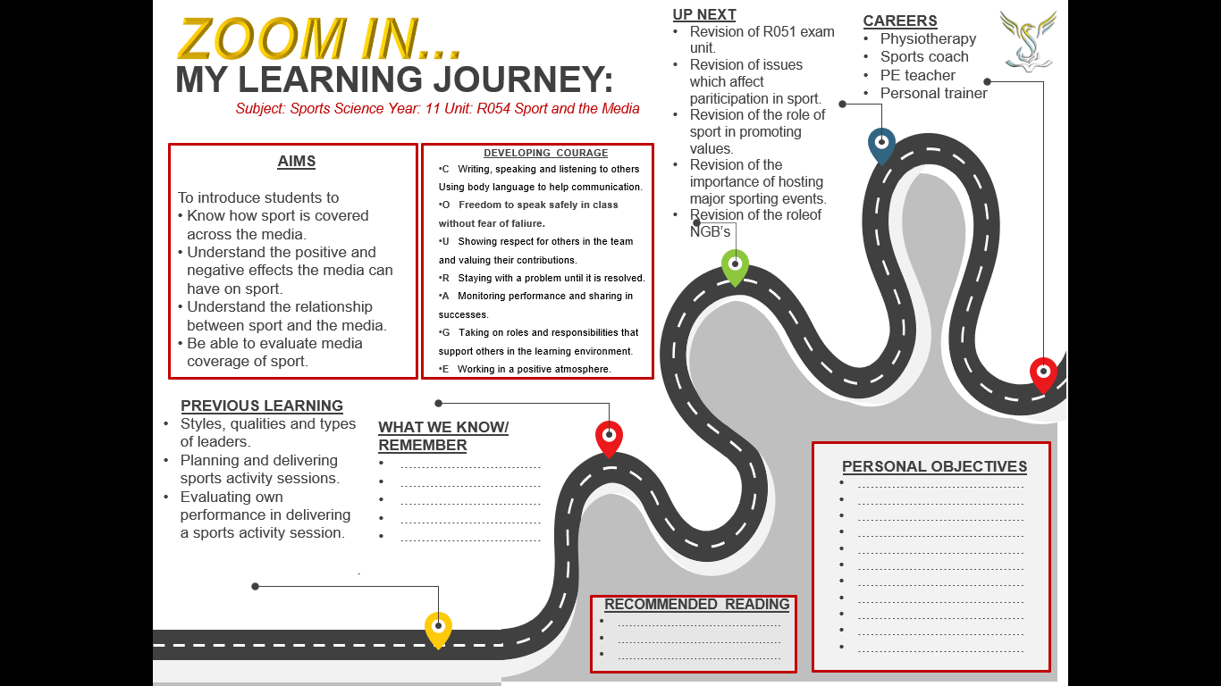Zoom in
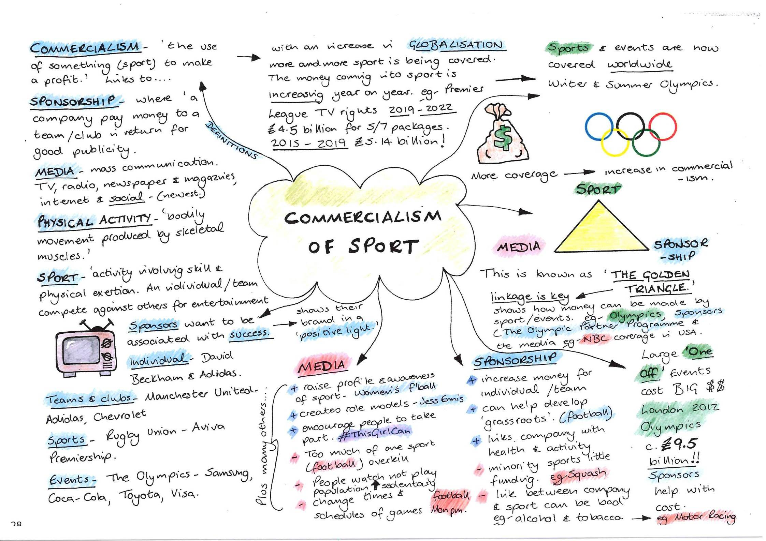Knowledge organiser

Lesson 7 and 8
Negative effects of the media
Understand the impacts the media has on sport.
Explain the positive effects that media can have on sport.

Starter
Choose a sport. Make a list of the ways that the media could negatively affect that sport:

The media has many roles in the negative influence it can have on sport, these include:
- The decline in live spectatorship
- The loss of traditional sporting values
- Media coverage of inappropriate behaviour of athletes
- Increased pressure on officials
- Newspapers are dominated by a few sports
- Saturation
The decline in live spectatorship.

Identify 4 minority sports that have become less popular because of media coverage.
Explain why.

The loss of traditional sporting values.

Describe using a sport of your choice, how some sporting values have been lost. Why may this have happened?

The media coverage of inappropriate behaviour of athletes.

Coursework preparation:
To complete pre coursework tasks.

Insert pages 121, 126, 133 here
Discuss, using examples from a sport of your choice, whether levels of sportsmanship have declined. Why may this have happened?

Increased pressure on officials.

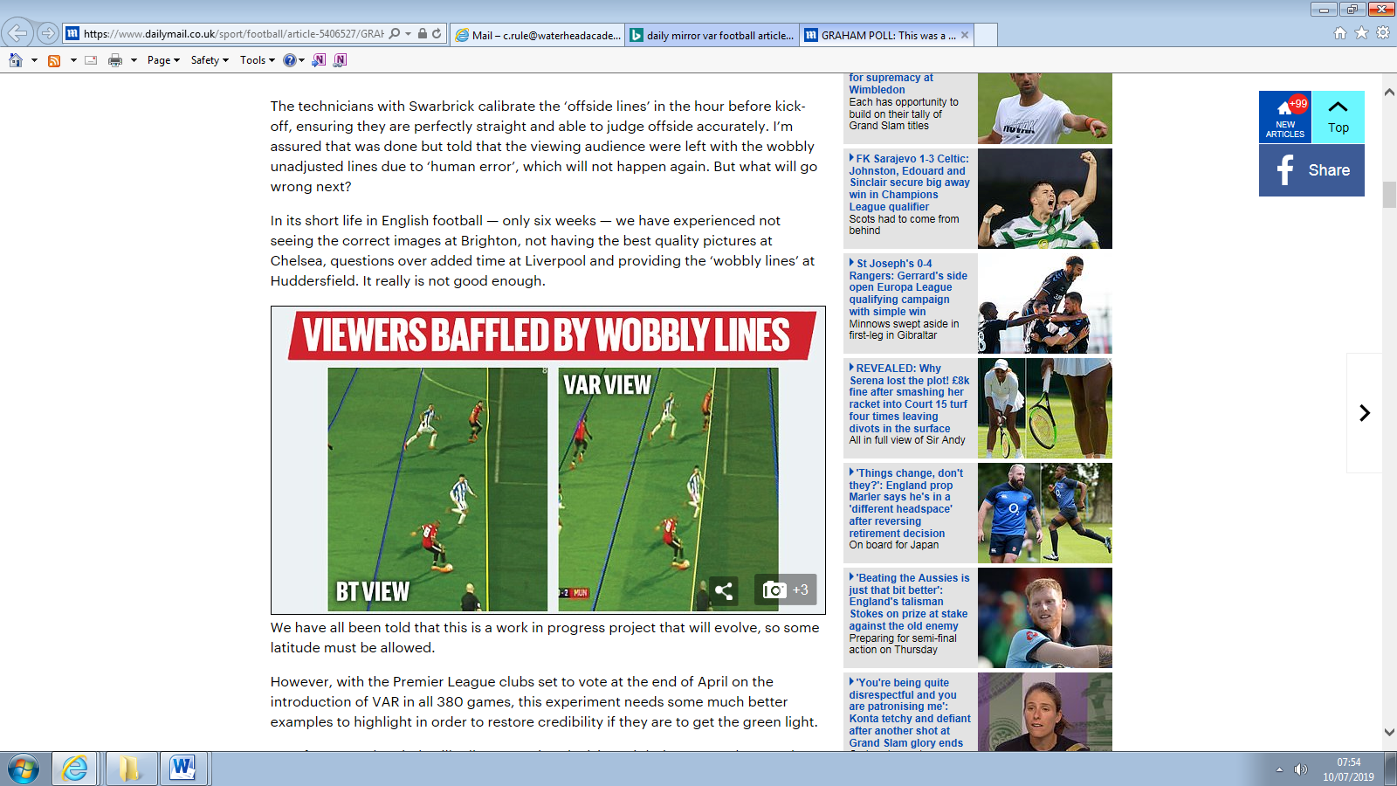

Discuss whether football fans encourage players to play well or behave badly. Do the players incite the fans to celebrate or abuse each other?

Explain how the media have increased the pressure on officials in football? Is this similar in other sports? Give examples

Newspapers are dominated by a few sports.

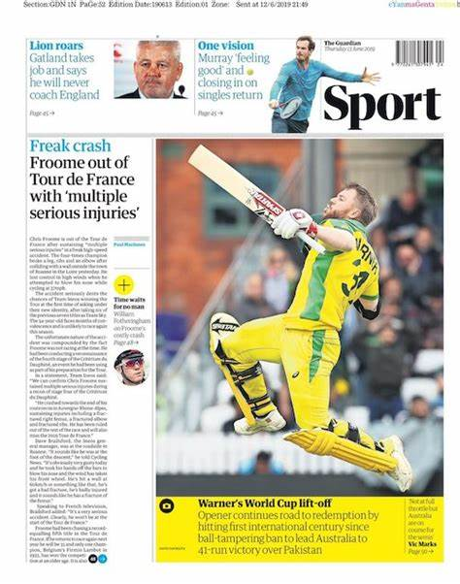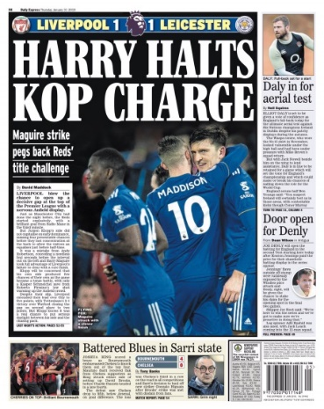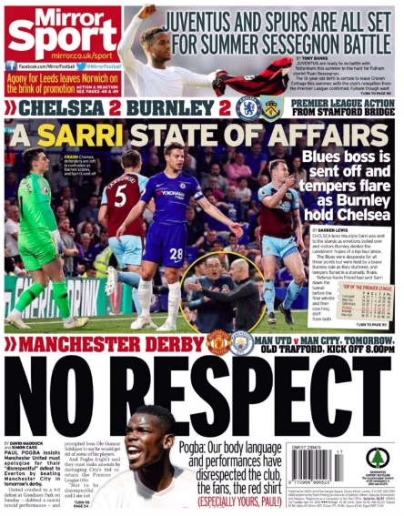

Saturation.

Make a list of 5 negative effects that a sport of your choice has suffered from media coverage.
1.

2.

3.

4.

5.

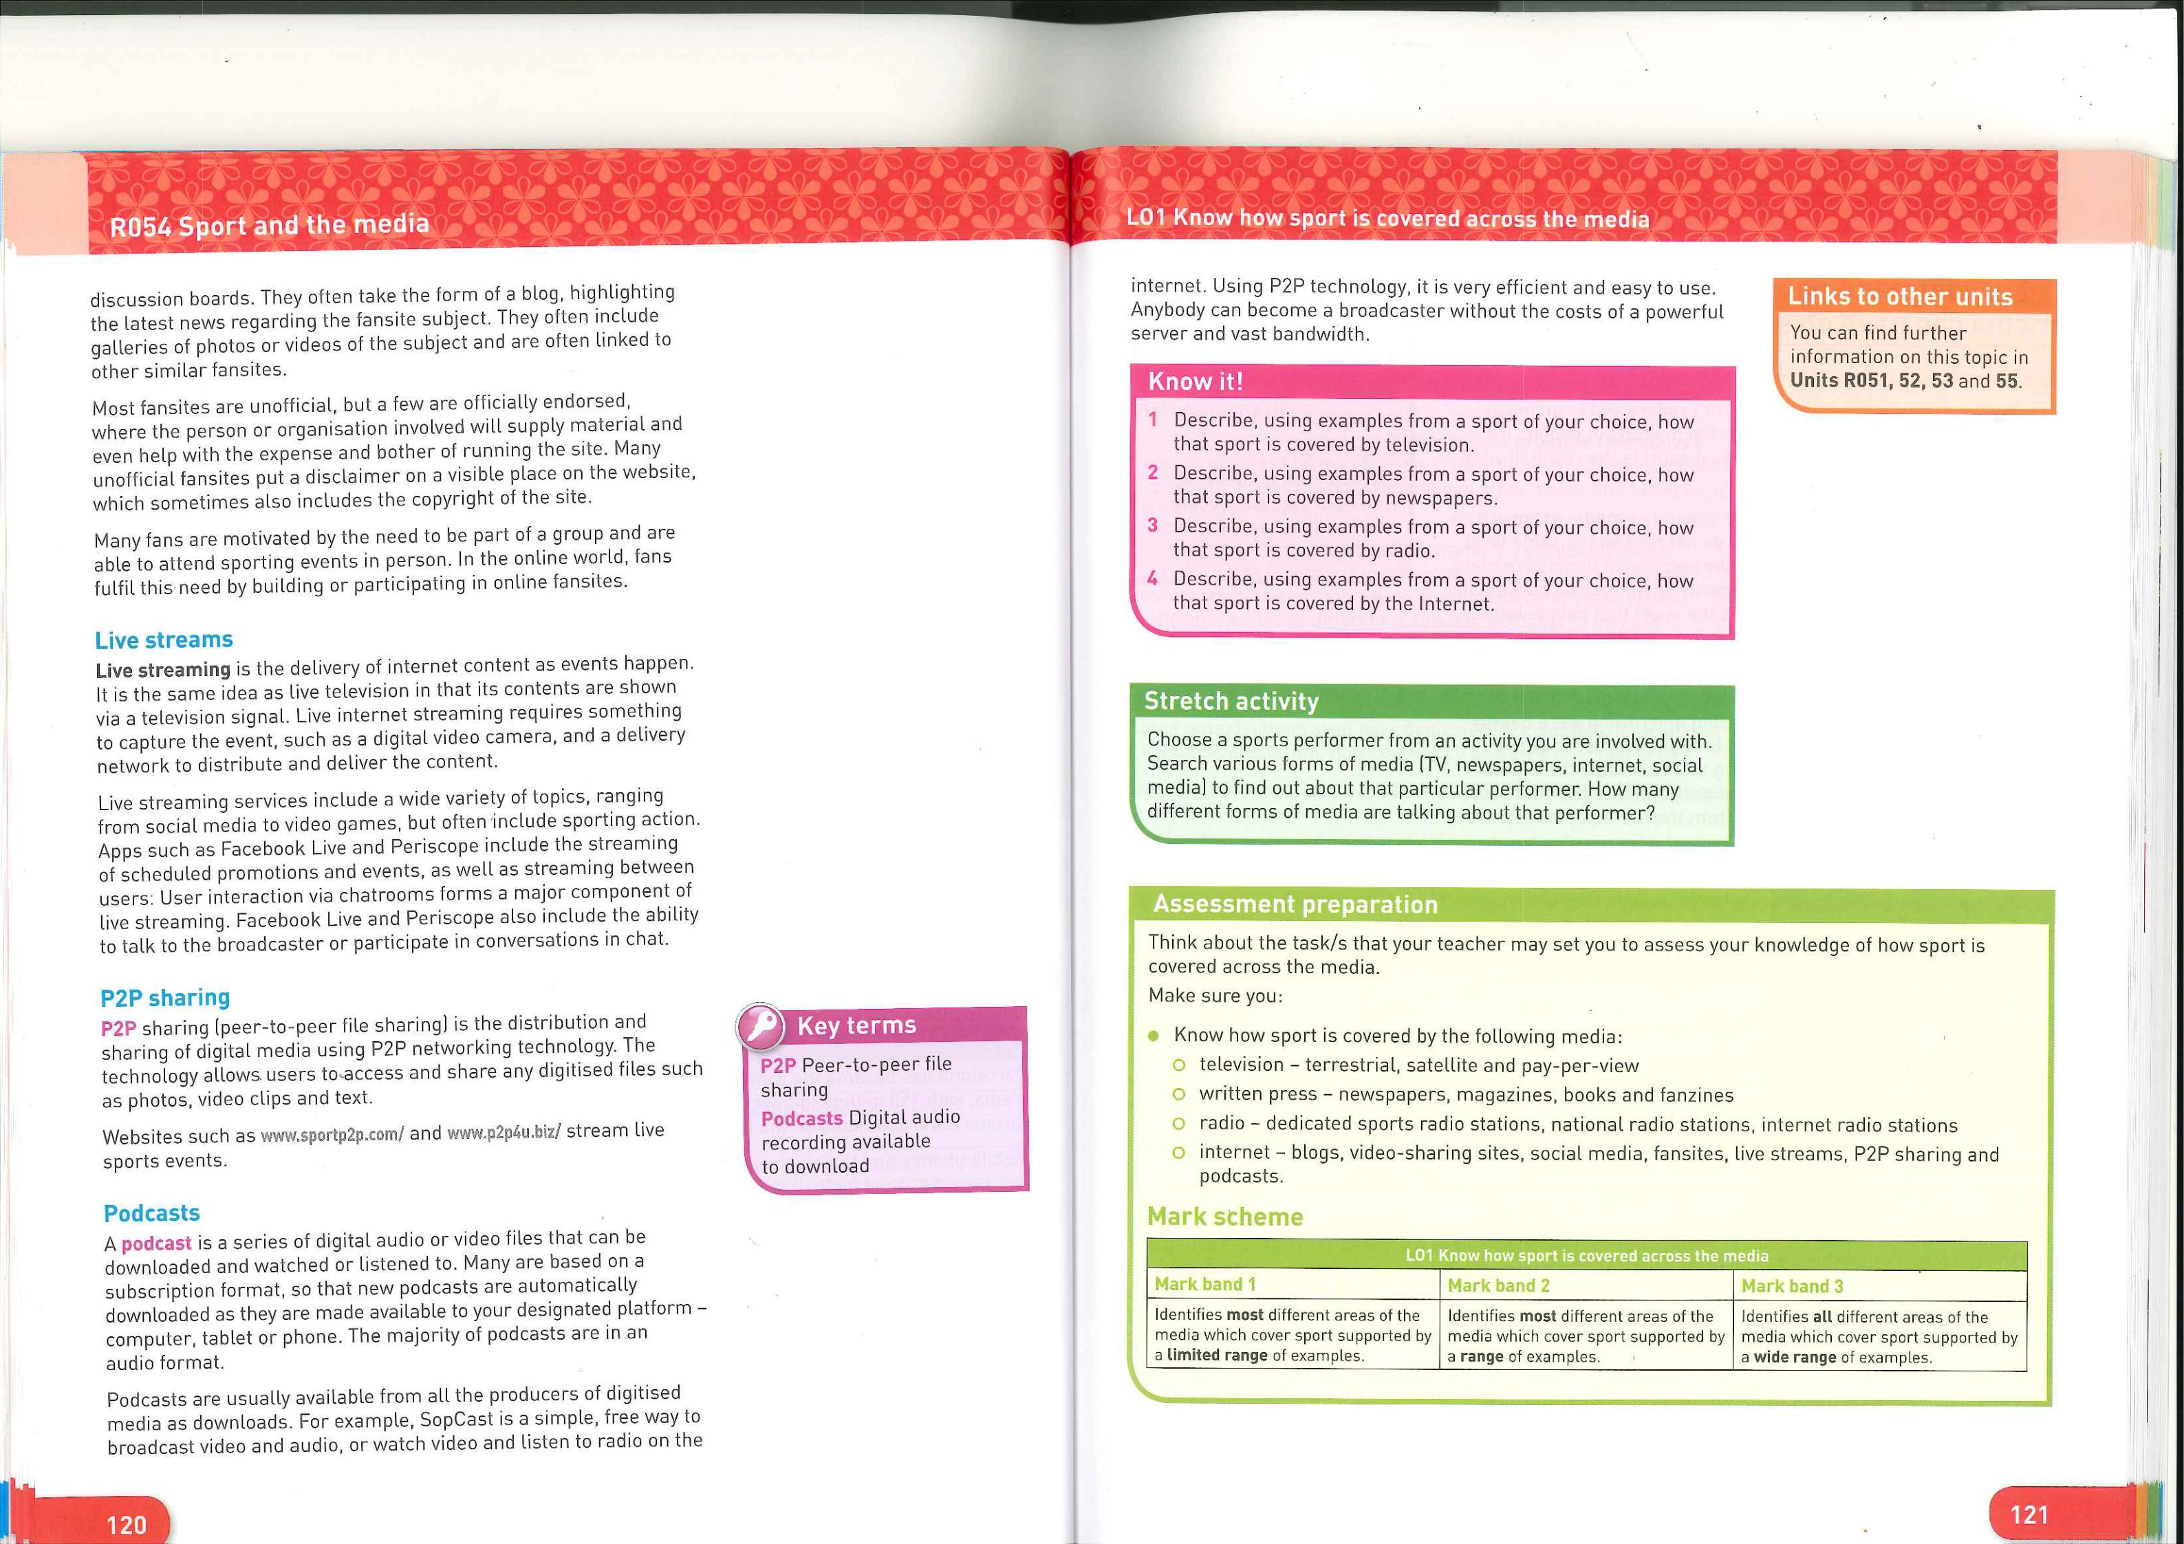Lesson 9
Coursework preparation

