

Stewards Academy
Year 11 French
Autumn 1 Blended Learning Booklet

Qui suis-je?
Le temps des loisirs

Name ………………………….
Form ……………..
Class Teacher ………………….

CONTENTS PAGE
YEAR 11 FRENCH
AUTUMN 1 BLENDED LEARNING BOOKLET LEARNING OVERVIEW
Qui suis je? / Le temps des loisirs
PAGE TITLE | LEARNING INTENTION | PAGE NUMBER
Big Picture – Year 8 Spanish |  | 4
Zoom In – Year 8 Spanish Autumn 1 |  | 5
Lesson 1 – Le présent | Objectif: To recap how to conjugate the present tense in French | 6
Lesson 2 – Le passé compose | Objectif: To recap how to conjugate the perfect/past tense in French | 7
Lesson 3 – Le futur | Objectif: To recap how to conjugate the future tenses in French | 10
Lesson 4 – Qui suis-je – Reading | Objectif: To practise and develop our reading skills by completing a range of GCSE reading questions on the topic of Qui suis-je? | 13
Lesson 5 – Qui suis-je – Reading | Objectif: To continue to practise and develop our reading skills by completing a range of GCSE reading questions on the topic of Qui suis-je? | 16
Lesson 6 – Qui suis-je – Translation (French – English) | Objectif: To practise and develop our translation skills from French to English on the topic of Qui suis-je? | 18
Lesson 7 – Qui suis-je – Translation (English - French) | Objectif: To practise and develop our translation skills from English to French on the topic of Qui suis-je? | 20
Lesson 8 – Qui suis-je – Listening | Objectif: To practise and develop our listening skills on the topic of Qui suis-je? using This Is Language | 23
Lesson 9 – Qui suis-je – Writing (Foundation) | Objectif: To practise and develop our writing skills on the topic of Qui suis-je? (Foundation) | 24
Lesson 10 – Qui suis-je – Writing (Higher) | Objectif: To practise and develop our writing skills on the topic of Qui suis-je? (Higher) | 27
Lesson 11 – le temps des loisirs – Reading | Objectif: To practise and develop our reading skills by completing a range of GCSE reading questions on the topic of le temps des loisirs | 29
Lesson 12 -le temps des loisirs -Reading | Objectif: To continue to practise and develop our reading skills by completing a range of GCSE reading questions on the topic of le temps des loisirs | 32
Lesson 13 - -le temps des loisirs - Translation (French – English) | Objectif: To practise and develop our translation skills from French to English on the topic of le temps des loisirs | 35
Lesson 14-le temps des loisirs -Translation (English - French) | Objectif: To practise and develop our translation skills from English to French on the topic of le temps des loisirs | 37
Lesson 15- -le temps des loisirs - Listening | Objectif: To practise and develop our listening skills on the topic of le temps des loisirs using This Is Language | 39
Lesson 16- -le temps des loisirs - Writing (Foundation) | Objectif: To practise and develop our writing skills on the topic of le temps des loisirs (Foundation) | 40
Lesson 17 - -le temps des loisirs - Writing (Higher) | Objectif: To practise and develop our writing skills on the topic of le temps des loisirs (Higher) | 43
Knowledge Organiser – Qui suis-je ? |  | 45
Knowledge Organiser – Le temps des loisirs |  | 47
Reading Assessment |  | 49
Translation Assessment |  | 53
Writing Assessment |  | 54
Assessment Ladder |  | 55

Big Picture

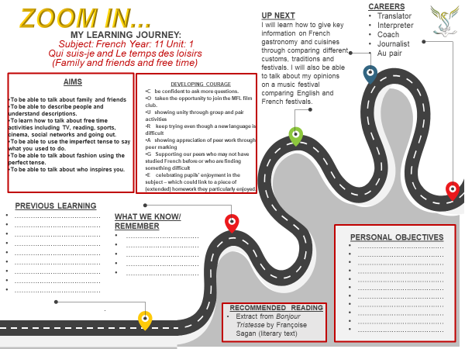

Lesson 1:
Present Tense
Objectif: To recap how to conjugate the present tense in French

Regular verbs in the present tense – formation
To conjugate a regular verb in the present tense, we need to:

1. Take the ending off the verb infinitive:
parler → parl
choisir → chois
vendre → vend
This is called the stem.

2. Add the correct ending as shown in the table below:

English | Subject pronoun | -er Verb:parler(to speak) | -ir Verb:choisir(to choose) | -re Verb:vendre(to sell)
I | je | e | is | s
you (informal) | tu | es | is | s
he/she/it (we) | il/elle/on | e | it
we | nous | ons | issons | ons
you (formal, plural) | vous | ez | issez | ez
they | ils/elles | ent | issent | ent

Complete the following online activities to practice conjugating the present tense.
-er verbs
https://www.languagesonline.org.uk/French/Grammar/ERVerbs/889.htm
-re verbs
https://www.languagesonline.org.uk/French/ET2/RE_Verbs/614.htm
-ir verbs
https://www.languagesonline.org.uk/French/ET2/IR_Verbs/634.htm

Complete the activities on the present tense on This Is Language.
Video ID: G34, G35, G36

ATTENTION!
The main verbs we use in French are irregular in the present tense! Make sure you learn them off by heart – they are all listed on the BBC bitesize guide below.

https://www.bbc.co.uk/bitesize/guides/z87jq6f/revision/4
Lesson 2:
Past Tense (Perfect tense)
Objectif: To recap how to conjugate the past tense in French

The perfect tense is used to talk about something that happened in the past and is completely finished. For example:
- J’ai regardé la télé. - I watched TV.
- Nous avons joué au rugby. - We played rugby.
These are the key elements needed to form the perfect tense:
- The subject - je, tu, il, etc. or a name or a person or thing, eg Sophie/ma mère/mon livre.
- The present tense of avoir or être – this is known as an auxiliary verb.
- The past participle - mangé (ate), fini (finished), attendu (waited), etc.

The perfect tense with avoir
Activity 1 – Make notes on how to conjugate the past tense with avoir in French.

Most verbs use avoir as an auxiliary verb.
These are the key elements needed to form the perfect tense with avoir:
- The subject - je, tu, il, etc. or a name or a person or thing, eg Sophie/ma mère/mon livre.
- The auxiliary verb - the present tense of avoir.
j’ai | I have
tu as | you have
il/elle/on a | he/she/it has
nous avons | we have
vous avez | you have
ils/elles ont | they have
- The past participle - mangé (ate), fini (finished), attendu (waited), etc.
Regular past participles are formed by removing the infinitive ending -er, -ir or -re and adding -é, -i or -u.
Infinitive ending | Past participle ending | Example
-er | -é | manger - to eat / – j’ai mangé - I ate
-ir | -i | finir - to finish / nous avons fini - we finished
-re | -u | attendre - to wait / ils ont attendu - they waited
Activity 2 -
Complete the activities on the following links to practice conjugating the past tense (avoir)
https://www.languagesonline.org.uk/French/Grammar/Perfect_Tense/941.htm
https://www.languagesonline.org.uk/French/Grammar/Perfect_Tense/942.htm

The perfect tense with être
Activity 3 – Make notes on how to conjugate the past tense with être in French.

Forming the perfect tense with être
Some verbs use être as an auxiliary verb. They are usually verbs that involve movement, such as aller (to go), arriver (to arrive), sortir (to go out) and partir (to leave). Reflexive verbs also use être.
The key elements needed to form the perfect tense with être are:
- The subject - je, tu, il, etc, or a name or a person or thing, eg Sophie/ma mère/mon livre.
- The auxiliary verb - the present tense of être.
je suis | I am
tu es | you are
il/elle/on est | he/she/it is
nous sommes | we are
vous êtes | you are
ils/elles sont | they are
- The past participle
- Regular past participles are formed by removing the infinitive ending -er, -ir or -re and adding -é, -i or -u. This is the same way past participles are formed with avoir.
Some verbs have irregular past participles:
Infinitive | Past participle | Example
venir - to come | venu | Il est (re)venu chez moi. – He came (back)to my house.
mourir - to die | mort | Il est mort en 1985. – He died in 1985.
naître - to be born | né | Elle est née au pays de Galles. – She was born in Wales.
The key difference between avoir verbs and the être verbs is that when using être, the past participle agrees with the subject of the verb, in gender and number:
 | Singular | Plural
Masculine | - | + s
Feminine | + e | + es
For example:
- Elle est allée à la banque. - She went to the bank.
- Ils sont sortis avec leurs copains. – They (masculine, or both masculine and feminine) went out with their friends.

There are 14 verbs that take être in the past tense. You must learn them by heart! They can be remembered by using the acronym: MRS VAN DER TRAMP

M – mourir – to die D – descendre – to descend T – tomber – to fall
R – retourner – to return E – entrer – to enter R – rester -to stay
S – sortir – to go out R- rentrer – to reenter A – aller- to go
M – monter – to climb
V – venir – to come P – partir – to leave
A – arriver -to arrive
N – naître – to be born
Activity 4 -
Complete the activities on the following links to practice conjugating the past tense (être)
https://www.languagesonline.org.uk/French/Grammar/Perfect_Tense/945.htm https://www.languagesonline.org.uk/French/Grammar/Perfect_Tense/949.htm

Lesson 3:
Future Tenses
Objectif: To recap how to conjugate the future tenses in French

Activity 1 – Make notes on the differences between the near future tense and the simple future tense.

Talking about the future
- The futur proche (near future tense) describes what is going to happen with certainty and is very commonly used in French. For example, Je vais faire les courses. – I’m going to do some shopping.
- The futur simple (simple future) describes what will happen for predictions and future projects and in sentences with si and quand. For example, J’irai à l’université si j’ai mon bac. - I’ll go to university if I pass my A levels.
The future can also be expressed using the present tense with a future time phrase. For example, on va au cinéma cet après-midi. – we’re going to the cinema this afternoon.
Useful future time phrases that can be used with any of the above structures include:
à l’avenir | in the future
l’année prochaine | next year
la semaine prochaine | next week
le weekend prochain | next weekend
demain | tomorrow
plus tard | later (on), in the future
ce soir | this evening
bientôt | soon
When using quand (when) to refer to a time in the future, a future verb is needed, eg quand j’aurai 18 ans – when I am 18.

The near future tense
Activity 2 -
Make notes on how to conjugate the near future tense.
The futur proche (near future) tense describes what is going to happen with certainty. It is often used for going to + infinitive.
Forming the near future tense
To form the futur proche, use the present tense of aller (to go) plus an infinitive.
 | present tense of aller | infinitive (example) | English
je | vais | regarder | I’m going to watch
tu | vas | manger | you’re going to eat
il/elle/on | va | faire | he/she/one is going to do
nous | allons | avoir | we’re going to have
vous | allez | vivre | you’re going to live
ils/elles | vont | aller | they’re going to go
Forming the negative
To make it negative and say something is not going to happen, put ne … pas or n’… pas around the conjugated verb aller. To say something is never going to happen, use ne/n’ … jamais. For example,
- Je ne vais pas aller au cinéma – I’m not going to go to the cinema
- Nous n’allons pas perdre nos portables. – We aren’t going to lose our mobile phones.

Activity 3 -
Complete the activities on the following links to practice conjugating the near future tense.
https://www.languagesonline.org.uk/French/Grammar/Aller_Infinitif/1002.htm
https://www.languagesonline.org.uk/French/Grammar/Aller_Infinitif/1007.htm
https://www.languagesonline.org.uk/French/Grammar/Aller_Infinitif/1011.htm

The simple future tense
Activity 4 -
Make notes on how to conjugate the simple future tense.
The futur simple (simple future) describes what will happen for predictions and future projects.
Form the simple future of regular -er and -ir verbs by taking the infinitive and adding the following endings:
Subject | Future ending | Example | English
je | -ai | je mangerai | I’ll eat
tu | -as | tu finiras | you’ll finish
il/elle/on | -a | il/elle/on regardera | they’ll watch
nous | -ons | nous jouerons | we’ll play
vous | -ez | vous parlerez | you’ll speak
ils/elles | -ont | ils/elles partiront | they’ll leave
The simple future of regular -re verbs is formed by removing the final -e from the infinitive and adding the endings above. For example:
- vendre - je vendrai – I will sell / I’ll sell
- boire - nous boirons – we will drink / we’ll drink
Activity 5 -
Complete the activities on the following links to practice conjugating the simple future tense.
https://www.languagesonline.org.uk/French/Grammar/Future/1024.htm
https://www.languagesonline.org.uk/French/Grammar/Future/1028.htma
https://www.languagesonline.org.uk/French/Grammar/Future/1033.htm

Module 1, Qui suis-je? - Lesson 4:
Qui suis-je? – Reading
Objectif: To practise and develop our reading skills by completing a range of GCSE reading questions on the topic of Qui suis-je?

GCSE READING TIPS:
  - read the text before the question
  - highlight/underline key vocabulary and annotate it in English
  - try to identify tenses within the text
  - read the question, due to annotating the text it should be quick to scan for the correct answer
  - make sure you double check your answers to make sure you’re not falling for a distractor

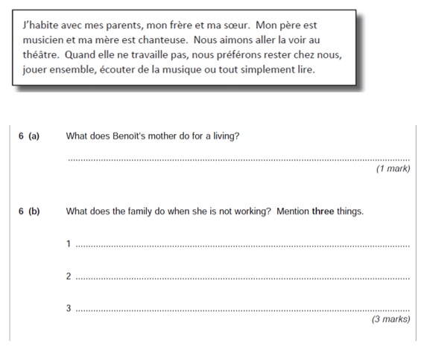
Activity 1 –

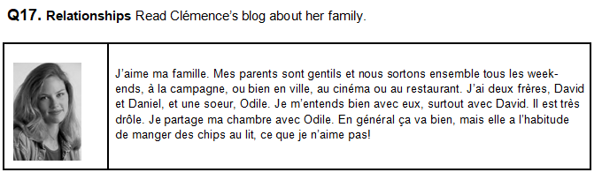
Activity 2 –

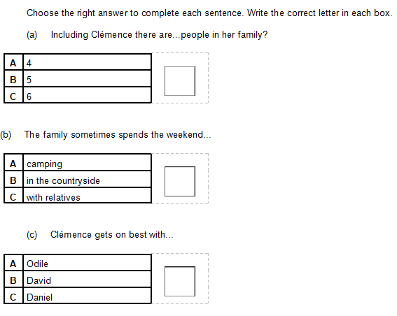

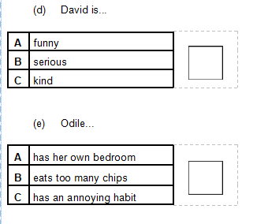

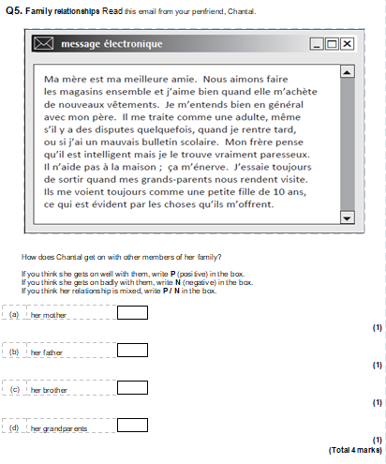
Activity 3 –

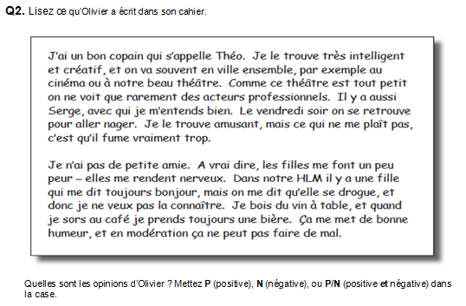
Activity 4 -

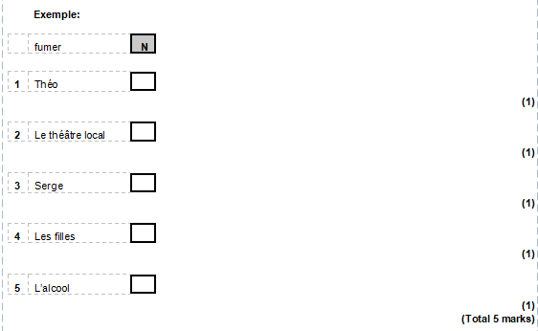

Activity 5 –
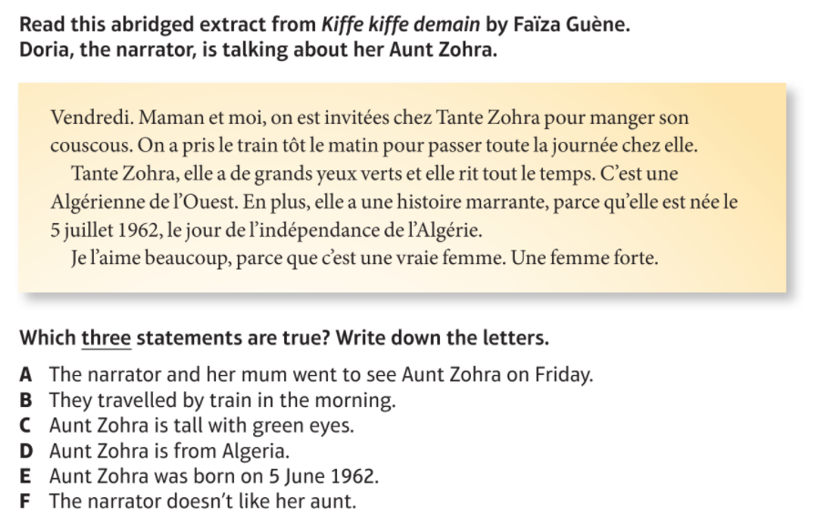

Module 1, Qui suis-je? - Lesson 5:
Qui suis-je? – Reading
Objectif: To continue to practise and develop our reading skills by completing a range of GCSE reading questions on the topic of Qui suis-je?

Activity 1
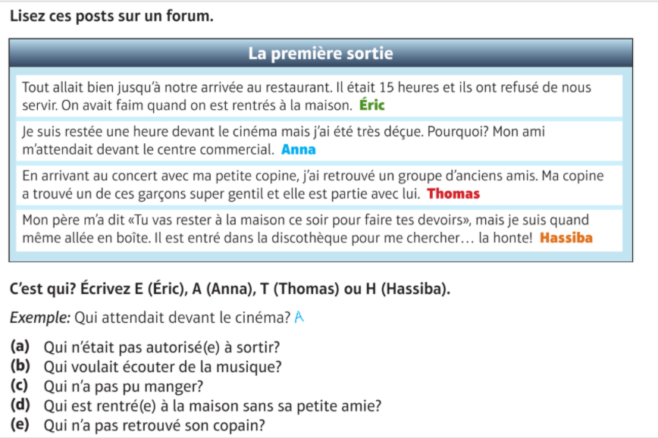

Activity 2 –

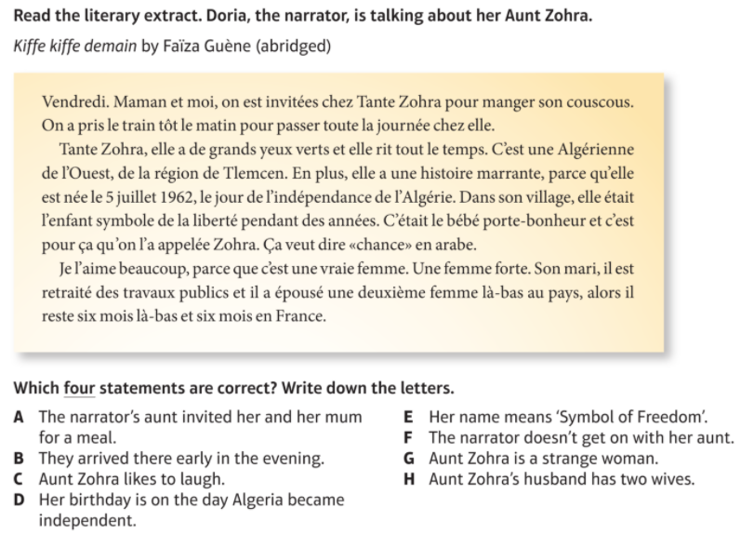

Activity 3 –
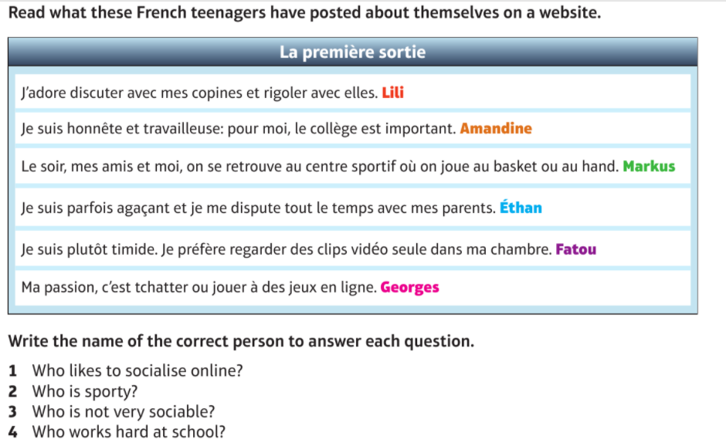

Activity 4 -
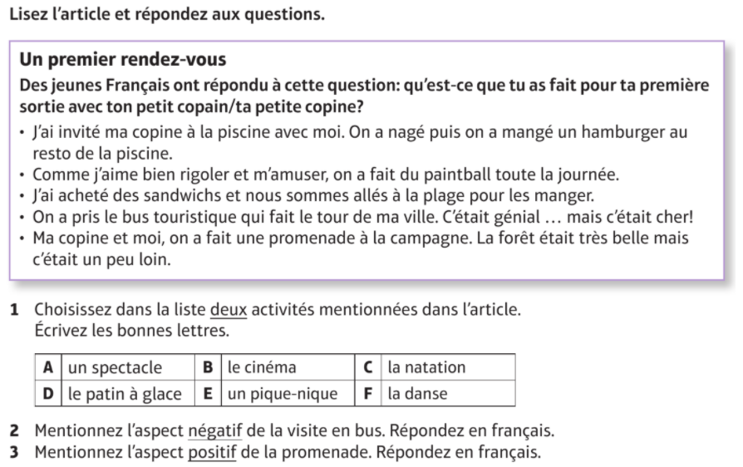

Module 1, Qui suis-je? - Lesson 6:
Qui suis-je? – Translation (French – English)
Objectif: To practise and develop our translation skills from French to English on the topic of Qui suis-je?

In your final GCSE exams, you will have to complete 2 translations. One of these appears on your reading paper. You will have to translate a short paragraph from French into English. This is on both the foundation and higher paper. We are going to focus on these translations in this lesson.

French – English Translation Tips
- Reading for gist. – read the whole passage first before you start translating it in order to establish the general meaning, even if you know that there are some words you don’t recognise or cannot immediately translate
- Annotate the translation with the words you do know, and underline any you don’t know before you start translating.
- If there is a word you don’t know in a sentence, try to make an informed guess. Ask yourself what makes sense in the context of the rest of the text.
- Pay attention to time indicators and your grammatical knowledge to work out the tense of a sentence
- Look for cognates (words which are very similar in both languages)
- Pay attention for False Friends! These are words which look similar to English but have totally different meanings:
Read these 3 sentences in French:
Mon frère est très sensible. Elle travaille à l’étranger. La journée était fatigante.
If you think about cognates, you might have tried the following:
My brother is very sensible. She travels abroad. The journey was tiring.
All three would be wrong! The correct translations are:
My brother is very sensitive. She works abroad. The day was tiring.
- Think about whether what you have translated makes sense in English! This is one of the biggest losses of marks in the reading exam, use your common sense! Remember that the word order is often different in French.

Activity 1 –
Translate into English:

J’habite avec mes parents, mon frère et mon chien, qui s’appelle Archie. Je m’entends bien avec mes parents mais je me dispute souvent avec mon frère, car il m’énerve. Mon meilleur ami s’appelle Jim et il a quinze ans. Ce soir nous allons jouer au foot chaque jour, car c’est génial.

Activity 2 -
Translate into English:
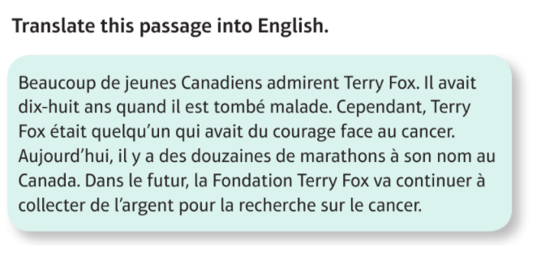

Activity 3 -
Translate into English:

Je m’appelle Amélie et je vais vous parler de ma famille. J’ai un petit frère qui s’appelle Luc et il m’énerve. Je m’entends bien avec ma sœur, Caroline, qui a douze ans. Elle est jolie et généreuse. Ma mère est gentille et nous allons souvent au centre sportif ensemble.

Activity 4 -
Translate into English
J’ai plein d’amis, mais ma meilleure amie s’appelle Michelle. Elle est ma meilleure amie car on a les mêmes centres d’intérêts, on bavarde, on va au ciné, mais on se dispute aussi de temps en temps. On s’entend bien car elle est drôle et compréhensive. Récemment on est allés en vacances avec sa famille et on s’est bien amusé. A l’avenir on va voyager ensemble en Afrique et on va aider les gens.

Module 1, Qui suis-je? - Lesson 7:
Qui suis-je? – Translation (English to French)
Objectif: To practise and develop our translation skills from English to French on the topic of Qui suis-je?

In your final GCSE exams, you will have to complete 2 translations. One of these appears on your writing paper. For this translation, you will need to translate from English into French. For the foundation paper, this will take the form of 5 short sentences that you will need to translate. For the higher paper, it will be a paragraph of similar length to the translations for the reading paper. Try to complete all of the translations in this lesson regardless of whether they are foundation or higher.

English - French Translation Tips
- Break down the sentence into clauses (different sections). ...
- Identify the connectives.
- Identify the verbs and tenses.
- Annotate vocabulary.
- Have a go at putting it into the target language.
- Check the spelling of the verbs and word order – remember that literal, “word for word” translations don't usually work.
- Build up your bank of little words, which you are likely to need in translations for example, intensifiers (quite – assez, very – très)
- Learn common time and frequency phrases (demain – tomorrow, quelquefois – sometimes)
- Remember your word order – In French they say a cat black rather than a black cat
- Think about adjectival agreement – adjectives need to agree in gender and number
un chat noir – a black cat deux chats noirs – 2 black cats
une chaussure noire – a black shoe deux chaussures noires – 2 black shoes

Activity 1 –
Translate these 5 sentences into French.
    - My sister is lazy and chatty
    - In my family there are five people
    - He doesn’t get on well with his parents.
    - Yesterday, I argued with my mum.
    - In the future, I would like to have purple hair.

Activity 2 -
Translate these 5 sentences into French.
a) My sister is called Ana.
b) She is very pretty and tall.
c) I get on well with my sister because she is kind.
d) Last night we watched a film at home and it was fun.
e) We like to spend time together and we like to listen to music.

Activity 3-
Complete the translation by filling in the gaps (Hint – the missing words are all verbs)
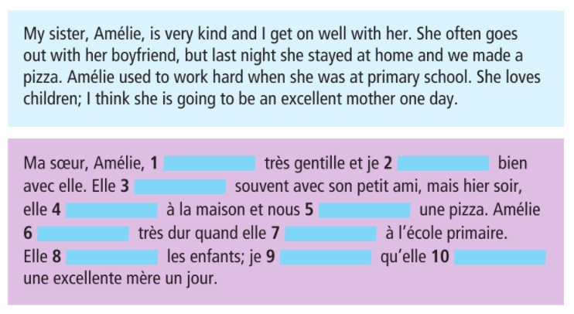

Activity 4 -
Translate this short paragraph into French.
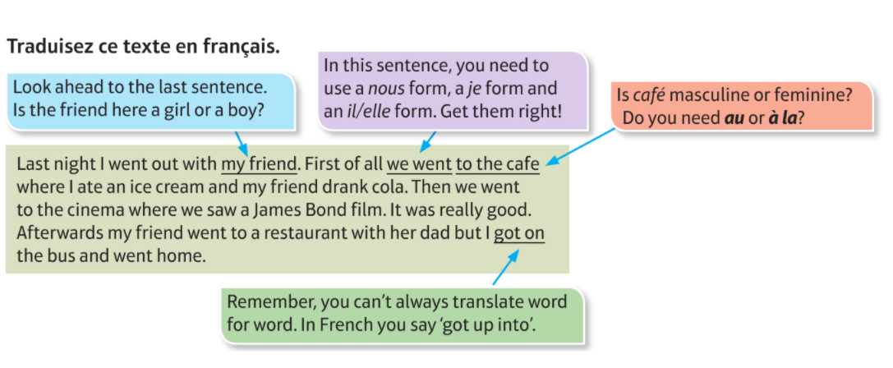

Activity 5 -
Translate this short paragraph into French.
Activity 5 =

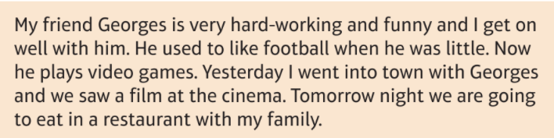

Module 1, Qui suis-je? - Lesson 8:
Qui suis-je? – Listening
Objectif: To practise and develop our listening skills on the topic of Qui suis-je? using This Is Language

Login to This Is Language and complete all videos listed below. Do this by following the link, or typing the ID of the video into the search bar.
If you have forgotten your login details for This Is Language, please contact your class teacher using the messaging system on Class Charts.

Tu t'entends bien avec ta famille? Pourquoi/pourquoi pas?
ID 210
https://my.thisislanguage.com/school/watch-video/210

Tu t'entends bien avec ta famille? Pourquoi/pourquoi pas?
ID 218
https://my.thisislanguage.com/school/watch-video/218

Parle-moi un peu de ta famille.
ID 186
https://my.thisislanguage.com/school/watch-video/186

Parle-moi un peu de ta famille.
ID 184
https://my.thisislanguage.com/school/watch-video/184

Qu'est-ce que tu as fait récemment en famille?
ID 200
https://my.thisislanguage.com/school/watch-video/200

Décris ton premier ami d’enfance.
ID 2693
https://my.thisislanguage.com/school/watch-video/2693

Selon toi, qu'est-ce qu'un bon ami ?
ID 9278
https://my.thisislanguage.com/school/watch-video/9278

Qu'est-ce que tu vas faire avec tes copains ce week-end?
ID 173
https://my.thisislanguage.com/school/watch-video/173

Module 1, Qui suis-je? - Lesson 9:
Qui suis-je? – Writing (Foundation)
Objectif: To practise and develop our writing skills on the topic of Qui suis-je

Even if you intend on taking the higher writing paper, please ensure that you complete all activities in this lesson as they will be beneficial in developing your writing skills.

The Foundation writing paper is made up of 4 questions: describing a photo; 40 word task; 5 translation sentences (we practiced this in lesson 7) and a 90 word task.

Describing a photo
Similarly to your speaking exam, you will need to write 4 sentences in French to describe a photo. It is best to try and keep these as SIMPLE as possible, i.e il y a une famille – there is a family. Don’t try to overcomplicate on this section, as you will lose marks for any mistakes and you won’t gain any more marks for giving a detailed answer.

Activity 1 -
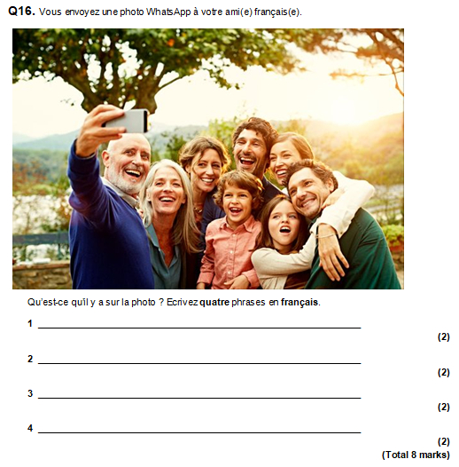

Activity 2 – Write 4 sentences about this photo in French
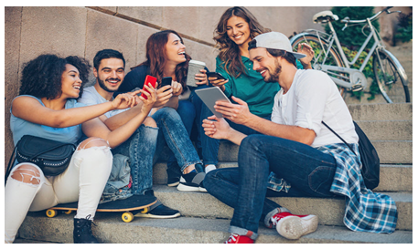

40 word task
There will only be one option for this task. For your 40 word task, you will be given four bullet points. These are often made up of 1 or 2 words. All you have to do to get near to full marks for this question, is to write a D.O.R.C sentence about each of the bullet points. Even if you can’t work out what one of the bullet points means, write it in a D.O.R.C sentence and it will most likely make sense and get you the marks! Make sure to use a variety of opinions, so saying you like something, but you dislike the other bullet point.

For example –
The bullet point is: l’école
Translate the bullet point to English – school
Write a D.O.R.C sentence – Je dirais que j’aime l’école parce que c’est fantastique

Activity 3 – write a 40 word response to this task. ANSWER ALL BULLET POINTS
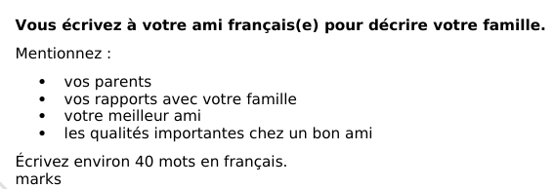

90 word task
In your final exam the 90 word tasks are the same in both the foundation and the higher paper.
In your exam, you will have the choice between 2 90 word tasks, and they will likely be from different topics. You must only complete 1 in your final exam, as only 1 will be marked.

Tips
- translate the bullet points before starting your task
- write what tense each bullet point is asking you to respond in
- write a separate paragraph for each bullet point
- complete the bullet points in order
- use D.O.R.C sentences and higher level opinion phrases (je dirais que – I would say that)
- ANSWER ALL 4 BULLET POINTS – EVEN IF IT IS JUST 1 SENTENCE! If you are really struggling and can’t work out what the bullet point means, try to include it in a D.O.R.C sentence
-To get full marks, you MUST use at least 3 tenses

Task 1

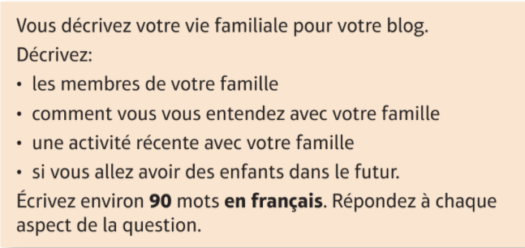

Module 1, Qui suis-je? - Lesson 10:
Qui suis-je? – Writing (Higher)
Objectif: To continue to practise and develop our writing skills on the topic of Qui suis-je

Even if you intend on taking the foundation paper, please complete all activities in this lesson for practice.

In the higher paper, there are 3 questions: 90 word task; 150 word task and to translate a short paragraph from English to French (we have already practiced these in lesson 7).

90 word task
In your final exam the 90 word tasks are the same in both the foundation and the higher paper.
In your exam, you will have the choice between 2 90 word tasks, and they will likely be from different topics. You must only complete 1 in your final exam, as only 1 will be marked.

Tips
- translate the bullet points before starting your task
- write what tense each bullet point is asking you to respond in
- write a separate paragraph for each bullet point
- complete the bullet points in order
- use D.O.R.C sentences and higher level opinion phrases (je dirais que – I would say that)
- ANSWER ALL 4 BULLET POINTS – EVEN IF IT IS JUST 1 SENTENCE! If you are really struggling and can’t work out what the bullet point means, try to include it in a D.O.R.C sentence
-To get full marks, you MUST use at least 3 tenses

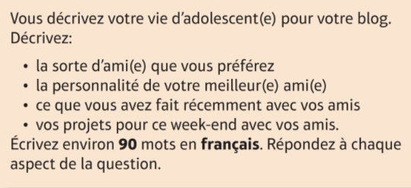
Activity 1 -

150 word task
You will need to choose between two 150 word tasks. Only complete one of them. There will only be two bullet points, but you will need to write a detailed and informative response to each bullet point. Try to use as many tenses as you can and higher level language (for example subjunctive)
TIPS
· Mention all of the bullet points, tick them off as you do, you don’t need to write the same amount about each one.
· Keep your response really relevant- don’t just waffle on about anything you know related to the topic, make sure you answer and respond to the bullet point.
· Develop and justify and explain your opinions, giving examples wherever possible.
· Once you have written a sentence read back through it and make sure it actually makes sense/ the message comes across. If not simplify or shorten it.
· Identify which bullet points target the different time frames/ tenses and check that your verb formation is accurate.
· In some cases, the language used in the bullet point can be manipulated to help you write a successful response. For example, in Question 1.1, the first bullet point ‘votre destination de vacances préférée’ is easily adapted to produce ‘ma destination de vacances préférée est…’
· Go for fewer, more impressive sentences featuring complex opinions, accurate verbs, developed opinions and connectives rather than writing lots of simpler sentences just to fill the pages.
· Vary your language where possible and aim for –CROISSANT- COMPARATIVES, REASONS, OPINIONS, INTENSIFIERS,SOPHISTICATED STRUCTURES,SUBORDINATE CLAUSES (extra bits),ADVERBS,NEGATIVES,TENSES.
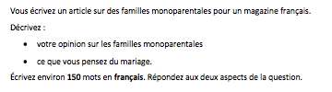
Activity 1 –

Module 2, Le temps des loisirs - Lesson 11:
Le temps des loisirs – Reading
Objectif: To practise and develop our reading skills by completing a range of GCSE reading questions on the topic of Le temps des loisirs

GCSE READING TIPS:
  - read the text before the question
  - highlight/underline key vocabulary and annotate it in English
  - try to identify tenses within the text
  - read the question, due to annotating the text it should be quick to scan for the correct answer
  - make sure you double check your answers to make sure you’re not falling for a distractor

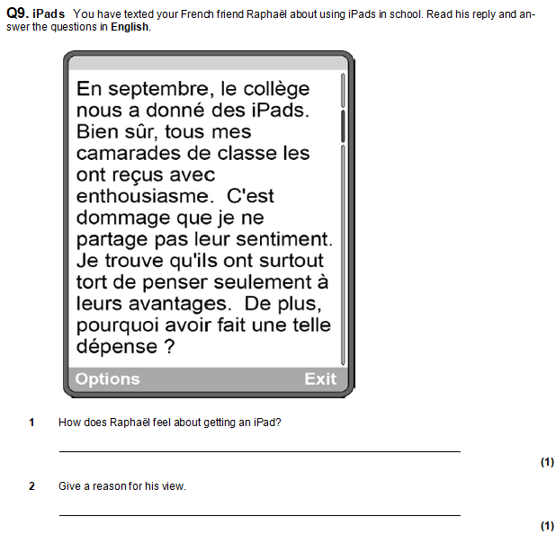
Activity 1-

Activity 2 –

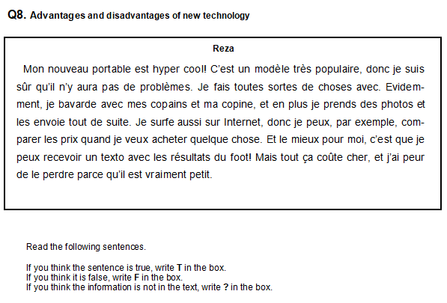

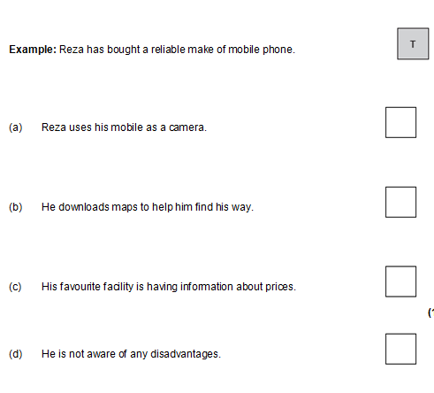

Activity 3-
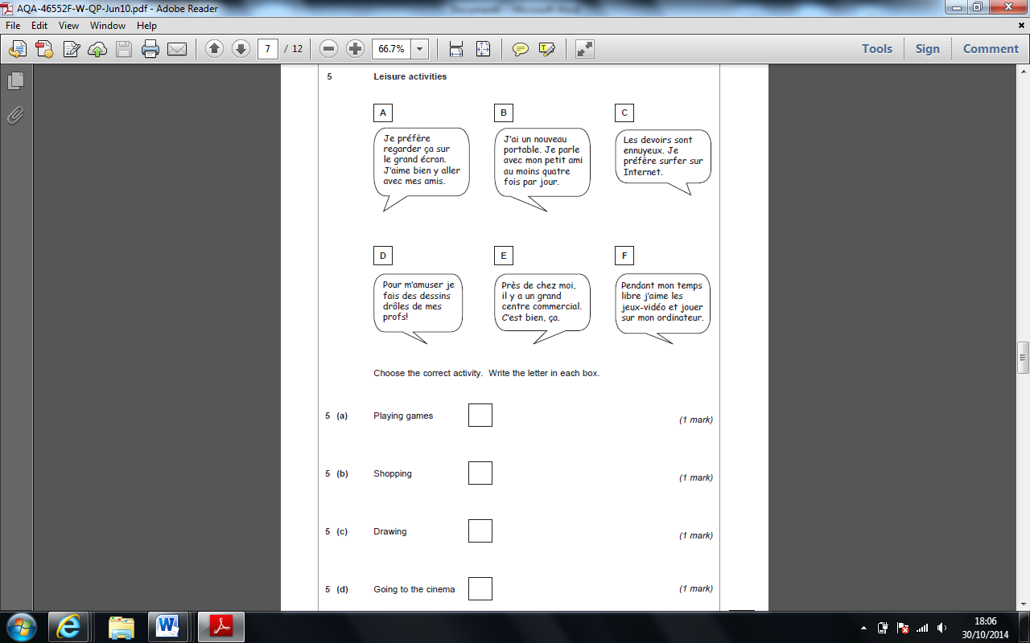

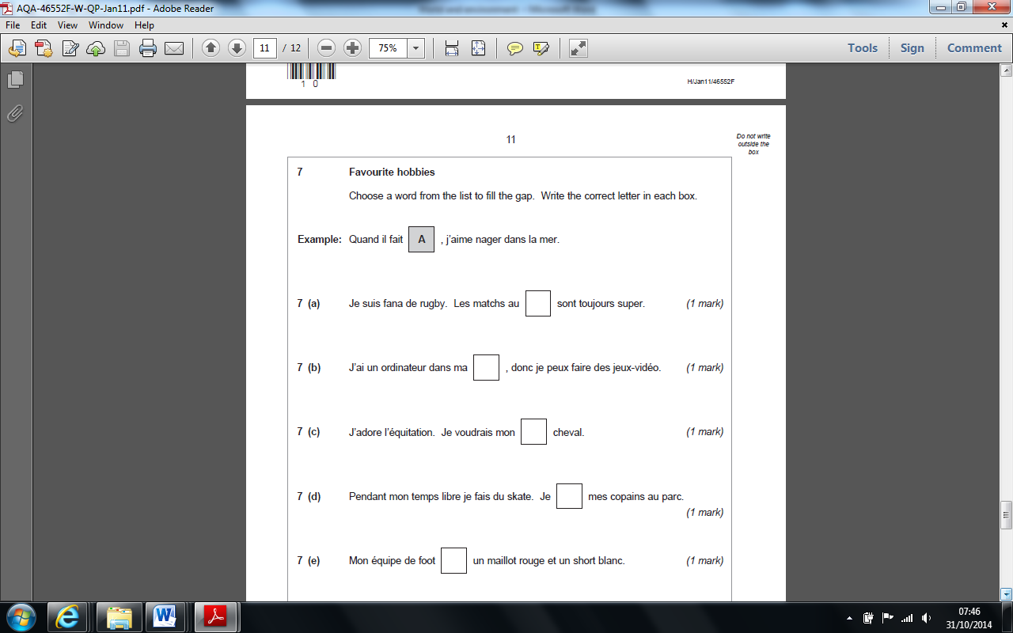

Activity 4 –

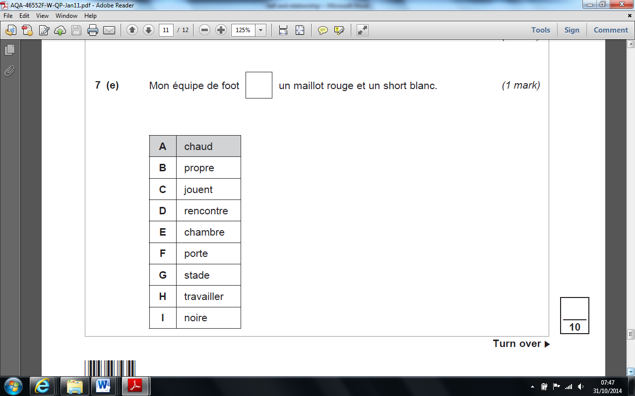

Module 2, Le temps des loisirs - Lesson 12:
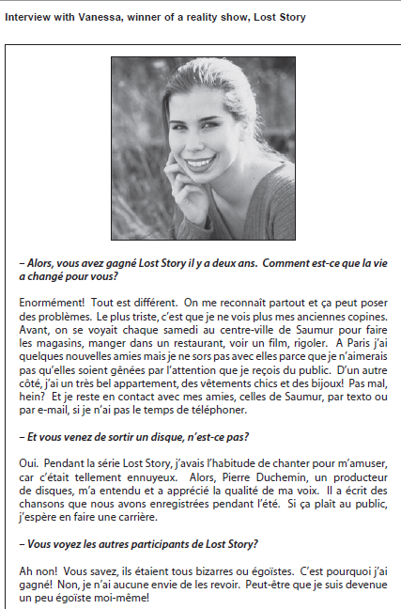
Le temps des loisirs – Reading
Objectif: To practise and develop our reading skills by completing a range of GCSE reading questions on the topic of Le temps des loisirs

Activity 1 –

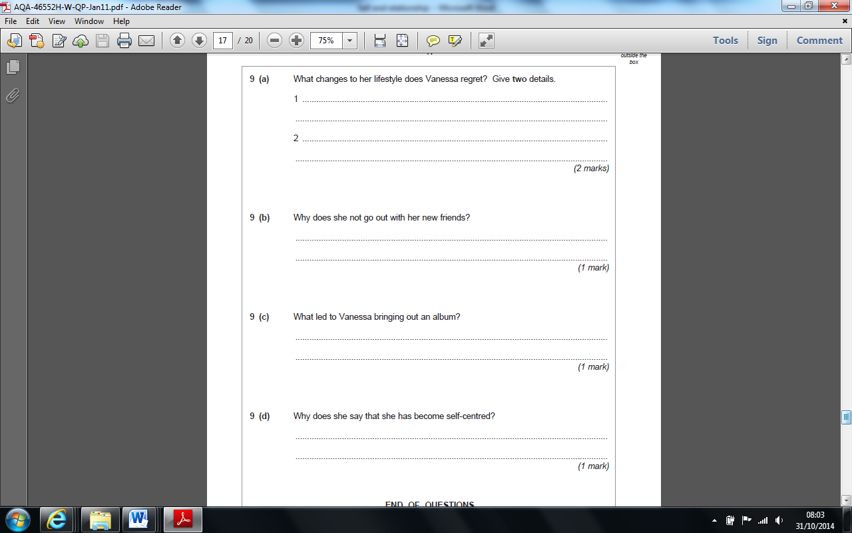

Activity 2 –
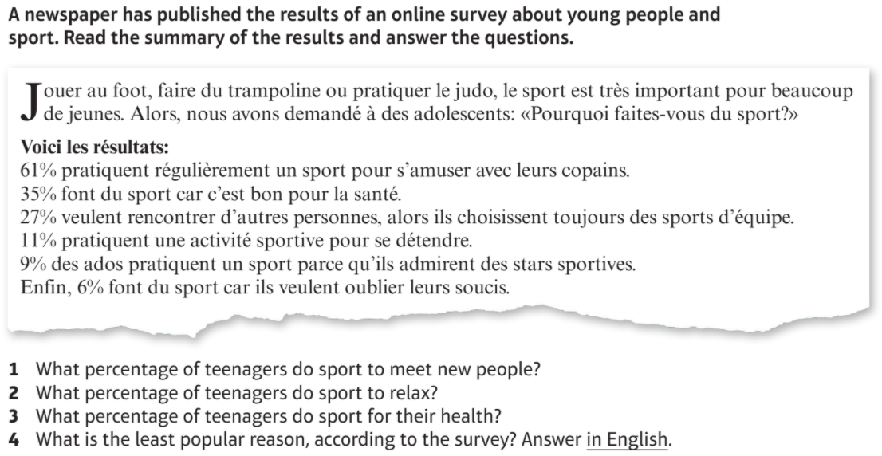

Activity 3 –
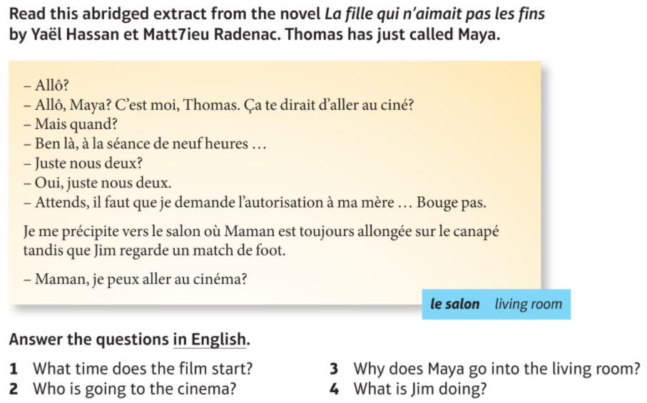

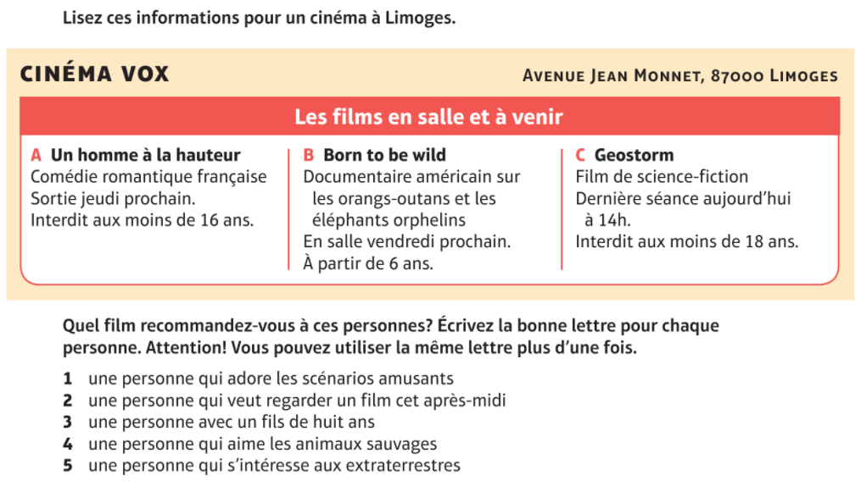
Activity 4 –

Module 2, Le temps des loisirs - Lesson 13:
Le temps des loisirs – Translation (French – English)
Objectif: To practise and develop our French to English translation skills by completing a range of GCSE reading questions on the topic of Le temps des loisirs

In your final GCSE exams, you will have to complete 2 translations. One of these appears on your reading paper. You will have to translate a short paragraph from French into English. This is on both the foundation and higher paper. We are going to focus on these translations in this lesson.

French – English Translation Tips
- Reading for gist. – read the whole passage first before you start translating it in order to establish the general meaning, even if you know that there are some words you don’t recognise or cannot immediately translate
- Annotate the translation with the words you do know, and underline any you don’t know before you start translating.
- If there is a word you don’t know in a sentence, try to make an informed guess. Ask yourself what makes sense in the context of the rest of the text.
- Pay attention to time indicators and your grammatical knowledge to work out the tense of a sentence
- Look for cognates (words which are very similar in both languages)
- Pay attention for False Friends! These are words which look similar to English but have totally different meanings:
Read these 3 sentences in French:
Mon frère est très sensible. Elle travaille à l’étranger. La journée était fatigante.
If you think about cognates, you might have tried the following:
My brother is very sensible. She travels abroad. The journey was tiring.
All three would be wrong! The correct translations are:
My brother is very sensitive. She works abroad. The day was tiring.
- Think about whether what you have translated makes sense in English! This is one of the biggest losses of marks in the reading exam, use your common sense! Remember that the word order is often different in French.

Activity 1 -
J’ai beaucoup d’amis. A mon avis c’est très important d’avoir des bons amis. Nous sortons ensemble au weekend. Souvent nous allons au cinéma ou faire du shopping. Il y a une semaine nous sommes allés au cinéma pour regarder un film d’amour. Le mois prochain nous aimerions aller à un concert de musique rock.

Activity 2 –
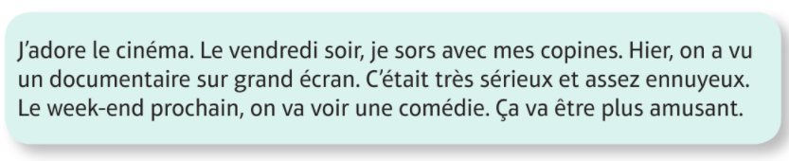

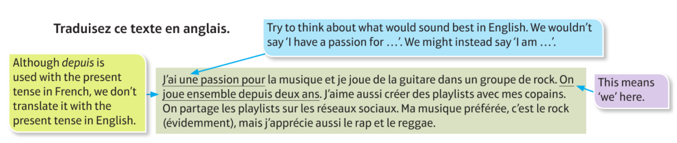
Activity 3 –

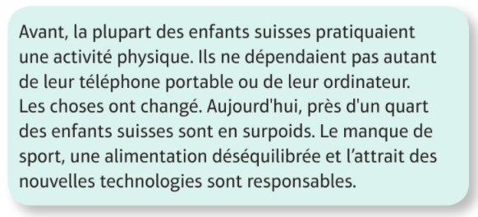
Activity 4 –

Module 2, Le temps des loisirs - Lesson 14:
Le temps des loisirs – Translation (English to French)
Objectif: To practise and develop our English to French translation skills by completing a range of GCSE reading questions on the topic of Le temps des loisirs

In your final GCSE exams, you will have to complete 2 translations. One of these appears on your writing paper. For this translation, you will need to translate from English into French. For the foundation paper, this will take the form of 5 short sentences that you will need to translate. For the higher paper, it will be a paragraph of similar length to the translations for the reading paper. Try to complete all of the translations in this lesson regardless of whether they are foundation or higher.

English - French Translation Tips
- Break down the sentence into clauses (different sections). ...
- Identify the connectives.
- Identify the verbs and tenses.
- Annotate vocabulary.
- Have a go at putting it into the target language.
- Check the spelling of the verbs and word order – remember that literal, “word for word” translations don't usually work.
- Build up your bank of little words, which you are likely to need in translations for example, intensifiers (quite – assez, very – très)
- Learn common time and frequency phrases (demain – tomorrow, quelquefois – sometimes)
- Remember your word order – In French they say a cat black rather than a black cat
- Think about adjectival agreement – adjectives need to agree in gender and number
un chat noir – a black cat deux chats noirs – 2 black cats
une chaussure noire – a black shoe deux chaussures noires – 2 black shoes

Activity 1 -
    - I take photos with my phone
    - I read books sometimes
    - We send lots of texts in the evening
    - Documentaries are my favourite TV show because they are educational.
    - Last night I used my phone to do my homework.

Activity 2 –

- I play basketball
- On Sundays I go swimming
- I prefer to watch TV
- I like doing exercise because it is good for you
- Next week we are going to go to the cinema

Activity 3 -
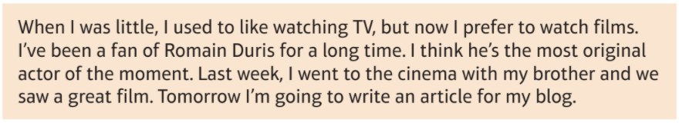

Activity 4 -

I play rugby once a week and I love it because it is exciting. Last weekend, I went swimming in the sea with my friend, but it was too cold! I usually swim in a swimming pool and it is warmer. My sister sometimes does winter sports, but I have never been skiing.

Activity 5 -

My parents don’t want me to use social networks. They think that it can be very dangerous, but I don’t agree. I don’t upload my photos and I never share my videos. We discuss the problems like bullying at school. However, I think that the teachers should give us more information.

Module 2, Le temps des loisirs - Lesson 15:
Le temps des loisirs – Listening
Objectif: To practise and develop our listening skills on the topic of le temps des loisirs

Login to This Is Language and complete all videos listed below. Do this by following the link, or typing the ID of the video into the search bar. If you have forgotten your login details for This Is Language, please contact your class teacher using the messaging system on Class Charts.

Qu'est-ce que tu aimes comme sports?
ID 302
https://my.thisislanguage.com/school/watch-video/302

Qu'est-ce que tu aimes comme sports?
ID 305
https://my.thisislanguage.com/school/watch-video/305

Quelle activité feras-tu cette semaine ?
ID 490
https://my.thisislanguage.com/school/watch-video/490

Sports collectifs, ou individuels ? Pourquoi ?
ID 2685
https://my.thisislanguage.com/school/watch-video/2685

Aimes-tu écouter de la musique ? Pourquoi la musique est-elle importante pour toi / les autres ?
ID 5266
https://my.thisislanguage.com/school/watch-video/5266

C’était quoi la dernière chanson que tu as acheté, et pourquoi ?
ID 2702
https://my.thisislanguage.com/school/watch-video/2702

Décris ta relation avec Facebook.
ID 375
https://my.thisislanguage.com/school/watch-video/375

Décris ta relation avec Facebook.
ID 2615
https://my.thisislanguage.com/school/watch-video/2615

Qu’est-ce que tu utilises le plus sur Internet ?
ID 435
https://my.thisislanguage.com/school/watch-video/435

Est-ce que tu aimes aller au cinéma ?
ID 320
https://my.thisislanguage.com/school/watch-video/320

Parle-moi du dernier film que tu as vu.
ID 2543 https://my.thisislanguage.com/school/watch-video/2543
Module 2, Le temps des loisirs - Lesson 16:
Le temps des loisirs – Writing (Foundation)
Objectif: To practise and develop our writing skills on the topic of Le temps des loisirs

Even if you intend on taking the higher writing paper, please ensure that you complete all activities in this lesson as they will be beneficial in developing your writing skills.

The Foundation writing paper is made up of 4 questions: describing a photo; 40 word task; 5 translation sentences (we practiced this in lesson 7) and a 90 word task.

Describing a photo
Similarly to your speaking exam, you will need to write 4 sentences in French to describe a photo. It is best to try and keep these as SIMPLE as possible, i.e il y a une famille – there is a family. Don’t try to overcomplicate on this section, as you will lose marks for any mistakes and you won’t gain any more marks for giving a detailed answer.

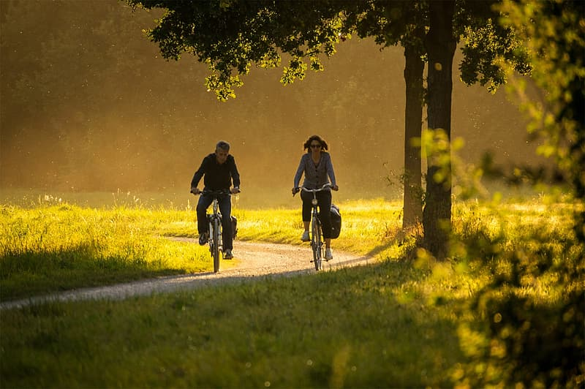
Activity 1 – write 4 sentences to describe this photo.

Activity 2 – write 4 sentences to describe this photo



40 word task
There will only be one option for this task. For your 40 word task, you will be given four bullet points. These are often made up of 1 or 2 words. All you have to do to get near to full marks for this question, is to write a D.O.R.C sentence about each of the bullet points. Even if you can’t work out what one of the bullet points means, write it in a D.O.R.C sentence and it will most likely make sense and get you the marks! Make sure to use a variety of opinions, so saying you like something, but you dislike the other bullet point.

For example –
The bullet point is: l’école
Translate the bullet point to English – school
Write a D.O.R.C sentence – Je dirais que j’aime l’école parce que c’est fantastique

Activity 3 – write a 40 word response to the following task

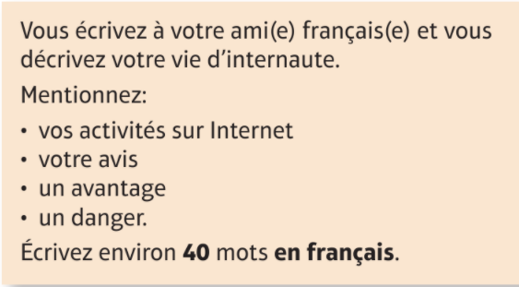

Activity 4 – write a 40 word response to the following task

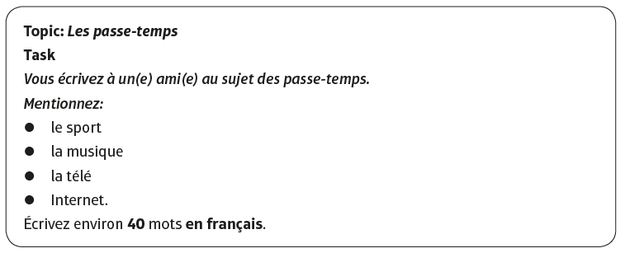
90 word task
In your final exam the 90 word tasks are the same in both the foundation and the higher paper.
In your exam, you will have the choice between 2 90 word tasks, and they will likely be from different topics. You must only complete 1 in your final exam, as only 1 will be marked. For this lesson, please complete both the 90 word tasks that are given to you.

Tips
- translate the bullet points before starting your task
- write what tense each bullet point is asking you to respond in
- write a separate paragraph for each bullet point
- complete the bullet points in order
- use D.O.R.C sentences and higher level opinion phrases (je dirais que – I would say that)
- ANSWER ALL 4 BULLET POINTS – EVEN IF IT IS JUST 1 SENTENCE! If you are really struggling and can’t work out what the bullet point means, try to include it in a D.O.R.C sentence
-To get full marks, you MUST use at least 3 tenses

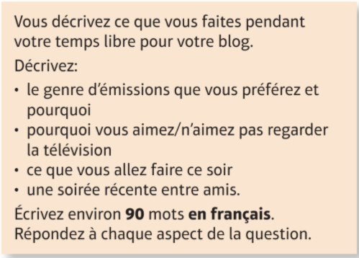
Activity 5 – write a 90 word response to this task

Module 2, Le temps des loisirs - Lesson 10:
Le temps des loisirs – Writing (Higher)
Objectif: To continue to practise and develop our writing skills on the topic of Qui suis-je

Even if you intend on taking the foundation paper, please complete all activities in this lesson for practice.

In the higher paper, there are 3 questions: 90 word task; 150 word task and to translate a short paragraph from English to French (we have already practiced these in lesson 7).

90 word task
In your final exam the 90 word tasks are the same in both the foundation and the higher paper.
In your exam, you will have the choice between 2 90 word tasks, and they will likely be from different topics. You must only complete 1 in your final exam, as only 1 will be marked.

Tips
- translate the bullet points before starting your task
- write what tense each bullet point is asking you to respond in
- write a separate paragraph for each bullet point
- complete the bullet points in order
- use D.O.R.C sentences and higher level opinion phrases (je dirais que – I would say that)
- ANSWER ALL 4 BULLET POINTS – EVEN IF IT IS JUST 1 SENTENCE! If you are really struggling and can’t work out what the bullet point means, try to include it in a D.O.R.C sentence
-To get full marks, you MUST use at least 3 tenses

Activity 1 – write a 90 word response to this task
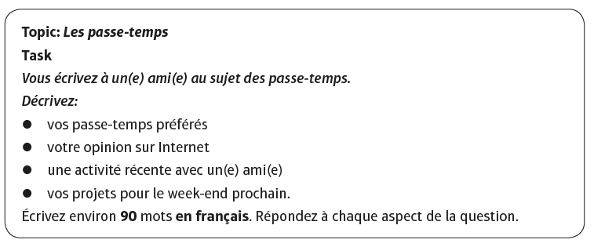

150 word task
You will need to choose between two 150 word tasks. Only complete one of them. There will only be two bullet points, but you will need to write a detailed and informative response to each bullet point. Try to use as many tenses as you can and higher level language (for example subjunctive)
TIPS
· Mention all of the bullet points, tick them off as you do, you don’t need to write the same amount about each one.
· Keep your response really relevant- don’t just waffle on about anything you know related to the topic, make sure you answer and respond to the bullet point.
· Develop and justify and explain your opinions, giving examples wherever possible.
· Once you have written a sentence read back through it and make sure it actually makes sense/ the message comes across. If not simplify or shorten it.
· Identify which bullet points target the different time frames/ tenses and check that your verb formation is accurate.
· In some cases, the language used in the bullet point can be manipulated to help you write a successful response. For example, in Question 1.1, the first bullet point ‘votre destination de vacances préférée’ is easily adapted to produce ‘ma destination de vacances préférée est…’(see note on pronouns in the speaking section).
· Go for fewer, more impressive sentences featuring complex opinions, accurate verbs, developed opinions and connectives rather than writing lots of simpler sentences just to fill the pages.
· Vary your language where possible and aim for –CROISSANT- COMPARATIVES, REASONS, OPINIONS, INTENSIFIERS,SOPHISTICATED STRUCTURES,SUBORDINATE CLAUSES (extra bits),ADVERBS,NEGATIVES,TENSES.
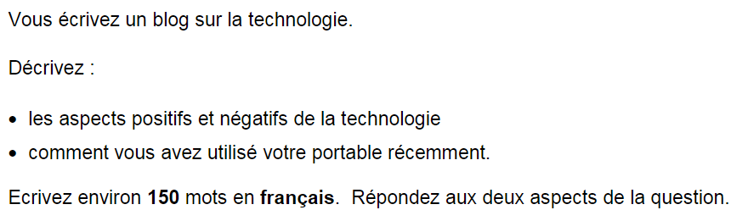
Activity 2 – write a 150 word response to this task

KNOWLEDGE ORGANISER – MODULE 1 QUI SUIS-JE ?
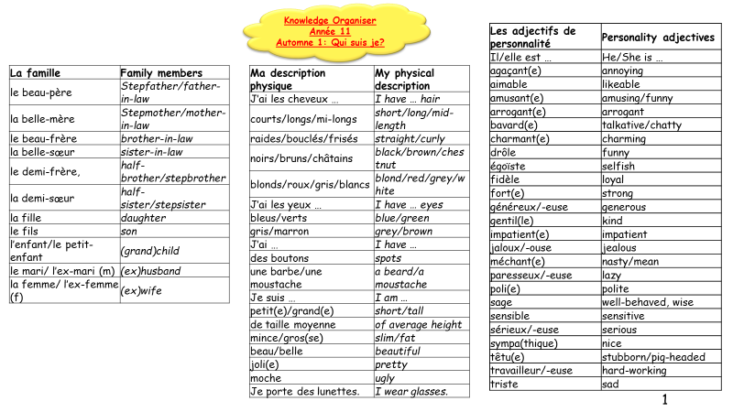

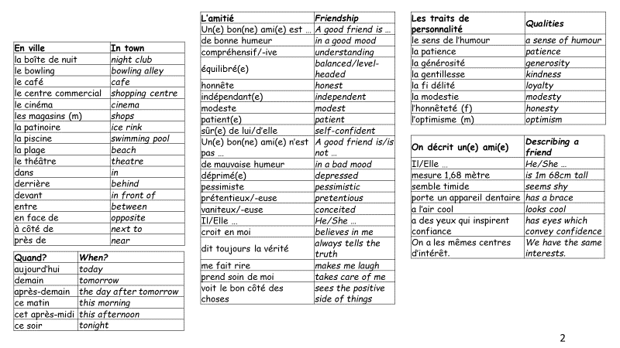

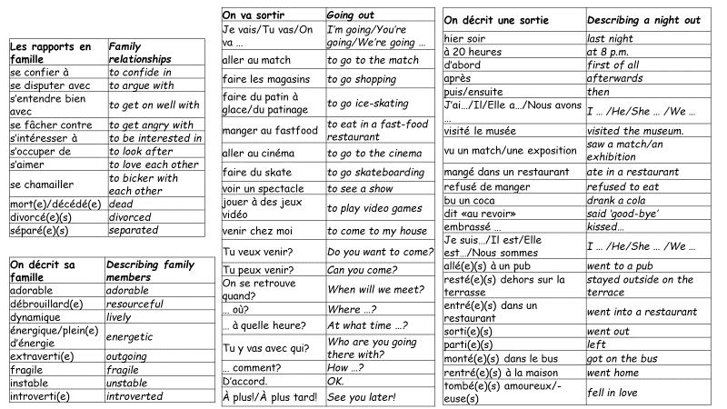

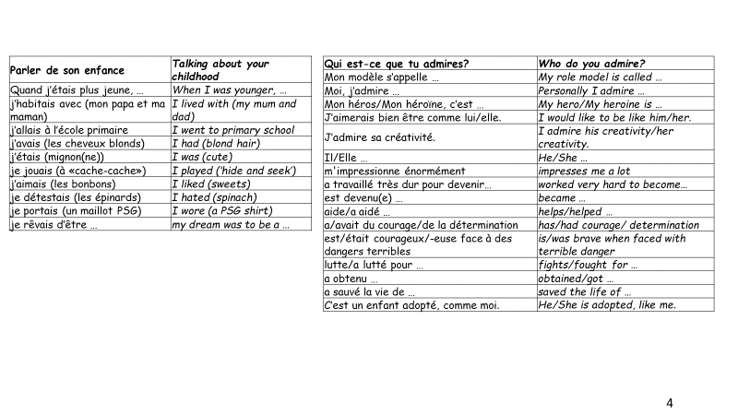

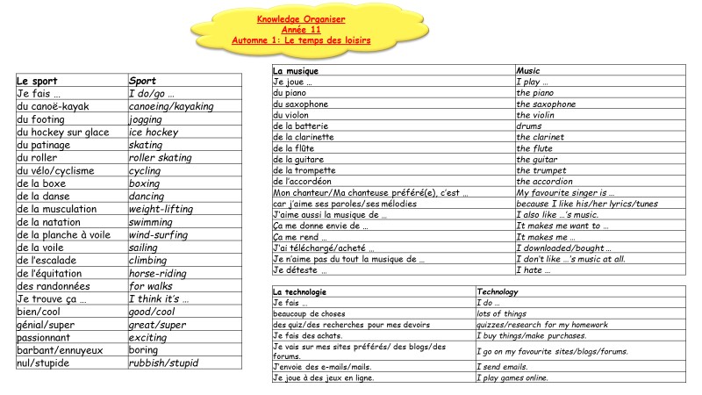
KNOWLEDGE ORGANISER – MODULE 2 LE TEMPS DES LOISIRS

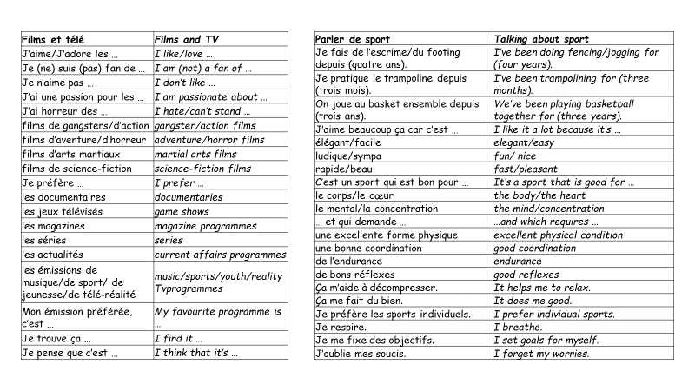

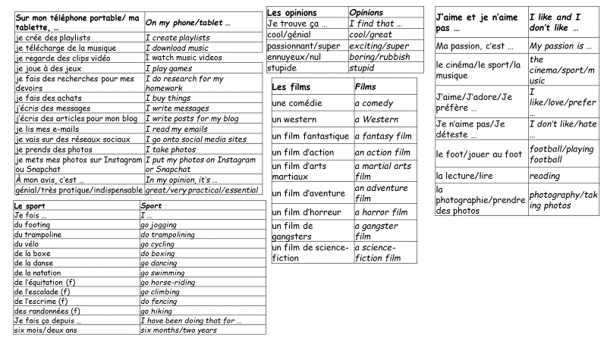

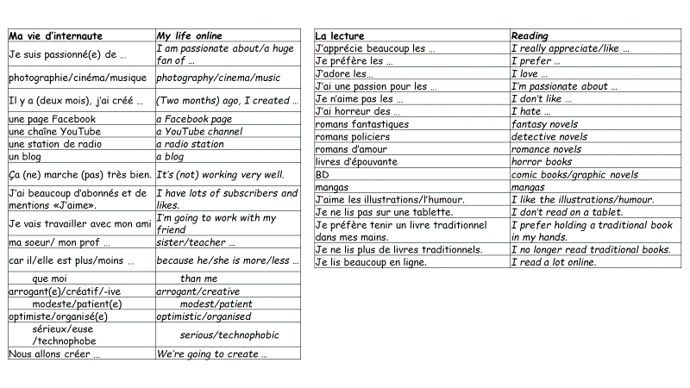

Reading Assessment
Reading
FOUNDATION
Social media
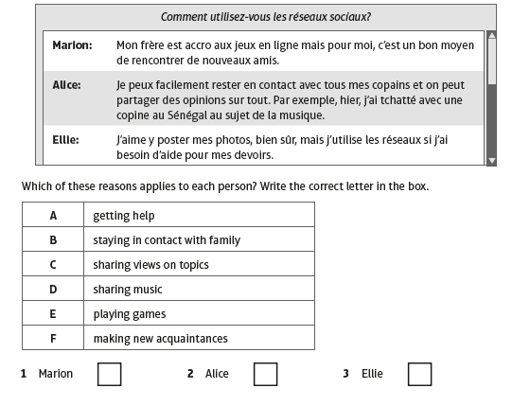
- Your exchange partners school has asked why people use social media. Read some of the responses.

Total marks: /3

FOUNDATION/HIGHER
My family
- Your Swiss friend, Lucien, has written to you about his family.
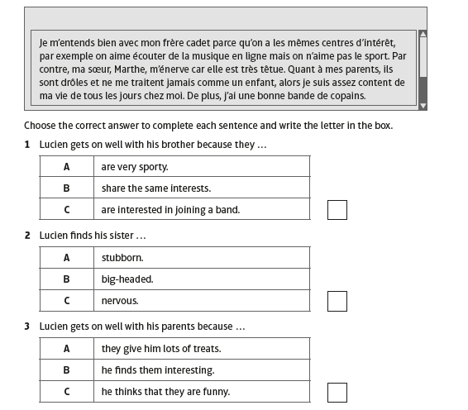

Total marks: /3
Foundation/Higher
Sport in France
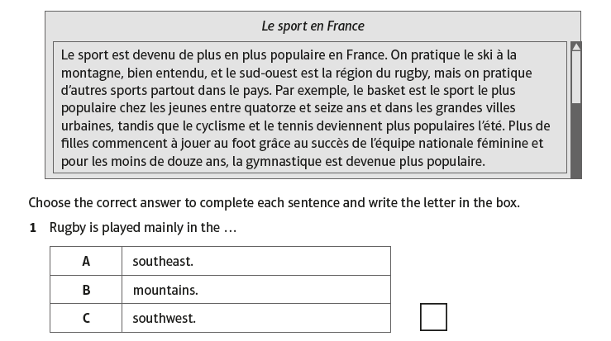
- You see this article about sport in France.

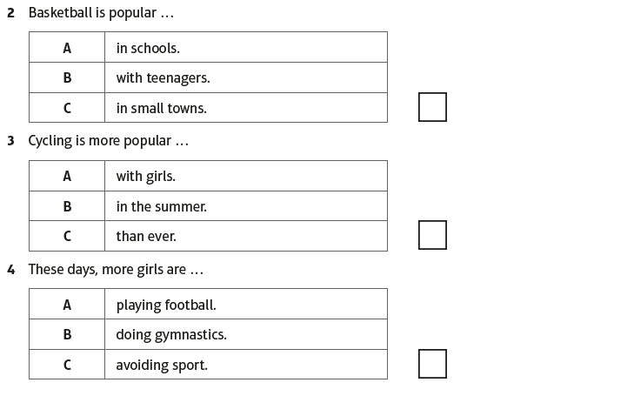

Total marks: /4
HIGHER
First dates
- Read the article about first dates by Sophie Mahut
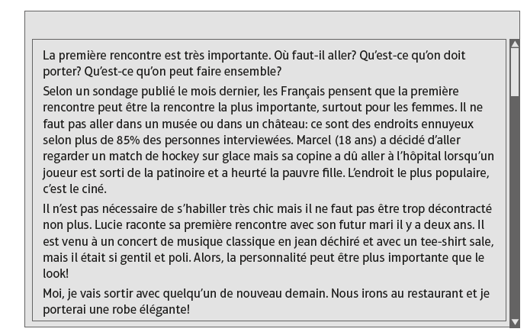

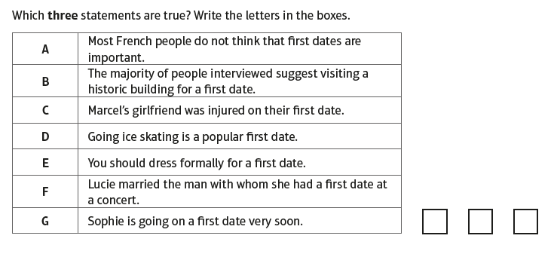

Total marks: /3
HIGHER
Mes préférences sportives
- Completez le texte suivant avec les mots de la liste ci-dessous.
Écrivez la bonne lettre dans chaque case.

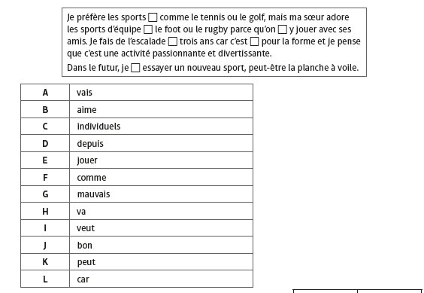

Total marks: /6

Translation Assessment
FOUNDATION
Translate the following sentences into French. [10 marks]

- I have long, blonde hair.
______________________________________________________________________________________________________________________________________________________
- I am intelligent but I am not funny.
______________________________________________________________________________________________________________________________________________________

- Snapchat is more fun than Instagram.
______________________________________________________________________________________________________________________________________________________

- I am a fan of romance novels because they are interesting.
______________________________________________________________________________________________________________________________________________________

- My favourite TV shows are game shows.

______________________________________________________________________________________________________________________________________________________

HIGHER
Task
Translate this text into French.

When I was little, I used to like watching TV but now I prefer to watch films. I’ve been a fan of Romain Duris for a long time. I think he is incredible. Last week, I went to the cinema with my brother and we saw a great film/ Tomorrow I’m going to play football with my friends.

Writing Assessment – 90 Word task (foundation and higher)

Task
Vous décrivez votre vie d’adolescent(e) pour votre blog.

Décrivez:
- Votre personnalité
- Vos rapports avec votre famille
- Une activité récente avec un(e) ami(e)
- Vos projets pour le week-end prochain

Écrivez environ 90 mots en français. Répondez à chaque aspect de la question.
[16 MARKS]

Year 11 French Assessment Ladder – 90 word task



