Year 11 English
Blended Learning Booklet
Spring A
Unit 3 – Language Paper One
Name:
Form:

Class Teacher:
Mark allocation
Examination Mark Schemes
AO2
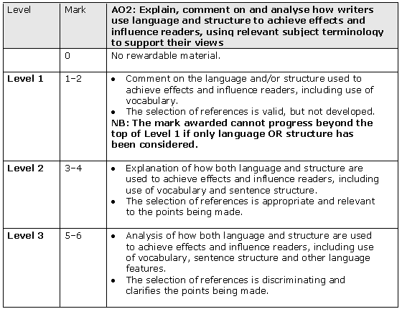
AO4
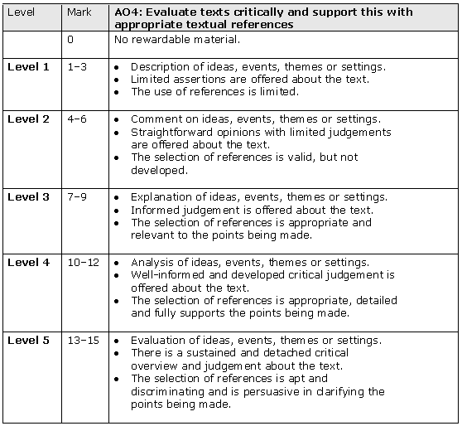
Examination Mark Schemes

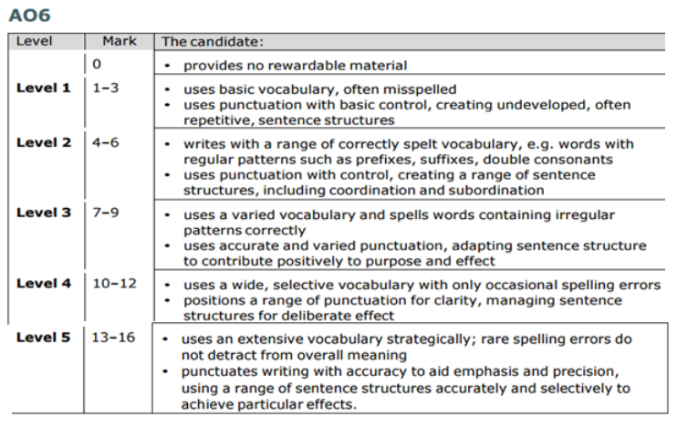


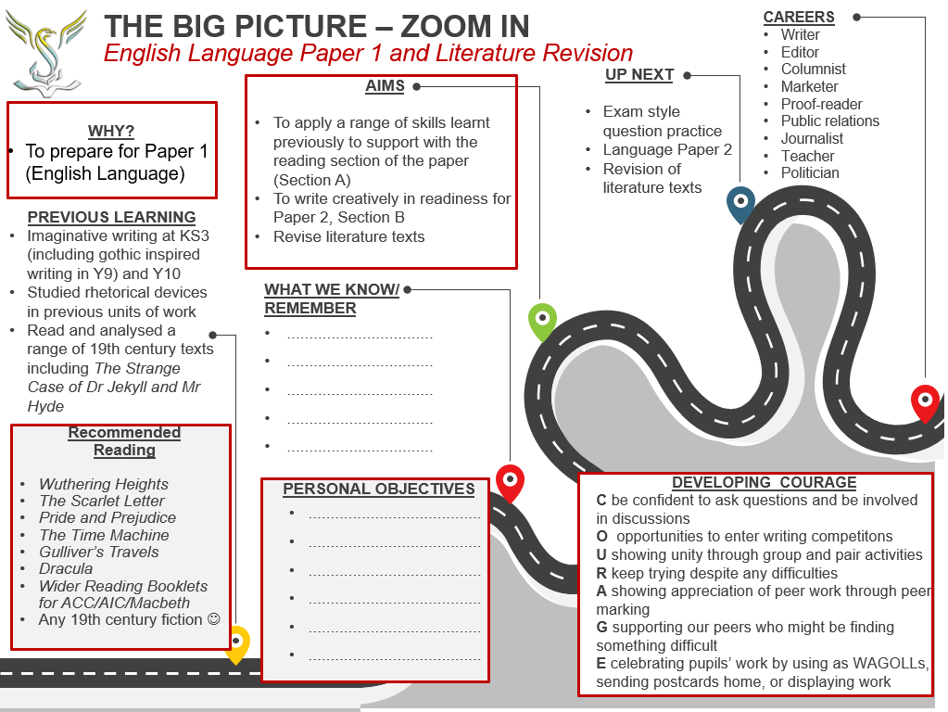

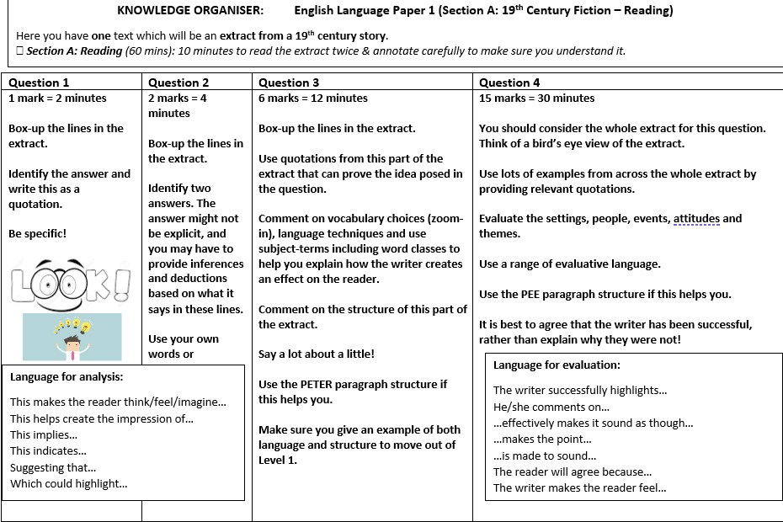

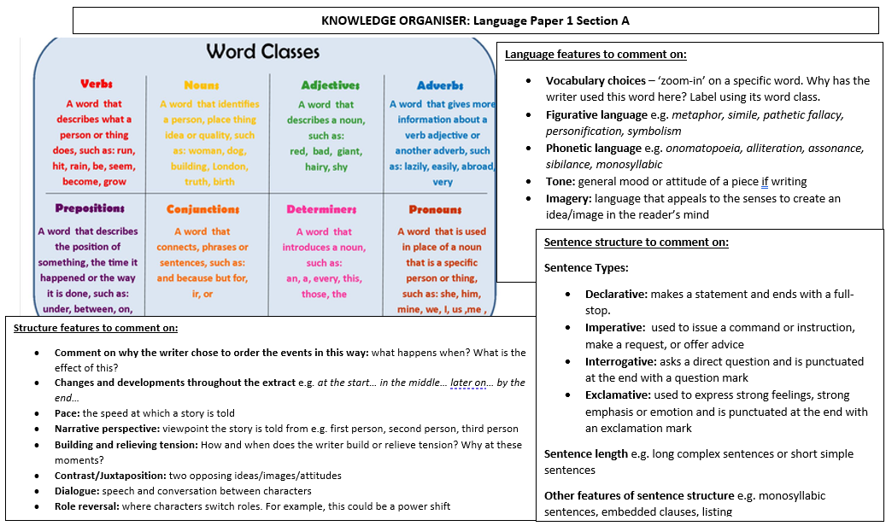

Lesson Focus: |  | Page | Tick when complete | RAG Rate
 | How do we approach Q3 Language Paper 1? Analysis | 9
 | How do we approach Q4 Language paper 1? Evaluation | 14
 | How do we generate ideas and use a story arc to plan a narrative? | 14
 | How is Scrooge presented in A Christmas Carol? | 17
 | How do I write a narrative? | 19
 | How do I become more successful at analysis? | 22
 | How do I become more successful at evaluation? | 22
 | What are Priestley’s intentions? | 22
 | Why is Kingship important in Macbeth? | 24
 | How can I use sentence structures effectively in my writing? | 25
 | How do I write an analytical paragraph? | 27
 | How do I evaluate using a detached critical overview? | 30
 | How can I use language and structure for effect in my own writing? | 34
 | How is language and structure used effectively in A Christmas Carol (extract)? | 37

Lesson 1: How do you approach Q3 of Language Paper 1?

LI: To revise approaches to answering the analysis question in the language exam

DART 1: read through the following examiners’ report based on the June 2018 paper. Answer the questions that follow:

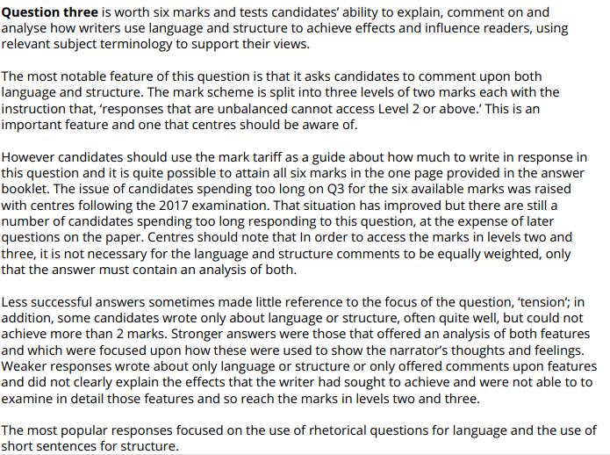

- How many marks is question 3 worth?
- What is your maximum mark if you don’t create an answer discussing both language and structure?
- What could happen if you spend too long on this question?

Activate
The following is an exemplar answer to question 3 from the June 2018 paper and is about how the writer creates tension. Read the answer and:

- Highlight and annotate where the writer has used elements of PETER
- How does the answer meet the success criteria for AO2 on page 2 of this document?
- What is good about the answer and could it be improved in any way?
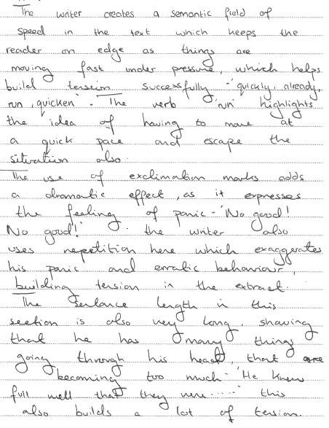
Here is the examiner report for this question:
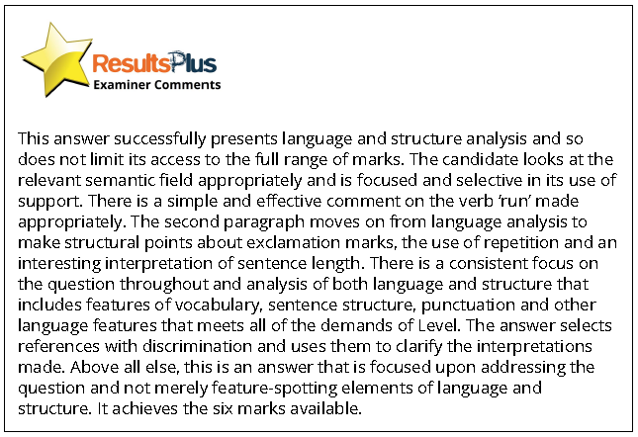

DART 2
Read the following extract from Lord Arthur Saville’s Crime by Oscar Wilde and then answer this question which is based on the extract. Submit your answer to your teacher via class charts.
Focus for annotations: the language and structure which show a change in character mood
DIP Task:
Q3. In lines 18 to 44, how does the writer use language and structure to show the change in both Mr Podgers’s and Lord Arthur’s moods?
Support your views with reference to the text. [6 marks]
Sentence Stems for help structuring your Q3 (AO2) answer:
The writer creates…when he/she writes “…”.
This means…
The (language technique) helps create…as it…highlighting/revealing/demonstrating that…

The writer creates…when he/she writes “…”.
This means…
The (sentence structure) helps create…as it…highlighting/revealing/demonstrating that…

The writer creates…when he/she writes “…”.
This means…
The (impact word: label word class) helps create…as it… highlighting/revealing/demonstrating that…

Suddenly Mr Podgers entered the room. When he saw Lord Arthur he started,
and his coarse, fat face became a sort of greenish-yellow colour. The two
men’s eyes met, and for a moment there was silence.

‘The Duchess has left one of her gloves here, Lord Arthur, and has asked me
to bring it to her,’ said Mr Podgers finally.
‘Ah, I see it on the sofa! Good evening.’
‘Mr Podgers, I must insist on your giving me a straightforward answer to a
question I am going to put to you.’
‘Another time, Lord Arthur, but the Duchess is anxious. I am afraid I must go.’
‘You shall not go. The Duchess is in no hurry.’
‘Ladies should not be kept waiting, Lord Arthur,’ said Mr Podgers, with his
sickly smile. ‘The fair sex is apt to be impatient.’
Lord Arthur’s finely chiselled lips curved in petulant disdain. The poor
Duchess seemed to him of very little importance at that moment. He walked
across the room to where Mr Podgers was standing, and held his hand out.
‘Tell me what you saw there,’ he said. ‘Tell me the truth. I must know it. I am
not a child.’
Mr Podgers’s eyes blinked behind his gold-rimmed spectacles, and he moved
uneasily from one foot to the other, while his fingers played nervously with a flash watch-chain.
‘What makes you think that I saw anything in your hand, Lord Arthur, more
than I told you?’
‘I know you did, and I insist on your telling me what it was. I will pay you. I will
give you a cheque for a hundred pounds.’
The green eyes flashed for a moment, and then became dull again.
‘Guineas?’ said Mr Podgers at last, in a low voice.
‘Certainly. I will send you a cheque tomorrow. What is your club?’
‘I have no club. That is to say, not just at present. My address is ___________, but
allow me to give you my card;’ and producing a bit of gilt-edged pasteboard
from his waistcoat pocket, Mr Podgers handed it, with a low bow to Lord
Arthur, who read on it,
Mr. SEPTIMUS R. PODGERS
Professional Cheiromantist¹
103a West Moon Street
‘My hours are from ten to four,’ murmured Mr Podgers mechanically, ‘and I
make a reduction for families.’
‘Be quick,’ cried Lord Arthur, looking very pale, and holding his hand out.
Mr Podgers glanced nervously round, and drew the heavy portiere² across
the door.
‘It will take a little time, Lord Arthur you had better sit down.’
‘Be quick, sir,’ cried Lord Arthur again, stamping his foot angrily on the
polished floor. Mr Podgers smiled, drew from his breast-pocket a small
magnifying glass, and wiped it carefully with his handkerchief.
‘I am quite ready,’ he said.
Ten minutes later, with face blanched by terror, and eyes wild with grief, Lord
Arthur Savile rushed from Bentinck House, crushing his way through the
crowd of fur-coated footmen that stood around the large striped awning, and
seeming not to see or hear anything. The night was bitter cold, and the gas
lamps around the square flared and flickered in the keen wind; but his hands
were hot with fever, and his forehead burned like fire. On and on he went,
almost with the gait of a drunken man. A policeman looked curiously at him
as he passed, and a beggar, who slouched from the archway to ask for alms,
grew frightened, seeing misery greater than his own. Once he stopped under a
lamp, and looked at his hands. He thought he could detect the stain of blood
already upon them, and a faint cry broke from his trembling lips.
Murder! That is what the cheiromantist had seen there. Murder! The very
night seemed to know it, and the desolate wind to howl it in his ear. The dark
corners of the streets were full of it. It grinned at him from the roofs of the
houses.
First he came to the Park, whose sombre woodland seemed to fascinate him.
He leaned wearily up against the railings, cooling his brow against the wet
metal, and listening to the tremulous silence of the trees. ‘Murder! Murder!’
he kept repeating, as though iteration could dim the horror of the word.

^{Glossary}
¹cheiromantist: fortune teller
²portiere: curtain covering the door

Lesson 2: How do we approach the evaluation question on Paper 1?
LI: To revise approaches to answering the evaluation question in the language exam

DART: Reread the extract and then answer this question
Focus for annotations: Where is tension created?

DIP Task:
Q4 In this extract, there is an attempt to create tension.
Evaluate how successfully this is achieved.
Support your views with detailed reference to the text. [15 marks]
Sentence stems to help:
The setting/idea/theme/event of (wording from question) is effectively demonstrated when the writer describes____________________: “_____________________”. This is effective in showing (wording from the question) as it shows____________________, showing the reader that _______________________________________________________________________.
The ______________________is also successful in creating (wording from the question), as it reinforces the setting/idea/theme/event of ________ making it ________________.
WAGOLL:
The idea of danger is effectively demonstrated when the writer describes the character’s panic: “Her heavy breathing quickened; her chest rising and falling noticeably”. This is effective in showing tension as it shows she is struggling to breathe, showing the reader that something must be out of the ordinary, which she is panicking about.
The repetition of this image is also successful in creating tension, as it reinforces the idea of panic making it seem worse.

Lesson 3: How do we generate ideas and use a story arc to plan a narrative?
LI: To generate ideas and use a story arc to plan a narrative

Read the mark scheme for AO5 and AO6 at the front of this booklet. Using a black pen, make your own individual annotations. Think about the following…what are you expected to do during this unit of study? How do you maximise your marks?
Familiarise yourself with the knowledge organiser for this unit
Annotate this exam-style question. Which one would you choose and why?
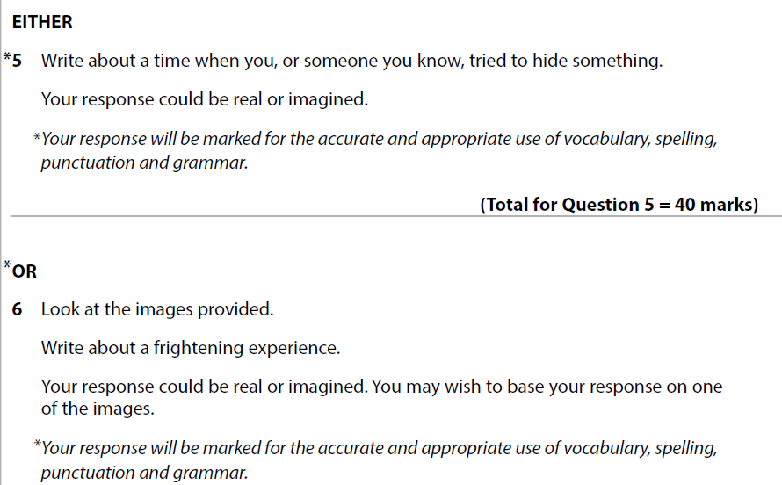

DART: Read Candidate C’s answer

Focus for annotations: where did they pick up marks for AO5/AO6
What mark would you award for AO5/AO6 and why?

Candidate C

I see the girl get out of her car and look around. I wonder why she’s out at this time of night. She walks towards the back of her car and opens the boot. I see her reach in, and drag out a coat. She shrugs it on, and shivers. No wonder, it’s below freezing outside.
She turns around as I look on. She’s short, pale and pretty. She looks towards where I am standing, but she cannot see me. No-one ever can. She starts to walk towards the building I am stood in. Why? I ask myself. This is no place for someone like her. This is a bad place. A place for bad people. A place for people like me. A place of nightmares and mystery. No place for a young lady to be. But yet, she walks on.
I see her walk into the building, into the very room I am stood in. She looks towards where I am standing, but she cannot see me. No one ever can.
“Hello?” She says in a quiet whisper. I want to go out and tell her not to. Tell her to be quiet and leave. Tell her that they will get to her. They always do. But I cannot. I am frozen in my place next to the desk. I cannot move. She reaches into her coat pocket and pulls out a torch. ‘Put it away’ I think. They’ll see you. But she cannot hear my thoughts.
She carries on through the room, to the doorway into the hall. She stops, and turns. She look towards where I am standing but she cannot hear my thoughts.
She continues into the hall and I force myself to follow. Maybe I can persuade them to leave this one.
“Hello?” she calls again and want to slap her. I want to slap her and shake her and scream at her to leave, but I don’t. I don’t do anything but watch on as she walks deeper into the corridor. Deeper into the corridor, deeper into the darkness, closer to them. I can hear their movements, hear their breathing, hear their excitement. But she can’t. I see her tremble, and I silently will her not to. They smell fear. She stops and turns. She looks towards where I am standing, but she cannot see me. No-one ever can.
She turns back around and carries on deeper into the depths of despair. I plead with her to stop and walk away. To find a new hotel with jolly waiters and happy guests, but she does not see me.
I follow here through the corridor to the end. Turn left, I tell her, but she ignores me and turns right. She continues down the long, dark corridor. Please not her I tell them, but they don’t listen. I feel their excitement buzzing through the air like lightening. She stops. She turns around pointing her torch in the direction she now takes. She looks towards where I am standing, but she cannot see me. No-one ever does. She turns back around. I tell her that I will do whatever she wants if she turns and leaves. I tell her that I will keep her safe if she leaves this dark, dingy building and drives away in her car. She does not hear me. She steps forward with a shaky leg, and their light comes on from within their room. She sighs, and it sounds like relief. It shouldn’t be. I know what’s coming next, and I tried to warn her. I tried to get her to leave, to leave and never come back, but she didn’t listen. She stops in front of their door and turns. She looks towards where I am standing, but she cannot see me. No-one ever can. “Hello?” She calls from the last time and I scream at her to run. To run as fast as she can, and to never look back.

The door opens and I stop and lean against the wall as she is pulled inside. This will be a long night. A long night of loud screams, then shouts, then whimpers until it dwindles away to nothing. Then she will stay in this dark place forever. Not really living, but not really dead either.
I walk to the door, and look in. She knows what’s coming.
She looks towards where I am standing, but she cannot see me. No-one ever can. I know this, because this is me, this is my story, and I know how it ends.
Questions:
How has this person considered overall structure? What about other structures?
What did you like about this answer?
Use a story arc to plot this story
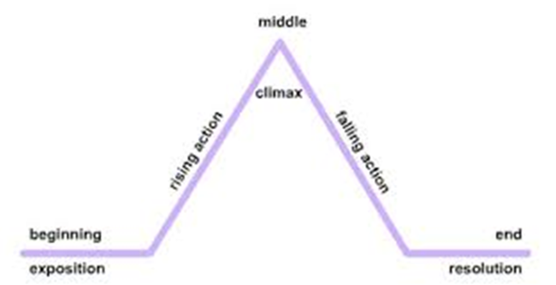
DIP Task:
Plan a story based on each of the questions at the beginning of the lesson. Plot your plan on a story arc.

Lesson 4: How is Scrooge presented in A Christmas Carol?
LI: I can consolidate knowledge of A Christmas Carol through revision

DART: Read the extract from Stave I
Focus for annotations: How Scrooge is presented
This lunatic, in letting Scrooge’s nephew out, had let two other people in. They were portly gentlemen, pleasant to behold, and now stood, with their hats off, in Scrooge’s office. They had books and papers in their hands, and bowed to him.
“Scrooge and Marley’s, I believe,” said one of the gentlemen, referring to his list. “Have I the pleasure of addressing Mr. Scrooge, or Mr. Marley?”
“Mr. Marley has been dead these seven years,” Scrooge replied. “He died seven years ago, this very night.”
“We have no doubt his liberality is well represented by his surviving partner,” said the gentleman, presenting his credentials.
It certainly was; for they had been two kindred spirits. At the ominous word “liberality,” Scrooge frowned, and shook his head, and handed the credentials back.
“At this festive season of the year, Mr. Scrooge,” said the gentleman, taking up a pen, “it is more than usually desirable that we should make some slight provision for the Poor and destitute, who suffer greatly at the present time. Many thousands are in want of common necessaries; hundreds of thousands are in want of common comforts, sir.”
“Are there no prisons?” asked Scrooge.
“Plenty of prisons,” said the gentleman, laying down the pen again.
“And the Union workhouses?” demanded Scrooge. “Are they still in operation?”
“They are. Still,” returned the gentleman, “I wish I could say they were not.”
“The Treadmill and the Poor Law are in full vigour, then?” said Scrooge.
“Both very busy, sir.”
“Oh! I was afraid, from what you said at first, that something had occurred to stop them in their useful course,” said Scrooge. “I’m very glad to hear it.”
“Under the impression that they scarcely furnish Christian cheer of mind or body to the multitude,” returned the gentleman, “a few of us are endeavouring to raise a fund to buy the Poor some meat and drink, and means of warmth. We choose this time, because it is a time, of all others, when Want is keenly felt, and Abundance rejoices. What shall I put you down for?”
“Nothing!” Scrooge replied.
“You wish to be anonymous?”
“I wish to be left alone,” said Scrooge.

DIP Task: How does the writer present Scrooge in this extract? Refer to language and structure in your answer. Use PETER structure if you like using this (Point-Evidence-Technique-Explain-Reader)
Extension: Write a paragraph about how Scrooge changes referring to elsewhere in the novel in your answer Use PEEL if you like this structure (Point -Evidence – Explain – Link to the question)

Lesson 5: How do I write a narrative?
LI: To write a narrative with a clear beginning, middle and end (and to use structure for effect)

Do now: Edit this sentence to make it tense:
The girl walked down the street.
DART: Read this slide and summarise it in your exercise book
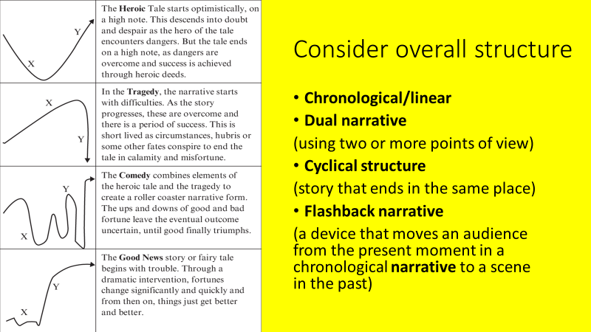

DIP TASK:
You have had some experience planning using a story arc. You now must answer an exam style question under exam conditions. Allow 30 mins, 5 minutes for planning, and 5 mins for proof-reading.
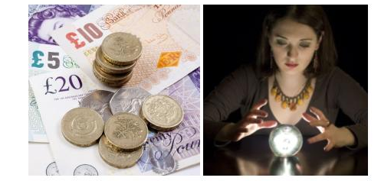
Q6. Look at the images provided.
Write about ‘one day in the future’.
Your response could be real or imagined. You may wish to base your response on one of the images.
(Total for Question 6 = 40 marks)

Have someone give you feedback about your overall structure – is it effective? Does it engage the reader?

Lesson 6: How can I be more successful at analysing?
LI: To revise approaches to answering the analysis questions in the Language Exam
Read over the success criteria for AO2 (see the mark scheme).
DART: Read ‘A Terribly Strange Bed’ by Wilkie Collins
Focus for annotations: Overall structure, paragraph and sentence structure, impact words, language devices. Focus on understanding first, then read again making annotations.

This is an extract from a short story. The narrator has won a lot of money gambling. He has been drugged and imprisoned in the house by men who want to rob him. They believe they have murdered him in the night, but he actually wakes up.

‘A Terribly Strange Bed’: Wilkie Collins
Now, for the first time, I was able to move — to rise from my knees — and to consider of how I should escape. If I betrayed by the smallest noise that the attempt to suffocate me had failed, I was certain to be murdered. Had I made any noise already? I listened intently, looking towards the door.
No! no footsteps in the passage outside — no sound of a tread, light or heavy, in the room above — absolute silence everywhere. Besides locking and bolting my door, I had moved an old wooden chest against it, which I had found under the bed. To remove this chest (my blood ran cold, as I thought what its contents might be!) without making some disturbance, was impossible; and, moreover, to think of escaping through the house, now barred-up for the night, was sheer insanity. Only one chance was left me — the window. I stole to it on tiptoe.
My bedroom was on the first floor, above an entresol1, and looked into the back street. I raised my hand to open the window, knowing that on that action hung, by the merest hair–breadth, my chance of safety. They keep vigilant watch in a House of Murder. If any part of the frame cracked, if the hinge creaked, I was a lost man! It must have occupied me at least five minutes, reckoning by time — five hours, reckoning by suspense — to open that window. I succeeded in doing it silently— in doing it with all the dexterity of a house-breaker — and then looked down into the street. To leap the distance beneath me would be almost certain destruction! Next, I looked round at the sides of the house. Down the left side ran the thick water-pipe — it passed close by the outer edge of the window. The moment I saw the pipe, I knew I was saved. My breath came and went freely for the first time since I had seen the canopy of the bed moving down upon me!
To some men, the means of escape which I had discovered might have seemed difficult or dangerous enough — to me, the prospect of slipping down the pipe into the street did not suggest even a thought of peril. I had always been accustomed, by the practice of gymnastics, to keep up my schoolboy powers as a daring and expert climber; and knew that my head, hands, and feet would serve me faithfully in any hazards of ascent or descent. I had already got one leg over the window-sill, when I remembered the handkerchief filled with money under my pillow. I could well have afforded to leave it behind me, but I was revengefully determined that the miscreants of the gambling-house should miss their plunder as well as their victim. So I went back to the bed, and tied the heavy handkerchief at my back by my cravat2.
The chill feeling of horror ran through me again as I listened. No! dead silence still in the passage — I had only heard the night air blowing softly into the room. The next moment I was on the window-sill — and the next, I had a firm grip on the water-pipe with my hands and knees.
I slid down into the street easily and quietly, as I thought I should, and immediately set off, at the top of my speed, to a branch ‘Prefecture’3 of Police, which I knew was situated in the immediate neighbourhood. A ‘Sub-prefect’ and several picked men among his subordinates happened to be up, maturing, I believe, some scheme for discovering the perpetrator of a mysterious murder, which all Paris was talking of just then. When I began my story, in a breathless hurry and in very bad French, I could see that the Sub-prefect suspected me of being a drunken Englishman who had robbed somebody; but he soon altered his opinion, as I went on, and before I had anything like concluded, he shoved all the papers before him into a drawer, put on his hat, supplied me with another (for I was bareheaded), ordered a file of soldiers, desired his expert followers to get ready all sorts of tools for breaking open doors and ripping up brick-flooring, and took my arm, in the most friendly and familiar manner possible to lead me with him out of the house.
Glossary
1 entresol: another smaller floor
2 cravat: large cloth-like tie
3 Prefecture: French police station
DIP Task - Q3. In lines 19 to 31, how does the writer use language and structure to show that the narrator feels confident he can escape. Support your views with reference to the text. [6 marks]

Lesson 7:
LI: To revise approaches to answering the evaluation questions in the Language Exam
Revisit the success criteria for evaluation (see mark scheme AO4)
DART: Read the extract ‘A Terribly Strange Bed’ again
Focus for annotations: What creates suspense? You could identify elements of SPITE (Settings/People/Ideas/Themes/Events) These help you to retain a critical detached overview of the text (rather than zooming in on individual features, consider how they work as a whole)
TIPs:
- Focus on how well the writer did something (not how they did it ) and explain why choices are effective.
- Make a judgement and refer to the location of the extract you are referring to e.g. at the beginning/towards the middle/towards the end etc. Or refer to paragraphs
- Evidence of his/her choices? (you are focussing on how events are used to create tension)
- Evaluate the choices made (e.g. use words like: powerfully/effectively/clearly/successfully)

DIP Task: Q4 In this extract, the writer tries to create suspense.
Evaluate how successfully this is achieved. Support your views with detailed reference to the text. [15 marks]

Lesson 8: What are Priestley’s intentions?
LI: To consolidate knowledge of An Inspector Calls through revision
DART: Priestley’s Political Journey
Annotation Focus: Priestley’s motivations for writing An Inspector Calls
Source: https://www.bl.uk/20th-century-literature/articles/an-inspector-calls-and-j-b-priestleys-political-journey

An Inspector Calls poses troubling questions: how can people live together? To what extent are individuals responsible for others? Gareth Lloyd Evans described the play as ‘perhaps the clearest expression made by Priestley of his belief that ‘no man is an island’ – the theme is guilt and social responsibility’.

An Inspector Calls was born out of this tumultuous wartime debate about society, though Priestley had first thought of using a mysterious inspector years before. He had then mentioned the idea to a theatrical director, Michael MacOwen, who reminded him about it during the autumn of 1944. Priestley was enthused by the idea, found it in his ‘little black notebook’, and quickly wrote a playscript based around it. No suitable theatre was available in London, so in May 1945 Priestley sent the script to his Russian translator to see if there was any interest (his work was already popular in the Soviet Union). An Inspector Calls was thus first seen in productions by the Kamerny Theatre and the Leningrad Theatre in Moscow, followed by a European tour ending at the Old Vic in London.

Priestley and his wife Jane later travelled to the USSR, as guests of the Society for Cultural Relations with Foreign Countries; he wrote about his experiences for the Sunday Express, his articles being reprinted in the pamphlet ‘Russian Journey’. Priestley found the Russian people highly congenial and wrote sympathetically about a country that had recently been Britain’s wartime ally. Later, he was to realise more about the nature of the regime.

The play embodies Priestley’s reasons for calling for the ‘new and vital democracy’ by showing the personal consequences of a selfish society, and the future that would result if lessons were not learned about being ‘responsible for each other’: ‘If men will not learn that lesson, then they will be taught it in blood and fire and anguish’. This future might be the Great War which Priestley’s 1945 audiences knew was just two years ahead for his 1912 protagonists, or it might be a terrible revolution yet to come: his Russian audiences had seen just that when the frustrations of an unequal society had led to violent revolution and terrible suffering. Such ambiguities Priestley leaves in the play, along with its origins in his own past and his deepest beliefs, allowing it to work for audiences worldwide ever since, despite its historical origins in a complacent 1912 and his bleak yet hopeful 1945.

DIP Task:
How does Priestley present inequality in the play? Refer to context (and Priestley’s intentions) in your answer

Lesson 9: Why is Kingship important in Macbeth?
LI : To consolidate knowledge of An Inspector Calls through revision
Do now: put these terms into sentences relating to Macbeth
Conflict, Regicide, Hamartia, Antithesis, Soliloquy, Hierarchy, Great Chain of Being, Divine Right of Kings, Hubris

DART: Macbeth notes
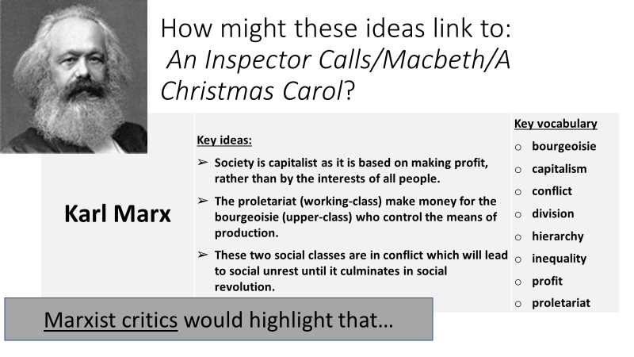
... the play Macbeth is a piece of bourgeois propaganda, promoting the idea that damnation is the fate of any challenge to the established social hierarchy.

…the state reinforces its authority via the belief system of ‘divine right’ of kingship; Macbeth’s regicide of Duncan is a disruption to the ‘natural’ order; his association with the witches is a direct challenge to the ‘religious’ order and like the biblical Adam, he succumbs to the temptations of his wife, subverting ‘patriarchal’ order. For this, he is punished.

***
The final scene of Shakespeare’s Macbeth signals balance after excess, kingship after tyranny, and calm after conflict. The noble Macduff has defeated Macbeth in single man-to-man combat, as an act of vengeance for the slaughter of his family. Macduff then presents the young Malcolm with Macbeth’s ‘cursed head’ as a trophy of victory. This marks the exchange of power from Macbeth as false ‘usurper’ to Malcolm as the legitimate ‘King’. Malcolm rewards his loyal thanes by making them Scotland’s first earls; he calls his people home from exile, and invites them to see him crowned. The broken circle seems mended as Malcolm – the son of the murdered King Duncan – is restored to the Scottish throne.

Malcolm’s words seem deliberately measured and precise after Macbeth’s excesses. He uses financial language, promising not to ‘spend a large expense of time’ before he reckons up the love of his thanes, and repays what he owes. Similarly Duncan expresses his gratitude in terms of debt and ‘payment’. When Malcolm says he will do what’s needed in ‘measure, time, and place’, the commas force the actor to pause, slow down and fully savour the moment, letting the audience breathe a collective sigh of relief. As so often in Shakespeare, the last lines are rhyming couplets, reinforcing the sense of balance: ‘So thanks to all at once, and to each one / Whom we invite to see us crown’d at Scone’.

DIP Task: How is Kingship presented in Macbeth?

You could refer to:
The type of king Duncan was; the type of king Malcolm wants to be, and the type of king Macbeth was…

Link to thread of Kingship quotation and discussion:
https://shakespeare-navigators.com/macbeth/King.html#:~:text=Macbeth%20says%20to%20himself%20that,17%2D20).

The Shakespeare Navigator:
https://shakespeare-navigators.com/macbeth/index.html

Lesson 10:
LI: To use a range of sentence structures for effect in my imaginative writing

Revise sentence structures using these pictures:
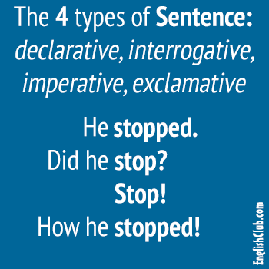
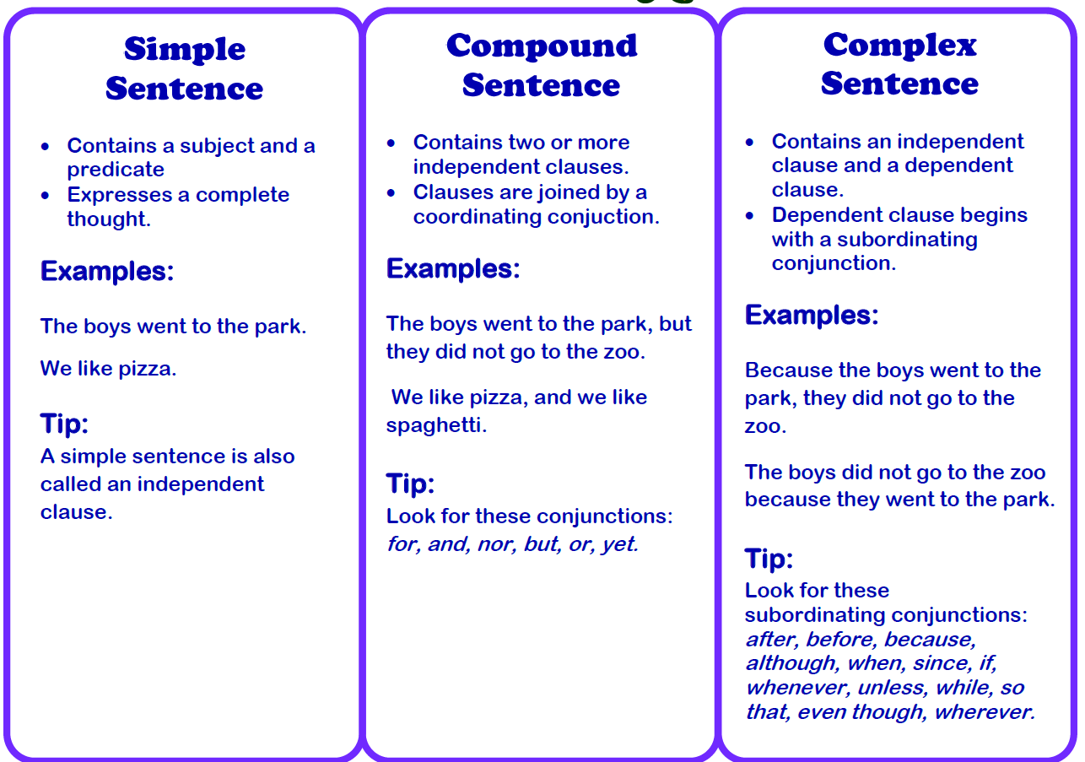
You must use a range of sentence structures in your writing to engage your reader. It will also ensure you receive more marks for AO6.
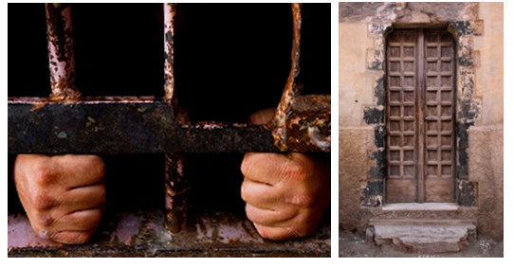
DIP TASK: Write about an escape. Your response could be real or imagined. You may wish to base your response on one of the images.

*Your response will be marked for the accurate and appropriate use of vocabulary, spelling, punctuation and grammar. [40 marks]

Remember to plan your answer. Use a story arc and consider how you will engage your reader through overall structure as well as sentence structure.

Lesson 11: How do I write an analytical paragraph?
LI: To write a paragraph analysing both language and structure together

DART: Extract The Woman in White: Wilkie Collins (Paper 1 June 2017)
Focus for annotation: The narrator’s thoughts and feelings
In this extract the narrator is walking back to London alone late at night. He has arrived at a
deserted crossroads.
In one moment, every drop of blood in my body was brought to a stop by the touch of a
hand laid lightly and suddenly on my shoulder from behind me.
I turned on the instant, with my fingers tightening round the handle of my stick.

There, in the middle of the broad bright high-road – there, as if it had that moment
sprung out of the earth or dropped from the heaven – stood the figure of a solitary
woman, dressed from head to foot in white garments, her face bent in grave inquiry on
mine, her hand pointing to the dark cloud over London, as I faced her.

I was far too seriously startled by the suddenness with which this extraordinary apparition
stood before me, in the dead of night and in that lonely place, to ask what she wanted.
The strange woman spoke first.

“Is that the road to London?” she said.

I looked attentively at her, as she put that singular question to me. It was then nearly one
o’clock. All I could discern distinctly by the moonlight was a colourless, youthful face,
meagre* and sharp to look at about the cheeks and chin; large, grave, wistfully attentive
eyes; nervous, uncertain lips; and light hair of a pale, brownish-yellow hue. There was
nothing wild, nothing immodest in her manner: it was quiet and self-controlled, a little
melancholy and a little touched by suspicion; not exactly the manner of a lady, and,
at the same time, not the manner of a woman in the humblest rank of life. The voice,
little as I had yet heard of it, had something curiously still and mechanical in its tones,
and the utterance was remarkably rapid. She held a small bag in her hand: and her
dress – bonnet, shawl, and gown all of white – was, so far as I could guess, certainly not
composed of very delicate or very expensive materials. Her figure was slight, and rather
above the average height – her gait** and actions free from the slightest approach to
extravagance. This was all that I could observe of her in the dim light and under the
perplexingly strange circumstances of our meeting. What sort of a woman she was, and
how she came to be out alone in the high-road, an hour after midnight, I altogether
failed to guess. The one thing of which I felt certain was, that the grossest of mankind
could not have misconstrued her motive in speaking, even at that suspiciously late hour
and in that suspiciously lonely place.

“Did you hear me?” she said, still quietly and rapidly, and without the least fretfulness or
impatience. “I asked if that was the way to London.”

“Yes,” I replied, “that is the way: it leads to St. John’s Wood and the Regent’s Park. You must
excuse my not answering you before. I was rather startled by your sudden appearance in
the road; and I am, even now, quite unable to account for it.”

“You don’t suspect me of doing anything wrong, do you? I have done nothing wrong.
I have met with an accident – I am very unfortunate in being here alone so late. Why do
you suspect me of doing wrong?”

She spoke with unnecessary earnestness and agitation, and shrank back from me several
paces. I did my best to reassure her.

“Pray don’t suppose that I have any idea of suspecting you,” I said, “or any other wish
than to be of assistance to you, if I can. I only wondered at your appearance in the road,
because it seemed to me to be empty the instant before I saw you.”

She turned, and pointed back to a place at the junction of the road to London and the
road to Hampstead, where there was a gap in the hedge.

“I heard you coming,” she said, “and hid there to see what sort of man you were, before I
risked speaking. I doubted and feared about it till you passed; and then I was obliged to
steal after you, and touch you.”

Steal after me and touch me? Why not call to me? Strange, to say the least of it.

meagre* – thin and undernourished
gait** – a person’s manner of walking

1 From lines 1-2, identify a word or phrase which describes how the hand is laid on the
narrator’s shoulder.
....................................................................................................................................................................................................................................................................................
(Total for Question 1 = 1 mark)

2 From lines 4-10, give two ways in which the appearance of the woman surprises
the narrator.
You may use your own words or quotations from the text.

DIP Task: How does the writer use language and structure to show the narrator’s
thoughts and feelings?
Support your views with reference to the text.
Practice analysing both language and structure in the same paragraph this time.
Before competing the DIP task, read and annotate the real exam answer from one of our own past pupils.
Note how they have annotated the question.
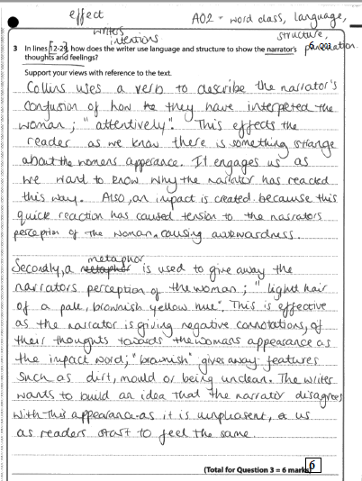

Lesson 12: How do I evaluate using a detached critical overview?
LI: To evaluate using a detached critical overview

DART: Reread The Woman in White extract from the last lesson
Focus for annotations: how an atmosphere of mystery is created
Before completing the DIP task, read the answer below from one of our own past pupils which got full marks. In the white space on the side, write a commentary linked to the mark scheme. Highlight where evaluative language has been used and where judgements are made.
DIP Task:
In this extract, there is an attempt to create an atmosphere of mystery.
Evaluate how successfully this is achieved. Support your views with detailed reference to the text.

WAGOLL:
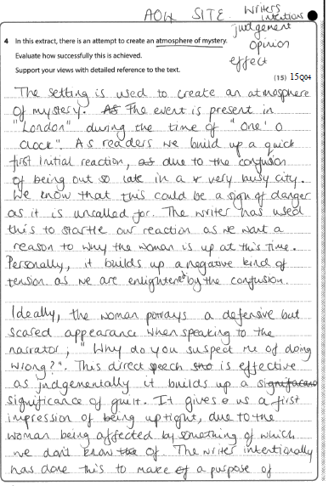

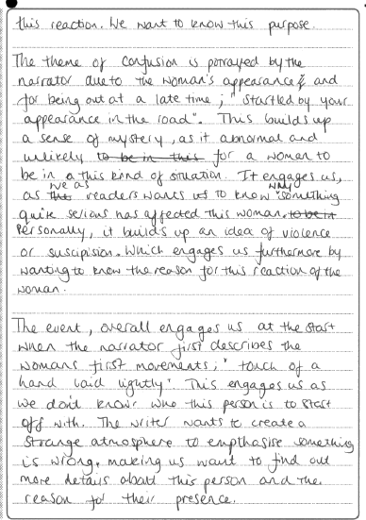

Lesson 13: How can I use language and structure for effect in my own writing?
LI: To practice using structural and language features in your writing

DART: Read the WAGOLL and follow these instructions:

- Which parts are effective and why? Refer to specific elements of AO5/AO6
- What is the overall structure? How is this particularly effective?
- Fit the plot on this story arc

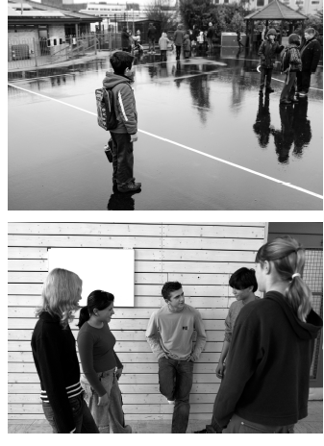
DIP Task:
Write about a time you met someone new
OR
6 Write about a time when something strange or unusual happened to you or someone you know.

Your response could be real or imagined.
* Your response will be marked for the accurate and appropriate use of vocabulary, spelling,
punctuation and grammar.
(Total for Question 6 = 40 marks)

WAGOLL:
Below is a real answer from a past pupil of Stewards. This boy wrote an excellent answer. Annotate it in the white space beside his writing.

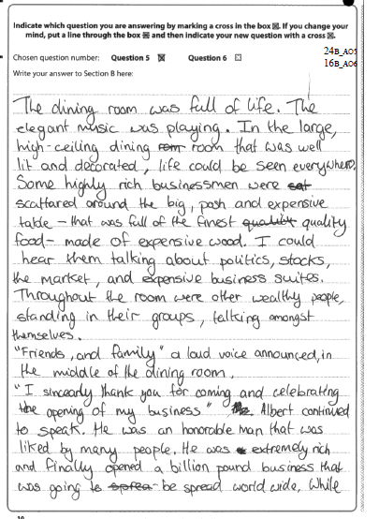
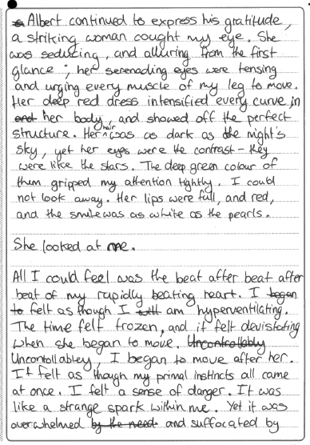
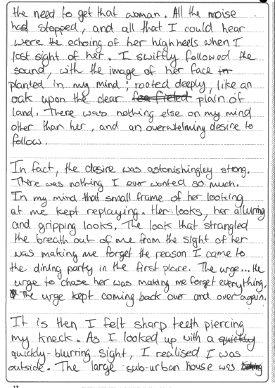
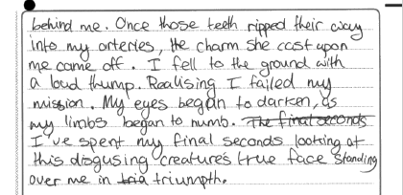

Lesson 14: How is language and structure used effectively in A Christmas Carol (extract)?
LI: To analyse how language and structure is used in a key extract

DART: A Christmas Carol Extract
Annotation focus: The mood of Scrooge (language and structure)

Yes! and the bedpost was his own. The bed was his own, the room was his own. Best and happiest of all, the Time before him was his own, to make amends in!
“I will live in the Past, the Present, and the Future!” Scrooge repeated, as he scrambled out of bed. “The Spirits of all Three shall strive within me. Oh Jacob Marley! Heaven, and the Christmas Time be praised for this! I say it on my knees, old Jacob; on my knees!”
He was so fluttered and so glowing with his good intentions, that his broken voice would scarcely answer to his call. He had been sobbing violently in his conflict with the Spirit, and his face was wet with tears.
“They are not torn down,” cried Scrooge, folding one of his bed-curtains in his arms, “they are not torn down, rings and all. They are here—I am here—the shadows of the things that would have been, may be dispelled. They will be. I know they will!”
His hands were busy with his garments all this time; turning them inside out, putting them on upside down, tearing them, mislaying them, making them parties to every kind of extravagance.
“I don’t know what to do!” cried Scrooge, laughing and crying in the same breath; and making a perfect Laocoön of himself with his stockings. “I am as light as a feather, I am as happy as an angel, I am as merry as a schoolboy. I am as giddy as a drunken man. A merry Christmas to everybody! A happy New Year to all the world. Hallo here! Whoop! Hallo!”
He had frisked into the sitting-room, and was now standing there: perfectly winded.
“There’s the saucepan that the gruel was in!” cried Scrooge, starting off again, and going round the fireplace. “There’s the door, by which the Ghost of Jacob Marley entered! There’s the corner where the Ghost of Christmas Present, sat! There’s the window where I saw the wandering Spirits! It’s all right, it’s all true, it all happened. Ha ha ha!”
Really, for a man who had been out of practice for so many years, it was a splendid laugh, a most illustrious laugh. The father of a long, long line of brilliant laughs!
“I don’t know what day of the month it is!” said Scrooge. “I don’t know how long I’ve been among the Spirits. I don’t know anything. I’m quite a baby. Never mind. I don’t care. I’d rather be a baby. Hallo! Whoop! Hallo here!”
He was checked in his transports by the churches ringing out the lustiest peals he had ever heard. Clash, clang, hammer; ding, dong, bell. Bell, dong, ding; hammer, clang, clash! Oh, glorious, glorious!
Running to the window, he opened it, and put out his head. No fog, no mist; clear, bright, jovial, stirring, cold; cold, piping for the blood to dance to; Golden sunlight; Heavenly sky; sweet fresh air; merry bells. Oh, glorious! Glorious!
“What’s to-day!” cried Scrooge, calling downward to a boy in Sunday clothes, who perhaps had loitered in to look about him.
“Eh?” returned the boy, with all his might of wonder.
“What’s to-day, my fine fellow?” said Scrooge.
“To-day!” replied the boy. “Why, Christmas Day.”

DIP Task: Explore how Scrooge’s mood is presented in this extract
*Remember, you must refer to both language and structure I your answer. You will not get this reminder in the exam! You must remember that part A of this question requires you to do this.
Point – Evidence – Technique – Explain/Explore – Reader (effect)

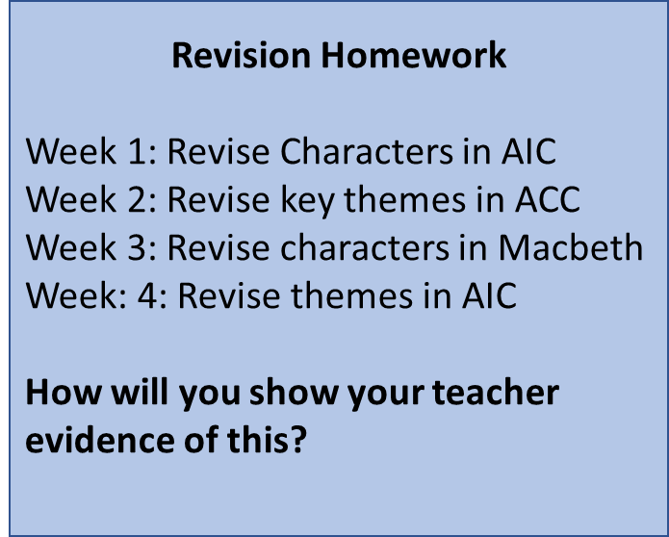
**********************************************************************************
Homework Tasks
You will write the best story you have ever written over the course of this half-term.
Each section of the story will be carefully crafted by you, and then evaluated by your peers in a weekly homework peer assessment lesson segment.
The best story will win a prize and lifelong celebrity.
Week 1: Planning
Here is the overall task:
Write about a time when you felt trapped. Your response can be real or imagined. (‘Imagined’ is always the better choice here as you can manipulate time, structures, setting, characters, genre etc. to suit the task).
Consider your overall plot and plan it on a story arc. The exposition can be in media res (in the middle of some action) - nobody wants to read about your shower and breakfast habits – so get on with the storytelling!

Who is your main character? Don’t use more than two. What settings will you use?
What twist can you have? How will you use overall structure to support this?
You will be required to discuss your plan in class, so be prepared.

Week 2: Write the opening two paragraphs of your story (exposition and rising action)
Week 3: Write the middle section of your story (the climax)
Week 4: Write the final section of your story (the falling action and resolution)

