Name:

Class:

Teacher:

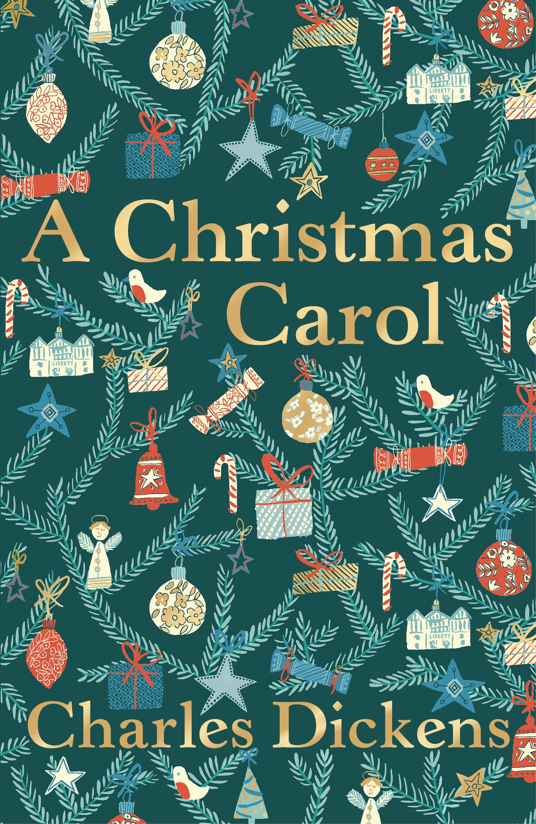

Introduction
This booklet has been created to help you understand the main events and characters in our 19th century set text ‘A Christmas Carol.’ It is made up of 17 lessons and I recommend you cover three sections each week. Below are some links and references to where you can read/listen to the story.
I strongly suggest that you don’t listen to the full story at once but do read or listen to a short summary before you start the activities in this booklet. Then you can come back to this page later to use when you have started the work in the workbook and want to look back to a certain part in the story or read through the full story when you have finished the booklet.

Short summaries – choose one to read / listen to before you start lesson 1:
- Watch this video for a quick summary of the whole story – it includes real quotes from the story and is acted out to help you understand what is happening: https://www.bbc.co.uk/bitesize/guides/zgvbgk7/video
- See the next page for a bullet point summary if you don’t have access to the internet or would rather read a summary.
The full book – for reading when you’ve finished the booklet or using to support you with the activities in the booklet (e.g. so you can hear it being read to you if that’s helpful)
- The audiobook – where you can see the text and hear it read aloud to you at the same time: https://www.bbc.co.uk/teach/school-radio/english-ks2-a-christmas-carol-index/zbp9bdm
- Online version of the book: https://www.ibiblio.org/ebooks/Dickens/Carol/Dickens_Carol.pdf
Hint and tips
You will get stuck at some point; it will feel challenging trying to understand the story without being in a classroom. But don’t worry! There are still some things you can do to help you as you go:
- Read the instructions carefully, at least twice, before you try the activity. Sometimes you’ll think you don’t understand but have not given yourself time to think about what you need to do. Don’t rush and panic!
- Use Google to get definitions for words you don’t know. Do this by typing in the word and then ‘simple definition’ after it into the Google search bar e.g. ‘ignorance simple definition.’
- Use www.naturalreaders.com to copy and paste text that you want to be read to you.
- Stay in touch with each other – if you’re stuck on a question or activity remember there are other people in the class doing it too and although you’re not in the same classroom anymore you can email each other or stay in touch to get help from each other.
- Stay in touch with me – same goes for me, even though I’m not in front of you teaching in the classroom I am available through email or Classcharts. If you’ve used all the options above and are still stuck, don’t hesitate to ask me for help.

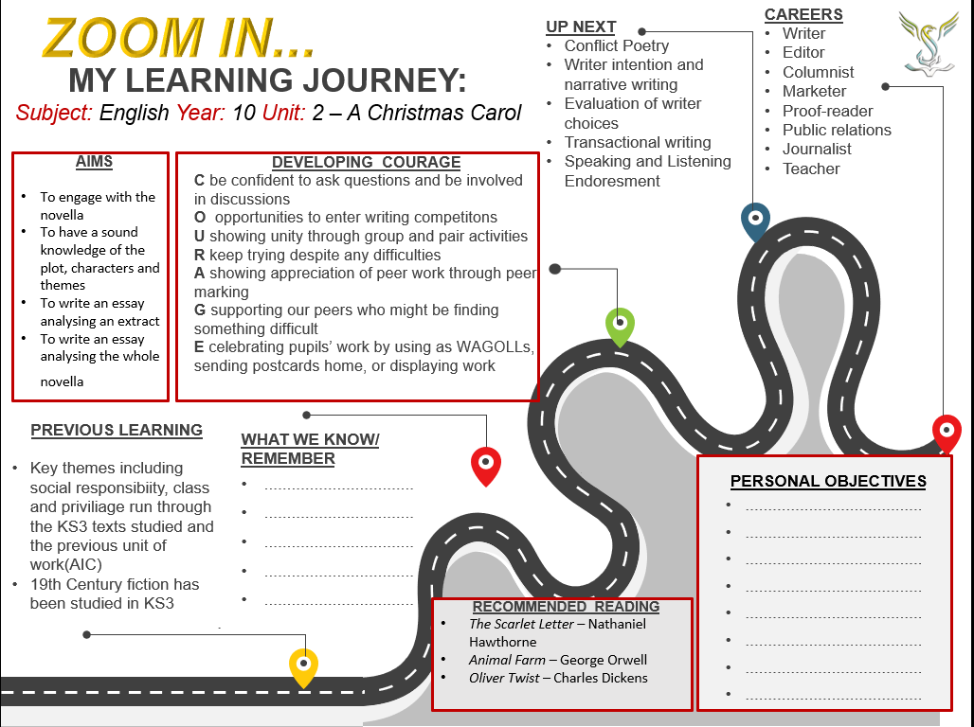

Themes: Dickens’ ‘Big Ideas’ in A Christmas Carol
Here are a list of the themes and ideas Dickens explores in A Christmas Carol. You will need them for some of the activities in this booklet. If you think any themes are missing, add them.



Social Injustice Redemption Moral Responsibility



Christmas Regret Family



Threat of Time Inequality Greed vs Generosity




Poverty Isolation Repentance


Gratitude

Lesson 1
LI: To know and understand the assessment expectations for the 19th Century text exam question

Prior learning  5 key moments of An Inspector Calls storyline. | Review  What % of your GCSE Literature course have you studied so far?
Explain  Why is 1912/1945 context important for An Inspector Calls? | Predict  What did Charles Dickens want to show about life in London at the time of writing A Christmas Carol? (1843)

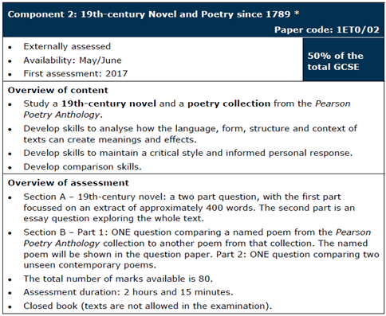
Part a- the extract
AO2: Analyse the language, form and structure used by a writer to create meanings and effects, using relevant subject terminology where appropriate.

Part (b) is an essay question exploring the whole text, which may focus on one or more of the following areas: plot, setting(s), character(s), theme(s).
AO1: Read, understand, and respond to texts.
- Maintain a critical style and develop an informed personal response.
- Use textual references, including quotations, to support and illustrate interpretations.

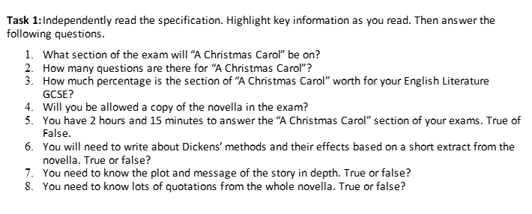
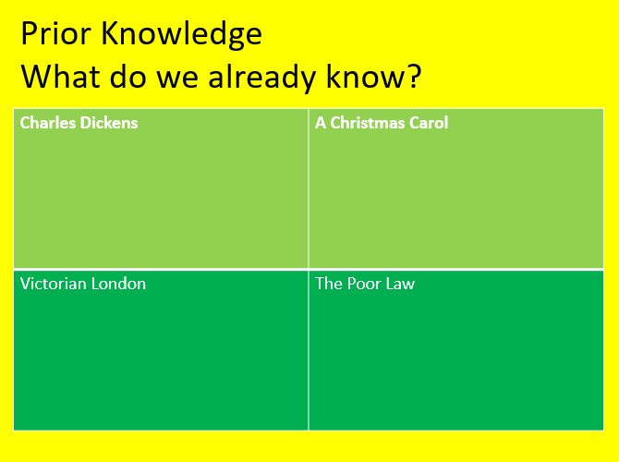
Language | Structure
- Imagery  - Powerful nouns/verbs/adjectives  - Simile  - Metaphor  - Personification  - Alliteration  - Onomatopoeia | - Punctuation  - Juxtaposition  - Lists  - Sentence/paragraph length  - Change in focus  - Pace of a sentence  - Repetition

Lesson 2
LI: To explore the historical and social context and Dickens’ motivations for writing the novella

DART - The Poor Law and Malthusian Theory
Identify 4 reasons why the new Poor Law of 1834 was introduced:
1.

2.

3.

4.
Challenge: Who was Thomas Malthus and what is Malthusian theory? (use the next page to help you)

Summarise: What was life really like inside the workhouse?

The Poor Law
In 1834 a new Poor Law was introduced. Some people welcomed it because they believed it would:
- reduce the cost of looking after the poor
- take beggars off the streets
- encourage poor people to work hard to support themselves
The new Poor Law ensured that the poor were housed in workhouses, clothed and fed. Children who entered the workhouse would receive some schooling. In return for this care, all workhouse paupers would have to work for several hours each day.
However, not all Victorians shared this point of view. Some people, such as Richard Oastler, spoke out against the new Poor Law, calling the workhouses ‘Prisons for the Poor’. The poor themselves hated and feared the threat of the workhouse so much that there were riots in northern towns.
Before 1834, the cost of looking after the poor was growing more expensive every year. This cost was paid for by the middle and upper classes in each town through their local taxes. There was a real suspicion amongst the middle and upper classes that they were paying the poor to be lazy and avoid work.
After years of complaint, a new Poor Law was introduced in 1834. The new Poor Law was meant to reduce the cost of looking after the poor and impose a system which would be the same all over the country.
Under the new Poor Law, parishes were grouped into unions and each union had to build a workhouse if they did not already have one. Except in special circumstances, poor people could now only get help if they were prepared to leave their homes and go into a workhouse.
Conditions inside the workhouse were deliberately harsh, so that only those who desperately needed help would ask for it. Families were split up and housed in different parts of the workhouse. The poor were made to wear a uniform and the diet was monotonous. There were also strict rules and regulations to follow. Inmates, male and female, young and old were made to work hard, often doing unpleasant jobs such as picking oakum or breaking stones. Children could also find themselves hired out to work in factories or mines.
Shortly after the new Poor Law was introduced, a number of scandals hit the headlines. The most famous was Andover Workhouse, where it was reported that half-starved inmates were found eating the rotting flesh from bones. In response to these scandals the government introduced stricter rules for those who ran the workhouses and they also set up a system of regular inspections. However, inmates were still at the mercy of unscrupulous masters and matrons who treated the poor with contempt and abused the rules.
Although most people did not have to go to the workhouse, it was always threatening if a worker became unemployed, sick or old. Increasingly, workhouses contained only orphans, the old, the sick and the insane. Not surprisingly the new Poor Law was very unpopular. It seemed to punish people who were poor through no fault of their own. https://www.nationalarchives.gov.uk/education/resources/1834-poor-law/

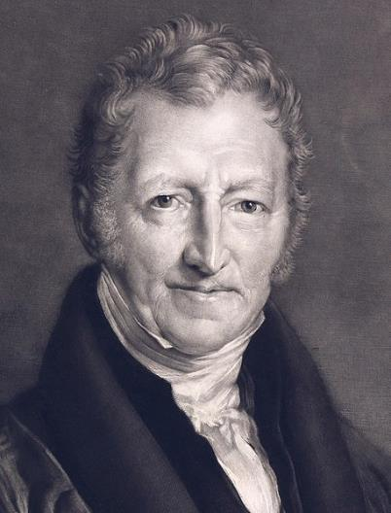
Challenge: Thomas Malthus and Malthusian Theory
Dickens was particularly disgusted with the writings of an economist named Thomas Robert Malthus, a wealthy man, who argued in his Essay on the Principle of Population (1798) that population growth would always outpace food supply resulting in unavoidable and catastrophic poverty and starvation.
In his pamphlet "The Crisis," Malthus supported the Poor Laws and the workhouses, arguing that any man unable to sustain himself had no right to live, much less participate in the development of society.

Life in Victorian London

Middle / upper class – in their living room Lower / working class – in a workhouse
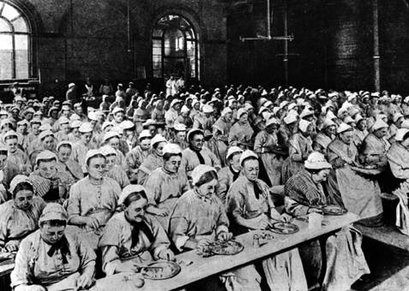
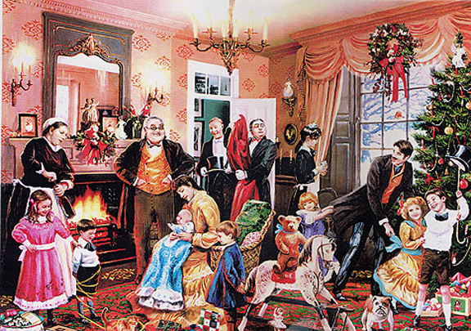

What’s different about the lives of people in these classes?

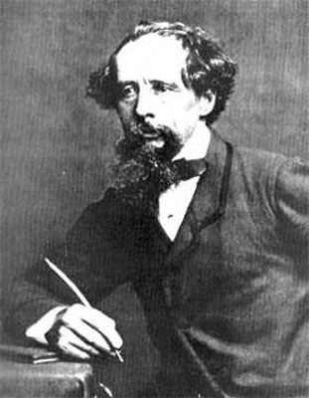
Charles Dickens’ Life

- His father was imprisoned for debt.
- Charles was sent to work in a factory and experienced awful conditions. After three years he was returned to school.
- From this experience, Dickens was very passionate about the poor in society and never forgot his experience at the factory.

https://classroom.thenational.academy/lessons/insight-into-dickens-life-c8rpct

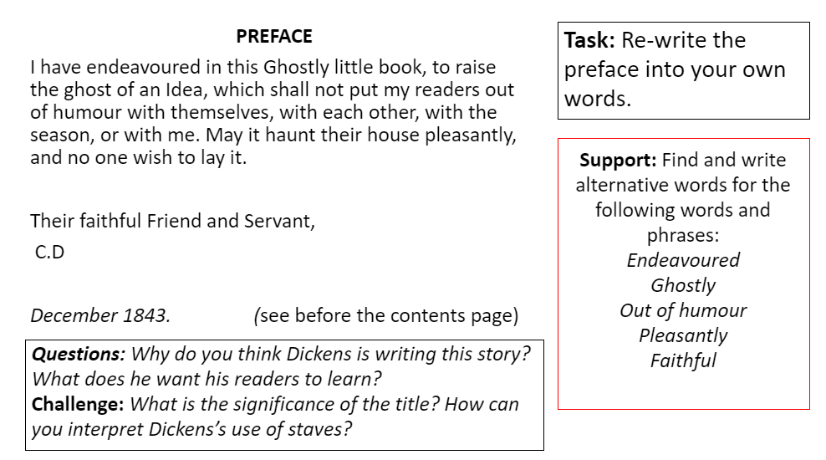
DIP – What was life like for the poor in Victorian times?

Lesson 3
LI: To evaluate how successful Dickens is in creating an engaging exposition

How do you think Dickens and Priestley could be connected?

You are now going to read the opening of the novella (short story). Remember this is a book written in the 1800s so do not worry if you don’t understand every word, you don’t need to. To get started read the extract then answer the questions below
Stave One
Marley’s Ghost

‘Marley was dead: to begin with. There is no doubt whatever about that. The register of his burial was signed by the clergyman, the clerk, the undertaker, and the chief mourner. Scrooge signed it: and Scrooge’s name was upon ‘Change for anything he chose to put his hand to. Old Marley was as dead as a door-nail.
Mind! I don’t mean to say that I know, of my own knowledge, what there is particularly dead about a door-nail. I might have been inclined, myself, to regard a coffin-nail as the deadest piece of ironmongery in the trade. But the wisdom of our ancestors is in the simile; and my unhallowed hands shall not disturb it, or the Country’s done for. You will therefore permit me to repeat, emphatically, that Marley was as dead as a door-nail.
Scrooge knew he was dead? Of course he did. How could it be otherwise? Scrooge and he were partners for I don’t know how many years. Scrooge was his sole executer, his sole administrator, his sole assign, his sole residuary legatee, his sole friend and his sole mourner. And even Scrooge was not so dreadfully cut up by the sad event, but that he was an excellent man of business on the very day of the funeral, and solemnized it with an undoubted bargain.
The mention of Marley’s funeral brings me back to the point I started from. There is no doubt that Markley was dead. This must be distinctly understand, or nothing wonderful can come of the story I am going to relate […]
Scrooge never painted out Old Marley’s name. There is stood, years afterwards, above the warehouse door: Scrooge and Marley. The firm was known as Scrooge and Marley. Sometimes people new to the business called Scrooge Scrooge, and sometimes Marley, but he answered to both names: it was all the same to him.’

Emphatically – with force // Sole – only / main

- What is the tone (feeling / emotion) of the opening of this novella? Write down at least three adjectives to describe it:
- Now choose one of your words from above and write a summary of how this tone is created in the opening of the novella (in the extract above).
Challenge: A stave is normally known as a line of music – Dickens structures this story using 5 staves. Why is this important and why do you think Dickens has chosen to title this stave of this novella ‘Marley’s Ghost’? How does this make the reader feel about the opening of the story?

DIP - Evaluate how successful Dickens has been in creating an engaging exposition.

WAGOLL
Dickens successfully engages the reader in the very first line of the exposition to the novel – “Marley was dead: to begin with.” This is effective as it immediately makes the reader question the information they have been given. This foreshadows that Marley’s death is going to be important event and influential to the overall story. As such, the reader will likely realise their questions are to be answered later in the book. Furthermore, the title is juxtaposed with the rather grim opening sentence to create a sense of conflict.

Lesson 4
LI: To track, summarise and know the plot

DART – read the simple summary below

Simple Summary of ‘A Christmas Carol’

Stave One
1. Introduced to Ebenezer Scrooge on Christmas Eve. He is a cruel and selfish man obsessed with money. He won’t pay to heat the office properly – meaning Bob Cratchit (who works for Scrooge) is very cold.
2. We learn Jacob Marley, Scrooge’s business partner, died exactly 7 years earlier.
3. Scrooge is irritated that Christmas Day seems to be interrupting his business.
4. Scrooge is visited by his nephew Fred, who invites his uncle to Christmas dinner. Scrooge refuses.
5. Scrooge is visited by two charity workers, asking for donations. Scrooge refuses and exclaims he wants to be left alone.
6. Scrooge allows Bob to have Christmas Day off, but wants him to be back at work on Boxing Day.
7. Scrooge, when he is home, is visited by the Ghost of Jacob Marley – warning him he will be visited by three more ghosts to help him change his ways.

Stave Two
1. Scrooge is visited by the Ghost of Christmas Past who takes him to witness his past.
2. Scrooge is taken first to his schoolboy years and he is reminded how his friends would go home from Christmas while he was left at school.
3. We see him with his sister, who one year took him home for the holidays.
4. Next we are shown Scrooge as a young apprentice, working for Fezziwig. Dickens describes the Christmas ball Fezziwig organised for his employees.
5. Finally, Scrooge is taken to see his ex-fiancée, Belle. We see the scene when they break up, as money has taken over Scrooge’s life.
6. Scrooge cannot bear to see any more.

Stave Three
1. Scrooge is then visited by the Ghost of Christmas Present.
2. The spirit shows Scrooge how the Cratchit family celebrate Christmas. Scrooge asked if Tiny Tim (Bob’s crippled son) will live. The spirit explains unless there are changes, he will die. The spirit reminds Scrooge of his earlier words: ‘If he is to die, he had better do it, and decrease the surplus population’
3. Scrooge is then taken to see how others celebrate Christmas: miners, lighthouse workers, sailors on a ship.
4. He is then taken to Fred’s house at Christmas, where they are playing games.
5. The spirit then begins to age, and Scrooge sees under the spirit’s robes two children: Want and Ignorance.
6. The Ghost of Christmas Future then appears.

Stave Four
1. The Ghost of Christmas Future is described – he looks like the Grim Reaper.
2. The spirit takes Scrooge to see a group of businessmen discussing someone who has died.
3. Scrooge is then taken to see Old Joe, where he is in the process of buying property of the dead man – which have been stolen.
4. Scrooge then returns to Bob Cratchit’s house, where it is revealed Tiny Tim has died.
5. Scrooge is then taken to the graveyard and is shown a grave stone and realises this is for him.
6. Scrooge falls to his knees and begs that he will change his ways.

Stave Five
1. Scrooge wakes up in his own bed.
2. Scrooge wonders how much time has passed and calls to a boy. He then sends the boy to the poulterer for the prize turkey to give to Bob Cratchit,
3. Scrooge meets one of the charity collectors from earlier and whispers to him that he will give a large donation.
4. Scrooge then goes to Fred’s house and is welcomed in. He enjoys the dinner and party.
5. On Boxing Day, Scrooge arrives early to work, and plays a trick on Bob. Scrooge then tells him he is going to raise his salary and promises to help Bob’s struggling family.
6. Scrooge is described to have completely changed and becomes a ‘second father’ to Tiny Tim – ‘who did not die’.

DIP – Write a summary of the whole story in your own words

Key Questions:
How are different characters presented in the novella?
How are the readers of the novella supposed to react to these characters?
Which themes are the most important in each stave?

Lesson 5
LI: To explore how Dickens presents the character of Scrooge and to compare how Scrooge and Fred are presented as opposite

What are the connotations of this name ‘Scrooge’? (What things does this make you imagine or feel?) Write down at this least three ideas.
Challenge: How does this character link to the context of the 1800s? What type of character will they be?
How might this character look? What makes you think this?
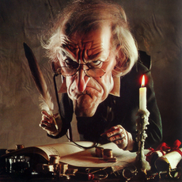
How would you expect this character to act towards others?

What would you expect this character to feel about Christmas?

Challenge: Do you think Dickens wants us to like this character or not? Why?

DART - You are now going to read an extract from ‘A Christmas Carol’ – choose one of the two options to complete after your reading.

Option 1
Draw what the story makes you imagine Scrooge looks like, include quotes from the extract as labels.

Challenge: Why do you think Dickens presents Scrooge in this way? What is he trying to teach us about this type of character?
Option 2
Create a mind-map to show what you think are the key features of Scrooge’s appearance and character.
Meeting Scrooge
Extract taken from Stave One: Marley’s Ghost

‘Oh! but he was a tight-fisted hand at the grindstone, Scrooge! A squeezing, wrenching, grasping, scraping, clutching, covetous old sinner! Hard and sharp as flint, from which no steel had ever struck out generous fire; secret, and self-contained, and solitary as an oyster. The cold within him froze his old features, nipped his pointed nose, shrivelled his cheek, stiffened his gait; made his eyes red, his thin lips blue; and spoke shrewdly in his grating voice. A frosty rime was on his head, and on his eyebrows, and his wiry chin. He carried his own low temperature always about with him; he iced his office in the dog-days; and didn’t thaw it one degree at Christmas.
External heat and cold had little influence on Scrooge. No warmth could warm, nor wintry weather chill him. No wind that blew was bitterer than he, no falling snow was more intent upon its purpose, no pelting rain less open to entreaty. Foul weather didn’t know where to have him. The heaviest rain, and snow, and hail, and sleet, could boast of the advantage over him in only one respect. They often ‘came down’ handsomely, and Scrooge never did.
Nobody ever stopped him in the street to say, with gladsome looks, ‘My dear Scrooge, how are you? When will you come to see me?’ No beggars implored him to bestow a trifle, no children asked him what it was o’clock, no man or woman ever once in all his life inquired the way to such and such a place, of Scrooge. Even the blindmen’s dogs appeared to know him; and when they saw him coming on, would tug their owners into doorways and up courts; and then would wag their tails as though they said, ‘no eye at all is better than an evil eye, dark master!’
But what did Scrooge care? It was the very thing he liked.

Use the glossary below to help you..

Glossary
Word | Definition | Word | Definition
grindstone | Scrooge was a hard worker who worked other people hard. | covetous | Wanting something that belongs to someone else.
flint | A sharp stone which when rubs together is used to spark a fire. | gait | A way of walking.
shrewdly | Speaking in a judging way. | rime | A cover.
dog-days | The hottest days of the year. | implored | Begged.
bestow | To give someone something. | trifle | A small thing e.g. a bit of bread / money.

Now let’s focus on some key quotes to develop our understanding of Scrooge – using the pictures to help you:

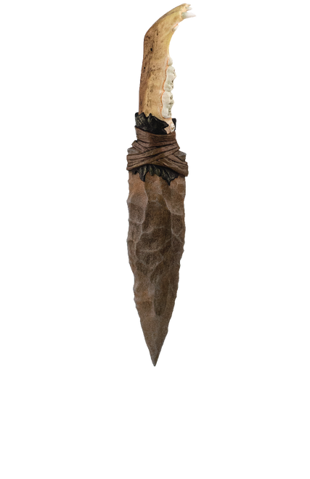
- ‘he was a tight-fisted hand’
What does the word ‘tight-fisted’ suggest about Scrooge?

- ‘Hard and sharp as flint’
What does this make us think about Scrooge? What kind of character is he?

3. ‘secret, and self-contained, and solitary as an oyster’
(‘Self-contained’ means he kept to himself, solitary means his was often on his own). Why does Dickens use the rule of three to describe Scrooge with three words which basically mean the same thing?

Challenge: what does the sibilance of the three words make us think about Scrooge?

What does the simile ‘solitary as an oyster’ suggest about how Scrooge thinks about being alone? (Think about what oysters hold and where you find them – research this if you’re not sure)

4. ‘The cold within him froze his old features’
What does it mean when someone is ‘cold’ – what is this suggesting about Scrooge? Why is it important that the cold comes from ‘within him’?

DIP - Later in the first stave, Scrooge’s nephew tells Scrooge how great Christmas is and two men arrive to ask people to donate to the poor over Christmas time. Scrooge reacts with his famous reply of ‘Bah, humbug!’ (which means ‘what a load of rubbish!’ or ‘ugh!’) and says, ‘I can’t afford to make idle people merry.’ (The word ‘idle’ means ‘lazy’). What does this final piece of information tell us about Scrooge?

Challenge: What do you think Dickens wants us to think about this and how do you know?

https://classroom.thenational.academy/lessons/meeting-scrooge-65j68c

Lesson 6
LI: To explain the symbolic significance of Marley’s chain

DART – Read the extract below. Focus on the description of the chain

Extract Taken from Stave One: Marley’s Ghost

‘It’s humbug still!’ said Scrooge. ‘I won’t believe it.’
His colour changed though, when, without a pause, it came on through the heavy door, and passed into the room before his eyes. Upon its coming in, the dying flame leaped up, as though it cried ‘I know him! Marley’s Ghost!’ and fell again.
The same face: the very same. Marley in his pig-tail, usual waistcoat, tights and boots; the tassels on the latter bristling, like his pigtail, and his coat-skirts, and the hair upon his head. The chain he drew about him like a tail; and it was made (for Scrooge observed it closely) of cash-boxes, key, padlocks, ledgers, deeds, and heavy purses wrought in steel. His body was transparent: so that Scrooge, observing him, and looking through his waistcoat, could see the two buttons on his coat behind.
Scrooge had often heard it said that Marley had no bowels, but he had never believed it until now.
No, nor did he believe it even now. Though he looked the phantom through and through, and saw it standing before him; though he felt the chilling influence of its death-cold eyes; and marked the very texture of the folded kerchief bound about its head and chin, which wrapper he had not observed before: he was still incredulous, and fought against his senses.
‘How now!’ said Scrooge, caustic and cold as ever. ‘What do you want with me?’
‘Much!’ – Marley’s voice, no doubt about it.
‘Who are you?’
‘Ask me who I was.’

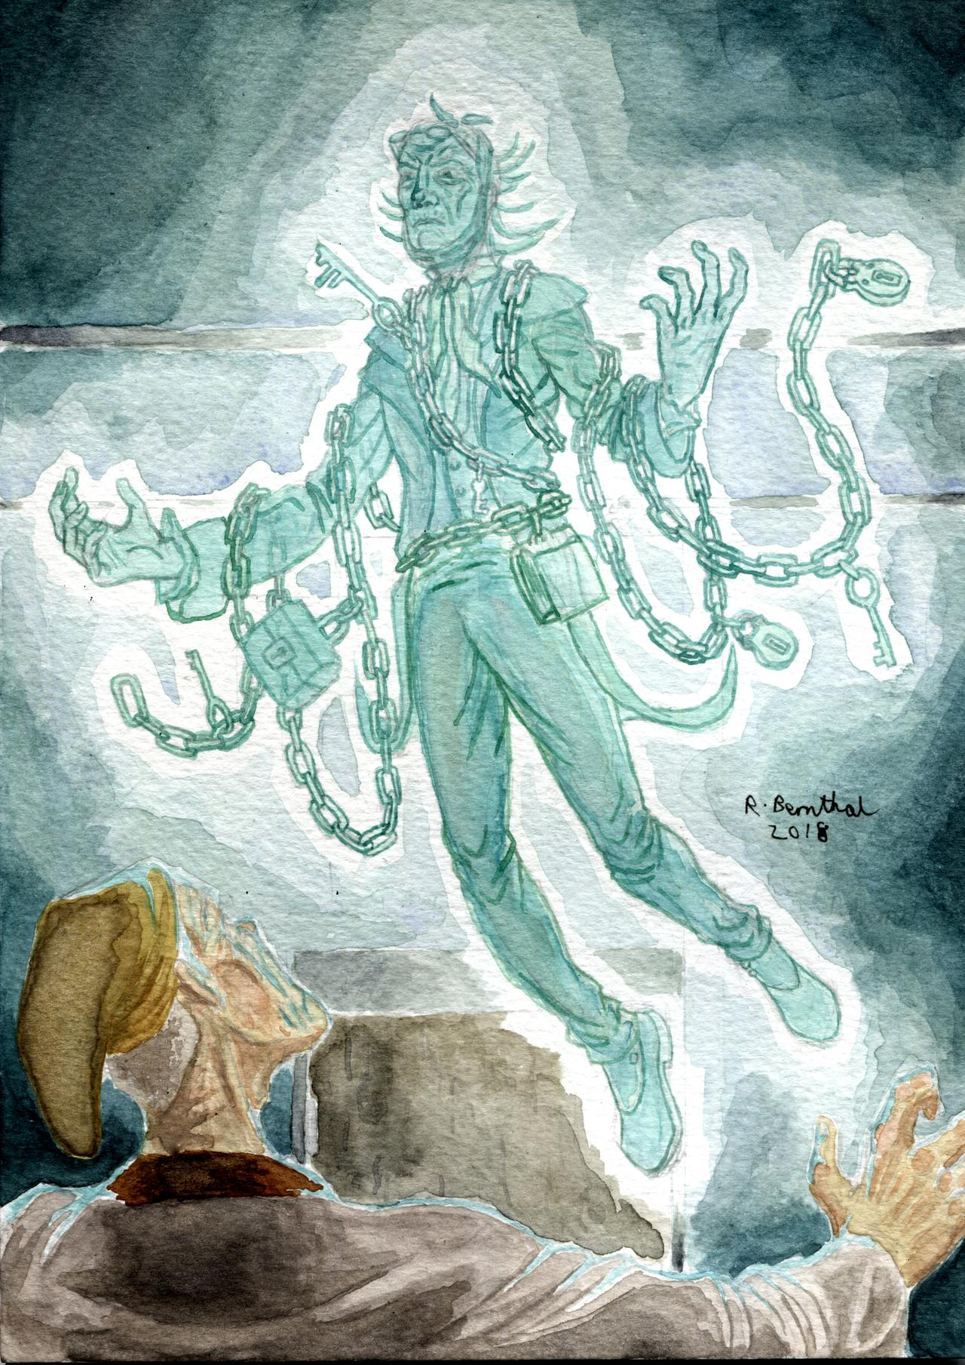

Glossary
Pig-tail – a suit with a ‘tail’
Ledgers – a book of accounts (like a big notebook)
Deeds – important documents to show someone owns something like a piece of land or a house
Had no bowels – back then it was believed your compassion (kindness) came from your bowels, so here it suggests that people thought Marley was not kind
Phantom – ghost
Incredulous – didn’t believe it
Caustic – mean, hurtful

- What’s symbolic about the fact that the ‘dying flame leaped up’ as Marley’s ghost entered Scrooge’s bedroom?

- ‘The chain he drew about him like a tail; and it was made (for Scrooge observed it closely) of cash-boxes, key, padlocks, ledgers, deeds, and heavy purses wrought in steel.’ What does the chain that Marley’s ghost carries around him represent? (Remember he is described as being as mean as Scrooge was)

- What does Marley’s ghost mean when he says ‘ask me who I was’ – how does this link to the previous question?

- What does it tell us about Scrooge if he reacts to the ghost in a mean and rude way even though he ‘felt the chilling influence of its death-cold eyes’?

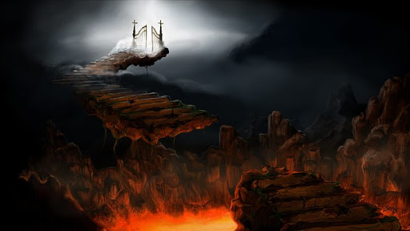
Purgatory

At this time Christians believed in a thing called ‘purgatory,’ where people would be sent if they had lived a life of sin while they were alive. Purgatory was a place in between heaven and hell and people sent there would get the chance to redeem themselves to be able to enter heaven.

Dickens was not a religious man, but in ‘A Christmas Carol’ the ghost of Marley says that he is ‘doomed to wander through the world’ and gets ‘no rest, no peace.’ This means that Dickens is telling us that because Marley was such a terrible person when he was living, his punishment in death is to walk on Earth as a ghost forever sorry for his sins and unable to do anything about it – it could be argued he is in a version of purgatory. This is why Marley’s ghost decides to send three other ghosts to Scrooge to get him to change his ways, so he doesn’t have to suffer the same fate as he has.

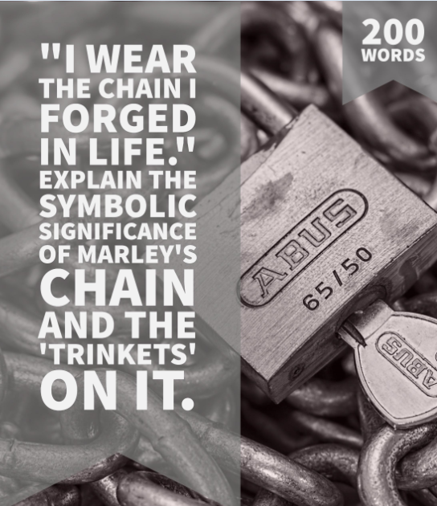
Go back to your answers above now and see if you can add anything more to develop your ideas now you have read this.

DIP – Write an answer to the following question. Use the words ‘symbolism’ and ‘imagery’ in your answer

Key Questions:
How would the chain feel? What does Marley say to explain why he has a chain? What warning does he give to Scrooge? How would readers expect Scrooge to feel about this? What does he actually feel? What’s Dickens’s intentions through this?

https://classroom.thenational.academy/lessons/marleys-ghost-69jk0d
Lesson 7
LI: To closely analyse how the Ghost of Christmas Past is presented

How important is our past experience? How do you think this shapes us into the person we become later in life (e.g. what job you end up getting, where you end up living)?
Challenge: Are we only a product of our past? Is this the only thing that shapes our identity and personality?

DART - Read the extract below which describes the first ghost that Scrooge is sent – the Ghost of Christmas Past.
Meeting the Ghost of Christmas Past
Extract taken from Stave Two: The First of the Three Spirits

It was a strange figure – like a child: yet not so like a child as like an old man, viewed through some supernatural medium, which gave him the appearance of having receded from view, and being diminished to a child’s proportions. Its hair, which hung about its neck and down its back, was white as if with age; and yet the face had not a wrinkle in it, and the tenderest bloom was on the skin. The arms were very long and muscular; the hands the same, as if its hold were of uncommon strength. Its legs and feet, most delicately formed, were, purest white; and round its waist was bound a lustrous belt, the sheen of which was beautiful. It held a branch of fresh green holly in its hand; and, in singular contradiction of that wintry emblem, had its dress trimmed with summer flowers. But the strangest thing about it was, that from the crown of its head there sprung a bright clear jet of light, by which all this was visible; and which was doubtless the occasion of its using, in its duller moments, a great extinguisher for a cap, which it now held under its arm.
Even this, though, when Scrooge looked at it with increasing steadiness, was not its strangest quality. For as its belt sparkled and glittered now in one part and now in another, and what was light one instant, at another time was dark, so the figure itself fluctuated in its distinctness: being now a thing with one arm, now with one leg, now with twenty legs, now a pair of legs without a head, now a head without a body: of which dissolving parts, no outline would be visible in the dense gloom wherein they melted away. And in the very wonder of this, it would be itself again; distinct and clear as ever.
‘Are you the Spirit, sir, whose coming was foretold to me?’ asked Scrooge.
‘I am!’
The voice was soft and gentle. Singularly low, as if instead of being so close beside him, it were at a distance.

Glossary
receded – disappeared / gone further back
diminished – become smaller
proportions - size
lustrous – shining / glowing
sheen - shine
fluctuated – went up and down
distinctness - clearness
dense – heavy / thick
foretold – told before / warned about

DIP - Choose a task below to complete:
- Draw an image of the Ghost of Christmas Past – focus on the highlighted quotes to help you create your image.
- Create a mind-map to describe what the Ghost of Christmas Past looks like – focus on the highlighted quotes to help you but write your ideas in your own words.

Challenge - The Ghost of Christmas Past is presented in quite a religious way, there’s lots of reference to light (‘sheen,’ ‘lustrous,’ ‘bright clear jet of light’). Why do you think Dickens presents the Ghost of Christmas Past in this way even though he himself was not religious? What does the light represent? (Remind yourself of why Marley is sending these ghosts to Scrooge if you are stuck).

https://classroom.thenational.academy/lessons/the-ghost-of-christmas-past-6tgp2c

Lesson 8
LI: To identify how the theme of isolation is explored through the Ghost of Christmas Past’s visit

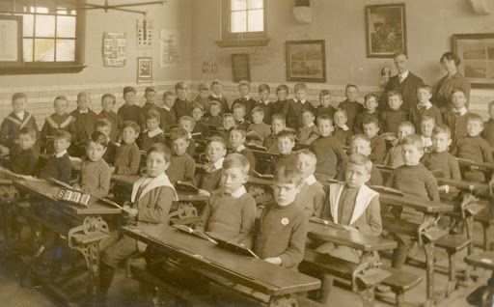
In the first part of Scrooge’s journey into the past with The Ghost of Christmas Past, we visit Scrooge’s old school. He used to attend a boarding school away from his family, he lived there for most of the year and often didn’t go home to his family even in the holidays. In the novella, Dickens suggests this is because his father didn’t really want Scrooge at home with the family.

Here is a picture of a boarding school. What do you think it would have felt like living at school during the holidays when most people went home?

DART - Read the description of Scrooge’s old school below, taken from Stave 2.
Scrooge’s School
Extract taken from Stave Two: The First of the Three Spirits

They left the high-road, by a well remembered lane and soon approached a mansion of dull red brick, with a little weathercock-surmounted cupola on the roof, and a bell hanging on it. It was a large house, but one of broken fortunes; for the spacious offices were little used, their walls were damp and mossy, their windows broken and their gates decayed. Fowls clucked and strutted in the stables; and the coach-houses and sheds were over-run with grass. Nor was it more retentive of its ancient state, within; for entering the dreary hall, and glancing through the open doors of many rooms, they found them poorly furnished, cold, and vast. There was an earthy savour in the air, a chilly bareness in the place, which associated itself somehow with too much getting up by candle-light, and not too much to eat.

Glossary
Weathercock-surmounted cupola - A small doom on top of a house, on which a metal cockerel is mounted. The cockerel (weathercock) will turn when the wind blows to show the direction of the wind.
Retentive of its ancient state, within – it was just as old-looking inside
Dreary – dull
Vast - big
Savour – taste

- Using the highlighted sections to help you, describe the atmosphere of the setting.

- What do these highlighted sections tell us about what Scrooge’s time at the boarding school was like?

- How does this make us feel about Scrooge now? Does it make you feel sorry for him in anyway or does it explain why he might behave the way he does? Why / why not?
Challenge: Why does the description of the school (‘cold’ and ‘chilly bareness’) sounds like the description of Scrooge (‘cold within him froze’)? What does this suggest?

DIP - As Scrooge and the Ghost of Christmas Past enter the school, Scrooge is shown his old schoolboy self who is described as a ‘lonely boy […] reading near a feeble fire.’ In the story the Ghost of Christmas Past shows Scrooge how as a child he used to get all his joy from stories because he was lonely when his friends went back home for the holidays and got used to making his own entertainment. How does this final piece of information make you feel about Scrooge?

The Ghost of Christmas Past next takes Scrooge to see himself as an apprentice working for Fezziwig. Now it’s Christmas and the Ghost of Christmas Past shows Scrooge one of the Christmas parties they had at work where Scrooge met Belle, the girl he falls in love with but fails to marry.

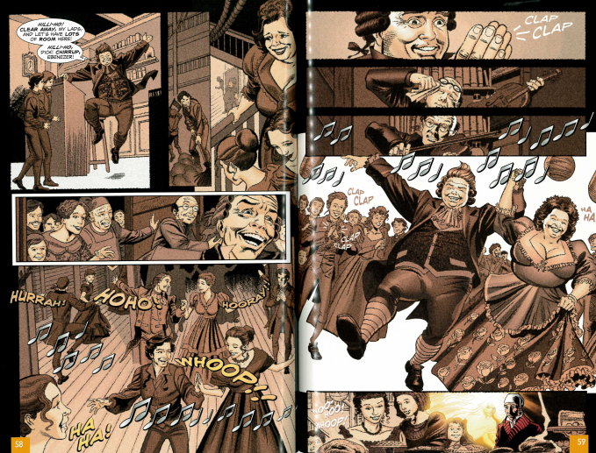

DART -Read an extract taken from Stave II
Extract taken from Stave Two: The First of the Three Spirits

In came a fiddler with a music-book, and went up to the lofty desk, and made an orchestra of it, and tuned the fifty stomach-aches. In came Mrs Fezziwig, one vast substantial smile. In came the three Miss Fezziwigs, beaming and lovable. In came the six young followers whose hearts they broke. In came all the young men and women employed in the business. In came the housemaid, with her cousin, the baker. In came the cook, with her brother’s particular friend, the milkman. In came the boy from over the way, who was suspected of not having board enough from his master; trying to hide himself behind the girl from next door but one, who was proved to have had her ears pulled by her Mistress…

Glossary
Fiddler – someone who plays a violin
Lofty – high
Vast substantial – both these words mean big and wide

- How does the repetition of the phrase ‘in came’ make the room sound like it was full of excitement and energy?

- Why does Dickens use complex (long) sentences in this extract? How does this also create an energetic and exciting atmosphere?

- What other emotions does Dickens make the reader feel here? Can you find evidence to show that the party was also loud and confusing?

Key Questions:
What do we learn about Scrooge from this ghost’s visit?
How should the reader react to Scrooge’s past?

https://classroom.thenational.academy/lessons/scrooge-in-the-past-part-1-68uk2c

https://classroom.thenational.academy/lessons/scrooge-in-the-past-part-2-c8w3jc

Lesson 9
LI: To analyse how the Ghost of Christmas Present is presented

DART - The following extract has been taken from Stave Three: ‘The Second of the Three Spirits’. In this extract, Scrooge is visited by the Ghost of Christmas Present.

The moment Scrooge’s hand was on the lock, a strange voice called him by his name, and bade him enter. He obeyed.

It was his own room. There was no doubt about that. But it had undergone a surprising transformation. The walls and ceiling were so hung with living green, that it looked a perfect grove; from every part of which, bright gleaming berries glistened. The crisp leaves of holly, mistletoe, and ivy reflected back the light, as if so many little mirrors had been scattered there; and such a mighty blaze went roaring up the chimney, as that dull petrification of a hearth had never known in Scrooge’s time, or Marley’s, or for many and many a winter season gone. Heaped up on the floor, to form a kind of throne, were turkeys, geese, game, poultry, brawn, great joints of meat, sucking-pigs, long wreaths of sausages, mince-pies, plum-puddings, barrels of oysters, red-hot chestnuts, cherry-cheeked apples, juicy oranges, luscious pears, immense twelfth-cakes, and seething bowls of punch, that made the chamber dim with their delicious steam. In easy state upon this couch, there sat a jolly Giant, glorious to see; who bore a glowing torch, in shape not unlike Plenty’s horn, and held it up, high up, to shed its light on Scrooge, as he came peeping round the door.

“Come in!” exclaimed the Ghost. “Come in! and know me better, man!”

Scrooge entered timidly, and hung his head before this Spirit. He was not the dogged Scrooge he had been; and though the Spirit’s eyes were clear and kind, he did not like to meet them.

“I am the Ghost of Christmas Present,” said the Spirit. “Look upon me!”

Scrooge reverently did so. It was clothed in one simple green robe, or mantle, bordered with white fur. This garment hung so loosely on the figure, that its capacious breast was bare, as if disdaining to be warded or concealed by any artifice. Its feet, observable beneath the ample folds of the garment, were also bare; and on its head it wore no other covering than a holly wreath, set here and there with shining icicles. Its dark brown curls were long and free; free as its genial face, its sparkling eye, its open hand, its cheery voice, its unconstrained demeanour, and its joyful air. Girded round its middle was an antique scabbard; but no sword was in it, and the ancient sheath was eaten up with rust.

“You have never seen the like of me before!” exclaimed the Spirit.

“Never,” Scrooge made answer to it.

“Have never walked forth with the younger members of my family; meaning (for I am very young) my elder brothers born in these later years?” pursued the Phantom.

“I don’t think I have,” said Scrooge. “I am afraid I have not. Have you had many brothers, Spirit?”

“More than eighteen hundred,” said the Ghost.

DIP
Summary Writer’s purpose
In full sentences, briefly explain what is happening in this extract. | Pick three analytical verbs. Complete the following sentence three times, each time using a different analytical verb.  Dickens has Scrooge enter ‘timidly’, perhaps  to criticise/ to warn/ to expose/ to teach/ to celebrate/ to reveal the importance of/ to question/to establish
Extract specific questions
Answer the following questions in full sentences. Use quotations where you can to help you explain your points.

- This ghost, like the Ghost of Christmas Past, is described as ‘strange’. Why does Dickens repeat this word?

- How does Dickens allude to generosity and abundance in this part of the novella?

- What does the ghost mean when he says he has more than eighteen hundred brothers?

Links to other areas of the text | Themes
In this extract, Scrooge is reverent, meaning respectful. Where else do we see Scrooge acting reverently in the novella? | Choose two themes from the front of the booklet that relate to this extract and briefly explain your choices.  1.  2.
Challenge task:
On a different piece of paper, write an extended response to the following activity:
Reverence in ‘A Christmas Carol’. Discuss.

Key Questions:
How does Scrooge’s impression of the ghost change throughout the visit? Why?
What does the Ghost of Christmas Present reveal about himself?
How are the Cratchit family presented in this section of the novella?

https://classroom.thenational.academy/lessons/the-ghost-of-christmas-present-6cvk2r

Lesson 10
LI: To explain what the children, Ignorance and Want, symbolise

DART - The following extract has been taken from Stave Three: ‘The Second of the Three Spirits’. In this extract, Scrooge is forced to face Ignorance and Want, two creations of a society that shuns its moral responsibility.
The chimes were ringing the three quarters past eleven at that moment.

“Forgive me if I am not justified in what I ask,” said Scrooge, looking intently at the Spirit’s robe, “but I see something strange, and not belonging to yourself, protruding from your skirts. Is it a foot or a claw?”

“It might be a claw, for the flesh there is upon it,” was the Spirit’s sorrowful reply. “Look here.”

From the foldings of its robe, it brought two children; wretched, abject, frightful, hideous, miserable. They knelt down at its feet, and clung upon the outside of its garment.

“Oh, Man! look here. Look, look, down here!” exclaimed the Ghost.

They were a boy and girl. Yellow, meagre, ragged, scowling, wolfish; but prostrate, too, in their humility. Where graceful youth should have filled their features out, and touched them with its freshest tints, a stale and shrivelled hand, like that of age, had pinched, and twisted them, and pulled them into shreds. Where angels might have sat enthroned, devils lurked, and glared out menacing. No change, no degradation, no perversion of humanity, in any grade, through all the mysteries of wonderful creation, has monsters half so horrible and dread.

Scrooge started back, appalled. Having them shown to him in this way, he tried to say they were fine children, but the words choked themselves, rather than be parties to a lie of such enormous magnitude.

“Spirit! are they yours?” Scrooge could say no more.

“They are Man’s,” said the Spirit, looking down upon them. “And they cling to me, appealing from their fathers. This boy is Ignorance. This girl is Want. Beware them both, and all of their degree, but most of all beware this boy, for on his brow I see that written which is Doom, unless the writing be erased. Deny it!” cried the Spirit, stretching out its hand towards the city. “Slander those who tell it ye! Admit it for your factious purposes, and make it worse. And bide the end!”

“Have they no refuge or resource?” cried Scrooge.

“Are there no prisons?” said the Spirit, turning on him for the last time with his own words. “Are there no workhouses?”

The bell struck twelve.

DIP:
Summary Writer’s purpose
In full sentences, briefly explain what is happening in this extract. | Pick three analytical verbs. Complete the following sentence three times, each time using a different analytical verb.  Through the figures of Ignorance and Want, Dickens is able  to criticise/ to warn/ to expose/ to teach/ to celebrate/ to reveal the importance of/ to question/ to establish/ to explore
Extract specific questions
Answer the following questions in full sentences. Use quotations where you can to help you explain your points.

- Why do you think Dickens presents Ignorance and Want as children?

- Why does the Ghost of Christmas Present force Scrooge to look at Ignorance and Want?

- The Ghost of Christmas Present says Ignorance and Want are ‘man’s’ and ‘doom’ is written on the brow of ‘Ignorance.’ What is he saying will happen if man remains ignorant to the plight of the poor?

Links to other areas of the text | Themes
Where else in the novel do we see examples of Scrooge’s own ignorance and want? | Choose two themes from the front of the booklet that relate to this extract and briefly explain your choices.  1.  2.
Challenge task
On a different piece of paper, write an extended response to the following question:

‘Ignorance and Want can never be rid from society because they are both deeply ingrained in humanity.’ Discuss.

https://classroom.thenational.academy/lessons/scrooge-and-the-children-6gw68t
Lesson 11
LI: To analyse how Dickens creates a sense of Doom in Stave IV

DART - The Ghost of Christmas Future is presented as a grim reaper like figure – read the description of the ghost below and highlight key words and phrases that create a sense of doom
Meeting the Ghost of Christmas Future
Taken from Stave Four: The Last of the Spirits

The Phantom slowly, gravely, silently, approached. When it came near him, Scrooge bent down upon his knee; for in the very air through which this Spirit moved it seemed to scatter gloom and mystery.
It was shrouded in a deep black garment, which concealed its head, its face, is form, and left nothing of it visible save one outstretched hand. But for this it would have been difficult to detach its figure from the night, and separate it from the darkness by which it was surrounded.
He felt that it was tall and stately when it came beside him, and that its mysterious presence filled him with a solemn dread. He knew no more, for the Spirit neither spoke nor moved.
‘I am in the presence of the Ghost of Christmas Yet To Come?’ said Scrooge.
The Spirit answered now, but pointed onward with its hand.
‘You are about to show me shadows of the things that have not yet happened, but will happen in the time before us,’ Scrooge pursued. ‘Is that so, Spirit?’
The upper portion of the garment was contracted for an instant in its fold, as if the Spirit had inclined its head. That was the only answer he received.
Although well used to ghostly company by this time, Scrooge feared the silent shape so much that his legs trembled beneath him, and he found that he could hardly stand when he prepared to follow it. The Spirit paused a moment, observing his condition, and giving him time to recover.
But Scrooge was the worst for this. It thrilled him with a vague uncertain horror, to know that behind the dusky shroud, there were ghostly eyes intently fixed upon him, while he, though he stretched his own to the utmost, could see nothing but a spectral hand and one great heap of black.

Glossary
Shrouded – covered / hidden
Garment – cloak
Concealed – hid
Stately – impressive in size
Solemn – serious
Inclined its head – nodded
Vague - unclear
Shroud – cover / hood
Intently – carefully, strongly
Spectral - ghostly

DIP:
WAGOLL: Extract Analysis
Read this example paragraph in response to the exam style question. Identify the features which make it a good example. Add your own paragraph afterwards.
Dickens uses triple adverbs in the opening of the extract to describe how the Phantom approaches: “slowly, gravely, silently”. The use of the triple adverbs emphasises the sense of doom that the phantom creates in this extract. Each of the adverbs reinforces the feeling of doom as they each have connotations of horror. This is followed by Dickens using the pronoun “it” which creates a sense of ambiguity - “when it came near him” - adding to the doom in the extract as the phantom seems inexplicable to Scrooge.
Dickens continues this theme of mystery by…

https://classroom.thenational.academy/lessons/the-ghost-of-christmas-yet-to-come-chk3jt

Lesson 12
LI: To explain instances when Scrooge learns something important
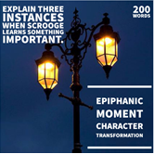
List events in the novella so far where Scrooge has learnt something (what happens, what does he learn, a quote to demonstrate this)

DART - The Ghost of Christmas Future is the last ghost to try and convince Scrooge of the error of his ways and the importance of reforming his character. One of the key things he shows him is what Christmas at the Cratchits will look like in the future if they are not supported out of poverty.
A Future Christmas at the Cratchits
Taken from Stave Four: The Last of the Spirits

She hurried out to meet him; and little Bob in his comforter – he had need of it, poor fellow – came in. His tea was ready for him on the hob, and they all tried who should help him to it most. Then the two young Cratchits got upon his knees and laid, each child a little cheek, against his face, as if they said, ‘Don’t mind it, father. Don’t be grieved!’
Bob was very cheerful with them, and spoke pleasantly to all the family. He looked at the work upon the table, and praise the industry and speed of Mrs Cratchit and the girls. They would be done long before Sunday, he said.
‘Sunday! You went to-day then, Robert?’ said he wife.
‘Yes, my dear,’ returned Bob. ‘I wish you could have gone. It would have done you good to see how green a place it is. But you’ll see it often. I promised him that I would walk there on Sunday. My little, little child!’ cried Bob. ‘My little child!’
He broke down all at once. He couldn’t help it. If he could have helped it, he and his child would have been farther apart perhaps than they were.
He left the room, and went up stairs into the room above, which was lighted cheerfully, and hung with Christmas. There was a chair set close beside the child, and there were signs of some one having been there, lately. Poor Bob sat down in it, and when he had thought a little and composed himself, he kissed the little face. He was reconciled to what had happened, and went down again quite happy.
[…]
‘I am sure we shall none of us forget poor Tiny Tim – shall we – or this first parting that there was among us?’
‘Never, father!’ cried they all.
‘And I know,’ said Bob, ‘I know, my dear, that when we recollect how patient and how mild he was; although he was a little, little child; we shall not quarrel easily among ourselves, and forget poor Tiny Tim in doing it.’
‘No, never, father!’ they all cried again.
‘I am very happy,’ said little Bob, ‘I am very happy!
Mrs Cratchit kissed him, his daughters kissed him, the two young Cratchits kissed him, and Peter and himself shook hands. Spirit of Tiny Tim, thy childish essence was from God!

- How does Dickens present the sorrow of Bob Cratchit in this extract? How does he make the reader feel sorry for Bob? (Use the yellow highlighted sections to help you if you are stuck)

Challenge: How does Dickens show that Bob Cratchit has been strongly affected by his grief? Zoom in on words or phrases for this question.

- How does Dickens present the resilience of the Cratchits in this extract? To answer this question think about how Dickens shows how they try to overcome their grief and sadness at having to go through their first Christmas without Tiny Tim. (Use the purple highlighted sections to help you if you are stuck.

Challenge: Why is it important that Bob Cratchit shouts ‘I am happy! […] I am very happy!’ even though he has lost his son? What is Dickens trying to teach Scrooge and the reader about the working class and what we can learn from them?

- After seeing this sad scene and being shown the fact that if he continues as he does then when he dies no-one will care, Scrooge declares that he will change his ways. He wakes up the next day, Christmas Day, and runs to the Cratchits to give them a great big turkey. The final description of Scrooge in the story is this: ‘Scrooge was better than his word. He did it all, and infinitely more; and to Tiny Tim, who did not die, he was a second father. He became as good a friend, as good a master, and as good a man, as the good old city knew…’
What do you think the message of ‘A Christmas Carol’ is and why?
DIP:
WAGOLL: Whole-text essay question - Transformation
Scrooge gradually transforms throughout the novella through a series of epiphanic moments brought on by the three spirits’ visits. During the ghost of Christmas Past’s visit, Scrooge is reminded of how he once used to feel about Christmas. He is shown a scene from when his younger sister comes to collect her “dear brother” from boarding school. There is a clear sense of glee in his sister as she declares that they are to be together “all the Christmas long”, and Scrooge goes with him “merrily” and “gaily”. Scrooge’s reaction to being shown this, is to be remember his sister fondly. When the ghost of Christmas past mentions that she died, but left a nephew for Scrooge, Scrooge is described as “uneasy” in his mind. This could be seen as an epiphanic moment as Scrooge seems to change his behaviour and usual way of thinking. He learns something again about the value of being with family at Christmas.

Lesson 13
LI: To use a planning tool to plan an answer to a whole-text style question

Q4b Explain how poverty is portrayed elsewhere in the novel. How poverty is shown and how it affects those involved must be considered.

- ‘I can’t afford to keep idle people merry’
- ‘Are there no prisons? Are there no workhouses?’
- ‘The Treadmill and the Poor Law are in full vigour, then?’
1. What do we learn about poverty from these key quotes?
Use the following questions as a planning support tool for the assessment question about poverty:
- How would you characterize Bob Cratchit’s attitude toward Scrooge? Scrooge’s attitude toward Cratchit? Besides literal heat, what might be the symbolism of the tiny coal fire that Cratchit has in the office?
- Why does Scrooge say that Fred should not be happy? What does this reveal about Scrooge’s priorities?
- What is the significance or symbolism of the fact that bells announce Marley’s ghost?
- Why is the Ghost of Christmas Past young, small, cloaked in white and shining bright? What does he mean when he says that Scrooge made his cap and has forced him to wear it?
- What has Marley’s ghost been doing since his death?
- What is Scrooge’s initial attitude toward the spirit?
- What is different about Scrooge when he says “Remember it? I could walk it with a blindfold?”
- How does Scrooge’s relationship with his sister Fan play into the story?
- What does the name Fezziweg suggest? When the spirit challenges Scrooge by asking if Fezziweg truly deserves such high praise for such a little party, how does Scrooge respond? How might Scrooge’s claim that Fezziweg “had the power to make us happy and to make us unhappy” reflect upon Scrooge himself?
- How does Scrooge try to extinguish the light of the first spirit? Does he succeed? What is the light a symbol of?
- How is what Scrooge is thinking as he lies in bed waiting to see if the spirit appears different from the previous chapter? How has Scrooge’s attitude toward his being escorted by a ghost changed?
- How is Scrooge affected by seeing the Cratchit family?
- What is the point of the visits with the Ghost of Christmas Present to the lighthouse and the ship?
- Why does Fred refuse to speak against Scrooge? How does his wife differ on this matter? Fred and his wife and Bob and his wife have different views on Scrooge. What does this say about each of them?
- What does the Ghost of Christmas Present mean when it says the boy and the girl under his robes, Ignorance and Want, are “Man’s”?
- How does Scrooge feel about the spirit of Christmas yet to come?
- What is the lesson Scrooge learns when the ghost shows him the Cratchit family after Tim’s death? Why is this lesson needed when Scrooge’s attitude has already changed so much?
- Is Scrooge’s transformation believable?

DIP:
WAGOLL: Extract Analysis
Read this example paragraph in response to the exam style question. Identify the features which make it a good example. How could this paragraph be improved?

The first example of the presentation of poverty in this book is the characterisation of Bob Cratchit. He is described to have ‘boasted no great coat’ but in the same scene he also is said to have ‘run home’. This could imply that he is embarrassed by his financial situation or it could be a sign of happiness and his keenness to get home and see his family. Dickens describes Cratchit in this way to portray the message that family is more important than money, and even though someone is impoverished, it doesn't necessarily mean they have to be unhappy. This would hopefully impact the readers to change the way they think about the poor and see them as equals or even role models.

Lesson 14
LI: To write an essay exploring how the theme of poverty is presented in the novella (assessment task)

Using your notes from last lesson to help you, write an essay answering the following exam question:

Q4b Explain how poverty is portrayed elsewhere in the novel. How poverty is shown and how it affects those involved must be considered.
This needs to be uploaded to Classcharts

Key Questions:
In what ways is poverty presented?
How does this affect the reader?
How does Scrooge’s attitude towards poverty change during the course of the novella?

Lesson 15
LI: To explain the importance of generosity in the novella

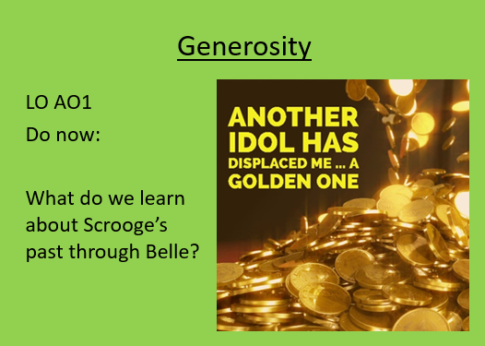

- Make a list of all of the times in the novella where generosity has been demonstrated.
- Choose your favourite one.
- Re-write that moment to change its meaning and effect.

Key Questions:
Why is the theme of generosity important to discuss in this novella?
What does Dickens want his readers to learn?
Is this a morality tale?

https://classroom.thenational.academy/units/a-christmas-carol-fa13

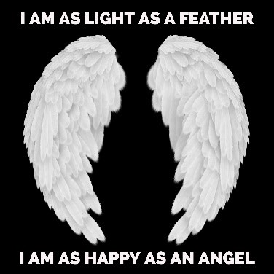
Lesson 16
LI: To prove Scrooge has transformed

What do these similes suggest about Scrooge in Stave V?

DART
- Make a list of quotes from Stave I that sum up the old Scrooge
- Make a list of quotes from Stave VI that sum up the new and improved Scrooge
- What questions could you ask each Scrooge?
DIP
- How has Scrooge changed from Stave 1 to Stave 5?
- What do you think were the top 3 pivotal moments of his transformation?
- Do you think that there is a moral message to this story?
- What can we as readers learn from his transformation?
https://classroom.thenational.academy/lessons/the-redemption-of-scrooge-cnjp8r

https://classroom.thenational.academy/lessons/scrooge-a-changed-man-6hh62c

https://classroom.thenational.academy/lessons/scrooge-a-new-life-crtp6r

Lesson 17
LI: To consolidate my learning of A Christmas Carol

Did you enjoy learning about the story of A Christmas Carol? Why/Why not?

Use the following online resources to ensure your understanding of the novella
https://classroom.thenational.academy/lessons/scrooge-the-messenger-of-dickens-c4u30c

https://app.senecalearning.com/classroom/course/0f799523-a0e8-4f66-a74d-85d4d29562cd

If you can, watch a film version of the story and compare how the film version is different/similar to the novella

 | Literature Paper 2 A Christmas Carol (AO2 20 marks)(AO1 20 marks)
 | Knowledge and Understanding | Skills
Yellow Plus 17-20 marks | AO2  Analyses language, form and structure features and their effect on the reader in a sustained way  Relevant subject terminology is used accurately and appropriately to develop ideas  AO1  In depth and assured understanding of the text.  Student understanding is perceptive with a mature critical style throughout | AO2  Shows a perceptive grasp of form and structure and their effect  Evaluates cohesively the language and its effect on the reader  Evaluates cohesively the interrelationship of language, form and structure and their effect on the reader  Integrates subject terminology precisely  AO1  There is an assured personal response, showing a high level of engagement with the text.  A critical style is developed with maturity, perceptive understanding and interpretation.  Discerning references are an integral part of the response, with points made with assurance and full support from the text.
Yellow 13-16 marks | AO2  The response shows an understanding of a range of language, form and structure features and links these to their effect on the reader.  Relevant subject terminology is used to support examples given.  AO1  Interpretation of the novel begins to be more developed and personal. Students can use references effectively. Critical style is sustained throughout. | AO2  Responds in a way that is focused and detailed  Analyses language, form and structure features, sustaining the effect on the reader  Uses relevant subject terminology accurately and appropriately to develop my ideas  AO1  The response has a developed personal response and thorough engagement, fully related to the text.  The critical style is sustained and there is well developed interpretation.  Well-chosen references to the text support a range of effective points.
Blue 9-12 marks | AO2  Demonstrates a range of interpretation using language,form and structure and links these to their effect on the reader  Integrates relevant subject terminology  AO1  Demonstrates an appropriate critical style, and can use references from the whole text | AO2  Comments on a range of language, form and/or structure features and links these to their effect on the reader  Write using relevant subject terminology to support examples  AO1  The response shows a relevant personal response, soundly related to the text.  There is an appropriate critical style, with comments showing a sound interpretation.  The response is relevant and focused points are made with support from the text.
Green 5-8 marks | AO2  Demonstrates an interpretation of the extract using features of language, form and structure to support  Selects relevant subject terminology  AO1  Demonstrates a basic understanding of the novel, beginning to adopt a more critical style | AO2  Responds with some description and personal response  Comments on language, form and structure  Attempts to use relevant subject terminology to support examples  AO1  The response may be largely narrative but has some elements of personal response.  There is some evidence of a critical style, but it is not always applied securely.  Some valid points are made, but without consistent or secure focus.
White 1-4 marks | AO2  Understands the features of an extract  Identifies features of language, form and/or structure  Knows relevant subject terminology  AO1  Understands the novel in a simple straightforward manner | AO2  Responds simply to the task  Comments on identified features of language, form and/or structure  Attempts to use relevant subject terminology  AO1  Response is simple with little personal response  Little evidence of a critical style  Little reference is made to content or themes of the text

