ICT KS4 Year 10 Autumn 2 Blended Learning Booklet
Computer Systems
Name:
Form:

Use BBC Bitesize for any research you may need to carry out to complete this book.
You can also use the website www.TeachICT.com
Username: cm187nq
Password: python4

Contents
Page3: Big Picture - Year 10 Overview
Page 4: Zoom in - My Learning Journey
Page 5 and 6: computer Systems
Page 7: CPU
Page 8 and 9: CPU performance
Page 10 and 12: Memory
Page 12 and 13: System Performance
Page 14: Secondary storage
Page 15 and 19: Operating system
Page 20: Utility and application software
Page 21: Summary
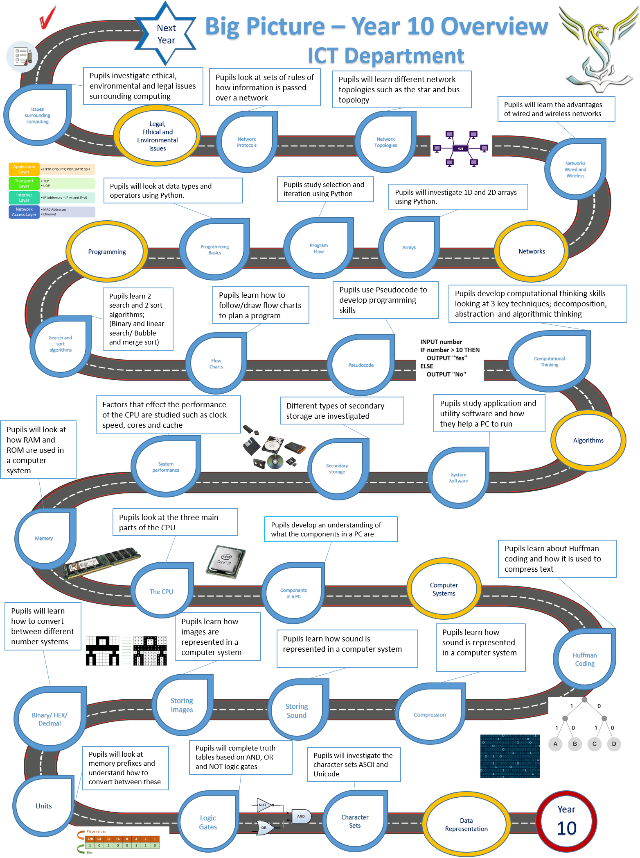

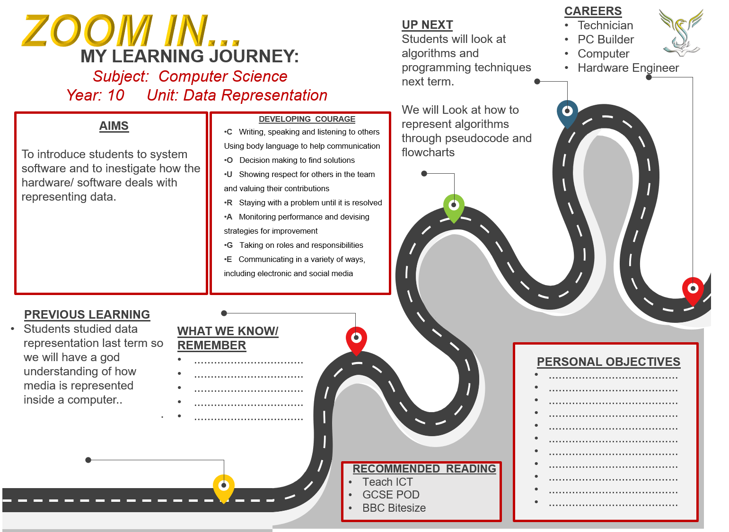
Lesson 1
LI: To learn about computer systems and how they work.
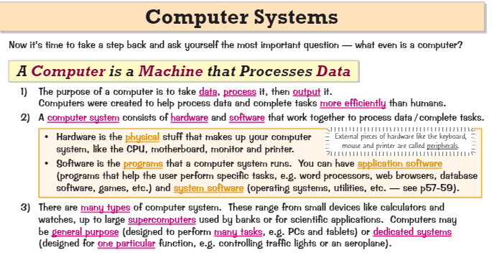
LI: To learn about the components inside a computer and how they work together.

Embedded Systems
Please revise the information in the link below
The login details are below
Username: cm187nq
Password: python4
https://teach-ict.com/2016/GCSE_Computing/AQA_8525/3_4_computer_systems/344_systems_architecture/embedded/miniweb/index.php

Notes box (Please make notes on embedded systems)

Questions
2 A microwave contains an embedded system which controls its cooking modes.
- What is an embedded system?
....................................................................................................................................
[1]
- Give two other examples of devices that may contain an embedded system.

1
.............................................................................................................................
2 ....................................................................................................................................
[2]
- Explain two benefits of embedded systems over non-embedded systems.

1 ....................................................................................................................................
....................................................................................................................................

2 ....................................................................................................................................
....................................................................................................................................
[4]
Inside a computer
Computers contain components which work together
This section covers the main hardware components of a computer.
Please explain in a short sentence what the below components do:
Power Supply -
Case Cooling fan -
CPU heat sink and colling fan -
CPU -
Optical Drive -
RAM sticks -
Motherboard -
Graphics Card –
Lesson 2
LI: To learn about the CPU and its 5 main parts.
The CPU is the central processing unit.
- The CPU is the brain of the computer
- It processes all of the data and instructions that make the system work
- The processing Power of a CPU depends on different characteristics, like its clock speed, cache size and number of cores
- The CPU architecture describes the main components of the CPU and how they interact with each other. You need to know the Von Neuman architecture.

Fill in the diagram below with the following words;

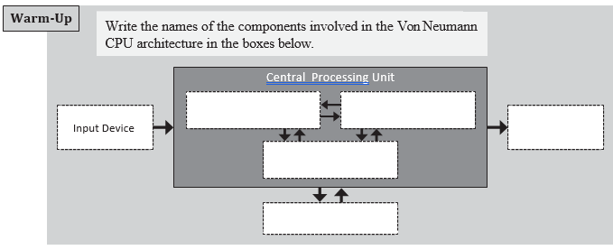
Control Unit (CU), Arithmetic Logic Unit(ALU), Registers, Memory, Output
Can you explain the jobs of the 5 main components of the CPU? Use the link below to help you complete this task
https://www.youtube.com/watch?v=S17wGhjlnJ8
- Control Unit
- Cache
- Arithmetic Logic Unit (ALU)
- The Clock

- Buses
Lesson 3
LI: To learn about the fetch decode execute cycle
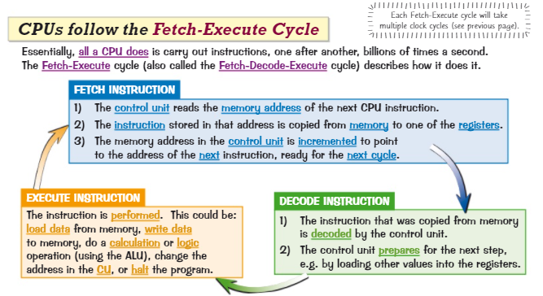
Please look at the information below.

Please watch this video from the AQA Tutor on YouTube
https://www.youtube.com/watch?v=wqCZu-Ct48U
Questions
Q1.
The diagram below shows a simplified diagram of the Fetch-Execute cycle.
Fill in the name of the missing stage in the diagram below.
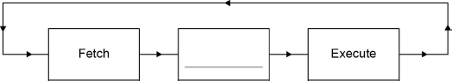
(Total 1 mark)

Q2.
Outline what happens at each of the stages of the fetch-execute cycle.
(a) Fetch
___________________________________________________________________
___________________________________________________________________
___________________________________________________________________
(2)
(b) Decode
___________________________________________________________________
___________________________________________________________________
___________________________________________________________________
(1)
(c) Execute
___________________________________________________________________
___________________________________________________________________
___________________________________________________________________
(2)
(Total 5 marks)
Q3.

Explain how main memory is used during the fetch-execute cycle.
_______________________________________________________________________
_______________________________________________________________________
_______________________________________________________________________
_______________________________________________________________________
_______________________________________________________________________
_______________________________________________________________________
_______________________________________________________________________
_______________________________________________________________________
(Total 4 marks)
Lesson 4
LI: To learn the differences between the different memory types inside a computer
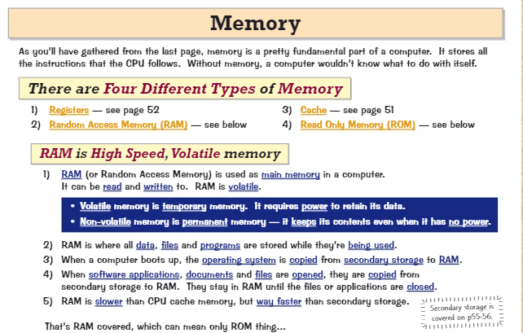
LI: to learn the differences of RAM and ROM
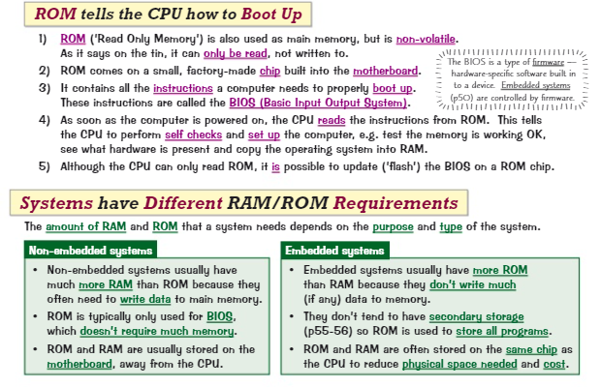

Questions
1 Describe the difference between volatile and non-volatile memory.
..............................................................................................................................................................
..............................................................................................................................................................
[Total 2 marks]

2
a) Explain the purpose of RAM in a computer system.
.........................................................................................................................................................
.........................................................................................................................................................
[2]
b) Give two reasons why Nigel may need to install more RAM in his computer.
1 ......................................................................................................................................................
2 ......................................................................................................................................................
[2]
[Total 4 marks]

3 When a computer is switched on, the BIOS runs. The BIOS is stored in the computer’s ROM.
a) State two functions of the BIOS.
1 ......................................................................................................................................................
2 ......................................................................................................................................................
[2]
b) Explain why the BIOS is stored in ROM instead of RAM.

.........................................................................................................................................................
.........................................................................................................................................................
[2]

c) Compare the RAM and ROM requirements in:
i) an embedded system ................................................................................................................
...................................................................................................................................................
[2]
ii) a non-embedded system .........................................................................................................
...................................................................................................................................................
[2]

Lesson 5
LI: To learn about the CPU performance and system performance
Many things can affect the performance of a computer system. The biggest factors are usually to do with the hardware. The CPU, RAM and the GPU can all have big effects on performance.
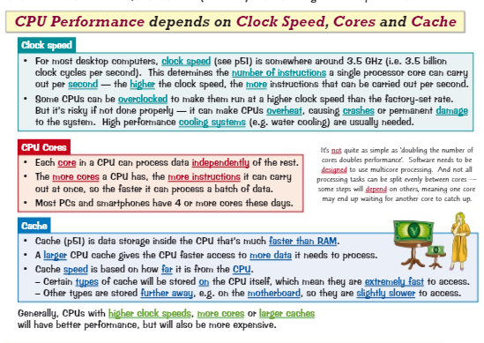

Overall performance is affected by the RAM and the graphical user interface too.

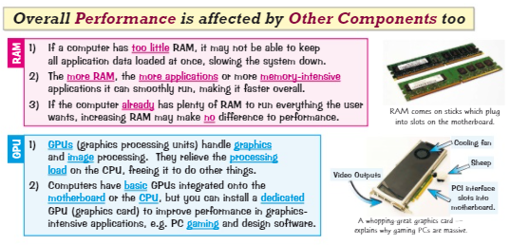
Question
There are several CPU characteristics that can affect its performance. One of these is clock speed.
Explain how clock speed and one other CPU characteristic can affect CPU performance.
In this question you will be marked on your ability to use good English, to organise information clearly and to use specialist vocabulary where appropriate.
_______________________________________________________________________
_______________________________________________________________________
_______________________________________________________________________
_______________________________________________________________________
_______________________________________________________________________
_______________________________________________________________________
_______________________________________________________________________
_______________________________________________________________________
_______________________________________________________________________
_______________________________________________________________________
(Total 6 marks)

Lesson 6
To learn about the different types of secondary storage
There are different types of secondary storage.
- Magnetic hard disks
- Solid State Drives
- Optical Storage
- Cloud Storage
Read the information from the website below
https://www.bbc.co.uk/bitesize/guides/z67j2nb/revision/1
Please take the test on this topic on the same website.

Lesson 7
LI: To learn about the jobs of an operating system

Please see the task on the next page.

Reduce It: Operating Systems

An operating system is the core software that allows a computer to run as an useful device. In essence, they have four main responsibilities:
- Controlling the hardware of the computer system
- Managing software in terms of loading into and unloading out of main memory
- Providing security such as user names and password control
- Providing an user interface to allow a person to interact with the computer

An operating system comprises of four main parts, the kernel, the device drivers,the user interface and the system utilities.

The kernel is responsible for the loading and unloading of applications into and out of memory. It also schedules tasks to run efficiently on the CPU. It is responsible for file management, file storage and data security. The kernel within each different type of operating system is responsible for a slightly different set of tasks.

Providing an user interface is another important feature of operating systems. User interfaces enable a person to interact with the computer. There are a number of different user interfaces with which you will be familiar. The most popular one is a graphical user interface (GUI). A GUI provides a straightforward and ‘friendly’ way to interact with the computer. It makes use of pictures, graphics and icons and to use it you simply need to click on the required icon either with a mouse or by touching it (on a touch sensitive screen). Another popular type of user interface is a menu interface. These provide a limited number of options from which you choose the most appropriate one. They can be found on ATM machines, airport check in systems, fast food menu ordering systems etc. One type of user interface that you may not have come across is a command line interface. This allows the user to interact directly with the computer system by typing in commands (instructions) into a screen.

Device drivers are a core part of the operating system. Every piece of hardware connected to the computer needs to communicate with the operating system. It does this through the device driver. There can be hundreds of device drivers pre-installed in the operating system but as new devices hit the market or technology changes then the driver may need to be updated or a new driver installed.

A multi-tasking operating system is probably operating on your computer or device right now. It enables you to have open, and run, more than one program at the same time. A multi-tasking operating system switches between processes allocating CPU processing time for each task that needs to run. The CPU is able to process billions of instructions per second, so this switching of processes is not apparent to the user.

Table 1 – write down the 20 most important words in the text above

Table 2 – Reduce these to the 8 most important words

Use the words in the table below to fill-in-the-gaps in the text. Each word may only be used once.

COMMUNICATE | MEMORY | PROGRAM | SCHEDULES
SOFTWARE | COMMAND | LIMITED | UPDATED
CPU | KERNEL | INSTALLED | ICON
INTERACT | TASKING | SECURITY | DIRECTLY

An operating system is the core ……………………… that allows a computer to run as an useful device. In essence, they have four main responsibilities:
- Controlling the hardware of the computer system
- Managing software in terms of loading into and unloading out of main …………………
- Providing ………………….. such as user names and password control
- Providing an user interface to allow a person to interact with the computer

An operating system comprises of four main parts, the kernel, the device drivers,the user interface and the system utilities.

The …………………….. is responsible for the loading and unloading of applications into and out of memory. It also ……………………. tasks to run efficiently on the CPU. It is responsible for file management, file storage and data security. The kernel within each different type of operating system is responsible for a slightly different set of tasks.

Providing an user interface is another important feature of operating systems. User interfaces enable a person to ………….with the computer. There are a number of different user interfaces with which you will be familiar. The most popular one is a graphical user interface (GUI).

COMMUNICATE | MEMORY | PROGRAM | SCHEDULES
SOFTWARE | COMMAND | LIMITED | UPDATED
CPU | KERNEL | INSTALLED | ICON
INTERACT | TASKING | SECURITY | DIRECTLY

A GUI provides a straightforward and ‘friendly’ way to interact with the computer. It makes use of pictures, graphics and icons and to use it you simply need to click on the required …………… either with a mouse or by touching it (on a touch sensitive screen). Another popular type of user interface is a menu interface. These provide a …………………. number of options from which you choose the most appropriate one. They can be found on ATM machines, airport check in systems, fast food menu ordering systems etc. One type of user interface that you may not have come across is a ………………………… line interface. This allows the user to interact ………………………… with the computer system by typing in commands (instructions) into a screen.

Device drivers are a core part of the operating system. Every piece of hardware connected to the computer needs to …………………….. with the operating system. It does this through the device driver. There can be hundreds of device drivers pre-……………………. in the operating system but as new devices hit the market or technology changes then the driver may need to be ……………………… or a new driver installed.

A multi-………………… operating system is probably operating on your computer or device right now. It enables you to have open, and run, more than one …………………..at the same time. A multi-tasking operating system switches between processes allocating …………… processing time for each task that needs to run. The CPU is able to process billions of instructions per second, so this switching of processes is not apparent to the user.
Lesson 8
LI: To learn about utility software and application software
Read the theory on the teach ICT website below
https://teach-ict.com/2016/GCSE_Computing/AQA_8525/3_4_computer_systems/343_software_classification/software/miniweb/index.php

Please answer the questions below
Explain what the following different types of software are, and give examples of them.
(a) System software.
What it is:___________________________________________________________
___________________________________________________________________
___________________________________________________________________
Example:___________________________________________________________
(2)
(b) Application software.
What it is:___________________________________________________________
___________________________________________________________________
___________________________________________________________________
Example:___________________________________________________________
(2)
(Total 4 marks)

Describe one difference between system software and application software.
_______________________________________________________________________
_______________________________________________________________________
_______________________________________________________________________
_______________________________________________________________________
(Total 2 marks)

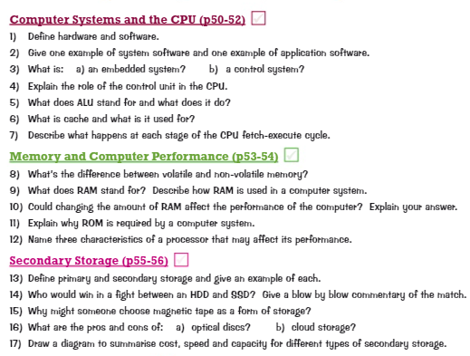
Summary Lesson


