Year 10
Unit 1.1.b - The Structure and Function of the Muscular System

Autumn 2 Blended Learning Booklet

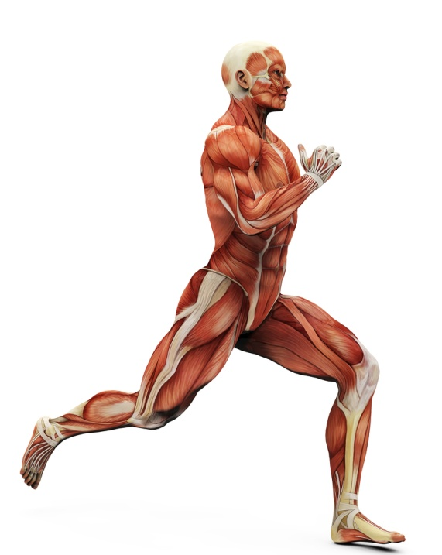

Name:
Aim to complete two lessons each week.
All video links and content are also uploaded on ClassCharts
The knowledge organisers have all the key information and vocabulary to help with this unit.
Upload all work onto ClassCharts for feedback

Contents:
Page 3: Big Picture – Year Overview
Page 4: Zoom in – My learning Journey
Page 5: Knowledge Organiser – Location of Major Muscle Groups
Page 6: Knowledge Organiser – Antagonistic Pairs
Page 7: Video Links – Muscles Powerpoint Links
Page 8-13: Lesson 1&2 – Muscles and their Functions
Page 14-19: Lesson 3&4 – The Muscle Movements in Sporting Actions
Page 20-21: Lesson 5 – 6 Mark Question
Page 22: Lesson 6 – Revision Lesson
Page 22: Lesson 7 – End of Topic Test
Page 22: Lesson 8 – Feedback Analysis
Page 23-24: Stewards Assessment Ladder

Big Picture

Muscular System- Video Links
Use these clips to help fill in the boxes in your following lessons
Description: | Link:
INTRODUCTION: Examples of muscles in action | https://www.youtube.com/watch?v=Sng5depwRNM
STARTER: The muscular system explained | https://www.youtube.com/watch?v=rMcg9YzNSEs
MUSCLES IN ACTION: Table tennis rally | https://www.youtube.com/watch?v=LOynR3gj8rE
MUSCLES IN ACTION: Rugby goal kicking | https://www.youtube.com/watch?v=H6J9dGdQXKQ
MUSCLES IN ACTION: 2016 Rio Olympic hurdles final | https://www.youtube.com/watch?v=FLEpqPW-sAA
MUSCLES IN ACTION: World Record 484kg lift | https://www.youtube.com/watch?v=EB_AdDptAB0
ANTAGONISTIC PAIRS: Musles move in pairs | https://www.youtube.com/watch?v=T-ozRNVhGVg
REVISION: The muscular system explained in 6 minutes | https://www.youtube.com/watch?v=rMcg9YzNSEs&t=3s
Lesson 1&2: Muscles and their Functions
LI: To know the name and location of the major muscles in the body (11 muscles).

LO: I can locate the major muscles of the muscular system (11 muscles).

LI: To understand the functions of the muscular system.

LO: I can identify the functions of the muscular system.

Seneca: 1.2 Muscular System, 1.2.1 Muscles

GCSE Bitesize: https://www.bbc.co.uk/bitesize/guides/zct2hv4/revision/1

Teacher Powerpoint: Uploaded on to Classcharts

The Muscular System
Muscles are used to perform everyday actions all the time. Many sportspeople rely on the power of muscles to perform at the highest level. Task: Label the diagram below.
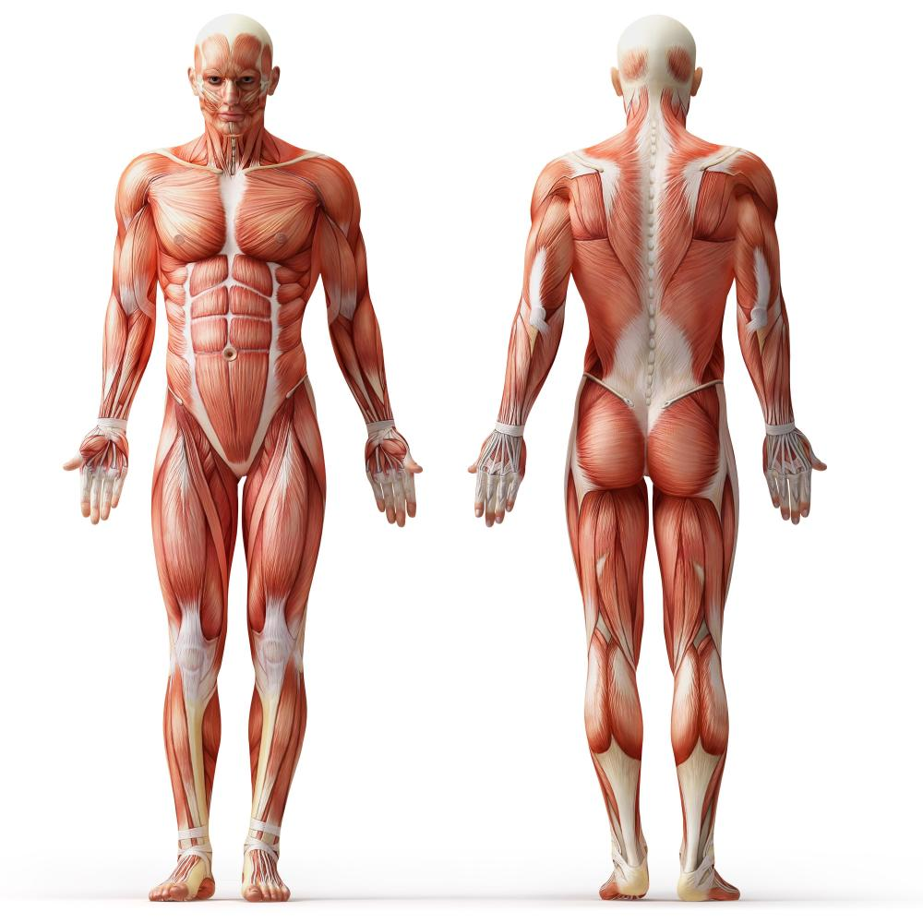

Which muscle is located across the top of the back?

Which muscle is commonly known as the calf?

Which muscle is located across the back, at the sides of the body?

Which three muscles contract to allow a tennis player to hit a tennis ball?

The Muscular System

Muscle Name:

Location:

Function:

Sporting Example:

Your Sporting Example (5-6):

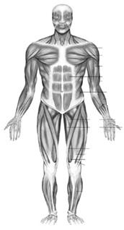
Muscle Name:

Location:

Function:

Sporting Example:

Your Sporting Example (5-6):

Muscle Name:

Location:

Function:

Sporting Example:

Your Sporting Example (5-6):

Muscle Name:

Location:

Function:

Sporting Example:

Your Sporting Example (5-6):

Muscle Name:

Location:

Function:

Sporting Example:

Your Sporting Example (5-6):

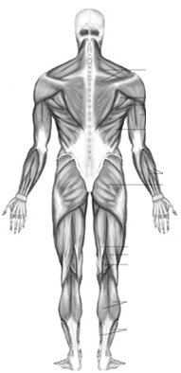
Muscle Name:

Location:

Function:

Sporting Example:

Your Sporting Example (5-6):

Muscle Name:

Location:

Function:

Sporting Example:

Your Sporting Example (5-6):

Muscle Name:

Location:

Function:

Sporting Example:

Your Sporting Example (5-6):

Muscle Name:

Location:

Function:

Sporting Example:

Your Sporting Example (5-6):

Muscle Name:

Location:

Function:

Sporting Example:

Your Sporting Example (5-6):

Muscle Name:

Location:

Function:

Sporting Example:

Your Sporting Example (5-6):

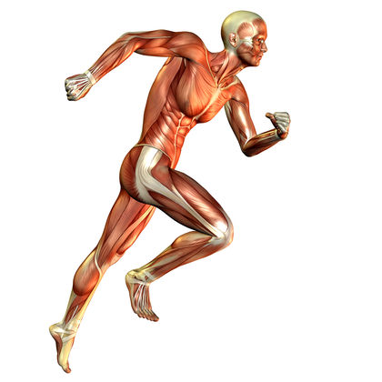
Lesson 3&4: The Muscle Movements in Sporting Actions
LI: To be able to apply their use to examples from physical sport and activities.

LO: I can apply the major muscles use and give examples from physical sport and activities.

LI: To know the major muscles in movement.

LO: I can describe the major muscles in different sports movements / actions.

LI: To be able to apply the definitions and roles of the; agonist, antagonist, fixator and antagonistic muscle action to examples from physical sport and actions.

LO: I can apply sporting examples when describing the definitions and roles of the; agonist, antagonist, fixator and antagonistic muscle action.

Seneca: 1.2 Muscular System, 1.2.2 Muscle Pairs

GCSE Bitesize: https://www.bbc.co.uk/bitesize/guides/zct2hv4/revision/2

Teacher Powerpoint: Uploaded on to Classcharts

Muscles in Sporting Actions

Task: Look at the photos below, write down the muscles that are responsible for performing the sporting action named.

Table Tennis Forehand Shot  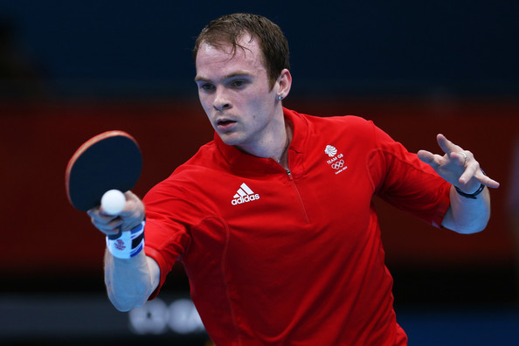  Muscles involved: | Rugby Conversion Kick  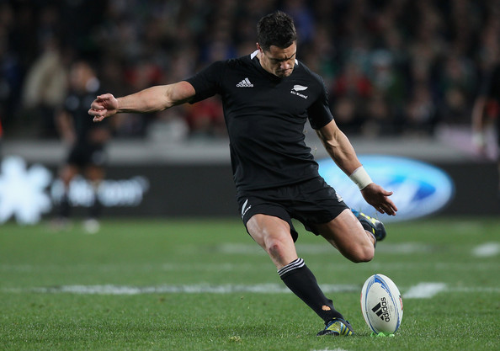  Muscles involved:
Hurdling in Athletics  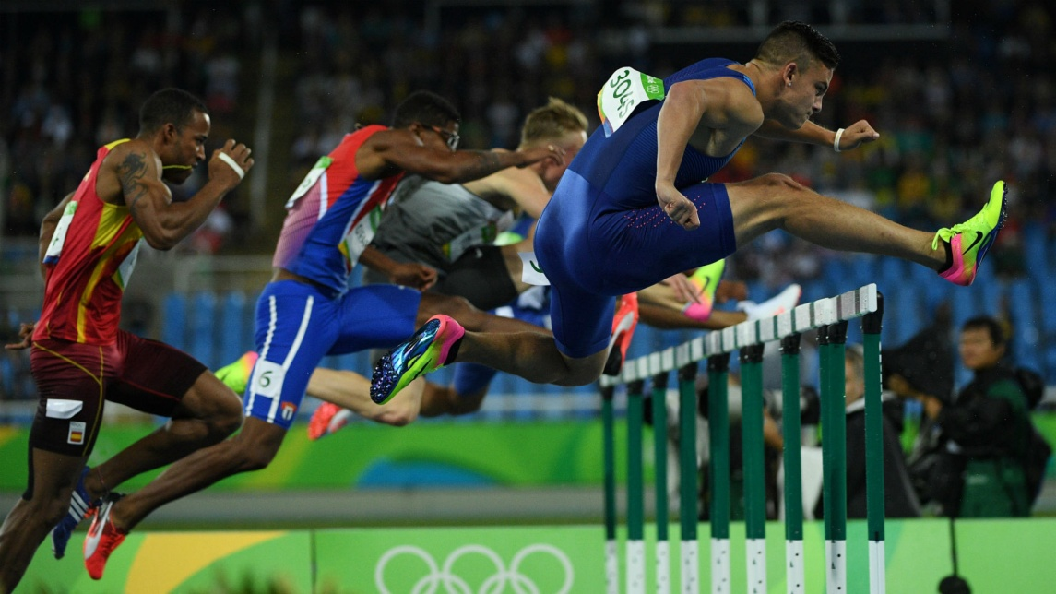  Muscles involved: | 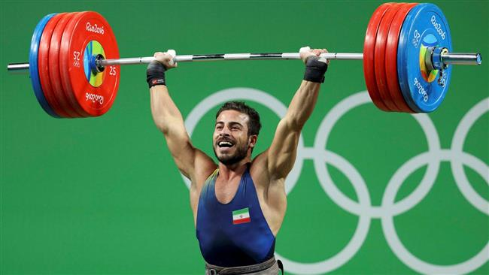  Clean and Jerk in Weightlifting  Muscles involved:

Task: Think of two other sporting actions and name the three major muscles involved. Be specific about the sporting action, for example say a ‘header in football’ rather than just ‘football’.
Sporting Action:  Muscles Involved: | Sporting Action:  Muscles Involved:
How Muscles Work

There is a vast range of movements that can be made by the human body.
To produce these movements muscles must contract.
When muscles contract they shorten, pulling on the bone and causing movement.
When muscles relax they lengthen.

Antagonistic Pairs

Task: Label this example of an antagonist pair in action; you need to label the agonist and antagonist at each stage of this bicep curl.
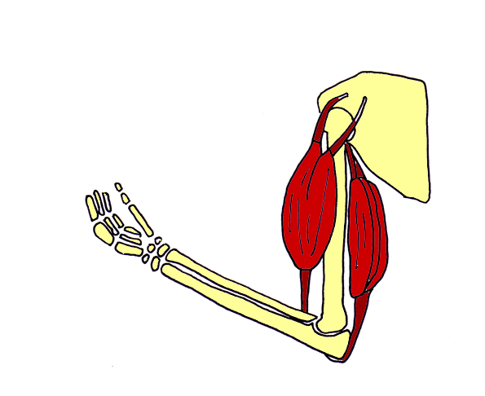
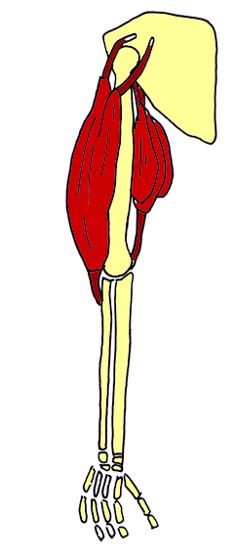

Antagonistic Pairs - Keywords

Antagonistic pairs are made up of three components.

The Agonist:

The Antagonist:

The Fixator:

Antagonistic Pairs in the Body

Antagonistic Pair 1

Joint: Muscles Involved:

How do the muscles work to provide movement at this joint:

Antagonistic Pair 2

Joint: Muscles Involved:

How do the muscles work to provide movement at this joint:

Antagonistic Pairs Exam Question

Task: Answer the following question using all of the words in the keywords box below.

Describe how the hamstring and quadriceps work as an antagonistic pair to kick a football. (3)

_______________________________________________________________________________________________________________________________________________________________________________________________________________________________________________________________________________________________________________________________________________________________________________________________________________________________________________________________________________________________________________________________________________________________________________________________________________________________________________________________________________________________________________________________________________________________________________________________________________________________________________________________________________________________________________________________________________________________________________________________________________
/3

Keywords:
Agonist Antagonist Contract Pull Shorten
Lengthen Hamstring Quadriceps Fixator

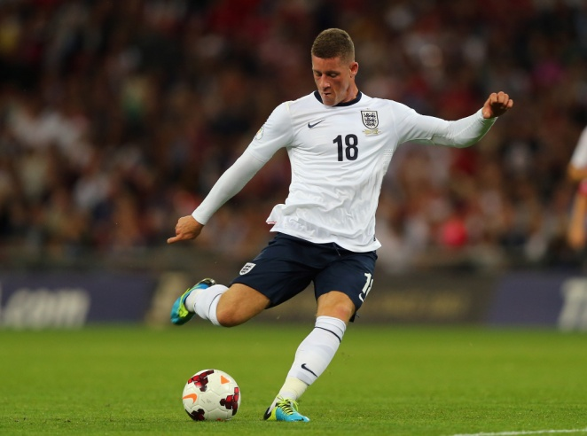
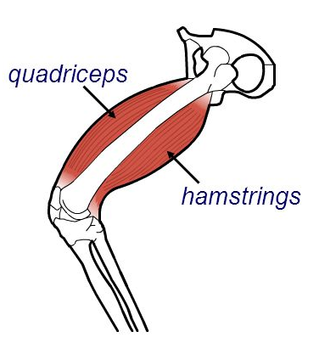

Identifying Antagonistic Pairs

Task: For each of the sporting actions identify the agonist (prime mover), antagonist, movement type, articulating bones and the joint type in the table below.

Sporting Action | Agonist | Antagonist | Movement Type | Articulating Bones | Joint Type
Rowers Elbow

Basketballers Elbow

Divers Knee

Footballers Knee

Lesson 5: 6 Mark Question
LI: To understand how to answer and structure a 6 mark question.

LO: I can plan and structure a 6 mark question.

Seneca: 1.2 Muscular System, 1.2.2 Muscle Pairs

GCSE Bitesize: https://www.bbc.co.uk/bitesize/guides/zct2hv4/revision/2

Teacher Powerpoint: Uploaded on to Classcharts

To produce movement muscles must work in pairs. Discuss the use of antagonistic pairs in sport. (6)
________________________________________________________________________________________________________________________________________________________________________________________________________________________________________________________________________________________________________________________________________________________________________________________________________________________________________________________________________________________________________________________________________________________________________________________________________________________________________________________________________________________________________________________________________________________________________________________________________________________________________________________________________________________________________________________________________________________________________________________________________________________________________________________________________________________________________________________________________________________________________________________________________________________________________________________________________________________________________________________________________________________________________________________________________________________________________________________________________________________________________________________________________________________________________________________________________________________________________________________________________________________________________________________________________________________________________________________________________________________________________________________________________________________________________________________________________________________________________________________________________________________________________________________________________________________________________________________________________________________________________________________________________________________________________________________________________________________________________________________________________________________________________________________________________________________________________________________________________________________________________________________________________________________________________________________________________________________________________________________________________________________________________________________________________________________________________________________________________________________________________________________________________________________________________________________________________________________________________________________________________________________________________________________________________________________________________________________________________________________________________________________________________________________________________________________________________________________________________________________________________________________________________________________________________________________________________________________________________________________________________________________________________________________________________________________________________________________________________________________________________________________________________________________________________________
Feedback:

Lesson 6: Exam Revision

LI: To understand the different revision techniques.
LI: To identify the areas of weakness
Seneca: 1.2 Muscular System

GCSE Bitesize: https://www.bbc.co.uk/bitesize/guides/zct2hv4/revision/1

Teacher Powerpoint: Uploaded on to Classcharts

Lesson 7: End of Topic Test

LI: To be able to complete the end of topic test to the best of my ability in exam conditions.

Topic Test will be uploaded on to Classcharts

Lesson 8: Feedback Analysis

LI: To understand personal areas of strength and weakness

Mark scheme and all feedback will be uploaded on to Classcharts

Theory Attainment Band : | Physical factors affecting performance
Theory Attainment Band : | Skills | Knowledge and Understanding
9 | - Flawlessly factual and perceptive responses that relate accurately to the focus of the question  - Demonstrate excellent understanding, providing clear and detailed descriptions and explanations  - Communication in writing is highly effective using appropriate and coherent terminology  - Spelling, punctuation and grammar is precise | Know the name and location of the major muscle groups in the human body  - Deltoid  - Trapezius  - Latissimus dorsi  - Pectorals  - Biceps  - Triceps  - Abdominals  - Quadriceps  - Hamstrings  - Gluteals  - Gastrocnemius  Know the definitions of the following and be able to apply them to examples from physical activity and sport  - Agonist  - Antagonist  - Fixator  - Antagonistic muscle action
8 | - Consistently factual and sustained responses that relate to the focus of the question  - Demonstrate excellent understanding, providing well-defined explanations and descriptions  - Communication in writing is highly effective using appropriate and coherent terminology  - Spelling, punctuation and grammar is precise
7 | - Offer factually and sustained responses that relate to the focus of the question  - Successfully and confidently address all aspects of the question  - Demonstrate high levels of understanding, providing clear and detailed descriptions and explanations  - Communication in writing is highly effective using appropriate and coherent terminology  - Spelling, punctuation and grammar is accurate
6 | - Confidently offer factually accurate and sustained responses that closely relate to the focus of the question  - Demonstrate excellent understanding and provide clear and detailed descriptions and explanations  - Writing shows strong evidence of communicating ideas with high efficiency and use of appropriate terminology  - On the whole, spelling, punctuation and grammar is accurate
5 | - Responses are consistently factually accurate that closely relate to the focus of the question  - Demonstrate good understanding and provide clear and detailed descriptions and explanations  - Writing shows evidence of communicating ideas with efficiency and use of appropriate terminology  - Spelling, punctuation and grammar is appropriate
4 | - Responses are often factually accurate and show some relation to the focus of the question  - Demonstrate sound understanding and provide adequate descriptions and explanations  - Writing shows evidence of communicating ideas with limited efficiency and use of appropriate terminology  - Spelling, punctuation and grammar is often adequate
3 | - Responses are often inaccurate and show little relation to the focus of the question  - Demonstrate basic understanding and provide limited descriptions and explanations  - Communication in writing is approaching an adequate level of coherence, using some appropriate terminology  - Spelling, punctuation and grammar is developing in consistency
2 | - Responses are vague and do not relate to the question  - Little demonstration of understanding and explanations are often incorrect  - Communication in writing is largely ineffective and lacking coherence  - Spelling, punctuation and grammar is inconsistent
1 | - Responses do not relate to the question  - No demonstration of understanding and explanations are incorrect  - Communication in writing is ineffective and disjointed  - Spelling, punctuation and grammar is weak

