Year 10
Unit 1.1.a - The structure and function of the skeletal system
Autumn 1 Blended Learning Booklet

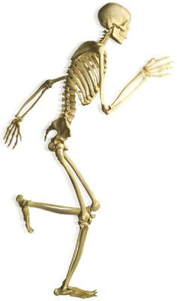

Name:
Aim to complete two lessons each week.
All video links and content are also uploaded on ClassCharts
The knowledge organisers have all the key information and vocabulary to help with this unit.
Upload all work onto ClassCharts for feedback

Contents:
Page 3: Big Picture – Year Overview
Page 4: Zoom in – My learning Journey
Page 5: Knowledge Organiser – Functions of the Skeleton
Page 6: Knowledge Organiser – Location of Major Bones
Page 7: Knowledge Organiser – Types of Synovial Joints and Movements
Page 8: Knowledge Organiser – Movement at Joints
Page 9-11: Lesson 1 – The Bones
Page 11-16: Lesson 2 – The Functions of the Skeleton
Page 17-20: Lesson 3 – Joints and their Movements
Page 21-23: Lesson 4 – Connective Tissues
Page 24-26: Lesson 6 – 6 Mark Question
Page 27: Lesson 7 – Revision Lesson
Page 27: Lesson 8 – End of Topic Test
Page 27: Lesson 9 – Feedback Analysis
Page 28-29: Stewards Assessment Ladder

Big Picture

Lesson 1: The Bones
LI: To know the name and location of the major bones in the skeletal system. (19 bones)

LO: I can locate the major bones of the skeletal system (19 bones)

Seneca: 1.1 Skeletal System, 1.1.1 Skeleton Structure and Function

GCSE Bitesize: https://www.bbc.co.uk/bitesize/guides/zxc34j6/revision/1

Teacher Powerpoint: Uploaded on to Classcharts

The Skeletal System
The adult skeleton has 206 bones and provides the framework for all movement.
Task: Label the skeleton below.
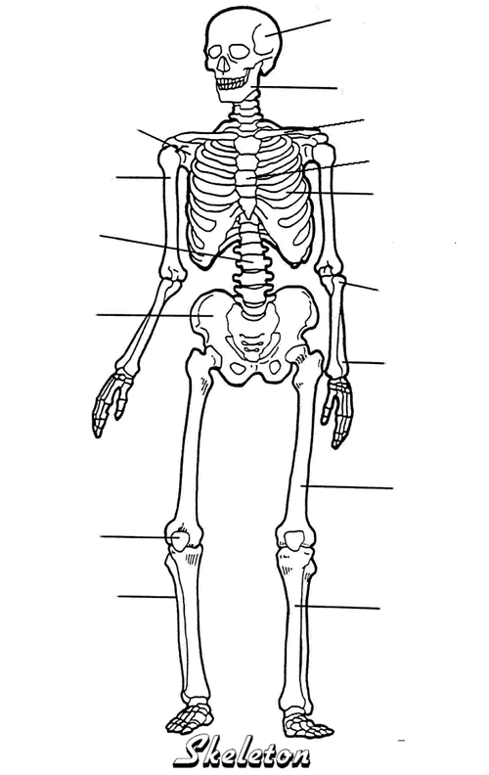

What is the longest bone in the body?

Which bones allow a tennis player to grip a racket?

Which bone protects the brain when heading a football?

Which bone allows us to stand up straight?

The skeleton has six functions, what do you think these are?

- 2. 3.
- 5. 6.

Skeletal System- Video Links
Use these clips to help fill in the boxes in your following lessons
Description: | Link:
STARTER: Skeleton bones song | https://www.youtube.com/watch?v=AkmHo7t3fy4
SUPPORT: Top 7 gymnasts performing on the rings | https://www.youtube.com/watch?v=BAtiWLnwgGQ
SUPPORT: Top 10 best free kicks | https://www.youtube.com/watch?v=daW7J5kdjv8
PROTECTION: Big rugby hits / tackles | https://www.youtube.com/watch?v=d6bKrs6gbWk
PROTECTION: Tom Daley, national competition | https://www.youtube.com/watch?v=Xz5hqV7VyrU
MOVEMENT: 4x100m record, featuring Bolt | https://www.youtube.com/watch?v=VqBGlPsKyNs
MOVEMENT: Best catches in World Cup 2019 | https://www.youtube.com/watch?v=CE_iOr_qb-E
POSTURE: Rewilding & Dettori amazing finish in horse racing | https://www.youtube.com/watch?v=H944v84oAZ0
POSTURE: Aly Raisman floor routine | https://www.youtube.com/watch?v=T8d3m0FRxN8
MINERAL STORAGE: Weightlifting records | https://www.youtube.com/watch?v=GhX8cB7JPYw
BLOOD CELL PRODUCTION: Best of Tour de France 2016 | https://www.youtube.com/watch?v=Ntkph3l2D1c
JOINT MOVEMENT: Usain Bolt 100m runs | https://www.youtube.com/watch?v=XPkh5zUhiJI
JOINT MOVEMENT: Wayne Rooney bicycle kick vs Man City | https://www.youtube.com/watch?v=km_9ntw05pw
JOINT MOVEMENT: Adam Peaty 50m world record, breaststroke | https://www.youtube.com/watch?v=mAGoRJU60D4
REVISION: Skeletal system | https://www.youtube.com/watch?v=abX0W-9qKfs&spfreload=10

Lesson 2: The Functions of the Skeleton
LI: To understand the functions of the skeletal system; support, posture, protection, movement, blood cell production, storage of minerals.

LO: I can identify the 6 functions of the skeletal system.

LO: I can understand and be able to apply examples of how the skeleton provides or allows: support, posture, protection, movement, blood cell production, storage of minerals.

Seneca: 1.1.1 Skeleton Structure and Function
GCSE Bitesize: https://www.bbc.co.uk/bitesize/guides/zxc34j6/revision/2
Teacher Powerpoint: Uploaded on to Classcharts

The Functions of the Skeleton

Function: | Description:
Examples in sport: | 1. | 2. | 3. | 4.
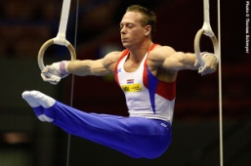  Clip one: | How does this function help the athlete to perform this action?
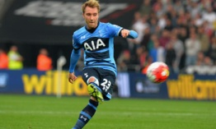  Clip two: | How does this function help the athlete to perform this action?
One of the functions of the skeletal system is to provide support. Give a sporting example of when the skeleton provides support to allow a sporting action to take place (2 marks).

Function: | Description:
Examples in sport: | 1. | 2. | 3. | 4.
Clip one:  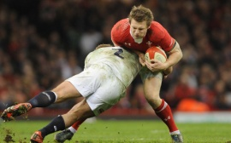 | How does this function help the athlete to perform this action?
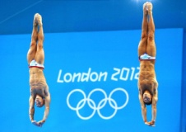  Clip two: | How does this function help the athlete to perform this action?
One of the functions of the skeletal system is to provide protection. Give a sporting example of when the skeleton provides protection during a sporting action to take place (2 marks).

Function: | Description:
Examples in sport: | 1. | 2. | 3. | 4.
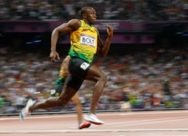  Clip one: | How does this function help the athlete to perform this action?
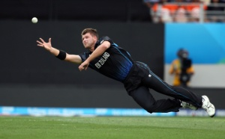  Clip two: | How does this function help the athlete to perform this action?
A gymnast performs a somersault in her routine, how does the skeleton help to allow this sporting action to take place? (2 marks).

Function: | Description:
Examples in sport: | 1. | 2. | 3. | 4.
Clip one:   | How does this function help the athlete to perform this action?
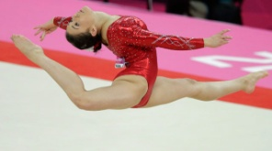  Clip two: | How does this function help the athlete to perform this action?
Which other function of the skeleton does this function link to and why? (2 marks)

Function: | Description:
Examples in sport: | 1. | 2. | 3. | 4.
Clip one:  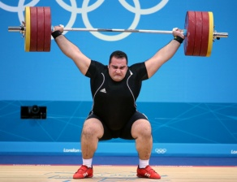 | How does this function help the athlete to perform this action?
Function: | Description:
Examples in sport: | 1. | 2. | 3. | 4.
Clip one:   | How does this function help the athlete to perform this action?

Lesson 3: Joints and their Movements
LI: To identify the different types of joints in the body.

LO: I can name the different types of joints in the body.

LI: To understand the different types of movements that occur at hinge joints and ball and socket joints.

LO: I can describe the types of movements at hinge joints and be able to apply them to different examples from physical activity / sport.

Seneca: 1.1.2 Joints, 1.1.3 Types of Joint

GCSE Bitesize: https://www.bbc.co.uk/bitesize/guides/zxc34j6/revision/3

Teacher Powerpoint: Uploaded on to Classcharts

The Structure of the Skeletal System

A joint is...

A synovial joint is...

The skeletal system has a number of joints which are responsible for the huge range of movement.
 | Movement and Description: | Sporting Example:
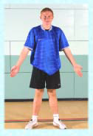
 | Movement and Description: | Sporting Example:
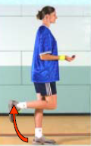
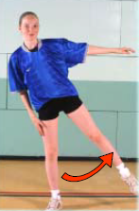
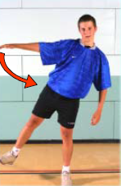
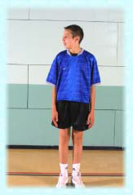 | Rotation:  Circumduction:

There are several different types of joint in the body which allow different types of movement.
Hinge Joints

Examples:

Movement possible:
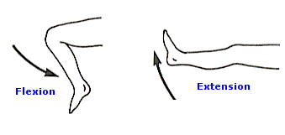
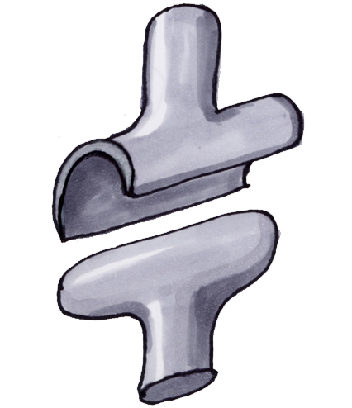
Why are they important for sport?

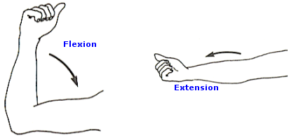
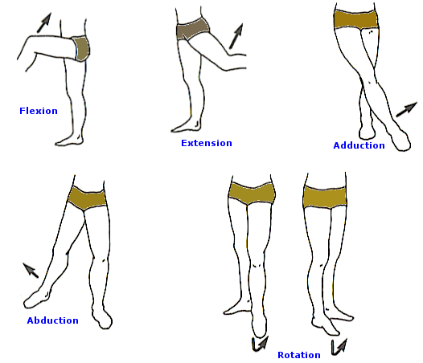
Ball and Socket Joints

Examples:

Movement possible:
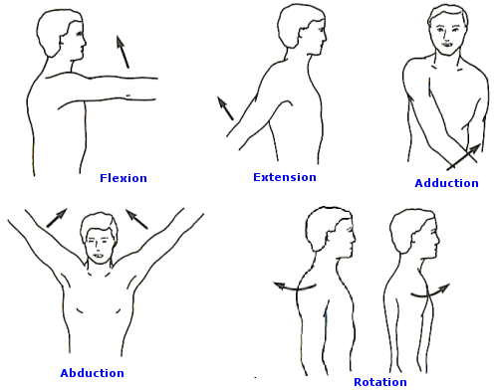

Why are they important for sport?
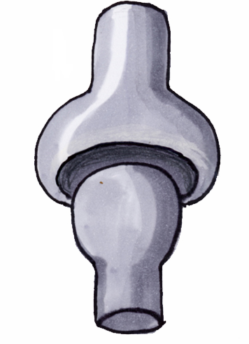

Type of Joint | Location | Articulating Bones | Movement Possible | Range of Movement | Sporting Example
Hinge
Hinge
Ball and Socket
Ball and Socket

Lesson 4: Connective Tissues
LI: To know the different connective tissues in the body

LI: To understand the roles of the connective tissues; tendons, ligaments, cartilage.

LO: I can describe the types of movements at ball and socket joints and be able to apply them to different examples from physical activity / sport.

LO: I can identify the different connective tissues in the body.

LO: I can explain the roles of the connective tissues.

Seneca: 1.1.2 Joints, 1.1.3 Types of Joint

GCSE Bitesize: https://www.bbc.co.uk/bitesize/guides/zxc34j6/revision/4

Teacher Powerpoint: Uploaded on to Classcharts

The Structure of a Synovial Joint
There are other components to the structure of a synovial joint. These help to prevent injury.
Task: After reading the descriptions of each structure, discuss how each structure helps/is used by Andy Murray in a tennis match.
Structure and Function: | How does this help Andy Murray?
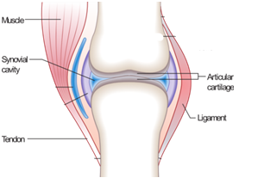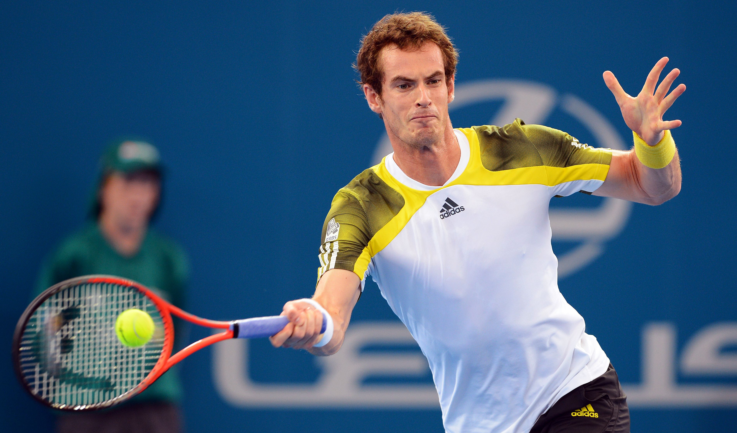
Identifying Joint Movement in Sporting Actions - Think, Pair, Share
Task: You have the time that it takes to watch the videos to think about the answers to the table below. After this time you and your partner will complete as much of the table as you can in three minutes. You will then share your answers with another pair and fill in any blanks.
Sporting Action | Joint | Type | Articulating Bones | Range of Movement
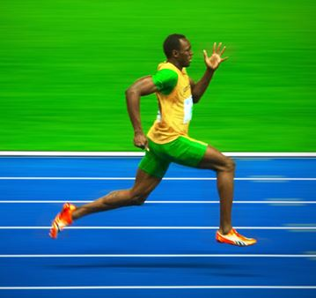 | Right Knee
 | Left Hip
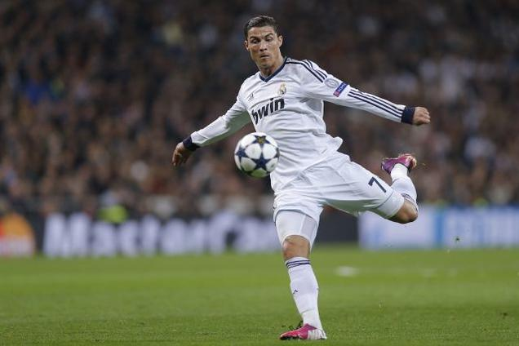 | Left Knee
 | Right Hip
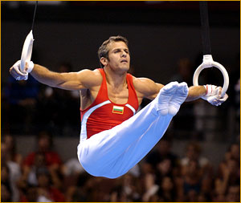 | Right Shoulder
 | Hips
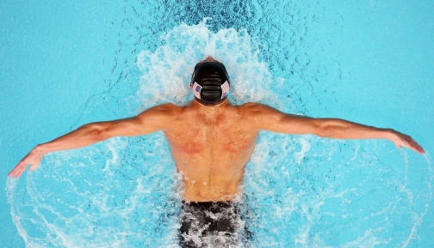 | Elbows
 | Shoulders |  |  | (There are two)

Lesson 5: 6 Mark Question
LI: To understand how to answer and structure a 6 mark question.

LO: I can plan and structure a 6 mark question.

Seneca: 1.1.2 Joints, 1.1.3 Types of Joint

GCSE Bitesize: https://www.bbc.co.uk/bitesize/guides/zxc34j6/revision/2

Teacher Powerpoint: Uploaded on to Classcharts

A function of the skeleton is that it stores minerals such as calcium; this allows a weightlifter to lift heavy weights by ensuring they have strong bones and a strong base of support.
With sporting examples, analyse how else the skeleton enables a person to take part in sport. (6)
____________________________________________________________________________________________________________________________________________________________________________________________________________________________________________________________________________________________________________________________________________________________________________________________________________________________________________________________________________________________________________________________________________________________________________________________________________________________________________________________________________________________________________________________________________________________________________________________________________________________________________________________________________________________________________________________________________________________________________________________________________________________________________________________________________________________________________________________________________________________________________________________________________________________________________________________________________________________________________________________________________________________________________________________________________________________________________________________________________________________________________________________________________________________________________________________________________________________________________________________________________________________________________________________________________________________________________________________________________________________________________________________________________________________________________________________________________________________________________________________________________________________________________________________________________________________________________________________________________________________________________________________________________________________________________________________________________________________________________________________________________________________________________________________________________________________________________________________________________________________________________________________________________________________________________________________________________________________________________________________________________________________________________________________________________________________________________________________________________________________________________________________________________________________________________________________________________________________________________________________________________________________________________________________________________________________________________________________________________________________________________________________________________________________________________________________________________________________________________________________________________________________________________________________________________________________________________________________________________________________________________________________________________________________________________________________________________________________________________________________________________________________________________________________________________________________________________________________________________________________________________________________________________________________________________________________________________________________________________________________________________________________________________________________________________________________________________________________________________________________________________________________________________________________________________________________________________________________________________________________________________________________________________________________________________________________________________________________________________________________________________________________________________________________________________________________________________________________________________________________________________________________________________________________________________________________________________________________________________________________________________________________________________________________________________________________________________________________________________________________________________________________________________________________________________________________________________________________________________________________________________________________________________________________________________________________________________________________________________
Feedback:

Lesson 6: Exam Revision

LI: To understand the different revision techniques.
LI: To identify the areas of weakness
Seneca: 1.1 Skeletal System

GCSE Bitesize: https://www.bbc.co.uk/bitesize/guides/zxc34j6/revision/1

Teacher Powerpoint: Uploaded on to Classcharts

Lesson 7: End of Topic Test

LI: To be able to complete the end of topic test to the best of my ability in exam conditions.

Topic Test will be uploaded on to Classcharts

Lesson 8: Feedback Analysis

LI: To understand personal areas of strength and weakness

Mark scheme and all feedback will be uploaded on to Classcharts

Theory Attainment Band : | Physical factors affecting performance
Theory Attainment Band : | Skills | Knowledge and Understanding
9 | - Flawlessly factual and perceptive responses that relate accurately to the focus of the question  - Demonstrate excellent understanding, providing clear and detailed descriptions and explanations  - Communication in writing is highly effective using appropriate and coherent terminology  - Spelling, punctuation and grammar is precise | Know the name and location of the major bones in the human body  Cranium/vertebrae/ribs/sternum/clavicale/scapula/pelvis/humerus/ulna/radius/carpals/metacarpals/  phalanges/femur/patella/tibia/fibula/tarsals/  metatarsals  Understand and be able to apply practical sporting examples of how the skeleton provides or allows:  - Support  - Posture  - Protection  - Movement  - Blood cell production  - Storage of minerals  Know the definition of a synovial joint  Describe the types of movement at hinge joints and be able to apply them to examples from physical activity/sport  - Flexion  - Extension  Describe the types of movement at ball and socket joints and be able to apply them to examples from physical activity/sport  - Flexion  - Extension  - Rotation  - Abduction  - Adduction  - Circumduction  Describe the components of the hinge joints at the knee and elbow with articulating bones  Describe the components of the ball and socket joints at the shoulder and hip with articulating bones  Know the roles of  - Ligaments  - Cartilage  - Tendons
8 | - Consistently factual and sustained responses that relate to the focus of the question  - Demonstrate excellent understanding, providing well-defined explanations and descriptions  - Communication in writing is highly effective using appropriate and coherent terminology  - Spelling, punctuation and grammar is precise
7 | - Offer factually and sustained responses that relate to the focus of the question  - Successfully and confidently address all aspects of the question  - Demonstrate high levels of understanding, providing clear and detailed descriptions and explanations  - Communication in writing is highly effective using appropriate and coherent terminology  - Spelling, punctuation and grammar is accurate
6 | - Confidently offer factually accurate and sustained responses that closely relate to the focus of the question  - Demonstrate excellent understanding and provide clear and detailed descriptions and explanations  - Writing shows strong evidence of communicating ideas with high efficiency and use of appropriate terminology  - On the whole, spelling, punctuation and grammar is accurate
5 | - Responses are consistently factually accurate that closely relate to the focus of the question  - Demonstrate good understanding and provide clear and detailed descriptions and explanations  - Writing shows evidence of communicating ideas with efficiency and use of appropriate terminology  - Spelling, punctuation and grammar is appropriate
4 | - Responses are often factually accurate and show some relation to the focus of the question  - Demonstrate sound understanding and provide adequate descriptions and explanations  - Writing shows evidence of communicating ideas with limited efficiency and use of appropriate terminology  - Spelling, punctuation and grammar is often adequate
3 | - Responses are often inaccurate and show little relation to the focus of the question  - Demonstrate basic understanding and provide limited descriptions and explanations  - Communication in writing is approaching an adequate level of coherence, using some appropriate terminology  - Spelling, punctuation and grammar is developing in consistency
2 | - Responses are vague and do not relate to the question  - Little demonstration of understanding and explanations are often incorrect  - Communication in writing is largely ineffective and lacking coherence  - Spelling, punctuation and grammar is inconsistent
1 | - Responses do not relate to the question  - No demonstration of understanding and explanations are incorrect  - Communication in writing is ineffective and disjointed  - Spelling, punctuation and grammar is weak

