
Stewards Academy

Geography Year 10
Blended Learning Booklet

Y10-2 Economic World (UK focus)

Name:
Form:

Aim to complete one lesson each week. Write down the title and LI for each lesson and then complete the tasks which are highlighted.
The Knowledge Organiser on page 3 has all the key information and vocabulary to help you with this unit.
Upload all work onto ClassCharts for feedback.

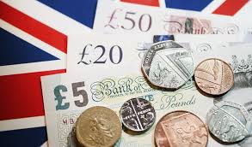

LESSON 1:
TITLE: Change and the UK economy
LI: To examine the major causes of economic change in the UK.

Causes of economic change in the UK
The UK is experiencing a period of economic change. This is happening because of several factors, including globalisation, government policies and deindustrialisation.

What is ‘Globalisation’?
Globalisation describes the way in which the world has become more interconnected. Globalisation has led to an increase in world trade, foreign investment, communication between different countries and the sharing of ideas.
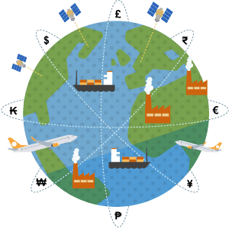

In the past, the UK economy was based on activities that took place within the country and within Commonwealth countries. The growth of globalisation has meant that the UK economy is now more dependent on other countries. An example of this is the manufacturing industry. In the 1900s, 55% of the UK population worked in secondary jobs. The 2011 census showed that this figure had dropped to just 9%. Globalisation has allowed people to connect with other countries - it is possible to send orders abroad, locate factories abroad and get products shipped in to UK ports.

TASK 1 - questions on globalisation
- What is globalisation?
………………………………………………………………………………………………………………………………………………………………………
………………………………………………………………………………………………………………………………………………………………………
………………………………………………………………………………………………………………………………………………………………………
- Why are i-phones a classic example of globalisation?
………………………………………………………………………………………………………………………………………………………………………
………………………………………………………………………………………………………………………………………………………………………
………………………………………………………………………………………………………………………………………………………………………
………………………………………………………………………………………………………………………………………………………………………
UK Government policies
The government manages the UK economy through the Treasury. Each year a budget is produced, which sets out things such as the minimum wage, spending on public services and levels of tax.
During the 1980s the UK was performing better than most other European countries. Several things helped this growth:
- Many state-owned businesses in the UK were privatised, e.g. British Telecom and British Gas. They had been owned by the government, but they were sold to individuals or other companies. This made a lot of money for the government.
- Markets were deregulated. This means that the government became less involved in running things and some companies had to find better ways to make a profit.
- Lots of factories and coal pits were closed. The government said that they could no longer compete with foreign countries where wages are lower. This is when UK jobs first began to go overseas.
- The service sector grew. Wages in the service sector are generally very good.

The UK economy continued to grow into the 1990s. The government had decided to keep taxes low so people had more money and could afford to buy more things.
In 2008, there was a global financial crisis and the UK entered a period of recession (or period of economic decline). Many of the UK's banks, e.g. RBS and Lloyds Banking Group, were helped out using government money. This was very expensive for the country and the level of national debt grew.
Since 2010, a programme of austerity has been in place. The government has made spending cuts to save money. There are 24 Enterprise Zones across the UK, e.g. Birmingham and Manchester. These locations have incentives for businesses to locate themselves there, such as reduced taxes and relaxed planning rules.

TASK 2 - gap fill

Government spending in the UK is controlled by the …………………………. which decides how money should be spent. During the 1980s many state-owned industries like British Telecom were ……………………………and this made a lot of money for the government. During the 1980s, lots of ………………………… and ………………………. were shut down and many jobs moved abroad. In the 1990’s the economy continued to ………………….., but in 2008 the global ……………………………………….. caused a recession and government borrowing and debt was forced to ………………….

Financial crisis grow Treasury coal mines factories privatised increase

LESSON 2:

TITLE: The UK’s post-industrial economy

LI: To examine the characteristics of the UK’s post-industrial economy.

Deindustrialisation in the UK
The UK has experienced deindustrialisation. There has been a decrease in the amount of manufacturing taking place in the country and a growth in the tertiary and quaternary sectors. Traditional industries, such as ship building and textiles, have declined. This has happened for two main reasons:
- A global shift in manufacturing to new emerging economies (NEEs), where wages are lower, working hours are longer and trade unions are sometimes banned.
- An increase in the number of machines used to carry out work. This is called mechanisation.
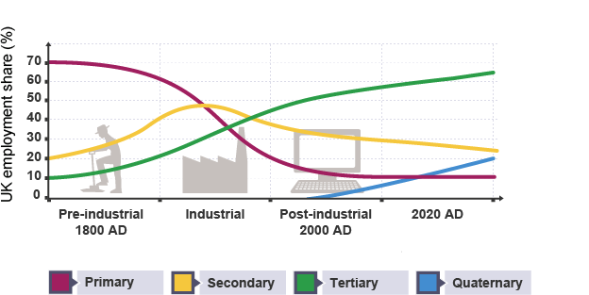
TASK 1 – questions on deindustrialisation
- What is deindustrialisation?
………………………………………………………………………………………………………………………………………………………………………
………………………………………………………………………………………………………………………………………………………………………
Briefly describe the changes in employment for the following sectors shown on the graph above:
Primary industry -
………………………………………………………………………………………………………………………………………………………………………
………………………………………………………………………………………………………………………………………………………………………
Secondary industry –
………………………………………………………………………………………………………………………………………………………………………
………………………………………………………………………………………………………………………………………………………………………
Tertiary industry –
………………………………………………………………………………………………………………………………………………………………………
………………………………………………………………………………………………………………………………………………………………………
Moving towards a post-industrial era
The UK has now entered a post-industrial era. This is a time when traditional industries have declined and new jobs have had to take their place.

The development of IT (Information Technology)
The IT industry in the UK is worth £58 billion a year:
- Around 100,000 software companies operate in the UK, e.g. Microsoft, Apple, Facebook and Google.
- The UK has the largest mobile phone market in Europe, with around 80 million mobile subscriptions. This is worth an estimated £14 billion a year.
- Cloud-based storage systems are a fast-growing part of the UK economy.
- Many UK companies are looking to locate data centres closer to home and so this is a growth area.
- The UK's cyber security market has grown, due to increased threats. This is worth about £2.8 billion a year.


TASK 2 – question on the UK IT industry
- Explain why the IT industry an important part of the UK economy.

………………………………………………………………………………………………………………………………………………………………………
………………………………………………………………………………………………………………………………………………………………………
………………………………………………………………………………………………………………………………………………………………………
………………………………………………………………………………………………………………………………………………………………………
………………………………………………………………………………………………………………………………………………………………………
………………………………………………………………………………………………………………………………………………………………………

The growth of service industries
The service sector makes up about three-quarters of the UK's economy. Services can include a range of job types, e.g. healthcare, IT support and entertainment. The UK exports services too, examples of this are tourism and education. People from other countries travel to the UK for these services and the money generated from this counts towards UK exports. The UK is the second largest exporter of services globally.

TASK 3 – examples of service sector jobs:
Add at least 8 more examples of jobs involved in the UK service industry:
* Hairdressers
* Doctors
* Police
*
*
*
*
*
*
*
*

Finance and research
Financial jobs are to do with money such as working in banks.
In the UK, these types of jobs include accountancy, working in banks and building societies, financial planning, insurance, investments and pensions. Large financial employers in the UK include Barclays, Aviva and KPMG.
The government believes that science and research are important for the UK's growth because they help discover new ways for the country to move forward in a sustainable way. Science and research takes place through government research councils, such as the Medical Research Council, universities, and other organisations, such as the UK Space Agency.

Science and business parks
Science and business parks are special places for company offices and research facilities. They are often found on the edge of cities, like Bristol and Cambridge, where there is good accessibility. Many are located close to universities to attract graduates. Science and business parks are designed to be pleasant environments for people to work in. They are often low-rise, with plenty of parking and green spaces. The growth of science and business parks has helped IT, service, finance and research businesses to work together.


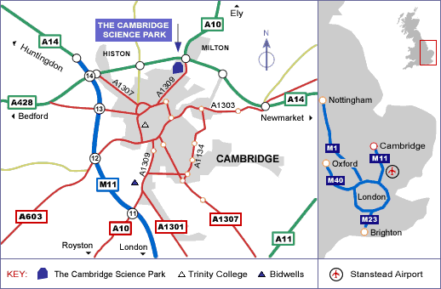
TASK 4 – question on Cambridge Science Park:
- Explain why Cambridge is an excellent location for a Science Park.
Include the following points in your answer – Cambridge University, examples of road connections, close to London, Stanstead airport, good quality of life

………………………………………………………………………………………………………………………………………………………………………
………………………………………………………………………………………………………………………………………………………………………
………………………………………………………………………………………………………………………………………………………………………
………………………………………………………………………………………………………………………………………………………………………
………………………………………………………………………………………………………………………………………………………………………
………………………………………………………………………………………………………………………………………………………………………
………………………………………………………………………………………………………………………………………………………………………
………………………………………………………………………………………………………………………………………………………………………
………………………………………………………………………………………………………………………………………………………………………
………………………………………………………………………………………………………………………………………………………………………
………………………………………………………………………………………………………………………………………………………………………
LESSON 3:
TITLE: Sustainable UK industries
LI: To examine the major causes of economic change in the UK

Developing more sustainable industry
Traditional UK industries often caused a lot of pollution. Modern industrial development aims to be more environmentally sustainable. Some developments are leading the way with new ideas and technologies.

The London Sustainable Industries Park (London SIP)
The London Sustainable Industries Park is located on the Thames Gateway to the east of the city near Lakeside. It was built on the site of the former Dagenham Ford car factory (a brownfield site) and it provides space for nine different businesses. The park is well-connected by the underground network, the national rail network, the M25 motorway and London City airport.
The image below shows London SIP
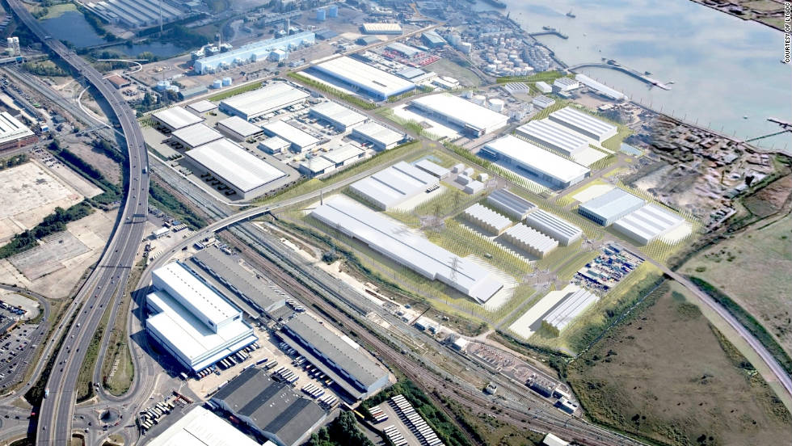
Three companies located in the park work on recycling, researching sustainability issues and using food waste to generate biogas. Other similar organisations will move in over time. The aim is that they will all work with one another through a closed loop system - sharing resources and ideas and exchanging waste and by-products. The government have invested money into this park because they believe that this is a good model for the future of industry in the UK.

TASK 1 – questions on sustainability
- Explain how the London SIP will help improve environmental sustainability.
………………………………………………………………………………………………………………………………………………………………………
………………………………………………………………………………………………………………………………………………………………………
………………………………………………………………………………………………………………………………………………………………………
………………………………………………………………………………………………………………………………………………………………………
………………………………………………………………………………………………………………………………………………………………………

- Why is the UK moving from using fossil fuels (coal, oil, gas) to using more sustainable sources of energy like solar and wind power?
………………………………………………………………………………………………………………………………………………………………………
………………………………………………………………………………………………………………………………………………………………………
………………………………………………………………………………………………………………………………………………………………………
………………………………………………………………………………………………………………………………………………………………………
………………………………………………………………………………………………………………………………………………………………………
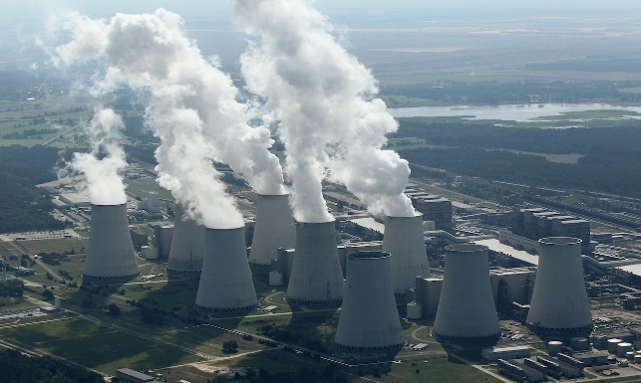

LESSON 4:
TITLE: Change in two rural areas
LI: To evaluate social and economic changes in two contrasting rural areas

Two contrasting rural areas in the UK
Traditionally, economic activity has taken place in UK towns and cities. However, rural landscapes are also increasingly being used for, or being affected by, economic activity.

Rural area with a growing population - Elmbridge in Surrey
Elmbridge in Surrey is a rural borough with an expanding population.
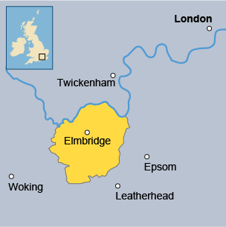

Elmbridge is located in Surrey and is a 25-minute commute from London and is well connected with the M3 and M25, making it an ideal place for commuters to live away from the hustle and bustle of the city.
The influx of people into the area has led to many social and economic changes:
- Many people in their 30s have moved into the area, many of whom have young children. This has reduced the average age of residents and led to a greater demand for school places.
- Over 20% of people living in Elmbridge commute into London, leaving many towns and villages empty during the daytime.
- Average incomes in Elmbridge far exceed national averages, with residents earning more than £1,000 per week. They have a high disposable income, which has brought money into the area.
- House prices are more expensive than anywhere else in the county of Surrey. Average house prices have risen to over £591,000 (in 2015). Many poorer people cannot afford to pay these prices.
TASK 1 – question on rural areas
  - Explain the impacts of social and economic changes which have taken place within Elmbridge.
………………………………………………………………………………………………………………………………………………………………………
………………………………………………………………………………………………………………………………………………………………………
………………………………………………………………………………………………………………………………………………………………………
………………………………………………………………………………………………………………………………………………………………………
………………………………………………………………………………………………………………………………………………………………………
………………………………………………………………………………………………………………………………………………………………………
………………………………………………………………………………………………………………………………………………………………………
………………………………………………………………………………………………………………………………………………………………………
………………………………………………………………………………………………………………………………………………………………………

Rural area with a declining population – Tibenham in Norfolk
Tibenham in Norfolk is a rural county with a declining population.
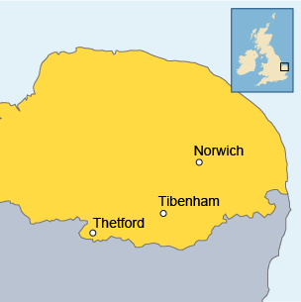

Tibenham is a rural area to the south west of Norwich, in the county of Norfolk. It has no major motorways and few major roads nearby. The mechanisation of farming techniques has led to fewer jobs. This has led to depopulation (falling population) as people have moved away to find work.
The movement of people from the area has led to many social and economic changes:
- Many people in their 30s have moved away from the area. The only school left is a primary school with just a few teachers and pupils between the ages of 5-11. 37% of the population have fewer than five GCSEs (as of 2015).
- The average age of residents is much higher than national averages. The largest age group of residents is the 45 – 59 bracket.
- The population has declined from a peak of over 600 in the late 1990s, to around 450 today.
- Local shops and services have closed, leaving just one pub in the village.
- Average house prices are £202,000 (in 2015), which is 46% lower than 2012 prices and lower than surrounding areas.
TASK 2 – Gap fill

Tibenham is a village in Norfolk. Tibenham has no major …………… connections and many jobs have been lost in the farming industry due to …………………………………….. or the increased use of machines. Many people in their 30s have moved ……………….. from Tibenham to look for better paid ……….. The largest age group living in the village are people are aged 45-59. The population of Tibenham has …………….. from 600 in the late 1990s to around 450 today.

mechanisation away road jobs factories fallen
LESSON 5:
TITLE: New infrastructure projects in the UK
LI: To assess new infrastructure and transport projects in the UK

New developments in UK infrastructure
The UK government is investing in infrastructure developments. These include new road, rail, port and airport facilities. The Department for Transport is the part of the government that oversees all forms of transport within the UK.

UK roads
The Highways Agency are responsible for any new major roads in the UK. They are part of the government and they collect money through Vehicle Excise Duty (VED). Smaller roads are managed by local councils and roads in Scotland and Wales are managed by either Transport Scotland or the Welsh Assembly.
The Highways Agency have an ongoing programme of resurfacing roads and building new roads. In December 2014, the government announced that they would be spending £15 billion on improving and expanding UK roads. This money involves building smart motorways that use technology to manage congestion. Smart motorways are planned for busy routes between London, Birmingham, Manchester and Yorkshire.
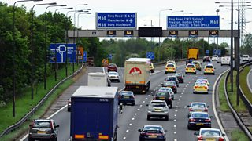

UK rail network
Network Rail is responsible for running, maintaining and developing Britain's railways. The number of rail journeys made have doubled over the last twenty years. As a result of this, £25 billion is being spent to upgrade the network by 2019. Improvements will include longer platforms that can cope with bigger trains and better stations.
High Speed 1 (HS1) is a fast train link between London and Paris. HS2 is a planned fast train link between London and the North of England (Manchester and Leeds). HS2 is planned to be completed in 2026, at an estimated cost of at least £43 billion. It will dramatically cut journey times, for example the current journey time from London to Birmingham will be cut from an hour and a half to just 49 minutes. A further extension of high-speed rail to Scotland is possible in the future.

UK sea ports
The importance of UK sea ports (such as Dover and Felixstowe) have declined over time. Many people now travel by air and the Channel Tunnel has meant that lorries no longer need to drive to a port to travel between the UK and France. Cargo ships do still arrive into UK ports, but containerisation has meant that fewer workers are needed to load and unload them. Larger ships are now used, which has made less accessible ports redundant.
UK ports remain the largest in Europe, in terms of volume of goods handled. UK ports are modern and work well, and so the government are not currently planning any major redevelopments.

UK airports
The Airports Commission is the part of the government that deals with UK airports. The Airports Commission produced a report in 2015, which recommended that the expansion of UK airports was important for the country's prosperity. This is a controversial issue because many people living close to airports don't like the noise and some lose their homes to make space for runways. Airport expansion can lead to a reduction in house prices in nearby areas.
A new 3rd runway has been proposed for Heathrow in west London. The development will generate an estimated £147 billion over 60 years and 70,000 new jobs by 2050. Flights will run to 40 new destinations. The cost of the scheme is estimated to be £18.6 billion. The 3rd runway has largely been backed by business groups. However, some special interest groups are unhappy as there are concerns about the impact on noise and air quality on the surrounding areas.
TASK – question on UK transport projects
  - What are the benefits and challenges of new transport infrastructure projects in the UK?
………………………………………………………………………………………………………………………………………………………………………
………………………………………………………………………………………………………………………………………………………………………
………………………………………………………………………………………………………………………………………………………………………
………………………………………………………………………………………………………………………………………………………………………
………………………………………………………………………………………………………………………………………………………………………
………………………………………………………………………………………………………………………………………………………………………
………………………………………………………………………………………………………………………………………………………………………
………………………………………………………………………………………………………………………………………………………………………
………………………………………………………………………………………………………………………………………………………………………
………………………………………………………………………………………………………………………………………………………………………
………………………………………………………………………………………………………………………………………………………………………
………………………………………………………………………………………………………………………………………………………………………
………………………………………………………………………………………………………………………………………………………………………
………………………………………………………………………………………………………………………………………………………………………
………………………………………………………………………………………………………………………………………………………………………
………………………………………………………………………………………………………………………………………………………………………
………………………………………………………………………………………………………………………………………………………………………
………………………………………………………………………………………………………………………………………………………………………
LESSON 6:
TITLE: What is the north-south divide?
LI: To examine causes and impacts the north-south divide and the strategies to overcome regional differences

The north/south divide in the UK
It has long been recognised that there is a North-South divide in the UK.
Watch the video on the north/south divide: https://www.youtube.com/watch?v=rJ-dtUUQCZA

What is the divide?
Although government spending on public services is roughly even across the country, many businesses are choosing to set up in the south. This creates a large wealth divide and those living in the north of the country experience lower incomes, higher unemployment and a lower standard of living than those living in the south.
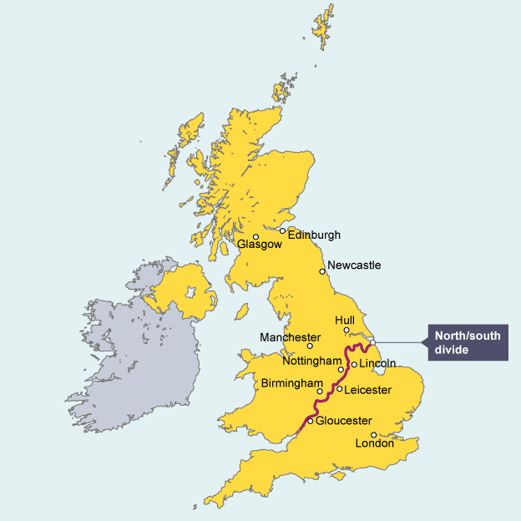
The Centre for Cities is a charity that measures economic growth and change in 64 UK cities. In 2015, it found that for every 12 jobs created since 2004 in southern cities, only one was created in cities elsewhere. Cities like London and Milton Keynes in the south have seen a large growth in the number of jobs available, whilst Blackpool and Hull in the north have seen a large decline. The rate of unemployment is lower in the north and wages are often higher in the south. The quality of life and life expectancy are higher in the south compared to the north.

Strategies to resolve regional differences
Resolving regional differences is a difficult task. The government have agreed devolution measures, which gives additional power and money to councils in the north. An example is the election of the Mayor for Greater Manchester, who has been given £1 billion of devolved funds to spend on improving the city and attracting new businesses. This will mean that fewer decisions about the city are made in London and more decisions are made by the people of Manchester. Other local councils are demanding the same control.
Some people believe that more professional jobs need to be created in the north. The popularity of universities such as Manchester, Liverpool and Leeds have encouraged professionals to settle in the north. The relocation of some businesses and organisations can also help. For example, the BBC moved many of its offices to the newly built ‘Media City UK’ in Salford in 2011. Since then, the multiplier effect has led to other companies locating close by, e.g. the Holiday Inn.
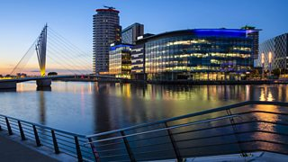
BBC offices at Media City UK, Salford in Manchester
TASK – true/false statements:
- The UK has a north/south divide – TRUE or FALSE?

- The north has higher unemployment than the south – TRUE OR FALSE?

- The south has higher average wages compared to the north – TRUE OR FALSE?

- Life expectancy is higher in the north compared to the south – TRUE OR FALSE?

- Regions of the UK have been given increased powers by the government – TRUE OR FALSE?

- Cities like Manchester can make more decisions about new projects – TRUE OR FALSE?

- Manchester, Leeds and Liverpool have highly popular universities – TRUE OR FALSE?

- The BBC moved to Salford in Manchester in 2008 – TRUE OR FALSE?

- Media City UK in Salford has attracted other businesses such as hotels to the area – TRUE OR FALSE?

- Harlow and London are located in the north of England – TRUE OR FALSE?

LESSON 7:
TITLE: The UK and the wider world
LI: To evaluate the place of the UK in the wider world

UK and the wider world: trading partners
The UK has undergone many changes and its position in relation to other countries is changing. As newly emerging economies (NEEs) continue to grow, where will the UK fit in to the global economy?

The place of the UK in the wider world
The UK has strong political links with many countries, although the UK left the European Union (EU) on 31st January 2020. This departure (or Brexit) from the EU was as a result a referendum held in 2016 to decide whether the UK would remain or leave the EU. As a former member of the European Union (EU), the UK still works closely with the 26 other countries. The UK is a member of the Commonwealth, which is one of the world's oldest political groups. The Commonwealth is a group of 54 countries, and it began when those countries were ruled by Britain. Current membership is optional. The UK also has other political links, such as the Group of Seven (G7). The G7 is made up of the United States, Canada, France, Germany, Italy, Japan, and the United Kingdom. They meet yearly to discuss global economic issues. The UK is also a nuclear armed country and has a permanent seat at the influential United Nations security council
The links that the UK has with other countries are based on a variety of factors:
- Trade – the UK imports and exports goods from many countries. Over 50% of UK trade is with EU countries. The UK's next biggest trading partners are found in north America, Asia and Oceania. Foreign exports also include money spent by tourists visiting the country. The UK's biggest exports are machinery, pharmaceuticals, and transport equipment.
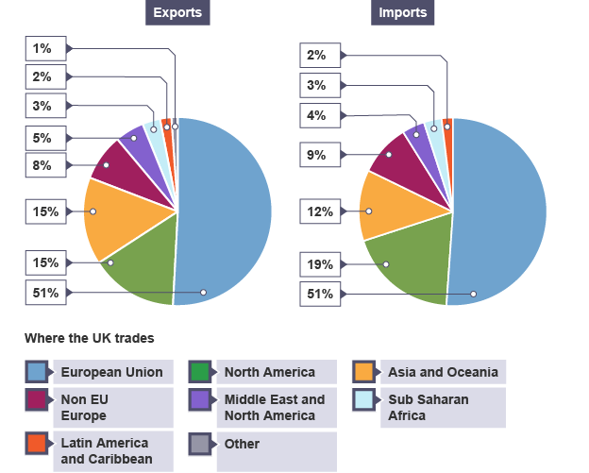
- Culture – UK literature, music, cinema, sport, television, history and architecture are important globally. Books, such as the Harry Potter series, are sold worldwide. UK sports are showcased through events such as the 2012 Olympics, the World Cup, the Wimbledon tennis championship, the Premier League and the London Marathon. UK architecture can be seen in many commonwealth countries. Tourists visit the UK to experience the culture and many UK cities have been labelled 'cities of culture'.
- Transport – increasing air travel is strengthening the UK's links with other countries. In addition to this, the UK has modern port facilities and a high-speed rail link to Europe.
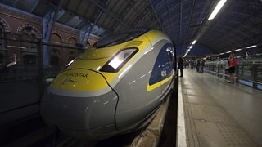
- Communications – the UK is linked to the rest of the world via the internet. Internet cables beneath the sea provide a fast connection to countries globally.

Questions about the UK and the wider world
Q1) When did the UK formally leave the EU?
Q2) What does “EU” stand for?
Q3) In which year did the UK hold a referendum to decide if it should remain in the EU?
Q4) What is the Commonwealth group of countries?
Q5) How many countries are members of the Commonwealth?
Q6) What is the G7 group of countries – who are the members and what do they do?
Q7) The UK is a permanent member of the UN security council – TRUE or FALSE?
Q8) What global regions are the UK’s 3 biggest trading partners?
Q9) What % of UK trade exports go to the EU?
Q10) What % of UK trade exports go to north America?
Q11) Explain why British sport and culture are globally important. What major sporting events are held in the UK?
Q12) Watch the video link and then explain why the UK is a popular tourist destination.

https://www.youtube.com/watch?v=wSHXd-K-jIk

