Year 10
Unit R052 – Developing Sports Skills
Autumn 2 Blended Learning Booklet
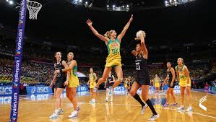
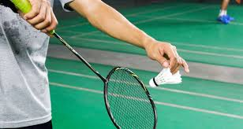

Name:

Aim to complete two lessons each week.
All video links and content are also uploaded on ClassCharts
The knowledge organisers have all the key information and vocabulary to help with this unit.
Upload all work onto ClassCharts for feedback

Contents

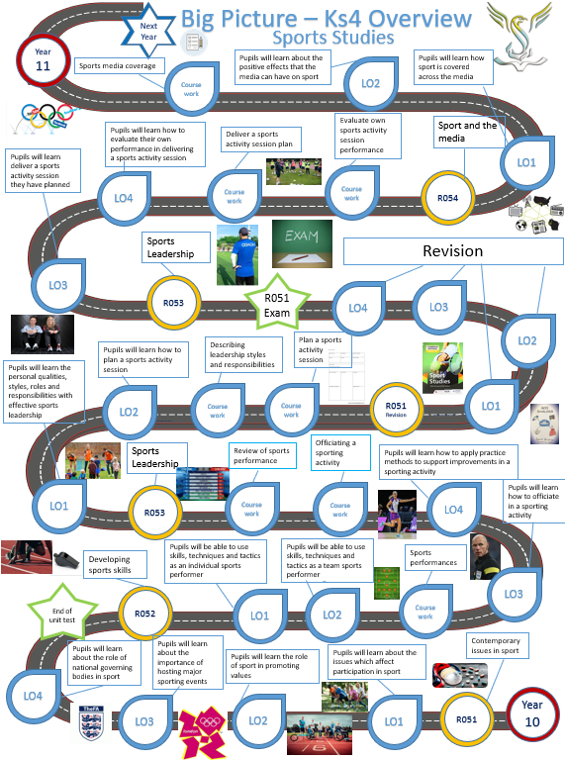
Big picture
Zoom in
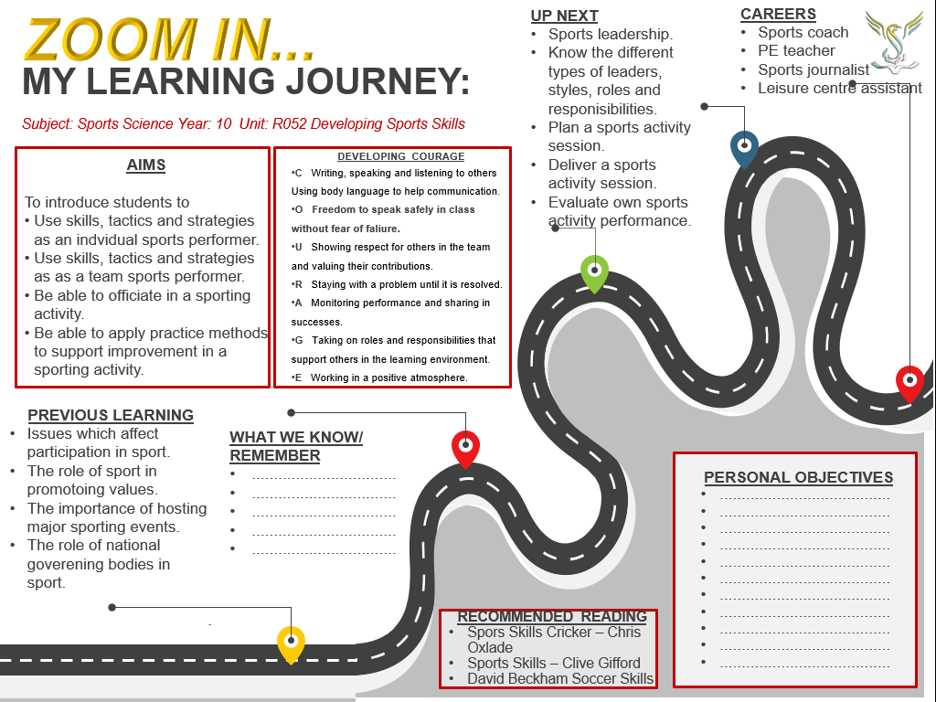

Knowledge organiser
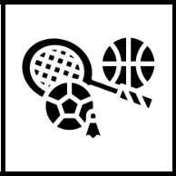
RO52 Developing Sports skills
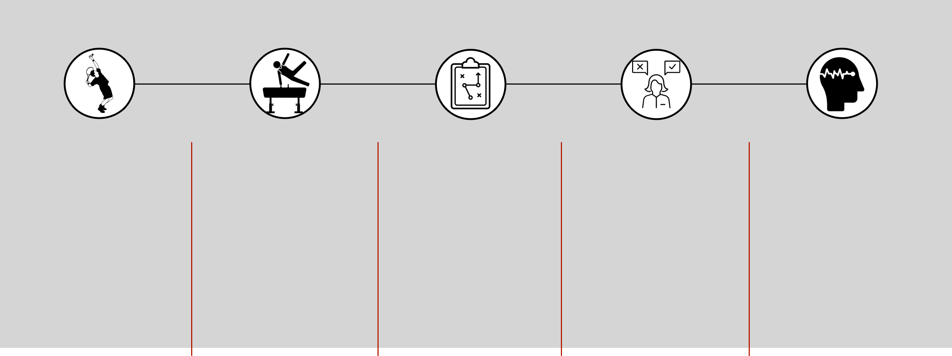
LO1: Be able to use skills, techniques and tactics as an individual performer
STEP 1 STEP 2 STEP 3 STEP 4 STEP 5

Performance of skills and |  | Creativity | Appropriate use of tactics / |  | Decision making during |  | Ability to manage /
techniques |  |  | strategies / compositional |  | performance |  | maintain own performance
 |  |  | ideas
• | Individual sports - | • Create or react to a | • | Tactics - plans used | • | Select a suitable | • | Arousal is a physical and
 | athletics, swimming, | situation in a unique or |  | against opponents |  | movement or skill |  | mental state of alertness
 | cycling, tennis | unusual way |  | weaknesses and for | • | Has to take place |  | varying from deep sleep
• | Skill - learned |  |  | own strengths |  | quickly in most sports |  | to intense excitement
 | combination of |  | • | Strategies - overall |  |  | • | The difficult thing is
 | movements |  |  | plan of how best to |  |  |  | trying to make sure that
• | Techniques - method |  |  | perform |  |  |  | levels of arousal are kept
 | used to perform a skill |  | • | Composition - art of |  |  |  | at the correct level
 |  |  |  | creating and arranging

Mark scheme
LO1: Be able to use skills, techniques and tactics as an individual performer
Mark Band 1 | Mark Band 2 | Mark Band 3
Demonstrates limited application of skills and | Demonstrates effective application of skills and | Demonstrates advanced application of skills and
techniques as an individual performer in a sporting | techniques as an individual performer in a sporting | techniques as an individual performer in a sporting
activity | activity | activity
Creativity, use of tactics / strategies / compositional | Creativity, use of tactics / strategies / compositional | Creativity, use of tactics / strategies / compositional
ideas and decision making often lacks accuracy and | ideas and decision making shows some accuracy and | ideas and decision making shows accuracy and fluency
fluency | fluency | on most occasions
Ability to maintain performance is inconsistent | Ability to maintain performance is consistent | Ability to maintain performance is consistent and
 |  | confident

LO2: Be able to use skills, techniques and tactics as a team performer
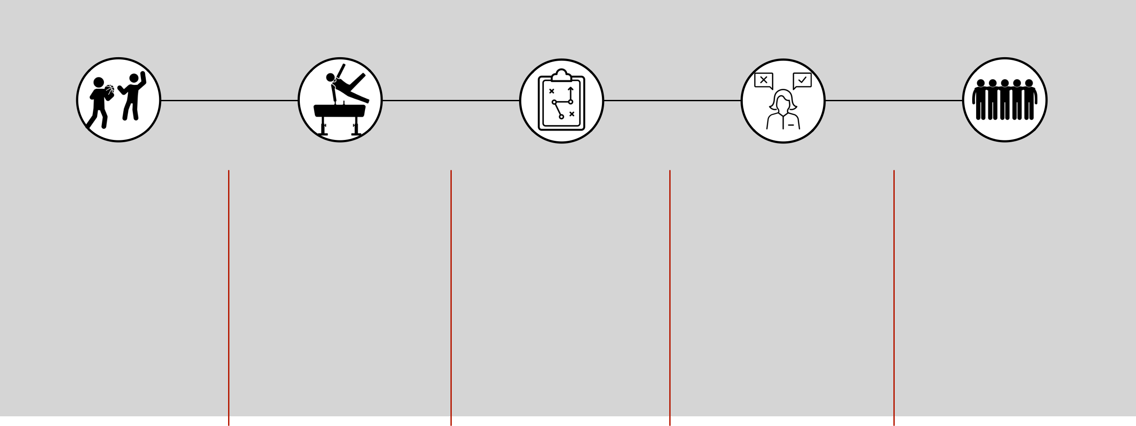

STEP 1 STEP 2 STEP 3 STEP 4 STEP 5

Performance of skills and |  | Creativity | Appropriate use of tactics / |  | Decision making during |  | Awareness of role within /
techniques |  |  | strategies / compositional |  | performance |  | contribution to the team
 |  |  | ideas
• | Team sports - | • Showing creativity in a | • | Tactics - plans used | • | Select a suitable | • Most team sports have
 | basketball, volleyball, | team sport is |  | against opponents |  | movement or skill | specific roles for a
 | rugby, football | concerned with using |  | weaknesses and for | • | Has to take place | number of players within
• | Skill - learned | your own ideas to |  | own strengths |  | quickly in most sports | the team, and players
 | combination of | solve a problem by | • | Strategies - overall |  |  | must be aware of their
 | movements | creating or reacting to |  | plan of how best to |  |  | role
• | Techniques - method | a situation in a unique |  | perform
 | used to perform a skill | way | • | Composition - art of
 |  |  |  | creating and arranging

Mark scheme
LO2: Be able to use skills, techniques and tactics as a team performer
Mark Band 1 | Mark Band 2 | Mark Band 3
Demonstrates limited application of skills and | Demonstrates effective application of skills and | Demonstrates advanced application of skills and
techniques as an individual performer in a sporting | techniques as an individual performer in a sporting | techniques as an individual performer in a sporting
activity | activity | activity
Creativity, use of tactics / strategies / compositional | Creativity, use of tactics / strategies / compositional | Creativity, use of tactics / strategies / compositional
fluency | fluency | on most occasions
limited | clear | well developed

Lesson 1
Individual sports and skills
LI: understand the key components of performance for an individual performer in a sporting activity
Below is a list of sports you will need to have an understanding of.
You will then perform in one Team and one Individual sport to be assessed in.
Alongside your performances in these sports, you will also need to produce a piece of coursework detailing your strengths, weaknesses and areas of improvements in.
Consider which 2 sports you are going to choose to be assessed in for this unit and REMEMBER if you choose sports that are NOT done within school time, you will have to provide your own evidence and complete assignments using your own knowledge and understanding
Team Sports | Comments
Acrobatic gymnastics | Cannot be assessed with gymnastics
Association football | Cannot be five-a-side or futsal
Badminton | Cannot be assessed with singles
Basketball
Cricket
Dance
Futsal | Cannot be assessed with football
Handball
Hockey | Must be field hockey, not ice hockey or roller hockey
Netball
Rugby union | Cannot be assessed as sevens or fifteen a side. Cannot be assessed with rugby league, cannot be tag rugby.  Only one form
Table tennis | Cannot be assessed with singles
Volleyball
Individual Sports | Comments
Amateur boxing
Athletics
Badminton | Cannot be assessed with doubles
Dance
Golf
Gymnastics | Floor routines and apparatus only
Skiing | Outdoor/indoor on snow; cannot be assessed with snowboarding.  Must not be dry slopes
Snowboarding
Swimming | Not synchronised swimming
Table tennis | Cannot be assessed with doubles
Tennis | Cannot be assessed with doubles
Trampolining
Task
Research the following questions and produce a word document on your chosen individual and team sports that you will be assessed in. Do each sport on a separate page.
What is your sport and who are the national governing body?
How many players are there?
What are the positions?
How do you play the game?
Tactics, how do you win the game?
Complete the following table on the skills needed in your sport:
Skills in sport | Strength | Weakness
Passing
Shooting
Footwork
Positional play
Receiving the ball
Specific types of passes
Tactics
Understanding the rules

Lesson 2
Assessing own individual performance
LI: understand the key components of performance in individual activities.
You will need to have an understanding of the following elements of the sports you are going to be assessed in:
- Performance of skills and techniques (e.g. a front somersault in trampolining)
- Creativity) (e.g. communicating a theme to the audience through performance of a ballet dance)
- Appropriate use of tactics/strategies/compositional ideas (e.g. when to bowl a bouncer in cricket)
- Decision-making during performance (e.g. shot selection from different lies in golf)
- Ability to manage/maintain own performance (e.g. staying composed after two illegal jumps in triple- jump).

Now chose one of your sports you will be assessed in and apply the headings in bold to your sport.
Watch the following videos to help your understanding of skills in rugby as an example.
https://www.youtube.com/watch?v=jYTeQ69ddIE
https://www.youtube.com/watch?v=qSVngih84cs
https://www.youtube.com/watch?v=20TQlvVhOgI
https://www.youtube.com/watch?v=x9X-70rMVDY
https://www.youtube.com/watch?v=xQYxqcLAzBw
https://www.youtube.com/watch?v=D0CexBvQ3BM
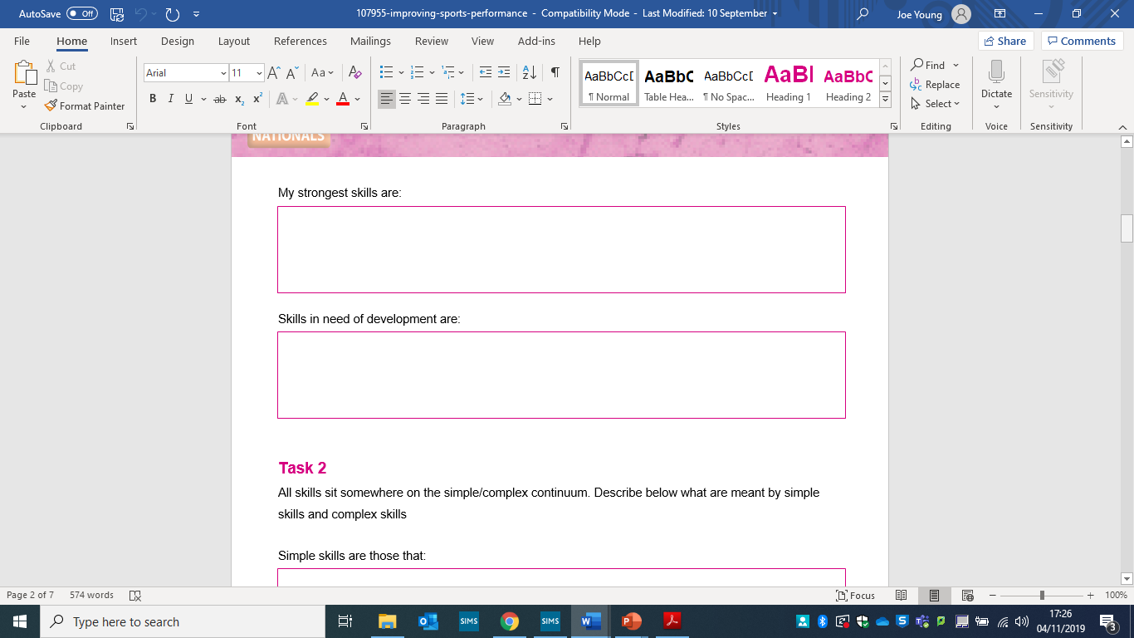
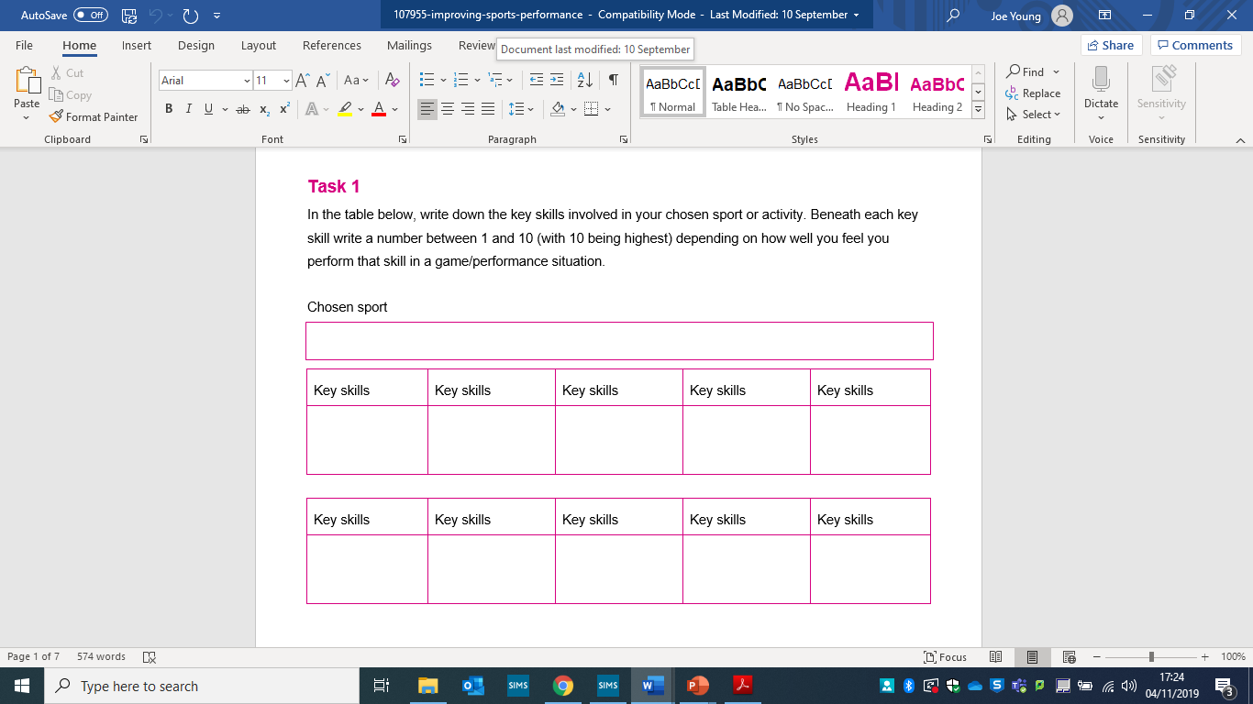
Now you have completed a break down of your individual sports skills, think about your scores on each of the skills. If you have marked yourself low (be honest) think about ways you can start to improve these skills.
Are you playing this sport outside of school? If not maybe think about joining a club to improve on your knowledge and understanding of the sport.

Lesson 3
Assessing own team performance
LI: understand the key components of performance in team activities.
- Performance of skills and techniques (e.g. a chest pass in netball)
- Creativity (e.g. feint to pass and then dribble in basketball)
- Appropriate use of tactics/strategies/compositional ideas (e.g. when to bowl a bouncer in cricket)
- Decision-making during performance (e.g. choice of pass in rugby union)
- Awareness of role within/contribution to the team (e.g. covering for a team mate who is out of position in football).
- Ability to manage/maintain own performance (e.g. staying composed after fouls committed against you)

How to explain the effect
You need to explain how your strengths and areas of development affects your game considering things such as:
Outcome – you are accurate, score, consistent
Team mates – support them, provide information
Performance – consistent, good technique, correct positioning
Sentence starters:
I believe I do these things well because…
This is my strength because I always show good technique
My strength is …. because I consistently
Strengths and areas of development.
Remember focus on how it affects the below:
Outcome – you are accurate, score, consistent
Team mates – support them, provide information
Performance – consistent, good technique, correct positioning
Sentence starters:
I believe I do these things well because…
This is my strength because I always show good technique
My strength is …. because I consistently
This is my weakness because I struggle when under pressure to perform it with…
…. Is another of my weaknesses as I am often inconsistent
How to explain a strength
I have identified my strengths as passing, tackling, lineout jumping.
I believe I do these things with good technique for example when passing I am often consistent meaning my passes always go to my teammates allowing us to move the ball into space.

Use the information above and sentence starters to evaluate your own performance in your team sport.
Make sure you include examples of why you do each part well or why you could improve on it.
Remember the more examples you include, the higher your mark
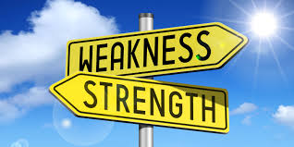

Lesson 4
Creativity
LI: understand how creativity is used in an individual sporting performance
Creativity task:
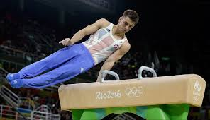
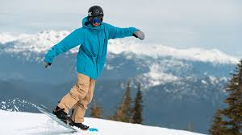
Think of an occasion when the following individual performers might show creativity…
Snowboarder
Gymnastics – Pommel Horse

Decision making
Golfers need to decide which club to use in different weather conditions, such as wind, to make sure that they achieve the required distance.
A boxer will make decisions about how to face an opponent e.g. being defensive against an aggressive puncher & waiting for the correct moment to attack.
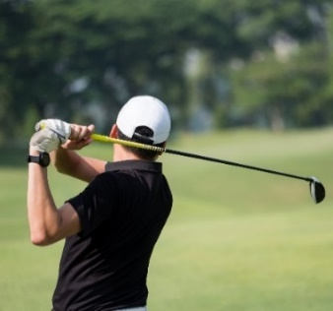


Examples of effective decision-making from individual performers…
A ski racer will need to decide how to approach an event according to the snow conditions and how fast their competitors have raced.
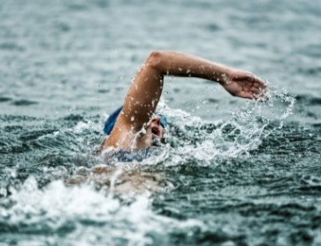
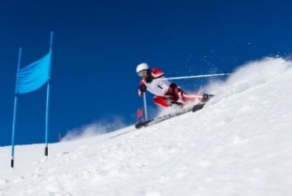
A distance swimmer will need to decide when to change their speed during the latter stages of a race. They must consider energy levels/competitors etc.

Match the correct example to each component of performance

Performance of skills and techniques |  | A coach suggesting to a badminton player that she hits everything to an opponents back hand
Creativity |  | A tennis player remaining calm after receiving a poor call from an umpire
Appropriate use of tactics / strategies / compositional ideas |  | A showjumper completing a difficult equestrian routine
Decision-making during performance |  | A dancer using a movement that they have designed specifically for a competition
Ability to manage / maintain own performance |  | A swimmer getting off to a flying start to try and get ahead of a strong finishing opponent

Lesson 5
Tactics
LI: how the appropriate use of tactics/ strategies/ compositional ideas can help gain an individual advantage
Name the skills being demonstrated in these images

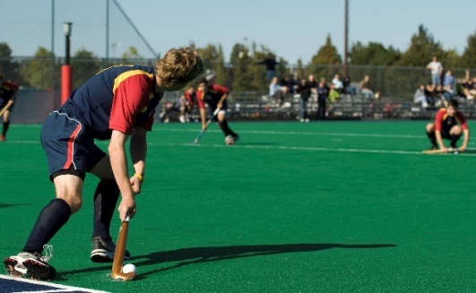 | 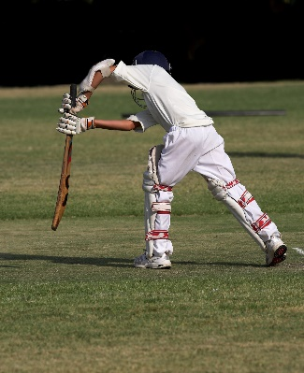
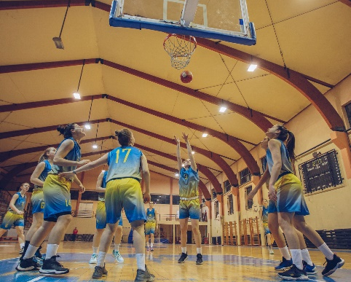 | 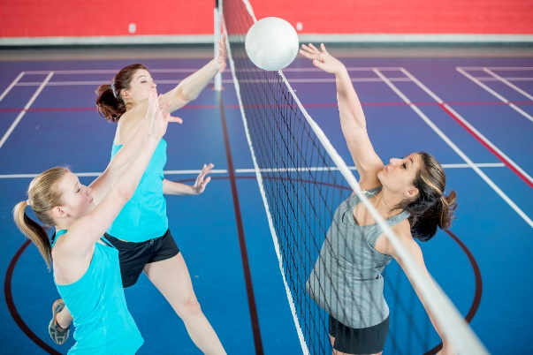
This video shows how a footballer performs a ‘Rabona’ kick. This is an example of creativity which can be used to outwit an opponent and gain a competitive advantage.

https://www.youtube.com/watch?v=NpcDYBSHEcY
Think of some examples of where you’ve used creativity in sport. Think of activities you’ve participated in at school as well as your own competitive activities. Explain the positive impact that this creativity had on your team.

Example one:

Explanation:

Example two:

Explanation:

Example three:
Explanation:
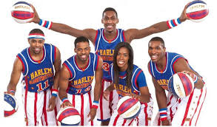
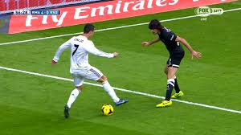

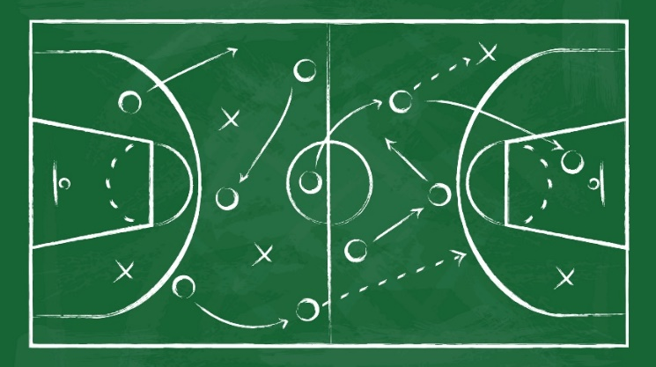
Appropriate use of tactics / strategies / compositional ideas

Make sure that you know the following information:
- Tactics can be implemented by a manager/coach, or by players during a game.
- Having a strategy is essential so that a team plays with cohesion and shape.
- Tactics can be very dynamic: they change all of the time.
- Different tactics will be used against different opposition.
- In some sports, (e.g. American Football), tactics can be very complex, and players will need to remember lots of complex set-plays and routines.

What tactics do you need to know and use in your chosen team and individual sports?

Individual
Team

Lesson 6
Decision making
LI: identify how decision-making during performance can help an individual
Decision-making during performance / awareness of role within team

Watch the following video: https://www.youtube.com/watch?v=KGNWrITO52w
It shows a series of poor decisions made by cricketers.
The image above shows a rugby player making a positive decision to release the ball before the incoming player tackles him. This would probably be a positive decision.

Answer the following questions:
- Why did the batsmen sometimes choose to leave the ball and not attempt to hit it?
- If you were the other batsmen in any of these shots, what decision could you have made to help / contribute to your team?
- Give an example of where you’ve made a good decision in sport which has contributed to your team’s performance.

Answers
1.

2.

3.

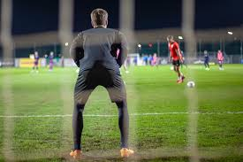

Research task:
Using your own knowledge of sport or the internet, write down all the tactics, decision making opportunities and creative opportunities that you would come across in both your team and individual sports.
Make sure you include examples of how these skills would help you in your game or what advantage they would give you over an opponent.
Tactics | Decision making | Creativity
Tactics examples | Decision making examples | Creativity examples

Performance log practical lesson 1

Session Objectives:

Date:

Warm-up:

Skills learnt (include key teaching points and diagrams of practices):

Tactical aspects covered (including game analysis):

Analysis of Self Performance:

- Did I understand the aims of the practices? What were they?

- Did these practices improve my performance? How?

- What aspects of this practice did I find easy / hard? Explain why

Your what went well & in needs of improvement identified from the session:
What went well | In need of improvement

Identify three ways in which your performance has improved

1.

2.

3.

Give yourself three action points that will help to improve your performance. These may include areas for development in your performance in aspects that are relatively new to you and require further practice. Now I will ….
- Action Point One

- Action Point Two

- Action Three

Performance log practical lesson 2

Session Objectives:

Date:

Warm-up:

Skills learnt (include key teaching points and diagrams of practices):

Tactical aspects covered (including game analysis):

Analysis of Self Performance:

- Did I understand the aims of the practices? What were they?

- Did these practices improve my performance? How?

- What aspects of this practice did I find easy / hard? Explain why

Your what went well & in needs of improvement identified from the session:
What went well | In need of improvement

Identify three ways in which your performance has improved

1.

2.

3.

Give yourself three action points that will help to improve your performance. These may include areas for development in your performance in aspects that are relatively new to you and require further practice. Now I will ….
- Action Point One

- Action Point Two

- Action Three

Performance log practical lesson 3

Session Objectives:

Date:

Warm-up:

Skills learnt (include key teaching points and diagrams of practices):

Tactical aspects covered (including game analysis):

Analysis of Self Performance:

- Did I understand the aims of the practices? What were they?

- Did these practices improve my performance? How?

- What aspects of this practice did I find easy / hard? Explain why

Your what went well & in needs of improvement identified from the session:
What went well | In need of improvement

Identify three ways in which your performance has improved

1.

2.

3.

Give yourself three action points that will help to improve your performance. These may include areas for development in your performance in aspects that are relatively new to you and require further practice. Now I will ….
- Action Point One

- Action Point Two

- Action Three

Performance log practical lesson 4

Session Objectives:

Date:

Warm-up:

Skills learnt (include key teaching points and diagrams of practices):

Tactical aspects covered (including game analysis):

Analysis of Self Performance:

- Did I understand the aims of the practices? What were they?

- Did these practices improve my performance? How?

- What aspects of this practice did I find easy / hard? Explain why

Your what went well & in needs of improvement identified from the session:
What went well | In need of improvement

Identify three ways in which your performance has improved

1.

2.

3.

Give yourself three action points that will help to improve your performance. These may include areas for development in your performance in aspects that are relatively new to you and require further practice. Now I will ….
- Action Point One

- Action Point Two

- Action Three

Performance log practical lesson 5

Session Objectives:

Date:

Warm-up:

Skills learnt (include key teaching points and diagrams of practices):

Tactical aspects covered (including game analysis):

Analysis of Self Performance:

- Did I understand the aims of the practices? What were they?

- Did these practices improve my performance? How?

- What aspects of this practice did I find easy / hard? Explain why

Your what went well & in needs of improvement identified from the session:
What went well | In need of improvement

Identify three ways in which your performance has improved

1.

2.

3.

Give yourself three action points that will help to improve your performance. These may include areas for development in your performance in aspects that are relatively new to you and require further practice. Now I will ….
- Action Point One

- Action Point Two

- Action Three

Performance log practical lesson 6

Session Objectives:

Date:

Warm-up:

Skills learnt (include key teaching points and diagrams of practices):

Tactical aspects covered (including game analysis):

Analysis of Self Performance:

- Did I understand the aims of the practices? What were they?

- Did these practices improve my performance? How?

- What aspects of this practice did I find easy / hard? Explain why

Your what went well & in needs of improvement identified from the session:
What went well | In need of improvement

Identify three ways in which your performance has improved

1.

2.

3.

Give yourself three action points that will help to improve your performance. These may include areas for development in your performance in aspects that are relatively new to you and require further practice. Now I will ….
- Action Point One

- Action Point Two

- Action Three

Stewards assessment ladder

