Year 10
Unit R053 - Sports Leadership
Spring 2 Blended Learning Booklet

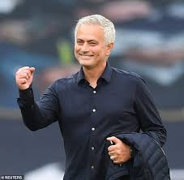


Name:

Aim to complete two lessons each week.
All video links and content are also uploaded on ClassCharts
The knowledge organisers have all the key information and vocabulary to help with this unit.
Upload all work onto ClassCharts for feedback

Contents
Page 3: Big Picture – Year overview
Page 4: Zoom in – My learning journey
Page 5: Knowledge organiser – Leadership
Page 7: Lesson 1
Page 10: Lesson 2
Page 11: Lesson 3
Page 12: Lesson 4
Page 13: Lesson 5
Page 14: Lesson 6
Page 15: Lesson 7 and 8
Page 18: lesson 9
Page 19: Lesson 10
Page 22: Coursework preparation task
Page 24: Stewards Assessment ladder

Big picture
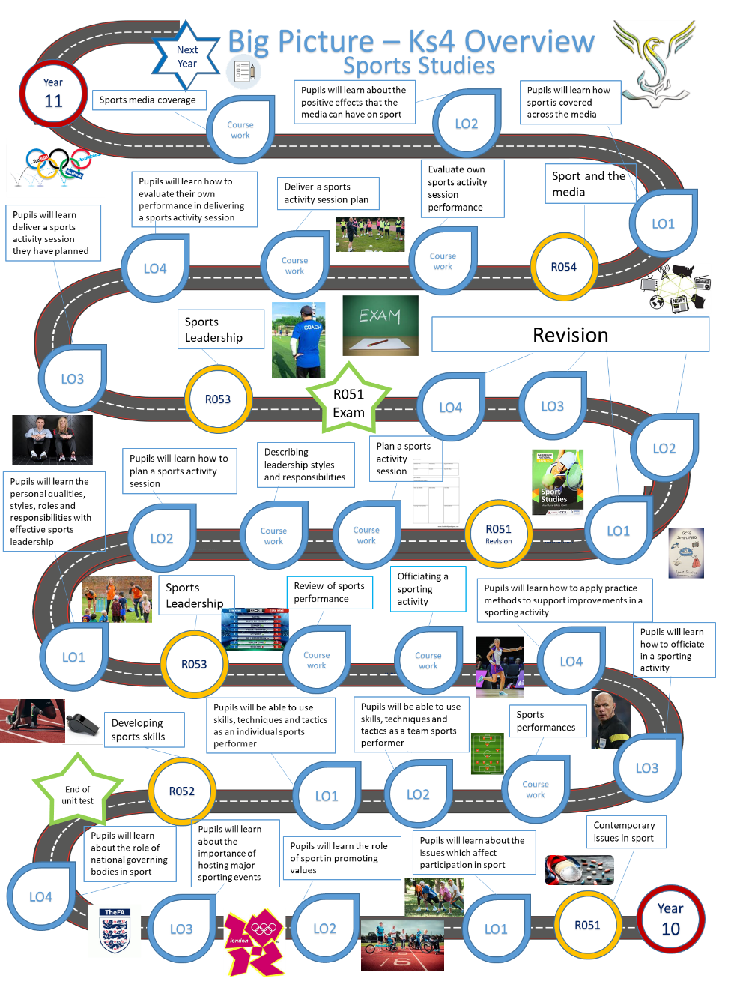

Zoom in
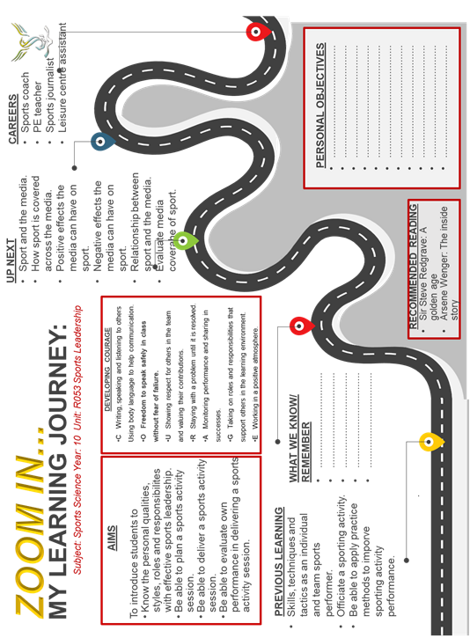

Knowledge organiser

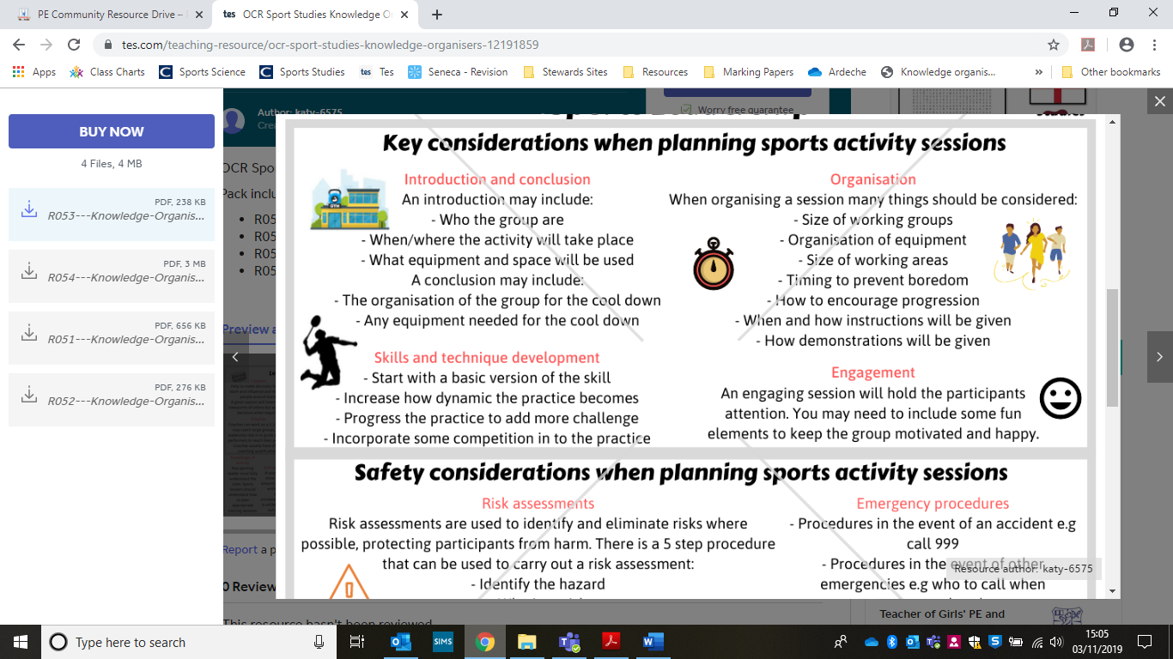
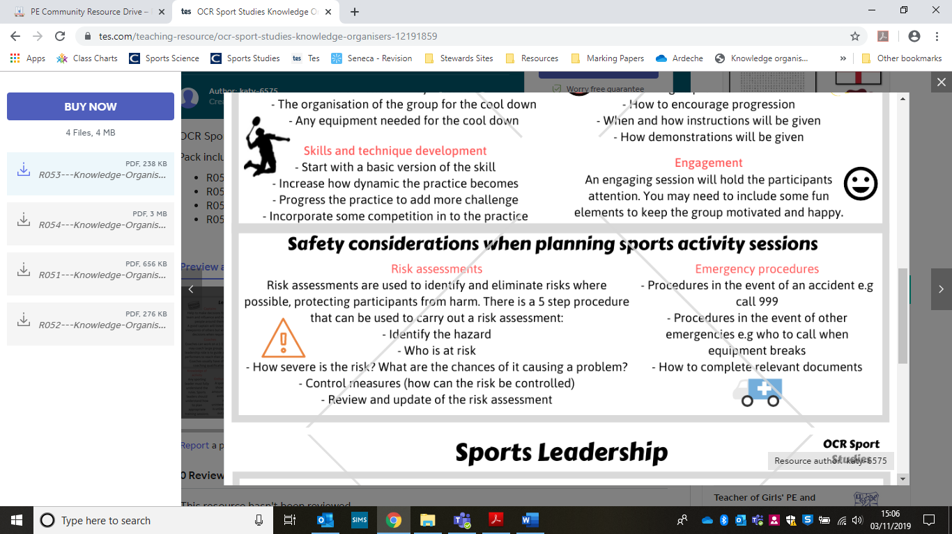

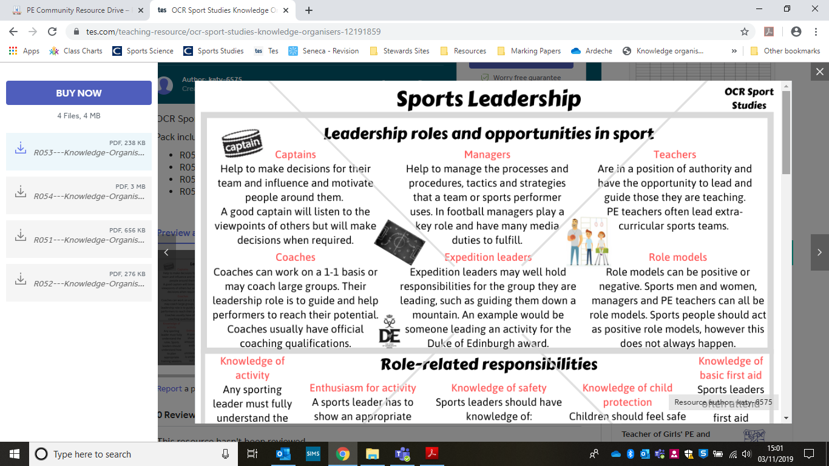
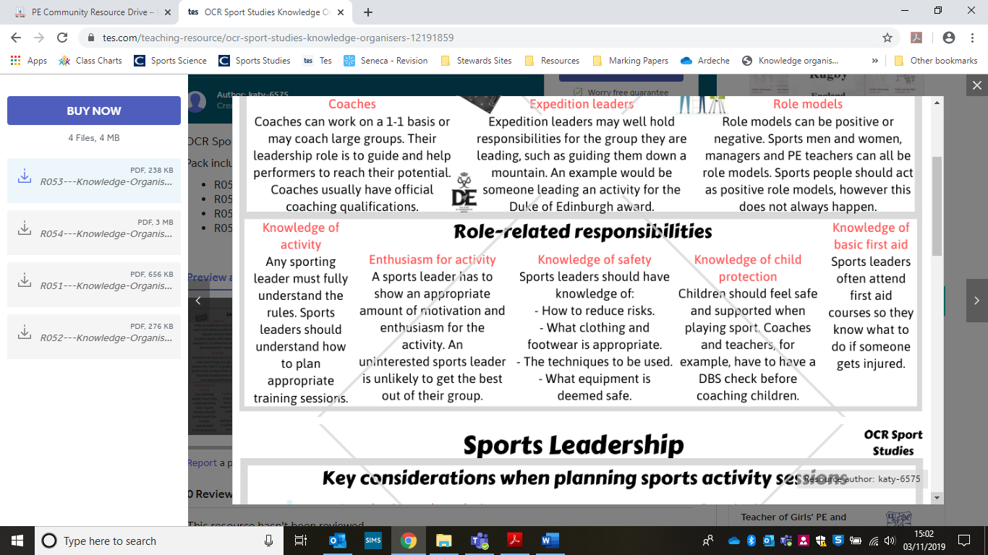
Lesson 1 and 2
Leadership roles

LO: explain the different leadership roles and opportunities in sport.
LO: explain what the role related responsibilities of a leader are.

Whether voluntary or professional, the role of the sport leader is imperative in any sport; adopting the role of coach, manager, teacher or team captain, sport leaders can shape the development of sport by influencing and inspiring those around them to participate and perform in sporting activities.

By completing this unit, you will develop some of the knowledge, understanding and practical skills required to be an effective sport leader and plan, deliver and review safe and effective sporting activity sessions yourself. You will be encouraged to consider and evaluate your delivery and, by doing so, develop your ability to communicate with an audience verbally and through practical demonstration, and adapt to developing situations and the different needs and abilities of those you are leading.

Different leadership roles and opportunities in sport

Sport in its nature provides opportunities for people to lead. Although not all sport is team-based, many activities need to work with others and to command respect and influence. In a sporting context, there are many examples of how leaders can influence others.

Q. What personal qualities make an effective leader?

- Expert communication skills

Q. can you give the role, qualities, and responsibilities of the following…
- Managers
- Captains
- Teachers
- Coaches
- Expedition leaders
- Role models

Managers
https://www.youtube.com/watch?v=fyemkQV4ygo

Role:

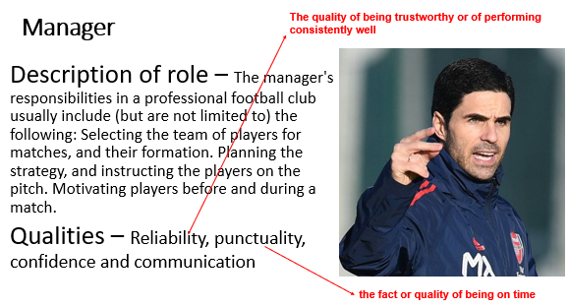
Qualities:

Responsibility:

Captains https://www.youtube.com/watch?v=3uZEs8iWrwo

Role:

Qualities:

Responsibility:

Teachers

Role:

Qualities:

Responsibility:
Coaches

Role:

Qualities:

Responsibility:

Expedition leaders

Role:

Qualities:

Responsibility:

Role Models

Role:

Qualities:

Responsibility:

Lesson 2
Responsibilities as a leader

LO: explain what the role related responsibilities of a leader are.

A major element of being an effective leader is having knowledge about the activity in which you are leading. This knowledge must cover many aspects of the leadership role

Q. why does a leader need to have knowledge of an activity?

Q. Why does a leader have to show enthusiasm for an activity?

Q. Why does a leader need to have knowledge of safety?

Q. Why do leaders need to have knowledge of child protection issues? – what is a DBS?

Q. Why do leaders need to have knowledge of basic first aid?

Lesson 3

Personal qualities which relate to leadership

LO: Understand the personal qualities which relate to leadership roles.

LO: Explain the 3 types of leadership styles; democratic, autocratic and laissez-faire

There are multitude of qualities that are common amongst good leaders

Q. What do the following words mean in relation to leadership qualities?

- Resilience:

- Punctuality:

- Confidence:

- Communication:

- Creativity:

- Charisma:

- Fairness:

- Reliability:

- Knowledge:

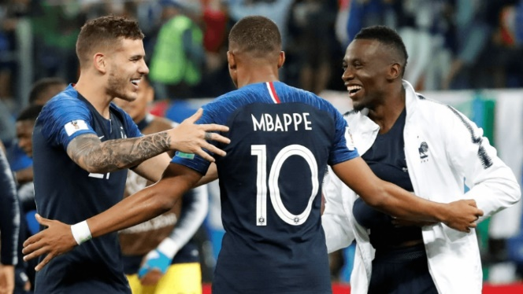

Lesson 4 –
Leadership styles

LO: Understand the personal qualities which relate to leadership roles.

LO: Explain the 3 types of leadership styles; democratic, autocratic and laissez-faire

Q. For the leadership styles below, find out what they mean and give an advantage and disadvantage of each

Autocratic
- Makes all the key decisions

Advantage:

Disadvantage:

Democratic
- Makes joint decisions with others

Advantage:

Disadvantage:

Laissez-faire

- Leaves the decision making and main responsibilities to others e.g. players, assistant coach, captains etc.

Advantage: Disadvantage:

Lesson 5
Re-cap and research
LO: Understand the personal qualities which relate to leadership roles

Q. Write down what leadership style or styles your sports coach use

Q. Do you feel that a particular style of leadership suits you when you were being led?

Q. Why style does your teacher use?

Q. What style would you be?

Q. Search on YouTube for footage sports leaders. What styles do you see them using and why do you think that is? Can you come up with examples of leaders who use different styles but are often successful?

Research different types of sports leaders that you can think of or that have been used in the lesson. You should include information about:
- What type of leader they are
- How effective their leadership style is
- What improvements they could make as a leader, if any
- How other players, coaches and spectators react to their leadership style.
Lesson 6

Key considerations when planning sports activity sessions

LI: understand the key considerations to take in to account when effectively and safely planning a sports activity session.
LO: identify what safe practice is in sport including organisation of the group and activity

Task: Match the word to the definition
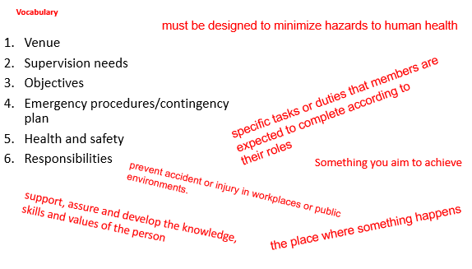
Task: Plan a session/pe lesson

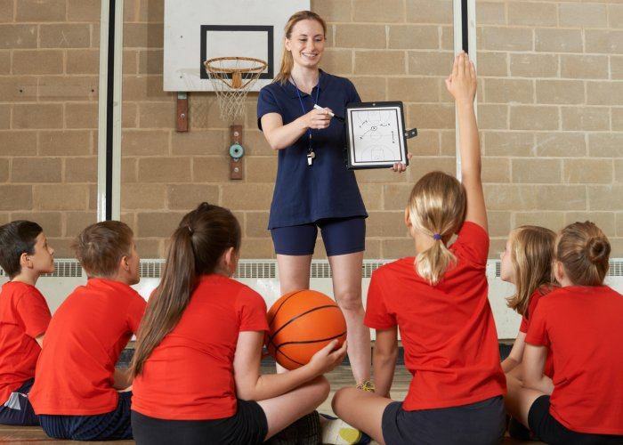
Must include the following….
- Objectives for the session
- Appropriate venue (e.g. type, size, indoor/outdoor)
- Equipment needs (e.g. type, size weight, arrangements)
- Supervision needs (e.g. additional leaders, roles, number of participants)
- Timing of activities (e.g. related to age, experience of participants, weather)
- Introduction/conclusion of session (e.g. how, when, where?)
- Warm up/cool down (e.g. physical and mental preparation of participants and activity)
- Skills and technique development (e.g. appropriate activities/structure of a session)
- Engaging (e.g. Will it be fun, flow smoothly? Will the activity hold their attention?
- Organisation (e.g. size/make up of working groups, size of working areas, length of warm up/drills, timing to prevent boredom, allowing progression)

Lesson 7/8
Safety considerations when planning sports activity sessions
LI: understand the key considerations to take in to account when effectively and safely planning a sports activity session.
LO: identify what safe practice is in sport including organisation of the group and activity

Risk assessments (e.g. facilities, equipment/clothing checks, activity-specific risks)

Task: Create your own risk assessment for your session (on a separate sheet or word document)
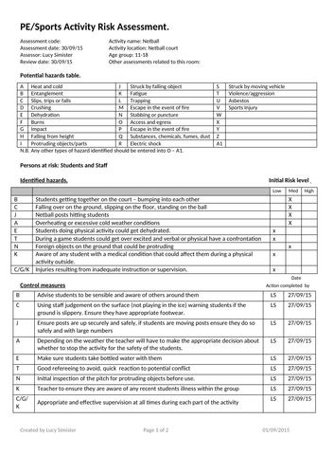

Example of a PE/Sports activity Risk Assessment

Q. What are your emergency procedures? (e.g. procedures in the event of an accident, procedures in the event of other emergencies, summoning qualified help, completion of relevant documents).

Q. What are the corrective actions? (e.g. wiping up puddles, removing litter, reporting faulty equipment)

Q. Do you feel the sports hall or playing area in your school are completely safe?

Q. What would need to be considered if you were to lead a session in this area?

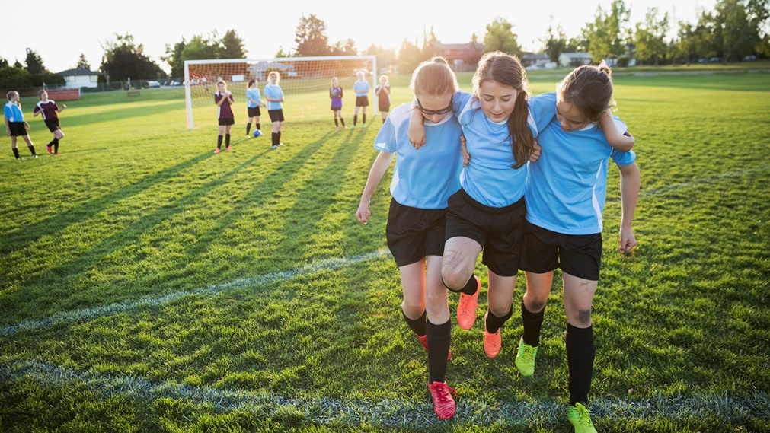

Lesson 9
Safe practice

LI: understand the key considerations to take in to account when effectively and safely planning a sports activity session.
LO: know the possible delivery styles when planning a sport session including proactive/reactive and demonstration/explanation

Deliver your session!

The assessor will consider whether the session was safe for all involved. This must be of paramount concern throughout and a conscientious effort should be made to prevent any identified risks from occurring

Q. Why do you need to be organised/how can you organise your group/activity?
Things to consider when answering the question….
- Positioning
- Is equipment accessible and available
- Make sure group sizes are not too large
- Keep an eye on time

Lesson 10
Safe supervision

LI: understand the key considerations to take in to account when effectively and safely planning a sports activity session.
LO: safely supervise a sports activity as a leader or coach

As a leader of the session safety is your responsibility…

Q. If you see practice this is unsafe what should you do?

Q. Why is it suggested to have a mobile phone to hand?

Q. Why should you rehearse the session in your head?

Delivery style, i.e. o proactive/reactive - You need to think about the delivery style and the way you will lead the session

Q. How can you avoid a lesson ‘dragging’? – slowly/tediously

Q. When delivering a session try to be proactive and reactive…. Research what the words in red mean and write them down below

Proactive -

Reactive –

Demonstrations –

Q. Give examples when demonstrations have been used in a session

Evaluation On My Own Performance
Sports Session

Coach
Sport/ Activity
Date

Warm Up (What did it consist of, would you change anything)
__________________________________________________________________________________________________________________________________________________________________________________________________________________________________________________________________________________________________________________________________________

Activity (How well did it go, would you make changes for the future)
________________________________________________________________________________________________________________________________________________________________________________________________________________________________________________________________________
__________________________________________________________________

Cool Down (How well did it go, would you make changes for the future)
__________________________________________________________________________________________________________________________________________________________________________________________________________________________________________________________________________________________________________________________________________

How was my performance | √ | × | Comments
Was I organised

Did I Have knowledge of sport

Did I praise efforts

Did I feel confident

Was my communication clear and well heard

Did I motivate

Was I encouraging?

Did I show a good character, ie posture, facial expressions

Evaluation On Sports Coach/Leader

Coach/
Name
Date

Circle Answer

- Did you enjoy the activity session.
Yes No
- Was the Coach/Leader Friendly.
Yes No
- Did the coach/leader praise you for your efforts.
Yes No
- Did the coach/leader speak loud and clearly.
Yes No
- Did the Coach/Leader help when you didn’t understand.
Yes No

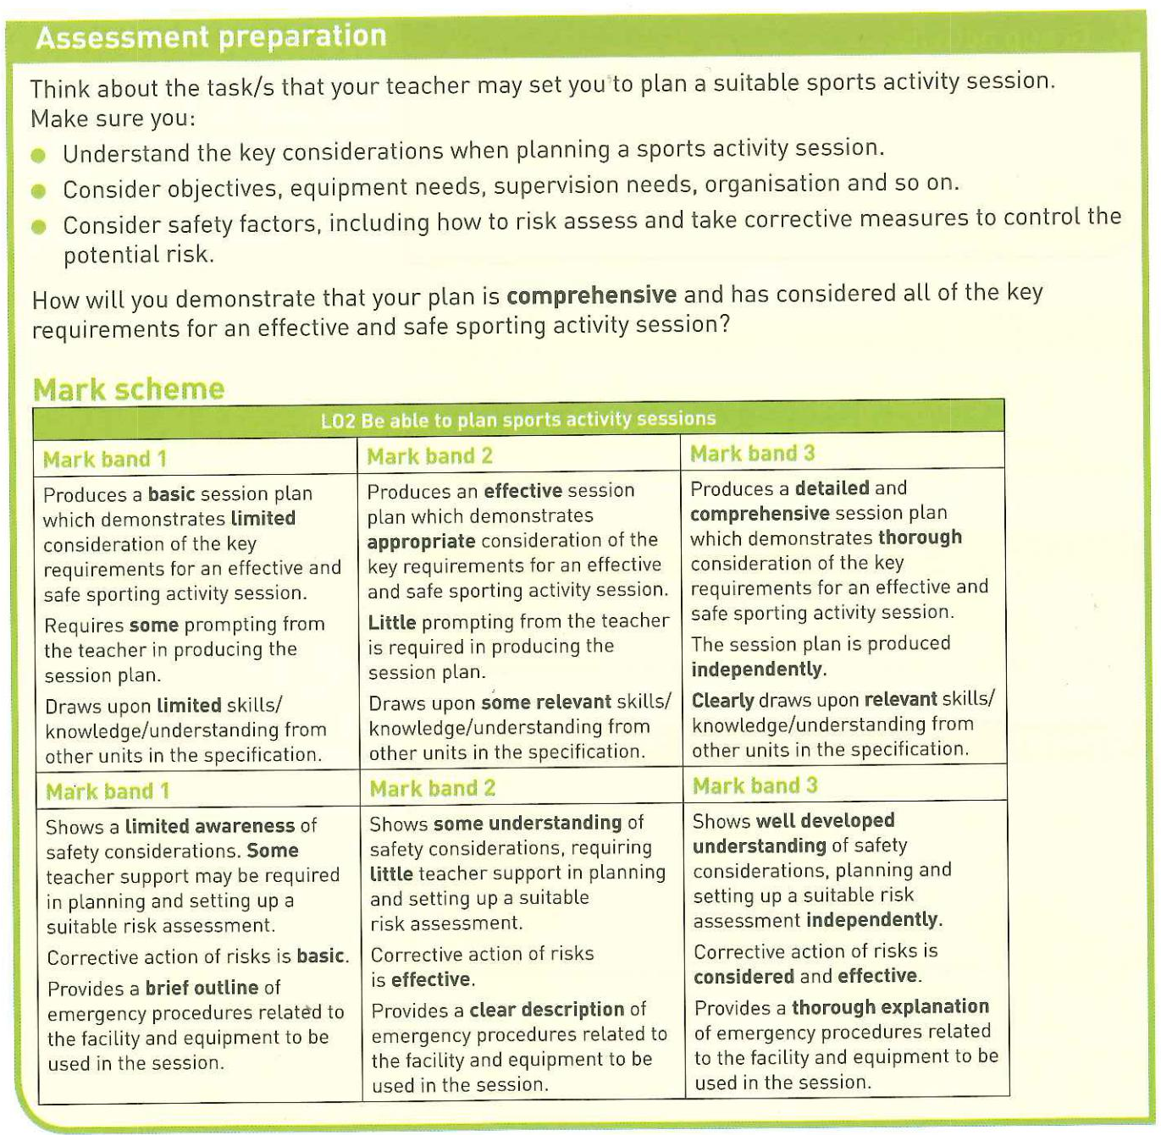
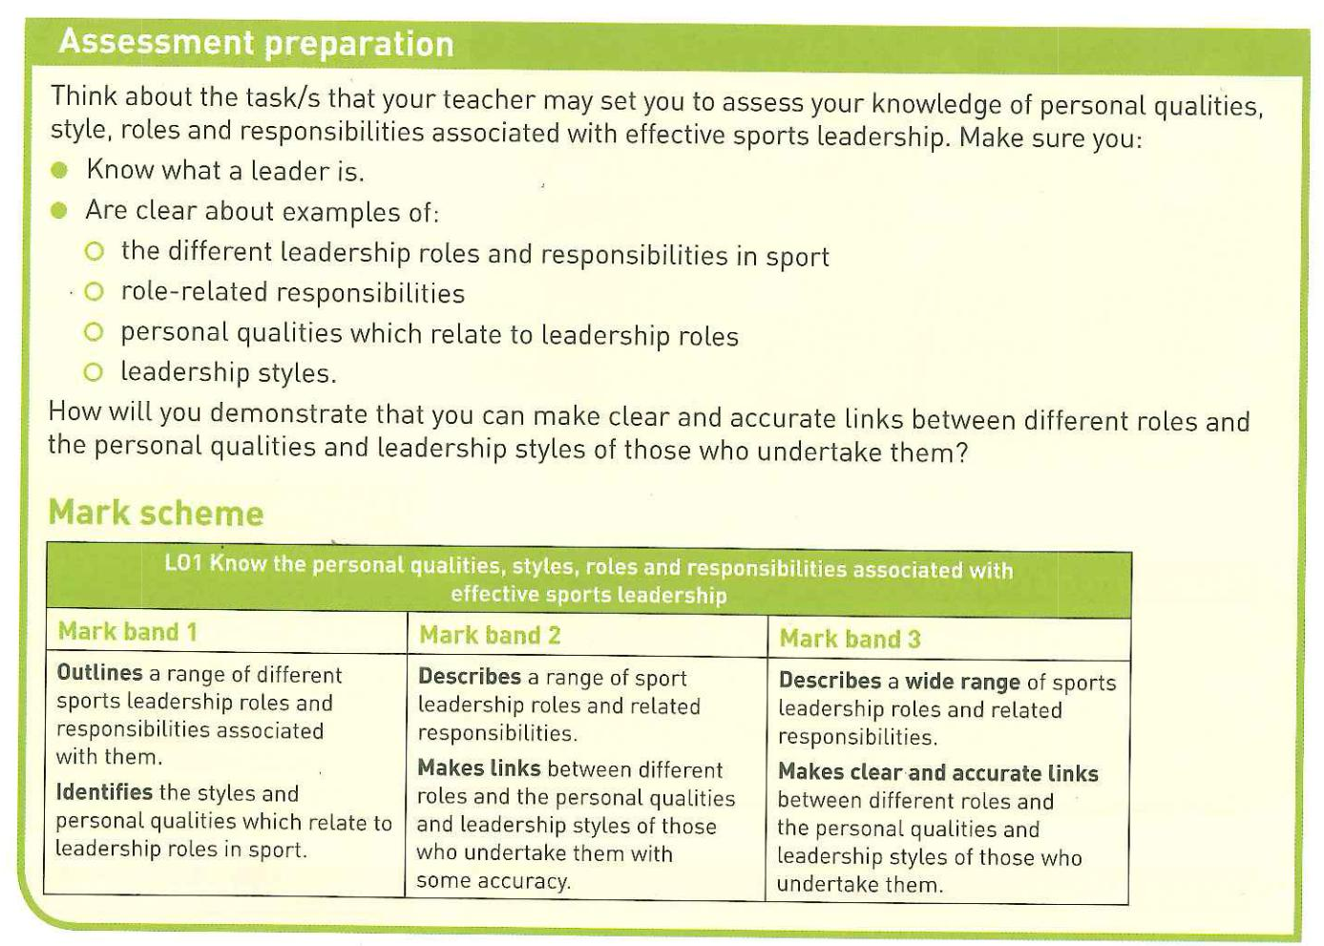
Coursework preparation

LO: know the personal qualities, styles, roles and responsibilities associated with effective sports leadership

Assessment ladders

Current Pathway | Unit 1 : know the personal qualities, styles, roles and responsibilities associated with effective sports leadership.  Learning objective 1
Current Pathway | Knowledge and Understanding | Skills
MB3 8-9 marks | Describes a wide range of sports leadership roles and related responsibilities.  Makes clear and accurate links between different roles and the personal qualities and leadership styles of those who undertake them. | Ability to work independently to create to create high standard of coursework  Extensive use of relevant examples to back up discussion.  Extensive and correct use of sports leadership terminology.
MB2 5-7 marks | Describes a range of sports leadership roles and related responsibilities.  Makes links between different roles and the personal qualities and leadership styles of those who undertake them with some accuracy. | Ability to work independently to create to create high standard of coursework  Extensive use of relevant examples to back up discussion.  Extensive and correct use of sports leadership terminology.
MB1 1-4 marks | Outlines a range of different sports leadership roles and responsibilities associated with them.  Identifies the styles and personal qualities which relate to leadership roles in sport. | Ability to produce some coursework with some comprehension of the task  Wide use of examples to back up discussion.  Wide and correct use of sports leadership terminology.

Current Pathway | Unit 1 : Be able to plan a sports activity session.  Learning Objective 2
Current Pathway | Knowledge and Understanding | Skills
MB3 8-10 marks | Produces a detailed and comprehensive session plan which demonstrates thorough consideration of the key requirements for an effective and safe sporting activity session.  The session plan is produced independently.  Clearly draws upon relevant skills/knowledge/understanding from other units in the specification. | Ability to work independently to create to create high standard of coursework  Extensive use of sports examples to back up discussion.  Extensive and correct use of sports skills terminology.
MB2 5-7 marks | Produces an effective session plan which demonstrates appropriate consideration of the key requirements for an effective and safe sporting activity session.  Little prompting from the teacher is required in producing the session plan.  Draws upon some relevant skills/knowledge/understanding from other units in the specification. | Ability to produce some coursework with some comprehension of the task  Wide use of sports examples to back up discussion.  Wide and correct use of sports skills terminology.
MB1 1-4 marks | Produces a basic session plan which demonstrates limited consideration of the key requirements for an effective and safe sporting activity session.  Requires some prompting from the teacher in producing the session plan.  Draws upon limited skills/knowledge/understanding from other units in the specification. | Ability to create some coursework.  Some sports examples used.  Some sports skills but not always correct.

Current Pathway | Unit 2: Be able to deliver a sports activity session Learning objective 3
Current Pathway | Knowledge and Understanding | Skills
MB3 13-18 marks | Demonstrates advanced application of skills and knowledge in delivering a sports activity session.  Delivery of the session shows advanced application of activity specific knowledge. Adapts the session efficiently as it progresses to meet the needs of the participants.  Appreciation of safe practice is well developed and evident throughout in both the organisation and supervision of the session.  Communication skills and motivation  techniques are clear and confident. | Ability to work independently to create to create high standard of coursework  Extensive use of relevant examples to back up discussion.  Extensive and correct use of sports leadership terminology.
MB2 7-12 marks | Demonstrates effective application of skills and knowledge in delivering a sports activity session.  Delivery of the session shows effective application of activity specific knowledge, with some awareness of adaptability as the session progresses.  Shows a clear appreciation of safe practice on most occasions during the delivery of the session.  Communication skills and motivation  techniques are clear. | Ability to work independently to create to create high standard of coursework  Extensive use of relevant examples to back up discussion.  Extensive and correct use of sports leadership terminology.
MB1 1-6 marks | Demonstrates limited application of skills and knowledge in delivering a sports activity session. Delivery of the session shows limited application of activity specific knowledge, with little awareness of adaptability as the session progresses.  Shows a basic appreciation of safe practice at times during the delivery of the session.  Communication skills and motivation techniques are hesitant. | Ability to produce some coursework with some comprehension of the task  Wide use of examples to back up discussion.  Wide and correct use of sports leadership terminology.

Current Pathway | Unit 2 : Be able to evaluate own performance in delivering sports activity sessions  Learning Objective 4
Current Pathway | Knowledge and Understanding | Skills
MB3 12-15 marks | Evaluation of performance is comprehensive.  Most positive and most negative aspects are identified.  The plan for the session and how it was delivered are fully considered in evaluating its overall success.  Ideas for improvement are insightful and address specific aspects of planning and delivery which have been identified. | Ability to work independently to create to create high standard of coursework  Extensive use of sports examples to back up discussion.  Extensive and correct use of sports skills development terminology.
MB2 7-11 marks | Evaluation of the session is detailed.  Both positive and negative aspects are identified.  Some consideration is given to the plan for the session and how it was delivered in evaluating its overall success.  Ideas for improvement are clear and relevant to the aspects identified. | Ability to produce some coursework with some comprehension of the task  Wide use of sports examples to back up discussion.  Wide and correct use of sports skills development terminology.
MB1 1-6 marks | Evaluation of the session is brief.  Some basic positives and/or negatives are identified.  Consideration of the plan for the session, how it was delivered and its overall success is minimal.  Ideas for improvement are limited. | Ability to create some coursework.  Some sports examples used.  Some sports skills development but not always correct.

