Year 10
Unit 2.1.a – Engagement Patterns of Different Social Groups in Physical Activity and Sport

Spring 2 Blended Learning Booklet

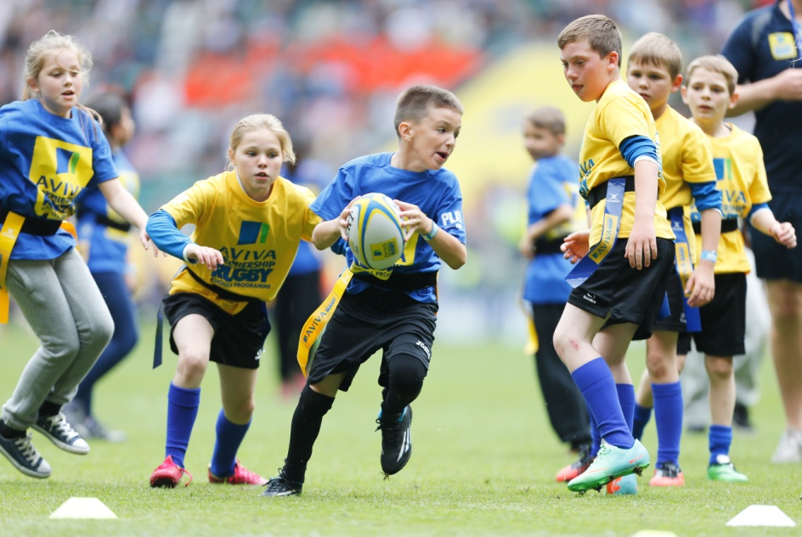
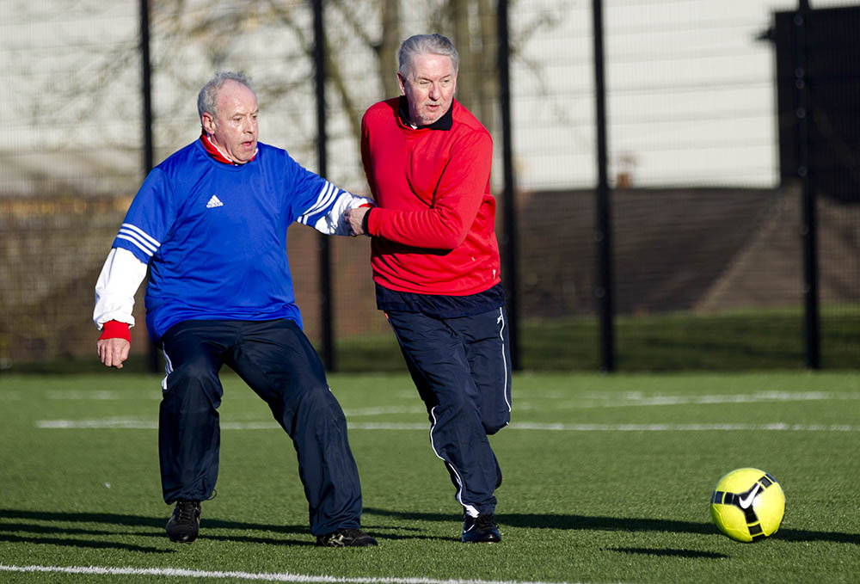

Name:

Aim to complete two lessons each week.
All video links and content are also uploaded on ClassCharts
The knowledge organisers have all the key information and vocabulary to help with this unit.
Upload all work onto ClassCharts for feedback

Contents:
Page 3: Big Picture – Year overview
Page 4: Zoom in – My learning Journey
Page 5: Knowledge Organiser – Participation in Physical Activity and Sport
Page 6: Knowledge Organiser – Physical Activity and Sport in the UK
Page 7-11: Lesson 1 – Engagement Patterns in Sport
Page 12-15: Lesson 2&3 – Social Groups in Sport
Page 16-23: Lesson 4&5 – The Factors Affecting Participation
Page 24-30: Lesson 6 – Strategies to Improve Participation
Page 31-34: Lesson 7 – The 6 Mark Question
Page 35: Lesson 6 – Revision Lesson
Page 35: Lesson 7 – End of Topic Test
Page 35: Lesson 8 – Feedback Analysis
Page 36-37: Stewards Assessment Ladder

Big Picture

Lesson 1: Engagement Patterns in Sport
LI: To be able to identify the current trends in participation in physical activity and sport.

LO: I can identify the current trends in participation in physical activity and sport.

Seneca: 3.1 Engagement patterns

GCSE Bitesize: https://www.bbc.co.uk/bitesize/guides/zy62hv4/revision/1

Teacher Powerpoint: Uploaded on to Classcharts

Engagement Patterns in Sport

Engagement patterns, also known as participation rates, are pieces of data which show us how many people are participating, or not participating in sport.
The definition of participation rates is ‘the number of people within a group who are involved in sport compared with those who are not’.
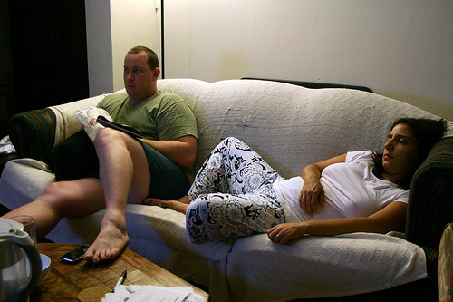
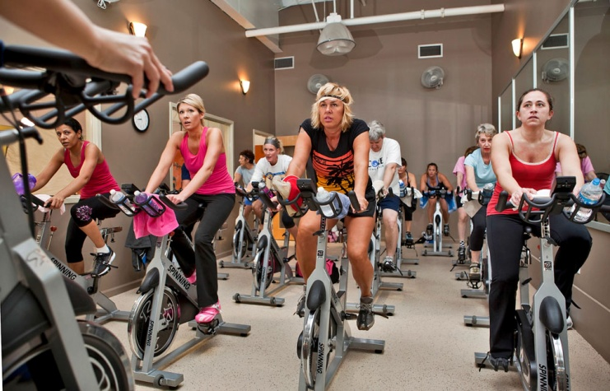

Task: In pairs rank the sports on the next slide in order of which you think is the most popular. By most popular this means which sports had the most people aged 16+ participating in them at least once a week.
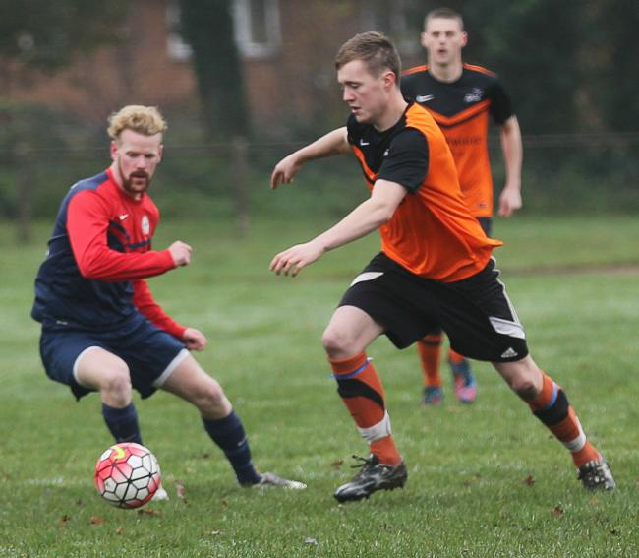 | 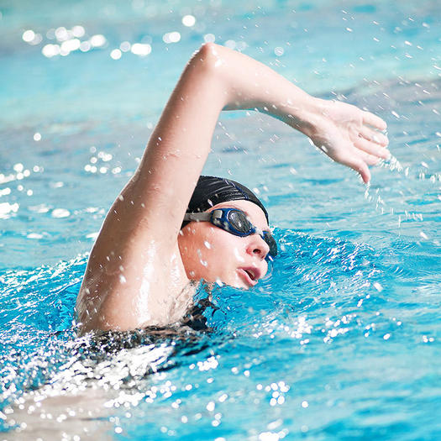
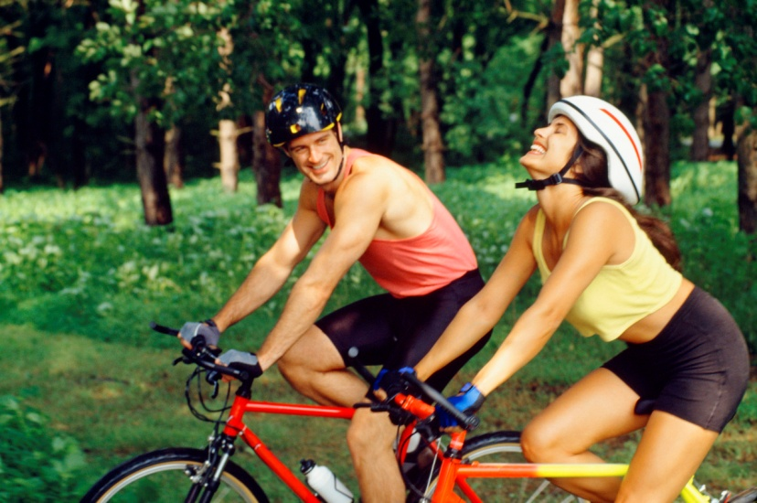 | 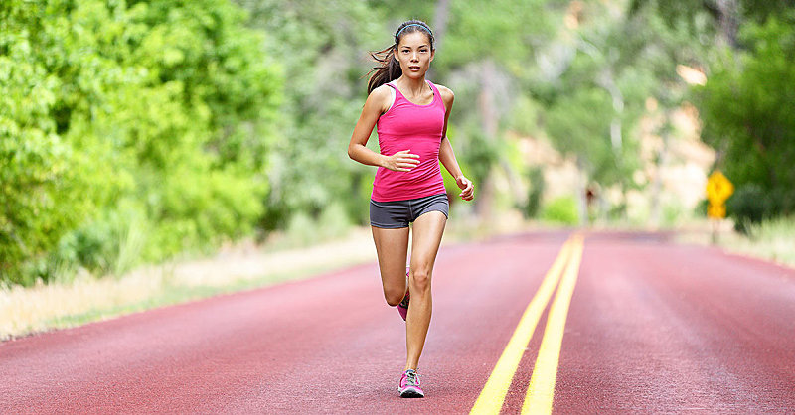
 | 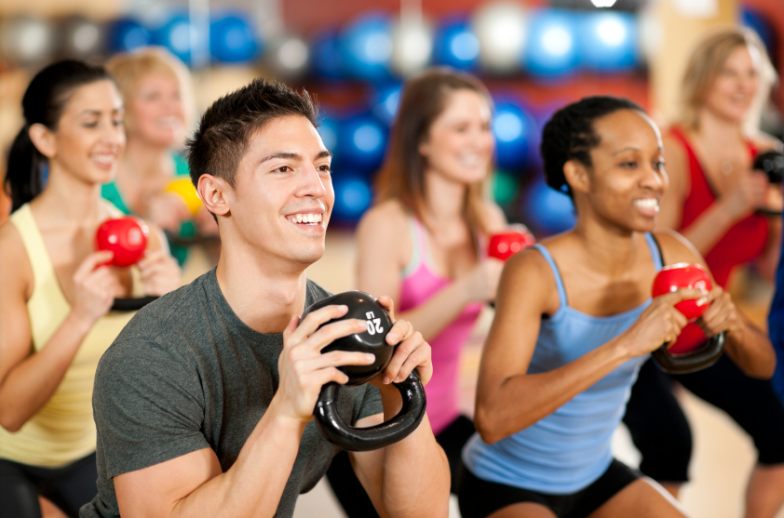
Sport England’s Active People Survey: Once a week participation in funded sports (aged 16+)
Sport: | Number of People Participating  (Oct 2014 - Sep 2015) | Number of People Participating  (Oct 2015 - Sep 2016) | Percentage of People Participating  (Oct 2015 - Sep 2016)
Swimming | 2,505,700 | 2,516,700 | 5.67%
Athletics | 2,326,200 | 2,217,800 | 5.01%
Cycling | 2,035,500 | 1,950,300 | 4.40%
Football | 1,815,000 | 1,844,900 | 4.21%
Golf | 740,100 | 729,300 | 1.64%
Exercise, Movement and Dance | 407,800 | 437,200 | 0.98%
Badminton | 431,600 | 425,800 | 0.97%
Tennis | 445,200 | 398,100 | 0.90%
Equestrian | 289,400 | 282,400 | 0.64%
Bowls | 206,700 | 211,900 | 0.49%

Task: Using the data in the table above work out which sports experienced an increase in participation rates in 2015-16 and which sports experienced a decrease in participation rates in the same year.
Sports that increased in popularity: | Sports that decreased in popularity:

Task: Choose one of the sports that experienced an increase in participation and explain why this may be.
Sport:

Task: Choose one of the sports that experienced a decrease in participation and explain why this may be.
Sport:

Engagement Patterns of Different Social Groups in Physical Activity & Sport - Video Links
Use these clips to help fill in the boxes in your following lessons
Description: | Link:
STARTER: Sport participation is down in the UK | https://www.youtube.com/watch?v=T_8hLOJXdwg
PARTICIPATION: NSPCC Why I love sport | https://www.youtube.com/watch?v=Xix50_BF6pI
SOCIAL GROUPS: Inspired facilities in London | https://www.youtube.com/watch?v=XbdlZxvQXQs
SOCIAL GROUPS (AGE): 101 year old runs the London Marathon | https://www.youtube.com/watch?v=gCY0Xx92YvQ
SOCIAL GROUPS (AGE): Child sporting prodigies | https://www.youtube.com/watch?v=ek57_lweazE
SOCIAL GROUPS (GENDER): Rugby’s first female referee, Sara Cox | https://www.youtube.com/watch?v=KF95K8uS048
SOCIAL GROUPS (GENDER): Life as a male cheerleader | https://www.youtube.com/watch?v=d_rtdhBCy8k
SOCIAL GROUPS (ETHNICITY): FIBA lifts ban on hijab | https://www.youtube.com/watch?v=utx-JAu5IiQ
SOCIAL GROUPS (ETHNICITY): Racism stops with me. | https://www.youtube.com/watch?v=kNT2SgcxhwM
SOCIAL GROUPS (DISABILITY): Sports England supports disability sport | https://www.youtube.com/watch?v=vjCh6EyHcRU
SOCIAL GROUPS (DISABILITY): The amazing story of Ibrahim Hamatou | https://www.youtube.com/watch?v=GEg4m5b54V4
SOCIAL GROUPS (SOCIO-ECONOMIC): Costs of being a PRO golfer | https://www.youtube.com/watch?v=PlhUVm4vrYg
SOCIAL GROUPS (SOCIO-ECONOMIC): Gitega Street children – street boys project. | https://www.youtube.com/watch?v=A4VY0PDMYuA
SOCIAL GROUPS (SOCIO-ECONOMIC): Independent schools competitors and medalists | https://www.youtube.com/watch?v=3dMHJqEVDdQ
FACTORS AFFECTING PARTICIPATION (AGE): 100 & 102 year olds break world records | https://www.youtube.com/watch?v=tOzCoDvRqyk
FACTORS AFFECTING PARTICIPATION (GENDER): A turning point for gender equality in sport | https://www.youtube.com/watch?v=r7RGZTExorA
FACTORS AFFECTING PARTICIPATION (ETHNICITY): The sports GENE. | https://www.youtube.com/watch?v=VOD4Pg4DJiw
FACTORS AFFECTING PARTICIPATION (RELIGION): Jawahir, the most remarkable referee. | https://www.youtube.com/watch?v=iTm2Gn94rfs
FACTORS AFFECTING PARTICIPATION (FAMILY): At home with Adam Peaty | https://www.youtube.com/watch?v=IwBHDo6v5lE
FACTORS AFFECTING PARTICIPATION (FAMILY): The truth about sports parents | https://www.youtube.com/watch?v=u2LR4c3JsmU
FACTORS AFFECTING PARTICIPATION (EDUCATION): Millfield sports facilities | https://www.youtube.com/watch?v=k44ZhnyZeqQ
FACTORS AFFECTING PARTICIPATION (EDUCATION): PE teachers lasting affect on a persons desire to exercise | https://www.youtube.com/watch?v=Q9BU-STDqLY
FACTORS AFFECTING PARTICIPATION (TIME): A day in the life of professional triathlete, Michi Weiss | https://www.youtube.com/watch?v=YNUHXPSByyU
FACTORS AFFECTING PARTICIPATION (COST / DISPOSABLE INCOME): When tennis too expensive | https://www.youtube.com/watch?v=gWvJ4PtxeFs  (Till 3:00, then 4:55-5:30)
FACTORS AFFECTING PARTICIPATION (DISABILITY): Disability in sport | https://www.youtube.com/watch?v=BymoSyjBspM
FACTORS AFFECTING PARTICIPATION (OPPORTUNITY / ACCESS): Disabled students and sports | https://www.youtube.com/watch?v=MFbaXVOFk9U
FACTORS AFFECTING PARTICIPATION (DISCRIMINATION): Celebrating equality for all athletes | https://www.youtube.com/watch?v=S14QJcI4KNs
FACTORS AFFECTING PARTICIPATION (ENVIRONMENT / CLIMATE): Skiing the Ben Nevis range | https://www.youtube.com/watch?v=V07r7q9THZE
FACTORS AFFECTING PARTICIPATION (COVERAGE): Media coverage of women’s sports | https://www.youtube.com/watch?v=zT_dhb6u64M
FACTORS AFFECTING PARTICIPATION (ROLE MODELS): Athletes as role models | https://www.youtube.com/watch?v=JdVNG2ulTGQ
STRATEGIES TO IMPROVE PARTICIPATION IN SPORT: Childhood obesity | https://www.youtube.com/watch?v=yuH8QQiH-d0
STRATEGIES TO IMPROVE PARTICIPATION IN SPORT: Childhood obesity | https://www.youtube.com/watch?v=zUpR-3cghjo
SPORT ENGLAND: This Girl Can | https://www.youtube.com/watch?v=kCdrJS1ojD8
NATIONAL GOVERNING BODIES: Rounders vs Work life balance | https://www.youtube.com/watch?v=ZjKeraMTL6Y
NATIONAL GOVERNING BODIES: The FA People’s Cup | https://www.youtube.com/watch?v=LCPDbwyRwhg
NATIONAL GOVERNING BODIES: Walking Netball | https://www.youtube.com/watch?v=qzQfnv7sFPg
Department for Culture, Media and Sport (DCMS): Sporting Future, Max Rushden Street League | https://www.youtube.com/watch?v=RvL5IGJLZPg
REVISION: Participation in sport – Flipped | https://www.youtube.com/watch?v=EEavTH8Y588

Lesson 2&3: Social Groups in Sport
LI: To be able to identify the different social groups to help identify trends in participation in physical activity and sport

LO: I can identify the different social groups to help identify trends in participation in physical activity and sport

Seneca: 3.1.1 Sport in the UK

GCSE Bitesize: https://www.bbc.co.uk/bitesize/guides/zy62hv4/revision/2

Teacher Powerpoint: Uploaded on to Classcharts

Social Groups in Sport

A social group is a group of two or more people who interact with one another, share similar characteristics, and collectively have a sense of unity.
Engagement patterns in physical activity and sport can differ between certain social groups.
These social groups are gender, age, ethnicity, disability and socio-economic groups.

Social Group: Age

- K

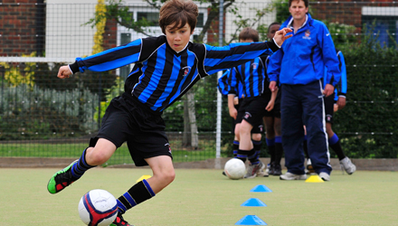

- J

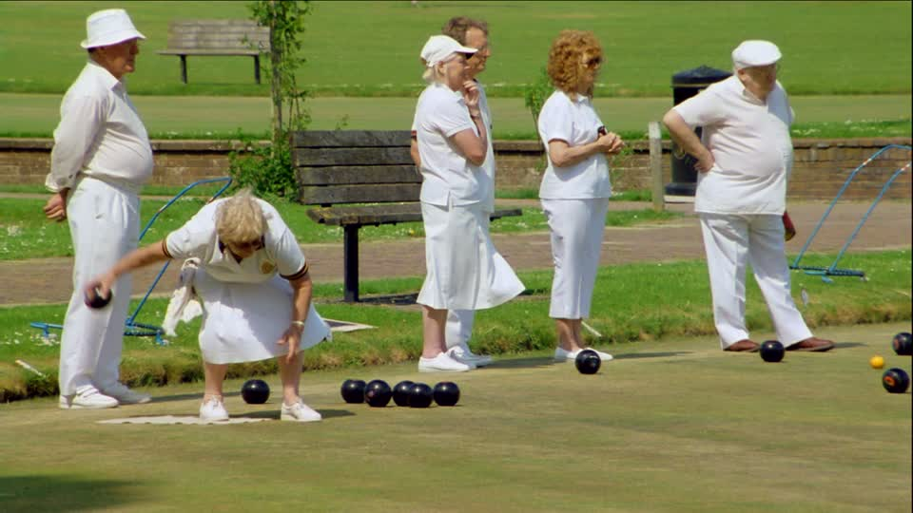
Sporting Examples:

- Football, running and cycling are more popular with younger age groups and the rates of participation in these sports decreases with age.

- Participation rates in swimming and exercise classes remain at similar levels between the ages of 16-44 then they fall.

- The most popular age group to participate in bowls is 60-69.

Social Group: Gender

- K

- J

- J

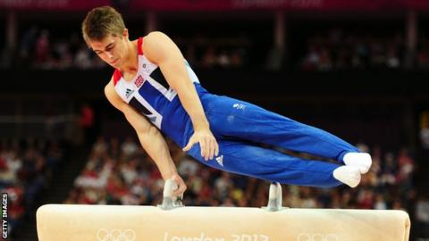
- H

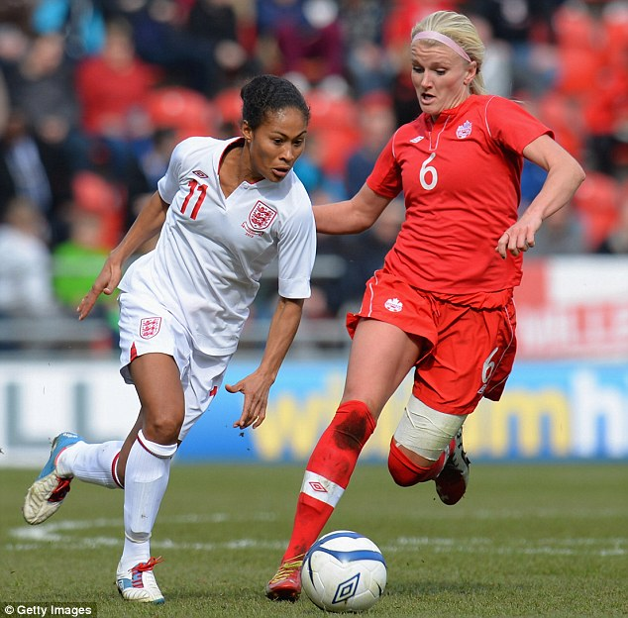
Barriers to Women’s Participation:

Social Group: Ethnicity

- K

- J
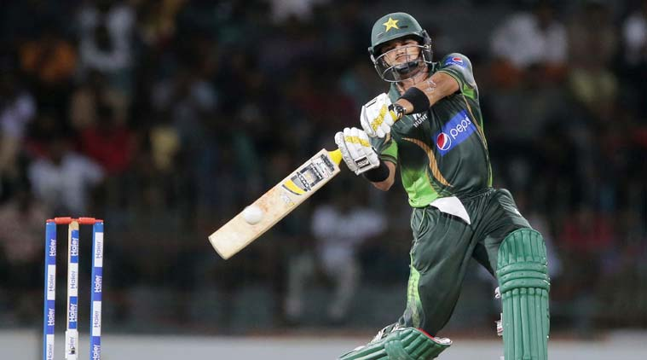

- J

- H

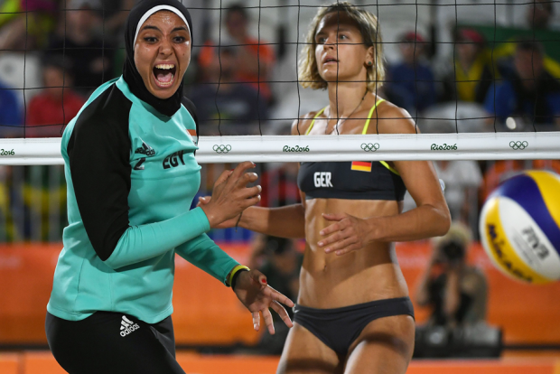

Social Group: Disability

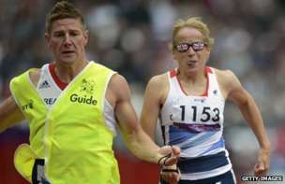
- K

- J

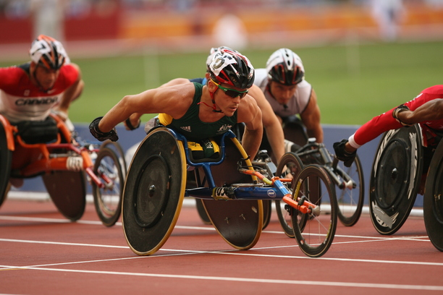
- J

Social Group: Socio-Economic Group

- K

- J

- J

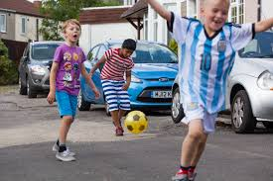
- H

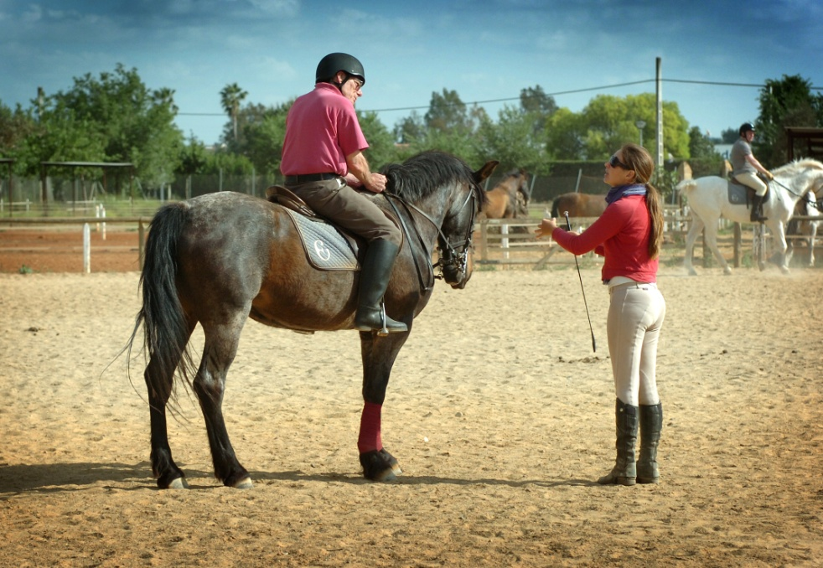

Lesson 4&5: The Factors Affecting Participation
LI: To understand how different factors can affect participation including; age, gender, ethnicity, religion/culture, family, education, time/work commitments, cost/disposable income, disability, opportunity/access, discrimination, environment/climate, media coverage, role models.

LO: I can understand how different factors can affect participation including; age, gender, ethnicity, religion/culture, family, education, time/work commitments, cost/disposable income, disability, opportunity/access, discrimination, environment/climate, media coverage, role models.

Seneca: 3.1.2 Participation in Physical Activity

GCSE Bitesize: https://www.bbc.co.uk/bitesize/guides/zy62hv4/revision/4

Teacher Powerpoint: Uploaded on to Classcharts

The Factors affecting Participation
Factor:

- K

- J

- J

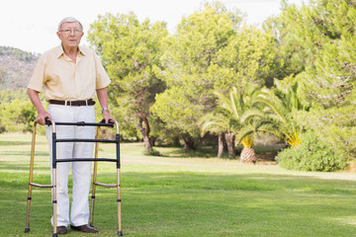
Sporting Example:

Extension Task (5+) - Your Example:

Factor:

- K

- J

- J

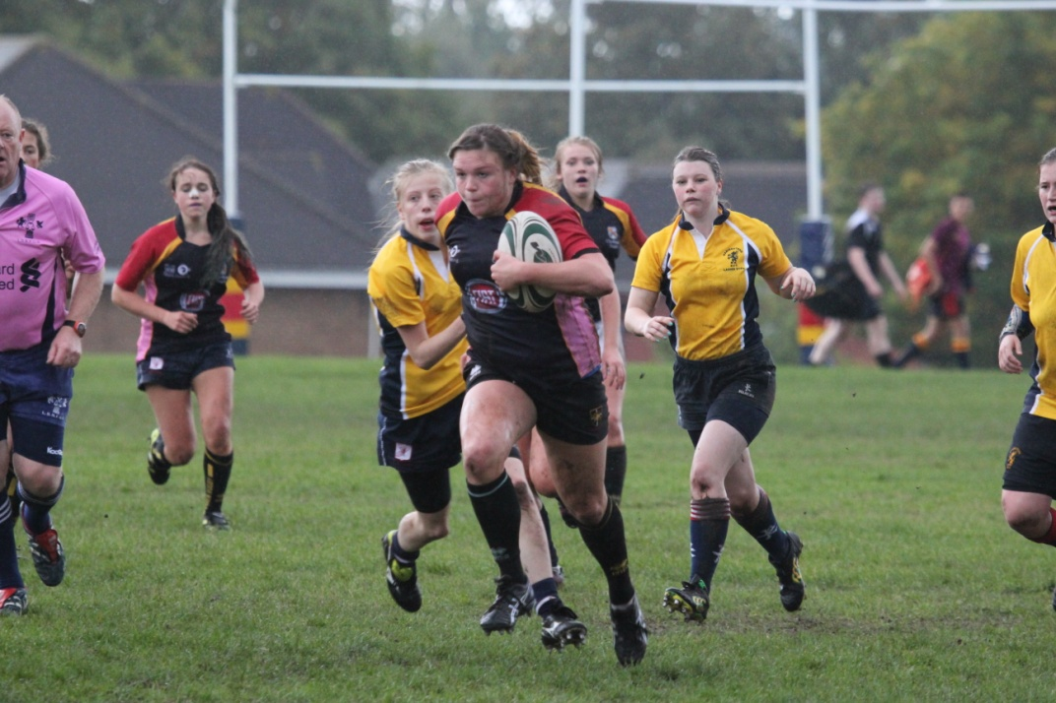
Sporting Example:

Extension Task (5+) - Your Example:

Factor:

- K

- J

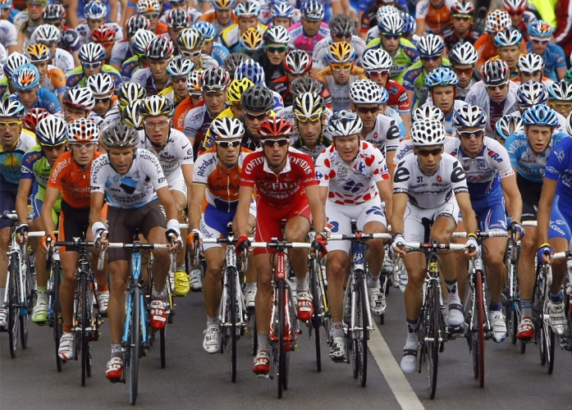
Sporting Example:

Extension Task (5+) - Your Example:

Factor:

- K

- J

- J

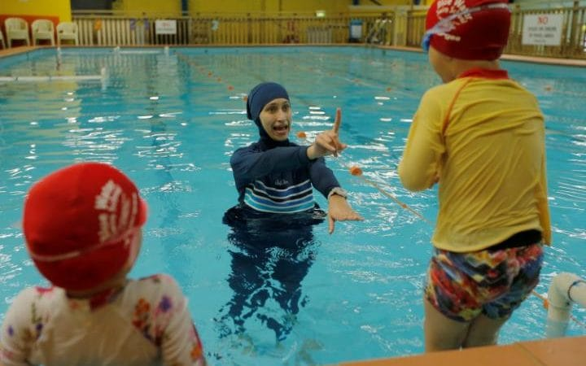
Sporting Example:

Extension Task (5+) - Your Example:

Factor:

- K

- J

- J

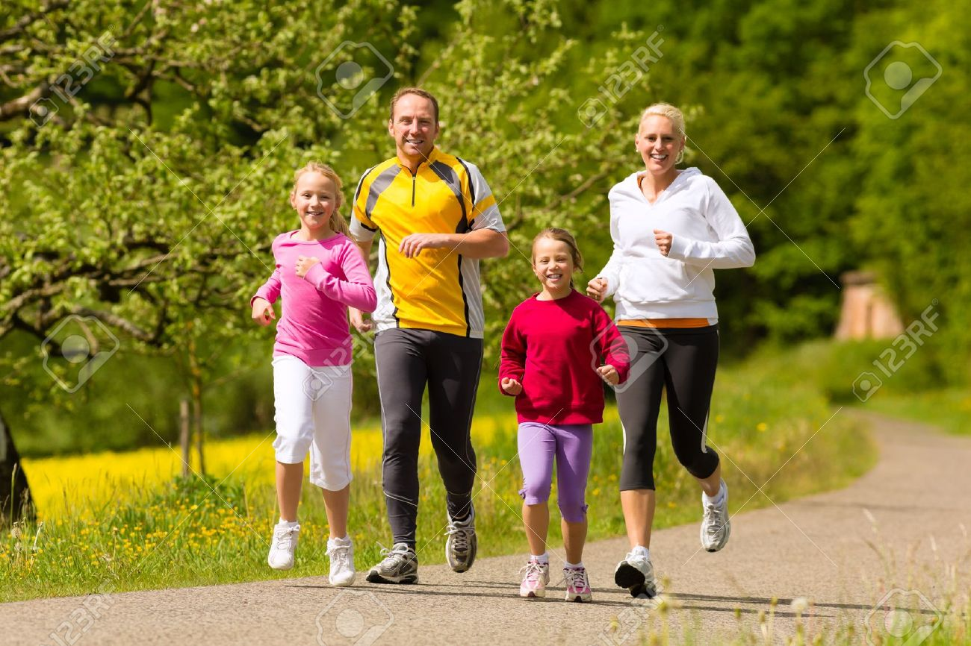
Sporting Example:

Extension Task (5+) - Your Example:

Factor:

- K

- J

- J

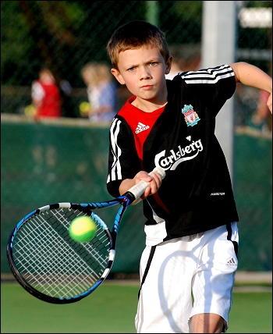
Sporting Example:

Extension Task (5+) - Your Example:

Factor:

- K

- J

- J

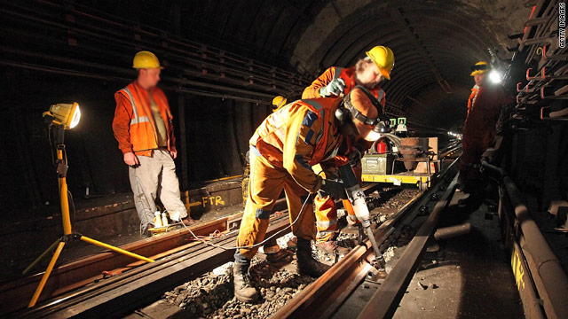
Sporting Example:

Extension Task (5+) - Your Example:

Factor:

- K

- J

- J

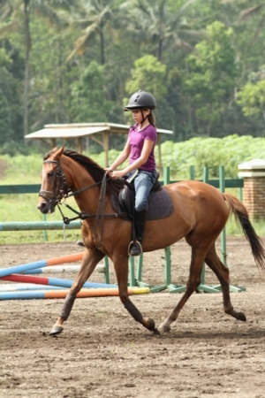
Sporting Example:

Extension Task (5+) - Your Example:

Factor:

- K

- J

- J

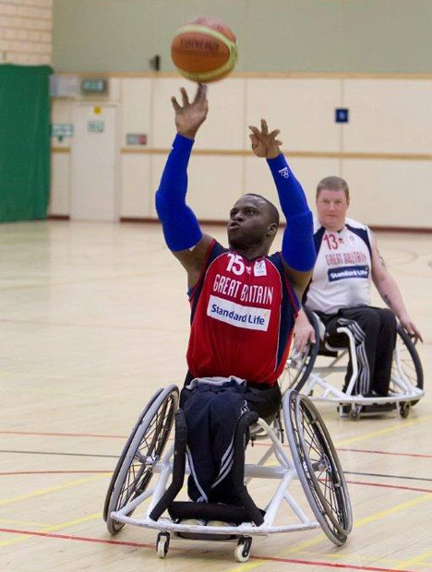
Sporting Example:

Extension Task (5+) - Your Example:

Factor:

- K

- J

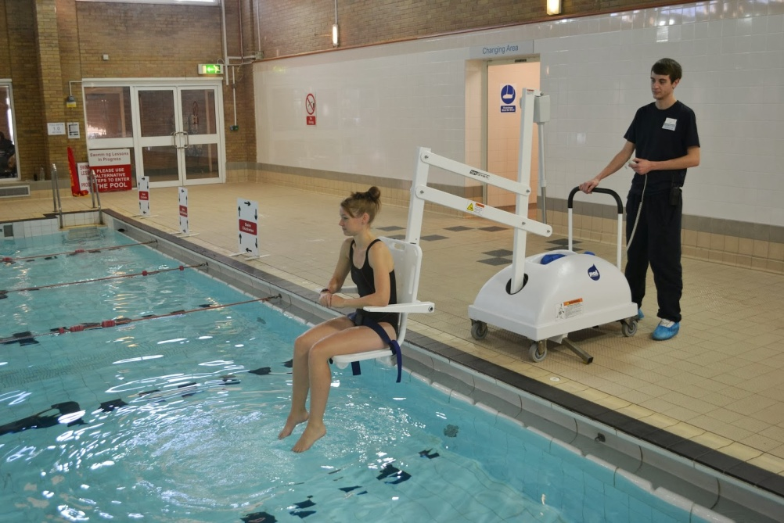
Sporting Example:

Extension Task (5+) - Your Example:

Factor:

- K

- J

- J

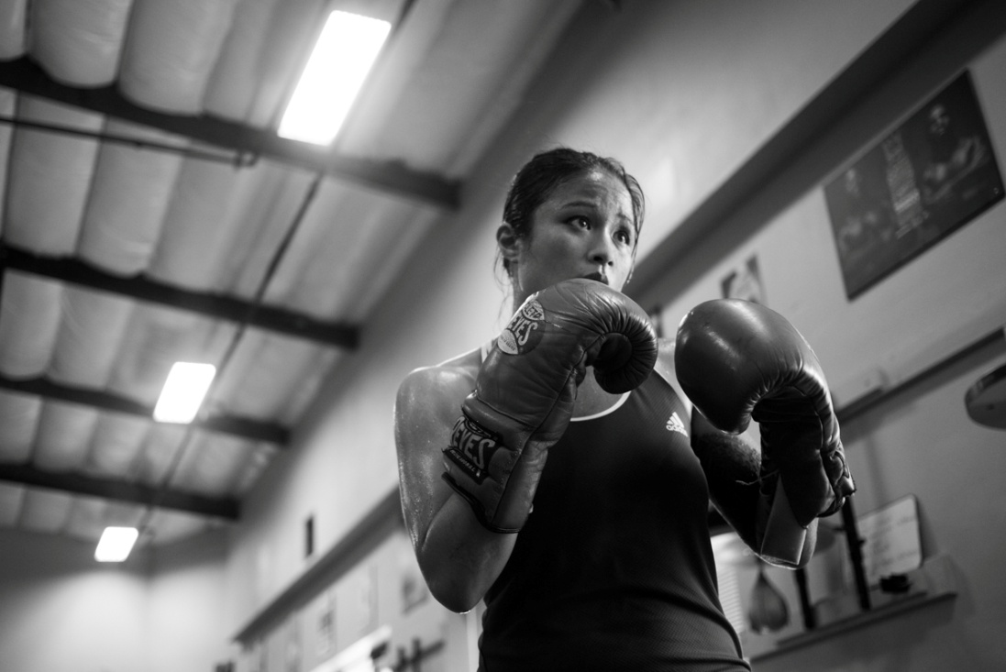
Sporting Example:

Extension Task (5+) - Your Example:

Factor:

- K

- J

- J

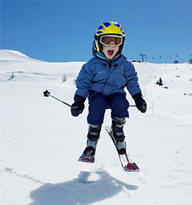
Sporting Example:

Extension Task (5+) - Your Example:

Factor:

- K

- J

- J

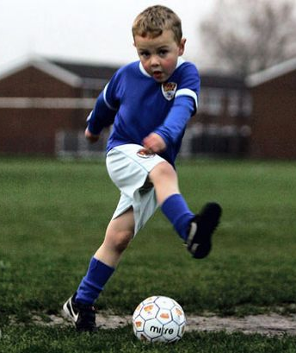
Sporting Example:

Extension Task (5+) - Your Example:

Factor:

- K

- J

- J

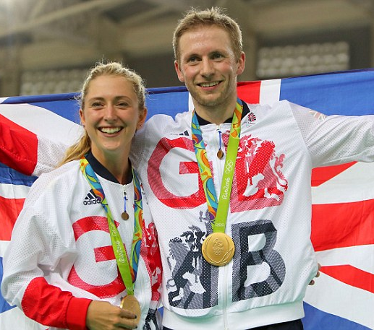
Sporting Example:

Extension Task (5+) - Your Example:

Lesson 6: Strategies to improve Participation
LI: To understand strategies which can be used to improve participation; promotion, provision, access.

LO: I can understand strategies which can be used to improve participation; promotion, provision, access.

LI: To be able to apply examples from physical activity /sport to participation issues.

LO: I can apply examples from physical activity /sport to participation issues.

LI: To be able to identify the current trends in participation in different physical activities and sports.

LO: I can identify the current trends in participation in different physical activities and sports.

LI: To be able to use different sources to identify trends in participation in physical activity and sport; Sport England, National Governing bodies (NGB), Department of Culture, Media and Sport (DCMS)

LO: I can use different sources to identify trends in participation in physical activity and sport; Sport England, National Governing bodies (NGB), Department of Culture, Media and Sport (DCMS)

Seneca: 3.1.2 Participation in Physical Activity

GCSE Bitesize: https://www.bbc.co.uk/bitesize/guides/zy62hv4/revision/6

Teacher Powerpoint: Uploaded on to Classcharts

DART: Match the Factors affecting Participation
Task: Below there are 14 positive and negative examples of the 14 factors. Read the examples and using your notes decide which factor is being described.

Positive: Exposure of less known sports or activities such as mountain biking or other extreme sports.  Negative: Coverage of injuries may put people off from participating or people spending their time watching rather than playing. | 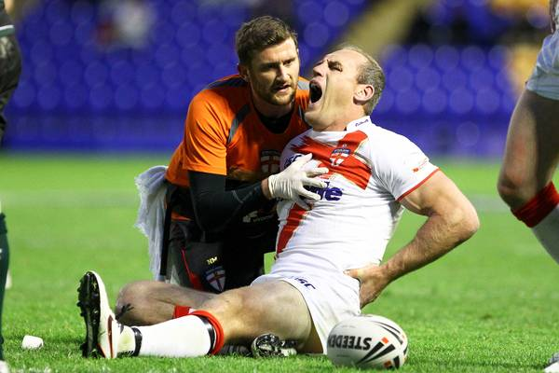 | Media Coverage
Positive: A brother that gives their sister a lift in the car to go swimming.  Negative: A young sprinter whose family don’t bother to watch him race. | 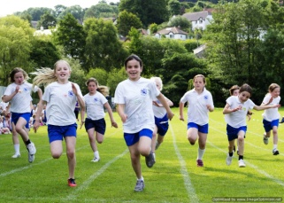
Positive: Investment of funding to encourage female participation including ‘Active Women’s projects and ‘This Girl Can’.  Negative: Stereotypical/traditionally linked gender sport bias. | 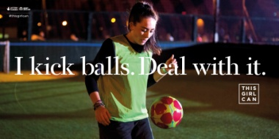
Positive: Concessions for children and the elderly in swimming pools.  Negative: People unable to afford expensive gym memberships. | 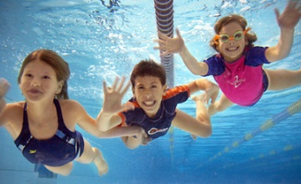
Positive: Successful Paralympic athletes in London 2012 and other major competitions inspiring people to participate.  Negative: Limited role models in less well known sports/activity such as Boccia and rock-climbing. | 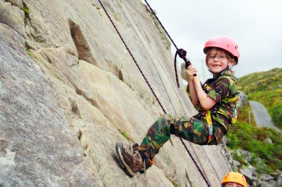
Positive: The Inclusive sports programme created to increase the number disabled people playing sport.  Negative: Clubs that are unable to afford specialist equipment required to enable disabled to participate. | 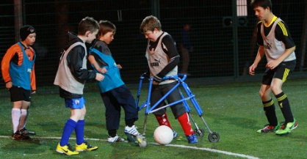
Positive: Development of sport hijabs being worn by female role models in different sporting competitions.  Negative: Certain faiths and beliefs discouraging participation in certain types of activity. | 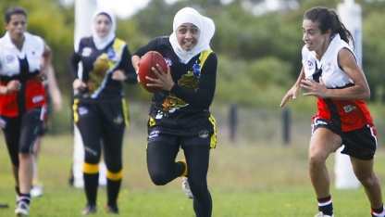
Positive: Sport England strategy ‘Create a sporting habit for life’.  Negative: Old or young people that have a lack of confidence/self-esteem in taking part. | 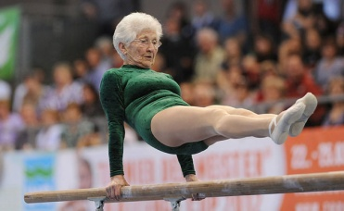
Positive: Sport England funding for schools towards improving facilities and practical support.  Negative: Schools with run down facilities and a limited extra-curricular programme. | 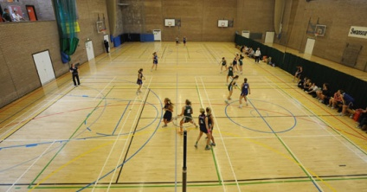
Positive: Companies who build leisure facilities within the workplace to make it easier for employees to keep fit and active.  Negative: Parents with a young family may find it difficult to take part regularly in their sporting interests. | 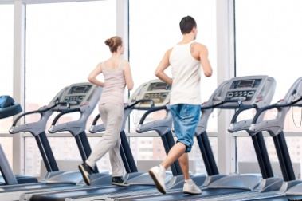
Positive: Funding of the ‘Sporting Equals’ project that is designed to help more people from black and minority ethnic (BME) communities to get involved.  Negative: Fewer coaching opportunities in football for black and minority ethnic groups. | 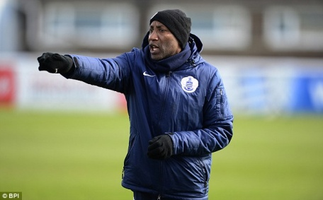
Positive: Sport England ‘Sportivate’ programme aimed at 14-25 year olds to find a sport they love.  Negative: Local gym facilities that are inaccessible, lack specialist equipment and untrained staff in disability awareness. | 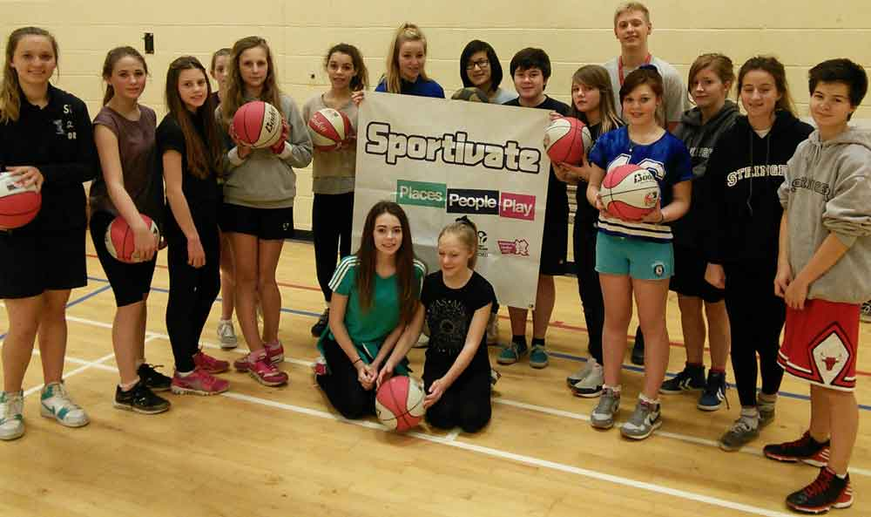
Positive: It can help raise the profile of issues such as the culture of male dominance in sport.  Negative: A lack of opportunity, provision and esteem for different social groups within sport and physical activity. | 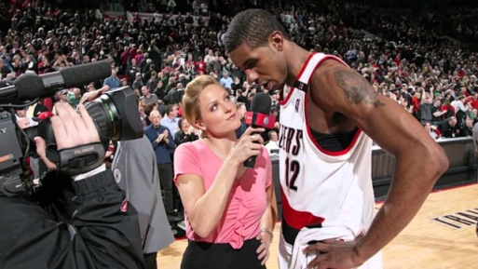
Positive: Access to green space and or natural environment that enables participation in outdoor adventurous activities.  Negative: Living in a rural area that has limited access to sports facilities such as an ice skating rink. | 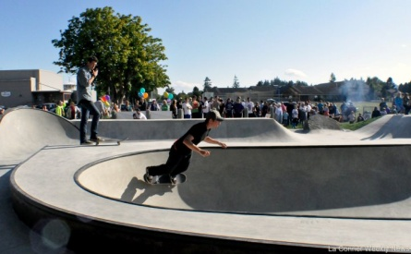

DART: Identifying the Barriers to Participation

Task: Below there are four scenarios. Read each scenario and list the factors that could/do affect the person’s participation in sport. Following this explain one of the factors in detail, specifically to that person.


Scenario 1:
Tom is 15 years old and loves playing sport and attending the school gym after school. Tom would like to do more outside of school. He does not receive much support from home and his family do not have much money. He has to work a part time job to earn some pocket money. His parents have never understood his passion for sport.

What barriers may Tom be facing? | What are the positive factors?
Explanation of one factor:

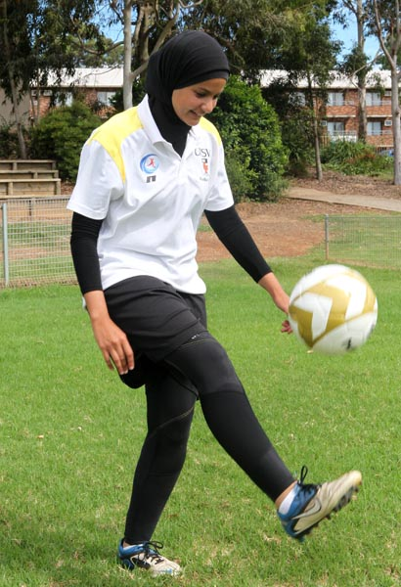
Scenario 2:
Zara is a 14 year old Muslim girl who loves taking part in sport. She loves outdoor sports and after seeing the Women’s world cup on TV wants to participate in football. She lives in a built up area of the city and neither of her very religious parents drive. Her family also have two pet dogs called Bella and Pixie.

What barriers may Zara be facing? | What are the positive factors?
Explanation of one factor:

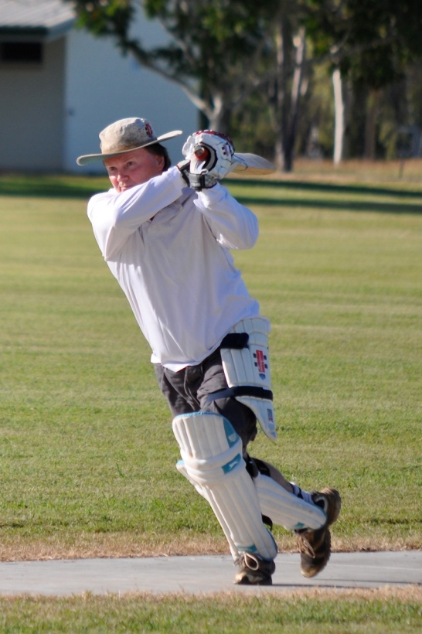
Scenario 3:
Frank is 62 years old and is looking to take up sport again as he has recently retired. He hopes that it will help with some of the health issues he has developed as he has got older. He is interested in playing cricket as he loved it in school but is anxious about his ability, his local club has a large majority of Pakistani/Indian players and he isn’t sure he will fit in. He would consider another club but this one is close by and he can use his bus pass to get there.

What barriers may Frank be facing? | What are the positive factors?
Explanation of one factor:

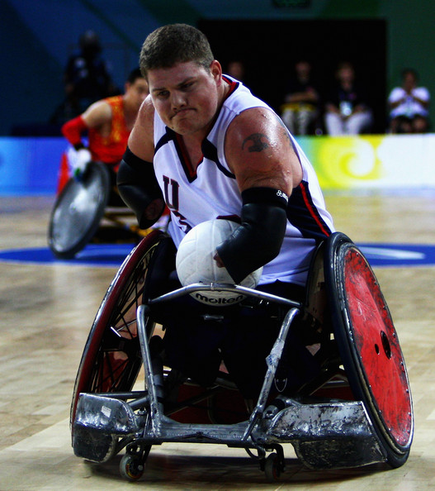
Scenario 4:
Sam is 21 years old and uses a wheelchair. Following watching the Paralympics he would love to get involved in wheelchair rugby. His mum is very happy that he wants to take up a sport and thinks it will build his confidence. However his local club don’t have a disability team and the nearest club is over 30 miles away.

What barriers may Sam be facing? | What are the positive factors?
Explanation of one factor:

Task: Create a scenario like the ones above describing how someone may be affected positively or negatively by the factors three factors you have chosen at random.
Strategies to improve Participation in Sport
It is important to the government that people regularly take part in physical activity and lead healthy lifestyles. With obesity rates rising exercise can help with many health conditions that currently cost the NHS billions of pounds each year.
Due to the importance of this and other aims such as achieving sporting success, there are many organisation and structures in place to increase the number of people regularly engaging in physical activity.
These organisations include:
- Sport England
- National Governing Bodies
- The Department for Culture, Media and Sport (DCMS)


Sport England:



National Governing Bodies:
The Department for Culture, Media and Sport (DCMS):


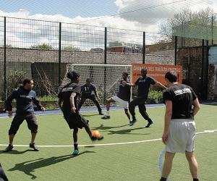

These organisations look to improve participation in sport by using the following strategies:

Task: Discuss the following statements with your partner; decide whether each one is an example of promotion, provision or access.

Statement: | Promotion, Provision or Access:
Making clubs free in poorer areas

Getting famous sporting role models in the media to talk about sport

Building public leisure centres

Displaying posters with sporting images in public

Funding some new gym equipment

Ensuring clubs are inclusive for all people

Providing local clubs with more funding to allow them to expand their club to accommodate more people

Creating TV adverts showing the public participating in sport

Training youth coaches on level 1 courses so that they can deliver high quality sessions

Lesson 7: The 6 Mark Question
LI: To understand how to answer and structure a 6 mark question.

LO: I can plan and structure a 6 mark question.

Seneca: 3.1.2 Participation in Physical Activity

GCSE Bitesize: https://www.bbc.co.uk/bitesize/guides/zy62hv4/revision/6

Teacher Powerpoint: Uploaded on to Classcharts

John is a 38 year old man. Explain how different factors could affect his participation in sport. (6)
What is the question asking?
What are the factors that affect participation? How do they do this?

Introduction
Answer the question briefly.
Which three factors would apply to John the most from those below? State these.
Age, Gender, Ethnicity, Religion/Culture, Family, Education, Time, Cost, Disability, Opportunity, Discrimination, Environment, Media, Role Models.
Say briefly what you are going to say in the rest of your answer.

__________________________________________________________________________________________________________________________________________________________________________________________________________________________________________________________________________________________________________________________________________________________________________________________________________________________________________________________________

Paragraph 1
Make a point, explain it, add a specific sporting example saying how John’s affected.
Name a factor that affects participation.
How would this affect John? Would it help him to participate or stop him?
Choose a sport that relates to this explanation and give a sporting example.

__________________________________________________________________________________________________________________________________________________________________________________________________________________________________________________________________________________________________________________________________________________________________________________________________________________________________________________________________________________________________________________________________________________________________________________________________________________________________________________________________________________________________________________________________________________________________________________________________________________________________________________________________________________________________________________________________________________________________________________________________________________________________________________________________________________________________________________________________________________________________________________________________________________________________________________________________________________________________________________________________________________________________________________________________________________________________________________________________________________________________________________________________________________________________________________________________________________________________________________________________________________________________________________

Paragraph 2
Make a point, explain it, add a specific sporting example saying how John’s affected.
Name a factor that affects participation.
How would this affect John? Would it help him to participate or stop him?
Choose a sport that relates to this explanation and give a sporting example.

________________________________________________________________________________________________________________________________________________________________________________________________________________________________________________________________________________________________________________________________________________________________________________________________________________________________________________________________________________________________________________________________________________________________________________________________________________________________________________________________________________________________________________________________________________________________________________________________________________________________________________________________________________________________________________________________________________________________________________________________________________________________________________________________________________________________________________________________________________________________________________________________________________________________________________

Paragraph 3
Make a point, explain it, add a specific sporting example saying how John’s affected.
Name a factor that affects participation.
How would this affect John? Would it help him to participate or stop him?
Choose a sport that relates to this explanation and give a sporting example.

____________________________________________________________________________________________________________________________________________________________________________________________________________________________________________________________________________________________________________________________________________________________________________________________________________________________________________________________________________________________________________________________________________________________________________________________________________________________________________________________________________________________________________________________________________________________________________________________________________________________________________________________________________________________________________________________________________________________________________________________________________________________________________________________________________________________________________________________________________________________________________________________________________________________________________________________________________________________________________________________________________________________________________________________________________________________________________________________________________________________________________________________________________________________________________________________________________________________________________________________________________________________________________________________________________________________________________________________________________________________________________________________________________________________________________________________________________________________________________________________________________________________________________________________________________________________________________________________________________________________________________________
Conclusion
How do these factors affect John?
Will this change? What does this depend on (age, time, money)?
Look back at the question and summarise your answer.

_____________________________________________________________________________________________________________________________________________________________________________________________________________________________________________________________________________________________________________________________________________________________________________________________________________________________________________________________________________________________________________________________________________

Feedback:

Lesson 7: Exam Revision

LI: To understand the different revision techniques.
LI: To identify the areas of weakness
Seneca: 3.1 Engagement Patterns
GCSE Bitesize: https://www.bbc.co.uk/bitesize/guides/zy62hv4/revision/1
Teacher Powerpoint: Uploaded on to Classcharts

Lesson 8: End of Topic Test

LI: To be able to complete the end of topic test to the best of my ability in exam conditions.

Topic Test will be uploaded on to Classcharts

Lesson 9: Feedback Analysis

LI: To understand personal areas of strength and weakness

Mark scheme and all feedback will be uploaded on to Classcharts

Attainment Band : | Physical factors affecting performance: Engagement patterns of different social groups in physical activity and sport.
Attainment Band : | Skills | Knowledge and Understanding
9 | - Flawlessly factual and perceptive responses that relate accurately to the focus of the question  - Demonstrate excellent understanding, providing clear and detailed descriptions and explanations  - Communication in writing is highly effective using appropriate and coherent terminology  - Spelling, punctuation and grammar is precise | Physical activity and sport in the UK  - be familiar with current trends in participation in physical activity and sport:  - using different sources (such as Sport England, National Governing Bodies (NGBs) and Department of Culture, Media and Sport (DCMS))  - of different social groups  - in different physical activities and sports.  Participation in physical activity and sport  - understand how different factors can affect participation, including:  - age  - gender  - ethnicity  - religion/culture  - family  - education  - time/work commitments  - cost/disposable income  - disability  - opportunity/access  - discrimination  - environment/climate  - media coverage  - role models.  - understand strategies which can be used to improve participation:  - promotion  - provision  - access.  - be able to apply examples from physical activity/sport to participation issues.
8 | - Consistently factual and sustained responses that relate to the focus of the question  - Demonstrate excellent understanding, providing well-defined explanations and descriptions  - Communication in writing is highly effective using appropriate and coherent terminology  - Spelling, punctuation and grammar is precise
7 | - Offer factually and sustained responses that relate to the focus of the question  - Successfully and confidently address all aspects of the question  - Demonstrate high levels of understanding, providing clear and detailed descriptions and explanations  - Communication in writing is highly effective using appropriate and coherent terminology  - Spelling, punctuation and grammar is accurate
6 | - Confidently offer factually accurate and sustained responses that closely relate to the focus of the question  - Demonstrate excellent understanding and provide clear and detailed descriptions and explanations  - Writing shows strong evidence of communicating ideas with high efficiency and use of appropriate terminology  - On the whole, spelling, punctuation and grammar is accurate
5 | - Responses are consistently factually accurate that closely relate to the focus of the question  - Demonstrate good understanding and provide clear and detailed descriptions and explanations  - Writing shows evidence of communicating ideas with efficiency and use of appropriate terminology  - Spelling, punctuation and grammar is appropriate
4 | - Responses are often factually accurate and show some relation to the focus of the question  - Demonstrate sound understanding and provide adequate descriptions and explanations  - Writing shows evidence of communicating ideas with limited efficiency and use of appropriate terminology  - Spelling, punctuation and grammar is often adequate
3 | - Responses are often inaccurate and show little relation to the focus of the question  - Demonstrate basic understanding and provide limited descriptions and explanations  - Communication in writing is approaching an adequate level of coherence, using some appropriate terminology  - Spelling, punctuation and grammar is developing in consistency
2 | - Responses are vague and do not relate to the question  - Little demonstration of understanding and explanations are often incorrect  - Communication in writing is largely ineffective and lacking coherence  - Spelling, punctuation and grammar is inconsistent
1 | - Responses do not relate to the question  - No demonstration of understanding and explanations are incorrect  - Communication in writing is ineffective and disjointed  - Spelling, punctuation and grammar is weak

