Year 10 Blended Learning Booklet Spring 2
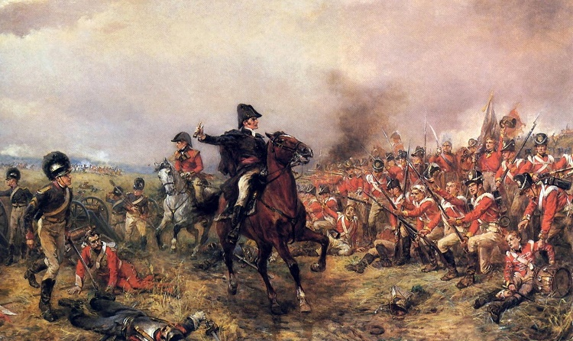
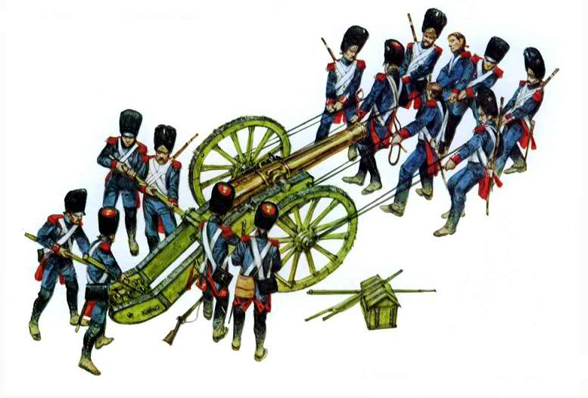
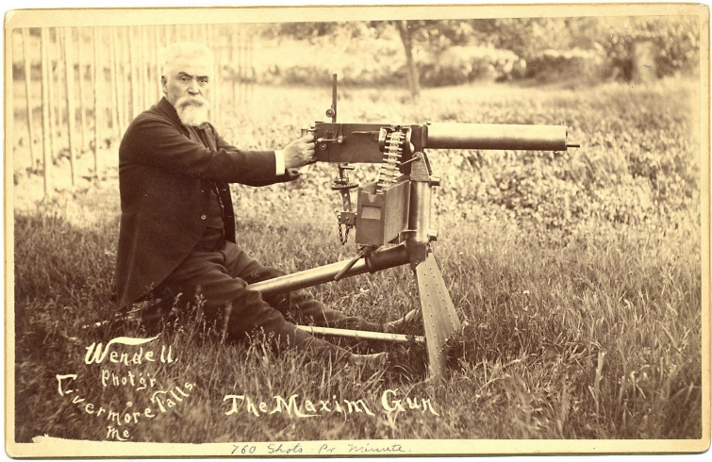
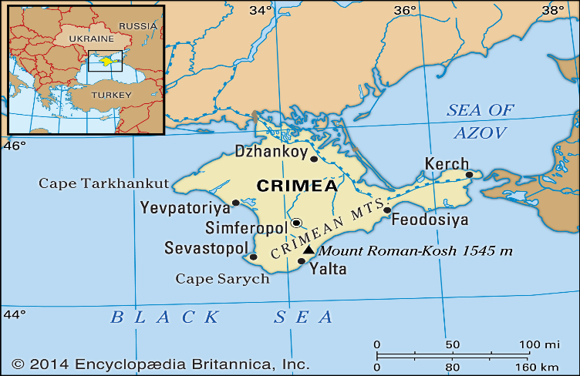
Name:
History Teacher:
Contents
Year 10 Big Picture 3
Knowledge Organisers 4
Lesson 1 The Nature of Warfare 1700-1850 5-6
Lesson 2 The Battle of Waterloo 1815 7-9
Lesson 3 The Battle of Balaclava 1854 10-11
Lesson 4 Change and Continuity 1850-1900 12-15
Lesson 5 Recruitment 1700-1900 16-18
Lesson 6 The Experience of Warfare 1700-1900 19-20

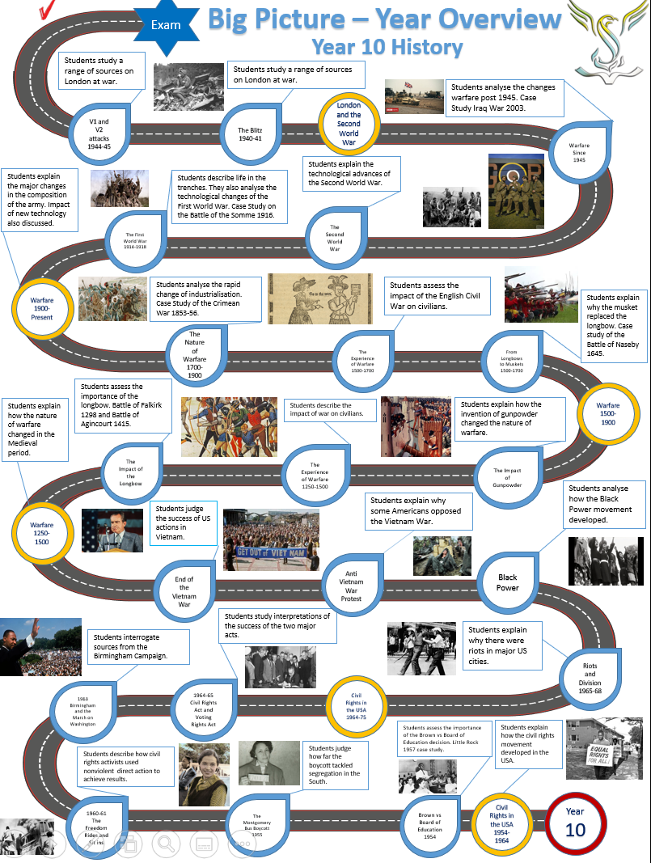
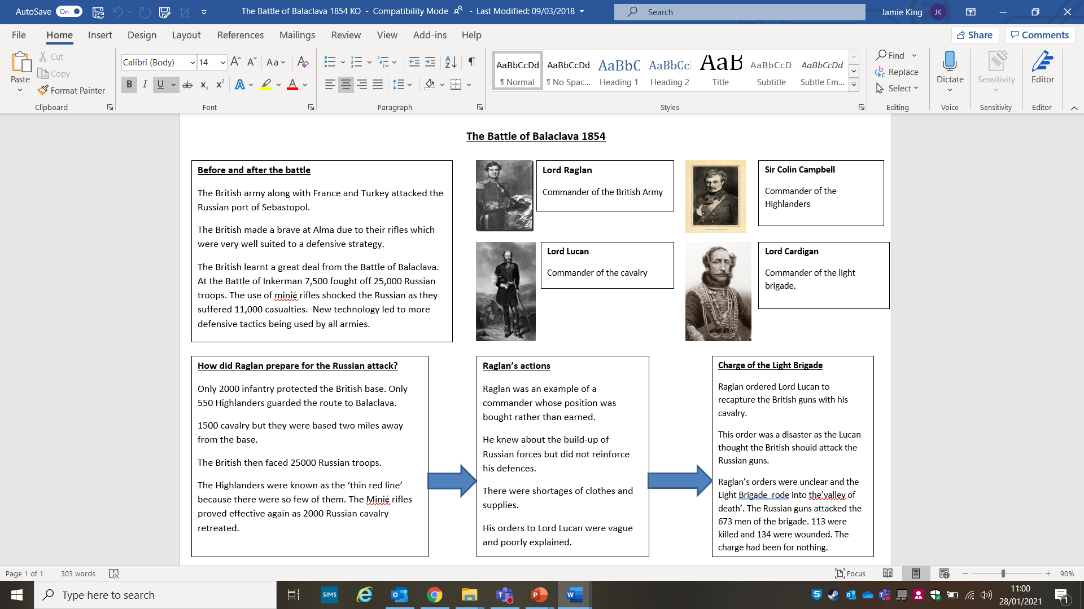
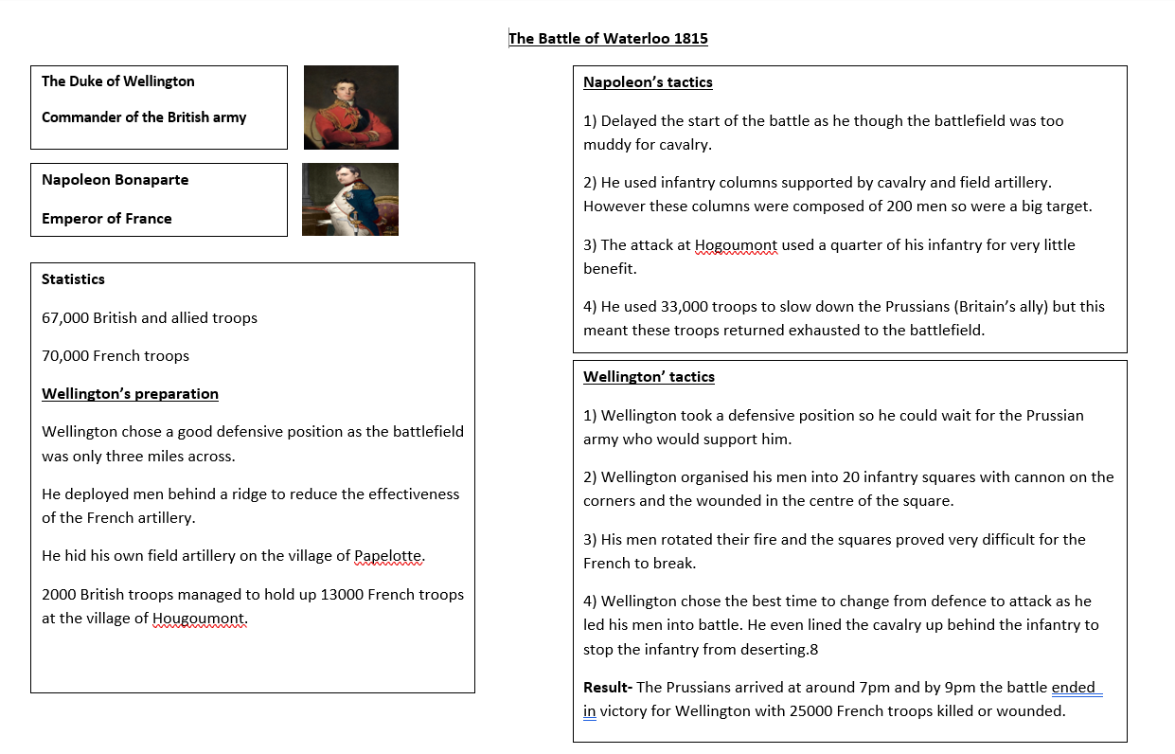
Lesson 1 The Nature of Warfare 1700-1850
LI: To recognise change and continuity
Recap of 1500-1700
Why did armies change from longbows to muskets?
……………………………………………………………………………………………………………………………………………………………………………………………………………………………………………………………………………………………………………………………………………………………………………………………………………………………….
How was the New Model Army different to the one before?
……………………………………………………………………………………………………………………………………………………………………………………………………………………………………………………………………………………………………………………………………………………………………………………………………………………………….
Why did parliament win at the Battle of Naseby?
……………………………………………………………………………………………………………………………………………………………………………………………………………………………………………………………………………………………………………………………………………………………………………………………………………………………….
Why did rulers favour a standing army after the English Civil War?
……………………………………………………………………………………………………………………………………………………………………………………………………………………………………………………………………………………………………………………………………………………………………………………………………………………………….

DART-What was warfare like in the period 1700-1850?
Throughout this period there was a standing army of around 50,000 men in peacetime. In times of war such as the Napoleonic wars (1803-15) it increased to 250,000. The infantry was still the dominant part of the army making up around 80% of all soldiers. Cavalry was around 15% and artillery made up 5% of the army.
The main weapon of the infantry was the Brown Bess musket which fired a lead ball and was effective from 100 metres. A bayonet was fitted on the end of the Brown Bess to protect soldiers in close combat. The Brown Bess was introduced in 1715 and was still being used by the British army in 1845. The cavalry were armed with swords and some had pistols these soldiers were known as dragoons.
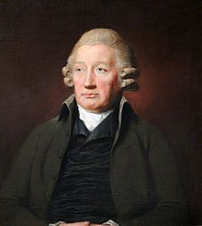
The artillery used cannon with a range of 500 metres against walls and large groups of enemy soldiers. They could fire grape shot (bags of small metal balls) and canisters (tin or wooden containers filled with metal balls). Both of these did a great deal of damage to the enemy’s infantry.
A major change in this 150 year period was the development of science and technology. In 1700 a cannon weighed around a ton. Once ammunition and its carriage were added to that soldiers would have to carry four tons of equipment on to the battlefield. This was the same weight as an elephant!
However, once the Industrial Revolution was underway in Britain people started to experiment with iron. In 1720, Britain produced 25 tons of iron by 1850 Britain was producing 2 million tons of iron. This led to iron become cheaper and industrialists working in the factories could experiment with it. Men such as John ‘Iron Mad’ Wilkinson made thinner cannon barrels out of a solid piece of metal. This meant cannon were far lighter than they had been. Later in the period lighter bronze cannon were introduced which were even lighter.
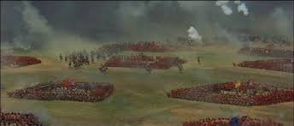
Tactics
There was not a great deal of change in tactics in this 150-year period. Muskets were the dominant weapon, so tactics were based on improving musket fire and marching. Four deep lines of men were required in 1700 to give every solider time to reload his musket. By 1760, the army just needed two lines as loading times had improved. Bayonets were still very important as close combat usually decided the outcome of battles.
When armies were under attack, they could form defence squares against the cavalry. Each man would be able to protect himself with his bayonet and any injured soldiers could be protected in the centre. This was a tactic used by Wellington at the Battle of Waterloo. Marching was introduced from around 1760 which meant soldiers had to be in step with each other, so they fired at the same time. It also meant soldiers could change formation from lines to squares quickly.
How far did warfare change from 1700-1850?
………………………………………………………………………………………………………………………………………………………………………………………………………………………………………………………………………………………………………………………………………………………………………………………………………………………………………………………………………………………………………………………………………………………………………………………………………………………………………………………………………………………………………………………………………………………………………………………………………………………………………………………………………………………………………………………………………………………………………………………………………………………………………………………………………………………………………………………………………………………………………………………………………………………………………………………………………………………………
Lesson 2 The Battle of Waterloo
LI: To measure the impact of Wellington on the victory at Waterloo.
Use the Battle of Waterloo knowledge organiser on page 4
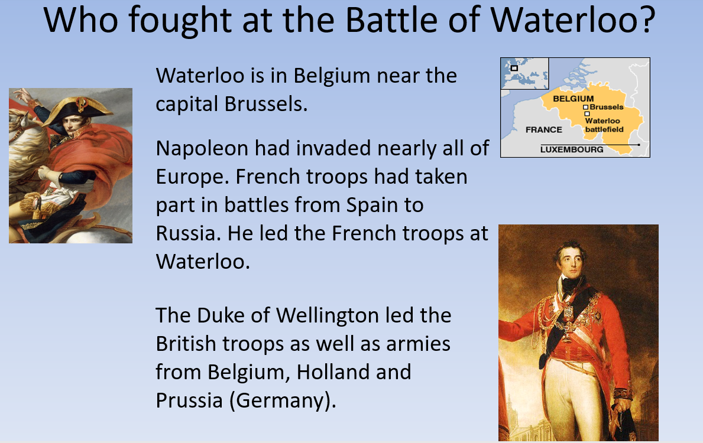

DART
At the Battle of Waterloo, Napoleon took on two armies: Wellington’s army of British, Dutch and German soldiers and the Prussian army led by Field Marshal Blucher. Napoleon had 100,000 troops. He sent 33,000 to deal with the Prussians and left the rest to attack Wellington’s army. Wellington had around 50,000 infantry, 12,000 cavalry and 5,000 gunners. He decided to take up a defensive position behind a ridge which proved to be an excellent decision. The battle filed was small and this suited Wellington’s defence position. He sent men to Hougoumont and La Haye Sainte (see map below).
Red=British
Blue=French
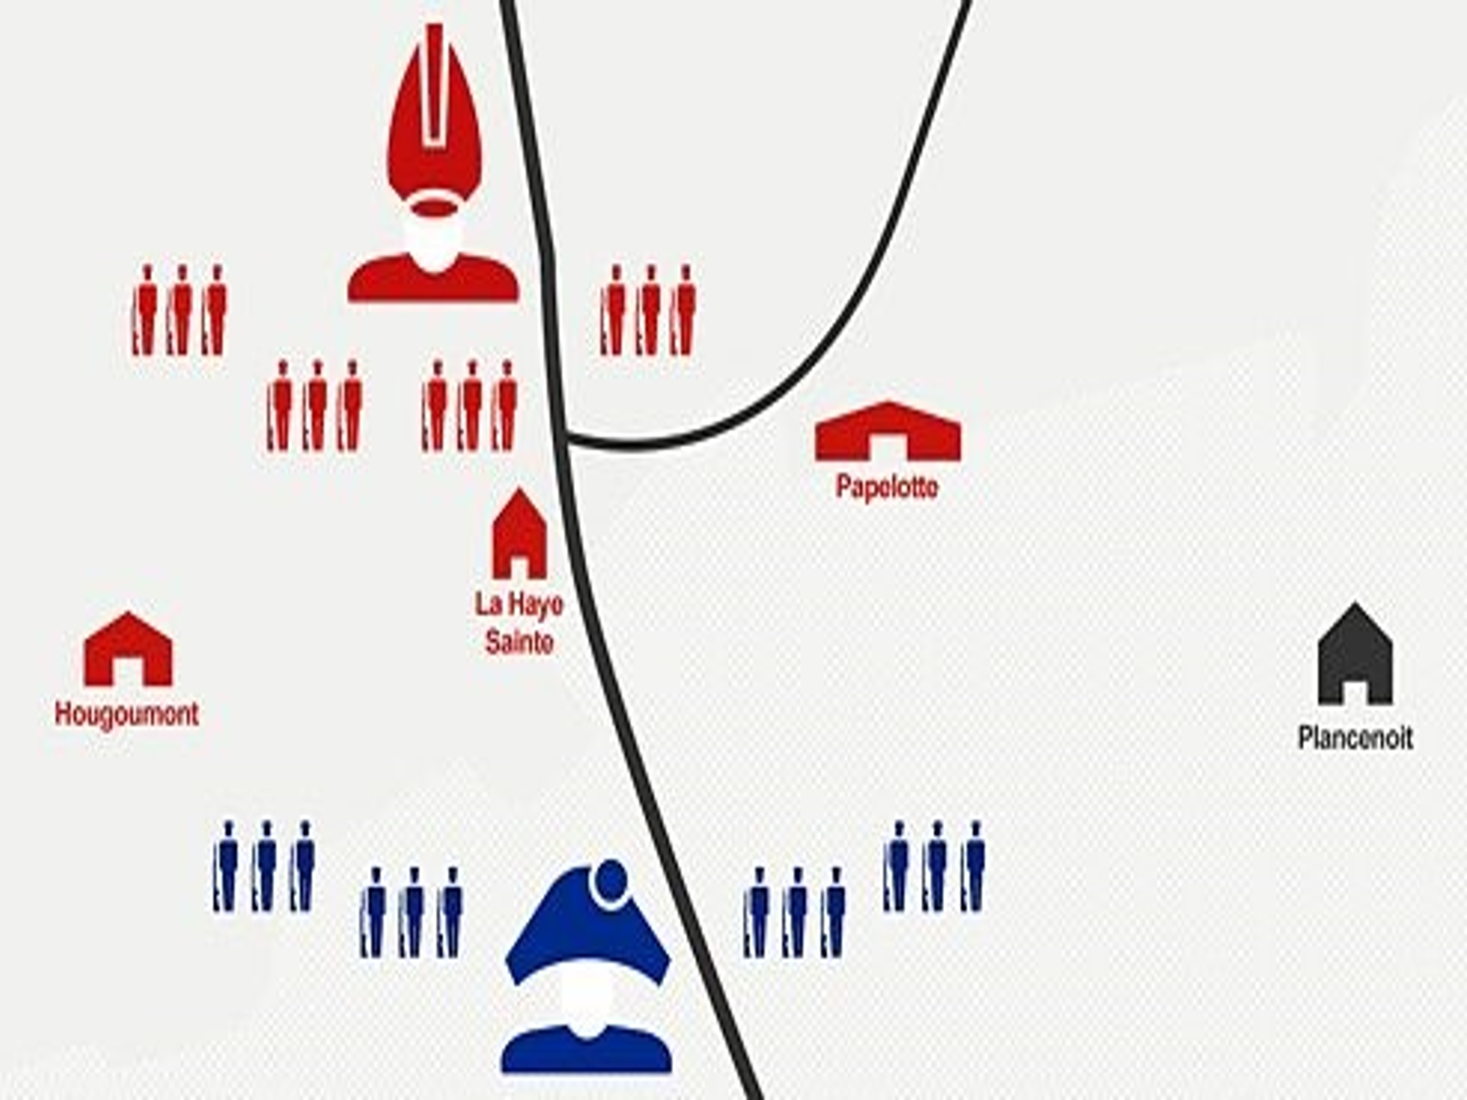

Napoleon had a few problems before the battle. He had sent away his troops to deal with the Prussians. The man in charge of Napoleon’s men was Marshal Grouchy who didn’t do very much to slow the Prussians down. Napoleon was also in a terrible mood as he was suffering from piles which led to him not inspecting the battlefield. This delayed the battle further.
The Battle started at 11:30 am. He fired his artillery at the Wellington’s army but because of Wellington’s position behind the ridge the French cannonballs simply hit the mud instead of doing damage to their enemy. The ridge also protected the British from shots being fired so the French aimed to high and the shots flew over their head.
Napoleon then sent 13,000 men to Hougoumont where 2000 British soldiers took position in an old farmhouse. The attack should have been swift but the British bravely held on and delayed the French for hours. A quarter of Napoleon’s infantry were used to attack just 2000 British soldiers.
By 1pm, Napoleon eventually attacked the centre of the British army. The British were being reinforced with Prussian troops who were arriving all the time. The French attacked in columns which were lines of 200 men wide. This was not very effective against Wellington’s defensive squares. The British were then able to fire their artillery at the French. Wellington’s defensive tactic had worked, and they were able to catch 3000 French prisoners.
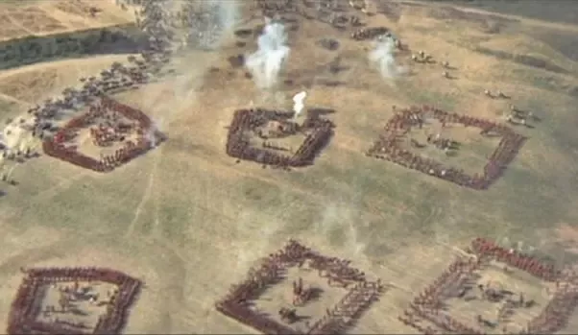

At 3pm, Napoleon regrouped his troops and decided to fight on rather than wait for the 33,000 men he had sent away to return. At 4pm the French managed to fire on the British from only 270 metres away it looked like they could win the battle. However, Wellington took the initiative and led some German troops to the centre of the battlefield to strengthen his lines. He brought his cavalry up behind them so they would not desert under pressure.
By 7pm there was a decisive breakthrough as Wellington’s allies the Prussians had arrived. This led to Napoleon being completely outnumbered. Wellington ordered the final advance and the French were driven from the battlefield. 25,000 French were killed or wounded.
Questions
1)What excellent decision did Wellington make at the start of the battle?
………………………………………………………………………………………………………………………………………………………………………………………………………………………………………………………………………………………………………………………………………………………………………………………………………………………………………………
2) Why was Napoleon at a disadvantage at the start of the battle?
………………………………………………………………………………………………………………………………………………………………………………………………………………………………………………………………………………………………………………………………………………………………………………………………………………………………………………
3) Why was the British defence of Hougoumont so important to the victory?
………………………………………………………………………………………………………………………………………………………………………………………………………………………………………………………………………………………………………………………………………………………………………………………………………………………………………………………………………………………………………………………………………………………………………………………………………………………………………………………………………………………………………………………………………………
4) Why were infantry squares so important to Wellington?
………………………………………………………………………………………………………………………………………………………………………………………………………………………………………………………………………………………………………………………………………………………………………………………………………………………………………………………………………………………………………………………………………………………………………………………………
5) What mistakes did Napoleon make?
………………………………………………………………………………………………………………………………………………………………………………………………………………………………………………………………………………………………
6) Why was Wellington such an effective leader?
………………………………………………………………………………………………………………………………………………………………………………………………………………………………………………………………………………………………………………………………………………………………………………………………………………………………………………………………………………………………………………………………………………………………………………………………
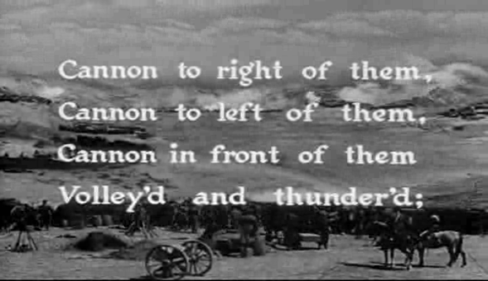
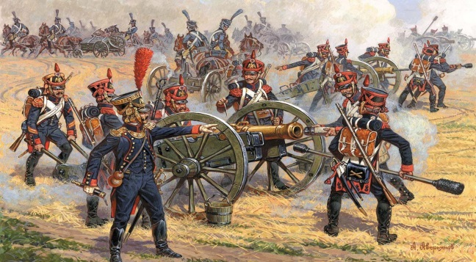
The Battle of Balaclava 1854

Fill this out as you watch the video on the Battle of Balaclava
Preparations for the Battle of Balaclava
1. Describe Lord Raglan’s preparations for the battle.
……………………………………………………………………………………………………………………………………………………………………………………………………………………………………………………………………………………………………………………………………………………………………………………………………………………………………………………………………………………….
2. How strong was the Russian force?
…………………………………………………………………………………………………………………………………………………………………………………………………………………………………………………………………………………………………………………………
3. What was the situation of Raglan’s force by 8am?
…………………………………………………………………………………………………………………………………………………………………………………………………………………………………………………………………………………………………………………………
4. Who were the ‘thin red line’?
…………………………………………………………………………………………………………………………………………………………………………………………………………………………………………………………………………………………………………………………
5. Why were they successful against the Russian charge?
……………………………………………………………………………………………………………………………………………………………………………………………………………………………………………………………………………………………………………………………………………………………………………………………………………………………………………………………………………………….…………………………………………………………………………………………………………………………………………………………………………………………………………………………………………………………………………………………………………………………
The Charge of the Heavy Brigade
6. Why was General James Scarlett’s decision to attack the Russians unusual?
…………………………………………………………………………………………………………………………………………………………………………………………………………………………………………………………………………………………………………………………
7. How successful was Scarlett’s charge of the Heavy Brigade?
……………………………………………………………………………………………………………………………………………………………………………………………………………………………………………………………………………………………………………………………………………………………………………………………………………………………………………………………………………………………………………………………………………………………………………………………………………………………………………………
The Charge of the Light Brigade
8. Why did Lord Lucan not send cavalry to the areas that the Russians had withdrawn from?
…………………………………………………………………………………………………………………………………………………………………………………………………………………………………………………………………………………………………………………………
9. Why was the British delay so important to the Russians?
…………………………………………………………………………………………………………………………………………………………………………………………………………………………………………………………………………………………………………………………
10. Why was there such confusion between Captain Nolan, Lord Lucan and Lord Cardigan?
……………………………………………………………………………………………………………………………………………………………………………………………………………………………………………………………………………………………………………………………………………………………………………………………………………………………………………………………………………………………………………………………………………………………………………………………………………………………………………………
11. Why was the Charge of the Light Brigade such a disaster for Lord Cardigan and his troops?
……………………………………………………………………………………………………………………………………………………………………………………………………………………………………………………………………………………………………………………………………………………………………………………………………………………………………………………………………………………………………………………………………………………………………………………………………………………………………………………

Change and Continuity 1850-1900
LI: To explain why this 50-year period was one of spiralling change.
DART
Britain fought in the Crimean War (1854-56) and the Boer War (1899-1902) as well as maintaining and Empire that spanned the globe. By 1899 the British army numbered 250,000 men. The composition of the army did not change in this time. Cavalry continued to be used despite the developments of rifles and machine guns which made it very vulnerable.
There were major developments in science, technology and industry. Steel cannon were far more reliable than bronze and did not crack like the iron ones. Breech (back) loading cannon made it far easier to load cannon and meant soldiers could fire ten rounds per minute. Rifled barrels of cannon meant they could now fire up to three miles whereas the old cannon could only fire a few hundred metres.
There were other advances with artillery such as smokeless gunpowder which meant smoke did not impair the soldiers aim and did not give the enemy an indication of where the cannon was. Recoiling field guns meant that the cannon did not have to be aimed every time there was a shot. The older cannon moved around after every shot but now the cannon stayed in position.
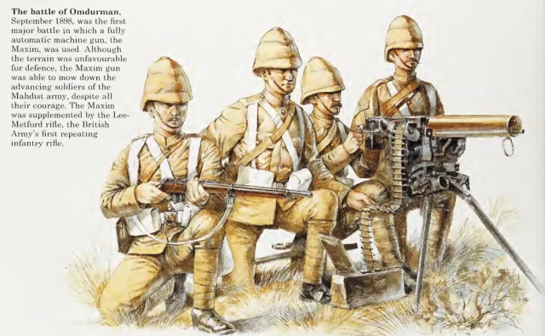
Rifles were a significant part of warfare and were a huge leap forward from the Brown Bess musket used by the British at Waterloo in 1815. Firstly, Minie bullets were invented which an improvement on the musket ball. These bullets expanded in the barrel of the gun once they made contact with the rifling. The bullets had a range of 300 metres. The next major development was percussion bullets, the trigger released a hammer which detonated a percussion cap at the base of the bullet, propelling out of the rifle. This brought an end to the reliance on flintlocks and powder which could be unreliable.
From the 1860s, the first machine guns appeared. The Gatling gun fired 150 round a minute up to 2000 metres. This was a gigantic step forward towards modern warfare but they were extremely heavy. The Maxim machine gun (invented by Hiram Maxim) was a very advanced piece of equipment which used the recoil of the pervious bullet to load the next. The Maxim gun could fire 500 bullets before reloading. By 1890, six major European countries had equipped their army with the Maxim gun. It was much lighter than the Gatling at 20kg.
DART continued: Industrialisation
The Industrial Revolution had made Britain the richest country on earth and had completely transformed warfare. The rest of Europe followed Britain’s lead and spent vasts amount of money on industry. An example of this was Henry Bessemer who patented a way of mass-producing steel. Before Bessemer, steel cost £60 per ton now it was just £7 per ton which meant industrialists could experiment with it a lot more. It also meant making weapons was now a lot cheaper.
A great example of the production line being used was at Enfield (near us) at the Small Arms Factory. 1000 workers could produce rifles for the British Army all with standardised parts (each rifle was the same meaning parts could be easily replaced).1000 workers could make 1750 rifles a week. By 1900, they were producing the famous Lee Enfield rifle.
Science
Alfred Nobel is best known for creating the Nobel Peace Prize. Which is quite ironic when you realise he invented nitro-glycerine. His first major invention was a blasting cap (igniter), a wooden plug filled with black gunpowder, which could be detonated by lighting a fuse. This in turn, caused an explosion of the surrounding nitro-glycerine. This chemical led to smokeless powder for rifles and cannon.
Individual
George Armstrong owned an engineering company in Newcastle that produced cranes and bridges. In 1861, The American Civil War broke out and he saw the opportunity to make a profit. He invented a cannon that could fire a 70kg shell. He became a pioneer in breech loading cannon. His cannon was known as the Armstrong Gun and was soon being used by the British Army.
Tactics
All of these development in science, technology and industry meant that the tactics on the battlefield changed dramatically from 1850 to 1900. Warfare was now based on the power of defence with rifles and cannon destroying the effectiveness of cavalry charges. Riding towards rifles and cannon was extremely dangerous for the cavalry. Their role was declining as the Charge of the Light Brigade had shown in 1854. However, due to social attitudes and many commanders in the army coming from the cavalry, the cavalry remained an important part of the army for far longer than it should have done.
7,500 British soldiers had defended themselves with their rifles against 25,000 Russians at the Battle of Inkerman. The Russians kept on attacking and lost 11,000 men in on day. The British had only lost 2,000.

12 Mark exam question
Now having read the DART you should have a good knowledge of how rapidly warfare changed in the period.
This 12 mark exam question should be 3 paragraphs and remember you do not need a conclusion.
Explain why warfare changed rapidly in the years 1850-1900.
- Rifles and machine guns
- Industrialisation

……………………………………………………………………………………………………………………………………………………………………………………………………………………………………………………………………………………………………………………………………………………………………………………………………………………………………………………………………………………………………………………………………………………………………………………………………………………………………………………………………………………………………………………………………………………………………………………………………………………………………………………………………………………………………………………………………………………………………………………………………………………………………………………………………………………………………………………………………………………………………………………………………………………………………………………………………………………………………………………………………………………………………………………………………………………………………………………………………………………………………………………………………………………………………………………..……………………………………………………………………………………………………………………………………………………………………………………………………………………………………………………………………………………………………………………………………………………………………………………………………………………………………………………………………………………………………………………………………………………………………………………………………………………………………………………………………………………………………………………………………………………………………………………………………………………………………………………………………………………………………………………………………………………………………………………………………………………………………………………………………………………………………………………………………………………………………………………………………………………………………………………………………………………………………………………………………………………………………………………………………………………………………………………………………………………………………………………………………………………………………………………..……………………………………………………………………………………………………………………………………………………………………………………………………………………………………………………………………………………………………………………………………………………………………………………………………………………………………………………………………………………………………………………………………………………………………………………………………………………………………………………………………………………………………………………………………………………………………………………………………………………………………………………………………………………………………………………………………………………………………………………………………………………………………………………………………………………………………………………………………………………………………………………………………………………………………………………………………………………………………………………………………………………………………………………………………………………………………………………………………………………………………………………………………………………………………………………..……………………………………………………………………………………………………………………………………………………………………………………………………………………………………………………………………………………………………………………………………………………………………………………………………………………………………………………………………………………………………………………………………………………………………………………………………………………………………………………………………………………………………………………………………………………………………………………………………………………………………………………………………………………………………………………………………………………………………………………………………………………………………………………………………………………………………………………………………………………………………………………………………………………………………………………………………………………………………………………………………………………………………………………………………………………………………………………………………………………………………………………………………………………………………………………..……………………………………………………………………………………………………………………………………………………………………………………………………………………………………………………………………………………………………………………………………………………………………………………………………………………………………………………………………………………………………………………………………………………………………………………………………………………………………………………………………………………………………………………………………………………………………………………………………………………………………………………………………………………………………………………………………………………………………………………………………………………………………………………………………………………………………………………………………………………………………………………………………………………………………………………………………………………………………………………………………………………………………………………………………………………………………………………………………………………………………………………………………………………………………………………..……………………………………………………………………………………………………………………………………………………………………………………………………………………………………………………………………………………………………………………………………………………………………………………………………………………………………………………………………………………………………………………………………………………………………………………………………………………………………………………………………………………………………………………………………………………………………………………………………………………………………………………………………………………………………………………………………………………………………………………………………………………………………………………………………………………………………………………………………………………………………………………………………………………………………………………………………………………………………………………………………………………………………………………………………………………………………………………………………………………………………………………………………………………………………………………………………………………………………………………………………………………………………………………………………………………………………………………………………………………………………………………………………………………………………………………………………………………………………………………………………………………..
Lesson 5 Recruitment-LI: To explain how men were recruited to the British Army.
DART
Recruitment 1700-1850
Britain had a permanent standing army by 1700. The officers still came from wealthy families and were promoted based on their family’s wealth rather than skill. Wealthy families could buy commissions which meant you could be in charge of an army with very little experience. This meant the quality of officers was unreliable.
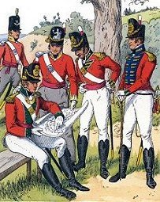
In the lower ranks of the army men could sign up for 8-12 years. However, recruitment was tough and very often the army did not have enough men. Warfare was tough and not ell paid for lower ranks. From 1660-1792 the average soldier was paid the equivalent of £3 a day. This was less than the average labourer. Travelling abroad meant conditions were even worse.
Very often men were recruited when they were drunk. One of the main ways soldiers were recruited was from prison. In the American War of Independence 7,000 men joined the British Army from prison. The British Army was disorganised, and the quality of recruits was very poor. Many men deserted and officers resorted to very harsh tactics when disciplining their men.
Colonel’s regiments were a tactic of recruitment that was similar to the captain indentures in the medieval period. The government would pay a large sum to an officer to go and recruit his regiment. Out of this money he had to clothe and equip them. However, this wasn’t always that effective as the officer wanted to keep as much profit as possible. His men would often by given the cheapest clothing and equipment leading to an ill-equipped army.
The 1757 Militia Act meant each parish in England had to make a list of every man from 18-50. These lists would be used in a lottery-based system. If you name was picked out, you had to serve in the local militia for five years. The militia protected the country from invasion. In the time of the Napoleonic Wars the militia grew to 118,000 men.
There were some attempts to improve training. In 1708, the Duke of Marlborough issued a manual called New Exercise of Firelocks and Bayonets. It was not widely used. In 1741, the Royal Military Academy was established at Woolwich to teach gunnery.
By the late 18th century the wars with France brought about further improvement with standard drills for troops, cavalry and the use of swords and rifles. However, many officers ignored them. In 1800, the Royal Military college was formed at Sandhurst to improve the training of officers. Despite these changes many officers refused to change and the training of both officers and troops was still very basic.
Recruitment 1850-1900
From 1815-1854 the British had not been involved in a major conflict this meant fewer men were recruited. Most of the army was abroad in the Empire. Local militias were called up to fight in the Crimean War as there were not enough men in the regular army. The Crimean War exposed problems with the quality of officers. Newspapers were now widely read and the British public knew far more about war overseas than before.
In 1868, William Gladstone brought in many reforms from Education to the Church of England. The British Army also needed reform. He put Edward Cardwell in charge of making the army more professional despite opposition from the officers.
Cardwell’s army reforms may not sound great by modern standards, but they were a huge improvement on what soldiers had experienced. Soldiers had far better food rations, they were no longer allowed to be hit by their officers. Reserves were paid an annual rate of 75p and were retrained annually. Soldiers could resign after 12 years or sign up again and receive at state pension when the retired.
The organisation of the army was vastly improved too. Regiments were reorganised into regions with local barracks (accommodation for soldiers to live in). Promotion of officers was to be based on merit rather than social class.
There were still some problems with the army despite Cardwell’s work. In 1899, the recruits for the Boer War were malnourished and physically weak. Low pay for lower ranks meant that the army was still low on numbers and had to rely on many men who were not fit to fight.
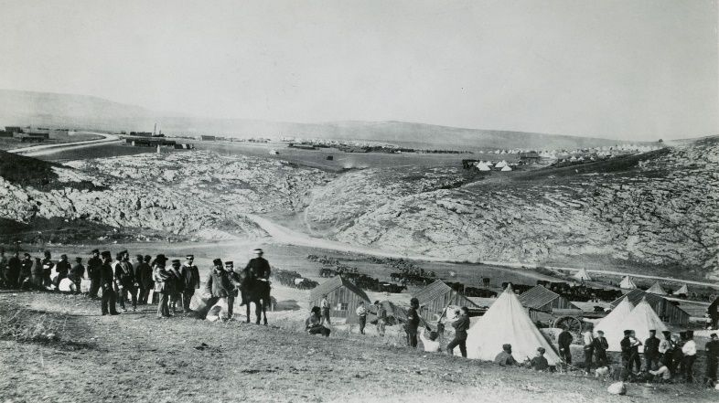
In 1888, the Army Service Corps was created. This specialised in the movement of supplies for soldiers. This development would bring an end to the awful conditions that soldiers suffered abroad. In the Crimean War in 1854 many soldiers went with basic equipment such as coats and boots. Requisitioning was still taking place just like it had done in 1250-1500. This was a highly inefficient system and the British Army needed better. The food supplies were not adequate, and the suffering was written about in the newspapers.
The Training of officers improved with the Royal Military College at Sandhurst and the Woolwich Military Academy for artillery and engineering officers.

Questions
- Why did the quality of soldiers in the British Army unreliable?
……………………………………………………………………………………………………………………………………………………………………………………………………………………………………………………………………………………………………………………………………………………………………………………………………………………………………………………………………………………………………………………………..

- Why were British troops of poor quality from 1700-1850?
……………………………………………………………………………………………………………………………………………………………………………………………………………………………………………………………………………………………………………………………………………………………………………………………..

- How were Colonel’s regiments similar to the way men were recruited in the period 1250-1500?
……………………………………………………………………………………………………………………………………………………………………………………………………………………………………………………………………………………………………………………………………………………………………………………………….

- Why did officer training not improve as much as it could have in the period 1700-1850?
……………………………………………………………………………………………………………………………………………………………………………………………………………………………………………………………………………………………………………………………………………………………………………………………..

- Why was the Crimean War a turning point for the treatment of soldiers in the British Army?
……………………………………………………………………………………………………………………………………………………………………………………………………………………………………………………………………………………………………………………………………………………………………………………………………………………………………………………………………………………………………………………………..

- How did Cardwell’s army reforms improve the army?
……………………………………………………………………………………………………………………………………………………………………………………………………………………………………………………………………………………………………………………………………………………………………………………………………………………………………………………………………………………………………………………………….

- Why was the Army Service Corps an important development?
………………………………………………………………………………………………………………………………………………………………………………………………………………………………………………………………
Lesson 6 The Impact of War on Civilians
1700-1850 | 1850-1900
Civilian Deaths  There was very little fighting on British soil during this period. Very few British civilians died. | Civilian Deaths  In this period there was no war on British soil but civilians were affected in many other ways.
Recruitment  In theory the 1757 Militia Act would increase the available men for an army. However, there were riots when people feared the militia might be forced to serve in the regular army. | Public Attitudes  During the Crimean War the British public were more aware of war overseas than ever before. Newspaper were booming and people such as William Howard Russell of the Times were able to send reports using the electric telegraph. It took only five hours to report where as before a report delivered by sea would take twenty days.  Howard Russell reported bravery but also the disorganised nature of the army. The British public could write letters criticising the government.
Requisitioning  This process continued as the army did not have transport of its own so had to still requisition ships and horses. | Public actions  The public donated money for the wounded and raised the equivalent of £3 million in a week.
Army Accommodation  There were no barracks in 1700, Large numbers of soldiers needing housing. Very often rowdy soldiers would disrupt life in a town or village. By 1800, there were more barracks, so this problem was not as common. | Imperialism and Jingoism  Reports of bravery from Crimea boosted the idea that British values were the best and should be shared around the world.  Jingoism-An extreme patriotic belief. Many people supported the idea that Britain should use its army to spread British dominance around the world.
Tax  The annual cost of the army rose from £1 million in 1700 to £8 million in 1836. It should be noted though that the population was far higher in1836 so there were more taxpayers to share the burden.  In wartime taxes did increase. For example, the cost of the army rose in the wars with France to £25 million a year so would mean hardship for many British people. | Pacifism  There were some in British society who questioned war and believed it was wrong. Groups such as the Quakers and some newspapers such as the Manchester Guardian were vocal in their opposition to the war.

Question
Is it accurate to say that civilians were affected far more by warfare in the period 1850-1900 than in the period 1700-1850?
……………………………………………………………………………………………………………………………………………………………………………………………………………………………………………………………………………………………………………………………………………………………………………………………………………………………………………………………………………………………………………………………………………………………………………………………………………………………………………………………………………………………………………………………………………………………………………………………………………………………………………………………………………………………………………………………………………………………………………………………………………………………………………………………………………………………………………………………………………………………………………………………………………………………………………………………………………………………………………………………………………………………………………………………………………………………………………………………………………………………………………………………………………………………………………………………………………………………………………………………………………………………………………………………………………………………………………………………………………………………………………………………………………………………………………………………………………………………………………………………………………………………………………………………………………………………………………………………………………………………………………………………………………………………………………………………………………………………………………………………………………………………………………………………………………………………………………………………………………………………………………………………………………………………………………………………………………………………………………………………………………………………………………………………………………………………………………………………………………………………………………………………………………………………………………………………………………………………………………………………………………………………………………………………………………………………………………………………………………………………………………………………………………………………………………………………………………………………………………………………………………………………………………………………………………………………………………………………………………………………………………………………………………………………………………………………………………………………………………………………………………………………………………………………………………………………………………………………………………………………………………………………………………………………………………………………………………………………………………………………………………………………………………..

