Year 10 English

Name:

Class:

Teacher:
Summer A/B
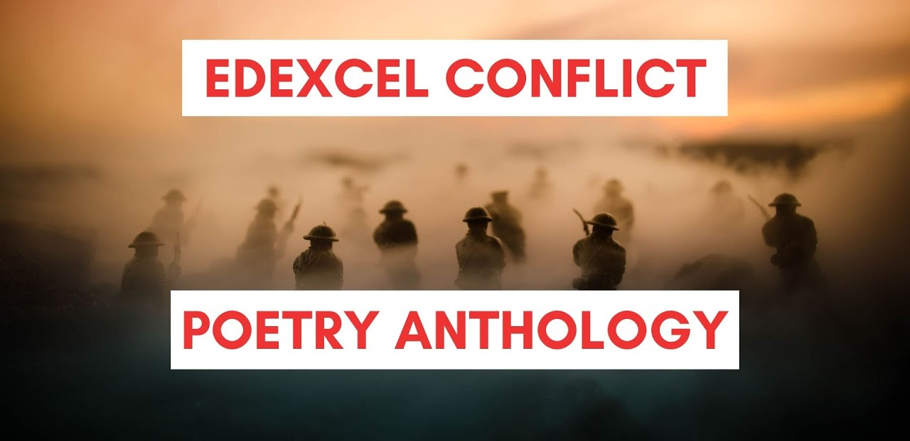

 | Unit 3 Literature: Poetry Anthology SAL
 | Knowledge, understanding, and skills
Yellow Plus  17-20 | - Perceptive comparisons and contrasts are made  - Varied and comprehensive range of similarities and/or differences are considered  - Perceptive grasp of form and structure and their effect  - Cohesive evaluation of the poets' use of language and its effect on the reader  - Integrated and precise use of relevant subject terminology  - Excellent understanding of context  - Convincing understanding of the relationship between poems and context is integrated into the response
Yellow  13-16 | - Effective comparison and contrast of the poems  - Considers a wide range of similarities and/or differences, which are supported throughout by relevant examples  - Analysis of form and structure and their effect is sustained  - Effective analysis of poets' use of language and its effect on the reader  - Accurate and relevant subject terminology is used appropriately to develop ideas  - Sustained comment on relevant context  - Detailed awareness of the relationship between poems and context
Blue  9-12 | - Makes a range of points regarding comparisons and contrasts  - Considers some similarities and/or differences between the poems  - Sound understanding of form and structure and links them to their effect  - Clear awareness of the poets' use of language and its effect on the reader, supported by sound examples  - Relevant subject terminology is used to support examples given  - Sound comment on relevant context  - Sound and relevant comment on the relationship between poems and context
Green  5-8 | - Some underdeveloped comparisons and contrasts  - Obvious similarities and/or differences are supported with some ideas from the text  - Some comment on the form and structure of the poems  - Some undeveloped awareness of the poets' use of language  - Limited use of relevant terminology to support examples given  - Some awareness of relevant context  - Some comment on the relationship between poems and context  NB: The mark awarded cannot progress beyond the top of Level 2 if only ONE poem has been considered.
White  1-4 | - Little or no comparison of the two poems  - Limited identification of form and structure  - Little awareness of the language used by the poets  - Little evidence of relevant subject terminology  - Little awareness of context  - Little comment on the relationship between poems and context

Lesson 1 - Belfast Confetti
LI: To understand what I am learning this unit, how this fits into the Big Picture and how I will be assessed
LI: To independently analyse the poem “Belfast Confetti” and identify the key ideas

TASK 1: Complete the table below

Poetic Technique | Definition | Example
Simile
Metaphor
Alliteration
Personification
Hyperbole
Repetition
Onomatopoeia
Rhyme
Assonance
Imagery
Rhythm

DART:
- Read the poem Belfast Confetti independently (page 36).
- Annotate the following words on the poem:
Fount = source/font
Asterisk = a symbol (*) used in text as a pointer to an annotation or footnote
Hyphenated = when two words are linked by a hyphen -
Labyrinth = maze
Balaclava, Raglan, Inkerman, Odessa = names of streets, named after famous military historical events
Crimea = An area near Russia where the Crimean war happened
Saracen = a brand of tank (named after medieval arab soldiers)
Kremlin-2= iron mesh protection around a tank, named after a place in Russia
Makrolon = type of plastic
Fusillade = series of shots being fired all at once
- Annotate any interesting features of language, structure, and form. What are the effects of the methods/devices/features you’ve identified?
- https://www.youtube.com/watch?v=MOyiuCV3OHg&list=PL3SL0Vb9FeCerK8LdoZZg-1_Tg3qThVol&index=13
- https://www.youtube.com/watch?v=NpMviItqdk8

DIP:
- Write a description of the aftermath of an explosion. You should include imagery of destruction. You could include an unanswered question. Think carefully about the punctuation you could use to help create the impression of an explosion.
- Now, write an explanation of how the poem influenced your writing. For example, the methods, themes, language used.
___________________________________________________________________________

Lesson 2 - Belfast Confetti
- LI: To understand and use key terms that help to describe and analyse language and structure (irregular structure, metaphor, imagery, assonance) – Belfast Confetti

TASK 1:
Find examples of the following subject terms in the poem Belfast Confetti:

- Irregular structure
- Metaphor
- Imagery
- Assonance
- Enjambment

What is the effect of using these features?
DART: Read the information about the Troubles in Ireland. Think about how this would have affected Carson who was born in 1948 in Belfast and lived through this time. He wrote Belfast Confetti in 1990. In 1969 he narrowly missed death when a bullet tore through a taxi he was sitting in.
DIP: Answer the following questions to develop your own personal response to the poem
The Troubles – Northern Ireland (1968 – 1998)
By the 1970s, Ireland was suffering poor living standards, growing unemployment, and high Irish emigration to Britain and America. Sean Lemass, the new Taoiseach (Prime Minister of the Republic of Ireland) brought great energy to Ireland in the 1960s. However, events in Northern Ireland were to dominate the political scene in Ireland for the next thirty years.
- In 1968 Catholics were demanding equal rights with Protestants.
- Protestant extremists and fervent Unionists were prepared to use violence to stop this.
- Riots broke out in Londonderry (Derry) in 1968 and Belfast in 1969 as Catholics were attacked and driven from their homes.

'The Troubles'
British troops were brought in to restore order, but the conflict intensified as the IRA and Protestant paramilitary groups carried out bombings and other acts of terrorism. This continuing conflict, which lingered into the 1990s, became known as 'The Troubles’.

Bloody Sunday 30 January 1972
During a march in Londonerry (Derry) by Northern Irish Catholics protesting against internment (imprisonment without trial), the British army opened fire on the marchers, killing 13 demonstrators. Journalists captured the event on film and the world was outraged.
- On 2 February, outraged Irish citizens set the British Embassy on fire.
- British Prime Minister, Edward Heath, abolished self-rule and introduced Direct Rule from London. He claimed the Unionists could no longer be trusted to run Northern Ireland.
- A Secretary of State was introduced to govern Northern Ireland.

Consequences of Bloody Sunday 1972
- In April 1972, the British government released a report clearing British troops of any illegal actions during the Derry protest.
- Irish anger grew and Britain increased its military presence in the North while removing any trace of Northern self-rule.
- On July 21, 1972, the IRA exploded around 21 bombs simultaneously in Belfast, killing British military personnel and a number of civilians.
- The IRA moved its bombing campaign to mainland Britain.
- British and Irish governments tried to find a solution to stop the violence. In December 1973, the Sunningdale Agreement was signed to allow a new power sharing government to rule Northern Ireland.
- On 1st January 1974, this new government took office. The Unionists refused to recognise it and called on all Protestants to join a General Strike. By May, the new government collapsed, and Direct Rule was restored.
- Why do you think Carson chose this title? Do you think it’s effective? Why/why not?
- Do you think the poem depicts the aftermath of an explosion effectively? Why/why not?
- What does the use of the word ‘again’ in line 7 suggest how the speaker feels?
- What is the effect of naming technical equipment in the penultimate line?

TASK 2: To develop your ideas further, fill out this table. The first one has been done for you.

Feature of the poem | Its effect | Why it has been used
The poem moves from exclamation marks in the beginning to question marks at the end. | This makes the poem seem to be upside down or back to front. | It emphasises that the conflict has caused confusion in the speaker’s head. He runs for safety, trying to make sense of what is happening, but he cannot escape.
The poem consists of two stanzas: the first is in the past tense and the second is in the present tense. | This shows that the confusion and conflict is still ongoing. | The shift in tense creates a sense of immediacy and that the speaker can’t come to terms with what they have seen. This could also demonstrate…
The title of the poem ‘Belfast Confetti’ | These words make the speaker seem…
Each line spills over so there are additional lines of one, two, or three words. | This emphasises…
The speaker uses first person narrative. | This has the effect of…

___________________________________________________________________________

Lesson 3 - War Photographer
LI: To independently analyse the language, form and structure of a poem

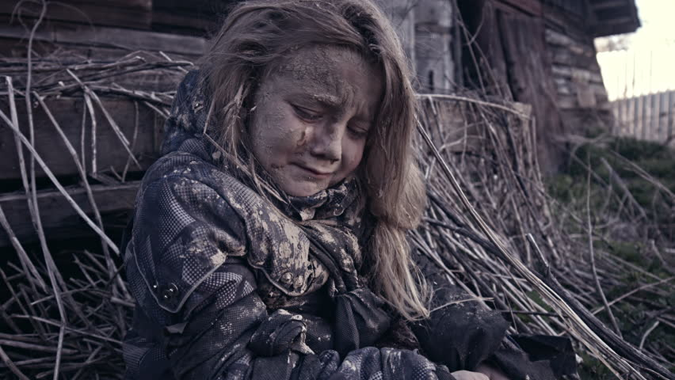
TASK 1: Write a short diary entry/reflection from the perspective of the photographer of this picture. (1st person, past tense)
DART:
- Read the poem War Photographer independently (page 35).
- Annotate the following words on the poem:
Reassurance = when something is comforting
Flexible = something unfixed, that can be changed
Absurd = ridiculous, not normal
Sun-gilded = surrounded by sunlight
Staggering = walking unsteadily
Prevailing = overcoming, overwhelming
Triumph = winning
Arbitrary = random, not based on a rule or reason
- Annotate any interesting features of language, structure, and form. What are the effects of the methods/devices/features you’ve identified?
- https://www.youtube.com/watch?v=mHkbIjDeuSQ&list=PL3SL0Vb9FeCerK8LdoZZg-1_Tg3qThVol&index=12
- https://www.youtube.com/watch?v=iMt09G5sYcw

DIP: Answer the following questions in as much detail as you can:
- What do you think the overall message of the poem is?
- How does the mood change throughout the poem?
- What do you think happened to the little girl? Explain your answer.
- How do you think the speaker feels about ‘how things are’? (line 8)
- What effect does the phrase ‘She saw me seeing her’ (line 16) have?
- Why do you think the poet chose to make both of the memories about girls?
- How did the poem link to the ideas you expressed in your creative writing in the beginning of the lesson? Why might this have been similar/different?

___________________________________________________________________________

Lesson 4 - War Photographer
LI: To identify how key ideas are developed (juxtaposition, emotive language, sibilance)

TASK 1: Answer the following questions:
- Write a summary of the poem in your own words.
- Write out two quotes that contrast with each other.
- Write out a quote that uses sibilance to stand out.
- At the end of the poem, what happens to the photograph of the little girl who was holding the baby?
- Name two types of conflict shown in this poem.

DART: Read the following information about Satyamurti and her message.
Carole Satyamurti
- Poet who focuses on painful subjects, such as cancer, war and the fragility of human life.
- This poem was written in 1987, at the time of several major conflicts. The poem draws on the experience of modern warfare and the pointless nature of suffering, not a specific conflict.
- At the time when the poem was written, many places across the globe were still in the middle of brutal wars and conflict, including:
  - Iran/Iraq war
  - Various wars in South Africa
  - The ‘Troubles’ in Northern Ireland
  - The Lebanon War
  - The Sri Lankan civil war
  - The 2nd Sudanese civil war.
- Satyamurti focusses on the tragedy of war, contrasting poverty and conflict to the life of wealth and leisure some people are living.
- Satyamurti wants to show the effects of modern warfare, and explicitly shows details about the effects of war. Rather than seeing war as a whole, the poet reveals that the details seen by a war photographer reveal that war is individual and personal and often hurts innocent lives.
- The poet shows how the media manipulates images to portray a less realistic and more positive version of events happening around the world in order to influence people into ignoring war and conflict around the world.

DIP: To develop your ideas further, fill out this table. The first one has been done for you.

Feature of the poem | Its effect | Why it has been used
The poem is written in free verse. | This reveals the speaker’s thoughts in a natural style – like a dramatic monologue. | It emphasises that the speaker is interested in telling the truth and revealing the reality of war and conflict.
The poet uses juxtaposition, such as ‘sun-gilded’ and ‘small’. | This highlights…
The poem contains powerful emotive language, such as ‘… | This emphasises…
The speaker addresses the reader directly ‘… | This has the effect of…

___________________________________________________________________________

Lesson 5 – The Man He Killed
LI: To independently analyse the language, form, and structure of a poem to identify how key ideas are developed

TASK 1:
Closely analyse the title of the poem – how does this affect our interpretation of the poem? How might it change if the words are different?
  - The Man I Killed
  - A Man He Killed
  - The Enemy He Killed
  - The Soldier He Killed
  - The Man He Murdered

DART:
- Read the poem The Man He Killed independently (page 27).
- Annotate the following words on the poem:
Wet = celebrate a new baby
Nipperkin = baby/small drink
Infantry = soldiers
Foe = enemy
‘list = join the army
Traps = stuff
Quaint = unusual, old-fashioned
Treat = buy a drink for
Half-a-crown = money
- Annotate any interesting features of language, structure, and form. What are the effects of the methods/devices/features you’ve identified?
- https://www.youtube.com/watch?v=_LifUy4Hy8A&list=PL3SL0Vb9FeCerK8LdoZZg-1_Tg3qThVol&index=8
- https://classroom.thenational.academy/lessons/the-man-he-killed-part-1-cmvk8r
- https://classroom.thenational.academy/lessons/the-man-he-killed-part-2-ccukjd

DIP: Answer the following questions in as much detail as you can:
- Do you think the speaker regrets what he has done? Why/why not?
- Why do you think the poet uses a mix of friendly and unemotional language?
- Why do you think the speaker describes war as ‘quaint and curious’ on line 17?
- How do the speaker’s opinions change over the course of the poem?
- Why do you think Hardy chose to write the poem using matter-of-fact language?
- What is the effect of the caesurae in the poem?

___________________________________________________________________________
Lesson 6 – The Man He Killed
LI: To analyse the plot, themes, ideas, and language of the poem

TASK 1: Answer the following questions in as much detail as you can:
- Write a summary of the poem in your own words.
- Write a quote that shows the narrator’s confusion.
- Write a quote that shows that soldiers could have been friends.
- What is a key theme of the poem?
- What war was happening when the poem was written?

DART: Read the following information about the Boer War and Thomas Hardy.
The Man He Killed was written in 1902, at the time of the Second Boer War. The Boer Wars were fought between the British and the Dutch settlers of the Boer republics in what is now South Africa. There were several wars throughout the 19th century which were aimed at consolidating British rule throughout the Empire.

Hardy was against the Boer War. Like many liberals of the time, he thought the Boers were simply defending their homes. Why did the British feel the need to keep their territory so strongly? Perhaps the diamond and gold mines of the area had something to do with it.

Thomas Hardy
- 1840 – 1928
- Famous novelist and poet.
- Born in a lower class and was passionate by the idea of class division in society.
- Wrote several significant war poems that relate to both the Boer Wars and World War I.
- Even though he wasn’t himself a soldier, his work had a profound influence on other war poets such as Rupert Brooke and Siegfried Sassoon.
- Often used the viewpoint of ordinary soldiers and their colloquial speech (writing the way they would have spoken.)

DIP: To develop your ideas further, fill out this table. The first one has been done for you.

Feature of the poem | Its effect | Why it has been used
The poem is a dramatic monologue with a regular metre and rhyme scheme (ABAB). | This reveals the speaker’s thoughts in a natural style. | The conversational tone contrasts with the poem’s dark subject matter
The poem has a cyclical structure. | This highlights…
The poem contains colloquial language, such as ‘… | This emphasises…
The speaker uses hesitant language ‘… | This has the effect of…

___________________________________________________________________________

Lesson 7 – Exposure
LI: To independently analyse the language, form, and structure of a poem to identify how key ideas are developed

TASK 1:
Closely analyse the title of the poem – what does the word ‘exposure’ mean?

DART:
- Read the poem Exposure independently (page 30).
- Annotate the following words on the poem:
Word | Definition
Merciless | Unkind, cruel
Wearied | Tired
Drooping | Falling in an arc
Flares | Sudden burst of fire
Salient | What’s most important
Sentries | Soldiers who keep a watch out
Gusts | Sudden rush of wind
Incessantly | Without stopping
Poignant | Makes you feel sadness
Massing | Gathering
Gunnery | Guns and weaponry
Melancholy | Sadness
Successive | Following each other
Streak | Moving fast in a specific direction
Flock | Group together
Nonchalance | Relaxed, careless attitude
Drowse | Fall asleep

- Annotate any interesting features of language, structure, and form. What are the effects of the methods/devices/features you’ve identified?
- https://classroom.thenational.academy/lessons/exposure-part-1-ccwp4d
- https://classroom.thenational.academy/lessons/exposure-part-2-68u62r

DIP: Answer the following questions in as much detail as you can:
- What do you think the title is referring to? Could it have more than one meaning?
- Do you think the men are relieved about a new day dawning? How can you tell?
- Why do you think the noun ‘ghosts’ is used to describe the men thinking about going home?
- What do you think the poem’s overall message is?
- Does the tone of the poem change at all? Why do you think this is?
- Give an example of a half-rhyme in the poem. What is its effect?

___________________________________________________________________________

Lesson 8 – Exposure
LI: To analyse the plot, themes, ideas, and language of the poem

TASK 1: Answer the following questions in as much detail as you can:
- What are the soldiers waiting for?
- Write a quote that shows the violent aspect of weather.
- Write a quote that shows the soldiers are losing their faith in God.
- What two types of conflict are happening in the poem?
- What war was happening when the poem was written?

DART: Read the following information about Wilfred Owen and WWI
Wilfred Owen (1893 – 1918)
- One of the most famous World War I poets.
- He enlisted in the army when he was 22.
- A year later, sent out of the army and to hospital because he was suffering from PTSD.
- In hospital, Wilfred Owen became friends with poet Siegfried Sassoon, who encouraged him to keep writing poems.
- Returned to the front in 1918 and kept it a secret from his friend Sassoon, who didn't want him to return.
- Killed in battle during the last month of the war. He died exactly one week before the signing of the Armistice which ended the war.
- Based on his own experiences of the trenches, Owen wanted people to know the horrific conditions the soldiers faced.
- Often, the soldiers would be waiting for combat rather than actually fighting. This meant that the soldiers were exposed to boredom, anxiety, extreme weather, horrific living conditions (mice and rats running around carrying diseases, no heating or running water etc.)
- Owen also wanted to expose to the incompetence of those in power, the Generals whose failure to protect the men from the weather leads to their death from hypothermia
WWI
- World War I was one of the worst wars in history.
- WWI killed almost 7 million civilians and 10 million soldiers.
- Newly developed technology such as tanks, machine guns and missiles were used for the first time, soldiers were killed in huge numbers.
- Began in 1914 and at first it was predicted that it would end quickly. However, as both sides dug trenches across France and Belgium, the opposing armies became locked in a stalemate that neither side could break.
- By the winter of 1917 both sides had sustained massive losses and extreme cold weather made the misery even worse.
- The soldiers suffered from hypothermia and frostbite and many developed trench foot, a crippling disease caused by feet being wet and cold and confined in boots for days on end.

DIP: To develop your ideas further, fill out this table. The first one has been done for you.

Feature of the poem | Its effect | Why it has been used
The poem is written in the present tense using the first person plural, for example ‘Our’, ‘we’, ‘us’. | This collective voice shows how the experience was shared by soldiers across the war. | The collective voice demonstrates the universal experiences faced by soldiers during warfare.
Each stanza has the same regular rhyme scheme (ABBAC) | This highlights…
The poem contains personification, such as ‘… | This emphasises…
The speaker uses bleak language ‘… | This has the effect of…

___________________________________________________________________________

Lesson 9 – The Charge of the Light Brigade
LI: To independently analyse the language, form, and structure of a poem to identify how key ideas are developed

TASK 1:
Closely analyse the title of the poem – what do you think the poem is going to be about?
Do you already know anything about this poem or Alfred Lord Tennyson?

DART:
- Read the poem The Charge of the Light Brigade independently (page 32).
- Annotate the following words on the poem:
Dismayed = shocked/horrified
Blundered = made a mistake
Shell = bomb
Sabre = long, curved sword
Sabring = to cut or wound with a sabre
Reeled = fell back
Sundered = shattered
- Annotate any interesting features of language, structure, and form. What are the effects of the methods/devices/features you’ve identified?
- https://classroom.thenational.academy/lessons/charge-of-the-light-brigade-part-1-6wv6cc
- https://classroom.thenational.academy/lessons/charge-of-the-light-brigade-part-2-cgrkjd
DIP: Answer the following questions in as much detail as you can:
- How does the phrase ‘jaws of Death’ (line 46) make you feel? Explain why.
- How does the speaker convey the terror and violence of the battle?
- Why do you think the stanzas in the poem are different lengths?
- Write a brief summary of what happens in each stanza of the poem.
- How does the speaker feel about the actions of the Light Brigade? How can you tell?
- Find some examples of repetition in the poem. What is its effect?

___________________________________________________________________________

Lesson 10 – The Charge of the Light Brigade
LI: To analyse the plot, themes, ideas, and language of the poem

TASK 1: Answer the following questions in as much detail as you can:
- Why do the soldiers go into the charge?
- Write a quote that foreshadows that the soldiers are going to die.
- Write a quote that contrasts the weapons of the British soldiers and the weapons of the Russian soldiers?
- What two types of conflict are happening in the poem?
- What war was happening when the poem was written?
DART: Read the following information about Alfred Lord Tennyson and the Crimean War
Alfred Lord Tennyson (1809 – 1892)
- Studied at Trinity College, Cambridge.
- At university met Arthur Henry Hallam, who soon became Tennyson’s closest friend.
- In 1833 received the most devastating blow of his entire life: he learned that Hallam had died suddenly of fever while traveling abroad.
- His terrible sadness at the news influenced much of Tennyson’s later poetry.
- In 1850 Tennyson became Poet Laureate.
- “The Charge of the Light Brigade” (1854) described a disastrous battle in the Crimean War and praised the heroism of the British soldiers there.
- The poem describes a disastrous battle between British cavalry (soldiers on horseback) and Russian forces during the Crimean War (1853 – 1856)
- A misunderstanding meant that the Light Brigade were ordered to advance into a valley surrounded by enemy soldiers.
- The cavalry were only armed with swords, whereas the Russian soldiers had guns. The Light Brigade were virtually defenceless against their enemies and most of the 673 cavalrymen were massacred in as little as 20 minutes.
- Tennyson wanted to show the contrast between the actual conflict of a war (between Britain and Russia) and the conflict within an army itself (between soldiers and commanders.)
- Tennyson wanted to show that the soldiers died for nothing because their job was to follow orders, but the commanders are responsible because their incompetence got the soldiers killed.
- Tennyson wanted people to remember and respect the soldiers for their bravery in the face of certain death.

DIP: To develop your ideas further, fill out this table. The first one has been done for you.

Feature of the poem | Its effect | Why it has been used
The poem is narrated in the third person in chronological order with a regular rhythm. | This makes the poem seem like a story, with the rhythm creating a quick pace. | The fast pace imitates the cavalry’s advance and the energy of the battle.
There is an inconsistent rhyme scheme. | This highlights…
The poem contains repetition, such as ‘… | This emphasises…
The speaker uses violent language ‘… | This has the effect of…

___________________________________________________________________________
Lesson 11 – Poppies
LI: To independently analyse the language, form, and structure of a poem to identify how key ideas are developed

TASK 1: What do poppies symbolise?
DART:
- Read the poem Poppies independently (page 38).
- Annotate the following words on the poem:
blackthorns
Bias binding
Lapel = edge of collar
Crimped = folded up
Blockade = blocking off a place to stop people from entering or leaving
Steel (verb) = mentally prepare to do something difficult
Eskimo (kiss) = rubbing your nose against someone else’s nose
Felt (noun) = a soft fabric
Intoxicated = drunk, drugged
Inscriptions = words carved on something
Ornamental = something used for decoration

- Annotate any interesting features of language, structure, and form. What are the effects of the methods/devices/features you’ve identified?
- https://classroom.thenational.academy/lessons/poppies-part-1-6dgk0d
- https://classroom.thenational.academy/lessons/poppies-part-2-6xjk4c

DIP: Answer the following questions in as much detail as you can:
- Is this a poem about war or a poem about family? Explain your choice.
- What impression do you get of the mother through the things that she does?
- Do you think the son is still alive? What clues does the poem give you?
- How do you think the title relates to the poem?
- What would you say in the overriding emotion in the poem? Explain your answer.
- Why do you think there are so many references to the mother touching things?

___________________________________________________________________________

Lesson 12 – Poppies
LI: To analyse the plot, themes, ideas, and language of the poem

TASK 1: Answer the following questions in as much detail as you can:
- What happens in the poem?
- Write a quote that shows the mother can’t express her emotions.
- Write a quote that shows the son’s attitude to war.
- What two types of conflict are in this poem?
- How does the poet hint that the son has died at war?

DART: Read the following information about Jane Weir and the context of the poem
- Jane Weir, born in 1963, grew up in Italy and Northern England, with an English mother and an Italian father. She has continued to absorb different cultural experiences throughout her life, also living in Northern Ireland during the troubled 1980s.
- The poem is set in the present day but reaches right back to the beginning of the Poppy Day tradition.
- Armistice Sunday began as a way of marking the end of the First World War in 1918.
- It was set up so people could remember the hundreds and thousands of ordinary men who had been killed in the First World War.
- Today, the event is used to remember soldiers of all wars who have died since then.
- When Poppies was written, British soldiers were still dying in wars in Iraq and Afghanistan.
- The poem is about the nature of loss and grief, especially from the point of view of a parent.
- The speaker is a mother who is speaking directly to her son who has gone off to the war which she struggles to come to terms with.
- The poem demonstrates the inner emotion of a narrator who is trying to remain calm and composed in front of her son but is breaking with sadness inside.
- The poem shows a parent’s inner conflict when they can no longer protect their child.

DIP: To develop your ideas further, fill out this table. The first one has been done for you.

Feature of the poem | Its effect | Why it has been used
The poem is in first person with no regular rhyme or rhythm. | This is a dramatic monologue, revealing the speaker’s thoughts and feelings about her son leaving home. | Long sentences and enjambment give the impression that the speaker is absorbed in her memories, whilst the caesurae show how she is trying to hold her emotions together.
The poem uses sensory language, for example ‘… | This highlights…
The poem contains war imagery, such as ‘… | This emphasises…
The speaker uses domestic imagery ‘… | This has the effect of…

___________________________________________________________________________

Lesson 13 – The Destruction of Sennacherib
LI: To independently analyse the language, form, and structure of a poem to identify how key ideas are developed

TASK 1: In your opinion, is the power of God impressive or frightening? Why?

DART:
- Read the poem The Destruction of Sennacherib independently (page 25).
- Annotate the following words on the poem:
Fold – can mean both a flock of sheep and a group with shared religious belief.
Cohort – members of a group (cohort is also an old-fashioned word for a group of soldiers)
Galiliee – a region in norther Israel
Host – an old-fashioned word for army
Angel of Death – an angel sent by God to kill enemies of the Israelites
Wax’d – an old-fashioned word for grew
Mail – armour made from metal rings linked together
Ashur – a cuty in Ancient Assyria
Baal – the King of Hell in the Hebrew Bible
Gentile – a person who isn’t Jewish
Unsmote – not hit
- Annotate any interesting features of language, structure, and form. What are the effects of the methods/devices/features you’ve identified?
- https://www.youtube.com/watch?v=josaCPpnKmQ&list=PL3SL0Vb9FeCerK8LdoZZg-1_Tg3qThVol&index=7

DIP: Answer the following questions in as much detail as you can:
- What is the effect of using imagery related to the natural world in the poem?
- Why do you think Byron has not made the Angel of Death a violent figure?
- Do you think the speaker wants us to sympathise with the 'widows of Asher'? Why/why not?
- What mood is Byron trying to create in the poem? How does he achieve this?
- Give an example of alliteration in the poem. What is the effect of this?

___________________________________________________________________________

Lesson 14 – The Destruction of Sennacherib
LI: To analyse the plot, themes, ideas, and language of the poem

TASK 1: Answer the following questions in as much detail as you can:
- Write a summary of the poem in your own words.
- Write a quote that shows the power of the Assyrian army.
- Write a quote that shows how quickly the army was defeated.
- What is a key theme of the poem?
- What war was happening when the poem was written?

DART: Read the following information about Lord Byron and the context of the poem
Lord Byron (1788 – 1824)
- Byron was a poet who was massively famous in his day. People were obsessed with him and looking like him.
- He was famous for having a huge number of affairs. Because of this, he suffered from multiple STDs.
- He was interest in the cultures and history of the Middle East and Far East, and died in Greece trying to help free Greece from the Ottoman Empire.
- He also had a fascination with the supernatural.
- Byron contrasted the beauty and power of the Assyrian army with the complete destruction of it to show the power of God.
- Although Byron was not Jewish, he strongly believed in the almighty power of God.
- Here, he shows how God protects those that worship him.
Sennacherib
- The poem is based on a short Bible story from the Old Testament (from chapters 18 and 19 of the second Book of Kings)
- It’s about an attempt by the Assyrian army to seize Jerusalem, the holy city of the Israelites. Assyria was a kingdom in the ancient Middle East.
- King Sennacherib orders the invasion of Jerusalem.

DIP: To develop your ideas further, fill out this table. The first one has been done for you.

Feature of the poem | Its effect | Why it has been used
The poem is written in rhyming couplets organised into quatrains. | The regular rhythm is a way to drive the poem forward. | This could represent the marching pace of the army and their horses or it could reflect the quick defeat of the Assyrian army. The organisation of the stanzas could represent the organised manner of the cohorts.
The poem uses repetition (anaphora), for example ‘… | This highlights…
The poem contains natural imagery, such as ‘… | This emphasises…
The poem has a calm tone to it, for example‘… | This has the effect of…

___________________________________________________________________________

Lesson 15 Literature PPE AIC question
LI: To answer an exam question on An Inspector Calls

___________________________________________________________________________

Lesson 16 – What Were They Like?
LI: To independently analyse the language, form, and structure of a poem to identify how key ideas are developed

TASK 1: What do you think the poem is going to be about, based on the title?

DART:
- Read the poem What Were They Like? independently (page 40).
- Annotate the following words on the poem:
Ivory = a hard, white material that make sup animal tusks
Jade = a hard, green-coloured type of stone
Reverence = pay respect to something
Bud = flower blossom
Ornament = something worn for decoration, like jewels
Distinguish = to be able to tell the difference between two things
Illumine= light up
Charred = burned to ashes
Epic poem = a long poem, usually about important events in a culture’s history
Paddies = fields that rice can be grown in
- Annotate any interesting features of language, structure, and form. What are the effects of the methods/devices/features you’ve identified?
- https://classroom.thenational.academy/lessons/what-were-they-like-part-1-75gk4d
- https://classroom.thenational.academy/lessons/what-were-they-like-part-2-cdh66c

DIP: Answer the following questions in as much detail as you can:
- What sort of people do you think the two individuals could be? Explain your answer.
- Why do you think the poet lists the four ornamental materials that she does?
- What effect does the phrase “A dream ago, perhaps” have on the reader?
- How do you think the first speaker might respond after hearing the answers?
- How do you think the poem should be read? Why?

___________________________________________________________________________

Lesson 17 – What Were They Like?
LI: To analyse the plot, themes, ideas, and language of the poem

TASK 1: Answer the following questions in as much detail as you can:
- How does the poet use nature imagery?
- What two types of conflict is the poet exploring?
- Write a quote that shows how the war has changed Vietnam.
- Write a quote that makes us feel pity.
- What aspects of the war in Vietnam is the poet criticising?

DART: Read the following information about the context of the poem
The Vietnam War (1955 – 1975)
- The Vietnam War took place at a time of great social change in the western world.
- The developing social and cultural freedoms of the 1960s resulted in an increased questioning of accepted authority.
- It was a conflict between North and South Vietnam. The US supported the South, but eventually withdrew and North Vietnam won. Although considered a humiliating defeat, the US still inflicted lots of damage on the Vietnamese people.
- A main focus of the anti-authority movement was protesting against the American involvement in the affairs of Vietnam and other countries in south-east Asia.
- A key tool used to do this was the protest song. Artists such as Bob Dylan, Joan Baez and Pete Seeger produced simple but heartfelt pieces of music criticising the Vietnam War and what they saw as the western world meddling where they had no right.
- Levertov uses the power of the question and response format to expose the wrongdoing and the crimes against humanity which so appalled her.

DIP: To develop your ideas further, fill out this table. The first one has been done for you.

Feature of the poem | Its effect | Why it has been used
The poem is written in question-and-answer form. | This form is unusual and not immediately recognisable as free verse. | This could represent how the peaceful and happy Vietnam in the poem is no longer identifiable. The questions create natural pauses which exaggerates the poignant sense of loss.
The poem can be read top to bottom or by reading each question and answer in turn. | This ambiguity highlights…
The poem contains peaceful imagery, such as ‘… | This emphasises…
The poem uses language of devastation, for example ‘… | This has the effect of…

___________________________________________________________________________

Lesson 18: Literature PPE ACC Part A and B
LI: To answer an exam question on A Christmas Carol
___________________________________________________________________________
Lesson 19 – A Poison Tree
LI: To independently analyse the language, form, and structure of a poem to identify how key ideas are developed
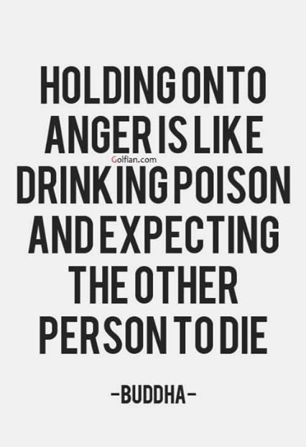
TASK 1: What do you think the poem is going to be about, based on the title?
What do you think this quotation means?

DART:
- Read the poem A Poison Tree independently (page 24).
- Annotate the following words on the poem:
Wrath – anger
Foe – enemy
Water’d – watered
Sunned – expose to sunlight
Deceitful– lying or misleading or hiding something
Wiles – ways of persuading someone to trick them into doing something
Beheld – saw/looked at
Stole– snuck in
Veil’d – veiled/covered
Outstretched – lying down
- Annotate any interesting features of language, structure, and form. What are the effects of the methods/devices/features you’ve identified?
- https://classroom.thenational.academy/lessons/a-poison-tree-part-1-6wtk6r
- https://classroom.thenational.academy/lessons/a-poison-tree-part-2-60tp8c

DIP: Answer the following questions in as much detail as you can:
- Do you think the poem presents a clear moral message? Why/why not?
- Do you think the tree is an effective metaphor? Why/why not?
- Why do you think the speaker’s enemy sneaks into the garden?
- Why do you think we are given so little information about the ‘foe’?
- Why do you think Blake chose to use a tree as a metaphor for the speaker’s anger?

___________________________________________________________________________
Lesson 20 – A Poison Tree
LI: To analyse the plot, themes, ideas, and language of the poem

TASK 1: Answer the following questions in as much detail as you can:
- Write a summary of the poem in your own words.
- Write a quote that shows how the narrator’s anger is growing.
- Write a quote that shows the negative side of anger.
- What is a key theme of the poem?
- When was the poem written?

DART: Read the following information about the context of the poem
William Blake (1757 – 1827)
The 18th century was a time of strict Christian attitudes and beliefs, which Blake disliked. Blake’s disapproved of institutionalized religion (when the government is linked to a religion that everybody has to follow), and of the tradition of marriage (though he was married himself).

The original title of the poem was Christian Forbearance (Self-Control).

The Book of Genesis
The apple in the poem could be an allusion to the story of Adam and Eve. In the Bible, God forbids Adam and Eve from eating the fruit from the tree of knowledge. However, they bout eat the fruit after Eve is tempted to do so by a snake. God punishes them, and all of humanity, for their sin. Although it isn’t specified in the Bible, the fruit is often depicted as an apple.

DIP: To develop your ideas further, fill out this table. The first one has been done for you.

Feature of the poem | Its effect | Why it has been used
The poem has a very simple rhyme scheme made up of rhyming couplets. | This creates a regular beat to the poem. | This makes it sound like a nursery rhyme which reinforces the moral message.
The poem uses contrasts, such as ‘… | This highlights…
The poem contains repetition, such as ‘… | This emphasises…
The poem uses nature imagery for example ‘… | This has the effect of…

___________________________________________________________________________

Lesson 21 Poetry PPE
LI: To answer an exam question on Poetry

___________________________________________________________________________

May Half-Term

___________________________________________________________________________

Lesson 1: Language Revision: Paper 1 Evaluation

___________________________________________________________________________

Lesson 2: Language Revision: Imaginative writing

___________________________________________________________________________

Lesson 3: Language PPE Paper 1

___________________________________________________________________________

Lesson 4: Language PPE Paper 1

___________________________________________________________________________

Lesson 5 – Extract from ‘The Prelude’
LI: To independently analyse the language, form, and structure of a poem to identify how key ideas are developed

TASK 1: What do you think the poem is going to be about, based on the title?

DART:
- Read the poem Extract from ‘The Prelude’ independently (page 26).
- Annotate the following words on the poem:
- Cove– a part of a beach or side of a lake
- Stealth – sneakily
- Idly – slowly, lazily
- Unswerving – going straight somewhere.
- Craggy– with harsh edges
- Utmost – complete
- Elfin – elf-like, magical, and delicate
- Horizon – edge of the distance
- Lustily - passionately
- Pinnace – peak, mountain
- Voluntary – by will
- Upreared– lifted, rising up.
- Stature– size
- Towered – standing high over something.
- Strode – walked quickly.
- Covert – sneaky, hidden.
- Dim – unclear, foggy
- Solitude – loneliness
- Desertion – abandonment
- Mighty – powerful
- Annotate any interesting features of language, structure, and form. What are the effects of the methods/devices/features you’ve identified?

DIP: Answer the following questions in as much detail as you can:
- What does ‘troubled pleasure’ suggest about the speaker’s actions and feelings?
- What is the effect of the repetition of ‘and’ in lines 24-29?
- Can you empathise with the speaker? Is his reaction understandable?
- What impression do you have of nature by the end of the extract?
- What do you think Wordsworth is saying about man’s relationship with nature?
- How do the speaker’s feelings change over the course of the extract?
- Why do you think the poet feels so intimidated by nature?
- Is the narrator overreacting or is his reaction understandable?
- In your opinion, is the power of nature presented in a positive or negative light?

___________________________________________________________________________
Lesson 6 – Extract from ‘The Prelude’
LI: To analyse the plot, themes, ideas, and language of the poem

TASK 1: Answer the following questions in as much detail as you can:
- Write a summary of the poem in your own words.
- Write a quote that shows the power of the narrator.
- Write a quote that shows how intimidating nature is.
- What is a key theme of the poem?
- What place in England inspired this poem?

DART: Read the following information about the context of the poem
William Wordsworth (1770 – 1850)
Wordsworth was a poet from the Lake District.
‘The Prelude’ is an autobiographical poem – it explores key moments and experiences in Wordsworth’s life. It was published shortly after his death in 1850.
Wordsworth contrasts the power of man to the power of nature. This is because he saw nature as an unstoppable force, and man’s place in the universe is less important than we imagine. He felt that that nature deserves more respect than humans give.

‘The Prelude’
This poem is an extract taken from the first of fourteen books that make up Wordsworth’s epic poem ‘The Prelude’. The book is entitled ‘Introduction – Childhood and School-Time’. Wordsworth was a Romantic poet. Like other Romantic poetry, this extract explores the connection between nature and human emotion, and the way human identity and character is shaped by experience.

DIP: To develop your ideas further, fill out this table. The first one has been done for you.

Feature of the poem | Its effect | Why it has been used
The poem is a first-person narrative in blank verse using iambic pentameter. | This makes it sound serious and important. | This reinforces that the poem is a personal account of a turning point in the poet’s life. The regular rhythm makes the poem sound like natural speech.
The poem uses nature imagery, such as ‘… | This highlights…
The poem contains sibilance, such as ‘… | This emphasises…
The poem uses personification, for example ‘… | This has the effect of…

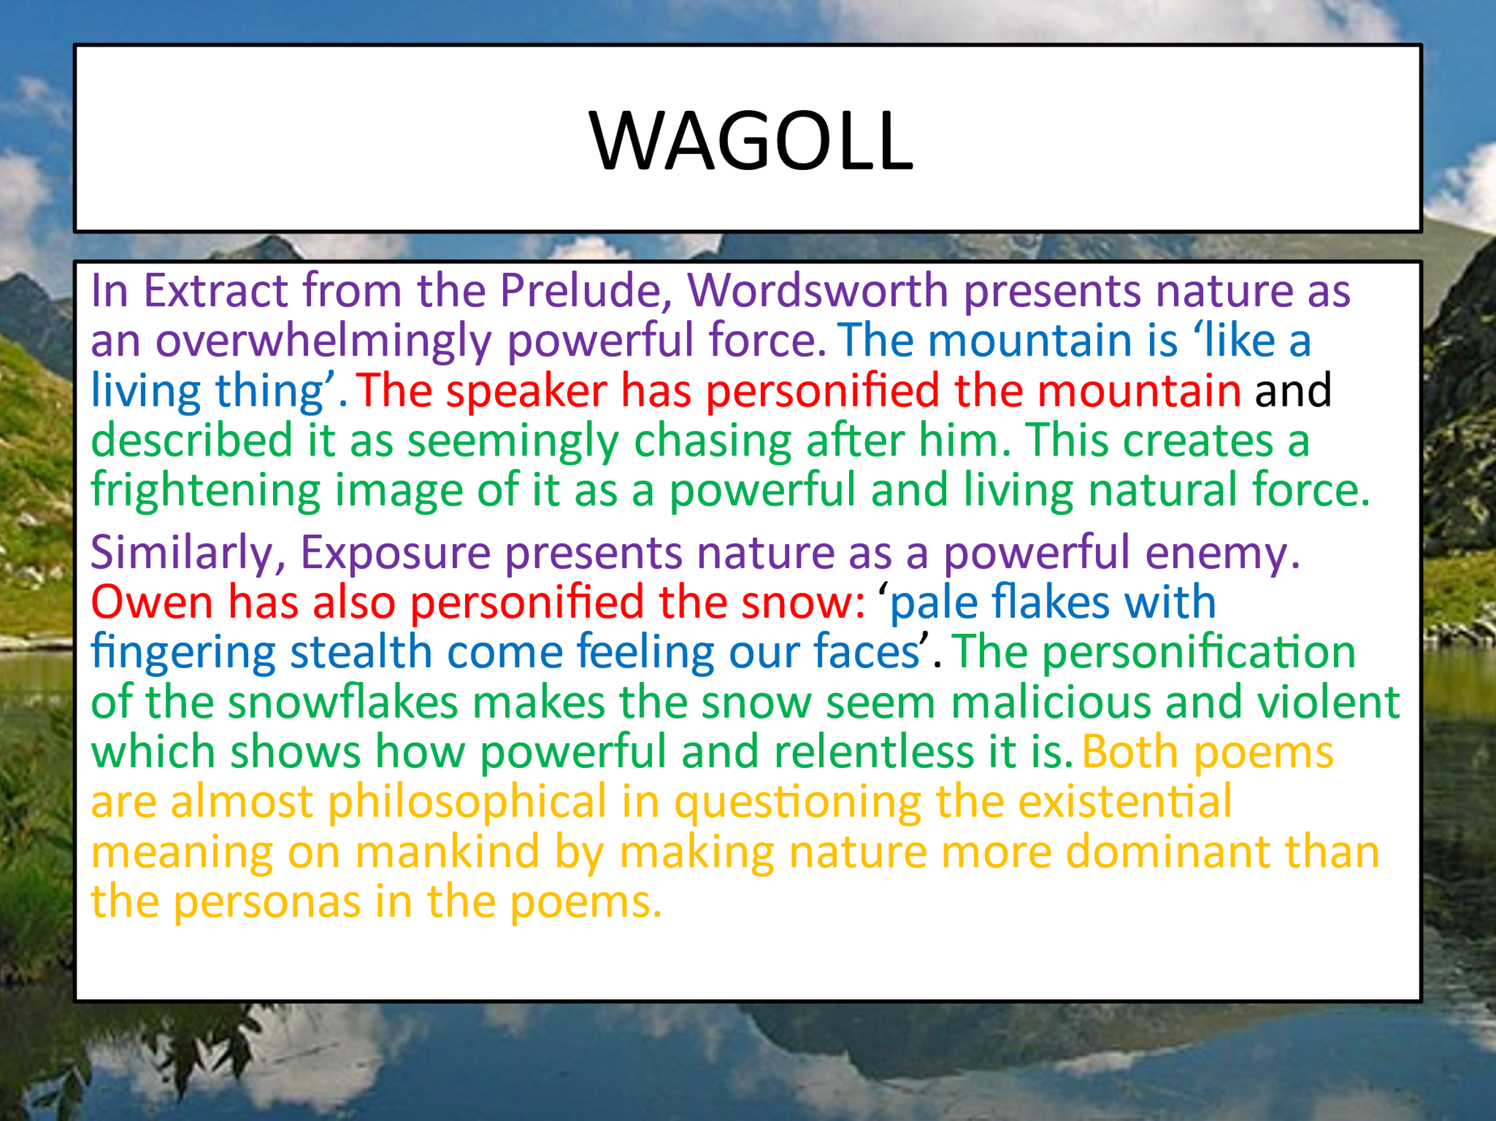

___________________________________________________________________________

Lesson 7 – Cousin Kate
LI: To independently analyse the language, form, and structure of a poem to identify how key ideas are developed

TASK 1: What do you think the poem is going to be about, based on the title?

DART:
- Read the poem Cousin Kate independently (page 28).
- Annotate the following words on the poem:
- Contended = happy
- Mindful = aware
- Fair = beautiful
- Flaxen = golden
- Cast = threw
- Rye = wheat
- Mean estate = poverty
- Sire = lord
- Coronet = crown
- Annotate any interesting features of language, structure, and form. What are the effects of the methods/devices/features you’ve identified?
- https://www.youtube.com/watch?v=_T1Niq_t7Bs&list=PL3SL0Vb9FeCerK8LdoZZg-1_Tg3qThVol&index=9

DIP: Answer the following questions in as much detail as you can:
- What does ‘He changed me like a glove’ show about the speaker’s relationship with the lord?
- Why do you think the lord was able to get away with his actions?
- Why do you think the poem is addressed to Kate and not the lord?
- Briefly explain how the speaker’s relationship with the lord changed.
- How does the tone of the poem change in the final stanza?
___________________________________________________________________________

Lesson 8 – Cousin Kate
LI: To analyse the plot, themes, ideas, and language of the poem

TASK 1: Answer the following questions in as much detail as you can:
- What 5 things do we know about the narrator?
- Write a quote that shows the narrator’s feeling.
- Write a quote that described Kate.
- What is a key theme of the poem?
- Where is the conflict in the poem?

DART: Read the following information about the context of the poem
Christina Rossetti (1830 – 1894)
Rossetti is one of the best-known poets of the Victorian era. Her poems cover themes such as Christianity and women’s roles in society.
Rossetti suffered from depression and mental breakdowns when she was a teenager due to financial and health issues in her family.
Although she never married, she volunteered at the St Mary Magdalene ‘House of Charity’ for ‘fallen women’ (prostitutes, single mothers, etc) for over 10 years; this experience caused her to become interested in women who were considered ‘fallen’ and their stories.
‘Cousin Kate’ was published in 1862.
Fallen Women
In the 19th Century, women were expected to conform to strict moral standards. Women who had sex outside of wedlock were considered to be ‘fallen women’ and were outcast by the rest of society.
Men, on the other hand, were known to often use prostitutes as an outlet for their sexuality until they were married.
Women were thought to be inferior to men in many ways including physically and intellectually. However, they were thought to be superior to men morally, so a much higher moral expectation was placed on women.
They were thought to have no sexual desire aside from for the purpose of becoming a mother. So, if a woman was found out to have had sexual relations outside of marriage, it was looked upon as an act of defiance against family, society, and God. For men, it was seen as a moment of weakness in which they gave in to an overwhelming sexual desire.
Women were considered the property of men and had to obey them. This was a problem for women: if a man of a higher class, like a Lord, Duke, or perhaps even the King wanted to be with a woman sexually, she was expected to obey him. And when he was done using her, she would be shamed for losing her virginity before marriage and her life would be ruined.
DIP: To develop your ideas further, fill out this table. The first one has been done for you.

Feature of the poem | Its effect | Why it has been used
The poem is a dramatic monologue addressed directly to the speaker’s cousin (‘you’). | The speaker is an unreliable narrator of the event | This highlights the speaker’s resentment towards her cousin and some of her opinions contradict each other.
The poem uses repetition, such as ‘… | This highlights…
The poem contains contrasts, such as ‘… | This emphasises…
The poem uses anaphora, for example ‘… | This has the effect of…

___________________________________________________________________________

Lesson 9 – PPE Feedback

Lesson 10 – PPE Feedback

Lesson 11 – PPE Feedback

___________________________________________________________________________
Lesson 12 – Catrin
LI: To independently analyse the language, form, and structure of a poem to identify how key ideas are developed

TASK 1: What do you think the poem is going to be about, based on the title?

DART:
- Read the poem Catrin independently (page 34).
- Annotate any interesting features of language, structure, and form. What are the effects of the methods/devices/features you’ve identified?
- https://www.youtube.com/watch?v=-sdzCy0D5xQ&list=PL3SL0Vb9FeCerK8LdoZZg-1_Tg3qThVol&index=11

DIP: Answer the following questions in as much detail as you can:
- Why do you think the speaker mentions the cars ‘taking/ Turn at the traffic lights’?
- What is the effect of describing the daughter’s ‘rosy,/Defiant glare’?
- Why do you think the speaker denies her daughter the chance to continue skating?
- Briefly describe how the speaker feels about her daughter.
- What is the effect of mentioning two different periods of time in the poem?

__________________________________________________________________________
Lesson 13 – Catrin
LI: To analyse the plot, themes, ideas, and language of the poem

TASK 1: Answer the following questions in as much detail as you can:
- How do we see conflict in this poem?
- Write a quote that shows the physical connection between mother and daughter.
- Write a quote that shows the mother’s love and admiration of her daughter?
- Even though the mother wants to be independent, why does she struggle to give her daughter more freedom?
- What does Catrin want to do that her mother doesn’t want to let her do?

DART: Read the following information about the context of the poem
Gillian Clarke (1937 - )
Many of her poems reflect her cultural identity and family relationships in Wales. She has a daughter (Catrin) and two sons.
Based on her own experiences of motherhood, Clarke shows that being a mother presents a challenge on two levels.
On one hand, the mother wants to be independent and wants to give her daughter freedom, because they should be separate people
On the other hand, the invisible connection makes the mother feel as though she has to be protective of her daughter, and this gets in the way of giving her daughter freedom.
Clarke wants to show the struggle between a parent and child trying to stay connected whilst also trying to be separate individuals.

DIP: To develop your ideas further, fill out this table. The first one has been done for you.
Feature of the poem | Its effect | Why it has been used
The poem has been divided into two very different stanzas. | This divides the poem into the past (giving birth) and present (the ongoing conflict with her daughter) | This emphasises that the conflict with her daughter is continuing; it happened in the past but it is still occurring.
The poet uses violent imagery, such as ‘Fierce concfrontation’, ‘wild’, ‘shouted’, and ‘fighting you off’. | These words makes the speaker seem…
There is repetition in the poem, for example ‘… | This emphasises…
The speaker addresses the daughter directly. She calls her ‘you’ rather than using the third person to refer to her. | This highlights…

___________________________________________________________________________

Lesson 14 – No Problem
LI: To independently analyse the language, form, and structure of a poem to identify how key ideas are developed

TASK 1: What do you think the poem is going to be about, based on the title?

DART:
- Read the poem No Problem independently (page 39).
- Annotate the following words on the poem:
- Bear the brunt = suffer the main effect of something
- Academic = with an ability for studying
- Timbuktu = an ancient city in the country of Mali, it has a lot of historical significance
- Versatile = able to do many different things/wide range of skills
- Chip on my shoulder = being angry at something unfair
- Annotate any interesting features of language, structure, and form. What are the effects of the methods/devices/features you’ve identified?
- https://www.youtube.com/watch?v=9UBmWVnOzBI&list=PL3SL0Vb9FeCerK8LdoZZg-1_Tg3qThVol&index=15

DIP: Answer the following questions in as much detail as you can:
- Do you think the speaker is happy living in their ‘Mother country’? why/why not?
- How effective do you think the speaker’s request for social change is?
- How do you think Zephaniah wanted to make different readers feel?
- What are the main feelings of the speaker in the poem? Do these feelings change at any point?
- How important do the speaker’s voice is in the poem? Explain your answer.

___________________________________________________________________________

Lesson 15 – No Problem
LI: To analyse the plot, themes, ideas, and language of the poem

TASK 1: Answer the following questions in as much detail as you can:
- What does the title mean?
- How does the poet use irony in the poem?
- What is the message the poet is trying to convey?
- How might the audience react to this poem?
- Write a quote that shows minorities are under-valued.

DART: Read the following information about the context of the poem
Benjamin Zephaniah (1958 - )
Zephaniah is a Rastafari and dub poet who grew up in Birmingham.

Zephaniah experienced difficulties at school as a black teenager with dyslexia. He was illiterate when he left his 'approved' school (following a criminal conviction) and educated himself as an adult.

‘No Problem’ was written in 1996 - the same year as ‘Half Caste’. Strong links between these two anti-racist performance poems.

He writes about his direct experience of racism and prejudice and is politically and socially very active campaigning on a range of issues.

He uses his poetry to speak to ordinary people and works to reject its association with ‘dead white men’.

DIP: To develop your ideas further, fill out this table. The first one has been done for you.
Feature of the poem | Its effect | Why it has been used
The poem is a dub poem which is written for live performance. | This gives the poem a strong, regular rhythm with a regular ABCB rhyme scheme. | This emphasises the Caribbean and Jamaican influences of the speaker and how the poem is a real story. This encourages the reader to care about the speaker.
The poet uses phonetic Caribbean English , such as ‘… | This makes the speaker seem…
There is sibilance in the poem, for example ‘… | This emphasises…
The speaker uses language of defiance, such as ‘… | This highlights…

___________________________________________________________________________
Lesson 16 – The Class Game
LI: To independently analyse the language, form, and structure of a poem to identify how key ideas are developed

TASK 1: What do you think the poem is going to be about, based on the title?

DART:
- Read the poem The Class Game independently (page 37).
- Annotate the following words on the poem:
- Wince = cringe
- Corpy = slang for a council house
- Semi = semi-detached house
- Wirral = a posh area outside Liverpool
- Commute = travel to work
- Toil = hard work, usually physical labour
- Crook = bend
- Gullet = throat
- Docker = someone who works on a boat
- Wet nelly= slang for bread pudding
- ‘Olly – can mean marble in Liverpool slang
- Annotate any interesting features of language, structure, and form. What are the effects of the methods/devices/features you’ve identified?
- https://www.youtube.com/watch?v=u5xttcCG64c&list=PL3SL0Vb9FeCerK8LdoZZg-1_Tg3qThVol&index=14

DIP: Answer the following questions in as much detail as you can:
- Do you think the speaker wants an actual answer to any of their questions? Why/why not?
- What is significant about the image of the hands that are ‘soft lily-white’?
- What effect does the second-person pronoun ‘you’ have on the reader?
- Does the tone of the poem change at all? Why do you think this is?
- What is the overall message of the poem?

___________________________________________________________________________

Lesson 17 – The Class Game
LI: To analyse the plot, themes, ideas, and language of the poem

TASK 1: Answer the following questions in as much detail as you can:
- Who is the poet speaking to?
- What does she want from the upper classes?
- What does she want from the working classes?
- What is the tone of the poem?
- Why do you think there are so many rhetorical questions in the poem?
DART: Read the following information about the context of the poem
Mary Casey
Not much is known about Mary Casey, except that she was a housewife from Liverpool.
Casey was a contributor to a poetry magazine called “Voices.” “Voices” published poems by working class writers. These authors were not professional poets and had no literary reputation; they were ordinary people who wrote largely about their everyday experiences.

Casey is challenging the reader’s class stereotypes. She argues that she is labeled by others in a certain way. Although people judge her and are prejudiced against her she is very proud to be working class and doesn’t feel ashamed of the way she speaks.

The British Class System
The Upper Class
- Often people with inherited wealth.
- Includes some of the oldest families, with many of them being titled aristocrats (Duke/Duchess of…Lord/Lady…)
The Middle Class
- The majority of the population of Britain.
- They include industrialists, professionals, business people and shop owners.
Lower or Working Class
- People who are agricultural, mine and factory workers.
- Lowest paid jobs
- Unemployed

DIP: To develop your ideas further, fill out this table. The first one has been done for you.
Feature of the poem | Its effect | Why it has been used
The poem consists of one stanza with irregular structure. | This reflects the speaker’s belief that their informal language is important to them. | This emphasises that the speaker refuses to stick to formal conventions because they are proud of their own identity.
The poet uses a lot of slang, such as ‘… | This makes the speaker seem…
There is repetition in the poem, for example ‘… | This emphasises…
The speaker uses contrasts, such as ‘… | This highlights…

___________________________________________________________________________

Lesson 18 – Half-Caste
LI: To independently analyse the language, form, and structure of a poem to identify how key ideas are developed

TASK 1: What do you think the poem is going to be about, based on the title?

DART:
- Read the poem Half-Caste independently (page 29).
- Annotate the following words on the poem:
- Picasso = a famous artist
- Spiteful = doing something in order to purposeful hurt, upset or annoy someone
- Tchaikovsky = a famous composer
- Symphony = a musical composition that uses a full orchestra
- half-caste = an outdated and offensive word for someone of mixed race
- ah rass = Caribbean slang to express anger
- Annotate any interesting features of language, structure, and form. What are the effects of the methods/devices/features you’ve identified?
- https://www.youtube.com/watch?v=q2KF23RawXY&list=PL3SL0Vb9FeCerK8LdoZZg-1_Tg3qThVol&index=10

DIP: Answer the following questions in as much detail as you can:
- What is the effect of the poem being written in first person?
- Why do you think the speaker repeats the word ‘half-caste’ multiple times?
- Why do you think the poem doesn’t end with a full stop?
- Do you think that ‘Half-Caste’ is an angry poem? Explain your answer.
- What do you think the overall message of the poem is?

___________________________________________________________________________

Lesson 19 – Half-Caste
LI: To analyse the plot, themes, ideas, and language of the poem

TASK 1: Answer the following questions in as much detail as you can:
- What 3 things does Agard compare to being “half-caste”?
- Write a quote that shows how stupid Agard thinks the term “half-caste is.”
- Where was Agard born?
- Where is the conflict in the poem?
- What does Agard want society to do?
DART: Read the following information about the context of the poem
John Agard
Agard was born in Guyana in 1949, with a Caribbean father and a Portuguese mother – he is of mixed race. In 1977, he moved to Britain where he became angry with people who referred to him as ‘half-caste’. Realising that most people who say this do so without thinking about what it really means so he tells off people who use this term without thinking.

The term ‘half-caste’ was commonly used before the 1980s to describe a person of mixed race. Although the term is still used by some people, the associations that the word “caste” has with racial hierarchy mean that it is now widely viewed as offensive. The word “caste” comes originally from the Latin word “castus,” which meant “pure.” This means that the word “caste” is clearly associated with a system in which people are ranked by their ethnic background. Another reason that the term is offensive is that it reminds people of the days of slavery, in which terms like “half-breed,” “mulatto” and “quadroon” were used to divide people up into categories and label, effectively, “how black they were.”

DIP: To develop your ideas further, fill out this table. The first one has been done for you.
Feature of the poem | Its effect | Why it has been used
The poem doesn’t have a regular rhyme scheme or any standard punctuation. | This reflects the speaker’s belief that their informal language is important to them. | This emphasises that the speaker refuses to stick to formal conventions. It also gives the poem a sense of urgency.
The poet uses a lot of slang, such as ‘… | This makes the speaker seem…
There is repetition in the poem, for example ‘… | This emphasises…
The speaker uses metaphors, such as ‘… | This highlights…

___________________________________________________________________________

Lesson 20 – Poetry Comparison
LI: To demonstrate my learning by planning and answering an exam question

DART: Read the WAGOLL below and give it a mark using the SAL.

Q: Re-read Belfast Confetti. Choose one other poem from the Conflict anthology.
Compare how the experience of conflict is presented in the two poems.
In your answer you should consider the:
- poets’ use of language, form, and structure
- influence of the contexts in which the poems were written.

Both poets present experiences of conflict in a way that shows battle to be glorified. Carson has a very modern free verse poetic form to do this. The lineation he uses shows a very chaotic way of presenting war. The non regular pattern shows the complete mess that a war can have and leave. Carson uses metaphors to get across the message that the war the narrator is stuck in is glorified. ‘Itself – an asterisk on the map’ this is talking about the bombs that where set off in Ireland at the time of the protestant and Catholic religious war. Differently Tennyson presents ‘The Charge of the light Brigade’ in a very strict poetic form that doesn’t change at all. This is due to when it was written. It is an old poem which in society at the time poets had to follow a very strict rhyme and rhythm scheme to just be known as an accomplished poet of the era. He shows battle to be good and how it should be. He uses the stressed, unstressed, unstressed syllables to create the need for war and Glorify war in a good way. ‘Half a league’. The ‘half’ is stressed so this shows the little distance that the army had to go to accomplish everything. Both poets present the glory of war one in a negative way as Carson didn’t like the idea of war to solve problems. And Tennyson in a positive way to show how society where at the time.

Both poets present bad decisions made by people in charge. Carson introduces the ‘labyrinth’ in which he says he knows so well when in fact the juxtaposition show something different. labyrinth suggests something you don’t know how to get out of and don’t know what to expect while you’re in there. The rhetorical questions the narrator asks himself further support the unknown feeling ‘why cant I escapes?’ this question is also a cry out about this civil war, about how it will never solve anything to be at war, and he blames the leaders of people and his government for allowing his home to become unknown to him. Carson wanted to show the world that war isn’t better than peace and how war doesn’t get anything changed by the area surrounding were you live. Similarly, Tennyson hides the fact a general made a wrong decision with his repetition that war is great and war should happen. Historically the general made this decision based onn the wrong intel he thought he could deal with and sent ‘six hundred’ soldiers to die. The repetition of ‘half a league’ ‘all through the valley of Death’ and the anaphora of ‘cannon to the right’ all show a trapped sense that their own general got them into so much trouble that they have no way of getting out. Both poets show the lack of good leaders through their complete defiance of their time period. Carson is Irish so should feel elated that religion was being bandied about and that they were getting a say yet because of his morals he doesn’t believe in war. Tennyson was the poet Laureant of England at the time he wrote the poem so he had to write for the amusement of others whilst having his political print secretly in.

Both poems have certain aspects that make the reader think in Belfast Confetti punctuation is used as words to show how Carson cant justify words for war ‘this hyphenated line’, ‘a burst of rapid fire’ and similarly in Charge of the light brigade ‘theres not to reason why, theres but to do and die’ suggest the complete complexity of war and the devastation it has on other people although Tennyson presents it as a necessity.

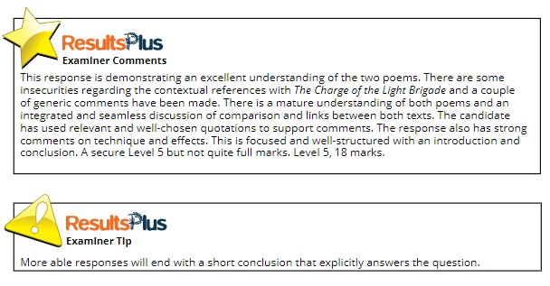
DIP: Using the exemplar to help you, write at least one paragraph answering the exam question.

___________________________________________________________________________

Lesson 21 – Poetry Comparison
LI: To demonstrate my learning by planning and answering an exam question

DART: Read the following sample answer to the exam question below. In this sample answer, the sentences followed by the letter A or B need to be developed further with at least an extra sentence.

Q: Re-read Cousin Kate. Choose one other poem from the Conflict anthology.
Compare how feelings of loss is presented in the two poems.
In your answer you should consider the:
- poets’ use of language, form, and structure
- influence of the contexts in which the poems were written.

In both poems, the feelings of loss are presented as having a strong impact on people. In ‘Cousin Kate’, the repetition of ‘why’ in the first stanza and ‘If’ in the penultimate stanza conveys how the speaker has started to obsess over her loss and wonders if her fate could have been avoided. (A) In contrast, the speakers in ‘What Were They Like?’ are trying to find a past that has been lost. The first speaker’s questions show their interest in what Vietnamese life was like. The second speaker tries to answer the questions but can only use what ‘was reported’ as the loss of the Vietnamese culture has left them uncertain. (B)
Remember – to develop your point you can write about its effect on the reader, how it links to another part of the poem, or how it relates to the poem’s context.

DIP: Write your own answer to the above exam question.

__________________________________________________
Lesson 22 – Unseen Poetry
LI: To develop my own informed personal response to an unseen poem and analyse the language, form, and structure used by the writer to create meanings and effects.

DART: Read the poem below. Use the steps next to the poem to help you understand how to approach the unseen poem element of the exam.
Reading an Unseen Poetry
STEP 1: Read
- Who is speaking?
- Who is being addressed?
- What is the speaker talking about?
- Where is the poem set?

STEP 2: Read
- What is the poem about thematically?
- What attitude does the poem express towards this idea?
- What idea is the poem about? Does it seem happy, sad or angry about this idea?

STEP 3: Annotate
- Highlight the three most important and interesting images in the poem
- Highlight any other interesting words in the poem
- Does the tone shift at any point?
- How does the poem begin and end?
- How does the poem utilise form?
- I like / I am puzzled by / I am interested in

You Being Born
Brian Jones

I saw you born.
It was remarkable.
You shot out from between your mother’s legs
like a rugby ball from a scrum
and the stocky Geordie midwife caught you neatly
and cried ‘Whoops! She’s come!’

You had a wrinkled jammy head
and spasmy legs like a portly frog’s.
From your belly button a white root waved
that had fed you all the months you’d grown

and ripened in your mother’s womb.
And let me tell you – I’m ashamed –
I forgot your mother completely – she had been
those things to me that one day you’ll discover
in someone else, and think ‘God, this is it!’
– My sweetheart, my warm dear, my red hot lover –

But for those moments, as the doctor
shoved cotton wool up your flat nose
and swabbed your eyes and cleaned your bum
I forgot completely all my life and love
and watched you like a pool of growing light
and whispered to myself ‘She’s come! She’s come!’

DIP: Answer the following questions in as much detail as you can:
- What picture do you get of the narrator as you read the poem? Think about what he is like and what are his feelings.
- What emotions is he experiencing?
- What effect do the following similes and metaphors have on the reader/listener? Pay particular attention to the words that have been underlined:
  - “You shot out from between your mother’s legs
like a rugby ball from a scrum”
  - “You had a wrinkled jammy head
and spasmy legs like a portly frog’s”
  - “From your bellybutton a white root waved
that had fed you all the month’s you’d grown”.
- What is the effect of the caesura in the opening lines of the poem? How does this contrast with the enjambment in the rest of the poem?
- How does the poet show his love and admiration for his new-born daughter?
- What is the poet “ashamed” of in this poem? Why do you think this is?

__________________________________________________________________________________

