GCSE DRAMA
Blended Learning Booklet
Year 10 GCSE Drama
Component 3: Texts in practice.
Name:
Teacher:
This booklet is to support you in your rehearsal process. The main work to be completed is the learning of lines. The tasks in this booklet assist independent learning at home but hopefully you will be able to use technology to rehearse with your partner/group from home.
Completed tasks can be uploaded to Class Charts.
Please use BBC Bitesize AQA GCSE to revise.

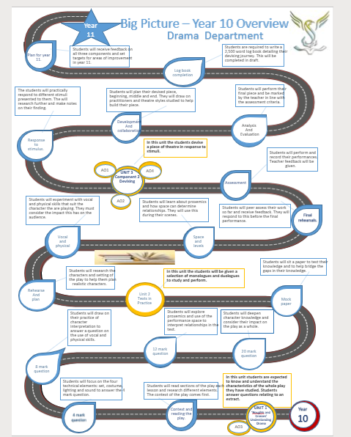

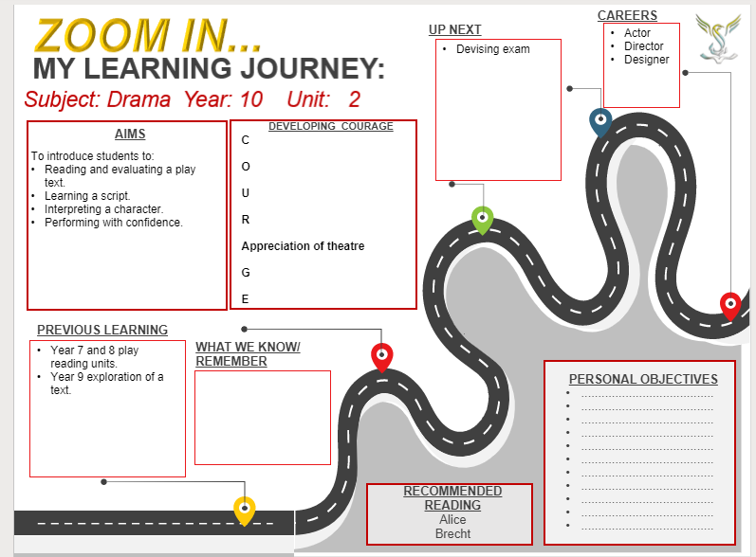

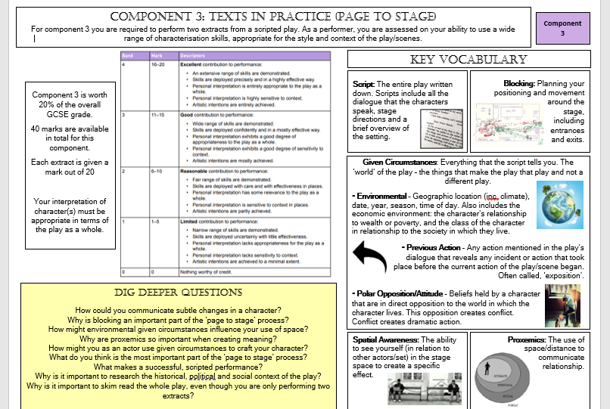

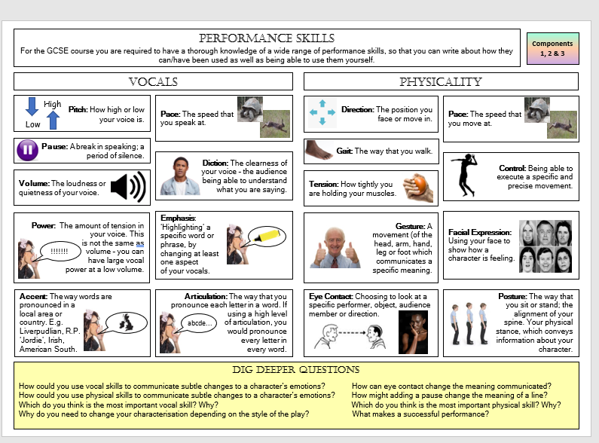
Component 3: Texts in Practice.
In this component we are focused on developing real characters who follow emotional and interesting pathways. The practitioner we will focus on is Konstantin Stanislavski.
Naturalism with Konstantin Stanislavski.
It’s very easy to over-simplify the method of Konstantin Stanislavski, one of the greatest and most influential of modern theatre practitioners. The main thing to remember is that he takes the approach that the actors should really inhabit the role that they are playing. So the actor shouldn’t only know what lines he needs to say and the motivation for those lines, but also every detail of that character’s life offstage as well as onstage. In this way we can establish Stanislavski as a director and practitioner whose productions are naturalistic.
BBC Bitesize
Task 1: Highlight the keywords in this extract.

Stanislavski: Objective, super-objective and the through line
An objective is the reason for our actions. What are we trying to achieve? Life, people and circumstances constantly put up barriers in our way. Each of these barriers presents us with the objective of getting through them. You shouldn't try to express the meaning of your objective in terms of a noun, always use a verb, eg 'I wish to...'
The super-objective is an over-reaching objective, probably linked to the overall outcome in the play. We use the word super-objective to characterise the essential idea, the core, which provided the impetus for the writing of the play. A character’s objectives are likely to be stages in the journey towards the super-objective. If that journey is perceived as a clear path to the super objective, then you have your through line.
BBC Bitesize
Task 2: Character questions:
1. What is your characters objective(s) in each extract?
2. What is your characters super- objective?
3. What barriers does your character come across when trying to reach their objectives?


Emotional memory:
Emotional memory is when the actor finds a real past experience where they felt a similar emotion to that demanded by the role they are playing. They then ‘borrow’ those feelings to bring the role to life.
BBC Bitesize
Task 3: Drama a picture of an emotional memory that connects to something your character is going through.
Write about your experience and decide how you are going to use this experience to help you build your character.

Magic If:
Stanislavski said that the character should answer the question, 'What would I do if I was in this situation?' Also known as the ‘magic if’, this technique means that the actor puts themselves into the character’s situation. This then stimulates the motivation to enable the actor to play the role.
BBC Bitesize
Task 4: Put yourself in your characters shoes at an important moment of each extract. Write down what you would do in that situation and how it differs from the decision-making process of the character. How does this change the way you interpret this moment?

Task 5: Physical skills- write your definition for each.
Physical skills include:
body language-
eye contact-
facial expressions-
gait-
gesture-
pace-
quality of movement-
space-
levels-
specialist skills-
physical tension-
Task 6: Write about the choices you have made in your extracts. Which of these physical skills have you used and what do they suggest about your character?

Task 7: Vocal skills- write your definition for each.
Vocal skills include:
accent-
emphasis-
pace and rhythm-
pause-
pitch-
quality-
resonance-
tone-
volume-

Task 8: Write about the choices you have made in your extracts. Which of these vocal skills have you used and what do they suggest about your character?

Hot seating
Hot seating helps real stage actors get into character, and is a good activity to practise your own drama skills.
You might choose a crucial moment in a play and take on the role of the character in the story at that particular moment. Focus on the emotions that your character is feeling at that moment, eg surprise, excitement, terror, anger, happiness, sadness, confusion.
When hot seating, you must speak, think and feel as though you are that character. If you can think, feel and speak like that character, an audience is more likely to believe you are that character.
BBC Bitesize
Task 9: Ask a relative or friend to Hot Seat you as both of your characters. Make sure the questions they are asking you are random as planning them will stop your creative and instinctive response.
Once completed, write down the questions and the answers you gave. Were these answers expected? How will this affect your character development?

Checklist
 | Action | To be successful | Advice
1 | · Speak clearly (diction) | · Try not to mumble. | · Record yourself saying your lines. Listen back to it. This will clearly show you what words you are not saying clearly.
1 | · Speak clearly (diction) | · Speak loud enough so that the audience can hear you. | · Get another pupil to stand at the back of the performance space to ensure that they can hear you.
1 | · Speak clearly (diction) | · Always face the audience when you are saying a line. | · Always direct your voice downstage - towards the front. This should ensure that your voice will carry into the audience.
2 | · Communicate the subtext through inflection | · Use your vocal skills to convey the irony of a scene. | · Experiment with different ways of communicating meaning of the same line. Use different inflections to see if the meaning of lines can be changed. Ensure you understand what your character is really saying
3 | · Using pauses and pace to help convey the emotions of your character through your voice | · Consider how to get the full meaning of the line across. Vary your pace to convey the best meaning. | · Vary the delivery speed of your line to create tension and heighten the emotion of a scene
3 |  | · Use pauses for effect. The audience needs time to consider what has been said. Also the actor you are performing with needs time to consider their response. | · Practise your piece with as many pauses as possible to see how much tension you can create. Remember the script is written line after line, but you don't have to say it like that; you can add a pause.
4 | · Choose a style and stick to it | · Use accents in your performance if you are able to sustain the accent throughout the performance. | · Practise your accent to ensure you can sustain it throughout your performance. Losing the accent could affect your mark.
5 | · Use pitch and tone for effect | · Vary the pitch and tone of your voice to avoid your voice being monotone. | · Make sure you understand the meaning of the lines your character is saying. If you do, then the inflection you use will ensure that you voice is not monotone.
5 | · Use pitch and tone for effect | · Use the correct tone so that the audience can appreciate the type of character you are and your intentions. | · Think about what you are saying and how you need to say it. Record yourself saying the lines in different ways to see which is the most effective for your performance.

Task 10: This checklist is an amazing resource to hep you perfect your characters.
Please go through the checklist and highlight the sections that you have completed. Recording yourself is the best way to understand if you have made the correct character choices if working on your own.

Task 11: Consolidate your character information in the tables below

