
Stewards Academy

Geography Year 10
Blended Learning Booklet

Y10-3 UK Urban Areas

Name:
Form:

Aim to complete one lesson each week. Write down the title and LI for each lesson and then complete the tasks which are highlighted.

Upload all work onto ClassCharts for feedback.

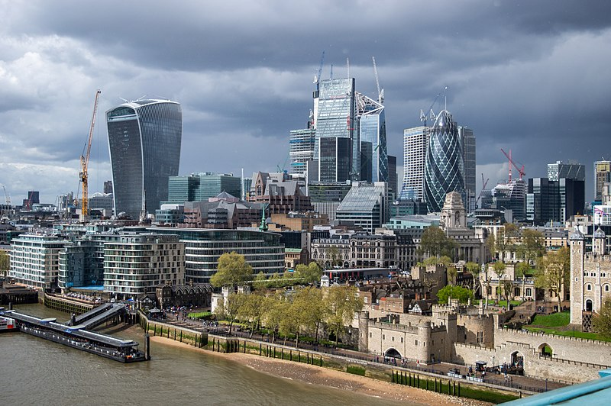

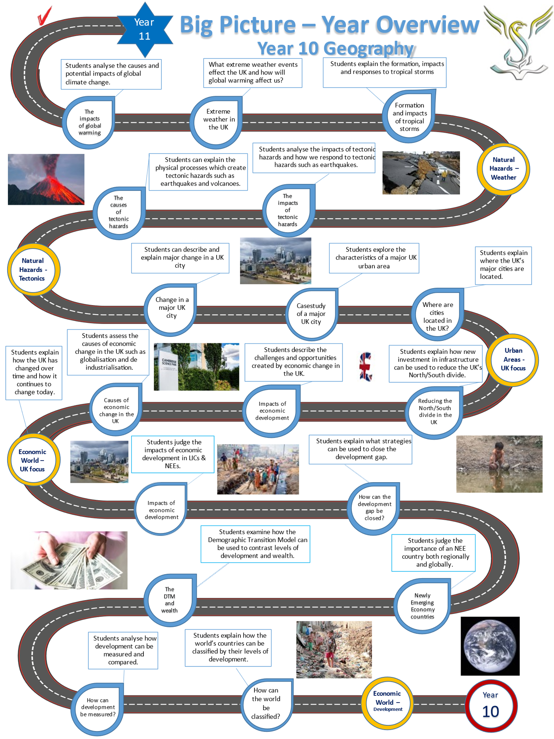

LESSON 1:
TITLE: Locating the UK’s major cities
LI: To understand the UK population distribution and the location of major UK urban areas.

TASK 1 – Read through the DART below:

Characteristics of the UK - population density
In 2021, the population of the UK rose to over 68 million people. The major cities of the UK can be seen on the map. London is the UK’s largest city and Birmingham is its second largest city. In 2021, London has an estimated population of 9.4 million and this could be growing by roughly 100,000 each year.
Population distribution in the UK is also uneven. Some parts of the UK are very crowded. The south east, which includes the city of London, has a much greater population than the highlands of Scotland.
The population is very unequally distributed over the four parts of the UK: England makes up about 84 per cent of the total population, Wales around 5 per cent, Scotland roughly 8.5 per cent, and Northern Ireland less than 3 per cent.
Population density is the number of people living in an area. It is worked out by dividing the number of people in an area by the size of the area. So, the population density in an area is equal to the number of people per sq. km, divided by the size of the area in sq. km.
The population density for the UK is approximately 260 people per sq. km but if we look at different areas within the UK, we see big differences in density.
London has a population density of 4,932 per sq. km. Urban spaces tend to be more crowded. Scotland has a density of 65 per sq. km. Rural spaces have less people and they are usually more spread out.
The UK is about 100 times as densely populated as Australia which has approximately two people per sq. km.
Population density and distribution is affected by many factors. People prefer to live in places where they can grow food, build homes and work. Some areas are very difficult places to live and so only very few people live there.
The south east of England covers one tenth of the land area but has over one third of the UK population living there.
The south east of England benefits from:
- good transport links
- easy access to the rest of Europe and beyond
- being the seat of Government
- the City - the financial heart of England
North West England has a high population density because many people located there because of raw materials (coal) and industry.
Scotland has a low population density because:
- Some areas of Scotland are remote
- It is mountainous, making areas less accessible

The map below shows the UK’s popluation distribution per sq. km
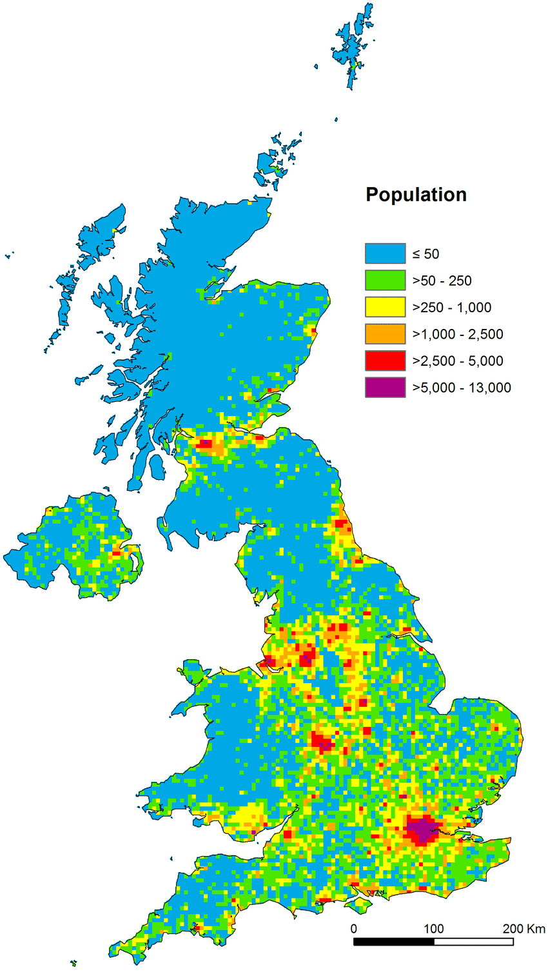
TASK 2: Answer the following questions
Q1) Why do more people live in south east England compared to Scotland?
………………………………………………………………………………………………………………………………………………………………………………………………………………………………………………………………………………………………………………………………………………………………………………………………………………………………………………………………………………………………………………………………………………………………………………………………………………………………………………………………………………………………………………………………………………………………………………………………………………………………………………………………………………………………………………………………………………………………………………………………………………………………………………
Q2) Why is London growing by 100,000 people each year? What attracts people to London?
………………………………………………………………………………………………………………………………………………………………………………………………………………………………………………………………………………………………………………………………………………………………………………………………………………………………………………………………………………………………………………………………………………………………………………………………………………………………………………………………………………………………………………………………………………………………………………………………………………………………………………………………………………………………………………………………………………………………………………………………………………………………………………
Q3) Explain why living in the UK major urban areas can cause problems – crime, congestion, expensive housing, pollution.
………………………………………………………………………………………………………………………………………………………………………………………………………………………………………………………………………………………………………………………………………………………………………………………………………………………………………………………………………………………………………………………………………………………………………………………………………………………………………………………………………………………………………………………………………………………………………………………………………………………………………………………………………………………………………………………………………………………………………………………………………………………………………………

TASK 3 – Look at the map showing the UK’s major urban areas. How many can you remember?

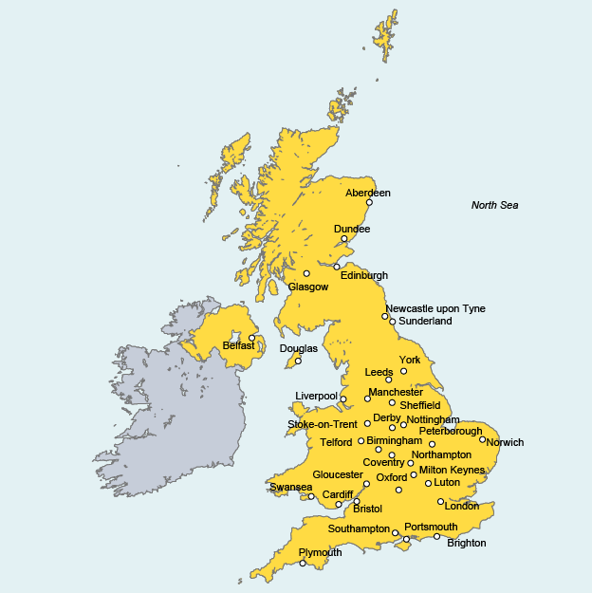

LESSON 2:
TITLE: Casestudy of a major UK city
LI: To describe the location and importance of a UK city on a regional and global scale.

TASK 1 – Complete the sorting activity and answer the questions about London

Why is London important?
To the UK Internationally
The West End is famous for its theatres and musicals like Les Misérables and The Lion King | It is the biggest city in the UK with 8.7 million people. | More than half of the biggest companies in the UK have headquarters in London.
London is a major international air transport hub – with Heathrow airport is busiest airport in the world | It is the economic hub of the UK, producing 20% of the UK’s GDP or our total wealth. | London is the 2nd most important city for finance and money in the world, only New York in the USA is more important.
The London Underground is the oldest underground railway network in the world – Crossrail is the latest underground improvement. | London has four UNESCO World Heritage sites including the Tower of London. 50% of foreign visitors to the UK visit London. | London’s schools are in the top 10% of all UK schools.  London also has leading universities like UCL and Imperial College which are among the very best in the world.
It is the world’s most-visited city by people from abroad: 16 million people visited in 2014. | London has a diverse range of people and cultures, with 300 languages spoken in the city. | London is the home of national sports stadiums like Wembley and Twickenham.

Questions about London
All answers should be written using full sentences and paragraphs
- Why is London important due to cultural reasons (think about theatres, music)
………………………………………………………………………………………………………………………………………………………………………
………………………………………………………………………………………………………………………………………………………………………
………………………………………………………………………………………………………………………………………………………………………
………………………………………………………………………………………………………………………………………………………………………
- Why is London important for business and money?
………………………………………………………………………………………………………………………………………………………………………
………………………………………………………………………………………………………………………………………………………………………
………………………………………………………………………………………………………………………………………………………………………
………………………………………………………………………………………………………………………………………………………………………
- Why is London called a ‘Global City’?
………………………………………………………………………………………………………………………………………………………………………
………………………………………………………………………………………………………………………………………………………………………
………………………………………………………………………………………………………………………………………………………………………
………………………………………………………………………………………………………………………………………………………………………
- Describe a time you have visited London – What or who did you visit? Where did you go? Did you visit any famous buildings or places such as Buckingham Palace?
………………………………………………………………………………………………………………………………………………………………………
………………………………………………………………………………………………………………………………………………………………………
………………………………………………………………………………………………………………………………………………………………………
………………………………………………………………………………………………………………………………………………………………………
- What are the bad things about London? What don’t you like about it?
………………………………………………………………………………………………………………………………………………………………………
………………………………………………………………………………………………………………………………………………………………………
………………………………………………………………………………………………………………………………………………………………………
………………………………………………………………………………………………………………………………………………………………………

LESSON 3
TITLE: Impact of migration in a UK city
LI: To examine the impacts of national and international migration in a UK city

TASK 1 – Read the table below:
Ethnic groups in London
White British | 45%
Other white (mostly EU citizens) | 15%
Indian heritage | 7%
African heritage | 7%
Mixed heritage | 5%
Caribbean heritage | 4%
‘Others’ such as Chinese, Brazilian | 17%

TASK 2: Using the table, describe the ethnic mix of London in 2011

………………………………………………………………………………………………………………………………………………………………………
………………………………………………………………………………………………………………………………………………………………………
………………………………………………………………………………………………………………………………………………………………………
………………………………………………………………………………………………………………………………………………………………………
………………………………………………………………………………………………………………………………………………………………………
………………………………………………………………………………………………………………………………………………………………………
………………………………………………………………………………………………………………………………………………………………………

TASK 3 – Watch the video and make 10 notes of you own:
https://www.youtube.com/watch?v=zylUmIuRaAw
1)
2)
3)
4)
5)
6)
7)
8)
9)
10)
TASK 4 – Read the DART below
The migrant community in Spitalfields, London

Brick Lane is a street in the Spitalfields area of East London, in the Borough of Tower Hamlets. Today, it is the heart of the city's Bangladeshi community and is known to some as Banglatown. It is famous for its many curry houses along Brick Lane. Spitalfields has seen several phases of migration over hundreds of years, with the Bangladeshi community being the most recent.

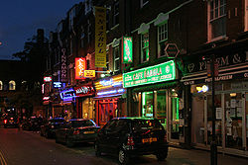

Phases of migration
In the 17th century, French protestant refugees called Huguenots arrived in the Spitalfields area, fleeing persecution in France. In the 19th century, Irish people and Jews immigrated to the area. Jewish immigration continued into the early 20th century. In the later 20th century, Bangladeshis comprised the major group of immigrants and gradually predominated in the area.

Religious changes
In 1742, La Neuve Eglise, a Huguenot chapel, was built on the corner of Brick Lane and Fournier Street. By 1809, it was used by missionaries as The Jews’ Chapel, where they promoted Christianity to the expanding Jewish population. It was adapted as a Methodist Chapel in 1819 for Protestant residents.
Reflecting the changing demographics of the area, in 1898, the building was consecrated as the Spitalfields Synagogue. After decades of change in the area, with Jews moving out and Bangladeshis moving in, in 1976 it was adapted again as the London Jamme Masjid (Great London Mosque) to serve the expanding Bangladeshi community.

Bengali settlement
In the 20th century the Brick Lane area was important in the second wave of development of Anglo-Indian cuisine, as families from countries such as Bangladesh migrated to London to look for work after World War 2. In London, many Bengali people settled in the East End attracted by work in factories producing clothing and by the cheaper rent for housing. Humble beginnings such as this gave birth to Brick Lane as the famous curry capital of the UK.

Regeneration of Spitalfields
More recently the area has also broadened to become a vibrant art and fashion area, with considerable exhibition space. Each year most of the fine art and fashion courses exhibit their work near Brick Lane.
Since the late 1990s, Brick Lane has been the site of several of the city's best known night clubs, notably 93 Feet East and The Vibe Bar, both built on the site of The Old Truman Brewery, once the industrial centre of the area, and now an office and entertainment complex. Brick Lane has a regular display of graffiti, which features artists such as Banksy, Stik, ROA, D*Face, Ben Eine and Omar Hassan. Rather than being regarded as a nuisance or vandalism, much of this graffiti is considered artwork which attract tourists from around the world.
TASK 5 – answer the following questions:

Q1) Why is Spitalfields called “Banglatown” by some people?

………………………………………………………………………………………………………………………………………………………………………
………………………………………………………………………………………………………………………………………………………………………
………………………………………………………………………………………………………………………………………………………………………
………………………………………………………………………………………………………………………………………………………………………

Q2) Who were the Huguenots? When did they arrive in London?

………………………………………………………………………………………………………………………………………………………………………
………………………………………………………………………………………………………………………………………………………………………
………………………………………………………………………………………………………………………………………………………………………
………………………………………………………………………………………………………………………………………………………………………

Q3) How has the Spitalfields area been regenerated since the late 1990s?

………………………………………………………………………………………………………………………………………………………………………
………………………………………………………………………………………………………………………………………………………………………
………………………………………………………………………………………………………………………………………………………………………
………………………………………………………………………………………………………………………………………………………………………
………………………………………………………………………………………………………………………………………………………………………
………………………………………………………………………………………………………………………………………………………………………
………………………………………………………………………………………………………………………………………………………………………
………………………………………………………………………………………………………………………………………………………………………

LESSON 4:
TITLE: Changes in a UK city
LI: To examine how urban change has created social and economic opportunities in a UK city

TASK 1 - Watch the video on the changes which have taken place in Canary Wharf, London

https://www.youtube.com/watch?v=1Bw5AoL0Qs4

TASK 2 – Read the DART and answer the 9-mark question

Changes in London - Canary Wharf
The Canary Wharf area of Tower Hamlets is a classic example of a major urban regeneration project. It is a good example of a BROWNFIELD development as it has been built in an urban area. The Canary Wharf area used to be called the ‘Isle of Dogs’ and it used to be a major port for ships from all over the world. But it became too small to handle the larger cargo ships from the 1960s and the area went into decline.
For over 20 years, the docks in London were derelict, abandoned, empty and people were leaving the area. In the early 1980’s, the government decided to transform the area. Since the 1980s, the docks have been ‘regenerated’ and transformed into a huge centre focused on banks and finance companies.
Old buildings were either pulled down or transformed into luxury flats. New office buildings were built and the Docklands Light Railway (DLR) allowed easy access between Canary Wharf and central London. Local road access was also improved. The regeneration of Canary Wharf continues today as new buildings are being built.
Many of our biggest accountants and banks are now found in the Canary Wharf. These include HSBC, Barclays, Bank of America, J.P. Morgan and Citigroup. The banks in Canary Wharf generate billions of pounds for the UK economy each year and employ tens of thousands of people. It is a global centre for banking.
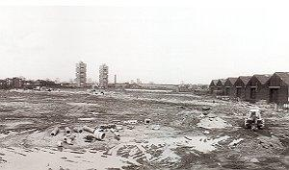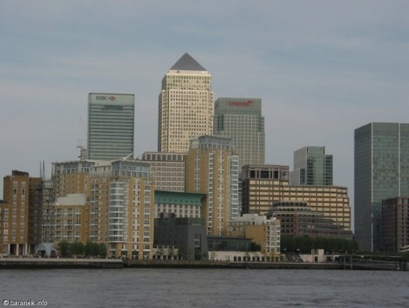
Back in the 1980s…. Canary Wharf today
Benefits of Canary Wharf:
- Before regeneration, the area was very deprived and had a high rate of unemployment. Thousands of people left the area.
- It also suffered from crime and vandalism. The redevelopment has helped to transform the area into banks, offices, luxury homes, shops and entertainment.
- The redevelopment has created tens of thousands of extra jobs and billions of pounds for the UK economy each year.
- Canary Wharf is a very important global centre for finance, business and trading in shares. Many leading banks have their Head Quarters in Canary Wharf.
- Transport links in the area have been improved with the Docklands Light Railway, improved road access and flights to Europe from London City Airport.

Problems of the Canary Wharf development:
- Many local people did not get jobs in the banks as they lacked the skills and education to the highly paid jobs.
- The gap between the rich and poor in the Canary Wharf area is still massive. Many local people resent the wealthy bankers and many local people cannot afford to buy homes. Many locals feel they have not benefitted from the regeneration project.

GCSE practice question

Q1) “Canary Wharf has been a hugely successful urban regeneration project and has transformed London’s Docklands for the better”. Do you agree with this statement?

………………………………………………………………………………………………………………………………………………………………………

………………………………………………………………………………………………………………………………………………………………………

………………………………………………………………………………………………………………………………………………………………………

………………………………………………………………………………………………………………………………………………………………………

………………………………………………………………………………………………………………………………………………………………………

………………………………………………………………………………………………………………………………………………………………………

………………………………………………………………………………………………………………………………………………………………………

………………………………………………………………………………………………………………………………………………………………………

………………………………………………………………………………………………………………………………………………………………………

………………………………………………………………………………………………………………………………………………………………………

………………………………………………………………………………………………………………………………………………………………………

………………………………………………………………………………………………………………………………………………………………………

………………………………………………………………………………………………………………………………………………………………………

………………………………………………………………………………………………………………………………………………………………………

………………………………………………………………………………………………………………………………………………………………………

………………………………………………………………………………………………………………………………………………………………………

………………………………………………………………………………………………………………………………………………………………………
(9 marks + 3 SPaG)
LESSON 5
TITLE: Challenges created by change in a UK city
LI: To examine the challenges created by social and economic change in a UK urban area

TASK 1 – Read the case study of Tower Hamlets and answer the questions

Inner city problems – Tower Hamlets in London
Map showing the location of Tower Hamlets
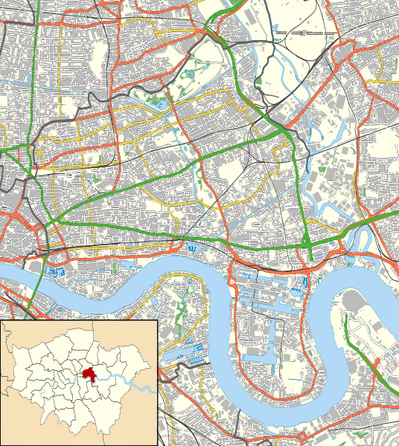
Site of the 2012 London Olympic games at Stratford
Canary Wharf – the redeveloped Docklands
Tower Hamlets is found in East London. It has a population of just over 250,000. It is a very diverse area. It is very ethnically diverse with roughly 31% of people described as “White British”. The number of white British living in the area has fallen by a quarter since 2001. A further 32% of residents are described as “Bangladeshi” and many other smaller ethnic groups such as “Black Caribbean”.
There have been racial and religious tensions in Tower Hamlets in recent years between different segments of the community. Although educational achievement has improved greatly in recent years, many 16 year olds in Tower Hamlets still leave school with very low GCSE grades compared to the UK national average. The area also has high unemployment compared to the UK average.
Tower Hamlets is one of the very poorest areas of the UK, with average income levels far below the UK national average of £28,000 a year. In 2010, 59% of children in Tower Hamlets lived in poverty. This is the highest rate of child poverty in the UK. Overall, poverty rates in Tower Hamlets are extremely high, even compared to other poor Inner City London areas, like Islington. Tower Hamlets also has lots of very poor quality housing estates, although some areas have been redeveloped or replaced with new housing.
Tower Hamlets also contains the ‘Canary Wharf’ business area, located on the Isle of Dogs. Canary Wharf is a redeveloped area. It has many new high cost houses and flats, tall office buildings such as the ‘Canada Tower’, high quality restaurants and expensive shops. The redevelopment of the Isle of Dogs area started in the 1980s and continues to this day. Canary Wharf is home to many big banks such as HSBC and Barclays Bank. It provides many very well-paid finance jobs, but most of the people who work at Canary Wharf commute into the area from places like Essex.

Q1) Where is Tower Hamlets located? What is the population of Tower Hamlets?

………………………………………………………………………………………………………………………………………………………………………

………………………………………………………………………………………………………………………………………………………………………

………………………………………………………………………………………………………………………………………………………………………

………………………………………………………………………………………………………………………………………………………………………

Q2) Why is Tower Hamlets described as ’ethnically diverse’?

………………………………………………………………………………………………………………………………………………………………………

………………………………………………………………………………………………………………………………………………………………………

………………………………………………………………………………………………………………………………………………………………………

………………………………………………………………………………………………………………………………………………………………………

Q3) What tensions have existed within the community of Tower Hamlets?

………………………………………………………………………………………………………………………………………………………………………

………………………………………………………………………………………………………………………………………………………………………

………………………………………………………………………………………………………………………………………………………………………

………………………………………………………………………………………………………………………………………………………………………

Q4) How does unemployment in Tower Hamlets compare the rest of the UK?

………………………………………………………………………………………………………………………………………………………………………

………………………………………………………………………………………………………………………………………………………………………

………………………………………………………………………………………………………………………………………………………………………

………………………………………………………………………………………………………………………………………………………………………

Q5) How many children in Tower Hamlets live in poverty?

………………………………………………………………………………………………………………………………………………………………………

………………………………………………………………………………………………………………………………………………………………………

………………………………………………………………………………………………………………………………………………………………………

………………………………………………………………………………………………………………………………………………………………………
Q6) How does child poverty in Tower Hamlets compare to the rest of the UK?

………………………………………………………………………………………………………………………………………………………………………

………………………………………………………………………………………………………………………………………………………………………

………………………………………………………………………………………………………………………………………………………………………

………………………………………………………………………………………………………………………………………………………………………

Q7) What is Canary Wharf? Why is it different to other parts of Tower Hamlets? How has Canary Wharf been redeveloped? What businesses are found in Canary Wharf?

………………………………………………………………………………………………………………………………………………………………………

………………………………………………………………………………………………………………………………………………………………………

………………………………………………………………………………………………………………………………………………………………………

………………………………………………………………………………………………………………………………………………………………………

………………………………………………………………………………………………………………………………………………………………………

………………………………………………………………………………………………………………………………………………………………………

………………………………………………………………………………………………………………………………………………………………………

………………………………………………………………………………………………………………………………………………………………………

TASK 2 – Complete the gap fill
Tower Hamlets is the poorest inner London Borough, but it is home to the huge ________________ _______________ redevelopment area. The ________ at Canary Wharf have created thousands of highly paid jobs, but few of which have gone to local people. ___________ prices in Tower Hamlets have risen, forcing some local people to move away. ________________ among local people remains high and the people of Tower Hamlets face many social and _______________ problems such as low GCSE results.

Unemployment House Canary Wharf Economic banks

LESSON 6:
TITLE: Environmental challenges in a UK city
LI: To examine the environmental challenges which are found in a UK city

TASK 1 – Read through the environmental problems facing London

Waste disposal and atmospheric pollution in London

London suffers from air pollution, mainly due to the sheer size of the city, a dense road network and high buildings. This means that central London tends to be one of the most polluted places in the UK.
London has failed many of the standards set by the EU and pollution can build up in London when high atmospheric pressure brings settled, calm weather. London has problems with the following pollutants:

• Ozone pollution in spring and summer, this gas is a poison to the human body
• Particulate matter – these are tiny particles of solids or liquids suspended in the air. They come from carbon emissions from engines, small bits of metal and rubber from engine wear and braking as well as dust from road surfaces. They can come from natural sources and from building and industry. The tiny particles, referred to as PM10, can settle in the airway and deep in the lungs and cause health problems, premature death and the worsening of heart and lung disease.
• Nitrogen Dioxide from burning fossil fuels in cars and central heating boilers is another problem gas. It is harmful to human health-giving respiratory problems such as shortness of breath and coughing. It can also lead to lung infections such as bronchitis.
Map showing the highest levels of Nitrous Dioxide air pollution in London (red, orange and yellow)
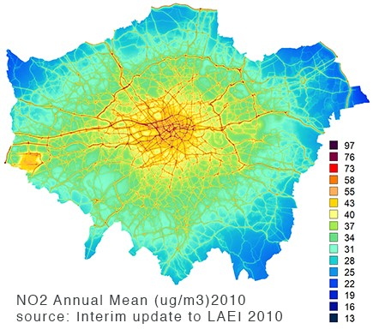
Management of London’s air pollution
London is working hard to try and protect people and clean up the air by:
• Offering a free to download app that informs people of air quality
• Cleaning up London's bus fleet by making them less polluting
• Introducing a congestion charge in central London to reduce traffic volumes
• Set new and tighter standards for the London Low Emission Zone
• Invest record amounts of money in cycling

Waste disposal in London
London also produces huge amounts of waste. It uses a mixture of recycling, landfill (where the waste is dumped into the ground and energy recovery (the waste is burnt to produce electricity) to deal with this waste. The London waste management strategy is aiming to:
1. To achieve zero municipal waste direct to landfill by 2025.
2. To reduce the amount of household waste produced from 970kg per household in 2009/10 to 790kg per household by 2031. This is equivalent to a 20 per cent reduction per household.
3. To increase London’s capacity to reuse or repair municipal waste
4. To cut London’s greenhouse gas emissions through the management of London’s municipal waste
5. To generate as much energy as practicable from London’s organic and non-recycled waste in a way that is no more polluting in carbon terms than the energy source it is replacing. This is estimated to be possible for about 40 per cent of London’s municipal waste after recycling or composting targets are achieved by 2031

TASK 2 – watch the video on air pollution in London: https://www.youtube.com/watch?v=EcpCpKPimPE

TASK 3 – Create your own fact file on the environmental problems facing London and how they can be managed.
What to include:
- Describe the problems created by air pollution in London, including the impacts on human health.
- Explain how air pollution can be managed.
- Describe the problems created by waste in London.
- Explain how waste management is being improved in London.

LESSON 7:
TITLE: The impacts of urban sprawl
LI: To evaluate the impact of urban sprawl on the rural-urban fringe in the UK

TASK 1 – Read through the following information:

Greenfield sites – areas of countryside which can be built on.
Greenbelt – an area of land which surrounds many UK cities and towns where building is very restricted to protect rural areas from URBAN SPRAWL.
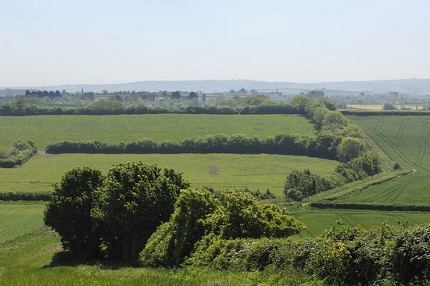

Map showing the green belts areas around England’s urban areas

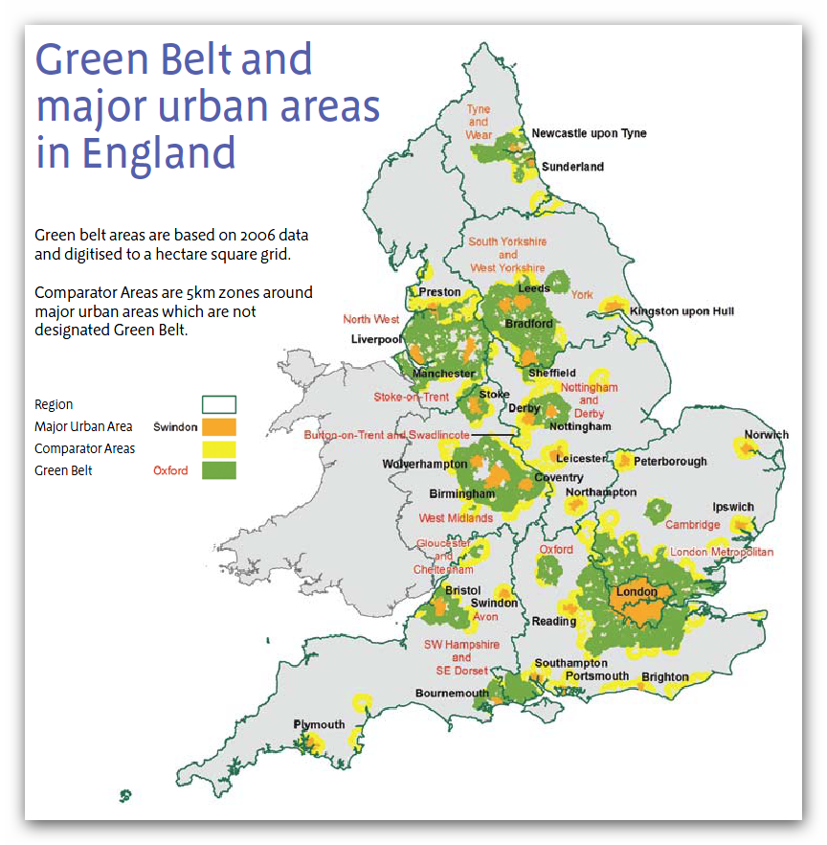

Brownfield and Greenfield sites
The UK is short of suitable housing. Approximately 3 million new homes are needed by 2030. They need to be built somewhere. The options are using Brownfield sites or Greenfield sites.

Brownfield sites in urban areas



The above photograph shows a brownfield site in a UK city – an old factory site
- Are often on disused or derelict land in an existing town or city.
- Are more available in the North and Midlands (but most housing demand is in the south east).
- Are valuable as existing buildings can be split up into more homes on any one site.
- The site has already been developed so reduces urban sprawl and helps to protect the countryside.
- Are found in urban areas, so building housing there reduces demand on car use.
- Are more expensive to build on as often the land needs to be cleared first (especially if land is contaminated from previous industrial use).

Greenfield sites – building in rural areas

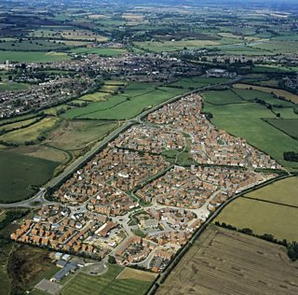

The photograph above shows a new housing development on a greenfield site
- Are sites which have not previously been built on such as farmers fields. This includes the greenbelt land around cities and will mean that the countryside will be built on.
- These areas are often easier and cheaper to build on.
- Are not favoured by environmentalists, as it encourages urban sprawl and destroys natural habitats.
- Encourage commuting and traffic congestion as people travel into urban areas from the countryside.

TASK 2 – answer the questions

Q1) Describe the advantages of using brownfield sites.

…………………………………………………………………………………………………………………………………………………………………

…………………………………………………………………………………………………………………………………………………………………

…………………………………………………………………………………………………………………………………………………………………

…………………………………………………………………………………………………………………………………………………………………

…………………………………………………………………………………………………………………………………………………………………

…………………………………………………………………………………………………………………………………………………………………

Q2) Describe the advantages of using greenfield sites.

…………………………………………………………………………………………………………………………………………………………………

…………………………………………………………………………………………………………………………………………………………………

…………………………………………………………………………………………………………………………………………………………………

…………………………………………………………………………………………………………………………………………………………………

…………………………………………………………………………………………………………………………………………………………………

…………………………………………………………………………………………………………………………………………………………………

Q3) “The UK needs 300,000 new homes each year and more should be built on greenfield sites.” Do you agree with this statement?

…………………………………………………………………………………………………………………………………………………………………

…………………………………………………………………………………………………………………………………………………………………

…………………………………………………………………………………………………………………………………………………………………

…………………………………………………………………………………………………………………………………………………………………

…………………………………………………………………………………………………………………………………………………………………

…………………………………………………………………………………………………………………………………………………………………

…………………………………………………………………………………………………………………………………………………………………

…………………………………………………………………………………………………………………………………………………………………

…………………………………………………………………………………………………………………………………………………………………
LESSONS 8 & 9:
TITLE: Urban redevelopment in the UK
LI: To evaluate a casestudy of a major urban redevelopment in the UK – why was redevelopment needed are what are the impacts?
TASK 1 – Read the DART on the Battersea Power regeneration and answer the questions

Battersea Power Station regeneration - London

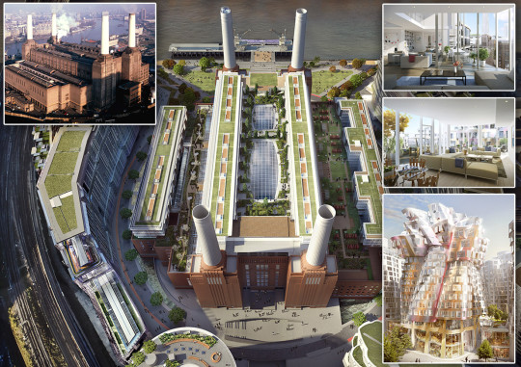

Battersea Power Station is a decommissioned coal-fired power station located in Wandsworth, South London which is now being redeveloped to bring new homes, offices, shops, restaurants, bars, open space and more. The redevelopment of the whole area will cost an estimated £8 billion and has been described as the largest urban regeneration project in Europe.

The project has been split into 3 main phases:

PHASE 1:
The first phase, Circus West Village, is already complete and now open to the public to eat, drink, shop, exercise and live. Situated on the south bank of the river by Chelsea Bridge, over 1000 people now live at Circus West Village, and 12 restaurants, bars and shops are open alongside a fitness studio and a hair salon. Circus West Village is accessible by river bus, as the new Battersea Power Station pier is serviced by Thames Clippers. Construction on Phase 1 commenced (started) in 2013and was completed in 2017.

PHASE 2:

The Power Station building itself is the second phase of the project, and will be home to over 250 residential units, bars, restaurants, office space, shops, entertainment space and more. The iconic buildings redevelopment is scheduled to be finished in 2019. A new Northern line tube station will open its ticket gates in 2020 just after the site’s very own high street is finished in 2019. Apple will locate its new London headquarters at Battersea Power Station, becoming the largest office tenant with 1,400 staff on six floors in the central boiler house by 2021, occupying around 500,000 square feet of the space. Apple and other firms will share the site with over 4,000 homes.

PHASE 3:

Electric Boulevard will be a vibrant and thriving part of the redevelopment. Stunning roof top gardens designed by James Corner, the architect who designed the famous New York Highline, will sit on the top of the 636 homes styled with 1930s décor, inspired by the original Power Station. Plans for another train station in Nine Elms to also be created. There will also be a health centre and a unique art’otel (hotel) for guests. Phase 3 is currently under construction and the whole regeneration should be complete by 2025.

Questions
Q1) Where is Battersea Power Station located?

……………………………………………………………………………………………………………………………………………………………………………………………………………………………………………………………………………………………………………………………………………………………………………………………………………………………………………………………………………………………………………………………………………………………………………………………………………………………………………………………………………………………...
Q2) Explain why the Battersea regeneration project is regarding as being a “very large-scale redevelopment”
……………………………………………………………………………………………………………………………………………………………………………………………………………………………………………………………………………………………………………………………………………………………………………………………………………………………………………………………………………………………………………………………………………………………………………………………………………………………………………………………………………………………...
Q3) What happened in PHASE 1 of the project?
……………………………………………………………………………………………………………………………………………………………………………………………………………………………………………………………………………………………………………………………………………………………………………………………………………………………………………………………………………………………………………………………………………………………………………………………………………………………………………………………………………………………...
Q4) What is happening in PHASE 2 of the project?
……………………………………………………………………………………………………………………………………………………………………………………………………………………………………………………………………………………………………………………………………………………………………………………………………………………………………………………………………………………………………………………………………………………………………………………………………………………………………………………………………………………………...
Q5) What will happen in PHASE 3 of the project?
……………………………………………………………………………………………………………………………………………………………………………………………………………………………………………………………………………………………………………………………………………………………………………………………………………………………………………………………………………………………………………………………………………………………………………………………………………………………………………………………………………………………...
Q6) In your opinion, is the Battersea regeneration project good or bad for London? Explain your reasoning.
……………………………………………………………………………………………………………………………………………………………………………………………………………………………………………………………………………………………………………………………………………………………………………………………………………………………………………………………………………………………………………………………………………………………………………………………………………………………………………………………………………………………...
……………………………………………………………………………………………………………………………………………………………………………………………………………………………………………………………………………………………………………………………………………………………………………………………………………………………………………………………………………………………………………………………………………………………………………………………………………………………………………………………………………………………...
TASK 1 – Read the criticisms of the Battersea Power regeneration and answer the 9-mark question
Criticisms of the Battersea regeneration project
The Battersea regeneration is a huge project, but some people have criticised it. Keith Garner, a local architect and a member of the Battersea Power Station Community Group (BPSCG), which campaigns against the project, says: “This famous London landmark will disappear behind this wall of flats. And the housing isn’t very nice – it’s crammed in. The power station will become a big Westfield with a shopping centre inside.”
But the developers behind the project say the height of the new buildings will be capped at 60 metres, which means the brick colossus’s four white chimneys will be visible from afar. “It’s these things,” he says, pointing at the luxury flats on a scale model of the power station, “that are paying for this [the restoration]. You don’t just regenerate this out of thin air.”
The regeneration project has also been criticised for not selling the new flats to local people. The Battersea project was faced with a barrage of criticism when most of the first phase of 865 flats were sold to overseas buyers, many from Asia, the developers marketed the second lot of 254 homes only in London. But for the third tranche of 539 apartments, a marketing campaign ran in Tokyo, Beijing and Kuala Lumpur, and there were celebrity-studded launch parties in New York and Los Angeles. People point out that these homes are not being offered to people from the UK and the cost of many apartments is far too high for most Londoners.
TASK – complete the 9-mark question below:
Using a casestudy, outline the advantages and disadvantages of a major urban renewal project which you have studied. 9 marks + 3 SPAG
………………………………………………………………………………………………………………………………………………………………………
………………………………………………………………………………………………………………………………………………………………………
………………………………………………………………………………………………………………………………………………………………………
………………………………………………………………………………………………………………………………………………………………………
………………………………………………………………………………………………………………………………………………………………………
………………………………………………………………………………………………………………………………………………………………………
………………………………………………………………………………………………………………………………………………………………………
………………………………………………………………………………………………………………………………………………………………………
………………………………………………………………………………………………………………………………………………………………………
………………………………………………………………………………………………………………………………………………………………………
………………………………………………………………………………………………………………………………………………………………………
………………………………………………………………………………………………………………………………………………………………………
………………………………………………………………………………………………………………………………………………………………………
………………………………………………………………………………………………………………………………………………………………………
………………………………………………………………………………………………………………………………………………………………………
………………………………………………………………………………………………………………………………………………………………………
………………………………………………………………………………………………………………………………………………………………………
………………………………………………………………………………………………………………………………………………………………………
………………………………………………………………………………………………………………………………………………………………………
………………………………………………………………………………………………………………………………………………………………………
………………………………………………………………………………………………………………………………………………………………………
………………………………………………………………………………………………………………………………………………………………………
………………………………………………………………………………………………………………………………………………………………………
………………………………………………………………………………………………………………………………………………………………………
………………………………………………………………………………………………………………………………………………………………………
………………………………………………………………………………………………………………………………………………………………………
………………………………………………………………………………………………………………………………………………………………………
LESSON 10:
TITLE: Sustainable urban living in the UK
LI: To evaluate sustainable urban living in the UK
Read through the DART and complete the activities

Urban Greening in London

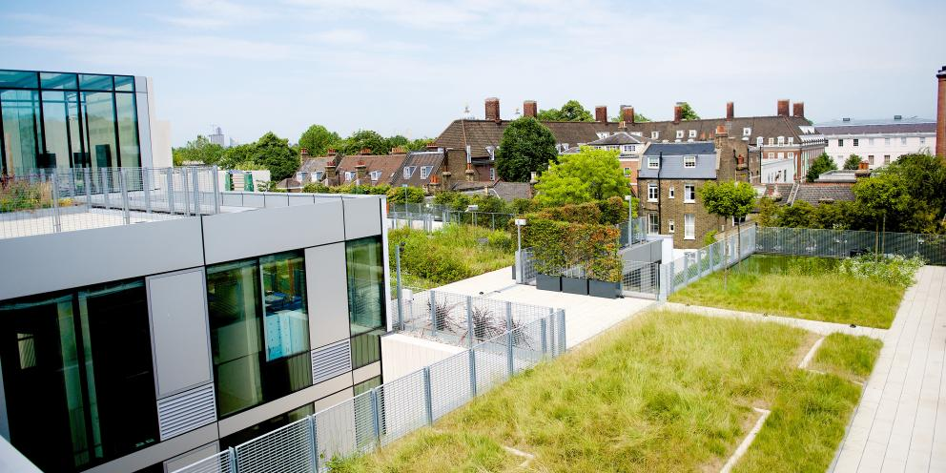
Greening of London’s streets, buildings and other public spaces does more than change the look of these places. Roofs and walls covered in plants, street trees and small pocket parks in between buildings make the city a better place to live and work in.
Why we need more urban greening?
London is a growing city. By 2050 it is expected that up to 12 million people will live in London. A well planned and managed green infrastructure network will be vital to help the city stay healthy and liveable as the population becomes larger. It will also help the city adapt as the climate changes and we experience hotter, dryer summers and more extreme downpours of rain.
The Mayor’s new London Plan includes policies that protect the city’s best greenspaces and natural areas. However, the pressures on land for the good quality homes, schools, hospitals and places of work which we need, means there will be less open space for traditional parks and nature reserves as the city’s population grows.

To meet this challenge new developments will need to include more green roofs on building, green walls on buildings, tree planting and other urban greening. Existing buildings, streets and public areas will need to become greener too.

Green London
London is already a very green city compared to many other global cities as it has open green spaces, parks and gardens covering a huge park of the city. These green places and features already provide us with space to relax, help to clean our air and are habitats for wildlife.
Green infrastructure is just as important to the city as its grey infrastructure of rail, roads, pipes and cables. It is a network of parks, green spaces, gardens, woodlands, rivers and wetlands, as well as urban greening features such as street trees and green roofs, that is planned, designed and managed to:
- More green spaces promote healthier living, provide space for physical activity and relaxation
- More trees and other plants cool the city and absorb stormwater to lessen the impacts of climate change
- Use plants and “Green Walls” on buildings to filter pollutants to improve air and water quality
- Make streets cleaner, more comfortable and more attractive to encourage walking and cycling to move people away from their cars
- Plant more trees to help store carbon dioxide in woodlands and to create more habitats for animals
TASKS and questions to complete
- Complete the gap fill:
Urban greening could significantly ………………. pollution in urban areas. It has been proven that plants can absorb large quantities of ……………..…………….. and other pollutants from vehicles. Urban green also benefits people’s ………………………………… and can encourage more wildlife such as insects into our cities. London already has large ……………..……………… compared too many other globally important cities. There are also plans to create “green zones” where …………… is banned from streets to encourage walking and cycling.
Mental health traffic reduce open spaces carbon dioxide

- What will London’s population reach by 2050?
………………………………………………………………………………………………………………………………………………………………………………………………………………………………………………………………………………………………………………………………………………
- What makes London a ‘green city’ compared to many other global cities?
………………………………………………………………………………………………………………………………………………………………………………………………………………………………………………………………………………………………………………………………………………………………………………………………………………………………………………………………………………………………………………………………………………………………………………………………………………………………………………………………………………………………
- What are the advantages of using urban greening in the UK’s cities and towns?
………………………………………………………………………………………………………………………………………………………………………
………………………………………………………………………………………………………………………………………………………………………
………………………………………………………………………………………………………………………………………………………………………
………………………………………………………………………………………………………………………………………………………………………
………………………………………………………………………………………………………………………………………………………………………
………………………………………………………………………………………………………………………………………………………………………

LESSON 11:
TITLE: Reducing traffic congestion in UK urban areas
LI: To evaluate how urban transport strategies are used to reduce traffic congestion
Read through the DART and complete the activities
UK developments in infrastructure
Infrastructure is the stuff that makes a country work. It is the basic equipment and structures (such as roads and bridges) that are needed for a country, region, or organisation to function properly. It is really important for the UK to have excellent infrastructure if it is to deliver a good quality of life for the people living there and to allow its businesses to compete across Europe and the world.
There are many ways in which we can improve our infrastructure including ports, roads, rail and airports.
ROADS
Our roads are going to get significant amounts of money. Extra lanes can be added to the busiest motorways, the equivalent of at least an additional 221 lane miles in total by opening the hard shoulder to traffic and using new technology – SMART MOTORWAYS.
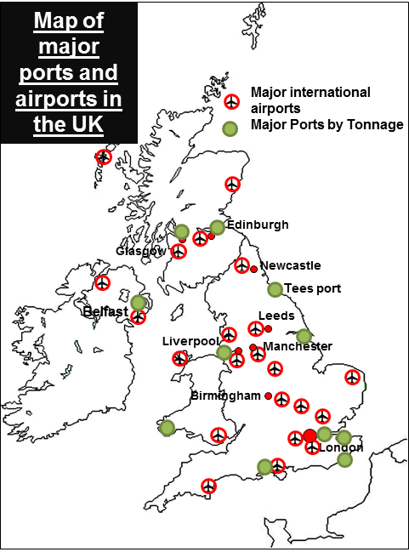
The government will also build all available Highways Agency road projects to tackle the most congested parts of the network, including the A14 from Cambridge to Huntingdon and the M4 from London to Reading

PORTS
There is also big investment in our ports. Ports are vital ways for the UK to get the resources and products it needs to function as a major country. For example, the London Gateway is a development on the north bank of the River Thames in Thurrock, Essex. It is just 20 miles (32 km) east of central London and has a new deep-water port, which is able to handle the biggest container ships in the world.
The port also has one of Europe’s largest logistics parks, providing access by road and railways to London and the rest of Great Britain.

AIR
Airports connect the UK to the world. Heathrow and Gatwick are our major airports, and act as “hubs” allowing passengers to connect to the rest of the world. There is a proposal to expand Heathrow and add a third runway and sixth terminal building. There are many economic and social benefits to this, but it would be damaging for people locally and for the environment.

Rail: High Speed Rail 2
HS2 is a major transport project designed to improve rail journeys in the UK and is split into 2 stages;
• The first phase between London and Birmingham will open in 2026.
• The second phase involves adding a V shaped section, with separate lines going from Birmingham to Manchester and Leeds.

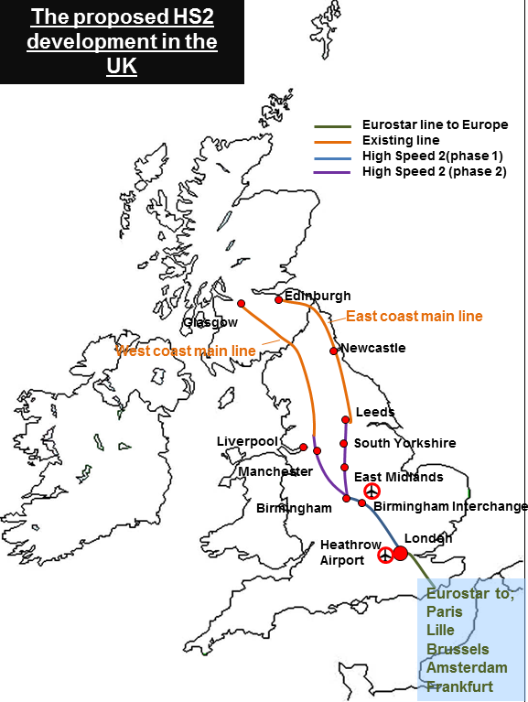

The objective of the scheme is to reduce journey times between the cities of the Northern part of England, and also to reduce the journey times to London. The idea is that businesses will function better with less loss of time spent travelling. The table below summarises the arguments that surround this massive project:
Argument | Reasons for | Reasons against
It will help bridge the north-south divide | The rail link could act as a way of growing industries in the North. The government expects 70% of jobs created to be outside London. | Some professors say that similar projects in France, Spain and South Korea show that it is capitals that benefit from these projects by sucking more wealth to the centre, in this case, London.
The final bill could be very expensive | The UK Government normally invests £50bn a year in projects like this. This project is spread over 20 years so equates to just 10 months of that budget. | The original price for HS2 was £32.7bn but the government added a further £10bn to a maximum of £42.6bn. Rolling stock (the trains etc.) is expected to cost another £7.5bn.
It will help boost the UK economy | HS2 is expected to generate 22,000 construction jobs in the next five years and once the entire line is running create 100,000 jobs.  It should also increase the UK’s GDP by £15bn a year - an increase of 0.8%.  Better transport connections like HS2 mean reduced production and transport costs, higher productivity and greater competition between UK regions. | The HS2 Action Alliance, which campaigns against the project, says there is no independent research backing up the £15bn figure. The money could be used to boost businesses in other ways.  The total cost of HS2 and HS3 could be over £100 billion – money which could be spent on other transport projects
The demolition of homes and damage to rural England is too costly and disruptive | Most of the disrupted homes are not in rural areas but are actually in London. The most disrupted area in the country will be to the north of London's Euston station. More than half of the properties affected by the scheme are here.  Only just over 600 homes will be bulldozed, and another 340 homes will be cut off from their wider neighbourhood by the project. Home owners affected will get money as compensation.  HS2 limited have added more tunnels and moved the location of parts of the line to minimise the number of people affected | Infrastructure supporting the line will be built on 250 acres of green belt land. Sites of special scientific interest will be sliced through by the line.  Historic houses in Buckinghamshire and Warwickshire will be demolished or blighted by the new line, campaigners say.
It will be good for the environment | The government claims that HS2 will move millions of air and road trips on to rail. It will open up space on the existing rail network for freight, taking hundreds of HGVs per hour off the roads. | Some experts say that few high-speed train passengers will transfer from air; most users would otherwise have taken normal train services or simply not have made the trip.  HS2's 250mph trains will use 50% more energy than the Eurostar trains, the HS2 Action Alliance says.
There are better value projects the UK could spend the money on | The government argues it is doing this anyway. Improving rail journey times between Leeds and Manchester and adding extra lanes to motorways. | One of the strongest arguments against HS2 is the opportunity cost. Spend £50bn on HS2 and that's £50bn gone from other projects. The UK is heavily in debt, public finances are stretched so spending must be carefully prioritised.

Questions - Answer all in full sentences. You do not need to write the question.
- What is infrastructure?
- Why is it important that countries have a good infrastructure?
- Why is long-term investment in infrastructure good?
- What challenges will the UK be able to face if it has good infrastructure?
- What are the four main ways that the UK can improve its infrastructure?
- How many additional lane miles could be added to the UK’s road network? How?
- Where is the most congested road network in the UK?
- What is the London Gateway?
- Name two of our major airports.
- What is being planned at Heathrow? Why?
- What is the HS2?
- Using the map, describe the path the HS2 will take from London across the UK.
- What is the objective of the HS2 scheme?

Write the following 9 marker question in your book and answer it.

“Discuss why some people in the UK are for and against the HS2 scheme” (9 marks)

Structure
Intro - Information on the scheme
Paragraph 1 - 3 arguments for
Paragraph 2 - 3 arguments against
Conclusion - Should the scheme be undertaken?

