Year 10
Unit R052 – Developing Sports Skills
Spring 1 Blended Learning Booklet
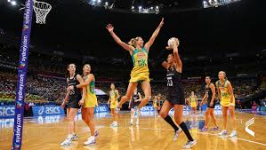
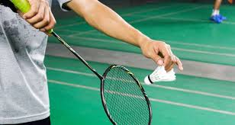

Name:

Aim to complete two lessons each week.
All video links and content are also uploaded on ClassCharts
The knowledge organisers have all the key information and vocabulary to help with this unit.
Upload all work onto ClassCharts for feedback

Contents

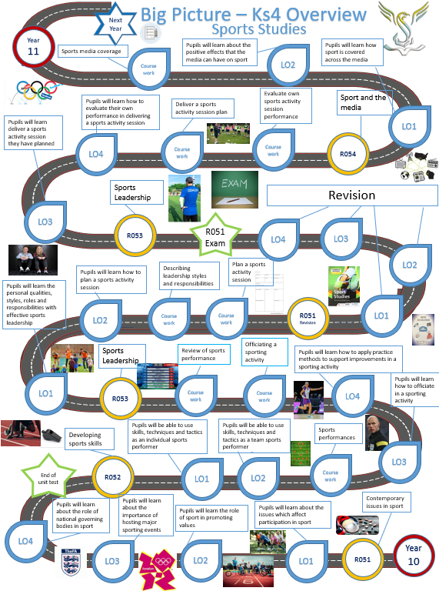
Big picture
Zoom in
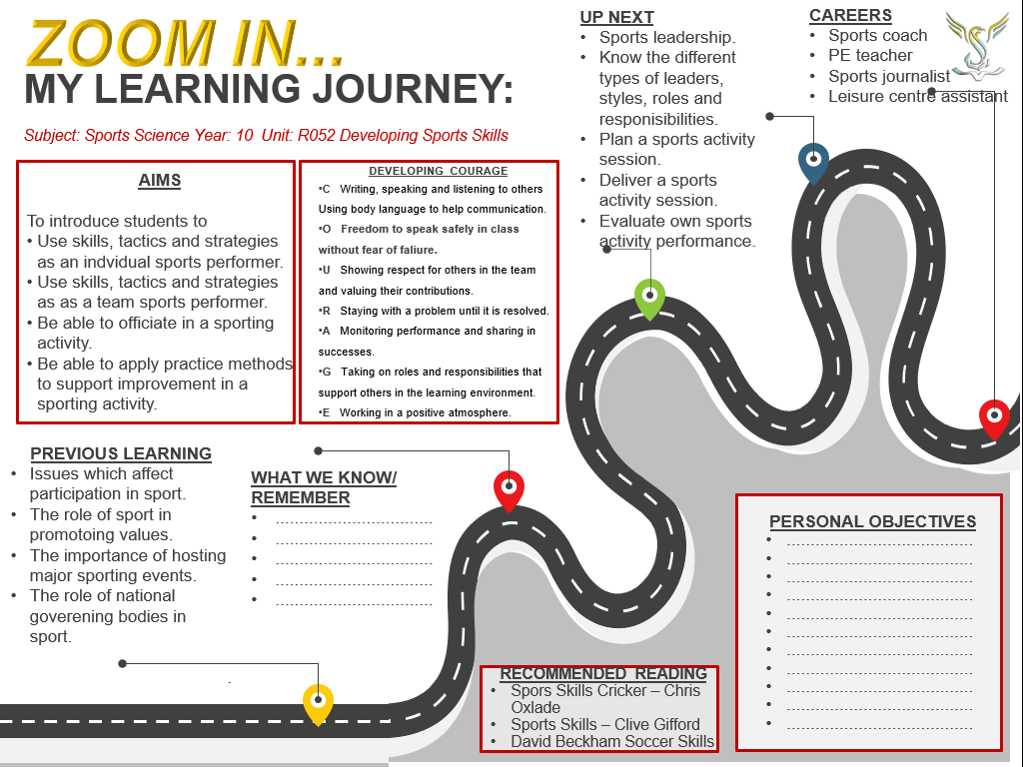

Knowledge organiser
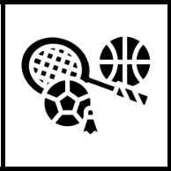
RO52 Developing Sports skills
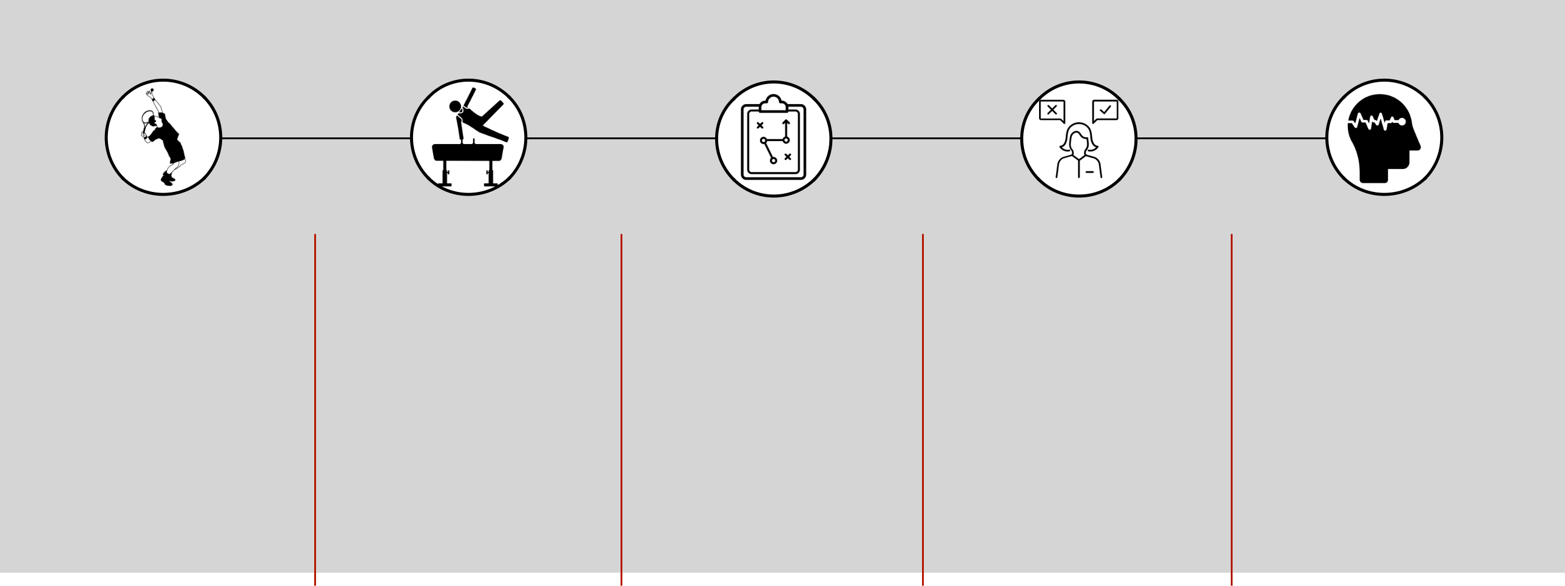
LO1: Be able to use skills, techniques and tactics as an individual performer
STEP 1 STEP 2 STEP 3 STEP 4 STEP 5

Performance of skills and |  | Creativity | Appropriate use of tactics / |  | Decision making during |  | Ability to manage /
techniques |  |  | strategies / compositional |  | performance |  | maintain own performance
 |  |  | ideas
• | Individual sports - | • Create or react to a | • | Tactics - plans used | • | Select a suitable | • | Arousal is a physical and
 | athletics, swimming, | situation in a unique or |  | against opponents |  | movement or skill |  | mental state of alertness
 | cycling, tennis | unusual way |  | weaknesses and for | • | Has to take place |  | varying from deep sleep
• | Skill - learned |  |  | own strengths |  | quickly in most sports |  | to intense excitement
 | combination of |  | • | Strategies - overall |  |  | • | The difficult thing is
 | movements |  |  | plan of how best to |  |  |  | trying to make sure that
• | Techniques - method |  |  | perform |  |  |  | levels of arousal are kept
 | used to perform a skill |  | • | Composition - art of |  |  |  | at the correct level
 |  |  |  | creating and arranging

Mark scheme
LO1: Be able to use skills, techniques and tactics as an individual performer
Mark Band 1 | Mark Band 2 | Mark Band 3
Demonstrates limited application of skills and | Demonstrates effective application of skills and | Demonstrates advanced application of skills and
techniques as an individual performer in a sporting | techniques as an individual performer in a sporting | techniques as an individual performer in a sporting
activity | activity | activity
Creativity, use of tactics / strategies / compositional | Creativity, use of tactics / strategies / compositional | Creativity, use of tactics / strategies / compositional
ideas and decision making often lacks accuracy and | ideas and decision making shows some accuracy and | ideas and decision making shows accuracy and fluency
fluency | fluency | on most occasions
Ability to maintain performance is inconsistent | Ability to maintain performance is consistent | Ability to maintain performance is consistent and
 |  | confident

LO2: Be able to use skills, techniques and tactics as a team performer
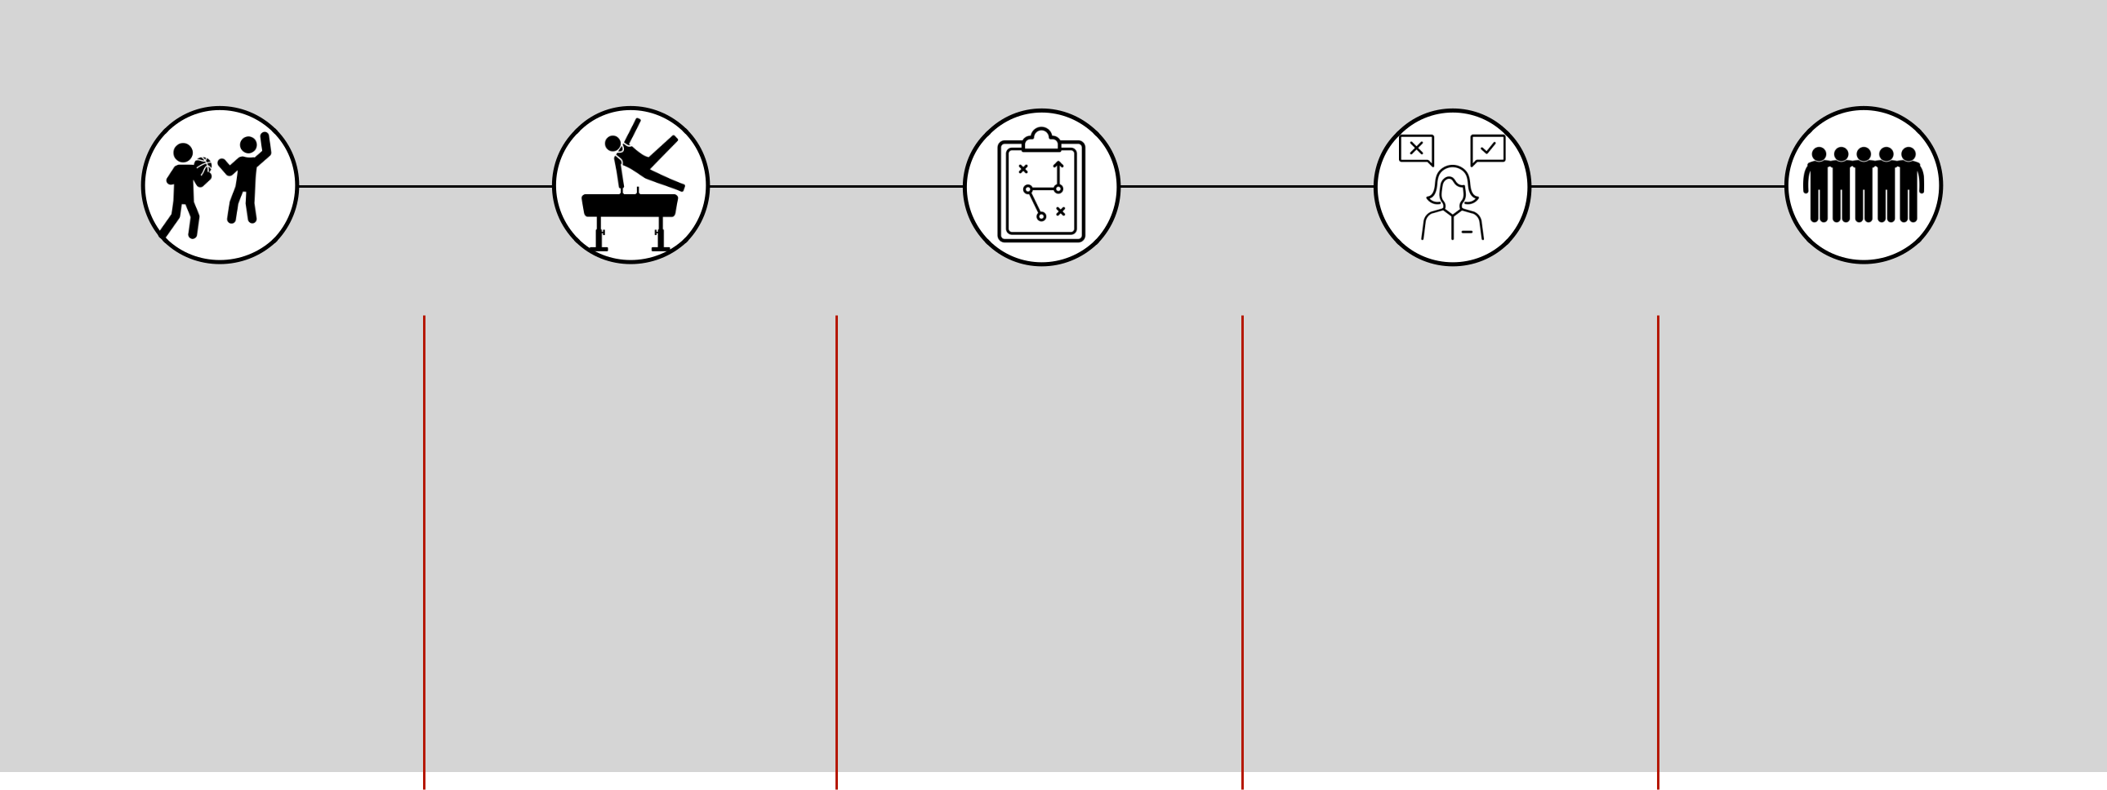

STEP 1 STEP 2 STEP 3 STEP 4 STEP 5

Performance of skills and |  | Creativity | Appropriate use of tactics / |  | Decision making during |  | Awareness of role within /
techniques |  |  | strategies / compositional |  | performance |  | contribution to the team
 |  |  | ideas
• | Team sports - | • Showing creativity in a | • | Tactics - plans used | • | Select a suitable | • Most team sports have
 | basketball, volleyball, | team sport is |  | against opponents |  | movement or skill | specific roles for a
 | rugby, football | concerned with using |  | weaknesses and for | • | Has to take place | number of players within
• | Skill - learned | your own ideas to |  | own strengths |  | quickly in most sports | the team, and players
 | combination of | solve a problem by | • | Strategies - overall |  |  | must be aware of their
 | movements | creating or reacting to |  | plan of how best to |  |  | role
• | Techniques - method | a situation in a unique |  | perform
 | used to perform a skill | way | • | Composition - art of
 |  |  |  | creating and arranging

Mark scheme
LO2: Be able to use skills, techniques and tactics as a team performer
Mark Band 1 | Mark Band 2 | Mark Band 3
Demonstrates limited application of skills and | Demonstrates effective application of skills and | Demonstrates advanced application of skills and
techniques as an individual performer in a sporting | techniques as an individual performer in a sporting | techniques as an individual performer in a sporting
activity | activity | activity
Creativity, use of tactics / strategies / compositional | Creativity, use of tactics / strategies / compositional | Creativity, use of tactics / strategies / compositional
fluency | fluency | on most occasions
limited | clear | well developed

Lesson 1
Officiating in a sporting activity
LI: how to apply rules and regulations relevant to a sporting activity.
LI: understand how to apply rules and regulations to the activity officiating in
Officials must know how to apply rules and regulations relevant to the activity.
The rules and regulations of sports are written and enforced by the national governing body of that sport. Often rule changes are actually set by the international sports federation of that sport.
Can you list 5 sports and their national governing bodies?
Sport | National governing body

Now chose two of the sports you have identified above to write down as many rules for the sport you can think of:
Sport two………………………………………….
Sport one………………………………………….

Rules and regulations
What is the difference between a rule and a regulation?
Rule……………………………………………………………………………………………………………………………
…………………………………………………………………………………………………………………………………..
Regulation…………………………………………………………………………………………………………………
…………………………………………………………………………………………………………………………………..
Rules are sometimes changed to improve the sport. For example the rules of rugby were altered in 2017 to allow a player in a scrum to pick the ball up from the feet of the players in front, instead of having to have the ball at their own feet.
What rule changes can you think of that have happened in sport recently?

Who are responsible for the rules of a game whilst it is being played? What are their main responsibilities and how do they achieve these? What would happen if these people were not involved in any games or sporting activities?

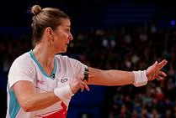
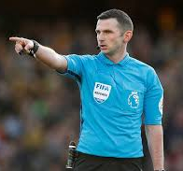
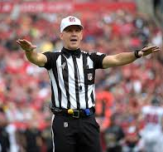

Lesson 2 and 3
Officiating in a sporting activity
LI: apply consistency when making decisions
LI: understand the importance of accuracy

As part of the course you are required to officiate in one of your chosen sports (either team or individual)
Answer the following questions about your officiating experience:
- Level officiated at:

- Explain your level of officiating:

- Describe how much you have officiated in school, and outside of school:

- Describe the amount of time you dedicate to officiating in terms of training, playing and related fitness work:

- Include photos and other information from officiating. If you are officiating outside of school we will need video evidence and a witness statement from your assessor.

- Include any links to video evidence.
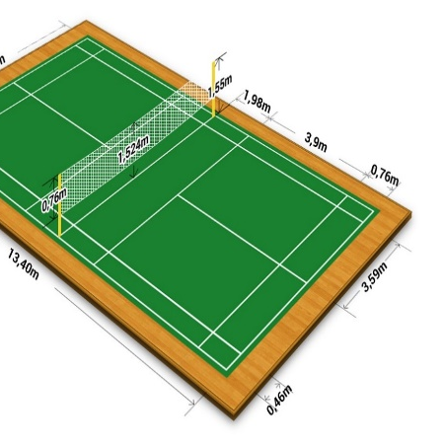
The officials in sport are responsible for ensuring that the rules or laws of the sport are correctly applied. If the rules are broken, then is the officials who have to recognise the offence and apply the appropriate sanction.
Officials are responsible for making sure that the correct number of players are involved. This especially important in sports where substitutions are allowed.
Officials are also responsible for making sure that the facilities and equipment being used for the sport are correct and suitable. Many sports require the performers to wear protective equipment such as the gum shields and pads worn by hockey goalkeepers and it is the officials who check that such equipment is appropriate.
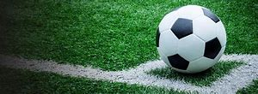
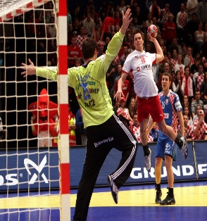
Rules I know or have researched

- 1.
- 2.
- 3.
- 4.
- 5.
- 6.
- 7.
- 8.
- 9.
- 10.
- 11.
- 12.
- 13.
- 14.
- 15.
- 16.
- 17.
- 18.
- 19.
- 20.

The importance of consistency

Stewards assessment ladder

