Year 10
Unit R053 - Sports Leadership
Summer 2 Blended Learning Booklet

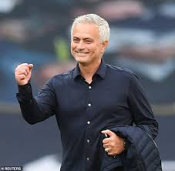


Name:

Aim to complete two lessons each week.
All video links and content are also uploaded on ClassCharts
The knowledge organisers have all the key information and vocabulary to help with this unit.
Upload all work onto ClassCharts for feedback

Contents
Page 3: Big Picture – Year overview
Page 4: Zoom in – My learning journey
Page 5: Knowledge organiser – Leadership
Page 7: Lesson 1
Page 10: Lesson 2
Page 11: Lesson 3
Page 12: Lesson 4
Page 13: Lesson 5
Page 14: Lesson 6
Page 15: Lesson 7 and 8
Page 18: lesson 9
Page 19: Lesson 10
Page Stewards Assessment ladder

Big picture
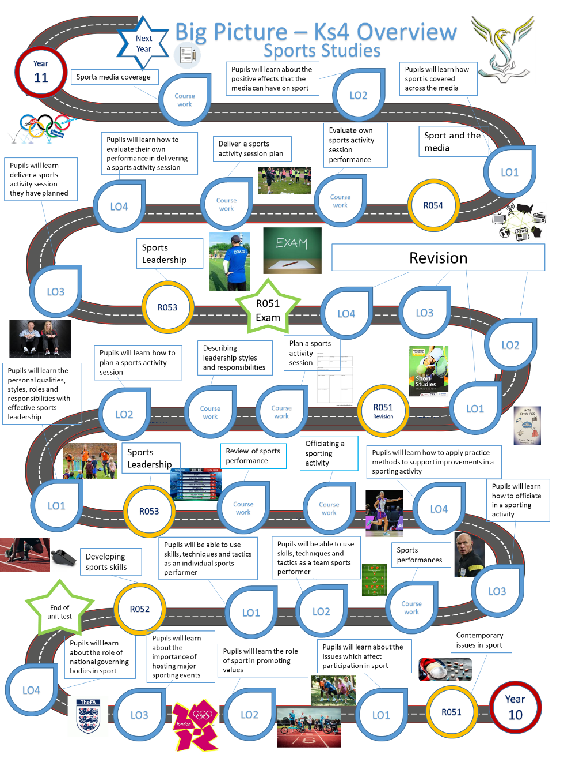

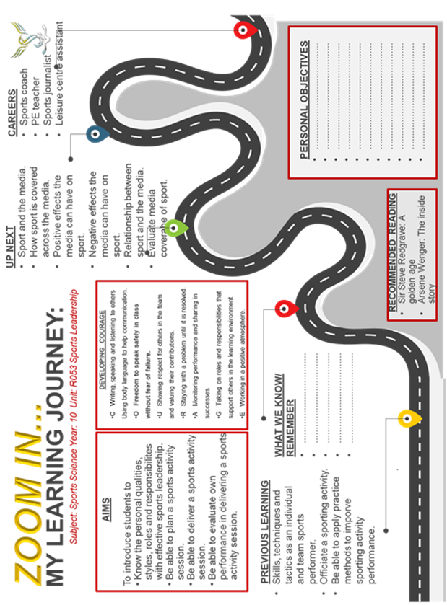
Zoom in
Knowledge organiser
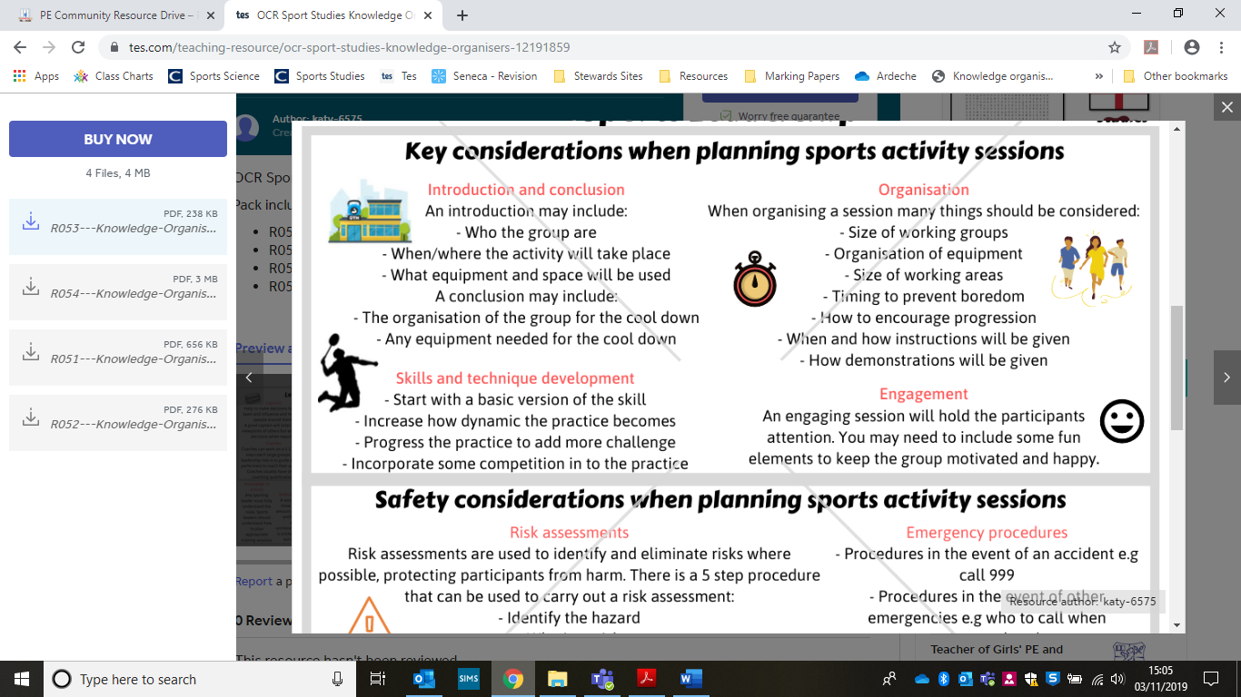
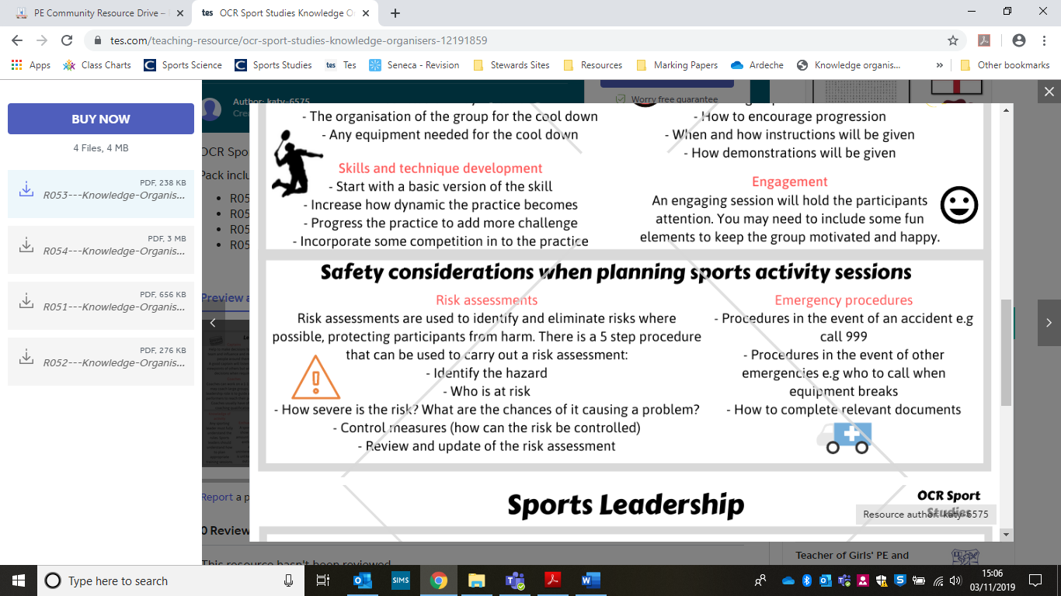
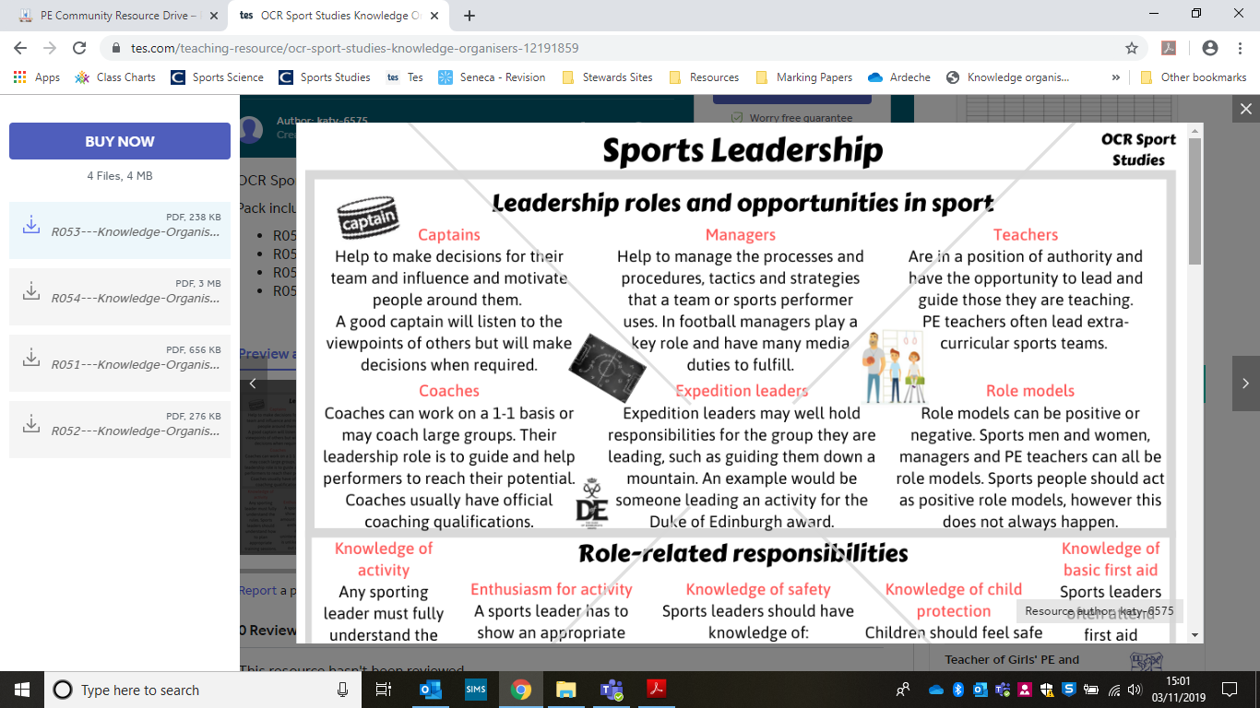
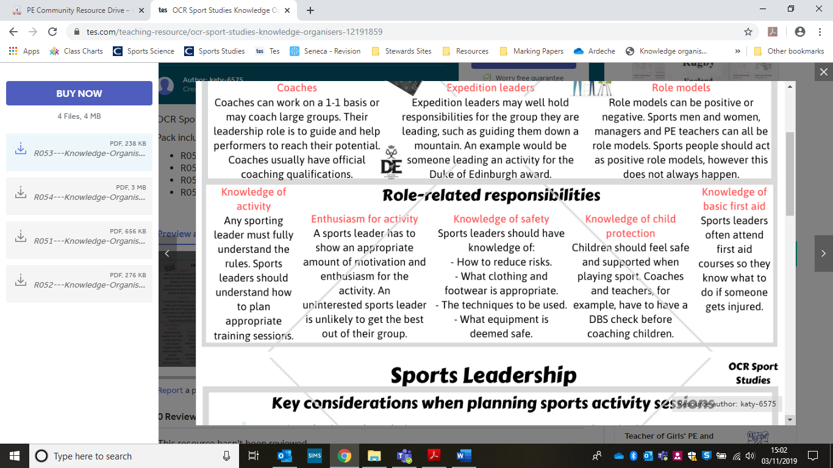

Lesson 1
Safe supervision

LI: understand the key considerations to take in to account when effectively and safely planning a sports activity session.
LO: safely supervise a sports activity as a leader or coach

As a leader of the session safety is your responsibility…

Q. If you see practice this is unsafe what should you do?

Q. Why is it suggested to have a mobile phone to hand?

Q. Why should you rehearse the session in your head?

Delivery style, i.e. o proactive/reactive - You need to think about the delivery style and the way you will lead the session

Q. How can you avoid a lesson ‘dragging’? – slowly/tediously

Q. When delivering a session try to be proactive and reactive…. Research what the words in red mean and write them down below

Proactive -

Reactive –

Demonstrations –

Q. Give examples when demonstrations have been used in a session

Evaluation On My Own Performance
Sports Session

Coach
Sport/ Activity
Date

Warm Up (What did it consist of, would you change anything)
__________________________________________________________________________________________________________________________________________________________________________________________________________________________________________________________________________________________________________________________________________

Activity (How well did it go, would you make changes for the future)
________________________________________________________________________________________________________________________________________________________________________________________________________________________________________________________________________
__________________________________________________________________

Cool Down (How well did it go, would you make changes for the future)
__________________________________________________________________________________________________________________________________________________________________________________________________________________________________________________________________________________________________________________________________________

How was my performance | √ | × | Comments
Was I organised

Did I Have knowledge of sport

Did I praise efforts

Did I feel confident

Was my communication clear and well heard

Did I motivate

Was I encouraging?

Did I show a good character, ie posture, facial expressions

Evaluation On Sports Coach/Leader

Coach/
Name
Date

Circle Answer

- Did you enjoy the activity session.
Yes No
- Was the Coach/Leader Friendly.
Yes No
- Did the coach/leader praise you for your efforts.
Yes No
- Did the coach/leader speak loud and clearly.
Yes No
- Did the Coach/Leader help when you didn’t understand.
Yes No

Coursework preparation
LO: know the personal qualities, styles, roles and responsibilities associated with
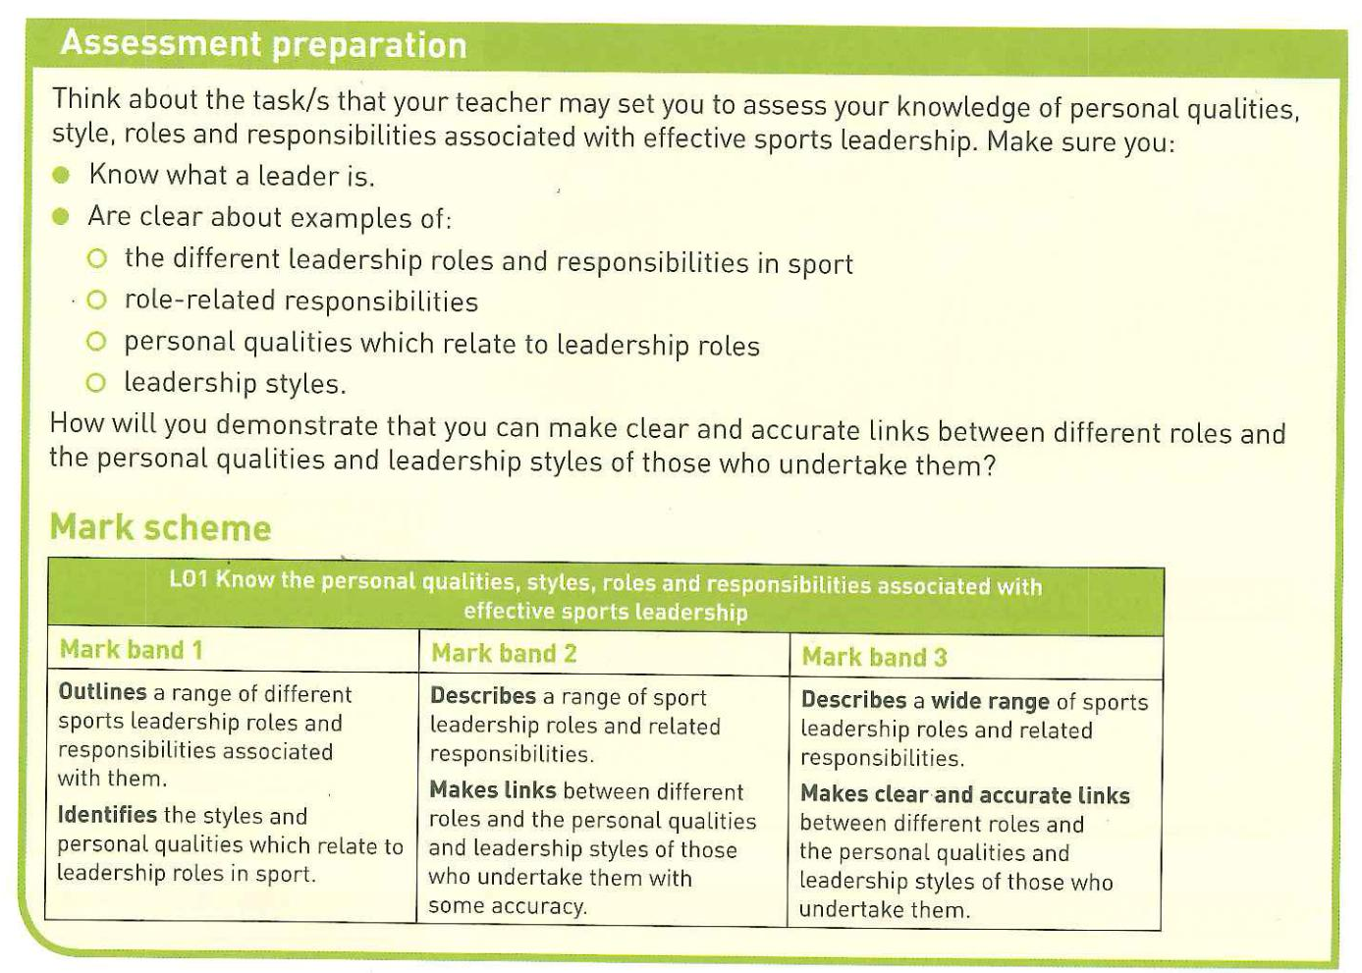
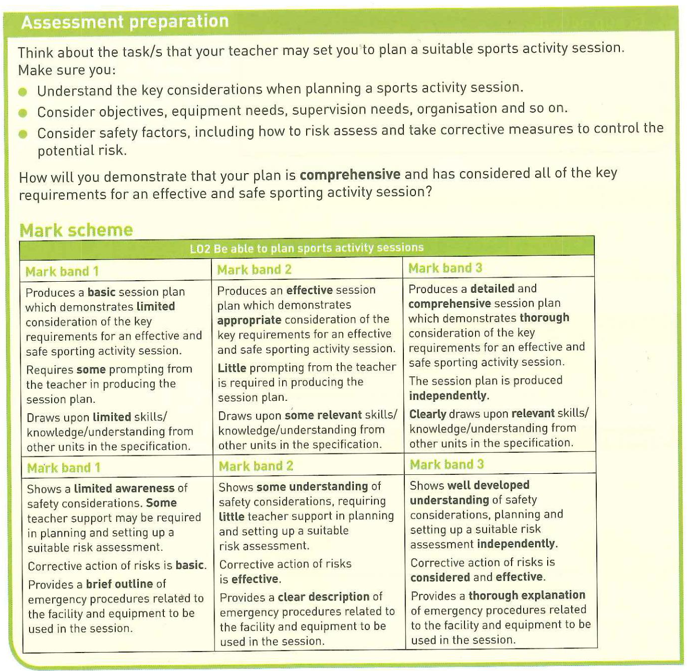

Assessment ladder

