Year 10 English

Blended Learning Booklet
Spring B
‘No one is Too Small’ Language Paper 2
Name:
Form:
Class Teacher:



Contents
Lesson | Page | Tick when complete
Lesson 1: What skills are tested in Language Paper 2?  Overview of the Language Paper and mark schemes | 6
Lesson 2: How does the writer use language to interest and engage the reader? Part I  Answering the short questions and Q3 – language and structure | 6
Lesson 3: How does the writer use language to interest and engage the reader? Part II  Consolidation of language and structure analysis | 8
Lesson 4: How do you judge the success of a writer in achieving their intentions? Part I  Revision of how to evaluate a writer’s success | 11
Lesson 5: How do you judge the success of a writer in achieving their intentions? Part II  Consolidation of how to evaluate success | 13
Lesson 6: How do assess the similarities between two texts? Part I  Introduction to comparison | 16
Lesson 7: How do you compare the ideas and perspectives presented by two different texts? Part I  Introduction to comparing ideas and perspectives | 18
Lesson 8: How do you compare the ideas and perspectives presented by two different texts? Part II  Consolidation of comparing ideas and perspectives | 19
Lesson 9: How do I write a news article?  Revision of transactional writing skills | 20
Lesson 10: How do I write a review?  Revision of review writing | 24
Lesson 11: Independent practice of comparison skills | 25
Lesson 12: How do I write formal letter?  Revision of formal letter writing | 27
Lesson 13: BOOK LOOK feedback lesson | 29
Lesson 14: How do I write an effective speech? | 29
Lesson 14: Lit Revision: ACC/AIC | 31
SALs | 32

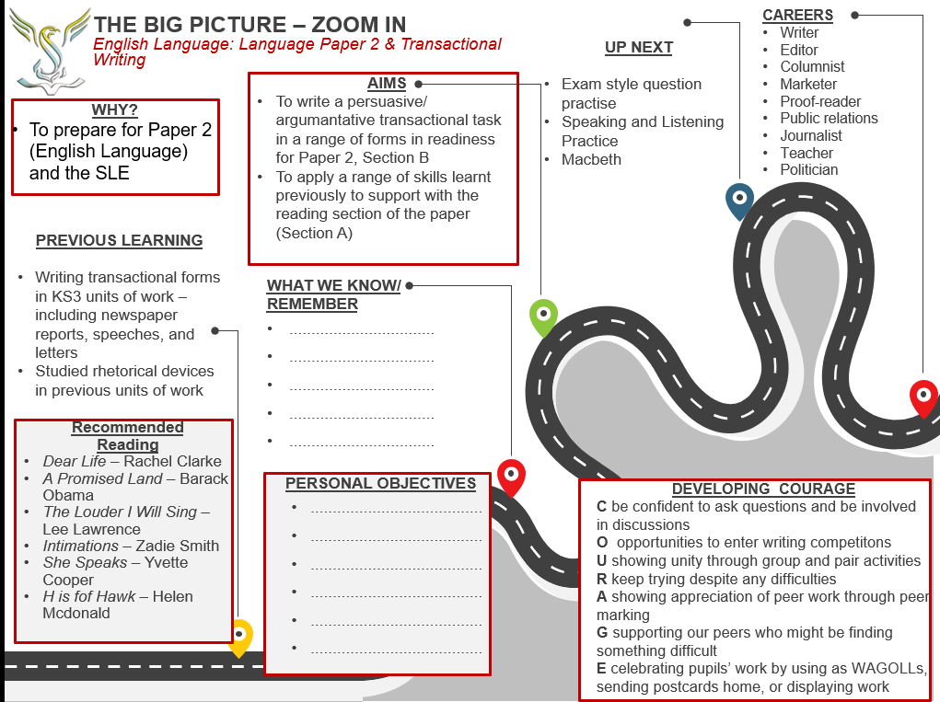

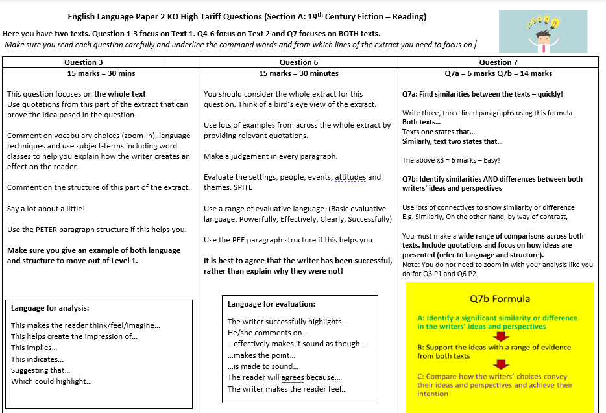

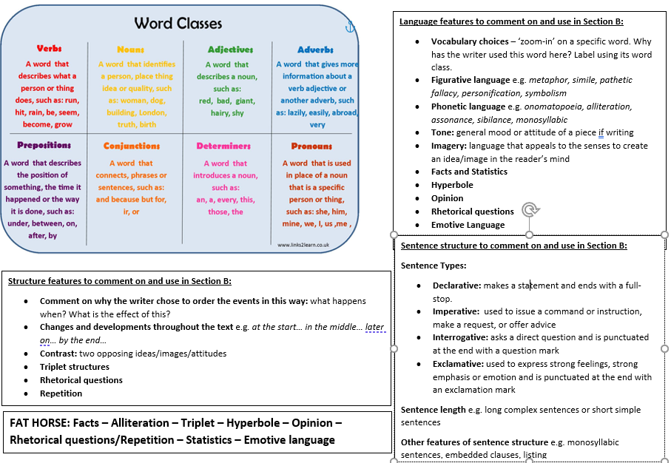
Lesson 1: What skills feature in Language paper 2?
LI: To understand what is expected for success in Language Paper 2
Do now: Read through the Zoom In – set a target for yourself

DART: Read over the KOs for Language Paper 2
DART Tasks
What are the key differences between Language Paper 1 and Language Paper 2?

DIP TASK: Timed writing transactional task – use the remainder of the lesson to complete this task. Plan your paragraphs BEFORE starting the write-up.
Q8 Your school or college is writing an information guide for students who are new to the school/college.
Write the section for the guide with the title ‘Stress-free Settling In’.
In your text, you could include:
• how to find your way around the site
• ways of getting to know new people
• what kinds of feelings new starters may experience
as well as any other ideas you might have.
*Your response will be marked for the accurate and appropriate use of vocabulary,
spelling, punctuation and grammar. (Total for Question 8 = 40 marks)

Lesson 2: How to Analyse Language and Structure
LI: To revise approaches to answering the analysis questions in the Language Exam

Do now: Read the AO2 SAL – hi,….ghlight the key points and make annotations
DART: June 2018 Text 1
Read the text below and answer Questions 1–3 on the question paper.
TEXT 1
Extract from ‘Little Milton’ by Tony Russell (2005).
This is an extract from an obituary written by Tony Russell and published in the Guardian
newspaper. It describes the musical career of an American singer, “Little” Milton Campbell.

Although he started out in music in the same place and at the same time as BB King,
Ike Turner and Elvis Presley, “Little” Milton Campbell, who has died aged 70, escaped
the confines of blues or rock ‘n’ roll to become a spokesman, through soul music, for the
entire African-American community.
He was born in Inverness, Mississippi, a town less than 10 miles from Indianola, and near
Leland. His first public appearances, singing and playing guitar, were in the clubs of
Leland and nearby Greenville’s notorious Nelson Street. At 16, he followed the example
of BB King, who was nine-years-older, and tried his luck in Memphis.

Before he was 20, Milton had made several records for Sam Phillips’s Sun label. They were
a heady* brew of shameless imitation and lawless bravado; several of his vocals were
blatantly modelled on King, but he also seemed to have an ear cocked to another local
contemporary, Bobby Bland.

Milton’s guitar playing was decidedly original, all spiky lines and muddy tone. Like Ike
Turner, who had produced and played on those records, he moved on to East St Louis,
where there were grooming stables of blues and soul artists.

Milton’s seven releases on Bobbin were well received, but it was his move, in 1962, to
the larger Chess label, in Chicago, that accelerated his progress through the ranks of
up-and-coming blues singers. Milton neither wished nor intended to be typecast as
a blues singer.

“In order to be successful at this,” he noted in an interview with Living Blues magazine,
“you have to be versatile.” When We’re Gonna Make It went to the top of the R&B chart in
the spring of 1965 – Milton was established as one of the leading figures in soul blues.

In the early 1970s, Milton made a logical move for anyone working to the templates of
soul and blues, and signed with Stax Records. During a five-year period, he produced
numerous records that were both artistically satisfying and quite successful in the R&B
charts, but he cannily** retained the affection of older and more blues-inclined listeners
with the passionate blues preaching of Blue Monday or The Thrill Is Gone.

Milton had always kept close ties with the region where he grew up, and would regularly
appear both at small clubs and festivals in Mississippi and Arkansas. In 1984, he joined
Malaco, the southern soul label based in Jackson, Mississippi. During the next 20 years,
he recorded more than a dozen albums.

Like BB King, too, Milton presided over a recorded conference with younger artists, titling
it Welcome To Little Milton and pleasing his English fans by including a photograph of
the roadsign for that quiet Oxfordshire village. His last album, Think Of Me, was issued
recently, and one of his last performances was earlier this year at the Barbican, London.
He suffered two strokes last month and had been in hospital in Memphis ever since.
His wife, Pat, survives him.

• Milton Campbell, blues and soul singer, born September 7 1934; died August 4 2005
heady* - strong
cannily** - cleverly
DIP Task: Q3 Analyse how the writer uses language and structure to interest and engage the reader.
Support your views with detailed reference to the text. 15 marks
__________________________________________________________________________________

Lesson 3: Consolidating Language and Structure Analysis
LI: To revise approaches to answering the analysis questions in the Language Exam

Do now: What are your top tips for answering Q3?
DART: Read two Q3 responses
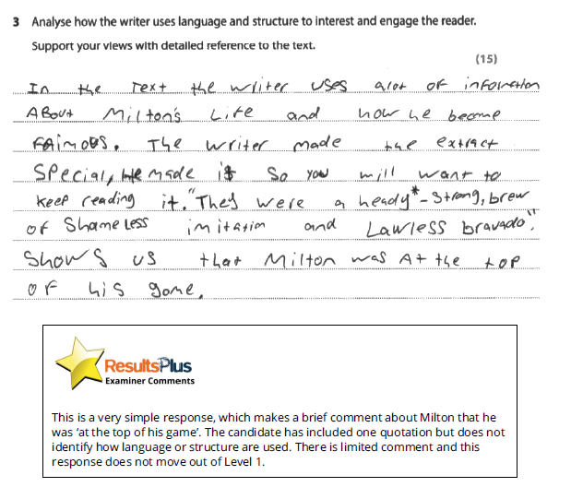
DART tasks:
- Create a WWW/EBI for both answers
DIP TASK: Redraft a section of your answer from yesterday in blue pen

Lesson 4: How do we approach evaluation?
LI: To revise approaches to answering the evaluation question in the Language Exam
Do now: Read the Evaluation SAL. Highlight and annotate key points.
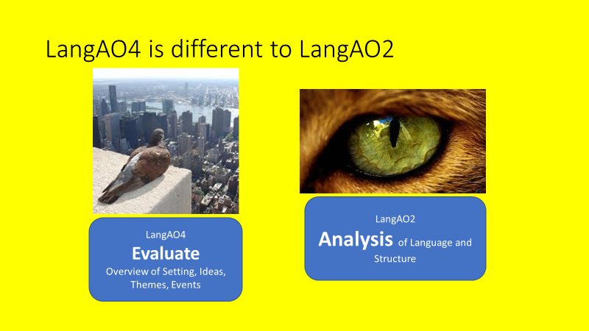
Evaluation notes: The focus of evaluation is upon how well something has been achieved, not merely upon how it has been achieved.
As you write your answer make sure that you are evaluating by saying how well something has been done by the writer, not just what has been done.
A detached critical overview is important. Look at the text holistically – mention the beginning, middle, end.
- How do things change as the extract progresses?
- Mention the tone of the text and “direction of travel”. What are the threads in the extract (tone, ideas, words, structure) and how are these linked?
- Focus on Settings/People/Ideas/Themes/Events
What – How - How well? Sample: 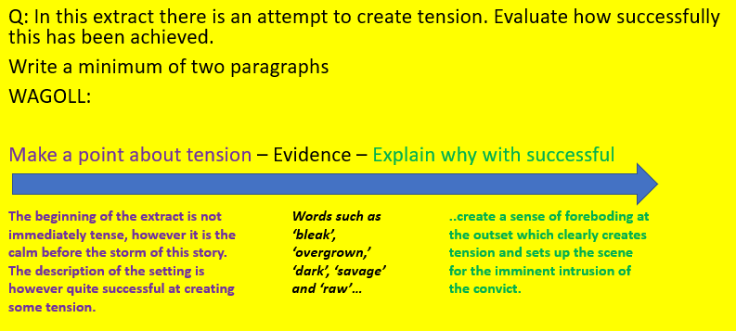

DART: June 2018 Text 2
TEXT 2
Extract from ‘Really the Blues’ by “Mezz” Mezzrow and Bernard Wolfe (1946).
This extract is taken from the section ‘Got the Heebies, Got the Jeebies’. In this extract Mezz
describes taking his friend Dave to see the jazz singer Bessie Smith perform.

Bessie had such a ringing vibration in that voice of hers, and her tones boomed out so
clear and clanging full, you could hear her singing all the way down the street. There was
a traffic jam out in front of that café; cats and their kittens* blocked up the side-walk,
hypnotized** by the walloping blues that came throbbing out of Bessie’s throat. She was
putting away Young Woman Blues, one of her greatest numbers, when we eased in …

Dave and I just melted together in the blaze of Bessie’s singing; that wasn’t a voice she
had, it was a flame-thrower licking out across the room.

Bessie was a real woman, all woman, all the femaleness the world ever saw in one sweet
package. She was tall and brown-skinned, with great big dimples creasing her cheeks,
dripping good looks – voluptuous, buxom and massive but stately too, shapely as an
hour-glass, with a high-voltage magnet for a personality. When she was in a room her
vitality flowed out like a cloud and stuffed the air till the walls bulged. She didn’t have
any mannerisms, she never needed any twirls and twitches to send those golden notes
of hers on their sunshiny way. She just stood there and sang, letting the love and the
laughter run out of her, and the heaving sadness too; she felt everything and swayed just
a little with the glory of being alive and feeling, and once in a while, with a grace that
made you want to laugh and cry all at once, she made an eloquent little gesture with her
hand. Bessie maybe never practised her scales in any conservatory of music, wrestling
with arpeggios***, but she was an artist right down to her fingertips – a very great
artist, born with silver strings for vocal cords and a foaming, churning soul to keep them
a-quiver.

Her style was so individual that nobody else ever grasped it. The way she let her rich
music tumble out was a perfect example of improvisation – the melody meant nothing
to her, she made up her own melody to fit the poetry of her story, phrasing all around
the original tune if it wasn’t just right, making the vowels come out just the right length,
dropping the consonants that might trip up her story, putting just enough emphasis on
each syllable to make you really know what she was getting at. She lived every song she
sang; she was just telling you how it happened to her.

… one day in 1937 she was in an automobile crash … and her arm was almost torn out
of its socket. They brought her to the hospital but it seemed like the people there didn’t
care for the color**** of her skin. The car turned around and drove away, with Bessie’s
blood dripping on the floor-mat. She was finally admitted to another hospital … but she
had lost so much blood that they couldn’t operate on her, and a little later she died.

Glossary:
cats and their kittens* – jazz slang for men and women
hypnotized** – American spelling of hypnotised
arpeggios*** – a sequence of musical notes
color**** – American spelling of colour

DIP
Q6: In this extract, the writer attempts to show his admiration for Bessie Smith.
Evaluate how successfully this is achieved.
Support your views with detailed reference to the text. 15 marks


Lesson 5: How do you judge the success of a writer in achieving their intentions? Part II Consolidation of how to evaluate successfully.
LI: To revise approaches to answering the evaluation question in the Language Exam
Do now: Evaluate how successful this designer has been at creating a non-spill product for toddler drinks

DART: Read the exemplar answer.
DART task: Annotate where you think the candidate has gained marks. Highlight any evaluative language.

DIP TASK: Redraft a section of your own answer from the previous lesson in blue pen

Lesson 6: How do assess the similarities between two texts?
LI: To identify specific approaches for identifying similarities between two texts
Do now: How are these two trees similar?

Read the SAL for AO1 – how can you ensure you will be successful?

Q7a seeks only similarities.
7a Formula:
Make a comparative point starting with ‘Both’ . Add an Example (quote) from Text 1. Use a Connective such as ‘similarly’ and add an Example (quote) from Text 2 x3

DIP Task: Q7a
The two texts show singers who are memorable.
What similarities do Milton and Bessie share in these extracts?
Use evidence from both texts to support your answer. 6 marks

Lesson 7: How do you compare the ideas and perspectives presented by two different texts?
LI: To identify specific approaches for identifying similarities/differences between the ideas and perspectives of two texts
Do now: At a glance, what are the key differences between Text 1 and Text 2?

Ideas and Perspectives = the viewpoints and opinions presented in each text
The writer’s choices are linked to how they achieve their intentions. Areas to consider when looking at how ideas and perspectives are presented are:
- Purpose/Audience/Form – do these affect the presentation of ideas?
- Overall Topic
- Ideas/Opinions
- Perspective (point of view)
- Writer intention
- Language and structure (how they help the writer put across their ideas/arguments)
- Effect on the reader
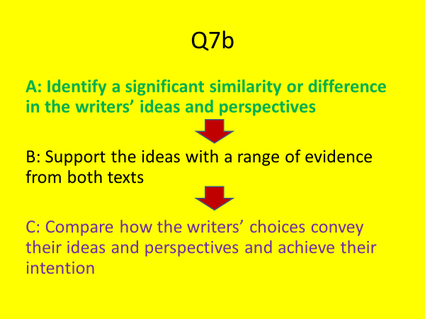
The steps for answering Q7b:
Make a comparative point starting with ‘Both/One/Neither’ about an idea/perspective’
+ Text 1 Quote + analyse the impact of quote 1.
+ Connective e.g. Similarly, in text 2…
+ Text 2 Quote + analyse the impact of quote 2.
+ compare the different ways that the writers have conveyed their ideas/perspectives and/or the impact of the writers’ choices on the reader

Q7b: Compare how the writers of Text 1 and Text 2 present ideas and perspectives about singers.
Support your answer with detailed references to the texts.
Revisit the two texts and annotate.
Annotating top tips:
- How do they describe and respond to singers?
- Any similarities or differences between their ideas and perspectives?
- Any similarities and differences in the ways the writers express their ideas and perspectives? (writer choices for language and structure)

DIP TASK: Students to plan three paragraphs of an answer. To be continued in the next lesson

Lesson 8: How do you compare the ideas and perspectives presented by two different texts?
LI: LI: To identify specific approaches for identifying similarities/differences between the ideas and perspectives of two texts
Do now:
- Compare the photographer’s intentions in photo 1 and photo 2.
- How have the photographer choices helped achieve their intentions? Write a comparative paragraph.

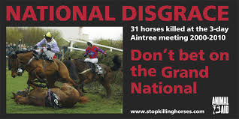


DART: WAGOLL paragraph
Create a WWW/EBI for this paragraph

DIP Task: Q7b: Compare how the writers of Text 1 and Text 2 present ideas and perspectives about singers.
Support your answer with detailed references to the texts.
*Do not use the sample paragraph in your answer.
__________________________________________________________________
Lesson 9: How do I write a newspaper article?
LI: To generate ideas and plan a newspaper article
Do now: Why is music so popular?
DART 1: Read the SAL for Section B Transactional Writing. Annotate and highlight the key points for success.
DART 2: Read the exemplar based on the June 2017 question: ‘It’s not the possessions that matter, it’s the memories associated with them.’ Write an article for a magazine about your most prized possessions.
Create a WWW/EBI for this answer.

DIP Task:
A: Retro-fit the exemplar answer into a plan. E.g. created a bullet pointed list for each paragraph including the introduction and ending.
B: Plan an answer for the following question: Q8 Write an article for a newspaper with the title ‘How Music Affects People’.
You could write about:
• what types of music people listen to
• where people listen to music
• how music makes people feel
as well as any other ideas you might have.

Lesson 10: How do we write a review?
LI: To write a review about an event
Do now: Why do people write reviews?

DART: Muse review – dizzying rock spectacle for the machine age
London Stadium
Neon robots, isolation-suit acrobats, 23rd-century cops … the glam sci-fi fantasists throw the lot at their extravagantly dystopian stadium romp

‘We are caged in simulations,” reads the gigantic, stage-wide convex screen as a legion of neon robots with trombones herald Matt Bellamy rising from the centre of the stadium with android fanfares, as if the AI have arisen and stolen the jobs of the nearest marching band. So have Muse been a glitch in the matrix all along?
They always seemed a spectacular rock’n’roll programming error: three Teignmouth lads who became superstars by deciphering the malevolent sociopolitical virus code of the 21st century and delivering their findings in a blitz of operatic space rock, dystopian stage fantasies and solos resembling a cyborg Queen ferociously malfunctioning.
Certainly the tour for 2015’s Drones – when remote-controlled spheres strafed the stands and diaphanous screens stretched the length of arenas – was so immersive that it’s surely only a matter of technology before they go fully virtual and play stadium gigs in your squat. Meantime, they bring the retro-futurist 80s teen flick unrealities of their VR-themed new album Simulation Theory to life.
Donning glowing glasses throughout, Bellamy plays an avatar being hunted through the machine. Space zombies chase him along the ego ramp throughout synthrock anthem Thought Contagion. Acrobats in isolation suits walk vertically down the screen during the Arabian-inflected Break It To Me, tracking him with flashlights. A 23rd-century task force, wielding steam-throwers, invade the stage for Propaganda, the sound of Prince being crushed beneath a grooving Terminator.
These breezy, synthetic new tunes interface seamlessly with Uprising, Supermassive Black Hole and Psycho – tracks that always sounded like glam being shot around the Large Hadron Collider – and the first hour zips by. A plodding gospel Dig Down hobbles the pace, but there’s enough momentum to sci-fi anthems such as Mercy and pop-metal classics Hysteria, Time Is Running Out and hellfire opera Take A Bow – sung by Bellamy to a silver skull like a Spielberg Hamlet – to ensure the most dizzying and future-facing of stadium spectacles.
At its climax, a giant alien borg bursts from the stage, flailing at the air, growing angrier as Stockholm Syndrome mashes magnificently into Reapers and New Born. Keep telling yourself: it’s only a simulation…

Reviewing:
-focuses on strengths and weaknesses
-uses evidence to support ideas
-draws a conclusion, saying whether something will be useful for, or interesting to, its audience
gives personal opinion with confidence and authority.
DIP Task
Q9 Write a review of a band, concert, film or book that you feel strongly about.
In your review, you could include:
• details of the band, concert, film or book
• the strengths and weaknesses of the band, concert, film or book
• reasons why you feel so strongly
as well as any other ideas you might have.
*Your response will be marked for the accurate and appropriate use of vocabulary,
spelling, punctuation and grammar.
________________________________________________________________
Lesson 11: Identifying Similarities and Comparing ideas and perspectives
LI: To consolidate approaches to the comparison of ideas and perspectives and how they are conveyed.
DART: Read both Text 1 and Text 2 from the 2018 Nov resit paper

DIP Tasks:
7 (a) The two texts show how pregnancy can change relationships.
What similarities do couples share in these extracts?
Use evidence from both texts to support your answer. 6m

7 (b) Compare how the writers of Text 1 and Text 2 present ideas and perspectives
about relationships.
Support your answer with detailed references to the texts. 14m

Your answers will be the focus of a teacher book look.

TEXT 1
Extract from a letter from E.B. White to his wife (1930).
This is an extract from a letter written by the author E.B. White, whose wife is expecting their
first baby. He is struggling to tell her how he feels. Instead of talking to his wife directly, he
imagines the family dog, Daisy, writing a letter to her explaining his feelings.
Dear Mrs. White:
[Mr.] White has been stewing around for two days now, a little bit worried because he is
not sure that he has made you realize* how glad he is that there is to be what the column
writer in the Mirror calls a blessed event. So I am taking this opportunity, Mrs. White, to
help him out to the extent of writing you a brief note which I haven’t done in quite a
long time but have been a little sick myself as you know. Well, the truth is White is beside
himself and would have said more about it but is holding himself back, not wanting to
appear ludicrous**.

What he feels, he told me, is a strange queer tight little twitchy feeling around the inside
of his throat whenever he thinks that something is happening which will require so much
love and all on account of you being so wonderful. (I am not making myself clear I am
afraid, but on the occasions when White has spoken privately with me about this he was
in no condition to make himself clear either and I am just doing the best I can in my own
way.) I know White so well that I always know what is the matter with him, and it always
comes to the same thing – he gets thinking that nothing that he writes or says ever
quite expresses his feeling, and he worries about his inarticulateness just the same as he
does about his bowels, except it is worse, and it makes him either mad, or sick, or with
a prickly sensation in the head. But my, my, my, last Sunday he was so full of this matter
which he couldn’t talk about, and he was what Josephine*** in her simple way would
call hoppy****. He was particularly so because it seemed so good that everything was
starting at once – the song sparrow that even I could hear from my confinement in the
house, and those little seeds that you were sprinkling – all starting at the same time as
the baby, which he seems to think exists already by the way he stands around staring at
you and muttering little prayers. Of course he is also very worried for fear you will get the
idea that he is regarding you merely as a future mother and not as a present person, or
that he wants a child merely as proof of his vanity. I doubt if those things are true; and as
for his regard for you, he has told me that, quite apart from this fertility, he admires you
in all kinds of situations or dilemmas.

Well, Mrs. White, I expect I am tiring you with this long letter, but as you often say
yourself, a husband and wife should tell each other about the things that are on their
mind, otherwise you get nowhere, and White didn’t seem to be able to tell you about his
happiness, so I thought I would attempt to put in a word…
Lovingly, Daisy
realize* - American spelling of realise ludicrous** – foolish, stupid Josephine*** - the couple’s housekeeper hoppy**** – a made-up word for excited

TEXT 2
Extract from ‘The Pregnancy Book’ by the Department of Health (2009).
In this extract, from the section ‘Feelings and Relationships’, there is information and advice
about relationships in pregnancy.
COUPLES
Pregnancy will bring about big changes to your relationship, especially if this is your first
baby. Some people cope with these changes easily, others find it harder. Everybody is
different.
It is quite common for couples to find themselves having arguments every now and then
during pregnancy, however much they are looking forward to the baby. Some arguments
may be nothing to do with the pregnancy, but others may be because one of you is
worried about the future and how you are going to cope. It’s important to realise that
during pregnancy there are understandable reasons for the odd difficulty between you,
and good reasons for feeling closer and more loving.
One practical question you will need to discuss is how you will cope with labour, and
whether your partner wants to be there. Many fathers do want to be present at their
baby’s birth. The chapter on labour and birth gives some suggestions for ways in which
fathers can help, and what it can mean for them to share this experience.
If your relationship is particularly problematic, or is abusive, do get help. For sources of
confidential support, like Relate or Women’s Aid, refer to the list of useful organisations
featured at the back of the book. It may be that you do not have a partner in this
pregnancy and you need extra support from family or friends. You may wish to talk to
your midwife about services that may be available.

YOUR RELATIONSHIPS
After you have had a baby, the relationships around you can change. Many women find
that they turn to their own mother for help and support. But your mother may not be
sure about how much to get involved. You may find that she is trying to take over or that
she is so anxious not to interfere that she doesn’t help at all. Try to let her and others
know what help and support you want from them.

Your relationship with your partner will also change. It is very easy in those exhausting
early weeks just to leave things to sort themselves out. You may wake up six months later
to find that you have not spent an hour alone together and have lost the knack* of easily
talking your problems through. You both need time alone, without the baby, to recharge
your own batteries. You also need time together, without the baby, to keep in touch
with each other. Your relationship with your baby may not be easy either, particularly if
you are not getting much sleep. Don’t feel guilty if you sometimes feel resentful at the
demands your baby makes, or if your feelings are not what you expected them to be.
Talk to your midwife or health visitor if you are upset or worried. But remember, many
mothers find their babies difficult at first and come to love them gradually over some
weeks.
knack* – ability
_______________________________________________________________________

Lesson 12: How do we plan and format a formal letter?
LI: To know and apply the conventions of a formal letter
DART: WAGOLL paragraphs (this is not a complete answer, but only an extract)
Create a WWW/EBI for this answer based on the Transactional Writing SAL/Mark Scheme
DIP Task: Write an open letter to your local MP, expressing your views on education during the pandemic.
- Highlight and label your use of high-impact devices inspired by the exemplar
___________________________________________________________________________

Lesson 13: Book Look Feedback Lesson

To consolidate approaches to the comparison of ideas and perspectives and how they are conveyed.
DART: Re-read your answer and create a WWW/EBI based on teacher feedback and your own observations
Read the exemplars provided by your teacher.

DIP Task: Redraft a section of your answer or add new paragraphs

Lesson 14: No One is too Small to make a Difference
LI: To know and apply the conventions of a speech
Do now: What does this phrase mean to you? ‘No One is too Small to make a Difference’
Revisit your EBI from the previous lesson – you must attempt to address this in today’s lesson.
DART: Read Greta Thunberg’s speech to the UN. How is it effective? What techniques could you borrow for your own speech writing?

Transcript: Greta Thunberg's Speech At The U.N. Climate Action Summit
Climate activist Greta Thunberg, 16, addressed the U.N.'s Climate Action Summit in New York City on Monday. Here's the full transcript of Thunberg's speech, beginning with her response to a question about the message she has for world leaders.

"My message is that we'll be watching you. This is all wrong. I shouldn't be up here. I should be back in school on the other side of the ocean. Yet you all come to us young people for hope. How dare you!
"You have stolen my dreams and my childhood with your empty words. And yet I'm one of the lucky ones. People are suffering. People are dying. Entire ecosystems are collapsing. We are in the beginning of a mass extinction, and all you can talk about is money and fairy tales of eternal economic growth. How dare you!

"For more than 30 years, the science has been crystal clear. How dare you continue to look away and come here saying that you're doing enough, when the politics and solutions needed are still nowhere in sight.
"You say you hear us and that you understand the urgency. But no matter how sad and angry I am, I do not want to believe that. Because if you really understood the situation and still kept on failing to act, then you would be evil. And that I refuse to believe.
"The popular idea of cutting our emissions in half in 10 years only gives us a 50% chance of staying below 1.5 degrees [Celsius], and the risk of setting off irreversible chain reactions beyond human control.
"Fifty percent may be acceptable to you. But those numbers do not include tipping points, most feedback loops, additional warming hidden by toxic air pollution or the aspects of equity and climate justice. They also rely on my generation sucking hundreds of billions of tons of your CO2 out of the air with technologies that barely exist.
"So a 50% risk is simply not acceptable to us — we who have to live with the consequences.
"To have a 67% chance of staying below a 1.5 degrees global temperature rise – the best odds given by the [Intergovernmental Panel on Climate Change] – the world had 420 gigatons of CO2 left to emit back on Jan. 1st, 2018. Today that figure is already down to less than 350 gigatons.
"How dare you pretend that this can be solved with just 'business as usual' and some technical solutions? With today's emissions levels, that remaining CO2 budget will be entirely gone within less than 8 1/2 years.
"There will not be any solutions or plans presented in line with these figures here today, because these numbers are too uncomfortable. And you are still not mature enough to tell it like it is.
"You are failing us. But the young people are starting to understand your betrayal. The eyes of all future generations are upon you. And if you choose to fail us, I say: We will never forgive you.
"We will not let you get away with this. Right here, right now is where we draw the line. The world is waking up. And change is coming, whether you like it or not.
"Thank you.”
DIP Task: Write a speech to the local council about the problems you feel exist in your local area. E.g. litter.
__________________________________________________________________________

Lesson 15: Literature Revision
LI: To revise key literature text plot/theme/characters
Do now: How are the characters of Scrooge and Mr Birling similar?
Ext task: If Charles Dickens and J B Priestley met, what do you think they would talk about?
Big Thinking Questions:
- Why do you think Dicken’s choose to set his morality tale at Christmas time?
- Why did Priestley choose to set An Inspector Calls in 1912?
- What do you think caused Scrooge to become miserly man who shunned company?
- What does Belle represent in A Christmas Carol?
- What places does the Ghost of Christmas Present bring Scrooge to and why?
- ‘But these girls aren’t cheap labour, they’re people’ – who states this? Why is this an important quote? (link to Priestley’s intentions.)
- ‘Public men Mr Birling, have responsibilities as well as privileges’ – who states this? Why is it an important quote? (link to Priestley’s intentions.)
DIP Task:
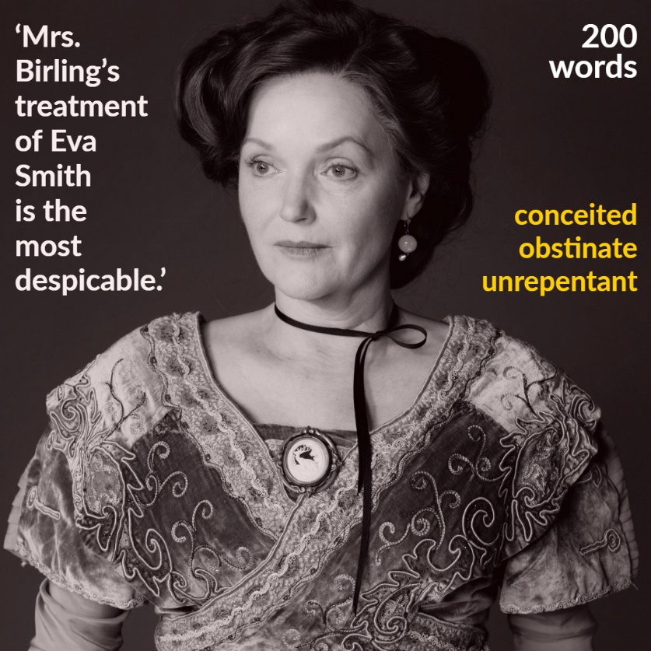
_____________________________________________________________________

 | AO4
 | Knowledge, Skills and Understanding
 |  | Question 4 (Paper 1 6 marks )and Question 6 (Paper 2 15 marks)
Yellow Plus | 13-14 | - Evaluation of ideas, events, themes or settings.  - There is a sustained and detached critical overview and judgement about the text.  - The selection of references is apt and discriminating and is persuasive in clarifying the points being made.
Yellow | 10-12 | - Analysis of ideas, events, themes or settings.  - Well-informed and developed critical judgement is offered about the text.  - The selection of references is appropriate, detailed and fully supports the points being made.
Blue | 7-9 | - Explanation of ideas, events, themes or settings.  - Informed judgement is offered about the text.  - The selection of references is appropriate and relevant to the points being made.
Green | 4-6 | - Comment on ideas, events, themes or settings.  - Straightforward opinions with limited judgements are offered about the text.  - The selection of references is valid, but not developed.
White | 1-3 | - Description of ideas, events, themes or settings.  - Limited assertions are offered about the text.  - The use of references is limited.
 | AO2
 | Knowledge, Skills and Understanding
 |  | Question 3 15 marks (paper 2)
Yellow Plus | 13-15 | - Analysis of the text.  - Analysis of how both language and structure are used to achieve effects and influence readers, including use of vocabulary, sentence structure and other language features.  - The selection of references is discriminating and clarifies the points being made.
Yellow | 10-12 | - Exploration of the text.  - Exploration of how both language and structure are used to achieve effects and influence readers, including use of vocabulary, sentence structure and other language features.  - The selection of references is detailed, appropriate and fully supports the points being made.
Blue | 7-9 | - Explanation of the text.  - Explanation of how both language and structure are used to achieve effects and influence readers, including use of vocabulary and sentence structure.  - The selection of references is appropriate and relevant to the points being made.
Green | 4-6 | - Comment on the text.  - Comment on the language and/or structure used to achieve effects and influence readers, including use of vocabulary.  - The selection of references is valid, but not developed.  - NB: The mark awarded cannot progress beyond the top of Level 2 if only language OR structure has been considered.
White | 1-3 | - Limited comment on the text.  - Identification of the language and/or structure used to achieve effects and influence readers.  - The use of references is limited.

 | AO1 Bullet 2
 | Knowledge, Skills and Understanding
 |  | Question 7a Language Paper 2
Yellow | 5-6 | - Detailed understanding of similarities  - Detailed synthesis of the two texts  - The selection of evidence is appropriate and relevant to the  - points being made.
Blue | 3-4 | - Sound understanding of similarities  - Clear synthesis of the two texts  - The selection of evidence is valid but not developed and there  - may be an imbalance.
Green | 1-2 | - Limited understanding of similarities  - Limited synthesis of the two texts  - The use of evidence is limited.
 | AO3
 | Knowledge, Skills and Understanding
 |  | Question 7b Language Paper 2
Yellow Plus | 12-14 | - The response considers a varied and comprehensive range of comparisons between the texts.  - Analysis of writers’ ideas and perspectives including how the theme, language and/or structure are used across the texts.  - References are balanced across both texts, they are discriminating, and clarify the points being made.
Yellow | 9-11 | - The response considers a wide range of comparisons between the texts.  - Exploration of writers’ ideas and perspectives including how the theme, language and/or structure are used across the texts.  - References are balanced across both texts and fully support the points being made.
Blue | 6-8 | - The response considers a range of comparisons between the texts.  - Explanation of writers’ ideas and perspectives including theme, language and/or structure.  - The selection of references is appropriate and relevant to the points being made.
Green | 3-5 | - The response considers obvious comparisons between the texts.  - Comment on writers’ ideas and perspectives, including theme,  - language and/or structure.  - The selection of references is valid, but not developed.  NB: The mark awarded cannot progress beyond the top of Level 2/Green if only ONE text has been considered in detail.
White | 1-2 | - The response does not compare the texts.  - Description of writers’ ideas and perspectives, including theme, language and/or structure.  - The use of references is limited.

AO1
Knowledge, Skills and Understanding
 |  | Paper 1: Questions 1/2 (1/2 marks ) and Paper 2: Questions 1/2/7a (2/1/6 marks)
Yellow/Yellow Plus | 5-6 | - Detailed understanding of similarities  - Detailed synthesis of the two texts  - The selection of evidence is appropriate and relevant to the points being made.
Blue | 3-4 | - Sound understanding of similarities  - Clear synthesis of the two texts  - The selection of evidence is valid but not developed and there may be an imbalance.
White/Green | 1-2 | - Limited understanding of similarities  - Limited synthesis of the two texts  - The use of evidence is limited.
AO3
Knowledge, Skills and Understanding
 |  | Paper 2: Question 7b (14 marks)
Yellow Plus | 13-15 | - The response considers a varied and comprehensive range of comparisons between the texts.  - Analysis of writers’ ideas and perspectives including how the theme, language and/or structure are used across the texts.  - References are balanced across both texts, they are discriminating, and clarify the points being made.
Yellow | 9-11 | - The response considers a wide range of comparisons between the texts.  - Exploration of writers’ ideas and perspectives including how the theme, language and/or structure are used across the texts.  - References are balanced across both texts and fully support the points being made.
Blue | 6-9 | - The response considers a range of comparisons between the texts.  - Explanation of writers’ ideas and perspectives including theme, language and/or structure.  - The selection of references is appropriate and relevant to the points being made.
Green | 3-5 | - The response considers obvious comparisons between the  - texts.  - Comment on writers’ ideas and perspectives, including theme, language and/or structure.  - The selection of references is valid, but not developed.  NB: The mark awarded cannot progress beyond the top of Level 2 if only ONE text has been considered in detail.
White | 1-2 | - The response does not compare the texts.  - Description of writers’ ideas and perspectives, including theme, language and/or structure.  - The use of references is limited.

 | AO5
 | Knowledge, Skills and Understanding
 |  | Question 5/6 Paper 1 Language Paper 1 Question 8/9 Language Paper 2
Yellow Plus | 20-24 | - Manipulate the reader’s response through subtle variation in tone, style and register  - Uses complex ideas, and a range of structural and grammatical features to support coherence and cohesion
Yellow | 15-19 | - Organises material for a particular effect, with effective use of tone, style and register  - Manages ideas, use structural and grammatical features cohesively and deliberatively
Blue | 10-14 | - Develop details using descriptive devices including figurative language to suit the PAF (Purpose/Audience/Form)  - Paragraphing make meaning clear. Ideas are developed and connected appropriately.
Green | 5-9 | - Write with purpose using a straightforward tone and style.  - Order ideas and use paragraphs.  - Begin to develop details and descriptive devices including metaphor and simile  - Use accurate and appropriate structures in my writing
White | 1-4 | - Choose words for impact and effect  - Use a range of punctuation including accurate use of comma, apostrophe and parenthesis  - Begin to develop descriptive detail using descriptive language, powerful nouns and prepositional phrases  - Select appropriate planning models to organise and structure my writing to make meaning clear and interesting.
 | AO6
 | Knowledge, Skills and Understanding
 |  | Question 5/6 Paper 1 Language Paper 1 Question 8/9 Language Paper 2
Yellow Plus | 13-16 | - Write with consistent clarity and precision  - Extensive range of vocabulary used strategically with rare spelling errors  - Use a full range of punctuation accurately to emphasise meaning and create stylistic effects
Yellow | 10-12 | - Use punctuation and sentence structures for deliberate effects.  - Use an extensive range of ambitious vocabulary choices to create subtle effects. Occasional spelling errors.
Blue | 7-9 | - Use a varied vocabulary and vary my punctuation and adapt some sentence structures for effect  - Spell words containing irregular patterns correctly
Green | 4-6 | - Use standard English and spell a range of vocabulary accurately  - Use a range of punctuation with control  - Use a range of sentences accurately, including frontal adverbials.
White | 1-3 | - Vary my choice of sentence structures including simple, compound and complex sentences and ensure verb tense agreement  - Use basic vocabulary with some spelling errors

