GCSE DRAMA
Blended Learning Booklet
Year 10 GCSE Drama
Component 1: Understanding Drama
Noughts and Crosses

Name:
Teacher:

Please aim to complete two questions a week. There is enough information in this booklet to keep you busy. Revision of key terminology is very important. It is essential that you have your own copy of the play for home learning. Please let your teacher know if you need assistance with purchasing the play.
Please upload work to Class Charts as regulary as possible. Your teacher can then provide feedback and next step targets. We will provide extra resources online if necessary.

Contents page:

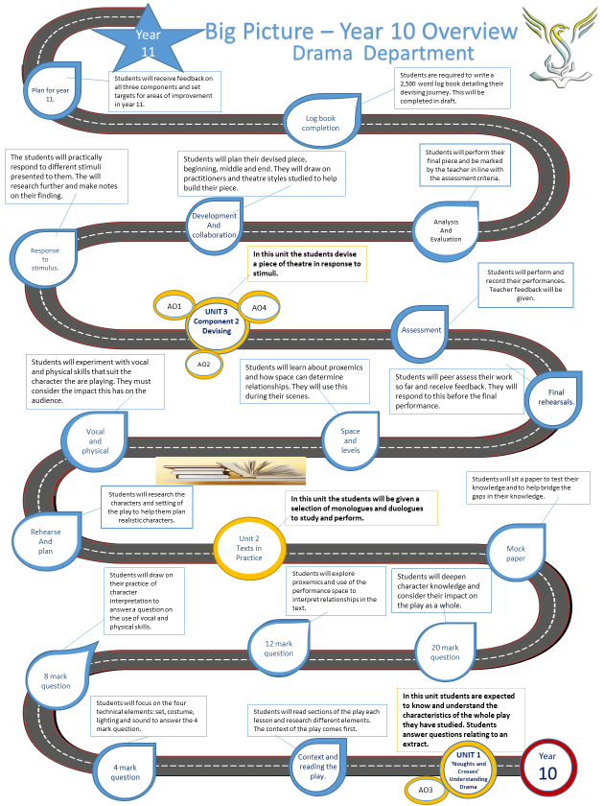

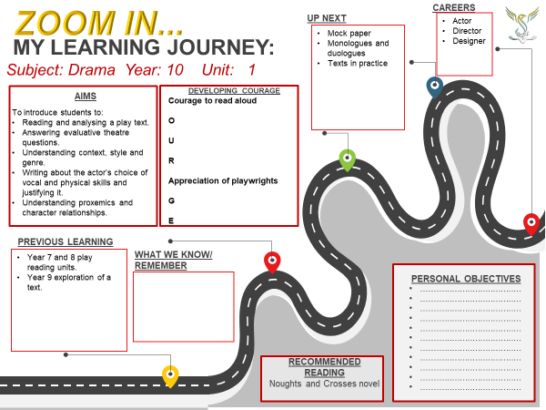

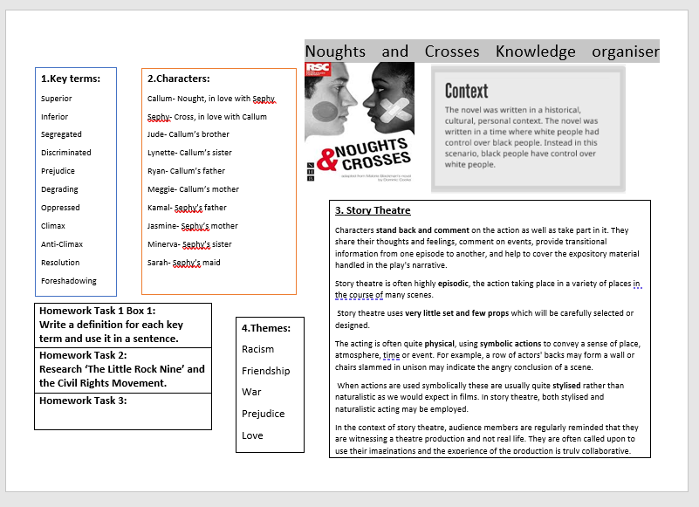

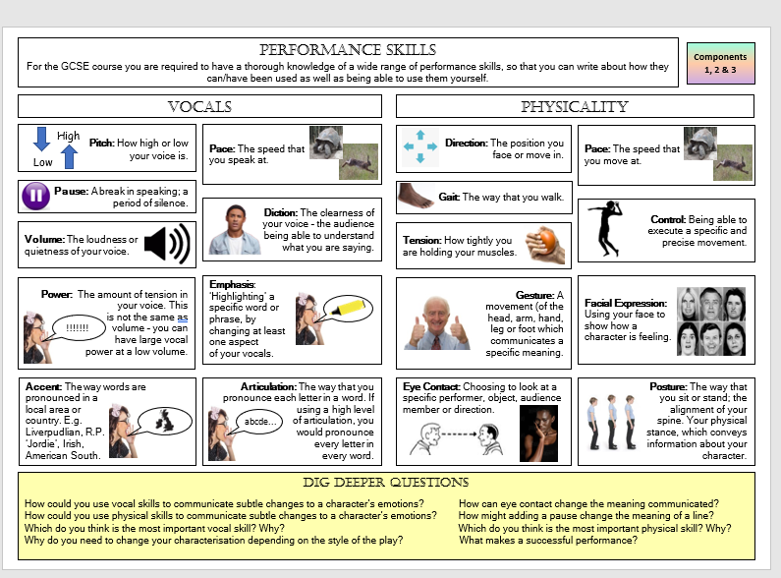

4-mark question checklist:
- Why have you chosen the design and how does it fit the ‘contemporary Dystopian’ style? Reference the themes of the play.
- Make 4 single choices or 2 detailed points.
- Describe the set/costume/lighting/sound choices using key vocabulary.
8-mark question:
- You are writing from the characters viewpoint.
- Introduce the answer by referencing the themes and issues.
- Make 2 vocal and 2 physical choices.
- Use key vocabulary to explain your choices.
12-mark question:
- You are writing from the characters viewpoint.
- Only write about the shaded part of the extract.
- Describe the relationships of the characters involved and analyse the text.
- Use key vocabulary to evaluate proxemics/tension/connections.
20-mark question:
- Write about the characters importance in the play, the relationships they have with others and the context in which they are seen.
- Quote lines from the script, stage directions and moments of importance in the rest of the play.
- Only write about acting skills in relation to the extract provided. Explore vocal, physical and spatial choices.
- This question should take you 20 minutes to write. IT IS IMPORTANT.

Extract 1
Act 1 Scene 3

The School Gates.

SEPHY (to audience) First day of school. I groaned at the thought. At least today would be different from the start of every other new term. Three Noughts, including Callum, were starting at my school. I wanted to show him the playing fields and the swimming pool, the gym and music rooms, the dining hall and science labs. And I’d introduce him to all my friends. It was going to be wonderful. But as I approached the corner, shouting like an angry wave rolled towards me.
An angry CROSS CROWD, PARENTS and STUDENTS.
CROWD. NO BLANKERS IN OUR SCHOOL! NO BLANKERS IN OUR SCHOOL! NO BLANKERS IN OUR SCHOOL!
MR CORSA. As the headmaster of this school it is my legal duty to ask that you let the new students enter the school.
The CROWD continues.
CROWD. NO BLANKERS IN OUR SCHOOL! NO BLANKERS IN OUR SCHOOL!
SEPHY watches as CALLUM, COLIN and SHANIA, all Noughts, try to push their way through the CROWD to get to the school entrance. POLICE try to push the CROWD into two separate groups. MR CORSA is in the other side of the CROWD, looking on. SHANIA is hit by a stone.
PROTESTER 1. One of them is hurt.
PROTESTER 2. A Blanker’s hurt.
The CROWD cheer. The struggle continues. SEPHY manages to get through.
SEPHY. Mr Corsa, we have to help that girl. She’s hurt.
He doesn’t move. SEPHY addresses the CROWD.
Stop it! Just stop it!
CROWD. BLANKERS OUT! BLANKERS OUT!
SEPHY. STOP IT! YOU’RE ALL BEHAVING LIKE ANIMALS!
The CROWD silences.
WORSE THAN ANIMALS! LIKE BLANKERS!
As CALLUM turns to the audience to speak, the CROWD melts away leaving CALLUM and SEPHY alone.
CALLUM (to audience). She didn’t say that. She couldn’t have. Not Sephy…I’m not a Blanker. I may be a Nought, but I’m worth more than nothing. I’m not a Blanker. A waste of time and space. A nothing.

Read Extract 1 carefully
Q1. You are designing a setting for a performance of this extract. The setting must reflect the conventions of Contemporary Dystopian Theatre used in Noughts and Crosses. Describe your design ideas for the setting.
(4 marks)
……………………………………………………………………………………………………………………………………………………………………………………………………………………………………………………………………………………………………………………………………………………………………………………………………………………………………………………………………………………………………………………………………………………………………………………………………………………………………………………………………………………………………………………………………………………………………………………………………………………………………………………………………………………………………………………………………………………………………………………………………………………………………………………………………………………………………………………………………………………………………………………………………………………………………………………………………………………………………………………………………………………………………………………………………………………………………………………………………………………………………………………………………………………………………………………………………………………………………………………………………………………………………………………………………………………………………………………………………………………………………………………………………………………………………………………………………………………………………………………………………………………………………………………………………………………………………………………………………………………………………………………………………………………………………………………………………………………………………………………………………………………………………………………………………………………………………………………………………………………………………………………………………………………………………………………………………………………………………………………………………………………………………………………………………………………………………………………………………………………………………………………………………………………………………………………………………………………………………………………………………………………………………………………………………………………………………………………………………………………………………………………………………………………………………………………………………………………………………………………………………………………………………………………………………………………………………………………………………………………………………………………………………………………………………………………………………………………………………………………………………………………………………………………………………………………………………………………………………………………………………………………………………………………………………………………………………………………………………………………………………………………………………………………………………………………………………………………………………………………………………………………………………………………………………………………………………………………………………………………………………………………………………………………………………………………………………………………………………………………………………………………………………………………………………………………………………………………………………………………………………………………………………………………………………………………………………………………………………………………………………………………………………………………………………………………………………………………………………………………………………………………………………………………………………………………………………………………………………………………………………………………………………………………………………………………………………………………………………………..............................
Read the extract carefully
Q2. You are performing the role of Sephy.
Describe how you would use your vocal and physical skills to perform the line below and explain the effects you want to create.
‘STOP IT! YOU’RE ALL BEHAVING LIKE ANIMALS! WORSE THAN ANIMALS! LIKE BLANKERS!
(8 marks)
…………………………………………………………………………………………………………………………………………………………………………………………………………………………………………………………………………………………………………………………………………………………………………………………………………………………………………………………………………………………………………………………………………………………………………………………………………………………………………………………………………………………………………………………………………………………………………………………………………………………………………………………………………………………………………………………………………………………………………………………………………………………………………………………………………………………………………………………………………………………………………………………………………………………………………………………………………………………………………………………………………………………………………………………………………………………………………………………………………………………………………………………………………………………………………………………………………………………………………………………………………………………………………………………………………………………………………………………………………………………………………………………………………………………………………………………………………………………………………………………………………………………………………………………………………………………………………………………………………………………………………………………………………………………………………………………………………………………………………………………………………………………………………………………………………………………………………………………………………………………………………………………………………………………………………………………………………………………………………………………………………………………………………………………………………………………………………………………………………………………………………………………………………………………………………………………………………………………………………………………………………………………………………………………………………………………………………………………………………………………………………………………………………………………………………………………………………………………………………………………………………………………………………………………………………………………………………………………………………………………………………………………………………………………………………………………………………………………………………………………………………………………………………………………………………………………………………………………………………………………………………………………………………………………………………………………………………………………………………………………………………………………………………………………………………………………………………………………………………………………………………………………………………………………………………………………………………………………………………………………………………………………………………………………………………………………………………………………………………………………………………………………………………………………………………………………………………………………………………………………………………………………………………………………………………………………………………………………………………………………………………………………………………………………………………………………………………………………………………………………………………………………...........................
Read the extract carefully
Q3. You are performing the role of Sephy.
Focus on the shaded part or the extract. Explain how you (Sephy) and the actors playing Mr Corsa, Crowd, Police, Callum, Colin and Shania might use the space and interact with each other to create a sense of tension for your audience.
(12 marks)
…………………………………………………………………………………………………………………………………………………………………………………………………………………………………………………………………………………………………………………………………………………………………………………………………………………………………………………………………………………………………………………………………………………………………………………………………………………………………………………………………………………………………………………………………………………………………………………………………………………………………………………………………………………………………………………………………………………………………………………………………………………………………………………………………………………………………………………………………………………………………………………………………………………………………………………………………………………………………………………………………………………………………………………………………………………………………………………………………………………………………………………………………………………………………………………………………………………………………………………………………………………………………………………………………………………………………………………………………………………………………………………………………………………………………………………………………………………………………………………………………………………………………………………………………………………………………………………………………………………………………………………………………………………………………………………………………………………………………………………………………………………………………………………………………………………………………………………………………………………………………………………………………………………………………………………………………………………………………………………………………………………………………………………………………………………………………………………………………………………………………………………………………………………………………………………………………………………………………………………………………………………………………………………………………………………………………………………………………………………………………………………………………………………………………………………………………………………………………………………………………………………………………………………………………………………………………………………………………………………………………………………………………………………………………………………………………………………………………………………………………………………………………………………………………………………………………………………………………………………………………………………………………………………………………………………………………………………………………………………………………………………………………………………………………………………………………………………………………………………………………………………………………………………………………………………………………………………………………………………………………………………………………………………………………………………………………………………………………………………………………………………………………………………………………………………………………………………………………………………………………………………………………………………………………………………………………………………………………………………………………………………………………………………………………………………………………………………………………………………………………………………………...........................
…………………………………………………………………………………………………………………………………………………………………………………………………………………………………………………………………………………………………………………………………………………………………………………………………………………………………………………………………………………………………………………………………………………………………………………………………………………………………………………………………………………………………………………………………………………………………………………………………………………………………………………………………………………………………………………………………………………………………………………………………………………………………………………………………………………………………………………………………………………………………………………………………………………………………………………………………………………………………………………………………………………………………………………………………………………………………………………………………………………………………………………………………………………………………………………………………………………………………………………………………………………………………………………………………………………………………………………………………………………………………………………………………………………………………………………………………………………………………………………………………………………………………………………………………………………………………………………………………………………………………………………………………………………………………………………………………………………………………………………………………………………………………………………………………………………………………………………………………………………………………………………………………………………………………………………………………………………………………………………………………………………………………………………………………………………………………………………………………………………………………………………………………………………………………………………………………………………………………………………………………………………………………………………………………………………………………………………………………………………………………………………………………………………………………………………………………………………………………………………………………………………………………………………………………………………………………………………………………………………………………………………………………………………………………………………………………………………………………………………………………………………………………………………………………………………………………………………………………………………………………………………………………………………………………………………………………………………………………………………………………………………………………………………………………………………………………………………………………………………………………………………………………………………………………………………………………………………………………………………………………………………………………………………………………………………………………………………………………………………………………………………………………………………………………………………………………………………………………………………………………………………………………………………………………………………………………………………………………………………………………………………………………………………………………………………………………………………………………………………………………………………………...........................
………………………………………………………………………………………………………………………………………………………………………………………………………………………………………………………………………………………………………………………………………………………………………………………………………………………………………………………………………………………………………………………………………………………………………………………………………………………………………………………………………………………………………………………………………………………………………………………………………………………………………………………………………………………………………………………………………………………………………………………………………...

Read the extract carefully
Q4. A. You are performing the role of Sephy.
Describe how you would use your acting skills to interprets Sephy’s character in the extract and explain why your ideas are appropriate both for this extract and the play as a whole.
(20 marks)
…………………………………………………………………………………………………………………………………………………………………………………………………………………………………………………………………………………………………………………………………………………………………………………………………………………………………………………………………………………………………………………………………………………………………………………………………………………………………………………………………………………………………………………………………………………………………………………………………………………………………………………………………………………………………………………………………………………………………………………………………………………………………………………………………………………………………………………………………………………………………………………………………………………………………………………………………………………………………………………………………………………………………………………………………………………………………………………………………………………………………………………………………………………………………………………………………………………………………………………………………………………………………………………………………………………………………………………………………………………………………………………………………………………………………………………………………………………………………………………………………………………………………………………………………………………………………………………………………………………………………………………………………………………………………………………………………………………………………………………………………………………………………………………………………………………………………………………………………………………………………………………………………………………………………………………………………………………………………………………………………………………………………………………………………………………………………………………………………………………………………………………………………………………………………………………………………………………………………………………………………………………………………………………………………………………………………………………………………………………………………………………………………………………………………………………………………………………………………………………………………………………………………………………………………………………………………………………………………………………………………………………………………………………………………………………………………………………………………………………………………………………………………………………………………………………………………………………………………………………………………………………………………………………………………………………………………………………………………………………………………………………………………………………………………………………………………………………………………………………………………………………………………………………………………………………………………………………………………………………………………………………………………………………………………………………………………………………………………………………………………………………………………………………………………………………………………………………………………………………………………………………………………………………………………………………………………………………………………………………………………………………………………………………………………………………………………………………………………………………………………………………………...........................
…………………………………………………………………………………………………………………………………………………………………………………………………………………………………………………………………………………………………………………………………………………………………………………………………………………………………………………………………………………………………………………………………………………………………………………………………………………………………………………………………………………………………………………………………………………………………………………………………………………………………………………………………………………………………………………………………………………………………………………………………………………………………………………………………………………………………………………………………………………………………………………………………………………………………………………………………………………………………………………………………………………………………………………………………………………………………………………………………………………………………………………………………………………………………………………………………………………………………………………………………………………………………………………………………………………………………………………………………………………………………………………………………………………………………………………………………………………………………………………………………………………………………………………………………………………………………………………………………………………………………………………………………………………………………………………………………………………………………………………………………………………………………………………………………………………………………………………………………………………………………………………………………………………………………………………………………………………………………………………………………………………………………………………………………………………………………………………………………………………………………………………………………………………………………………………………………………………………………………………………………………………………………………………………………………………………………………………………………………………………………………………………………………………………………………………………………………………………………………………………………………………………………………………………………………………………………………………………………………………………………………………………………………………………………………………………………………………………………………………………………………………………………………………………………………………………………………………………………………………………………………………………………………………………………………………………………………………………………………………………………………………………………………………………………………………………………………………………………………………………………………………………………………………………………………………………………………………………………………………………………………………………………………………………………………………………………………………………………………………………………………………………………………………………………………………………………………………………………………………………………………………………………………………………………………………………………………………………………………………………………………………………………………………………………………………………………………………………………………………………………………………………...........................
…………………………………………………………………………………………………………………………………………………………………………………………………………………………………………………………………………………………………………………………………………………………………………………………………………………………………………………………………………………………………………………………………………………………………………………………………………………………………………………………………………………………………………………………………………………………………………………………………………………………………………………………………………………………………………………………………………………………………………………………………………………………………………………………………………………………………………………………………………………..
Read the extract carefully
Q4. B. You are a designer working on one aspect of design for this extract.
Describe how you would use your design skills to create effects which support the action of this extract and explain why your ideas are appropriate both for this extract and the play as a whole.
(20 marks)
…………………………………………………………………………………………………………………………………………………………………………………………………………………………………………………………………………………………………………………………………………………………………………………………………………………………………………………………………………………………………………………………………………………………………………………………………………………………………………………………………………………………………………………………………………………………………………………………………………………………………………………………………………………………………………………………………………………………………………………………………………………………………………………………………………………………………………………………………………………………………………………………………………………………………………………………………………………………………………………………………………………………………………………………………………………………………………………………………………………………………………………………………………………………………………………………………………………………………………………………………………………………………………………………………………………………………………………………………………………………………………………………………………………………………………………………………………………………………………………………………………………………………………………………………………………………………………………………………………………………………………………………………………………………………………………………………………………………………………………………………………………………………………………………………………………………………………………………………………………………………………………………………………………………………………………………………………………………………………………………………………………………………………………………………………………………………………………………………………………………………………………………………………………………………………………………………………………………………………………………………………………………………………………………………………………………………………………………………………………………………………………………………………………………………………………………………………………………………………………………………………………………………………………………………………………………………………………………………………………………………………………………………………………………………………………………………………………………………………………………………………………………………………………………………………………………………………………………………………………………………………………………………………………………………………………………………………………………………………………………………………………………………………………………………………………………………………………………………………………………………………………………………………………………………………………………………………………………………………………………………………………………………………………………………………………………………………………………………………………………………………………………………………………………………………………………………………………………………………………………………………………………………………………………………………………………………………………………………………………………………………………………………………………………………………………………………………………………………………………………………………………………...........................
…………………………………………………………………………………………………………………………………………………………………………………………………………………………………………………………………………………………………………………………………………………………………………………………………………………………………………………………………………………………………………………………………………………………………………………………………………………………………………………………………………………………………………………………………………………………………………………………………………………………………………………………………………………………………………………………………………………………………………………………………………………………………………………………………………………………………………………………………………………………………………………………………………………………………………………………………………………………………………………………………………………………………………………………………………………………………………………………………………………………………………………………………………………………………………………………………………………………………………………………………………………………………………………………………………………………………………………………………………………………………………………………………………………………………………………………………………………………………………………………………………………………………………………………………………………………………………………………………………………………………………………………………………………………………………………………………………………………………………………………………………………………………………………………………………………………………………………………………………………………………………………………………………………………………………………………………………………………………………………………………………………………………………………………………………………………………………………………………………………………………………………………………………………………………………………………………………………………………………………………………………………………………………………………………………………………………………………………………………………………………………………………………………………………………………………………………………………………………………………………………………………………………………………………………………………………………………………………………………………………………………………………………………………………………………………………………………………………………………………………………………………………………………………………………………………………………………………………………………………………………………………………………………………………………………………………………………………………………………………………………………………………………………………………………………………………………………………………………………………………………………………………………………………………………………………………………………………………………………………………………………………………………………………………………………………………………………………………………………………………………………………………………………………………………………………………………………………………………………………………………………………………………………………………………………………………………………………………………………………………………………………………………………………………………………………………………………………………………………………………………………………………...........................…………………………………………………………………………………………………………………………………………………………………………………………………………………………………………………………………………………………………………………………………………………………………………………………………………………………………………………………………………………………………………………………………………………………………………………………………………………………………………………………………………………………………………………………………………………………………………………………………………………………………………………………………………………………………………………………………………………………………………………………………………………………………………………………………………………………………………………………...........................
Extract 2
Act 2 Scene 8
The Prison. The execution chamber.
A gallows. CALLUM and the rest of the MCGREGORS, SEPHY and the rest of the HADLEYS. A NOUGHT CROWD on one side, and a CROSS CROWD on the other. The REPORTER is also present, and taking notes.
CLERK. Ladies and Gentleman and Noughts, we are here today to witness the execution of Ryan McGregor of 15 Hugo Yard, Meadowview, having been found guilty of seven counts of murder and the charge of political terrorism. The sentence will be carried out of hanging by the neck until he is dead.
SEPHY. (to audience). I didn’t know, Callum.
Clerk. Bring in the prisoner.
A GUARD brings RYAN in. SEPHY looks at CALLUM.
SEPHY (to audience). How to make my desperate thoughts reach him? I swear I didn’t know, Callum. I wouldn’t have come if I’d known where we were going. Wild horses couldn’t have dragged me through those gates. That’s the truth. Callum, you must believe me.
CLERK (to RYAN). Do you have anything to say?
SEPHY. Mother, I want to leave.
RYAN shakes his head, An EXECUTIONER covers his head with a hood.
JASMINE. Not now, Sephy.
SEPHY (standing). I want to leave – NOW.
JASMINE. Sit down, Persephone, and stop making an exhibition of yourself.
SEPHY. Nothing is going to make me sit here and watch this. I’m leaving.
She goes to leave. JASMINE grabs her.
JASMINE. Now sit down and don’t say another word.
SEPHY sits down. The prison clock chimes four times. On the fifth:
RYAN. Long live The Liberation Militia!
The PRISON GOVERNOR enters.
GOVERNOR. Wait! Wait!
The clock strikes six.
Ladies and Gentleman and Noughts, I am Governor Giustini. I have just been informed that Ryan McGregor has received a reprieve. His sentence has been commuted to life imprisonment.
RYAN. Long live the …
RYAN collapses, but is caught by the GUARD and led out.
The NOUGHTS riot under:
CALLUM (to audience). We could have torn down Hewmett Prison brick by brick. We would’ve. I turned to where they were sitting. I couldn’t see her. Where was she? Watching all this and enjoying the free entertainment. At that precise moment, I felt like I could rip the metal barriers out of the concrete beneath my feet with my bare hands. Someone grabbed my arm. It was Mum. And just like that, all my anger subsided. I stood watching Mum. Waiting for the pain to dampen down. Waiting for the world to turn multi-coloured again. Instead of blood red.
The HADLEYS leave. The CROWD melts away.

Read the extract carefully
Q1. You are designing the lighting for a performance of this extract. The lighting must reflect the conventions of contemporary Dystopian Theatre used in Noughts and Crosses. Describe your design ideas for the setting.
(4 marks)
…………………………………………………………………………………………………………………………………………………………………………………………………………………………………………………………………………………………………………………………………………………………………………………………………………………………………………………………………………………………………………………………………………………………………………………………………………………………………………………………………………………………………………………………………………………………………………………………………………………………………………………………………………………………………………………………………………………………………………………………………………………………………………………………………………………………………………………………………………………………………………………………………………………………………………………………………………………………………………………………………………………………………………………………………………………………………………………………………………………………………………………………………………………………………………………………………………………………………………………………………………………………………………………………………………………………………………………………………………………………………………………………………………………………………………………………………………………………………………………………………………………………………………………………………………………………………………………………………………………………………………………………………………………………………………………………………………………………………………………………………………………………………………………………………………………………………………………………………………………………………………………………………………………………………………………………………………………………………………………………………………………………………………………………………………………………………………………………………………………………………………………………………………………………………………………………………………………………………………………………………………………………………………………………………………………………………………………………………………………………………………………………………………………………………………………………………………………………………………………………………………………………………………………………………………………………………………………………………………………………………………………………………………………………………………………………………………………………………………………………………………………………………………………………………………………………………………………………………………………………………………………………………………………………………………………………………………………………………………………………………………………………………………………………………………………………………………………………………………………………………………………………………………………………………………………………………………………………………………………………………………………………………………………………………………………………………………………………………………………………………………………………………………………………………………………………………………………………………………………………………………………………………………………………………………………………………………………………………………………………………………………………………………………………………………………………………………………………………………………………………………………………...........................
…………………………………………………………………………………………………………………………………………………………………………………………………………………………………………………………………………………..
Read the extract carefully
Q2. You are performing the role of Callum.
Describe how you would use your vocal and physical skills to perform the line below and explain the effects you want to create.
‘We could have torn down Hewmett Prison brick by brick. We would’ve. I turned to where they were sitting. I couldn’t see her. Where was she?’
(8 marks)
…………………………………………………………………………………………………………………………………………………………………………………………………………………………………………………………………………………………………………………………………………………………………………………………………………………………………………………………………………………………………………………………………………………………………………………………………………………………………………………………………………………………………………………………………………………………………………………………………………………………………………………………………………………………………………………………………………………………………………………………………………………………………………………………………………………………………………………………………………………………………………………………………………………………………………………………………………………………………………………………………………………………………………………………………………………………………………………………………………………………………………………………………………………………………………………………………………………………………………………………………………………………………………………………………………………………………………………………………………………………………………………………………………………………………………………………………………………………………………………………………………………………………………………………………………………………………………………………………………………………………………………………………………………………………………………………………………………………………………………………………………………………………………………………………………………………………………………………………………………………………………………………………………………………………………………………………………………………………………………………………………………………………………………………………………………………………………………………………………………………………………………………………………………………………………………………………………………………………………………………………………………………………………………………………………………………………………………………………………………………………………………………………………………………………………………………………………………………………………………………………………………………………………………………………………………………………………………………………………………………………………………………………………………………………………………………………………………………………………………………………………………………………………………………………………………………………………………………………………………………………………………………………………………………………………………………………………………………………………………………………………………………………………………………………………………………………………………………………………………………………………………………………………………………………………………………………………………………………………………………………………………………………………………………………………………………………………………………………………………………………………………………………………………………………………………………………………………………………………………………………………………………………………………………………………………………………………………………………………………………………………………………………………………………………………
Read the extract carefully
Q3. You are performing the role of Sephy.
Focus on the shaded part or the extract. Explain how you (Sephy) and the actor playing Jasmine might use the space and interact with each other to create a sense of heightened emotion for your audience.
(12 marks)

…………………………………………………………………………………………………………………………………………………………………………………………………………………………………………………………………………………………………………………………………………………………………………………………………………………………………………………………………………………………………………………………………………………………………………………………………………………………………………………………………………………………………………………………………………………………………………………………………………………………………………………………………………………………………………………………………………………………………………………………………………………………………………………………………………………………………………………………………………………………………………………………………………………………………………………………………………………………………………………………………………………………………………………………………………………………………………………………………………………………………………………………………………………………………………………………………………………………………………………………………………………………………………………………………………………………………………………………………………………………………………………………………………………………………………………………………………………………………………………………………………………………………………………………………………………………………………………………………………………………………………………………………………………………………………………………………………………………………………………………………………………………………………………………………………………………………………………………………………………………………………………………………………………………………………………………………………………………………………………………………………………………………………………………………………………………………………………………………………………………………………………………………………………………………………………………………………………………………………………………………………………………………………………………………………………………………………………………………………………………………………………………………………………………………………………………………………………………………………………………………………………………………………………………………………………………………………………………………………………………………………………………………………………………………………………………………………………………………………………………………………………………………………………………………………………………………………………………………………………………………………………………………………………………………………………………………………………………………………………………………………………………………………………………………………………………………………………………………………………………………………………………………………………………………………………………………………………………………………………………………………………………………………………………………………………………………………………………………………………………………………………………………………………………………………………………………………………………………………………………………………………………………………………………………………………………………………………………………………………………………………………………………………………………………………………………………………………………………………………………………………………………...........................
…………………………………………………………………………………………………………………………………………………………………………………………………………………………………………………………………………………..
…………………………………………………………………………………………………………………………………………………………………………………………………………………………………………………………………………………………………………………………………………………………………………………………………………………………………………………………………………………………………………………………………………………………………………………………………………………………………………………………………………………………………………………………………………………………………………………………………………………………………………………………………………………………………………………………………………………………………………………………………………………………………………………………………………………………………………………………………………………………………………………………………………………………………………………………………………………………………………………………………………………………………………………………………………………………………………………………………………………………………………………………………………………………………………………………………………………………………………………………………………………………………………………………………………………………………………………………………………………………………………………………………………………………………………………………………………………………………………………………………………………………………………………………………………………………………………………………………………………………………………………………………………………………………………………………………………………………………………………………………………………………………………………………………………………………………………………………………………………………………………………………………………………………………………………………………………………………………………………………………………………………………………………………………………………………………………………………………………………………………………………………………………………………………………………………………………………………………………………………………………………………………………………………………………………………………………………………………………………………………………………………………………………………………………………………………………………………………………………………………………………………………………………………………………………………………………………………………………………………………………………………………………………………………………………………………………………………………………………………………………………………………………………………………………………………………………………………………………………………………………………………………………………………………………………………………………………………………………………………………………………………………………………………………………………………………………………………………………………………………………………………………………………………………………………………………………………………………………………………………………………………………………………………………………………………………………………………………………………………………………………………………………………………………………………………………………………………………………………………………………………………………………………………………………………………………………………………………………………………………………………………………………………………………………………………………………………………………………………………………………………………...........................
………………………………………………………………………………………………………………………………………………………………………………………………………………………………………………………………………………….

Read the extract carefully
Q4. A. You are performing the role of Callum.
Describe how you would use your acting skills to interpret Cullum’s character in the extract and explain why your ideas are appropriate both for this extract and the play as a whole.
(20 marks)
…………………………………………………………………………………………………………………………………………………………………………………………………………………………………………………………………………………………………………………………………………………………………………………………………………………………………………………………………………………………………………………………………………………………………………………………………………………………………………………………………………………………………………………………………………………………………………………………………………………………………………………………………………………………………………………………………………………………………………………………………………………………………………………………………………………………………………………………………………………………………………………………………………………………………………………………………………………………………………………………………………………………………………………………………………………………………………………………………………………………………………………………………………………………………………………………………………………………………………………………………………………………………………………………………………………………………………………………………………………………………………………………………………………………………………………………………………………………………………………………………………………………………………………………………………………………………………………………………………………………………………………………………………………………………………………………………………………………………………………………………………………………………………………………………………………………………………………………………………………………………………………………………………………………………………………………………………………………………………………………………………………………………………………………………………………………………………………………………………………………………………………………………………………………………………………………………………………………………………………………………………………………………………………………………………………………………………………………………………………………………………………………………………………………………………………………………………………………………………………………………………………………………………………………………………………………………………………………………………………………………………………………………………………………………………………………………………………………………………………………………………………………………………………………………………………………………………………………………………………………………………………………………………………………………………………………………………………………………………………………………………………………………………………………………………………………………………………………………………………………………………………………………………………………………………………………………………………………………………………………………………………………………………………………………………………………………………………………………………………………………………………………………………………………………………………………………………………………………………………………………………………………………………………………………………………………………………………………………………………………………………………………………………………………………………………………………………………………………………………………………………………………...........................
…………………………………………………………………………………………………………………………………………………………………………………………………………………………………………………………………………………..
…………………………………………………………………………………………………………………………………………………………………………………………………………………………………………………………………………………………………………………………………………………………………………………………………………………………………………………………………………………………………………………………………………………………………………………………………………………………………………………………………………………………………………………………………………………………………………………………………………………………………………………………………………………………………………………………………………………………………………………………………………………………………………………………………………………………………………………………………………………………………………………………………………………………………………………………………………………………………………………………………………………………………………………………………………………………………………………………………………………………………………………………………………………………………………………………………………………………………………………………………………………………………………………………………………………………………………………………………………………………………………………………………………………………………………………………………………………………………………………………………………………………………………………………………………………………………………………………………………………………………………………………………………………………………………………………………………………………………………………………………………………………………………………………………………………………………………………………………………………………………………………………………………………………………………………………………………………………………………………………………………………………………………………………………………………………………………………………………………………………………………………………………………………………………………………………………………………………………………………………………………………………………………………………………………………………………………………………………………………………………………………………………………………………………………………………………………………………………………………………………………………………………………………………………………………………………………………………………………………………………………………………………………………………………………………………………………………………………………………………………………………………………………………………………………………………………………………………………………………………………………………………………………………………………………………………………………………………………………………………………………………………………………………………………………………………………………………………………………………………………………………………………………………………………………………………………………………………………………………………………………………………………………………………………………………………………………………………………………………………………………………………………………………………………………………………………………………………………………………………………………………………………………………………………………………………………………………………………………………………………………………………………………………………………………………………………………………………………………………………………………………………...........................
…………………………………………………………………………………………………………………………………………………………………………………………………………………………………………………………………………………..

Read the extract carefully
Q4. B. You are a designer working on one aspect of design for this extract.
Describe how you would use your design skills to create effects which support the action of this extract and explain why your ideas are appropriate both for this extract and the play as a whole.
(20 marks)
…………………………………………………………………………………………………………………………………………………………………………………………………………………………………………………………………………………………………………………………………………………………………………………………………………………………………………………………………………………………………………………………………………………………………………………………………………………………………………………………………………………………………………………………………………………………………………………………………………………………………………………………………………………………………………………………………………………………………………………………………………………………………………………………………………………………………………………………………………………………………………………………………………………………………………………………………………………………………………………………………………………………………………………………………………………………………………………………………………………………………………………………………………………………………………………………………………………………………………………………………………………………………………………………………………………………………………………………………………………………………………………………………………………………………………………………………………………………………………………………………………………………………………………………………………………………………………………………………………………………………………………………………………………………………………………………………………………………………………………………………………………………………………………………………………………………………………………………………………………………………………………………………………………………………………………………………………………………………………………………………………………………………………………………………………………………………………………………………………………………………………………………………………………………………………………………………………………………………………………………………………………………………………………………………………………………………………………………………………………………………………………………………………………………………………………………………………………………………………………………………………………………………………………………………………………………………………………………………………………………………………………………………………………………………………………………………………………………………………………………………………………………………………………………………………………………………………………………………………………………………………………………………………………………………………………………………………………………………………………………………………………………………………………………………………………………………………………………………………………………………………………………………………………………………………………………………………………………………………………………………………………………………………………………………………………………………………………………………………………………………………………………………………………………………………………………………………………………………………………………………………………………………………………………………………………………………………………………………………………………………………………………………………………………………………………………………………………………………………………………………………………………...........................
…………………………………………………………………………………………………………………………………………………………………………………………………………………………………………………………………………………..
…………………………………………………………………………………………………………………………………………………………………………………………………………………………………………………………………………………………………………………………………………………………………………………………………………………………………………………………………………………………………………………………………………………………………………………………………………………………………………………………………………………………………………………………………………………………………………………………………………………………………………………………………………………………………………………………………………………………………………………………………………………………………………………………………………………………………………………………………………………………………………………………………………………………………………………………………………………………………………………………………………………………………………………………………………………………………………………………………………………………………………………………………………………………………………………………………………………………………………………………………………………………………………………………………………………………………………………………………………………………………………………………………………………………………………………………………………………………………………………………………………………………………………………………………………………………………………………………………………………………………………………………………………………………………………………………………………………………………………………………………………………………………………………………………………………………………………………………………………………………………………………………………………………………………………………………………………………………………………………………………………………………………………………………………………………………………………………………………………………………………………………………………………………………………………………………………………………………………………………………………………………………………………………………………………………………………………………………………………………………………………………………………………………………………………………………………………………………………………………………………………………………………………………………………………………………………………………………………………………………………………………………………………………………………………………………………………………………………………………………………………………………………………………………………………………………………………………………………………………………………………………………………………………………………………………………………………………………………………………………………………………………………………………………………………………………………………………………………………………………………………………………………………………………………………………………………………………………………………………………………………………………………………………………………………………………………………………………………………………………………………………………………………………………………………………………………………………………………………………………………………………………………………………………………………………………………………………………………………………………………………………………………………………………………………………………………………………………………………………………………………………………...........................
…………………………………………………………………………………………………………………………………………………………………………………………………………………………………………………………………………………..



