Geography Year 10
Blended Learning Booklet

Y10-5 Natural Hazards - weather

Name:
Form:

Aim to complete one lesson each week. Write down the title and LI for each lesson and then complete the tasks which are highlighted.
The Knowledge Organiser on page 3 has all the key information and vocabulary to help you with this unit.
Upload all work onto ClassCharts for feedback.

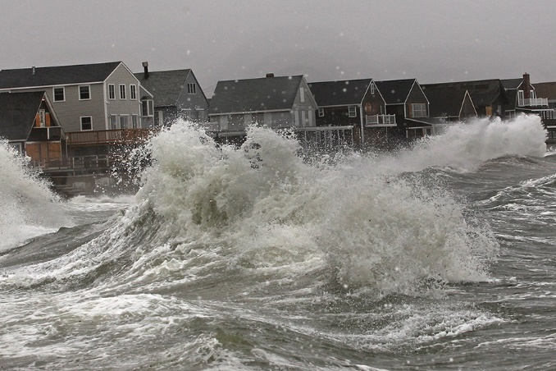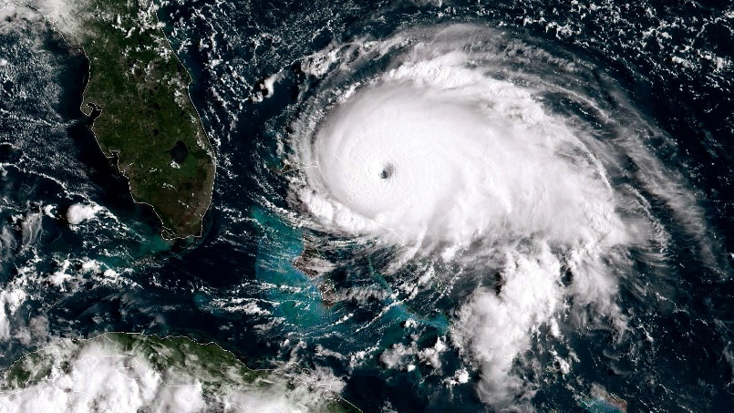

Contents
Page 3: Big Picture - Year 10 Overview
Page 4: Zoom in - My Learning Journey
Pages 5 & 6: Lesson 1
Page 7: Lesson 2
Pages 8: Lesson 3
Page 9: Lesson 4
Page 10: Lesson 5
Pages 11 & 12: Lesson 6
Page 13: Lesson 7
Page 14: Lesson 8
Page 15: Lesson 9
Page 16: Lesson 10
Page 17: Lesson 11
Page 18: Lesson 12

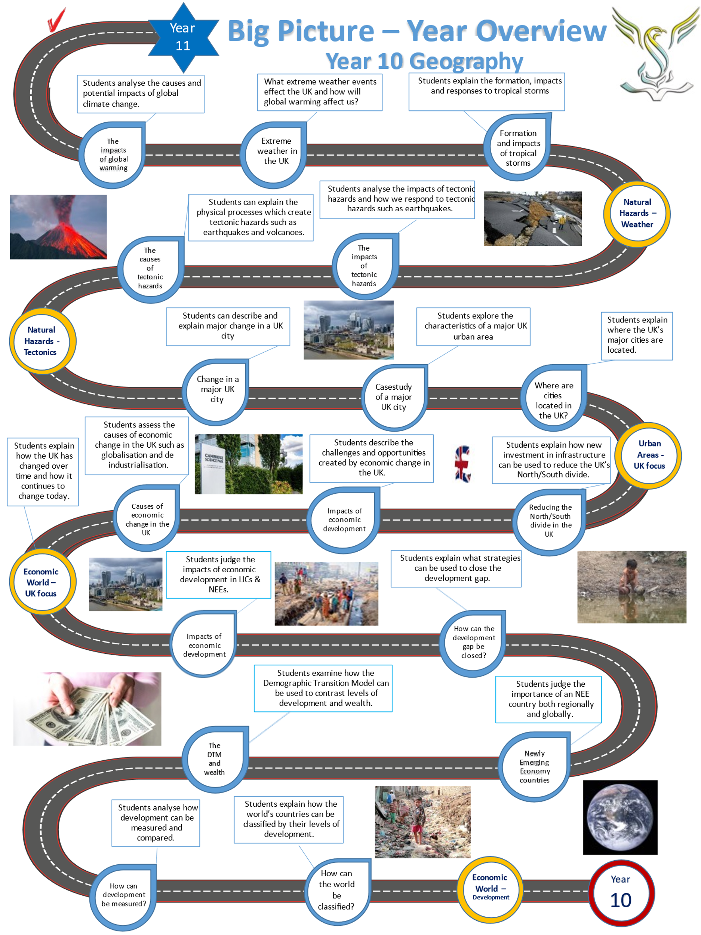

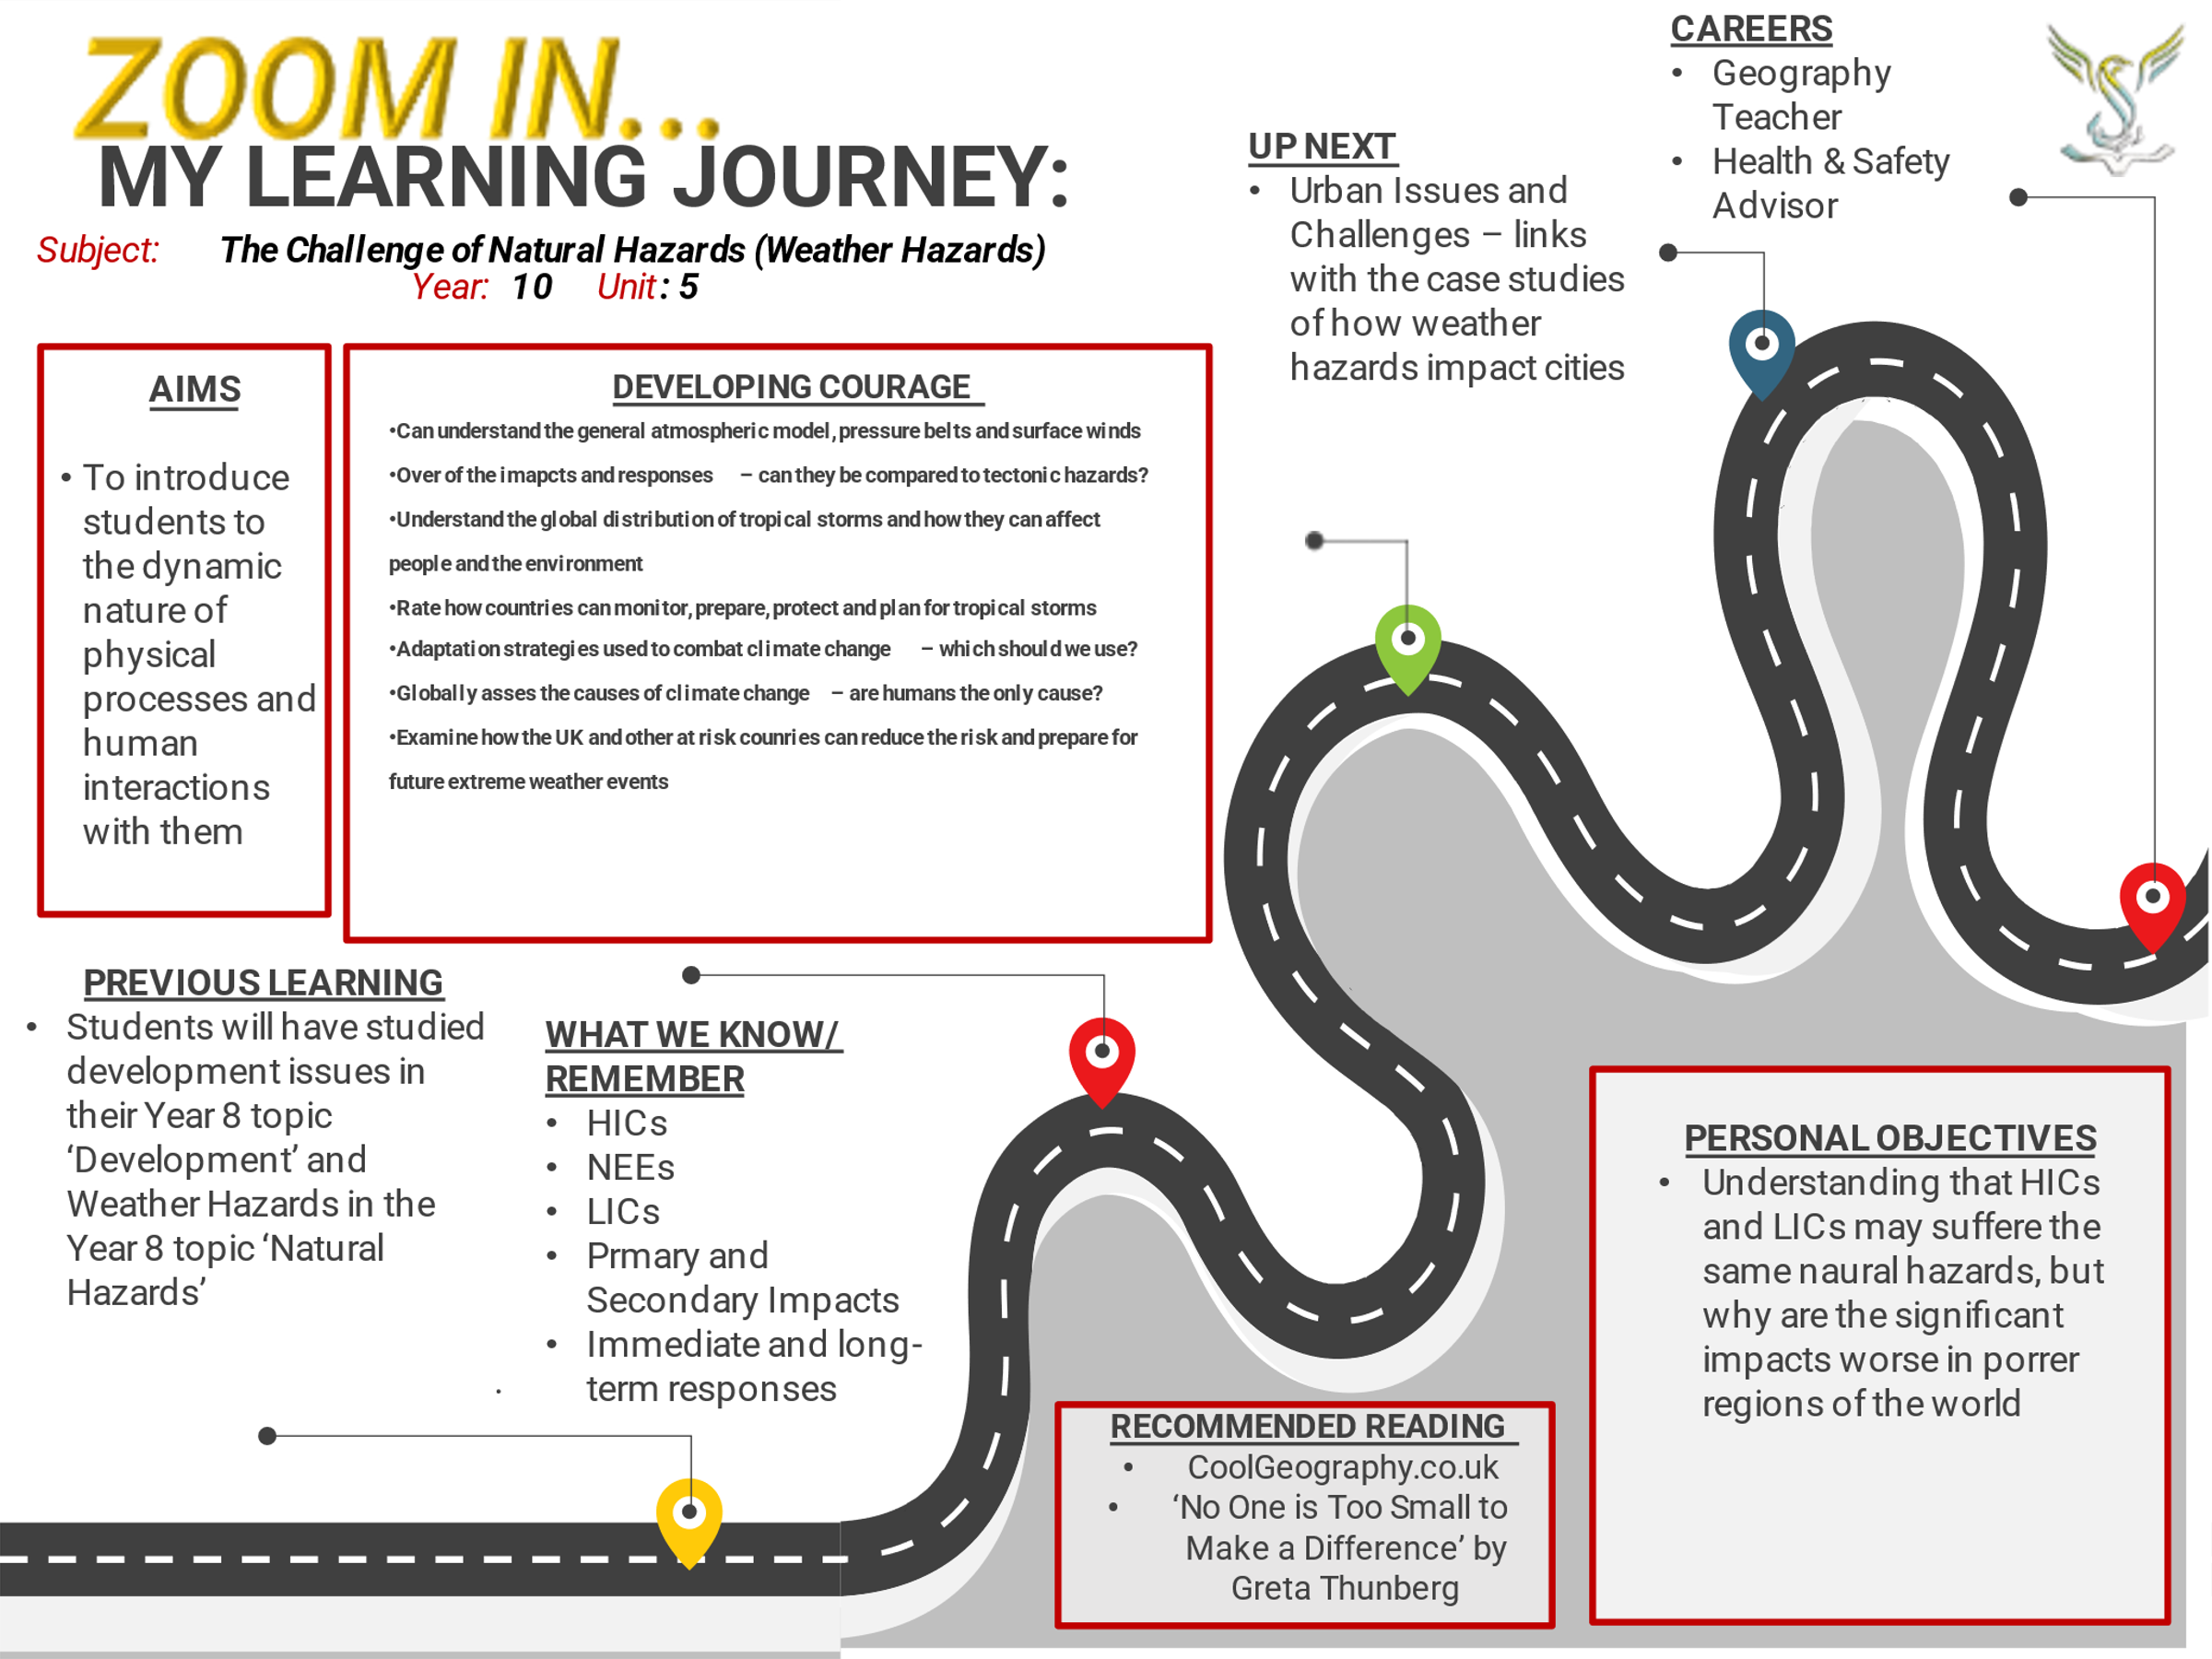

Lesson One: Global atmospheric circulation
- LI: To understand the general atmospheric circulation model, pressure belts and surface winds.

READ THE FOLLOWING:

Global atmospheric circulation

The Earth’s weather is largely created by the tri-cellular model of atmospheric circulation (diagram opposite). The model shows the large-scale movements within our atmosphere.

This movement is caused by the different levels of energy received from the sun at the Poles and the Equator.

At the Equator, the suns energy passes through a thinner layer of atmosphere (sunlight hots the Equator at a 90-degree angle) and more energy reaches the surface. Therefore, the Equator is hot.

At the North Pole and South Pole, the suns energy hits the atmosphere at 45-degree angle. More energy is lost as the sunlight passes through more atmosphere. Therefore, the Polar regions are much colder than the Equator.

The 3 cells are called:

HADLEY CELL: At the Equator warm air rises high into the atmosphere and moves away from Equator. Along the Equator this creates low pressure. The cooler air sinks eventually to create high pressure at 30 degrees of latitude.

POLAR CELL: At the north and south Poles, cold air sinks to create high pressure. This cold air moves away from the Polar regions and warms. As it warms at 60 degrees of latitude, the air rises to create low pressure.

FERREL CELL: The Ferrel cell is driven by the Hadley and Polar cells. It is not directly created by the sun’s energy. The UK sits roughly between the Polar cell and the Ferrel cell and our weather can be extremely variable!

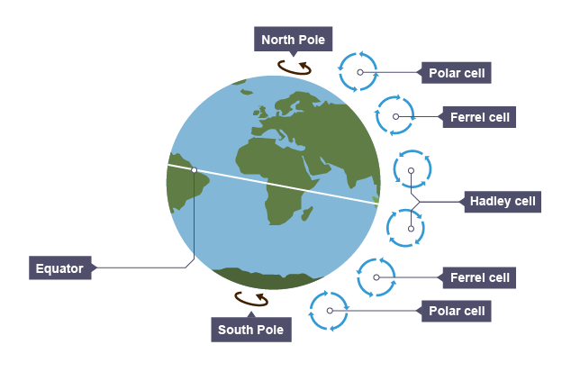
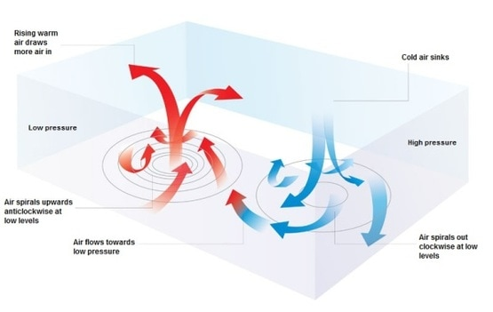

Answer the questions:
Q1) Which cells are located nearest to the Poles?
Q2) How does air move at the Equator?
Q3) In High Pressure areas is air rising or sinking?
Q4) In Low Pressure areas is air rising or sinking?

Watch the video on global atmospheric circulation: https://www.youtube.com/watch?v=7fd03fBRsuU

Watch the video on global atmospheric circulation: https://www.youtube.com/watch?v=xqM83_og1Fc

Lesson Two: Tropical Storms
- LI: To describe the global distribution and formation of tropical storms

TASK: Using the information below, describe the location of tropical storms

What is a tropical storm?
A tropical storm is a very powerful low-pressure weather system which results in strong winds (over 120 km/h) and heavy rainfall (up to 250 mm in one day). Tropical storms have different names depending on where they occur in the world. In the US and the Caribbean, they are known as hurricanes, in South Asia - cyclones, in East Asia - typhoons. They all develop in the same way and have the same characteristics.
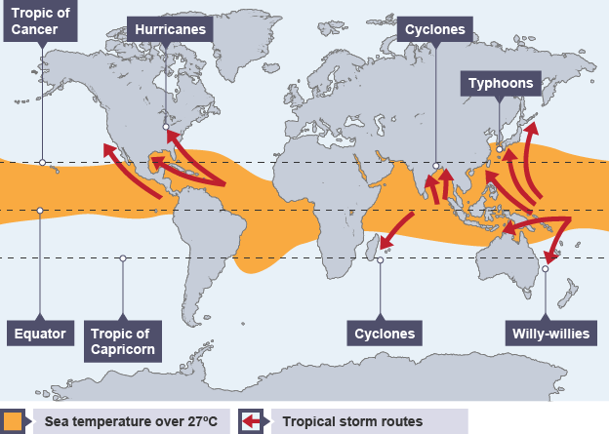

How tropical storms develop
- Tropical storms form between approximately 5° and 30° latitude. Because of easterly winds they initially move westward.
- The air above the warm ocean is heated. Once the ocean water reaches at least 27°C, the warm air rises quickly, causing an area of very low pressure.
- As the air continues to rise quickly it draws more warm moist air up from above the ocean leading to strong winds.
- The rapidly rising warm air spirals upwards, cools, condenses and large cumulonimbus clouds form.
- These clouds form the eye wall of the storm and produce heavy rainfall.
- In the centre of the storm, cold air sinks forming the eye of the storm - here, conditions are calm and dry.

TASK: Using the information above, explain the formation of a tropical storm in your own words

Lesson Three: The effects of tropical storms
- LI: To examine the effects of tropical storms on people and the environment

Read through the following information about the impacts of tropical storms

The Effects of Tropical Storms
Most natural disasters can have both primary and secondary effects.

Primary Effects
The primary effects are visible immediately, both during and right after the tropical storm has passed over an area. These include:
- Due to the amount of energy that tropical storms have, a lot of structural damage is visible straight away. It is also common for areas to flood.
- During the tropical storm, people may drown or they could easily get killed because of the structural damage that surrounds them. It is also incredibly common for people to get seriously injured.
- Transport links are usually damaged and cut off. The same can be said about energy supplies, which can inhibit the way that people can communicate immediately after a tropical storm.
The ways in which people respond to the primary effects of a tropical storm are known as immediate responses and they actually begin before the storm hits land. Because we can predict the path that a tropical storm is going to take, people can usually be evacuated. In an ideal world, temporary shelters will also be set up due to the damage that tropical storms cause.
Immediately after the tropical storm has hit, it is important for the emergency services to go in and recover any cadavers that may have been left behind. They should also aim to rescue anyone who has been trapped during the storm.

Secondary Effects
The secondary effects are the effects that we can see after a tropical storm. These include:
- Because of the amount of destruction that tropical storms can cause, it is normal for people to be left without a home. This can cause a lot of problems, including death because are not protected from the elements.
- Supplies that we greatly rely on, like water supplies, often run short after a tropical storm. This can make dehydration commonplace and it can affect the way that diseases spread and how easily they do.
- Because of the damage to transport links, emergency aid vehicles often struggle to get to places that have been hit by tropical storms straight away. This delay can result in the loss of life.
After a tropical storm, we can take a look at some of the long-term responses that are usually applicable. For example, it is important for governments to work to repair structural damage as quickly as possible so that people can get back to living their lives. A lot of plans are also put in place to improve flood defence systems that may already be present.

Task: Describe the primary and secondary impacts of tropical storms

Watch the video on Typhoon Haiyan: https://www.youtube.com/watch?v=2DxYbnWmM-0

Lesson Four: Responding to tropical storms
- LI: To evaluate the immediate and long-term responses to tropical storms

Task: Read through the ‘Responses to tropical storms’

What are the ‘Immediate’ and ‘Long term’ responses to Tropical Storms?

Tropical Storms are known by different names depending where they occur:

Typhoons – these occur in the Western Pacific Ocean.

Hurricanes - these occur in the Atlantic Ocean and Eastern Pacific Ocean.

Cyclones – these occur in the Indian Ocean.

All tropical storms have the potential to create a very large amount of destruction (see picture opposite).

The Primary and Secondary impacts created by Tropical Storms like Typhoon Haiyan in 2013 can be long lasting and devastating.

People need help both immediately and during the long term to help them recover from the worst impacts.

IMMEDIATE RESPONSES can include supplies of water and food, medicines, tents, rescue services, evacuating homeless or injured people, using soldiers to provide security and other forms of humanitarian aid. Immediate responses are meant to help people safe from the risks of further injury, disease and being left homeless.

LONG TERM RESPONSES can include helping people to rebuild following a major disaster. One major barrier to recovering from any natural disaster is clearing rubble and debris which can months. However, this is needed before people can start to rebuild.

People in affected areas will need financial aid (money) to rebuild their homes and businesses. Governments and aid agencies may also need rebuild essential services such as schools, hospitals and doctors’ surgeries.

The rebuilding of complex infrastructure such as roads, rail lines, electricity supplies, water mains, internet and other forms of communication.

The cost of Tropical Storms

The long-term rebuilding following a Tropical Storm can be hugely expensive. In the USA the average cost of each hurricane is $22 billion. Hurricane Maria which hit the Caribbean and the USA in 2017 killed more than 3000 people and left damage which cost over $90 billion to repair.

READ THE DART: Rainforest biodiversity

RAINFOREST BIODIVERSITY

Key questions:

- What are the immediate responses to tropical storms?
- How much money can be spent repairing the damage following a tropical storm?
- Describe the damage you can see in the photograph above, showing the impacts of Typhoon Haiyan
- Do you agree that the long-term responses to tropical storms are more important than the immediate responses?

Lesson Five: Tropical Storms and the 3P’s
- LI: To evaluate how countries can monitor, prepare, protect and plan for tropical storms

Task: Read the following:

PLANNING FOR TROPICAL STORMS
Tropical storms are natural hazards that are unpredictable, however, there are a number of strategies that are used to reduce their risk.

MONITORING AND PREDICTION
Satellite and radar technology are used to track the development and approach of a tropical storm. These, combined with weather charts and computer software, are used to predict the path a tropical storm could take.
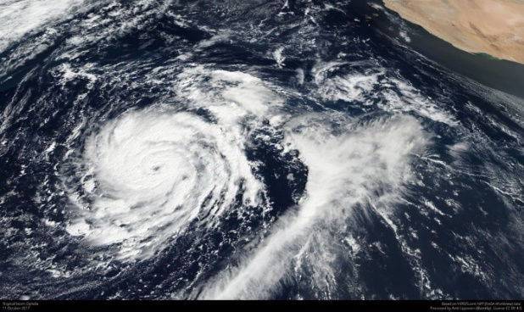
Satellite image technology is used to monitor and predict tropical storms
High-income countries (HICs), such as the USA, have an effective hurricane monitoring and prediction system. This is because they have the finances available to invest in these systems. All tropical storm activity over the Atlantic and Eastern Pacific are tracked by the National Hurricane Centre, located in Florida. As the result of this a hurricane watch is issued when hurricane strength winds are detected to alert people and give them time to prepare. This information is publicised by the National Weather Service.
Low-income countries are often less prepared for tropical storms. This is because monitoring equipment is expensive and they may not have the ability to communicate information to people likely to be affected.

PROTECTION
One of the most reliable methods of reducing the loss of life during a tropical storm is storm shelters. They are strong enough to withstand hurricane force winds because they:
- have windows covered with metal shutters;
- are often built off the ground with deep-pile concrete pillars that dissipate energy;
- are made from reinforced concrete.
- High sea walls are also constructed along the coast to protect communities from storm surges.

PLANNING
Preparation is very important in reducing the impacts of tropical storms. People who live in areas prone to tropical storms are advised to stock up on food and water as they may be housebound for several days following a storm. Governments and NGOs, such as the Red Cross, advise people how to prepare for and respond to tropical storms.
Task: Explain how monitoring, prediction, protection and planning can help people prepare for tropical storms

Lesson eight: Weather hazards in the UK
- LI: To examine the types of weather hazard experienced in the UK

Task: Read the DART ‘Amazon deforestation’

UK extreme weather – the heatwave of summer 2018

The 2018 British Isles heat wave was a period of unusually hot weather that took place in June, July and August. It led to record-breaking temperatures in the UK and Ireland.

Cold then hot!
2018 started with record cold in early March with the 2018 Great Britain and Ireland cold wave and the famous snowy weather associated with the ‘Beast from the East’ which spread snow across most of the UK.
Just a few weeks later the 2018 heatwave started in early May and finally finished in early August, a span of almost 3 months.
A heat wave was ‘officially’ declared on 22 June, with Scotland and Northern Ireland recording temperatures above 30 °C (86 °F) for the first time since the July 2013 heat wave. The causes of the 2018 heatwave were due to high pressure sitting over the British Isles. The Met Office declared summer 2018 the joint hottest on record together with 2006, 2003 and 1976. The weather also affected Britain's roads as tarmac began to melt in the extreme heat. A man's leg sank into a melted road in Newcastle, and he had to be rescued by firefighters.
Essex had 56 consecutive days without rainfall, as did many other parts of the UK. The hot weather continued into early August until the heatwave finally ended. The Met Office said the official UK hotspot on 26 July was 35.3C recorded at Faversham in Kent.

Positive impact on the economy
The long period of dry warm weather strongly boosted UK tourism trade during this period. The official ‘Visit Britain’ group forecast the number of international visitors to the UK would increase by around 15% from the USA alone.
Many companies who sell outdoor equipment such as barbeques reported the usual boost in sales that comes from a good summer, and estate agents reported that the warm dry summer was also helping their industry as house sales increased. Restaurants and pubs also reported good business during the heatwave.
During the 3 months of the summer heatwave, the UK economy grew at 0.6%, its fastest rate for over 4 years.

Health effects
The heatwave added to pressure on the NHS, on A&E departments and elsewhere. There are fears of over 1,000 excess deaths during the 2018 heat wave. The Environmental Audit Committee of MP's fears 7,000 heat-related UK deaths annually by 2050 unless the government acts promptly. At risk, groups include elderly people, small children and people with heart and lung conditions. Also, dress codes for work and school uniform policy should be relaxed during heatwaves to improve work productivity and school learning.

Drought and hosepipe bans
On 29 June, Northern Ireland Water introduced the first hosepipe ban in Northern Ireland since 1995. On 5 July in the Republic of Ireland a state of absolute drought was declared because there had been no rainfall at 96% of its weather stations in the previous two weeks.

Crop failures
The heat wave has affected many crops, and there is concern for the wheat and barley harvests. Cases include wheat dying of drought before it could set seed, and withering of grass intended for livestock grazing, so that dairy cattle had to be grazed on land intended to grow hay or silage for winter feed for the cows.
A Global heatwave?
The UK heatwave was just a small part of a heat wave spanning virtually the whole Northern Hemisphere. This included near record temperatures across Spain and many parts of Europe. The global heatwave included the hottest night time temperature ever recorded on Earth in Oman, where the lowest temperature was 42.6 °C.

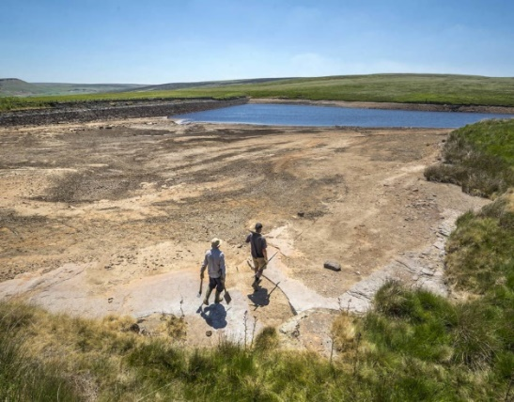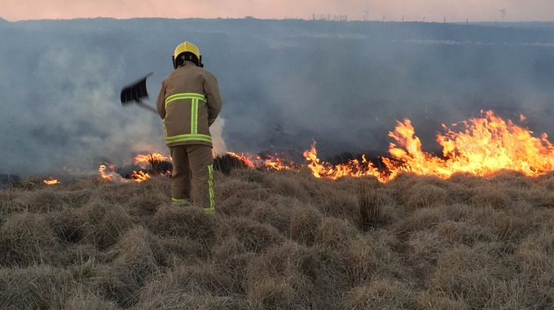

Answer the questions:
- Briefly describe the weather in March across the UK.
- When did the 2018 heatwave start and roughly how long did it last?
- What caused the 2018 heatwave?
- What was the highest temperature in 2018?
- How did the 2018 heatwave compare to previous heatwaves?
- How long did Essex have no rainfall for?
- Describe your experience of the heatwave – did you enjoy it or was it just too hot? What was it like being in school and trying to work during a heatwave?
- Why was the heatwave good for our economy? Which businesses enjoyed the heatwave and how well did the UK economy grow?
- What problems did the heatwave create? Think about the impacts on people’s health, our roads, crop production and the impacts of drought – a chronic lack of water.
- Why was 2018 described as the ‘hottest year ever’ around the world? Was the UK the only country affected by a heatwave?

Lesson nine: Preparing the UK for future extreme weather hazards
- LI: To examine how the UK can reduce the risk of future extreme weather events

Task: Read the following advice for preparing for extreme weather from EDF energy

How to prepare for extreme weather in the UK
Preparing for floods
Raise electrical appliances from the floor
- Mount your TV on the wall
- Put your fridge freezer and washing machine on a raised platform
Avoid putting irreplaceable possessions in the loft or basement
- Invest in a home safe with a secure seal to prevent water damage
- Place valuable items on high-raised shelves around your home
Long-term preparation if you live in a high-risk flood area
- Install water-resistant hardwood flooring on the lower ground
- Install tiles with waterproof adhesive and grout in your kitchen
- Fit covers over ventilation bricks to prevent damage from drizzling

Preparing for storm season
Stay up to date with weather warnings
- Check the Met Office website or download the app
- Order an Amazon Alexa or Google Home that'll notify you if a storm is coming
Keep an emergency kit to hand
- Keep a battery-powered torch
- Invest in a power generator in case of a power outage
- Prepare the exterior of your home if a storms on its way
- Hire a roofer to check if you have any loose tiles
- Check your gutters to prevent water dripping down external walls
Task: answer the following questions

Q1) How is the advice given by EDF energy meant to help people?
Q2) Which piece of advice is the most useful to help people to prepare for floods?
Q3) Is preparing for weather hazards in the UK likely to be cheap or expensive? Explain your answer
Q3) Are extreme weather events more or less likely to happen in the future?

Watch the video about flooding in the UK: https://www.youtube.com/watch?v=XPqlfLuioC8

Lesson ten: What is the evidence for past climates?
- LI: To examine the evidence for past climates and the pattern of climate change during the Quaternary period

Task: Read the following DART which provide evidence for climate change

Evidence for climate change and global warming
The global climate has been changing since time began and will continue to change into the future. The Earth's temperature has fluctuated in the last few hundred years. However, since around 1950 there has been a dramatic increase in global temperatures, shown on the graph below:
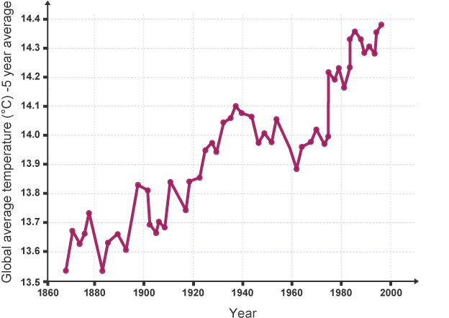
This rapid increase is known as global warming are there are several important sources of evidence for climate change.

Thermometer readings
Ongoing temperature recordings using thermometers have shown a clear warming of the Earth's temperature over the past few decades. By using this data, scientists have seen an average combined land and ocean surface temperature increase of 0.85°C since the end of the 19th century. In the northern hemisphere, the period between 1983 and 2012 was the warmest 30-year period of the last 1,400 years.

Ice cores
Scientists often use ice cores to detect changes in temperatures. When snow falls it traps air into the ice. When scientists take a sample of ice it reveals the atmospheric gas concentrations at the time the snow fell. This is used to calculate temperature at that time. The ice can reveal the temperature of each year for the past 400,000 years. Scientists that study the ice cores say there is clear evidence that there has been a rapid increase in temperature in the past decades.

Rising sea levels
Between 1901 and 2010, average global sea level rose by 0.19 m.
TASK – answer the questions:

Q1) Describe the temperature changes shown on the climate graph above.
Q2) Do you think there is clear evidence of climate change? Explain your answer.

Lesson eleven: The causes of climate change
- LI: To examine the possible causes of climate change – both human and natural

Watch the video on climate change: https://www.youtube.com/watch?v=G4H1N_yXBiA

Causes of climate change - human and natural factors
A natural function of the Earth's atmosphere is to keep in some of the heat that is lost from the Earth. This is known as the greenhouse effect.
- The atmosphere allows the heat from the Sun (short-wave radiation) to pass through to heat the Earth's surface.
- The Earth's surface then gives off heat (long-wave radiation).
- This heat is trapped by greenhouse gases (e.g. methane, carbon dioxide and nitrous oxide), which radiate the heat back towards Earth. This process heats up the Earth.

Human factors increasing global warming
Some human activities increase the greenhouse gases in the atmosphere:
- Burning fossil fuels, e.g. coal, gas and oil - these release carbon dioxide into the atmosphere.
- Deforestation - trees absorb carbon dioxide during photosynthesis. If they are cut down, there will be higher amounts of carbon dioxide in the atmosphere.
- Dumping waste in landfill - when the waste decomposes it produces methane.
- Agriculture - agricultural practices lead to the release of nitrogen oxides into the atmosphere.

Natural factors increasing global warming
There are also natural factors which contribute to increased global warming:
- Orbital changes - the Earth has natural warming and cooling periods caused by Milankovitch cycles or variations in the tilt and/or orbit of the Earth around the Sun (Wobble, roll and stretch theory).
- Volcanic activity - during a volcanic eruption carbon dioxide is released into the atmosphere.
- Solar output - there can be fluctuations in the amount of radiation from the sun. If there is high amount emitted there will be an increase in Earth's temperatures.

Question to complete:
Q1) Describe how greenhouse gases can heat up the Earth.
Q2) Explain how human activity can heat up the Earth.
Q3) Explain how natural factors can alter the Earth’s climate.
Q4) Do you think human or natural factors are responsible for the current extremely rapid rise in global temperatures?

Lesson twelve: The impacts of climate change
- LI: To examine the impacts of climate change on people and the environment

Watch the video on the impacts of climate change: https://www.youtube.com/watch?v=u2UVmqrdC4I

The Maldives – A paradise soon to be lost?

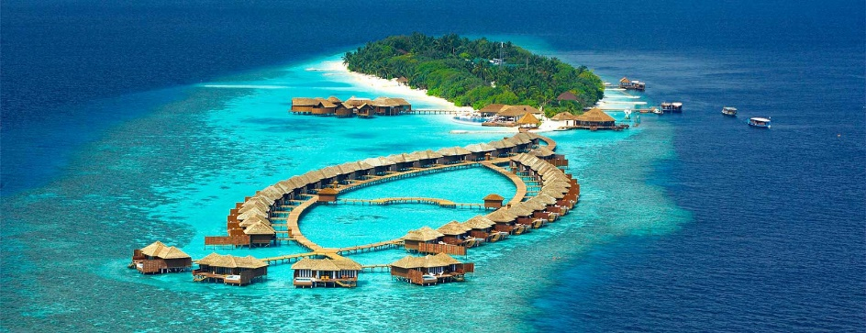

To visit the Maldives is to witness the slow death of an entire nation. This tourist paradise is facing an environmental disaster. Global warming is causing ice at the north and south poles to melt, rising global sea levels up to 0.9cm a year.

No wonder that Male, the capital of the Maldives, is surrounded by a 10-foot-high wall to prevent flooding from the sea.

Most of the Maldives 1,200 islands are no more than 100cm above sea level. Within 100 years the Maldives could be completely flooded. The country's 360,000 citizens would be forced to evacuate to other countries like India.

The Maldives' survival as a nation is truly at stake.

No wonder it was the first country to sign up to the Paris Climate Agreement. This agreement has set countries the target of cutting CO2 emissions by reducing their use of fossil fuels such as coal, oil and gas.

The Maldives government is trying to stop the worst effects of climate change. It is planting palm trees to prevent beach erosion and is cleaning litter from the country's coral reefs - natural barriers against the sea.

Environmental science is taught in every school and given the same importance as writing and arithmetic. All new resorts are subject to a rigorous environmental impact study and developers are allowed to build on only 20% of the islands.

People in the Maldives are aware their fate lies in the hands of countries like the USA, China, UK and Germany which produce the most CO2 emissions.

This tiny nation faces a huge task - to persuade other countries like the USA to help them prevent global warming. Without help, this is a paradise faced with extinction.

Complete the questions and thinking points:

Q1. Why are the Maldives at risk of being flooded?
Q2. What is causing global sea levels to rise?
Q3. Explain what the Maldives government is doing to prevent climate change.
Q4. Can you think of solutions to prevent global warming?

Extension: Suggest at least 5 ways we could all reduce our energy use. How will this help save the
Maldives?

Lesson thirteen: Mitigating climate change
- LI: To examine the mitigation strategies to manage climate change

What is climate change mitigation?
The term mitigation refers to efforts to cut or prevent the emission of greenhouse gases - limiting the magnitude of future warming.

Which energy technologies can help?
Switching to low-carbon energy sources such as wind power, solar, geothermal, hydroelectric or nuclear represents one of the major strategies for lowering the emissions of greenhouse gases in the atmosphere.
The take-up of renewable energy - from sources that do not deplete over time - is growing. Figures from the UN show that renewable energy raised its share of total energy generation last year from 7.8% to 8.5%. But they also reveal that investment fell by 14%.
The scale of the challenge is daunting - fossil fuels make up about 80% of all energy. But technologies such as carbon capture and storage (CCS) could help reduce their impact.
Existing oil fields, un-mineable coal seams and underground salty aquifers are all among the geological sites that are considered suitable for CO2 storage. But while CCS could, in theory, limit the amount of carbon going into the atmosphere, it doesn't do much for the CO2 already there.

How else can we help curb climate change?
Greening urban areas can also make a difference. Cities are home to half the planet's population and are responsible for three-quarters of energy consumption and 80% of carbon emissions. Retro-fitting buildings to make them more energy efficient and cutting the impact of transport emissions represent some of the strategies for doing this.
Tackling waste is also an issue. About 11.2 billion metric tonnes of solid waste is currently being collected around the world every year, and the organic portion that decays is contributing around 5% to global greenhouse gas emissions.
Experts would like to reduce its impact primarily by producing less but also recycling more and treating waste in a way that is less harmful to the environment or even using it as a sustainable energy fuel source.
Mitigation also extends to the protection of natural carbon "sinks" like the forests or oceans. New sinks can be created through, for example, forest regeneration.

What other options are there?
Geo-engineering is one controversial area that has gathered momentum in recent years. It requires the deliberate intervention in the climate system with the aim of curbing global warming.
One example is Solar Radiation Management (SRM), which involves reflecting more of the Sun's rays away from the planet back into space. This could be done by pumping sulphur aerosols into the high reaches of the atmosphere, where they would have similar reflective properties to the ash released naturally by volcanoes.

Answer the questions:
Q1) What is climate change mitigation?
Q2) Explain how technology could help improve climate change mitigation.
Q3) What is ‘Geo-engineering’ and how could it work to mitigate climate change?
Q4) Should we be doing more to mitigate (or prevent) climate change?

Lesson fourteen: Adapting to climate change
- LI: To examine the adaptation strategies to respond to climate change

Read the information below provided by NASA:
Adaptation – adapting to life in a changing climate

The goal is to reduce our vulnerability to the harmful effects of climate change (like sea-level rise, more extreme weather events or food shortages). It also encompasses making the most of any potential beneficial opportunities associated with climate change (for example, longer growing seasons or increased crop yields in some regions).
Throughout history, people and societies have adjusted to and coped with changes in climate and extremes with varying degrees of success. Climate change (drought in particular) has been at least partly responsible for the rise and fall of civilizations. Earth’s climate has been relatively stable for the past 12,000 years and this stability has been crucial for the development of our modern civilization and life as we know it. Modern life is tailored to the stable climate we have become accustomed to. As our climate changes, we will have to learn to adapt. The faster the climate changes, the harder it could be.

While climate change is a global issue, it is felt on a local scale. Cities are therefore at the frontline of adaptation. In the absence of national or international climate policy direction, cities and local communities around the world have been focusing on solving their own climate problems. They are working to build flood defences, plan for heatwaves and higher temperatures, install water-permeable pavements to better deal with floods and stormwater and improve water storage and use.

Climate change is starting to be factored into a variety of development plans: how to manage the increasingly extreme disasters we are seeing and their associated risks, how to protect coastlines and deal with sea-level rise, how to best manage land and forests, how to deal with and plan for reduced water availability, how to develop resilient crop varieties and how to protect energy and public infrastructure.

Questions:
Q1) What are the aims of adapting to climate change?
Q2) For how long has the Earth’s climate been stable?
Q3) How has a stable climate benefited people?
Q4) How are local cities adapting to climate change?
Q5) How can cities and people start to adapt to climate change?

Watch the video on adapting to climate change: https://www.youtube.com/watch?v=lGMx2xP3dcM

