1
Year 10
Unit R051 – Contemporary issues in sport

Autumn 1 Blended Learning Booklet

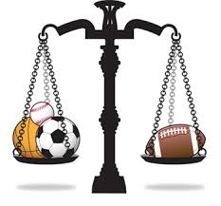

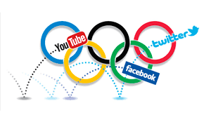


Group Discussion – For these tasks, you are able to discuss your ideas with a partner

Quiet Learning – for these tasks you can only use the resources around you to help.

Tech Zone – For tasks with this symbol, you may research on iPads.

2

User groups: Gender – pg 3


User groups: Age – pg 5



User groups: Socio-Economic Background – pg 6

Reason exam question – pg 8

Influences on participation – pg 9

Participation: Gender – pg 10

Gender exam question – pg 11 

Commercialisation – pg 12

Commercialisation exam question – pg 15

Participation: Age & Ethnicity – pg 16

Participation: Disability – pg 17

Influences: Socio-Economic – pg 18

Extension Questions – pg 19

3

User groups in Sport


Sport is played and enjoyed by people of all ages, genders,

cultural backgrounds and abilities. You need to know how participants can be placed into different categories called “USER GROUPS” and that each have potential barriers to participation.

Gender

Stereotypically male sports (list 3):

Stereotypically female sports (list 3):

Are any of the sports above now “breaking the mould” of who plays them?

---------------------------------------------------------------------------------------------------------

---------------------------------------------------------------------------------------------------------

---------------------------------------------------------------------------------------------------------


51% Men

36% Women

Study by UK Sport (2015) showing the percentage of men & women that regularly take part in sport


Question: Why do you think the figures may show a difference between men and women?

---------------------------------------------------------------------------------------------------------

---------------------------------------------------------------------------------------------------------

---------------------------------------------------------------------------------------------------------

---------------------------------------------------------------------------------------------------------

---------------------------------------------------------------------------------------------------------

Hints:


4


Age

Different age groups to consider for their participation in sport. For each age group, can you identify how each bullet point can either help or hinder participation in sport:

1. Children and Teenagers

Age restrictions on sports –__________________________________________


________________________________________________________________

________________________________________________________________

Cost of subscriptions – _____________________________________________
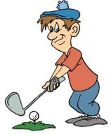

________________________________________________________________

________________________________________________________________

Transport - _______________________________________________________

________________________________________________________________

________________________________________________________________

2. People in their 20’s-50’s

Work commitments - ______________________________________________


________________________________________________________________

________________________________________________________________

Family - _________________________________________________________

________________________________________________________________

________________________________________________________________

3. Retired

Stereotyped? - ____________________________________________________
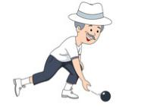

________________________________________________________________

________________________________________________________________

More free time - __________________________________________________
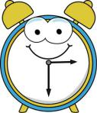

________________________________________________________________

________________________________________________________________

5


Socio-economic Background

Definition of Socio-economic background (in a way that YOU understand it):

________________________________________________________________

________________________________________________________________

________________________________________________________________


Some activities cost a lot of money to do, for example:

•

•

•

They cost a lot of money because _____________________________________

Socio-economic groups: People are split within society according to their job/profession/status.

Use the socio-economic groups differ in the sports they participate in and also any potential barriers

Unemployed - ____________________________________________________

________________________________________________________________

________________________________________________________________

Working Class - ___________________________________________________

________________________________________________________________

________________________________________________________________
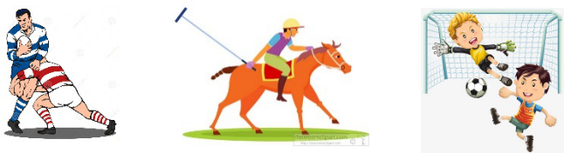

Upper Class - _____________________________________________________

________________________________________________________________

________________________________________________________________

6


Ethnicity

Use the website below to find statistics of participation rates taken from the Sport England Active Lives Survey for Adults in 2012.

https://www.sportengland.org/research/understanding-audiences/sport-and-ethnicity/

What did the study show for male participation in sport across various ethic backgrounds?_____________________________________________________

For Females, which ethnic background is more likely to take part in sport?

---------------------------------------------------------------------------------------------------------

 | Participation in Sport by Faith |  |  |  |  |  |  |  |  |  |  |  |  |  |  | All Adults
 |  |  |  |  |  |  |  |  |  |  | 36%
 | Buddhist
 | Christian |  |  |  |  |  |  |  | 34%
 | Hindu |  |  |  |  |  |  |  | 30%
All | Jewish |  |  |  |  |  |  |  | 34%
All | Muslim |  |  |  |  |  |  |  | 32% |  |  |  | 40%
 | Sikh
 | Other religion |  |  |  |  |  |  |  | 31%
 | No religion |  |  |  |  |  |  |  |  |  |  |  | 42%
.
 | Buddhist |  |  |  |  |  |  |  |  |  |  |  | 44%
 | Christian |  |  |  |  |  |  |  | 39%
Male | Hindu |  |  |  |  |  |  |  | 36%
Male | Jewish |  |  |  |  |  |  |  | 36%
Male | Muslim |  |  |  |  |  |  |  |  |  |  |  |  |  |  | 47%
 | Sikh |  |  |  |  |  |  |  |  |  |  |  |  |  |  |  |  |  | 51%
 | Other religion |  |  |  |  |  |  |  | 36%
 | No religion |  |  |  |  |  |  |  |  |  |  |  |  |  |  | 46%
.
 | Buddhist |  |  |  |  |  | 26%
 | Christian |  |  |  |  |  |  |  | 30%
Female | Hindu |  |  |  | 23%
 | Jewish |  |  |  |  |  |  |  | 32%
 | Muslim |  |  |  | 18%
 | Sikh |  |  |  |  |  | 24%
 | Other religion |  |  |  | 24%
 | No religion |  |  |  |  |  |  |  |  |  | 36%
 | 0% |  | 10% |  | 20% |  |  |  | 30% |  |  |  | 40% |  |  |  |  |  | 50%
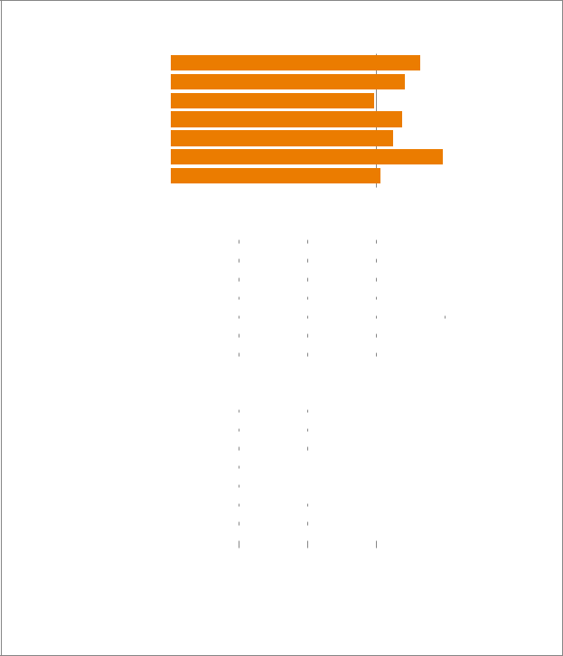

Source: APS 6 Q2 (Apr 11-Apr 12)

Notes: Participation in sport refers to at least 4 sessions of 30 minutes, moderate intesity sport in the last 28 days (once a week)

10

8

6

4

2

0

Analyse these results:

------------------------------------------------

------------------------------------------------

------------------------------------------------

------------------------------------------------

------------------------------------------------

------------------------------------------------

------------------------------------------------

------------------------------------------------

------------------------------------------------

------------------------------------------------

------------------------------------------------

------------------------------------------------

------------------------------------------------

Linking gender and religion to culture and sports participation, can you identify any barriers that could lead to the results shown above? Use the internet to find information that will support your answer.

---------------------------------------------------------------------------------------------------------

---------------------------------------------------------------------------------------------------------

---------------------------------------------------------------------------------------------------------

---------------------------------------------------------------------------------------------------------

---------------------------------------------------------------------------------------------------------

7

Disability

Using the website below, download the report and research the participation levels for people with disabilities in the UK for 2016-17.
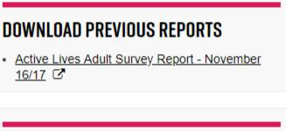

https://www.sportengland.org/research/active-lives-survey/

What percentage of people with a disability only state to have one impairment? ___________________

What percentage of people with a disability only state to have two impairments? ___________________

What percentage of people with a disability only state to have three or more impairments? ___________________

Use the Active Lives Survey data to complete the table below;
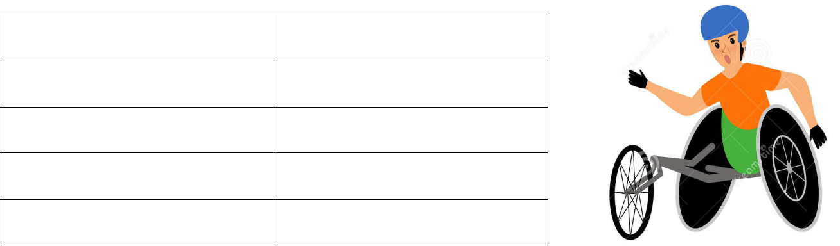

Disability |  | % of Active participants

No impairment

- impairment

2 impairments

3 or more impairments

How has disability sport changed over the past 10 years?

---------------------------------------------------------------------------------------------------------

---------------------------------------------------------------------------------------------------------
---------------------------------------------------------------------------------------------------------
---------------------------------------------------------------------------------------------------------

Explain the potential barriers to participation in sport for someone with a disability:

Lack of access -

Equipment -

Discrimination –

8

Exam Question: Paul is a wheelchair user and wants to start to play basketball. Identify the potential barriers Paul could face and explain the ways in which he could overcome this.


________________________________________________________________

________________________________________________________________

________________________________________________________________

________________________________________________________________

________________________________________________________________

________________________________________________________________

________________________________________________________________

________________________________________________________________

________________________________________________________________

________________________________________________________________

________________________________________________________________

________________________________________________________________

________________________________________________________________

________________________________________________________________

________________________________________________________________

9


Below are two more user groups which you need to know. Each has three potential barriers to them participating in regular sport and physical activity. Can you explain how?

Families with young children

- Does the leisure facility have a crèche?

- Balancing work/family commitments with sport/activity

- Childcare – Women still viewed in society as the ‘homemaker’

Single Parents

- Time after work

- Childcare

- Lack of disposable income
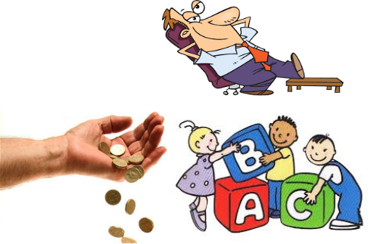

10


Past Exam Question (Jan 2018)

Tom is 66 years old and his partner Caroline is 59. Tom is retired but Caroline still works full-time. They only have one car. Both would like to get fitter by playing more sport.

Describe TWO barriers to Tom’s participation in sport and TWO possible solutions.


Barrier 1:

Solution:


Barrier 2:

Solution:

11

Solutions to Barriers Affecting Participation
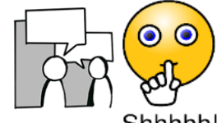

Remember P.A.P (Promotion, Access, Provision). For each of the

solution headings and subheadings, can you IDENTIFY some initiatives and (more importantly) EXPLAIN how they work to breaking down barriers to participation.

Promotion – Letting groups know what is on for them

How can sports clubs and government increase the visibility of their services in the local areas?

How can using role models help promote sports or activities for SPECIFIC user groups? Can you give an example?

Initiatives can help increase participation in targeted groups.

Access – Making activities easier to get to/use

Improved facilities

Equipment

Sensible pricing/concessions

Provision – SHOULD be adequate and equal in all parts of the country

Targeted programming of sessions:

Planning times of sessions:

Providing appropriate activities in local area:

12

Factors Impacting the Popularity of Sports in the UK

For this section, remember REPS & MAPS (Role Models, Environment,

Participation, Spectatorship, Media Coverage, Acceptability, Provision & Success)


ROLE MODELS

Children see role models as their_____________. Because of this, children

want to __________ their role model’s ______________ in their given sport.

For example, _________________ in the sport of _______________ is widely

seen as a role model to children because ______________________________

________________________________________________________________

Some user groups have a lack of role models in specific sports, that can inhibit the sports’ popularity to that particular group. On the other hand, they have many role models in other sports that are popular for their group. For example;

 | User group |  |  | Sport which lacks role |  |  | Sport which have
 | User group |  |  | models |  |  | sufficient role models
Ethnicity - Person of
Asian descent
Disability - Person with
disability
Gender - Women

ENVIRONMENT

Location of activities and where you live go hand in hand with the popularity of some activities.

Sports popular for people that live in the Lake District:

________________________________________________________________

Why is skiing not as popular in the UK as it is on the continent? How many indoor ski slopes are there in the UK? _________________________________

________________________________________________________________

13

PARTICIPATION

Football has the highest participation rates in the UK- Why?

Lots of clubs – ____________________________________________________

Lots of pitches – __________________________________________________

Tradition – _______________________________________________________

Family influence – _________________________________________________

SPECTATORSHIP


Live matches across football and rugby easy to find/ watch. What impact does this have on sports’ popularity?

_______________________________________________________

________________________________________________________________

Sports that are not popular spectator sports in the UK:

________________________________________________________________

Is there a link between these sports and their popularity for participation? Why? ___________________________________________________________

________________________________________________________________

MEDIA COVERAGE
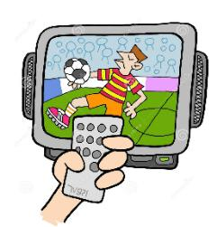

Terrestrial TV Channels –

Satellite TV Channels -

Other means of watch sport -

How can media coverage of a sport influence how popular it is? Link to annual events such as Ryder Cup (golf), Wimbledon Tennis Championship, World Cup etc. (can you find any statistics online to support your answer?) ____________

________________________________________________________________

________________________________________________________________

________________________________________________________________

14

ACCEPTABILITY


Some sports are viewed as “unacceptable” by some members of society. Complete the table below to explain why the examples given may be deemed controversial sporting choices.

Sport | Unacceptable view | Impact on popularity
 | Muirfield lost the hosting | Golf was seen as a sexist sport
Golf | Muirfield lost the hosting | in the UK played my men.
Golf | of ‘The Open’ 2016 due to | in the UK played my men.
Golf | of ‘The Open’ 2016 due to | Women driven away from the
 | no women members | Women driven away from the
 | no women members | sport
Boxing for
children
Women’s
Boxing
Horse Racing | Viewed as animal cruelty
Horse Racing | due to use of whip

PROVISION

Provision of sports varies widely depending on where you live (inner city/countryside) and the sports available nearby.

Sports that have high accessibility across most of the country:

- Rugby/Football – Lots of clubs and pitches available (not necessarily good for winter sport in UK – WHY?) _____________________________

- Swimming – Lots of public swimming pools and leisure centres

Sports that lack accessibility across most of the country:

1.

2.

3.

How would you describe the popularity of the 3 sports you have highlighted above in terms of their nationwide popularity? _________________________

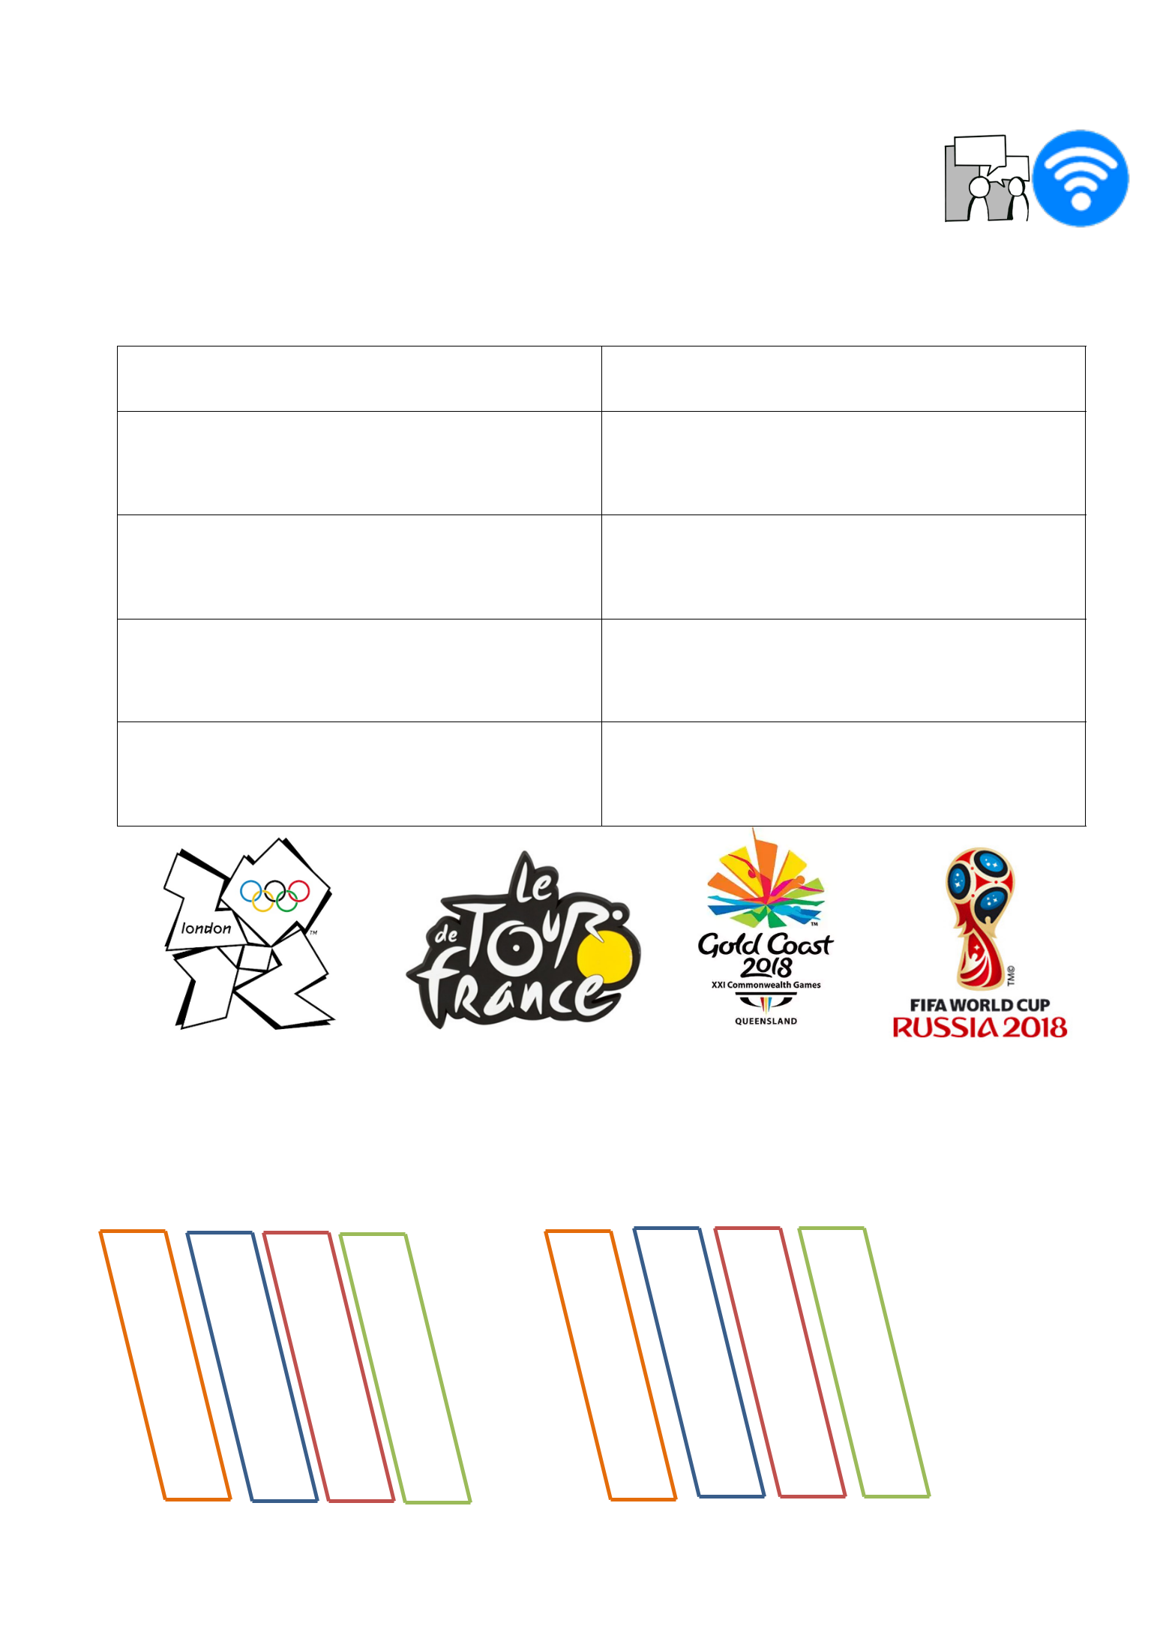
15

SUCCESS

Team, individual and Country success can have a positive impact on the popularity of their respective sports.

Complete the table below to highlight how this can happen.

Sporting Success | Impact on popularity of the sport

Team GB at London 2012 Olympic

Games

Bradley Wiggins/Chris Froome/Geraint

Thomas Tour de France victories

England win Gold in Netball at 2018

Commonwealth games

England Football team reach World Cup

Semi-Final at Russia 2018

Factors that impact on the popularity of a sport – Remember..

R E P S and M A P S

16

VALUES PROMOTED THROUGH SPORT

There are 7 values that are promoted through all sports participation.

Value 1 – Fair Play
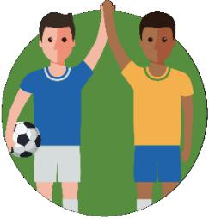

What does the term “fair play” mean?

______________________________________________________

Why is Fair play important in sport?

________________________________________________________________

Give a sporting example of fair play in action

________________________________________________________________

Value 2 – Team Spirit

Teamwork – Definition

________________________________________________________________

Why is team spirit important in sport?

________________________________________________________________
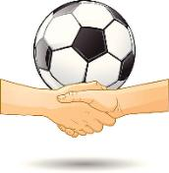

Value 3 – Citizenship

Citizenship – Definition

________________________________________________________________

How might this be displayed through sport?

________________________________________________________________

Value 4 – Tolerance and Respect

Give an example of how sport allows you to develop an understanding of others cultures and values_________________________________
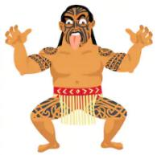
_________________________________________________________

_________________________________________________________

17

Value 5 – Inclusion

What is “inclusion”?

_______________________________________________________________

How does sport allow for inclusion?

________________________________________________________________

Which user groups benefit most from making sport inclusive?

________________________________________________________________

Value 6 – Excellence
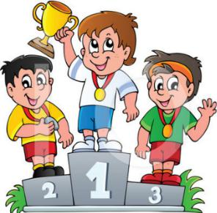

Regardless of level playing at, all athletes should strive to be

______________. In order for this to be achieved, the sportsman

must give _____% every time they play.

Value 7 – National Pride

How can sport promote National Pride? Give an example to support your answer
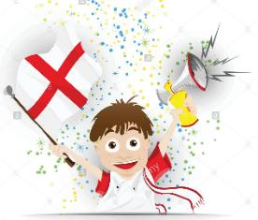

_____________________________________________________

_____________________________________________________

_____________________________________________________

_____________________________________________________

18

The Olympic and Paralympic Games


The Olympic Creed

Fill in the gaps – The Olympic creed is important to know for your exam! It has been on a number of past papers.

“The most important thing is not to _____ but to __________, just

as the most important thing in life is not the ___________, but the

__________. The essential thing is______________________,

but to have________________.” Pierre de Coubertin

Pierre de Coubertin

In this section, research about Pierre de Coubertin – Who is he and why is he SO important to the modern Olympics?


The Olympic Flag/Logo

Why are there 5 interlocking rings?
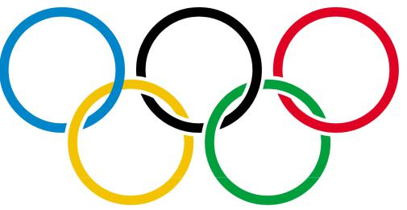

________________________________________

What is significant about the 6 colours?

________________________________________

________________________________________

19


Olympic Values |  | What they stand for

Excellence

Friendship

Respect
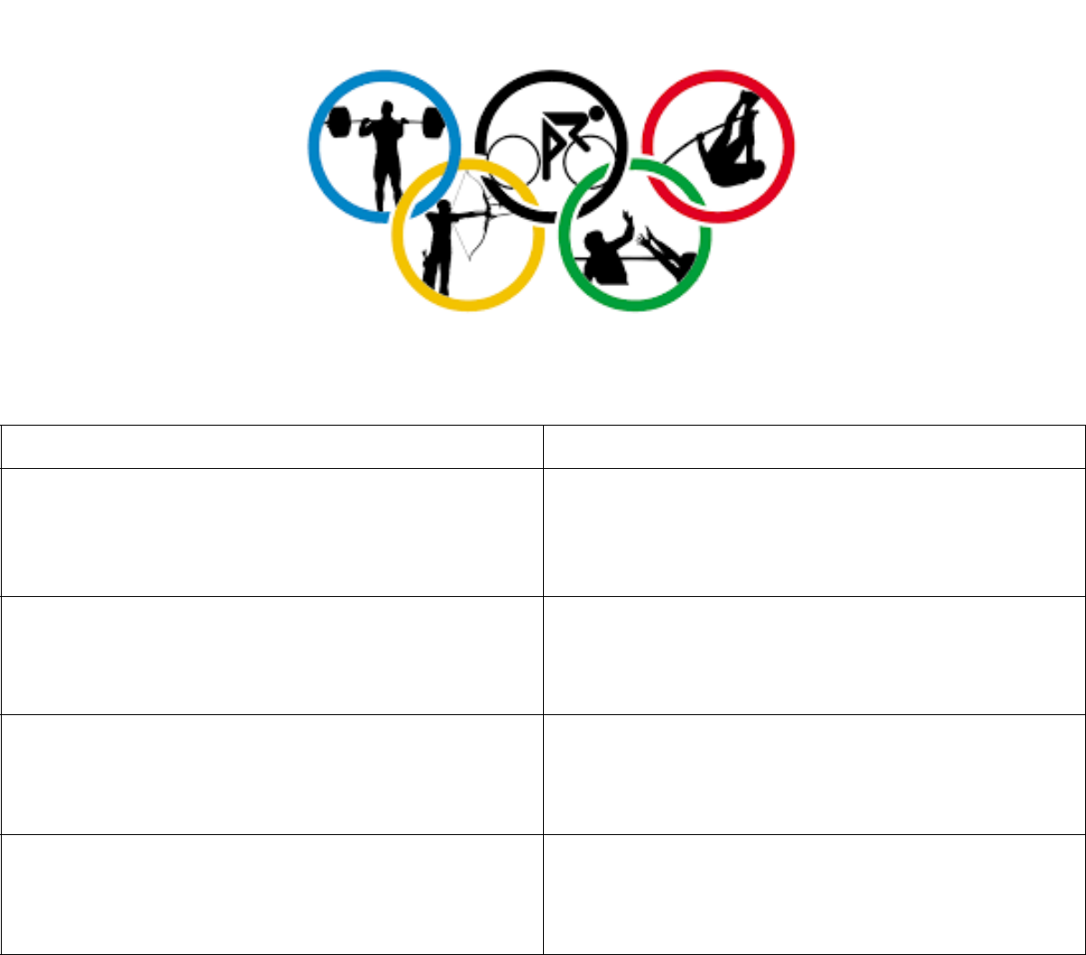

Paralympic Values |  | What they stand for

Courage

Determination

Inspiration

Equality
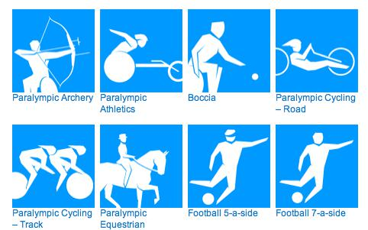

20

Initiatives – Used to promote Sporting Values


Compete the table below using information within revision guide and on the internet.

Initiative | Aim | Focus | Additional Info


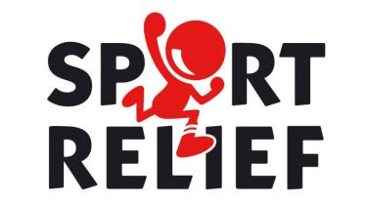



21

Sporting Etiquette and Behaviour

What does the word “etiquette” mean in sport? _______________________

________________________________________________________________

Why is it important for performers to respect etiquette within their sport?

________________________________________________________________

________________________________________________________________

How might etiquette be shown by spectators within sport and why is it important? _______________________________________________________

________________________________________________________________

________________________________________________________________
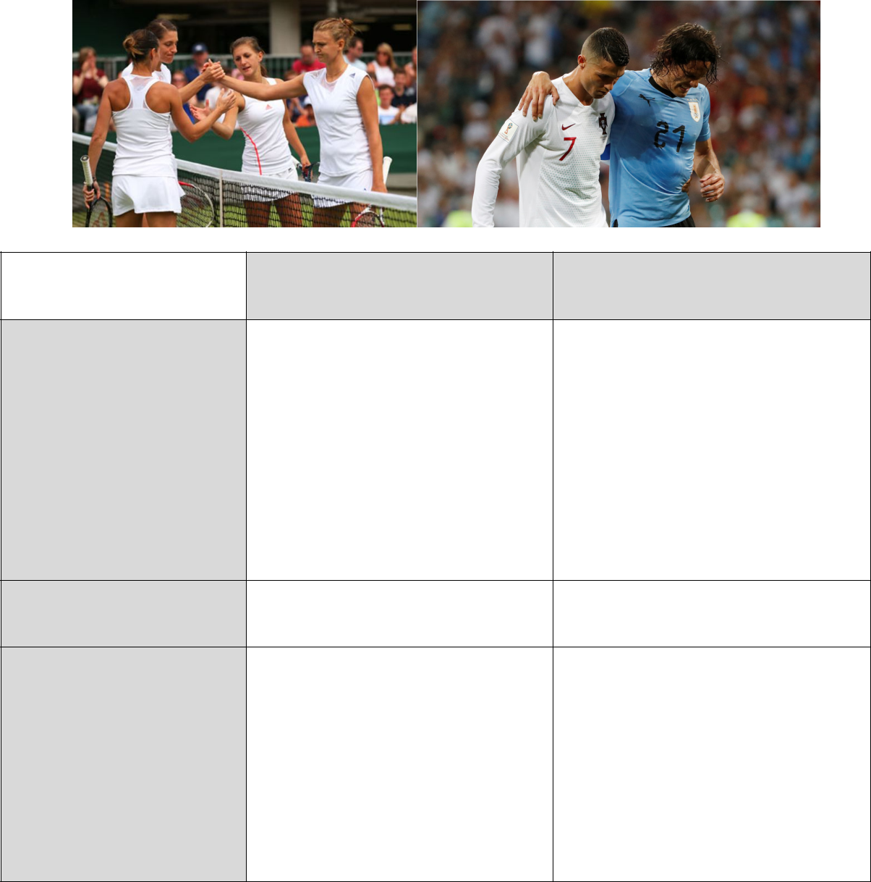

Sportsmanship Gamesmanship

Definition

Positive or negative

for sport?

Examples

22

Drugs in sport

Who/what are W.A.D.A?

________________________________________________________________

What is W.A.D.A’s role?

________________________________________________________________

________________________________________________________________

Drug testing - “Whereabouts Rule”

The whereabouts rule was introduces in ___________. It states that all

athletes must provide their sport’s __________________________________

details of their location for ____________________ every day between the

hours of ______________.

If an athlete misses ________ slots within a year, they can receive a standard

__________________ ban.

Drug testing – the process

Drug testing is used to highlight use of both Performance Enhancing and/or Recreational drugs. Remember to HUNT down the cheats.

Hair –

Urine –

Nails –

Testing blood –

If an athlete is found to have a positive drugs test for the first time, they will receive an __________ ban. If they are caught thereafter, they could be

looking at _______________!

 |  |  | 23
 | Drugs in Sport (Cont’)
 | Examples of Performance enhancing |  |  | Examples of Recreational Drugs
 | drugs
1. |  |  | 1.
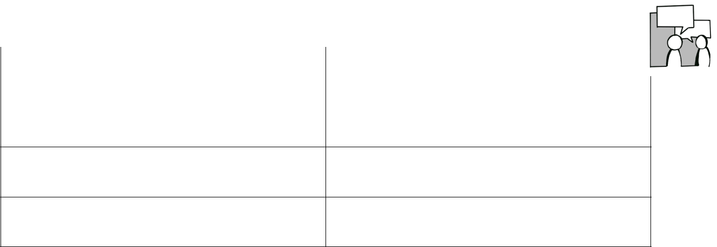

2. 2.

3. 3.

The use of performance enhancing and/or recreational drugs can lead to lengthy bans from sport. What affect can this have on the athlete and sport involved?________________________________________________________

________________________________________________________________

________________________________________________________________

________________________________________________________________

Past exam Question (Jan 2018): Name two performers who have been caught with performance enhancing drugs and the sport they perform in. [2 marks]

- ___________________________________________________________

- ___________________________________________________________

The risk of being caught when taking drugs is high. So why do athletes do it? Using the hints below, suggest why taking drugs to enhance performance may be a beneficial option for an athlete.

Better chance of winning: ___________________________________________

________________________________________________________________

Pressure: ________________________________________________________

________________________________________________________________

Allow to train for longer: ____________________________________________

________________________________________________________________

Others are getting away with it: ______________________________________

________________________________________________________________

24

Performance Enhancing Drugs: For your exam, you will need to know the 7 performance enhancing drugs and 1 process. What they do and what types of athletes they may benefit.

 | Performance |  |  | Benefit given |  |  | Side effects |  |  | Athletes they
 | Enhancing Drug |  |  | Benefit given |  |  | Side effects |  |  | benefit
 | Anabolic Steroids
 | Beta Blockers
 | Diuretics
 | Stimulants
 | Narcotic Analgesics
 | Peptide Hormones
 | (EPO)
 | Human Growth
 | Hormone
 | Performance |  |  | Benefit given |  |  | Side effects |  |  | Athletes they
 | Enhancing Process |  |  | Benefit given |  |  | Side effects |  |  | benefit
 | Blood Doping

25


Hosting Major Sporting Events

Category 1: Regular

These major sporting events are regular and re-ocurring. This means that although they are not every week, ____________________________________
________________________________________________________________

Examples of regular major sporting events hosted in the UK are:
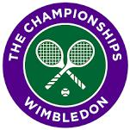

FA Cup Final held at ___________________

Wimbledon Tennis Championship held every ______________

Grand Prix – British GP has been held at _____________ for the past ___ years

Your example: ____________________________________________________

Category 2: One Off

These events are hosted by a country/city once a generation!

Can you think of any major sporting events in which the host country/city are selected only once or once in a generation?

1_____________________________________________
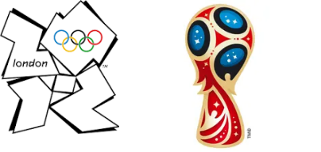

2_____________________________________________

3_____________________________________________

Legacy of hosting major sporting events

There are many long lasting benefits of hosting a successful major event. This is called the event’s LEGACY.

Sporting Legacy - sports profile is __________, Role models created, ultimately

participation rates in sport _________________.

Social and Economic Legacy – investment in infrastructure creates new ______.

Regeneration of facilities in local area means _____________ increases

bringing _____________ to the local economy.

26

Benefits and Drawbacks of Hosting Major Sporting Events


Benefit | Additional information

Increase in national pride

Raise status of country

Increase tourism

New facilities / improved

infrastructure

Increased commercialism
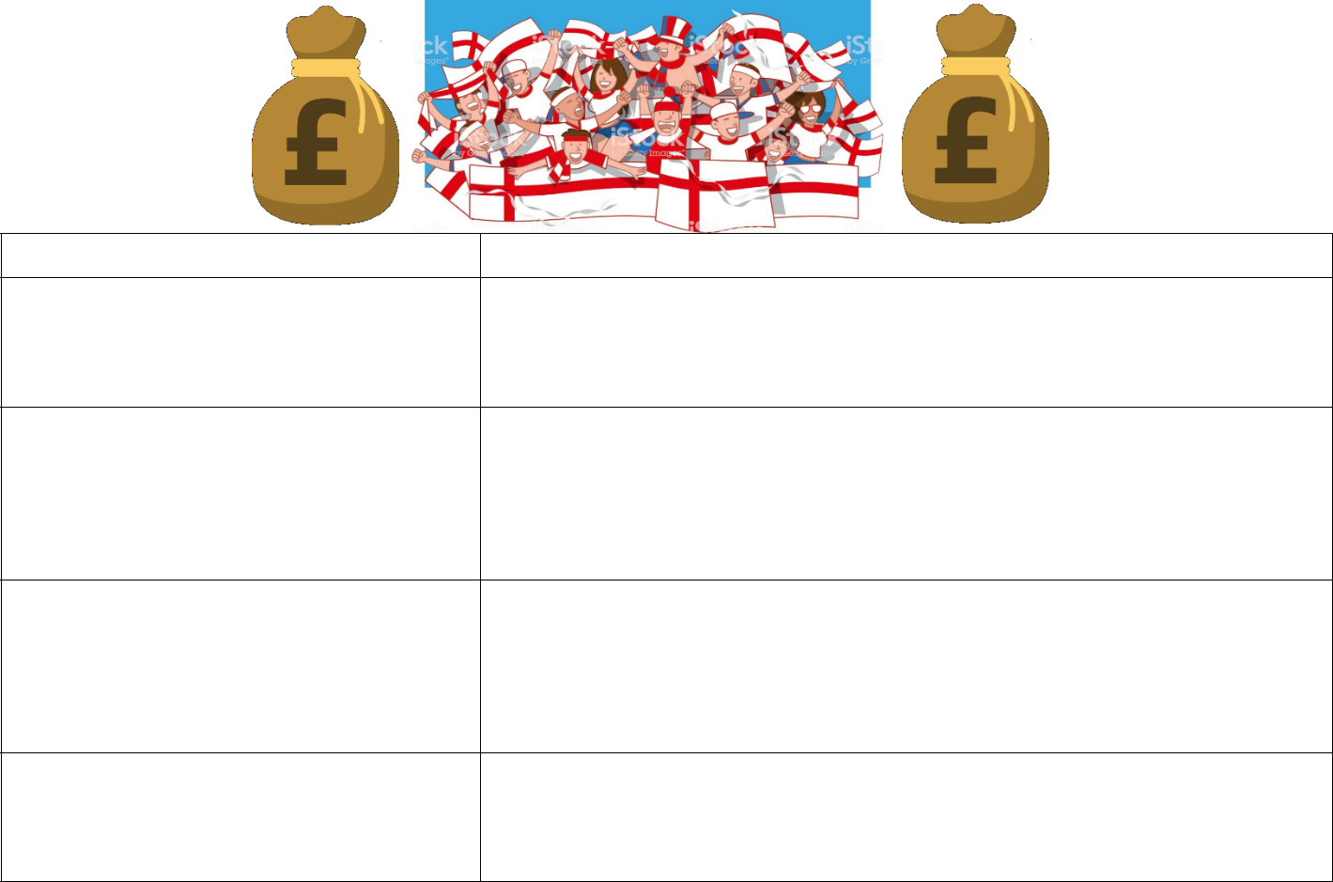

Drawback |  | Additional information

Cost of Bidding to host

May cost more to host than

brings in through the various
benefits!

Wasted facilities after the

games

Division within country –

spending on event rather than
other national priorities

27

National Governing Bodies

A sports’ National governing Body is the organisation responsible for monitoring and enforcing the rules and development of the sport across all levels within the country.

Identify the National Governing Bodies for the sports below:

Football in England - ________________________________________

Rugby Union in England - ____________________________________
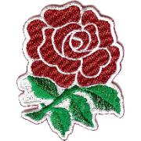

Athletics in the UK - ________________________________________

Netball in England - ________________________________________

Common Roles of NGB’s

All National Governing bodies share common roles. From the list below, highlight the jobs you think are the responsibility of the the NGB’s.

Select national teams Drug Testing Ticket sales Organise Competitions Coach Education paying professional establish rules and regulations Increase participation Fan Funding Distribute funding across all levels talent identification

How do NGB’s run a sport?

1 – Promotion

It is the job of the NGBs to promote their sport to increase popularity and participation amongst user groups. Think of ‘G.A.S.E.D’ user groups – how can an NGB promote their sport to increase participation? ____________________

________________________________________________________________

________________________________________________________________

Publicise events, success and initiatives – How can the media be used to promote recent success of a given sport? ______________________________

________________________________________________________________

________________________________________________________________


28

2 – Development

NGB’s are responsible for the development of their elite performers. Especially those who represent the country for their sport on the international stage.

How do the elements below help with the development of the sport at elite level?

Elite development squad/camps -_____________________________________

________________________________________________________________

Coaching courses -_______________________________________
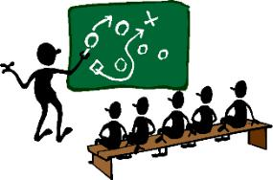

_______________________________________________________

Officiating courses - ______________________________________

_______________________________________________________

3 – Infrastructure

The structure of sport and competition across all levels around the country. How do they help with…

Competitions - ____________________________________________________

Make and enforce rules - ___________________________________________

________________________________________________________________

Help with the bidding process for facility development - __________________

________________________________________________________________

4 – Support

Technical advice – Usually when it comes to new facilities. How might the FA advise on a new council football pitch? ________________________________

________________________________________________________________

Contact Detail – Somebody new to the area looking to participate in the NGB’s sport could be support by ___________________________________________

________________________________________________________________

29

5 – Policies and initiatives

Work closely with UK anti-doping to __________________________________

________________________________________________________________

Promote fair play across their sport – The FA rolled out the ‘Respect’ campaign in the 2008-09 season. What were some of the key aims of this? ____________

________________________________________________________________

________________________________________________________________


Responsible for safeguarding within their sport. What does this mean?

________________________________________________________________

________________________________________________________________

6 – Funding

NGB’s get money from Sport England, Lottery funding and Government Grants. How else might they make money – think about earning on a commercial level

1. ___________________ 2. ____________________ 3.________________

This money is distributed across all levels of the sport to support with _______

________________________________________________________________

________________________________________________________________

________________________________________________________________

________________________________________________________________

Hints: Coaches, facilities, grants, competition prizes, initiatives

30

Past Exam Question (Jan 2018)

Identify THREE ways national governing bodies such as English Basketball Association are involved in developing their sport and give an example for each [6 marks]

- ___________________________________________________________

___________________________________________________________

___________________________________________________________

___________________________________________________________

- ___________________________________________________________

___________________________________________________________

___________________________________________________________

___________________________________________________________

- ___________________________________________________________

___________________________________________________________

___________________________________________________________

___________________________________________________________

Suggest TWO ways a national governing body might promote sport to women [2 marks]
- ___________________________________________________________

___________________________________________________________

___________________________________________________________

___________________________________________________________

- ___________________________________________________________

___________________________________________________________

___________________________________________________________

___________________________________________________________

