Year 10 History Blended Learning Booklet
Civil Rights in the USA 1954-64

Aim to complete two lessons each week. Write out the title and LI and then complete the tasks.
All video links are online using the ClassCharts link.
Upload all work onto ClassCharts for feedback.

Name:
Form:
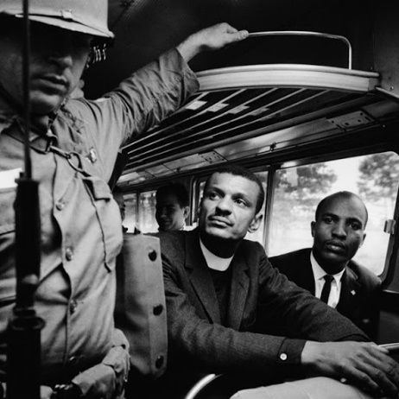
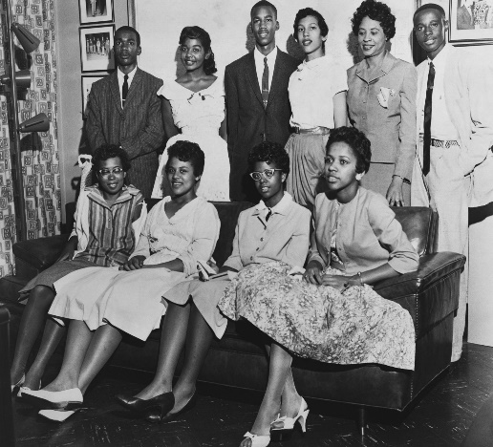
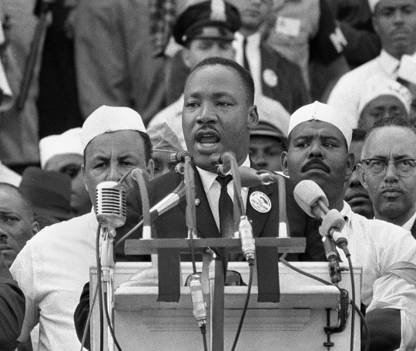

Contents
Big Picture 3
Zoom in 4
Knowledge Organiser 5
Lesson One-Segregation 6
Lesson Two-Attitudes in the South and the Murder of Emmett Till 7-8
Lesson Three-The Montgomery Bus Boycott 9-10
Lesson Four-Little Rock 11-12
Lesson Five-Exam Question 13-14
Lesson Six-The Sit Ins 15
Lesson Seven-Freedom Rides and Ole Miss 16-18
Lesson Eight-Birmingham 19-20
Lesson Nine-The March on Washington 21
Lesson Ten- Malcolm X and Black Power 22

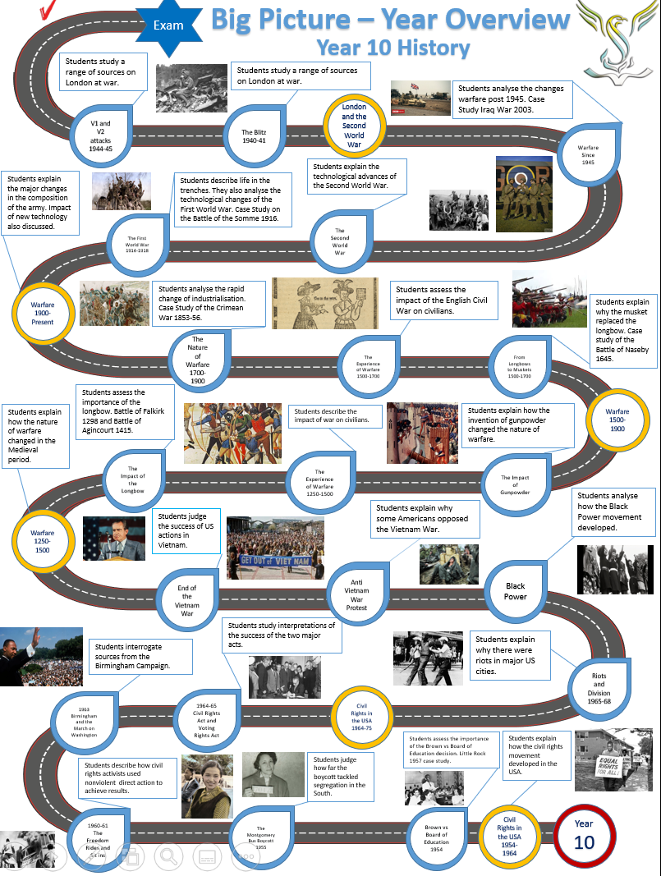
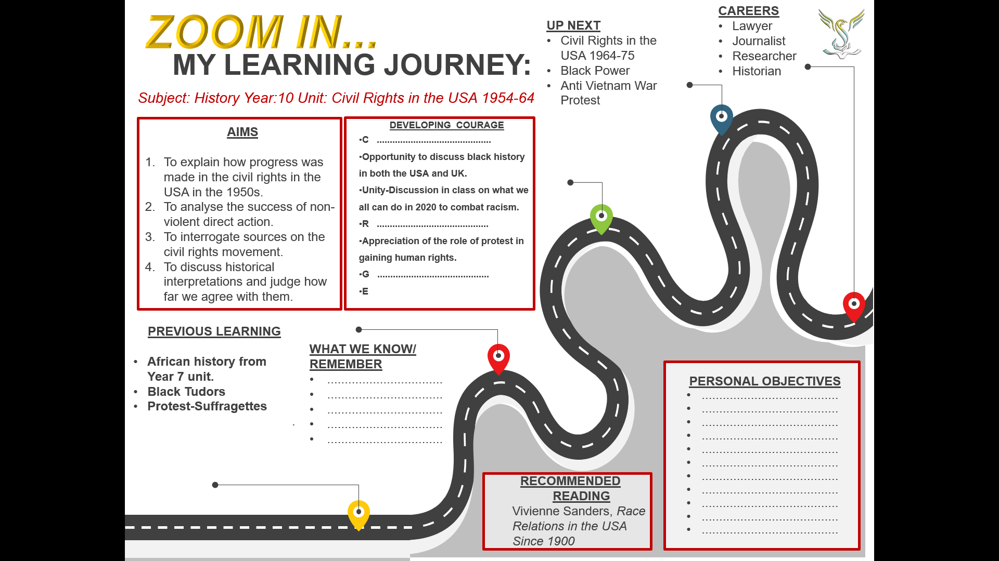
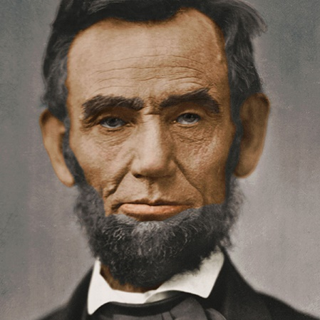
Knowledge Oragnaiser-Civil Rights in the USA
Abraham Lincoln
Background
The USA declared its independence in 1776. It had a population of 2.5 million and 20% of these people were black slaves. The founding fathers of the USA had said ‘all men were created equal’ however this did not apply to slaves. Many white Americans in the South of the USA became extremely rich from slave labour. Slavery became the backbone of the Southern economy.
Slaves were treated horrendously with no choice over where they lived, family life or culture. Salves were regularly beaten by their owners.
In 1863, Abraham Lincoln issued the Emancipation Proclamation which declared all slaves would be freed. In the following years, the lives of black people in the USA did improve on paper but equality was still very far away.

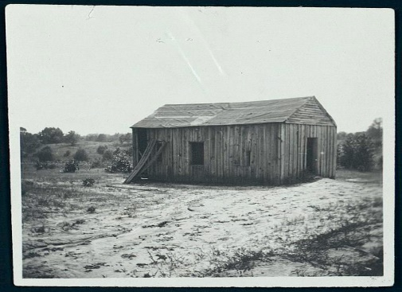
Civil Rights Groups
The NAACP-The National Association for the Advancement of Colored People
The NAACP fought for civil rights in the courts. They created a legal defense fund to fight cases for wrongly convicted black people. It also focused on appeals to get white murderers of black people convicted.
CORE-Congress of Racial Equality
CORE was based in the North and used nonviolent direct actions. Most members were white and middle class.
Church organisations were the centre of the black community. Many civil rights leaders were educated through the church. The church allowed black people to organise and use the church network to provide them with a platform.

Segregation
After the end of slavery, American states brought in many laws to segregate white and black Americans. All public facilities were segregated. Schools, theatres, churches, parks and schools were all divided. The Plessy vs Ferguson ruling of 1896 said this was fair as facilities were ‘separate but equal’. This was not the case as facilities for black Americans were far worse.
A school for black children showing the inequality in the USA.
Lesson One-Segregation in the South
Black Americans faced discrimination throughout the USA in the 1950s. In the North, black people had the lowest paid jobs, lived in the poorest parts of cities and had access to the worst facilities.
In the South, racist laws existed which were called Jim Crow laws. These laws segregated the black and white populations. Black Americans could not eat in white restaurants, had to sit at the back of the bus and were educated in segregated schools. In the USA states are allowed to make their own laws so could continue this practice.
Use Senaca to gain more knowledge on this topic then take the test.
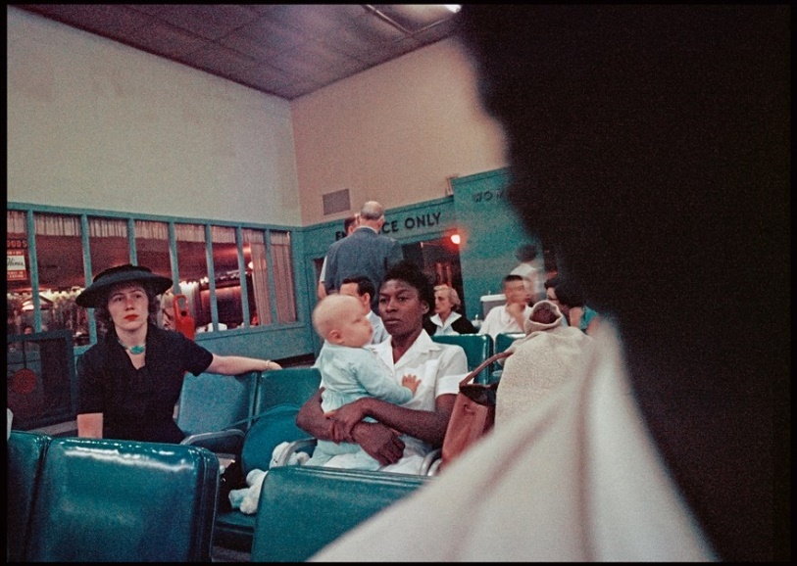
https://app.senecalearning.com/classroom/course/1e30b767-1284-4788-b136-0579c8147162/section/17b3cbaf-7fd4-4d96-943e-b159db144013/session
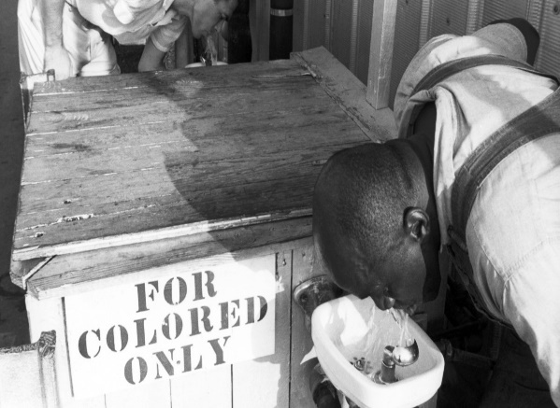
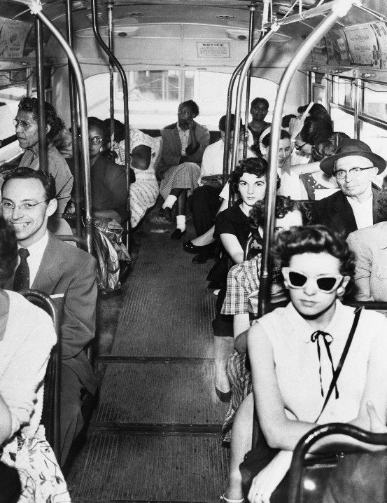
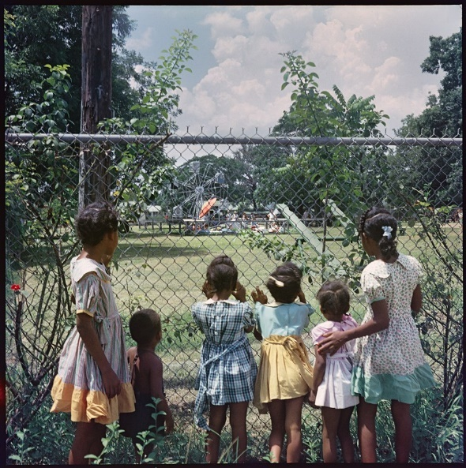

Key Question
What can you infer from these four sources about segregation in the South?

Attitudes in the South and the Murder of Emmett Till
Attitudes in the South towards black Americans had changed very little since the end of slavery. Many Southern white people were brought up to view black people as ‘lazy,inferior and unintelligent’ Most black Americans were employed on farms or in domestic service (serving white people and looking after their children).White people called black adults ‘boy’ or ‘girl’ to reinforce ideas of inferiority. Some white Southerners would not even shake hands with a black person.
The police and courts did not take crime against black Americans seriously. Many black people were beaten or even killed without their attacker ever being brought to justice. Some policemen and judges were ven members of the Ku Klux Klan (KKK). The KKK were a group who hated anyone who was not white, anglo saxon and protestant. They targeted jews, catholics and black Americans. They blew up homes of civil rights activits and committed murders in the Deep South.
The Murder of Emmett Till 1955
The level of injustice in the Deep South was demonstarted in the case of the murder of Emmett Till in 1955. Till was from Chicago and visited relatives in Mississippi. He told his Southern cousins about how different life was in the North. He said he had a white girlfriend so his cousins dared him to go and speak to a white lady in a nearby store.
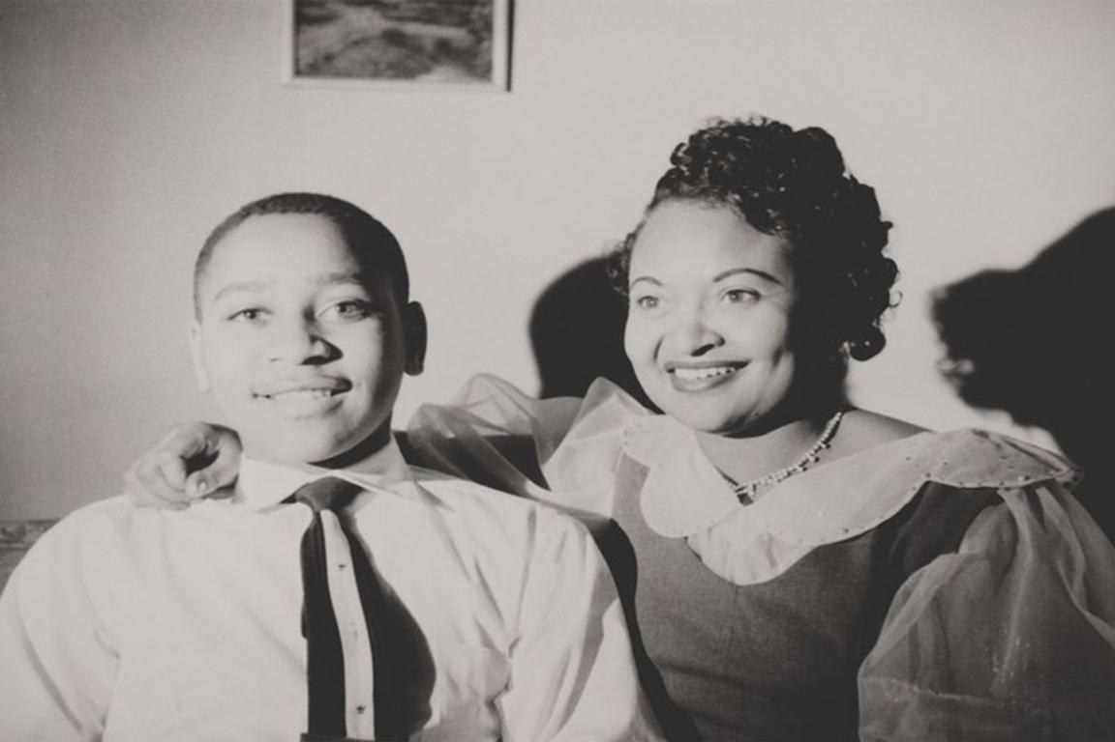
Emmett Till and his mother Mamie Till.
Till walked into the store bought some sweets and allegedly wolf whistled at the white lady. The lady was Carolyn Bryant who said she was scared and even went to her car to get a gun to protect herself. When Carolyn’s husband returned from a trip the next day she told him about the incident. Roy Bryant went with his half brother to Emmett’s uncle house. They forced Emmett into a truck. They beat him and shot him then threw him in a river with a heavy weight attached to his neck. His body was found three days later.
Mamie Till demanded that her son’s body was returned to Chicago and he would have an open casket funeral so the whole of America could see the horror of the racism that existed in the South. This led to huge publicity and shocked both black and white Americans.
When the trial of Roy Bryant and J.W Milam began the coverage was nationwide. The defendents were faced with an all white jury as black American were not allowed to be on a jury. The three black journalists who covered the story were told to go to a separate room to cover the case.
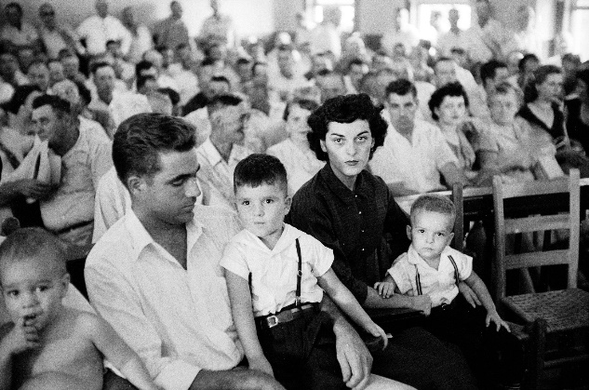
Roy and Carolyn Bryant with their children at the trial.

Despite overwhelming evidence that Bryant and Milam had committed the murder, the jury cleared them after an hour. The defendents even sold their story to a magazine for $3,500 where they admitted the murder. Emmett Till’s murder showed how racist the legal system was in the Deep South. Murders of black men were still committed in Mississippi.
For black Americans the Till case was a turning point. For many young people it was what motivated them to become involved in the civil rights movement. Across the USA young black people were determined to change the system they lived in. It also won support from liberal white people.

Key Questions
- How were nearly all black Americans employed in the South?
- How did the police deal with crimes against black people?
- Who did the KKK target?
- Why did Mamie Till insist that her son had an open casket funeral?
- Why was it not surprising that Bryant and Milam were not convicted?
- How did the Emmett Till case affect black Americans?
- ‘ The murder of Emmett Till created a lot of publicity but made no difference to the position of black Americans’. How far do you agree with this statement?

Lesson Three-The Montgomery Bus Boycott 1955-56
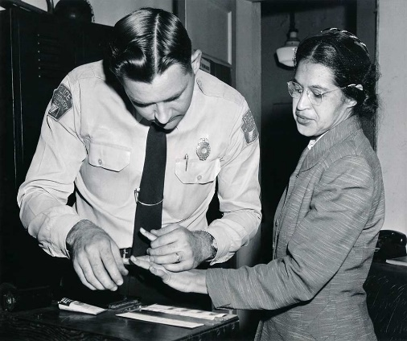
In the South the rules of segregation were clear to both black and white Americans. White people sat at the front of the bus and black people sat at the back. Black people had to pay for their fare at the front then get off the bus and board using the middle door. If there were no more seats for white people on the bus black people had to give their seat up.
On 1st December 1955, Rosa Parks refused to give up her seat when white people asked her to. This happened from time to time in Montgomery and if a black person did refuse to give up their seat the driver would drive to the nearest payphone and call the policewho would then arrest the person refusing to give up their seat. However this time Parks’ arrest inspured a boycott that became nationwide news.
The most important organisation in creating the boycott were the Women’s Political Council (WPC) led by Jo-Ann Robinson. They created 35,000 flyers and sent them across the town asking black people to boycott the buses. On 5th December 90% of black people in Montgomery boycotted the buses. Given this huge success the civil rights activits knew they could continue the boycott and gain even more publicty for their movment. The Montgomery Improvement Association (MIA) was created to ensure that the boycott was well organised and imprve the lives of black people.
Use the GCSE Pod video to answer the questions on the emergence of Martin Luther King during the boycott.
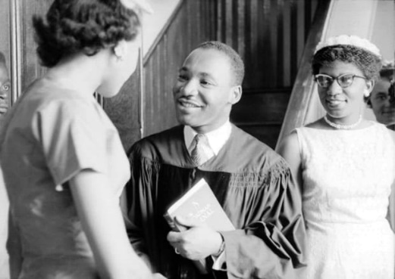

https://members.gcsepod.com/shared/podcasts/title/11799/72899
Key Questions
- How did King’s background help him to become a leader of the boycott?
- What did King do during the boycott?

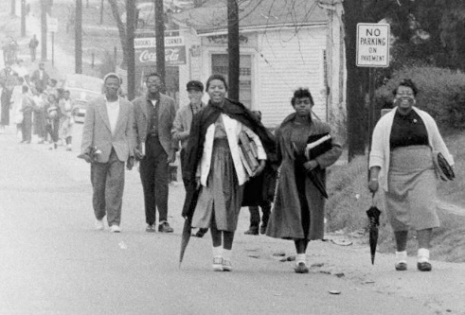
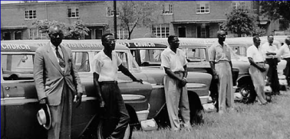
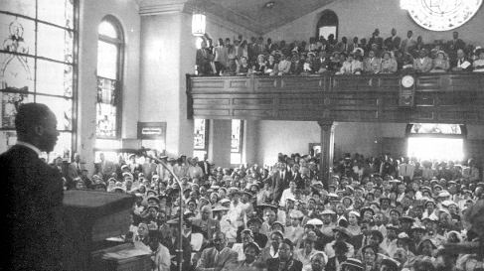
12 Mark Exam Question
Explain why the Montgomery Bus Boycott succeeded in achieving its aims.
- The MIA
- Martin Luther King
Results of the boycott
All buses in Montgomery were desegregated. By 20th December 1956, all bus services were integrated.
It showed that black Americans could organise a successful campaign using non-violence.
The success of a civil rights campaign relied heavily on creating publicity and gaining support from all Americans.
The bus company almost went out of business, losing $1million. This showed how the black community could cause change through economic boycotts of facilities.
There was a white backlash. The buses had been desegregated but nearly all other facilities were still segregated.
Car pools organised by the MIA helped boycotters get to work. Black Americans faced the threat of losing their job, going to jail and even bomb threats on their home. The church meetings held by King and other leaders brought the community together and encouraged people to continue the boycott. King’s inspirational speeches inspired black Americans everywhere. King’s home was bombed as the KKK and White Citizens Councils reacted to the boycott. King’s message of non-violence was clear and the boycott gained support.
The boycott succeeded because of the commitment of the black community. The WPC and MIA included everyone. When times were especially tough the church meetings and car pools made life easier for the black community of Montgomery. Even when MIA members and King were arrested for disrupting business the community paid King’s $500 fine.

Lesson Four-Little Rock 1957
Watch this video from GCSE Pod and answer the questions.
https://members.gcsepod.com/shared/podcasts/title/11798/72896
- How were schools organised before 1954?
- Why would southern governors keep white and black children apart?
- Describe the facilities of black schools in the south.
- Why did Thurgood Marshall think segregated schools should be made illegal?
- What did the Southern Manifesto say about school desegregation?

Timeline of events at Little Rock 1957
3rd September
Governor of Arkansas, Orval Faubus ordered 250 state troops to surround the school to stop black students entering. Eight of the nine students took the advice of Daisy Bates (NAACP organiser) and stayed home on the 3rd and planned to arrive together at the school on the 4th.
4th September
Elizabeth Eckford (pictured above) did not get the message and arrived alone. She was met by a white mob who shouted racist language and threatened her with violence. She was denied entry to the school and was led away by a white woman who saved her from the mob. 250 reporters and photographers were gathered outside the school. Pictures of Elizabeth Eckford were published in newspapers across the world and shamed the USA. The USA was supposed to be the leader of the free world but these pictures clearly showed that Black Americans suffered horrific racist abuse.
23rd September
After three weeks of little action President Eisenhower (right) ordered Governor Faubus to remove his troops from the school. Eisenhower had been so slow to react because he was concerned that more integration would make the white population even more angry and violent. He sent in his own federal troops to protect the black students to ensure they could get to school.
Rest of the year
The troops stayed until the end of term to ensure the students were safe. They even accompanied students between classes. The school year ended in May 1958 with Ernest Green graduating. Faubus then took the extreme step of closing every school for the 1958/59 academic year to stop integration.

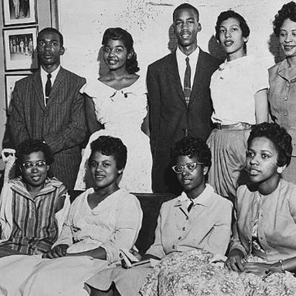
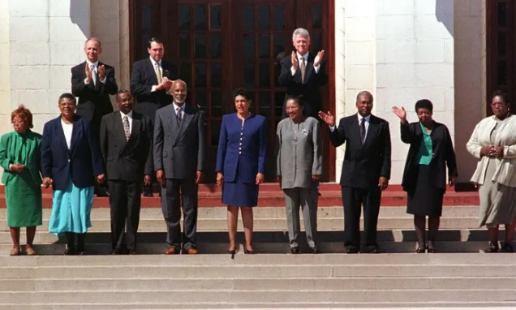

Questions

1)Why was it so difficult for black students to attend white schools even though the law said they could?
……………………………………………………………………………………………………………………………………………………………………………………………………………………………………………………………………………………………………………………………………………………………………………………………………………………………………………………………………………………………………………………………………………………

2)Why did the presence of the journalists and photographers force President Eisenhower to react to the crisis at Little Rock?

……………………………………………………………………………………………………………………………………………………………………………………………………………………………………………………………………………………………………………………………………………………………………………………………………………………………………………………………………………………………………………………………………………………

3)Do you think that Little Rock should be viewed as a success for the civil rights movement?
………………………………………………………………………………………………………………………………………………………………………………………………………………………………………………………………………………………………………………………………………………………………………………………………………………………………………………………………………………………………………………………………………………………………………………………………………………………………………………………………………………………………………………………………………………

Lesson Five- 8 Mark How Useful Question
Writing a how useful question involves several steps when studying historical sources. The first is NOP. NOP means nature, origin and purpose.
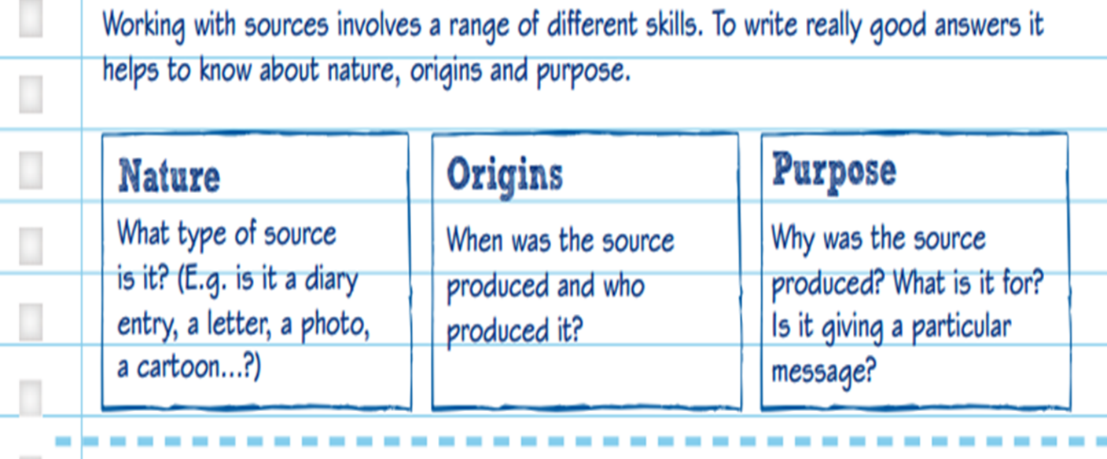
For example, if we had the Stewards Academy Newsletter the nature of the source would be a newsletter, the origin would be Stewards Academy in April 2020 and the purpose of the source is to inform pupils, parents and staff about what is happening in the school.
The next part is content. You must quote from the source or if it is a picture describe the picture.
The third part is own knowledge. Explain what you know about the event and how that fits together with the source. The information on the previous page will be a huge help in you explaining what you know about the sit ins.
Finally, explain how useful the source is for that specific enquiry. What can you learn about the sit ins from that source? Is it useful for finding out how sucessful the sit ins were?
You do this for each source. YOU DO NOT NEED TO COMPARE THE SOURCES.
This is your plan:
Source E Source F
NOP NOP
Content Content
Own Knowledge Own Knowledge
How Useful? How Useful?

Exam Question-Answer in your exercise books.
Study Sources E and F. How useful are Source E and F for an enquiry into integration in the Deep South?
8 marks
*Integration=Black and white children going to school together.
*Deep South=Southern states of the USA. Little Rock is in Arkansas.

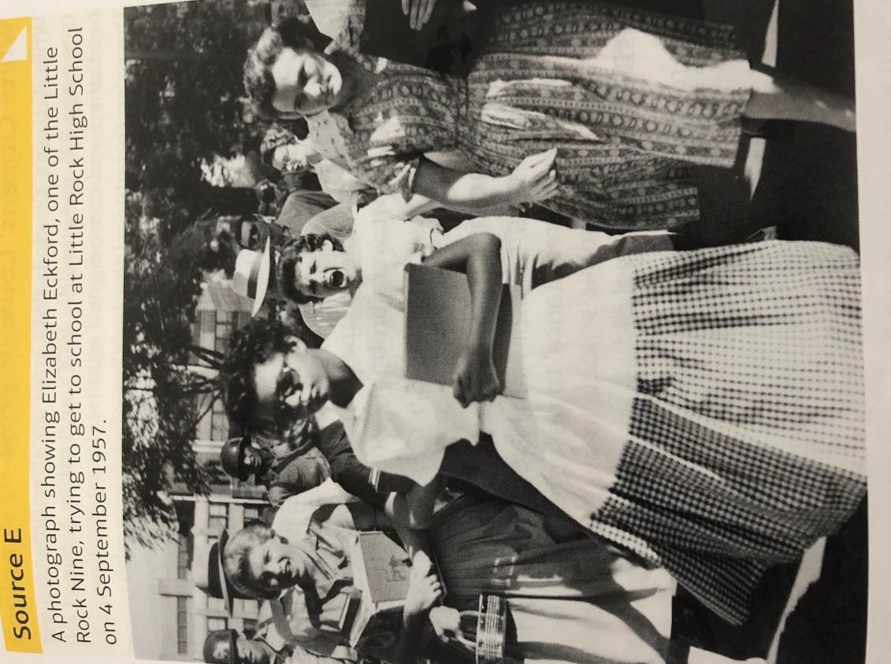

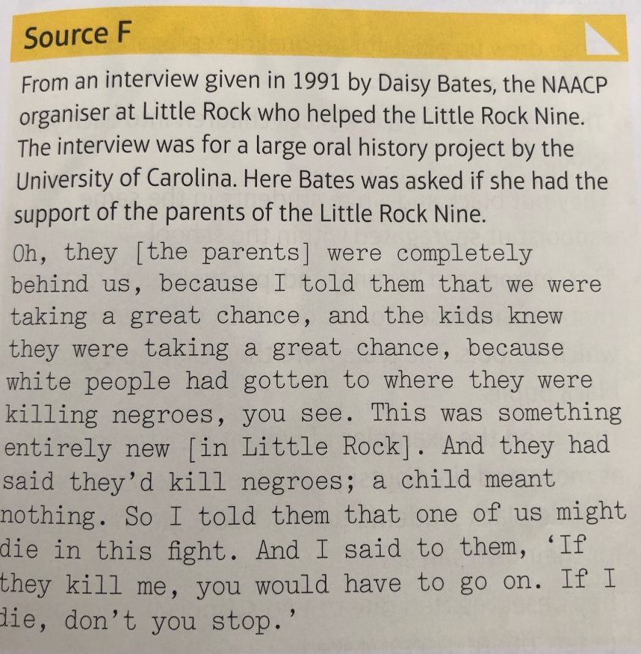
Highlight important information in this source that you can use to show how much resistance there was to schools being desegregated.

Lesson Six-The Sit ins
The next episode in the civil rights movement did not begin with King and SCLC but with students. Students in Greensboro North Carolina refused to leave the white area of the Woolworth’s Canteen. Initially only four students took part but the campaign grew rapidly. Soon the sit ins spread all over the South. Ella Baker was a member of King’s SCLC but she warned the students not to let King take over their protest.
The Student Non Violent Co-Ordinating Committee (SNCC) was formed and went on to become a significant part of the civil rights movement. Some white Southerners joined SNCC and CORE in the sit ins. These white Southerners were also attacked by those who wanted to keep segregation (segregationists).
By mid-1960,50,000 Americans were taking part in the sit ins. This led to increased publicity and support for the civil rights movement. Desegregating public facilities was the ultimate aim. As the protest grew so did the backlash from segregationists. Students were attacked as they sat in canteens. They were sworn at, beaten and had food and hot drinks poured over them. The news coverage of these attacks provided support for the students from across the USA. Black and white, northerners and southerners.
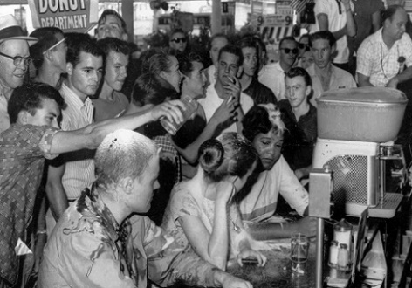
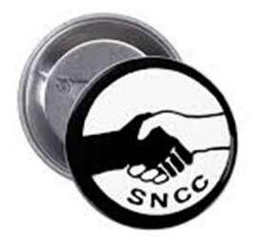

What were the results of the sit ins?
The tactic had spread to other cities and by the end of 1960 lunch counters had been desegregated in 126 southern cities.
Woolworths lost 20% business.
There were wade-ins at segregated swimming pools and kneel-ins at segregated churches.

Take the test on the Sit Ins 1960, Freedom Rides 1961 and Ole Miss 1962 https://app.senecalearning.com/classroom/course/1e30b767-1284-4788-b136-0579c8147162/section/4a33b266-18f4-4bea-87e7-36e129a3ec56/session
Lesson Seven-Freedom Rides 1961 and Ole Miss 1962
The Freedom Rides 1961
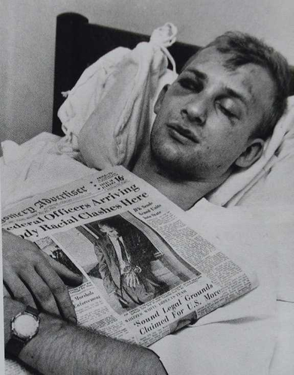
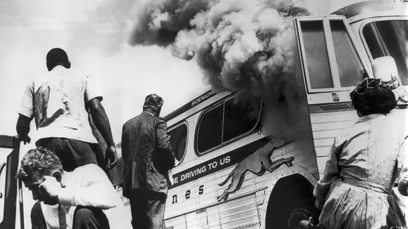
In 1961, the Congress of Racial Equality (CORE) wanted to challenge the segregation of bus facilities. Buses had been segregated after the Montgomery Bus Boycott In 1956. However, toilets and waiting rooms at bus terminals were still segregated. CORE activists decided to ride buses from the North to the South. The aim was to create a crisis that would then create publicity for the civil rights movement and put pressure on the government. The first bus had seven black and six white protesters. The protesters became known as the ‘Freedom Riders’. It was important for CORE to show the unity between black and white Americans.
When Southern governors such as John Paterson (Alabama) and Ross Barnett (Mississippi) spoke out against the Freedom Riders it encouraged many in the South to protest violently against their presence.
On 15th May 1961, the first bus reached Anniston, Alabama. Over 100 members of the KKK surrounded the bus, slashed its tyres and smashed the windows. Then a firebomb was thrown into the bus and the KKK held the doors shut. Many of the Freedom Riders thought they would die. Fortunately, a white policeman forced the doors open just before the petrol tank on the bus exploded.
Jim Zwerg-Injured after taking part in the Freedom Rides
Riders on the second bus arrived in Birmingham and were pulled off the bus and beaten up by the KKK. The police chief of Birmingham, Bull Connor even told policeman not to stop the KKK. Eventually the protesters were led to safety and got to their airport. The huge amount of press coverage from both Anniston and Birmingham was a massive challenge for the Kennedy government who had only been in power for four months.
The government were forced to protect the Freedom Riders who followed on from the first two buses. SNCC were now also involved and they continued the Freedom Rides. Over the Summer of 1961 there were 60 Freedom Rides. Many Freedom Riders went to jails in the south. All their efforts did secure a result though as Kennedy’s government promised to force to force Southern states like Alabama and Mississippi to desegregate their bus facilities. If the states did not agree, federal officers would be sent from Washington to ensure that facilities were desegregated. Once again, the combination of bravery from protesters, organisation from civil rights groups and publicity from the media forced the government to act.
https://www.youtube.com/watch?v=nAyfoyfLsnQ Watch the reunion of the Freedom Riders on Oprah
- Why were the Freedom Riders protesting if buses had been desegregated?
……………………………………………………………………………………………………………………………………………………………………………………………………………………………………………………………………………………………………………………………………………………………………………….
- What was the aim of the Freedom Riders?
………………………………………………………………………………………………………………………………………………………………………………………………………………………………………………………………………………………………………………………………………………………………………………
- Describe what happened in Anniston.
………………………………………………………………………………………………………………………………………………………………………………………………………………………………………………………………………………………………………………………………………………………………………………
- What role did Bull Connor play in helping the KKK?
………………………………………………………………………………………………………………………………………………………………………………………………………………………………………………………………………………………………………………………………………………………………………………
- What were the results of the Freedom Rides?
………………………………………………………………………………………………………………………………………………………………………………………………………………………………………………………………………………………………………………………………………………………………………………

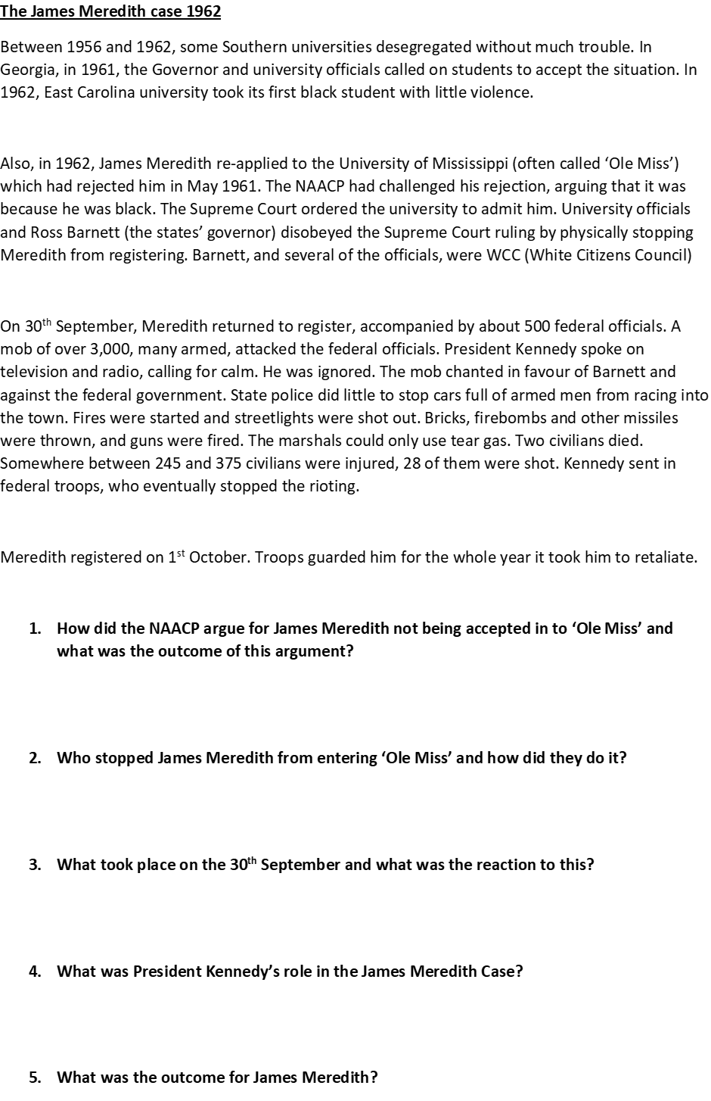
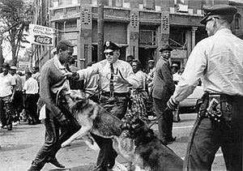
Lesson Eight-Birmingham 1963
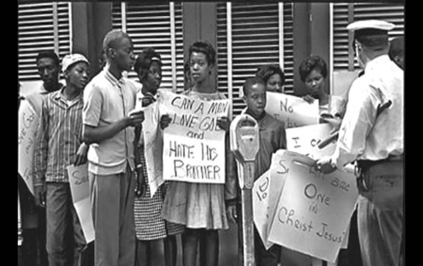
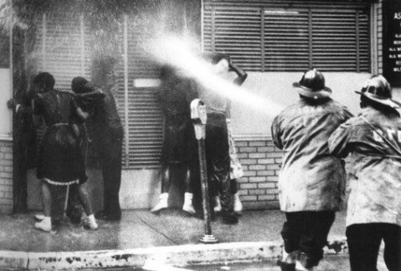

Events
On 2nd May 1963. School children were placed at the front of the march, due to the lack of adults and television footage of children being arrested for protesting peacefully would embarrass the Birmingham Police.
However, the Police Chief, Eugene 'Bull' Connor ordered the arrest of over 900 children between the ages of 6 and 18.
On the 3rd May 1963, Connor ordered water cannons and dogs to be used on the marchers. The news reports and photos of this event spread worldwide. The photo below shows Walter Gadsden, who was not even taking part in the protest, but was watching from the side of the road.
By the third day, many police and fire service men refused to attack the protesters as they saw how they were being portrayed in the media.
By the fourth day of the protest both sides were having second thoughts. King was worried about the safety of the demonstrators, while local businessmen were concerned about the negative publicity and the drop in trade.
Causes
In January 1963, Martin Luther King announced that he would lead a demonstration in Birmingham, Alabama.
He chose Birmingham specifically as it was one of the most segregated cities in the USA. It was notorious for police brutality and the local Ku Klux Klan was one of the most violent.
Birmingham was probably best summed up by the Governor, George Wallace who said, “segregation now, segregation tomorrow, segregation forever.”
Campaign C (for confrontation) was launched in Birmingham. It included sit-ins, mass meetings, peaceful protest marches and shop boycotts. Most of the adults that participated, were put in jail, including Martin Luther King.

Impact
Positives
An agreement was reached - in exchange for stopping the protest it was agreed that lunch counters, rest rooms and drinking fountains would be desegregated within ninety days.
Many more Americans saw civil rights as the most urgent issue for the USA.
The images from Birmingham were shown across the world and the USA was ashamed. The country was meant to be the leader of the free world but these images were the complete opposite.
President Kennedy promised a Civil Rights Bill which was the strongest commitment to tackling segregation to date.

Negatives
Some black Americans questioned the tactics used by civil rights campaigners. E.g. they felt it was wrong to put children in danger in protests.
Many black people began to feel progress was too slow.
Over 1,000 black students were expelled from school due to protesting or imprisonment and black homes and business were bombed.
Watch the PBS video on the children’s march to gain more knowledge on the Birmingham Campaign.
http://www.pbs.org/black-culture/explore/civil-rights-movement-birmingham-campaign/

Key Questions
- Why was Birmingham chosen as a place to protest?
- What actions were taken in campaign C?
- What tactics did Bull Connor use on the protestors? -Use the video for this question
- Do you think the Birmingham Campaign was a success?

Lesson Nine-The March on Washington 1963
After the Birmingham campaign President Kennedy promised a Civil Rights Bill that would aim to tackle segregation. The Civil Rights movement wanted to maintain the momentum that Birmingham had provided. On 28th August 1963, the March on Washington for Jobs and Freedom took place and it became one of the most important days in American History.
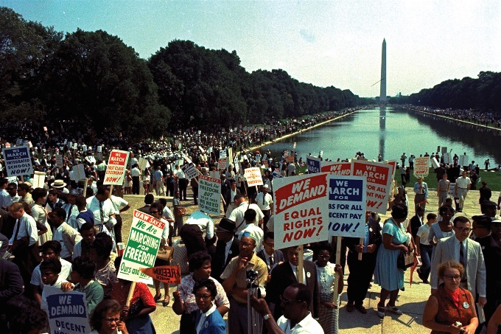
People from all over the USA marched on Washington DC. They gathered near to the White House and Congress. 250,000 people attended including 40,000 white Americans which was important to show the unity of the movement. The march was televised and was based around speeches by civil rights activists such as John Lewis (SNCC) and Martin Luther King (SCLC). It was King’s emotional ‘I Have a Dream’ speech the confirmed him as the leader of the civil rights movement.
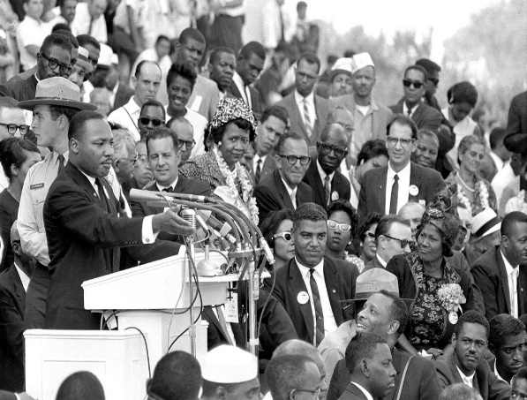

Martin Luther King, ‘I Have a Dream’ speech, 28th August 1963
I have a dream the one day this nation will rise up and live out the true meaning of its creed, “we hold these truths to be self-evident, that all men are created equal.” I have a dream that one day on the red hills of Georgia, sons of former slaves and the sons of former slaves owners will be able to sit down together at the table of brotherhood, I have a dream that one day even in the state of Mississippi, a state sweltering with the heat of injustice, sweltering with the heat of oppression, will be transformed into an oasis of freedom and justice. I have a dream that my four little children will one day live in a nation where they will not be judged by the colour of their skin but by the content of their character.
- Why did the Civil Rights movement choose to march just a few months after Birmingham?
- Why was the March on Washington a significant moment for all of the USA?
- Which part of the ‘I Have a Dream’ speech best represents what King was trying to achieve?
Lesson Ten-Malcolm X and Black Power

https://members.gcsepod.com/shared/podcasts/title/11799/72902
Watch the GCSE Pod video and answer the following questions:
- What united people in the Black Power movement?

- Why did the Black Power movement not agree with King’s non-violent tactics?

- Why was Malcolm X an important figure?

- Why was Malcolm X criticised?

- Why did X’s views change?

- Why was Stokely Carmichael an important figure?

- Describe the Black Panthers and their aims.

- How successful were the Black Panthers?

