Year 10 History Blended Learning Booklet
The Vietnam War 1954-75

Aim to complete two lessons each week. Write out the title and LI and then complete the tasks.
All video links are online using the ClassCharts link.
Upload all work onto ClassCharts for feedback.

Name:
Form:
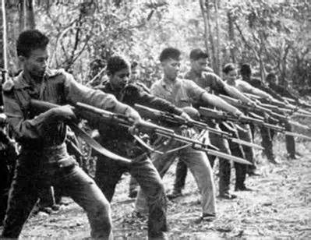
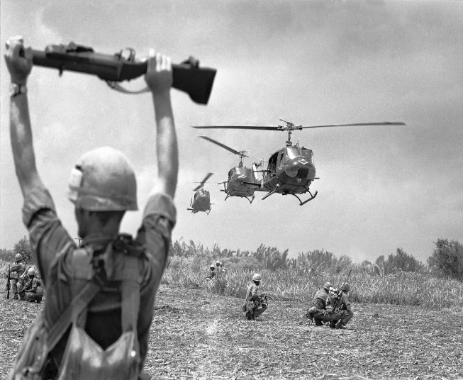
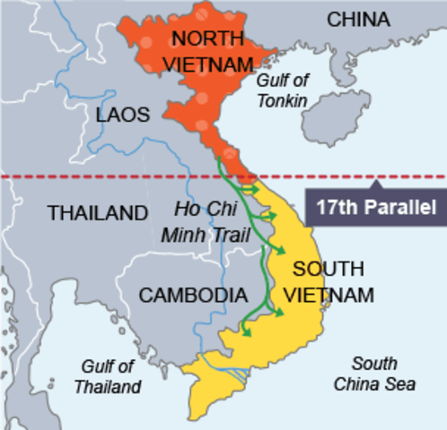

Contents
Big Picture 3
Zoom in 4
Knowledge Organiser 5
Lesson One-The End of French Rule 6
Lesson Two-The Domino Theory and US Involvement 7
Lesson Three-Diem 8
Lesson Four-Johnson and the Escalation of the War 9
Lesson Five-Vietcong Guerrilla Tactics 10
Lesson Six-US tactics 11
Lesson Seven-The Tet Offensive 12
Lesson Eight-Vietnamisation 13-15
Lesson Nine-Opposition and support for the war 16
Lesson Ten- The War Ends 17

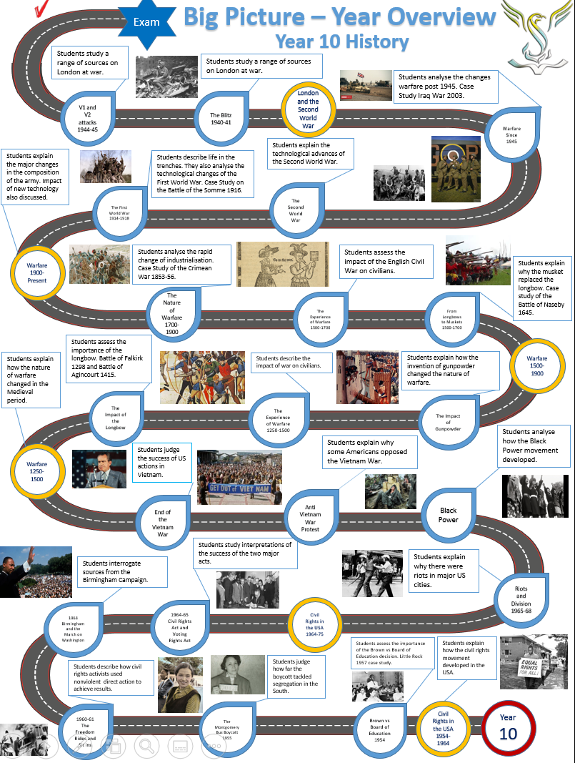
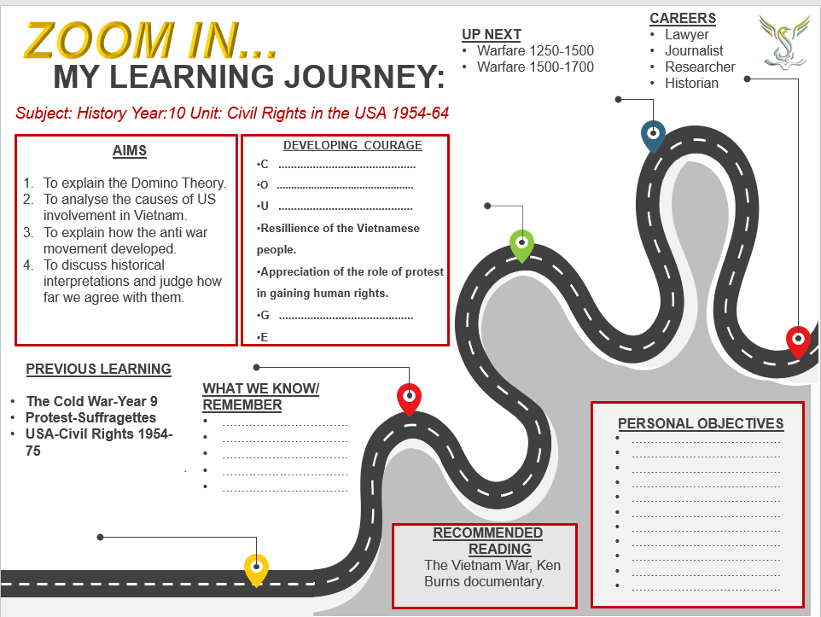

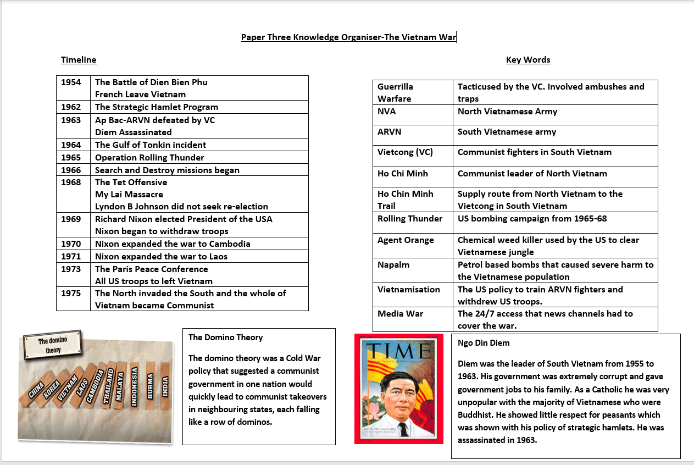
Lesson One-The End of French Rule
Vietnam was part of the French Empire. It was part of Indochina along with Cambodia and Laos. After the Second World War the French wanted to re-establish their control of the country. The Vietnamese people wanted independence. In 1954 a crucial battle against the French at Dien Bien Phu led to the end of French control. The Vietminh were led by Ho Chi Minh who wanted to make the country communist.
Answer the key questions using the GCSE Pod video
https://members.gcsepod.com/shared/podcasts/title/12081/74699
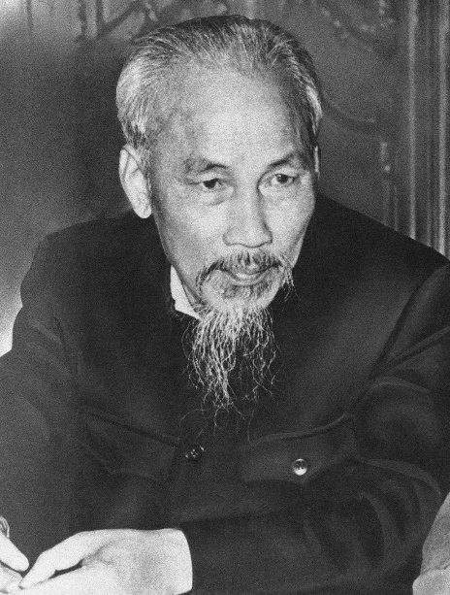
Key Questions
- What was the French plan about how to fight the Vietminh?
- What mistakes did the French make?
- How did the French public react?
- What were the details of the agreements made at the Geneva conference? (Provide at least three)
- Why did the South Vietnamese feel betrayed by the USA?
- Why was Ho Chi Minh delighted with the agreements?
- Why did the USA approve of Diem as the leader of South Vietnam?
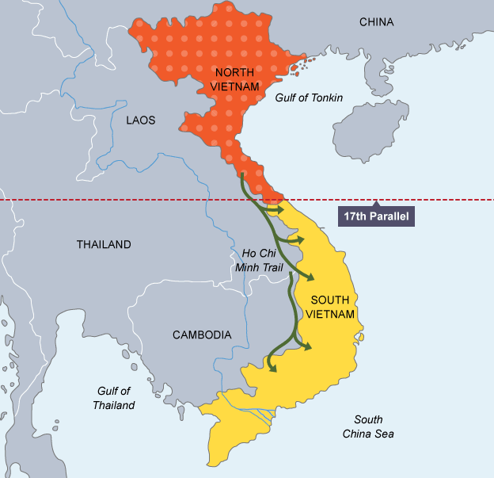

Lesson Two-The Domino Theory and US Involvement
The Domino Theory was the most significant reason for US involvement in Vietnam. The USA feared the spread of communism. It had spread throughout Eastern Europe in the 40s and 50s and now the US feared it would spread throughout Asia. In 1949, China turned communist under Mao Zedong.
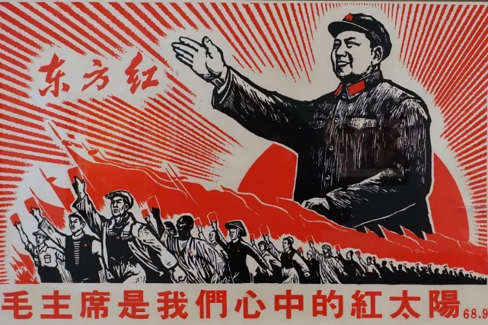

Watch the GCSE Pod video and answer the questions https://members.gcsepod.com/shared/podcasts/title/12081/74700
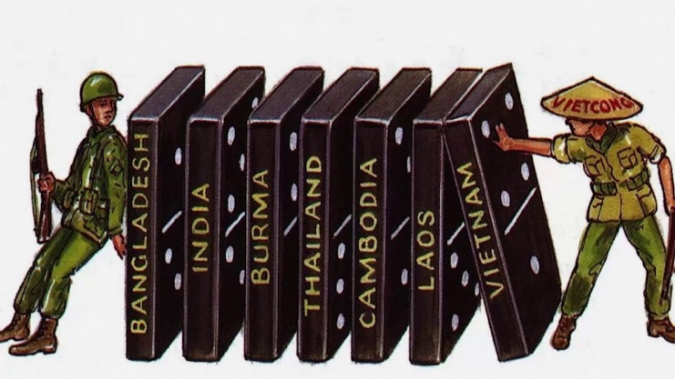

1.Describe the Domino Theory
2. How did the American Public feel about anti-communist policies?
3.What had happened to Korea in the early 1950s?
4. Who came up with the phrase ‘Domino Theory’?
5. How did Eisenhower support South Vietnam?
6. Why was the USA criticised?
7. How many American advisers were in Vietnam in 1961?

Lesson Three-Ngo Dinh Diem
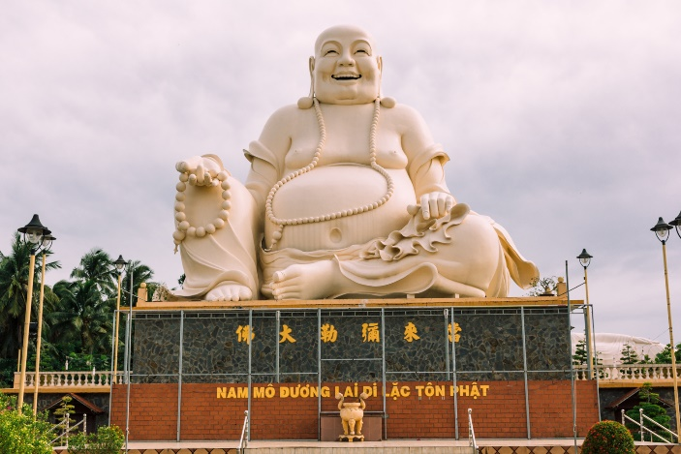
Emperor Bao Dai ran South Vietnam in 1954 but was replaced by Ngo Dinh Diem in 1955 when elections were held. Diem did not have the complete support of South Vietnam. There were still many communits in the South. Diem was Catholic and most of South Vietnam was Buddhist. Diem gave people in his family the top jobs in government. Diem’s government was based in the South Vietnamese capital Saigon and struggled to gain support from those in the countryside.
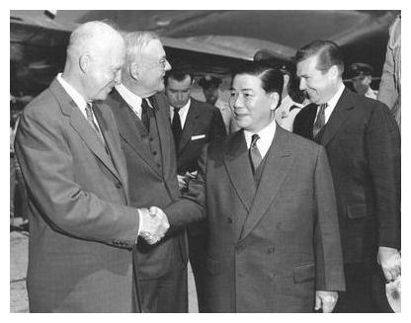
The Strategic Hamlet Program
Due to the growth of the Vietcong (communists in the south) the Diem government created the Straetic Hamlets Program with the support of US advisers. Vietnamese villagers were removed from their ancestoral homes and the places where the grew crops. They were placed in small villages surrounded by barbed wire and guarded by the South Vietnames army (ARVN). The idea was to keep the villagers away from communists. The villagers were furious at being moved from their homes and not being supllied with enough food by Diem’s government. It was a disaster and probably increased support for the communists.
Answer the questions below using the GCSE Pod video and the information on this page.
- Who ruled North Vietnam?
- Who ruled South Vietnam?
- Where did Diem visit?
- What was SEATO?
- Why did Diem refuse to hold free elections in 1956?
- What happened to Diem’s political opponents?
- How did Diem anger the people of Vietnam?
- How did Diem discriminate against Buddhists?
- What did Dulles say about Diem?
- Why was the Strategic Hamlet Program a disaster for Diem?
https://members.gcsepod.com/shared/podcasts/title/12081/74701

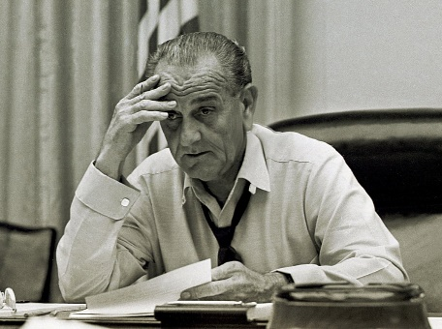
Lesson Four-Escalation under Johnson
Lyndon B Johnson became President of the USA in November 1963 after John F Kennedy assassination. The Vietnam War would define Johnson’s presidency. In 1964, Johnson escalted the war after the Gulf of Tonkin incident:
Two US Navy ships, the Maddox and the C Turner Joy patrolled the Gulf of Tonkin.
2nd August The USS Maddox radar showed three North Vietnamese torpedo boats. The North Vietnamese boats fired: the Maddox fired back and withdrew when air support arrived.
4th August During a bad storm, the Maddox and C Turner Joyreported more attacks from torpedo boats and claimed to have sunk two of them. However, there was confusion if the attack had happened at all. Johnson ignored the confusion and orded US planes to bomb North Vietnamese targets.
5th August Johnson told US Congress about the attacks. He asked them to give him the power to stop further attacks on US forces.
7th August Congress passed the Gulf of Tonkin Resolution. It gave Johnson the power to take whatever steps he wanted to stop attacks. He did not have to ask congress for permission from now on. He could send troops to Vietnam without offically declaring war.
The End of 1964
-20,000 US advisers in Vietnam.
-216 US troops dead
-Johnson had power to send troops to Vietnam.
-$400-500 million spent of Vietnam
Watch the video and answer the questions below
https://members.gcsepod.com/shared/podcasts/title/12081/74702
- How did Johnson describe Vietnam when he took over from Kennedy?
- Why was the Gulf of Tonkin incident significant?
- Why was the attack at Pleiku an important step in support for the war?
- Why was Johnson careful not to officially declare war in 1964?

Lesson Five-Vietcong Guerrilla Tactics
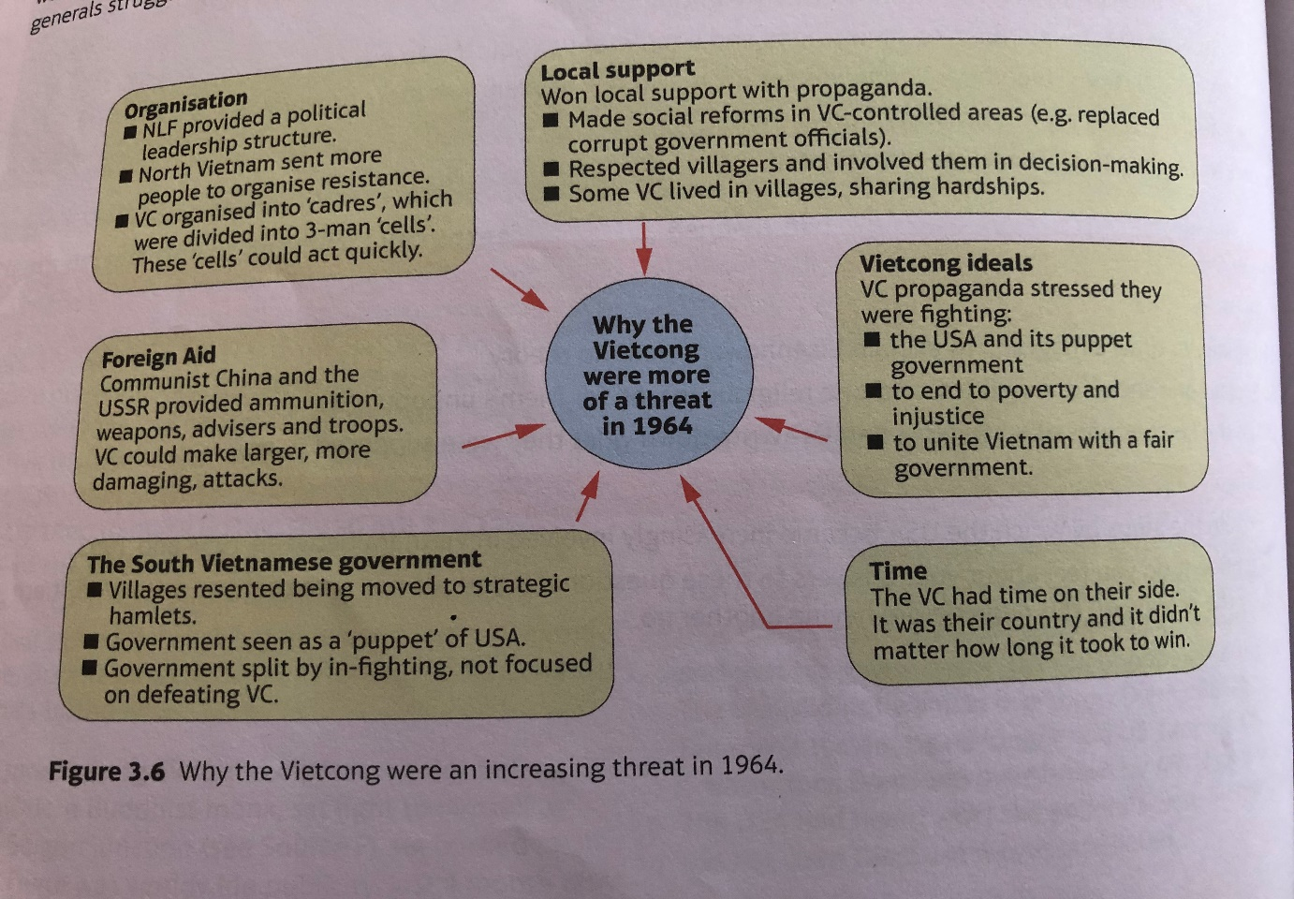

Using the diagram above and the GCSE Pod video, answer the questions below

https://members.gcsepod.com/shared/podcasts/title/12081/74705
Key Questions
- Why were the Vietcong such a threat by 1964?
- Why was it so difficult for the South Vietnamese government to win support?
- Who were the NVA?
- Who were the VC?
- Why were the guerrilla tactics that Vietcong used so difficult for the US and ARVN to stop?
- What disadvantages did US marines have in jungle warfare?
- What was the impact of traps on US morale?
- Why did the US bomb the Ho Chi Minh Trail?
- Why did US tactics do more harm than good?
Lesson Six-US Tactics-Rolling Thunder/Search and Destroy
Rolling Thunder was a bombing campaign of North Vietnam. Johnson did not want to escalate the war too much, so he instructed the air force to bomb near the South Vietnamese border and to avoid the North Vietnamese capital of Hanoi. Johnson also instructed the air force to avoid Haiphong which was the port where supplies from the USSR were delivered. He did not wan to start a wider war.
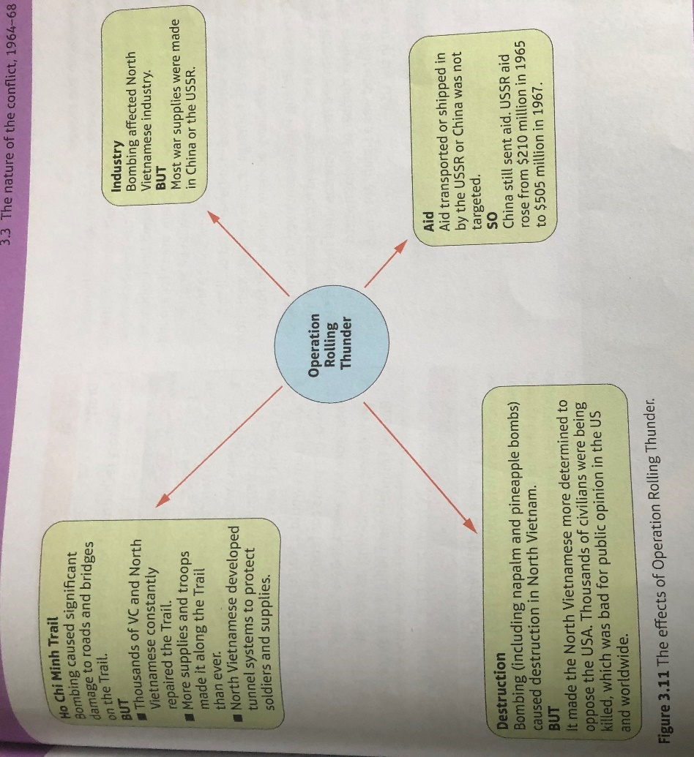
Johnson targeted the Ho Chi Minh trail to stop supplies being taken to the Vietcong in the South. He also targeted North Vietnamese industry, but this was limited and made little impact.

Key Questions
- Do you think Rolling Thunder was a success?
GCSE Pod video https://members.gcsepod.com/shared/podcasts/title/12081/74706
- What was Search and Destroy?
- How did US forces react when they suspected villagers of belonging to the Vietcong?
- What happened at My Lai in March 1968?
- How did Search and Destroy missions help the North Vietnamese?

Lesson Seven-The Tet Offensive
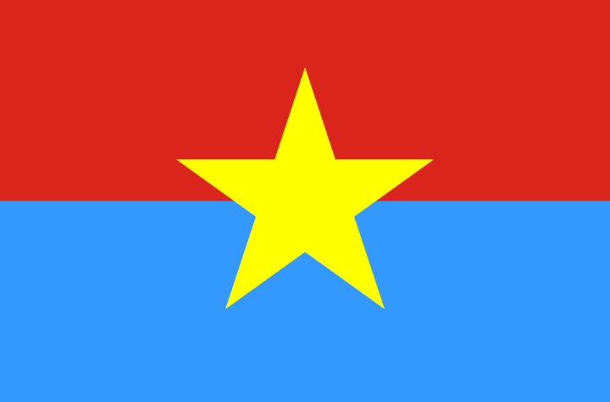
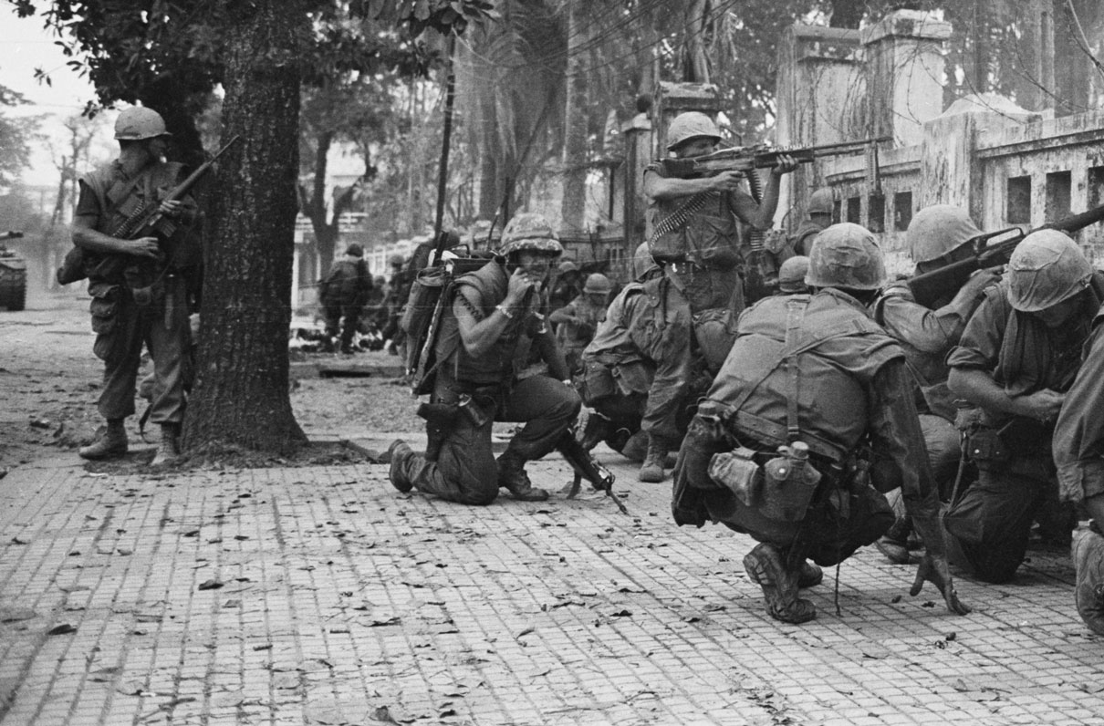

The Tet Offensive was a series of attacks by the NVA and VC over the Tet Lunar New Year. The attack was unexpected for two reasons. The US and ARVN did not expect the NVA and VC to attack over the holiday period and the tactics used were on a huge scale and very different from the guerrilla warfare that the US and ARVN troops expected.
84,000 communists took part and the start of the offensive was very successful. The NVA and VC got into the US embassy which was supposedly the safest place in Vietnam. The sight of the VC in the US embassy was shown on US television and clearly showed that the US was not winning the war like the Johnson government had said.
Key Questions
First Video https://members.gcsepod.com/shared/podcasts/title/12081/74708
- How many US troops were in Vietnam by 1968?
- What was Tet?
- How did Ho Chi Minh surprise the USA and ARVN?
- What happened at Khe Sanh?
Second Video https://members.gcsepod.com/shared/podcasts/title/12081/74709
- Why was the attack on the US embassy so shocking for the US public?
- Why was the Tet Offensive a turning point for how the US viewed the war?
- Why was a military victory over the communists not enough for the US?
- How was President Johnson affected by the Tet Offensive?
- How did the Tet Offensive affect the VC?
- Why did Ho Chi Minh’s hopes of an American withdrawal in 1968 not happen?

Lesson Eight-Nixon and Vietnamisation
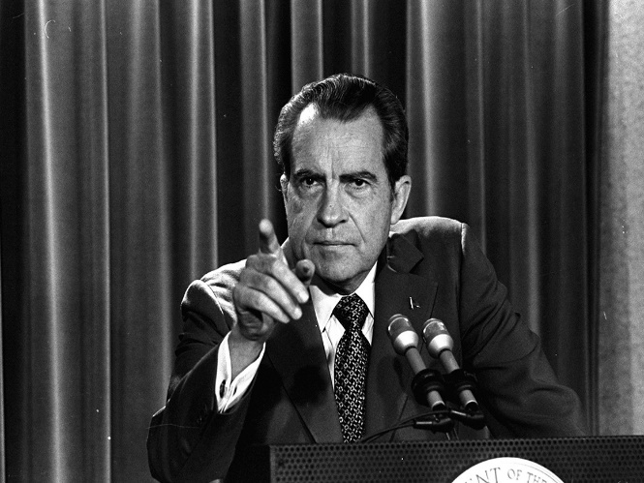
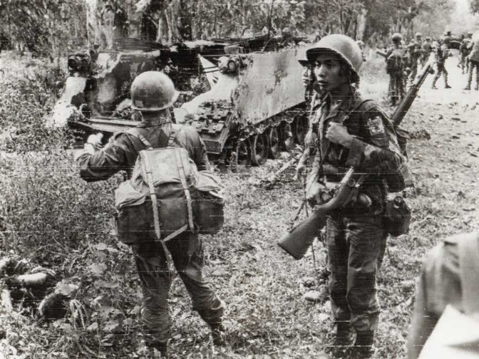
The Vietnam War exhausted Lyndon B Johnson. He did not seek re-election in 1968. Richard Nixon won the presidency and became President of the USA in January 1969. Nixon introduced Vietnamisation. This word meant that the USA would withdraw troops from Vietnam without making it look like they had been defeated. The idea was to shift the fighting and casualties from US troops to the South Vietnamese army (ARVN).
Vietnamisation
- US troops were to withdraw
- The ARVN was to provide its own officers
- The US would still provide training and equipment
- The US withdrawal would not leave South Vietnam at the mercy of the NVA and VC
- South Vietnam would remain and independent country.

 | 1968 | 1970
ARVN troops | 820,000 | 970,000
US troops | 536,000 | 335,000
ARVN deaths | 28,000 | 24,000
US deaths | 16,000 | 6,000
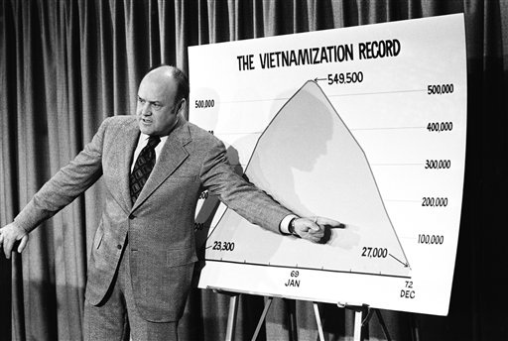

Partial Success
Vietnamisation succeeded in its most basic aim. There were fewer US troops in Vietnam and fewer deaths.
Many people said that US troops were withdrawn too quickly and the ARVN were not well trained enough to combat the NVA and VC.
From the point of view of many in the US Vietnamisation was welcomed as it meant fewer young American men returning home wounded or dying on the battlefield in Vietnam.
Watch the GCSE Pod video on Vietnamisation
https://members.gcsepod.com/shared/podcasts/title/12081/76419
- Provide the key statistics for 1969
- Why was Nixon successful in the election?
- How did the Nixon Doctrine reduce the commitment of us troops?
- Why was Vietnamisation a huge risk?
- How did US generals feel about Vietnamisation?
- Why did Vietnamisation fail?
- What happened in March 1972?
Exam Question
How far do you agree with interpretation 1 about the success of Vietnamisation?
Explain your answer using interpretations 1 and 2 and your own knowledge of the historical context.

Plan
Paragraph 1-Interpretation 1-Success
Use the statistics in the interpretation and explain how they could be viewed as a success.
Use your own knowledge explaining how Vietnamisation was welcomed by many Americans
Paragraph 2-Interpretation 2-Failure
Use the doubts raised in interpretation 2
Own knowledge of the weakness of the ARVN

Paragraph 3-Own knowledge on failures
US troops-lack of discipline and motivation/fragging/drug use
Training of the ARVN and equipment
The Vietnamese government
Strengths of the NVA and VC
Conclusion-How far do you agree?
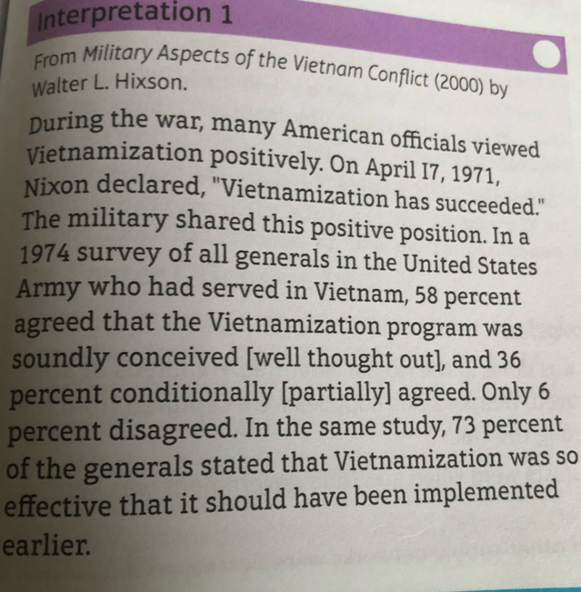

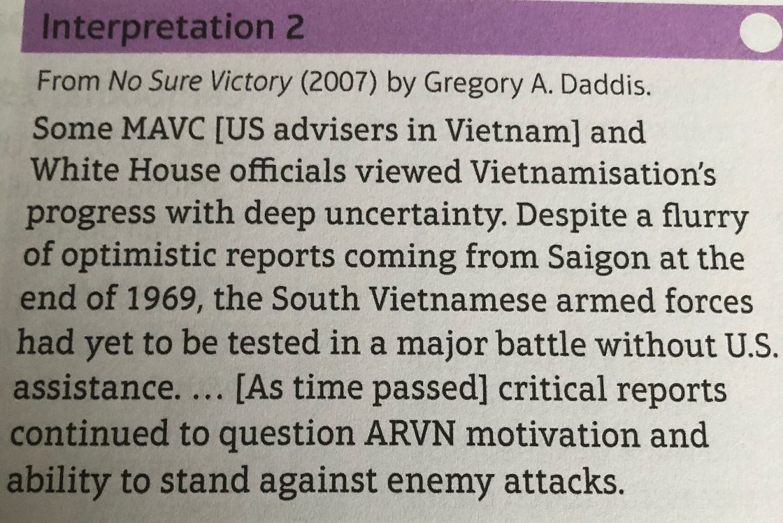

Lesson 9-Opposition to the War
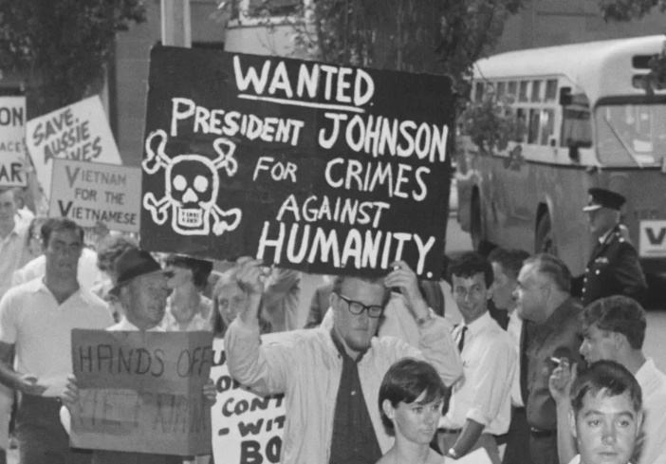
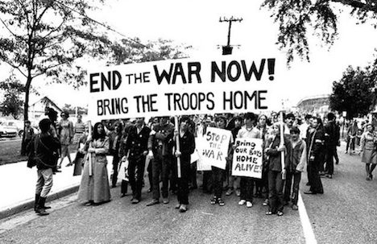

Watch the video and answer the questions below: https://members.gcsepod.com/shared/podcasts/title/12082/74711
- Why did the US public support wars against Communism?
- Provide three causes of opposition to the war
- What role did students play in protesting against the war?
- What was the draft?
- Why did many American hate the draft?
- How could you avoid the draft?
- How did the draft laws affect African Americans?
- Describe what happened to Muhammed Ali when he refused the draft?
- Explain how the media increased opposition to the war
- What percentage of the American public turned against the war by 1967?

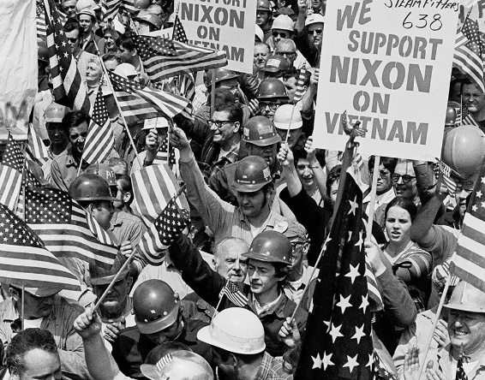
Support for the war- https://members.gcsepod.com/shared/podcasts/title/12082/76428
- What were the features of a typical Vietnam supporter?
- Why did many support the war?
- How was communism viewed by the US?
- Who were the silent majority?
- Who were the hard hats?

Lesson Ten-The War Ends
The USA wanted to bring the war to an end from 1968 onwards. Nixon had made an election promise to get troops home. Paris Peace talks started in 1968 but ended with no agreement. The North wanted a unified Vietnam run on a communist basis. The US wanted South Vietnam to remain independent.
North Vietnam agreed to secret peace talks in 1970 as they were worried aid from the USSR and China would end. The USA entered these talks without even informing the President of South Vietnam Thieu.
Nixon tried to strike the balance between ending the war and gaining favourable terms for the US and South Vietnam. Congress had cut funding for the war and the American people were tired of the war.
The North Vietnamese launched an Easter Offensive in 1972. 120,000 North Vietnamese troops invaded the South but the ARVN and US air support saw them off. Nixon responded to this with Operation Linebacker. This time there would be no limit on what the US could bomb. They severely disrupted supplies from the USSR and China. The Chinese encourage the North Vietnamese to negotiate for peace. Both sides realised this war could drag on for years. There was no victory in sight for the US and the astronomical cost of the war could no longer be tolerated.
The Paris Peace Accords 27th January 1973
- All countries to accept Vietnam as a single unified country. New government to be elected with international supervision.
- Army of South Vietnam to remain but no more aid from the USA
- All US troops, equipment and advisers to be withdrawn in 60 days
- The US government could not interfere with Vietnamese politics
- Prisoners of war on both sides would be returned in 60 days
Cost of the war for the USA
$167 billion
303,704 wounded
58,220 US dead
Cost of the War South Vietnam
The economy of South Vietnam collapsed as so many South Vietnamese relied on the US for jobs.
The VC were strong as Thieu continued to make the same mistakes of working with the communists.

