Year 10 English

Blended Learning Booklet
Spring A
‘Rising Tension’ Language Paper 1
Name:
Form:
Class Teacher:



Contents
Lesson | Page | Tick when complete
Lesson 1: How do you summarise a text? | 7
Lesson 2: How do I generate ideas? | 9
Lesson 3: How does the writer achieve their intentions? | 10
Lesson 4: Why use sensory language? | 12
Lesson 5: Why is vocabulary choice significant? | 14
Lesson 6: How do you evaluate writer success? | 17
Lesson 7: What makes a narrative successful? | 19
Lesson 8: How does language reveal a writer’s perspective? | 20
Lesson 9: What are the different sentence types? | 24
Lesson 10: How can you use structure to create an effect? | 25
Lesson 11: How do we use punctuation to achieve an effect? | 27
Lesson 12: Assessment Preparation (planning) | 28
Lesson 13: Assessment | N/A
Lesson 14: How do we create a detailed evaluative response? | 29
Homework | 35
SALs

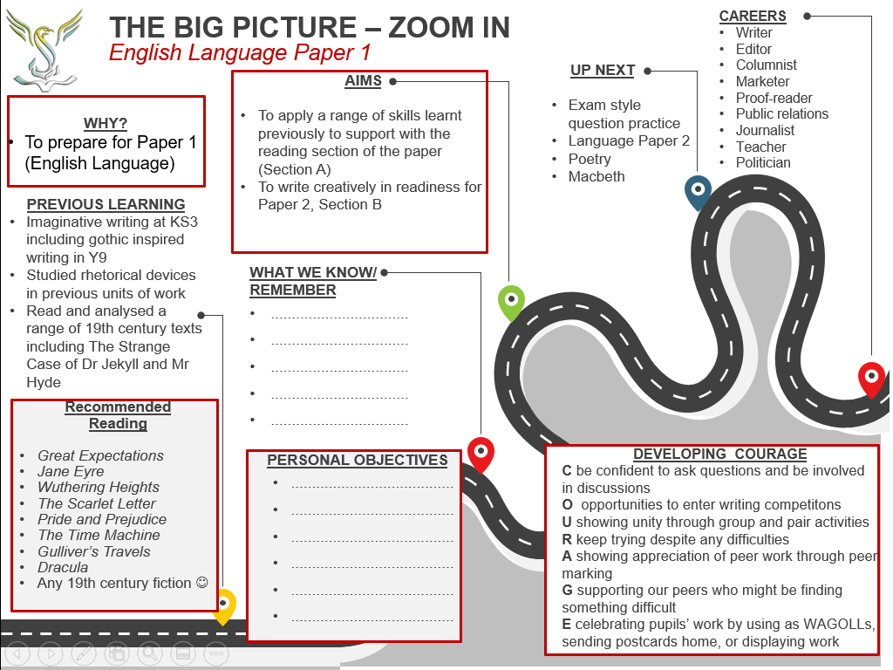

KNOWLEDGE ORGANISER: English Language Paper 1 (Section A: 19th Century Fiction – Reading)
Here you have one text which will be an extract from a 19th century story.
Section A: Reading (60 mins): 10 minutes to read the extract twice & annotate carefully to make sure you understand it.
Make sure you read each question carefully and underline the command words and from which lines of the extract.
Question 1 | Question 2 | Question 3 | Question 4
1 mark = 2 minutes  Box-up the lines in the extract.  Identify the answer and write this as a quotation.  Be specific! | 2 marks = 4 minutes  Box-up the lines in the extract.  Identify two answers. The answer might not be explicit, and you may have to provide inferences and deductions based on what it says in these lines.  Use your own words or quotations from the text. | 6 marks = 12 minutes  Box-up the lines in the extract.  Use quotations from this part of the extract that can prove the idea posed in the question.  Comment on vocabulary choices (zoom-in), language techniques and use subject-terms including word classes to help you explain how the writer creates an effect on the reader.  Comment on the structure of this part of the extract.  Say a lot about a little!  Use the PETER paragraph structure if this helps you.  Make sure you give an example of both language and structure to move out of Level 1. | 15 marks = 30 minutes  You should consider the whole extract for this question. Think of a bird’s eye view of the extract.  Use lots of examples from across the whole extract by providing relevant quotations.  Evaluate the settings, people, events, attitudes and themes.  Use a range of evaluative language.  Use the PEE paragraph structure if this helps you.  It is best to agree that the writer has been successful, rather than explain why they were not!  Language for evaluation:  The writer successfully highlights…  He/she comments on…  …effectively makes it sound as though…  …makes the point…  …is made to sound…  The reader will agree because…  The writer makes the reader feel…
Language for analysis:
This makes the reader think/feel/imagine…
This helps create the impression of…
This implies…
This indicates…
Suggesting that…
Which could highlight…

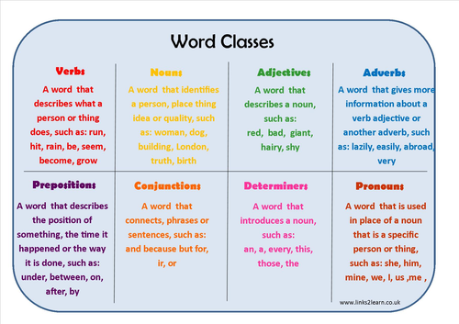
Language features to comment on:
- Vocabulary choices – ‘zoom-in’ on a specific word. Why has the writer used this word here? Label using its word class.
- Figurative language e.g. metaphor, simile, pathetic fallacy, personification, symbolism
- Phonetic language e.g. onomatopoeia, alliteration, assonance, sibilance, monosyllabic
- Tone: general mood or attitude of a piece if writing
- Imagery: language that appeals to the senses to create an idea/image in the reader’s mind

Sentence structure to comment on:
Sentence Types:
- Declarative: makes a statement and ends with a full-stop.
- Imperative: used to issue a command or instruction, make a request, or offer advice
- Interrogative: asks a direct question and is punctuated at the end with a question mark
- Exclamative: used to express strong feelings, strong emphasis or emotion and is punctuated at the end with an exclamation mark
Sentence length e.g. long complex sentences or short simple sentences
Other features of sentence structure e.g. monosyllabic sentences, embedded clauses, listing
Structure features to comment on:
- Comment on why the writer chose to order the events in this way: what happens when? What is the effect of this?
- Changes and developments throughout the extract e.g. at the start… in the middle… later on… by the end…
- Pace: the speed at which a story is told
- Narrative perspective: viewpoint the story is told from e.g. first person, second person, third person
- Building and relieving tension: How and when does the writer build or relieve tension? Why at these moments?
- Contrast/Juxtaposition: two opposing ideas/images/attitudes
- Dialogue: speech and conversation between characters
- Role reversal: where characters switch roles. For example, this could be a power shift
KNOWLEDGE ORGANISER: Language Paper 1 Section A
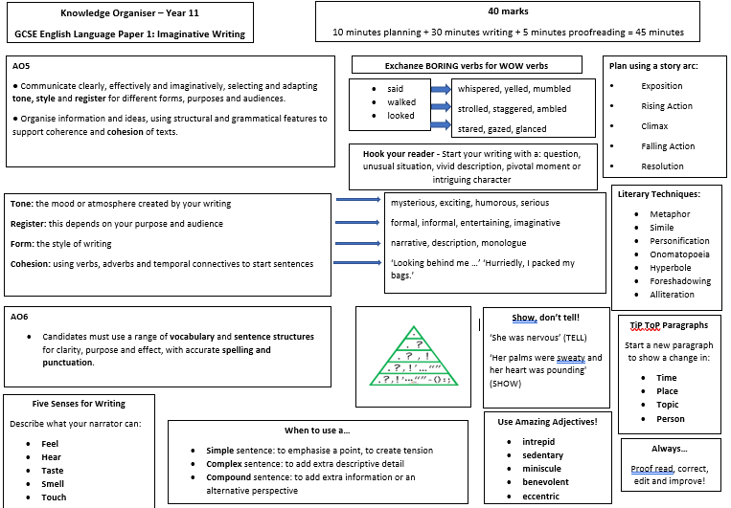

Lesson 1: How do you summarise a text?
LI: To know different strategies for working out a writer’s main ideas and to summarise a text
Do now:
Read the Zoom In to see where your learning fits in with what you have done before
Can you make other links that are not mentioned on the Zoom in document?

DART 1: Discuss the SAL and annotate appropriately
DART 2: The Turn of the Screw by Henry James
DART Tasks
Work out the writer’s main ideas by:
- highlighting words in the text they do not understand and working out the meaning using the context of the extract
- summarising the ideas of each paragraph
- highlighting the key points in the text
- highlighting the topic sentences at the start of each paragraph as a speed-reading method of grasping the main ideas in a text.
DIP TASK:
Write an overall summary
Write a one sentence summary
These skills will help you with Q1/2 and Q4 of the exam where you must find key information and have a clear overview for evaluation.

Extract: THE TURN OF THE SCREW by Henry James
The story had held us, round the fire, sufficiently breathless, but except the obvious remark that it was gruesome, as, on Christmas Eve in an old house, a strange tale should essentially be, I remember no comment uttered till somebody happened to say that it was the only case he had met in which such a visitation had fallen on a child. The case, I may mention, was that of an apparition in just such an old house as had gathered us for the occasion—an appearance, of a dreadful kind, to a little boy sleeping in the room with his mother and waking her up in the terror of it; waking her not to dissipate his dread and soothe him to sleep again, but to encounter also, herself, before she had succeeded in doing so, the same sight that had shaken him. It was this observation that drew from Douglas—not immediately, but later in the evening—a reply that had the interesting consequence to which I call attention. Someone else told a story not particularly effective, which I saw he was not following. This I took for a sign that he had himself something to produce and that we should only have to wait. We waited in fact till two nights later; but that same evening, before we scattered, he brought out what was in his mind.
“I quite agree—in regard to Griffin’s ghost, or whatever it was—that its appearing first to the little boy, at so tender an age, adds a particular touch. But it’s not the first occurrence of its charming kind that I know to have involved a child. If the child gives the effect another turn of the screw, what do you say to two children—?”
“We say, of course,” somebody exclaimed, “that they give two turns! Also that we want to hear about them.”
I can see Douglas there before the fire, to which he had got up to present his back, looking down at his interlocutor with his hands in his pockets. “Nobody but me, till now, has ever heard. It’s quite too horrible.” This, naturally, was declared by several voices to give the thing the utmost price, and our friend, with quiet art, prepared his triumph by turning his eyes over the rest of us and going on: “It’s beyond everything. Nothing at all that I know touches it.”
“For sheer terror?” I remember asking.
He seemed to say it was not so simple as that; to be really at a loss how to qualify it. He passed his hand over his eyes, made a little wincing grimace. “For dreadful—dreadfulness!”
“Oh, how delicious!” cried one of the women.
He took no notice of her; he looked at me, but as if, instead of me, he saw what he spoke of. “For general uncanny ugliness and horror and pain.”
“Well then,” I said, “just sit right down and begin.”
He turned round to the fire, gave a kick to a log, watched it an instant. Then as he faced us again: “I can’t begin. I shall have to send to town.” There was a unanimous groan at this, and much reproach; after which, in his preoccupied way, he explained. “The story’s written. It’s in a locked drawer—it has not been out for years. I could write to my man and enclose the key; he could send down the packet as he finds it.” It was to me in particular that he appeared to propound this—appeared almost to appeal for aid not to hesitate. He had broken a thickness of ice, the formation of many a winter; had had his reasons for a long silence. The others resented postponement, but it was just his scruples that charmed me. I adjured him to write by the first post and to agree with us for an early hearing; then I asked him if the experience in question had been his own. To this his answer was prompt. “Oh, thank God, no!”
“And is the record yours? You took the thing down?”
“Nothing but the impression. I took that here”—he tapped his heart. “I’ve never lost it.”
“Then your manuscript—?”
“Is in old, faded ink, and in the most beautiful hand.” He hung fire again. “A woman’s. She has been dead these twenty years. She sent me the pages in question before she died.

Lesson 2: How do I generate ideas?
LI: To know strategies to generate ideas for engaging writing

Do now: Write a summary for A Christmas Carol
Challenge: Write a one sentence summary
Subject - Purpose – Audience - Form (SPAF) – what do you think each of these means?
Think of something you’ve read in the last 24 hours – what is the SPAF for that text?

Read exam questions: highlight and annotate for the SPAF

- Write about a childhood friendship.
Your response could be real or imagined. You may wish to base your response on one
of the images.
OR
- Write about a time when you, or someone you know, had an exciting experience.
Your response could be real or imagined.

Where will your ideas come from? How do you ensure you have can generate ideas?
- Prior knowledge
- Experience
- Reading about a topic (e.g. from the reading tasks)
- Reading done before the examination
- Others?
List/Table/Mind map are all good ways to plan your writing. Choose one of the questions above and plan an answer (remember to consider SPAF)

Set a personal objective (on your ZOOM IN) which will help you generate ideas in future.

Look over the image below, then describe it in detail.
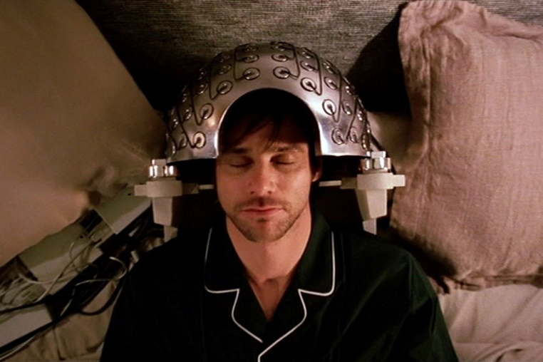
What’s happening?
Describe what you see.
Read over what you have written.
What can you change to improve it?
DIP TasK:
Redraft in blue pen - Make it more descriptive by upgrading the vocabulary and using language devices.

__________________________________________________________________________________

Lesson 3: How does the writer use techniques to achieve their intentions?

LI: To identify a range of techniques used by the writer and understand the writer’s intentions through these: voice, language choice, imagery, appeal to the senses, speech and thought, sentence length and variety of structure.
Do now: Read over your KO paying particular attention to language and structural devices.
DART: Extract 3 Jane Eyre
Highlight and annotate for techniques used by the writer
What do you think was the writer’s intention?
Extract: JANE EYRE by Charlotte Bronte
The red-room was a square chamber, very seldom slept in, I might say never, indeed, unless when a chance influx of visitors at Gateshead Hall rendered it necessary to turn to account all the accommodation it contained: yet it was one of the largest and stateliest chambers in the mansion. A bed supported on massive pillars of mahogany, hung with curtains of deep red damask, stood out like a tabernacle in the centre; the two large windows, with their blinds always drawn down, were half shrouded in festoons and falls of similar drapery; the carpet was red; the table at the foot of the bed was covered with a crimson cloth; the walls were a soft fawn colour with a blush of pink in it; the wardrobe, the toilet-table, the chairs were of darkly polished old mahogany. Out of these deep surrounding shades rose high, and glared white, the piled-up mattresses and pillows of the bed, spread with a snowy Marseilles counterpane. Scarcely less prominent was an ample cushioned easy-chair near the head of the bed, also white, with a footstool before it; and looking, as I thought, like a pale throne.
This room was chill, because it seldom had a fire; it was silent, because remote from the nursery and kitchen; solemn, because it was known to be so seldom entered. The house-maid alone came here on Saturdays, to wipe from the mirrors and the furniture a week's quiet dust: and Mrs. Reed herself, at far intervals, visited it to review the contents of a certain secret drawer in the wardrobe, where were stored divers parchments, her jewel-casket, and a miniature of her deceased husband; and in those last words lies the secret of the red-room--the spell which kept it so lonely in spite of its grandeur.
Mr. Reed had been dead nine years: it was in this chamber he breathed his last; here he lay in state; hence his coffin was borne by the undertaker's men; and, since that day, a sense of dreary consecration had guarded it from frequent intrusion.
My seat, to which Bessie and the bitter Miss Abbot had left me riveted, was a low ottoman near the marble chimney-piece; the bed rose before me; to my right hand there was the high, dark wardrobe, with subdued, broken reflections varying the gloss of its panels; to my left were the muffled windows; a great looking-glass between them repeated the vacant majesty of the bed and room. I was not quite
sure whether they had locked the door; and when I dared move, I got up and went to see. Alas! yes: no jail was ever more secure. Returning, I had to cross before the looking-glass; my fascinated glance involuntarily explored the depth it revealed. All looked colder and darker in that visionary hollow than in reality: and the strange little figure there gazing at me, with a white face and arms
specking the gloom, and glittering eyes of fear moving where all else was still, had the effect of a real spirit: I thought it like one of the tiny phantoms, half fairy, half imp, Bessie's evening stories represented as coming out of lone, ferny dells in moors, and appearing before the eyes of belated travellers. I returned to my stool.

DIP TASK: How does the writer interest and engage the reader? (use of techniques to achieve their intention)
Write a series of PETER/WHW paragraphs (Point-Evidence-Technique-Explain-Reader / What-How-Why)

How effective is the setting at creating tension?

Lesson 4: Why use sensory language?
LI: To demonstrate their understanding of how the writer uses language to appeal to and influence readers
Do now: Think about how Scrooge was portrayed in A Christmas Carol, can you remember any specific imagery or description?
Why was this effective?
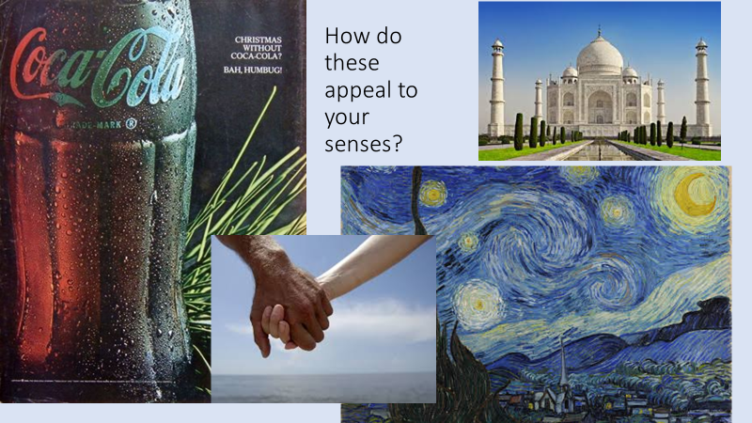

DART: Extract 5 The Handmaid’s Tale
Highlight and annotate features of language and structure
Turn to your partner and add further annotations in blue
Turn to a pair near you and discuss the best features you found – what effect do those features have?

Extract: THE HANDMAID’S TALE by Margaret Atwood
A chair, a table, a lamp. Above, on the white ceiling, a relief ornament in the shape of a wreath, and in the centre of it a blank space, plastered over, like the place in a face where the eye has been taken out. There must have been a chandelier, once. They’ve removed anything you could tie a rope to.
A window, two white curtains. Under the window, a window seat with a little cushion. When the window is partly open – it only opens partly – the air can come in and make the curtains move. I can sit in the chair, or on the window seat, hands folded, and watch this. Sunlight comes in through the window too, and falls on the floor, which is made of wood, in narrow strips, highly polished. I can smell the polish. There’s a rug on the floor, oval, of braided rags. This is the kind of touch they like: folk art, archaic, made by women, in their spare time, from things that have no further use. A return to traditional values. Waste not want not. I am not being wasted. Why do I want?
On the wall above the chair, a picture, framed but with no glass: a print of flowers, blue irises, water-colour. Flowers are still allowed. Does each of us have the same print, the same chair, the same white curtains, I wonder? Government issue?
Think of it as being in the army, said Aunt Lydia.
A bed. Single, mattress medium-hard, covered with a flocked white spread. Nothing takes place in the bed but sleep; or no sleep. I try not to think too much. Like other things now, thought must be rationed. There’s a lot that doesn’t bear thinking about. Thinking can hurt your chances, and I intend to last. I know why there is no glass, in front of the watercolour picture of blue irises, and why the window only opens partly and why the glass in it is shatterproof. It isn’t running away they’re afraid of. We wouldn’t get far. It’s those other escapes, the ones you can open in yourself, given a cutting edge.

Lesson 5: Why is Vocabulary Significant?
LI: To understand how the writer uses vocabulary to create character
Do now:
Consider the vocabulary used in The Handmaid’s Tale extract – is it complicated or complex? Why do you think the writer decided to write this way?

DART: Great Expectations extract

Focus for reading: Vocabulary used by each speaker
E.g. Dialect, accent, words that are repeated, sophisticated or simplicity of vocabulary.
Read, annotate and colour code for each speaker

Extract: GREAT EXPECTATIONS by Charles Dickens

Ours was the marsh country, down by the river, within, as the river wound, twenty miles of the sea. My first most vivid and broad impression of the identity of things, seems to me to have been gained on a memorable raw afternoon towards evening. At such a time I found out for certain, that this bleak place overgrown with nettles was the churchyard; and that Philip Pirrip, late of this parish, and also Georgiana wife of the above, were dead and buried; and that Alexander, Bartholomew, Abraham, Tobias, and Roger, infant children of the aforesaid, were also dead and buried; and that the dark flat wilderness beyond the churchyard, intersected with dykes and mounds and gates, with scattered cattle feeding on it, was the marshes; and that the low leaden line beyond, was the river; and that the distant savage lair from which the wind was rushing, was the sea; and that the small bundle of shivers growing afraid of it all and beginning to cry, was Pip.
"Hold your noise!" cried a terrible voice, as a man started up from among the graves at the side of the church porch. "Keep still, you little devil, or I'll cut your throat!"
A fearful man, all in coarse grey, with a great iron on his leg. A man with no hat, and with broken shoes, and with an old rag tied round his head. A man who had been soaked in water, and smothered in mud, and lamed by stones, and cut by flints, and stung by nettles, and torn by briars; who limped, and shivered, and glared and growled; and whose teeth chattered in his head as he seized me by the chin.
"O! Don't cut my throat, sir," I pleaded in terror. "Pray don't do
it, sir."
"Tell us your name!" said the man. "Quick!"
"Pip, sir."
"Once more," said the man, staring at me. "Give it mouth!"
"Pip. Pip, sir."
"Show us where you live," said the man. "Pint out the place!"
I pointed to where our village lay, on the flat in-shore among the alder-trees and pollards, a mile or more from the church.
The man, after looking at me for a moment, turned me upside down, and emptied my pockets. There was nothing in them but a piece of bread. When the church came to itself - for he was so sudden and strong that he made it go head over heels before me, and I saw the steeple under my feet - when the church came to itself, I say, I was seated on a high tombstone, trembling, while he ate the bread
ravenously.
"You young dog," said the man, licking his lips, "what fat cheeks you ha' got."
I believe they were fat, though I was at that time undersized for my years, and not strong.
"Darn me if I couldn't eat em," said the man, with a threatening shake of his head, "and if I han't half a mind to't!"
I earnestly expressed my hope that he wouldn't, and held tighter to the tombstone on which he had put me; partly, to keep myself upon it; partly, to keep myself from crying.
"Now lookee here!" said the man. "Where's your mother?"
"There, sir!" said I.
He started, made a short run, and stopped and looked over his shoulder.
"There, sir!" I timidly explained. "Also Georgiana. That's my mother."
"Oh!" said he, coming back. "And is that your father alonger your mother?"
"Yes, sir," said I; "him too; late of this parish."
"Ha!" he muttered then, considering. "Who d'ye live with - supposin' you're kindly let to live, which I han't made up my mind about?"
"My sister, sir - Mrs. Joe Gargery - wife of Joe Gargery, the blacksmith, sir."
"Blacksmith, eh?" said he. And looked down at his leg.
After darkly looking at his leg and me several times, he came closer to my tombstone, took me by both arms, and tilted me back as far as he could hold me; so that his eyes looked most powerfully down into mine, and mine looked most helplessly up into his.
"Now lookee here," he said, "the question being whether you're to be let to live. You know what a file is?"
"Yes, sir."
"And you know what wittles is?"
"Yes, sir."
After each question he tilted me over a little more, so as to give me a greater sense of helplessness and danger.
"You get me a file." He tilted me again. "And you get me wittles." He tilted me again. "You bring 'em both to me." He tilted me again. "Or I'll have your heart and liver out." He tilted me again.
I was dreadfully frightened, and so giddy that I clung to him with both hands, and said, "If you would kindly please to let me keep upright, sir, perhaps I shouldn't be sick, and perhaps I could attend more."
He gave me a most tremendous dip and roll, so that the church jumped over its own weather-cock. Then, he held me by the arms, in an upright position on the top of the stone, and went on in these fearful terms:
"You bring me, to-morrow morning early, that file and them wittles. You bring the lot to me, at that old Battery over yonder. You do it, and you never dare to say a word or dare to make a sign concerning your having seen such a person as me, or any person sumever, and you shall be let to live. You fail, or you go from my words in any partickler, no matter how small it is, and your heart and your liver shall be tore out, roasted and ate. Now, I ain't alone, as you may think I am. There's a young man hid with me, in comparison with which young man I am a Angel. That young man hears the words I speak. That young man has a secret way pecooliar to himself, of getting at a boy, and at his heart, and at his liver. It is in wain for a boy to attempt to hide himself from that young man. A boy may lock his door, may be warm in bed, may tuck himself up, may draw the clothes over his head, may think himself comfortable and safe, but that young man will softly creep and creep his way to him and tear him open. I am a-keeping that young man from harming of you at the present moment, with great difficulty. I find it wery hard to hold that young man off of your inside. Now, what do you say?"
I said that I would get him the file, and I would get him what broken bits of food I could, and I would come to him at the Battery, early in the morning.
"Say Lord strike you dead if you don't!" said the man.
I said so, and he took me down.
"Now," he pursued, "you remember what you've undertook, and you
remember that young man, and you get home!"
"Goo-good night, sir," I faltered.
"Much of that!" said he, glancing about him over the cold wet flat. "I wish I was a frog. Or a eel!"
At the same time, he hugged his shuddering body in both his arms - clasping himself, as if to hold himself together - and limped towards the low church wall. As I saw him go, picking his way among the nettles, and among the brambles that bound the green mounds, he looked in my young eyes as if he were eluding the hands of the dead people, stretching up cautiously out of their graves, to get a twist upon his ankle and pull him in.

How successful is the writer at creating sympathy for the protagonist?
Do we feel sorry for him and fearful of the convict? Refer to vocabulary in your answer.

DIP TASK
You must create a character that is to be disliked by the reader.
Quick revision! Think about how Dicken’s did this with Scrooge and how Priestley did this with Mr Birling… What do you remember?
Character ideas: police inspector, teacher, nuisance neighbour

Write at least three paragraphs about your character.

Lesson 6: How do you evaluate writer success?
LI: To evaluate the effectiveness of the writer’s choice of events
Do now:
How successful was the photographer at capturing love in this photo? Write a paragraph explaining why you think it is or isn’t successful.


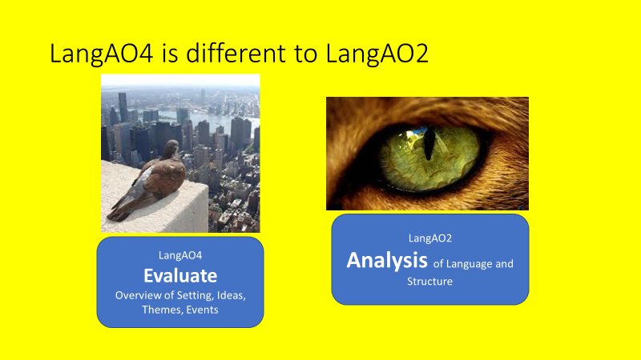

How to approach evaluation:
- Make a judgement
- Evidence of his/her choices? (SPITE)
- Evaluate the choices made
WAGOLL:
The photographer was quite successful at capturing the love between the couple. The photographer captured an intimate embrace, using close-up, showing them together with extremely happy expressions. The photo is powerful at capturing a seemingly spontaneous outpouring of love.

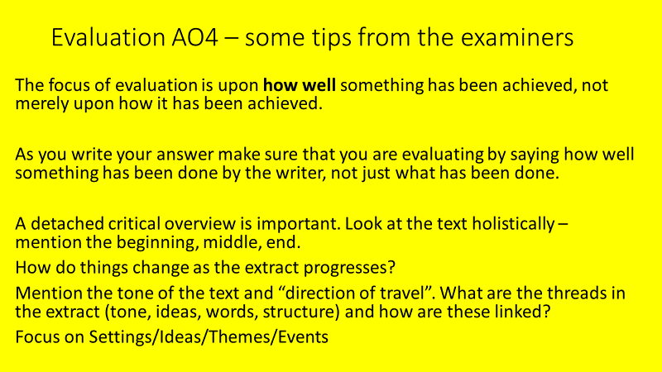

There are 5 levels of response that can be summarised as follows:
- Level 1 – description and limited
- Level 2 – comment and straightforward
- Level 3 – explanation and informed
- Level 4 – analysis, well informed and critical judgements
- Level 5 – evaluation, sustained and detached critical overview

DART: Great Expectation Extract
DART annotation focus: Events in the extract. Section up the text into events. Draw a box around each section.
How does each event create tension?
Focus on one section and identify specific techniques which create tension.

DIP task: Write a paragraph answering the following question
In this extract there was an attempt to create tension. Evaluate how successfully this was achieved.
Tips:
How to approach evaluation:
- Make a judgement and refer to the location of the extract you are referring to e.g. at the beginning/towards the middle/towards the end etc. Or refer to paragraphs
- Evidence of his/her choices? (you are focussing on how events are used to create tension)
- Evaluate the choices made (e.g. use words like: powerfully/effectively/clearly/successfully)

Lesson 7: What makes a narrative successful?

LI: To consider what should be included in a short narrative.
Do now: Consider extracts you have read this half-term and books you have read; what makes them effective?

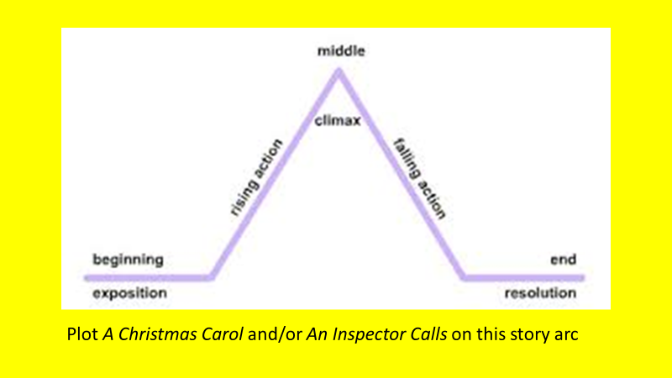

Planning a Narrative: Below is a typical exam style question.

Write about a time when you, or someone you know, tried to hide something. Your response can be real or imagined.
- Come up with a few ideas (do this quickly)
- Decide on one idea (whittle it down to your favourite)
- What events could you include – what would you consider the key event? Use the story arc to plan your story
- Using the SAL, create a list of success criteria for the writing.
- Write your narrative (story)

Lesson 8: How does Language reveal a writer’s perspective?
LI: To understand how language reveals a writer’s perspective.
Do now:
Why should you plan a piece of extended writing?
DART: The Tell-Tale Heart

- Summarise the key idea/main message of the Tell-Tale Heart extract in 15 words.
- Now re-read it - identify words and phrases in the text that show the writer’s perspective/attitude.
- Next, list any language features you identified
- What is the impact of each feature selected (minimum of three) - How do they help to communicate the writer’s ideas and perspective?
- Repeat the above steps for the Jane Eyre extract
DIP Task:
Write a paragraph comparing how the two texts present fear. How are they similar and different (you can refer to key ideas and perspectives as well as language and structure).

Extract: THE TELL-TALE HEART by Edgar Allen Poe

Now this is the point. You fancy me mad. Madmen know nothing. But you should have seen me. You should have seen how wisely I proceeded--with what caution--with what foresight--with what dissimulation I went to work!
***
I then took up three planks from the flooring of the chamber, and deposited all between the scantlings. I then replaced the boards so cleverly, so cunningly, that no human eye—not even his—could have detected any thing wrong. There was nothing to wash out—no stain of any kind—no blood-spot whatever. I had been too wary for that. A tub had caught all—ha! ha!
When I had made an end of these labors, it was four o'clock—still dark as midnight. As the bell sounded the hour, there came a knocking at the street door. I went down to open it with a light heart,—for what had I now to fear? There entered three men, who introduced themselves, with perfect suavity, as officers of the police. A shriek had been heard by a neighbour during the night; suspicion of foul play had been aroused; information had been lodged at the police office, and they (the officers) had been deputed to search the premises.
I smiled,—for what had I to fear? I bade the gentlemen welcome. The shriek, I said, was my own in a dream. The old man, I mentioned, was absent in the country. I took my visitors all over the house. I bade them search—search well. I led them, at length, to his chamber. I showed them his treasures, secure, undisturbed. In the enthusiasm of my confidence, I brought chairs into the room, and desired them here to rest from their fatigues, while I myself, in the wild audacity of my perfect triumph, placed my own seat upon the very spot beneath which reposed the corpse of the victim.
The officers were satisfied. My manner had convinced them. I was singularly at ease. They sat, and while I answered cheerily, they chatted of familiar things. But, ere long, I felt myself getting pale and wished them gone. My head ached, and I fancied a ringing in my ears: but still they sat and still chatted. The ringing became more distinct:—It continued and became more distinct: I talked more freely to get rid of the feeling: but it continued and gained definiteness—until, at length, I found that the noise was not within my ears.
No doubt I now grew very pale;—but I talked more fluently, and with a heightened voice. Yet the sound increased—and what could I do? It was a low, dull, quick sound—much such a sound as a watch makes when enveloped in cotton. I gasped for breath—and yet the officers heard it not. I talked more quickly—more vehemently; but the noise steadily increased. I arose and argued about trifles, in a high key and with violent gesticulations; but the noise steadily increased. Why would they not be gone? I paced the floor to and fro with heavy strides, as if excited to fury by the observations of the men—but the noise steadily increased. Oh God! what could I do? I foamed—I raved—I swore! I swung the chair upon which I had been sitting, and grated it upon the boards, but the noise arose over all and continually increased. It grew louder—louder—louder! And still the men chatted pleasantly, and smiled. Was it possible they heard not? Almighty God!—no, no! They heard!—they suspected!—they knew!—they were making a mockery of my horror!-this I thought, and this I think. But anything was better than this agony! Anything was more tolerable than this derision! I could bear those hypocritical smiles no longer! I felt that I must scream or die! and now—again!—hark! louder! louder! louder! louder!

Extract: JANE EYRE by Charlotte Bronte
The red-room was a square chamber, very seldom slept in, I might say never, indeed, unless when a chance influx of visitors at Gateshead Hall rendered it necessary to turn to account all the accommodation it contained: yet it was one of the largest and stateliest chambers in the mansion. A bed supported on massive pillars of mahogany, hung with curtains of deep red damask, stood out like a tabernacle in the centre; the two large windows, with their blinds always drawn down, were half shrouded in festoons and falls of similar drapery; the carpet was red; the table at the foot of the bed was covered with a crimson cloth; the walls were a soft fawn colour with a blush of pink in it; the wardrobe, the toilet-table, the chairs were of darkly polished old mahogany. Out of these deep surrounding shades rose high, and glared white, the piled-up mattresses and pillows of the bed, spread with a snowy Marseilles counterpane. Scarcely less prominent was an ample cushioned easy-chair near the head of the bed, also white, with a footstool before it; and looking, as I thought, like a pale throne.
This room was chill, because it seldom had a fire; it was silent, because remote from the nursery and kitchen; solemn, because it was known to be so seldom entered. The house-maid alone came here on Saturdays, to wipe from the mirrors and the furniture a week's quiet dust: and Mrs. Reed herself, at far intervals, visited it to review the contents of a certain secret drawer in the wardrobe, where were stored divers parchments, her jewel-casket, and a miniature of her deceased husband; and in those last words lies the secret of the red-room--the spell which kept it so lonely in spite of its grandeur.
Mr. Reed had been dead nine years: it was in this chamber he breathed his last; here he lay in state; hence his coffin was borne by the undertaker's men; and, since that day, a sense of dreary consecration had guarded it from frequent intrusion.
My seat, to which Bessie and the bitter Miss Abbot had left me riveted, was a low ottoman near the marble chimney-piece; the bed rose before me; to my right hand there was the high, dark wardrobe, with subdued, broken reflections varying the gloss of its panels; to my left were the muffled windows; a great looking-glass between them repeated the vacant majesty of the bed and room. I was not quite
sure whether they had locked the door; and when I dared move, I got up and went to see. Alas! yes: no jail was ever more secure. Returning, I had to cross before the looking-glass; my fascinated glance involuntarily explored the depth it revealed. All looked colder and darker in that visionary hollow than in reality: and the strange little figure there gazing at me, with a white face and arms
specking the gloom, and glittering eyes of fear moving where all else was still, had the effect of a real spirit: I thought it like one of the tiny phantoms, half fairy, half imp, Bessie's evening stories represented as coming out of lone, ferny dells in moors, and appearing before the eyes of belated travellers. I returned to my stool.
Lesson 9: What are the different sentence types?
LI: To know and understand main sentence types and functions.
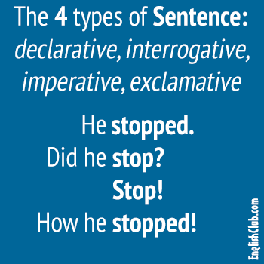

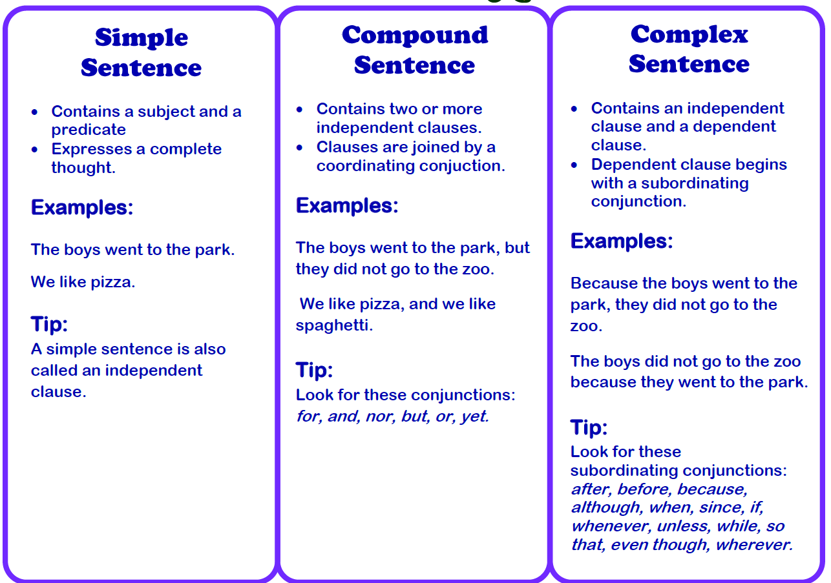
Look back over the Great Expectations extract and identify two examples of each sentence.
Now write examples of your own based on this image:

DIP Task:
Write a narrative (story) beginning in medias res (in the middle of action with no preamble), paying particular attention to the types of sentences you are using – variety is key.

Lesson 10: How can you use structure to create an effect?
LI: To understand how writers use structure to create their intended effect
Do now:
Consider a book you’ve read before (use A Christmas Carol or An Inspector Calls if you are stuck) and how the writer structured the story.
Was there anything unusual about it? Did it start in medias res?

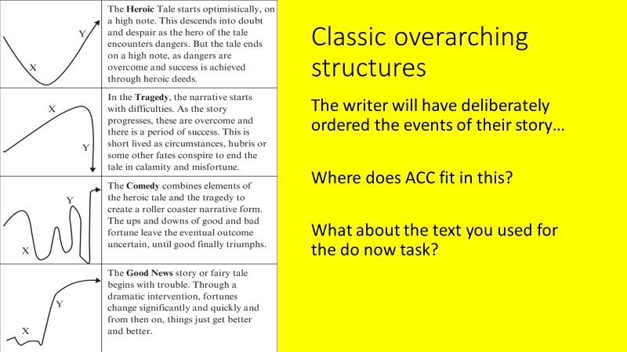
You might like to experiment with moving away from a linear structure:
- Dual narrative
(using two or more points of view)
- Cyclical structure
(story that ends in the same place)
- Flashback narrative
(a device that moves an audience from the present moment in a chronological narrative to a scene in the past)
Revisit The Handmaid’s Tale extract.

- Create a bullet point summary of the storyline
- Is the order significant? Why?
Ideas: beginnings and endings, juxtaposition of ideas, contrast, irony, suspense, sentence structure?
DIP Task
How has the writer used structure to engage the reader?
Next - Revising the order of your narrative…

Revisit your writing from the last lesson
Would it be possible to order your narrative differently. What could you do to make it more engaging for the reader?
Think about the order you unfold the story, do you deliberately omit information for a big reveal later?
Lesson 11: How do we use punctuation to achieve different effects?
LI: To select punctuation to create specific effects.
Do now:
You can uses dashes in the same way as parentheses, but what’s is the subtle difference?
Write a sentence using one and a different sentence using the other.
You can use a dash in a similar way to a colon.
- There was only one thing left to do – eat!
- There was only one thing left to do: eat!
You try!

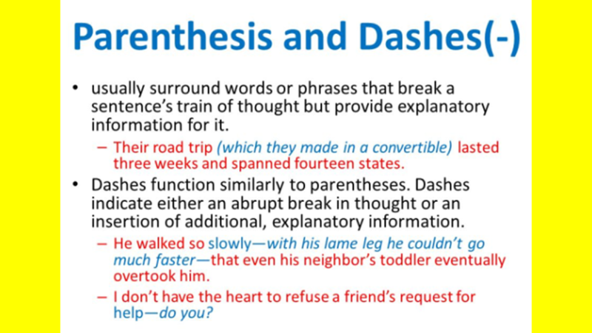
Punctuate this extract: Pay attention to punctuation placement as it will change the effect of the extract.
The story had held us round the fire sufficiently breathless but except the obvious remark that it was gruesome as on Christmas Eve in an old house a strange tale should essentially be I remember no comment uttered till somebody happened to say that it was the only case he had met in which such a visitation had fallen on a child The case I may mention, was that of an apparition in just such an old house as had gathered us for the occasion an appearance of a dreadful kind to a little boy sleeping in the room with his mother and waking her up in the terror of it waking her not to dissipate his dread and soothe him to sleep again but to encounter also herself before she had succeeded in doing so the same sight that had shaken him It was this observation that drew from Douglas not immediately but later in the evening a reply that had the interesting consequence to which I call attention
DIP Task: Write another paragraph of your story from the previous lesson, but you must use punctuation to either build up tension or relieve tension already created.
Lesson 12: Assessment Lesson (preparation)
LI: To plan a narrative taking careful consideration of overall structure and sentence level structures.
Choose one of the following:
Q 5. Write about a time when you, or someone you know, saw something unusual. Your response can be real or imagined. (40 marks)
Q 6. Look at the image provided. Write about a mysterious door. Your response could be real or imagined. You may wish to base your response on one of the images. (40 marks)
Come up with an idea to base your story around
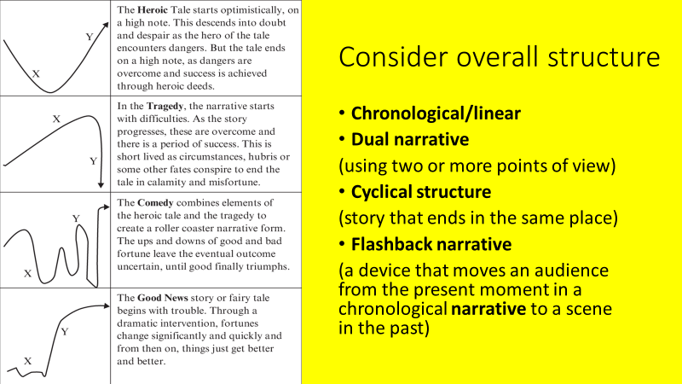
How will you connect and organise your ideas?
Connectives and openers, topic sentences, repetition, lexical field, questions, anaphora, parallelism, juxtaposition…
Revisit the SAL/mark scheme
How will you be successful?

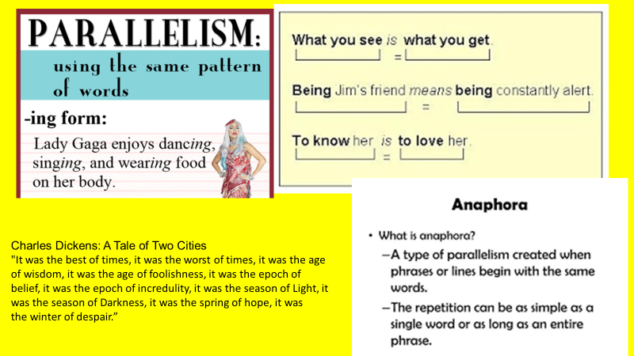

DIP Task:
Part 1: Create your plan and underneath answer the following questions:
- What is your overall structure – why did you choose this?
- Within your narrative how are you going t vary your structure?

Part 2: Write your opening paragraph, then evaluate it – what is successful structurally?

Lesson 13: Assessment Lesson
Read over your plan and spend 45 minutes writing up your assessment on paper.

Lesson 14: How do we create a detailed evaluative response?


LI: To select examples that help support a detailed response (SITE)
Focus: The Tell-Tale Heart extract

Do now: What’s the difference between analysing and evaluating (lesson 6)

Read the AO2 vs AO4 extract. Then read the AO2 (analysis) style question
and the AO4 (evaluation) question.
DART: Read and annotate the ‘Spot the Difference’ .
How are they similar and how are they different?
Which is an AO2 answer and which is an AO4 answer – how do you know?

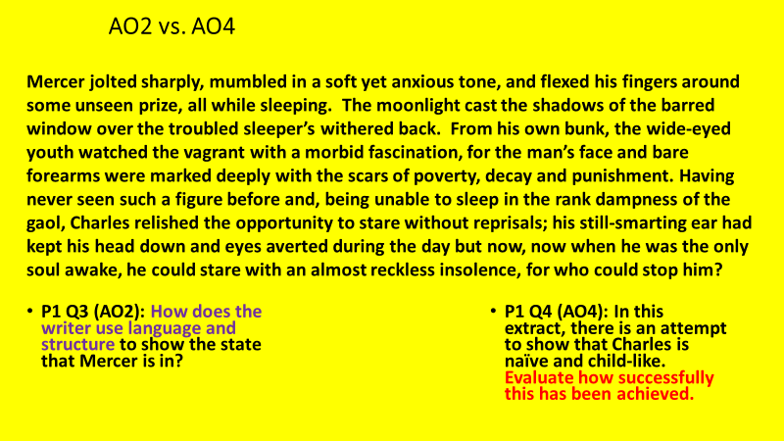

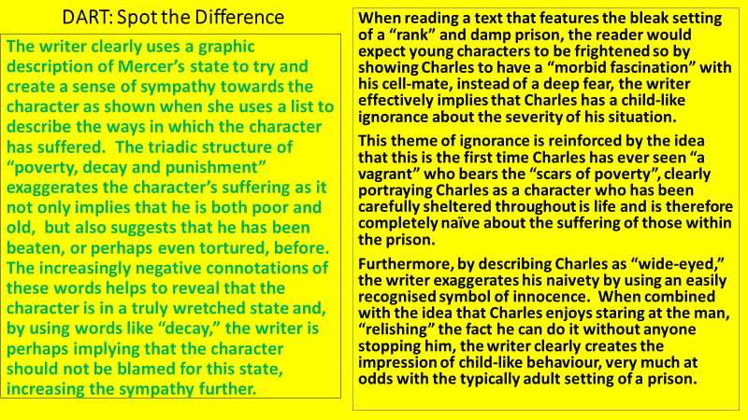

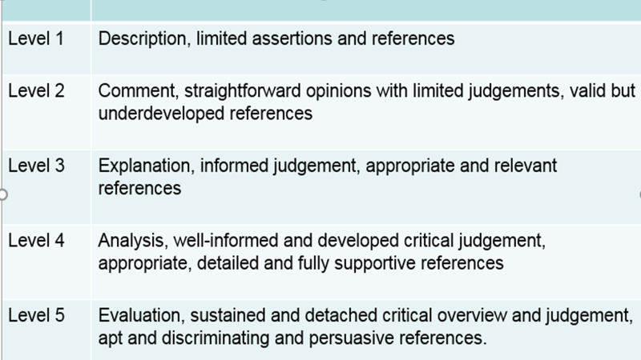

AO4 Evaluative WABOLLs/WAGOLLs: (based on The Tell-Tale Heart extract)
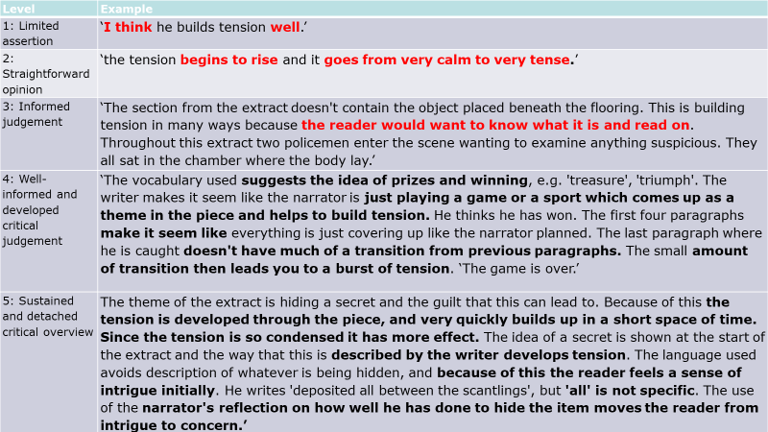
SPITE – Areas to focus on to help you create a ‘detached critical overview’
Settings - People - Ideas – Themes – Events
The best answers will track the progression of these. How do they develop and change through the extract?
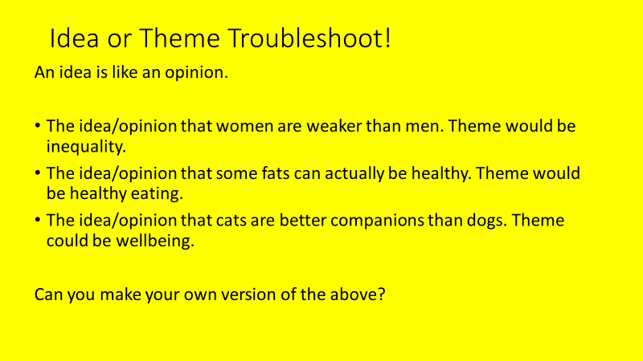
DART Extract: THE TELL-TALE HEART by Edgar Allen Poe
- Focus for your annotations: SPITE (focus on one to begin)
- What about the story creates tension? Think about it overall (in general terms) rather than specifics you’ve zoomed in on
Where does this fit into SPITE. Is it something you can track the progress of?
Note: You do not have to mention SPITE in your exam – it is a guide

DIP Task: In this extract there is an attempt to create tension. How successful has the writer been in this attempt?
Write a series of evaluative paragraphs tracking an element/s of SPITE through the extract.

Now this is the point. You fancy me mad. Madmen know nothing. But you should have seen me. You should have seen how wisely I proceeded--with what caution--with what foresight--with what dissimulation I went to work!
***
I then took up three planks from the flooring of the chamber, and deposited all between the scantlings. I then replaced the boards so cleverly, so cunningly, that no human eye—not even his—could have detected any thing wrong. There was nothing to wash out—no stain of any kind—no blood-spot whatever. I had been too wary for that. A tub had caught all—ha! ha!
When I had made an end of these labors, it was four o'clock—still dark as midnight. As the bell sounded the hour, there came a knocking at the street door. I went down to open it with a light heart,—for what had I now to fear? There entered three men, who introduced themselves, with perfect suavity, as officers of the police. A shriek had been heard by a neighbour during the night; suspicion of foul play had been aroused; information had been lodged at the police office, and they (the officers) had been deputed to search the premises.
I smiled,—for what had I to fear? I bade the gentlemen welcome. The shriek, I said, was my own in a dream. The old man, I mentioned, was absent in the country. I took my visitors all over the house. I bade them search—search well. I led them, at length, to his chamber. I showed them his treasures, secure, undisturbed. In the enthusiasm of my confidence, I brought chairs into the room, and desired them here to rest from their fatigues, while I myself, in the wild audacity of my perfect triumph, placed my own seat upon the very spot beneath which reposed the corpse of the victim.
The officers were satisfied. My manner had convinced them. I was singularly at ease. They sat, and while I answered cheerily, they chatted of familiar things. But, ere long, I felt myself getting pale and wished them gone. My head ached, and I fancied a ringing in my ears: but still they sat and still chatted. The ringing became more distinct:—It continued and became more distinct: I talked more freely to get rid of the feeling: but it continued and gained definiteness—until, at length, I found that the noise was not within my ears.
No doubt I now grew very pale;—but I talked more fluently, and with a heightened voice. Yet the sound increased—and what could I do? It was a low, dull, quick sound—much such a sound as a watch makes when enveloped in cotton. I gasped for breath—and yet the officers heard it not. I talked more quickly—more vehemently; but the noise steadily increased. I arose and argued about trifles, in a high key and with violent gesticulations; but the noise steadily increased. Why would they not be gone? I paced the floor to and fro with heavy strides, as if excited to fury by the observations of the men—but the noise steadily increased. Oh God! what could I do? I foamed—I raved—I swore! I swung the chair upon which I had been sitting, and grated it upon the boards, but the noise arose over all and continually increased. It grew louder—louder—louder! And still the men chatted pleasantly, and smiled. Was it possible they heard not? Almighty God!—no, no! They heard!—they suspected!—they knew!—they were making a mockery of my horror!-this I thought, and this I think. But anything was better than this agony! Anything was more tolerable than this derision! I could bear those hypocritical smiles no longer! I felt that I must scream or die! and now—again!—hark! louder! louder! louder! louder!

Homework Tasks
You will write the best story you have ever written over the course of this half-term.
Each section of the story will be carefully crafted by you, and then evaluated by your peers in a weekly homework peer assessment lesson segment.
The best story will win a prize and lifelong celebrity.

Week 1: Planning
Here is the overall task:
Write about a time when you felt trapped. Your response can be real or imagined. (‘Imagined’ is always the better choice here as you can manipulate time, structures, setting, characters, genre etc. to suit the task).
Consider your overall plot and plan it on a story arc. The exposition can be in media res (in the middle of some action) - nobody wants to read about your shower and breakfast habits – so get on with the storytelling!

Who is your main character? Don’t use more than two.
What settings will you use?
What twist can you have? How will you use overall structure to support this?
You will be required to discuss your plan in class, so be prepared.

Week 2: Write the opening two paragraphs of your story (exposition and rising action)
Week 3: Write the middle section of your story (the climax)
Week 4: Write the final section of your story (the falling action and resolution)

 | AO4
 | Knowledge, Skills and Understanding
 |  | Question 4 (Paper 1 6 marks )and Question 6 (Paper 2 15 marks)
Yellow Plus | 13-14 | - Evaluation of ideas, events, themes or settings.  - There is a sustained and detached critical overview and judgement about the text.  - The selection of references is apt and discriminating and is persuasive in clarifying the points being made.
Yellow | 10-12 | - Analysis of ideas, events, themes or settings.  - Well-informed and developed critical judgement is offered about the text.  - The selection of references is appropriate, detailed and fully supports the points being made.
Blue | 7-9 | - Explanation of ideas, events, themes or settings.  - Informed judgement is offered about the text.  - The selection of references is appropriate and relevant to the points being made.
Green | 4-6 | - Comment on ideas, events, themes or settings.  - Straightforward opinions with limited judgements are offered about the text.  - The selection of references is valid, but not developed.
White | 1-3 | - Description of ideas, events, themes or settings.  - Limited assertions are offered about the text.  - The use of references is limited.
 | AO2
 | Knowledge, Skills and Understanding
 |  | Question 3 15 marks (paper 2)
Yellow Plus | 13-15 | - Analysis of the text.  - Analysis of how both language and structure are used to achieve effects and influence readers, including use of vocabulary, sentence structure and other language features.  - The selection of references is discriminating and clarifies the points being made.
Yellow | 10-12 | - Exploration of the text.  - Exploration of how both language and structure are used to achieve effects and influence readers, including use of vocabulary, sentence structure and other language features.  - The selection of references is detailed, appropriate and fully supports the points being made.
Blue | 7-9 | - Explanation of the text.  - Explanation of how both language and structure are used to achieve effects and influence readers, including use of vocabulary and sentence structure.  - The selection of references is appropriate and relevant to the points being made.
Green | 4-6 | - Comment on the text.  - Comment on the language and/or structure used to achieve effects and influence readers, including use of vocabulary.  - The selection of references is valid, but not developed.  - NB: The mark awarded cannot progress beyond the top of Level 2 if only language OR structure has been considered.
White | 1-3 | - Limited comment on the text.  - Identification of the language and/or structure used to achieve effects and influence readers.  - The use of references is limited.

 | Year 11 Imaginative Writing Language Paper 1
 | Knowledge and Understanding  PAF, Planning, Technique | Skills
Yellow Plus | Critical awareness of purpose audience and form  Structure makes a significant contribution to purpose and intention  Exceptional awareness of language and structure  Craft the writing to anticipate the reader’s response | AO5:  Manipulate the reader’s response through subtle variation in tone, style and register  Uses complex ideas, and a range of structural and grammatical features to support coherence and cohesion  AO6:  Write with consistent clarity and precision  Extensive range of vocabulary used strategically with rare spelling errors  Use a full range of punctuation accurately to emphasise meaning and create stylistic effects
Yellow | Assured awareness of purpose, audience and form  Planning models to support assured and cohesive ideas  Organise material for a particular effect (tone, style and register)  Assured awareness of how language and structure can be used for impact and effect | AO5:  Organises material for a particular effect, with effective use of tone, style and register  Manages ideas, use structural and grammatical features cohesively and deliberatively  AO6:  Use punctuation and sentence structures for deliberate effects.  Use an extensive range of ambitious vocabulary choices to create subtle effects. Occasional spelling errors.
Blue | Developed awareness of purpose, audience and form  Planning models to ensure ideas are developed  Developed awareness of how language and structure can be used for impact and effect | AO5:  Develop details using descriptive devices including figurative language to suit the PAF (Purpose/Audience/Form)  Paragraphing make meaning clear. Ideas are developed and connected appropriately.  AO6:  Use a varied vocabulary and vary my punctuation and adapt some sentence structures for effect  Spell words containing irregular patterns correctly
Green | Sound awareness of purpose, audience and form  Planning models to ensure sound coverage of ideas  Simple, compound, complex sentences and a range of sentence openers  Sound whole text structure and paragraphs | AO5:  Write with purpose using a straightforward tone and style.  Order ideas and use paragraphs.  Begin to develop details and descriptive devices including metaphor and simile  Use accurate and appropriate structures in my writing  AO6:  Use standard English and spell a range of vocabulary accurately  Use a range of punctuation with control  Use a range of sentences accurately, including frontal adverbials.
White | Awareness of the impact of purpose, audience and form on written style  Planning models to ensure the coverage of key ideas  Awareness of different types of sentence structures  Clear whole text structure and cohesion of paragrpahs | AO5:  Choose words for impact and effect  Use a range of punctuation including accurate use of comma, apostrophe and parenthesis  Begin to develop descriptive detail using descriptive language, powerful nouns and prepositional phrases  Select appropriate planning models to organise and structure my writing to make meaning clear and interesting.  AO6:  Vary my choice of sentence structures including simple, compound and complex sentences and ensure verb tense agreement  Use basic vocabulary with some spelling errors

