English Autumn 2 Blended Learning Booklet
Year 9 – Gothic Short Stories
Name:
Form:
Aim to complete three lessons each week. Write out the title and LI and then complete the tasks.
All video links are online using the ClassCharts link.
The Knowledge Organiser on page 3 has all the key information and vocabulary to help you with this unit.
Upload all work onto ClassCharts for feedback.
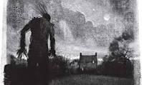

Contents
Page 3: Big Picture - Year 9 Overview
Page 4: Zoom in - My Learning Journey
Page 5: Knowledge Organiser
Page 6: Lesson 1
Page 7: Lesson 2
Page 9: Lesson 3
Page 11: Lesson 4
Page 13: Lesson 5
Page 16: Lesson 6
Page 18: Lesson 7
Page 19: Lesson 8
Page 21: Lesson 9
Page 24: Lesson 10
Page 25: Lesson 11
Page 28: Lesson 12
Page 30: Lesson 13
Page 33: Lesson 14
Page 35: Lesson 15
Page 36: Lesson 16
Page 38: Lesson 17
Page 40: Lesson 18
Page 41: Assessment Ladder
Page 42: The short stories
Page 42: The Werewolf by Angela Carter
Page 45: The Red Room by H.G Wells
Page 61: The Tell-Tale Heart by Edgar Allen Poe
Page 65: The Metamorphosis by Franz Kafka
Page 67: The Yellow Wallpaper by Charlotte Perkins Gilman

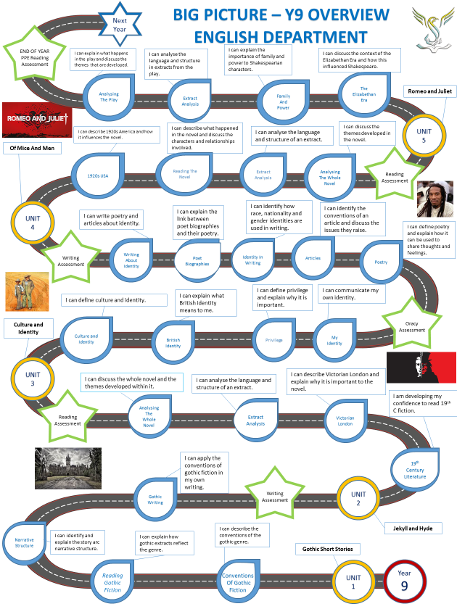

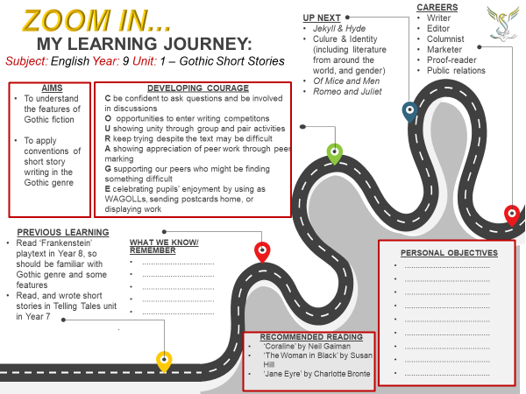


Lesson One Introduction
- LI: to understand the expectations for this unit
GPS
Connect
Reflect on last year:
What were you good at last year?
How could you improve this year?
Key questions:
- What do you expect from your teacher?
- What do you expect from your classmates?
- What do you expect from yourself?
- What is the difference between narrative and descriptive writing?
- What are adjectives and nouns?
- Why is it important to use the best possible adjectives?
DART: read through the Knowledge Organiser.
Read through the SAL.
Activate
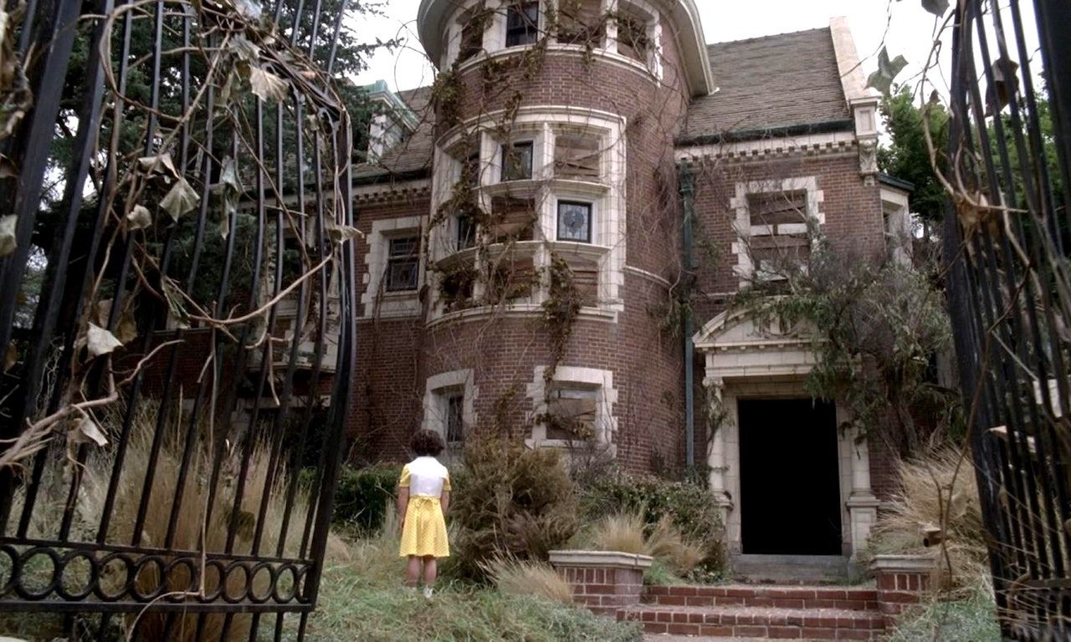
Write down ten things you could describe in the image.
Write down an adjective you could use to describe each noun. Be as imaginative as you can.

Demonstrate
Write a description of the image above. Use the nouns and adjectives you wrote down in the activation phase.
Challenge: can you create a character or a series of events to match the image?
Consolidate
Homework:
Using the extract booklet…
Learn the week one vocabulary
KO quizzes
Reading – 30 minutes daily

What is good about the writing you have done today?
What could you improve?
What did you do well last year?
What could you improve?
Lesson Two The Gothic Genre
LI: to understand the conventions of the gothic genre
Connect
Watch this video about Gothic conventions from the British Library:
https://www.youtube.com/watch?v=gNohDegnaOQ
Key questions:
- What is a convention?
- What is a genre?
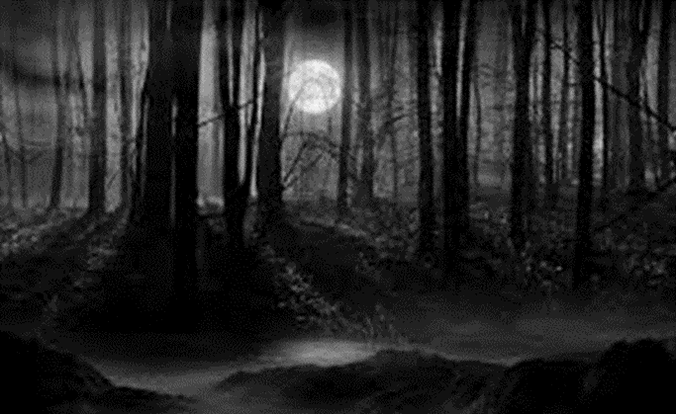
- What are characters, settings, and events?
- What are the conventions of the gothic genre?
- What are the common features of a gothic building?
- How do gothic buildings create mood in gothic texts?

Using the images on the right, write down five words to
describe each image.
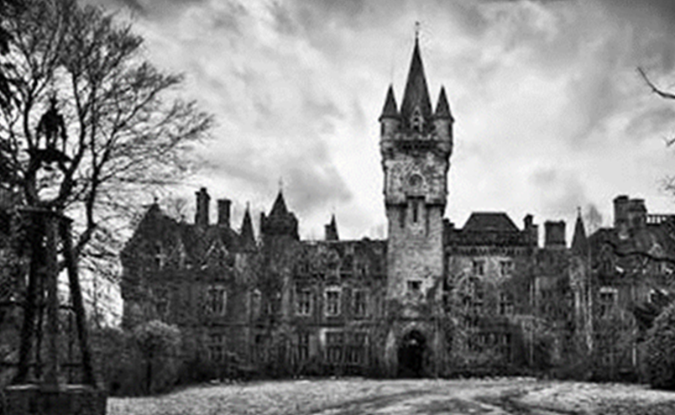
Can you identify any gothic conventions in the images?
Activate
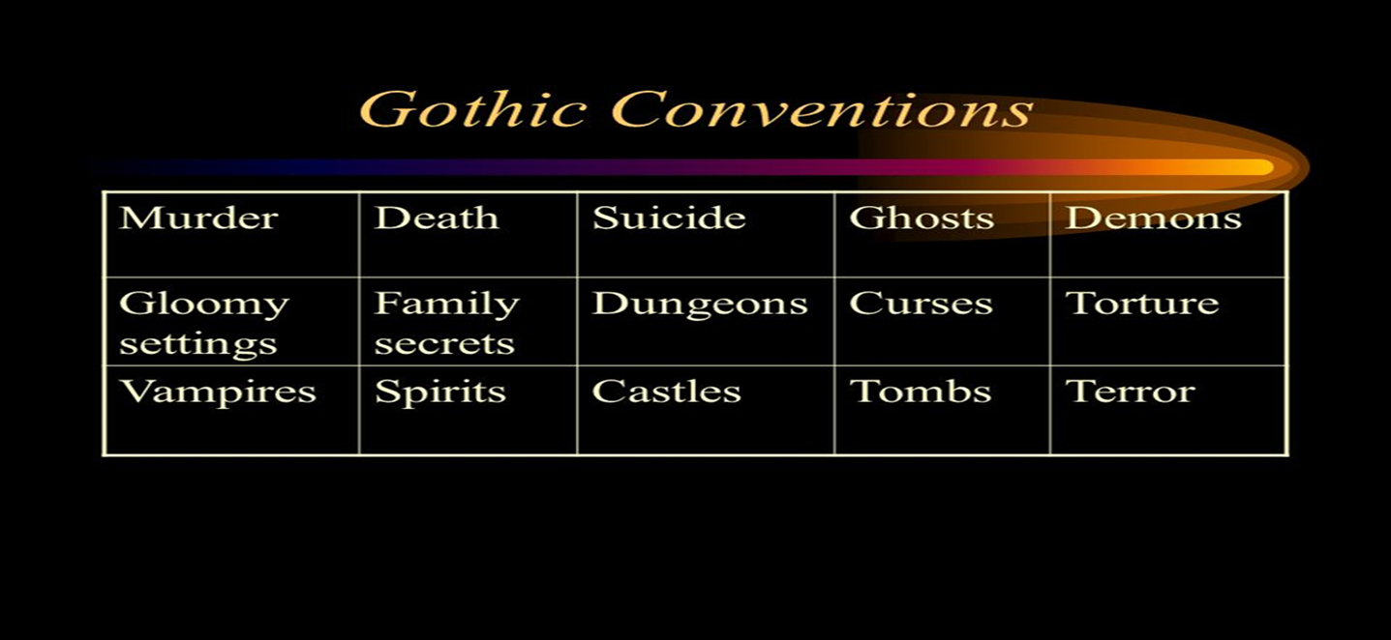
Group the above gothic conventions into characters, settings, and events.

Demonstrate
Gothic Buildings:
- In a quest for creating atmosphere, gothic novels are often set in imposing buildings. The ruins of gothic buildings gave rise to multiple linked emotions by representing the inevitable decay and collapse of human creations. Dark, gloomy, crumbling monuments are also a sign of fear – we nowadays we associate these buildings with gothic stories and horror.
- English Gothic writers often associated medieval buildings with what they saw as a dark and terrifying period, characterized by harsh laws enforced by torture, and with mysterious, fantastic, and superstitious rituals.

Gothic Buildings DART questions:
Where are gothic novels usually set?
What three adjectives are used to describe the monuments?
How do gothic buildings set the mood of the text?

Rewrite a section of your description from lesson 1.
How many gothic conventions that you have learnt in this lesson can you include?

Consolidate
Write down your own definition of gothic literature. Here’s a word bank to help you:

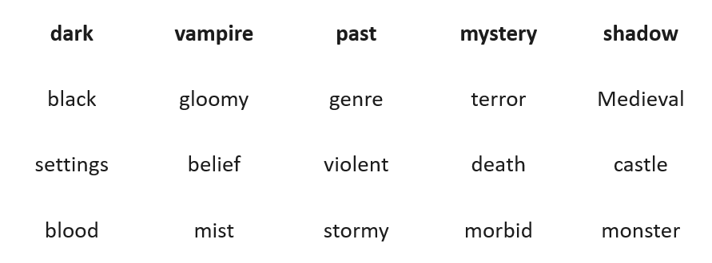
Lesson Three The Werewolf
LI: to understand the plot structure of a short story
Connect
What is a genre?
What types of building are found in gothic literature?
Name three types of character and three common events in gothic literature.
Activate
DART: Read The Werewolf by Angela Carter and answer these questions:
What happens in the story?
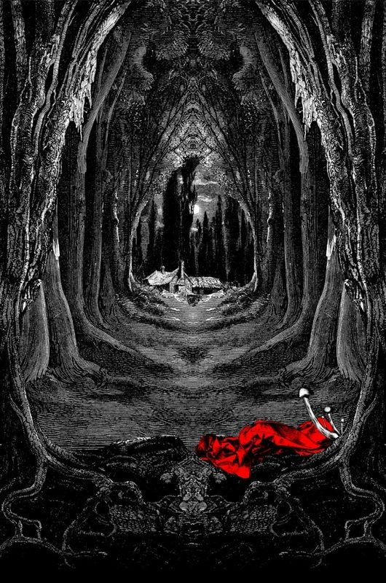
Who is in the story?
Where is the story set?
What fairy-tale is Carter’s short story based on?
Challenge: how many of the following can you define:
- The virgin
- Margins
- Wreaths
- Second-sight
- Hearthstone
- Chops
- Fore-paw
- Cold-compress
- Shift

Revision: this is a basic story arc:
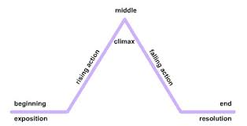

Demonstrate
Create the story arc for The Werewolf.
Write a five sentence summary of the plot based on the story arc.

Consolidate
Which fairy tale is The Werewolf based on?
What is similar/different about The Werewolf compared to the original fairy tale?
Key questions:
- What is a fairy tale?
- What are the five points on the story arc?
- What types of character would you commonly find in fairy tales?
- How does The Werewolf fit on the story arc?
- Which fairy tale is The Werewolf based on?
- How does The Werewolf reflect the gothic genre?

Lesson Four: The Werewolf
LI: to use the story arc as a planning tool
Connect
Re-read the opening to The Werewolf (lines 1 – 7)
DART: Answer the following questions:
- How is the weather described in the opening?
- What is a cold heart?
- How does this set the mood of the story?
- How are the houses described?
- What three words are used to describe life in this place?
Activate
How are each of these sentences gothic?

Squawking and shrieking like a thing possessed.

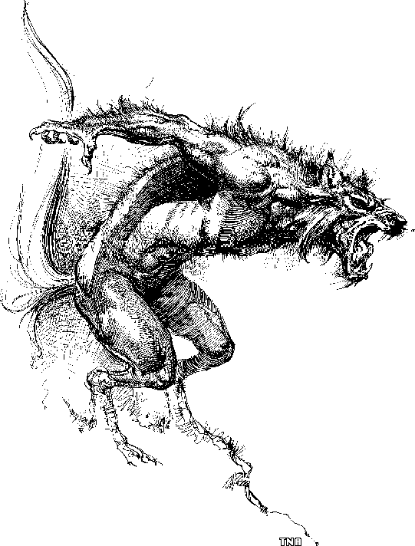
Wild beasts in the forest.

The devil is as real as you and I

Red eyes and running grizzled chops.
Demonstrate
Think of another fairy tale you have read previously.
How would it fit on the story arc?
How could you make each stage of the story arc gothic?
Plot a story arc for your retelling of a fairy tale.

Consolidate
Write a short plot outline for your story.
What gothic conventions are you going to use?
How is it different to the original fairy tale?

Key Questions
- How does the weather set the mood in The Werewolf?
- Which fairy tale is Carter’s short story based on?
- How was The Werewolf different to the original fairy tale?
- How does another fairy tale fit on the story arc?
- What features of a fairy tale could you change to reflect the gothic genre?
- How does Carter use gothic language and imagery?

Lesson Five: Gothic Openings
LI: to know and understand the conventions of a gothic opening
Connect
- What happened in The Werewolf?
- Which fairy tale was it based on?
- How were The Werewolf and the original fairy tale different?

Activate
DART:
‘I have always liked to take a breath of the evening, to smell the air, whether it is sweetly scented and balmy with the flowers of midsummer, pungent with the bonfires and leaf-mould of autumn, or crackling cold from frost and snow. I like to look about me at the sky above my head, whether there are moon and stars or utter blackness, and into the darkness ahead of me; I like to listen for the cries of nocturnal creatures and the moaning rise and fall of the wind, or the pattering of rain in the orchard trees, I enjoy the rush of air towards me up the hill from the flat pastures of the river valley’

How does the language used in the extract from The Woman in Black reflect the conventions of the gothic genre?
Here are some different ways of starting a narrative using dialogue, action, setting, character, and
structural considerations:
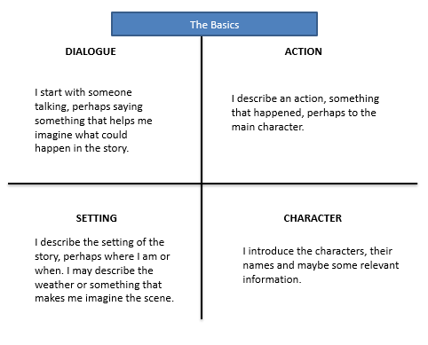

Here are some structural considerations when beginning a narrative:

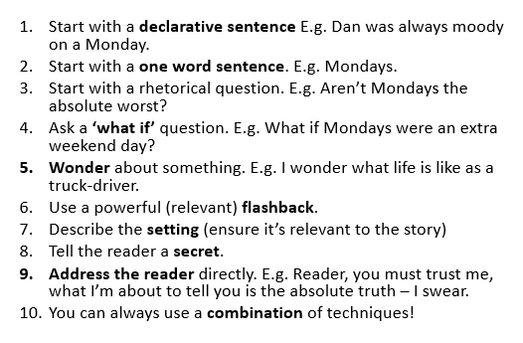

Demonstrate

Here are four story openings. How can these be made gothic?

The hottest day of the summer so far was drawing to a close and a drowsy silence lay over the large, square houses of Privet Drive.
“I’m going shopping in the village,” George’s mother said to George on Saturday morning. “So be a good boy and don’t get up to mischief.”

Teacher example
The hot day had ended. Thick fog descended. An owl could be heard hooting in the distance. The castle’s turrets reflected the moonlight.
Once there were four children whose names were Peter, Susan, Edmund and Lucy.
When I was four months old, my mother died suddenly and my father was left to look after me all by himself.

Consolidate
What conventions have you used in the opening to your short story?
What is going to happen next?
Key Questions:
- How did the opening to The Werewolf set the mood for the story?
- Why is the opening to a story so important?
- How can you start a short story?
- What makes the opening to a story gothic?
- How can openings to stories be adapted to make them gothic?
- Can you identify gothic conventions in your own writing?

Lesson six: The Red Room
LI: to identify the conventions of a gothic narrative in The Red Room.
Connect
What is the supernatural?
How do people feel about supernatural characters?
How many books or films can you name that include the supernatural?

Activate
Foreshadowing is defined as something which hints at events to come later through your opening.
E.g. The Red Room
‘I assure you,’ I said, ‘that it will take a very tangible ghost to frighten me.’
Read the first nine pages of The Red Room.
DART:
‘I heard the faint sound of a stick and a shambling step on the flags in the passage outside. The door creaked on its hinges as a second old man entered, more bent, more wrinkled, more aged even than the first. He supported himself by the help of a crutch, his eyes were covered by a shade, and his lower lip, half averted, hung pale and pink from his decaying yellow teeth. He made straight for an armchair on the opposite side of the table, sat down clumsily and began to cough. The man with the withered hand gave the newcomer a short glance of positive dislike; the old woman took no notice of his arrival, but remained with her eyes fixed steadily on the fire’
- Highlight any examples of gothic conventions
- Highlight any phrases you might use in your own work
- Highlight any examples of sensory description

Demonstrate
DIP: How is The Red Room a gothic story? Use the extract and your annotations to help you focus on a specific section if required.

Consolidate
Make two predications about what is going to happen in the rest of the story.
Key Questions:
- What is pathetic fallacy?
- What does the word “gothic” mean to you?
- What is the supernatural?
- What are the conventions of a gothic story?
- How is The Red Room a gothic story?
- What do you think is going to happen in The Red Room? Why?
Lesson seven: The Red Room
LI: to identify the conventions of a gothic narrative in The Red Room.
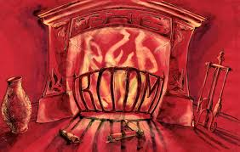
Connect
What are the connotations of the colour red?
Can you identify connotations of two other colours?

Activate
What are gothic conventions?
Identify the gothic conventions we have already seen in The Red Room?
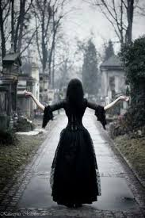
DART:
Finish reading the narrative and continue to highlight any gothic
conventions you spot in the text.
Describe what happens in the narrative.
Is this what you expected? Does it match your prediction from earlier?

Demonstrate
Choose between four and six quotations from The Red Room and draw a storyboard of the plot.
(Focus on the exposition).
Label your storyboard with gothic conventions in the text.

Consolidate
How did Wells use the exposition to build towards the climax of the action in The Red Room?
How did this build suspense in the story?
Key Questions
- What is colour symbolism?
- What are the connotations of different colours?
- How does Wells create suspense at the beginning of The Red Room?
- What are your three favourite descriptions from the opening and why?
- What is the climax of The Red Room?
- How does this compare to your expectations?
Lesson Eight: The Exposition

LI: to use gothic conventions to write the exposition of a ghost story.

Connect
What are the five points on the story arc?
How does The Red Room fit onto a story arc?

Activate

Dart: Read this extract from Frankenstein and answer the questions below
It was on a dreary night of November that I beheld the accomplishment of my toils. With an anxiety that almost amounted to agony, I collected the instruments of life around me, that I might infuse a spark of being into the lifeless thing that lay at my feet. It was already one in the morning; the rain pattered dismally against the panes, and my candle was nearly burnt out, when, by the glimmer of the half-extinguished light, I saw the dull yellow eye of the creature open; it breathed hard, and a convulsive motion agitated its limbs.

- How is the night described?
- What time was it?
- What colour was the creature’s eye?
- What is happening in the extract?
- How does Shelley use the weather and setting to create atmosphere?
- What section of the story arc is covered here?
- Planning – what gothic conventions would you like to include in your own writing?

Demonstrate
DIP:
Use the story outline you wrote earlier in this unit to write the exposition of a gothic story in the style of Wells.
What conventions could you use?
Can you use foreshadowing?
What can you magpie from what we have read? (Use the grid below if needed)


Consolidate
What do you like about your work?
What could be improved in the future?
Key Questions:
- 1. What effect does a story written in first person have on the reader?
- 2. What effect do gothic stories intend to have on the reader?
- 3. What does foreshadowing mean?
- 4. What gothic conventions can you magpie from what we have read?
- 5. What time of day are gothic stories often set?
- 6. What is the weather often like during gothic stories?
Lesson Nine: The Metamorphosis
LI: to understand the turning point in a gothic story.

Connect
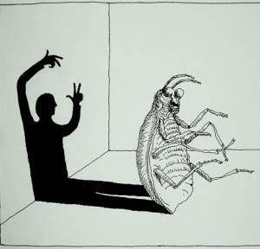
What is a turning point?
Why are they important?
Can you identify a turning point in something you have read?
Why was it significant?

Activate

Metamorphosis
noun: a change of the form or nature of a thing or person into a completely different one.

Dart: Read extracts 1 and 2 of The Metamorphosis. Focus on the turning point at the end of extract two and then answer the questions below.

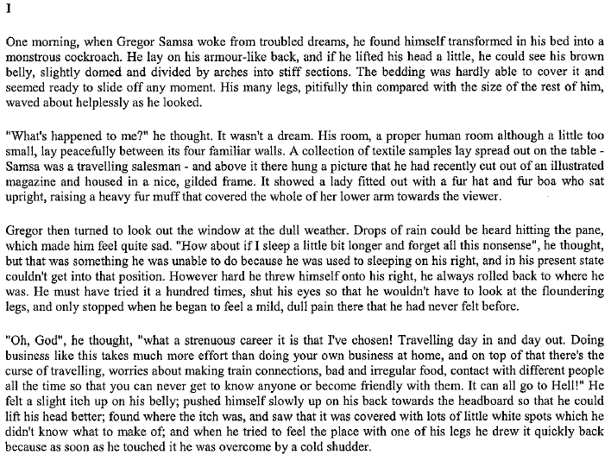

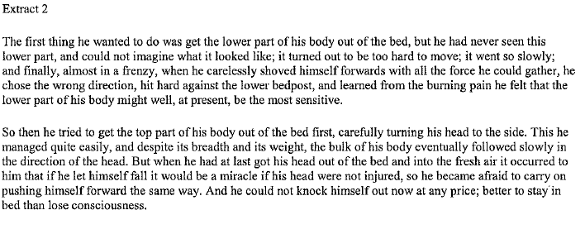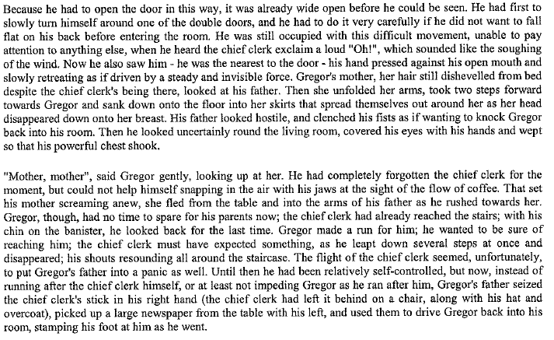

Questions:
If this happened to you…
- How would it feel?
- What would you look like?
- What would you do?
- Where would you go?
- How would others react?
- How would it end?

Demonstrate
DIP: Write (in the style of Kafka) a description of how it would feel to wake up in the situation Gregor finds himself in.

Consolidate
Pick an example of a gothic convention or sensory description you have included in your description and write a what, how, why (or PETER) paragraph to analyse your own work.
Key Questions:
- What happens in the climax of a story?
- What happens in the lead up to this?
- What is sensory description?
- How would it feel if everything in your life changed?
- How would you have to adapt?
- Why are the views of other people important?

Lesson Ten: The Climax of The Metamorphosis
LI: to understand the key subject term - climax.
Connect
What has happened in The Metamorphosis so far?
What challenges if Gregor going to face?
What do you think will happen?
Activate
Finish reading The Metamorphosis and annotate your copy for gothic conventions.
How did Gregor react to his transformation?
What did he originally want?
How do you think he feels about this now?
Demonstrate
Create a story arc for The Metamorphosis.
What is the climax of the story?

Consolidate
DIP: write a paragraph explaining what happens in the turning point and how it leads to the climax.
Key Questions
- If you could wake up tomorrow and be transformed into any animal, what animal would you be and why?
- What is a ‘metamorphosis’?
- How does this story fit into the gothic genre?
- How will Gregor reflect on his views on his initial situation?
- What is the climax of the story?
- How does the turning point of this story lead towards the climax?

Lesson eleven: gothic characters
LI: to write in the style of Kafka (absurdism)

Connect
What are the stereotypical gothic characters?
What characters have we met so far in this unit?
How do they reflect the gothic stereotypes?
DART: read the following description of Dracula by Bram Stoker.
Complete the vocabulary related activities and answer the questions.
Use the glossary below the extract which defines some of the more tricky words.
Dracula by Bram Stoker
His face was a strong, a very strong, aquiline, with high bridge of the thin nose and peculiarly arched nostrils, with lofty domed forehead, and hair growing scantily round the temples but profusely elsewhere. His eyebrows were very massive, almost meeting over the nose, and with bushy hair that seemed to curl in its own profusion. The mouth, so far as I could see it under the heavy moustache, was fixed and rather cruel-looking, with peculiarly sharp white teeth. These protruded over the lips, whose remarkable ruddiness showed astonishing vitality in a man of his years. For the rest, his ears were pale, and at the tops extremely pointed. The chin was broad and strong, and the cheeks firm though thin. The general effect was one of extraordinary pallor.
Hitherto I had noticed the backs of his hands as they lay on his knees in the firelight, and they had seemed rather white and fine. But seeing them now close to me, I could not but notice that they were rather coarse, broad, with squat fingers. Strange to say, there were hairs in the centre of the palm. The nails were long and fine, and cut to a sharp point. As the Count leaned over me and his hands touched me, I could not repress a shudder. It may have been that his breath was rank, but a horrible feeling of nausea came over me, which, do what I would, I could not conceal.

Glossary:
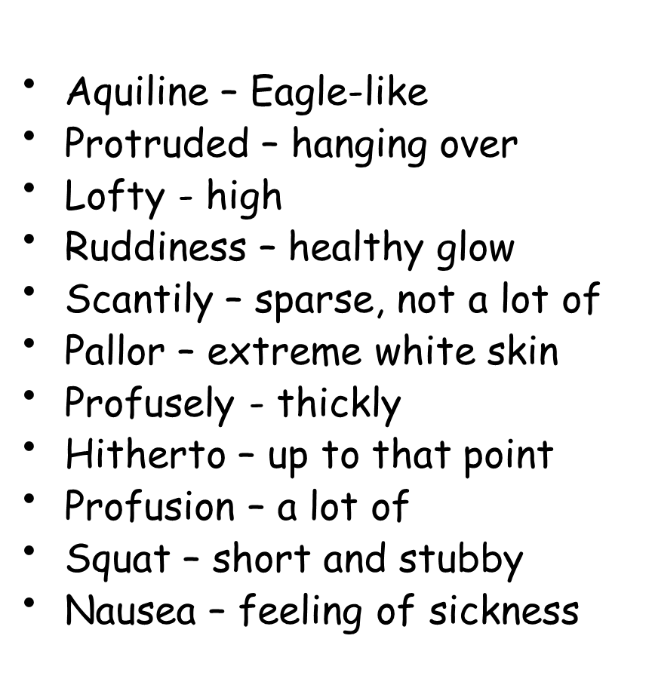
Activate
Write down these definitions of words relating to the noun isolation:
Isolate
verb
Cause (a person or place) to be or remain alone or apart from others.
Alienated
verb
Experiencing feelings of isolation

Answer these questions:
How do these ideas of isolation relate to Gregor from The Metamorphosis?
Is this typical of gothic characters?

Demonstrate
Write about a time when you felt isolated.
Your response can be real or imagined.
You should use gothic conventions.
You can use these prompts to help…
Imagine… you work as a door to door salesperson, but… you are treated badly by your boss, nobody appreciates all the work you do.
You are the only one bringing in money and it is not appreciated at home…
You are growing more disillusioned by the day…
You begin to resent your life…
You long for a life with less responsibility and obligations to family…

Consolidate
What have you focused on today?
How will it improve your writing?

- What is a stereotypical gothic character?
- How does Dracula reflect these stereotypes?
- What are alienation and isolation?
- How do they relate to gothic characters?
- How could you develop a gothic character?
- How is your character isolated or alienated and what from?

Key questions:

Lesson Twelve: The Tell-tale heart
LI: to understand what makes an effective resolution to a short story.

Connect

DART: read the following mid-topic review and answer the question below:

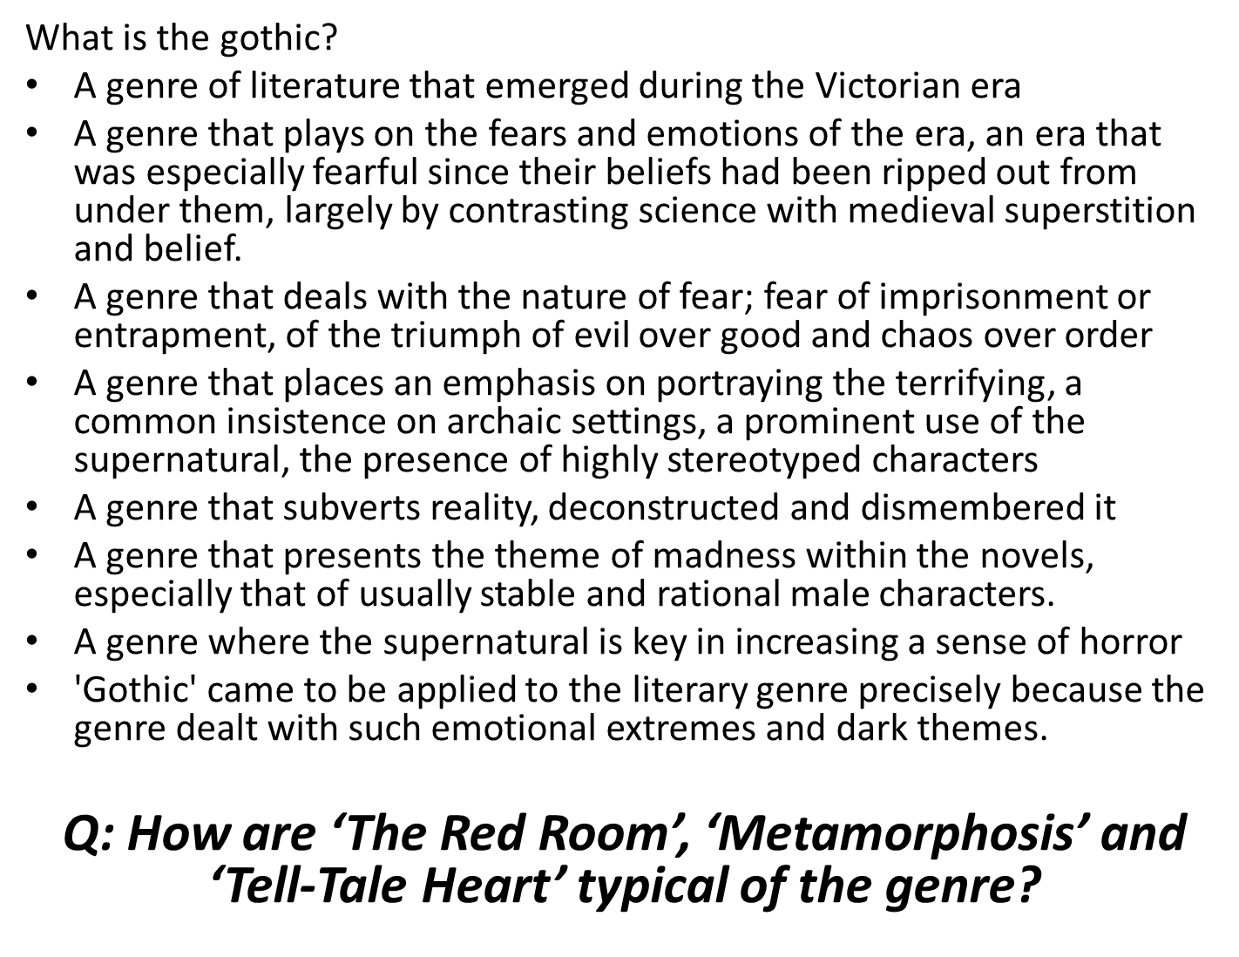
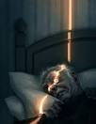
Activate

Read The Tell-tale Heart which is in your short story booklet.

Plot the story on the story arc.
What is the resolution to the story?

Demonstrate
Re-read the ending of The Tell-tale Heart which is reproduced below.
Is this a happy ending?
Is it a satisfactory ending?
What is the difference between these two things?
Which character(s) do you feel sympathy for?

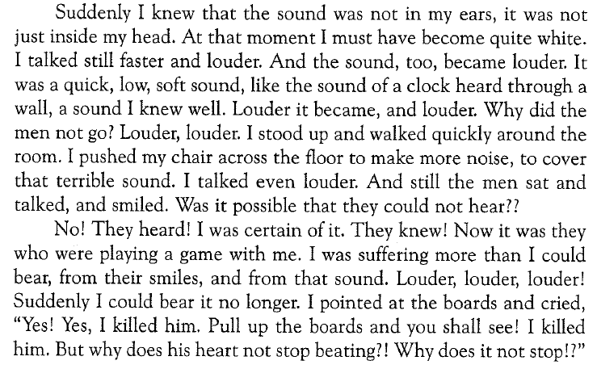

Consolidate
DIP: write a diary entry from the perspective of the narrator. Record the period of time between the killing of the old man, but before the police arrive.
Consider:
- What he did
- Why he did it
- How is he feeling?
Remember to use informal language, first person perspective, past tense, and to use dates.

Key Questions:
- What is a resolution?
- What is the difference between a happy and a satisfactory ending?
- What do you think are the characteristics of a mad man?
- How are ‘The Red Room’, ‘Metamorphosis’ and ‘Tell-Tale Heart’ typical of the genre?
- How would the mad man explain what he did?
Lesson thirteen: The Resolution
LI: to understand what makes an effective resolution to a short story.
Connect
Unscramble the following words. How does each word link to The Tell-Tale Heart?
- Rebliaelnu rratroan
- Thoigc
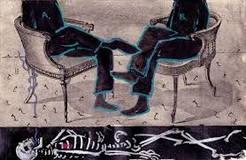
- Niosent
- Damsens
- Redrum
- Olsymismb
- Rrohro
- Sciconceen gltyui
- mtacirda

Activate
Answer the following questions about The Tell-Tale Heart…
- How does the writer let us know that this is an unreliable narrator telling the story?
- Why would the Victorians have found this murder particularly disturbing?
- Choose 3 areas of the story where Poe uses punctuation to create tension. Copy them out and explain HOW the use of punctuation builds tension.
- What tone of voice do you imagine the narrator to use? What makes you think this?
- Why isn’t the narrator’s name ever revealed?

Demonstrate
How do your answers to the above questions (and any other examples from the text) build tension?

Consolidate
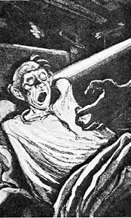
How has Poe created tension in The Tell-Tale Heart?
Key Questions:
1. Why do you think Poe has set this story at night-time, in the dark?
2. Why would the Victorians have found this murder particularly disturbing?
3. Why isn’t the narrator’s name ever revealed?
4. How does Poe create tension in The Tell-Tale Heart?
5. How does The Tell-Tale Heart conform to gothic conventions?
6. What do you think are the most important events in the story?

Lesson fourteen: The Yellow Wallpaper
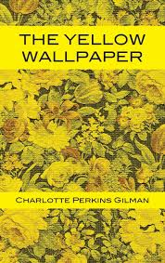
LI: to understand what makes an effective resolution to a short story.
Connect
Can you predict what the short story is about based on these images?
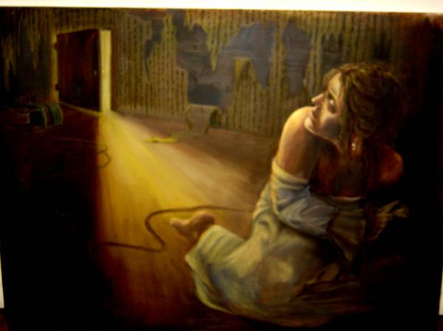
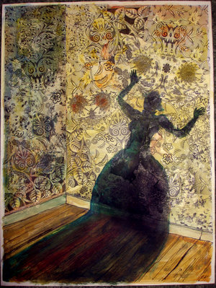
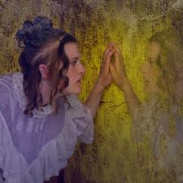
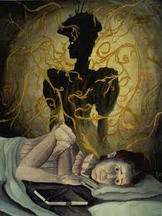
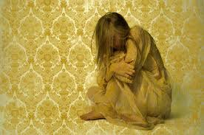

What three things do we learn about the narrator from the following quote:
“It is very seldom that mere ordinary people like John and myself secure ancestral homes for the summer.”

Activate
DART: read the opening of The Yellow Wallpaper (up to the first set of asterisks (*******)) and answer the following questions:
- Where has the narrator moved to?
- Why have they moved there? What is wrong with the narrator?
- How does the narrator feel about the place? Why?
- What is the narrator’s opinion of the wallpaper?

Demonstrate
Is John a caring, considerate husband?
What does the narrator think?
Find quotations to support your answer.

Consolidate
How would John’s perspective differ from his wife’s?
Key questions:
- What is the purpose of a narrator?
- What is perspective?
- From which perspective is the Yellow Wallpaper told?
- What do we learn about the narrator from her perspective?
- Would her husband agree?
- How would John’s perspective be different?

Lesson fifteen: The Yellow Wallpaper
LI: to understand what makes an effective resolution to a short story.
Connect
Write down three words to describe the narrator from your perspective.
Write down three words from the narrator’s perspective and John’s perspective.
Why are they different?
Activate
Finish reading the short story.
Annotate and highlight for Gilman’s use of gothic conventions.
Demonstrate
We’re going to answer the following question:
How does Gilman show that the narrator feels helpless in her situation?
First, find some evidence that shows her feelings of helplessness. Here’s an example:
“What is one to do?”
Then, create a PETER paragraph which answers the question (which is about helplessness):
(P)oint: Gilman shows that the narrator feels helpless in her situation through the narrator’s utterings of despair.
(E)vidence: this is shown when Gilman writes “what is one to do?”
(T)echnique: the use of the rhetorical question
(E)xplain: demonstrates the narrators lack of resolve to address her illness and
(R)eader effect: underlines to the reader the narrator’s despair and helplessness at her situation.
Consolidate
Now, choose a piece of evidence for yourself that shows the narrator’s helplessness and build your own PETER paragraph.
Key Questions:
- Do you agree or disagree that John is a caring and considerate husband? Why?
- What is the narrator’s opinion of the wallpaper?
- What do you think about the narrator?
- Why does the narrator feel helpless?
- How does Gilman communicate this?
- What does this show about the role of women in Victorian society?
Lesson sixteen: John’s Perspective
LI: to understand how alternative perspectives create effects.

Connect
DART: read the two extracts from page 88 and 94 of The Yellow Wallpaper and answer these questions:

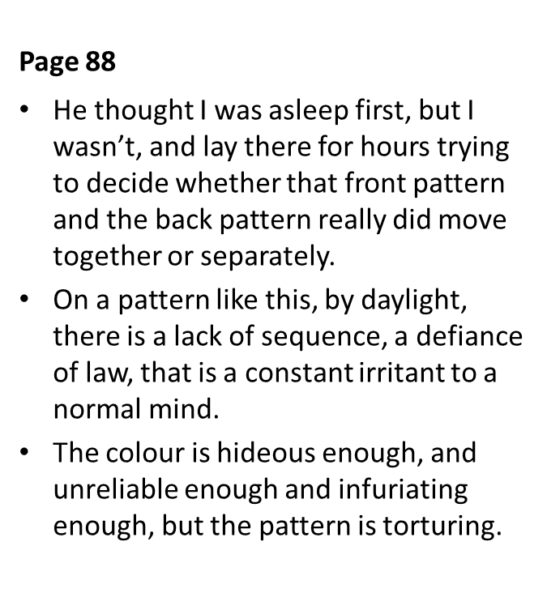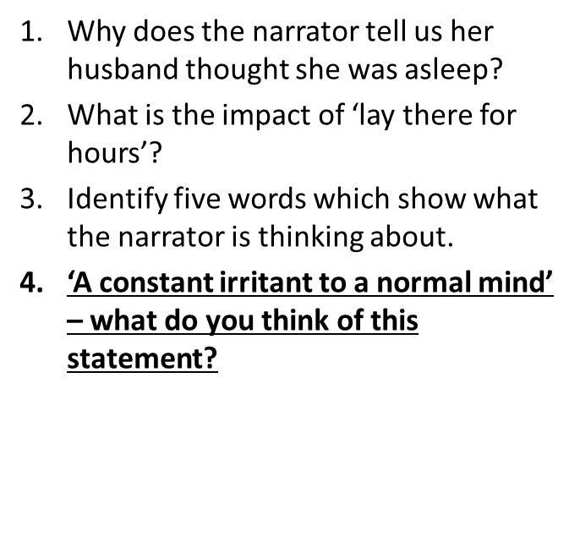
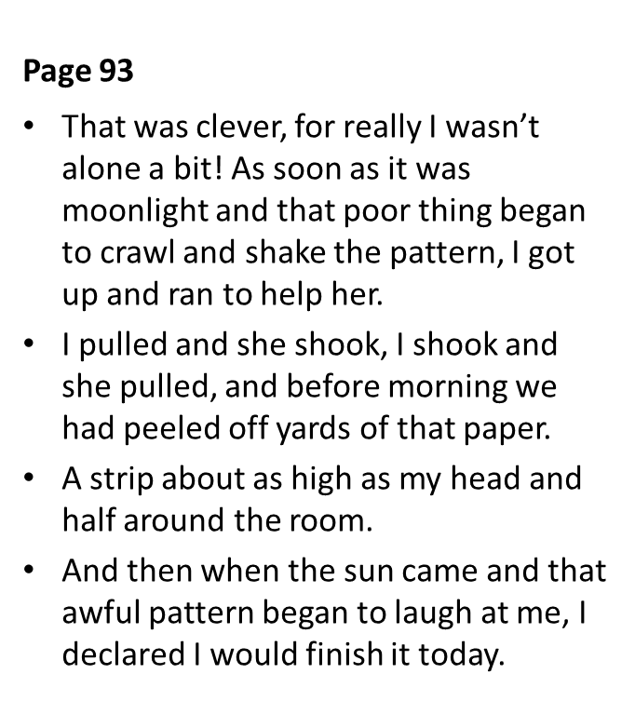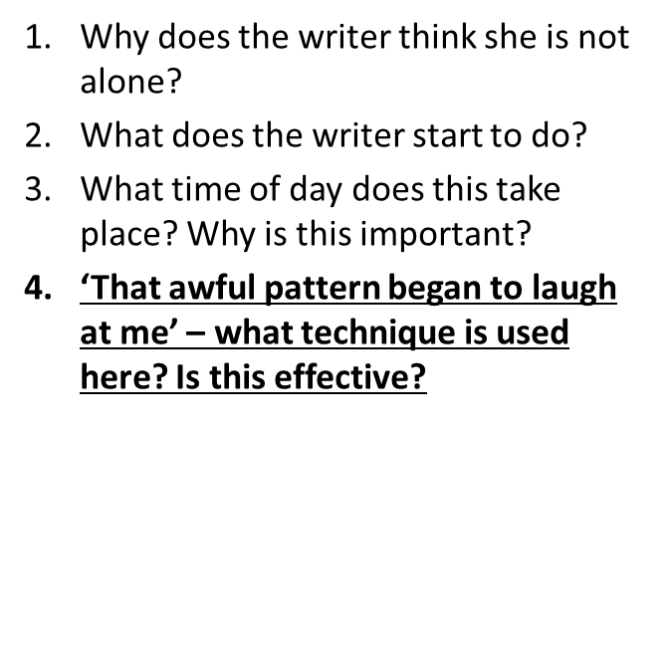

The following shows Voldemort’s view of Harry potter. What does this tell us about narrative perspective?
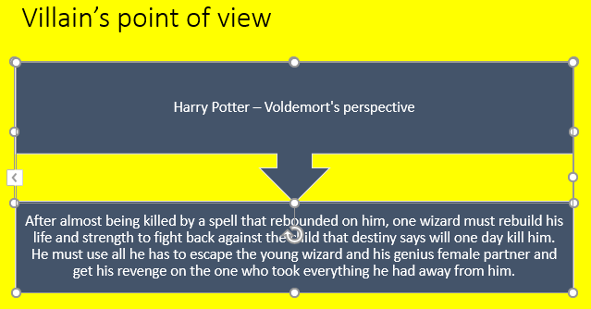
Now, answer these questions about the character of John from The Yellow Wallpaper.
- What two questions does the writer ask about the house?
- How does John react to these questions?
- What does John tell their friends and relatives about his wife?
- What does John do to help his wife? (page 81)
- What does John think about his wife’s situation? (You might have to imagine this)
- Is there anything else we find out about John during the story?
Demonstrate
DIP: re-write the beginning and end of The Yellow Wallpaper from John’s perspective.

Consolidate
Why is perspective important?
Key Questions:
- Why do people have different perspectives on the same event?
- Why is John’s perspective of the story different to his wife?
- Which moments would be the most different?
- Who has the ‘right perspective’?
- What is the effect of using different perspectives?
- What does this show about the role of women in Victorian society?

Lesson seventeen: story planning
LI: to plan a gothic short story.

Connect

What are the five points on a story arc?
Write down ten conventions of gothic literature.
What stories have we read?

Activate
DART: read the following gothic extracts and answer the questions that follow.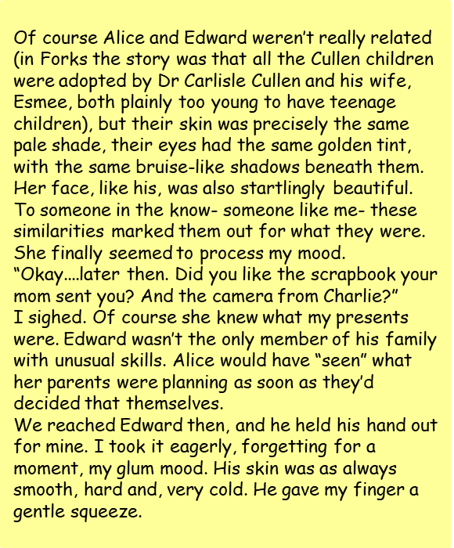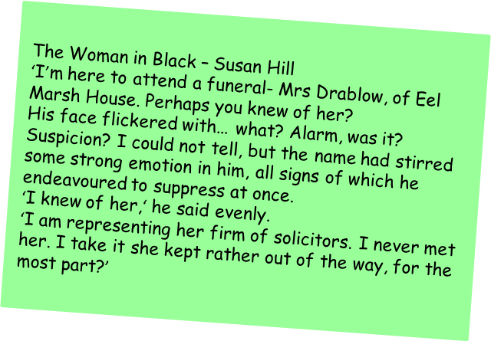
How do these extracts reflect the gothic genre?
Are there any elements you could magpie?

Demonstrate

Plan your story. Make sure you have a complete story arc and you have planned your use of gothic conventions.

Consolidate

DIP – write the opening to your story.

Key Questions:

- What Gothic conventions are you going to use in your story?
- What elements of the stories we have studied are you going to magpie to use in your own writing?
- What characters will you include?
- How will you introduce them to the reader?
- Whose perspective are you writing from?
- What happens at each stage of the narrative (story arc)?
- Where will your story be set?
- What effect do you want to have on your reader?

Lesson eighteen: Story Writing
LI: to use my learning to inform my writing.

Connect

Reread the two gothic extracts from the previous lesson.

Activate

Read through your story arc and your opening from the previous lesson.

Demonstrate

Write your story.

Consolidate

Proof read your work.

Attainment Band | Gothic Short Stories
Yellow Plus | - Your narrative is interesting and engaging; descriptions of setting and characters are fundamental to the high quality of your work.  - You make accurate use of well-chosen, ambitious vocabulary, and your deliberate use of language devices is wide-ranging and reflective of clear authorial intent.  - The structure of your work and your use of conventions allow your text to undeniably belong to a particular genre, demonstrating multiple traits of that genre.  - Decisions on the structure of sentences and paragraphs are deliberate, purposeful, and fundamental to the high quality of your work.  - Your use of punctuation is accurate and deliberate, consistently contributing to the overall meaning and mood of the text.
Yellow | - Your writing balances a clear narrative with detailed description of well-developed characters and setting.  - The words and language devices you use are carefully chosen to convey specific meaning and to achieve a particular effect.  - The structure of your text is cohesive, clearly reflects the genre, purpose, and audience of the text, and contributes to the overall effectiveness of your writing.  - A wide range of sentence and paragraph structures are used deliberately to achieve a specific impact and effect.  - You use a full range of punctuation accurately and to achieve a specific effect.
Blue | - Your writing includes imaginative and original ideas, developed with awareness of the reader and their likely response.  - You deliberately use a wide range of language devices to convey characters and setting, and use taught and increasingly ambitious vocabulary for impact and effect.  - Conventions of a narrative and genre are used accurately and effectively with proof-reading helping you to make better choices in your writing.  - Cohesive paragraphing guides the reader through the text, and your variation of sentence structure is used to shift the mood and tone throughout the text.  - You use a range of punctuation accurately with an increasing awareness of potential effect.
Green | - Your writing includes a complete plot, and you attempt to develop characters and settings to support this.  - You start to make deliberate word choices and use simple language devices to develop the detail of your descriptions, using some taught vocabulary.  - Your work is structured deliberately to recognise conventions of narratives and genre, and for purpose or audience, and you proof-read to correct most errors after writing.  - You develop your ideas using paragraphs with some cohesion linking them together, and your sentences use a variety of structures.  - You use a range of punctuation accurately (commas, end stopping, apostrophes, parentheses, colons before a list).
White | - You respond to the task and use planning or writing frames to create simple characters, settings, and events.  - You attempt to write descriptively using basic vocabulary.  - Your work includes some clustering of related ideas and is structure to show progression (e.g. there is an opening and ending, and events take place in chronological order).  - Your sentences are simple, and you use paragraphs.  - You use simple punctuation mostly accurately (capital letters, full stops, commas).

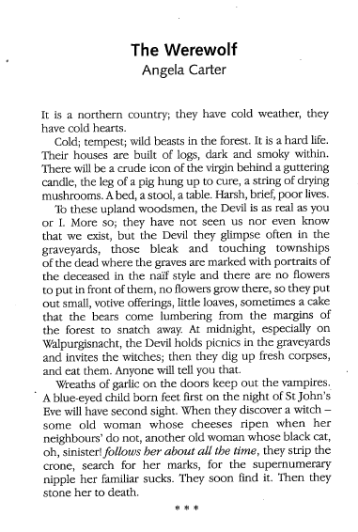

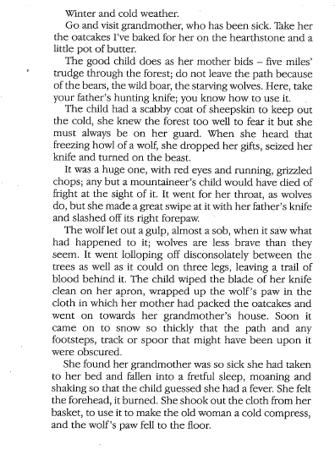

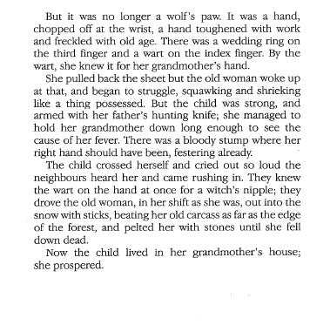

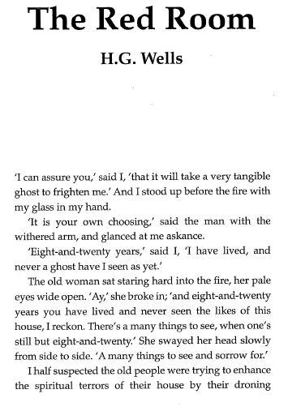

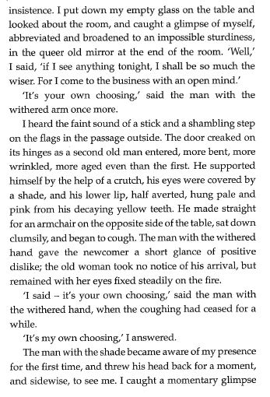

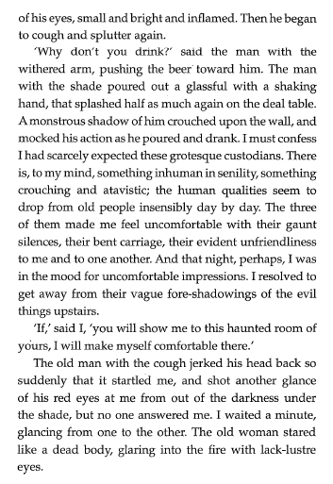

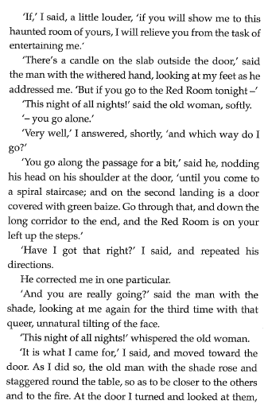

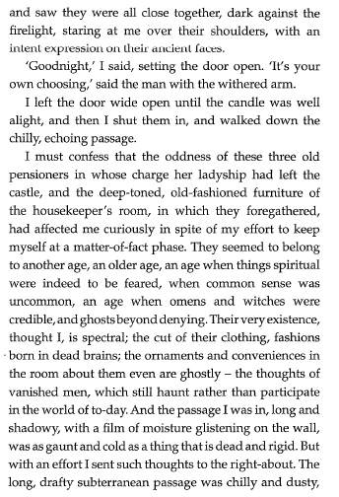

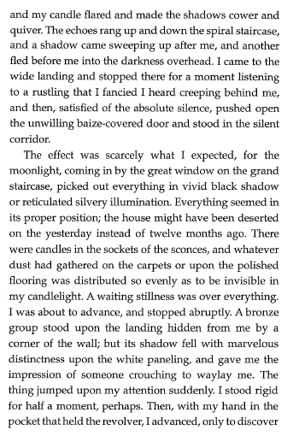

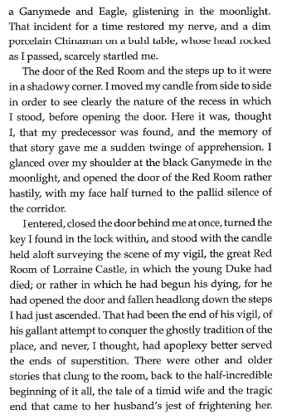

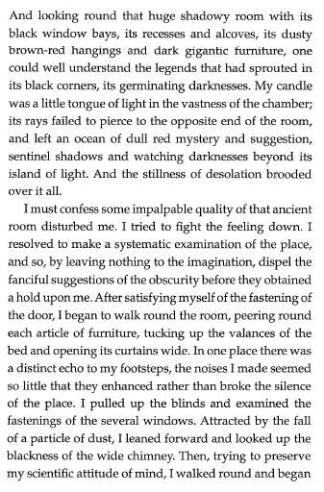

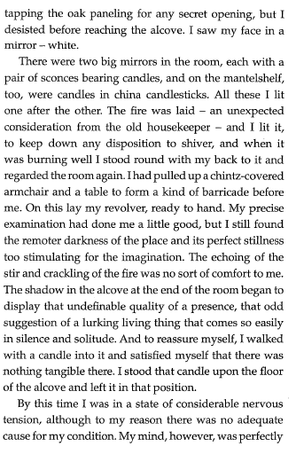

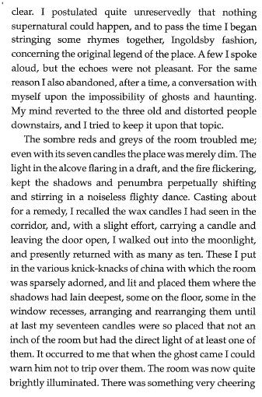

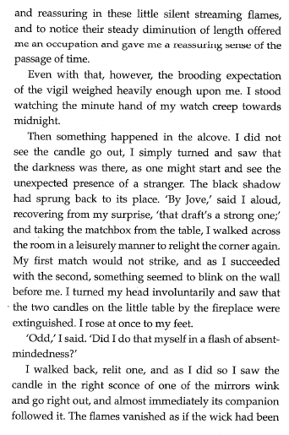

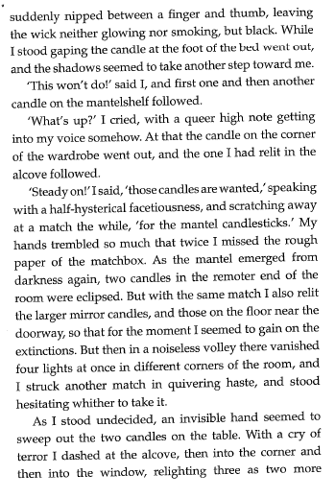

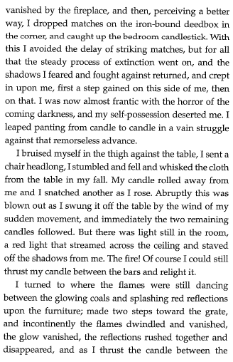

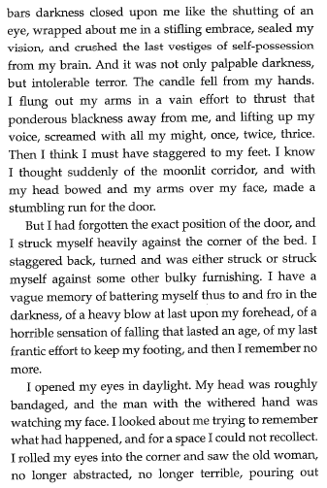

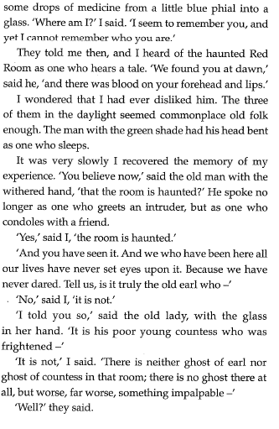

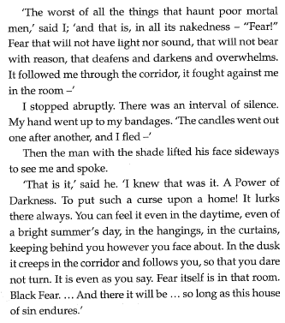

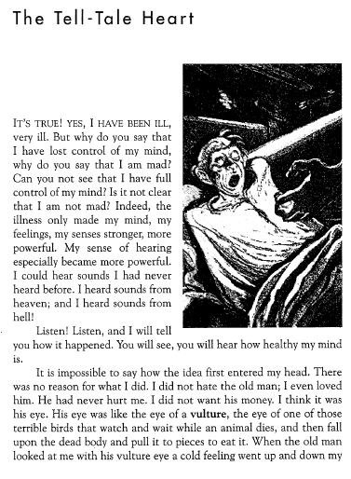

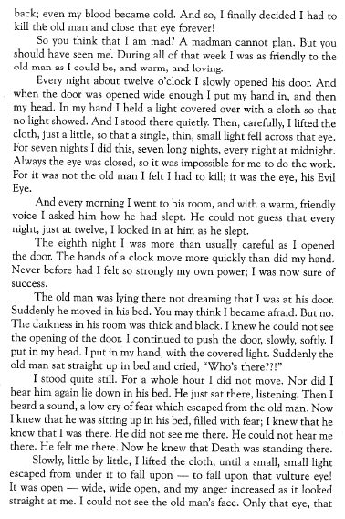

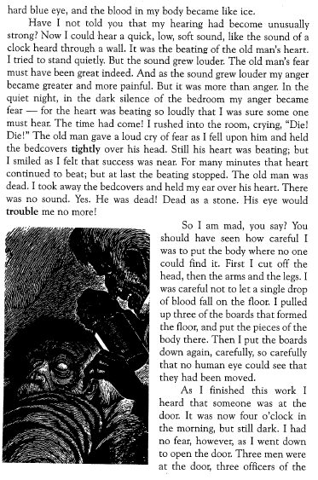

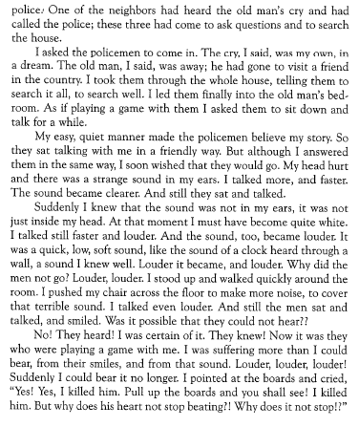

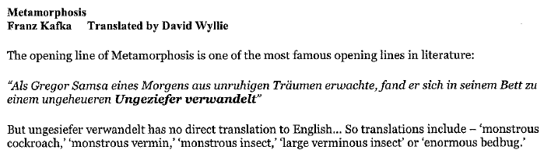
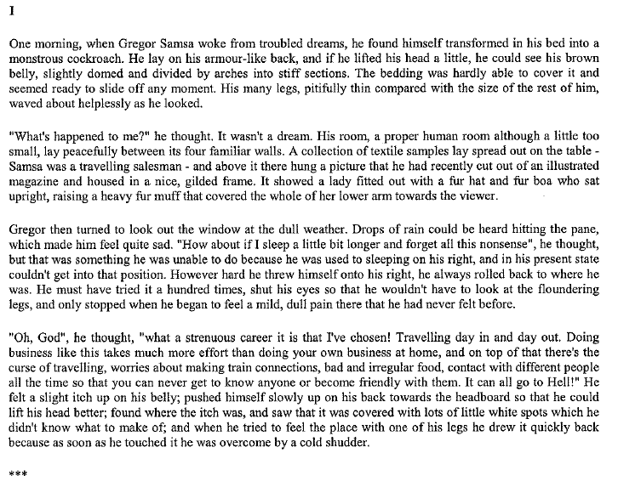
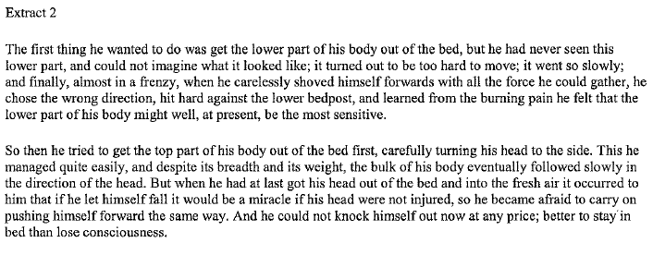
Extract 3


