Geography Year 9
Blended Learning Booklet

Y9-2 Hot Deserts

Name:
Form:

Aim to complete one lesson each week. Write down the title and LI for each lesson and then complete the tasks which are highlighted.
The Knowledge Organiser on page 3 has all the key information and vocabulary to help you with this unit.
Upload all work onto ClassCharts for feedback.
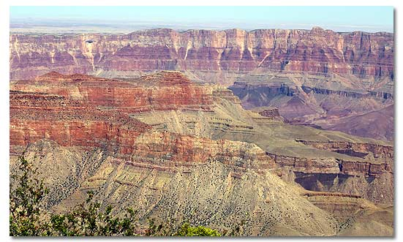
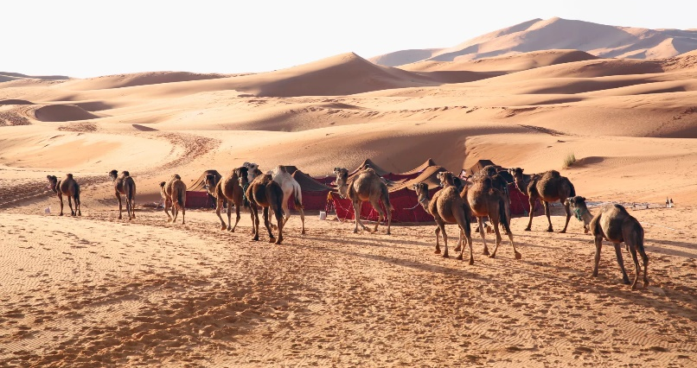

Contents
Page 3: Big Picture - Year 9 Overview
Page 4: Zoom in - My Learning Journey
Pages 5 & 6: Knowledge Organiser
Pages 7,8 & 9: Lesson 1
Pages 9 & 10: Lesson 2
Pages 10 & 11: Lesson 3
Page 12: Lesson 4
Page 12 & 13: Lesson 5
Pages 13, 14 & 15: Lesson 6
Page 16: Lesson 7

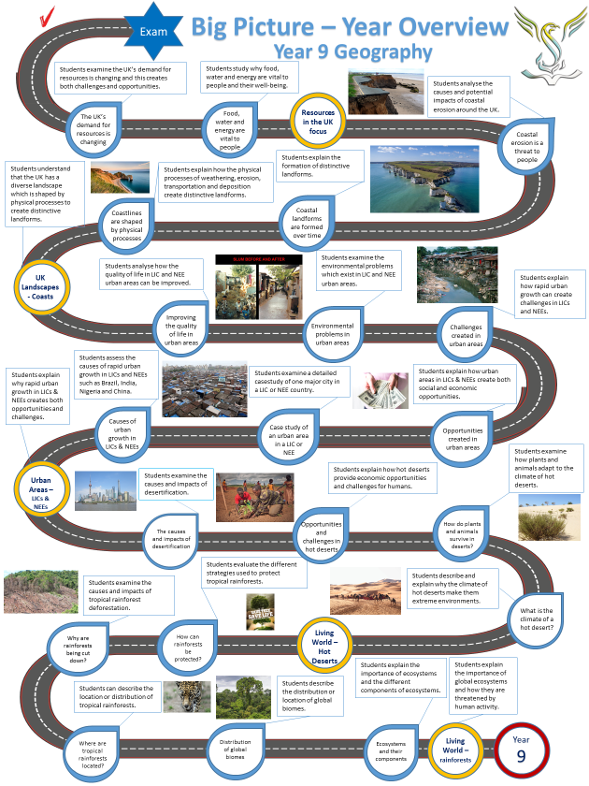

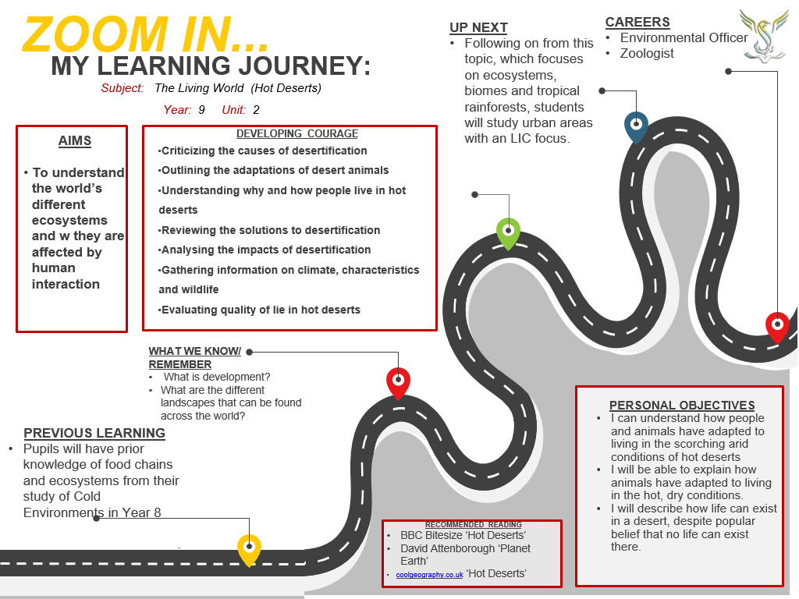

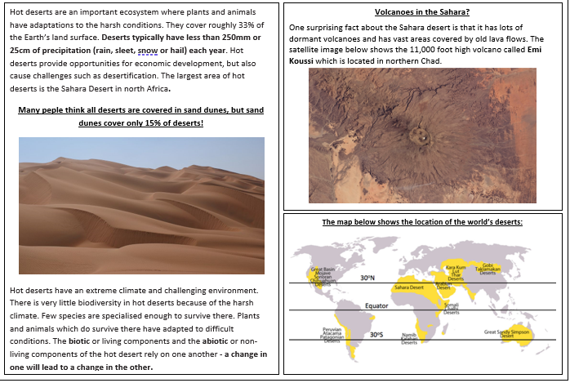
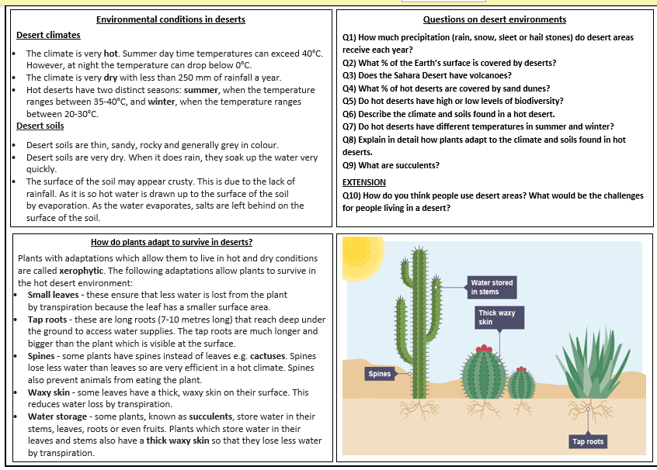
KO 1: Introducing Hot Deserts

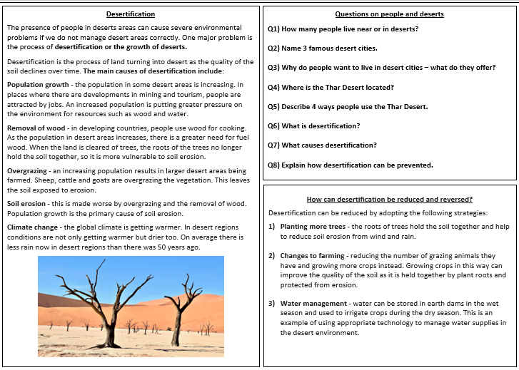
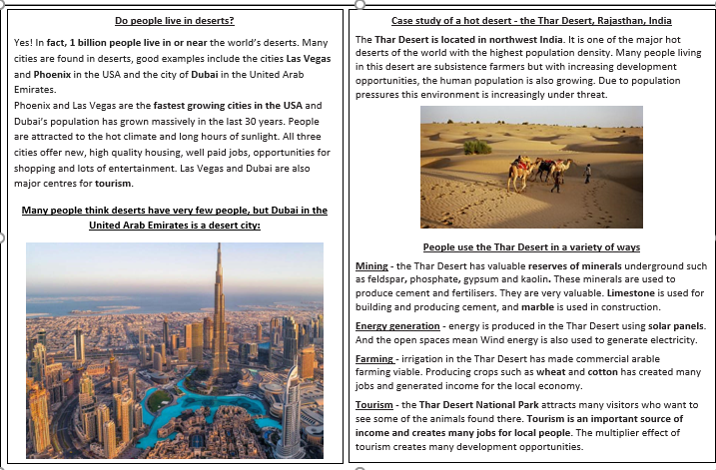
KO 2: People and Hot Deserts

Lesson One: Introducing hot deserts
- LI: To examine the unique physical characteristics of hot deserts

Read through the KO ‘Introducing hot deserts’. Using the information, answer the following questions.
Q. Where are the hot deserts of the world located?
Q. What are conditions in ho deserts like?

RECALL: What are biotic and abiotic factors?

Read the DART below, and answer the questions at the end.
Comparing hot and cold deserts
Hot and cold are the two main ways of classifying the deserts based on the temperature. An obvious difference between the hot and cold deserts could be identified in terms of temperature, yet there are many other physical and interesting biological characteristics about these ecosystems.
The distribution of hot and cold deserts is shown on the map below:
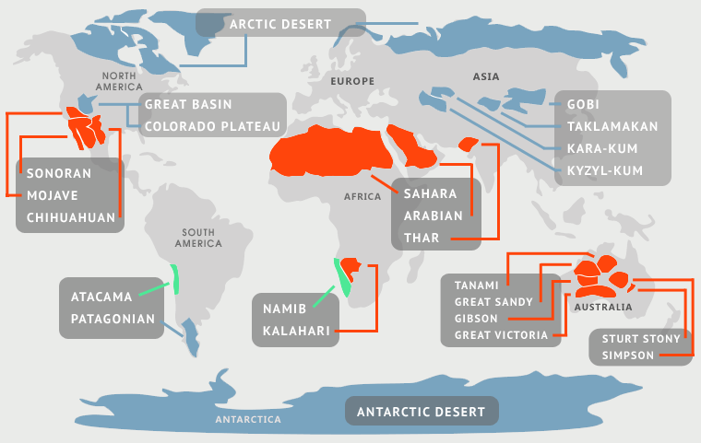
Hot Deserts
With extreme temperatures present in both day and night, hot deserts are dry. However, these deserts are utterly hot during daytime but extremely cold at night. The usual temperatures reach 43° – 49° Celsius in daytime while it goes down towards -18° Celsius at night. The annual rainfall does not usually exceed 250 millimetres.
Hot deserts can be found in almost all the continents; Sahara and Kalahari in Africa, Arabian Desert in Middle East, Great Victoria Desert in Australia, Gobi Desert in Asia, and Great Basin Desert in North America are some of the largest and amongst the most known deserts.
Hot deserts are surprisingly varied landscapes some are very mountainous and rocky, others are covered by sands dunes:
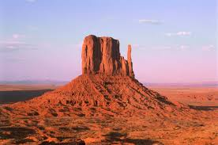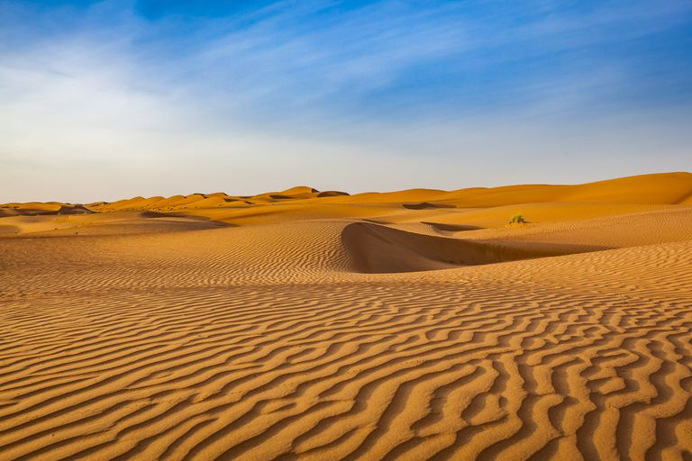

There is not much soil in hot deserts, where it does exist it is mainly loose, coarse, or gravelly. Most of the time fine dust and sand particles are blown away by the wind. The biological diversity in hot deserts is low. Cactus species, small shrubs, and very few trees with short shoots are the typical vegetation in these deserts. Water conservation techniques such as thick leaves and spines can be observed in the vegetation.
Most of the animals have adapted to live under soil or in burrows such as kangaroo rats, reptiles, and spiders. Insects inhabit trees and flowers while carnivorous birds hover around the sky looking for prey animals. Plants weather the hot daytime, but animals wait until it becomes cool enough to forage.
Cold Deserts
Cold deserts are almost lifeless regions with snowing winters during most of the time of year. Out of all the deserts in the world, the Antarctic and Arctic deserts are two of the largest in land area covering more than 27,000,000 square kilometres together.
Antarctica is the largest and coldest of the cold deserts:
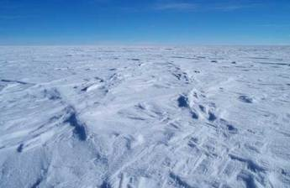
The winter lasts for nine months with an average temperature ranging around -20 to -40° Celsius, yet it could go as down as -70° Celsius or even colder. During the three months of summer, the mean temperature lies around 12° Celsius. Precipitation takes place in two ways, raining and snowing.
The annual rainfall does not exceed 250 millimetres, and most of the raining takes place in the summer. Since the sun does not strike hard on cold deserts, the evaporation is not as much as in hot deserts. The soil is almost covered in snow, yet its texture is silty but heavy. Polar bear, flatfish, caribou, arctic fox, arctic hare, and penguin are the well-known cold desert animals. Grasses and shrubs are the main forms of vegetation in this ecosystem.

What are the main differences between Hot and Cold Deserts?
• Both places are dry, but temperatures vary in the two as the names suggest, hot and cold.
• Hot deserts are found in many tropical places of the world while cold deserts are found towards the Polar Regions or on mountains.
• Precipitation is low in both biomes, but evaporation is much higher in the hot desert than in the cold desert.
• Cold deserts experience long winters and short summers, but there are no seasonal effects taking place in hot deserts.
• Hot deserts feature the presence of reptiles and amphibians but not in cold deserts.

Questions:
Q1) What is the main difference between hot and cold deserts?
Q2) Describe the climate of a hot desert.
Q3) Describe the levels of biodiversity found in hot deserts.
Q4) How does the climate of a cold desert compare to the climate of a hot desert?
Q5) Explain the main differences between hot and cold deserts

Lesson Two: Climate and animals of hot deserts
- LI: To explain the unique climate and animal biodiversity of hot deserts

Analyse the climate graph and answer the questions.
The annual climate of the Sahara Desert
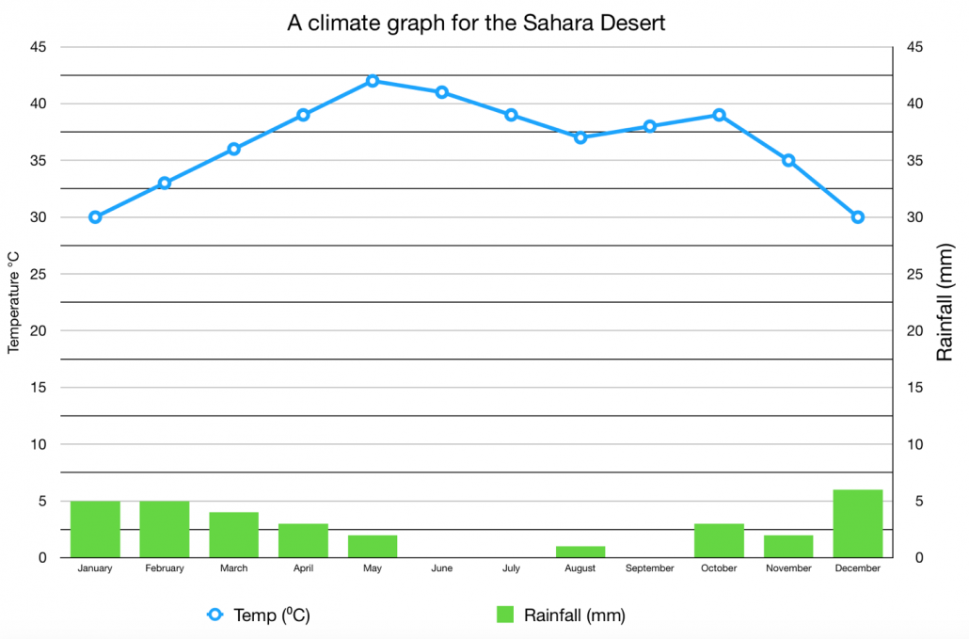

- What two months have the lowest average temperature?
- What is the peak average temperature?
- What is the difference between the highest and lowest temperatures?
- What are the three driest months?
- What is the amount of rainfall during October?
- Which months have the highest amount of rainfall?
- How many months have rainfall exceeding 40mm?
- What is the amount of rainfall in January?
- What is the temperature in June and July?
- Does the Sahara have any months without rainfall?
- What is the temperature range in the Sahara Desert?
- Is the hottest month also one of the wettest?
- What are the 3 wettest months?
- Does the Sahara Desert have a wet season?
- Is the Sahara Desert always hot?
- Does the temperature vary through between summer and winter?

Extension questions:
Q17) Describe the climate (temperature and rainfall) of the Sahara Desert between January and December.
Q18) Compare and contrast the temperature and rainfall patterns of the UK and the Sahara Desert.
Watch the following video, which explains some animal adaptations in the desert:

https://www.youtube.com/watch?v=Lx-p9i3TSpk

Q. What are some of the main animal adaptations in the desert?

Lesson Three: How do plants survive in a hot desert?
- LI: To examine how plants adapt to the climate of a hot desert
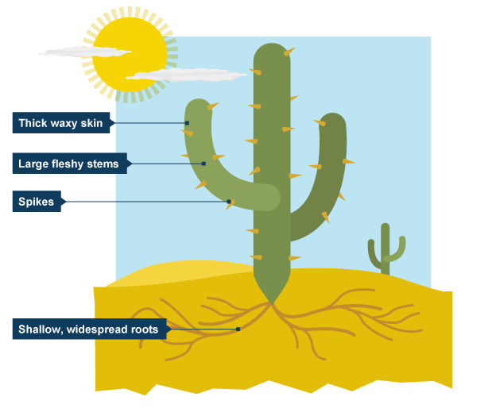
- thick, waxy skin to reduce loss of water and to reflect heat
- large, fleshy stems to store water
- thorns and thin, spiky or glossy leaves to reduce water loss
- spikes protect cacti from animals wishing to use stored water
- deep roots to tap groundwater
- long shallow roots which spread over a wide area
- plants lie dormant for years until rain falls

Read the above information and answer the following question in your own words.
Q. How have plants adapted to living in hot desert environments?
Then read the DART about how to improve greening in the desert. Answer the questions.

‘Desert Greening’ and desert farming
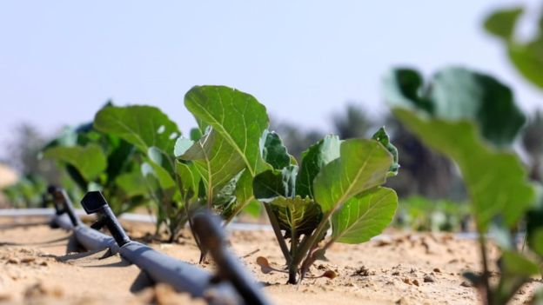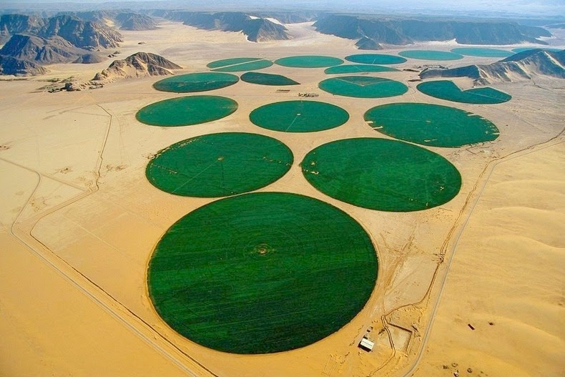
Deserts could be the future for global farming and transforming them into green spaces using new technology. Deserts have been used for growing crops for many years.
Huge ‘crops circles’ are common in the deserts of the USA, but they need colossal amounts of water for the crops to grow. Watering crops is called IRRIGATION. In poorer desert countries like Chad in Africa, 80% of their water is used to water crops.
There is also an increasing demand for food as the global population grows, but one scientist has come up with an innovation that could turn those deserts green again.

Liquid clay
Norwegian scientist Kristian Morten Olesen has patented a process to mix tiny particles of clay with water and bind them to sand particles to improve desert soil - he has been working on Liquid Nano-Clay (LNC) since 2005.
He says: "The treatment gives sand particles a clay coating which completely changes their physical properties and allows them to bind with water. We just mix natural clay in water with desert sand. This creates a good, fertile, 50cm deep layer which crops can grow in".
Normal sand particles are very loose, which means that they cannot hold water easily. But when you add Liquid Nano-Clay to the sand it binds those sand particles together. This means the new soil can hold water for longer, allowing more crops to grow, but only using half the water.

United Arab Emirates trial
In the UAE, local farmer Faisal Mohammed Al Shimmari agreed to host a trial of Liquid Nano-Clay in December 2017, and two areas were planted with a selection of crops: tomatoes, aubergines and okra.
"I am amazed to see the success of LNC," says Faisal. "It just saved consumption of water by more than 50%, it means now I can double the green cover with the same water."
He says that the untreated area used almost 137 cubic metres of water for irrigation and the one treated with LNC used just 81 cubic metres. "I can double the farming area using the same amount of water I was using before," says Faisal.

Questions:
- Why could deserts be the future for farming?
- How much water is used to grow crops in poor desert countries like Chad?
- Why does the world need to grow more food?
- Explain how Liquid Nano-Clay helps to create good soil in a desert.
- How much water does Liquid Nano-Clay use compare to normal irrigation?
- How has Liquid Nano-Clay help farmers in the United Arab Emirates?

Lesson Four: People and deserts
- LI: To examine how people use desert regions and the Sahara Desert

Read through KO: ‘People and Hot Deserts’ at the beginning of this booklet, then answer the questions on the KO.
RESEARCH: What would living or travelling in a desert be like without modern technology?
What would the most essential resources for all desert cities?

Lesson Five: Why are desert cities expanding?
- LI: To examine why desert cities in HICs are expanding.

Watch the following video; https://www.youtube.com/watch?v=EctE3dEAwEY

Q. Why did Dubai get so rich?
Q. What are some of the disadvantages of Dubai’s growth?

Dubai – a desert dream?
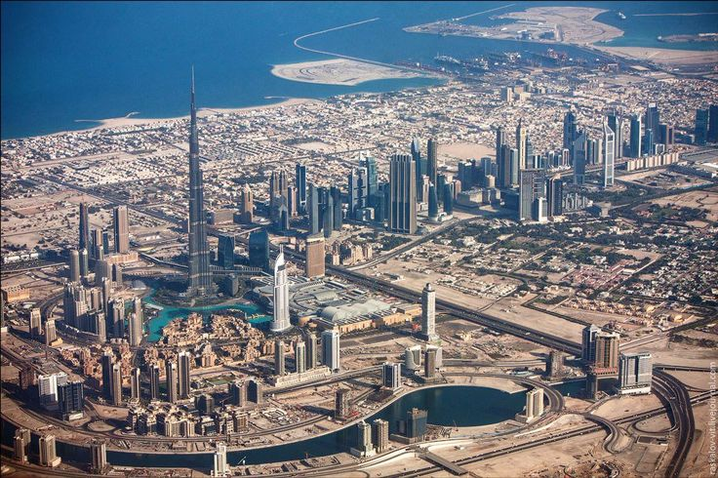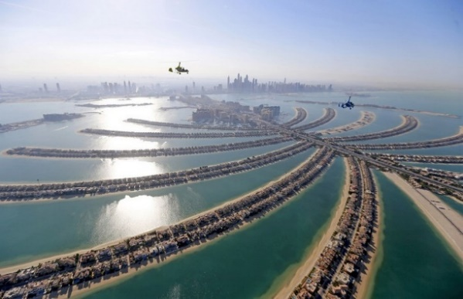
Dubai's spectacular skyline from above shows the high-rise modernity of the city today.

Dubai has been revealed as one of the fastest-growing cities in the world, claiming a population boom of over 500% in recent decades. Here’s how a small fishing village on the edge of the desert became the most populous city in the United Arab Emirates (UAE) and one of the fastest growing in the world.

The port city that grew from the desert
100 years ago, Dubai was a small fishing village that first began to grow thanks to its proximity to Iran, evolving into an important trade route to the Persian Gulf. Other areas in the United Arab Emirates were expanding from the profits of vast oil field reserves found underground, but it wasn’t until a chance discovery of offshore oil in 1966 that fortunes began to change for Dubai, too. However, the money from oil is reducing every year as the stocks of oil run out.

Dubai’s ongoing success
The last 30 years have seen the population of Dubai grow to 2,785,000. That is a remarkable growth of 569%. To secure future success, Dubai started a massive building boom to attracts tourists and business people from all over the world.
Dubai has worked hard to become a top tourist attraction and it attracts tourists from around the world who are drawn to the golden, sandy beaches, luxury hotels and spectacular attractions. These include the world’s largest indoor ski centre, the world’s largest shopping centre, the world’s tallest building (the Burj Khalifa) and many others. Dubai built colossal structures to draw people to it including the huge artificial ‘Palm islands’ and the ‘World Islands’.

Dubai is also a global business hub, with many companies locating offices here due to low taxes, easy planning laws and no restrictions of foreign ownership. Thanks to its warm climate and easy accessibility from Europe, Dubai is a luxury tourist destination popular year-round.

The darker side of Dubai’s growth
Despite Dubai’s success, there is a darker side. Many of the workers who have built the modern city of Dubai are from India and other poorer parts of Asia. They work very long hours, are very poorly paid by Dubai’s standards and live in appalling conditions. Construction companies in Dubai have been accused of exploiting these workers and using ‘modern day slavery’ to build the very attractions which have made modern Dubai.
Questions
- What was Dubai like 100 years ago? Why did it grow in the 1960s?
- Why has Dubai grown so quickly in the last 30 years?
- Why are tourists attracted to Dubai? What has been built to attract tourists?
- Why are businesses attracted to Dubai?
EXTENSION TASK - Is it fair that Dubai has been accused of using modern day slavery? Are foreign workers exploited by construction companies in the UAE? What are the ethical considerations of using cheap foreign labour?

Lesson six: What is desertification?
- LI: To examine the causes and impacts of desertification

Read the DART on the next page, then answer questions 1, 2 and 3 in the Activities box.
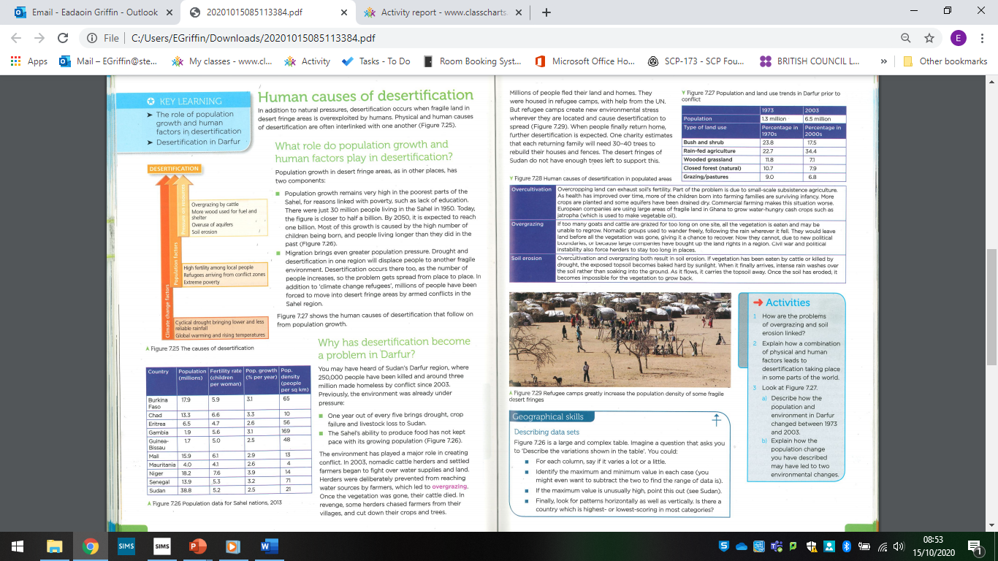

Answer the following 9-mark question.

Explain the causes and impacts of desertification in a region you have studied. (9 marks)

Attainment band: | Year 9 Unit 2 – ‘Causes and impacts of desertification’ 9-mark question
Attainment band: | Knowledge and Understanding | Skills
Yellow Plus  (8 to 9 marks) | - Student can clearly evaluate the causes of desertification in a specific region  -Student can clearly evaluate the impacts of desertification in a specific region  - Student can reach substantiated conclusions about the issues created by desertification in a named area | - Effectively use figures to answer geographical questions and draw geographical conclusions  - Independently use maps to locate places and identify key features  - SPaG is always correct
Yellow  (6 to 7 marks) | - Student can evaluate the causes of desertification in a specific region  -Student can evaluate the impacts of desertification in a specific region  - Student can reach clear conclusions about the issues created by desertification in a named area | -Shows an ability to use figures to answer geographical questions and draw geographical conclusions  - Confidently use maps to locate places and identify key features  - SPaG is generally correct
Blue  (4 to 5 marks) | - Student can discuss the causes of desertification in a named area  -Student can discuss the impacts of desertification in a specific region  - Student can reach conclusions about the issues created by desertification in a named area | -Identify useful geographic information from figures  -Use maps to locate places and identify some key features  - SPaG contains a few key word errors
Green  (2 to 3 marks) | - Student can describe some of the causes of desertification  -Student can describe some of the impacts of desertification  - Student can reach some conclusions about the issues created by desertification | -Describe what figures are showing and link them to the topic of cold environments  -Use maps to locate places  - SPaG contains frequent errors, particularly of key words
White  (0 to 1 marks) | - Student recognises some of the causes of desertification  - Student recognises some of the impacts of desertification  - Student can reach some very basic conclusions about the issues created by desertification | -Describe basic facts about what figures are showing  -Use maps to locate places with support  - SPaG contains lots of errors, particularly of key words

Lesson seven: Preventing desertification
- LI: To examine the solutions to prevent desertification
Read the DART below and answer questions 1, 2 and 3 in the blue activities box.


