Year 9
Music Booklet
Autumn A
West African Drumming
Go to: https://www.inspire-works.co.uk/youtube-west-african-drumming

Name:________________________________

Class:________

Design an image to distinguish your booklet from others
Music Year 9 Unit 1 West African Drumming KO
- Djembe:  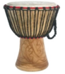  An-ke djem, an-ke be’ is a West African phrase: ‘Gather everyone together in peace’ | - Map of Africa  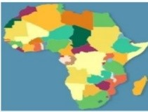  Some countries in West Africa:  Mali Ivory Coast  Ghana Senegal Burkino Faso  NOT in West Africa: Kenya | 3. The leader in a group of  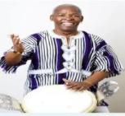West African drummers is called the Master Drummer Mamady Keita | 4. The Master Drummer, Stop! Signal is:  The rhythm of:  Play, the djembe and shout, Africa. Stop!  (Up to here for Workshop 1)
5. Polyrhythm:  Several rhythms played together | 6. Bass, Tone & Slap:  The 3 ways of playing a djembe | 7. Improvising:  In West African drumming, a solo is improvising | 8. Each solo lasted 2 beats during the lesson  (Up to here for Workshop 2)
9. Doum doum has many names, but NOT the ‘Dunno’  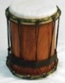 | 10. Doum doum’s name is onomatopoeic  (The name sounds like the sound it makes) | 11. Doum doum often played in 3s  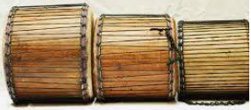 | 12. Syncopation is less like marching and more like dancing  (Up to here for Workshop 3)
13. Call and Response:  One plays a rhythm, another answers with a different rhythm | 14. In copyback, everyone plays the same as the leader | 15.  Shekere | 16. The talking drum imitates the s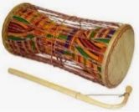sound of their speech. (Up to here for Workshop 4)
17. Table Mountain is in South Africa, not west Africa.   | 18. Djembes are made from 3 things:  Wood, leather and rope | 19. The structure of West African music is made up of 3 parts:  Rhythmic patterns, Call and Response and solos   | 20. All west African music is music for purpose. (It is played for a reason)  (Up to here for Workshop 5)

Music: West African Drumming SAL

Name of performer:_________________________________

Colour / Grade | ATL | Skill
Gold | Understands and appreciates the context for West African Drumming and relates appropriately and purposefully | Improvises on cue on the djembe/other instrument, fluently and at ease
Yellow | Participates and relates meaningfully to the activities | Demonstrates ‘Call and Response’ appropriately
Blue | Participates mostly well and relates to an extent | Able to ‘copyback’ accurately, and keep the beat
Green | Participates minimally | Able to keep the beat with the rest of the drum circle
White | Does not yet relate to the activities | Minimum interaction as yet

Comment:____________________________________________________

Marked by:______________________________________ Date:_______________
Lesson 0
CONNECT: Puzzle:
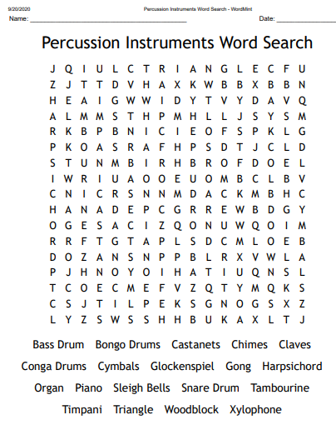
ACTIVATE:
DART: The Health Benefits of Beating Your Own Drum by Dr Christiane Northrup May, 2020
Christiane Northrup, M.D., is a visionary pioneer and a leading authority in the field of health and wellness, which includes the unity of mind, body, emotions, and spirit. Internationally known for her empowering approach to health and wellness, Dr. Northrup teaches how to thrive at every stage of life.
A board-certified physician, Dr. Northrup graduated from Dartmouth Medical School and completed her residency at Tufts New England Medical Center in Boston. She was also an assistant clinical professor of at Maine Medical Center for 20 years.

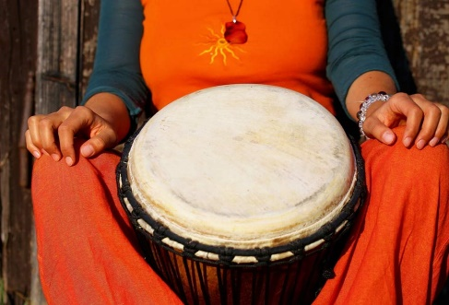
10 Health Reasons to Start Drumming
Drumming can have positive effects on your health and may help with many conditions from stress, fatigue, and anxiety, to hypertension, asthma, chronic pain, arthritis, mental illness, addiction, and even cancer.
Here’s why drumming is good for you:
- Makes you happy. Participate in a drum circle or take a cardio drumming class and you will see how happy it makes you. Drumming releases endorphins, enkephalins and Alpha waves in the brain, which are associated with general feelings of well-being and euphoria.
- Induces deep relaxation. In one study, blood samples from participants who participated in an hour-long drumming session revealed a reversal in stress hormones.
- Helps control chronic pain. Drumming can certainly serve as a distraction from pain. And, it promotes the production of endorphins and endogenous opiates, which are the body’s own morphine-like painkillers.

- The Assessment Test is to get a baseline of where you are at right now, so that you your progress throughout the year and later, can be measured.
- Don’t worry if you don’t understand or know something
- Do this test alone, without help from anything or anyone so that you can gain an accurate result
- Upload the result and send it to your teacher
DEMONSTRATE:
Take the test and self mark it. It is out of 50. Upload it for your teacher to check.
Name:_____________________________ Class:________ Date:__________ Mark out of 50: _____
Theory Basics: Assessment Test
- Pitch (Out of 10)
Name these treble & bass clef notes:
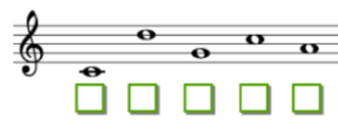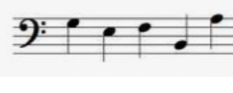
- Sonority (Voice) (Out of 5)
Writh the name the instruments under each picture:
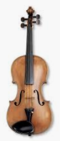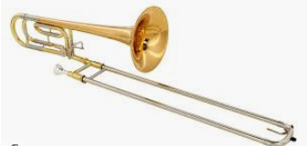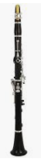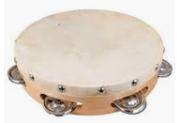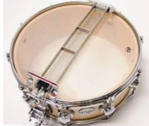
- ________ 2. _____________ 3. _______ 4. ____________ 5. ___________

- Structure (Out of 5)
Name these structures:
- AB 2. ABA 3. ABACADA 4. Exposition 5. Verse
Development Chorus
Recapitulation Verse
Chorus

- __________2. _______________ 3. _____________ 4. ____________ 5. ____________
- Tempo (Out of 5)
Write under each Italian term to say if they mean fast, medium or slow
1. Grave 2. Allegro 3. Andante 4. Presto 5. Adagio
__________ __________ ___________ ___________ __________

- Texture (Out of 5)
Match up the following:
-  Heterophonic
-  Polyphonic
-  Monophonic
-  Thick texture
-  Homophonic

- Tonality (Out of 5)
Listen to the following and decide if the chord is major or minor
- __________ 2. __________ 3. ___________ 4. ___________ 5. _______

- Dynamics (Out of 5)
Write the meanings of the following Italian terms for volume using the words soft – loud - medium
- Piano 2. Forte 3. Mezzo forte 4. Pianissimo 5. Fortissimo
__________ __________ ___________ ___________ __________

- Context (Out of 5)
Place the number of the genre of music in front of the performance venue.
- Classical Symphony 2.Traditional Bhangra 3. Cool Jazz 4. Gospel Concert 5. Taylor Swift concert
Café Field Church The O2 Arena Royal Albert Hall

- Historical Context (Out of 5)
Place a number from 1 to 5 in front of the musical period, 1 meaning earliest, 5 meaning most recent
Modern Baroque Romantic Renaissance Classical

See answers at the end. Mark your test out of 50. SCORE: _____ /50

Lesson 1 LI: To improvise rhythms within a given framework LI: To master given rhythms on specific percussion instruments
https://www.inspire-works.co.uk/youtube-west-african-drumming
CONNECT:​
- Check your KOs and SALs​
- Write 4 Things You Know About: Drumming, West Africa, Music, Music lessons​

- Puzzle​ (See below)
EXTRA DART if not already covered:
DART: The Health Benefits of Beating Your Own Drum by Dr Christiane Northrup May, 2020
Christiane Northrup, M.D., is a visionary pioneer and a leading authority in the field of health and wellness, which includes the unity of mind, body, emotions, and spirit. Internationally known for her empowering approach to health and wellness, Dr. Northrup teaches how to thrive at every stage of life.
A board-certified physician, Dr. Northrup graduated from Dartmouth Medical School and completed her residency at Tufts New England Medical Center in Boston. She was also an assistant clinical professor of at Maine Medical Center for 20 years.

10 Health Reasons to Start Drumming
Drumming can have positive effects on your health and may help with many conditions from stress, fatigue, and anxiety, to hypertension, asthma, chronic pain, arthritis, mental illness, addiction, and even cancer.
Here’s why drumming is good for you:
- Makes you happy. Participate in a drum circle or take a cardio drumming class and you will see how happy it makes you. Drumming releases endorphins, enkephalins and Alpha waves in the brain, which are associated with general feelings of well-being and euphoria.
- Induces deep relaxation. In one study, blood samples from participants who participated in an hour-long drumming session revealed a reversal in stress hormones.
Helps control chronic pain. Drumming can certainly serve as a distraction from pain. And, it promotes the production of endorphins and endogenous opiates, which are the body’s own morphine-like painkillers.
- 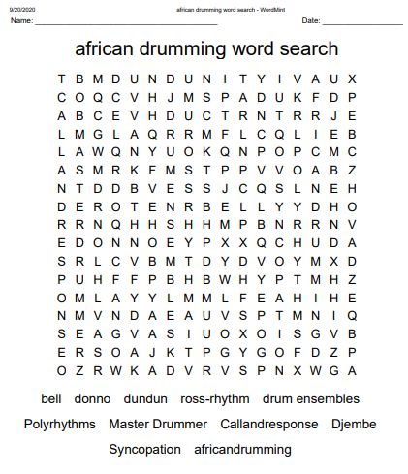
ACTIVATE:​
- The videos are interactive and you are expected to fully participate in them.
- This will increase enjoyment, too
DART:

DEMONSTRATE:​ Dr Christiane Northrup May, 2020
10 Health Reasons to Start Drumming (Continued)

- Workshop 1: Boosts your immune system. Studies show that drumming circles boost the immune system. Barry Bittman, MD, neurologist and President of the Yamaha Music & Wellness Institute, has shown that group drumming actually increases natural T-cells, which help the body combat cancer as well as other viruses, including AIDS.
- Creates a sense of connectedness. Drumming circles and group drumming classes provide an opportunity for “synchronicity” in that you connect with your own spirit at a deeper level while also connecting with other like-minded people.
- Aligns your body and mind with the natural world. The Greek origin of the word “rhythm” is “to flow.” Drumming allows you to flow with the rhythms of life by simply feeling the beat.

- How to attain: Bass, Tone, Slap​
- Copy back over 2 beats​
- Start of body percussion​
- Instrument: A Djembe from Africa and one made from plastic​
- Rhythm: Bass Tone Djembe ​
(Ta Ta Ti-ti) ​
(Tum, Chest, Chest-chest)​
6. Ostinato (Repeated pattern)​
7. Master Drummer leads​
8. When you hear or play this, it means STOP: ​
Play, the djembe and shout, Africa. Stop.
Workshop 2:
- Bass, Tone, Djembe, Rest, Cla-ap, Cla-ap​
(Ta Ta Ti-ti, Rest, Ta-a Ta-a) faster​
- Improvisation/solo​
- No two solos at same time​
- All play the ostinato while one improvises​
- Master plays the stop rhythm and all stop​
- Another rhythm: Sla-ap, a two (and a)​
(Ta-a-ti Ta-a)​
- Can do on chest​
- Can add ‘and a’ R, L, R, R, L (Slap, Slap, Slap, Tone, Tone) Sla-ap a two, and a​
- Polyrhythm: more than 1 different rhythms playing simultaneously​
- Put both above rhythms together QUITE HARD​!
- Quiz

CONSOLIDATE:​
- Answer the questions in quizzes 1 & 2.​
- H/W: Review the questions for a quiz next lesson​ (See Knowledge Organiser, rows 1 & 2)
- Look at the Assessment Ladder and self assess where you are/ask someone else to assess you

Lesson 2
LI: To 'copy back' rhythmic patterns
CONNECT:​
- Puzzle​
- 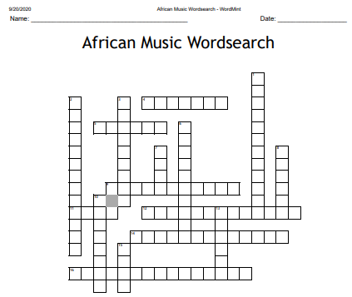
- 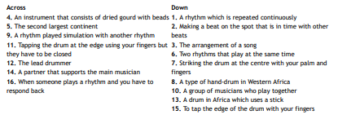
- Quiz from last lesson: questions from Workshops 1 & 2. Peer mark and hand in result​
ACTIVATE:​
- Watch and actively participate in Lessons 3 & 4 of the West African Drumming Workshop Videos and quizzes​
DART: :​ Dr Christiane Northrup May, 2020
10 Health Reasons to Start Drumming (Continued)
7. Provides a way to access a higher power. Shamans often use drumming as a means to integrate mind, body and spirit. They focus on the whole body and then integrate the healing at both the physical and spiritual level by drumming, which connects spiritual forces.
- Releases negative feelings. The act of drumming can serve as a form of self-expression. You can literally drum out your feelings. When held, negative emotions can form energy blockages. The physical stimulation of hitting the drums can help remove those blockages. Drumming has even been used therapeutically to help addicts deal with their emotions.

DEMONSTRATE:​
- Students play in pairs, same two of the rhythms on instruments​
- Students join two others with different rhythms/instruments to form group of 4​

- Workshop 3:
- Copyback over 4 beats – listen to 4 beats before you copy back ​

Copy back – just rhythm, then with sounds (tone etc) ​
Ti-ti Ta Ti-ki-ti-ki ​
(Bass bass tone, tone tone tone tone tone) ​
- Ti-ti-ki Ta Ti-ki-ti Ta ​
(All bass, last one tone) ​
- Ti-ki-ti-ki Ta Ti-ki-ti-ki Ta ​
(Tone tone tone tone tone, ​
Bass, bass bass bass tone)
- Ti-ti-ki Ta Trip-a-let Ta ​
(Bass, tone tone bass, tone tone tone bass) ​
- Check the bass and tones now

- Workshop 4:

9. Bells (from Ghana) made from iron ​
10. Gankogui. Cuts through the drums. Low and high sound ​
11. Rhythms: Play the song the bell ​
12. Ta Ti-ta-a ti ta ​
13. Drum: Dhoun Dhoun (low bass sound) (onomatopoeia) Use stick or hand) 3 different sizes ​
14. Rhythm Don Don, Syn-co-pa-tion a (Ta-a, Ta-a, Ti-Ta-a Ta-a-ti Ta) ​
15. Put both parts together and stop with the stop rhythm ​
16. Then put all 4 together (with Slap, a – two, baby) and Slap, tone, djembe (Quite hard)
17. Look at the SAL and assess where you think you might be on the Assessment Ladder – what colour would this be? How can you go up the ladder?
Colour: | How can you get to the next colour?

CONSOLIDATE​
- Students show what you have achieved to someone at home
- H/W: Review the questions in the quiz from Workshops 3 & 4​

Lesson 3
LI: To participate appropriately in Call and Response patterns in the drum circle context
LI: To give a formal or informal performance of the music
LI: To understand the context/audience for West African drumming
LI: To appraise performance and self-correct
LI: To show courage when learning and performing, even when it is not easy

CONNECT:​
- Quiz from last lesson: questions from Workshops 1 & 2. Peer mark and hand in result​
ACTIVATE:​
- Watch and actively participate in Workshop 5 of the West African Drumming Workshop Videos and quiz​
- DART:
- :​ Dr Christiane Northrup May, 2020
- 10 Health Reasons to Start Drumming (Continued)
- Puts you in the present moment. While drumming you are moving your awareness toward the flow of life. When you are flowing with the rhythm of life you cannot be caught up in your past or worrying about your future.
- Allows for personal transformation. Drumming stimulates creative expression. When you drum in a group, you not only get to self-express, but you get feedback from the other drummers. It’s the equivalent of talk therapy! Drum circles provide a means of exploring your inner self, and expanding your consciousness while being part of a community.

DEMONSTRATE:​
- Students try all rhythms on their instrument​
- Remind of their own​
- Play their part with homogenous group​
- Play their part in mixed group​
- Students take quiz, peer mark and hand in result​
- Practice to do solos: Double the length of the rhythms:​
- Slap, a two, slap a two, Clap, clap, clap, clap​
- Each person does a solo during the 4 claps​
- Mix up the basses, tones and slap​
- Use slower/faster rhythms​
- Decide on order​
​
7. Scenes from Mali:​
- Niger River​
- Dogan Cliffs – UNESCO World Heritage Site​
- Bamako: marketplace selling drums and masks​
When dancing, wear masks​
- Camel train going through desert
8. Music is always played for a reason in West Africa​
9. Put all the music learned, together​
Call and Response​
Patterns​
4 beat solos (four different solos)​
Patterns​
​
10. Call and Response from before:​
- Watch the master drummer play this back (Copy)​
Watch the master drummer play this back ​
​
- Watch the master drummer, do not co-py. ​
That’s because this isn’t copyback​
​
- Watch the master drummer play this back (Copy)​
Watch the master drummer play this back​
​
- Watch the master drummer, call and response​
Call and response, Call and response
11. Patterns:​
- (Bell) Play this on the bell ​
(Ta Ti-ta A-ti Ta)​
- (Dhoun Dhoun) Don Don, Syn-co-pa-tion a ​
(Ta-a, Ta-a, Ti-Ta-a Ta-a-ti Ta)​
- (Djembe) Slap, a – two, baby​
- (Djembe) Slap, tone, djembe​
Solos: Slap a two, slap a two Clap, clap, clap, clap​
​
12. Patterns again:​
- (Bell) Play this on the bell ​
(Ta Ti-ta-a ti ta)​
- (Dhoun Dhoun) Don Don, Syn-co-pa-tion a ​
(Ta-a, Ta-a, Ti-Ta-a Ta-a-ti Ta)​
- (Djembe) Slap, a – two, baby​
- (Djembe) Slap, tone, djembe​
Solos: Play, the djembe and shout, Africa. Stop​
13. Patterns again:​
​
14. Finish: Play, the djembe and shout, Africa. Stop.​
​
​
15. About the djembe: (Review)​
3 different sounds​
3 parts: wood is carved, leather on top, ropes to keep leather on​
3 different musical sections (call and response, patterns and solos)​
​
16. Do a performance, now​, with the video or someone you live with
Film it and look at what you think worked and what didn’t.
Perform again, to see what you can adjust
​
17. Quiz​

CONSOLIDATE​
- Whole class 'performance'​ or whole family performance
- H/W: Review all questions from all 5 quizzes if time​
- Postcards home for those who have participated fully and courageously :)​

Theory Basics: Assessment Test: Answers (Out of 50)
- Pitch (Out of 10)
C D G C A AND G E F B A
- Sonority (Voice) (Out of 5)
- Violin 2. Trombone 3. Clarinet 4. Tambourine 5. Snare Drum

- Structure (Out of 5)
- Binary 2. Ternary 3. Rondo 4. Sonata Form 5. Song

- Tempo (Out of 5)
- Slow 2. Fast 3. Medium 4. Fast 5. Slow

- Texture (Out of 5)
- Monophonic 2. Polyphonic 3. Homophonic 4. Heterophonic 5. Thick texture

- Tonality (Out of 5)
- Minor 2. Major 3. Major 4. Minor 5. Major

- Dynamics (Out of 5)
- Soft 2. Loud 3. Medium loud 4. Soft 5. Loud

- Context (Out of 5)
3 Café 2 Field 4 Church 5 The O2 Arena 1 Royal Albert Hall

- Historical Context (Out of 5)
5 Modern 2 Baroque 4 Romantic 1 Renaissance 3 Classical
**********END********

Answer key for African Music Crossword:


