Geography Year 9
Blended Learning Booklet

Y9-1 Ecosystems & rainforests

Name:
Form:

Aim to complete one lesson each week. Write down the title and LI for each lesson and then complete the tasks which are highlighted.
The Knowledge Organiser on page 3 has all the key information and vocabulary to help you with this unit.
Upload all work onto ClassCharts for feedback.

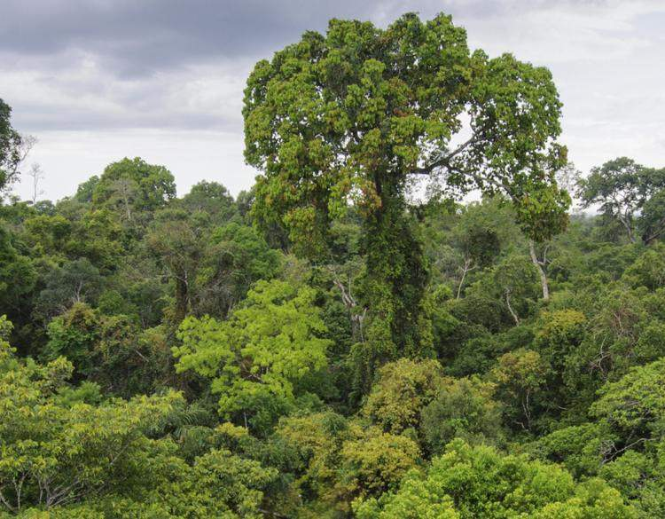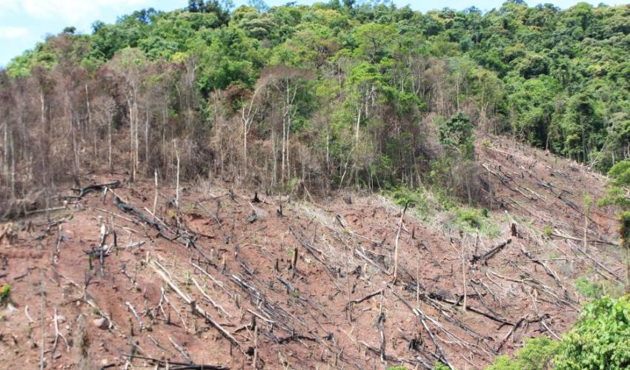

Contents
Page 3: Big Picture - Year 9 Overview
Page 4: Zoom in - My Learning Journey
Pages 5 & 6: Lesson 1
Page 7: Lesson 2
Pages 8 & 9: Lesson 3
Page 10: Lesson 4
Pages 11 & 12: Lesson 5
Page 12: Lesson 6
Pages 13 & 14: Lesson 7

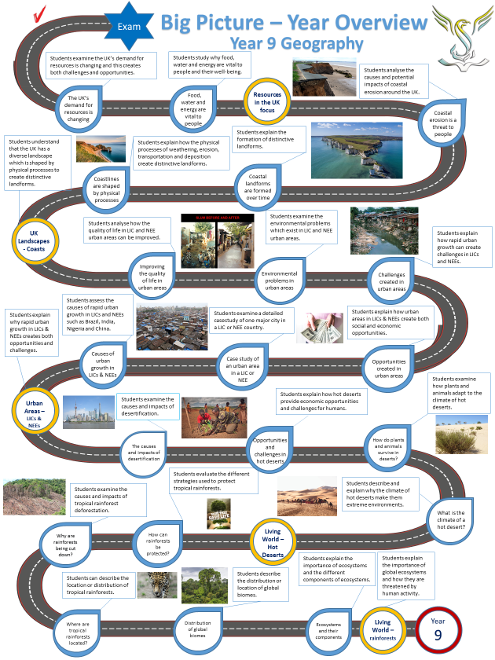

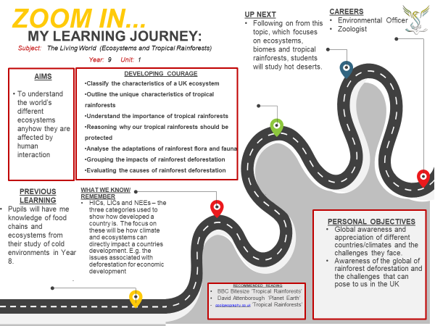

Lesson One: What are ecosystems?
- LI: To examine the characteristics of ecosystems.

READ THE DART: The components of ecosystems

The components of ecosystems

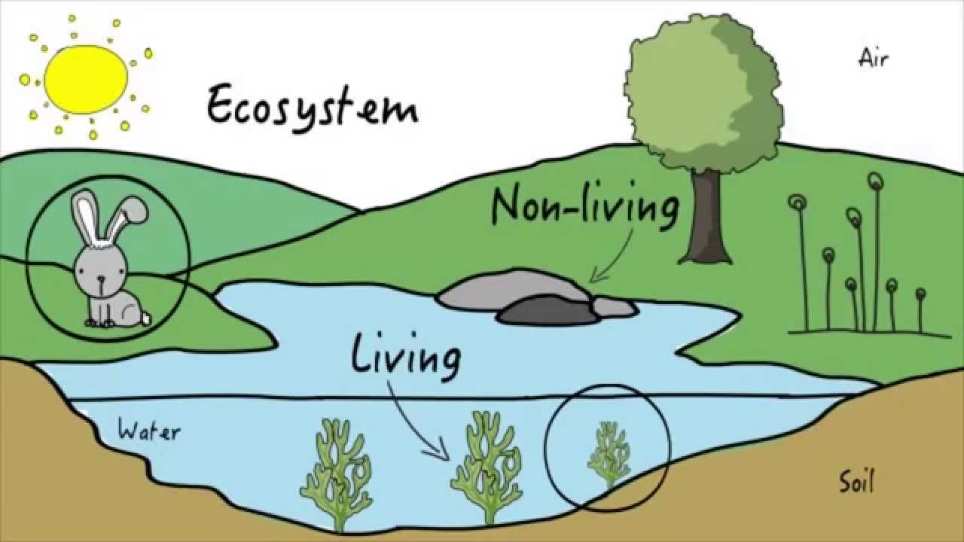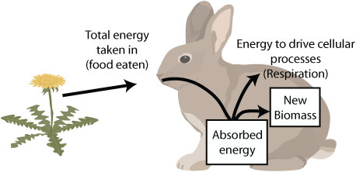

An ecosystem is a complex set of relations between the living and non-living aspects of nature. It includes plants, micro-organisms, water, birds, trees, air, and people.
If one side of the ecosystem is destructed or disappears, it will impact all other parts of the ecosystem. An ecosystem can be as big as an entire ocean or as small as a drop of water. All ecosystems are made up from biotic and abiotic components.
Abiotic Components

These are non-living components of ecosystems. There are several abiotic components:
- The Sun - The Sun is the main powerhouse of energy and is essential for the maintenance of life. The sun directly provides the energy to the plants while the animals use this energy through plants by eating them.

- Water - Water is important for the survival of living beings. It also regulates body temperature and water is also a habitat for many living forms.

- Temperature - It is one of the essential factors of the environment which in many ways influence the survival of the organisms. Different organisms are adapted to a different range of temperatures around them e.g. polar bears need a cold environment.

- Atmosphere - The existence of life on this planet is the result of a suitable atmosphere that is present on the earth. It is made up of oxygen (21%), nitrogen (78%) and other gases like neon, argon and carbon dioxide.

- Latitude - The temperature of an area is greatly influenced by its latitude or distance away from the Equator; therefore rainforests are found near the Equator and the polar regions are found at the north and south pole.

Biotic Components

These components consist of living organisms such as plants, animals, and microorganisms. These can be categorised into consumers and producers.
Producers are plants and vegetables. All energy comes from the Sun and plants are the ones who make food with that energy. They use the process of photosynthesis. Plants also make loads of other nutrients for other organisms to eat.

Consumers are living organisms that eat other living organisms. There are 3 types of consumers:

- Herbivores – These organisms eat plants e.g. cows eat grass
- Carnivores – These organisms eat meat e.g. lions eat zebra
- Omnivores – These organisms eat both meat and plants e.g. humans

QUESTIONS – write your answers as sentences

- What is an ‘ecosystem’? How large and small can ecosystems be?
- Are ‘abiotic components’ living or non-living? Are ‘biotic components’ living or non-living?
- Which do you think is the most important abiotic component? Justify your answer.
- What are producers? How do producers create food? What do the 3 types of consumer eat?
- Explain how humans harm ecosystems and harm living creatures.

TASK: Describe the location of the following global ecosystems or global biomes using the map below:
- Tundra
- Hot Deserts
- Tropical Rainforests
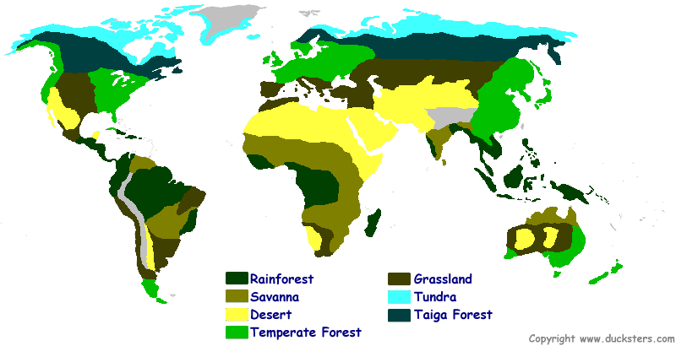

Lesson Two: What are food chains?
- LI: To explain the importance of food chains, food webs and decomposers.

Task: Describe this simple food chain in your own words starting with the producer:

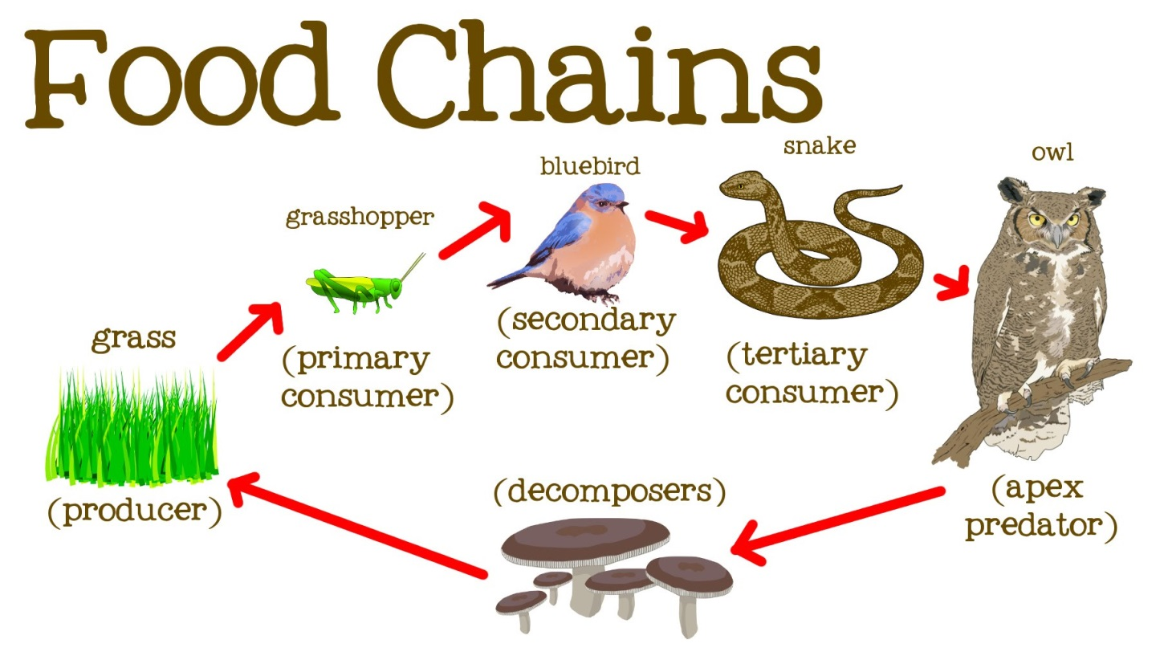

Task: Describe this food web in your own words. Why are the fox and the owl the top predators?

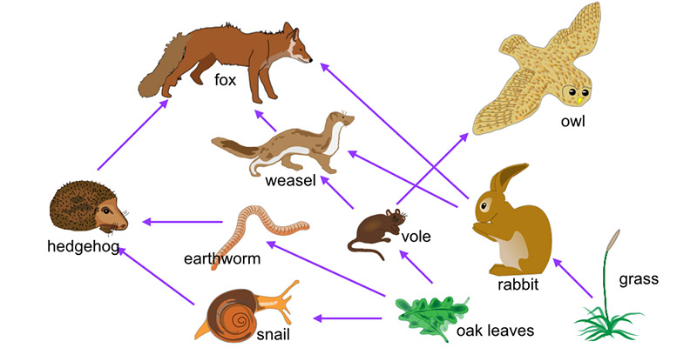

Task: Explain what would happen to this food web if the grass did not grow.

Lesson Three: Tropical Rainforests?
- LI: To examine the unique physical characteristics of tropical rainforests.

Task: Using the blue boxes on the diagram below, describe the layers found in a rainforest: emergent trees, canopy, under-canopy and shrub layer
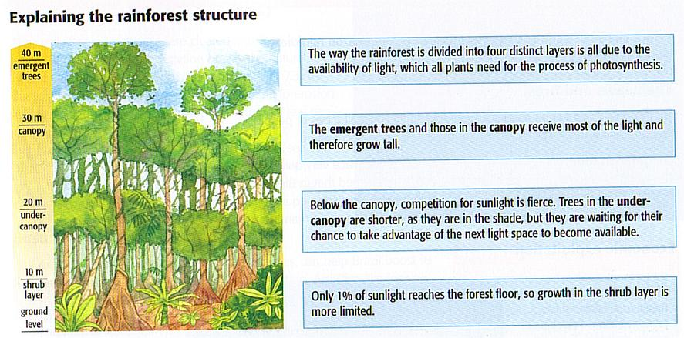

READ THE DART: Rainforest biodiversity

RAINFOREST BIODIVERSITY

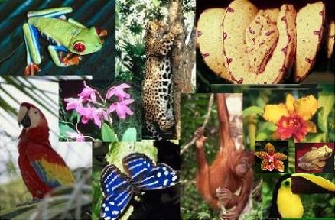
The tropical rainforest is a hot, moist biome found near Earth's equator. The world's largest tropical rainforests are in South America, Africa, and Southeast Asia. Tropical rainforests receive from 60 to 160

inches of precipitation that is fairly evenly distributed throughout the year. Tropical rainforests support the greatest diversity of living organisms on Earth. Although they cover less than 2 percent of Earth's surface, rainforests house an estimated 50 percent of all life on the planet's land masses.

The tropical rainforest biome is one of the most productive areas on earth. More than half of the different species of animals and plants live in tropical rainforests. The abundant sunlight, warm temperatures, and daily rain lead to a fast turnover of nutrients. Subsequently plant growth is very rapid. This is because they contain a diversity of ecological niches from the forest floor to the canopy.

What is biodiversity?
Biodiversity (short for biological diversity) is the number and types of organisms within an ecosystem. No one knows exactly how many species live in the world's tropical rainforests — estimates range from 3 to 5 million species — rainforests are the undisputed champions of biodiversity among the world's ecosystems.
Tropical rainforests contain far higher numbers of species compared to temperate climates like the UK. For example, whereas UK temperate forests are often dominated by around 6 tree species that make up 90 percent of the trees in the forest, a tropical rainforest may have more than 480 tree species in a single hectare (2.5 acres). A single bush in the Amazon may have more species of ants than the entire British Isles. This diversity of rainforests is not a haphazard event, but is the result of a series of unique circumstances.

Answer these questions:
Q1) What are the general characteristics of tropical rainforests?
Q2) Why are tropical rainforests ‘highly productive’? What does this mean?
Q3) What is biodiversity? How is biodiversity measured?
Q4) To what extent is biodiversity in tropical rainforests more complex compared to the UK?
Q5) Explain how human activity can reduce biodiversity in tropical rainforests.

Watch the video on Rainforests: https://www.youtube.com/watch?v=UIbplCn8-zs

Lesson Four: Rainforest adaptations
- LI: To examine the unique physical characteristics of tropical rainforests.

Task: Read the following:

Plant adaptations
The following adaptations allow plants to survive in the conditions of the rainforest.
- Lianas - these are woody vines that have roots in the ground but climb up the trees to reach the sunlight. Their leaves and flowers grow in the canopy.
- Tree trunks - these are tall and thin to allow trees to reach the sunlight. The bark on these trees is smooth to allow water to flow down to the roots easily.
- Drip tip leaves - plants have leaves with pointy tips. This allows water to run off the leaves quickly without damaging or breaking them. This can be seen in the photograph below:
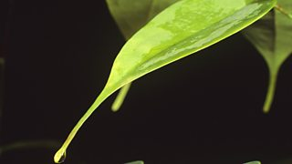
- Buttress roots - large roots have ridges which create a large surface area that help to support large trees.
- Epiphytes - these are plants which live on the branches of trees high up in the canopy. They get their nutrients from the air and water, not from the soil.

Animal adaptations
Many animals have adapted to the unique conditions of the tropical rainforests.
The sloth uses camouflage and moves very slowly to make it difficult for predators to spot.
The spider monkey has long, strong limbs to help it to climb through the rainforest trees.
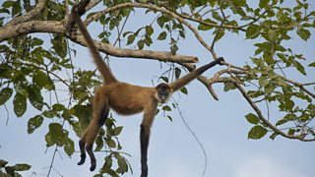

Task: Explain how plants and animals adapt to the climate and physical conditions in a rainforest.

Watch the video on rainforest animal adaptations: https://www.youtube.com/watch?v=cFFx7PH3ujQ
Lesson Five: Rainforest deforestation
- LI: To examine the causes of tropical rainforest deforestation.

Task: Read the DART ‘Amazon deforestation’

Causes of deforestation in the Amazon

Logging
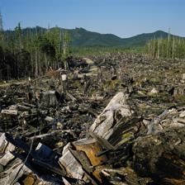
Commercial logging companies cut down trees for timber, which is mostly sold to developed countries. In most cases, large areas of forest are destroyed just to remove a few highly valued trees. The effect of this devastation has lasting consequences:
- Heavy machinery compacts soil and makes it more vulnerable to erosion
- Silt is washed into rivers
- Logging roads open up the area to new settlers who remove even more trees

Farming
Land is cleared (e.g. by slash and burn) and planted with cash crops, usually just one – such as palm oil. Alternatively, it will be used for grazing by cattle ranchers. Most cash crops and cattle are eventually sold to developed countries.
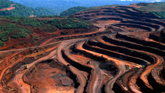
These actions affect the soil for future use because fertility falls after just a few years. Only farmers who can afford fertilisers will be able to use the soil to grow crops in the future. If they can’t afford fertilisers, farmers simply move on and clear more land... More forest is lost.

Mining
Land is completely deforested. Soil is often removed with high-pressure hoses and chemicals are used. The run-off goes into local rivers and pollutes them. Huge scars from open-cast pits are left – the soil can’t recover.
Road building
Loggers and miners build roads to get their materials out. People use the roads to enter the forest and build new settlements and set up industries. The Trans-Amazonian Highway in South America is 5,300 km long and has opened up some remote parts of Brazil to development.

Settlement
Land is being cleared for new homes and settlements. There is more need for these in countries with increasing populations, especially around large overcrowded cities.

Dam building
Hydro-electric dams provide energy but also result in deforestation. Problems include:
- Flooding of large areas of forest
- People may have to move
- Drowned forest rots and adds carbon to the atmosphere

Wood for fuel
Many people rely on wood for their main source of fuel, particularly in developing countries. As the population grows, more wood is chopped down.
Task: complete the following questions
- What are the benefits of deforestation and why does it take place?
- What problems does deforestation create and should it be stopped?

Lesson six: The impacts of deforestation
- LI: To examine the impacts of deforestation.

Task: read through the table below:
IMPACTS OF DEFORESTATION
CLIMATE CHANGE - GLOBAL | Burning the forest releases greenhouse gases like CO2. This contributes to the warming of our planet via climate change and global warming. In addition, the Amazon also helps to drive the global atmospheric system. There is a lot of rainfall there and changes to the Amazon could disrupt the global system.
ECONOMIC DEVELOPMENT - REGIONAL | Brazil has used forests to develop the country. The forest has many national riches that can be exploited. In addition, Brazil has huge foreign debt and lots of poor people to feed, so they want to develop the forest. Many Brazilians see deforestation to help develop their country and improve people’s standard of living.
SOIL EROSION - LOCAL | The soils of the Amazon forest are not fertile and are quickly exhausted once the forest is cleared. The farmers now artificially fertilise the soil when in the past the nutrient cycle would have done this naturally. In addition, the lack of forest cover means that soils are exposed to the rainfall. This washes huge amounts of soil into rivers in the process of soil erosion.

TASK: Complete the following question

Do you agree with the statement “Deforestation in the Amazon creates jobs and opportunities, but is a catastrophic environmental disaster”?

Lesson seven: Protecting rainforests
- LI: To explain how rainforests can be protected.

TASK: Read the following information about protecting rainforests
4 methods of controlling deforestation

Tropical rainforests can be managed in the following ways to reduce deforestation:

Logging and replanting - selective logging of mature trees ensures that the rainforest canopy is preserved. This method allows the forest to recover because the younger trees gain more space and sunlight to grow. Planned and controlled logging ensures that for every tree logged another is planted.
Education - It is important that local people, businesses and politicians understand the true value of the tropical rainforest. Once they understand the value of biodiversity, particularly in terms of tourism, they will be more likely to want to protect it from deforestation.
Ecotourism - this encourages sustainable tourism that creates jobs and money for local people whilst ensuring that the money generated is used to protect and conserve the tropical rainforest for future generations to enjoy.
International agreements - agreements to protect tropical rainforests have been made between different countries through debt-for-nature swaps. This is when a country which is owed money by another country cancels part of the debt if an agreement is made by the debtor country to ensure the conservation of its tropical rainforests.
The image below shows logging (cutting down trees for the wood) in the Amazon

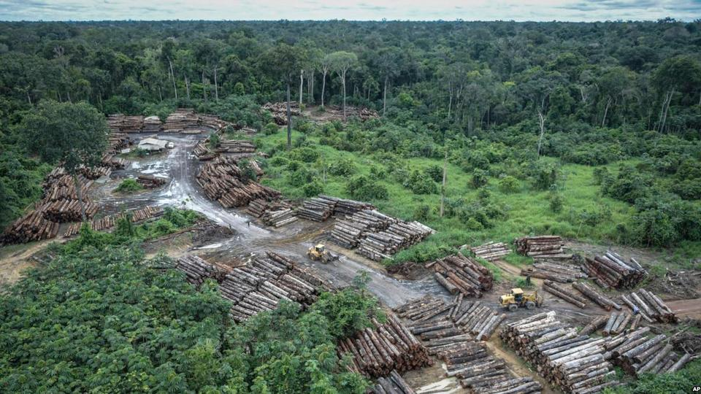

Case study of sustainable management: Malaysia’s SMS

The Malaysian government have implemented the ‘Selective Management System’ or SMS to ensure that Malaysia’s tropical rainforest can be conserved and enjoyed by future generations. It works by:
- Raising public awareness of the value of tropical rainforests increased through education.
- Involving local communities included and involved in forest conservation projects.
- Using of alternative timber sources such as rubber trees was encouraged.
- Selective logging of mature and commercially viable trees over a 40-year cycle to ensure that trees had time to re-establish themselves. This is known as the Selective Management System.
- Ecotourism promoted and developed in tropical rainforest areas.
- Permanent Forest Estates have been created by the government where no change of land use is allowed.
- Creation of National Parks to protect biodiversity.

TASK: questions about protecting rainforests:

- Describe the causes of tropical rainforest deforestation.
- How much rainforest is being destroyed each year?
- Describe each of the main 4 methods of protecting tropical rainforests.
- Which method of protecting tropical rainforests do you think is the most effective?
- How does Malaysia’s Selective Management System (SMS) work?
- How can ecotourism benefit local people living in areas of rainforest?

Watch the video on protecting rainforests: https://www.youtube.com/watch?v=mV6GL7RrXz8
Watch the video on protecting rainforests: https://www.youtube.com/watch?v=tfQTFt1mJfA

