History KS3 Autumn 1 Blended Learning Booklet
Beginning of the Cold War
Name:
Form:
Aim to complete one lesson each week. Write out the title and LI and then complete the tasks.
All video links are online using the ClassCharts link.
Upload all work onto ClassCharts for feedback.

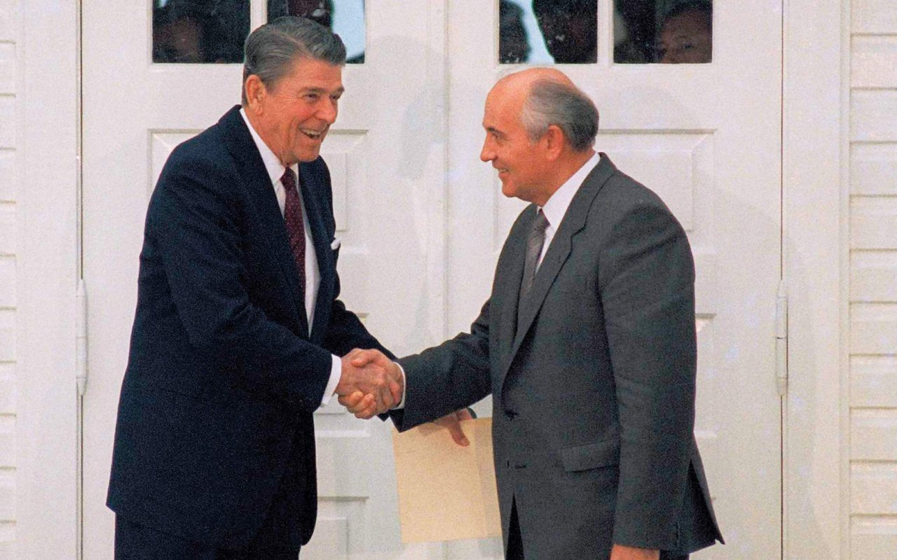

Contents
Page 3: Big Picture - Year 9 Overview
Page 4: Zoom in - My Learning Journey
Page 5: Lesson 1
Page 9: Lesson 2
Page 12: Lesson 3
Page 15: Lesson 4
Page 16: Lesson 5
Page 19: Lesson 6

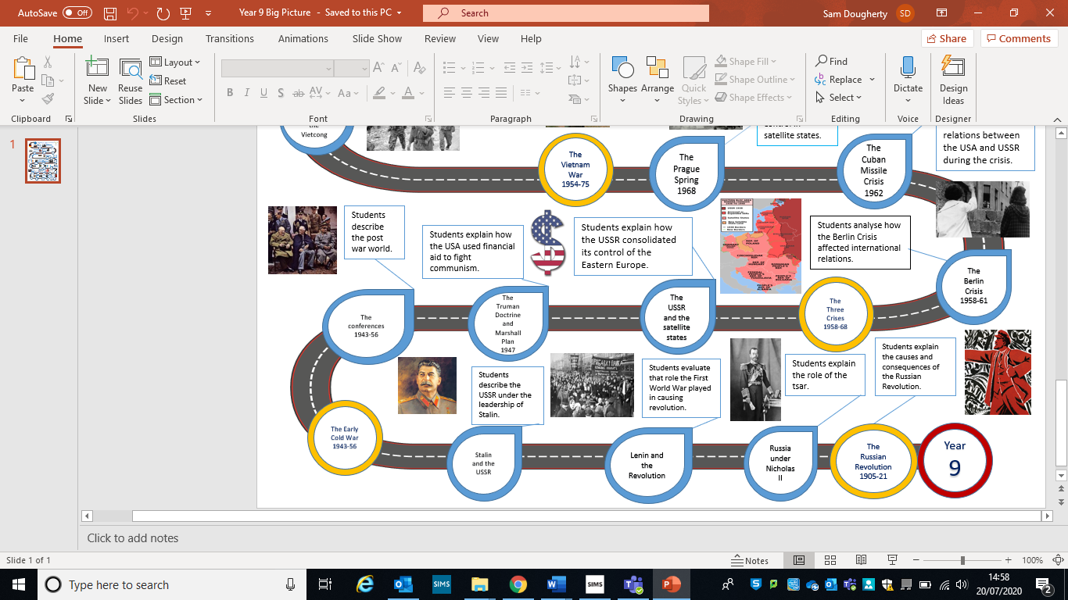
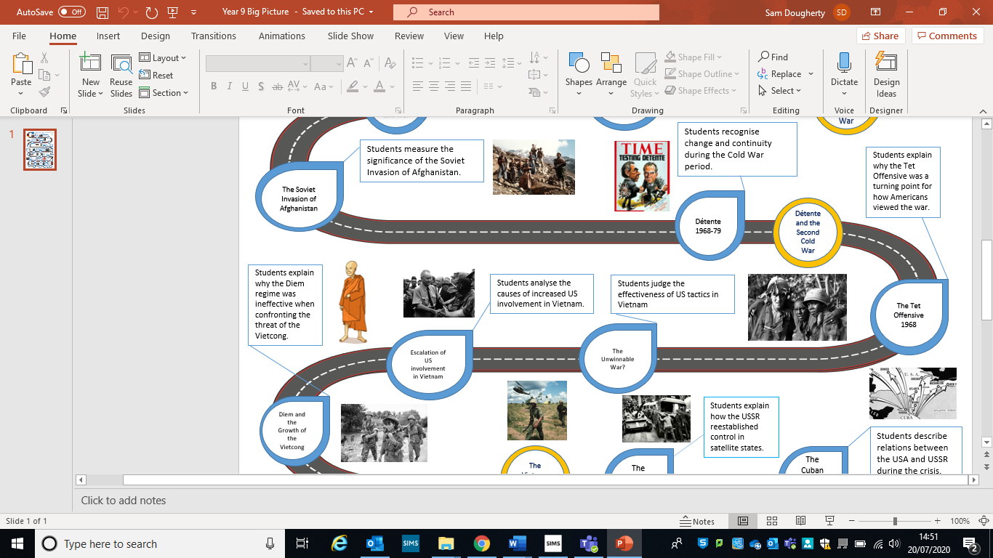
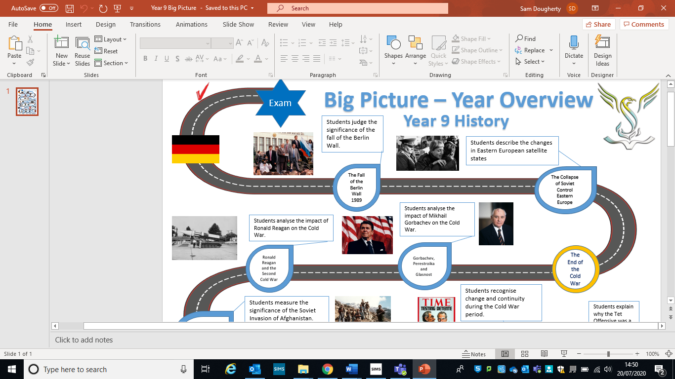
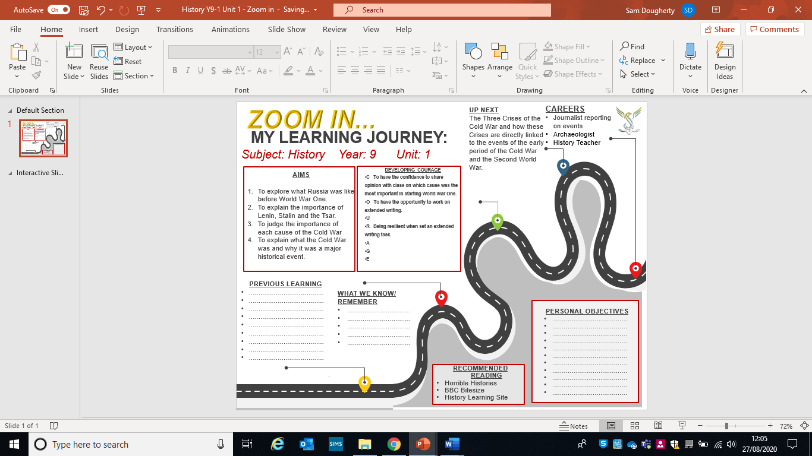

Lesson One – The Significance of Gorbachev
L/I: To explain how Gorbachev had a big impact on relations between the Superpowers.

Task One: The Soviet leaders from 1982-1985.

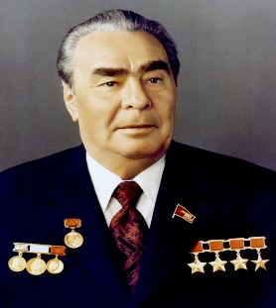
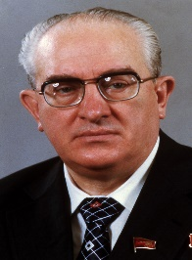
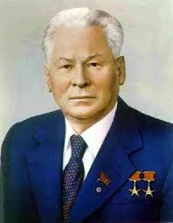
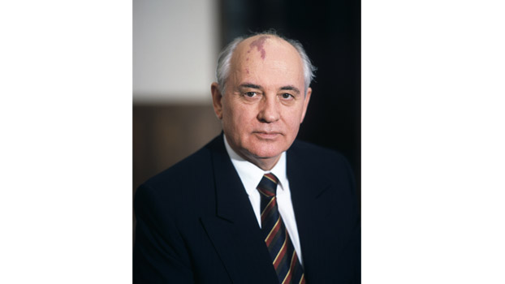
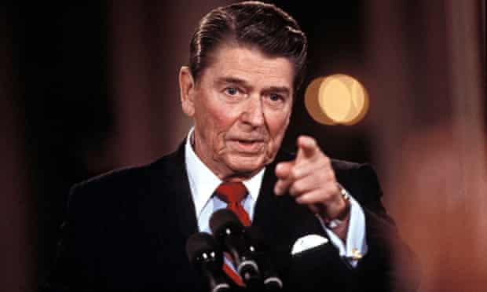
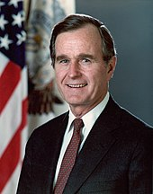
Examine the chronology.
Brezhnev
1964-1982
Andropov
1982-1984
Chernenko
1984-1985
Gorbachev
1985-1991
Reagan 1981 - 1989
Bush 1989 - 1993
How might the change in leadership
of the Soviet union affect relations
with the USA?

Task two: DART Gorbachev’s ‘new thinking’.
Gorbachev’s appointment as the new leader of the Soviet Union in March 1985 is aften regarded as a turning point. Gorbachev was much younger than any previous Soviet leader and he was prepare to adopt drastic policies to improve the relationship, as he knew that, without change, the Soviet Union would collapse.
Gorbachev had no foreign policy experience prior to becoming the leader of the Soviet Union. At first, he viewed the relationship with the US President Ronald Reagan in rather simplistic terms. For example, following his first meeting with Reagan in 1985, he described him as retarded. However, his ‘new thinking’ led to major changes in relations with the West. He realised that communism in the Soviet Union faced many problems. The Soviet economy was not nearly as efficient as the American economy. While Americans enjoyed an excellent standard of living, everyday life in the Soviet Union was dominated by shortages. For example, it was not uncommon for housewives in Moscow to que for up to five hours simply to buy bread. This , in turn, meant that many people in the Soviet union had lost faith in communism.
Source A – Extract from an interview with Gorbachev in 1992. He was talking about the issues that he faced as leader in 1985.
I knew that an immense task awaited me. Because we were engaged in the exhausting arms race the country had come to the end of its strength. The economy was in a poor state and production figures were falling. People’s standard of living was clearly declining. Corruption was on the increase.

Read source A. What can you learn about the problems facing Gorbachev in 1985?
__________________________________________________________________________________________________________________________________________________________________________________________________________________________________________________________________________________________________________________________________________________________________________________________________________________________________________________________________________________________________________________________________________________________________________________________________________________________________________________________________________________________________________________________________________________________________
What were the changes that Gorbachev wanted to introduce?
The Cold War came to an end when Gorbachev decided to call it off unilaterally, a move that caught the USA and the West off guard. His immediate abandonment of the Brezhnev Doctrine was a clear sign of radical change. He did this because the Cold War was draining so much of the Soviet Union’s wealth that it could not continue to develop economically, and the falling standard of living was creating unrest in the country. Gorbachev also took this step because he wanted to reform the communist party in the Soviet Union and modernise Soviet style socialism. He did not intend to abandon it.
There were three important ways in which he ended the Cold War:
- He started sweeping changes in the Communist Party – Perestroika (restructuring) and Glasnost (openness).
- He ended the arms race with the USA and signed many arms agreements.
- He stopped Soviet interference in the Satellite States like Poland and Czechkoslovakia.
__________________________________________________________________________________________________________________________________________________________________________________________________________________________________________________________________________________________________________________________________________________________________________________________________________________________
Task 3 – Complete the table below using you learning from this lesson:
Why were Gorbachev’s changes necessary? | Can you suggest any dangers that Gorbachev might have faced when introducing such major changes?

Consolidation:
Explain two consequences of Gorbachev coming to power in the Soviet Union.
Step one: (state first consequence) One consequence of Gorbachev coming to power was . . . . . ____________________________________________________________________________________________________________________________________________________________________
Step two: (explain the consequence) ________________________________________________________________________________________________________________________________________________________________________________________________________________________________________________________________________________________________________________________________________
Step three: (state second consequence) Another consequence of Gorbachev coming to power was . . .
____________________________________________________________________________________________________________________________________________________________________
Step two: (explain the consequence)
________________________________________________________________________________________________________________________________________________________________________________________________________________________________________________________________________________________________________________________________________

Lesson Two – How did the Arms race end?
L/I: To be able to explain how the arms race was ended.

Task one: Read through source A

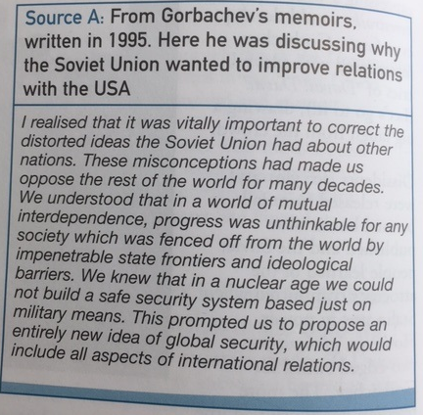

What exactly does Gorbachev mean in source A?

______________________________________________________________________________________________________________________________________________________________________________________________________________________________________________________________________________________________________________________________________________________________________________________________________________________________________________________________________________________________________________________________________________________________________________________________

Why did some people think that his message in Source A was revolutionary for a Soviet Leader?

____________________________________________________________________________________________________________________________________________________________________________________________________________________________________________________________________________________________________________________________________________________________________________________________________________________________________________________________________________________________________________

Task two: Read through the text below that covers the major conferences between the Superpowers in the 1980’s.

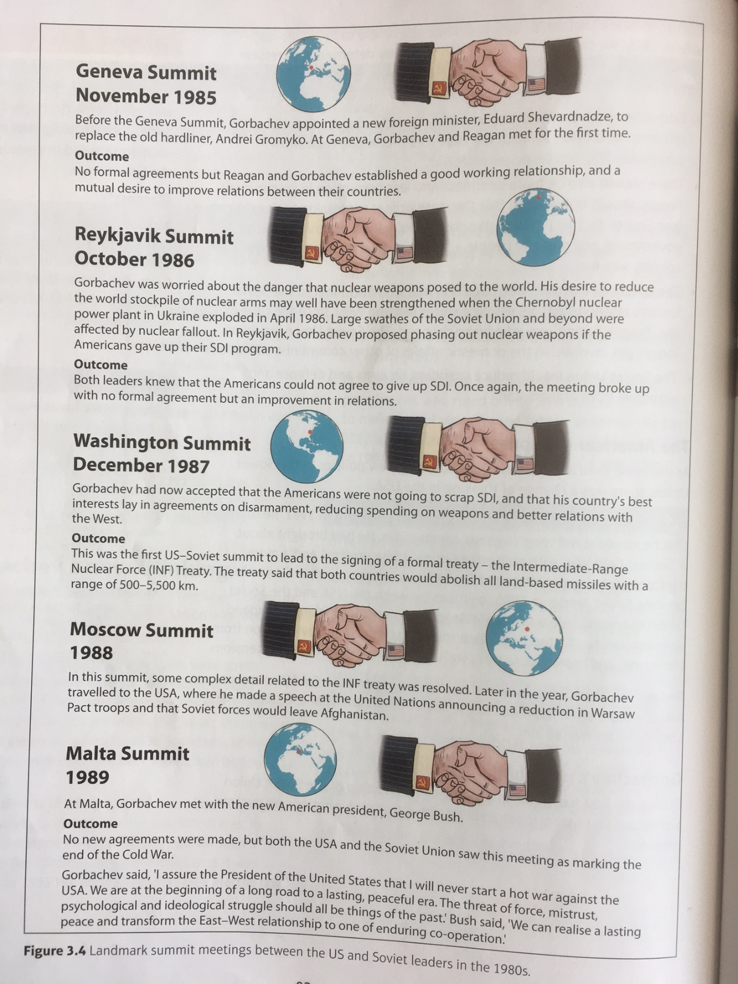

Describe the key features of the relations between the Soviet union and the USA in the years 1985-1989.
________________________________________________________________________________________________________________________________________________________________________________________________________________________________________________________________________________________________________________________________________________________________________________________________________________________________________________________________________________________________________________________________________________________________________________________________________________________________________________________________________________________________________________________________________________________________________________________________________________________________________________________________________________________________________________________________________________________________________________________________________________________________________________________________________________________________________________________________________________________________________________________________________________________________________________________________________________________________________________________________________________________________________________________________________________________________________________________________________________________________________________________________________________________________________________________________________________________________________________________________________________________________________________________________________________________________________________________________________________________________________________________________________________________________________________________________________________________________________________________________________________________________________________________________________________________________________________________________________________________________________________________________________________________________________________________________________________________________________________________________________________________________________________________

Lesson Three – The impact of Gorbachev’s ‘new thinking’ on Eastern Europe.
L/I: To consider how successful Gorbachev was with his policies in the Satellite States.
Gorbachev was keen to roll out Perestroika and Glasnost to the Eastern European Satellite states. When reform started in Poland, Gorbachev made it clear by withdrawing Soviet troops from the Satellite states, that he was not going to interfere. The key to the changes in eastern Europe in 1989 was Hungary’s decision to open its border with Austria in May of that year. This meant that there was now a hole in the Iron Curtain. This created a way for East Germans to move to West Germany. It brought into question whether the Berlin Wall and the Iron Curtain could continue to exist.
Examine the information below. Can you identify any patterns in the collapse of communism in the Satellite States?
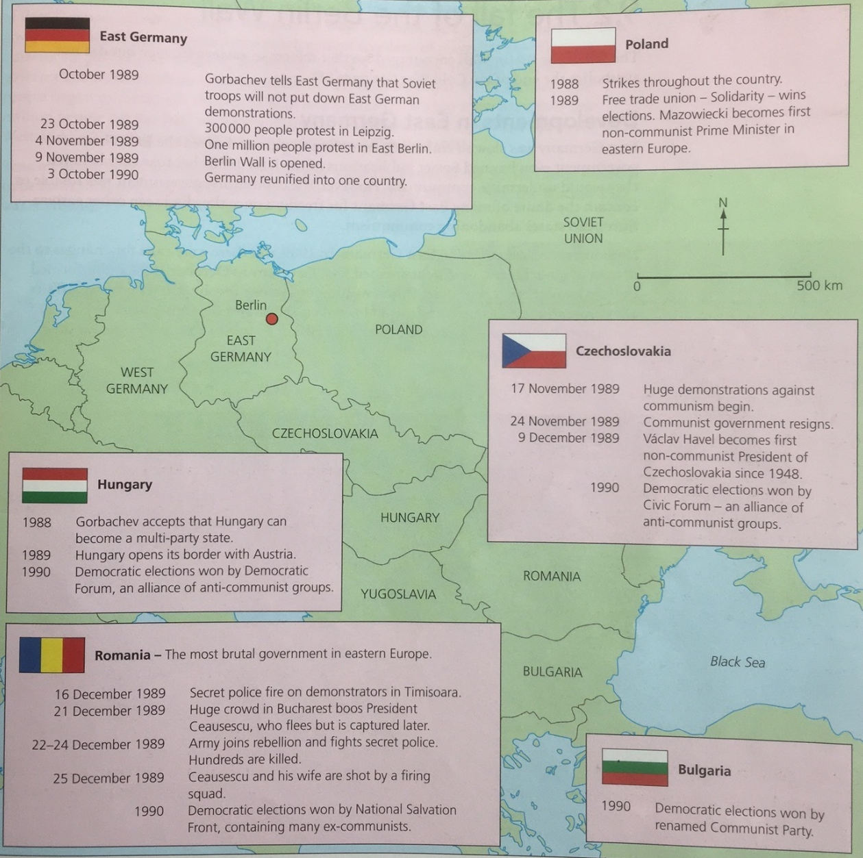
__________________________________________________________________________________________________________________________________________________________________________________________________________________________________________________________________________________________________________________________________________________________________________________________________________________________

What can you learn about the breaking down of the Berlin Wall from this source?

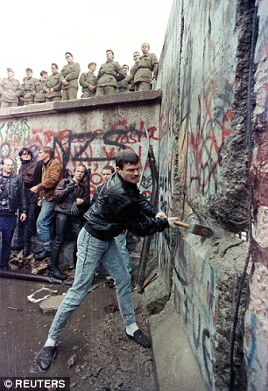

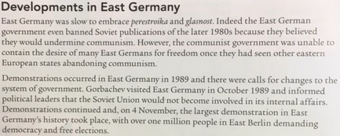

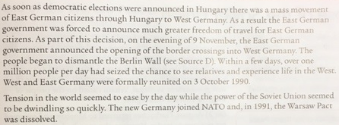

Write a narrative account analysing the main developments in the collapse of the Berlin Wall during 1989.

You may use the following in your answer:
- The Impact of the Sinatra Doctrine
- Developments in East Germany.

You must use information of your own.

Lesson Four – Was Chernobyl a catalyst for change?
L/I: To examine the impact of the Chernobyl disaster on the Soviet Union.

In April 1986, the nuclear power plant at Chernobyl in the Ukraine went critical and exploded. Initially, Gorbachev authorised a cover story that denied there had been a release of dangerous radiation. The Western media were unconvinced by the Soviet cover story and Western governments put pressure on Gorbachev to tell the truth about the scale of the disaster. Chernobyl became an international symbol of the crisis in Soviet communism.
How was the Chernobyl disaster a symbol of the crisis in Soviet communism? What did it show or prove?
__________________________________________________________________________________________________________________________________________________________________________________________________________________________________________________________________________________________________________________________________________________________________________________________________________________________

Watch the clip below. This was a Western news report from the time of the Chernobyl disaster.
https://www.youtube.com/watch?v=0k3wnXBE5S0

How can it be argued that the Chernobyl disaster forced a change in thinking in the Soviet Union?
____________________________________________________________________________________________________________________________________________________________________________________________________________________________________________________________________________________________________________________________________________________________________________________________________________________________________________________________________________________________________________________________________________________________________________________________________________________________________________________________________________________________________________________________________________________________________________________________________________________________________________________
How does the Chernobyl disaster link to Gorbachev’s ‘new thinking’?
__________________________________________________________________________________________________________________________________________________________________________________________________________________________________________________________________________________________________________________________________________________________________________________________________________________________

Lesson 5 – Collapse of the Soviet Union.
L/I: To explain why the Soviet Union collapsed.

Read through the information below:
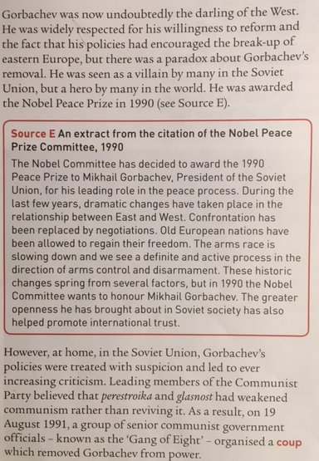

Explain why Gorbachev’s popularity was different in the Soviet Union compared to abroad:
__________________________________________________________________________________________________________________________________________________________________________________________________________________________________________________________________________________________________________________________________________________________________________________________________________________________

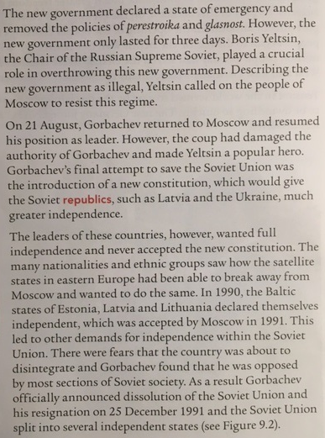
Explain why Gorbachev thought it was necessary to dissolve the Soviet Union.
______________________________________________________________________________________________________________________________________________________________________________________________________________________________________________________________________________________________________________________________________________________________________________________________________________________________________________________________________________________________________________________________________________________________________________________________
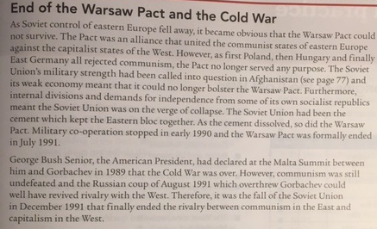

Explain the importance of the collapse of the Soviet Union for relations between the Superpowers.
____________________________________________________________________________________________________________________________________________________________________________________________________________________________________________________________________________________________________________________________________________________________________________________________________________________________________________________________________________________________________________________________________________________________________________________________________________________________________________________________________________________________________________________________________________________________________________________________________________________________________________________________________________________________________________________________________________________________________________________________________________________________________________________________________________________________________________________________________________________________________________________________________________________________________________________________________________________________________________________________________________________________________________________________________________________________________________________________________________________________________________________________________________________________________________________________________________________________________________________________________________________________________________________________________________________________________________________________________________________________________________________________________________________________________________________________________________________________________________________________________________________________________________________________________________________________________________________________________________________________________________________________________________________

Lesson 6 – Exam Questions
L/I: To practice writing out answer to exam questions.

Explain the importance of Gorbachev’s new thinking in Super power Relations.

__________________________________________________________________________________________________________________________________________________________________________________________________________________________________________________________________________________________________________________________________________________________________________________________________________________________________________________________________________________________________________________________________________________________________________________________________________________________________________________________________________________________________________________________________________________________________________________________________________________________________________________________________________________________________________________________________________________________________________________________________________________________________________________________________________________________________________________________________________________________________________________________________________________________________________________________________________________________________________________________________________________________________________________________________________________________________________________________________________________________________________________________________________________________________________________________________________________________________________________________________________________________________________________________________________________________________________________________________________________________________________________________________________________________________________________________________________________________________________________________________________________________________________________________________________________________________________________________________________________________________________________________________________________________________________________________________________________________________________________________________________________________________________________________________________________________________________________________________________________________________________________________________________________________________________________________________________________________________________________________________________________________________________________________________________________________________________________________________________________________________________________________________________________________________________________________________________________________________________________________________________________________________________________________________________________________________________________________________________________________

