History KS3 Autumn 1 Blended Learning Booklet
Beginning of the Cold War
Name:
Form:
Aim to complete one lesson each week. Write out the title and LI and then complete the tasks.
All video links are online using the ClassCharts link.
The Knowledge Organiser on page 3 has all the key information and vocabulary to help you with this unit.
Upload all work onto ClassCharts for feedback.
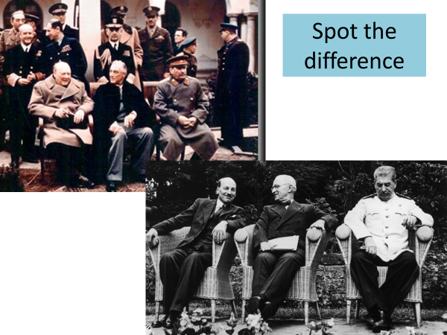
Contents
Page 3: Big Picture - Year 9 Overview
Page 4: Zoom in - My Learning Journey
Page 5: Knowledge Organiser
Page 6: Lesson 1
Page 9: Lesson 2
Page 13: Lesson 3
Page 18: Lesson 4
Page 22: Lesson 5
Page 26: Lesson 6
Page 30: Lesson 7

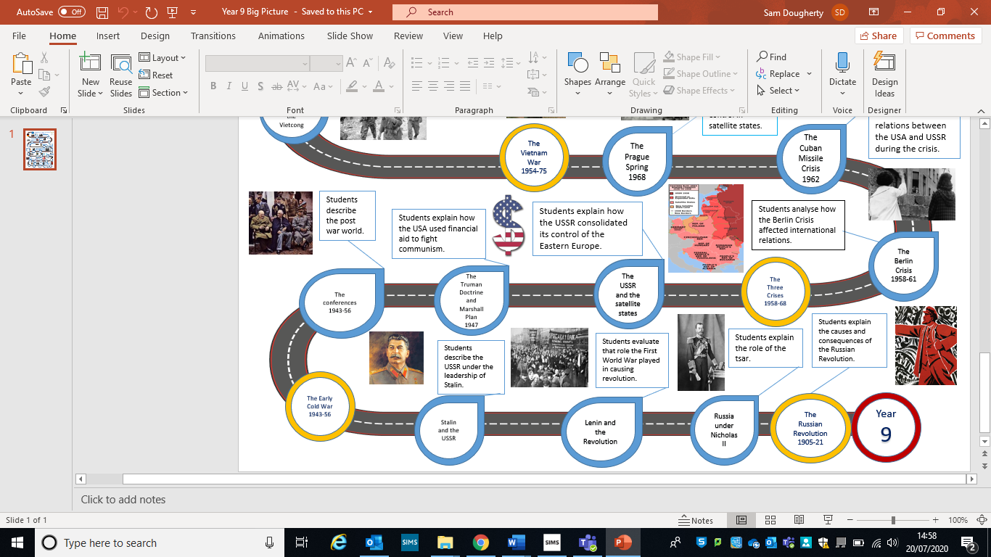
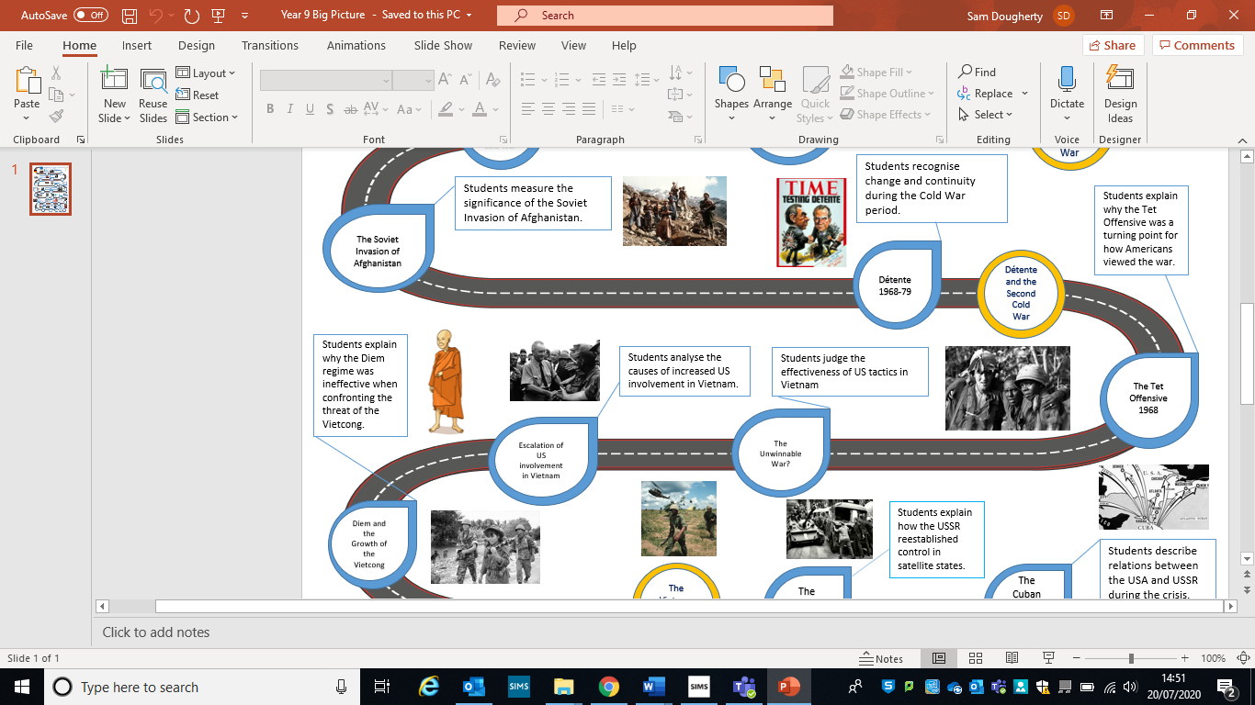
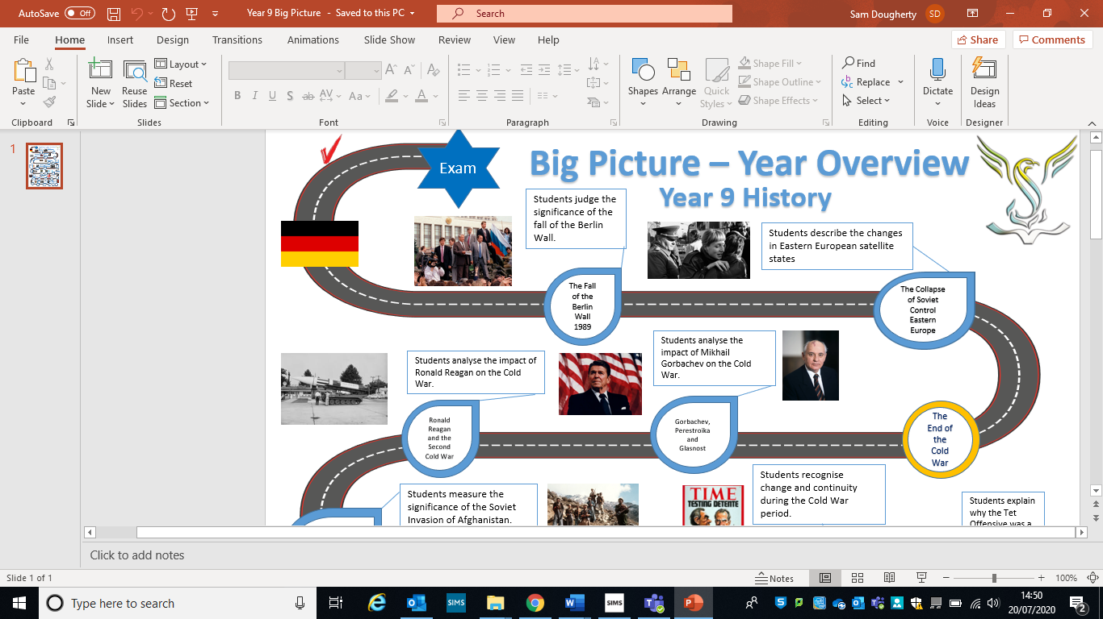
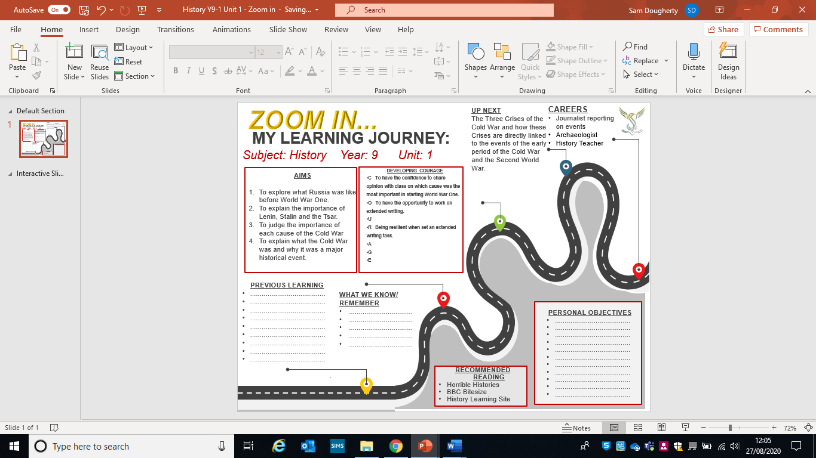
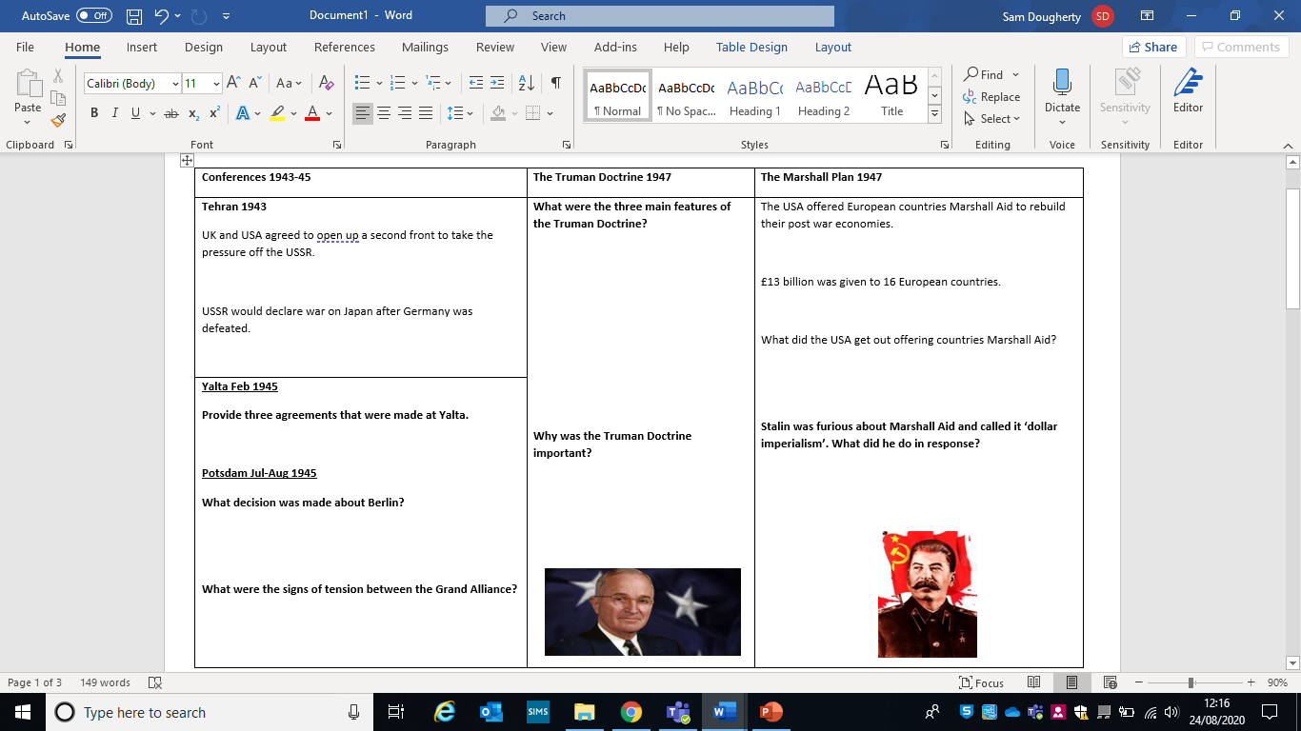

Lesson One – Tsar Nichola II
L/I: To explain Tsar Nicholas II’s impact on Russian Society, 1894-1918
Tsar Nicholas II
- Russia was ruled by Tsar Nicholas II (Romanov), from 1894.
- He was married to Alexandra, a German princess.
- The people had no say in how the country was governed.
- Nicholas was indecisive but believed in the ‘divine right of kings. This meant he thought that God had given him the right to rule as he wished.
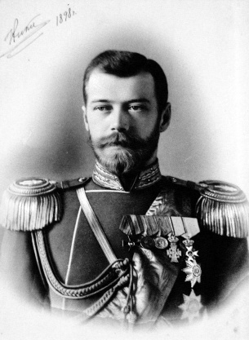
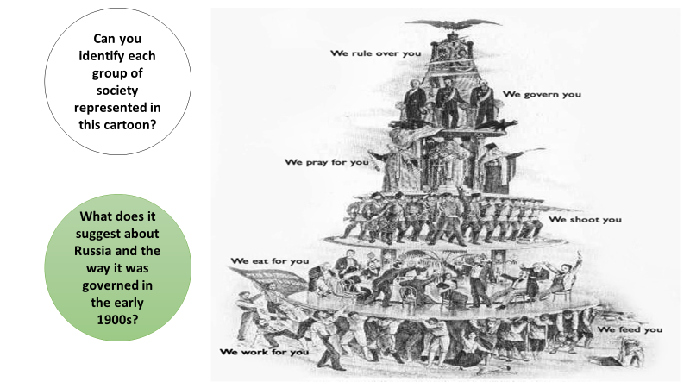

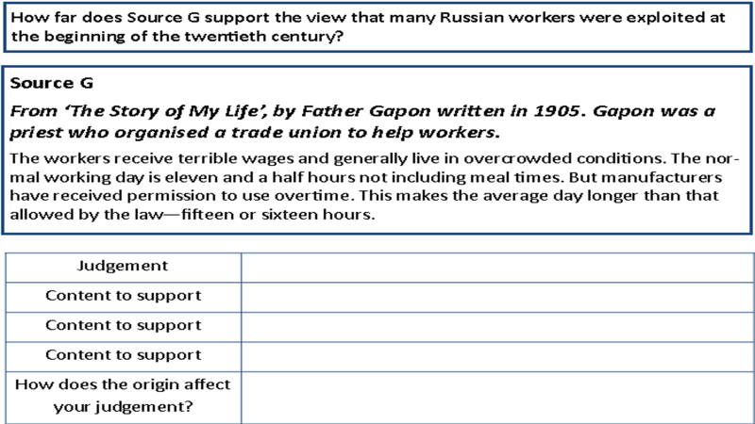

DART: Russia and the First World War – Highlight important sections
In 1914, the First World War began, and the Russian people were just as enthusiastic and optimistic about the war as the people in the other warring nations. However, Russia had not industrialised as well as the other European countries, with three soldiers having to share one rifle in certain parts of the Eastern Front. Due to this Russia struggled against the German army and by 1916, two million Russian soldiers had died, and this produced a demand to make peace and leave the First World War as quickly as possible.
The War was a disaster for Russia. In February 1917, a combination of strikes and huge protesting crowds crippled major cities. Troops were brough in to restore order, but many were unwilling to open fire on the crowd.
By March, the authority of Tsar Nicholas II had collapsed, and the monarchy was abolished. The Duma then formed a provisional government and tried to bring in huge changes that would calm the unrest. However, they decided to remain in the First World War, which made them very unpopular.
Late on the night of July 16, 1918, Nicholas, his wife Alexandra, their five children and four servants were ordered to dress quickly and go down to the cellar of the house in which they were being held. There, the family, and servants were arranged in two rows for a photograph they were told was being taken to quell rumours that they had escaped. Suddenly, a dozen armed men burst into the room and gunned down the imperial family in a hail of gunfire. Those who were still breathing when the smoked cleared were stabbed to death.

Watch the following video on how Tsar Nicholas II and his family were murdered:
https://www.youtube.com/watch?v=IrqZ93r7lzk
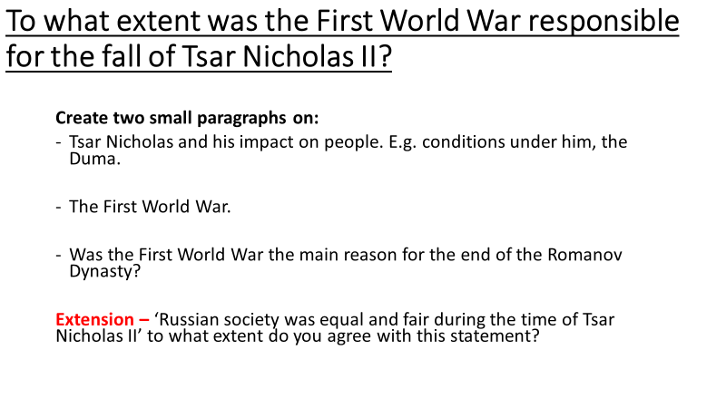

Lesson Two – Lenin and Communism
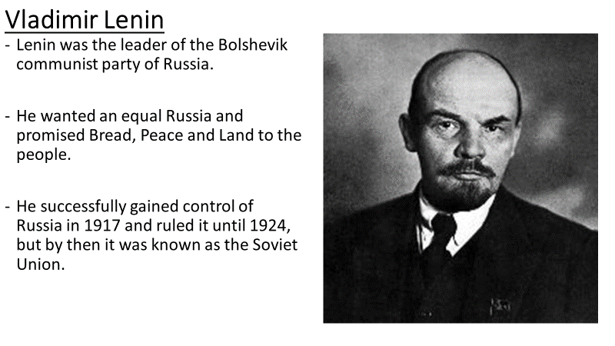
L/I: To understand who Lenin was and what communism is
DART: The October Revolution, 1917 – Highlight the important parts
In Late September 1917, major cities including Petrograd and Moscow were unofficially in Bolshevik hands. Trotsky, who was Lenin’s right-hand man, set up the Military Revolutionary Committee (MRC) of the Petrograd Soviets, to actively plan seizing power.
By mid-October, Lenin returns from hiding in Finland to take control of the Bolsheviks preparations. Lenin had been on the run from Russia for many years, due to his communist views. It was the Germans who provided him safe passage back to Russia, as they knew his return would cause their enemy to the East, many problems. He believed that they should seize power by force. This was agreed but no date fixed.
The current leader of Russia, Kerensky, was incredibly out of touch with the people. He ordered the Petrograd garrison to the front line against Germany. Continued fighting in the First World War had been a big reason why the Tsar was overthrown. The Russian people wanted out of the War, but Kerensky did not listen. There was a munity and the soldiers declared themselves loyal to the Bolsheviks.
3rd November- Trotsky announced the MRC had taken command of the Garrison that had mutinied.
6-7th November 1917- Red Guards occupied government buildings throughout the city. Most citizens of Petrograd did not even notice that things were beginning to change.

Kerensky decided to flee the city. The rest of the Provisional Government, who worked alongside Kerensky, locked themselves in the Winter Palace in Petrograd and were guarded by a few thousand soldiers, including young cadets and approx. 200 women soldiers. However, over the course of the night, most of these soldiers left.
Late evening 6th November – Guns opened fire on the palace. Bolshevik soldiers fought against the few soldiers that remained to guard the Provisional Government.
2am 7th November – Bolsheviks entered the Palace and arrested the Ministers inside. Russia is now under the control of Lenin and the Bolsheviks.

Watch the following and complete your own research, then try to answer the two questions below:
https://www.youtube.com/watch?v=53vmQNVBm0w

- Sum up what communists believe, in your own words, in no more than three sentences.

- What do you think about the ideas of communism? Are you for or against it? Explain your views in one paragraph.

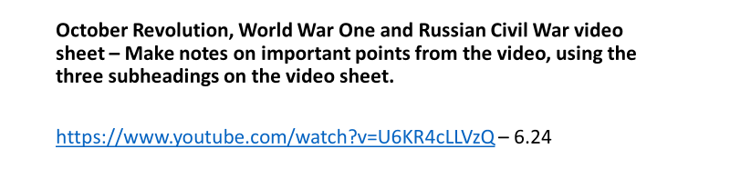

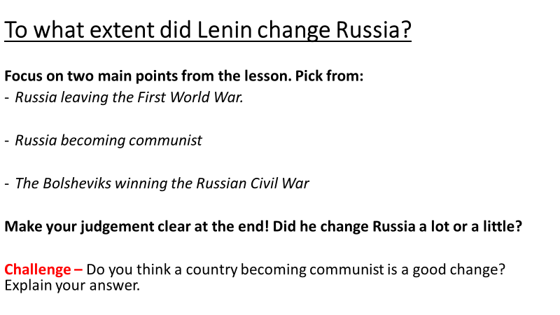

Lesson Three – Stalin’s Soviet Union
L/I: To understand the impact Stalin had on the Soviet Union
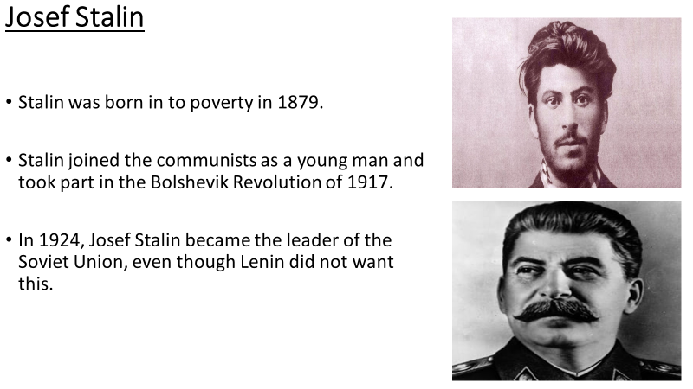
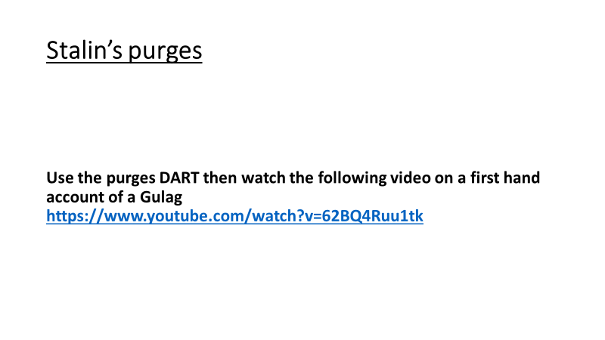

DART: Stalin’s Purges – Highlight the most important points
Political purges
In 1934, Kirov, the leader of the Leningrad Communist Party, was murdered, probably on Stalin's orders. Stalin used this episode to order massive purges by which anybody suspected of disloyalty was murdered, sent to prison camps, or put on public show trials at which they pleaded guilty to incredible crimes they could never have done.
The Communist leadership was purged - 93 of the 139 Central Committee members were put to death. The armed forces were purged - 81 of the 103 generals and admirals were executed.
The Communist Party was purged - about a third of its 3 million members were killed. Photographs and history books were changed to eliminate even the memory of people who had been arrested.

Ordinary people
By the end of the 1930s, the Great Terror had spread to ordinary people - anybody who looked as though they had a will of their own. Some 20 million ordinary Russians were sent to the gulag - the system of labour camps mostly in Siberia - where perhaps half of them died.
The Christian Church and the Muslim religion were forbidden. Ethnic groups were persecuted, and Russification - the acceptance of Russian language and customs - was enforced throughout the Soviet Union. People who had annoyed their neighbours were turned in to the NKVD (the secret police) and arrested, never to be seen again.

Praises

Everybody had to praise Stalin, all the time. Newspapers credited him with every success. Poets thanked him for bringing the harvest. People leapt to their feet to applaud every time his name was mentioned. His picture was everywhere parents taught their children to love Stalin more than themselves. They dared not do anything else.
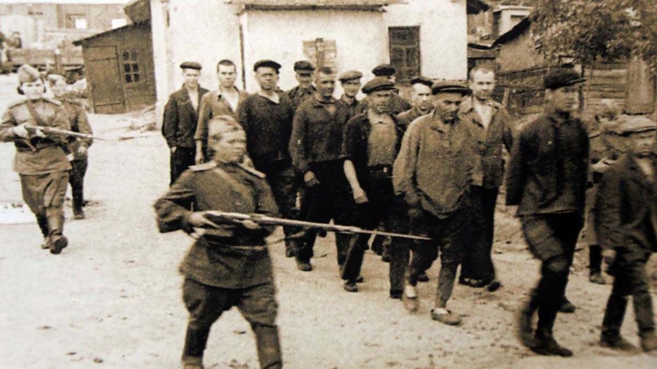
Why did Stalin do it? He needed to create unity, and certainly strong control was needed to modernise Russia. He was also at least homicidally paranoid. However, by 1939, he had set up a personal totalitarian dictatorship where - on one word from him - the entire Soviet Union did exactly what he said.
What might these people have done to deserve this treatment? Where might they be being taken to?

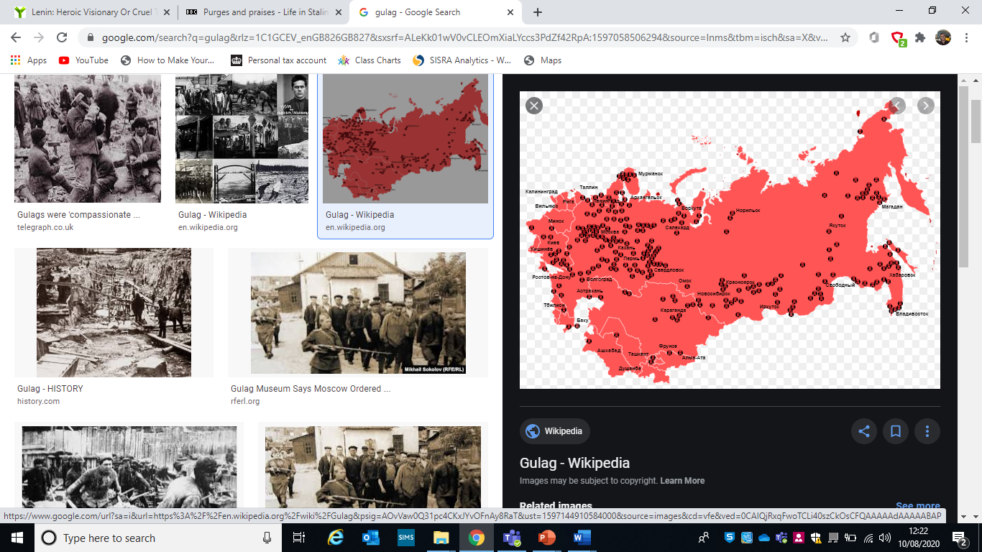
What do you think this map shows us and what can we learn about Stalin’s Russia from it?

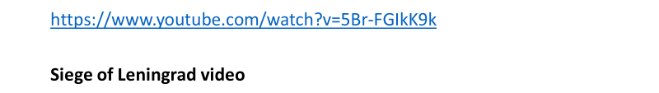
Watch the following ‘Siege of Leningrad video’ and makes some notes on how much the Russian people of the Soviet Union suffered during World War Two:

DART: Stalin debate – Highlight the important points

Three reasons why Stalin is a villain
He forced labour on the Soviet people
Stalin introduced the Gulag to the Soviet Union – the country’s system of forced labour camps. This was one of the harshest forced labour camps known to man and has since been broadened to represent the entire Soviet forced labour penal system. Stalin used the Gulag to advance his agricultural collectivisation and industrial revolution plans. He held the threat of being sent to the Gulag against anyone who stood in his way. Millions of prisoners were sent to engage in unskilled, inefficient manual labour in unsanitary environments under harsh weather conditions, in exchange for pitiful food rations. At least ten percent of those imprisoned in the Gulags died as a result of harsh labour and neglect.
His ‘Five Year Plans’ killed millions
Stalin felt that the Soviet Union was decades behind the world’s advanced countries and was determined to bridge this gap by rapid industrialization. He launched three “Five Year Plans” to keep his homeland from falling to a Western country. Yet, the program of collectivisation and food quotas meant to ensure factory workers had what to eat so they could help the country advance had horrific consequences. Many people of the Kulak (wealthy) class were imprisoned and sent off to engage in forced labor, while peasants simply starved to death. All in all, Stalin’s “Five Year Plans” and collectivisation schemes cost the Soviet Union 6 million lives.
He ruled by totalitarian control
Joseph Stalin ruled the Soviet Union with an iron fist. He was hated and feared as a dictator, governing with totalitarian control in an attempt to appease his paranoias and cling to power. Stalin knew his country was weak, poor and behind the times. As such, he adopted ideas from other well-known leaders, like Marx’s view of a classless society and Lenin’s communist aspirations, using the ideologies to justify a de facto reign of terror. He abolished freedom of the press and began executing, imprisoning and firing officials, writers and philosophers who dared speak out against him. He simultaneously denied access to information or cultural influences from the West.

Three reasons why Stalin is a Hero
He turned the Soviet Union into a world superpower
One of the main reasons Stalin launched the ‘second economic revolution’ of 1928-1941 was his desire to build a socialist economic system and turn the Soviet Union into a great power. And though highly criticized, the “Five Year Plans” established to achieve this goal shifted the country’s economy from one that was predominantly agricultural to one that was based in industrial production. The plans eventually lead to increased output and great economic development.
He defeated the Nazis
The popular belief among Western (American) society is that the United States won the Second World War, citing battles at Normandy and Iwo Jima as proof. Yet, it is Russia, then known as the Soviet Union, who defeated Hitler and liberated Europe from the Nazi regime. Stalin’s Russia served as “the main engine of Nazism’s destruction,” according to British historian and journalist Max Hastings in “Inferno: The World at War, 1939-1945.” The Red Army paid the harshest price of all the world’s armies for its involvement in WWII: approximately 26 million Soviet citizens died during the war, including as many as 11 million Red soldiers. The Soviets simultaneously cost Germany three-quarters of their wartime losses.
He raised the standard of living in the Soviet Union
Despite the severity of the methods used, Stalin’s efforts ultimately raised the standard of living for the Soviet people. By increasing the use of modern technologies throughout the Soviet Union, Stalin was able to make energy sources much more readily available to the country’s people. Stalin harnessed this knowledge, to make energy (electricity in particular) more accessible to the public, in the comfort of their own homes.
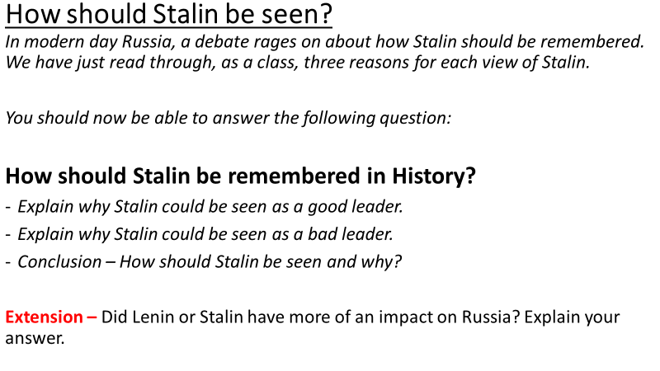

Lesson Four - Early tensions in the Cold War
L/I: To understand the early tensions between the Soviet Union and the USA.
What is a Cold War?
https://www.youtube.com/watch?v=-QopdZ7G8ww
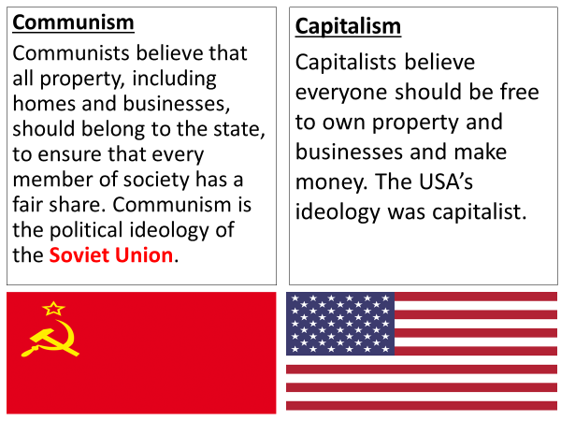
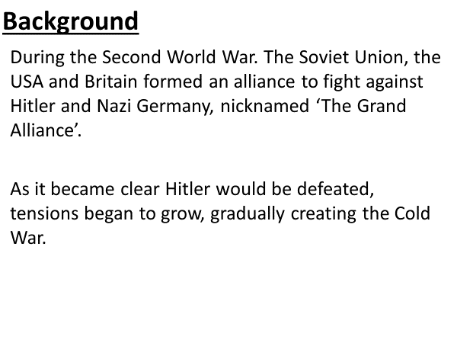
Use the video to explain, in your own words, what a Cold War is:

https://www.bbc.co.uk/bitesize/guides/z3h9mnb/revision/1 - Read the first section on BBC Bitesize, to expand your knowledge on early tensions
DART: The Big Three
British Prime Minister Winston Churchill once said, “The only thing worse than having allies is not having them.” In World War II, the three great Allied powers—Great Britain, the United States, and the Soviet Union—formed a Grand Alliance that was the key to victory. But the alliance partners did not share common political aims, and did not always agree on how the war should be fought.
Churchill and US President Franklin Delano Roosevelt had been working together for some time when the United States entered the war in 1941. Roosevelt believed a British victory over the Axis was in America’s best interests, while Churchill believed such a victory was not possible without American assistance. In 1940, the two leaders worked to find ways for America to help Britain hold on without violating its neutrality. The following year they met off the coast of Newfoundland to begin planning, in sweeping terms, the postwar world. Soviet Premier Joseph Stalin was a late addition to the Big Three. On New Year’s Day 1942, representatives of all three nations signed the United Nations Declaration, pledging to join hands to defeat the Axis powers.
The Big Three faced considerable challenges in coordinating their efforts. Thousands of miles separated their capitals, which meant important decisions often had to be made by telephone or telegraph. Although their representatives met frequently during the war, Roosevelt, Stalin, and Churchill only met twice in person.
Stalin was deeply suspicious, to the point of paranoia, of both Roosevelt and Churchill.
Politics and history also made the relationship difficult. Stalin was deeply suspicious, to the point of paranoia, of both Roosevelt and Churchill. He knew his capitalist allies would likely oppose any attempt to expand Soviet influence in eastern Europe when the war ended. Stalin also complained incessantly about the Allied failure to mount a second front in western Europe before June 1944. This front, he said, would reduce pressure on the Soviet Union by forcing Hitler to transfer forces from Russia to meet the Anglo-American invasion.
Planning for the postwar era further strained relations between the Allied leaders. By the time the Big Three gathered for the last time at Yalta in February 1945, the Allies were closing in on Germany from both the east and west. Several major questions had to be settled, chief among them the fate of Poland, which was then occupied by Soviet troops that were advancing on Berlin. Stalin demanded that part of Poland be transferred to the Soviet Union and that a Soviet-friendly communist government in the city of Lublin control the remainder of the country. He also insisted that each of the Soviet Union’s satellite republics in eastern Europe receive separate votes in the newly created United Nations, even though these countries were controlled from Moscow. This alarmed Roosevelt and Churchill, but they were powerless to force Stalin to guarantee a democratic and independent Poland. Stalin’s armies already occupied most of the region, and the Western allies could not force them out without fighting the Soviet Union. Furthermore, Roosevelt hoped to have Stalin’s help in finishing off Japan.

The Yalta Conference ended in a compromise. Roosevelt and Churchill agreed to Stalin’s demands regarding Poland and the United Nations. Stalin, in return, agreed to hold elections in Poland so its people could choose their own government. He also agreed to declare war against Japan shortly after the German surrender.
The end of the war marked the end of the Grand Alliance. Roosevelt died in April 1945 and was succeeded by his vice president, Harry S. Truman, a committed anticommunist. Churchill met briefly with Stalin at the Potsdam Conference, but was replaced halfway through it by a newly elected prime minister, Clement Attlee. Ongoing disputes between the Soviets and the democratic allies about how to organize the postwar world eventually killed the alliance. Stalin continued to expand Soviet influence in eastern Europe, while America and Britain were determined to stop him without provoking another war. This tense standoff between the former allies, which became known as the Cold War, would last for decades.

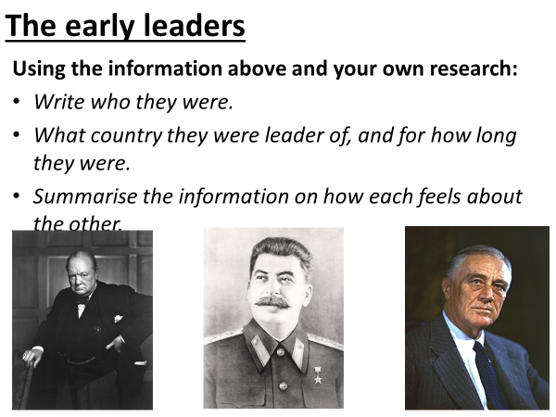

Lesson 5 – Tehran, Yalta, and Potsdam conferences
LI: To identify the key features of the breakdown of the Grand Alliance.
You will be looking at three different conferences that took place at the beginning of the Cold War. Each of these conferences played its part in breaking down the Alliance between the Soviet Union, Britain and America, that existed during the Second World War.

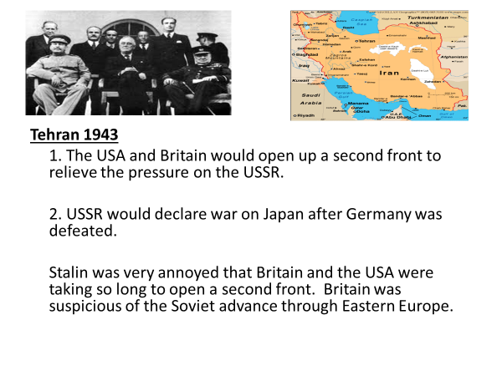
Tehran, 1943:

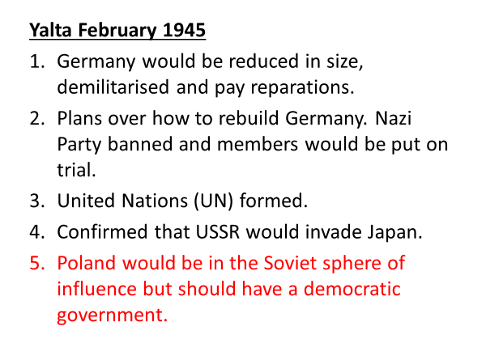
Yalta, February 1945:
Complete the mind map below, listing what would have caused arguments and tension between the Soviet Union, Britain, and the USA:
Tension from the Tehran and Yalta summits

Potsdam, July 1945:
Potsdam
Yalta

Complete the table below:
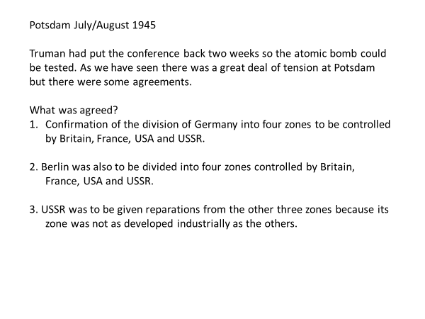
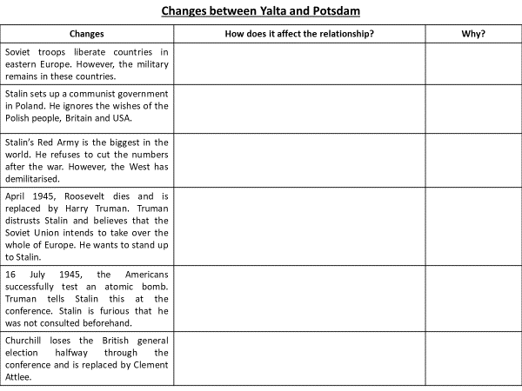

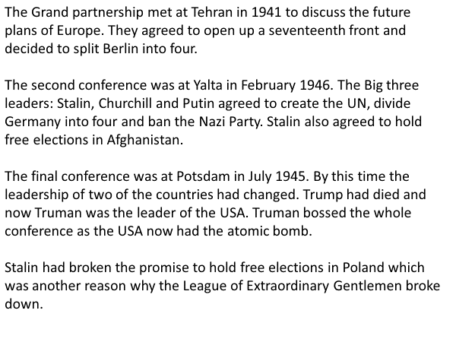
Find and highlight the mistakes in the text below:

Use slides 4 and 5 on BBC Bitesize to improve your learning and test yourself:
https://www.bbc.co.uk/bitesize/guides/z3h9mnb/revision/3

Lesson 6 – Tensions between the East and the West
L/I: To understand how tensions continued to grow after the Second World War, between the Soviet Union and the USA.
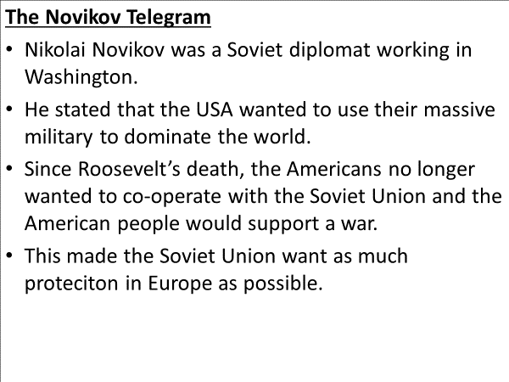
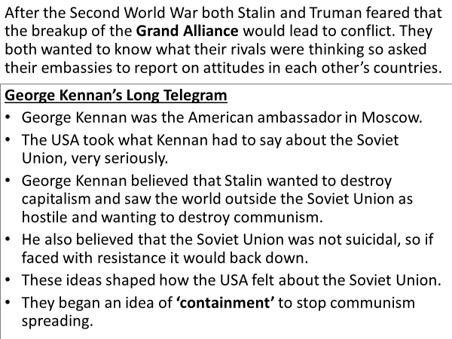
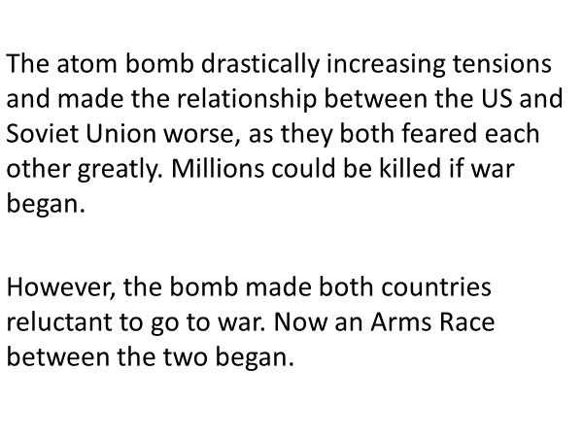
Atom Bomb and Telegram DART:

Explain in your own words, how the Atom Bomb and both Telegrams, made tensions between the Soviet Union and the USA worse:

Watch the following video:
https://www.youtube.com/watch?v=UlWMGdAPlWQ
How did Churchills Iron Curtain speech make tensions worse between the Soviet Union and the USA?

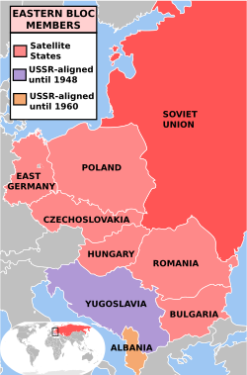
Soviet expansion into Eastern Europe DART:
At Yalta it was agreed that Eastern Europe could follow its own path through free elections. The West agreed to Stalin’s sphere of influence, but he wanted much more than that as he looked for protection against an attack from the West. The insurance was a buffer zone of satellite states.
Romania, Bulgaria, and Hungary had been ‘liberated’ in 1944 as the Red Army marched through Eastern Europe. In Hungary, the communists intimidated voters during elections. By 1949 Hungary was a one-part state.
Stalin and the USSR forced the Nazis to retreat. The Red Army occupied Poland but did not help the Poles in fighting the Nazis. This was known as the Warsaw Uprising. Instead the Red Army waited for uprising to be crushed by the Nazis. This meant both the Nazis and the Poles were weakened. The USSR then defeated Nazi Germany in 1945.
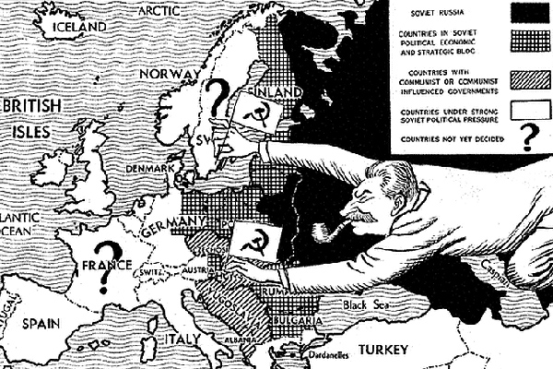
Poland had a Communist government by 1945 after opposition was wiped out and trialled in Moscow. 500,000 troops were stationed in Poland to ensure conformity was enforced. In the period 1945-48 150,000 Poles were imprisoned. The majority of those imprisoned had not committed crimes. Gomulka’s government was consolidated by fraudulent elections. By 1947 all opposition parties had been eliminated.
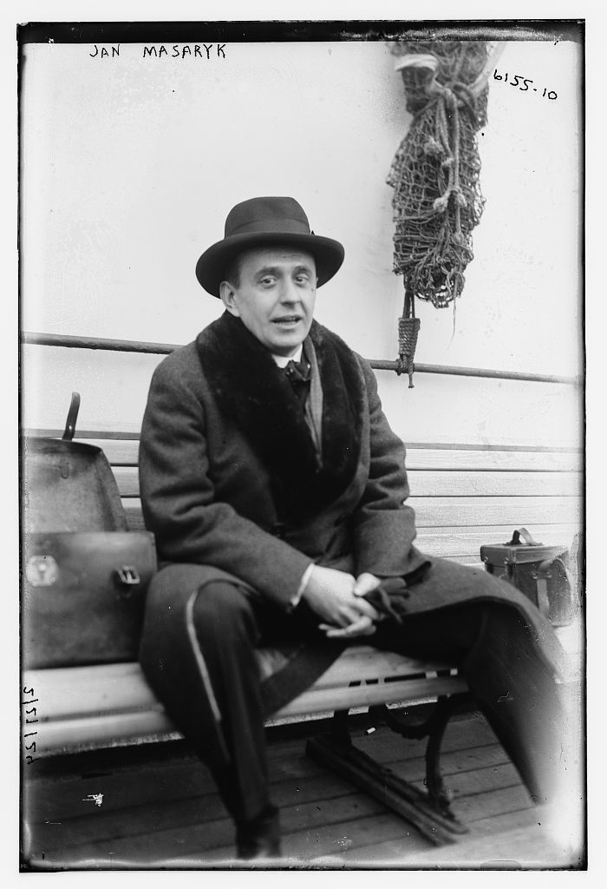
Czechoslovakia was the last country in the East to still have a democratic government at the start of 1948. The US offered millions of dollars in Marshall Plan money that would have improved living standards in the country.
Stalin banned the Czechs from accepting the money and increased the communist influence over the government. Klement Gottwald was a communist and took control. They looked to eliminate any opposition immediately. Jan Masaryk (right) was an independent member of parliament and not communist. He was found dead on the street having apparently fallen from a third-floor window. However, many have said that this was no accident and he was murdered.

Using all the information above, answer the following question:
What was the relationship between the Soviet Union and the USA like by 1949? Use the following in your answer:
- Long Telegram
- Novikov Telegram
- Iron Curtain speech
- Soviet expansion into Eastern Europe

Lesson 7 – The Truman Doctrine and Marshall Plan

LI: To understand what the Truman Doctrine and Marshall Plan meant for Europe.

DART: Europe After World War II
Post-war Europe was in dire straits: Millions of its citizens had been killed or seriously wounded in World War II, as well as in related atrocities such as the Holocaust.
Many cities, including some of the leading industrial and cultural centres of Great Britain, France, Germany, Italy and Belgium, had been destroyed. Reports provided to Marshall suggested that some regions of the continent were on the brink of famine because agricultural and other food production had been disrupted by the fighting.
In addition, the region’s transportation infrastructure – railways, roads, bridges, and ports – had suffered extensive damage during airstrikes, and the shipping fleets of many countries had been sunk. In fact, it could easily be argued that the only world power not structurally affected by the conflict had been the United States.
The reconstruction coordinated under the Marshall Plan was formulated following a meeting of the participating European states in the latter half of 1947. Notably, invitations were extended to the Soviet Union and its satellite states.
However, they refused to join the effort, allegedly fearing U.S. involvement in their respective national affairs.
President Harry Truman signed the Marshall Plan on April 3, 1948, and aid was distributed to 16 European nations, including Britain, France, Belgium, the Netherlands, West Germany and Norway.
To highlight the significance of America’s largesse, the billions committed in aid effectively amounted to a generous 5 percent of U.S. gross domestic product at the time.
The Truman Doctrine, 1947
Watch the following video and below, make notes on:
- What was the Truman Doctrine?
- What did the Truman Doctrine do?
- How did the Truman Doctrine anger the Soviet Union but help other European countries?
https://www.youtube.com/watch?v=Jb8aW46T3bg

The Marshall Plan
- The USA had not faced any damage to its own country during the war.
- This meant that it was in a unique place to provide financial aid for the rest of Europe, to stop countries turning communist.
- The plan was laid out by US secretary of state George Marshall. The plan meant that between 1948 and 1952, the USA gave $12.7 billion dollars of aid to Europe.
Using the video below, make notes on the following:
https://www.youtube.com/watch?v=tMXjsVLOznc
- What was the Marshall Plan?
- What did the Marshall Plan do?
- How would it have angered the Soviet Union but helped other European countries?

Explain the Importance of the Truman Doctrine and the Marshall Plan to the increase of tensions between the Soviet Union and the USA during the early Cold War 8 Marks

Above is an exam style question on the Cold War. To answer this question properly, you will need to do the following:
- Create two paragraphs
- One should be on the Truman Doctrine and the other should be on the Marshall Plan
- You should state clearly how important each were, in making the Cold War worse.
- Try to use as much detail as possible in both paragraphs.
Paragraph Structure:
- Explain what the Truman Doctrine/Marshall Plan were.
- Explain what the Truman Doctrine/Marshall Plan did.
- Explain their importance in increasing tensions during the Cold War and making the Cold War worse.

Paragraph One – Truman Doctrine 1947

Paragraph Two – The Marshall Plan 1947

