History KS3 Year 9 Spring 2 Blended Learning Booklet
The Cold War 1969-1984
Name:
Form:
Aim to complete one lesson each week. Write out the title and LI and then complete the tasks.
All video links are online using the ClassCharts link.
The Knowledge Organiser on page 3 has all the key information and vocabulary to help you with this unit.
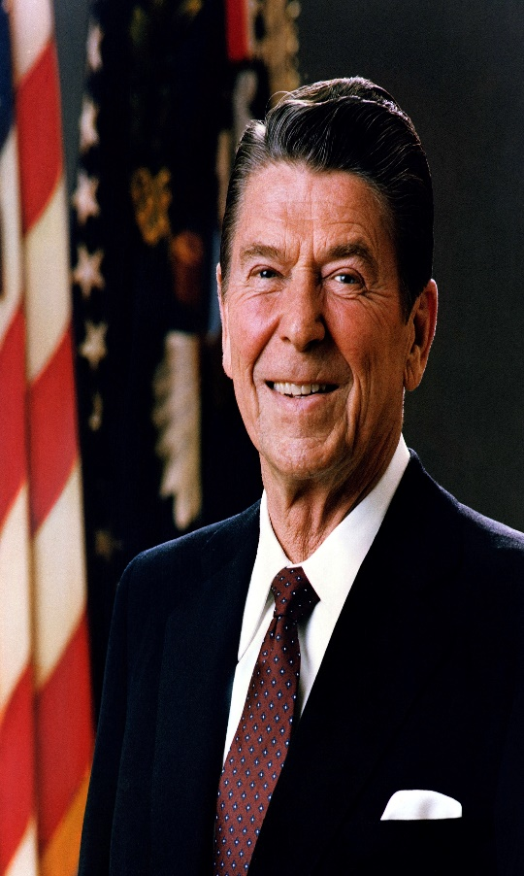
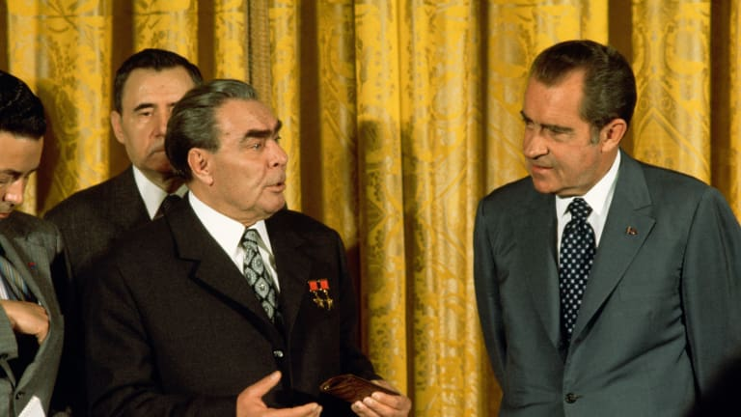
Upload all work onto ClassCharts for feedback.
Contents
Page 3: Big Picture - Year 9 Overview
Page 4: Zoom in - My Learning Journey
Page 5 and 6: Knowledge Organiser Questions
Page 7: Lesson One
Page 11: Lesson Two
Page 15: Lesson Three
Page 19: Lesson Four
Page 23: Lesson Five
Page 26: Lesson Six

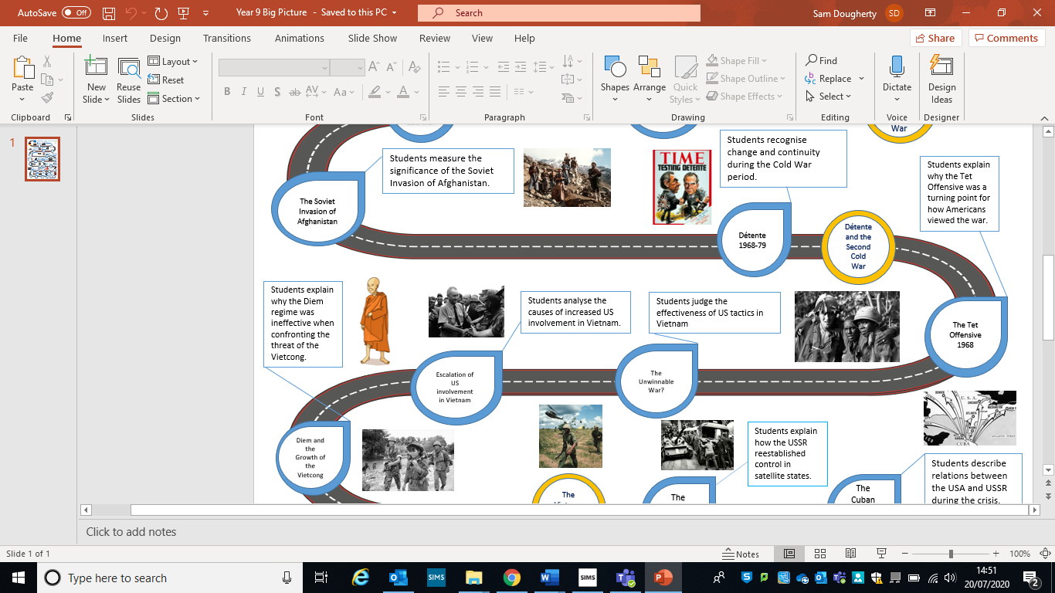
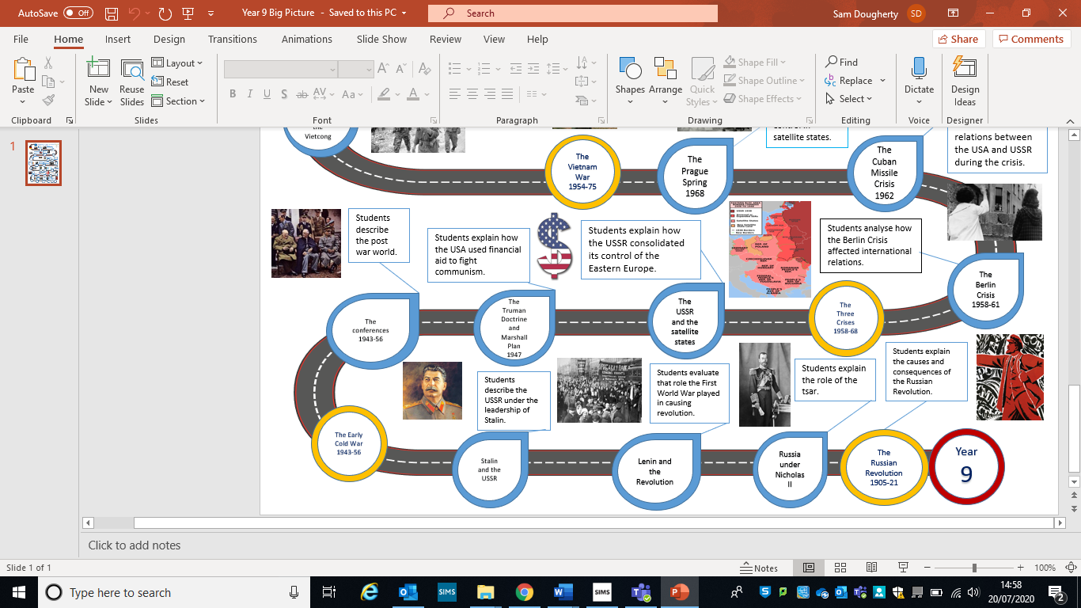
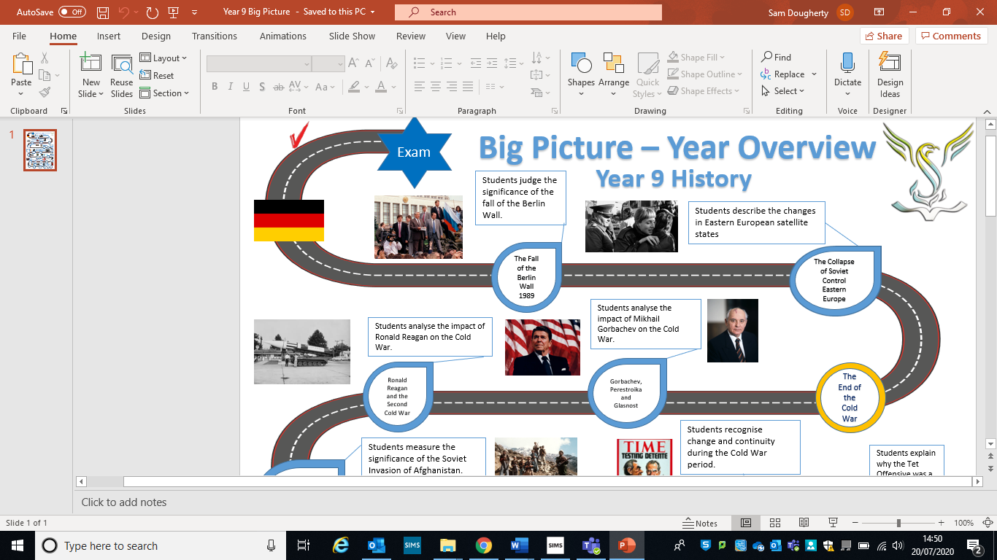

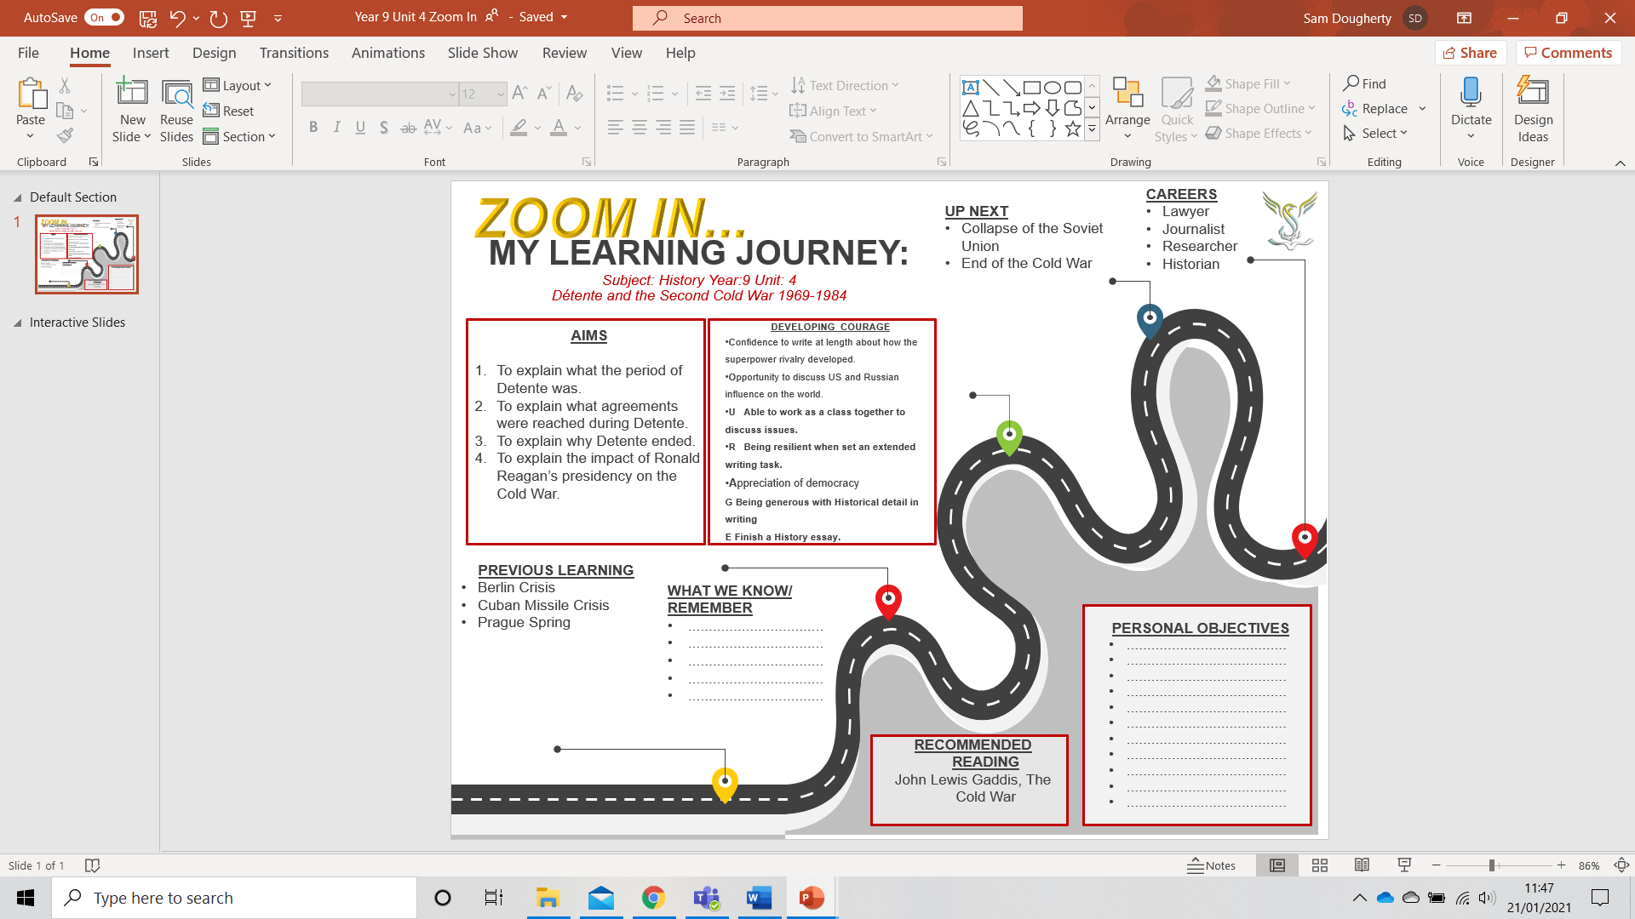
The beginning of Détente and SALT 1 | The Helsinki Accords and SALT 2 | The end of Détente – Soviet invasion of Afghanistan and Ronald Reagan
The Cuban Missile Crisis had shown that even if the leaders did not want war, things could get out of hand very quickly. This led o both following a policy of Détente.  What was Détente? | What were the three main baskets of the Helsinki Accords?  1.  2.  3. | What was the cause of the Soviet Invasion of Afghanistan?
Why did the USA want to follow a policy of Détente? | What were the success and failures of the Helsinki Accords? | What was the American reaction to the Soviet invasion of Afghanistan?  Include the Olympic Boycotts.
Why did the Soviet Union want to follow a policy of Détente? | What were the agreements laid out in SALT II?
What agreements were reached through SALT 1? | What were the agreements laid out in SALT II? | What was Ronald Reagans view on the Soviet Union and communism?
What were the strengths and weaknesses of SALT 1? | Why did Détente come to an end? | What was SDI and why was it a threat to the Soviet Union?

Lesson One – The beginning of Détente and SALT 1
L/I: To understand what Détente meant during the Cold War.

Task One – Read through the DART below and then complete the Question at the end:
Détente
The Cuban Missile Crisis had shown that even if the leaders did not want war, things could get out of hand very quickly. This led to a genuine attempt to have a more co-operative and stable relationship. The policy has generally been referred to as Détente.

Apart from the desire to avoid plunging the world into nuclear war, both the USA and the Soviet Union had internal reasons for improving relations in the late 1960’s and 1970’s.

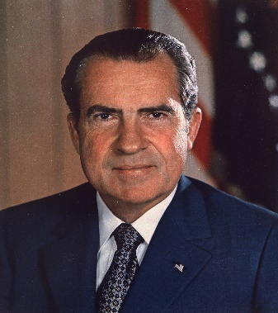
The USA:
Richard Nixon was elected president in 1968, he was determined to take his country out of the Vietnam War, which had cost the USA billions of dollars and resulted in the deaths of almost 60,000 American soldiers.

There had also been large scale demonstrations against the war in the USA (which sometimes ended in violence) and many Americans thought the USA should take a less active role in international affairs. E.g., stop trying to contain communism and rival the Soviet Union. On top of this, the USA also had a lot of inequality between rich and poor and white and black people. Spending less money on creating nuclear weapons to fight the Soviets, meant they would have more money to spend on fixing these inequalities.

The Soviet Union:
The Soviet Union was facing economic problems and wanted to cut spending on nuclear weapons and devote more money to improving living standards.
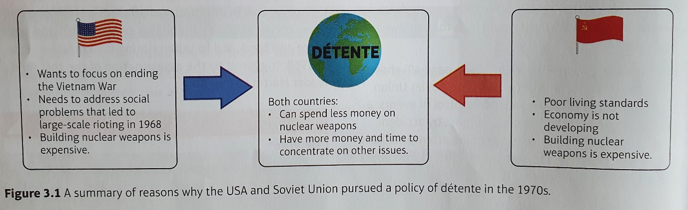
For the Soviet Union, spending less money on nuclear weapons and improving relations with the USA was a very safe policy, that they wanted to follow.

Q. Explain in your own words why it was so important for the world, the USA, and the Soviet Union, to follow a policy of Détente.

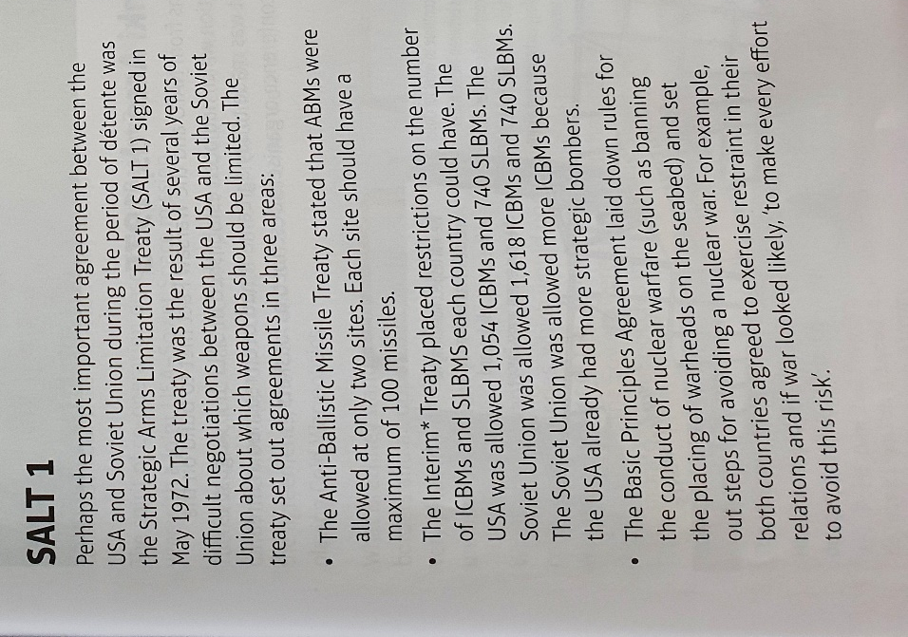
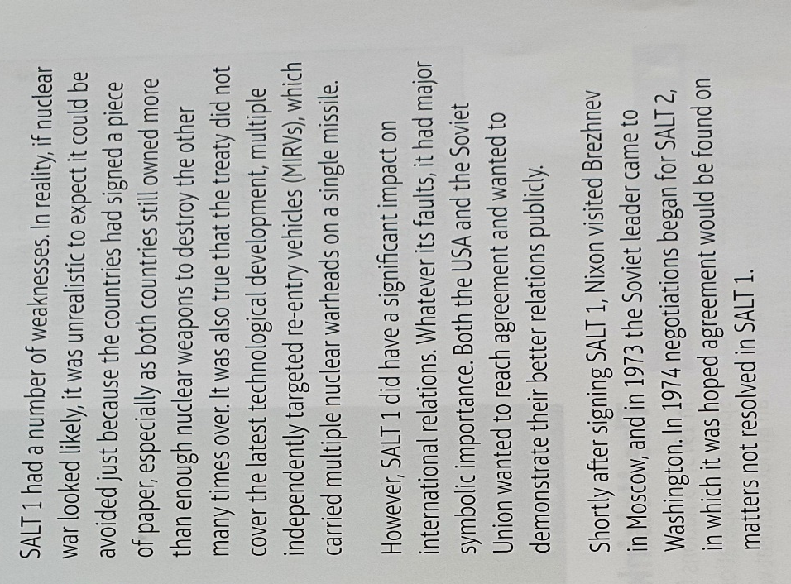
Task Two – Use the information below, watch the video and highlight the answers to the questions below - https://www.youtube.com/watch?v=ZsdKQ-Nbp4Q
- What does SALT 1 stand for?

- What were the three main agreements reached?

- What were the weaknesses of SALT 1?

- What was the positive of SALT 1?

- What took place after signing SALT 1?

Main Task - Pick one of the following statements and prepare a short talk (no more than 30 seconds – 1 minute) in support of the statement:
- SALT 1 was an important move towards world peace.
- SALT 1 had too many weaknesses to be considered an important agreement.

Lesson Two – The Helsinki Accords and SALT 2
L/I: To reflect on the period of Détente, including its successes and failures.
Starter – Use the previous lessons notes to complete the column of your Knowledge Organiser on Page 5 titled the beginning of Détente and SALT 1

Task One – Read through the DART below and complete the questions below.
The Helsinki Accords, 1975 DART
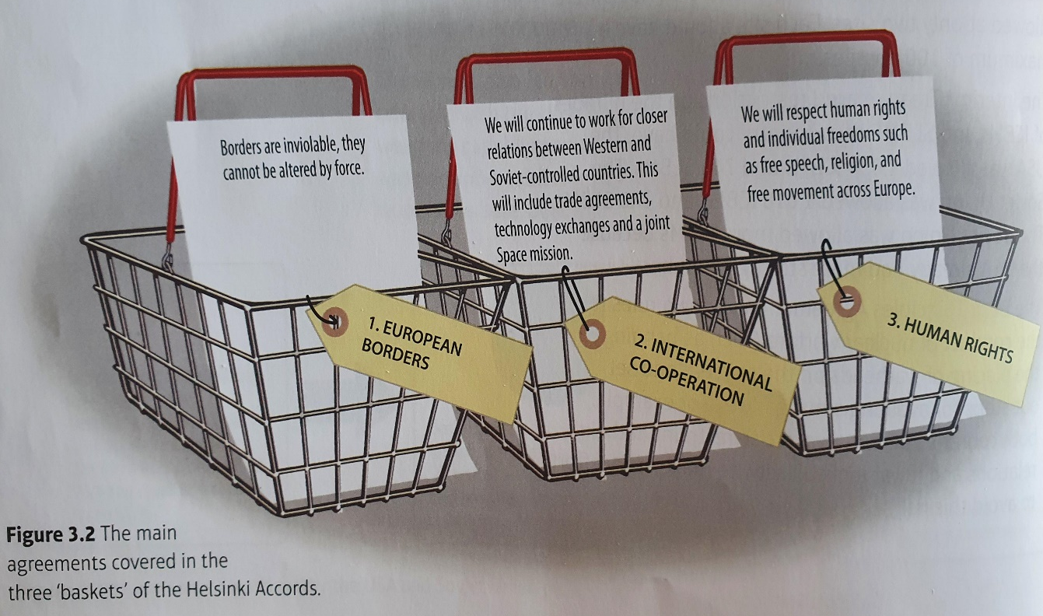
In 1973, 33 nations from NATO and the Warsaw Pact met to build on the spirit of co-operation which had been established in SALT 1. In August 1975, an announcement was made to say agreements had been reached in three areas, which the conference organisers described as ‘baskets’.
Basket 1 was very signifigant as this was the first time that boundaries between East and West Germany and the existing boundaries of the Soviet-controlled countreis were formally accepted.

The spirit of co-operation described n Basket 2 was followed up that same year with a joint USA-Soviet space mission. You can see more of this on the video below:
https://www.youtube.com/watch?v=hM25uYAQWeo

Helsinki was the high point of Détente. It seemed to mark the dawn of a new approach to international relations. However, not everything was friendly between the two superpowers. Brezhnev liked the agreements of Baskets 1 and 2, as it gave him exactly what he wanted. E.g. border secruity and trade which meant a boost to the Soviet economy. However, many American politicians didn’t like how much Brezhnev and the Soviets were getting from this deal.
The USA desperately wanted an extension of human rights into Soviet-controlled territories, which could undermine communist authority and weaken the power of the Soviet Union. So, while the Americans were pleased with Basket 3, the Soviets were concerned that organsiations would be set up to monitor Soviet policies in satellite states.

- Why can the Helsinki Accords be seen as the high point of Détente? Explain the positives that came from the Helsinki Accords, for the two countries.

- Explain why the Helsinki Accords did not completely heal the relations between the two countries. Explain what both countries were unhappy with.

Task Two – Read the information below and answer the three questions
- What is the main issue that affected relations between the Soviet Union and the USA after the Helsinki Accords?

Look at the graph.
- What positive occurred with missiles and nuclear warheads from 1972-1974.

- What negative occurred with missiles and nuclear warheads from 1976-1980.

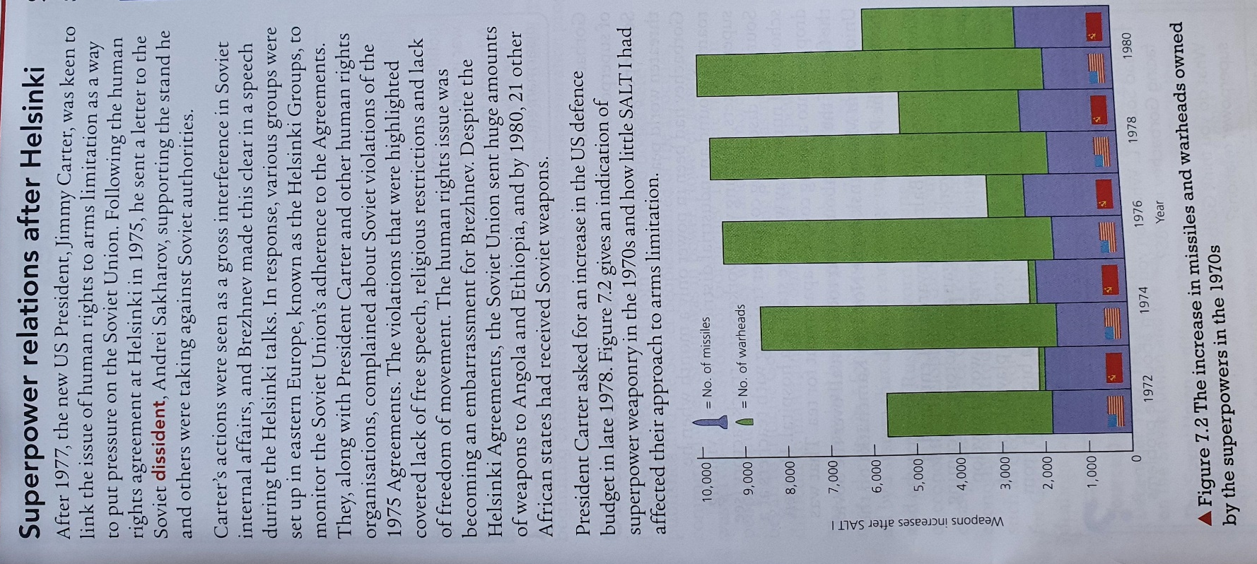

Read through the information below:
Worsening Relations
SALT II
A new SALT agreement began in 1974 and the treaty was signed in June 1979. This became known as SALT II. The agreements are outlined below:
- A limit of 2400 strategic nuclear delivery vehicles for each side. E.g., Submarine Lunched Ballistic Missiles (SLBM) and heavy bombers. Things to deliver the missiles to their target.
- A 1320 limit on MRV systems for each side. These were systems that could shoot down incoming nuclear missiles.
- Limits on deployment of new types of strategic offensive weapons.
However, the SALT II agreement failed to begin. On top of this, the improved relations between the Soviet Union and the USA through the 1970’s, were beginning to fade.
- In the USA, there was a growing believe that the Soviets could not be trusted and therefore any agreement made with the Soviet Union would be seen by some Americans as a sign of weakness.
- Many Americans wanted to return to the top of the world stage and therefore wanted a strong er stance against the Soviet Union.
- Finally, in December 1979, the Soviet Union invaded Afghanistan, which brought Détente to an end.

Main Task:
Reflect back on the period of Détente over the 1970’s, which you have studied over the last two lessons.
Look at both the successes and failure of Détente and weigh up if it was more of a success than a failure and explain why.

Lesson Three – The Soviet Invasion of Afghanistan 1979
L/I: To measure the significance of the Soviet Invasion of Afghanistan.

Starter - Starter – Use the previous lessons notes to complete the column of your Knowledge Organiser on Page 5 titled The Helsinki Accords and SALT 2

Read through the information below:
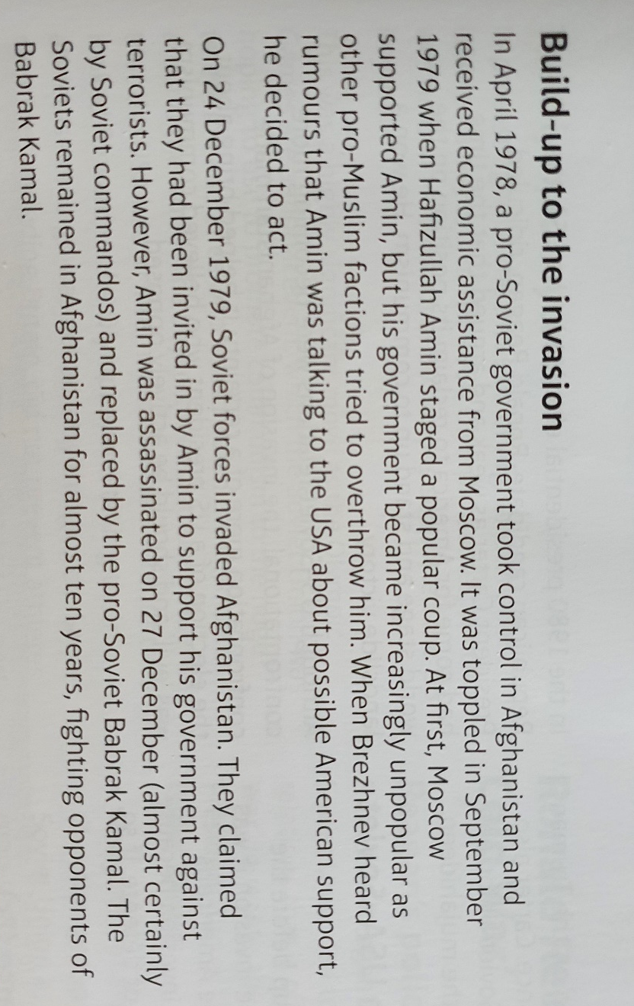
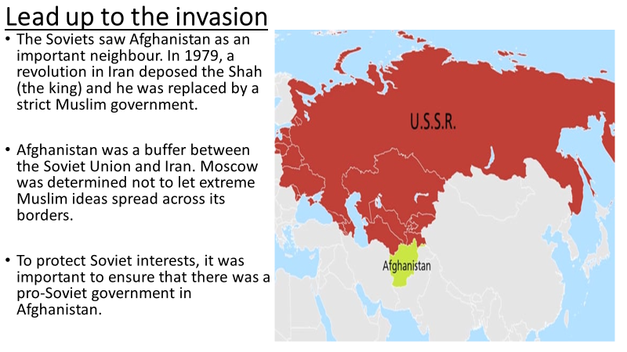

Task One – Use the information above to create a timeline of the following dates:

April 1978

September 1979

24th December 1979

27th December 1979.

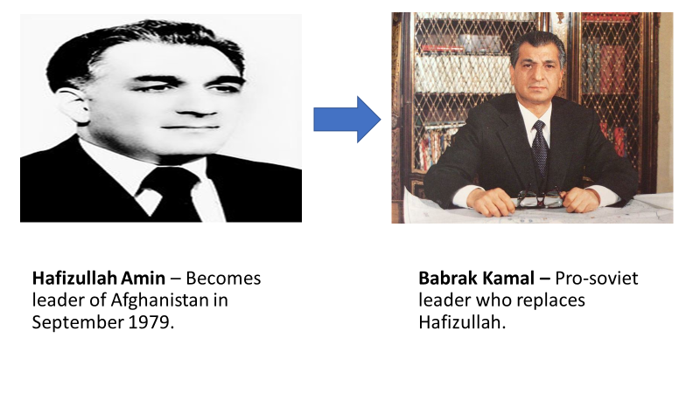

Read through the information below and watch the video:
The Mujahideen
- The Muslim fighters that fought against the Soviets and Babrak Kamal were known as the Mujahideen.
- The USA supplied the Mujahideen with weapons and billions of dollars and for the Soviets, the cost of the war was $8 billion a year (ended in 1989) and 15,000 Soviet troops.
https://www.youtube.com/watch?v=-8ZFf7Fufok

The end of Détente and consequences of the invasion DART
The Americans saw the Soviets as trying to spread communism abroad, which they did not like. President Carter went as far to say that the invasion was the biggest threat to world peace, since the end of the Second World War. President Jimmy Carter cancelled SALT 2 and increased spending on arms. He also promised that he would repel by force, if necessary, any threat to American interests in the Persian Gulf. This became known as the Carter Doctrine.

Détente was already close to breaking up before the invasion. After the invasion, it was finished. In the 1980 the presidential election in the USA, Ronald Reagan ridiculed the President at the time of the invasion, Jimmy Carter, for looking weak and argued that the time had come to reclaim its top position on the world stage and stand up to communism. Reagan won in a landslide victory.

The Olympic Boycotts 1980/1984:
In protest the invasion of Afghanistan, the USA led a boycott of the 1980 Olympic Games, which was held in Moscow. Over 60 nations supported the US boycott.
- Olympic Games are a global event which the Soviet Union was hoping to promote communism to the huge television audience.
- The boycott reflected the influence that the USA had in international affairs.
- The boycott was successful because the Moscow Games looked second-class, with star athletes not featuring.
- Soviet Union was extremely angry about this, they felt undermined and relations with the USA deteriorated even further.
- Soviet Union reacted by trying to boycott the USA’s Olympics in Los Angeles in 1984 and Soviet Union led a boycott of the games which was joined by 15 communist countries.
Main Task - Write a narrative account of the Soviet Invasion of Afghanistan:

A narrative account needs three paragraphs and must explain the beginning, middle and end of an event. E.g., Causes, Event, Consequences:

Paragraph One – Beginning – What caused the Soviets to invade Afghanistan?
Paragraph Two – Middle – What did the Soviets do in Afghanistan and who fought against them?
Paragraph Three – End – What were the consequences of the invasion?

Lesson Four – Ronald Reagan and the ‘Second Cold War’
L/I: To analyse how the superpower relationship changed in the late Cold War.

Task One – Use the points below, to explain Reagan’s attitude towards the Soviet Union, when he became President. Try to include information from all three bullet points below!
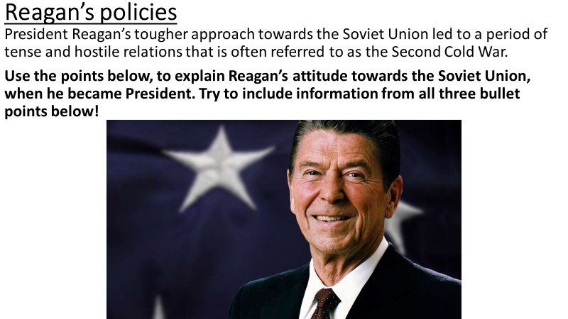

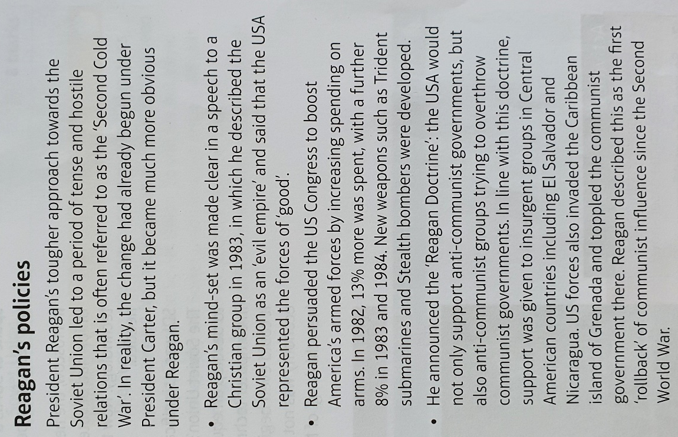

Read through the information below – Crisis point for Soviet leadership and their economy:
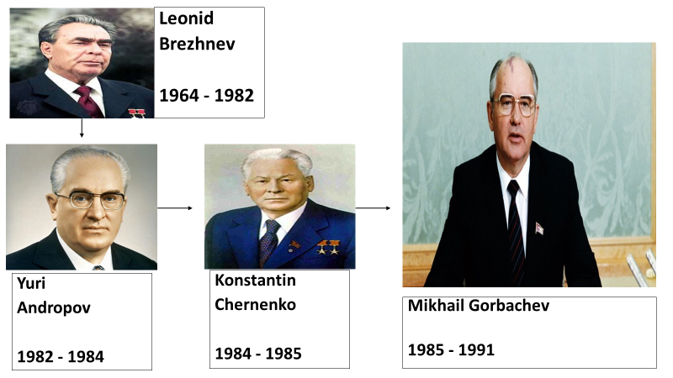
Regan was a strong new President for the USA, who was completely against communism and the Soviet Union. However, in the Soviet Union, leadership was a huge problem. You can see from the diagram below, until Gorbachev became leader of the Soviet Union, leaders kept dying very quickly!

- President Reagan knew that the Soviet economy was struggling, largely due to the Soviet invasion of Afghanistan.
- He knew that if he increased spending and support for anti-communists, he could create real difficulties for the Soviet Union.
- The Soviet Union would need to find extra funding, that it did not have, to properly counter the USA. The Soviet economy was just too weak to compete.

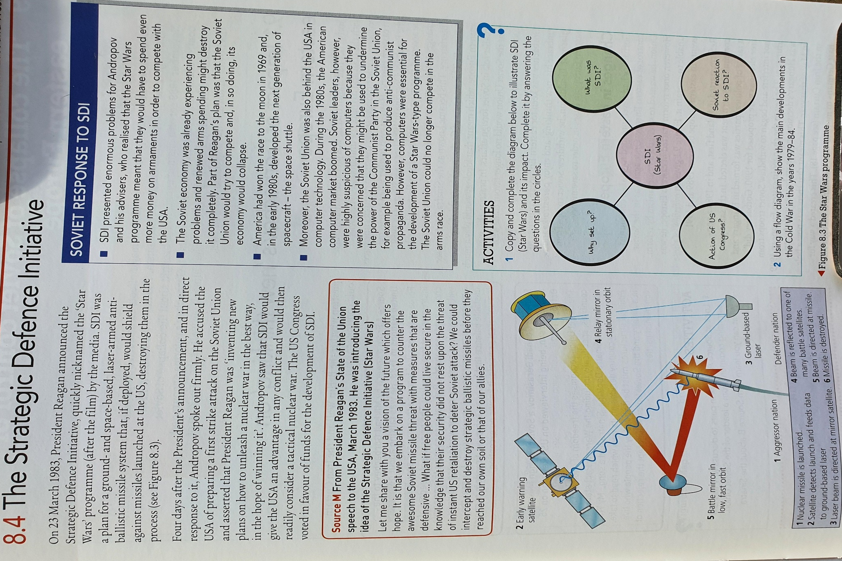
Task Two – Read through the information, watch the video and then answer the questions below

https://www.youtube.com/watch?v=sMfmVzHZvkc

The Strategic defence Initiative:
- Why was SDI set up?

- What was SDI?

- What was the Soviet reaction to SDI?

Main Task – Explain in your own words below, how Reagan was being aggressive towards the Soviet Union.
Consider the following in your answer:
- What Reagan said about the Soviet Union.
- SDI
- Reagan’s support for anti-communists

Lesson Five - Year 9 History Assessment One – Question One
L/I: To complete two GCSE style questions

Starter – Use the previous lessons notes to complete the column of your Knowledge Organiser on Page 5 titled the end of Détente – Soviet invasion of Afghanistan and Ronald Reagan

Use Lesson Three to help you with Q1.
Q1. Explain two consequences of the Soviet Invasion of Afghanistan
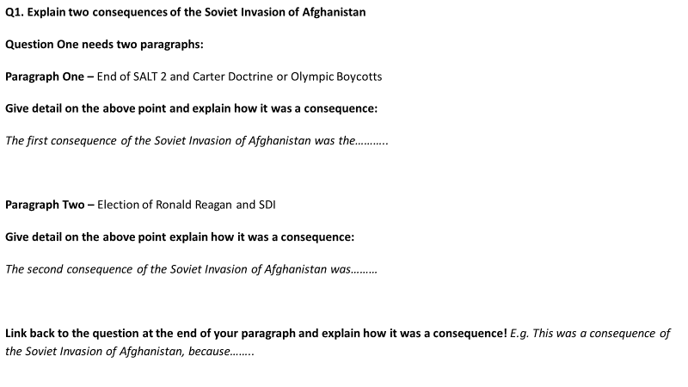

Question One - Consequence question mark scheme
Consequence One
Level 1 | 1-2 | Simple comment on a consequence.  Limited knowledge of the period.
Level 2 | 3-4 | Features of the period are explained to explain a consequence.  Good understanding of the period.

Consequence Two
Level 1 | 1-2 | Simple comment on a consequence.  Limited knowledge of the period.
Level 2 | 3-4 | Features of the period are explained to explain a consequence.  Good understanding of the period.

Lesson Six - Year 9 History Assessment One – Question Two
L/I: To complete two GCSE style questions
Use Lesson One and Two to help you with Q2.
Q2. Write narrative account of the period of Détente.
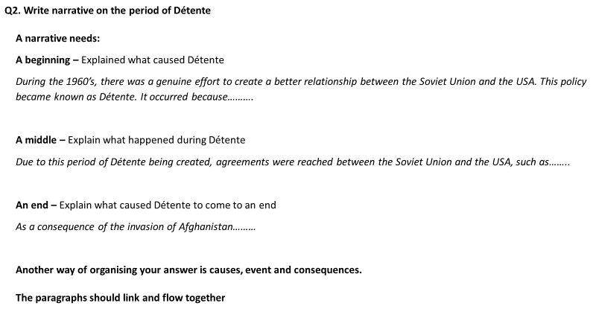

Question Two - Narrative Account question mark scheme
Level 1 | 1-2 | General comment about the event.  Limited analysis or organisation.
Level 2 | 3-5 | Narrative given showing organisation of events.  Some linkage between them.  Some knowledge of and understanding of events.
Level 3 | 6-8 | Narrative is organised into a clear sequence of events.  Analysis of links between the events.  Good knowledge of events.

