Geography Year 9
Blended Learning Booklet

Y9-3 Urban Issues and Challenges

Name:
Form:
Teacher Initials:
- Aim to complete follow your existing timetable of lessons (4 lessons over 2 weeks)
- Write down the title and LI for each lesson and then complete the tasks.
- Upload all work onto ClassCharts for feedback.
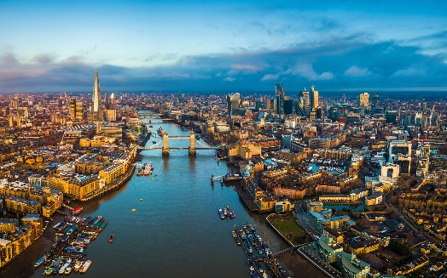
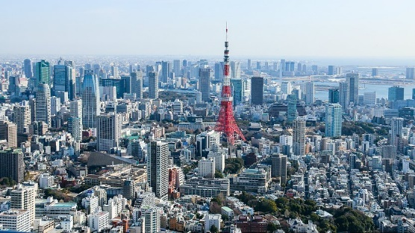
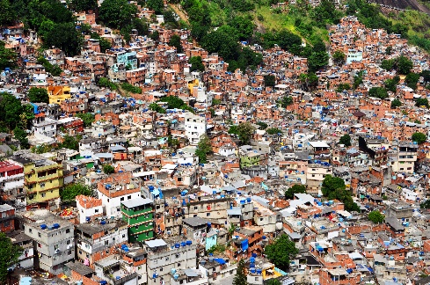
Contents
P.2: Year 9 Overview
P.3: Zoom In
P.4: Urban theory KO
P.5: Rio (NEE case study) KO
-
P.6 & 7: Lesson 1
P.8 & 9: Lesson 2
P.9 & 10: Lesson 3
P.11 & 12: Lesson 4
P.13: Lesson 5
P.14: Lesson 6
P.15: Lesson 7
P.16: Past Paper Questions

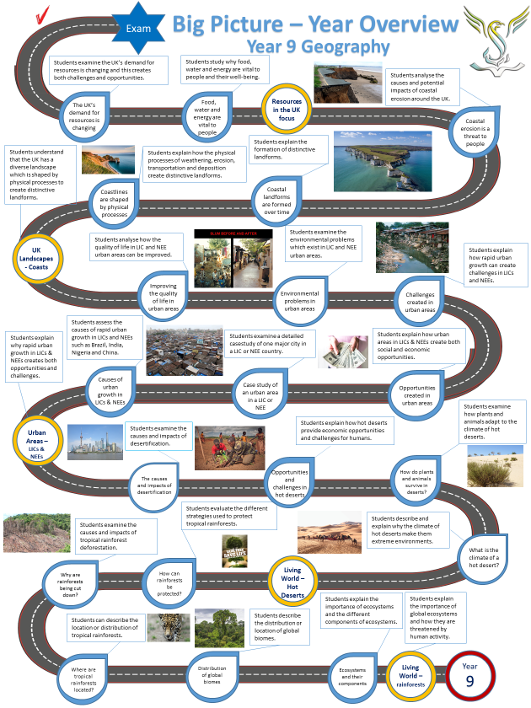

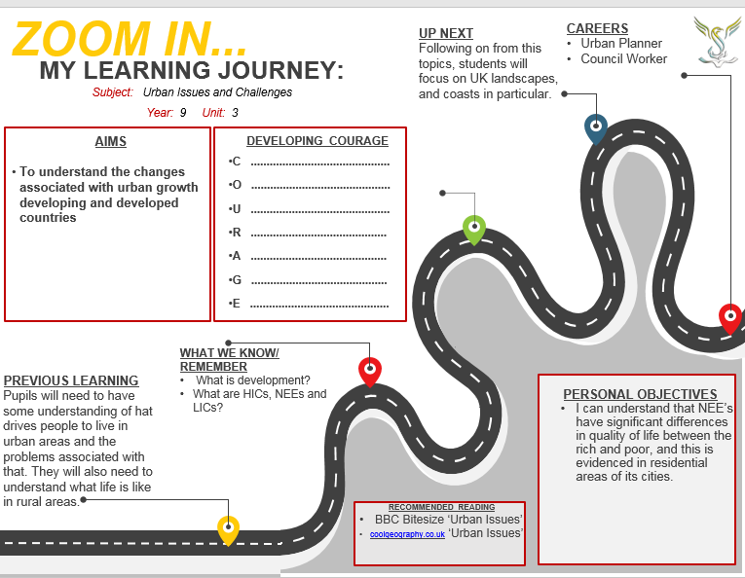

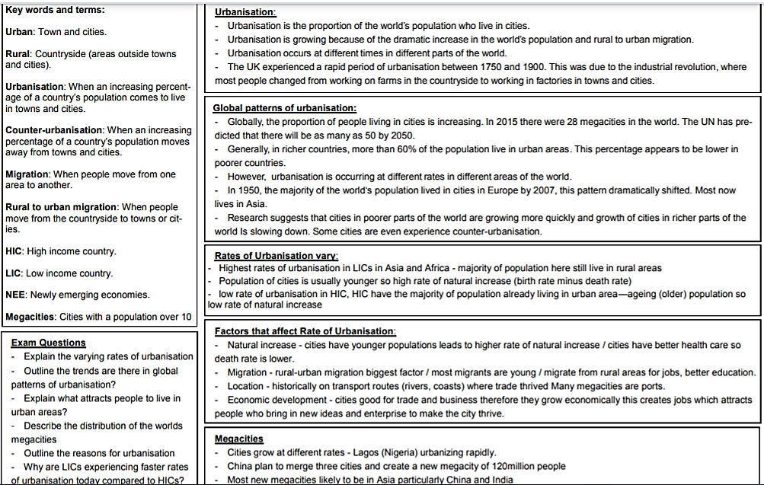
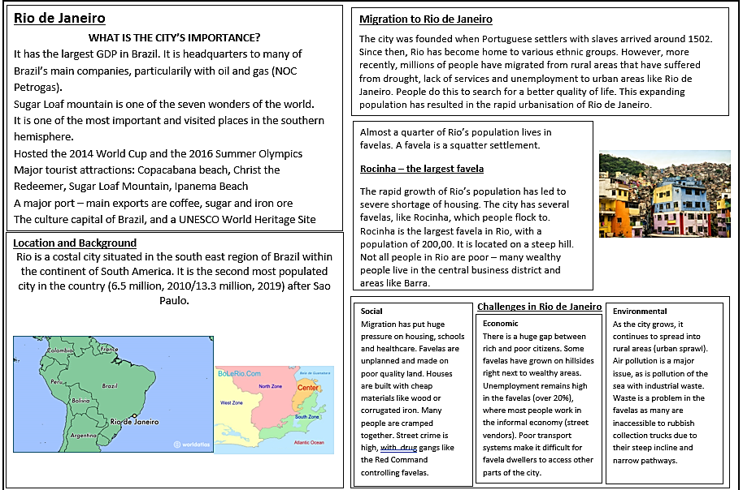


Lesson 1 – Changing urban areas in LICs/NEEs
LI: To understand the global pattern of urban change
Task 1: Read through the key terms. Practice covering the terms to check what you can recall
HIC: High Income Country
LIC: Low Income Country
NEE: Newly Emerging Economy
Rural: countryside
Urban: cities and towns
Migration: movement of people from one place to another
Natural Increase: when the birth rate is higher than the death rate
Urbanisation: increase in the number of people living in urban areas

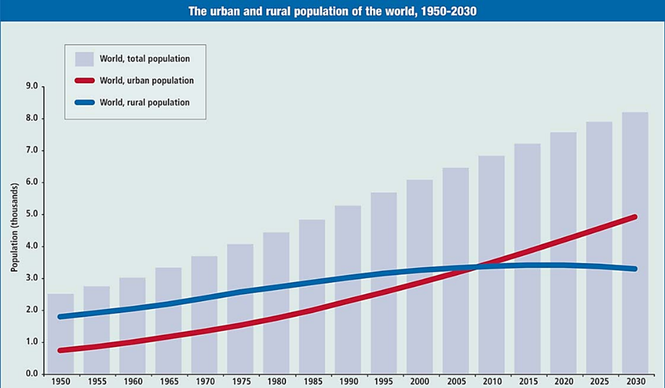
Task 2: Describe the patterns of urban change shown on Figure 1
Figure 1 Urban and rural population change

Task 3: Read through the different rates of urban change
Newly Emerging Economies & Low Income Countries
- Fastest rates of urbanisation
- Economic development is increasing rapidly
- The percentage of population living in urban areas varies
- NEEs tend to have very high urban densities
- Due to informal housing
High Income Countries
- Slowest rates
- Urbanisation has already happened
- People now move out of cities for a better quality of life
- In some regions there is still overcrowding, and conditions are poor

Question: Compare the rate of urbanisation in HICs and LICs.
Lesson 2 – Urbanisation in LICs/NEEs
LI: To understand the push and pull factors which affect the rate of urbanisation in LICs/NEES
Task 1: Complete gap fill to recap patterns of urban change
As a country ________________, the number of people living in urban areas tends to _______________. The UK and many other HICs urbanised during the 18th and 19th _______________. People migrated from rural areas (due to the mechanisation in _______________) to ______________ areas where there was employment in the new _______________ and rows of terraced housing were built for these workers. Today the UK is a mostly urban society, with ________ of the population living in towns or cities. Prior to 1950 the majority of urbanisation occurred in _____________. Rapid urbanisation took place during the period of _________________ that took place in Europe and North America in the nineteenth and early twentieth centuries. Many people moved from rural to urban areas to get jobs in the rapidly ________________ industries in many large towns and cities. Since 1950 _______________ has slowed in most HICs, and now some of the biggest cities are losing population as people move away from the city to rural ________________. Since 1950 the most ___________ growth in urbanisation has occurred in LICs in South America, ____________ and Asia. Between 1950 and 1990 the urban population living in LICs ____________. In ____________ countries the increase was less than half.
doubled increase Africa expanding farming
rapid urbanisation industrialises 90% HICs urban
industrialisation environments developed centuries factories

Task 2: Factors causing urbanisation
- Migration affects the rate of urbanisation, and push-pull theory helps to explain this. For each of the factors below, say whether it is push or pull, and explain how it causes migration.
A push factor is something that encourages someone to leave an area; a pull factor is something that encourages someone to move to an area
Factor | Push or Pull? | How does it cause migration?
Natural disasters
Mechanisation of farming
Family living abroad
Better job opportunities
Desertification
Improved quality of life
Better health care and education
Conflict or war
- Natural increase also causes urbanisation. This is when there are more births than deaths and so the greater the difference the faster the population grows. Younger people often move to cities and then have children – causing urban populations to increase.
Task 3: Complete the exam question below
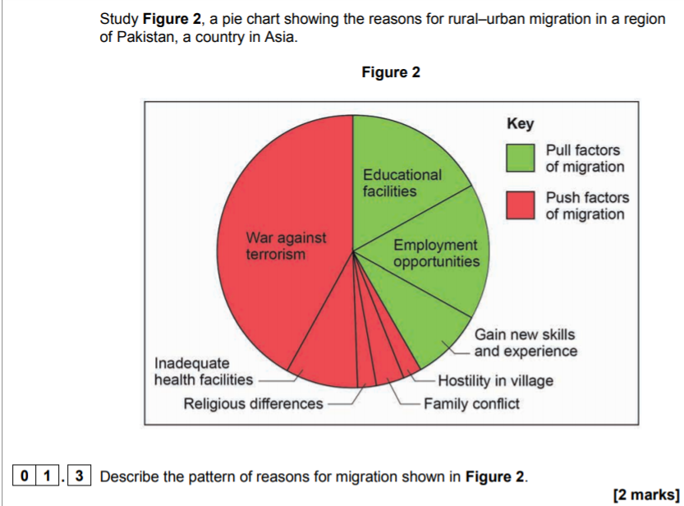

Lesson 3 – What are Megacities?
LI: To examine the rise of global ‘megacities’ and what problems they face?
Today more than 50% of the world's population live in urban areas. The number of cities with over 10 million people is increasing. These are called megacities. There are now 34 megacities in the world.
Task 1: With reference to Figure 2, suggest reasons for the locations of future megacities
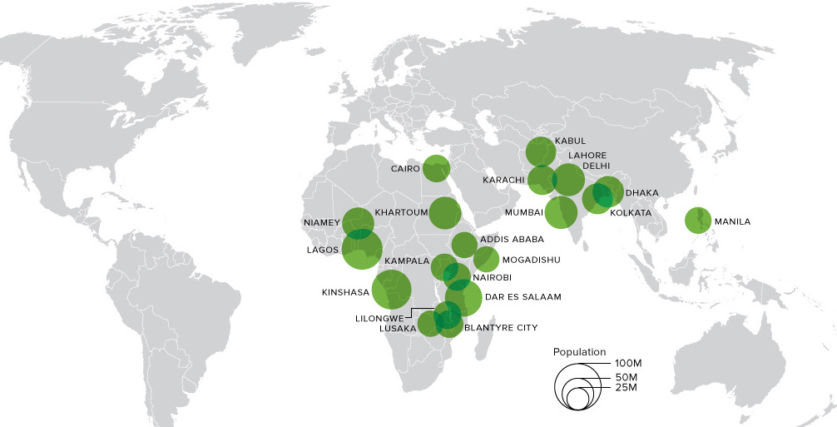
Figure 2 Most populous cities by 2100

Task 2: Read through the DART and answer the questions
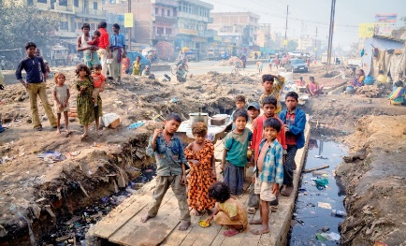
DART: The growth of Asia’s cities
The two faces of Asia’s megacities – extreme poverty and extreme wealth
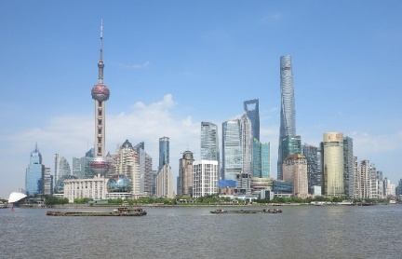
Asians are on the move. Hundreds of millions of people across Asia are migrating from rural areas and moving into cities. Asia’s megacities (a city with a population of 10 million or more) have already reached a scale that is unimaginable in the Europe and North America.
The pace of Asia’s urban population growth is breath-taking. The United Nations estimates that well over half of Asia’s 4.5 billion residents will live in cities by 2026. Some will move to megacities – Asia will be home to 60% of all of them by 2025. While the spectacular expansion of megacities such as Tokyo (Japan), New Delhi (India), Shanghai (China) and Dhaka (Bangladesh) is mesmerizing. Collectively, Asian cities experience nearly one million new arrivals every single week.
For the most part, Asia's spectacular city growth has been good for its residents and creates opportunities. Many larger cities offer a wider choice of jobs, higher wages and more chances to enjoy social activities. With some exceptions, the overall quality of life for many Asian city dwellers is improving.
Even so, city growth in NEEs like China and India creates challenges with traffic congestion, unemployment and slums emerging as critical problems for many Asian cities. Large pockets of poverty and educational inequalities exist. Many people are stuck in a ‘cycle of poverty’, they are born into poor families, they often do not receive a good enough education to get well-paid jobs and remain ‘stuck’ in poverty throughout their lives.
Even in Asia’s most developed HICs like South Korea and Japan, city planners simply cannot afford to ignore problems such as a lack of affordable housing, inadequate water and sewage provision, rising air pollution, crime and loneliness. Dealing with these challenges will be vital to the health and success of all megacities over the next 100 years. Large scale improvements such as new sewage systems and improving the environment in cities will take careful planning, lots of money and for leaders to agree.
India’s megacities also suffer from notoriously poor urban planning and decaying infrastructure, including poor roads, a lack of water and appalling levels of pollution. Mumbai recently used new laws to increase the stock of affordable housing for poorer people, while New Delhi – which faces record levels of smog – is building more public transportation and reducing diesel vehicles.
Questions
- What is a megacity?
- How many people in Asia will live in a city by 2026?
- How many people arrive in Asia’s cities each week?
- What opportunities do cities provide?
- Describe the problems and challenges found in many of Asia’s cities.
- In your own words, explain what the ‘cycle of poverty’ is.
- What solutions have the Indian cities of Mumbai and New Delhi used to partly solve their problems?

Lesson 4 – NEE/LIC Case Study (Rio de Janeiro)
LI: To examine a case study of a major city in a LIC/NEE – location and context
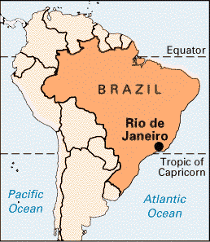
Task 1: Describe the location of Rio de Janeiro using the maps provided
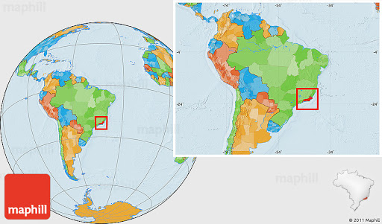

Task 2: Read through the information below about Rio de Janeiro and summarise into 10 key points about the context of the city – what makes Rio de Janeiro special and unique?
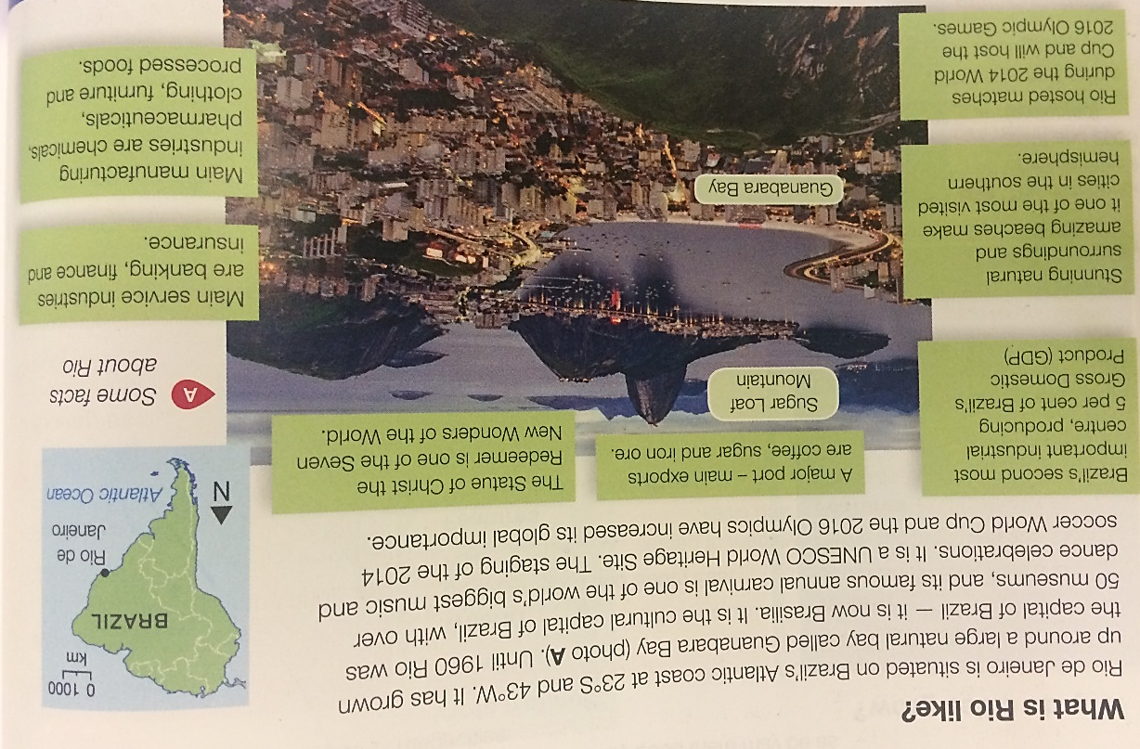

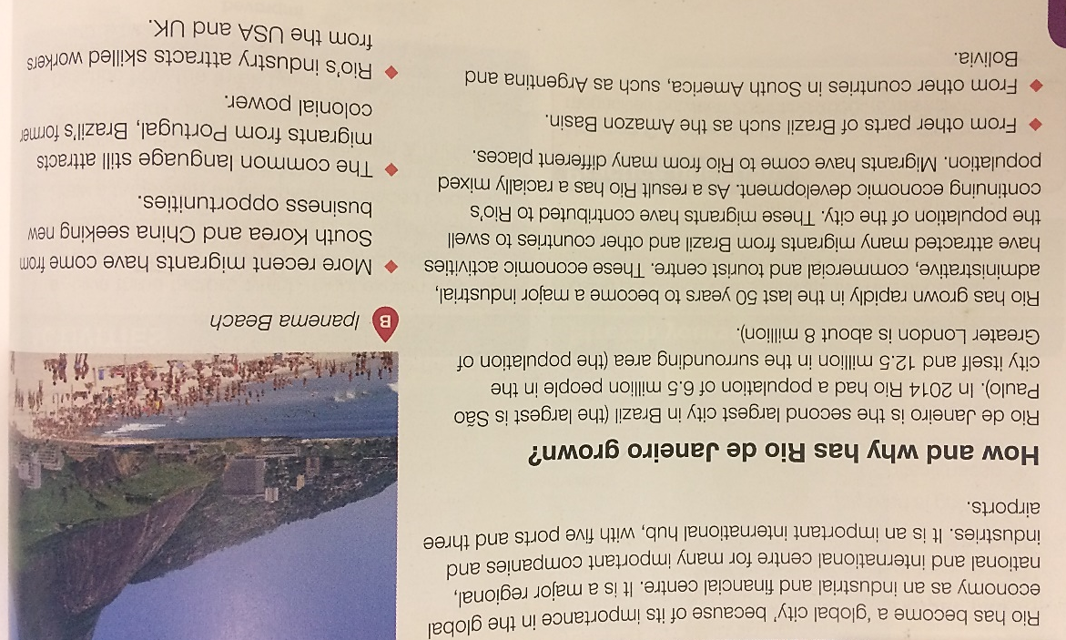

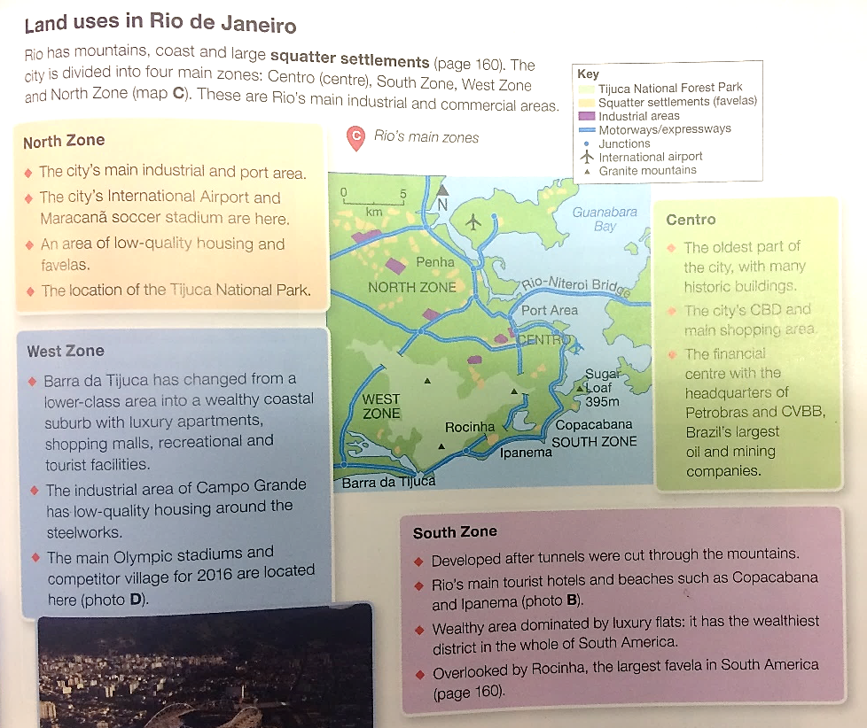

Task 3 Questions on Rio de Janeiro:
Q1) Explain why Rio de Janeiro has grown rapidly during the last 50 years.
Q2) Use the map above to describe the land use and characteristics of each of the ‘4 zones’ in Rio de Janeiro.

Lesson 5 – NEE/LIC Case Study (Rio de Janeiro)
LI: To understand the challenges facing a city in a LIC/NEE

Task 1: Watch the two videos about Rio’s favelas and the Olympics
https://www.youtube.com/watch?v=1W_zM7koJy8 (Part 1)
https://www.youtube.com/watch?v=c3BRTlHFpBU (Part 2)
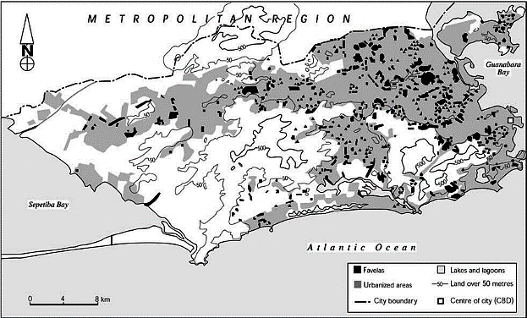

Task 2: Read through the challenges that face Rio. Sort into SOCIAL, ECONOMIC and ENVIRONMENTAL
- Life expectancy is as low as 56 years in Rio’s favelas
- An estimated 200 tons of raw sewage pour into Guanabara Bay.
- Rapid urban population growth has caused an increase in informal settlements – favelas
- Rio de Janeiro possesses high rates of violent crimes such as murder and armed robberies
- Only 50% of children continue in education after 14. Many go to work to earn money for their families
- There is a shortage of housing which has led to overcrowding
- Rio currently has around 1000 favelas
- Power cuts are frequent in rear this is because electric supplies are overloaded
- Rates of unemployment in favelas are high, while those who are working typically earn a low wage.
- The informal sector makes up around 60% of the work force in Rio
- In the first 9 months of 2017 there were around 5000 murders in Rio
- Droughts have increased the pressure on supplying freshwater as reservoirs have dried up.
- The informal sector is unregulated and unsupported by the government
- Due to poor sewage treatment there is a high risk of water-borne diseases in the favelas
- The Red Command is the largest and most violent drug gang that operates in Rio’s favelas
- Following heavy rain in 2010 one slides destroyed thousands of homes and 200 people were killed.
- Millions of people have been forced to build their own homes due to the lack of affordable housing.
- In the poorest areas, 10% of people do not have access to fresh piped water
- 50% lack proper sanitation which means human waste can follow through the streets.
- 30% of people have no electricity.
- 3.1 million tons of waste is generated in Rio every year. Most of this is taken to landfill.
Lesson 6 – NEE/LIC Case Study (Rio de Janeiro)
LI: To explore what opportunities can be found in a major city in a LIC/NEE
Task 1: Read through the opportunities found in Rio de Janeiro
Ethnic and cultural diversity - providing a huge mix of different religions, foods and customs. 51 per cent of Rio's population is white (including the largest Portuguese population outside of Lisbon), 36 per cent is multi-racial, 12 per cent is black, 1 per cent Asian, and 0.1 per cent Amerindian. Rio is an attractive location for internal and international migrants which contributes to its rich cultural diversity. This cultural mix of Rio de Janeiro also contributes to the sense of the community that is felt in the city. This is particularly strong in the favelas where they favelas demonstrate tremendous community spirit, co-operation and recycling of materials. Furthermore, Rio is famous for its annual carnival, samba schools, and sporting events. The Maracanã Stadium is one of the largest football stadiums in the world. The football World Cup was hosted there in 2014, and the Olympic Games were held there in 2016.
Rio has several universities and higher education institutions. It is the second largest centre for research and development in the country. This provides a high level of schooling for those people who have access to the schools and universities which can then lead to more job opportunities.
Rio is a major trading port, with important oil refining and ship-building industries. The main exports from Rio are crude petroleum and semi-finished iron and steel products. Headquarters of major industries are located here, including Petrobras (energy company), Vale (mining company) and Grupo Globa (telecommunications). Favelas create their own economies, and recent improvements have allowed shops and restaurants to develop.
Another big industry in Rio is tourism. It is one of the most visited cities in the southern hemisphere. Major attractions include the beaches (e.g. Copacabana and Ipanema), the statue of Christ the Redeemer (on Corcovado peak), and Sugar Loaf Mountain. These iconic and crowded beaches of Copacabana, Ipanema and Leblon face the Atlantic and are flanked by mountains in the background. This area, known as the 'Carioca' is listed as a World Heritage Site. There are also urban forests which include the Tijuca National Park and White Rock Forests are two of the largest urban forests in the world.
Task 2: Make a list or mind map of all the opportunities (keep this a brief summary – no more than 4 words each)

Opportunities of urban growth in Rio

Task 3: Answer the question: Using a named example of a city in an LIC or NEE, discuss the challenges and opportunities created by urban growth (9 marks + 3 SPG)
Lesson 7 – Urban Planning and Management (Rio de Janeiro)
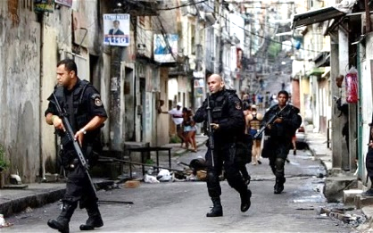
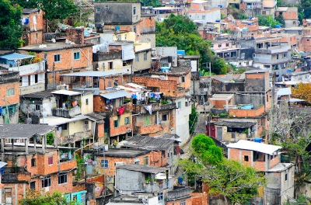
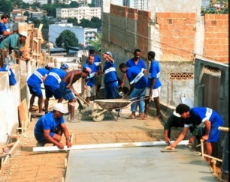
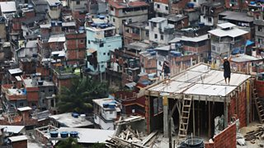
LI: To examine how urban planning can be used to improve the quality of life in a major LIC/NEE city

Task 1: Read through the DART about urban planning to improve life in Rio de Janeiro
In the 1990s, the Favela Bairro Project was set up to help improve life in the favelas and upgrade them rather than demolish them, as has happened in other locations. This work has been carried out with government funding to provide facilities like electricity, sewage systems, rubbish collection and public transport.
Self-help schemes have also been supported. Here, residents are provided with building materials like concrete blocks and cement in order to replace home-made shelters with permanent dwellings. These are often three or four storeys high, and with water, electricity and sewage systems installed. Legal rights such as granting the favela residents rights to own their own properties. Low rents have also been offered.
Transport systems have been extended to include the favelas to give residents the opportunity to travel to work in the city centre and industrial areas.
Law and order have been improved in the favelas by trying to rid these areas of crime and drug abuse. Several large favelas have been improved in this way through federal 'Pacification Programmes'.
New towns like Barra da Tijuca, built 20 kilometres along the coastline, have been built to relocate some residents from city favelas.
Task 2: Answer the questions
- When was the Favela Bairro Project set up?
- What were the aims?
- How have the favela been improved?
- Why are self-help schemes sustainable? (why will they have a lasting effect?)
- What are the benefits of improved transport systems?
- What’s the name of the law and order scheme?
- Can you remember the name of any of the favelas where it has been successful?
- Why do you think new towns have been built?

Task 3: Read through the information about Rio’s traffic management. Write down 3 reasons why traffic management is hard in Rio.
Due to its physical geography with steep slopes and mountains, Rio is one of the most congested locations in South America. This has led to high levels of air pollution and commuters spending a lot of time travelling.
The metro system is being extended to address this problem. Also, road tolls in the city centre are being introduced.
Tunnels through mountains have also been constructed to improve transport links across the city.
Past paper questions: Urban Issues and Challenges
(1, 2, 3 markers)
- Outline one way that national migration has led to change in the character of a named UK city. (2 marks)
- Explain one economic problem caused by traffic congestion. (2 marks)
- Explain how natural increase contributes to urbanisation. (3 marks)
- Describe two environmental challenges caused by urban growth in an LIC or NEE. (2 marks)
- For a UK city that you have studied, outline two ways in which migration into the city has affected its character. (2 marks)
- Explain one environmental opportunity that has resulted from urban change in a UK city that you have studied. (2 marks)
- What is meant by the term ‘urban deprivation’? (1 mark)
- Give one reason why rates of natural increase are high in many cities in LIC/NEEs. (2 marks)
(4 markers)
- Explain how an urban planning scheme in an LIC or NEE has had a positive effect on people living in the area. (4 marks)
- Using an example of a UK urban regeneration project you have studied, explain how the area has been improved. (4 marks)
- Using a named example, explain how rural-urban fringe has been affected by urban sprawl. (4 marks)
- Explain how the sustainability of urban areas can be improved through energy conservation schemes. (4 marks)
- Explain why urban growth in LICs and NEEs often leads to serious challenges for the city. (4 marks)
- Explain how regeneration can help to solve urban problems. (4 marks)

(6 & 9 markers)
- Using a case study of a city in a LIC or NEE, suggest why managing traffic congestion and air pollution may be challenging. (6 marks)
- To what extent has urban change created environmental challenges in a UK city you have studied? (9 marks)
- To what extent do urban areas in LICs or NEEs provide social and economic opportunities for people? (6 marks)
- Discuss the effects of urban sprawl on people and the environment. Use a case study of a major city in the UK. (6 marks)
- Evaluate the effectiveness of an urban transport scheme you have studied. (9 marks)
- Using a named example of a city in a LIC or NEE, discuss the challenges created by urban growth. (9 marks)
- ‘Urban change presents more challenges than opportunities.’ Using a case study of a UK city, discuss the extent to which you agree with this statement. (9 marks)
- Using your case study of a major city in the UK, assess the challenges faced because of social and economic inequalities in different parts of the city. (9 marks)
- Use a case study of a major UK city to assess the extent to which urban change has created social and economic opportunities for the city. (9 marks)

