History KS3 Year 9 Spring 1 Blended Learning Booklet
The Cold War 1958-70
Name:
Form:
Aim to complete one lesson each week. Write out the title and LI and then complete the tasks.
All video links are online using the ClassCharts link.
The Knowledge Organiser on page 3 has all the key information and vocabulary to help you with this unit.
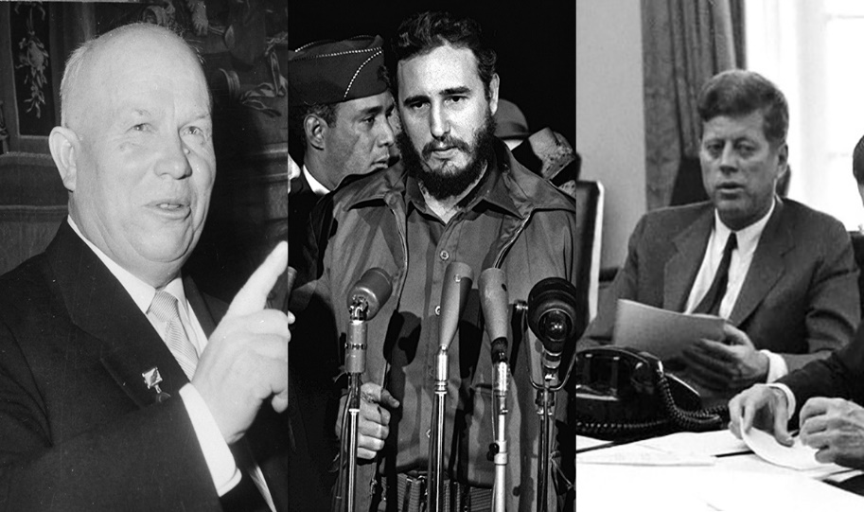
Upload all work onto ClassCharts for feedback.

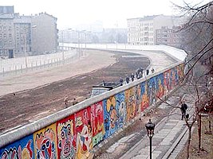

Contents
Page 3: Big Picture - Year 9 Overview
Page 4: Zoom in - My Learning Journey
Page 5 and 6: Knowledge Organiser Questions
Page 7: Lesson One
Page 12: Lesson Two
Page 15: Lesson Three
Page 18: Lesson Four
Page 22: Lesson Five
Page 25: Lesson Six

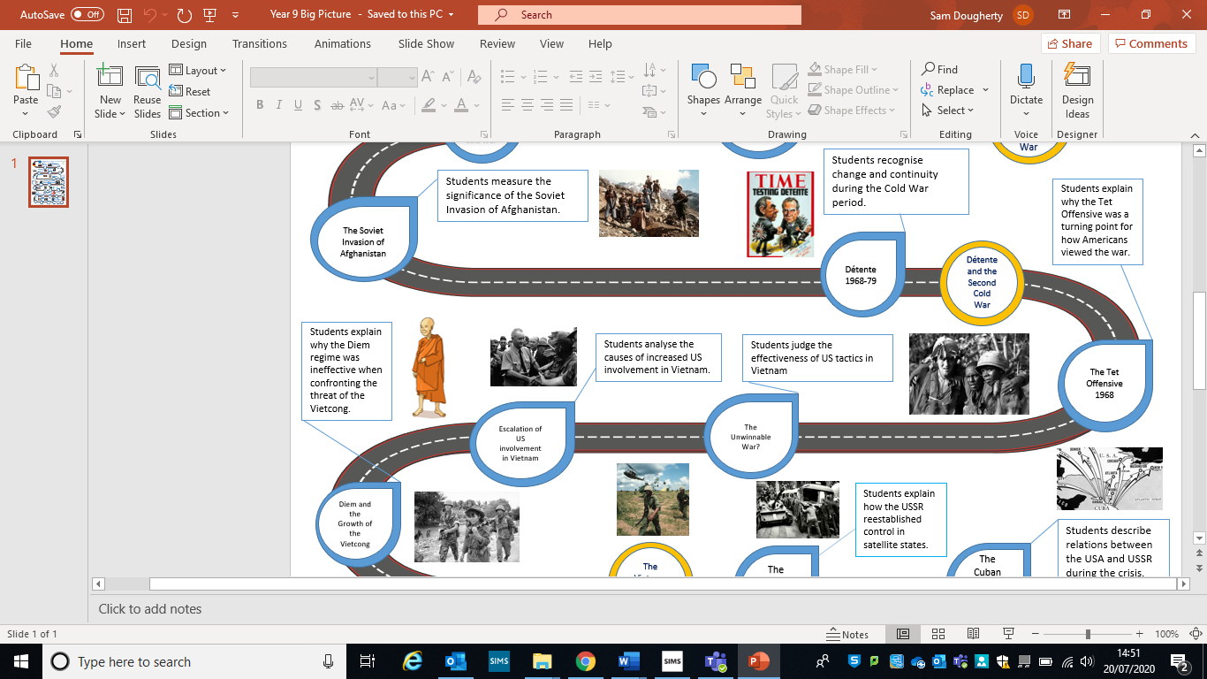
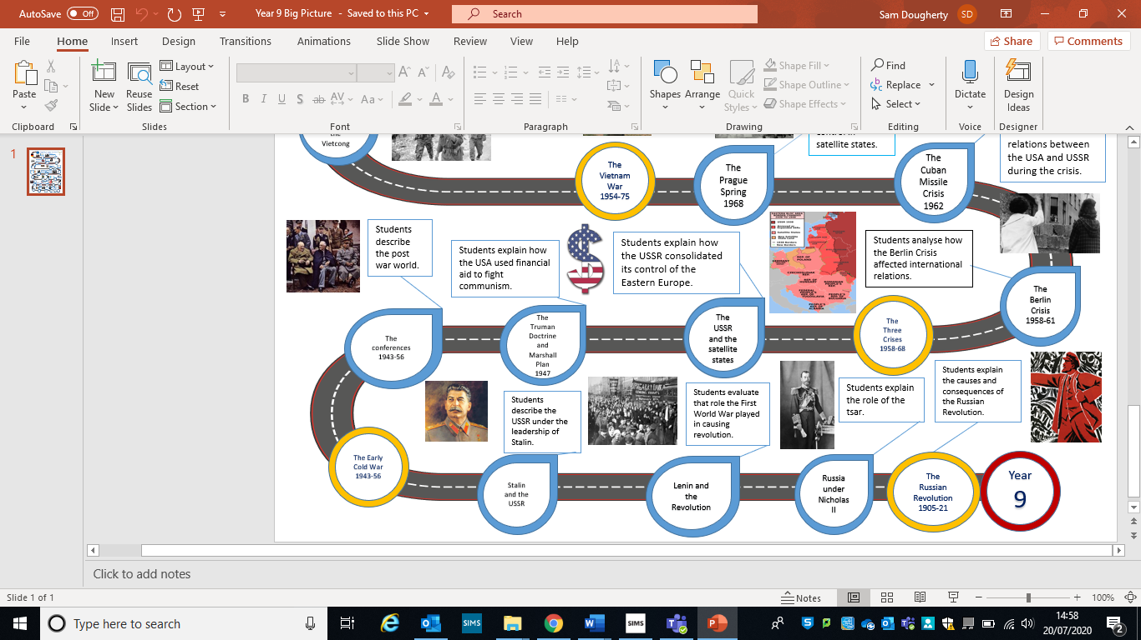
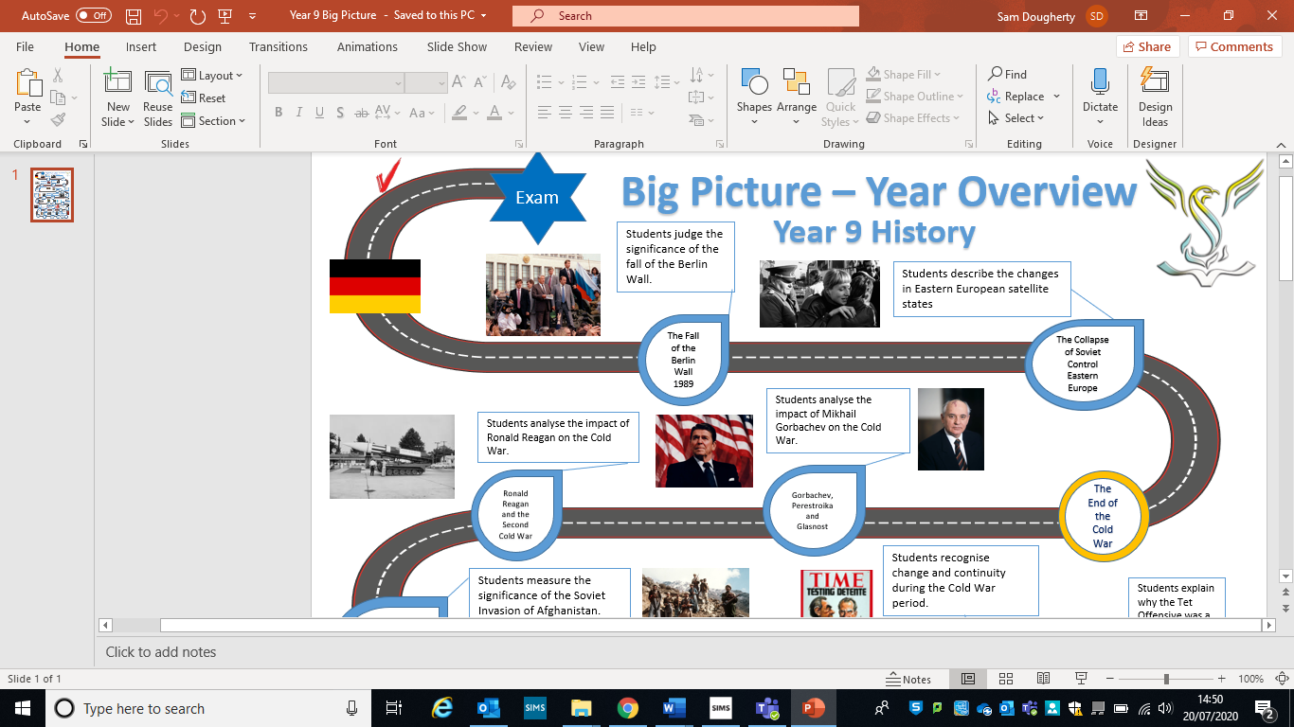
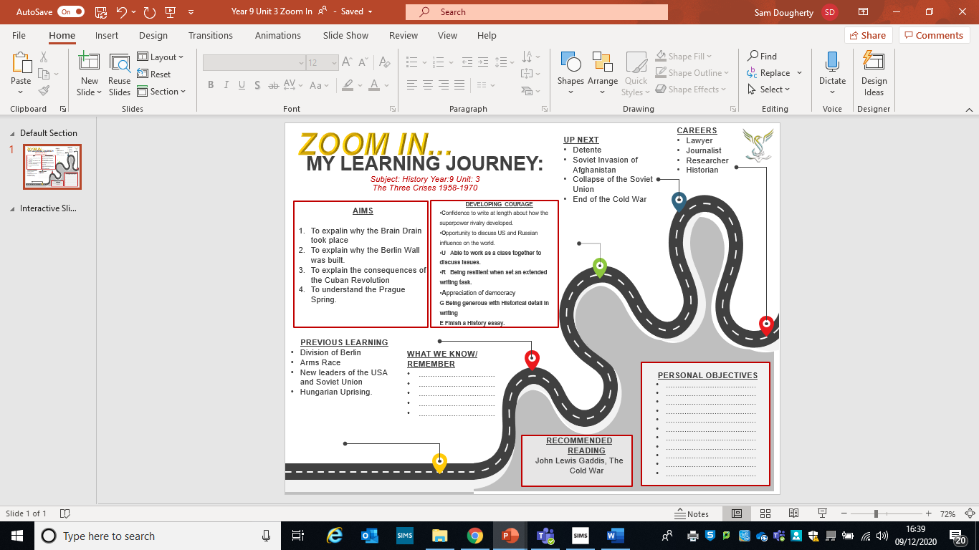
The Berlin Crisis 1958-61 | The Cuban Missile Crisis 1962 | The Prague Spring 1968
Between 1949 and 1961 2.7 million people left East Germany and moved to West Germany.  What were their reasons for leaving? | The Cuban Revolution 1959  How did Castro change Cuba when he came to power in 1959? | What were living conditions like in Czechoslovakia in 1967 under Novotny?
By 1958 Khrushchev was extremely worried about the amount of people crossing East Berlin to escape to the West. German people clearly thought that Capitalism was better than Communism. If this crisis continued East Germany might even collapse.  The Ultimatum  In 1958 he demanded that the Western powers remove their troops from Berlin within six months and make it a free city. | 1961 The Bay of Pigs  What was the aim of the Bay of Pigs?  Why was this event a disaster for Kennedy? | What did Dubcek mean by ‘socialism with a human face’?  Why could Brezhnev not allow Dubcek’s reforms to continue?  How was the Prague Spring different to the Hungarian Uprising of 1956?
The Summits 1958-61  What happened at the following summits?  Geneva  Camp David  Paris  Vienna | The Cuban Missile Crisis 1962  Having led the revolution in 1959 Castro had angered the USA greatly. Eisenhower had refused to deal with Castro and the USA reduced imports of Cuban sugar by 95%. This tension pushed Castro further towards Communism and Khrushchev.  By 1962 the Soviet Union and Cuba were strong allies. Khrushchev placed Soviet missiles in Cuba. In October 1962, an American U2 spy plane spotted the missile sites and reported them to Kennedy.  Why did Kennedy decide to react by introducing a naval blockade?  What was the deal that ended the crisis that had almost resulted in a nuclear war?
The Construction of the Berlin Wall August 1961  Khrushchev decided to build the wall to stop the refugee crisis and consolidate control of East Germany. Although the wall partly solved the question of the ultimatum it still created a great deal of tension between the US and USSR. Thousands of families were divided for the next 28 years. |  | What were the key points of the Brezhnev Doctrine?
‘Ich Bin Ein Berliner’1963  Why was Kennedy’s speech to West Berlin a significant event? | Consequences of the Cuban Missile Crisis  1963  1963  1968 | Consequences of the Brezhnev Doctrine 1968  1.  2.  3.
Lesson One – The Berlin Crisis – The Refugee Crisis and Summits
L/I: To explain how tension in Berlin increased in the late 1950s.
Activity One – Read through the information below and highlight points that explain what the major problem for Berlin was, during the Cold War.
The Refugee problem in Berlin, 1958 DART
In 1949, Germany had been divided in to two: West Germany was democratic and East Germany was communist. West Germany received a lot of money from Marshal Aid and during the 1950’s, it was rebuilt and became a rich country where people enjoyed a high standard of living. East Germany received far less aid from the Soviet Union and because of this, East Germans suffered a very low standard of living with shortages of basic goods. The communist government in East Germany became very unpopular, with many restrictions on what people could say or do. They were constantly monitored by the Secret police.

Due to all these reasons, many East Germans chose to leave their homes and moved to the West. They knew that their quality of life was going to be much better in the West. Most of the crossings between East and West Germany were closed and fenced off, but in Berlin, it was as simple as getting a bus from East Berlin to West Berlin. Once they were in West Berlin, they could move into West Germany, or any other part of the world, by getting on a plane.

By 1958, three million East Germans, over a sixth of the country’s population, had moved over to the West. Many of them were exactly the kind of people East Germany urgently needed to build its economy. Skilled workers, such as engineers, technicians and even teachers, left knowing that they could earn much higher salaries in West Germany. This became known as the Brain Drain. Khrushchev could not allow this to continue. Not only was East Germany losing valuable people, but this was also a complete embarrassment for East Germany and communism

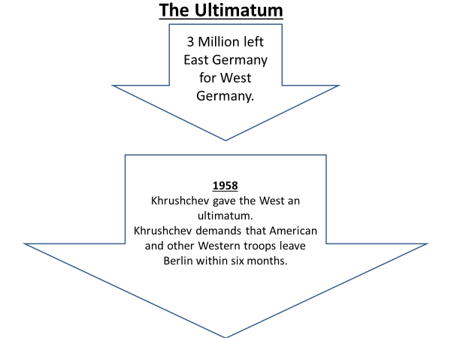

Activity Two – Watch the following video
https://www.bbc.co.uk/archive/panorama--panorama-goes-to-berlin/zhk9scw

Main Activity – Use the information below to complete the questions below
By 1958, both the USA and Soviet Union had large numbers of nuclear weapons. Neither side wanted the crisis to lead to war, so between 1959 and 1961, a series of talks were held to try and solve the Berlin problem.

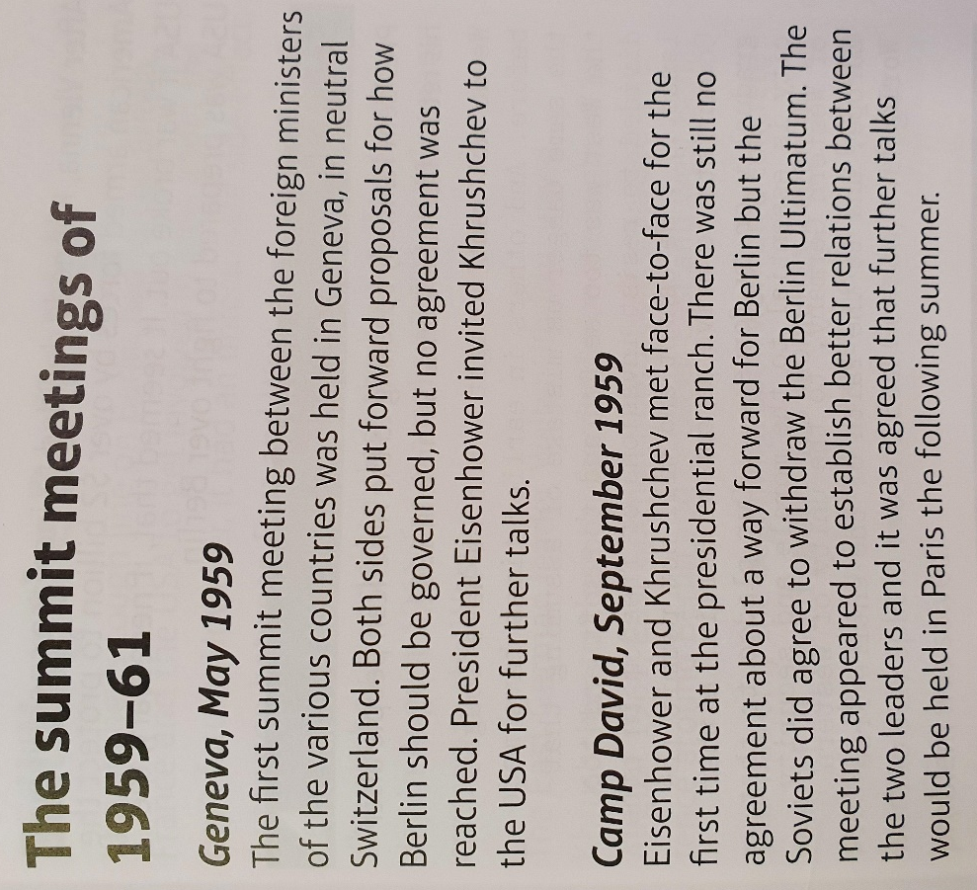

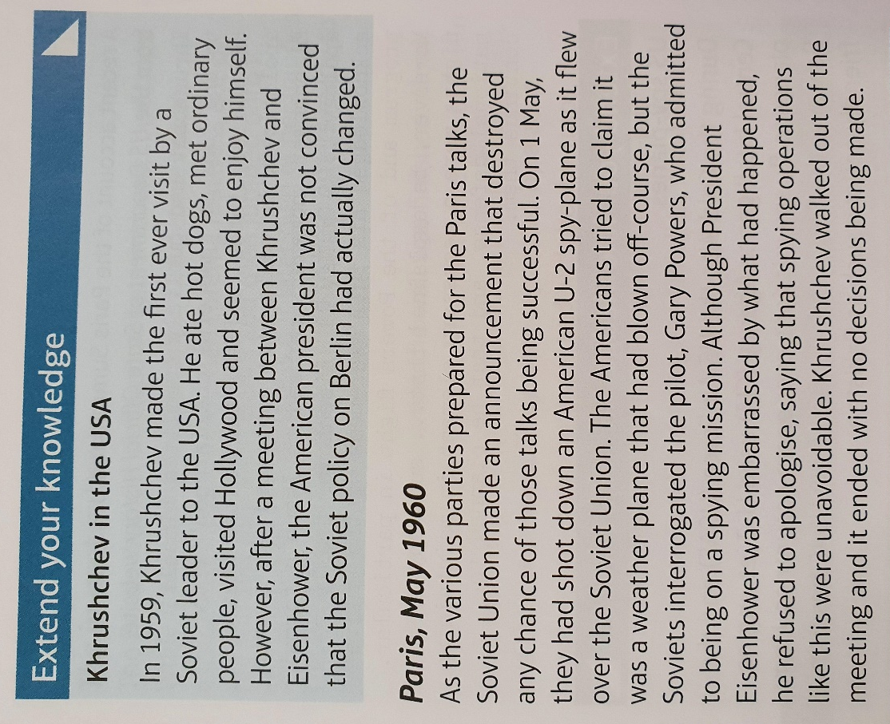

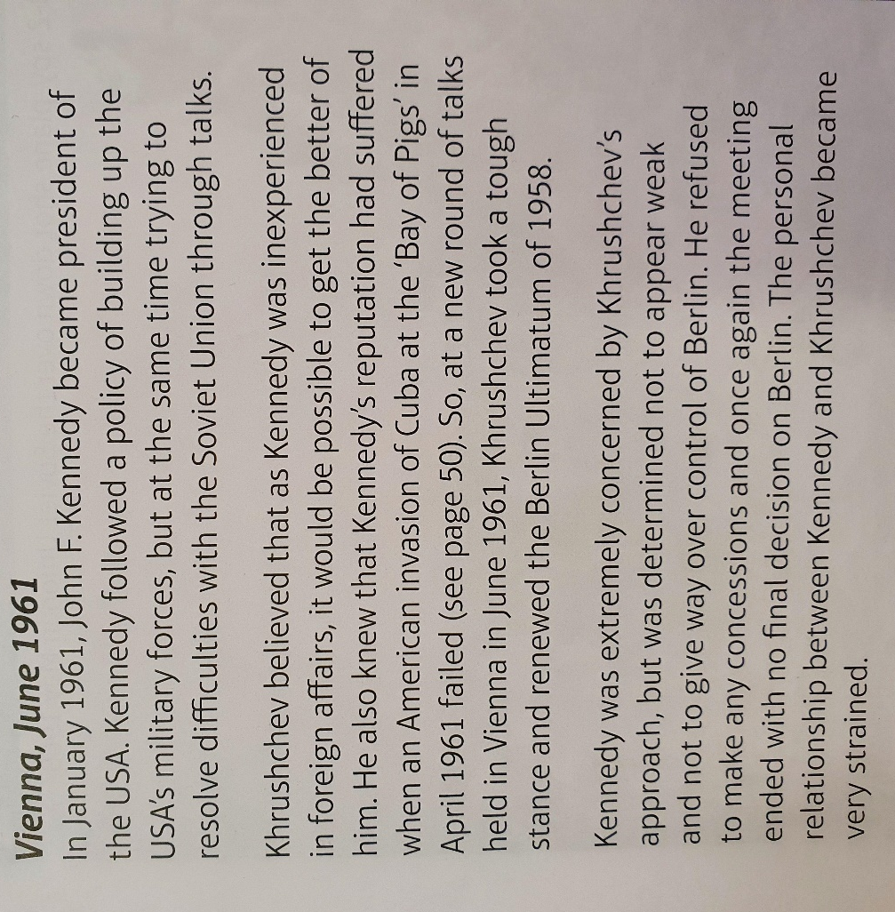

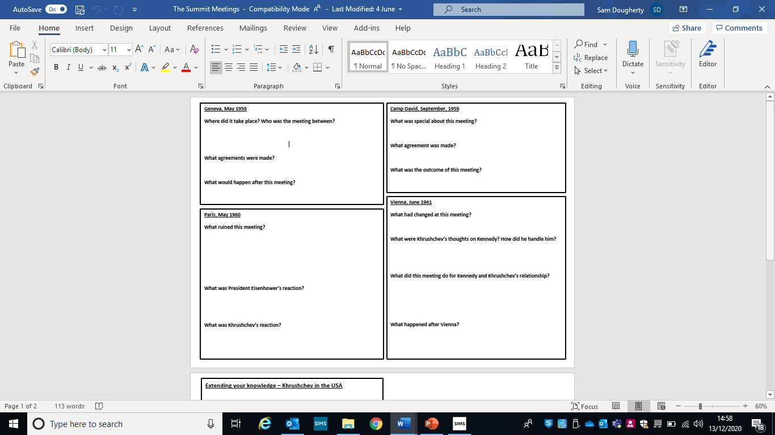
Lesson Two - The Berlin Crisis - The Berlin Wall
L/I: To describe the key stages of the Berlin crisis.
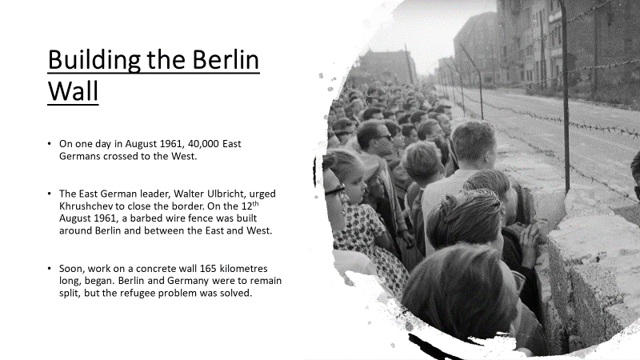
Activity One – Read the information and watch the following video
https://www.youtube.com/watch?v=XIfJfa23TIA

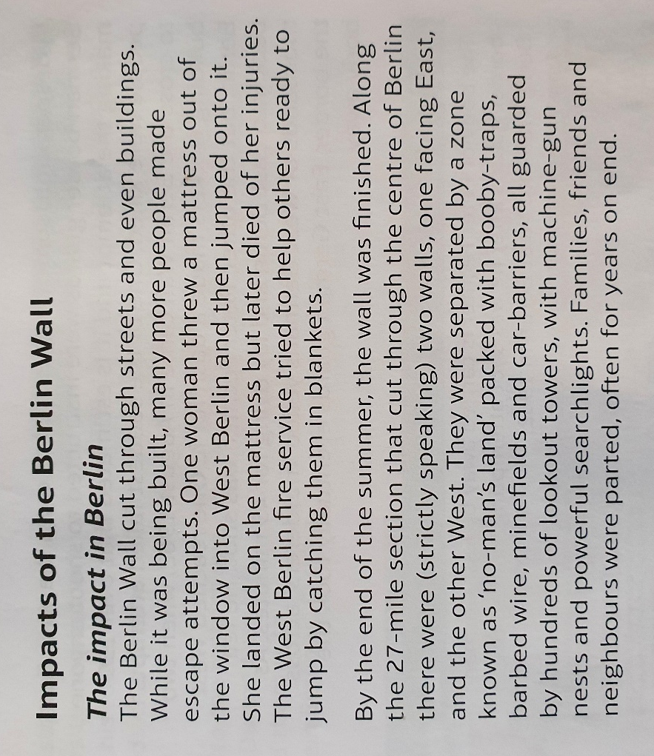
Activity Two – Answer the following question using the text below

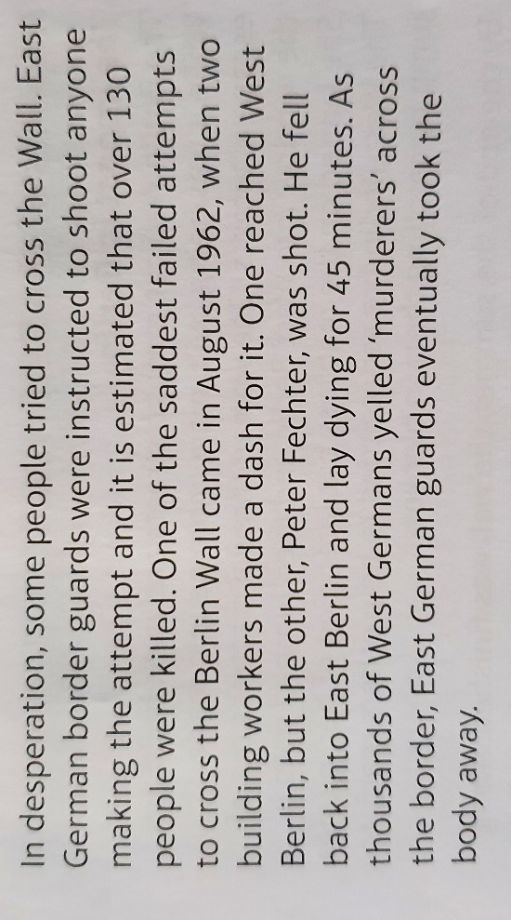

How dangerous was trying to cross the Berlin Wall and how successful were those trying to escape? Explain your answer with examples. Use this video to help you https://www.youtube.com/watch?v=railtJHRYIc

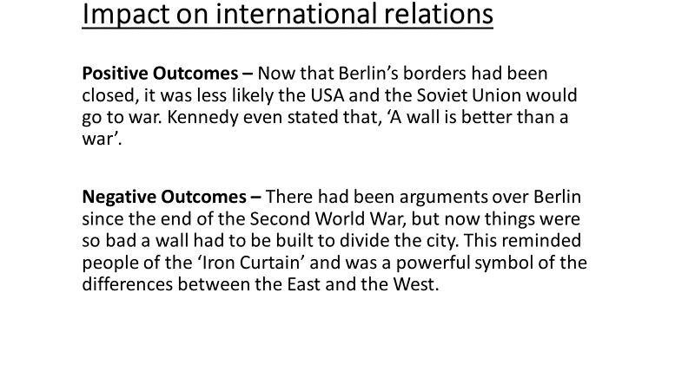

Lesson Three – The Cuban Revolution and the Bay of Pigs
L/I: L/I: To evaluate the significance of the Cuban Revolution.
H/W – Complete the questions on the Berlin Crisis on Page 5 and 6
Activity One – Read through the information and highlight key points
The Cuban Revolution
In January 1959, a group of revolutionaries, led by Fidel Castro and Che Guevara, toppled the pro-American government led by Batista. Eisenhower was concerned, as Cuba is close to the USA, only 145 kilometres away and has close business links with the USA, too.

Much of the Cuban land was owned by the USA and so was a lot of Cuban railways, oil refineries, electricity, and phone networks. The USA also bought a lot of Cuba’s main export, sugar.
Fidel Castro was a nationalist, who no longer wanted the USA to have so much control over Cuba. This created great tension between the USA and Cuba.

The aftermath of the Revolution
- The USA said that it would stop giving any kind of economic aid (money) to Cuba, unless it follows strict guidelines.
- All the land in Cuba that was owned by the USA, was taken over by the Cubans – May 1959
- In February 1960, the Cubans turned to the Soviet Union and Khrushchev for help. The Soviet Union would now start buying Cuban sugar and would give the Cubans weapons and arms.

The USA intervenes
- President Kennedy did not want a communist ally so close to the USA, so supported a CIA plan that had been agreed when Eisenhower was still president.
- The attack would have Cuban exiles trained to launch an invasion of Cuba and they would then overthrow Castro.
- This would look like a Cuban counter-revolution, so the USA could claim they were not involved.
- On the 17th April 1961, around 1,400 Cuban exiles landed in the ‘Bay of Pigs’ in Cuba. This was a massive failure, as the plan had leaked, and 20,000 Cuban soldiers were waiting for them.
https://www.youtube.com/watch?v=iT6msx5nVgk
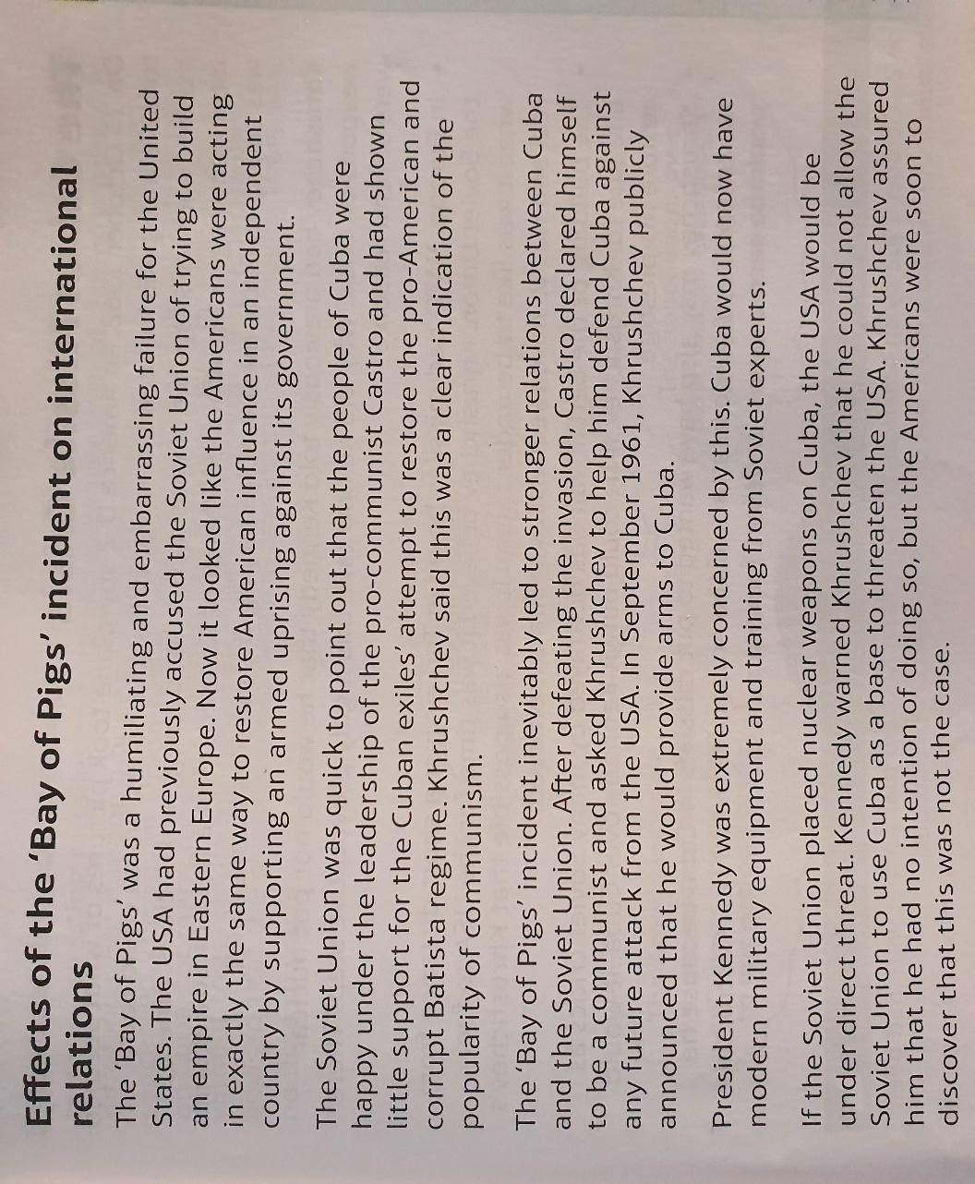
Activity Two Answer the questions below using the text below

Effects of the ‘Bay of Pigs’ on international relations
- How did the USA look after the incident?

2. What was the reaction of the following:
- Khrushchev

- Fidel Castro

- President Kennedy

Main activity - Was it necessary for the USA to intervene in Cuba? Explain your answer.
You must look at the argument from both sides.

Lesson Four - The Cuban Missile Crisis
L/I: To understand what the Cuban Missile Crisis was.

Activity One – Read through the information and highlight what the problem for Kennedy was
On 14th October 1962, an American U-2 spy-plane took pictures of what seemed to be launch pads for medium-range ballistic missiles, which could carry nuclear warheads capable of causing terrible damage to US cities. American intelligence agencies informed President Kennedy that a fleet of Soviet ships was sailing to Cuba, presumably carrying the missiles to go on the launchpads. Khrushchev had previously told Kennedy that he would not place missiles in Cuba, but missiles had been based in Turkey, just a short distance from the Soviet Union. Khrushchev wanted to make the USA feel under threat, just like how the Soviets felt.

If the Soviet Union had wanted to, they could have launched an attack on the USA from their own soil. This meant it did not make a great deal of practical difference, but it mattered a great deal politically. The big problem was how to stop the missiles getting to Cuba, without starting a nuclear war. Defence Secretary Robert McNamara advised Kennedy that the missiles would be operational within two weeks. – Kennedy could not allow enemy nuclear missiles so close to the USA. He must stop them somehow.
https://www.youtube.com/watch?v=5HRU5yonyK8

Activity Two – Create a timeline of the following days, on a separate piece of paper, using the information below.
16th October
22nd October
24 October
26th October
27th October
28th October

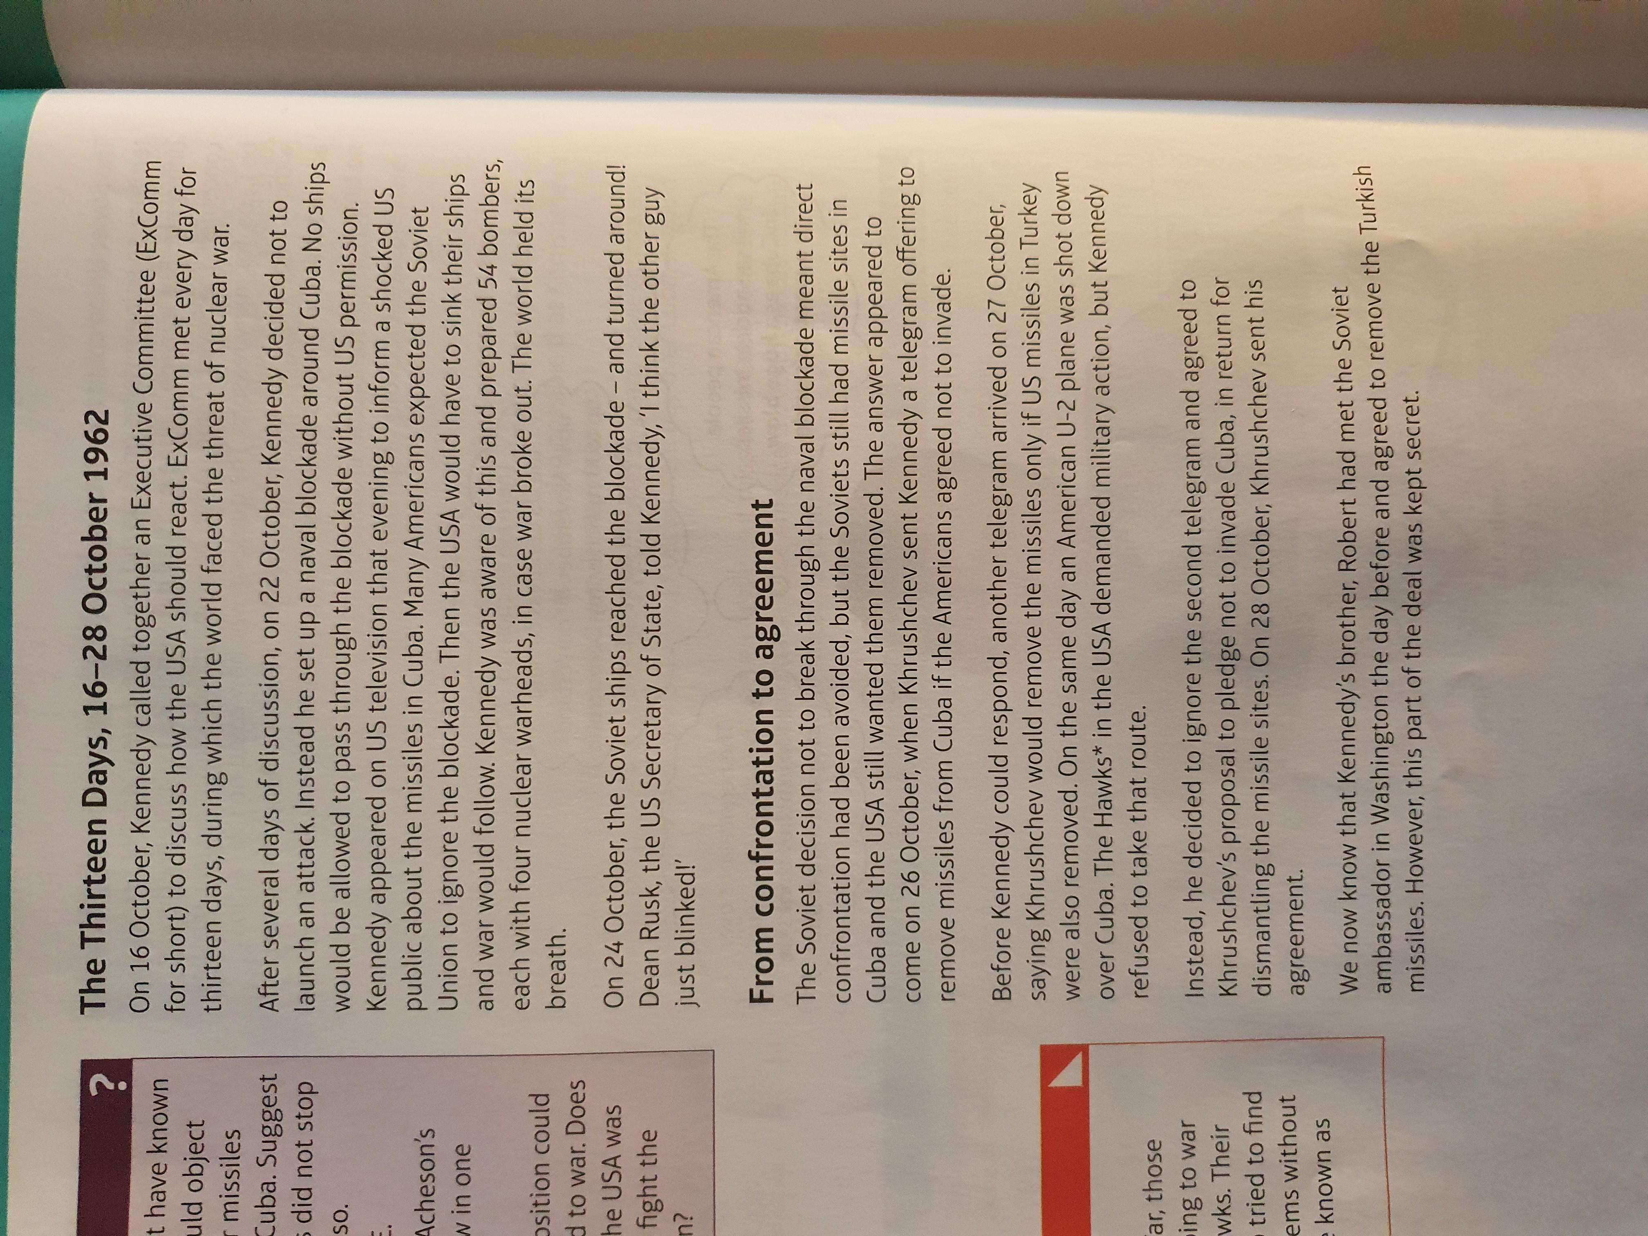

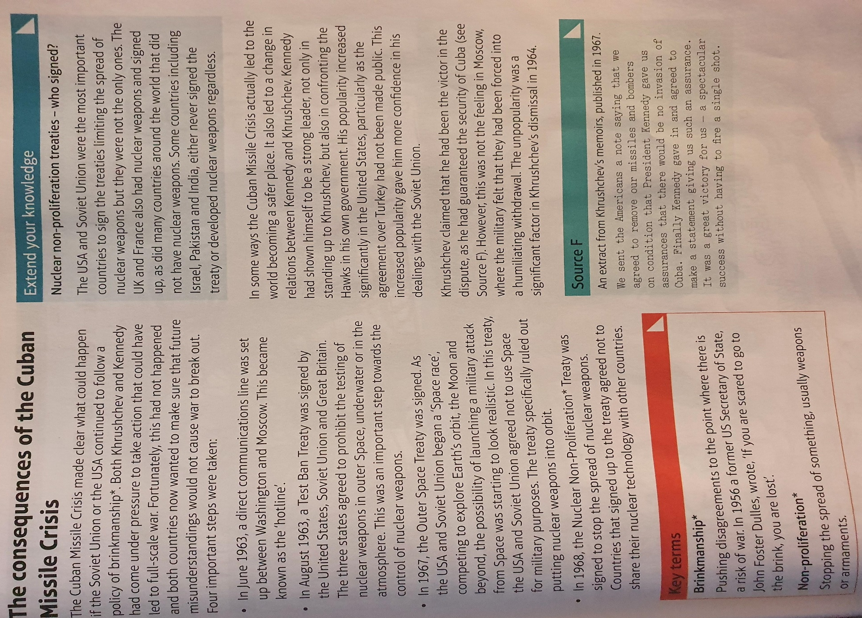
Main Activity – Complete the questions below using the information below

The consequences of the Cuban Missile Crisis
How would this help prevent nuclear war?

How would this help prevent nuclear war?

How would this help prevent nuclear war?

1968 – Nuclear Non-Proliferation Treaty
August 1963 – Test Ban Treaty
Hotline – June 1963
1967 – Outer Space Treaty
How would this help prevent nuclear war?

Lesson five - Czechoslovakia – The ‘Prague Spring’
L/I: To explain why there was unrest in Czechoslovakia in 1968.
H/W – Complete the Cuban Missile Crisis questions on Page 5 and 6

Activity One – read through the information below. Highlight the reasons wht life was difficult for the Czech people and what was done to try and fix it.

In 1948, Stalin supported a communist takeover in Czechoslovakia, which removed all non-communists from power and established a pro-Soviet communist government. This government was under the control of a man named Klement Gottwald. Life was very difficult for the Czech people. Secret police were used to maintain control through fear, there were barely any consumer goods to buy, no freedom of speech and all news was censored to only say positive things about the Soviet Union and the communist government of Czechoslovakia. In 1968, Alexander Dubcek was elected as First Secretary of the Czech Communist Party. The head of the Czech government.

The Soviet Union trusted that Dubcek would sort out the government of Czechoslovakia while keeping the country loyal to the Soviets. Dubcek was a devoted communist. He believed though, that communism should not make you miserable. He wanted ‘communism with a human face’. He thought citizens should be able to express their views about communism without fear of being punished.

Activity Two – Use the information below to answer the questions below

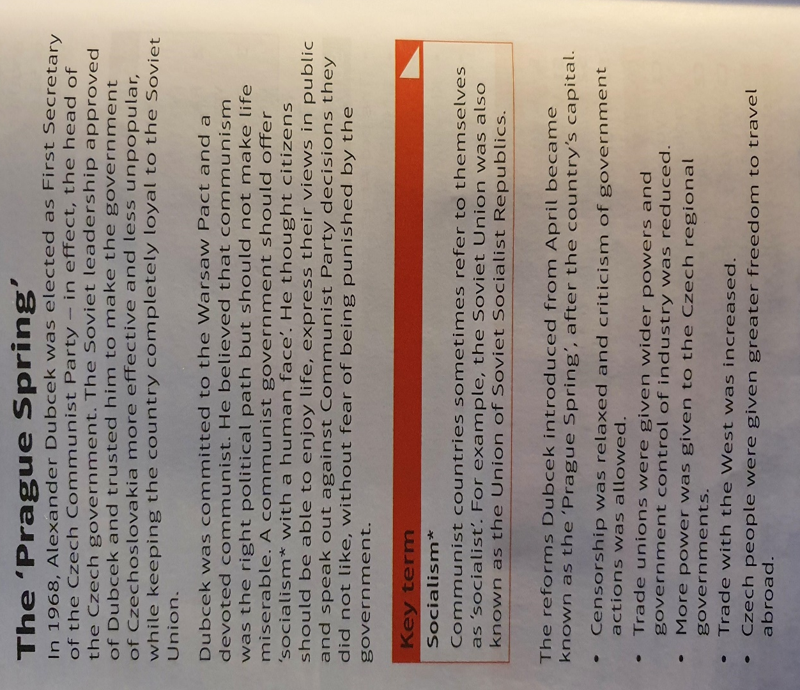

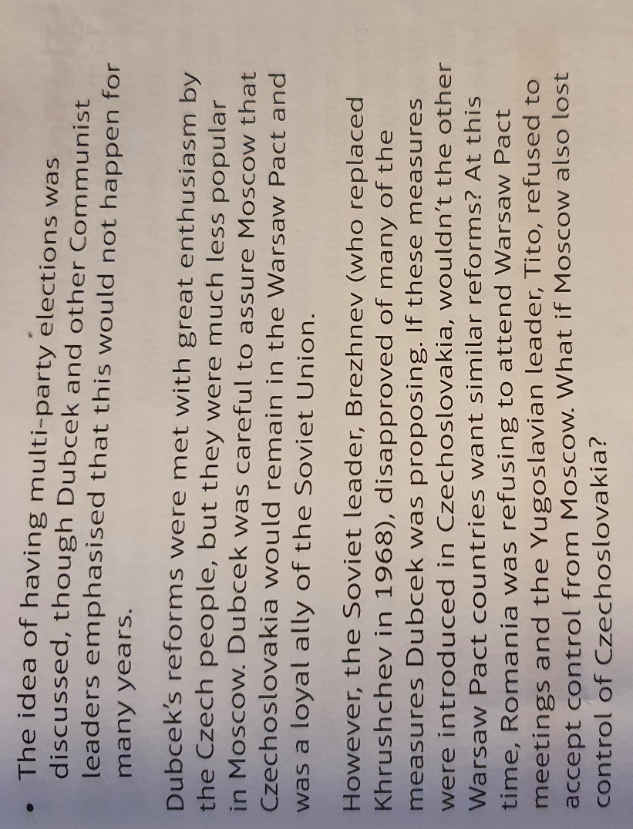

Write three changes that Dubcek made.
-

-

-

What did the Czech people think of these changes?

What did Dubcek promise Moscow?

Who was Brezhnev and what did he think?

Main activity - Why were the reforms put in place by Alexander Dubcek, such major changes? Explain your answer.

Lesson Six - Czechoslovakia – The Soviet Reaction
L/I: To explain why Brezhnev ensured the Prague Spring was stopped.

Activity One – Highlight the following in the text below:
- How did the Soviets react to the Prague Spring?
- What happened to Dubcek?
- Who was Gustav Husak?
- What was the Brezhnev Doctrine?
The Soviet reaction
Throughout the months after Dubcek became leader, Brezhnev remained in contact, urging him not to endanger communism in Czechoslovakia by going too far with his reforms. He also ordered Warsaw Pact troops to carry out practice in Czechoslovakia, to threaten Dubcek. Brezhnev eventually decided to act.
On 20th August 1968, 500,000 Warsaw Pact troops invaded Czechoslovakia and ended the Prague Spring. There was little opposition to the invasion. Brezhnev had ordered the Czech army to remain in its barracks and not to fight back. The Czech people could do little against such a powerful force. The invading forces had been told they were invited to help restore order in Czechoslovakia. They were shocked by the hostility they encountered.
Dubcek was arrested, sent to Moscow, and ordered to reverse his reforms. In 1969 he was dismissed from office and replaced by Gustav Husak. Husak was loyal to the Soviet Union and would not go against Brezhnev. For the next 20 years, the country was firmly under communist control.

Brezhnev Doctrine
- The invasion of Czechoslovakia was justified by the Soviet Union, by stating that they were defending the unity of communism in Europe.
- On the 26th September 1968, the Soviet paper Pravda, set out what was to be known as the Brezhnev Doctrine.
- The Doctrine stated that actions of individual communist countries affected every communist country. Therefore, if one countries action threatens the rest, it is the duty of the other countries to stop those actions.
- What he was really saying was the no communist country would be able to make changes to make their country freer.

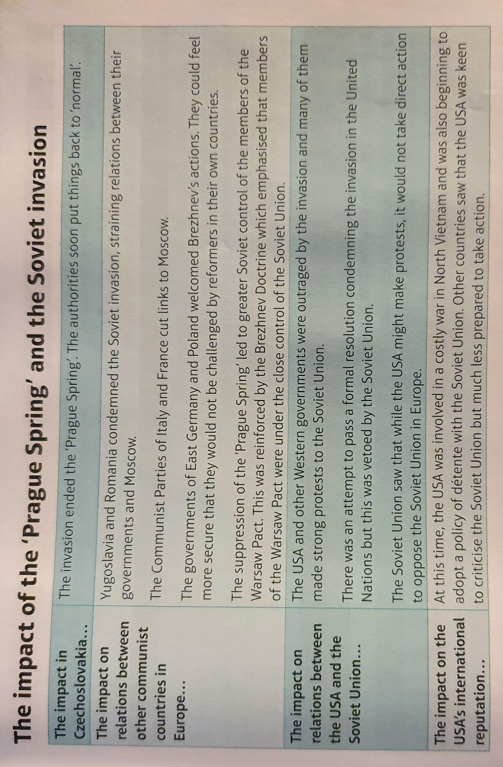
Activity Two
Did the Prague Spring have a big impact or a small impact on the Cold War? You must explain your answer.

Main Activity – Watch the following video then compete the questions on Page 5 and 6 on the Prague Spring - https://www.youtube.com/watch?v=-F4du579rcg

