Vocational
Health and Social care
Summer B Booklet
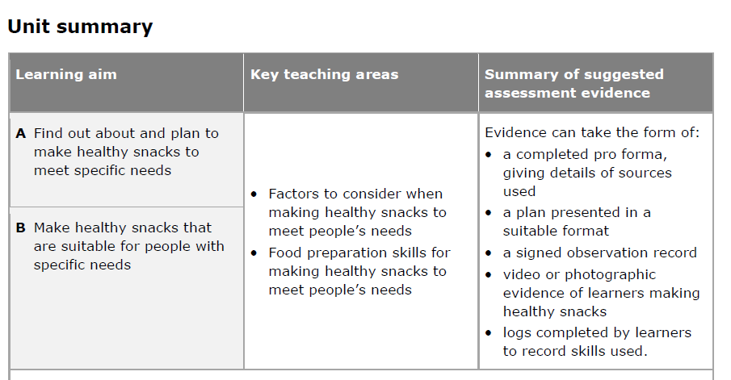

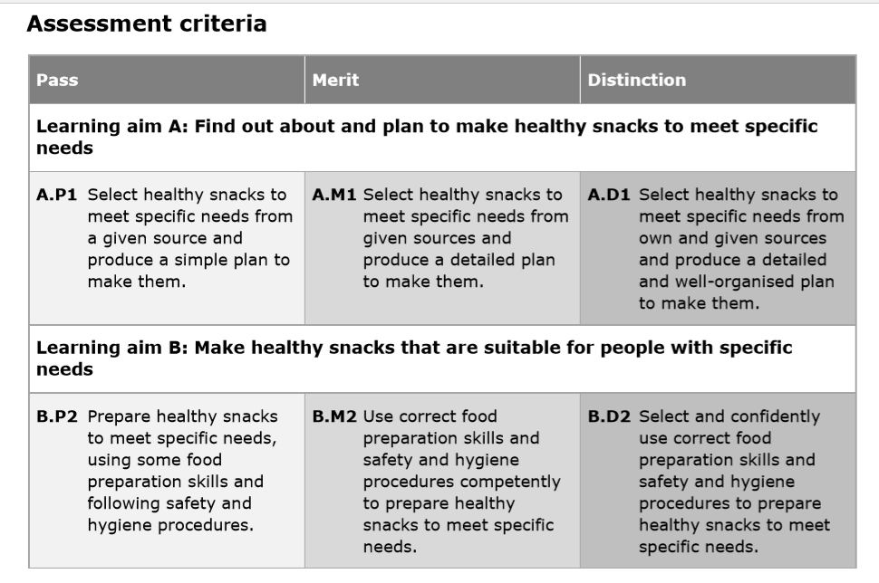

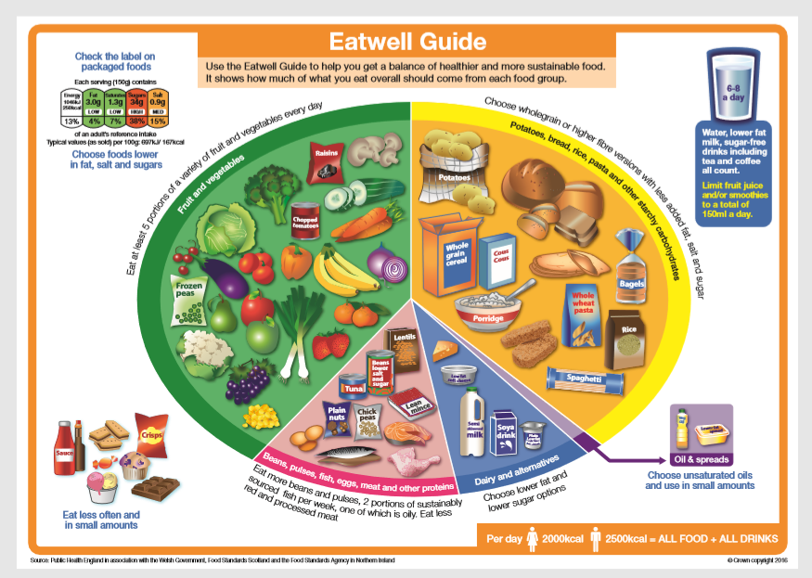

Lesson 1: I understand the importance of a balanced diet and can identify the changes needed to my own diet to ensure it is balanced and healthy.
What do you eat daily?
Write out your daily food intake in a week
(breakfast, lunch, dinner and snacks)
Diet plans
- Using www.nhs.uk/live-well/eat-well have a look at their tips for a healthy diet.
- What is the purpose of a diet plan?
- What changes would you make to your own diet to make it more healthy?
- What is meant by ‘5 a day’?
- Look under ‘healthy eating for teens’, what tips does it give you to alter your diet?
Healthy Aging with Nutrition
https://www.youtube.com/watch?v=KD-FmeueFUo&feature=youtu.be
malnutrition: A hidden epidemic in older adults https://www.youtube.com/watch?v=iPNZKyXqN1U&feature=youtu.be

Task: Create a balanced diet plate of foods you would have for dinner.

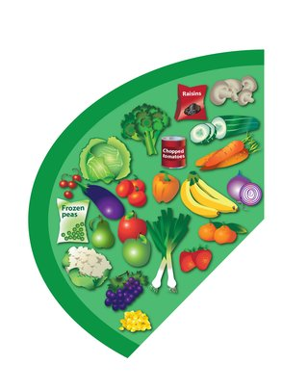
Most of us still are not eating enough fruit and vegetables. They should make up over a third of the food we eat each day.
Aim to eat at least 5 portions of a variety of fruit and veg each day. Choose from fresh, frozen, tinned, dried or juiced.
Remember that fruit juice and smoothies should be limited to no more than a combined total of 150ml a day.
Fruit and vegetables are a good source of vitamins, minerals and fibre.

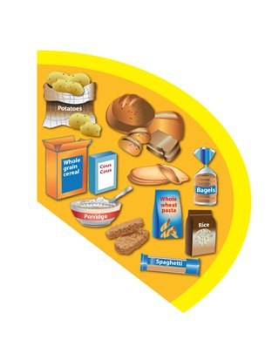
Base meals on potatoes, bread, rice, pasta or other starchy carbohydrates.
Starchy food should make up just over a third of the food we eat. Choose higher fibre wholegrain varieties, such as whole-wheat pasta and brown rice, or simply leave skins on potatoes.
There are also higher fibre versions of white bread and pasta.
Starchy foods are a good source of energy and the main source of a range of nutrients in our diet.

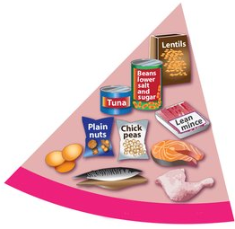
Eat some beans, pulses, fish, eggs, meat and other protein.
These foods are good sources of protein, vitamins and minerals. Pulses, such as beans, peas and lentils, are good alternatives to meat because they're lower in fat and higher in fibre and protein, too.
Choose lean cuts of meat and mince, and eat less red and processed meat like bacon, ham and sausages.
Aim for at least 2 portions of fish every week, 1 of which should be oily, such as salmon or mackerel.

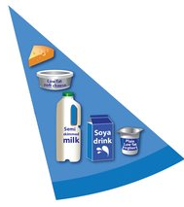

Milk, cheese, yoghurt and fromage frais are good sources of protein and some vitamins, and they're also an important source of calcium, which helps keep our bones strong.
Try to go for lower fat and lower sugar products where possible, like 1% fat milk, reduced-fat cheese or plain low-fat yoghurt.
Soya drinks and yogurts can be used as an alternative for those with allergies or vegan and vegetarians.

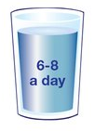

Fruit juice and smoothies also count towards your fluid consumption, but they contain free sugars that can damage teeth, so limit these drinks to a combined total of 150ml a day.

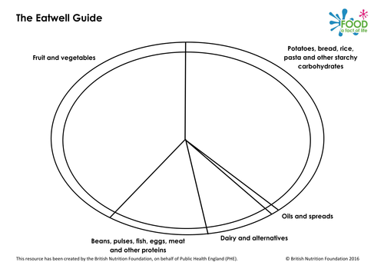

Lesson 2: I can identify healthy options for snacks not just for myself but for those of other age groups.
Healthy Processed Food Choices! Mind over munch
https://www.youtube.com/watch?v=h0aa5LAFtPs&feature=youtu.be

Using recipe books and the internet search 10 healthy snacks for your chosen persons.
Use https://www.verywellfit.com/recipe-nutrition-analyzer-4157076 to calculate the nutritional values for each and print the labels to stick in your book.
What is in your basket?
- Research the prices of the different foods in your recipe at different shops.
- Where are the ingredients cheaper? What are the prices of each, highest and lowest prices
- Why do you think they are?
- Where have these products been imported from?

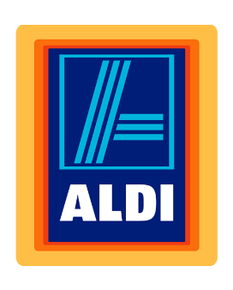

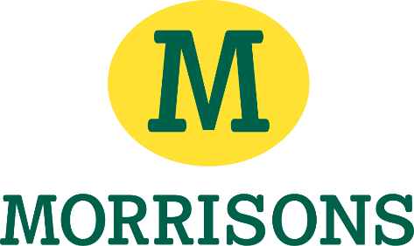


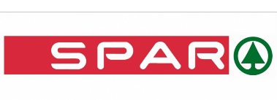


Go around the house and find out what everyone’s favourite snacks are.
Write them in a table and find the nutritional values, using the online calculator.

Lesson 3: I can identify costing and ingredient to create healthy snacks and meals.
Try to figure out how much each of these items is worth in the supermarket.
Draw out a table similar to the one below. Write your own estimation for each product.
Once you have done that, using the computer, find the real values of each of these products at these supermarkets.
Food | My Estimation | Sainsburys | Tescos | Morrisons | Asda
Pasta | £1.85 | £3 | £2.75 | £2.25 | £2.20

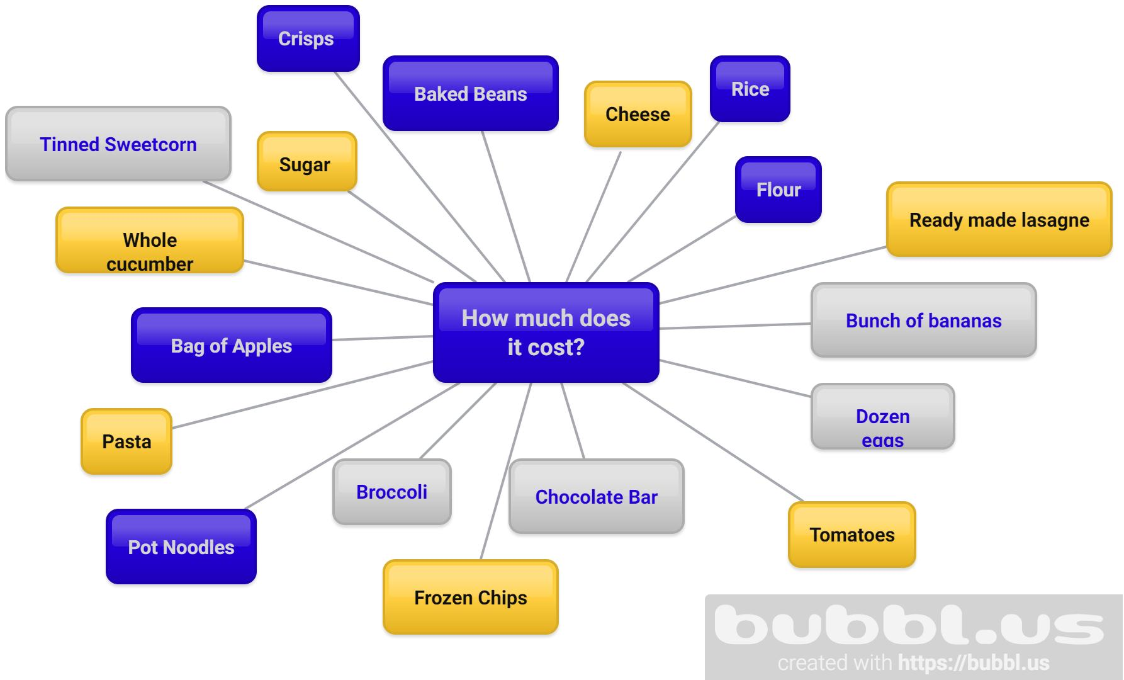

Think of four starters.
Write down a list
- of their ingredients,
- how much each think would cost,
- how many of each you will need
They can be anything from soup to salad, you decide

Lesson 4: I have an understanding of dietary requirements including intolerance and cultural/religious influences.
Here I have put together 2 different dietary requirements and what they mean in terms of food for your chosen age group.
I want you to think of other groups of individuals and different dietary requirement and what they mean.
Some examples are:
- Muslims
- Diabetics
- Allergies
- Weaning babies
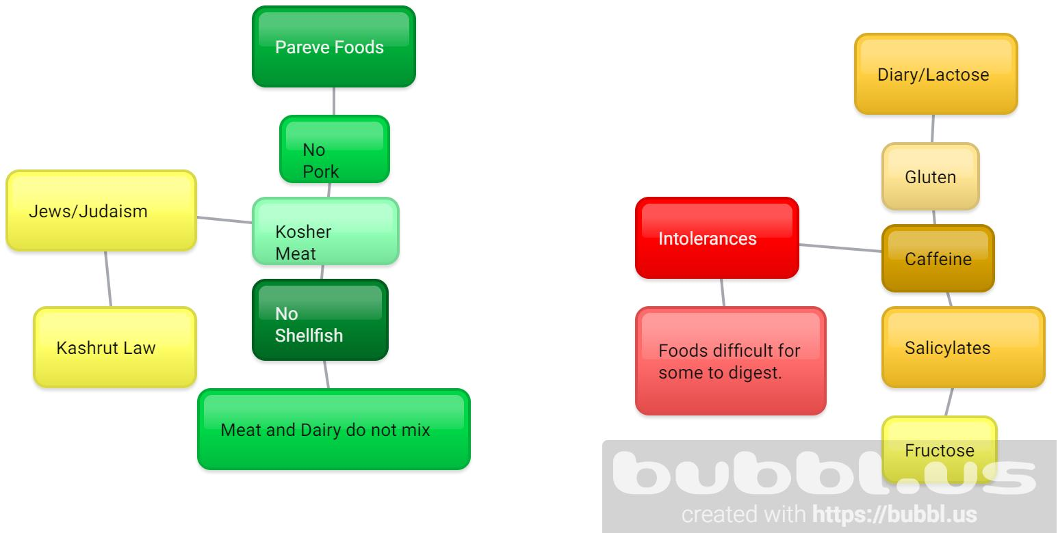

Now that we know the different dietary requirements, choose one group of individuals and consider their needs creating a starter, main and desert.
It can be any group of your choice from what you have written down.
Make the meals exciting! Think about foods you like and adapt them accordingly.

Lesson 5: I can explore different cultural perspectives on food and menus related to religious or cultural decisions.

Culture has a HUGE influence on what we eat!
Food from where our parents are from, grandparents, great-grandparents….and so on.
What cultural food have you explored?
Write down some of your favourite dishes that are NOT English (this includes pasta!) and tell me where they are from.
As a class we will discuss these meals and some of their nutritional values.

Choose a country you have NEVER eaten food from and research their native dish.
Find out
- What country is it?
- What continent is it in?
- What is the native language?
- What is the native dish called?
- What are the ingredient of the native dish?
- What is the recipe for the native dish?
- Where did it originated?
Once you have completed one, try another country from another continent and do the same.

Lesson 6: I can apply detail to a plate of food, making it aesthetically pleasing as well as taste good.


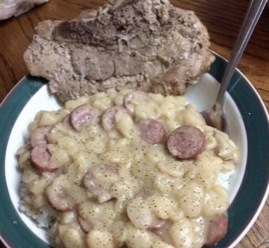
What does ‘aesthetically pleasing’ mean?
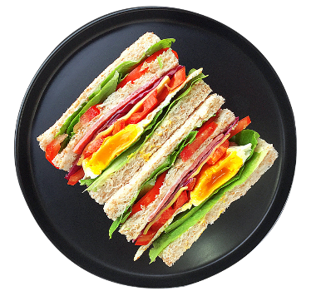
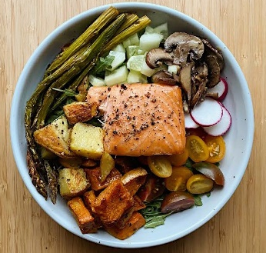
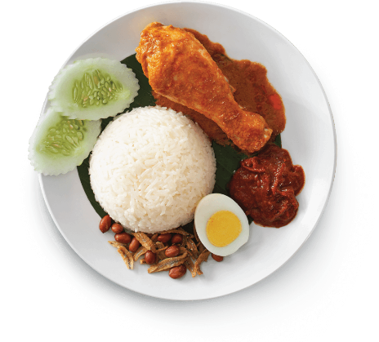
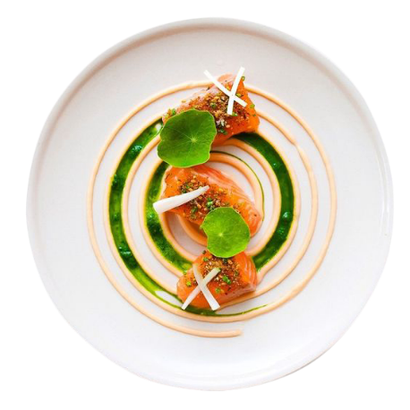
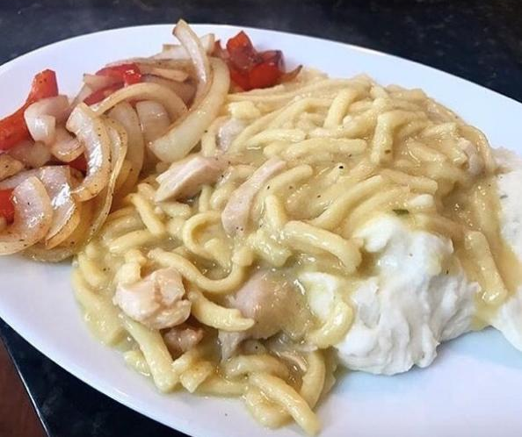
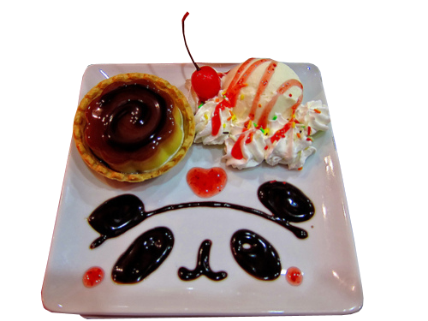
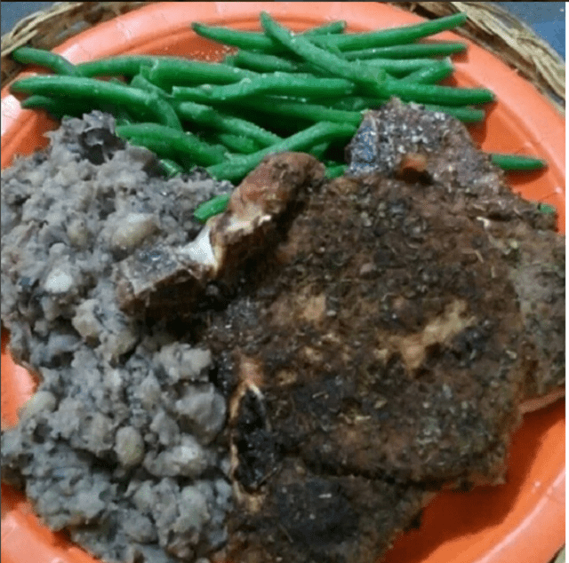
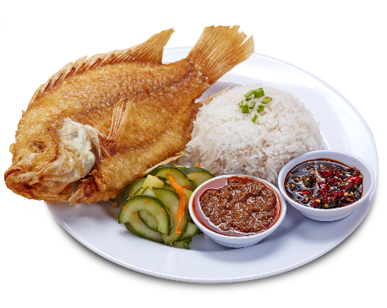
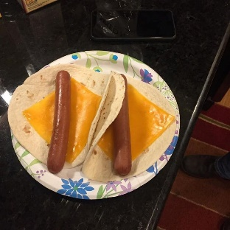

Draw out a plate of food. Make it as aesthetically pleasing as you can!
Remember- if you don’t like how it looks would you really eat it? And if you wouldn’t, can you expect someone else to?

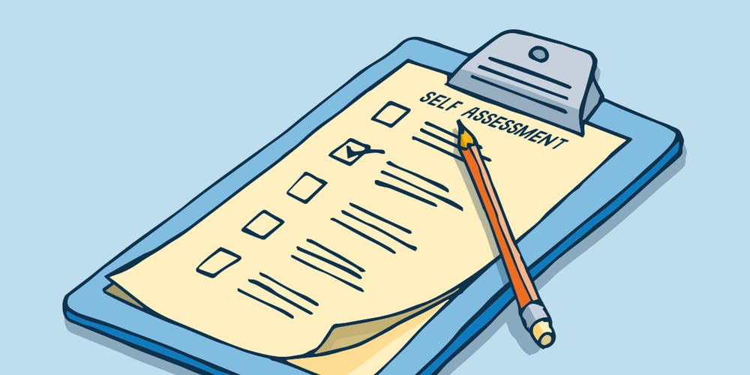
Self/Peer Assessment
Can you add anything extra or take away something to extend your information?

Suggested scenario
You will select, prepare, and produce three healthy snacks to meet the specific needs of people in given scenarios provided by your tutor
Scenario 1 – a child who has just started eating solid foods
Scenario 2 – a school dinner for a child who is lactose intolerant
Scenario 3 – a group of children preparing for a school sports day and needs snacks to maintain energy and strength.
Scenario 4 – an elderly home needs to supply a starter, mains and dessert for their residence that have a high nutritional value.

You will need to select suitable snacks to prepare from appropriate sources, and then produce a full plan for each of your selected snacks that explains how they will meet the needs and preferences of the people you are preparing them for. You will include how you will acquire the ingredients, including any budgeting details, quantities and measurements of ingredients needed, equipment needed, including PPE, steps to be taken to prepare food with timings for each step, and steps for following procedures relating to hygiene practices. You will leave the workplace clean and tidy and present a tasty snack in an attractive way.

Attainment Band: | HSC7: Making Healthy Snacks When Caring for People
Attainment Band: | Knowledge and Understanding | Skills
Yellow Plus | Explain the factors to consider when making healthy snacks to meet people’s needs  • Types of people who may be cared for, to include young children, adolescents, adults and older people.  • Food for good health, to include relative proportions of the five food groups – meat, fish and alternatives; milk and dairy food; fruit and vegetables; foods containing fat/sugar; bread, cereals and potatoes. | • Φοοδ πρεπαρατιον σκιλλσ, ινχλυδινγ χηοππινγ, γρατινγ ανδ σηοππινγ  • Ωειγηινγ ινγρεδιεντσ  • Μαναγινγ οων σαφετψ ωηεν πρεπαρινγ φοοδ  • Μαναγινγ οων ηψγιενε ωηεν πρεπαρινγ φοοδ  • Τψπεσ οφ πεοπλε ανδ τηε ινδιϖιδυαλ διεταρψ νεεδσ τηεψ μαψ ηαϖε  • Ρεθυιρεμεντσ οφ ηεαλτηψ εατινγ  • Τψπεσ οφ ηεαλτηψ σναχκσ  • Σαφετψ ανδ ηψγιενε προχεδυρεσ  • Φινδινγ ουτ ινφορματιον  • Πλαννινγ  • Υσε λανγυαγε, φορματ ανδ στρυχτυρε συιταβλε φορ πυρποσε ανδ αυδιενχε  • Πρεσεντ ινφορματιον ιν α λογιχαλ σεθυενχε.  • Σολϖε προβλεμσ ρεθυιρινγ χαλχυλατιον ωιτη χομμον μεασυρεσ,  ινχλυδινγ μονεψ, τιμε, λενγτη, ωειγητ, χαπαχιτψ ανδ τεμπερατυρε.
Yellow | Explain the factors to consider when making healthy snacks to meet people’s needs  • Meeting individual needs and choices, to include:  o physical health needs – food for growth, food to fight infection, taking other health needs into consideration, e.g. allergies, lactose intolerance  o emotional wellbeing – empowering people by considering personal preferences, providing choice and considering cultural needs, e.g. vegetarianism.  • Definition of snacks, to include light meals or small portions of food to eat between main meals.  • Types of healthy snacks to prepare, to include salads, raw vegetables with dips, sandwiches, wraps, scrambled eggs on toast, soup and fruit salad.
Blue | Explain the food preparation skills for making healthy snacks to meet people’s needs  • Following a recipe, following steps and procedures for preparing food.  • Measuring and weighing ingredients to ensure suitable portion size prepared.  • Food preparation skills, to include using correct utensils for the correct use, e.g. chopping, liquidising and mixing.
Green | Explain the food preparation skills for making healthy snacks to meet people’s needs  • Managing hygiene, to include personal hygiene, washing hands, tying up hair, clean personal protective equipment (PPE), e.g. aprons; food hygiene, to include clean work surfaces, equipment, washing food, washing work area and equipment between preparing different snacks and after use.  • Managing own safety, to include using equipment and tools correctly and safely, dealing with spillages, procedures to follow in case of accidents, e.g. cutting self.
White | Explain the food preparation skills for making healthy snacks to meet people’s needs  • Presenting food well so that people want to eat it, e.g. arrangement of food, colour

Stewards Academy
Vocational HSC7 ASSESSMENT FEEDBACK Year 9 – Summer Term 3

