Geography Year 9
Blended Learning Booklet

Y9-4 Coasts

Name:
Form:

Aim to complete one lesson each week. Write down the title and LI for each lesson and then complete the tasks which are highlighted.

Upload all work onto ClassCharts for feedback.

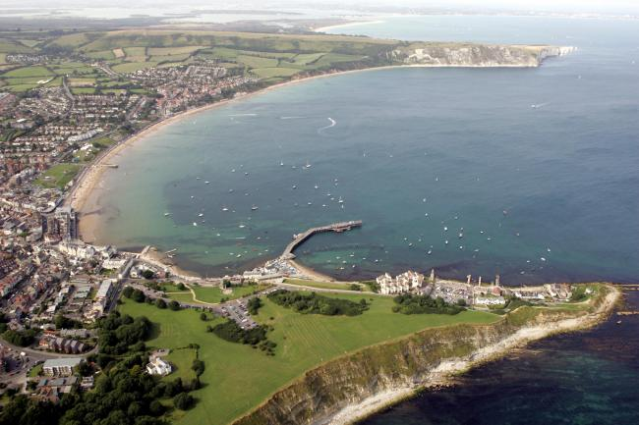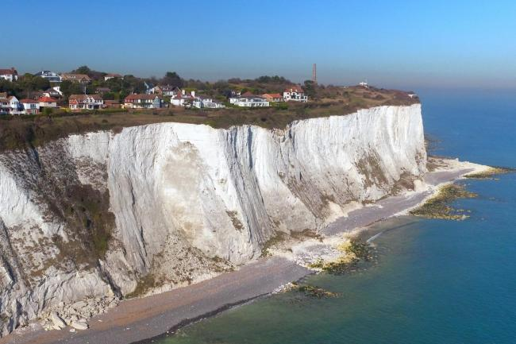

Contents
Page 3: Year 9 overview
Page 4 & 5: Lesson 1
Pages 5 to 7: Lesson 2
Pages 8 to 10: Lesson 3
Page 11: Lesson 4
Pages 12 & 13: Lesson 5
Page 14: Lesson 6
Page 15: Lesson 7
Page 16: Lesson 8
Page 17: Lesson 9

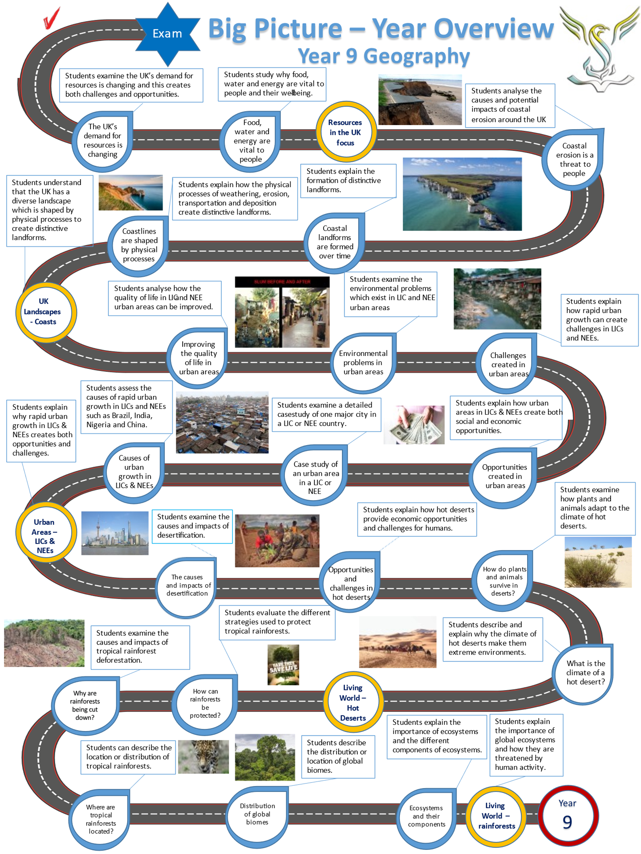

Lesson One: UK Landscapes
- LI: To identify that the UK has a range of diverse landscapes.

Lake District (Northern England):

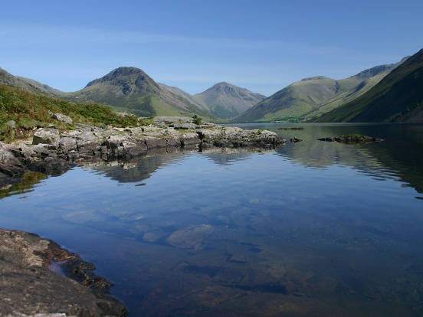
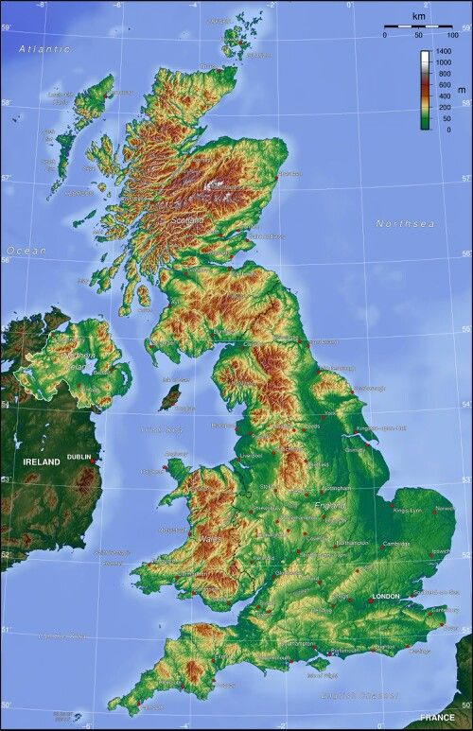
TASKS to complete:
- Describe each landscape – notable features, height and shape of the land.
- Draw a line from each photo and locate the landscape on the map above. Use online maps or an atlas to help you.
- Use the map to identify highland and mountain areas and areas which are low lands

Dorset Coast (Southern England):

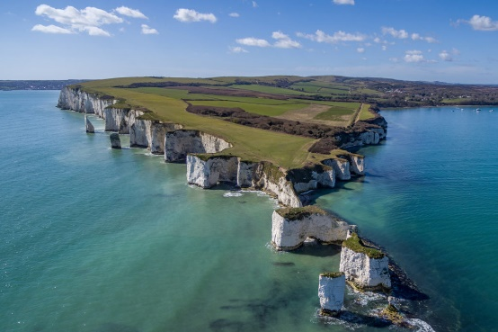

Scottish Highlands:

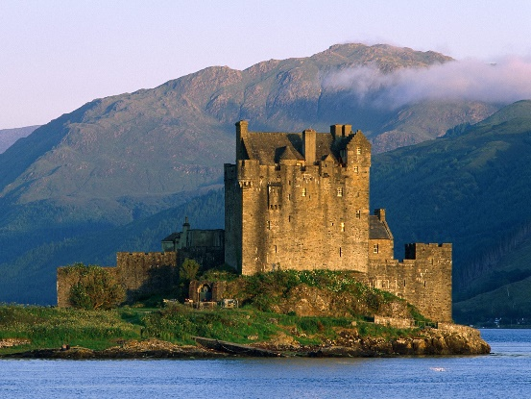

Essex countryside:

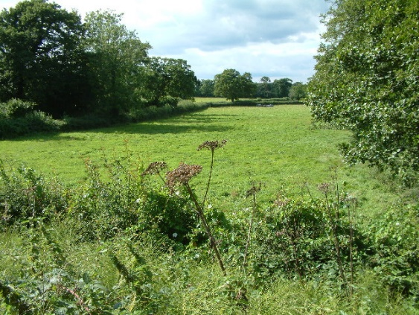

TASK: Watch the video on UK landscapes https://www.youtube.com/watch?v=H8uy86v6Kaw

Lesson 1 continued:

TASK: Complete the following gap fill

The UK has a …………………. range of landscapes. Much of Scotland, northern England and Wales is dominated by ……………………………such as the Grampians, the Pennines and the ……………………. Mountains in Wales. The southern part of England is largely ………………………, with some hilly areas and large areas of countryside. The UK also has an extensive range of coastal landscapes from high ……………………., bays to mudflats and river estuaries.

Cliffs low-lying Cambrian mountain ranges diverse

Lesson Two: Physical processes and coastlines
- LI: To define and describe the physical processes which shape coastlines – weathering, erosion and mass movement.

TASK: Read through the following weathering processes

Types of weathering
Exposed rocks along the coastline can be broken down by the processes of weathering.

Freeze-thaw weathering
Freeze-thaw weathering occurs when rocks are porous (contain holes) or permeable (allow water to pass through).
- Water enters cracks in the rock.
- When temperatures drop, the water freezes and expands causing the crack to widen.
- The ice melts and water makes its way deeper into the cracks.
- The process repeats itself until the rock splits entirely.

Biological weathering
Plants and animals can also have an effect on rocks. Roots burrow down, weakening the structure of the rock until it breaks away.
- Plant roots can get into small cracks in the rock.
- As the roots grow, the cracks become larger.
- This causes small pieces of rock to break away.

Chemical weathering
Rainwater and seawater can be a weak acid. If a coastline is made up of rocks such as limestone or chalk, over time they can become dissolved by the acid in the water.

TASK: Watch the video on the different types of weathering https://www.youtube.com/watch?v=2yJZES3bDOY

Lesson 2 continued:

Methods of erosion
Erosion is the wearing away of rock along the coastline. Destructive waves are responsible for erosion on the coastline. There are four types of erosion:
- Hydraulic action - this is the sheer power of the waves as they smash against the cliff. Air becomes trapped in the cracks in the rock and causes the rock to break apart.
- Abrasion - this is when pebbles grind along a rock, much like sandpaper. Over time the rock becomes smooth.
- Attrition - this is when rocks that the sea is carrying knock against each other. They break apart to become smaller and more rounded.
- Solution - this is when sea water dissolves certain types of rocks. In the UK, chalk and limestone cliffs are prone to this type of erosion.

TASK: Create you own revision cards or a poster which describe and define the processes of weathering and erosion

TASK: Create your own revision notes for each of the processes of mass movement detailed below:

Mass movements

Rockfall: Bits of rock fall off the cliff face, usually due to freeze-thaw weathering.

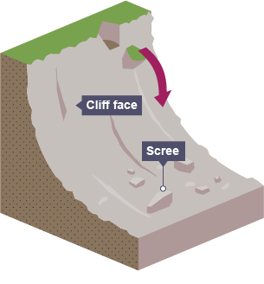

Landslide: Large blocks of rock slide downhill.

Lesson 2 continued:

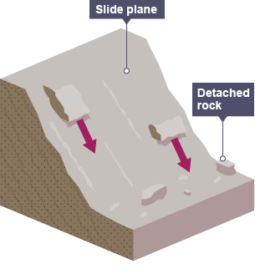

Rotational slip: Saturated soil slumps down a curved surface.

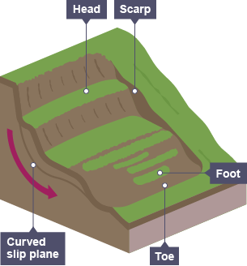

TASK: Complete the following gap fill to describe the methods of erosion

Hydraulic action is caused by the ………………… force of water compressing ………… in rocks, which then shatter as the pressure is released. Abrasion is caused by pebbles act like…………………… and …….…. against a rock, eroding it over time. …………………. occurs when rocks crash into each other and break apart. Solution occurs when ……………. in sea water chemically dissolve rocks.

acids rub sheer Attrition sandpaper air

Lesson Three: Physical processes and coastlines
- LI: To define and describe the physical processes which shape coastlines – waves, transportation and deposition.

TASK: Read through the following information on constructive and destructive waves

Wave types

There are two different types of wave - constructive and destructive. They can affect the coastline in different ways. When a wave reaches the shore, the water that rushes up the beach is known as the swash. The water that flows back towards the sea is known as the backwash. The energy of the swash and backwash determine the type of wave.
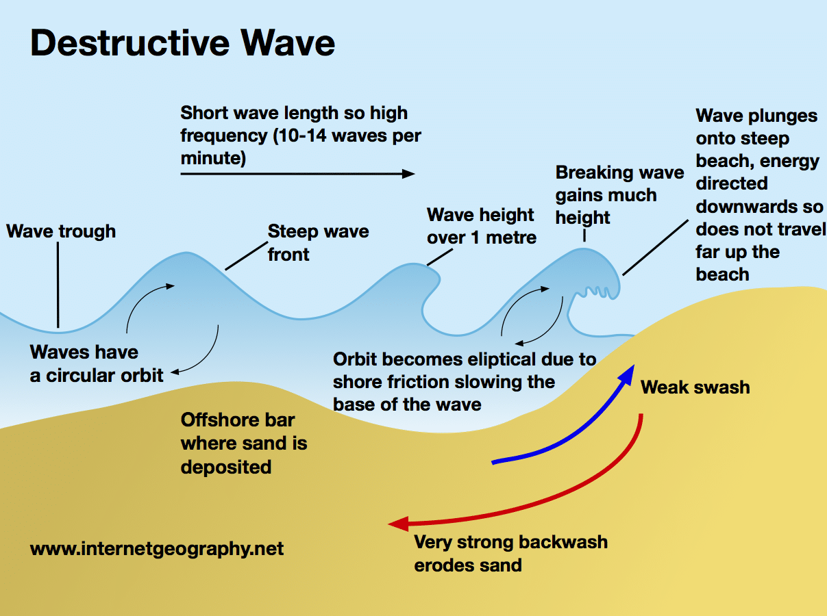

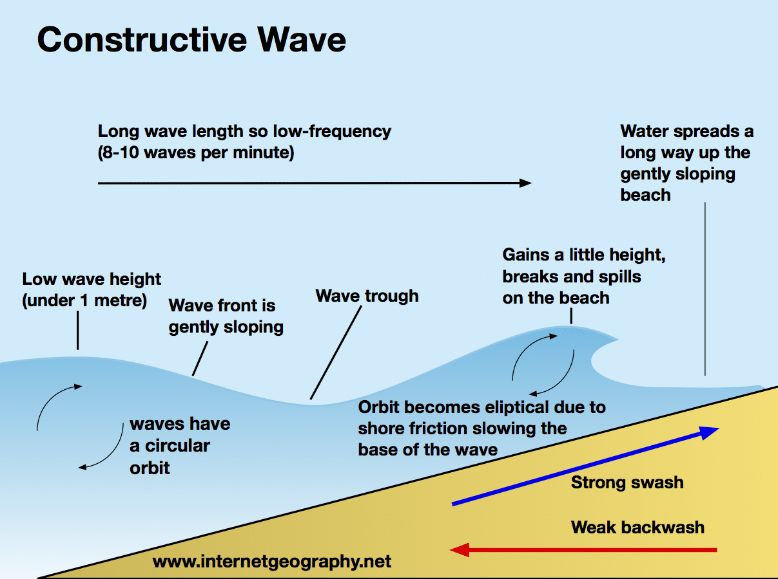

TASK – watch the video on waves: https://www.youtube.com/watch?v=YtEAXPlfUK8

Lesson 3 continued:
TASK: 7 questions about waves
Q1) Which type of wave occurs mostly in calm weather conditions?
Q2) What is ‘swash’?
Q3) What is ’backwash’?
Q4) Which type of wave has strong ‘swash’?
Q5) Which type of wave has weak ‘backwash’?
Q6) Which type of wave helps to build beaches?
Q7) Which type of wave often occurs during stormy winter weather?

Processes of transportation
Beach material can be moved in four different ways. These are:
- Solution - when minerals in rocks like chalk and limestone are dissolved in sea water and then carried in solution. The load is not visible.
- Suspension - small particles such as silts and clays are suspended in the flow of the water.
- Saltation – where small pieces of shingle or large sand grains are bounced along the sea bed.
- Traction – where pebbles and larger material are rolled along the sea bed.

Longshore drift
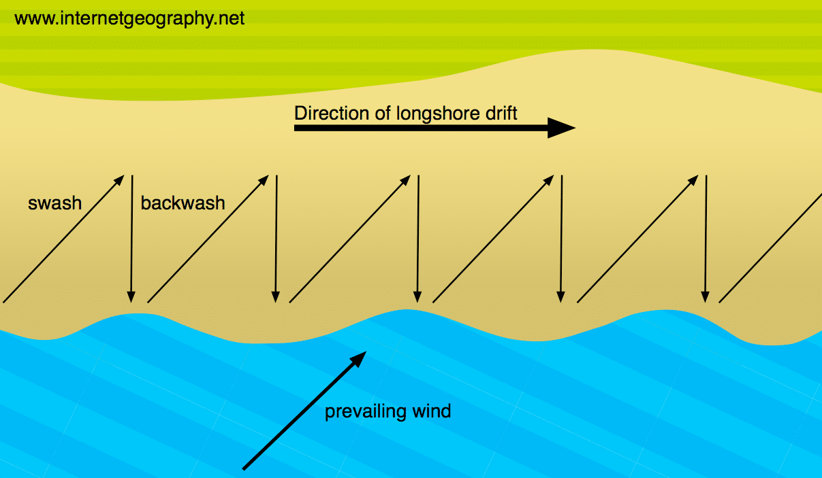

Lesson 3 continued
TASK: Complete the gap fill activity
Sediment is carried by the …………. along the coastline. The movement of the material is known as longshore drift. Waves approach the coast at an …………… because of the direction of the ……………. wind. The swash will carry the material towards the beach at an angle. The ……………… then flows back to the sea, down the slope of the beach. The process repeats itself along the coast in the zigzag movement.
Angle along backwash prevailing

TASK – watch the video on longshore drift https://www.youtube.com/watch?v=3bENNfLUIdw

Deposition
When the sea loses energy, it drops the material it has been carrying. This is known as deposition. Deposition can occur on coastlines that have constructive waves.
Factors leading to deposition include:
- waves starting to slow down and lose energy
- shallow water
- sheltered areas, e.g. bays
- little or no wind

TASK: Describe when and where deposition is most likely to occur.
TASK: Explain why a beach has formed in the bay shown in the photograph below
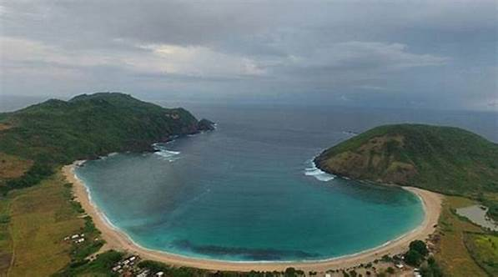

Lesson Four: Headlands & Bays and cliffs
- LI: To explain the formation of distinctive coastal landforms created by erosion – headlands and bays.

Task - watch the video on the formation of headlands & bays https://www.youtube.com/watch?v=F1PtFRs23EA

Headlands and bays
Cliffs along the coastline do not erode at the same pace. When a stretch of coastline is formed from different types of rock, headlands and bays can form.
Bands of soft rock such as clay and sand are weaker therefore, they can be eroded quickly. This process forms bays. A bay is an inlet of the sea where the land curves inwards, usually with a beach. Hard rock such as chalk is more resistant to the processes of erosion. When the softer rock is eroded inland, the hard rock sticks out into the sea, forming a headland.
Erosional features such as wave-cut platforms and cliffs can be found on headlands, since they are more open to the waves. Bays are more sheltered with constructive waves which deposit sediment to form a beach.
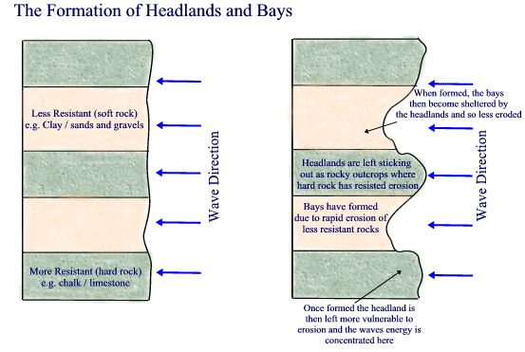

TASK: Using the diagram and notes above, describe the formation of ‘headlands and bays’ and include the key terms – headland, bay, soft rock, hard rock, beach. Draw your own diagram to help you.

Lesson Five: Erosion and coastal landforms – caves, arches and stacks
- LI: To explain the formation of distinctive coastal landforms – caves, arches & stacks and cliffs.

TASK: Watch the video on the formation of caves, arches and stacks: https://www.youtube.com/watch?v=00Khn0RSpYA

Caves, arches and stacks
Caves, arches, stacks and stumps are erosional features that are commonly found on a headland.
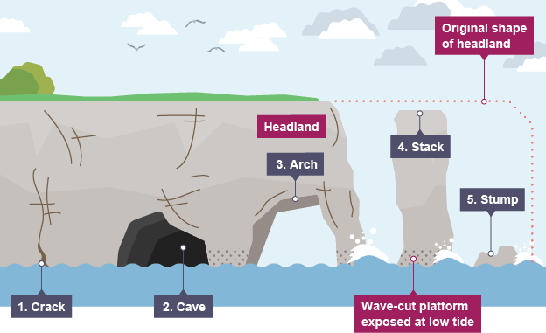

Formation of caves, arches and stacks

- ……….. are widened in the headland through the erosional processes of hydraulic action and abrasion.
- As the waves continue to grind away at the crack, it begins to open to form a ……..
- The cave becomes larger and eventually breaks through the headland to form an ……….
- The base of the arch continually becomes wider through further erosion, until its roof becomes too heavy and collapses into the sea. This leaves a ………. (an isolated column of rock).
- The stack is undercut at the base until it collapses to form a ………..
Stump cracks arch cave stack
TASK: Fill in the missing words into the description above
TASK: Describe the formation of caves, arches and stacks in your own words.

Lesson five continued

Cliffs and wave-cut platforms
Cliffs are shaped through erosion and weathering. Soft rock erodes quickly and forms gentle sloping cliffs, whereas hard rock is more resistant and forms steep cliffs. A wave-cut platform is a wide gently-sloping surface found at the foot of a cliff.
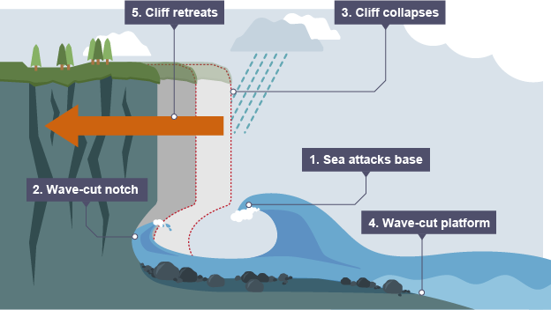
A wave-cut platform is formed when the following occurs:

- The sea attacks the base of the cliff between the high and low water mark.
- A wave-cut notch is formed by erosional processes such as abrasion and hydraulic action - this is a dent in the cliff usually at the level of high tide.
- As the notch increases in size, the cliff becomes unstable and collapses, leading to the retreat of the cliff face.
- The backwash carries away the eroded material, leaving a wave-cut platform.
- The process repeats. The cliff continues to retreat.

TASK: Describe the formation of cliffs and wave-cut platforms in your own words.

TASK: complete the following 6 questions
Q1) The sea attacks which part of the cliff – the top or the bottom?
Q2) What ‘notch’ is found at the base of the cliff?
Q3) Name two processes of erosion which could erode a cliff.
Q4) What happens to the top of the cliff when the base is eroded?
Q5) Does the cliff retreat inland or out towards the sea?
Q6) What platform is left behind as the cliff retreats inland?

Lesson six: Deposition and landforms – beaches, bars and sand dunes
- LI: To explain the formation of distinctive coastal landforms created by deposition – beaches, bars and sand dunes.

TASK: Read through the following information

Spits
A spit is an extended stretch of sand or shingle jutting out into the sea from the land. Spits occur when there is a change in the shape of the landscape or there is a river mouth.
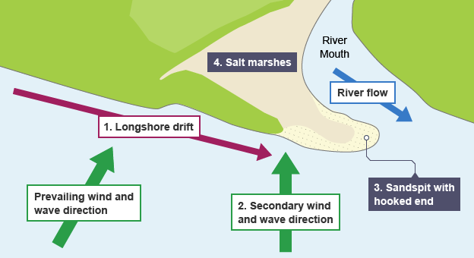
This is how spits are formed:
- Sediment is carried by longshore drift.
- When there is a change in the shape of the coastline, deposition occurs. A long thin ridge of material is deposited. This is the spit.
- A hooked end can form if there is a change in wind direction.
- Waves cannot get past a spit, therefore the water behind a spit is very sheltered. Silts are deposited here to form salt marshes or mud flats.

Beaches
Beaches are made up from eroded material that has been transported from elsewhere and then deposited by the sea. For this to occur, waves must have limited energy, so beaches often form in sheltered areas like bays. Constructive waves build up beaches as they have a strong swash and a weak backwash.
Sandy beaches are usually found in bays where the water is shallow and the waves have less energy. Pebble beaches often form where cliffs are being eroded, and where there are higher energy waves.
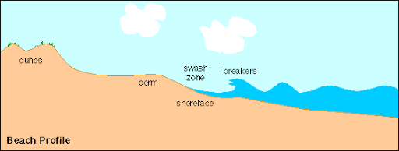
A cross-profile of a beach is called the beach profile. The beach profile has lots of ridges called berms. They show the lines of the high tide and the storm tides. A sandy beach typically has a gentle sloping profile, whereas a shingle beach can be much steeper. The size of the material is larger at the top of the beach, due to the high-energy storm waves carrying large sediment. The smallest material is found nearest the water as the waves break here and break down the rock through attrition.
TASK: Describe the formation of a spit.

TASK: Explain why beaches usually form in sheltered areas.

Lesson Seven: Protecting coastlines - hard engineering.
- LI: To explain how hard engineering management strategies can be used to protect coastlines.

TASK: Read through the following information about hard engineering:

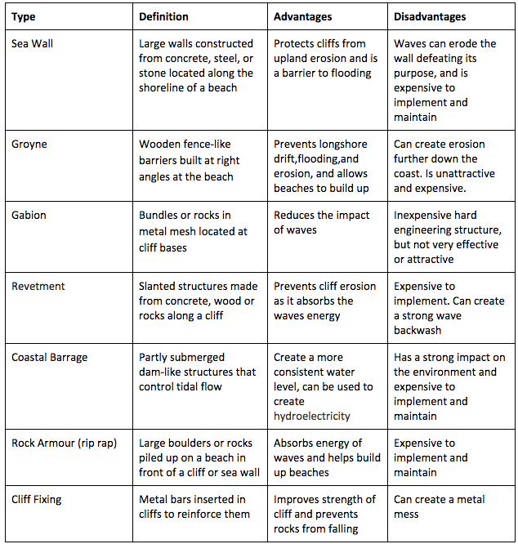

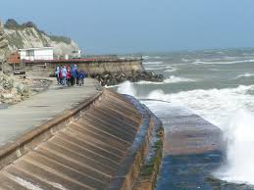

TASK: Which methods of hard engineering have been used in the image above? Are they effective? TASK: Explain the advantages and disadvantages of using hard engineering to protect coastlines – use 4 examples in your answer.

Lesson Eight: Protecting coastlines - Soft engineering.
- LI: To explain how soft engineering management strategies can be used to protect coastlines.

TASK: Read through the following information about hard engineering

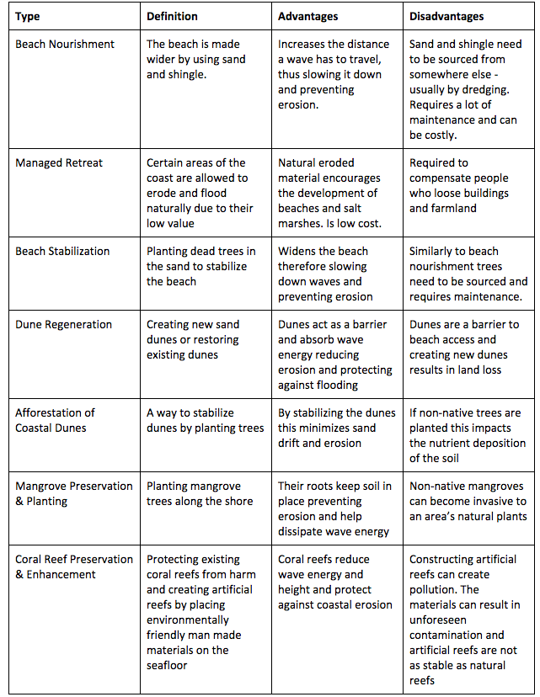

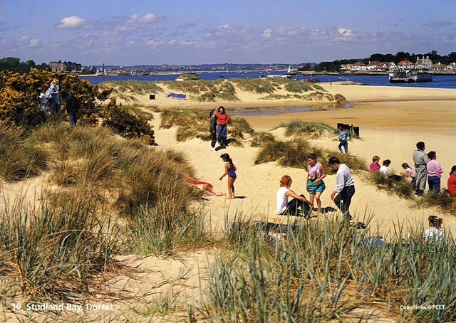
Studland Bay in Dorset

TASK: Which method of soft engineering has been used in the image above? Why is it highly effective?
TASK: What are the advantages and disadvantages of using soft engineering to protect coastlines?

Lesson Nine: Protecting coastlines – Holderness case study.
- LI: To explain how management strategies have been used to protect a specific UK coastline.

TASK: Read through the following information about a coastal management case study

The Holderness coastline – UK
The Holderness coastline in East Yorkshire is eroding very quickly. It is made from soft mud called Boulder Clay.
The coastline is retreating almost 2 metres every year – a European record! In the last 2000 years, the coast line has retreated by almost 2 miles.
The material from Holderness travels south towards the Essex coast and protects London from erosion.
There are many arguments for and against trying to save Holderness from erosion through building coastal defences along the coastline.
Arguments for saving Holderness:
- Local people want to save their own homes.
- Holderness is an area of good farmland and is useful for food production.
- People do not want to move to another area as they will lose their sense of community.
- Major North Sea gas terminals are located to the north of the village of Easington along the Holderness coast. This gas terminal supplies the UK with 25% of our gas for heating and cooking.

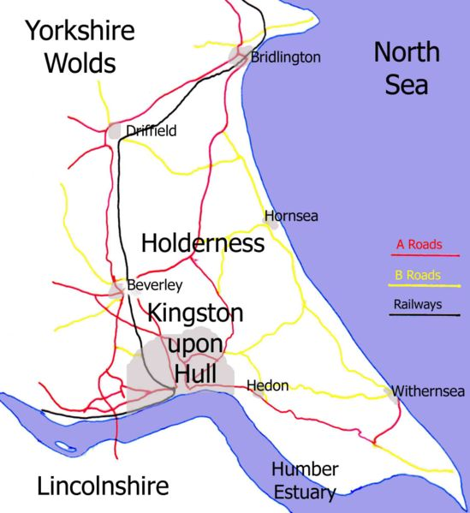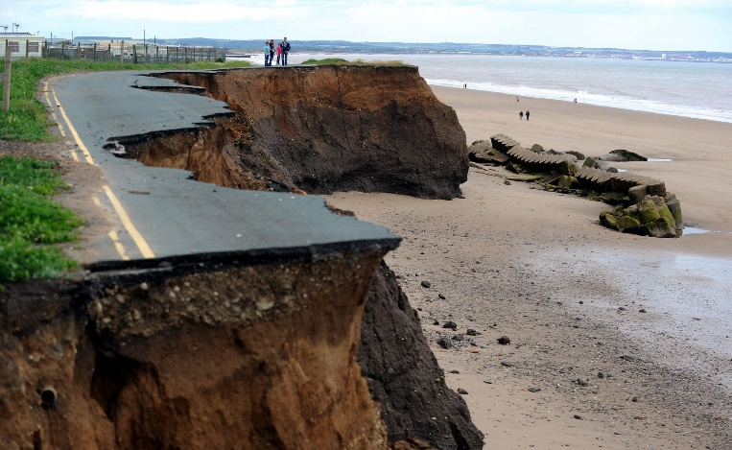
A map of the Holderness area and an example of coastal erosion along the Holderness coast
Arguments for NOT saving Holderness:
- Erosion is a natural process and the sand from Holderness helps protect more valuable places like London which has a population of nearly 9 million.
- Very few people live along this coastline (about 70,000).
- Building coastal defences will cost hundreds of millions of pounds – it could be spent elsewhere.
- Taxes would have to rise to pay for any coastal defences at Holderness. This would make people in other parts of the UK angry as they will see it as a waste of money.

TASK: 6 questions on Holderness
Q1) Describe the location of the Holderness coast.
Q2) How quickly is the Holderness coastline eroding?
Q3) What is the link between erosion at Holderness and London?
Q4) What are the arguments for protecting the Holderness coastline?
Q5) What are the argument for letting the Holderness coastline erode?
Q6) Do you think the Holderness coastline should be protected or should it be allowed to erode to help protect more important places like London?

Name: _____________________________________
[Type a quote from the document or the summary of an interesting point. You can position the text box anywhere in the document. Use the Drawing Tools tab to change the formatting of the pull quote text box.]
[Type a quote from the document or the summary of an interesting point. You can position the text box anywhere in the document. Use the Drawing Tools tab to change the formatting of the pull quote text box.]
A practise assessment for

GEOGRAPHY

YEAR 9 – Unit 4
Coasts Assessment

Assessment Date Time allowed: 40 minutes
Materials
For this paper you must have:
• a pencil
• a ruler.

Instructions
• Use black ink or black ball-point pen.
• Fill in the boxes at the bottom of this page.
• You must answer the questions on the spaces provided. Do not write outside the box around each page or on blank pages.
• Do all rough work in this book. Cross through any work you do not want to be marked.

Information

• The marks for questions are shown in brackets.
• The total number of marks available for this paper is 24.

Total: /24
Percentage:
PATHWAY:

Answer all questions in this section.

Question 1 Coastal landscapes in the UK
Study Figure 1, a 1:50 000 Google map extract of part of the coast of Southern England.

Figure 1
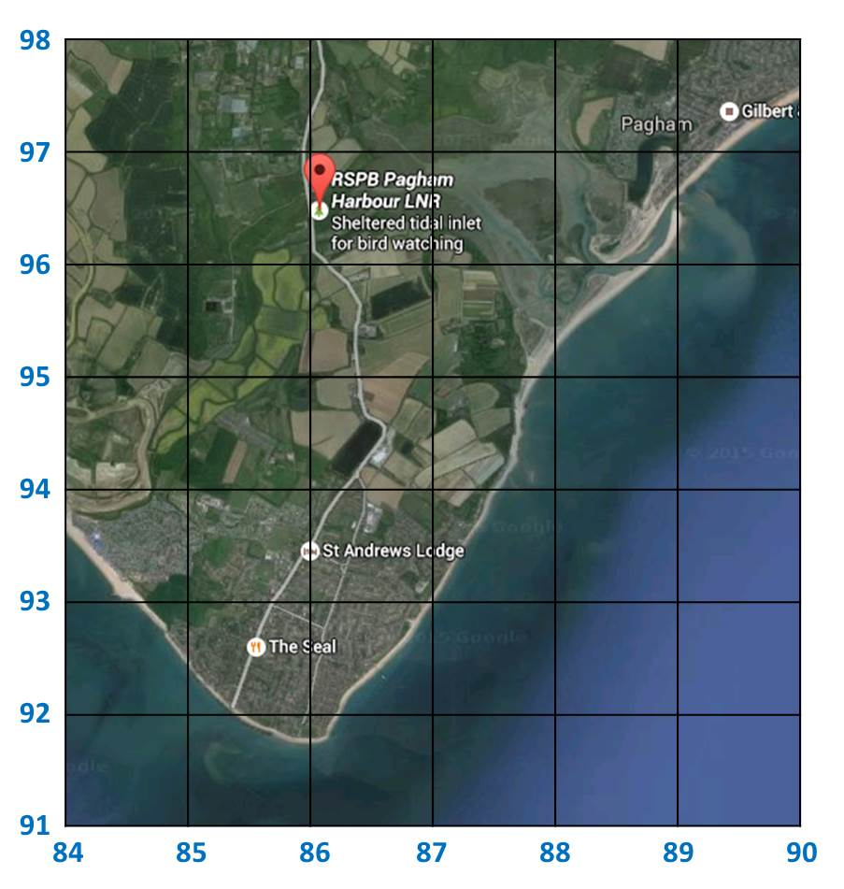
1.1 Using Figure 1, match the three coastal features shown in the table below to the correct grid references.

Shade one circle for each coastal feature. Choose from the following grid references:
A 8896 B 8493 C 8796 D 8592

Coastal Feature | Grid reference
Marsh & Mud flats
Spit
Beach

[3 marks]
Study Figure 2, an aerial photograph of Pagham Harbour and its surroundings (8796) shown in Figure 1.
Figure 2
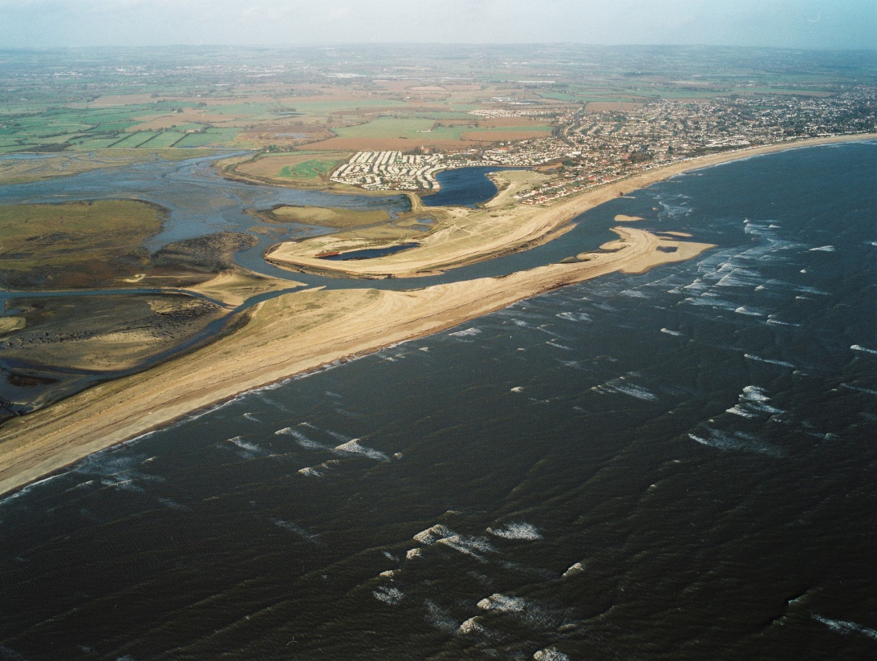
X
1.2 Using Figures 1 and 2, in which direction was the photographer facing when the picture was taken? Shade one circle only.
A North east
B North west
C South east
D South west
[1 mark]

1.3 Name one process of erosion that may affect this area.

[1 mark]

1.4 Name one process of coastal transportation that may affect this area.

[1 mark]

Figure 3 below shows Swanage in Dorset – a typical ‘Headlands and Bays’ landscape.

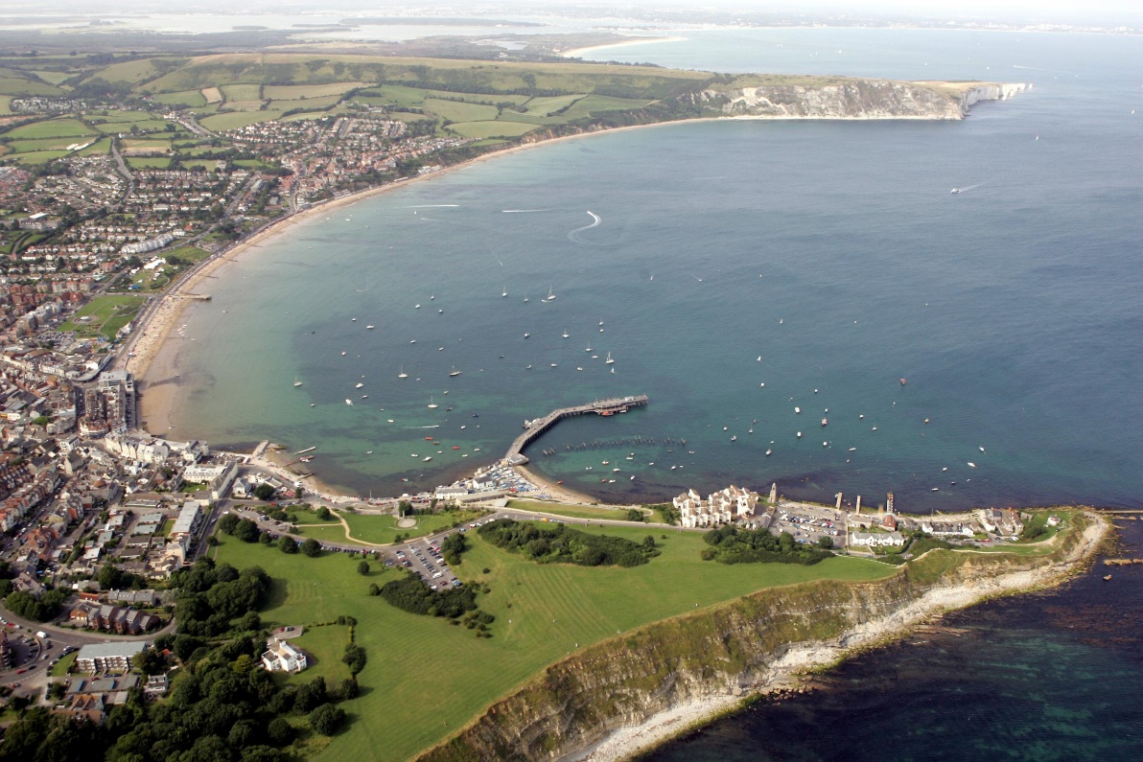

1.5 Using figure 3 and your own knowledge, explain the formation of ‘Headlands and Bays’

[6 marks]

Study Figure 4, a photograph of a soft engineering strategy used to manage a coastline in England

Figure 4
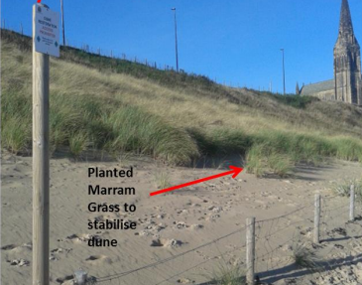

1.6 Evaluate the effectiveness of soft engineering sea defences such as those shown in Figure 4 help to protect the coastline.

[6 marks]

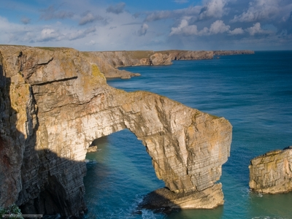
Figure 5 - The Greenbridge of Wales

1.7 Using figure 5 as an example, explain the formation of caves, arches and stacks.

[6 marks]

Attainment band: | Year 9 Unit 4 – ‘Coasts’
Attainment band: | Knowledge and Understanding | Skills
Yellow Plus  (20 to 24 marks) | - Student fluently explain the formation of erosion landforms ‘headlands and bays’ and ‘caves, arches and stacks’  -Student can fluently evaluate the effectiveness of soft engineering along a specific UK coastline  - Student can use OS maps with skill and accurately identify from which direction a photography was taken. | - Effectively use figures to answer geographical questions and draw geographical conclusions  - Independently use maps to locate places and identify key features  - SPaG is correct at all times
Yellow  (15 to 19 marks) | - Student can explain the formation of erosion landforms ‘headlands and bays’ and ‘caves, arches and stacks’  -Student can evaluate the effectiveness of soft engineering along a specific UK coastline  - Student can use OS maps with skill and accurately identify from which direction a photography was taken | -Shows an ability to use figures to answer geographical questions and draw geographical conclusions  - Confidently use maps to locate places and identify key features  - SPaG is generally correct
Blue  (10 to 14 marks) | - Student can describe the formation of erosion landforms ‘headlands and bays’ and ‘caves, arches and stacks’  -Student can describe the effectiveness of soft engineering and refers to some advantages and disadvantages  - Student can use OS maps to help answer geographical questions | -Identify useful geographic information from figures  -Use maps to locate places and identify some key features  - SPaG contains a few key word errors
Green  (5 to 9 marks) | - Student can start to describe some of the formation of erosion landforms ‘headlands and bays’ and ‘caves, arches and stacks’  -Student can make some judgements on the effectiveness of soft engineering.  - Student can use OS maps to help answer geographical questions | -Describe what figures are showing and link them to the topic of cold environments  -Use maps to locate places  - SPaG contains frequent errors, particularly of key words
White  (0 to 4 marks) | - Student can recognise some aspects of the formation of erosion landforms ‘headlands and bays’ and ‘caves, arches and stacks’  -Student can make some basic judgements on the effectiveness of soft engineering.  - Student can use OS maps to help answer geographical questions | -Describe basic facts about what figures are showing  -Use maps to locate places with support  - SPaG contains lots of errors, particularly of key words

